**BI**

**Part-1**

**SQL**

Initialization And Table Creation:

Code:

*CREATE DATABASE Foodpanda;*

*USE Foodpanda;*

*CREATE TABLE Orders(rdbms_id INT(3),*

*country_name VARCHAR(100),*

*date_local DATETIME,*

*vendor_id INT(10),*

*customer_id INT(10),*

*gmv_local Double,*

*is_voucher_used CHAR(10),*

*is_successful_order CHAR(10)*

*);*

*CREATE TABLE Orders1(rdbms_id INT(3),*

*country_name VARCHAR(100),*

*date_local timestamp,*

*vendor_id INT(10),*

*customer_id INT(10),*

*gmv_local Double,*

*is_voucher_used CHAR(10),*

*is_successful_order CHAR(10)*

*);*

*CREATE TABLE Vendors( vendor_id INT(10),*

*rdbms_id INT(3),*

*country_name VARCHAR(100),*

*is_active CHAR(10),*

*vendor_name VARCHAR(100),*

*budget INT(3),*

*chain_id CHAR(10) DEFAULT NULL*

*);*

Query – 1: List all the orders that were made in Taiwan

Code:

*select * from Orders where country_name = 'Taiwan';*

Output:

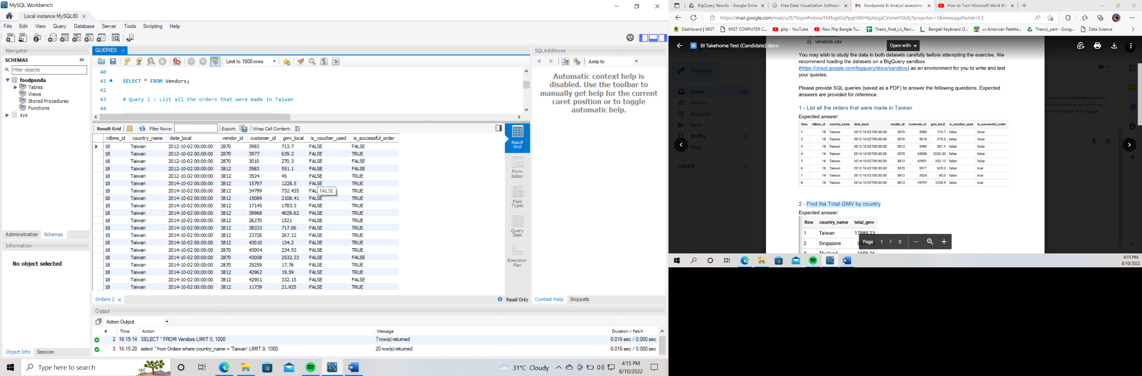

Query – 2: Find the Total GMV by country

Code:

*select country_name, round(SUM(gmv_local),2) as total_gmv from Orders group by country_name;*

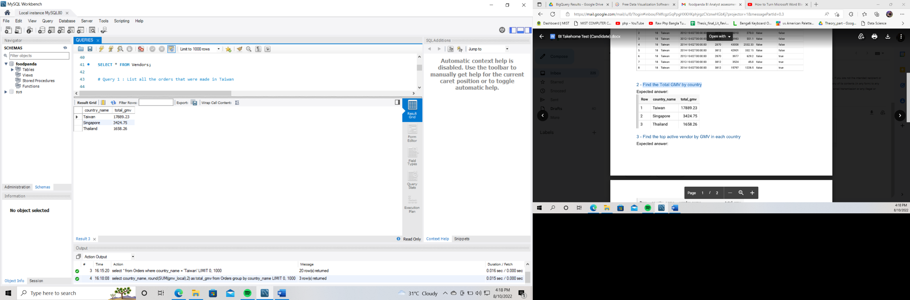Output:

Query – 3: Find the top active vendor by GMV in each country

Code:

*select B.country_name, ven.vendor_name, B.total_gmv from*

*(*

*select D.country_name, E.vendor_id, D.total_gmv from*

*(*

*select country_name, max(A.total_gmv) as total_gmv from*

*(select country_name, vendor_id, round(SUM(gmv_local),2) as total_gmv from Orders group by vendor_id) as A*

*group by country_name*

*) as D,*

*(*

*select country_name, vendor_id, round(SUM(gmv_local),2) as total_gmv from Orders group by vendor_id*

*) as E*

*where E.total_gmv = D.total_gmv*

*) as B, Vendors ven*

*where B.vendor_id = ven.vendor_id*

*order by B.country_name;*

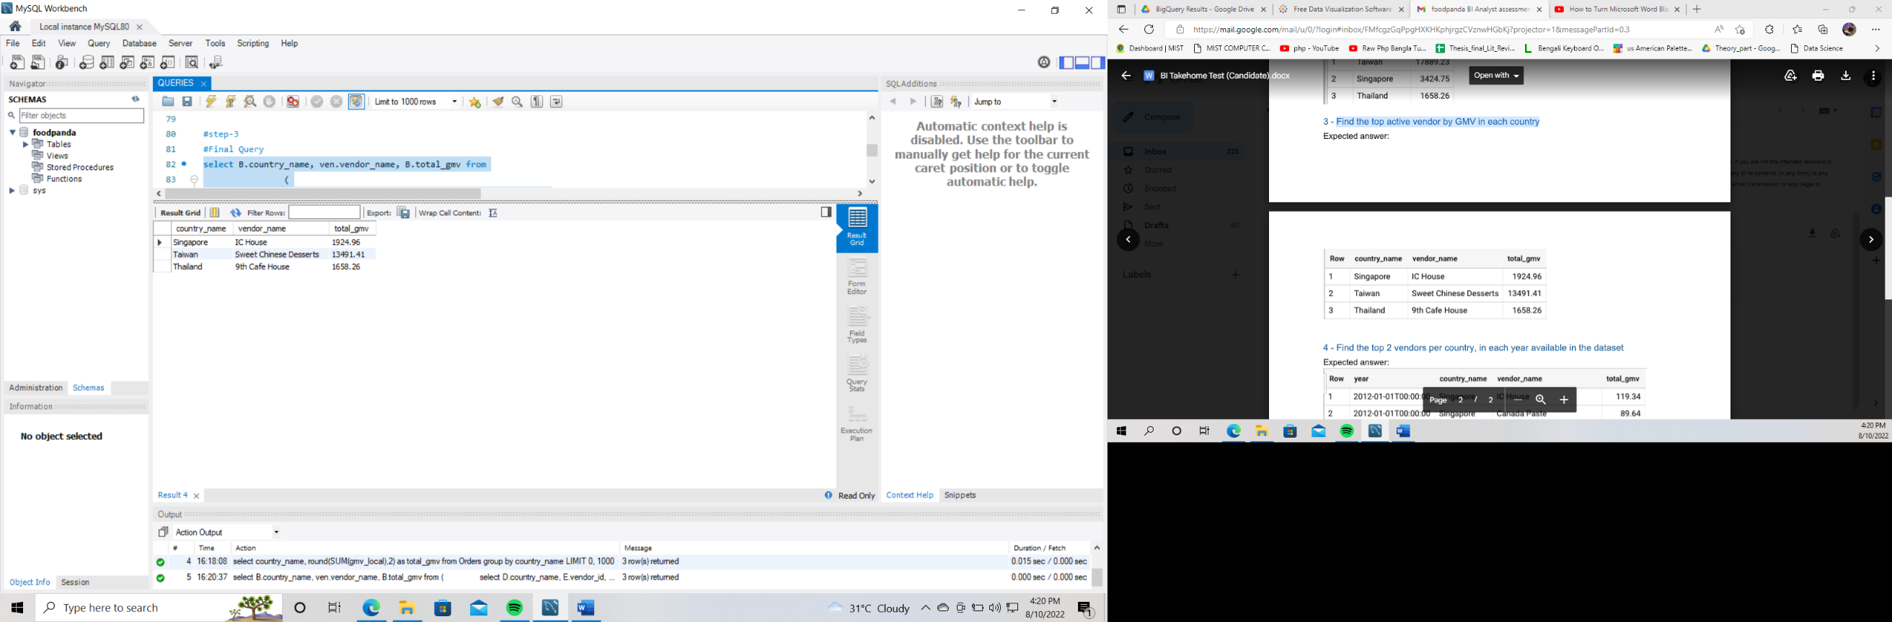Output:

Query – 4: Find the top 2 vendors per country, in each year available in the dataset.

Code:

*select Ft.date_local as year, Ft.country_name, Ft.vendor_name, Ft.total_gmv*

*from*

*(*

*select A.country_name, A.date_local, vn.vendor_name, A.total_gmv ,*

*ROW_NUMBER() OVER (PARTITION BY A.country_name, A.date_local*

*ORDER BY total_gmv DESC) max_count*

*from*

*(*

*select country_name, date_local,vendor_id, round(SUM(gmv_local),2) as total_gmv from Orders1 group by vendor_id,date_local*

*) as A left join Vendors as vn ON A.vendor_id = vn.vendor_id*

*group by A.date_local, A.vendor_id*

*order by A.date_local asc, A.country_name asc,A.total_gmv desc*

*) as Ft*

*where Ft.max_count <= 2;*

Output:

