**Hierarchy for Group 08 “HIPO” Chart**

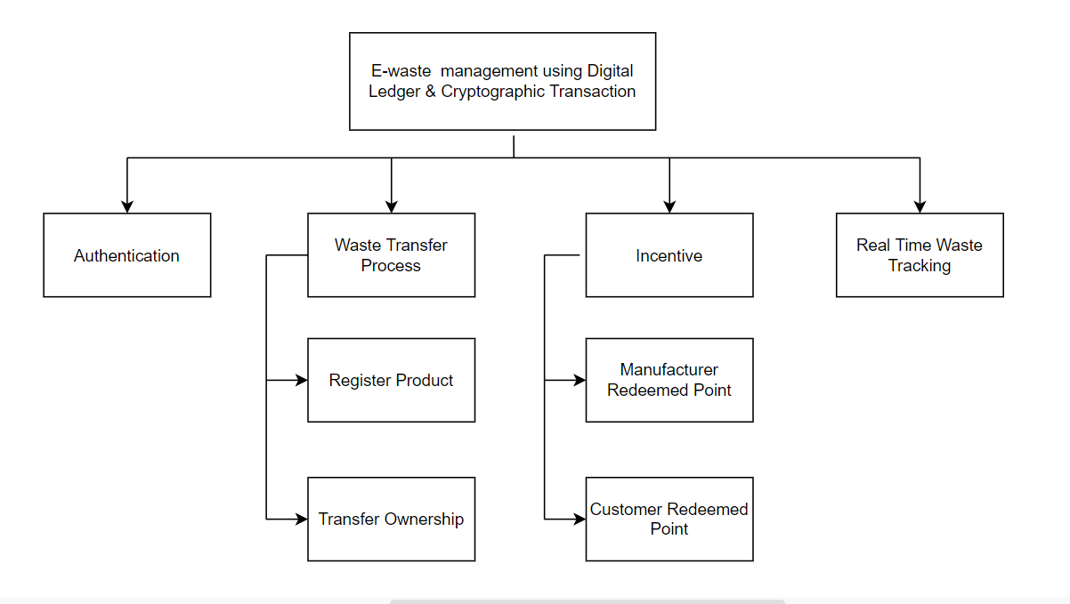

Logged into

The system

Email, Password verification

by the hashes earlier registered on the blockchain

User Email

Password

Authentication

Input Process Output

Append the new block to the chain

And display the product

Creation of a new block with the given data and run method to find a correct nonce value

Product Name

Product ID

Image

Register Product

Input Process Output

Authentication

Re-registered the block of the product to the buyer

Generate trade ID

Seller Name

Product Name

Product Amount

Product Price

Transfer Ownership

Input Process Output

Add Points to Manufacturer’s profile

Calculate Points based on quantity

Disposed Product Quantity

Incentive: Manufacturer Redeemed Pont

Input Process Output

Add Points to Customer’s profile

Calculate Points based on quantity

Disposed Product Quantity

Incentive: Customer Redeemed Pont

Input Process Output

Display present owner and past Owner records

Analyze information with Reference information

Provide Product ID

Real Time Waste Tracking

Input Process Output