

# Department of Computer Science And Engineering

## System Analysis Design and Development CSE - 402

Feasibility Report

E-waste Management Using Digital Ledger

And Cryptographic Transactions

### Prepared By :

**Group - 03**

|  |  |  |
| --- | --- | --- |
| 1 Asima Oshin Putul | 201814048 | [asima.oshi](mailto:asima.oshin1998@gmail.com)[n1998@gmail.com](mailto:n1998@gmail.com) |
| 2 Kazi Rafid Raiyan | 201814022 | [kazirafidraiyan0](mailto:kazirafidraiyan031@gmail.com)[31@gmail.com](mailto:31@gmail.com) |
| 3 Sumaiya Kashmin Zim | 201814016 | [skashminzim@gmail.com](mailto:skashminzim@gmail.com) |
| 4 Fardeen Ashraf | 201814046 | [fardeenashraf98@gmail.com](mailto:fardeenashraf98@gmail.com) |
| 5 Sabrina Haque | 201814020 | [sabrinahaque77254@gmail.com](mailto:sabrinahaque@gmail.com) |
| 6 Mostafizur Rahman | 201814036 | [akrahman76@gmail.com](mailto:akrahman76@gmail.com) |

**Submitted To: Lt. Col. Nazrul Islam , Assistant Professor Nuzhat Tabassum**

# Table of Contents

Table of Contents. 2

Abstract Summary 3

1. Inroduction 4
   1. Scope **4**
2. Existing System 5
   1. Information Gathering and Analysis **5**
      1. Overview and Objectives **5**
      2. The Sources of Information **6**

2.1.4 Information Gathering Methodology **7**

* 1. Presenting the Existing System **12**

1. Proposed Candidate System 14
   1. Potential Candidate System **14**
   2. Characteristics of Candidate System **18**
   3. Performance and Cost-Effectiveness of the Candidate Systems **20**
   4. Selection of the Best Candidate System **25**
2. Specification of the Selected Candidate Systems 25
   1. Functional Requirement **25**
   2. Non-Functional Requirement **26**
   3. Data Flow Diagram (DFD) **27**
   4. Decision Tree **28**
   5. Decision Table **29**
3. Conclusion 30
4. Appendices 31

Appendix A – References 31

Appendix B – Questionnaire sheets. 32

**ABSTRACT SUMMARY**

With the rapid urbanization and continuous economic progress, the dependency on technology are increasing day by day in developing countries like Bangladesh. Thus, the amount of e-waste generated after their life cycle is increasing at an unprecedented pace. Besides, Typical consumer electronics contain a rich amount of chemicals and toxic compounds which can cause environmental and health hazards if they are not disposed properly. In the perspective of Bangladesh, a large percentage of e-waste is not regulated and the disposal process of generated e- waste is quite dissatisfactory. We create too much e-waste and reuse or recycle way too little. To overcome this problem, we have proposed three candidate systems as a blockchain and smart contract-based system, an Enterprise resource planning-based system and an IOT based system here. In this report, each candidate system has been analyzed on the basis of System Characteristics, Qualitative Evaluation Matrix, Performance & Cost Evaluation Matrix and Weighted Evaluation Matrix. With the help of these detailed procedure, we have proposed the best candidate system to solve the problem effectively.

# Introduction

Electronic waste (E-waste) is the fastest growing category of solid hazardous waste. Until 2016, the world generated 44.7 million metric tons of e-waste, and only 20% of this tonnage found its way through proper recycling channels [1]. At present, in every year Bangladesh generates roughly 2.8 million metric tons of e- waste. But without knowing the harmful effect of the e-waste, these has been dumped in to the open landfills, farming land and in the open sources of water bodies. So, it is necessary to introduce a proper e-waste management system. Thus, we have proposed a system to solve this problem taking the appropriate situations in consideration.

### Scope:

* + - The purpose of our system is to create a secured and transparent solution in e-waste management system.
    - We have considered that our proposed system is capable of recording every stage of e-waste management and every vital information of every electronic.
    - These records cannot be changed or overwritten to ensure the security of the system.
    - Also, the system will bring more coordination among producers, importers, retailers and recyclers without the help of any middle man.

# Existing System

## Information Gathering and Analysis

### Overview and Objectives

In Bangladesh, there is a growing concern of generation of e-waste and its subsequent handling and disposal. E-waste and its reuse and recycling processes can cause significant environmental and health hazards. At present, there is a lack of awareness about the hazards of electronic waste in Bangladesh. The electronic waste is reused, broken down for parts or disposed of completely. The present informal practice of recycling is not carried out safely and it becomes a danger to human health and the surrounding environment. This paper will share the trend of usage of electronic equipment and what is being done at the end of lifetime of the equipment. It will also share what hazards have been created from this electronic waste, what are the present dumping practices and what rules are in place for dumping. It will also identify the level of awareness regarding e-waste and to determine a way to reduce environmental hazards.

### The Sources of Information

The aim of this project is to make the e-waste management system in Bangladesh efficient. For this, we gathered some important information about e-waste recycling process in Bangladesh and how to make this existing system more efficient. The sources we chose for our feasibility report are as follows:

* + - * General Users.
      * Local E-waste collectors.
      * Online articles and research papers.
      * Field Visit

We have selected the Source “General Users” to acquire information about general knowledge of people regarding e-waste and their procedure to process domestic e- waste products. We have gathered idea about the security, the processing of e- waste and how to create a proper supply chain from manufacturers, retailers, users and recyclers using blockchain and smart contacts. Finally, we have done a field visit to know about the procedure of collecting e-waste from local e-wastes collection shop (vangari) as well as corporate and public clients and the methods of recycling in Bangladesh.

### Information Gathering Methodology

To gather the information needed, 3 of 5 traditional methods of information gathering were used. The methods are given below:

* + - 1. Questionnaires.
      2. Literature review.
      3. Interview.

A mapping of the gathered information is shown below:

|  |  |  |  |
| --- | --- | --- | --- |
| **Method** | **Source** | **Information** | **Outcome** |
| Information Gathered Through Questionnaires. (M1) | General Users (S1) | What idea does general people have electronic  waste? (I1) | Most of the people have idea about electronic waste.  (O1) |
| How do people process  domestic e-waste products? (I2) | Most of the people sell  their e-waste on second hand. (O2) |
| Do people know about the environmental impact of e-waste? (I3) | Most of the users think improper disposal of e- waste is harmful for environment. (O3) |
| How to create awareness about proper e-waste disposal among  general people? (I4) | Most of the people wants to grow awareness and have education about e-waste.  (O4) |
| What do general users prefer to do with their e-waste? (I5 | Most people are willing to sell their e-waste product in order to have someone  effective dispose it. (O5) |

|  |  |  |  |
| --- | --- | --- | --- |
| **Method** | **Source** | **Information** | **Outcome** |
| Information Gathered through Literature Review (M2) | Research Papers (S2) | How can we make the system secured using blockchain? (I6) | Blockchain can be implemented in e-waste recycling schemes where people can exchange their old gadgets and non- working electronics for  digital tokens. (O6) |
| Where does the existing systems fail? (I7) | A set of international regulations, including repair, reuse, remanufacture, refurbish, fake/counterfeit product and copyright  exhaustion disparage E-  waste recyclers. (O7) |
| How important is the participation of the manufactures in this whole process? (I8) | To create a proper supply chain from manufacturers, retailers, users and recyclers manufactures  plays a big role. (O8) |
| Do people know about the environmental impact of e-waste ? (I3) | Most of the people ignore the environmental impact of e-waste. (O9) |

|  |  |  |  |
| --- | --- | --- | --- |
| **Method** | **Source** | **Information** | **Outcome** |
| Information Gathered through Literature Review (M2) | Research Papers (S2) | What conditions need to be set for the smart contacts to operate?  (I9) | Co-ordination among producers, importers, retailers and recyclers of  EEEs is needed. (O10) |
| Can the system be used for illicit activities? If so, how to reduce that? (I10) | Every user can add information to the blockchain and all data in the blockchain is secured through cryptography.  (O11) |
| What information can be shared with suppliers? (I11) | One of the most prominent capabilities of blockchain technology is this context is to enable transparency and traceability of e-products by storing the entire life- cycle, starting from their origin through every  point of contact on the  journey. (O12) |
| How revenue is generated in e-waste recycling process? (I12) | After purchasing a waste product, recyclers first run a check to see whether the product is functioning or not. (O13) |

|  |  |  |  |
| --- | --- | --- | --- |
| **Method** | **Source** | **Information** | **Outcome** |
| Information Gathered through Literature Review (M2) | Research Papers (S2) | How revenue is generated in e-waste recycling process? (I12) | If a product is functioning they sell it to a purchaser who looks for second hand  parts. (O14) |
| Sometimes they break the product into pieces to separate iron, lead, copper, silver, plastic etc. and sell this to a purchaser of these  things. (O15) |
| They sell the raw materials to factories and plants.  (O16) |
| Those items which are not recyclable in our country are sold to recyclers from  overseas. (O17) |
| Information Gathered through Interview (M3) | Azizu Correspondent ( Local E-waste collector )  (S3) | How are the e-wastes collected from the locality? (I13) | E-wastes are collected from local e-wastes collection shop (vangari) as well as corporate and public  clients. (O18) |
| How are the e-wastes processed? (I14) | If a product is functioning they sell it to a purchaser who looks for second hand parts. (O14) |

|  |  |  |  |
| --- | --- | --- | --- |
| **Method** | **Source** | **Information** | **Outcome** |
| Information Gathered through Interview (M3) | Azizu Correspondent ( Local E-waste collector )  (S3) | How are the e-wastes processed? (I14) | Sometimes they break the product into pieces to separate iron, lead, copper, silver, plastic etc. and sell this to a purchaser of these  things. (O15) |
| How revenue is generated in e-waste recycling process? (I12) | Sometimes they break the product into pieces to separate iron, lead, copper, silver, plastic etc. and sell this to a purchaser of these  things. (O15) |
| They sell the raw materials to factories and plants.  (O16) |
| Those items which are not recyclable in our country are sold to recyclers from  overseas. (O17) |

## Presenting The Existing System

Most of the activities right from the collection, transportation, segregation, dismantling, etc., are done by unorganized sectors manually. Being a rich source of reusable and precious material, E-waste is also a good source of revenue generation for many people. The big portion (rag pickers) of the population earned their livelihood by collecting and selling the inorganic waste-like plastics, polythene bags, glass bottles, cardboards, paper, other ferrous metals, etc.

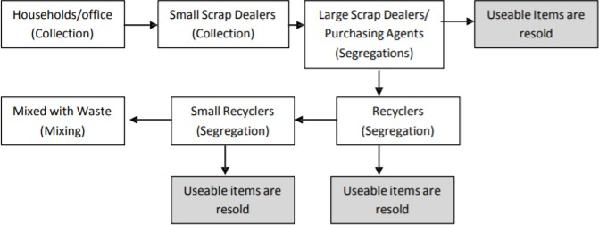

Figure-2.2.1: Informal Sector Recycling Process

The recycling flow of the informal sector in Dhaka is shown by Figure 2.2.1. Vangari shops buy personal computer (PC) parts from various organizations through auction. They also buy from hawkers, personal users, retail shops (old parts) and internal buying from the waste shops. After purchasing a waste product, they first run a check to see whether the product is functioning or not. If the product is functioning then they sell it to a purchaser who looks for second hand parts. Otherwise they break the product into pieces to separate iron, lead, copper, silver, plastic etc. and sell this to a purchaser of these things. They disassemble these products without any protection which can be injurious to their health.

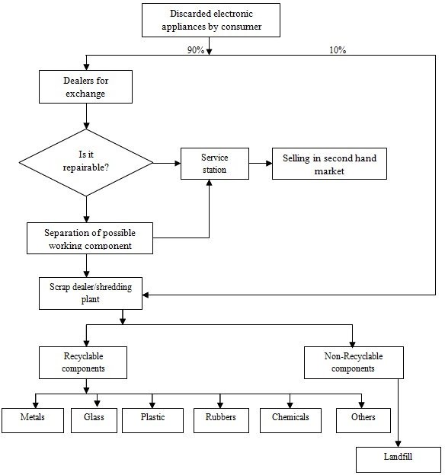

Figure-2.2.2: Flow chart of the present E-waste trade cycle

Figure 2.2.2 shows the road map/trade chain of Electronic and Electrical Equipment's journey from manufacturer/ importer to recycler/disposer found in most of the cities.

# Proposed Candidate System

## Potential Candidate System:

Here we have proposed three candidate systems to achieve our goal. The proposed system is based upon some fundamental characteristics of e-waste recycling system but there are some major changes.

The first candidate system is a blockchain and smart contract-based e-waste management system(C1). The proposed system will be transparent in the e-waste collection as well as will be channelize for preventing stakeholders who follow unjust ways to justify their collection targets. It will also make the owners accountable for the e-waste they deposit as they claim.

The second candidate system is a database-based e-waste management system(C2) which provides with an interactive e-waste collection system. User can sell their e- waste using this database and collect money in exchange.

The third candidate system is an IoT based e-waste management system(C3) which provides with an advanced e-waste collection system as well as user incentive feature throughout the use of e-waste collection vending machine.

The candidate systems are chosen such that it fulfills the requirements of the users that were extracted from the information gathering methodology (survey, interviews etc). The features of the candidate systems are stated in a tabular from in table 3.1:

Table-3.1: Features of the candidate systems

|  |  |
| --- | --- |
| **Candidate Systems** | **Features** |
| E-waste management using digital ledger and cryptographic transaction (C1) | * The system will be built upon blockchain where primary nodes are manufacturers, suppliers, retailers, customers and recyclers. * The product details will be added by the manufacturers. * The transfer in ownership from the manufacturers to the suppliers will be logged. * The information of distributing the products from the suppliers to the retailers will be stored. * Sales from the retailers to the customers will be inserted into the blockchain network. * E-waste will be disposed in to the e-waste center by the customers in exchange of digital token. * Smart contracts will be deployed in the e-waste module where digital token will be given as incentive to the customers who properly dispose their e-waste properly in the waste collection center. |
| E-waste management using ERP (Enterprise resource planning) (C2) | * Pickup requests can be made by the normal users, scrap dealers, local e-waste collectors and corporate users. * E-waste will be collected by the e-waste collector. * Refurbish-able products will be updated in the page after refurbishing is done. |

|  |  |
| --- | --- |
| E-waste management using ERP (Enterprise resource planning) (C2) | * Nonrecyclable products will be exported. * All records will be stored manually in a centralized database. |
| E-waste collection system using Iot (C3) | * The attached RFID tags can be scanned by the users and E-waste can be disposed. * There will be smart e-waste collection boxes in different areas. * Users will be guided to the nearest collection box(vending Machine) by mobile app using GPS. * User can collect points from the vending machine according to their disposal. * Automated e-mail alert system will be used to notify the E-waste center to collect the e-waste from the boxes which are full (80%). * User Information and quantity of the disposed   E-waste will be stored in the cloud database. |

A short description is given below about the candidate systems and how they work:

### E-waste management using digital ledger and cryptographic transaction (C1):

In blockchain based system, the primary nodes are manufacturers, suppliers, retailers, customers and recyclers. The product detail, exchange of ownership, exchange of capital, amount of electronics produced, amount of e-waste that should be generated from those electronics, the whole life cycle of the product, all information is kept in the blockchain network. Blockchain will produce an unique id to each product produced by the manufacturer so they are bound to include all the information about the product in the market. It will make the owners accountable for the e-waste they deposit as they claim. Same goes for the suppliers

and retailers. The customers will sell the products to the recyclers and they will collect digital tokens in return. They can get a discount when they buy new electronic product using those smart tokens. All those will be handled by smart contracts. This system provides effective monitoring and regulatory activities throughout the whole life cycle of e-products.

### E-waste management using ERP (Enterprise resource planning) (C2):

Here E-waste will be manually collected from general users, Scrap dealers, Community workers and Corporate users. If the product is refurbish able then the product will be refurbished and then will be sold. Otherwise it will be recycled. The whole transaction from consumers to recycles will be stored on a centralized database.

### E-waste collection system using Iot (C3):

In IoT based e-waste management system e-waste collection vending machine is set in different areas that has photoelectric , radio frequency identification (RFID), weight, infrared and ultrasonic sensors. Users will be guided to the nearest collection box (vending machine) by mobile app using GPS. The attached RFID tags can be scanned by the users and E-waste can be disposed. User can collect points from the vending machine by disposing e-waste. Automated e-mail alert system will be used to notify the E-waste center to collect the e-waste from the boxes which are full (80%). User Information and quantity of the disposed E-waste will be stored in the cloud database.

### Hardware and software requirements for each candidate system are also identified to visualize the practical system models:

Table-3.1.1: HW and SW requirements of the candidate systems

|  |  |  |
| --- | --- | --- |
| **Candidate Systems** | **Hardware** | **Software** |
| E-waste management using digital ledger and cryptographic transaction (C1) | none | Remix (a browser based compiler),  Ganache (Creating private Ethereum blockchain ),  VS Code (Code editor for developing dApp),  Meta-Mask (browser extension) |
| E-waste management using ERP (Enterprise resource  planning) (C2) | none | Oracle , Cloud server. |
| E-waste collection system using Iot (C3) | photoelectric , radio frequency identification (RFID), weight, infrared and ultrasonic sensors. | Wireless Fidelity (Wi-Fi) module, e cloud servers, mobile/web applications |

## Characteristics of Candidate System

We proposed three candidate systems in potential candidate systems. In the below table we compared the characteristics of these systems. The first candidate system is based on blockchain and smart contracts. The second candidate system is based on enterprise resource planning of an e-waste management system. The third candidate system is RFID based e-waste management system using IOT.

Table-3.2: Characteristics of the proposed candidate system

|  |  |  |  |
| --- | --- | --- | --- |
| **Characteristics** | **E-waste management using digital ledger and**  **cryptographic transaction (C1)** | **E-waste management using ERP (Enterprise**  **resource planning) (C2)** | **E-waste collection system using IOT (C3)** |
| Decentralized database | Data is stored in the blockchain in a distributed fashion ensuring no centralized  database. | Data stored in a centralized database of the recycler enterprise. | Data is stored in a centralized database of smart receptacle operator. |
| Smart contract usage | Smart contract is used to for automating transactions and product  traceability. | No smart contract is used. | No smart contract is used. |
| Digital token usage | Digital token system is present for increased user  incentive. | No digital token system. | No digital token system. |
| Automated traceability | Automated traceability of product from manufacturer to recycler is ensured using smart  contract. | Traceability can be ensured manually. | No traceability is done. |
| Intermediate  authority independency | Blockchain essentially  removes the need for an intermediate authority. | Intermediate authority  is needed for accountability. | Intermediate  authority is needed for accountability. |
| RFID tag scanning | No RFID tag scanning is  done. | No RFID tag scanning  is done. | Integral part of this  system. |
| Smart waste  receptacle | No smart waste  receptacle is used. | No smart waste  receptacle is used. | Integral part of this  system. |

## Performance and Cost-Effectiveness of the Candidate Systems:

After stating the characteristics, performance and effectiveness of the proposed candidate systems, It is required to choose the best candidate system among them. For this some key performance indicator was developed to compare these systems. The notable KPIs are Accountability, monitoring, transparency, traceability, Security and all. The E-waste management using digital ledger and cryptographic transaction is good at Traceability and security. E-waste management using ERP is very cost effective and E-waste collection system using Iot is excellent in collection process. Here, each candidate system's performance, cost etc. are evaluated using qualitative measures which are given in table 3.3:

Table-3.3: Candidate qualitative evaluation matrix:

|  |  |  |  |
| --- | --- | --- | --- |
| **Evaluation Criteria** | **E-waste management using blockchain and smart contracts (C1)** | **E-waste management using ERP (C2)** | **E-waste collection system using Iot (C3)** |
| Accountability | Excellent | Bad | Bad |
| Monitoring | Excellent | Very bad | Good |
| Transparency | Excellent | Very bad | Good |
| Traceability | Excellent | Good | Bad |
| Security | Excellent | Good | Good |
| Rate of waste disposal | Very Good | Bad | Good |
| Information accuracy | Excellent | Bad | Bad |
| Coordination | Excellent | Good | Bad |
| Development cost | Expensive | Less | More expensive |
| User friendly | Very Good | Good | Good |
| Collection process | Good | Very good | Excellent |
| User incentive | Excellent | Good | Bad |

Table-3.3.1: Candidate cost evaluation matrix:

|  |  |  |  |
| --- | --- | --- | --- |
| **Evaluation Criteria** | **E-waste management using blockchain and smart contracts (C1)** | **E-waste management using ERP (C2)** | **E-waste collection system using Iot (C3)** |
| Accountability | Decentralized | Centralized | Centralized |
| Transparency | Encryption & control  mechanisms | Mapping and naming | mapping |
| Traceability | end-to-end  traceability | Manual traceability | Manual traceability |
| Security | Hash-based history | SQL database  No extra security | SQL database  No extra security |
| Rate of waste  disposal | 93%(rounded) | 70%(rounded) | 85%(rounded) |
| Information accuracy | 99%(rounded) | 90%(rounded) | 90%(rounded) |
| Coordination | Decentralized | Centralized | Centralized |
| Development cost | $5,000-$10,000 | $2,000-$3,000 | $15,000-$20,000 |
| User friendly | Menu driven  Interactive | Command driven | Command driven |
| Collection process | Through peer to peer  connection | Through local  collection agency | Through collection  box |
| User incentive | Voucher through  smart coupon | No extra benefit | Points collection |

As the key performance indicators and cost data might not always produce the best candidate system, A quantitative weighted rating is used to weigh the importance of each criterion where we assigned some weight based on their necessity and we

calculated the total weight of each candidate system and chose the highest weighted system among them.

Table-3.3.2: Weighted matrix for the Proposed System

|  |  |  |  |  |  |  |  |
| --- | --- | --- | --- | --- | --- | --- | --- |
| **Evaluation Criteria** | **Weighting factor** | **C1**  **Rating** | **C1**  **Score** | **C2**  **Rating** | **C2**  **Score** | **C3**  **Rating** | **C3**  **Score** |
| Accountability | 5 | 5 | 25 | 1 | 5 | 3 | 15 |
| Monitoring | 4 | 5 | 20 | 1 | 4 | 3 | 12 |
| Transparency | 4 | 4 | 16 | 1 | 4 | 3 | 12 |
| Traceability | 5 | 5 | 25 | 4 | 20 | 3 | 15 |
| Security | 5 | 5 | 25 | 4 | 20 | 4 | 20 |
| Rate of waste  disposal | 5 | 5 | 25 | 3 | 15 | 4 | 20 |
| Information  accuracy | 5 | 5 | 25 | 3 | 15 | 3 | 15 |
| Coordination | 3 | 5 | 15 | 4 | 12 | 3 | 9 |
| Development  cost | 4 | 2 | 8 | 5 | 20 | 1 | 4 |
| User friendly | 3 | 4 | 12 | 3 | 9 | 3 | 9 |
| Collection  process | 3 | 4 | 12 | 4 | 12 | 5 | 15 |
| User incentive | 4 | 5 | 20 | 4 | 16 | 4 | 16 |
| Total |  |  | 228 |  | 152 |  | 162 |

All the mentioned evaluation criteria and their weight factor were discovered based on literature review, study on existing system and current industry requirements. The weight factors are used to uphold an unbiased comparison between all the proposed systems and choose the best one.

Considering weight factors, the evaluation criteria can be divided into three classes: high, medium and low. High priority evaluation criteria are Accountability, Traceability, Security, Rate of disposal and Information accuracy each having a factor of 5. These must have criteria are key markers for considering if the project is successful or not. Accountability ensures if a project can be trusted in terms of efficiency which is always sought after. The project aims to implement a block chain thus blockchain relevant features like Data Traceability, Security and Information Accuracy were also given high priority. Rate of Disposal will ensure how practical the proposed system is considering one of its main tasks, hence it also has high priority.

Medium priority criteria are Monitoring, Transparency, Development cost, User incentive. These criteria are not first priority, if not met will cause a significant downgrade in project efficiency. Monitoring and transparency ensures availability of the traced data to the general mass and an extra layer of security from internal corruption or extremities. Development cost should also be considered as lower development cost will encourage authority more to adapt this system. User incentive ensures how general users are encouraged to actually use this system in their day to day life, a very complex system which can ensure more efficient recycling and tracing but it may lessen the average daily user number causing Rate of Waste Disposal to fall.

Low priority criteria are Coordination, User friendly, Collection process. These criteria are not essential for performance enhancement but can impact considering the long term operational phase of the system. Coordinated systems always are long running efficient systems. User friendliness may motivate users to stick around and keep using the system. Efficient Collection Process may lessen overall operational cost of the system.

## Selection of the Best Candidate System

Among the three candidate systems we select the E-waste management using digital ledger and cryptography transaction as the best one. As it’s the combination of better characteristics, better performance and more information accuracy. It also has the highest score in the weighted evaluation matrix which makes it more suitable than the other two candidate systems.

The reasons are also specified below:

1. It is better in traceability.
2. It is more secured.
3. It has higher information accuracy.
4. Rate of waste disposal is also higher in this system.
5. It offers better transparency.
6. It’s more user friendly.
7. It is more accountable than other systems.

# Specification of the Selected Candidate Systems

As the best candidate system “E-waste management using digital ledger and cryptography transaction” has been selected, now we are going to discuss about the functional and non-functional requirements of the system:

## Functional Requirement

**Decentralized Database:** The system should have a decentralized database.All the datas in the system should not be centered around one data centre rather distributed along all the block chain nodes .

**Blockchain Node:** Blockchain runs upon data blocks . The system should have practical nodes which will form its infrastructure. These nodes will constantly share data between them and keep updating each other if any changes occur.

**Data Flow between Nodes:** The system should have a continuous connection between its nodes and ensure smooth data flow between them

**Automated Data Update:** The system should update any changes to its data automatically using smart contracts

**Recycling Network:** The system should have a recycling network stretched out among recyclers, manufacturers and general users to ensure e-waste management.

**Token Incentive:** The system should have its own token system which can be used inside the network by the users as incentives.

## Non-Functional Requirement

**Security:** In e-waste disposal, it is essential to protect individuals/businesses from security breaches. So, the system will consider necessary security standards.

**Accessibility:** The system will be accessible by individuals with the capabilities to supply, collect and dispose of e-waste.

**Transparency:** From a data management and privacy perspective for refurbishing of e-waste devices, the system will provide a better transparency for customers by supplying them the access to the system so that they can check important information about their collection and have access to the main reports.

**Traceability:** The whole system will be traceable to ensure that the wastage from mining is properly disposed of.

## Structured Analysis

## 4.3.1 Data Flow Diagram (DFD):

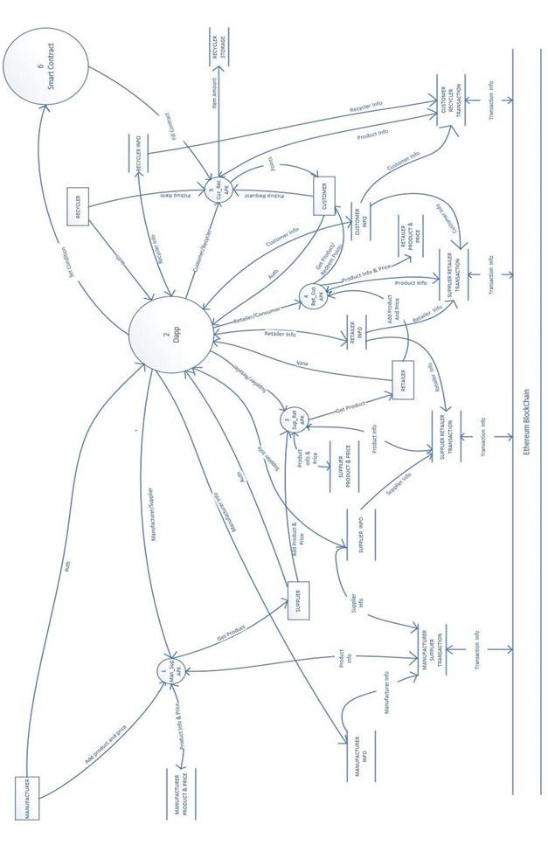

Fig 4.3.1: DFD (Data Flow Diagram) of selected candidate system

Particular types of users, who dispose their e-waste properly in the waste collection center, will be given digital token as incentive. This token mainly adds points to their personal account. By using these points, they can secure several discounts while purchasing electronic products. To better understand these features of the proposed system we have used decision tree, decision table and structured English.

## 4.3.2 Decision Tree:

## Decision tree is made on the senario where user gets incentives for disposing e-waste. The generel user gets incentives for disposing it to the e-waste where for 1 to 5 products he gets 10 points, for to 10 he gets 25 points and for more than 10 products he gets 50 point. The manufacturers dispose huge amount of e-waste that’s why the unit used here is in tons. For less than 10 tons they get 1000 points. For 10 to 50 tons 25000 points and for more than 50 tons they get 5000 points.

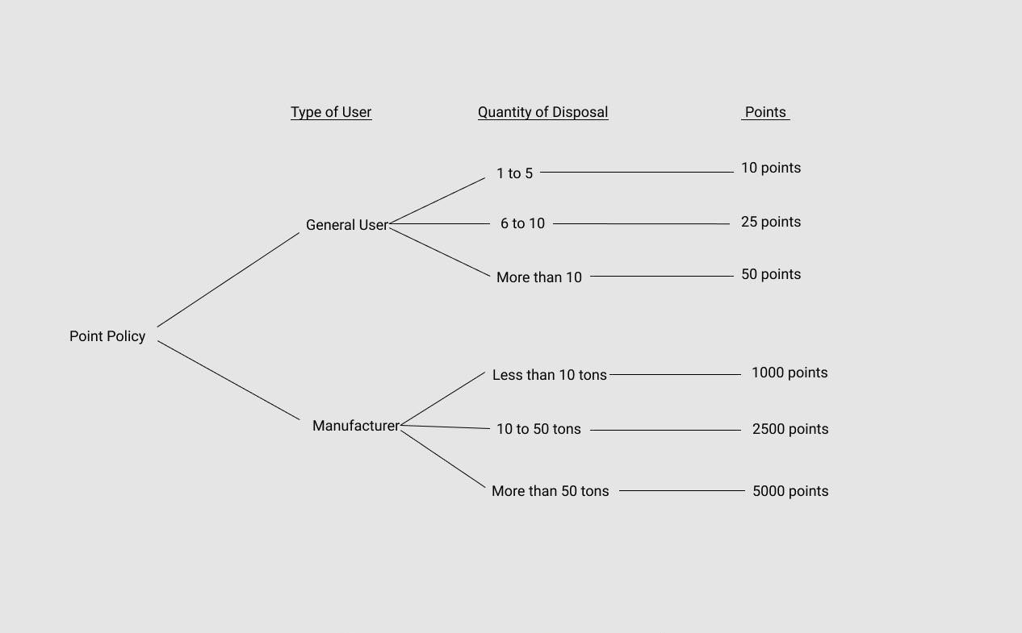

Fig 4.3.2: Decision tree of selected candidate system

## 4.3.3 Decision Table:

Table-4.3.3: Decision Table of Selected Candidate System

|  |  |  |  |  |  |  |  |  |  |
| --- | --- | --- | --- | --- | --- | --- | --- | --- | --- |
| **Condition Stub** | | **Condition Entry** | | | | | | | |
| **1** | **2** | **3** | **4** | **5** | **6** | **7** | **8** |
| **IF**  **(Condition)** | User is a General User? | Y | Y | Y | N | N | N | N | N |
| Disposed quantity from 1 to 5 products? | Y | N | N | N | N | N | N | N |
| Disposed quantity from 6 to 10 products? |  | Y | N | N | N | N | N | N |
| Disposed quantity more than 10 products? |  |  | Y | N | N | N | N | N |
| User is a Manufacturer? |  |  |  | Y | Y | Y | Y | N |
| Disposed quantity less than 10 tons? |  |  |  | Y | N | N | N | N |
| Disposed quantity from 10 to 50 tons? |  |  |  |  | Y | N | N | N |
| Disposed quantity more than 50 tons? |  |  |  |  |  | Y | N | N |
| **THEN**  **(Action)** | 10 points | X |  |  |  |  |  |  |  |
| 25 Points |  | X |  |  |  |  |  |  |
| 50 points |  |  | X |  |  |  |  |  |
| 1000 points |  |  |  | X |  |  |  |  |
| 2500 points |  |  |  |  | X |  |  |  |
| 5000 points |  |  |  |  |  | X |  |  |
|  | No points |  |  |  |  |  |  | X | X |
| **Action Stub** | | **Action Entry** | | | | | | | |

## 

## 4.3.4 Structured English:

|  |
| --- |
| IF user is a General User  And-IF waste disposed quantity from 1 to 5 products  THEN: user’s earned point is 10  ELSE IF waste disposed quantity from 6 to 10 products  THEN: user’s earned point is 20  ELSE: (waste disposed quantity from more than 10 products)  SO: user’s earned point is 20  ELSE IF user is a Manufacturer  And-IF waste disposed quantity less than 10 tons  THEN: user’s earned point is 1000  ELSE IF waste disposed quantity from 10 to 50 tons  THEN: user’s earned point is 2500  ELSE: (waste disposed quantity from more than 50 tons)  SO: user’s earned point is 5000  ELSE: (user is neither General user nor Manufacturer)  SO: No point given |

Fig 4.3.5: Structured English of selected candidate system

**4.4 Economic Justification**

**Cost Benefit Analysis For Our Selected Candidate System:**

|  |  |
| --- | --- |
| **Name of the cost** | **Description** |
| Tangible cost | **Software:** Cost for developing and purchasing the software to build blockchain.  Software cost includes: purchasing browser based Remix compiler, Ganache for deploying smart contracts, VS code editor for developing the front-end, Metamask browser extension.  Also purchasing database for storage, building up p2p network.  **Hardware:** Computers with Intel Core i8, 8GB RAM, 1TB hard drive.  **Others:** Training employes of manufacturars, suppliers and retailers .  Salaries for professionals to develop necessary software and network. |
| Intangible cost | Breakdown of p2p network can cause losing money. |
| Direct cost | Cost of computer is 50000 tk. |
| Indirect cost | Maintenance of blockchain, network repairing. |
| Fixed cost | Salaries of employee, interest expenses. |
| Variable cost | Utility, maintenance and repairment cost of blockchain. |
| **Name of the benefits** | **Description** |
| Tangible benefits | Better accountability, monitoring, treacibility, security and coordination. |
| Intangible benefits | More userfriendly, better accuracy and user incentive. |
| Direct benefits | 20% more rate of disposal. |
| Indirect benefits | Enthusiasm in disposing e-waste properly. |
| Variable benefits | Rate of waste disposal. |

# 5.Conclusion:

The preceding discussions demonstrate that there are some fundamental issues that need to be resolved before blockchain technology applications within the waste sector can have the desired effects for supporting sustainable waste management. Moreover, waste management is usually focused on managing waste that has already been created. The direct impact of applying blockchain in this domain is therefore to ensure its proper management and processing (i.e., landfill is avoided). The discussion of challenges also highlights that the usefulness of blockchains currently is in uncovering issues of any technology (whether blockchain or another technology) can be used effectively.

# References:

1. https://cutt.ly/zvd2HCU
2. https://sci-hub.do/https://ieeexplore.ieee.org/abstract/document/9221346/
3. https://sci-hub.se/https://ieeexplore.ieee.org/abstract/document/9162845 [4] https://link.springer.com/chapter/10.1007/978-3-030-63924-2_12
4. https://sci-hub.do/https://ieeexplore.ieee.org/abstract/document/8554912
5. https://escholarship.org/content/qt80v7g7qg/qt80v7g7qg.pdf [7] https://sci-hub.do/10.1109/5GWF49715.2020.9221346

[8] <https://cutt.ly/Xvd2Wda>

# APPENDIX - QUESTIONNAIRE SHEETS:

