**Military Institute of Science and Technology**

**Department of CSE**

**CSE-310 (Networking Sessional)**

**VLSM (Variable-Length Subnet Mask)**

Design the following network in Packet Tracer using an IP address 192.168.10.0. Ensure that each PC can communicate with each other (use static routing).

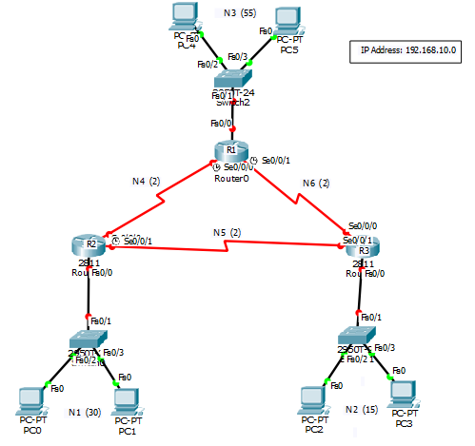

**Network Table:**

|  |  |  |  |  |  |  |
| --- | --- | --- | --- | --- | --- | --- |
| **Network** | **# of Host** | **Block Size** | **Prefix** | **Network Address &**  **Broadcast Address** | **Available Host IPs** | **Subnet Mask** |
| 3 | 55 |  |  |  |  |  |
| 1 | 30 |  |  |  |  |  |
| 2 | 15 |  |  |  |  |  |
| 4 | 2 |  |  |  |  |  |
| 5 | 2 |  |  |  |  |  |
| 6 | 2 |  |  |  |  |  |