CASE STUDY 01 | SEE ALL LIBRARY
Heritage Home Décor
$848 in ad spend generated $4,918 in tracked revenue

1. Case Study Overview
A craft-led home décor brand selling internationally needed a more dependable way to turn attention from potential customers into store orders. ScaleXpertz organised the account around separate campaign roles instead of relying on one broad campaign. The reported account result was $4,918 in revenue from $848 in spend, with 82 purchases.
The brand had attractive, craft-led products and shipped worldwide, but the source describes a gap between global attention and predictable orders. The challenge was not simply to attract more people. The account needed a structure that could reach new shoppers, reconnect with people who had already shown interest, present the wider collection and test fresh creative without treating every audience as the same.

Performance snapshot from the original case record
Metric | Reported figure
Ad spend | $848
Tracked revenue | $4,918
Reported ROAS | 5.80x
Purchases | 82
Cost per purchase | $10.34
Add-to-carts | 610

BUSINESS CONTEXT

2. The Challenge
A single, scattered campaign structure can make it difficult to understand which activity is finding new buyers and which activity is bringing interested shoppers back. In this case, ScaleXpertz moved to six focused campaigns. The source specifically names broad prospecting, retargeting, a collection campaign and a creative-test campaign. It does not name the other two campaigns, so they are not guessed or described here.
For this type of store, attracting attention is only one part of the job. People may discover a product, browse a collection and leave before placing an order. The account therefore needed to separate first contact from follow-up, while still giving the brand a way to test new messages.

What made this case difficult
The account had to balance four documented needs: reach new buyers, bring interested people back, give the wider collection visibility and keep new creative entering the account. The source says six campaigns were used, but names only four of them. The remaining two are not identified.

Practical effect on the business
If prospecting, retargeting and creative testing are all mixed into one campaign, it becomes harder to understand which part is producing the outcome. A structured account makes the performance of each role visible and gives the team a clearer basis for budget decisions.

3. Objective
The stated business need was to make global attention more consistently translate into orders. The campaign structure therefore separated discovery from follow-up and gave the team a way to keep testing new creative. The source does not provide a formal KPI target set before launch, so the reported outcomes are presented as results rather than as proof that a pre-agreed target was exceeded.
The practical objectives supported by the source were to improve the path from international discovery to an order, measure prospecting and retargeting separately, and keep creative testing active. No pre-campaign numerical target or campaign date is supplied, so the case reports the achieved figures without comparing them with an undisclosed target.

Objective and available success measures
Objective area | Evidence available in the source
New-buyer reach | Broad prospecting result: 6.10x ROAS
Follow-up | Retargeting result: 6.20x ROAS
Purchase efficiency | 82 purchases at $10.34 each
Shopping intent | 610 add-to-carts recorded

APPROACH AND DELIVERY

4. Strategy
The account was organised around different stages of customer interest. Broad prospecting was responsible for reaching people who had not yet shown intent. Retargeting was used for people who had already interacted with the brand. A collection campaign gave the wider range its own place in the account, while creative testing kept new ad ideas in circulation.
The important choice was to give each campaign a clear role. This makes results easier to read: the team can see whether new audiences are responding, whether interested visitors are returning, and whether new creative is producing a useful result. The reported performance supports this structure because both prospecting and retargeting delivered strong returns, while the test campaign also remained above 4x.

How the strategy addressed the business need
The structure made the account easier to manage because each campaign had a defined job. The results also show that discovery and follow-up both mattered: prospecting delivered 6.10x ROAS and retargeting delivered 6.20x.

Why this structure fits the case
The strategy is strongest when viewed as a connected account rather than a list of isolated campaigns. Prospecting brings new people into the store's consideration set. Retargeting works with people who have already interacted. The collection campaign gives the range visibility, and creative testing keeps the account learning. The reported returns show that discovery and follow-up were both contributing in this case.

5. Campaign Execution
The account was split into six focused campaigns rather than being left as one scattered setup. Broad prospecting was used to find new buyers. Retargeting focused on people who had already shown intent, giving the brand another opportunity to convert existing interest. A collection campaign presented the wider product range, while a creative-test campaign kept new ideas entering the account. This separation made it easier to see the role each campaign played in the overall result. The source reports that retargeting was the strongest campaign group at 6.20x ROAS and broad prospecting followed at 6.10x. Even the weakest test campaign remained above 4x. The exact audience definitions, creative concepts, placements, bidding settings and names of all six campaigns are not included in the source, so this explanation stays with the documented structure.

Campaign or activity breakdown
Campaign / activity | Role in the account | Reported evidence
Broad prospecting | Find new buyers | 6.10x ROAS
Retargeting | Reconnect with people who had shown intent | 6.20x ROAS
Collection campaign | Present the wider product range | No separate result stated
Creative-test campaign | Keep new creative ideas entering the account | Weakest test campaign remained above 4x

The source names four of the six campaigns, so the other two are left unnamed. No audience sizes, locations, ad formats, placement settings, bid strategy or daily budgets are provided.
Prospecting reached new shoppers, retargeting followed up with interested visitors, the collection campaign presented the range, and creative testing kept new ads in circulation. These named roles show the balance between discovery and follow-up.

NUMBERS AND REPORTING

6. Performance Analysis

Reading the main metrics
ROAS compares tracked revenue with ad spend. The reported 5.80x means the dashboard attributed $5.80 in revenue for each $1 of spend in that reporting view. Cost per purchase was $10.34, while 610 add-to-carts show additional shopping intent before the 82 recorded purchases. Add-to-carts and purchases are separate actions and should not be added together.
The 610 add-to-carts and 82 purchases are useful to view together because they show that the account generated both shopping intent and completed orders. However, they should not be used to calculate a cart-to-purchase rate unless the reporting period and attribution definitions are confirmed to match. The strongest campaign groups were retargeting and broad prospecting, only 0.10x apart in reported ROAS. That narrow difference suggests both campaign roles were contributing meaningfully in the reported view.

What the figures do and do not show
The source does not state product prices, gross margin, repeat-purchase rate, campaign dates or incremental revenue. The ROAS is the reported dashboard result for this account; it is not a profit margin or a guarantee of what another home décor brand will achieve.
Metric | Reported figure
Ad spend | $848
Tracked revenue | $4,918
Reported ROAS | 5.80x
Purchases | 82
Cost per purchase | $10.34
Add-to-carts | 610

Original Dashboard Evidence
The following images are the original screenshots supplied in the source case-study document. They are included as visual supporting evidence and have not been altered.
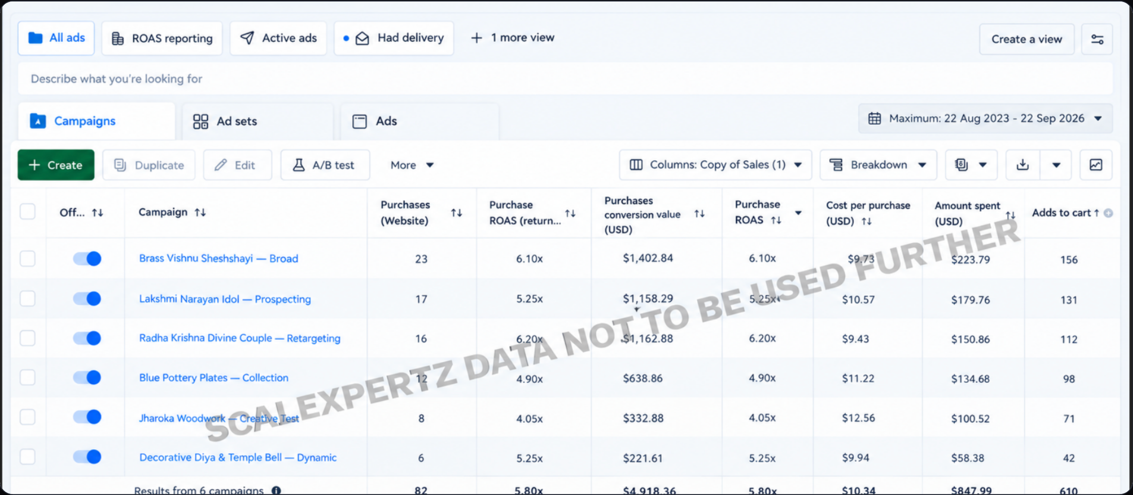
Figure 1. Meta Ads campaign dashboard screenshot - original source image.

7. Results & Outcomes
The account recorded $4,918 in tracked revenue from $848 in ad spend, producing the reported 5.80x return on ad spend. It generated 82 purchases at a reported $10.34 cost per purchase, alongside 610 add-to-carts. Retargeting returned 6.20x and broad prospecting returned 6.10x. The weakest test campaign still cleared 4x, which matters because testing activity did not appear as a low-return drag in the reported view. The $10.34 cost per purchase gives a practical efficiency reference for this specific account and reporting period; it should not be treated as a benchmark for every home décor brand.
The outcome was not only an account-level ROAS. The campaign examples show where the return came from: retargeting led at 6.20x and broad prospecting followed at 6.10x. The test campaign also remained above 4x, which means the source does not describe creative testing as an activity that weakened the overall account result.

What stands out in the result
The main result is the balance between new-buyer activity and follow-up. The strongest named ROAS values were close to each other, and testing remained above 4x. The case therefore supports a story about a structured account, not only a single winning ad.

8. Key Learnings
- Keep new-customer prospecting and retargeting visible as separate parts of the account. Their performance can be compared without mixing their roles.
- A collection campaign can give the wider product range space instead of asking one product ad to represent the whole store.
- Testing should be measured by its contribution, not removed automatically. The weakest test campaign still reported more than 4x ROAS in this account.

BUSINESS VALUE AND CLOSE

9. Business Impact
For the brand, the reported result provides evidence that international product interest could be converted into purchases at a measurable cost. The combination of 82 purchases, 610 add-to-carts and a 5.80x reported ROAS gives the team several ways to review the customer journey. It also shows that the account was not dependent on one campaign type: prospecting and retargeting both produced strong returns.
From a business point of view, the figures can support decisions about where to keep testing and where to increase attention. They do not show profit, repeat purchase or the incremental sales caused by advertising, so those should not be claimed from this case.

Business decisions this case can inform
Decision area | What the case suggests | What should be checked next
Campaign allocation | Compare prospecting and retargeting as separate roles. | Margin, new-vs-returning customer split and incrementality.
Creative planning | Keep a regular test stream; the weakest test still cleared 4x. | Creative-level spend and fatigue over time.
Funnel review | Use add-to-carts and purchases as separate signals. | Matching date range and event attribution.

10. Conclusion
This case shows how a global home décor account used separate campaign roles to move shoppers from discovery towards purchase. The account reported $4,918 in tracked revenue from $848 in spend, 82 purchases and a 5.80x ROAS. Retargeting and broad prospecting both performed strongly, while testing continued to produce a reported return above 4x. The result is a clear example of why campaign structure and the role of each campaign matter.

Publishing accuracy note
The source does not disclose the brand name, product prices, profit margin, shipping markets, customer acquisition value, repeat-purchase rate, campaign dates, exact six-campaign naming or the attribution settings. It also does not show how much of the tracked revenue was incremental. These details should not be added to the public case study unless they are confirmed separately.

