CASE STUDY 07 | HOMEPAGE FEATURED - RANK 2
Multi-Category Catalogue
₹1.02 Cr in ad spend across 251 campaigns

1. Case Study Overview
A large catalogue business needed an advertising structure that could handle crore-level spend without a sharp loss of efficiency. ScaleXpertz ran CPA-capped, ABO and CBO structures side by side. Across 251 live campaigns, the account recorded ₹1.02 Cr in spend, 9,089 purchases and a reported average ROAS of 12.54x.
The business operated a large, multi-category catalogue and needed an ad engine that could absorb a high level of spend. At this scale, the challenge is not only finding one successful campaign. It is maintaining enough control to compare different campaign structures, keep a broad catalogue active and preserve efficiency as spend increases.

Performance snapshot from the original case record
Metric | Reported figure
Total ad spend | ₹1.02 Cr
Average ROAS | 12.54x
Purchases | 9,089
Live campaigns | 251
Link clicks | 8M+
Average cost per link click | ₹1.05

Homepage position: Featured case #2 in the five-case homepage selection. The complete case remains part of the full case-study library.

BUSINESS CONTEXT

2. The Challenge
The source describes the need to handle crore-level advertising spend without efficiency collapsing. Campaign structures can behave differently as budgets, products and audiences change. The account therefore needed a framework that allowed CPA-capped campaigns, ABO and CBO setups to run side by side, giving the team multiple ways to evaluate performance.
The scale of the catalogue and spend created a management challenge. An account with 251 campaigns needs more than a single high-performing ad. It needs structures that can be compared, monitored and adjusted while keeping the account-wide result visible.

What made this case difficult
The source reports an account running 251 live campaigns and more than ₹1 crore of spend. The practical difficulty is scale: results from a single campaign cannot represent the whole account. The average ROAS, purchase total and click volume provide the account-level view.

Practical effect on the business
At this level of activity, small reporting mistakes can lead to poor budget choices. The team needs to know which structure and campaign is producing purchases, and it needs to view the whole account rather than judge success by a single top-performing row.

3. Objective
The stated objective was to scale spend while holding performance. The source does not specify a pre-agreed ROAS floor, profit target or exact time period for the full campaign set. The reported results should therefore be read as the dashboard outcome for the 251-campaign account, not as a guarantee that the same returns apply at every spend level.
The objective was to scale a large catalogue account while keeping efficiency visible. The reported spend, average ROAS, purchases and campaign count are the main measures of that outcome. The source does not disclose a target ROAS or an agreed profit threshold.

Objective and available success measures
Objective area | Evidence available in the source
High-spend management | ₹1.02 Cr reported spend
Campaign scale | 251 live campaigns
Purchase volume | 9,089 purchases
Efficiency | 12.54x reported average ROAS

APPROACH AND DELIVERY

4. Strategy
The strategy was to build an account structure that could handle a large catalogue and substantial spend. CPA-capped, ABO and CBO structures ran side by side. This created a way to compare different campaign controls and catalogue approaches instead of relying on one setup for every product group.
Influencer creative was used in the leading All Products campaign, while catalogue campaigns ran under both ABO and narrower CBO/ABO structures. The results show that more than one structure contributed a strong ROAS. The account's scale is central to the case: the reported average was achieved across 251 live campaigns, not just a single winning ad.

How the strategy addressed the business need
Running CPA-capped, ABO and CBO structures side by side created a way to compare how different campaign setups performed across a large product range.

Why this structure fits the case
The strategy paired different campaign-control methods with catalogue activity. CPA-capped, ABO and CBO structures can be compared because they organise budgets and delivery in different ways. The documented results show strong ROAS in multiple structures, while the 251-campaign account average provides the view of overall performance at scale.

5. Campaign Execution
ScaleXpertz used CPA-capped, ABO and CBO structures side by side. The top campaign was an All Products campaign using influencer creative, which reached 16.08x ROAS. An ABO catalogue campaign delivered 12.12x with 107 purchases. Narrow CBO and ABO setups recorded 10.59x and 9.13x respectively. Running these structures together gave the account more than one route to scale and made it possible to compare the performance of broad catalogue and narrower campaign setups. The source does not provide all 251 campaign names, their individual budgets, audiences or the exact CPA caps, so those details are not invented.

Campaign or activity breakdown
Campaign / activity | Role in the account | Reported evidence
CPA-capped, ABO and CBO structures | Run multiple campaign structures side by side | 251 live campaigns
All Products with influencer creative | Scale a leading catalogue campaign | 16.08x ROAS
ABO catalogue campaign | Support catalogue purchases | 12.12x ROAS; 107 purchases
Narrow CBO and ABO setups | Compare narrower campaign structures | 10.59x and 9.13x ROAS

The source provides selected examples from the 251-campaign account. It does not provide a full line-by-line breakdown of all campaigns, so the table shows only the reported structures and named outcomes.
The execution involved three documented structure types: CPA-capped campaigns, ABO and CBO. The leading All Products campaign used influencer creative, while catalogue activity also ran through ABO and narrower CBO/ABO setups. The examples show that strong results appeared in more than one structure. The source does not provide a full 251-row campaign report, so the table presents only the named examples and their reported results.

NUMBERS AND REPORTING

6. Performance Analysis

Reading the main metrics
The headline figures are ₹1.02 crore spend, 12.54x average ROAS, 9,089 purchases and 251 live campaigns. The source also reports more than 8 million link clicks at ₹1.05 each. The All Products influencer campaign reached 16.08x, while named ABO/CBO examples returned 12.12x, 10.59x and 9.13x. Individual campaign results are higher or lower than the account average and should be labelled clearly.
The reported account average of 12.54x is the main efficiency measure across all 251 live campaigns. The 16.08x All Products influencer campaign is a top performer, while the 12.12x ABO catalogue result and 10.59x / 9.13x narrower setups provide more comparisons. The more than 8 million link clicks at ₹1.05 each adds traffic scale, while 9,089 purchases shows that the account also recorded purchase outcomes.

What the figures do and do not show
The source does not disclose gross margin, refunds, contribution profit or the attribution settings behind the reported ROAS. A high ROAS is not the same as net profit, and the best campaign result is not the account average.
Metric | Reported figure
Total ad spend | ₹1.02 Cr
Average ROAS | 12.54x
Purchases | 9,089
Live campaigns | 251
Link clicks | 8M+
Average cost per link click | ₹1.05

Original Dashboard Evidence
The following images are the original screenshots supplied in the source case-study document. They are included as visual supporting evidence and have not been altered.
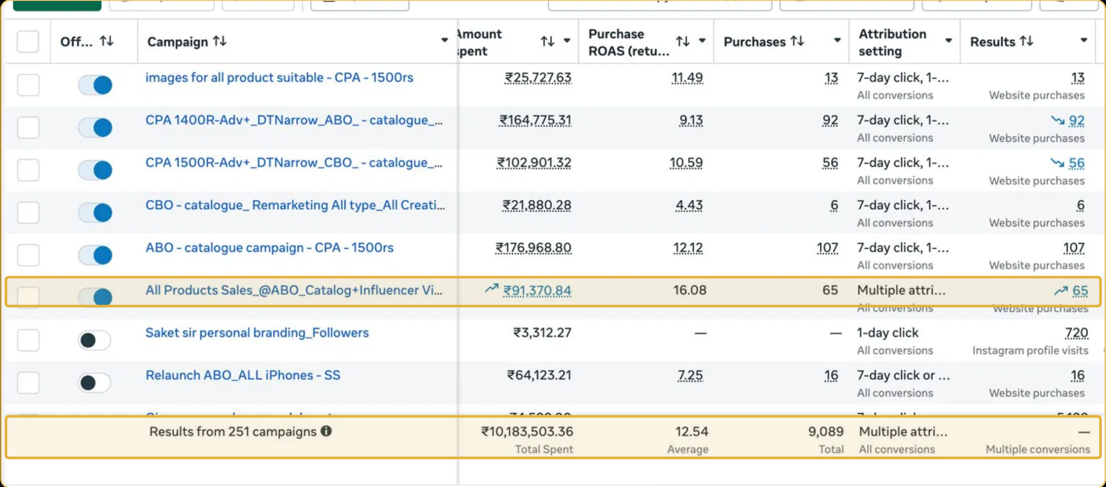
Figure 1. Meta Ads campaign performance reporting screenshot - original source image.
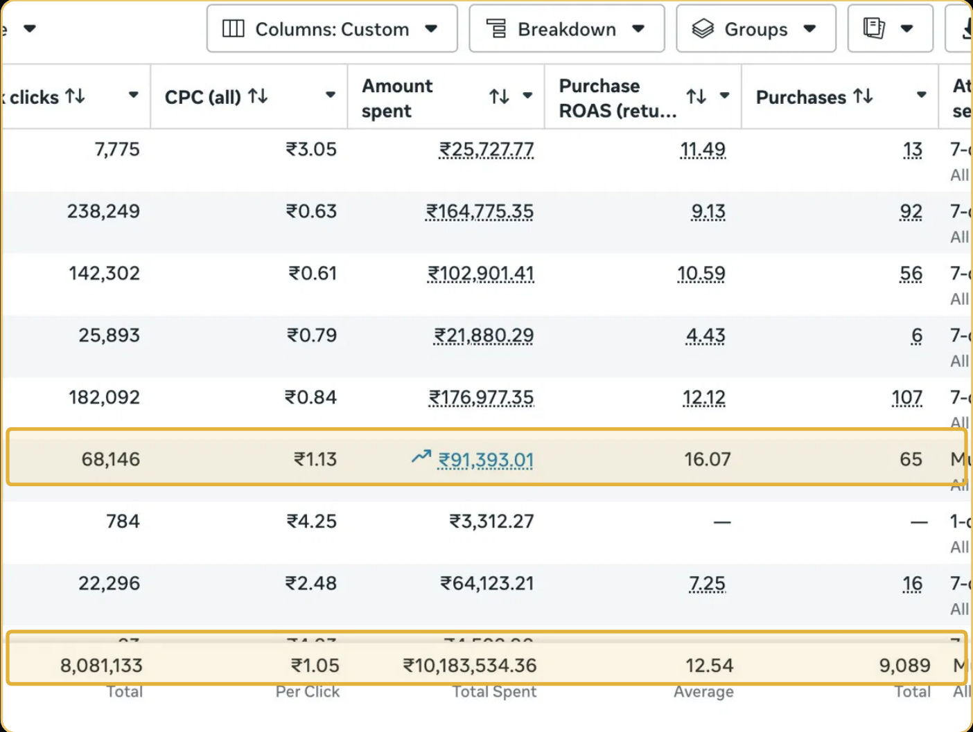
Figure 2. Meta Ads campaign performance reporting screenshot - original source image.

7. Results & Outcomes
The account recorded ₹1.02 Cr in total spend, 12.54x average ROAS and 9,089 purchases across 251 live campaigns. It also generated more than 8 million link clicks at an average ₹1.05 per click. The influencer-led All Products campaign reached 16.08x ROAS. The ABO catalogue campaign recorded 12.12x with 107 purchases; narrow CBO and ABO setups reached 10.59x and 9.13x. The result is notable because the reported average ROAS is an account-level figure covering a very large campaign set, while the higher figures refer to individual campaigns.
The All Products campaign with influencer creative recorded 16.08x ROAS. The ABO catalogue campaign recorded 12.12x with 107 purchases, while narrower CBO and ABO setups recorded 10.59x and 9.13x. Across all 251 campaigns, the reported average was 12.54x with 9,089 purchases.

What stands out in the result
The result matters because the reported average applies across 251 campaigns and more than ₹1 crore in spend. The leading campaign result helps show the ceiling, while the account average shows the wider level of performance.

8. Key Learnings
- Large-scale advertising needs structure. Different budget and campaign types can be tested side by side across a broad catalogue.
- Show both scale and efficiency. The source reports ₹1.02 Cr spend, 251 live campaigns and a 12.54x average ROAS.
- Keep the best campaign result distinct from the account average. The All Products influencer campaign reached 16.08x, while the overall average was 12.54x.

BUSINESS VALUE AND CLOSE

9. Business Impact
The account handled ₹1.02 Cr in reported spend across 251 live campaigns while recording 9,089 purchases and a 12.54x average ROAS. That combination is the central business impact: the account was not only running at scale, but the reported average remained strong across a wide campaign set.
The figures can support a discussion about campaign management at scale. They do not prove net profitability or incremental return because product margins, refunds, shipping costs and attribution details are not disclosed.

Business decisions this case can inform
Decision area | What the case suggests | What should be checked next
Structure selection | Compare CPA-capped, ABO and CBO approaches. | Full campaign-level spend and purchase data.
Scale management | 251 live campaigns show the size of the operating task. | Account structure, overlap and team workflow.
Commercial efficiency | Use 12.54x as the reported account average. | Margin, refunds and net contribution.

10. Conclusion
This case shows the reported scale of a large catalogue account: ₹1.02 crore in spend, 251 live campaigns, 9,089 purchases and 12.54x average ROAS. Selected ABO, CBO and influencer-led examples help explain the account result, but the 16.08x top campaign should not be mistaken for the average across all campaigns.

Publishing accuracy note
The source does not disclose the client name, reporting dates, gross revenue, profit, product categories, gross margin, returns or the attribution settings. It does not confirm that all 8 million clicks were unique or purchase-intent visitors. The 12.54x ROAS is reported by the source and should not be converted into a revenue claim unless the underlying attributed revenue is separately confirmed.

