

**FAKULTI TEKNOLOGI KEJURUTERAAN**

**UNIVERSITI TEKNIKAL MALAYSIA MELAKA**

**SEM 1 SESSION 2013/2014**

**2BETT**

**ASSIGNMENT CONTINUOUS SIGNAL AND SYSTEM**

**(CONVOLUTION OF SOUND WAVES)**

**OBJECTIVE**

* To investigate the convolution of two signals.
* To determine the sound and graph of convolution.

**INTRODUCTION**

**Convolution**

The convolution of f and g is written f∗g, using an asterisk or star. It is defined as the integral of the product of the two functions after one is reversed and shifted. As such, it is a particular kind of integral transform:

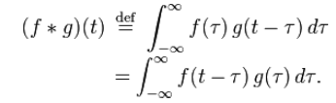

While the symbol t is used above, it need not represent the time domain. But in that context, the convolution formula can be described as a weighted average of the function f(τ) at the moment t where the weighting is given by g(−τ) simply shifted by amount t. As t changes, the weighting function emphasizes different parts of the input function.

**MATLAB codes**

Wavwrite

wavwrite(y,filename) writes the data stored in the variable y to a WAVE file called filename. The filename input is a string enclosed in single quotes. The data has a sample rate of 8000 Hz and is assumed to be 16-bit. Each column of the data represents a separate channel. Therefore, stereo data should be specified as a matrix with two columns. Wavwrite(y,Fs,filename) writes the data stored in the variable y to a WAVE file called filename. The data has a sample rate of Fs Hz and is assumed to be 16 Bit. Wavwrite(y,Fs,N,filename) writes the data stored in the variable y to a WAVE file called filename. The data has a sample rate of Fs Hz and is N-bit, where N is 8, 16, 24, or 32.

Wavrecord

y = wavrecord(n,Fs) records n samples of an audio signal, sampled at a rate of Fs Hz (samples per second). The default value for Fs is 11025 Hz. y = wavrecord(___,ch) uses ch number of input channels from the audio device. ch can be either 1 or 2, for mono or stereo, respectively. The default value for ch is 1. y = wavrecord(___,'dtype') uses the data type specified by the string 'dtype' to record the sound.

Wavread

y = wavread(filename) loads a WAVE file specified by the string filename, returning the sampled data in y. If filename does not include an extension, wavread appends .wav. [y, Fs] = wavread(filename) returns the sample rate (Fs) in Hertz used to encode the data in the file.

Wavplay

wavplay(y,Fs) plays the audio signal stored in the vector y on a PC-based audio output device. Fs is the integer sample rate in Hz (samples per second). The default value for Fs is 11025 Hz. wavplay supports only 1- or 2-channel (mono or stereo) audio signals. To play in stereo, y must be a two-column matrix. 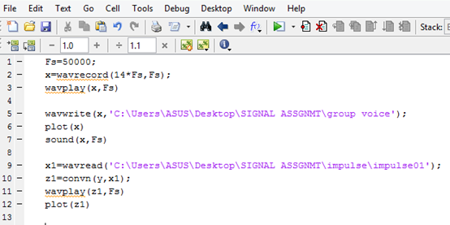

Figure 1: shows how to save recorded files using MATLAB

**Convolution in MATLAB**

The convolution in matlab is accomplished by using “conv” command. If “u” is a vector with length ‘n’ and “v” is a vector with length ‘m’, then their convolution will be of length “n+m-1”. Convolution is a commutative operation. Convolution in time domain corresponds to multiplication in frequency domain.

convn(A,B) computes the N-dimensional convolution of the arrays A and B. The size of the result is size(A)+size(B)-1. convn(A,B,'shape') returns a subsection of the N-dimensional convolution, as specified by the shape parameter.

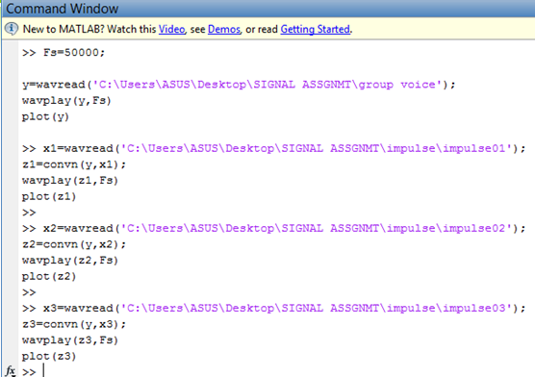

Figure 2 : The convolution of signals

**PROCEDURE**

1. The voice of all group members were recorded in an empty hall using MATLAB software.
2. The three different types of natural impulses were created and recorded using MATLAB.
3. The sound files were saved using the coding shown in figure 1.
4. The voice and impulse 1 were convolved using coding in figure 2.
5. The sound files played and saved.
6. The graph of convolution plotted.
7. The same procedure repeated by replacing impulse 1 with impulse 2 and impulse 3.

**RESULT**

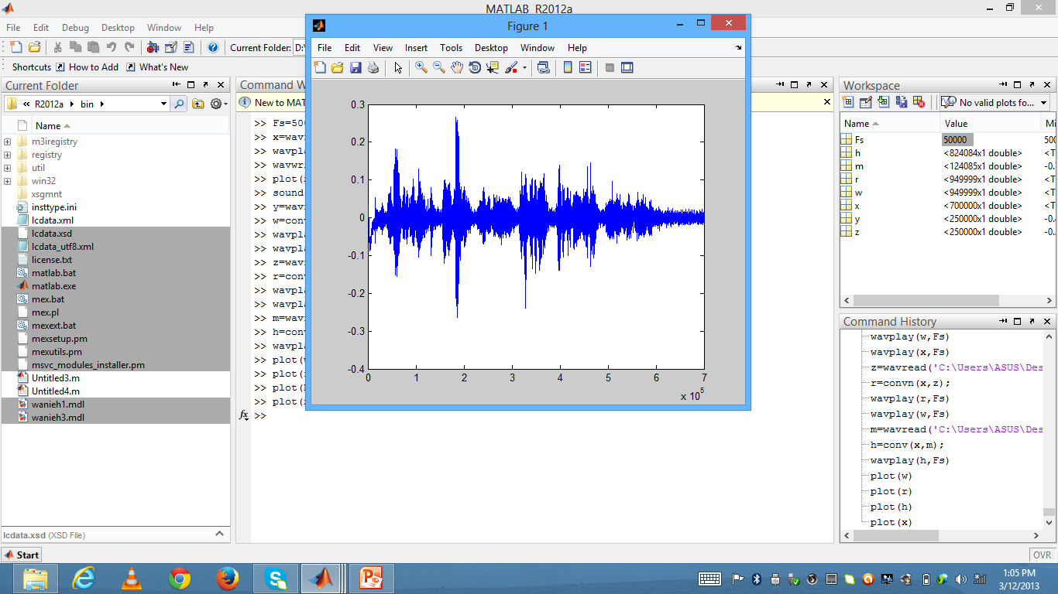

Figure 3 : Plot of group members voice signal.

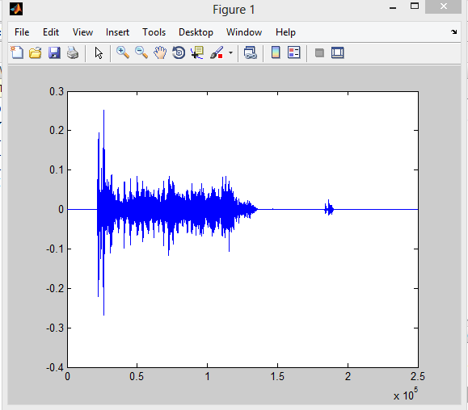

Figure 4 : Impulse of flipping coin

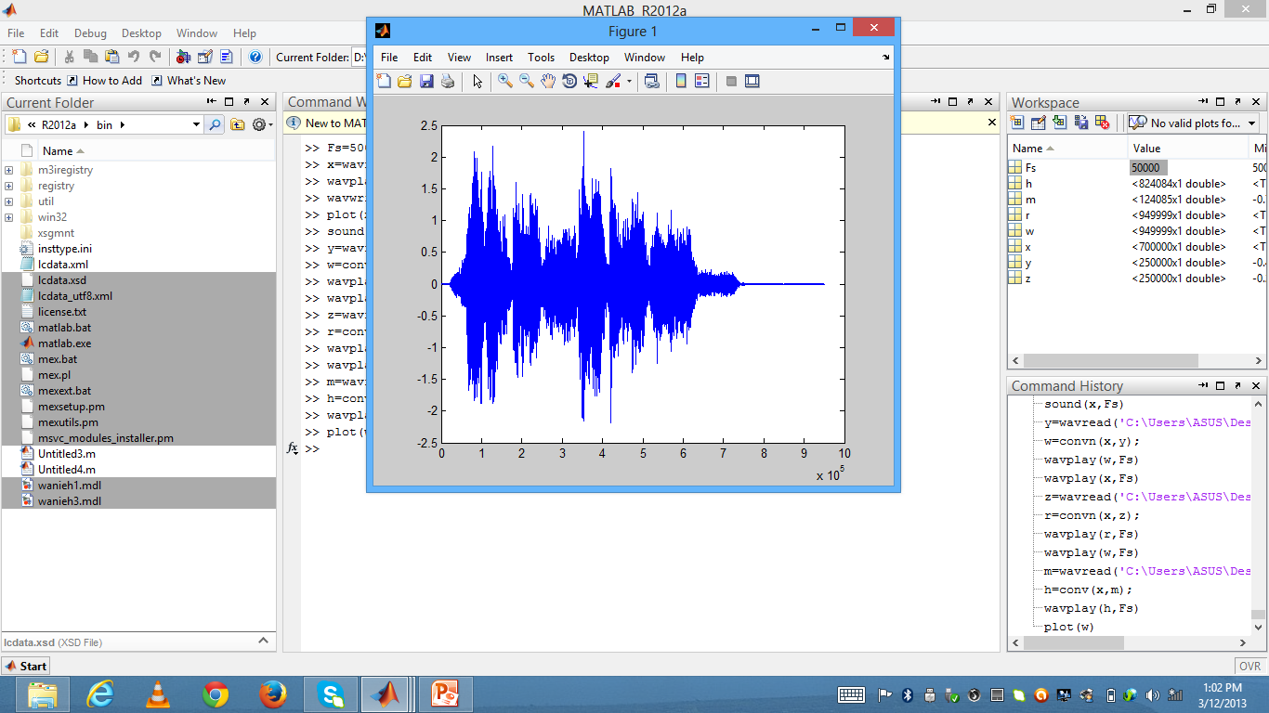

Figure 5 : Convolution of voice signal and flipping coin.

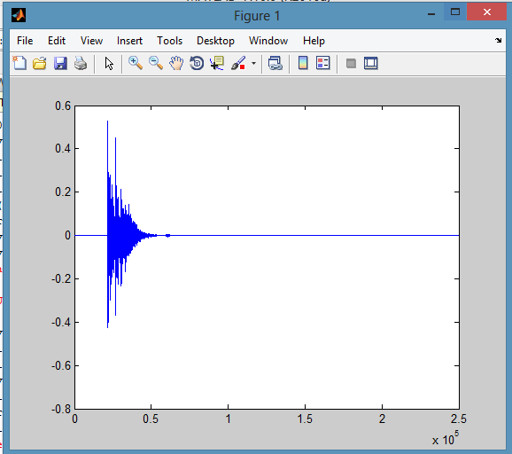

Figure 6 : Impulse of beverage can.

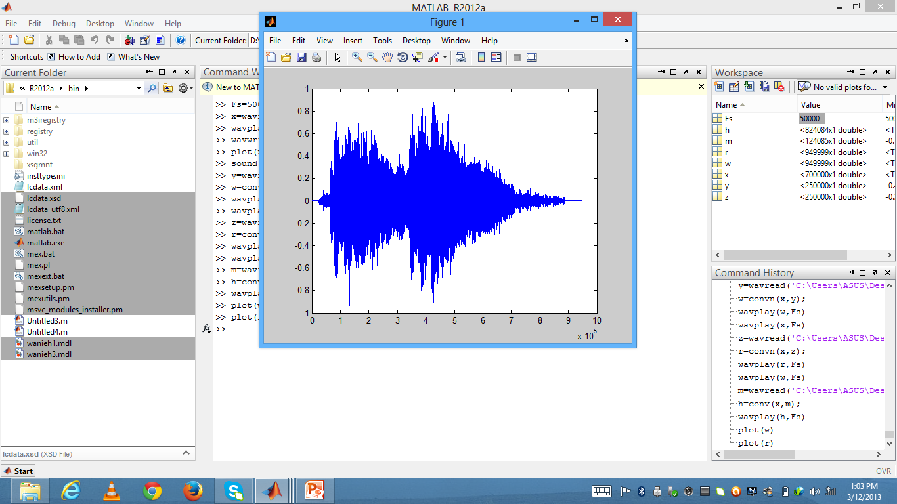

Figure 7 : convolution of voice signal and beverage can.

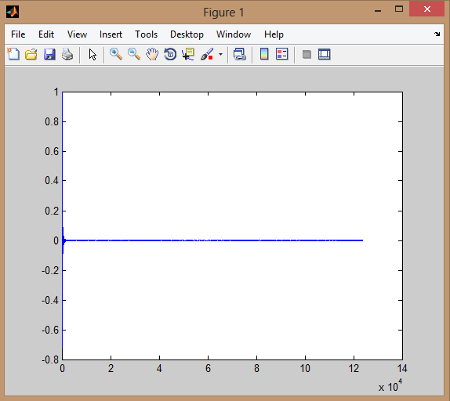

Figure 8 : Impulse of finger snapping sound.

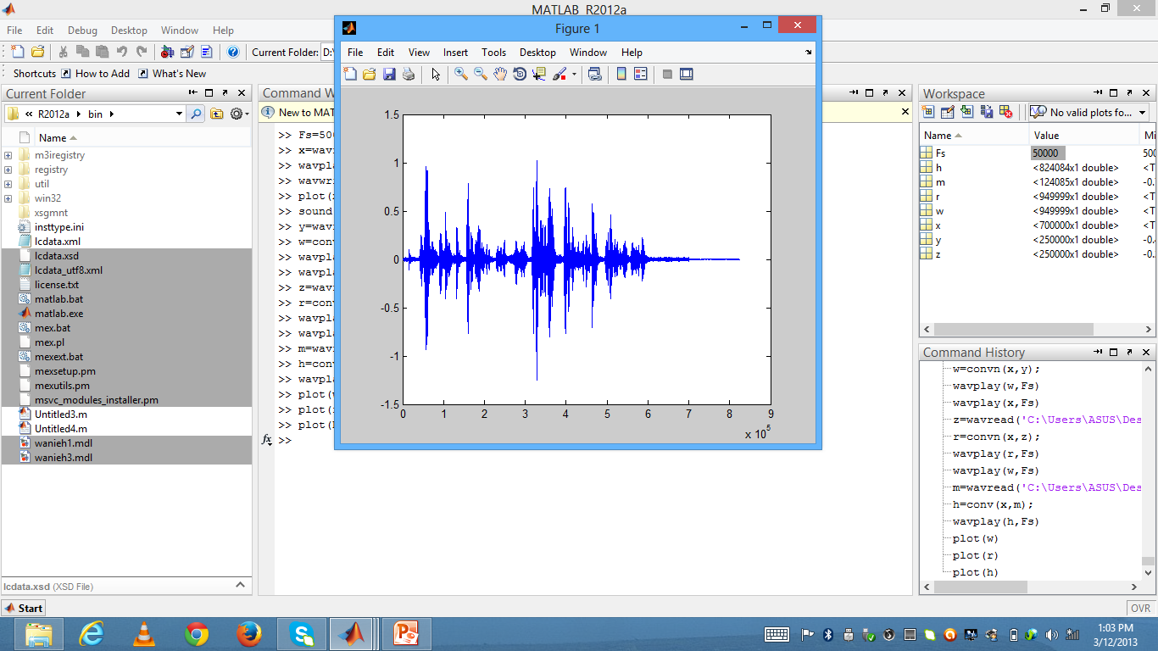

Figure 9 : Convolution of voice signal and finger snapping sound.

**DISCUSSION**

In this assignment, we were instructed to do the convolution of two signals using MATLAB software. Convolution is an operation performed on two signals which involves multiplying one signal by a delayed or shifted version of another signal, integrating or averaging the product, and repeating the process for different delays. Convolution is a useful process because it accurately describes some effects that occur widely in scientific measurements, such as the influence of a low-pass filter on an electrical signal or of the spectral bandpass of a spectrometer on the shape of a spectrum. To prove this theory, we were carried out an experiment to convolve two different types of sound waves.

Before we began to start our assignment we were go through the MATLAB website in order to find out how it works to do convolution. The first thing that we learned about how to record sound on MATLAB software. The code of 'wavrecord' used for record sound. Then, we learned about how to save the recorded file. The code 'wavwrite' used to save the recorded file. Apart from that, we also found out about how to play again the file. This can be done by using code of 'wavread'. This code can search the file on the system by input the file location. For the convolution we used the code of 'convn'. This code can be used when we used sound files from different vectors. For example, when we used 2D files, the convolution does not happen with the other convolution codes, such as 'conv2', 'convmtx', and etc.

Based on the assignment question, we were instructed to do the convolution using group members voice, with three different types of impulses. We were recorded all of our group members voice by using the MATLAB software. We were said our full name in that 14 seconds recording . The sample rate (Fs) we used for our recording was 50000Hz. The location we carried out recording was at FKM BK8 classroom . The length of recording about 14 seconds. After completed the voice recording, we were move on to the impulse recording.

After group discussion, we were decided to do three different impulses such as flipping coin sound, hit beverage can sound , and finger snapping sound. This three types of sounds considered as impulses, because strong sound happen in short period of time. The length of time recording for all the impulses were less than 14 seconds. Before do convolution, we plot the signal of voice and signal of impulses, in order to see differences happen after convolution. Then, we ensured that all the sound files in wav format. Because the MATLAB can only read WAVEform audio files(.WAV). Actually, our sound recording all used the MATLAB software, so we no need to do any conversion.

The first convolution we did was using voice signal and impulse of flipping coin. Then, we used variables input to do convolution. The convolution process takes time depends on the computer processor. The convolves sound can be played by using code 'wavplay'. The convolved sound makes noise or in other words different sound effects. From the sound, we still can hear the voice of group members and impulse, but with echoes. We proceeded the same convolution process by replacing the impulses with the same voice sound.

In order to distinguish the differences happen after convolution, we were plot the graph of convolution. From the graph , we can clearly seen the overlapping happen between the two different sound signals. A convolution multiplies every frequency content in one sound by every frequency content in another.

**CONCLUSION**

From this assignment, we were learned about how to convolve two different signals, especially sound signals. Based on our experiment we knew how to use MATLAB software to convolve two signals. Besides, we also learned many MATLAB specific codes to design our sound convolution. In addition, we also put some efforts on how to make our own impulse sound. We were able to distinguish the differences between impulse sound and non-impulse sound.

**REFERENCE**

* By Charles K.Alexander, *Fundamental of Electric Circuit*, Pg 697-704.
* By Thad B. Welch, ‎Cameron H.G. Wright, ‎Michael G. Morrow, Real-Time Digital Signal Processing from MATLAB, Pg 152.
* By By Steven T. Karris, Signals and Systems: With MATLAB Computing and Simulink Modeling, Pg 11-35.
* By Robert A. Schilling, ‎Robert Joseph Schilling, ‎Sandra L. Harris, Ph. D, Fundamentals of Digital Signal Processing Using MATLAB, Pg 143.
* By Israel Gohberg, ‎Izrail Aronovich Felʹdman, Convolution Equations and Projection Methods for Their Solution , Pg 123.