Aprill month development Requirement for belaobela

1.we need 2 floating scroll fixed button in single product page of mobile view like bikroy .com mobile

View.it would be call and buy now (instead of chat)

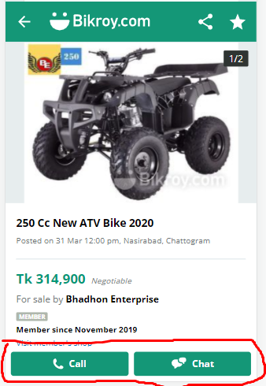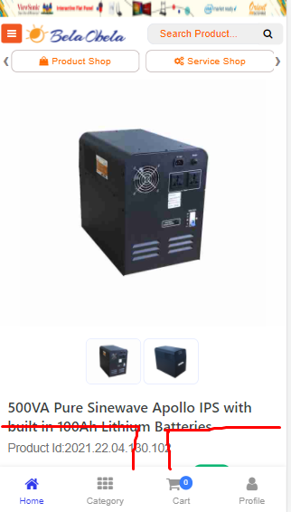

2.All advertise banner should be dynamic for both mobile view and pc view with link.banner gular control option thakbe like starting time,ending time,payment etc

2.when any order status is changed ,customers will get auto sms.currently customers are getting only order confirmation message after order placed and payment success message after status changed to delivered.we need auto sms for confirmed,cancel and on delivery.

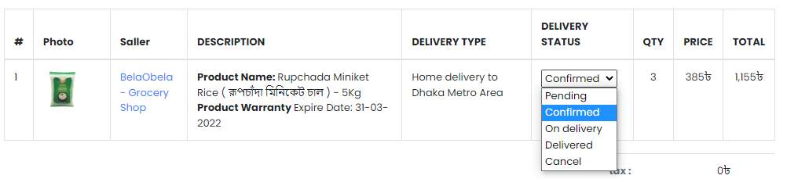

3.after sucesfully purchase by nagad .in the last page design is missing.it was said before.

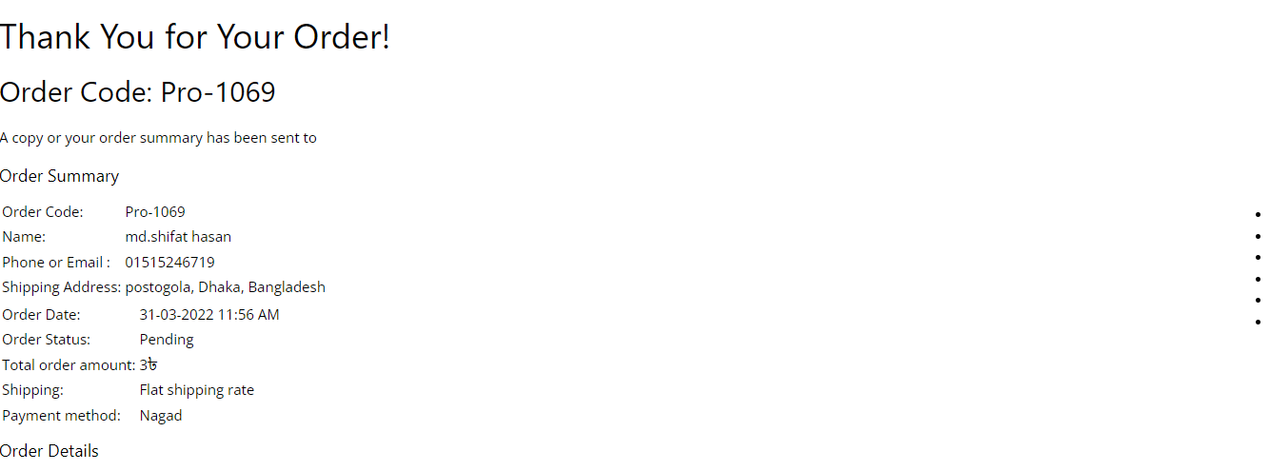

Probably from callback url public should be removed



4.mobile view te new product dynamic kora hoy nai.desktop a thik ache.mobile a onno gula ashe.

Desktop mobile

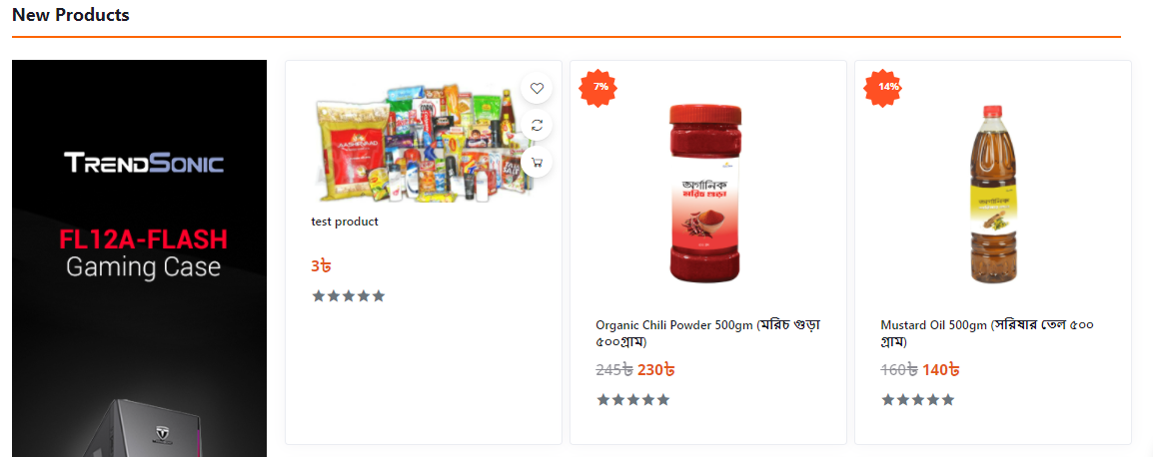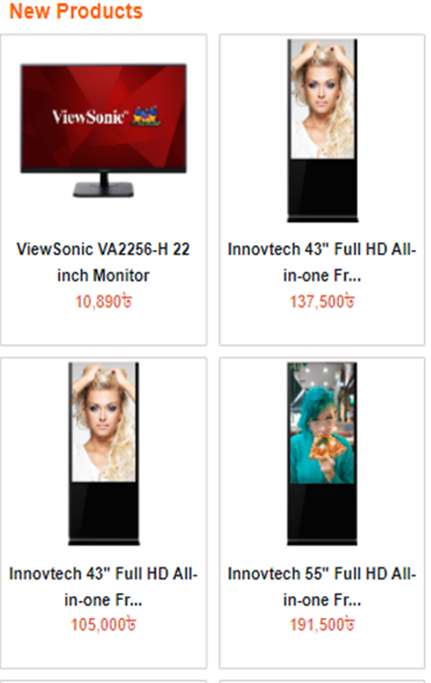

Desktop er top rank product er sathe mobile er top rank product er mil nai.

Mobile a popular product section nai.dektop a ache

5.discount badge ta product er baa dike hobe.new product section je rokom vabe ache sob section gulate oirokom vabe hobe for both mobile and pc view.

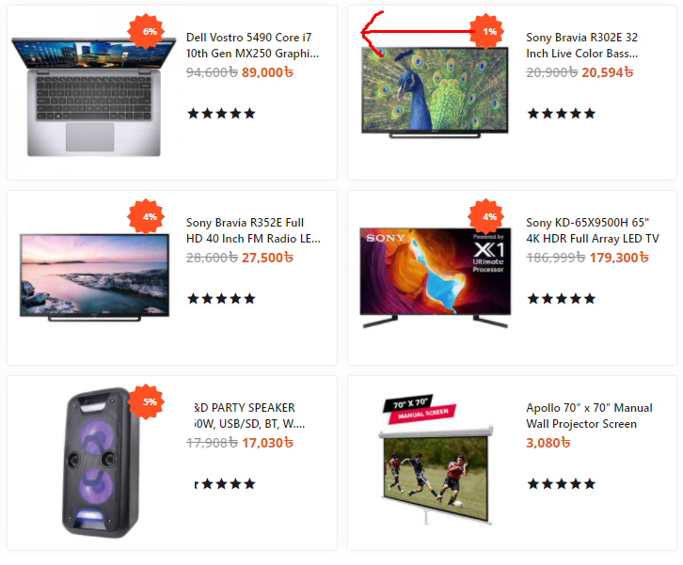

5.admin panel -> inventory -> all store a barcode scan option lagbe jaate product in/out korar somoy scan kora jay(if neede any information in this regard hr azim sir will help)

6.invoice a transaction id ,details show kore na

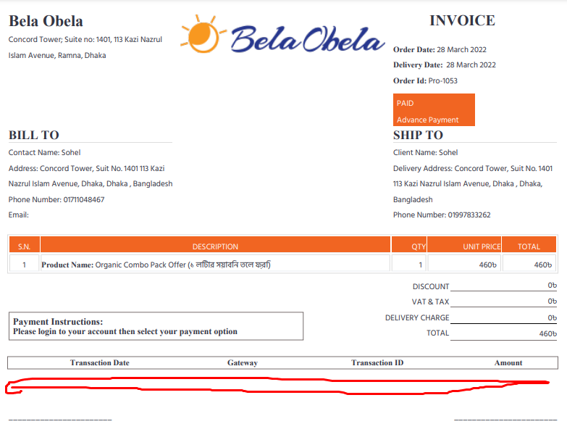

If any requirement is not clear to you,contact with me.

if any thing is needed except this we will add.till now it is enough