# **Inhouse service provider Panel**

**1. Dashboard**

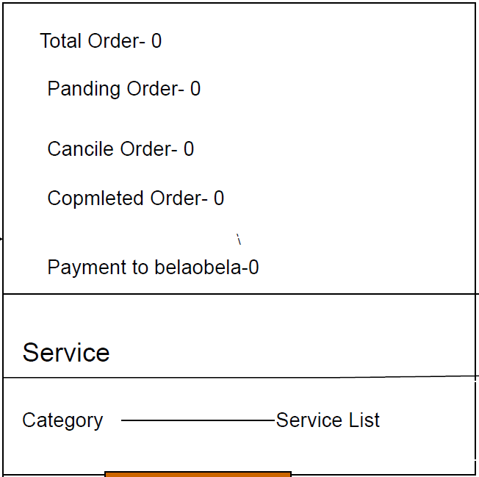

**2. Profile**

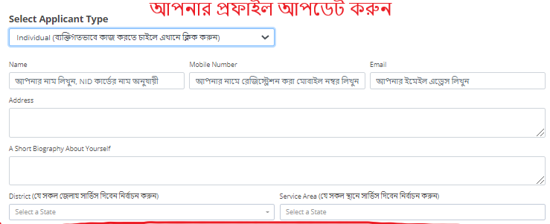

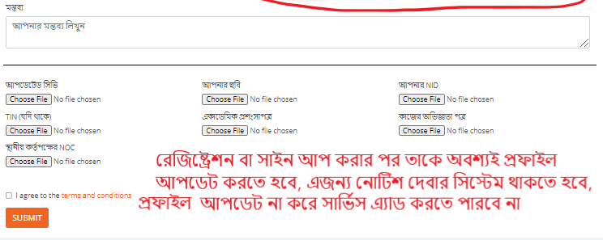

**3. My Service**

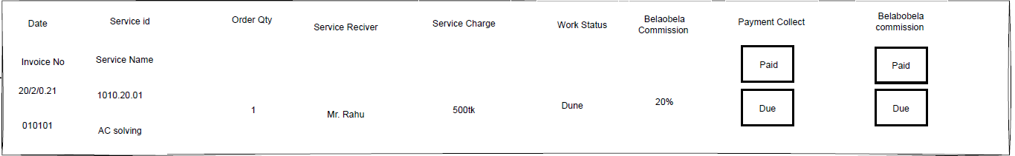

**4. Pending Service**

All Assigned service list by the admin are shown here

**5. Requisition for spare parts**

All requisition lists are shown here related to service order

**6. Conveyance bill**

All Conveyance bill lists are shown here related to completed service.

Provider can apply for new bill to completed service.

**7. Investigation**

Complete & pending Investigation lists are shown here.

**8. Movement History**

No Specification yet

# **Outside service provider Panel**

**1. Dashboard**

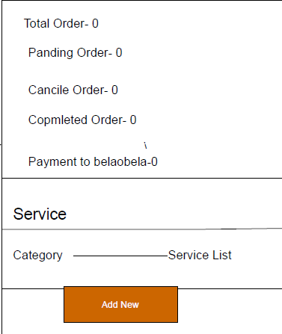

**2. Profile**





**3. My Service**



* Add Service

* + Edit Service

**4. Pending Service**

All Assigned service list by the admin are shown here

**5. Requisition for spare parts**

All requisition lists are shown here related to service order

**6. Investigation**

Complete & pending Investigation lists are shown here.

**7. Movement History**

No Specification yet

**8. Conversation**

Same as E-commerce

# **Customer Panel**

**1. Dashboard**

**2. Manage Profile (Profile edit & details)**

**3. My Service Orders**

**4. Conversation (same as Ecommerce)**

# **Admin Panel**

**1. Dashboard**

**2. Service**

* Add Service

* + Edit Service
* All Services
* Category

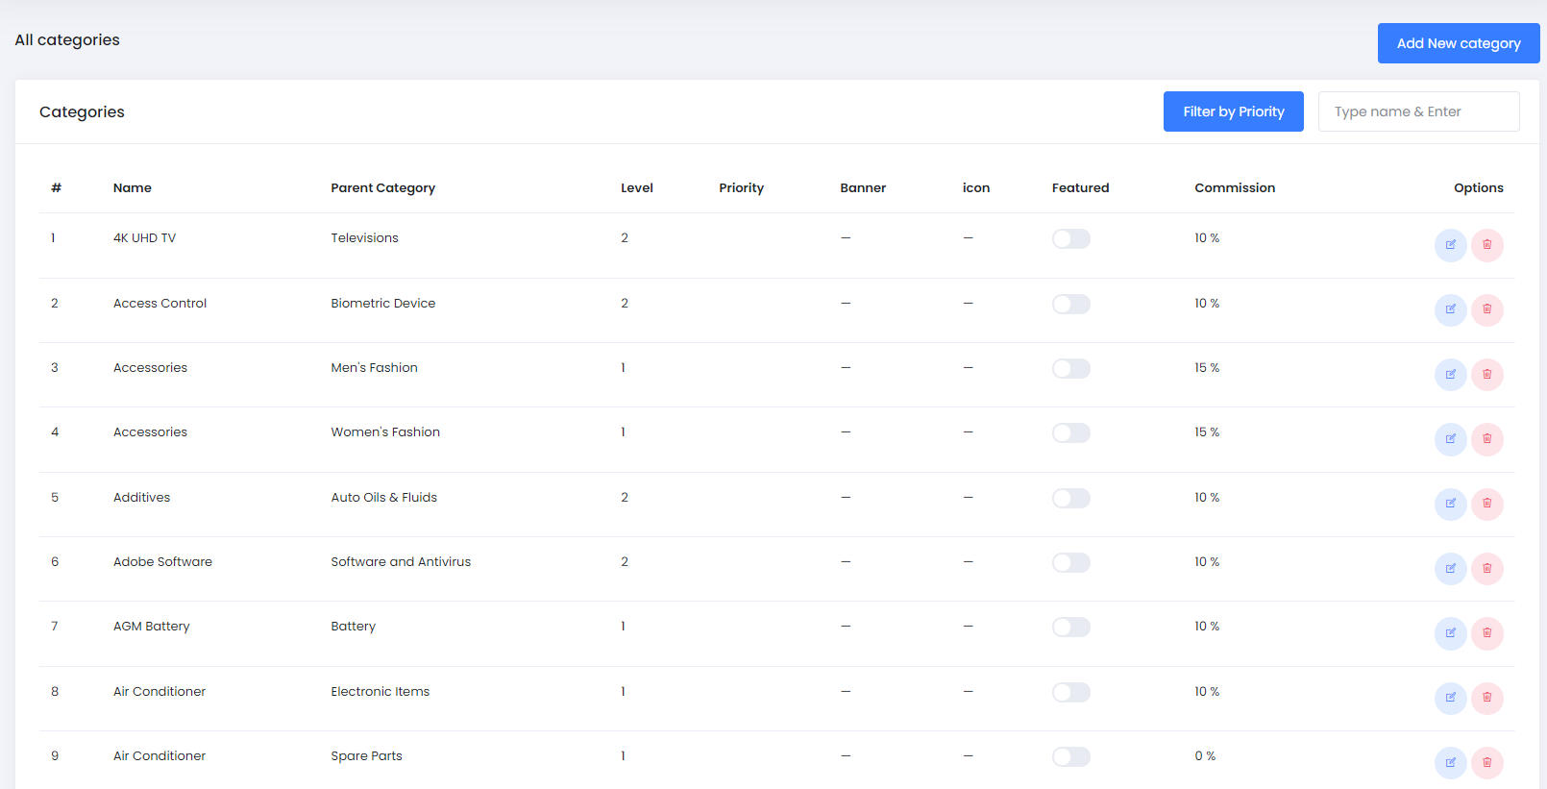

* Brand

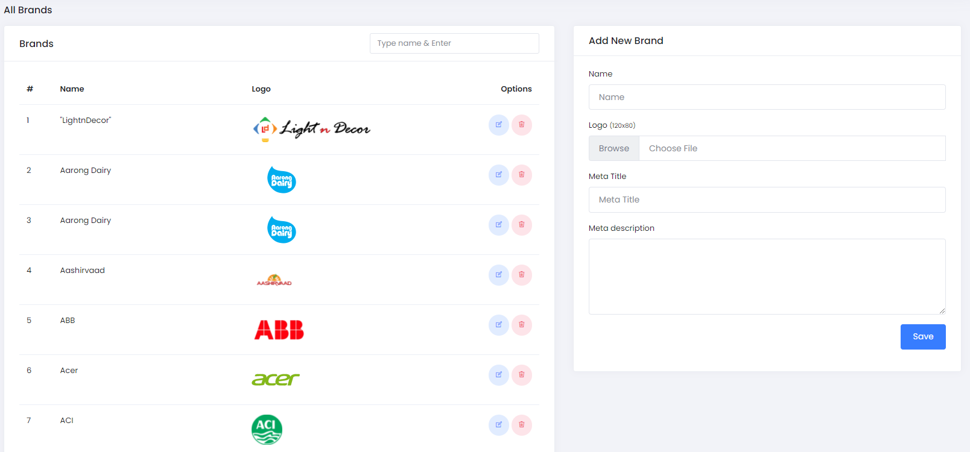

**3. Service Orders**

* Pending Orders (all function like ecommerce)
  + Assigning Order to S.P

* All Orders (all function like ecommerce)

**4. Service Providers**

* Outside Service Provider (all function like ecommerce)
  + Payment Request (same as ecommerce)
  + Payment History (same as ecommerce)
* Inhouse Service Provider (all function like ecommerce)
  + Add New Service Provider
  + Conveyance Bill request according to Completed service
  + Conveyance Bill History

**5. MIS Report**

No details specification yet

**6. OTP System**

Same as Ecommerce

**7. Investigation**

Complete & pending Investigation lists are shown here.

**8. Requisition for spare parts**

All requisition lists are shown here related to service order

 Requisition from S.P > Admin sent to > S.R > Agreed to admin > Admin sent to S.P



**9. Staff**

Create, Edit Role & staff for Specific Permission

**10. Warranty Claim List**

# **Frontend Panel**

**Home Page (Including Header & Footer)**

**Service Details Page**

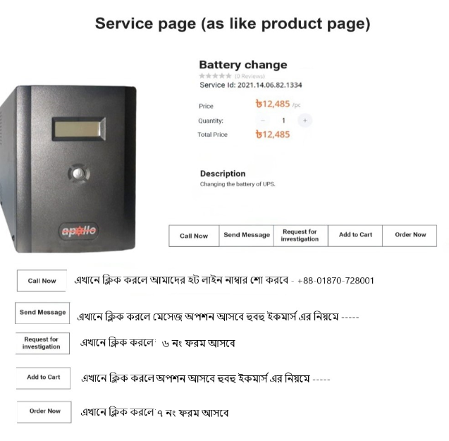

**Cart Page**

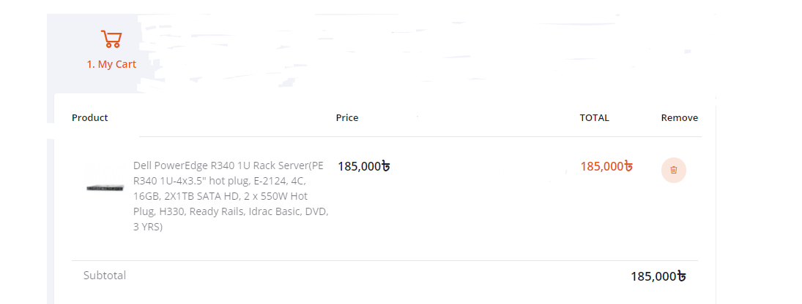

**Order Form**

**Sign Up for Service Provider**

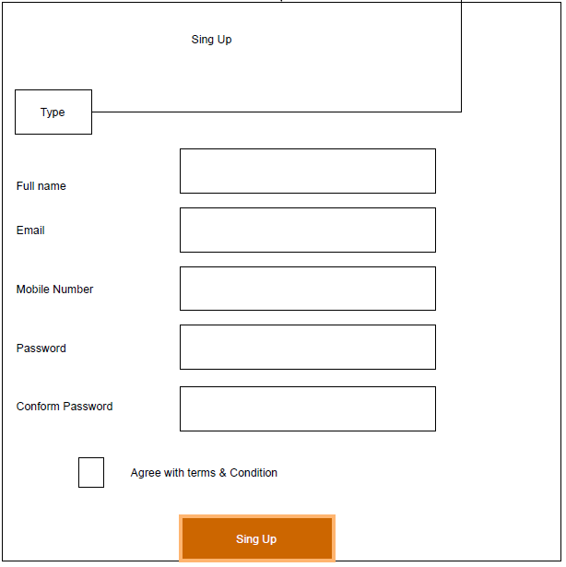

**Login for Service Provider**

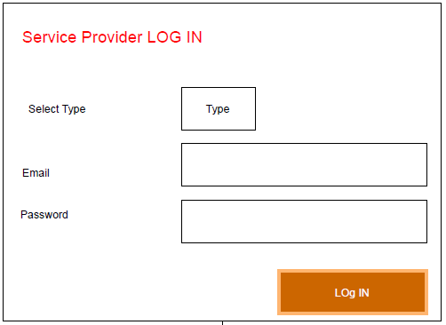

**Customer Sign Up**

Same as Ecommerce using OTP verification Process

**Warranty Claim**

