

**CSE370 Lab HW-01**

Name – Kazi Mahathir Rahman

ID – 23341066

Sec – 10

Faculty – AMM

1. create table Developers

(

member_id char(10),

name varchar(20),

email varchar(20),

influence_count double,

joining_date date,

multiplier int );

insert into Developers values

('1','Taylor Otwell','otwell@laravel.com',739360,'2020-6-10',10),

('2','Ryan Dahl','ryan@nodejs.org',633632,'2020-04-22',10),

('3','Brendan Eich','eich@javascript.com',939570,'2020-05-07',8),

('5','Evan You','you@vuejs.org',982630,'2020-06-11',7),

('6','Rasmus Lerdorf','lerdorf@php.net',937927,'2020-06-3',8),

('7','Guido van Rossum','guido@python.org',968827,'2020-07-18',19), ('8','Adrian Holovaty','adrian@djangoproject.com',570724,'2020-05-07',5),

('9','Simon Willison','simon@djangoproject.com',864615,'2020-04-30',4),

('10','James Gosling','james@java.com',719491,'2020-05-18',5),

('11','Rod Johnson','rod@spring.io',601744,'2020-05-18',7),

('12','Satoshi Nakamoto','nakamoto@blockchain.com',630488,'2020-05-10',10);

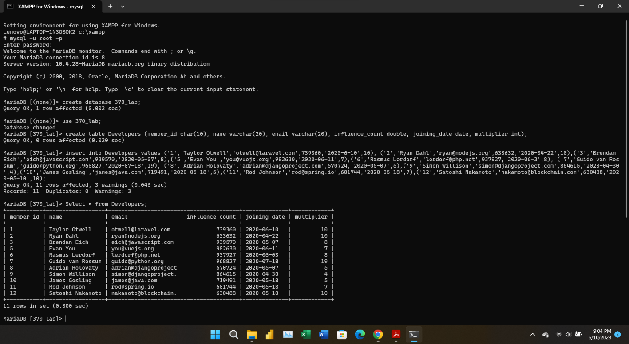

1. ALTER TABLE Developers CHANGE influence_count followers int;  
     
   Select * from Developers;

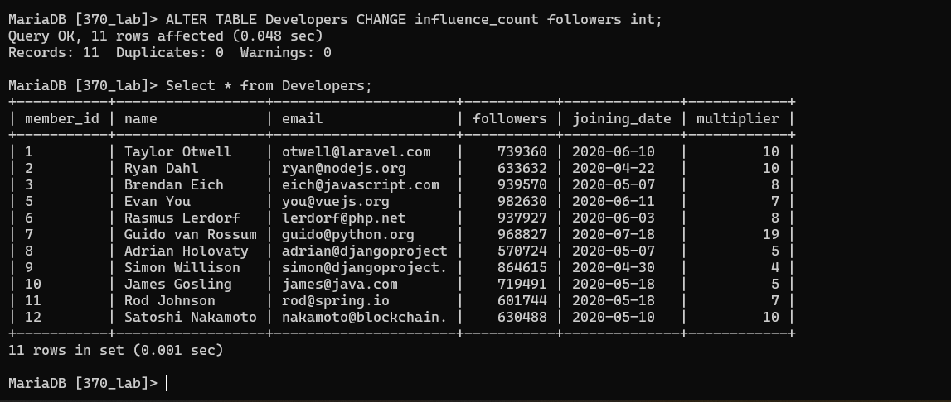

1. Update Developers set followers = followers + 10;  
     
   Select * from Developers;

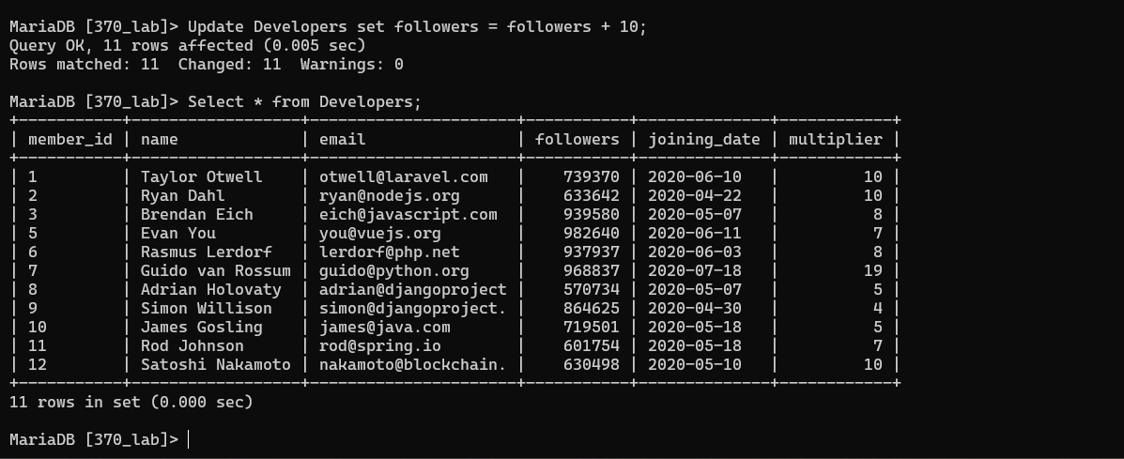

1. Select name, email, followers from Developers;

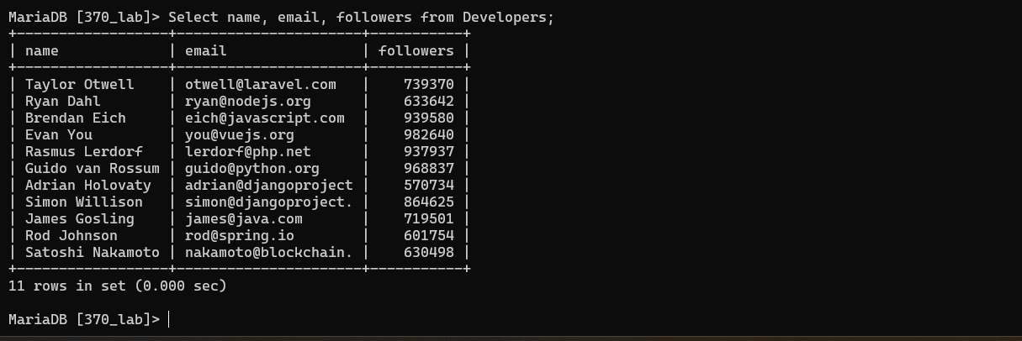

1. Select name, ((followers*100/1000000) * (multiplier*100/20))/100 as efficiency from developers;

