

**CSE370 Lab HW-02**

Name – Kazi Mahathir Rahman

ID – 23341066

Sec – 10

Faculty – AMM

1. use 370_lab

Select distinct joining_date from developers order by joining_date asc;

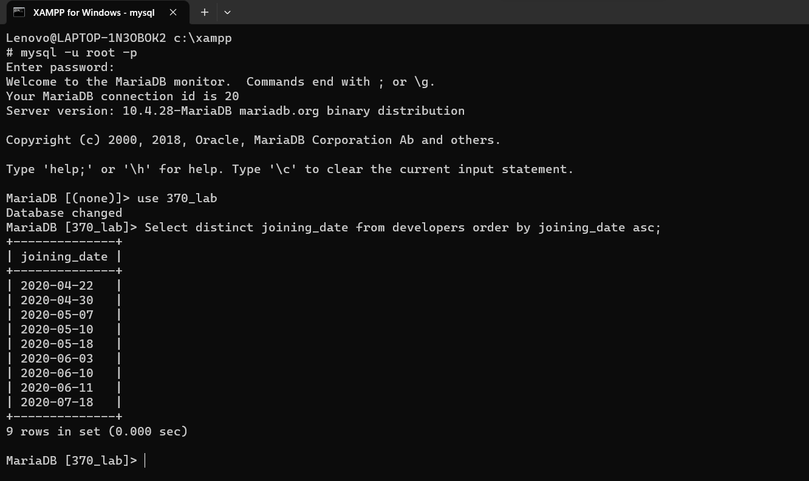

1. Select name, email from developers order by followers desc limit 5;

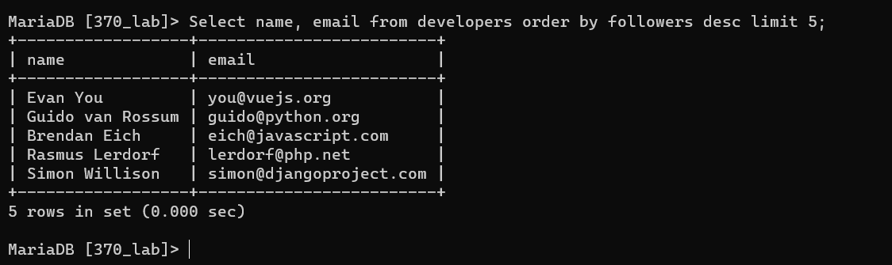

1. Select multiplier, count(*) from developers group by multiplier;

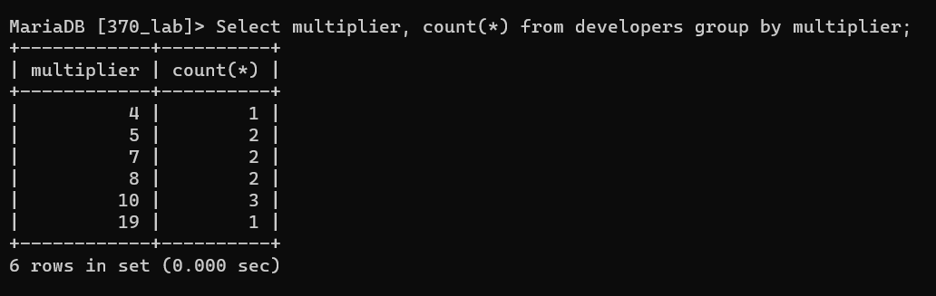

1. Select name from developers where followers < 700000 order by multiplier desc;

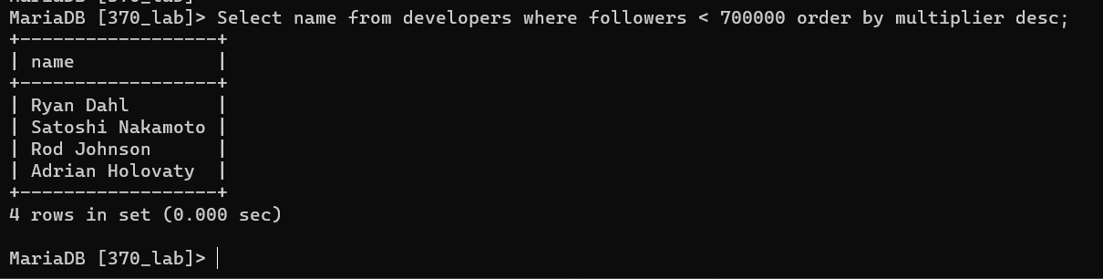

1. Select avg(followers) from developers where joining_date < '2020-06-11';

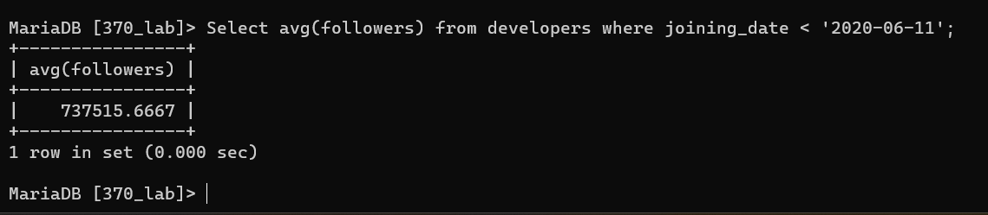

1. Select member_id, name, email, followers from developers where email like '%.com' or email like '%.net';

