

**CSE370 Lab HW-03**

Name – Kazi Mahathir Rahman

ID – 23341066

Sec – 10

Faculty – AMM

1. use 370_lab

CREATE TABLE Employees (

employee_id char(10),

first_name varchar(20),

last_name varchar(20),

email varchar(60),

phone_number char(14),

hire_date date,

job_id char(10),

salary int,

commission_pct decimal(5,3),

manager_id char(10),

department_id char(10));

INSERT INTO Employees VALUES

("EMP001", "Michael" ,"Scott”,"ms1@gmail.com","0177654093", "1999-09-20","JOB001", 100000, 15.4,"MNG001","DPT001"),

("EMP002", "Jim", "Harper","jh2@gmail.com","0177654045", "2004-09-30","JOB002", 60000, 12.1,"MNG002","DPT005"),

("EMP003", "Pam" ,"Beesly","pb3@gmail.net","0177654031", "2003-09-30","JOB003", 25000, 9.4,"MNG003","DPT003"),

("EMP004", "Angela" ,"Martin","am4@yahoo.com","0173454093", "2005-09-28","JOB004", 65000, 2.1,"MNG004","DPT007"),

("EMP005", "Dwight", "Shrute","ds5@gmail.com","0177634093", "2003-09-30","JOB005", 60000, 1.5,"MNG005","DPT005"),

("EMP006", "Kelly", "Kapoor","kk6@gmail.net","0177651293", "2003-09-30","JOB006", 45000, 9.6,"MNG006","DPT001"),

("EMP007", "Andrew", "Bernard","ab7@gmail.com","0188654093", "2007-05-10","JOB007", 50000, 6.2,"MNG007","DPT007"),

("EMP008", "Kevin","Malone","km8@gmail.com","0187954093", "2004-10-30","JOB008", 60000, 10.1,"MNG008","DPT007"),

("EMP009", "Toby","Flender","tf9@gmail.net", "0198054193", "2004-09-30","JOB009", 70000, 15.9,"MNG009","DPT007"),

("EMP010", "Phyllis", "Vance","pv10@yahoo.net","0177765093", "1999-09-20","JOB010", 61000, 13.7,"MNG010","DPT005"),

("EMP011", "Creed", "Bratton","cb11@gmail.com", "0177672193", "1980-06-01","JOB011", 80000, 11.89,"MNG011","DPT005");

SELECT first_name, last_name, email, phone_number, hire_date, department_id FROM employees WHERE hire_date = ( SELECT MAX(hire_date) FROM employees);

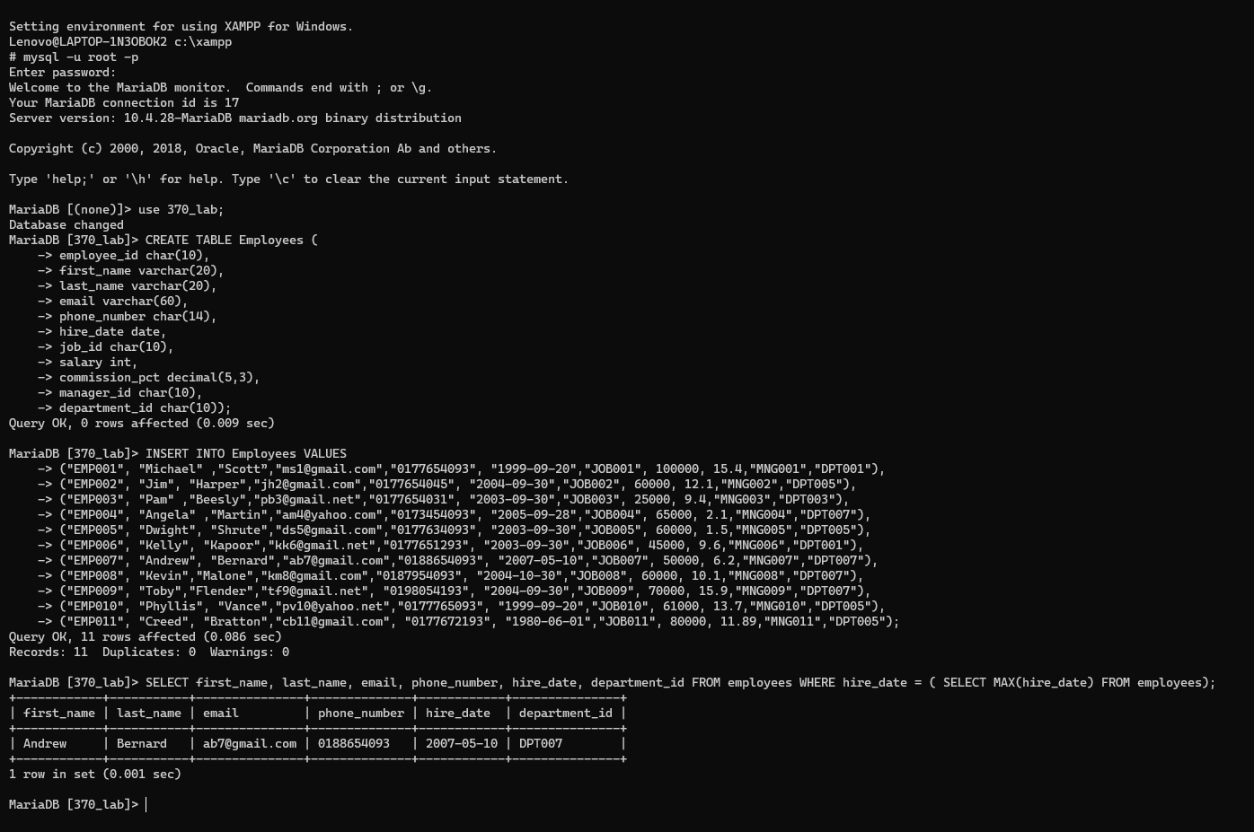

1. SELECT first_name, last_name, employee_id, phone_number, salary, department_id FROM employees WHERE (department_id, salary) IN (SELECT department_id, MIN(salary) FROM employees GROUP BY department_id);

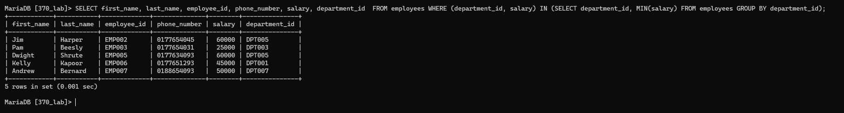

1. SELECT first_name, last_name, employee_id, commission_pct, department_id FROM employees WHERE commission_pct < (SELECT MIN(commission_pct) FROM employees WHERE department_id = 'DPT005') AND department_id = 'DPT007';



1. SELECT department_id, COUNT(*) AS total_number_of_employees FROM employees WHERE salary < 30000 GROUP BY department_id;

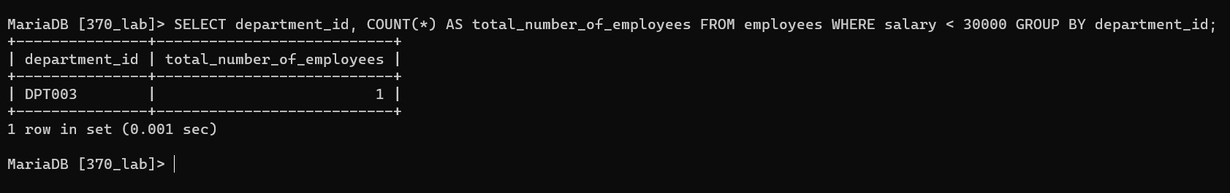

1. SELECT department_id, job_id, commission_pct FROM employees L1 WHERE EXISTS ( SELECT * FROM employees L2 WHERE L2.department_id= L1.department_id AND L2.commission_pct < L1.commission_pct AND L2.job_id <> L1.job_id);

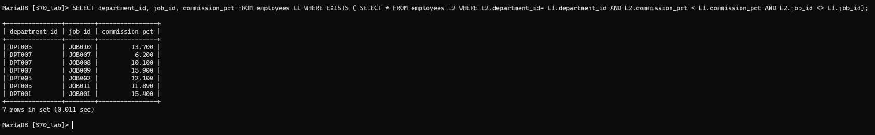

1. SELECT manager_id FROM employees L1 WHERE NOT EXISTS (SELECT * FROM employees L2 WHERE L1.manager_id = L2.manager_id AND L2.salary < 3500);

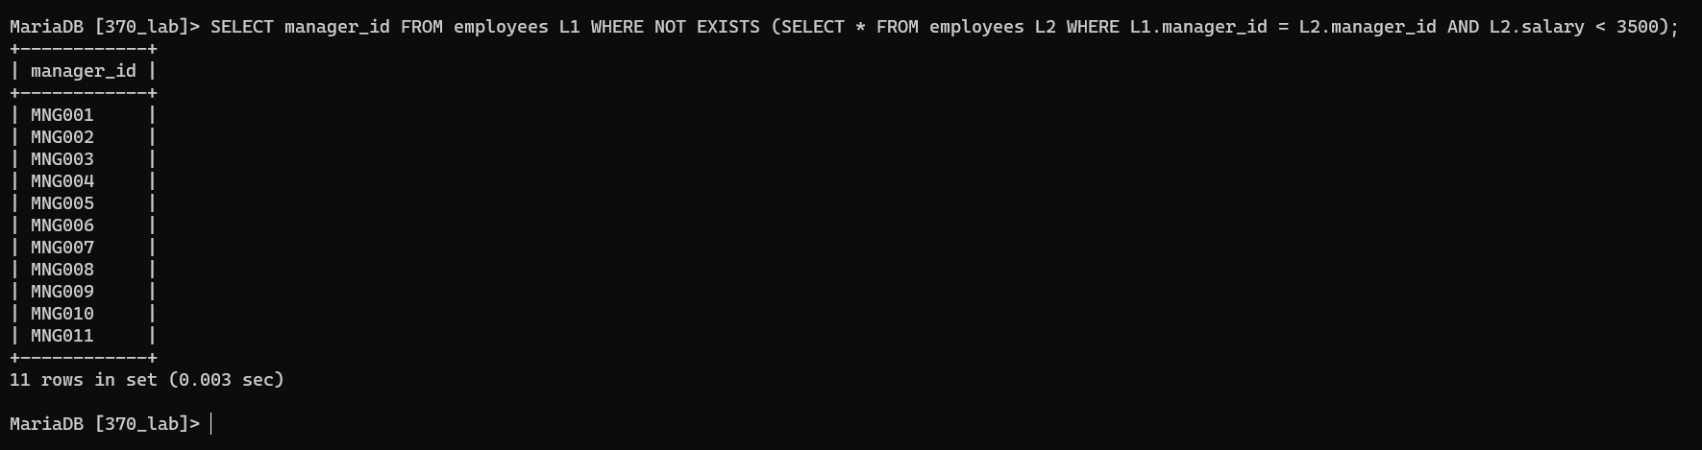

1. SELECT first_name, last_name, employee_id, email, salary, department_id, commission_pct FROM employees WHERE (manager_id, commission_pct) IN (SELECT manager_id, MIN(commission_pct) FROM employees GROUP BY manager_id);

