

**CSE370 Lab HW-04**

Name – Kazi Mahathir Rahman

ID – 23341066

Sec – 10

Faculty – AMM

1. USE Bank;

SELECT t1.customer_name, t3.loan_number

FROM customer t1

JOIN borrower t2 ON t1.customer_id = t2.customer_id

JOIN loan t3 ON t2.loan_number = t3.loan_number

WHERE t3.branch_name = 'Downtown';



1. SELECT t1.customer_name AS Customer1, t2.customer_name AS Customer2, t1.customer_city AS City

FROM customer t1

JOIN customer t2 ON t1.customer_city = t2.customer_city

WHERE t1.customer_id < t2.customer_id;

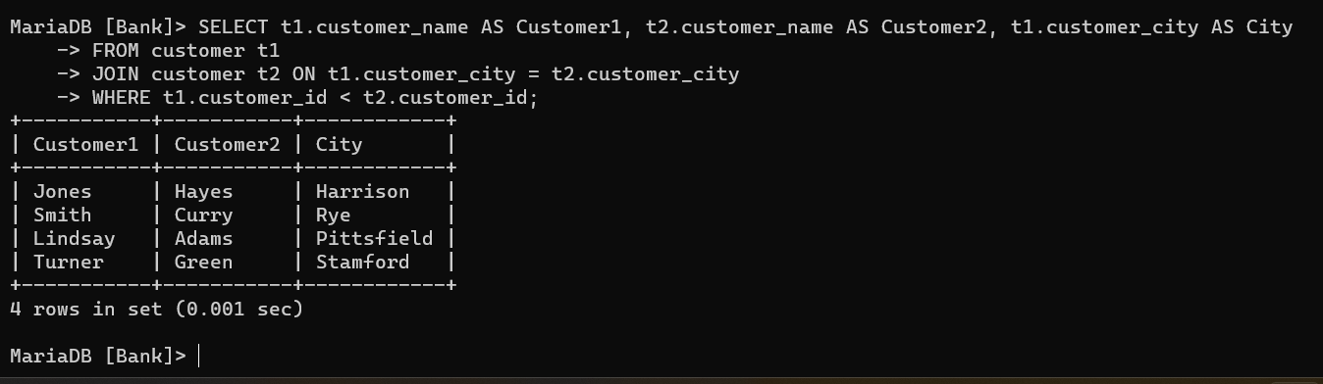

1. SELECT t1.branch_name AS Branch_name, SUM(t2.balance * 0.04) AS Total_Interest

FROM branch t1

JOIN account t2 ON t1.branch_name = t2.branch_name

GROUP BY t1.branch_name;

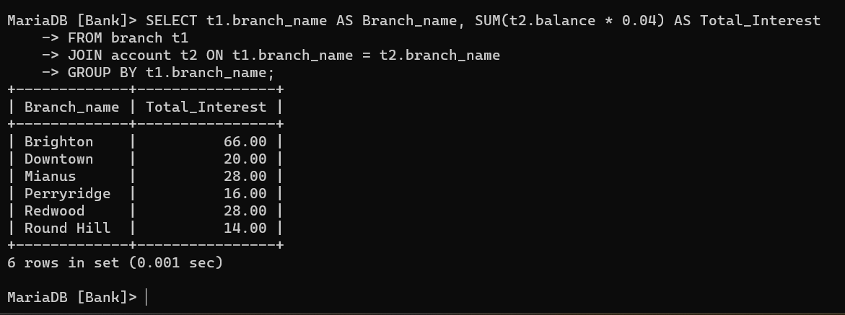

1. SELECT t1.customer_city, t3.account_number

FROM customer t1

JOIN depositor t2 ON t1.customer_id = t2.customer_id

JOIN account t3 ON t2.account_number = t3.account_number

WHERE t3.balance = (

SELECT MAX(balance)

FROM account

WHERE customer_city = t1.customer_city);

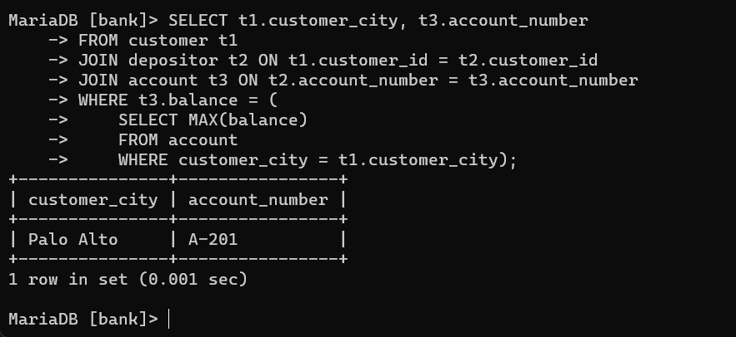

1. SELECT t1.loan_number, t1.amount, t3.customer_name

FROM loan t1

JOIN borrower t2 ON t1.loan_number = t2.loan_number

JOIN customer t3 ON t2.customer_id = t3.customer_id

ORDER BY t1.amount ASC, t1.loan_number DESC

LIMIT 5;

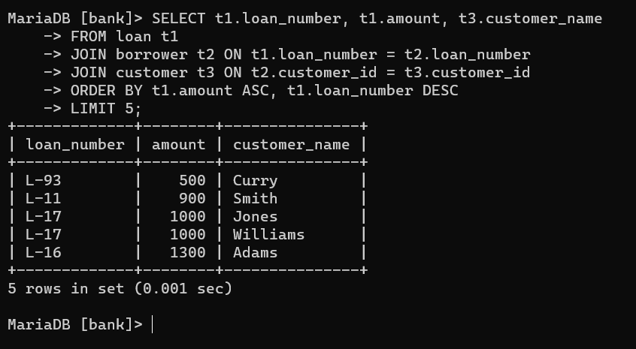

1. SELECT t1.customer_name

FROM customer t1

JOIN depositor t2 ON t1.customer_id = t2.customer_id

JOIN account t3 ON t2.account_number = t3.account_number

JOIN borrower t4 ON t1.customer_id = t4.customer_id

JOIN loan t5 ON t4.loan_number = t5.loan_number

WHERE t3.branch_name = 'Perryridge' AND t5.branch_name = 'Perryridge';

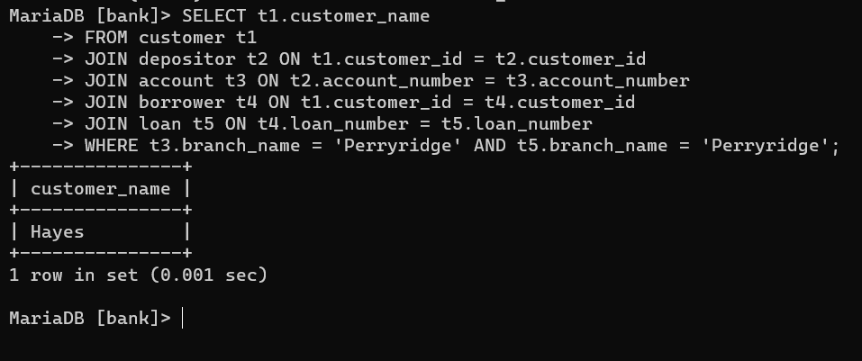

1. SELECT t1.customer_name, SUM(t3.amount) AS total_loan

FROM customer t1

JOIN borrower t2 ON t1.customer_id = t2.customer_id

JOIN loan t3 ON t2.loan_number = t3.loan_number

GROUP BY t1.customer_name

HAVING COUNT(*) >= 2;

