SG-ACO Experiments

This repository contains the code, benchmark metadata, run outputs, statistical tests, and figures for the experimental study of SHAP-Guided Ant Colony Optimization (SG-ACO) for the Job-Shop Scheduling Problem (JSSP).
SG-ACO uses a gradient-boosted surrogate model and signed TreeSHAP feature attributions to guide the construction heuristic inside Ant Colony Optimization. The experiments compare SG-ACO against standard ACO variants, tabu search, and deterministic dispatching rules on named public JSSP benchmark instances.

Repository contents
File | Description
engine.py | JSSP decoder, feature extraction, schedule construction, dispatching rules, ACO kernels, and tabu search.
methods.py | SG-ACO method logic: corpus generation, surrogate training, TreeSHAP signed weights, and ACO variants.
run_resumable.py | Resumable experiment runner for the full stochastic grid.
analyze.py | Generates summary tables, statistical tests, ablation results, timing tables, and figures.
make_report.py | Produces a manuscript-ready experimental report from the generated outputs.
instances.json | Benchmark metadata, sizes, best-known/optimal values, and expected instance paths.
inst_info.json | Per-instance surrogate information, corpus best values, training sizes, timings, and SHAP weights.
results.csv | Per-run results for each instance, method, and seed.
summary.csv | Per-instance summary statistics: mean, standard deviation, minimum, and BKS gap.
wilcoxon.csv | Per-instance Wilcoxon signed-rank tests with Holm correction.
wilcoxon_pooled.csv | Pooled Wilcoxon tests over BKS-normalized paired blocks.
friedman.json | Friedman test statistic, p-value, number of blocks, and average ranks.
nemenyi.csv | Nemenyi post-hoc p-values.
ablation.csv | Signed-SHAP vs magnitude-only SHAP ablation results.
timings.csv | Raw SG-ACO timing outputs.
treeshap_timing.csv | Aggregated TreeSHAP refresh-cost table.
fig_gap.png | Percentage gap to the best-known solution by instance and method.
fig_conv.png | Mean convergence curves for FT10 and TA01.
fig_weights.png | Signed TreeSHAP feature weights by instance.

Benchmark instances
The main experiments use ten named public JSSP benchmark instances with published best-known or optimal makespans:
FT06, LA01, LA02, LA03, LA04, LA05, FT10, ABZ5, ORB01, and TA01.
Instance metadata are stored in instances.json. The expected raw instance files should be placed under:
instances/<instance_name>
For example:
instances/ft06
instances/la01
instances/ta01
The Fisher–Thompson FT06 instance is available from Beasley’s OR-Library. Taillard-format instances should be generated or stored using the fixed seeds and paths reported in the study so that the experiments are exactly reproducible.

Experimental setup
The stochastic methods are evaluated with the same budget:
- 25 independent seeds per stochastic method
- 12 ants × 250 iterations = 3000 schedule evaluations per ACO run
- 3000 neighbor evaluations for tabu search
- SG-ACO refresh interval G = 25
- ACO parameters: alpha = 1, beta = 2, rho = 0.1, lambda = 1
Compared methods:
- Standard ACO / Ant System (AS-std)
- MAX-MIN Ant System (MMAS)
- Ant Colony System (ACS)
- Tabu search (Tabu)
- Offline SHAP-guided ACO (SHAP-off)
- Closed-loop SG-ACO (SG-ACO)
- Deterministic rules: SPT, MWKR, and MOR
Because the benchmark instances optimize makespan and do not provide native due dates, the JobSlack feature uses the total-work-content rule:
d_j = 1.5 × sum of processing times of job j

Key figures

Percentage gap to best-known solution
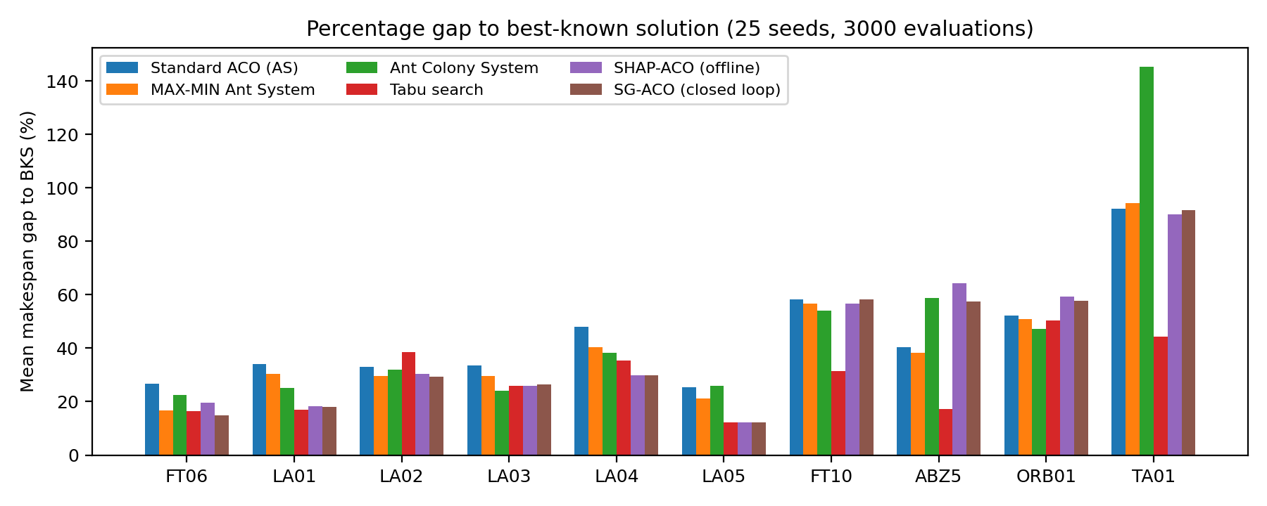
Percentage gap to best-known solution

Convergence on FT10 and TA01
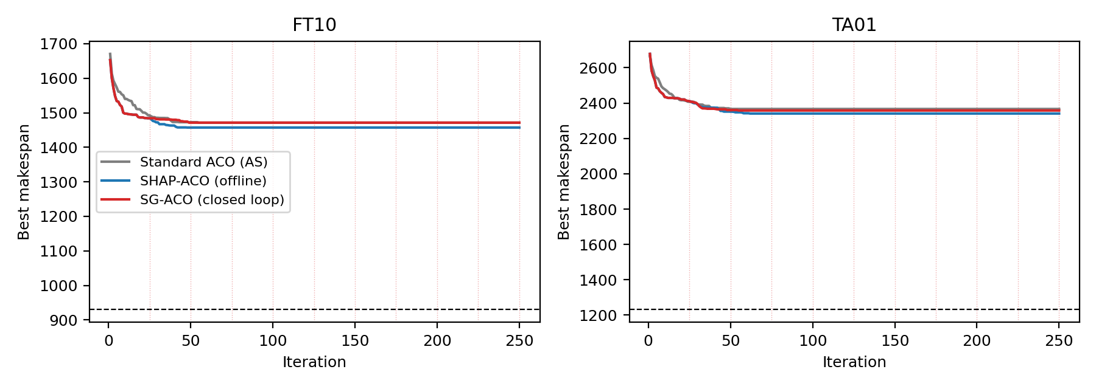
Convergence curves

Signed TreeSHAP feature weights
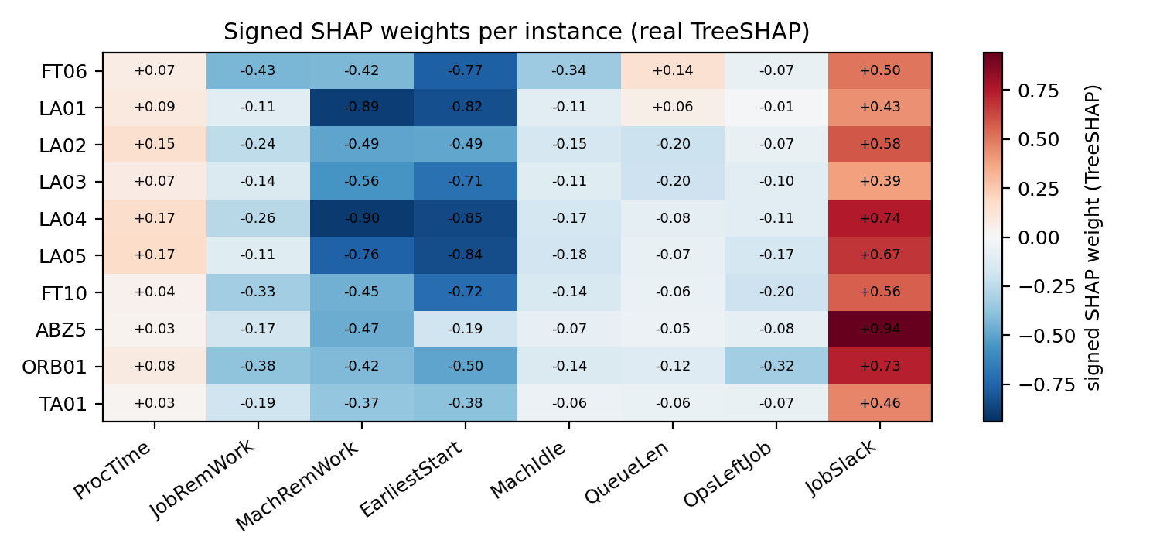
Signed TreeSHAP weights

Summary of main results
Average percentage gap to the best-known solution across the ten main instances:
Method | Mean gap (%)
Standard ACO (AS) | 44.37
MAX-MIN Ant System | 40.83
Ant Colony System | 47.32
Tabu search | 28.84
SHAP-ACO (offline) | 40.65
SG-ACO (closed loop) | 39.55

The Friedman test over 250 BKS-normalized paired blocks rejects equal performance across the six stochastic methods:
chi-square = 187.71
p-value = 1.21e-38
blocks = 250
Average Friedman ranks, where lower is better:
Method | Average rank
Tabu search | 2.394
SG-ACO (closed loop) | 3.180
SHAP-ACO (offline) | 3.378
MAX-MIN Ant System | 3.620
Ant Colony System | 3.888
Standard ACO (AS) | 4.540

These results support the narrower claim that signed explanation-derived guidance improves the ACO family under the tested budget, while tabu search remains the strongest baseline overall on the larger instances.

Installation
Python 3.12 is recommended.
Create a virtual environment:
python -m venv .venv
source .venv/bin/activate # Linux/macOS
# .venv\Scripts\activate # Windows
Install dependencies:
pip install numpy pandas scipy scikit-posthocs matplotlib numba scikit-learn shap
Numba compiles several inner loops during the first run, so the first execution may be slower.

Reproducing the experiments
1. Place the benchmark instance files in the instances/ directory.
2. Run the resumable experiment grid:
python run_resumable.py
run_resumable.py is designed to be rerun safely. It appends completed runs to results.csv and exits periodically, so repeat the command until it exits with code 0.
3. Generate summaries, statistical tests, and figures:
python analyze.py
4. Generate the manuscript-ready report:
python make_report.py
Expected generated outputs include:
summary.csv
wilcoxon.csv
wilcoxon_pooled.csv
friedman.json
nemenyi.csv
ablation.csv
treeshap_timing.csv
fig_gap.png
fig_conv.png
fig_weights.png
report.md
If fig_conv.png is regenerated, the convergence-curve chunks curves_*.npz must be present. They are produced automatically by run_resumable.py.

Data and reproducibility notes
The repository is intended to archive the complete computational record for the study:
- source code
- benchmark metadata
- instance files
- per-run results
- statistical outputs
- generated figures
For submission, update this section with the final public links:
GitHub repository: <insert URL>
Zenodo DOI: <insert DOI>
Suggested data-availability statement:
The FT06 benchmark instance is publicly available in Beasley’s OR-Library. Larger job-shop instances were generated using the standard Taillard procedure with the fixed random seeds reported in the paper. All experiment code, instance files, per-run results, and statistical outputs are included in this repository and archived with a Zenodo DOI.

Suggested GitHub upload checklist
Before pushing the repository, confirm that the following are included:
README.md
*.py
*.csv
*.json
*.png
instances/
curves_*.npz # optional, needed to regenerate convergence curves exactly
inst_cache/ # optional, speeds reruns if cached surrogate artifacts are shared
Suggested commands:
git init
git add README.md *.py *.csv *.json *.png instances/
git commit -m "Add SG-ACO experiment archive"
git branch -M main
git remote add origin <your-github-repository-url>
git push -u origin main

License
Add the license selected for the project before public release. For academic code releases, common choices are MIT, BSD-3-Clause, or Apache-2.0.

Citation
Please cite the associated paper and archived release once the repository is public:
@misc{sgaco_experiments,
title = {SG-ACO Experiments: SHAP-Guided Ant Colony Optimization for Job-Shop Scheduling},
author = {<insert authors>},
year = {<insert year>},
doi = {<insert Zenodo DOI>},
url = {<insert GitHub URL>}
}

