Microsoft excel tutorial for beginners
subtitle

Heading 1

Heading 2

Heading 3

Heading 4

SELECT Id, ActivityDate, Subject FROM Task WHERE ActivityDate > NEXT_N_DAYS:365

Mass deleting future tasks greater than one year from now
public class DeleteYearOldTask implements Database.Batchable<SObject> {

public Database.QueryLocator start(Database.BatchableContext BC){
return Database.QueryLocator([
SELECT Id FROM Task WHERE activitydate!=null and ActivityDate > NEXT_N_DAYS:365
]);
}

public void execute(Database.BatchableContext BC, List<sObject> scope){
List<Task> toDelete= (List<Task>) scope;
Database.DeleteResult[] results= Database.delete(toDelete, false);

for(Integer i=0; i<result.size();i++){
if(!results.isSuccess()){
for(Database.Error err: results[i].getErrors()){
System.debug(
'Delete failed for Id=' + toDelete[i].Id
+ ' : ' + err.getStatusCode() + ' - ' + err.getMessage()
);
}
}
}
}
public void finish(Database.BatchableContext BC){
System.debug('DeleteYearOldTasksBatch finished. Job Id: ' + BC.getJobId());
}
}

// Instantiate the batch class
DeleteYearOldTask deleteBatch = new DeleteYearOldTask();

// Execute the batch job
// The second parameter (scope size) is set to 200, which is the maximum allowed.
// Smaller sizes may be needed if the delete triggers complex automation.
Database.executeBatch(deleteBatch, 200);

System.debug('Batch job submitted to delete all AcquiredAccount__c records.');

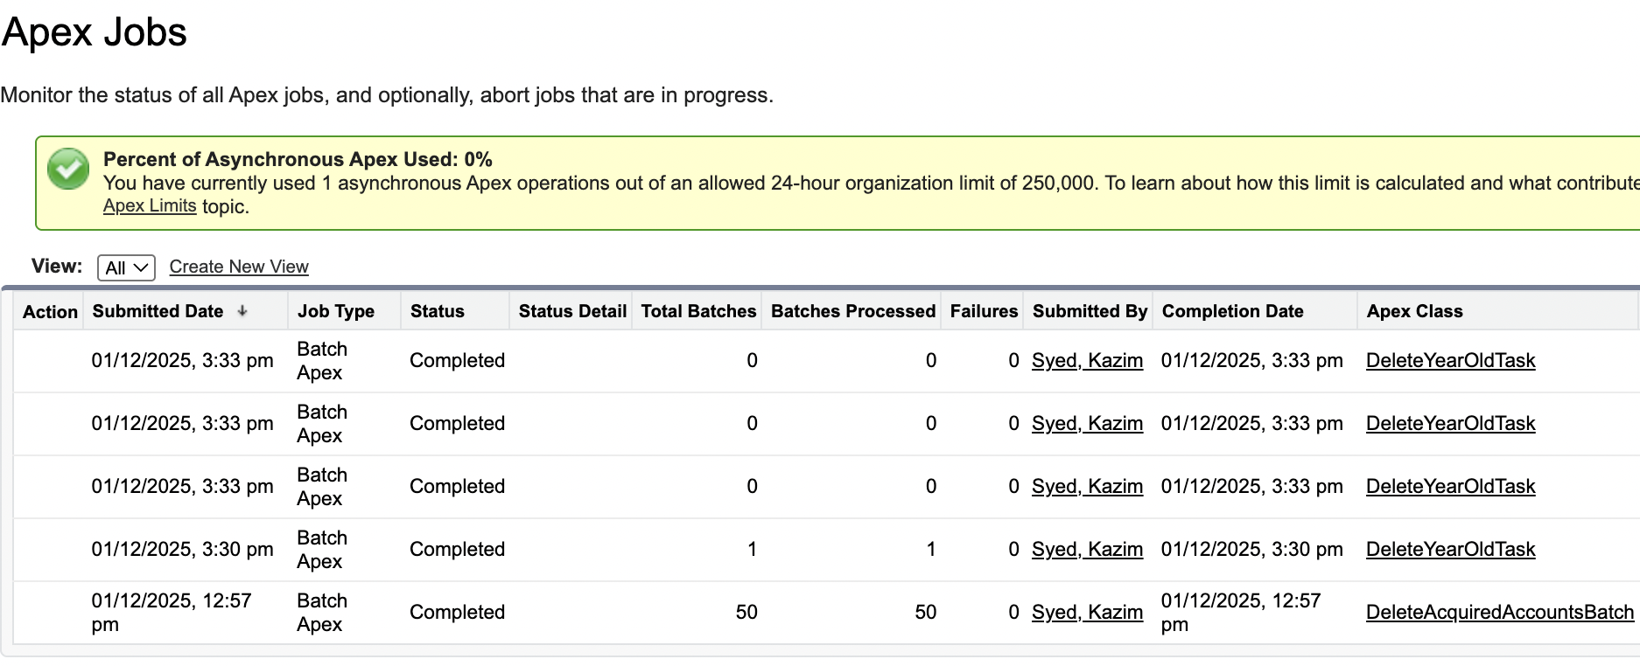

Mass deleting Acquired Account records
public class DeleteAcquiredAccountsBatch implements Database.Batchable<SObject> {

public Database.QueryLocator start(Database.BatchableContext bc) {
// Query all records of the custom object
return Database.getQueryLocator([
SELECT Id
FROM AcquiredAccount__c
]);
}

public void execute(Database.BatchableContext bc, List<SObject> scope) {
// Cast to concrete type for clearer debugging/logging if desired
List<AcquiredAccount__c> toDelete = (List<AcquiredAccount__c>) scope;

// Use Database.delete with allOrNone = false to allow partial success
Database.DeleteResult[] results = Database.delete(toDelete, false);

// Optional: log failures to the debug log
for (Integer i = 0; i < results.size(); i++) {
if (!results[i].isSuccess()) {
for (Database.Error err : results[i].getErrors()) {
System.debug(
'Delete failed for Id=' + toDelete[i].Id
+ ' : ' + err.getStatusCode() + ' - ' + err.getMessage()
);
}
}
}
}

public void finish(Database.BatchableContext BC) {
System.debug('DeleteAcquiredAccountsBatch finished. Batch Id: ' + BC.getJobId());
// Optional: Send an email notification to the administrator upon completion.
AsyncApexJob job = [SELECT Id, Status, NumberOfErrors, JobItemsProcessed, TotalJobItems
FROM AsyncApexJob
WHERE Id = :BC.getJobId()];

System.debug('Batch Job finished. Status: ' + job.Status +
', Total Records: ' + job.TotalJobItems +
', Errors: ' + job.NumberOfErrors);

// Example Email Notification:

Messaging.SingleEmailMessage mail = new Messaging.SingleEmailMessage();
String[] toAddresses = new String[] {'kazimsyed9911@gmail.com'}; // <-- CHANGE THIS EMAIL
mail.setToAddresses(toAddresses);
mail.setSubject('Batch Delete Job Complete: AcquiredAccount__c');
mail.setPlainTextBody('The mass deletion of AcquiredAccount__c records has finished. Status: ' + job.Status);
Messaging.sendEmail(new Messaging.SingleEmailMessage[] { mail });

}
}

Restoring Records from the recycle bin
Setup > Recycle bin
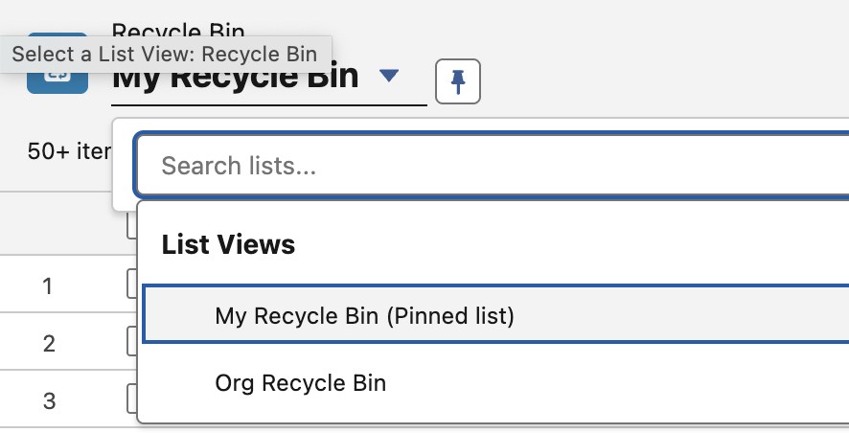 | You have records deleted by you in my recycle bin and records deleted by others in Org Recycle bin.
 | So it doesn’t delete, it just flag the isDelete field to be true. The way to hard-delete is using data-loader. You can also sort by deletedate.
The way mike did it. | Date x=Date.today.addyears(1)  select id from task where activitydate > x;

FAQ
does scope(0) means the the first chunk or is it the first record of the chunk.
First record of the chunk. Its a one dimensional array that gets converted into subarray that is chunks.
Chunk 1 would from i=0-200 scope(i)
chunk 2 would from i=201-400 scope(i)

public void execute(Database.BatchableContext bc, List<SObject> scope) { // Cast to concrete type for clearer debugging/logging if desired List<AcquiredAccount__c> toDelete = (List<AcquiredAccount__c>) scope; // Use Database.delete with allOrNone = false to allow partial success Database.DeleteResult[] results = Database.delete(toDelete, false); is their a need to cast it. or can we do? Database.DeleteResult[] results = Database.delete(scope, false);
No, its not necessary.
1. clarity
Casting tells you what object type you EXPECT.
2. Strong typing
Code completion in VS Code
- Compile-time validation
- Access to child fields during debugging before DML

Simple dml stmt | Insert contactstoinsert  update accounts  delete tasks
Partial dml stmt | Database.insert(records, false)  Database.update(records, false)  Database.delete(records, false)
Error handling | Result.getId()  Result.isSuccess()  Result.getErrors()

Estimating Your Organization Code Coverage
Setup → Apex classes | 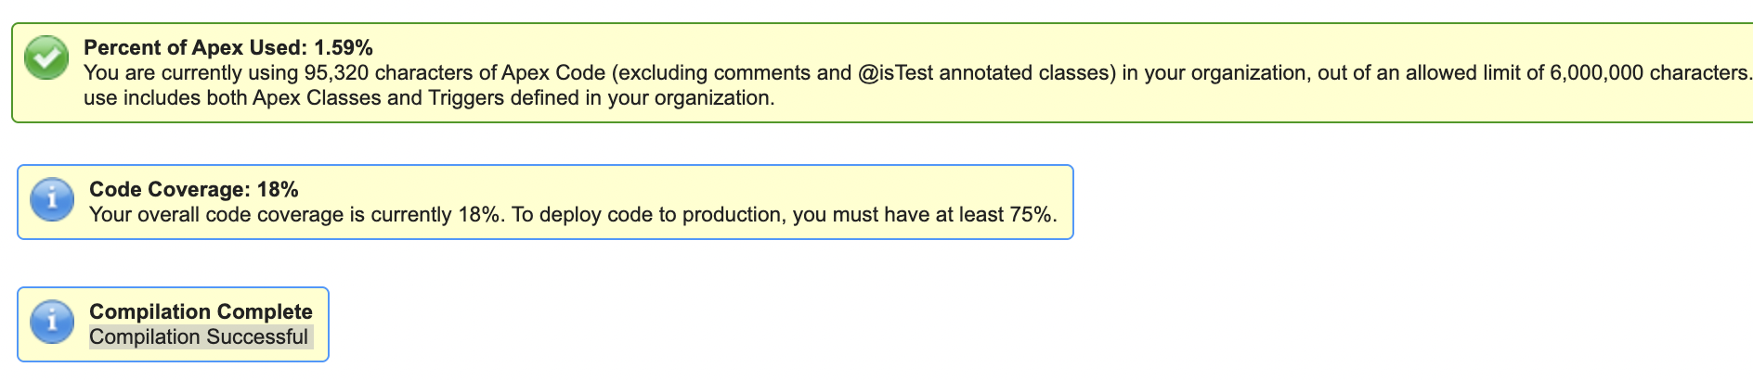

Creating a validation rule to enforce Positive numeric values
 | You create validation rules at the object level.
 | No of employees could be negative without validation rules.
Object manager → lead → validation rule | 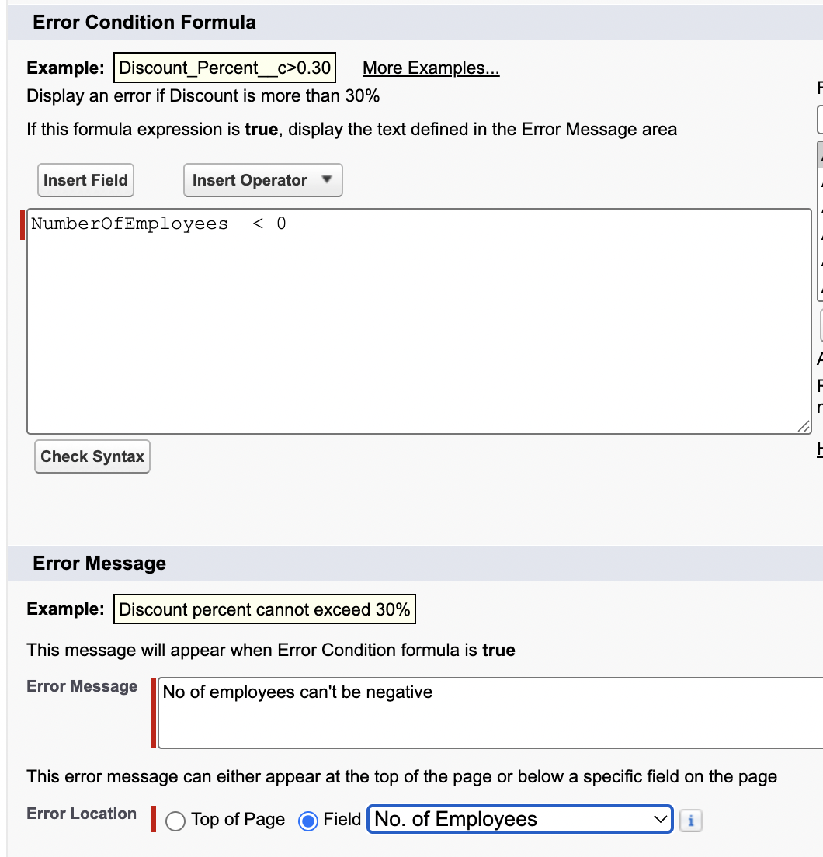

Make a field Required via a Validation rule
Task | How to make a field required?
We can’t uncheck it to make not required. | 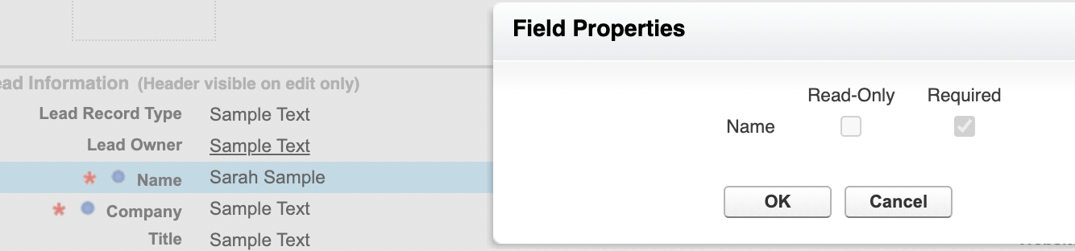
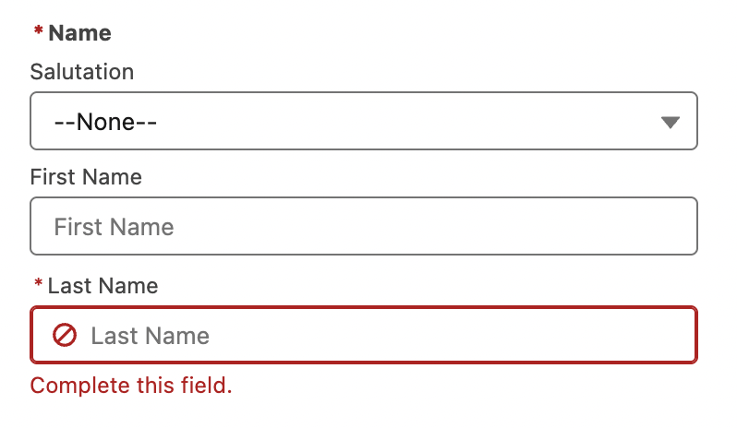 | Name and lname is required.
The way we do it.  Note: it doesn’t retroactively fix the issue of legacy records. It will block any future updates on this record.  Note: you can combine validation rule. But then u are occupied with a vague error message that states that either the field is empty or #ofemployees is less than zero. | 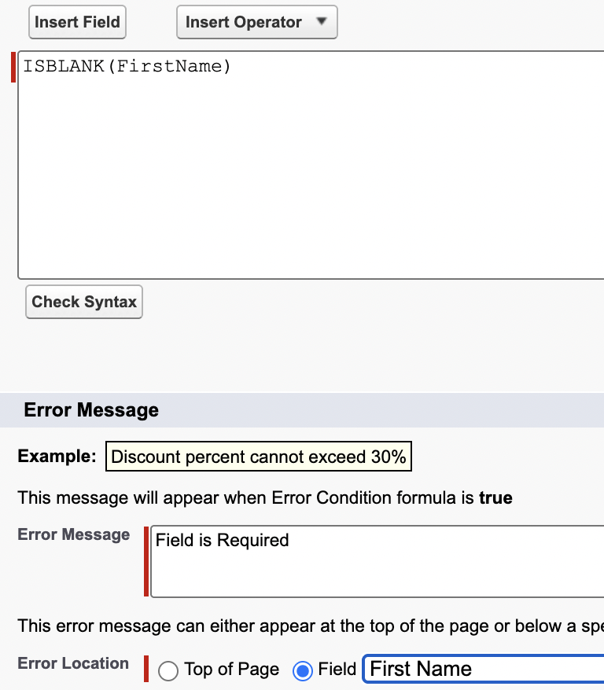

Use chatgpt to generate validation rules
refer to prompt library

Duplicate Management and Duplicate rules
 | You will find duplicate rules for account, contact, lead.
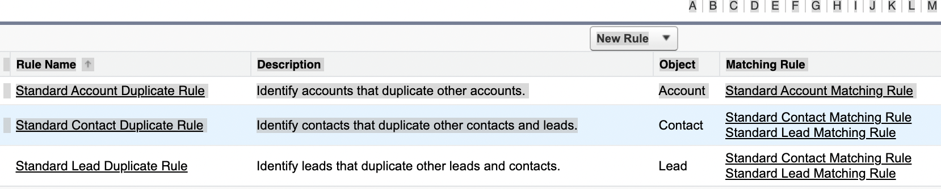
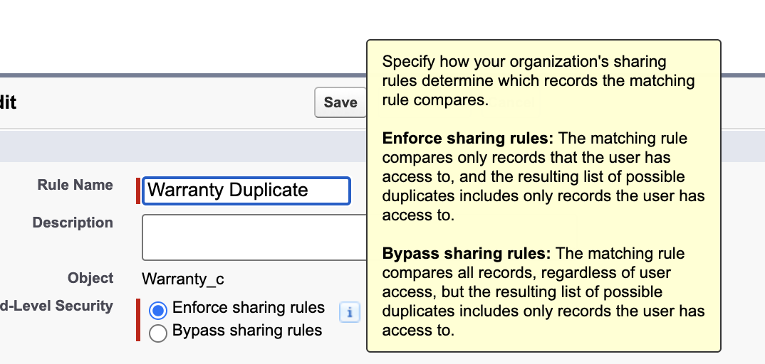 | Only compares record which user has.  OR  Even compare that.
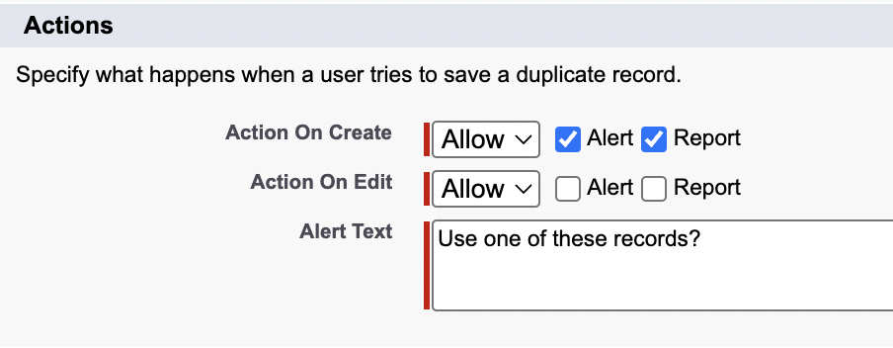 | You can allow to create a duplicat record and inform the user.  In case of insert from dataloader, it will trigger an error and those records will not be inserted.
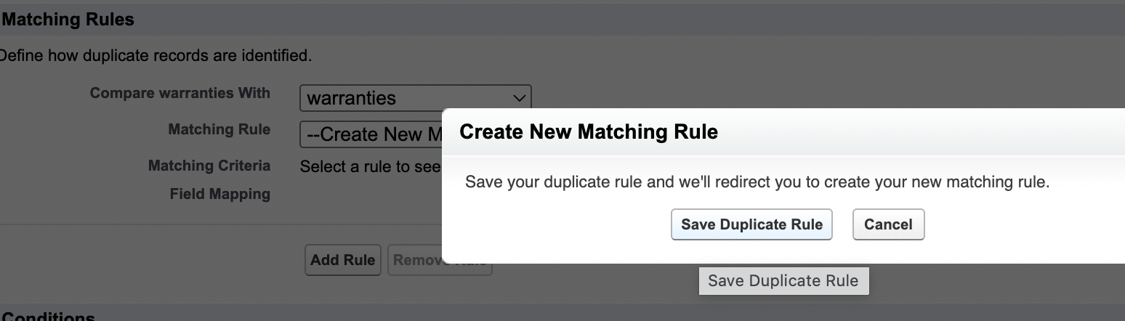
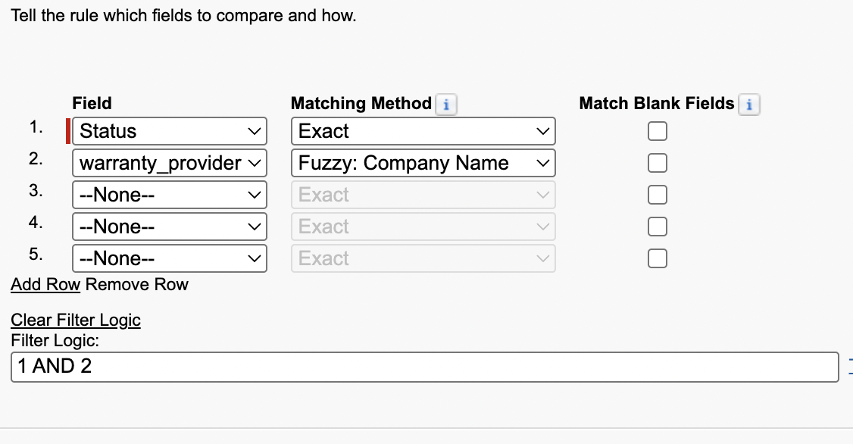 | Then click the activate button. We can also set the criteria to when to run the rule.

Potential Duplicates Lightning component
It only exists for std objects like account, contact and lead. Even if u open the lightning app builder, u wont see it as a components in the detail section.

Merging duplicates
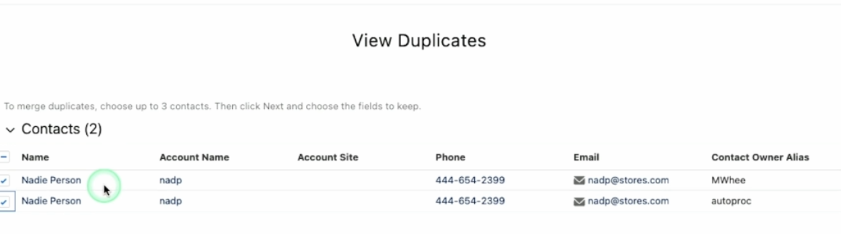
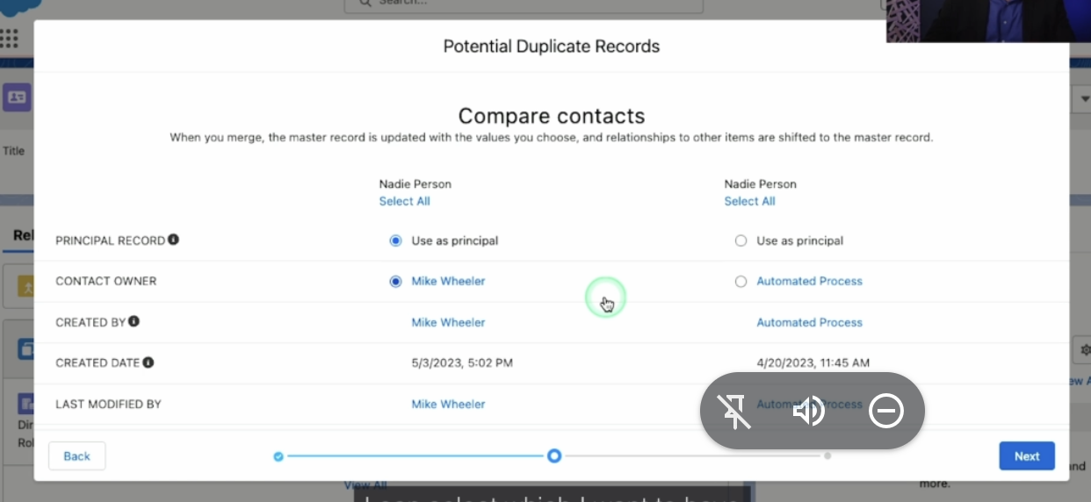

Duplicated record set
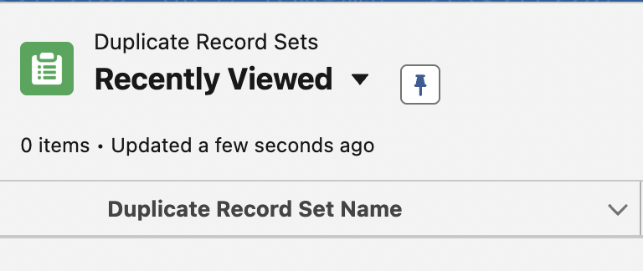 | App launcher → duplicated record set

