Current
subtitle

Heading 1

Heading 2

Heading 3

Heading 4

 | Yes, when you rub a balloon on your hair, electrons are transferred from your hair to the balloon, causing the balloon to become and your hair to become positively charged due to the loss of electrons; this is the process of static electricity. Your hair contains sulfur.
 | Hair is primarily made up of keratin, a protein composed of carbon (C), hydrogen (H), nitrogen (N), oxygen (O), and sulfur (S)
After sometime, the effect of the balloon and the hair getting attracted stops. Why does that happen? Does the hair gains some electrons again while the balloon loses some?
Also, how do the electrons get transferred?
Rubbing a balloon on hair leads to electron transfer between the materials due to their differing electron affinities. The mechanical action of rubbing causes atoms in both materials to interact, and electrons move from the material with lower electron affinity (hair) to the one with higher affinity (balloon made of rubber or latex).
The attraction between a charged balloon and hair diminishes due to charge neutralization or discharge, where charges redistribute, reducing the electric potential difference. After rubbing, the balloon becomes negatively charged, and the hair becomes positively charged. Factors like air and nearby objects influence charge distribution. Neutralization can occur through conduction (direct contact), induction (charge redistribution without contact), and ionization (creation of ions in the surrounding air).
 | In an atom or anything charge, opposite attract and same charges repel. The protons in the nucleas are hold together in the nucleus cause of the nuclear forces.
charge | An electron carries a charge.
current | The flow of something per sec. Like water current.
Electric current | The flow of charge per time. I.e I=q/t

 | 8when we assign the direction of the 7:10electric current we had no idea about 7:13electrons and protons and everything it 7:15was way before we discovered them we 7:18just thought there is some kind of 7:19positive charge that is moving in a wire 7:21and that's what's giving us current and 7:23therefore we chose the convention for 7:26the current as the direction of flow of 7:29positive charges and because electrons 7:33turn out to be negatively charged 7:35particles we have no option now we have 7:38to choose the convention to be in the 7:40opposite direction of electrons so if 7:42the flow if the flow is of positive •Current transcript segment:7:45charges the current will be in the same 7:47direction if the flow is of negative 7:50charges the current will be in the 7:51opposite direction since electrons are 7:53negatively charged particle the current 7:55direction we choose is in the opposite
Direction of current | Direction of Current is in the opposite direction of flow of electrons.
Unit of current | Electric current is in Amperes.
Q | what is meant by free electrons
Answer | A free electron is an electron that has been knocked out of an orbit of a particular atom, or it could be an electron that has been emitted via radioactive decay, or is fleeing from a collapsing star. It is essentially an electron that has been knocked out of an orbit and has yet to be picked up by another atom.
Q | Is conductivity based on how easily a substance can lose electrons?
Answer | You are partially correct. Electrical conductivity is indeed related to how easily a substance can give up or accept electrons. Let's break it down:  Metals: Excellent conductors because their atoms readily lose electrons from their outermost shell, creating freely moving charged particles called ions that can carry current.  Non-metals: Generally poor conductors as their electrons are tightly bound to their atoms.  Exceptions: Some non-metals can conduct electricity under specific conditions. For instance, electrolytes** (ionic solutions) can conduct electricity because they contain free-moving ions.  So, while losing electrons is a key factor, it's not the whole story. Conductivity also depends on the structure of the material and the presence of mobile charged particles.
Metallic conductivity | Metals have a "sea of delocalized electrons" in their atomic structure  The ease with which these electrons move determines the electrical conductivity of the metal. For example, copper and silver are excellent conductors because their electrons are highly mobile.
Ionic conductivity | In ionic compounds (like salts dissolved in water or molten salts), conductivity is due to the movement of ions (positively or negatively charged atoms or molecules).

Ionic conductivity | - When an ionic compound dissolves in water or melts, the ions become free to move and carry charge.  - The conductivity here depends on how easily the ions can move through the solution or molten state, not on the loss of electrons
Note | Conductivity depends on the resistivity of the conductor. They are inversely proportional.
Resistivity | Resistivity is a material's intrinsic property that measures how strongly it opposes the flow of electric current.
 | Materials with high resistivity (e.g., rubber, glass) are poor conductors of electricity, while materials with low resistivity (e.g., copper, silver) are good conductors.

i like to think it this way. Idk if its right or wrong. A battery has two terminals. I wanna think that the electrons are attracted to the positive terminal of the battery. Since, current is in the opposite direction of the flow of electron it make sense.
But why this idea of positive charges that are pushed by the positive terminal of the battery that generates current in the same direction is use. Cause we know its the flow of electrons causing the charge?
Deepseek | - In a battery, the positive terminal has a deficit of electrons (it’s positively charged), and the negative terminal has an excess of electrons (it’s negatively charged).  - Electrons, being negatively charged, are indeed attracted to the positive terminal and repelled by the negative terminal.  - This means electrons flow from the negative terminal to the positive terminal through the circuit.  - Since current is defined as the flow of positive charge, the direction of current is opposite to the flow of electrons.
 | - Your way of thinking is actually correct and aligns with the physical reality of how electrons move in a circuit! Let’s break it down and address why the "positive charge flow" convention is still used, even though we know it’s the electrons that are moving.



In the battery there is a chemical reaction that is happening that is running the entire thing.
When the kids slide down the slide. If the slides had some bumps aka friction. Heat will be generated. Where this heat comes from? The energy for it. The energy was already present as potential energy. Who gives them potential energy is the man who put them on the slide.
Similarly, in the bulb there is heat generated. So the charges might already have stored energy. As they move through the bulb they loose their stored energy.

On the slide, the children at every moment of going down the slide loses their potential energy. But for simplicity case for our circuit will imagine, there is little to zero loss of potential energy when the charges travel through the wire. And when it crossess the bulb, it goes from high potential energy to low potential energy. Cause the wire doesn’t get as hot as the bulb. The chemicals in the bulb pushes the positive charges up and they gain potential energy. Voltage is simply the difference of potential energy of the charges.

1. Does the Positive Terminal Have Protons?
- Yes, the positive terminal (and all matter) contains protons in the atomic nuclei. Protons are positively charged particles that are tightly bound in the nucleus of atoms.
- However, protons do not move in a circuit. They are fixed in place within the atomic structure of the material.

Why Electrons Move Toward the Positive Terminal

- Electrons are negatively charged, and they are attracted to the positive terminal because it has a charge deficit (fewer electrons than protons).
- The positive terminal is positively charged not because it has extra protons, but because it has fewer electrons compared to the negative terminal.
- Electrons are pushed toward the positive terminal by two main forces:
  - Repulsion from the Negative Terminal: The negative terminal has an excess of electrons, so electrons repel each other and are pushed away from the negative terminal.
  - Attraction to the Positive Terminal: The positive terminal has a deficit of electrons, creating an electric field that pulls electrons toward it.

What’s Really Happening in the Battery
- Inside the battery, chemical reactions occur that separate charges:
  - At the negative terminal, a chemical reaction releases electrons, creating an excess of electrons.
  - At the positive terminal, a chemical reaction absorbs electrons, creating a deficit of electrons.
- This separation of charges creates a potential difference (voltage) between the two terminals, which drives the flow of electrons through an external circuit.

Protons Don’t Move in a Circuit
- Protons are part of the atomic nucleus and are held in place by strong nuclear forces. They cannot move freely like electrons.
- In most conductors (like metals), the charge carriers are electrons, which are free to move through the material.
- In some cases (like electrolytes or plasmas), ions (charged atoms or molecules) can move, but even then, it’s the electrons that do most of the work in carrying current.

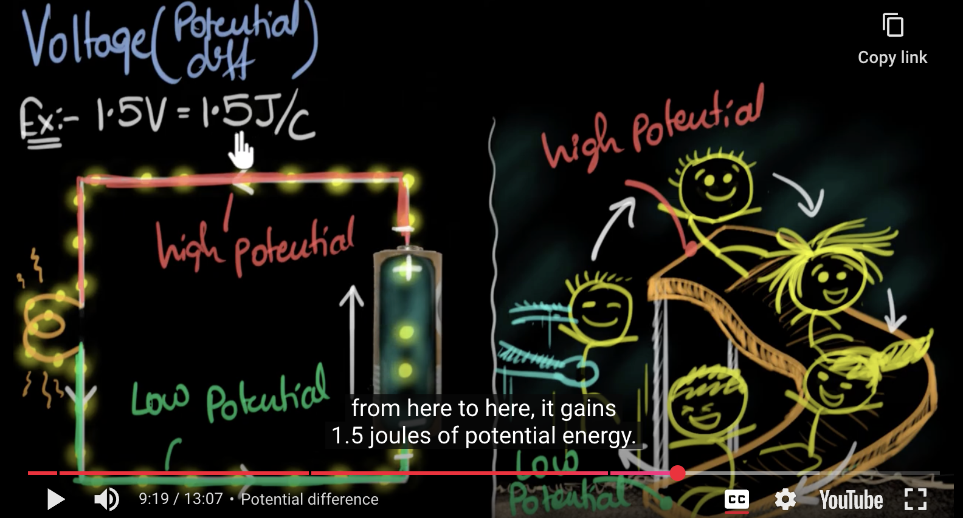
Joules is the unit of work or energy.
1.5J/C. Is how much energy a columb gets.
One coulomb is equal to the electrical charge of about 6.24 x 10¹⁹ electrons or protons.
Since, 1 electron carries -1.602 x 10^-¹⁸ .
So if there was 9v battery then every columbs gains 9 volts.
So when the columb(x no of electrons) exits the bulb after (heating and causing light to be emitted) or exiting through a resistor. It loses 1.5Joules over there. So If 2 columbs passes through the black box then it will lose 3 joules of energy.

Potential energy. | What is potential energy.  Think of it like electrons being in tense circumstance and being released into the circuit coming from the negative terminal of the battery by some chemical reactions happening inside of it. They feel repulsive forces and overcrowded, which cause a stampede, alongside they feel an electrical field coming from the positive terminal of the battery where there is an electron deficit since electrons are being absorbed by the positive terminal. And the electrons are thus attracted to the positive side of the terminal where there are protons as well.
 | When the electron passess a resistor or a bulb. They do some work or ignite the bulb causing themselves to loose some potential energy. So when exiting the bulb even though the distance between the positive terminal electrons are less and thus the electrical field stronger. But just like a water slide in a park having the the end a little steeper doesn’t make the entire slide faster. So they are at a low potential energy and then are absorbed by the positive terminal. Throughout the circuit there Is this difference of potential energy that keeps the circuit running and for us to have continious flow of electrons.

For the continious flow of water. From high potential to low potential.  We need to elevate the water level in A and lower the water level in B. Such that it works continously and doesn’t reach equilibrium where both have equal wate r level aka equal potential energy. | 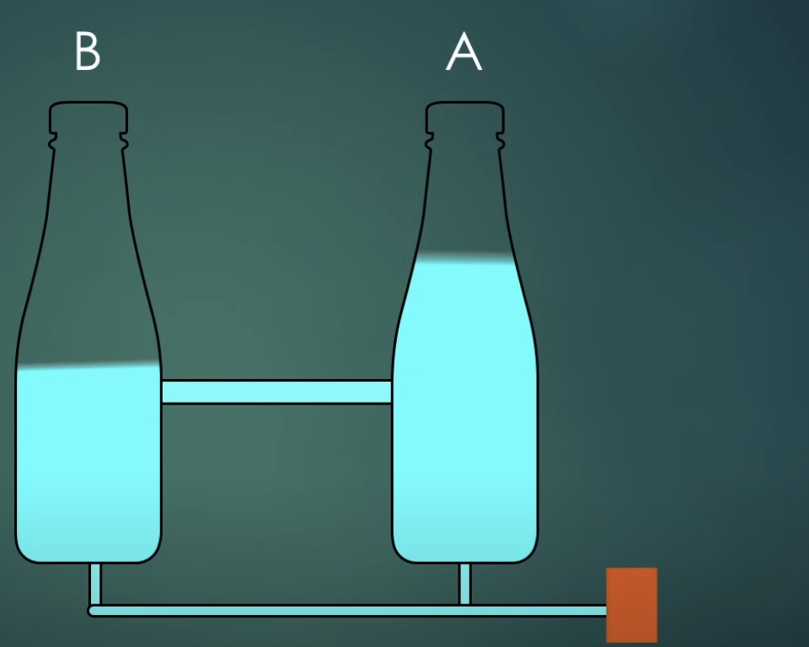
Maintaining the potential | So we need EMF to do maintain the difference in potential. It isn’t a force, it’s an energy supplied by a device like Battery. So Potential difference causes electron to move from position to another.

Electric field is relatively uniform along the conducting path. | - The electric field is indeed stronger closer to a charged object (like the positive terminal of a battery). This is because the electric field follows an inverse-square law for point charges, meaning it weakens with distance.  - In a circuit, however, the electric field is relatively uniform along the conducting path (like a wire) because the battery maintains a constant potential difference (voltage) between its terminals.
 | Whenever we transfer energy we do work.
12:31So to summarize what we learned, we saw that in order  12:34to maintain an electric current in a circuit,  12:37we need to maintain a potential difference.  12:40The potential difference or voltage, is simply an indicator  12:44of how much potential energy is gained or lost per coulomb,  12:50when it moves from one point to another.  12:53It can also be thought of as how much work needs to be done 12:58to transfer the potential energy  •Current transcript segment:13:00per coulomb from one point to another. | 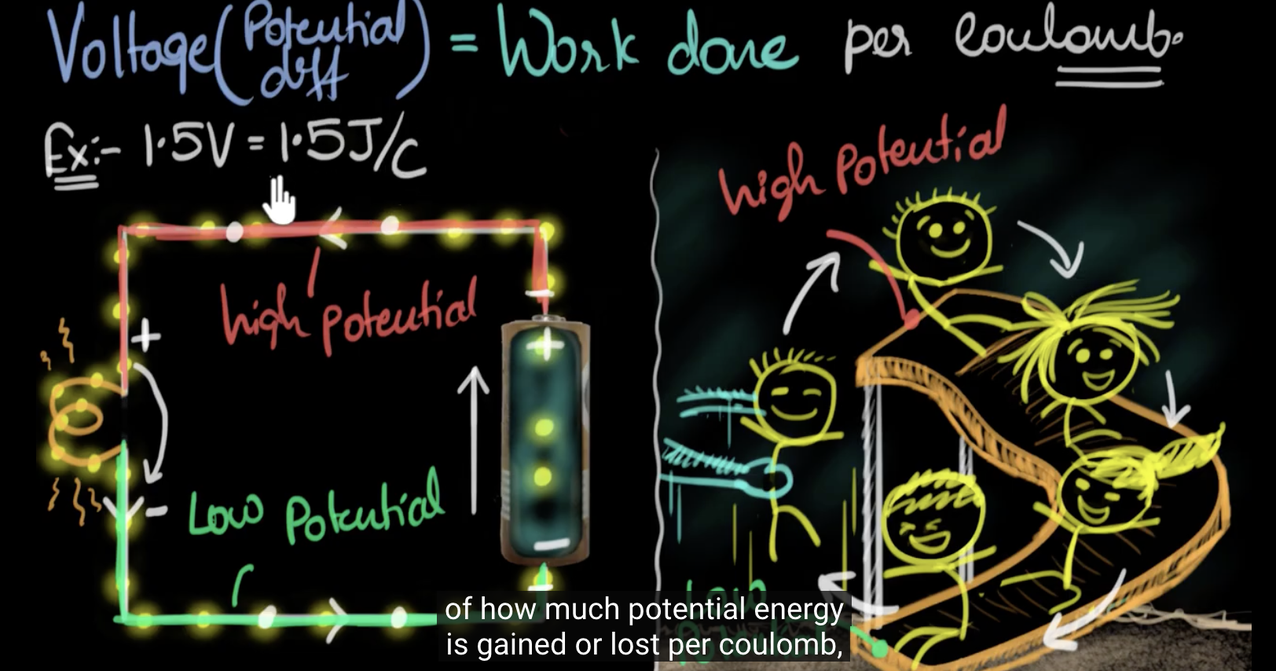

Easy | 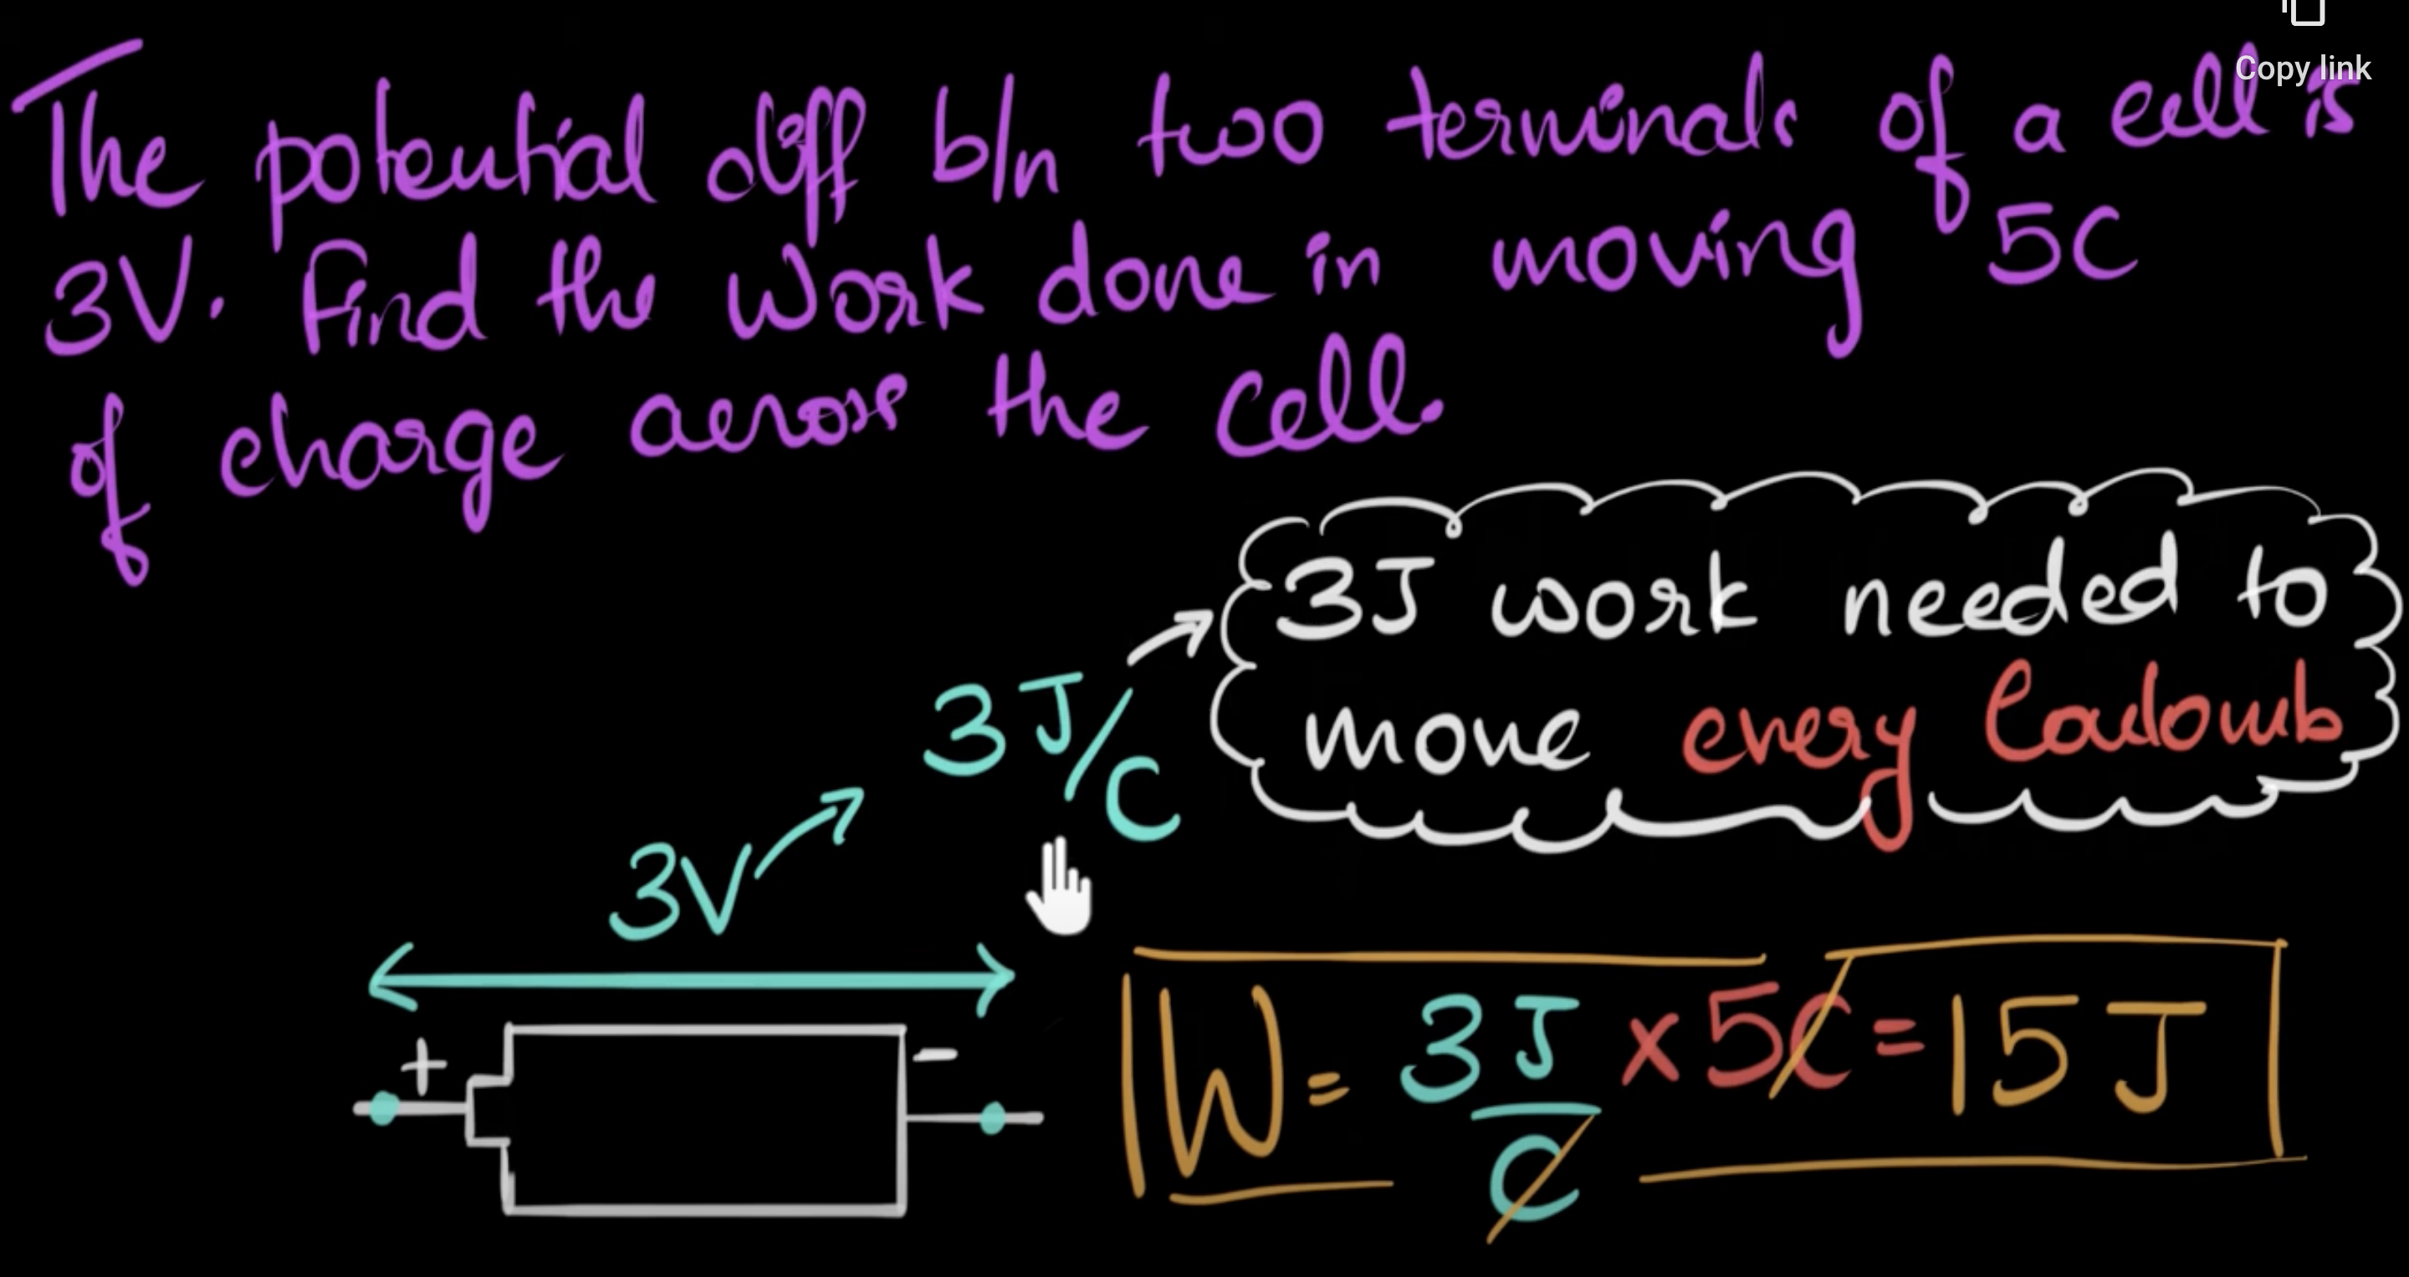
Easy | 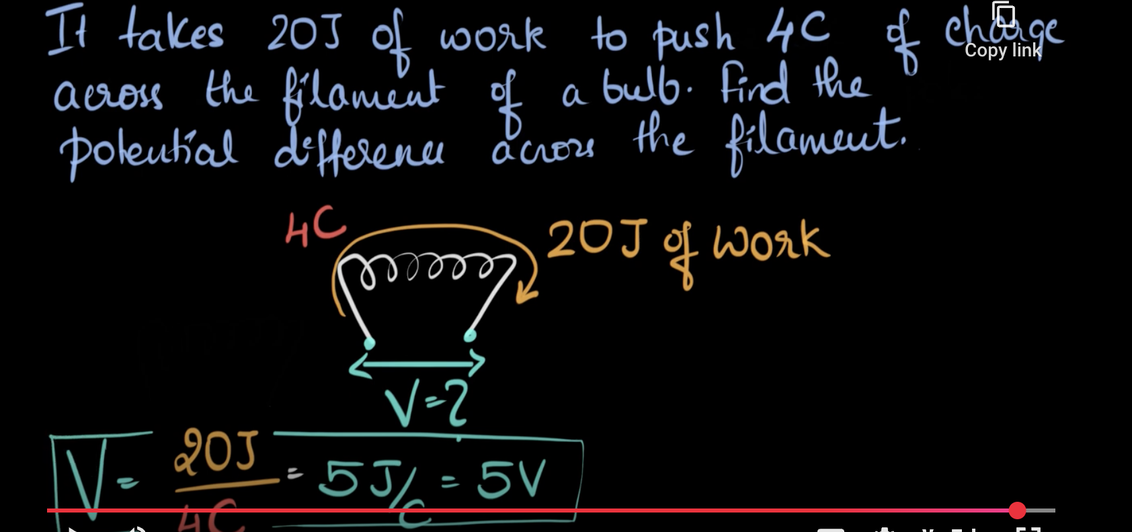

 | 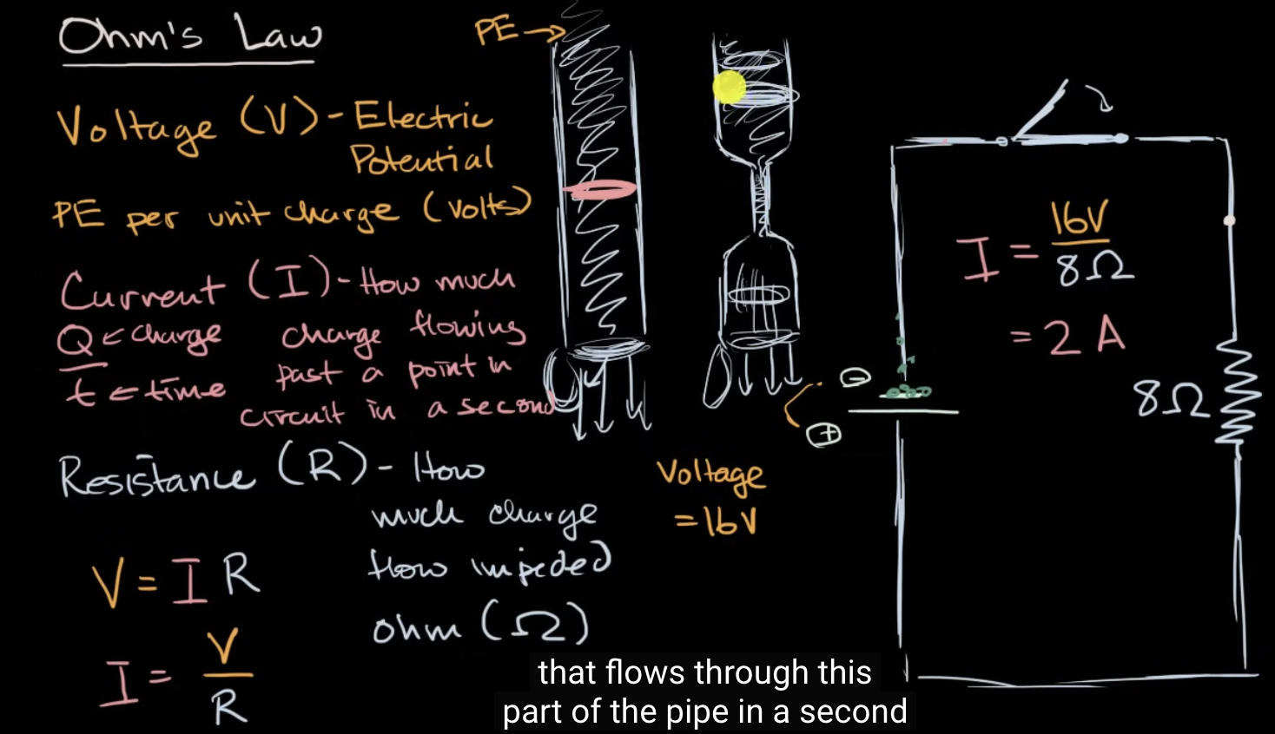
Electric potential | Potential energy per columb.
Electric current | The flow of electric current would be determine by the potential energy and obstructed/impeded by the resistor.
V=IR | IF r is constant, as we increase the the potential energy, we increase the flow of current.
Example | In the figure, we gonna have 2A I.e Columb/sec. So we gonna have two columb per sec flowing.

 | what happen when there is no resistor in a circuit ?
Answer | It is impossible to have a zero resistance wire because there are factors of the wire to provide resistance. If the resistance is very low, however, then it would probably trip a circuit breaker or blown a fuse. If you didn't have a circuit breaker, which is not likely, then the wire would melt and you would probably start a fire.
 | Because whoever is designing the electrical circuit in real life has the NEC (National Electric Code), or Manufacturer's resistance rating available. Resistance is documented based on the type of conductor you are using, typically aluminum or copper in commercial construction. Resistance over distance is also how we determine voltage drop. There is also resistance in each appliance or device receptacle, switch, connection on a circuit. This is also determined by the manufacturer, or physically metering a circuit.

Temperature and resisitivity situation | Remember that in metals, conductivity is due to the movement of electrons. When temperature increases, the atoms in the metal lattice vibrate more. These vibrations can impede the flow of electrons, right? So higher temperature would mean more collisions between electrons and the lattice ions. That should increase resistivity, making the wire less conductive. So the answer should be that a hotter wire becomes less conductive, not more.

