Induction
subtitle

Heading 1

Heading 2

Heading 3

Heading 4

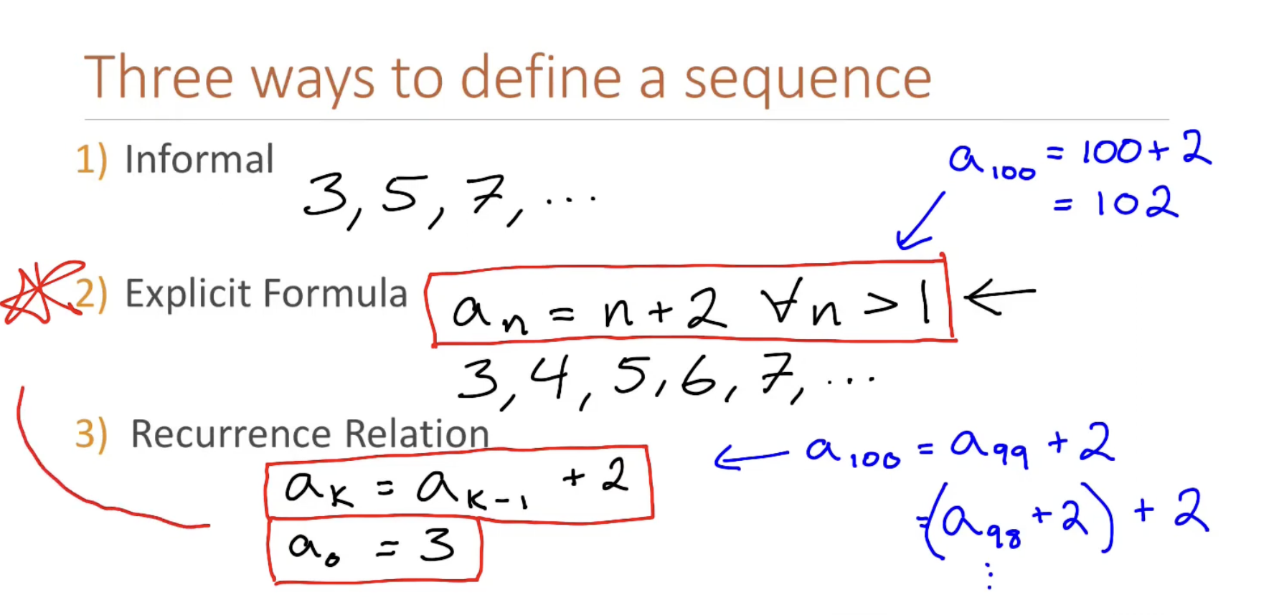
Ideally, what we would like to do is convert the recurrence relation into an explicit formula.
Why would we do this? Recurrence relation are easier to come up with than coming up with an Explicit formula directly.
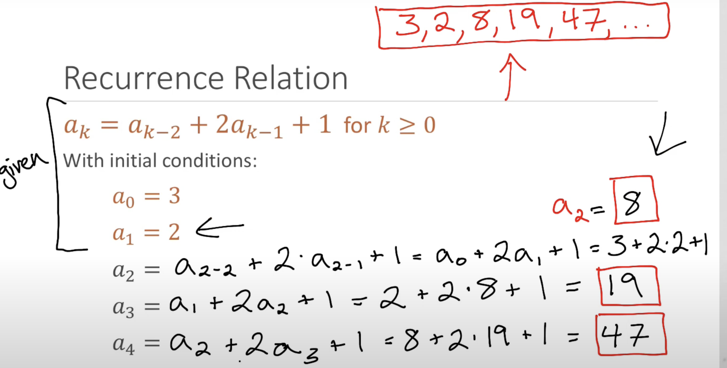 | 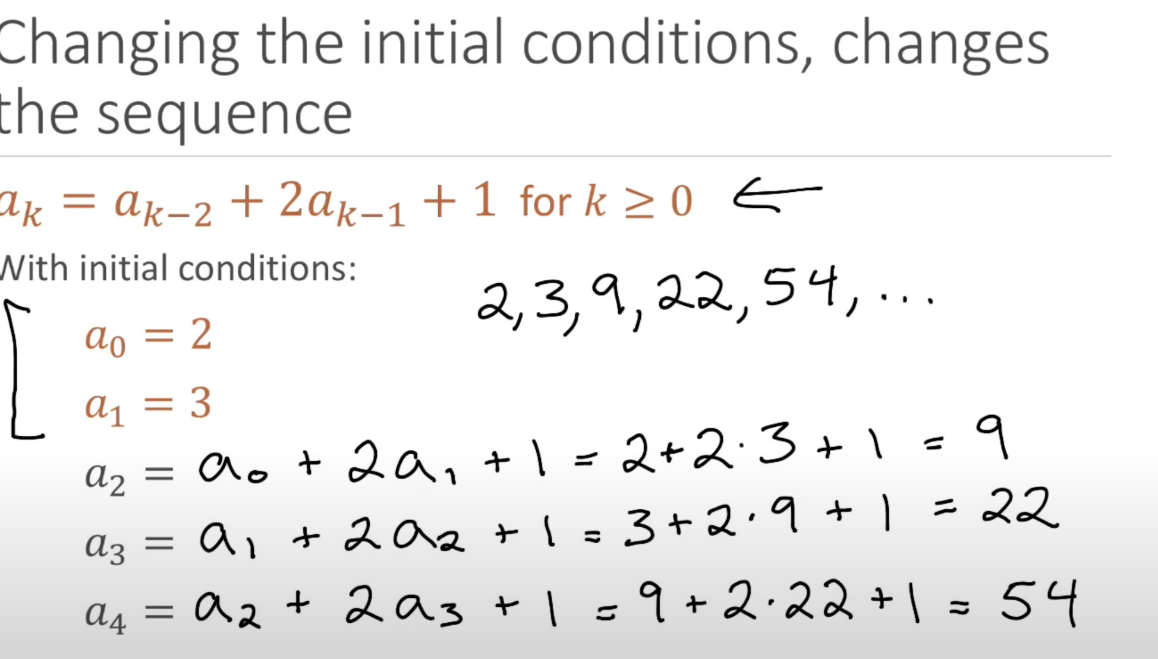

By just swapping the a0,a1. The sequence changed

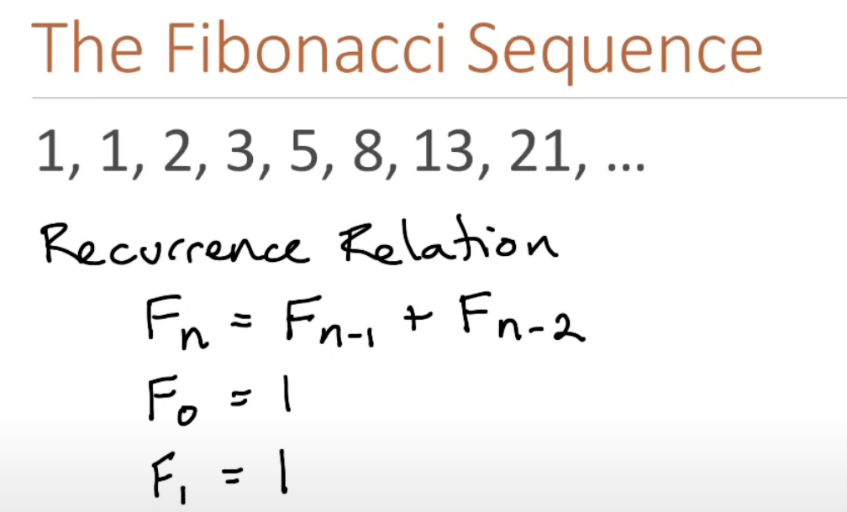
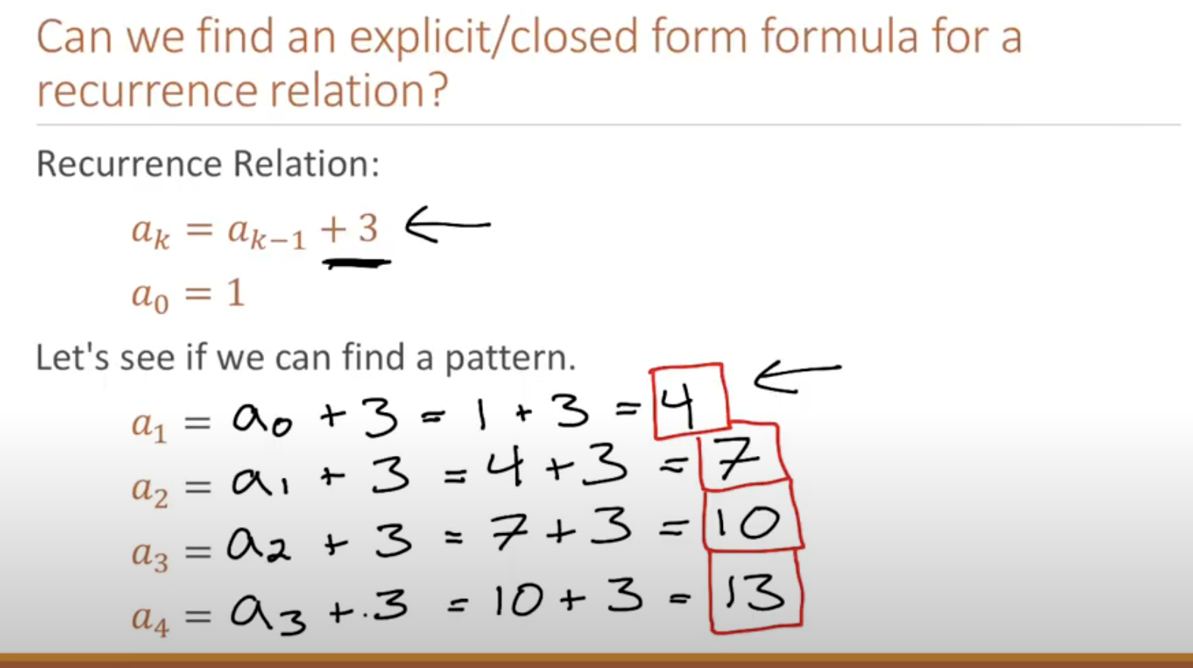 | 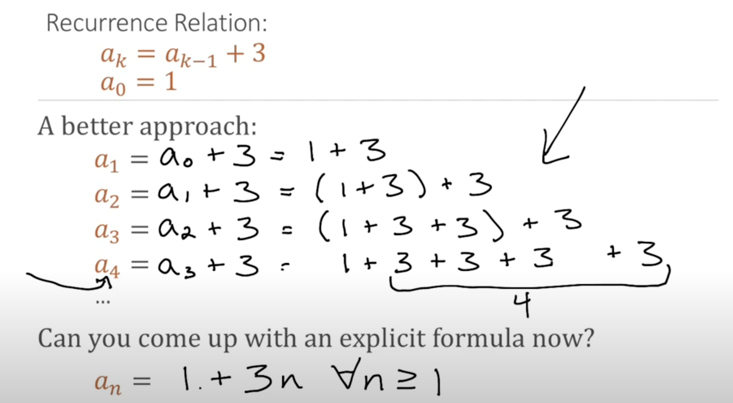
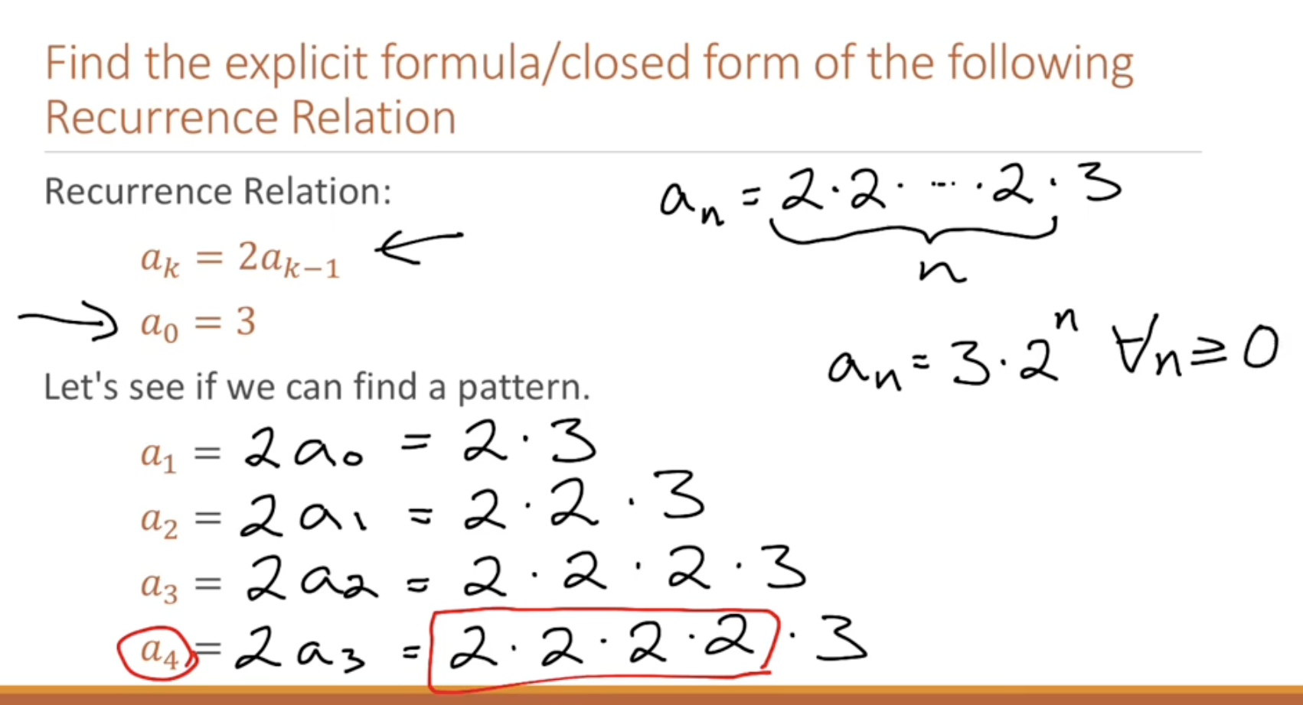 | Even kazim was able to come up, by not looking just at the op. But seeing how it is developed.
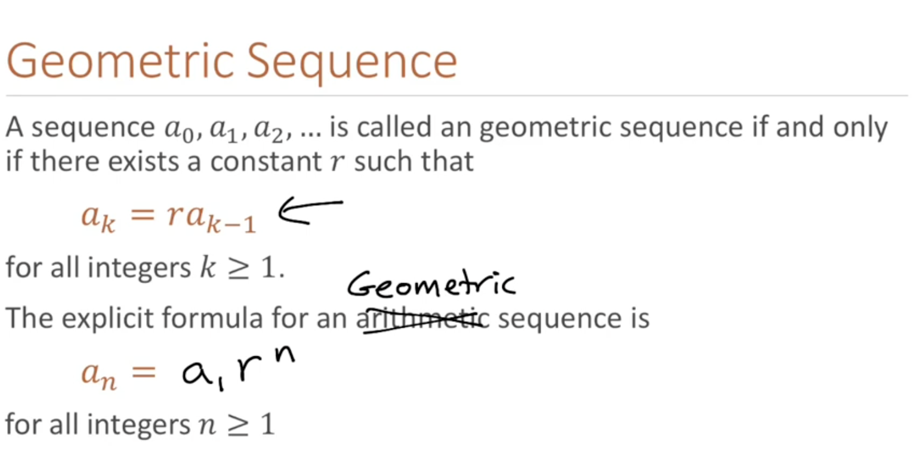
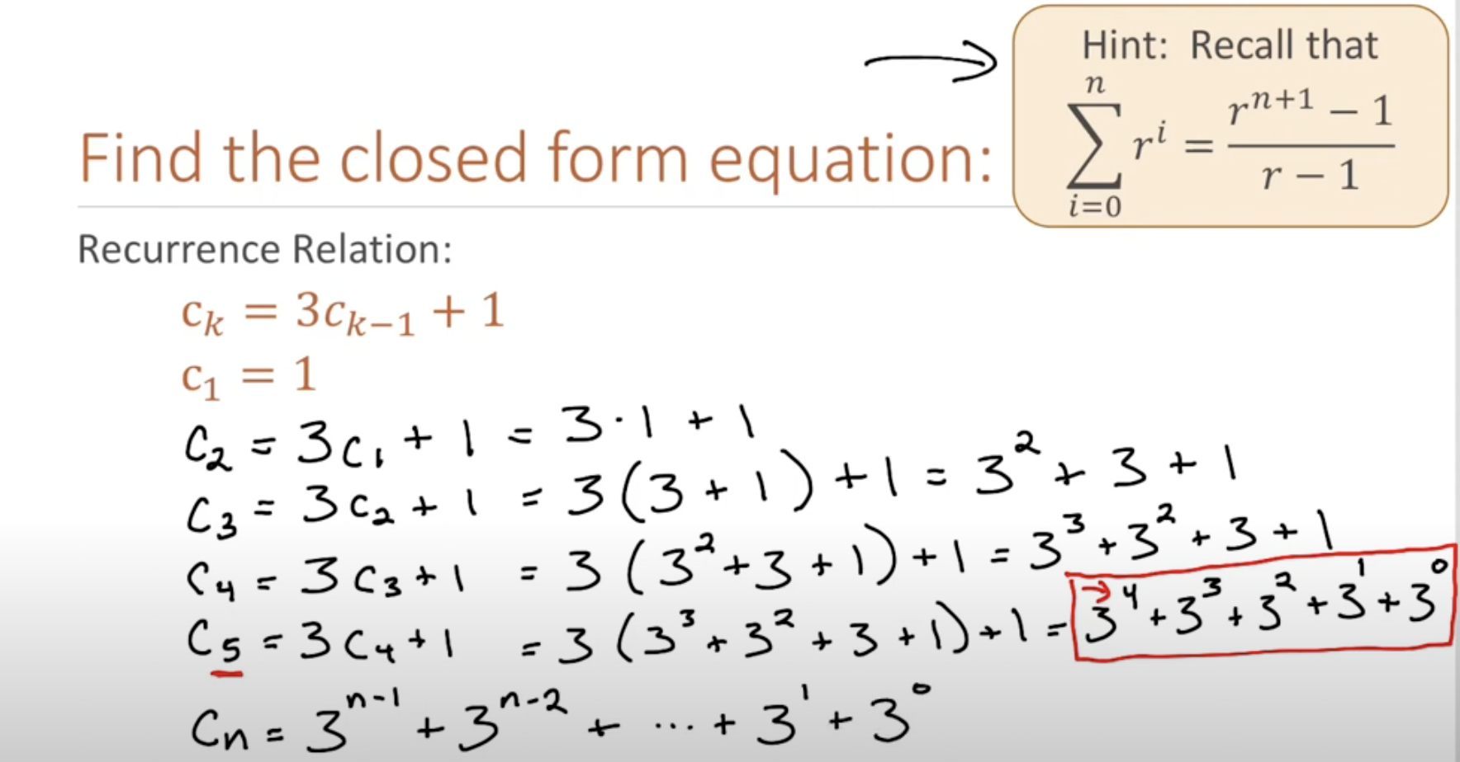 | 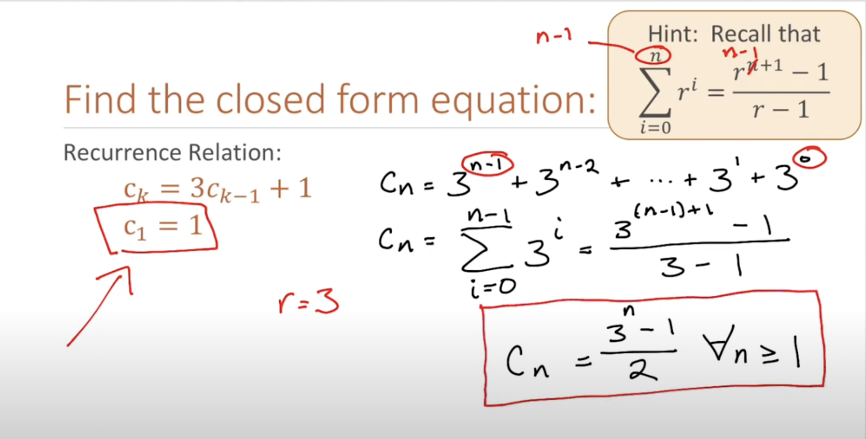

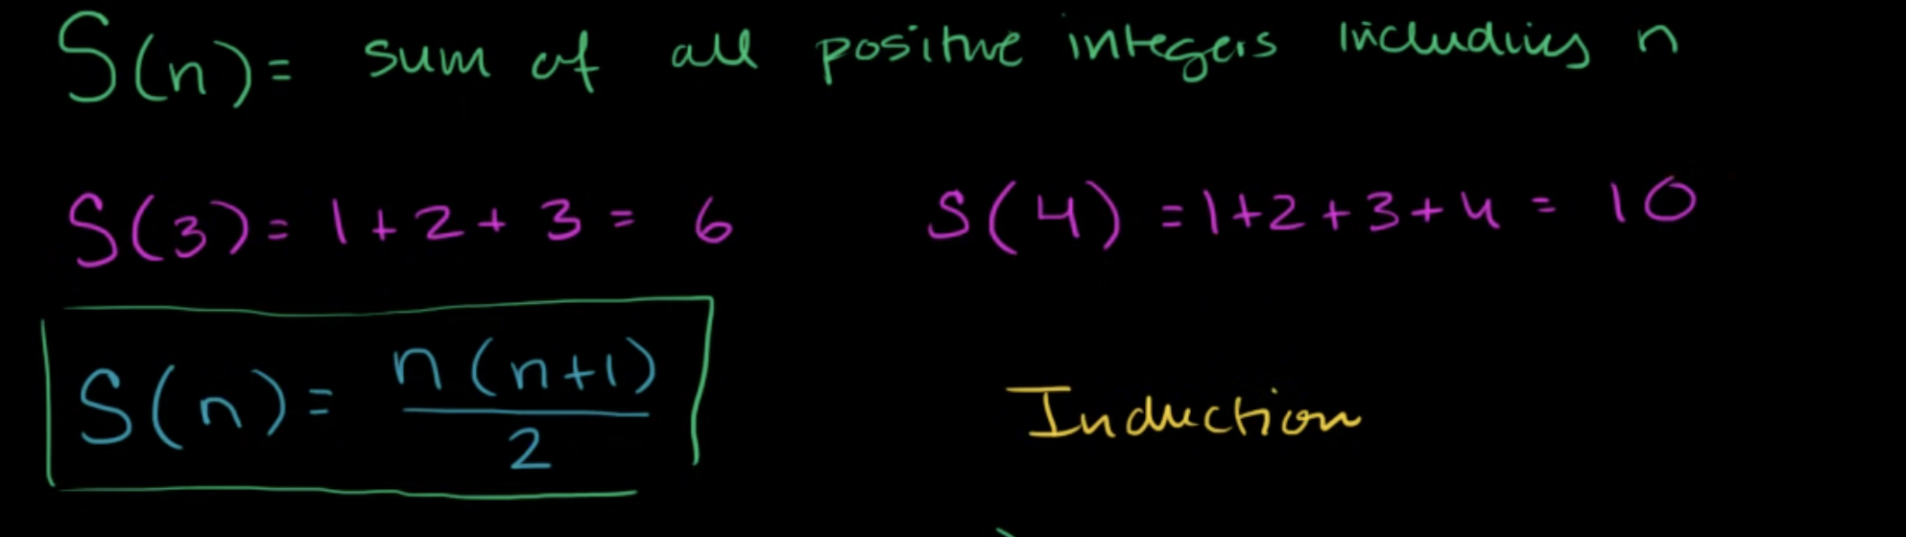
Proof by induction
To Prove for all positive integers.
You do on the only boundary u have that is One.
To Prove for all positive integers.
Then you pick k. Assume true for k
inputting k+1 into formula = 1+2+...+k+k+1
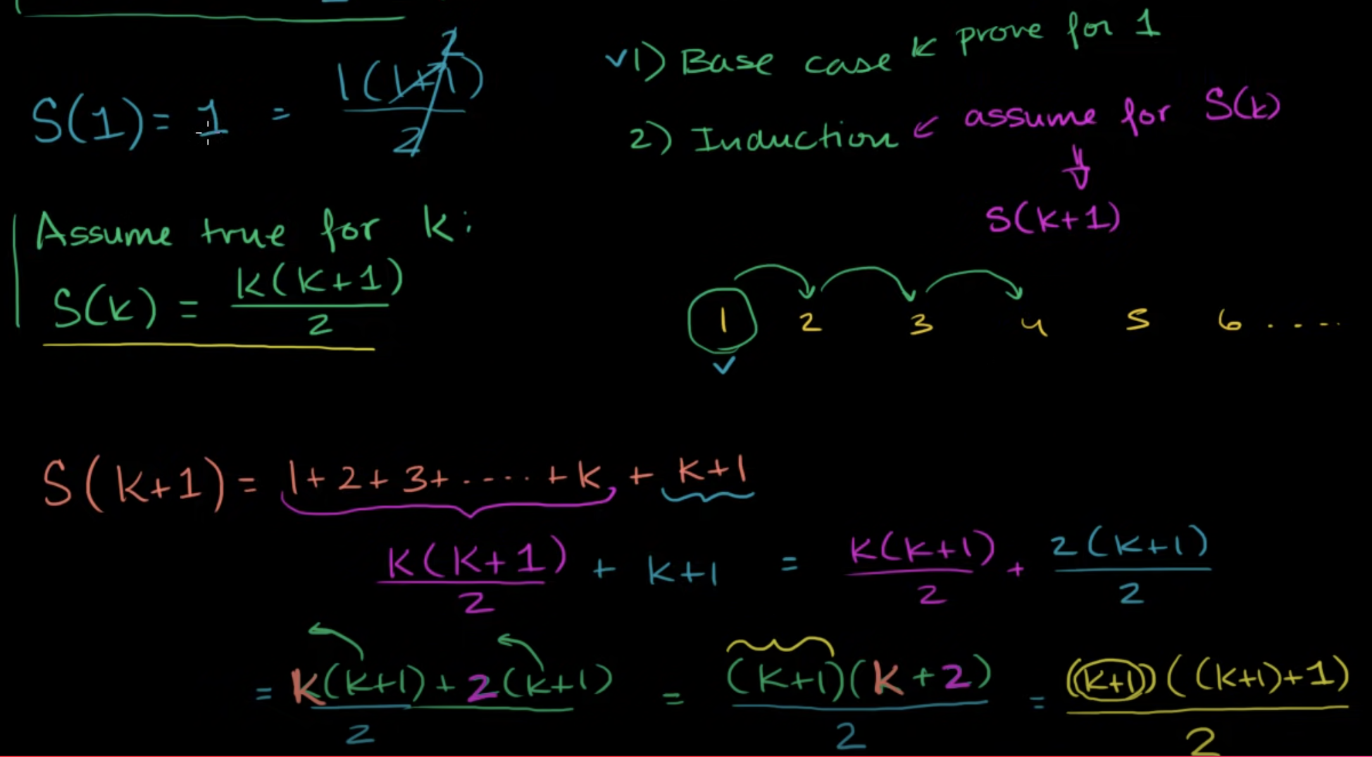 | 1+2+3+...K+k+1;  k(k+1)/2 + k+1  same as inputing k+1 into the formula.  K is any integer for all each Integer.  We prove for the boundary I.e n=1;  then we prove for K.  So if it works for any num lets say K.  Then it must be true for K+1
We test if it works for 1, then we test for 2, then we test for 3, then we test for 4. so we assume It works for k, then it must work for k+1.

Sequence and infinite sequence.
