Networking
subtitle

Heading 1

Heading 2

Heading 3

Heading 4

different types of physical media, including coaxial cable, copper wire, optical fiber, and radio spectrum Different links can transmit data at different rates, with the transmission rate of a link measured in bits/second. When one end system has data to send to another end system, the sending end sys- tem segments the data and adds header bytes to each segment.
A packet switch takes a packet arriving on one of its incoming communication links and forwards that packet on one of its outgoing communication links.
routers and link-layer switches. Both types of switches for- ward packets toward their ultimate destinations. Link-layer switches are typically used in access networks, while routers are typically used in the network core.

Packet-switched networks (which transport packets) are in many ways simi- lar to transportation networks of highways, roads, and intersections (which trans- port vehicles). Consider, for example, a factory that needs to move a large amount of cargo to some destination warehouse located thousands of kilometers away. At the factory, the cargo is segmented and loaded into a fleet of trucks. Each of the trucks then independently travels through the network of highways, roads, and intersections to the destination warehouse. At the destination ware- house, the cargo is unloaded and grouped with the rest of the cargo arriving from the same shipment. Thus, in many ways, packets are analogous to trucks, com- munication links are analogous to highways and roads, packet switches are anal- ogous to intersections, and end systems are analogous to buildings. Just as a truck takes a path through the transportation network, a packet takes a path through a computer network.
End systems access the Internet through Internet Service Providers (ISPs), including residential ISPs such as local cable or telephone companies.
These lower-tier ISPs are interconnected through national and interna- tional upper-tier ISPs such as Level 3 Communications, AT&T, Sprint, and NTT. An upper-tier ISP consists of high-speed routers interconnected with high-speed fiber-optic links. Each ISP network, whether upper-tier or lower-tier, is managed independently, runs the IP protocol.
End systems, packet switches, and other pieces of the Internet run protocols that control the sending and receiving of information within the Internet. The Transmission Control Protocol (TCP) and the Internet Protocol (IP) are two of the most important protocols in the Internet. The IP protocol specifies the format of the packets that are sent and received among routers and end systems. The Internet’s principal protocols are collectively known as TCP/IP.
Given the importance of protocols to the Internet, it’s important that everyone agree on what each and every protocol does, so that people can create systems and products that interoperate. This is where standards come into play. Internet stan- dards are developed by the Internet Engineering Task Force
They define protocols such as TCP, IP, HTTP (for the Web), and SMTP (for e-mail).
End systems attached to the Internet provide an Application Programming Interface (API) that specifies how a program running on one end system asks the Internet infrastructure to deliver data to a specific destination program run- ning on another end system. This Internet API is a set of rules that the sending program must follow so that the Internet can deliver the data to the destination program.
Sup- pose Alice wants to send a letter to Bob using the postal service. Alice, of course, can’t just write the letter (the data) and drop the letter out her window. Instead, the postal service requires that Alice put the letter in an envelope; write Bob’s full name, address, and zip code in the center of the envelope; seal the envelope; put a stamp in the upper-right-hand corner of the envelope; and finally, drop the envelope into an official postal service mailbox. Thus, the postal service has its own “postal service API,” or set of rules, that Alice must follow to have the postal service deliver her letter to Bob. In a similar manner, the Internet has an API that the program sending data must follow to have the Internet deliver the data to the program that will receive the data.

The postal service, of course, provides more than one service to its customers. It provides express delivery, reception confirmation, ordinary use, and many more services. In a similar manner, the Internet provides multiple services to its applica- tions. When you develop an Internet application, you too must choose one of the Internet’s services for your application.
What is a protocol?
If people run different protocols (for example, if one person has manners but the other does not, or if one understands the concept of time and the other does not) the protocols do not interoperate and no useful work can be accomplished
Let’s consider a second human analogy. Suppose you’re in a college class (a computer networking class, for example!). The teacher is droning on about proto- cols and you’re confused. The teacher stops to ask, “Are there any questions?” (a message that is transmitted to, and received by, all students who are not sleeping). You raise your hand (transmitting an implicit message to the teacher). Your teacher acknowledges you with a smile, saying “Yes . . .” (a transmitted message encourag- ing you to ask your question—teachers love to be asked questions), and you then ask your question (that is, transmit your message to your teacher). Your teacher hears your question (receives your question message) and answers (transmits a reply to you). Once again, we see that the transmission and receipt of messages, and a set of conventional actions taken when these messages are sent and received, are at the heart of this question-and-answer protocol.
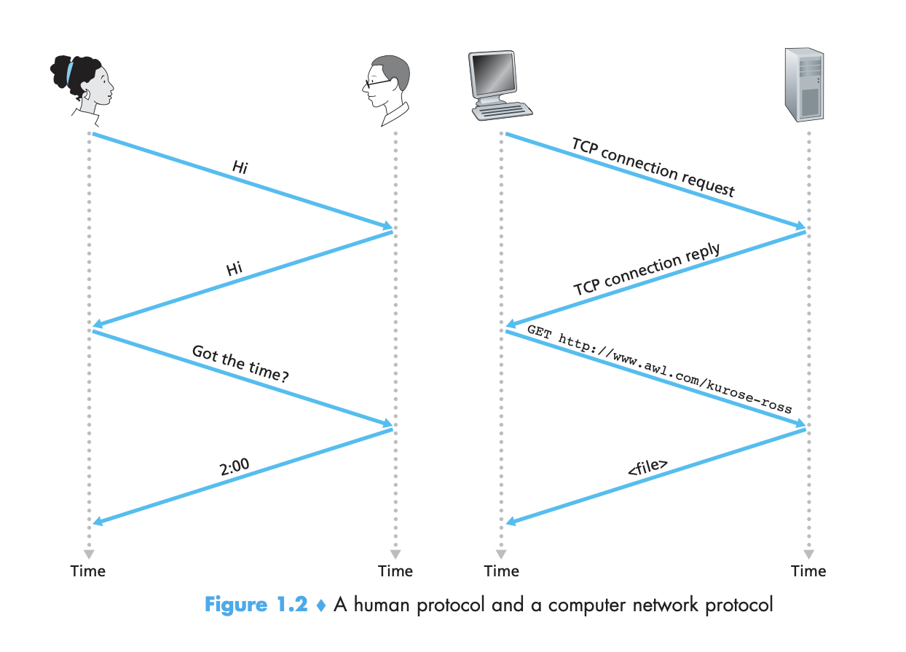

Network Protocol
All activity in the Internet that involves two or more communicating remote entities is governed by a protocol. For example, hardware-implemented protocols in two physically connected computers control the flow of bits on the “wire” between the two network interface cards; congestion-control protocols in end systems con- trol the rate at which packets are transmitted between sender and receiver; protocols in routers determine a packet’s path from source to destination. Protocols are run- ning everywhere in the Internet,
As an example of a computer network protocol with which you are probably familiar, consider what happens when you make a request to a Web server, that is, when you type the URL of a Web page into your Web browser. First, your computer will send a connection request message to the Web server and wait for a reply. The Web server will eventu- ally receive your connection request message and return a connection reply message. Knowing that it is now OK to request the Web document, your computer then sends the name of the Web page it wants to fetch from that Web server in a GET message. Finally, the Web server returns the Web page (file) to your computer.
A protocol defines the format and the order of messages exchanged between two or more communicating entities, as well as the actions taken on the trans- mission and/or receipt of a message or other event.
Networking devices are referred to as end systems because they sit at the edge of the Internet.
Also called as hosts because they hosts applications like web-server or web-browser or email program. Host are of two types: clients or servers. Servers are more powerful machine.

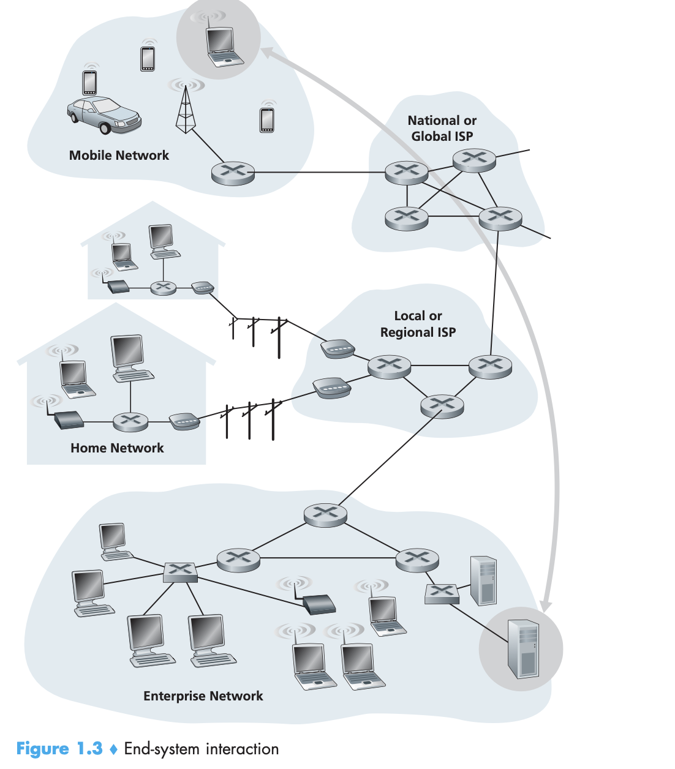

Google has 30–50 data centers, with many having more than one hundred thousand servers.

Access Networks
Edge router: the network that physically connects an end system to the first router (also known as the “edge router”) on a path from the end system to any other distant end system.

Network core:

Message into chunks(packets).  Rate= bits in packet/ total time  The rate used is the transmission rate of the Link.  time taken= L/R | In a network application, end systems exchange messages with each other. Mes- sages can contain anything the application designer wants. Messages may perform a control function (for example, the “Hi” messages in our handshaking example in Figure 1.2) or can contain data, such as an email message, a JPEG image, or an MP3 audio file. To send a message from a source end system to a destination end system, the source breaks long messages into smaller chunks of data known as packets. Between source and destination, each packet travels through communication links and packet switches (for which there are two predominant types, routers and link- layer switches). Packets are transmitted over each communication link at a rate equal to the full transmission rate of the link. So, if a source end system or a packet switch is sending a packet of L bits over a link with transmission rate R bits/sec, then the time to transmit the packet is L/R seconds.
 | Store and forward transmission
Wait for the entire bits of packets to be received before transmitting. | Most packet switches use store-and-forward transmission at the inputs to the links. Store-and-forward transmission means that the packet switch must receive the entire packet before it can begin to transmit the first bit of the packet onto the outbound link.
 | 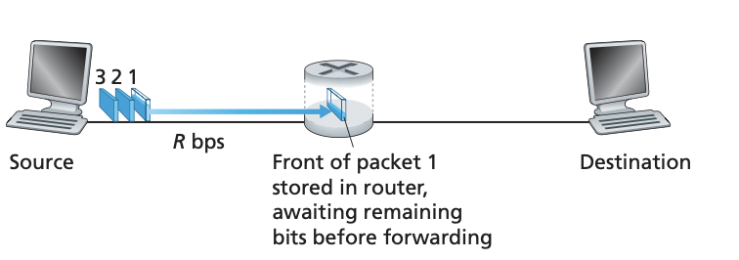
At time L/R, All the bits of the first packet is received by the router. And the router transmit the bits to its outbound link directed towards the destination.
at time 2L/R, the router has transmitted the entire packet, and the entire packet has been received by the destination. Thus, the total delay is 2L/R
 | Now consider sending the packet from the source to destination consisting of n links.
 | 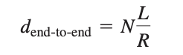

Queuing delays and packet loss
Each packet switch has multiple links attached to it. For each attached link, the packet switch has an output buffer (also called an output queue), which stores packets that the router is about to send into that link.
The output buffers play a key role in packet switching. If an arriving packet needs to be transmitted onto a link but finds the link busy with the transmission of another packet, the arriving packet must wait in the output buffer. Thus, in addition to the store-and-forward delays, packets suffer output buffer queuing delays. These delays are variable and depend on the level of congestion in the network. Since the amount of buffer space is finite, an arriving packet may find that the buffer is completely full with other packets wait- ing for transmission. In this case, packet loss will occur—either the arriving packet or one of the already-queued packets will be dropped.

 | Fowarding and routing tables
Router has a fowarding table, when a packet arrives at the router, it examines the destination ip and forwards the packet to that router’s outbound link directed towards the destination through adjacent router. | In the Internet, every end system has an address called an IP address. When a source end system wants to send a packet to a destination end system, the source includes the destination’s IP address in the packet’s header. As with postal addresses, this address has a hierarchical structure. When a packet arrives at a router in the network, the router examines a portion of the packet’s destination address and for- wards the packet to an adjacent router. More specifically, each router has a forwarding table that maps destination addresses (or portions of the destination addresses) to that router’s outbound links. When a packet arrives at a router, the router examines the address and searches its forwarding table, using this destination address, to find the appropriate outbound link. The router then directs the packet to this outbound link.
 | The end-to-end routing process is analogous to a car driver who does not use maps but instead prefers to ask for directions.
 | that the Internet has a number of special routing protocols that are used to automatically set the forwarding tables. A routing protocol may, for exam- ple, determine the shortest path from each router to each destination and use the shortest path results to configure the forwarding tables in the routers

Circuit Switching
 | In circuit-switched networks, the resources needed along a path (buffers, link transmission rate) to provide for communication between the end systems are reserved for the duration of the communication session between the end systems.
 | As a simple analogy, consider two restaurants, one that requires reservations and another that neither requires reservations nor accepts them.
 | 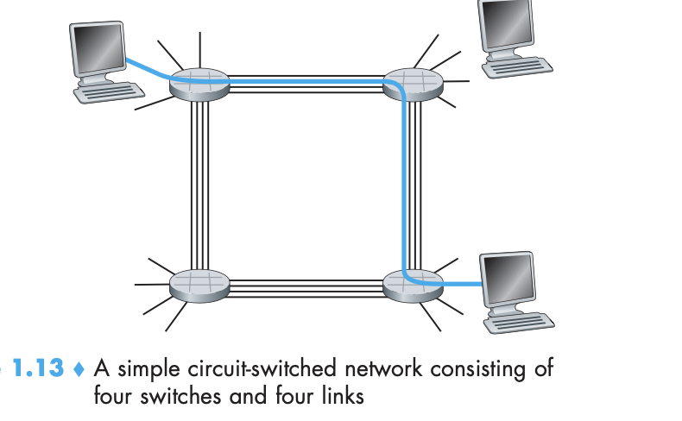
 | Each of these links has four circuits, so that each link can support four simultaneous connection
Here, he meant the 4wire as 1 link. | In this example, the dedicated end-to-end connection uses the second circuit in the first link and the fourth circuit in the second link. Because each link has four circuits, for each link used by the end-to-end connection, the connection gets one fourth of the link’s total transmission capacity for the duration of the connection. Thus, for example, if each link between adjacent switches has a transmission rate of 1 Mbps, then each end-to-end circuit-switch connection gets 250 kbps of dedicated transmission rate.
 | consider what happens when one host wants to send a packet to another host over a packet-switched network, such as the Internet. As with circuit switching, the packet is transmitted over a series of communication links. But different from circuit switching, the packet is sent into the network without reserving any link resources whatsoever. If one of the links is congested because other packets need to be transmitted over the link at the same time, then the packet will have to wait in a buffer at the sending side of the transmission link and suffer a delay. The Internet makes its best effort to deliver packets in a timely manner, but it does not make any guarantees

Packet switching versus Circuit Switching
offers better sharing of transmission capacity.
Simpler, more efficient.
Less costly to implement.

Throughput in CN.
If we are sending a large file from Host A to Host B. Lets Say the file has F bits. In P2P, the average throughput of the file is F/T.
T is the time it takes B to receive all F bits.
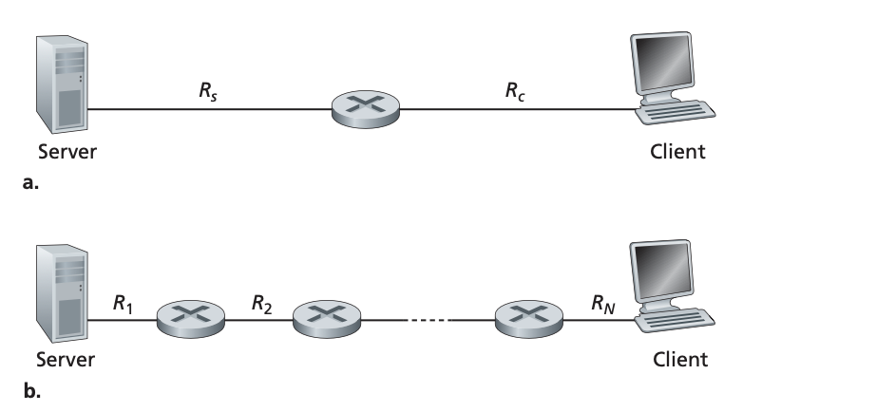
If Rs > Rc, so the packet will flow at the rate of Rc.
If Rc>Rs, so the packet will reach the client at rate of Rs.
Thus, for this simple two-link network, the throughput is min{Rc, Rs}, that is, it is the transmission rate of the bottleneck link.
Let Rs denote the rate of the link between the server and the router; and Rc denote the rate of the link between the router and the client.

TCP vs UDP
Level 2  level 3 switches  Addresses  5 Layers  Func of physical.  Ipv4 vs Ipv6 in regards to fragmentation at network layer.  ARP Broadcast.  MSS, segmentation at Transport layer  TCP vs UDP  Transport layer does error control at process to process to get the entire payload intact. | Level 2 switches do source to destination delivery of packet when the destination networking device is within the same network. Handle using physical address inscribed on the NIC card. You don’t need Logical address in this scenario.  Level 3 switches(connecting devices) does source to destination delivery of packet when the destinated network device crosses our networking boundary.  In the scenario, when the destination networking device outside our network, the output ip address will be the address of the default gateway.  4 Types of Addresses are stored.  Mac Address of the source and destination. They are stagnant.  Logical address of the sender and receiver's intermediaries. Which changes.  Logical address of the destination and the sender.  Port address of the application that generate the message.  So the message is generated by the process at the application layer.  It follows Application→ Transport → Network → datalink layer → Physical layer.  Physical layer sends data in a serialized form 1’s and 0’s. The data link layer does flow control and congestion control node to node. Packets are fragmented at the Network layer based on Maximum Transmission unit. In Ipv4 addressing, different MTU dependent on different cable encountering an exceeding MTU size, the ipv4 would further fragment the data to fit the MTU. In the case of ipv6, the path and MTU is calculated at once. If there is an error of such, it will do over that packet.  When the packet arrives to the destination’s router, the destination router does an ARP broadcast, asking which outbound link or device this ip address belong to. The destination does an ACK. And the router caches the information in the table.  Message Is generated from an application that is using one port address(client/Server machine/application) and the client/server using another. Port address might differ. Transport handles the breaking down of the application data into segments(TCP or UDP segments) that fit within the maximum segment size (MSS, or MTU considerations for UDP). Transport layer attempts to avoid IP fragmentation by using path MTU discovery to set an appropriate MSS.  UDP May Rely on IP Fragmentation: Since UDP doesn’t handle segmentation itself, large UDP datagrams may be fragmented by IP (but this is less reliable due to no reassembly guarantees).Reassembly: The destination's Transport layer reassembles these segments into the original data stream (TCP) or passes individual datagrams (UDP) to the application.  TCP VS UDP: Connection oriented vs Connection less. TCP sends data in a sequence. TCP has 3 ways ack. That ensure that the recipient is listening. Network layer (IP): fragments and reassembles IP packets Transport layer: segments and reassembles original data.  Error control. Like the data link layer, the transport layer is responsible for error control. However, error control at this layer is performed process-to-process rather than across a single link. The sending transport layer makes sure that the entire message arrives at the receiving transport layer without error (damage, loss, or duplication). Error correction is usually achieved through retransmission.
Session Layer | Add checkpoints to large files. So for 1000 pg document, it will be every 100pg mark. So if an error happens at pg 523. Only 23 pages will have to be resent.
Presentation layer | Does encryption(senders side) and decryption(reciever side). And because diff OS use different encoding, the presentation layer translate the serialized data from sender-dependent format to common format. And at the reciever side, from common format to a receiver dependent format. Handles data compression.

Application Layer
The application layer enables the user, whether human or software, to access the net- work. It provides user interfaces and support for services such as electronic mail, remote file access and transfer, shared database management, and other types of distrib- uted information services. Specific services provided by the application layer include the following:
  - ❑ Network virtual terminal. A network virtual terminal is a software version of a physical terminal and allows a user to log on to a remote host. To do so, the appli- cation creates a software emulation of a terminal at the remote host. The user’s computer talks to the software terminal, which, in turn, talks to the host, and vice versa. The remote host believes it is communicating with one of its own terminals and allows you to log on.
  - ❑ File transfer, access, and management (FTAM). This application allows a user to access files in a remote host (to make changes or read data), to retrieve files from a remote computer for use in the local computer, and to manage or control files in a remote computer locally.
❑ E-mail services. This application provides the basis for e-mail forwarding and storage.
❑ Directory services. This application provides distributed database sources and access for global information about various objects and services.

TCP vs UDP

1. Reliability & Connection Handling
Feature | TCP (Transmission Control Protocol) | UDP (User Datagram Protocol)
Connection | Connection-oriented (establishes a handshake: SYN, SYN-ACK, ACK) | Connectionless (no handshake)
Reliability | Guaranteed delivery (ACKs, retransmissions) | No guarantees (best-effort delivery)
Ordering | In-order delivery (sequence numbers) | No ordering (packets may arrive out of order)
Flow Control | Adjusts sending rate (sliding window) | No flow control (sender can overwhelm receiver)
Congestion Control | Reduces speed if network is congested | No congestion control.

✅ Use TCP when:
- You need reliable, error-free data transfer (e.g., web browsing, file downloads, email).
- Data order matters (e.g., streaming a video in sequence).
✅ Use UDP when:
- You prioritize speed over reliability (e.g., live video streaming, VoIP, online gaming).
- You can tolerate some data loss (e.g., real-time sensor data).

2. Speed & Efficiency
Feature | TCP | UDP
Overhead | High (headers, ACKs, retransmissions) | Low (small headers, no ACKs)
Latency | Higher (due to handshake & retransmissions) | Lower (no connection setup)
Throughput | Adaptive (slows down if congestion occurs) | Fixed (sends at full speed)
✅ Use UDP for low-latency applications where delays are unacceptable:
- Real-time gaming (dropped packets are better than lag).
- Live video/audio streaming (missing a few frames is better than buffering).
- DNS lookups (small, fast requests).
✅ Use TCP for high-reliability needs where data integrity is critical:
- File transfers (FTP, HTTP) – corruption is unacceptable.
- Web browsing (HTTPS) – pages must load correctly.
- Email (SMTP) – messages must arrive intact.

3. Use Cases Summary
Application | Preferred Protocol | Why?
Web Browsing (HTTP/HTTPS) | TCP | Needs reliability, correct page loading
File Transfer (FTP, SFTP) | TCP | Data must arrive error-free
Email (SMTP, IMAP) | TCP | Messages must be delivered completely
Online Gaming | UDP | Speed matters more than occasional packet loss
Live Streaming (VoIP, Zoom, Twitch) | UDP | Low latency is critical
DNS Queries | UDP | Small, fast requests; retries are easy
IoT Sensors (Real-time Data) | UDP | Tolerates minor loss, needs fast updates

4. When to Choose One Over the Other?

Choose TCP if:
✔ You need guaranteed delivery (e.g., banking transactions).
✔ Data order matters (e.g., downloading a file).
✔ You can tolerate some latency (e.g., web browsing).

Choose UDP if:
✔ You need minimum latency (e.g., gaming, live video).
✔ Some data loss is acceptable (e.g., VoIP calls).
✔ You don’t want connection overhead (e.g., DNS queries).

5. Hybrid Approaches
Some modern protocols use both TCP and UDP depending on the scenario:
- QUIC (HTTP/3) – Uses UDP but adds reliability like TCP.
- WebRTC – Uses UDP for real-time video but can fall back to TCP if needed.

Final Verdict
- TCP = Reliable but slower (best for data integrity).
- UDP = Fast but unreliable (best for real-time speed).

FAQ
so if packets are fragmented at network layer, so for each packet they must incorporate the port address as well.
the crucial point is that the transport layer header (containing the source and destination port numbers) is included only in the first fragment. The fragments are assembled at the destination device by the IP layer/Network layer. Once the Network layer has reassembled(MSS(Maximum segment size into smaller fragments to fit MTU) the complete IP datagram, it sends the payload to the transport layer.
The Network layer only assemble what they fragmented to fit the MTU.

