Profile_Licenses
subtitle

Heading 1

Heading 2

Heading 3

Heading 4

Nuances

IsPrivate or IsClosed
OWDS
Object | Internal access | Grant using Hierarchies
Opportunity | Private

Bobs opportunity gets bubbled through to his supervisor. Opportunity object in the Detail section has private checkbox or IsPrivate Api. Which checked will not let this record to surfaced to his supervisor.
This option is used to hide an opportunity record until a milestone is reached. This is just programming discipline.

User license
User license. | A user's license determines the baseline of features that the user can access. You assign user permissions for data access through a profile and optionally one or more permission sets.
Custom app focused → Lightning platform  full crm access → Salesforce user license. | Allison needs access to custom apps, but not the full CRM functionality. Assign Allison a Lightning Platform user license, which supports standard object permissions for accounts and contacts, but not cases.  George needs full access to standard CRM apps and objects. Assign George a Salesforce user license, which allows you to grant them standard object permissions for accounts, contacts, and cases.
You change user license at User detail page. | You assign licenses to users when they’re added to your org. You can change a user’s license on their User Detail page. Changing a user's license also removes any permission sets and permission set licenses that are assigned to the user.

Update a user license
 | User permissions needed
To create, edit, delete profile | Manage profile and PS
To manage profile and login as users | Manage users

When to use an Internal or External Licenses
 | Sf supports multiple usecases and shareholders, such as employees, partners, brokers and end customers.
Internal user an internal license | Login either through login.salesforce.com or through company specific my domain login url acme.my.salesforce.com. Using an internal license.  Internal users can also access Experience cloud sites.
External user  (connected to CRM) | SF customers wants to create an experience connected to their CRM data for their end customers, prospects, partners, brokers, dealers and external shareholders use external licenses to provide access.
Usecases | Some typical use cases are partner portals, self-service forums and help centers, customer portals, and broker and dealer portals
What about consultants? Or lawyers and accountants who work for multiple companies. | Give them internal license.
??? | If your company is using a custom app to allow internal users to access CRM data, you can use the Salesforce Platform Login license, instead of buying a seat-based license. The Salesforce Platform Login license allows you to pay for internal user access by login.
When do customer use external license | Privacy, security. Restrict access to data. Limited PS(cant manage other users in org or have modify all data).  For example, a broker could need access only to a subset of information in your org. Acme has an internal sales team, but it also has independent brokers who sell Acme products. The brokers must access leads and opportunities, but they don’t need to see the company’s internal Chatter feeds or cases.

Other examples of Acme users who could need external licenses are:
- End customers (that is, customers of Acme)
- System integrators
- Franchisees
- Resellers
- Distributors
- Wholesalers
- Retailers
- Agents
- Dealers
- Anyone in the Acme sphere who isn’t an employee
These Experience Cloud licenses are only to be used by external users. Don’t assign them to internal employees or contractors. | External Apps  External Apps Login  Channel Account  Customer Community  Customer Community Login  Customer Community Plus  Customer Community Plus Login  Partner Community  Partner Community Login

Standard users licenses
 | These licenses include the Salesforce and Platform user licenses.
Salesforce user license | Salesforce user licenses are for users who need full access to Salesforce CRM objects and AppExchange apps.
Platform user license | are for users who need access to custom apps but don’t need full access to standard CRM objects.
Seat based and login-based licenses  - Same access and functionalities.  - With different pricing options  - SF Platform is seat based. | Salesforce platform and salesforce platform login licenses offers the same access and functionality, but with different pricing option.  SF platform licenses is seat based for an extent of the contract.  SF login license is for occasional needs. You purchase the no of logins. You can login multiple times, its counted as one.
Salesforce and platform user license
Salesforce | Designed for users who require full access to standard CRM and AppExchange apps. Users with this user license are entitled to access any standard or custom app.
Knowledge Only User  PS: Manage Article permission.  To view, AllowViewKnowledge PS on a cloned profile. | Access to SF knowledge app. This license provides access to custom objects, tabs and these standard objects.  Articles  - Article Management  - Chatter  - Files  - Home  - Profile  - Reports  - Custom objects  - Custom tabs  Article management tab. Only profile that grants access to the articles tab. To view and manage Article management tab, a user must have the manage article permission.  To view articles, a user must have the AllowViewKnowledge permission on their profile. But this permission is off for default profiles. To give a user the AllowViewKnowledge permission on their profile, activate the permission on a cloned profile and assign the cloned profile to the user.
Identity only

Identity only | Provides extra licenses for employees to access only identity services, such as single sign-on (SSO). For example, some of your employees don’t need access to all the solutions included with a Salesforce license. But you want these employees to be able to sign in to a custom Your Benefits web app directly from your Salesforce org using SSO. You can purchase the Identity Only license for them. This license provides access to the same identity services that are included with your other paid licenses in the Enterprise, Unlimited, Performance, and Developer Editions.
External only | Access to Salesforce Customer Identity, which enables customers and partners to self-register, log in, update their profile, and securely access web and mobile apps with a single identity. Plus, you can customize Customer Identity to your specific business process and brand using the power of the Salesforce Platform. For more information, see External Identity License Details and Salesforce Identity Licenses.
Salesforce integration | Grants access to Salesforce data and features only through the API. This license is designed for system-to-system integrations. It can’t be used for human users that must access Salesforce data or features through any user interface.
WDC Only User | Designed for users who don’t have a Salesforce license and need access to WDC.

Salesforce platform
Custom access w/ subset of crm std apps.  Have not: access to leads, opportunities, cases and campaign. | Seat-based license, designed for users who need access to custom apps but not to standard CRM functionality. Users with this user license can use custom apps developed in your organization or installed from AppExchange. Also, they can access core platform functionality such as accounts, contacts, reports, dashboards, documents, and custom tabs. These users aren’t entitled to some user permissions and standard apps, including standard tabs and objects such as forecasts, leads, campaigns, and opportunities. Users with this license can also use Connect Offline.  Users with a Salesforce Platform user license can access all the custom apps in your organization and can access the Lightning Console app if enabled.
SF platform login | It has the same features and functionality as the Salesforce platform license but with flexible, usage-based, pricing option instead of fixed per user/per month cost.  targeted for employees who access it occasionally.
Lightning Platform – One app | Has the same rights as Salesforce platform user , plus they have access to unlimited number of custom tabs. But they are limited to one custom app, which is defined as up to ten custom objects. Limited to read only access to account and contact.
?? | Users with this license can only view dashboards if the running user also has the same license.

Left the remaining:
https://help.salesforce.com/s/articleView?id=platform.users_license_types_available.htm&type=5

PSL
To provide and give access to features not included in their user license. | For example, you previously assigned a user a Salesforce Platform user license, which entitled the user to the objects and functionality required for the user’s day-to-day tasks. You now want this user to have access to Lightning console apps, which isn’t included in their user license. You purchase and assign a Lightning Console permission set license to the user, which allows them to be granted the Lightning Console User permission. After you grant this user this permission via a permission set, the user can use Lightning Console apps.
Permission sets extend users’ functional access without changing their profiles. | Permission set licenses extend the functionality of user licenses. With permission set licenses, you can assign more permissions to users than their user license supports.  Permission sets extend users’ functional access without changing their profiles.
PSL comes before permission set | Said another way, users’ assigned licenses define the maximum functionality available to them. Admins use permission sets to control the subset of permissions that each user has, so that each license can be tailored to fit numerous different user roles. For users to access additional license functionality, they must both be assigned the permission set license and a permission set containing the feature permissions. If you assign users permissions via a permission set and they don’t have the required licenses, you receive an assignment error.
You can assign standard ps and the permission set license would be automatically be taken care of. | Some permission set licenses come with auto-generated standard permission sets, which make the administration process easier. When you assign users the standard permission set, these users are automatically assigned the related permission set license. For info on specific permission set licenses, see the related feature documentation.

Feature license Overview
Feature | PS | Feature Assginment
Purpose | Grants the right to use specific features and permissions that are not included in the User License. | Enables a specific, discrete feature for a user.
Granularity | High. It acts as a prerequisite license for assigning a granular Permission Set that grants specific CRUD permissions, custom object access, etc. | Low. It is a simple on/off switch on the User record to enable one feature.
Administrative Use | Required for complex add-ons and features (e.g., CPQ, Field Service, Health Cloud). You assign the PSL, then assign the related Permission Set. | Required for small, discrete features (e.g., Marketing User, Knowledge User, Flow User).
Example | Salesforce CPQ User, Salesforce Field Service Dispatcher. | Knowledge User, Marketing User, Flow User.

Feature License | What It Unlocks | Notes
Marketing User | Allows user to create, edit, and send Campaigns | Checkbox on User record
Flow User | Allows user to run flows | Legacy orgs only
Knowledge User | Grants ability to create/edit Knowledge Articles | Required for Knowledge
Service Cloud User | Enables Service Console, Entitlements, Case Teams | Used in Service Cloud
Offline User | Allows offline access in Salesforce Classic | Legacy feature

🧠 Key Trait: Each Feature License = one narrow feature.
You can assign multiple to a single user (they’re stackable).

A Permission Set License (PSL) defines a collection of permissions that a user can gain through ps.

Permission Set License | What It Unlocks | Example Permission Sets
Salesforce CPQ | Access to CPQ objects like Quote, Product, Price Rule | “CPQ User”, “CPQ Admin”
Inbox | Email integration features | “Inbox Users”
Salesforce Scheduler | Appointment scheduling | “Scheduler User”
High Velocity Sales | Sales Cadences, Work Queues | “Sales Cadence User”
Einstein Analytics Plus | Analytics Studio features | “Analytics User”

Category | Feature License | Permission Set License (PSL)
Purpose | Toggle access to one feature | Bundle of advanced permissions
Assignment | Checkbox on User record | Assigned via Permission Sets or directly
Granularity | Single feature (e.g. Knowledge) | Multi-feature (e.g. CPQ, Einstein)
Stackable | ✅ Yes | ✅ Yes
Linked to Permission Sets? | ❌ No | ✅ Yes
Revocable | ✅ Yes (uncheck box) | ✅ Yes (remove PSL or permission set)
Common In | Core Salesforce features | Add-ons, managed packages
Analogy | Light switch | Expansion pack license
Example | “Service Cloud User” | “CPQ” or “Inbox PSL”

PSL
License aware license | Is a license aware PSL. Your PSL should be compatible with the user license.
 | Field service dispatcher is only compatible with sales cloud.
 | A Permission Set License is like an entitlement add-on that unlocks specific capabilities (features, objects, or app access) for a user. Think of it as “license keys” that enable features not automatically included in the user’s base license (like “Salesforce” or “Platform”). PSLs don’t directly grant CRUD permissions — instead, they make specific permission sets available that the user can then be assigned.

other examples of psl who they are compatible with:
PSL:
PSL Name | What It Unlocks | Who Typically Needs It | Compatible With | Notes / Use Case
Knowledge User | Grants access to Knowledge objects and features | Support Agents | Service Cloud / Salesforce | Required for Knowledge authors/editors
Field Service | Access to Work Orders, Service Resources, Scheduling | Field Technicians | Service Cloud | Adds FSL managed package objects
Einstein Activity Capture | Sync emails/calendar between Salesforce & Gmail/Outlook | Sales Reps | Sales Cloud, Platform | Requires Exchange/Google integration
High Velocity Sales (HVS) | Sales Cadences, Work Queues | Inside Sales Teams | Sales Cloud | Adds advanced sales workflow features
CPQ License | Configure-Price-Quote managed package access | Sales Reps | Salesforce / Platform | Enables CPQ custom objects & logic
Inbox License | Email integration, Send Later, Templates | Sales / Service Reps | Sales / Service Cloud | Adds Salesforce Inbox UI features
Platform Encryption | Ability to use Salesforce Shield encryption | Admins / Compliance | Any full license | Needed for Shield-level encryption setup
Service Cloud Voice | Telephony integration with Salesforce UI | Contact Center Agents | Service Cloud | Adds Voice Call object & voice panel
Einstein Analytics (CRM Analytics) | Analytics Studio app & datasets | Data Analysts | Salesforce / Platform | Used for AI dashboards
Chat User (Live Agent) | Access to Live Chat objects | Support Agents | Service Cloud | Adds Chat Transcript object
Financial Services Cloud PSL | FSC-specific managed package access | Bankers / Wealth Advisors | Salesforce / Platform | Adds Relationship Groups, Financial Accounts

Example
Scenario | Allowed? | Explanation
Platform user gets “Knowledge User” PSL | ❌ | Platform license doesn’t include Case/Service features
Service Cloud user gets “Field Service” PSL | ✅ | Compatible with Service Cloud features
Sales Cloud user gets “Einstein Activity Capture” PSL | ✅ | Common Sales add-on
Platform user gets “CPQ License” PSL | ✅ | Allowed if CPQ package supports Platform license
Community (Experience) user gets “Inbox” PSL | ❌ | Not supported outside full internal licenses

Analogy
Level | Description | Analogy
User License | Defines which floors you’re allowed to enter | “Sales”, “Service”, or “Platform” floor access
Profile | Defines which rooms on your floor you can enter | “Opportunities” room, “Cases” room, etc.
Permission Set License (PSL) | Adds special keys to open premium rooms on that same floor | “Einstein”, “CPQ”, “Inbox”
Permission Set | The actual keycard settings applied to the user | CRUD, FLS, and App visibility

Explanation:
Case | Possible? | Why
Add “Case” access to Platform user via PSL | ❌ | Base license excludes Cases
Add “Einstein Search” to Platform user via PSL | ✅ | PSL fits inside license boundary
Add “Field Service” PSL to Service Cloud user | ✅ | Compatible
Add “CPQ” PSL to Platform user | ✅ | Compatible (if CPQ package supports Platform)

Object permissions w.r.t License
Feature / Object | Salesforce | Salesforce Platform | Sales Cloud | Service Cloud
Accounts | ✅ Full | ✅ Full | ✅ Full | ✅ Full
Contacts | ✅ Full | ✅ Read-only | ✅ Full | ✅ Full
Opportunities | ✅ Full | ❌ None | ✅ Full | ❌ None
Leads | ✅ Full | ❌ None | ✅ Full | ❌ None
Cases | ✅ Full | ❌ None | ❌ None | ✅ Full
Campaigns | ✅ Full | ✅ Read-only | ✅ Full | ✅ Read-only
Custom Objects | ✅ Unlimited | ✅ Unlimited | ✅ Unlimited | ✅ Unlimited
Reports / Dashboards | ✅ Full | ✅ Full | ✅ Full | ✅ Full
Chatter | ✅ | ✅ | ✅ | ✅
App Access | All | 1 Custom App (10 Custom Objects) | All | All
Knowledge Articles | ✅ | ❌ | ✅ | ✅
Entitlements / SLAs | ✅ | ❌ | ❌ | ✅
Service Console | ✅ | ❌ | ❌ | ✅
Einstein Features | Optional (via PSL) | Optional (via PSL) | Optional (via PSL) | Optional (via PSL)

Deleting field and implications
Issue 1. | If u have field dependency
Issue 2. | If u have assignment or escalation rules that rely on custom field data.
U can click on deleted fields to restore them. You have 15 days to restore them. | 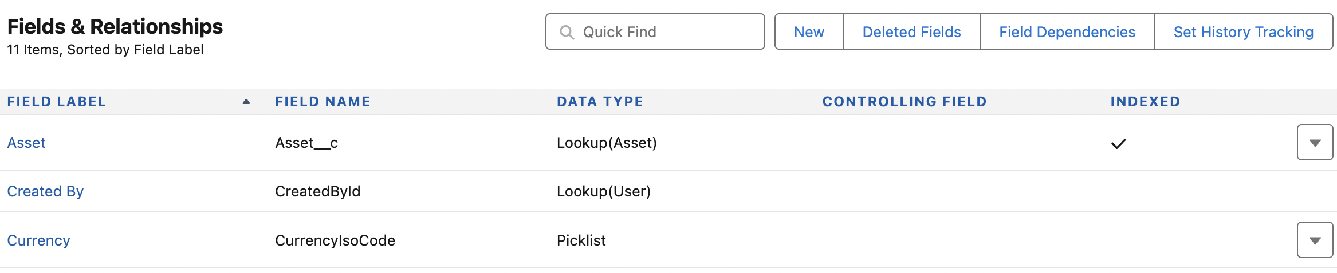
 | Impact report or formula field.
 | Impact workflow or validation rules
?? | Impact on page layout and record types
If an external system relies on a field that you just delete, the integration may fail or not function correctly. | Impact on integration
Best practice | Remove the field from all page layouts: This will hide the field from users without deleting any data.  - Remove the field from any automations: Check for and remove any references to the field in workflows, flows, or other automation tools.  - Check for dependencies: Ensure the field is not referenced in other metadata or integrations.  - Delete the field definition: Once all dependencies and automations are removed, you can safely delete the field itself.

Record type and chatgpt examples

Issue: when we create the asset followed by warranty record. In the warranty record, when we select accounts, it gives me the entire list of accounts almost all except few are not warranty providers.
Goal:
So we introduce record type.

Record type let you offer different business process, picklist values and page layout to different users.
You may create record types to differentiate between your regular sales deals with personal service agreement or engagement.
You might display different page layout for your customer support cases versus your billing cases.
If objects are nouns, then record types are the adjectives of the salesforce.

Scare me | It’s important to consider the implications of the record type before doing so. That’s because it does add a layer of complexity. You never want to introduce a record type unless you really need to have them.
Page layout based on record type | Scenarios: if u need different page layout based on the type of the record you’re dealing with on an object.
picklist | If you’re needing to provide different picklist values on different types of records for an object.
What we get | So on account record, we would be able to tell which are warranty providers, vendors, clients and so on.
 | 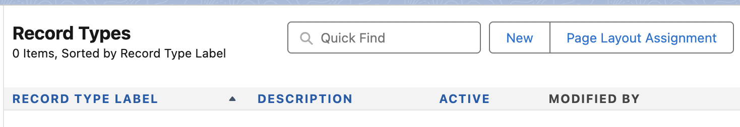
 | 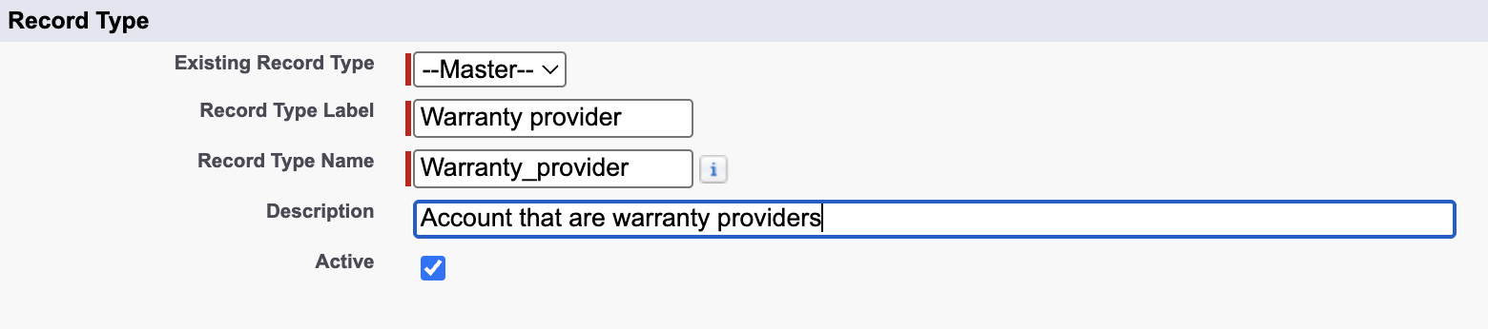
Make Available to create/clone/set default of this record type. | Select Make Available to give users assigned to this profile the ability to create and clone records of this record type, or assign this record type to existing records. To make the new record type the default for a profile, select Make Default. Users assigned to this record type can still view and edit records associated with record types not available for their profiles.
profiles | 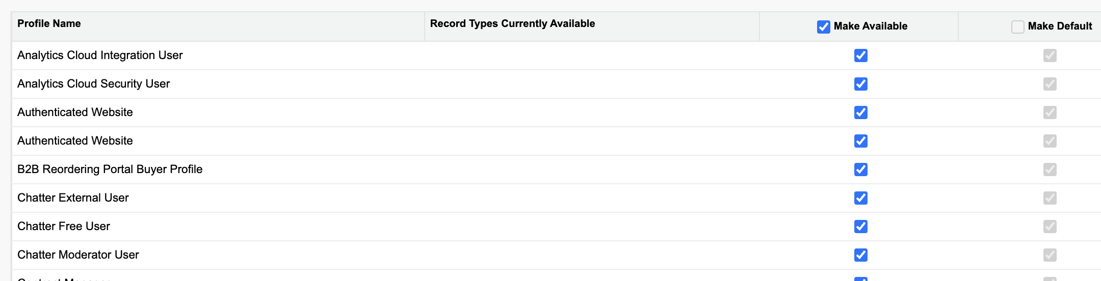

User | Profile | Available Record Types | Default | What Happens
Alice | Sales Rep | Retail, Enterprise | Retail | When she clicks “New Opportunity,” Retail is preselected, but she can choose Enterprise.
Bob | Support Agent | Service Only | Service | Can only create Service record types; can still view Retail Opportunities if shared with him.

 | You can assign different page layout based on record types.
 | 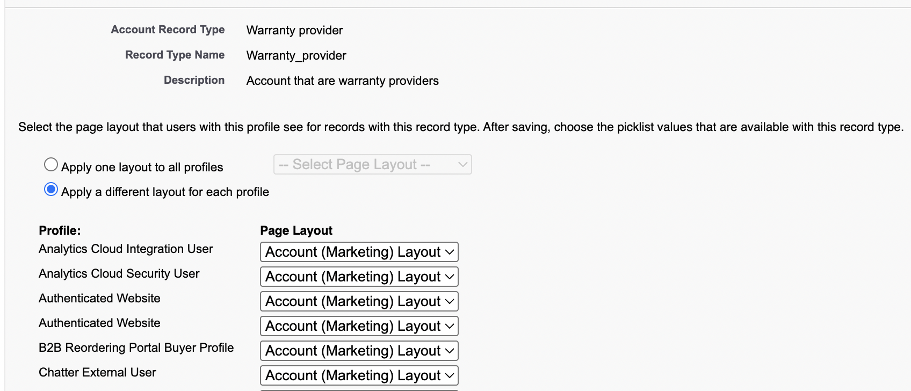
 | For warranty provider, I can provide different layout for each profile. This way u are more granular. This way, some receive one page layout and other receive a different layout.
We got our very first record type. | 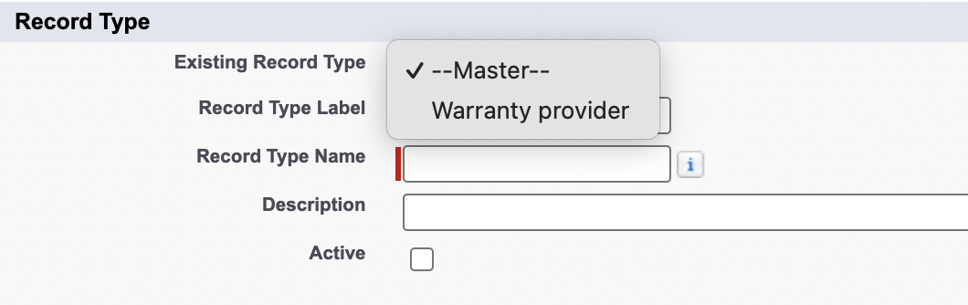

Now, lets create another record type:
Existing record type is a template | The existing record type it ask for Master or warranty provider. In essence its asking that what picklist values configuration u want for this new record type.
 | Do u want the default I.e Master or Warranty provider. If u choose Warranty provider, it will inherit the configuration of Warranty provider.
 | 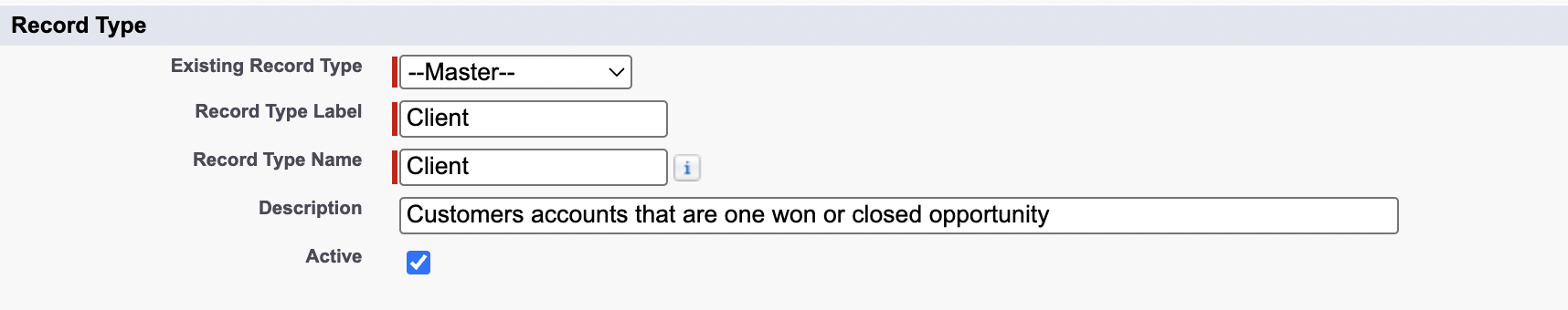
 | 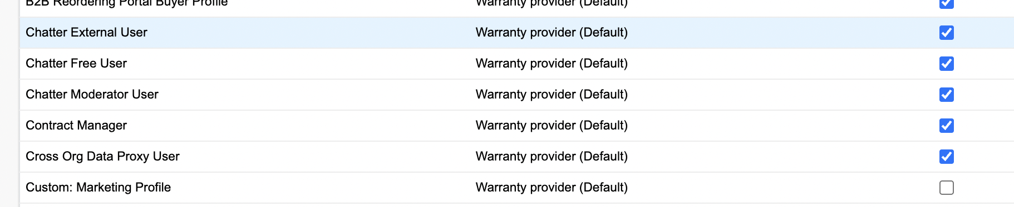
 | 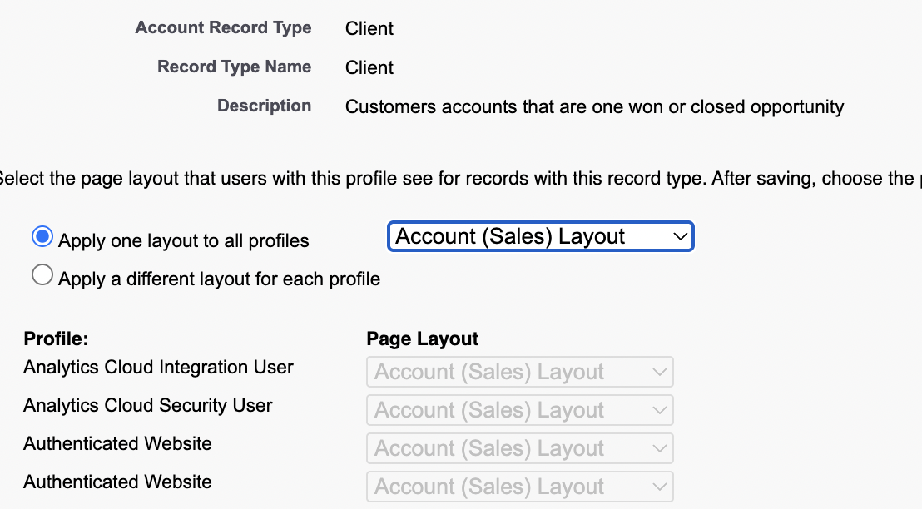

He created another record type.
 | 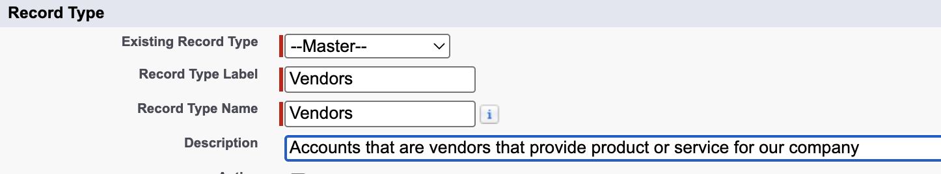
 | He made the record type available for all profiles except custom marketing profile. Poor Jim.
 | Layout was Account(Support) layout
Another record type | Prospect: Accounts yet to have a closed won or closed opportunity
 | So it would make sense to have prospect to be the default for accounts. They later be converted to Client in the sales funnel. We can do that by automation.
 | 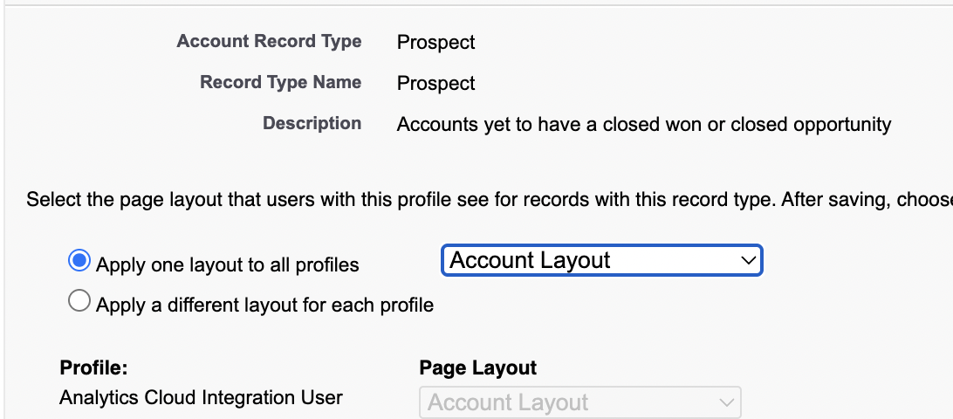
Output: | 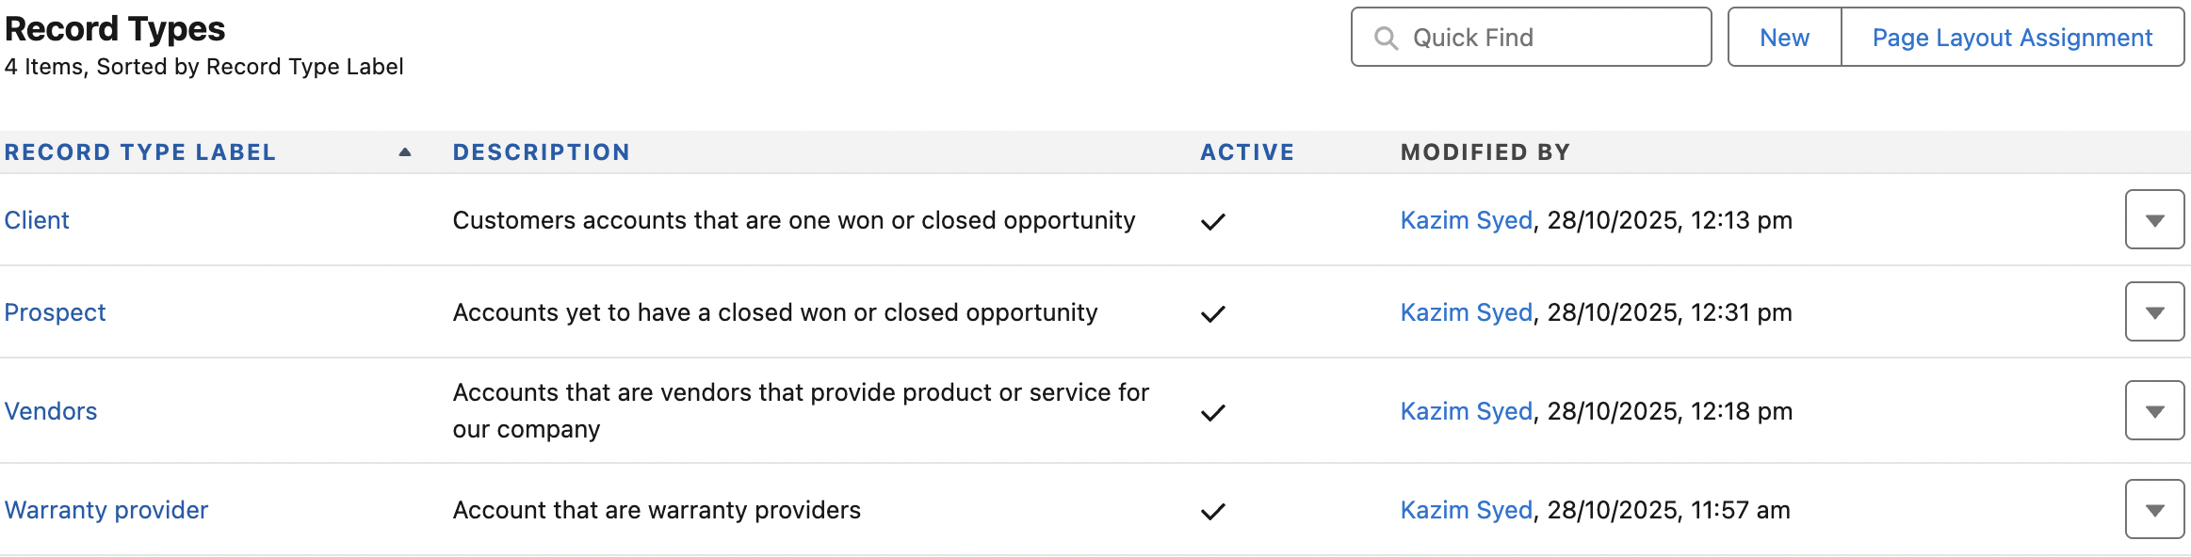

Now, if when account record has warranty provider as record type for when Account source the purchase list dropdown item isn’t available.  Or if u are warranty provider, then account source for purchased list wont be available. | 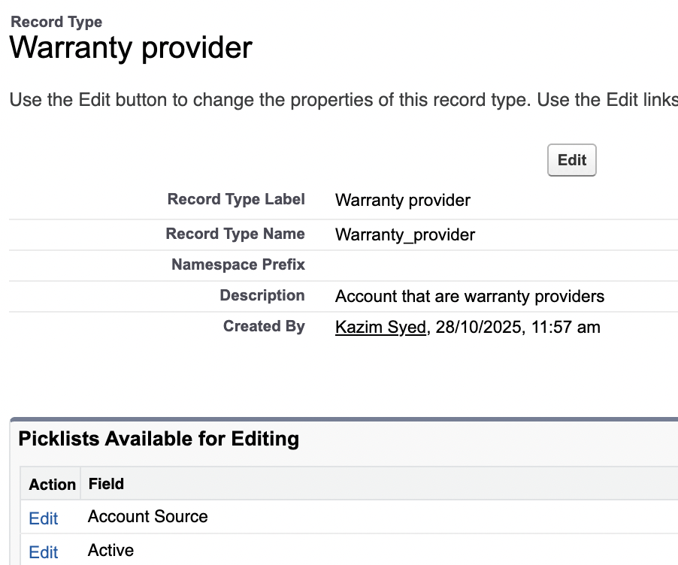
 | 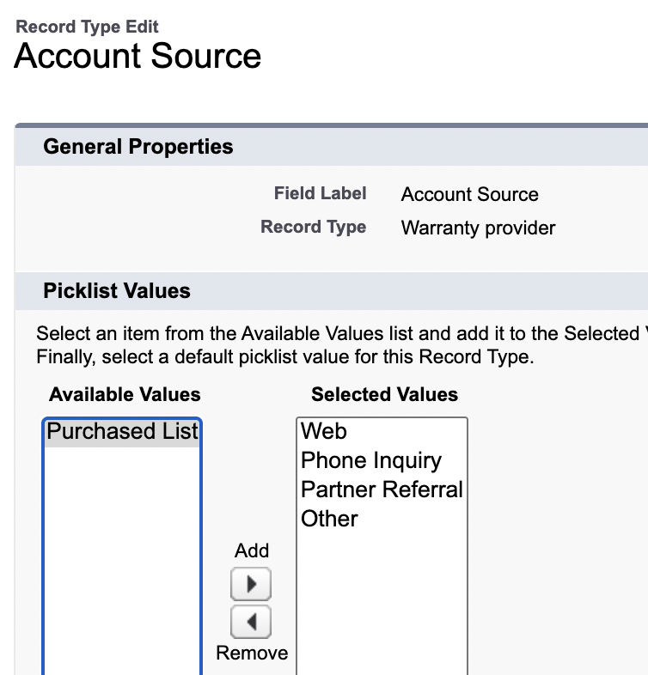

Renaming Page Layouts for Page layout assignment
Goal:
1. To educate when a user (with a particular profile) only have one record type, lets say prospect then any std/custom object records he will create will have the record type as prospect. No click events needed. Whereas, if a user(with other profile) having multiple options as record type, will be given an option to choose which record type.
2. The use of Picklist values. Its like dependent list.

New account record | 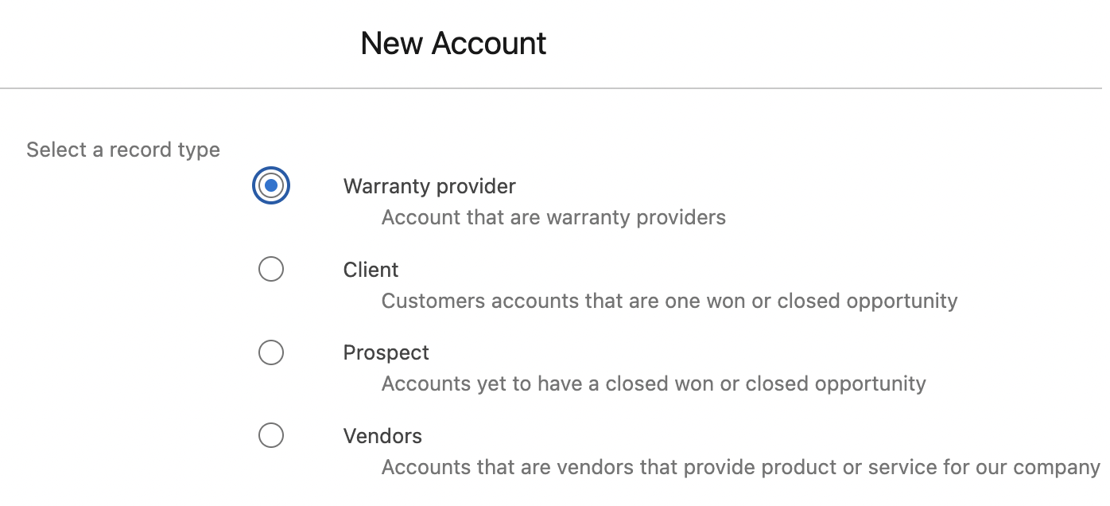
If u cant find which record type for warranty provider.  Goto  Object manager → Account → Record types → Page layout assignment.  Since the layout is called Account(Marketing) layout. I can goto page layout and change it. | 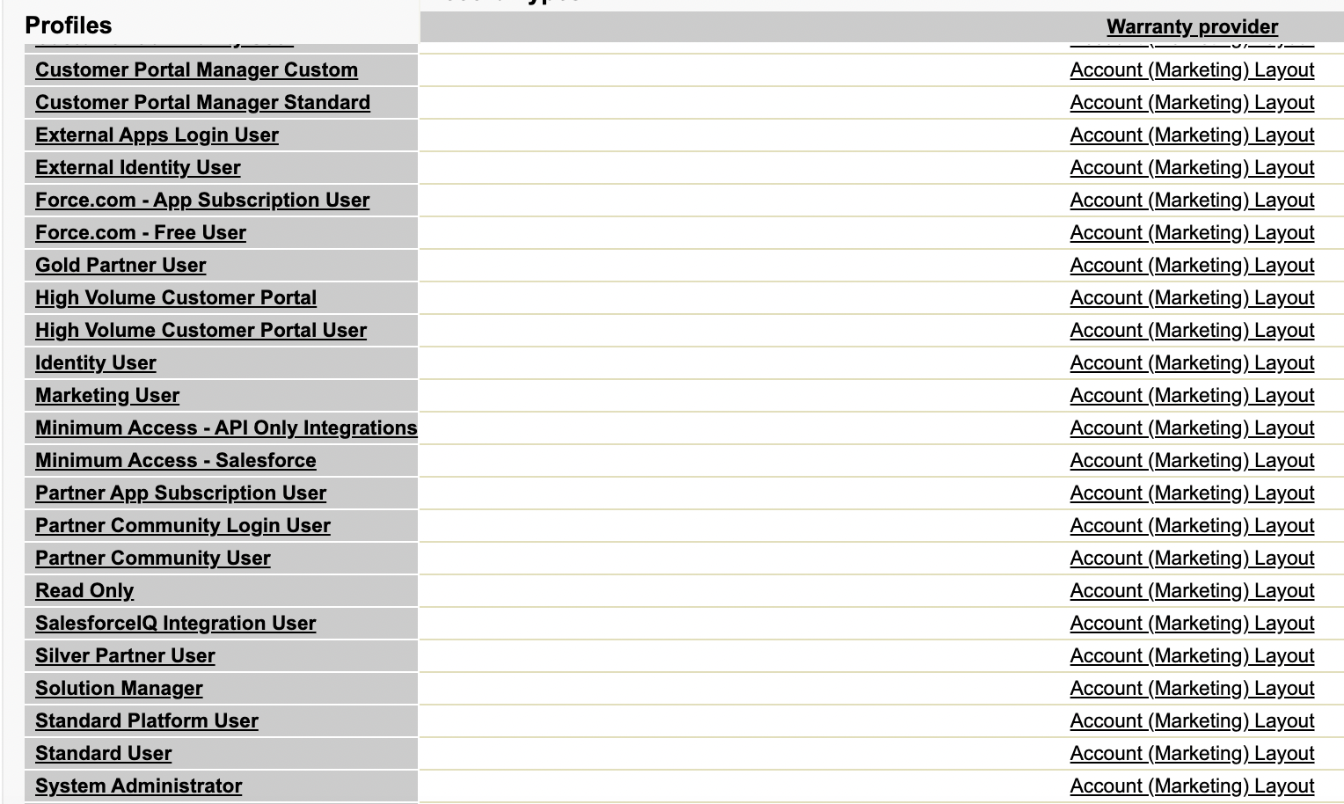
Page layout → Account(Marketing) Layout → Layout properties → Change it. | 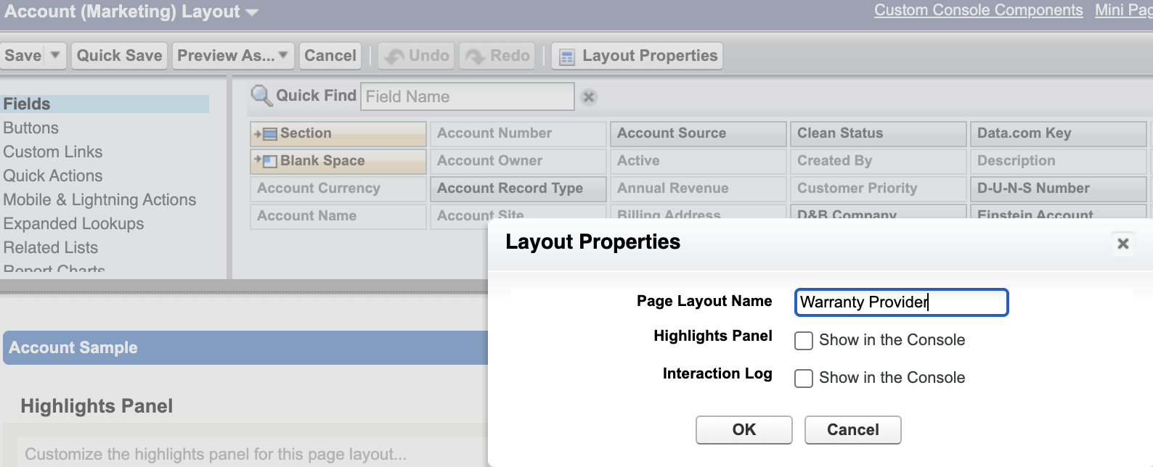
 | I drag and drop Account source for record-detail page.

Purchase List present in Warranty provider | Purchase List absent in Warranty provider
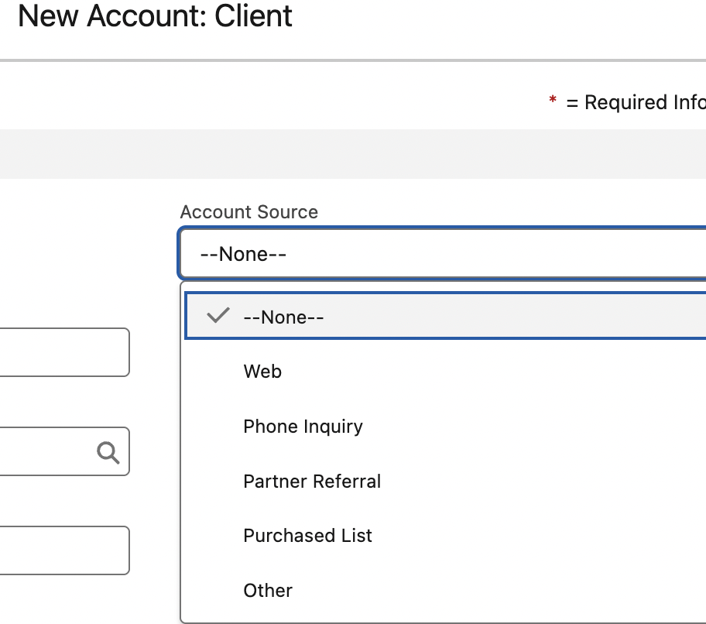 | 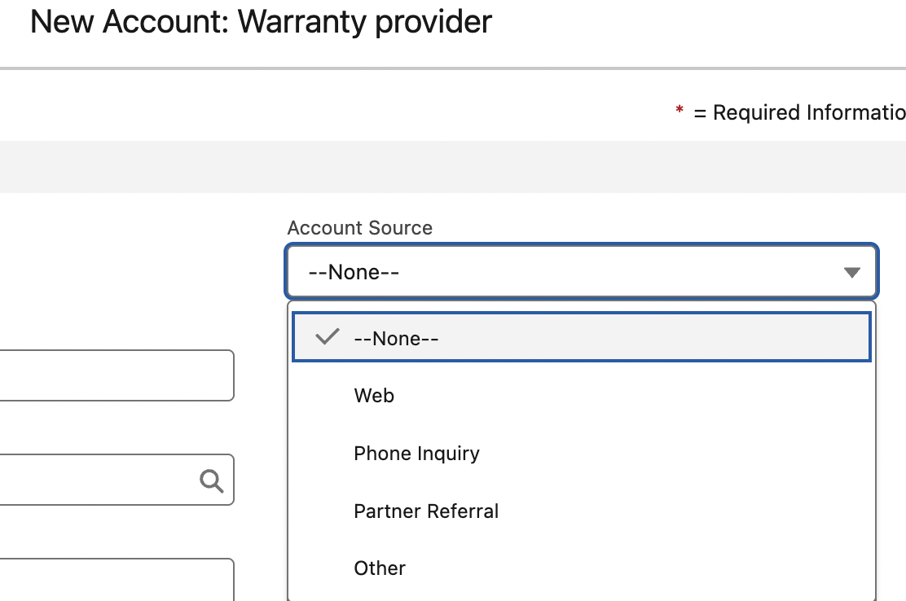
I logged in as Jim Lindsay who has custom marketing profile. Who only has warranty provider record type and layout.  I can observe for warranty provider record type we d | 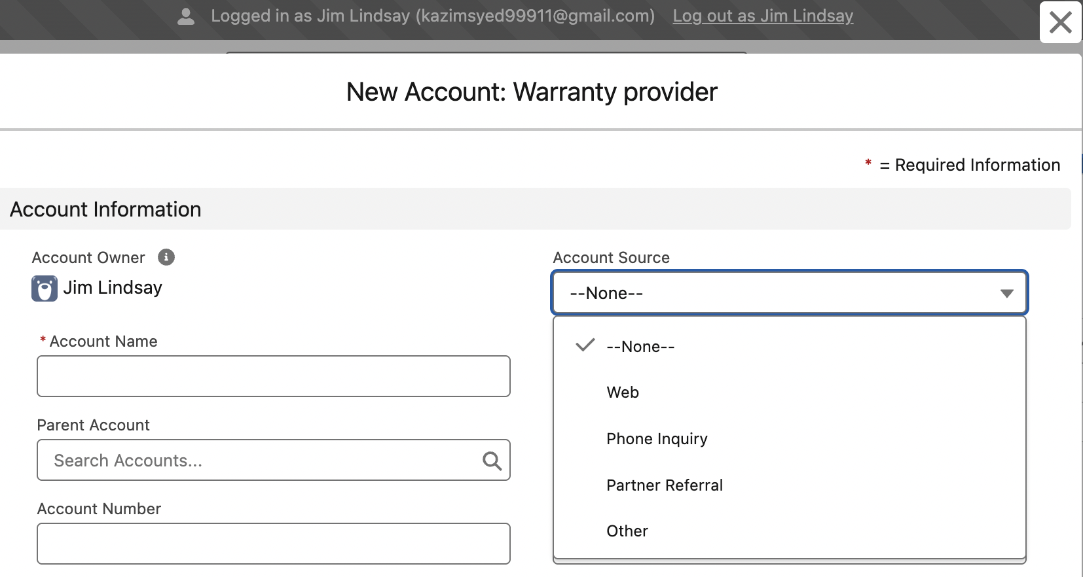

Creating lookup filters by Record type
Goal: To have Only warranty providers account to appear when creating a warranty record.
Objective:
1. Acme is an existing Account that doesn’t have record type.
2. Assets are insured by warranties. Warranties are provided by warranty provider aka Acme accounts and others. Have Acme and other warranty providers only appear when creating a new warranty record.
 | I have to drag and drop Account record type in the page layout and then manually setup the Acme account.
 | 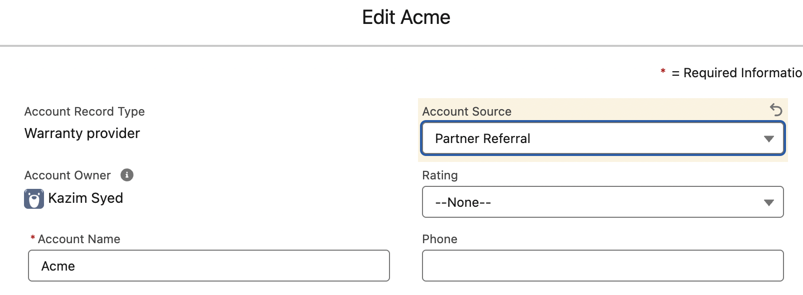
When we create a warranty, we see there are multiple accounts that aren’t warranty providers. | 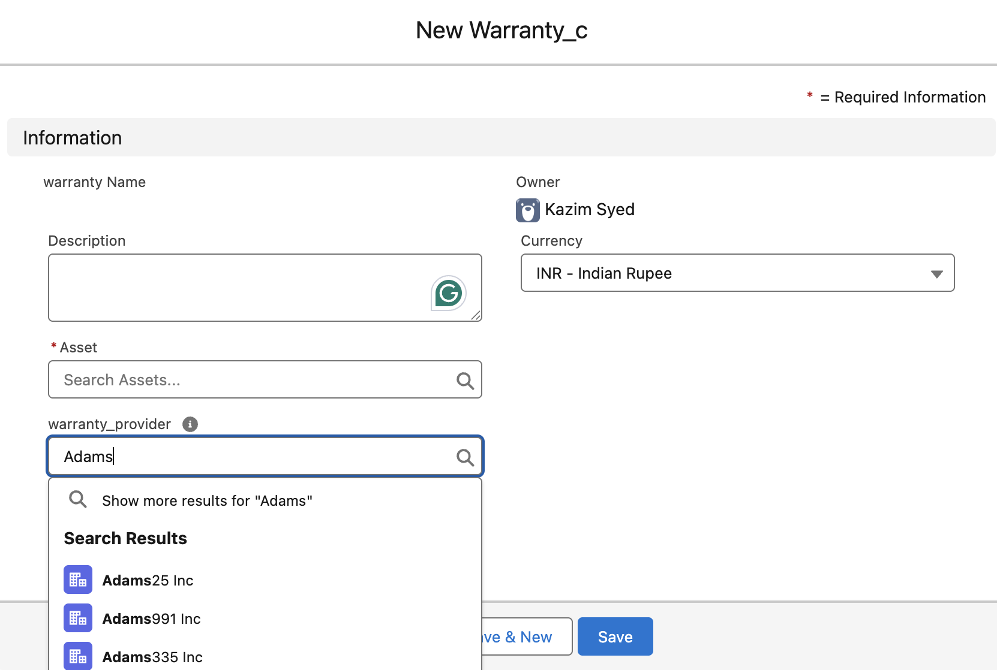
Lets create a filter
Goto Object Manager → Warranty_c → Fields and relationship → Warranty provider(Lookup)

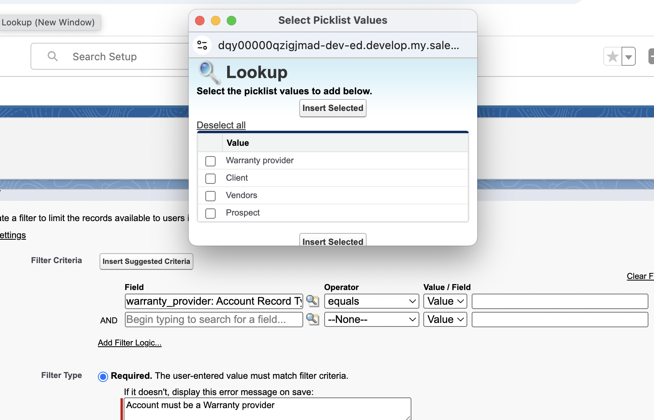

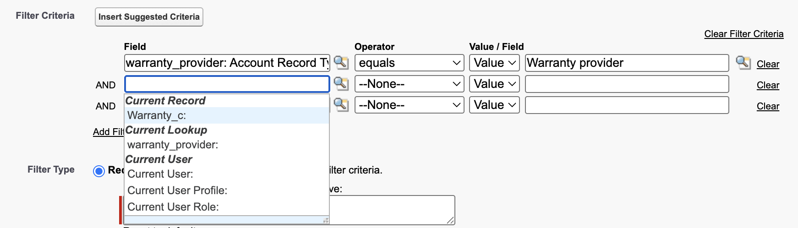
We have made the filter-type required.
If it was optional: the user can remove the filter or enter values that don’t match criteria.
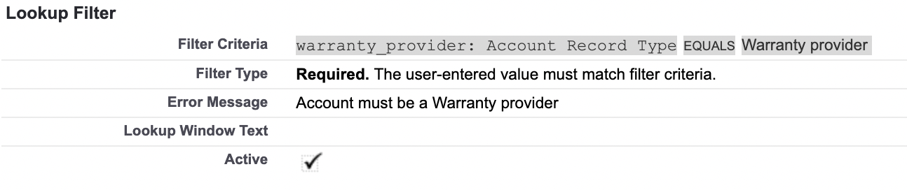

Now only warranty providers accounts appear in the warranty record which is a lookup(Accounts). | 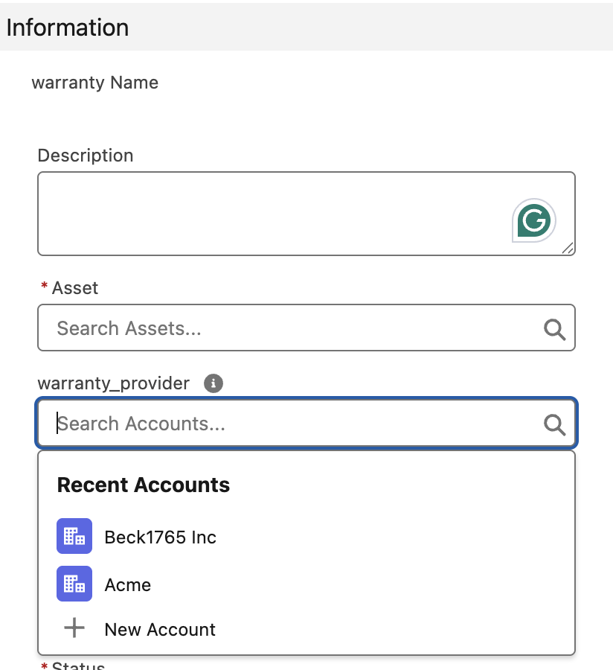

Using chatgpt to create formula fields
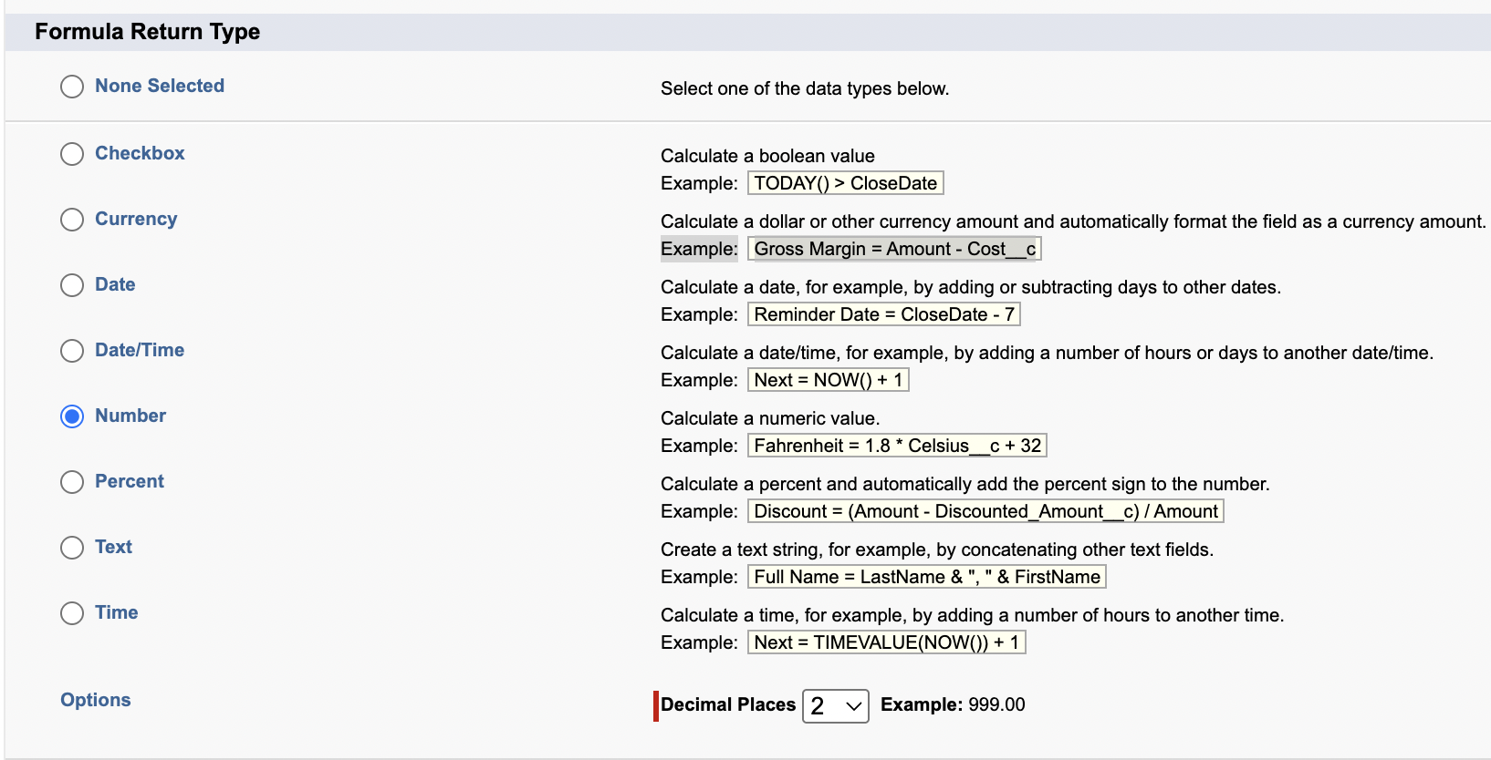

Time | TIMEVALUE(NOW())
Today | TODAY()
year | YEAR(TODAY())
Concatenation | & “,” &
Conditional | >

THEN WRITE THE FOLLOWING  YEAR(TODAY()) - YEAR(Birthdate) | 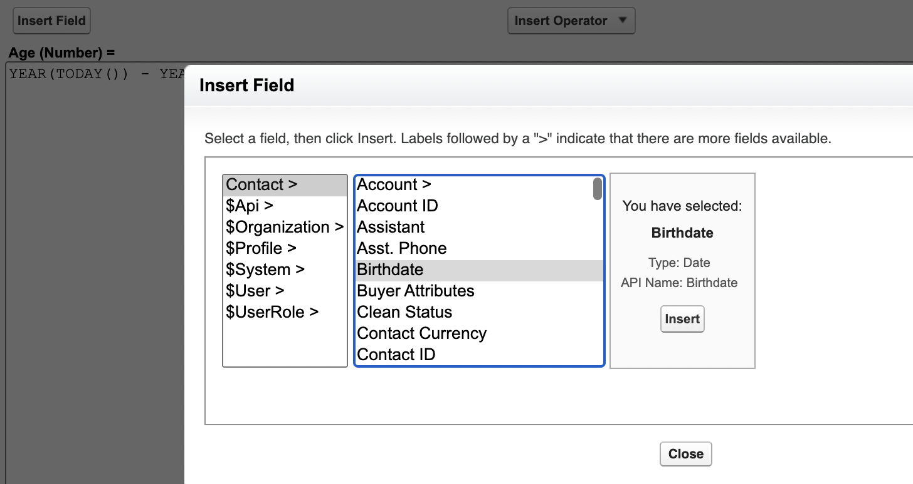
 | 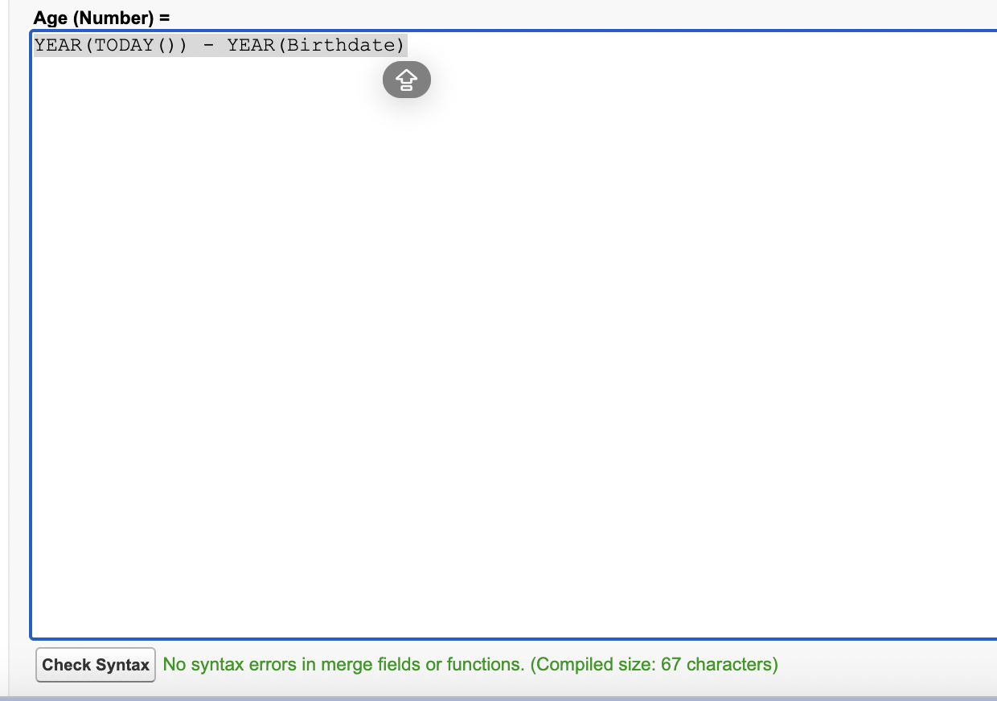
 | 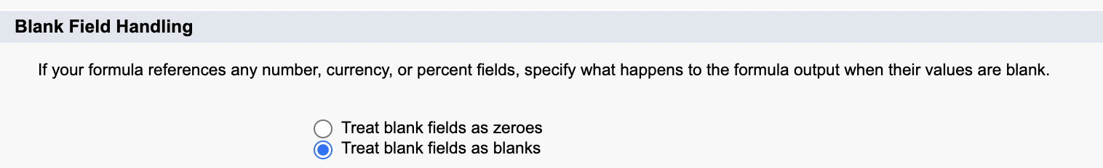
This field is calculated upon save. | 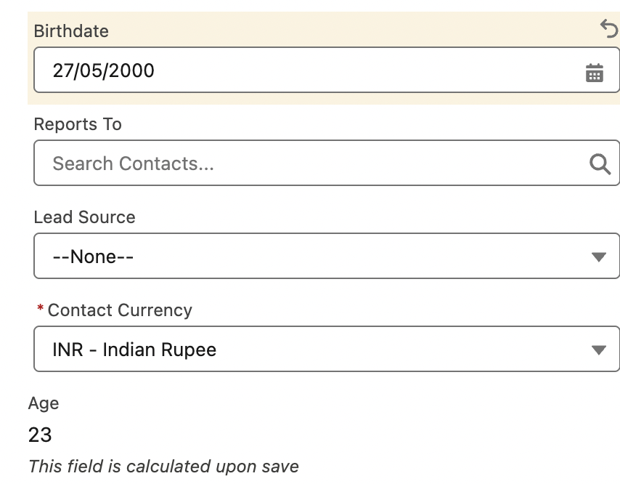

Editing page layout by record type
 | 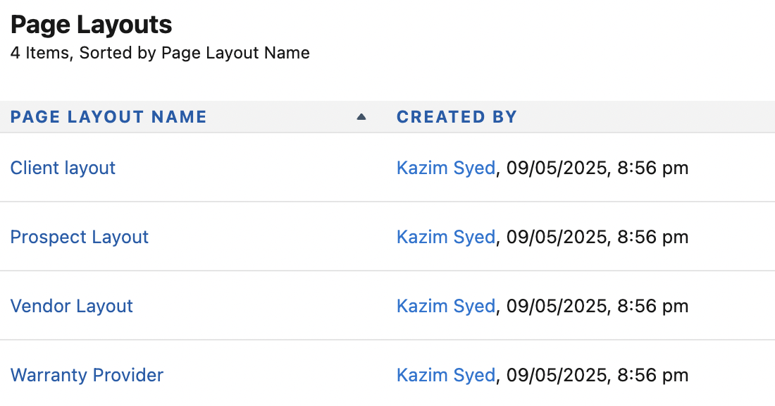
Different layout  Since only account who are warranty providers. Will only see warranties. | 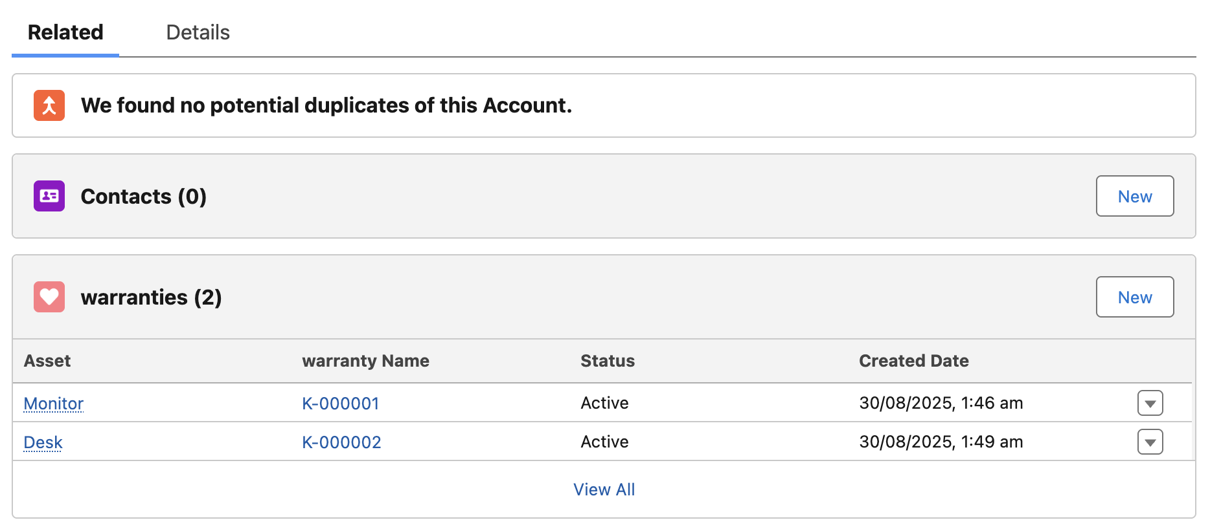

Using Chat-gpt for mass assigning Account record types
Problem: Whenever u introduce record type, there exist legacy record that have no input for that field.
 | We don’t want to mass update manually. Even if we filtered those record that are empty.
 | You can handle them using flow or Apex triggers.
Apex code | List<Account> accountsToUpdate=[SELECT ID FROM Account WHERE RecordTypeId = null];  for(Account acc: accountsToUpdate){  acc.RecordTypeId='012Qy0000091DqrIAE';  }  update accountsToUpdate;
I copied the record type id by going into Object Manager → Account → Record type → Select the record type → copy the url. | Or I could do this instead.
SELECT Id, Name, DeveloperName FROM RecordType
WHERE SObjectType = 'Account' AND Name = 'Prospect'
 | 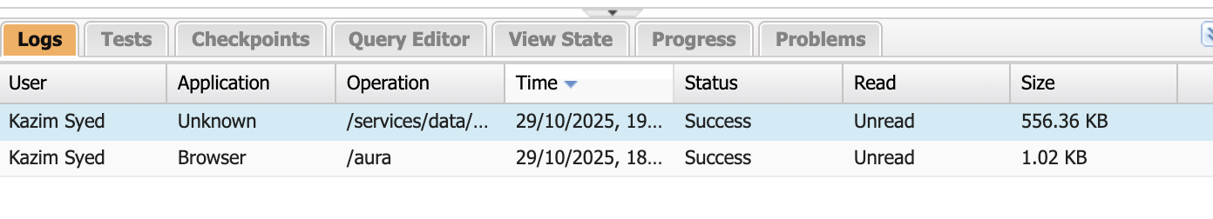
 | 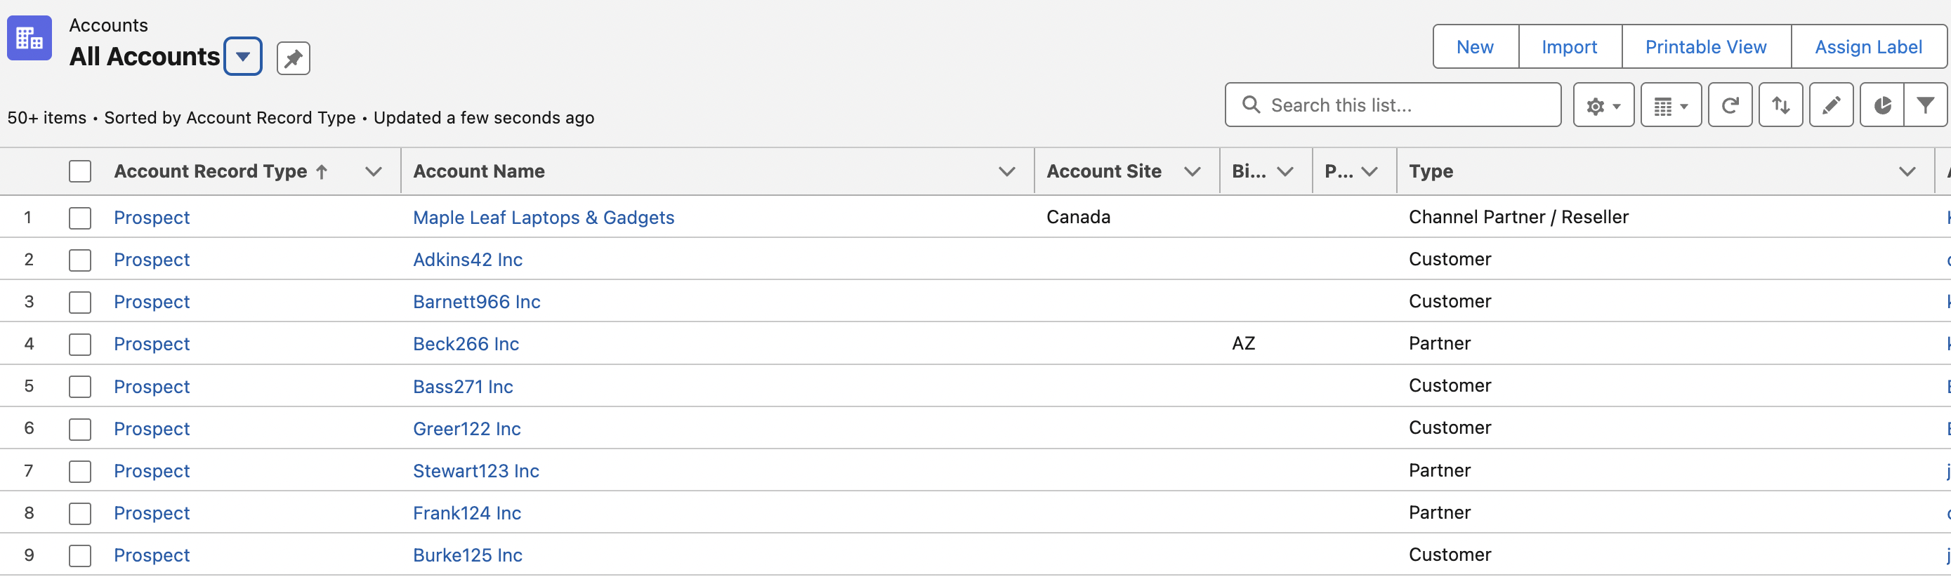

Page layout Assignments Review
He mentioned there you could have another type of master record page layout.
He mentioned Client layout and Client administrator. In Client administrator layout where you could have admin fields displayed.
 | This is quite common in the real world, as an administrator wanna see things that you wanna hide from your end users.
So we goto Client Layout
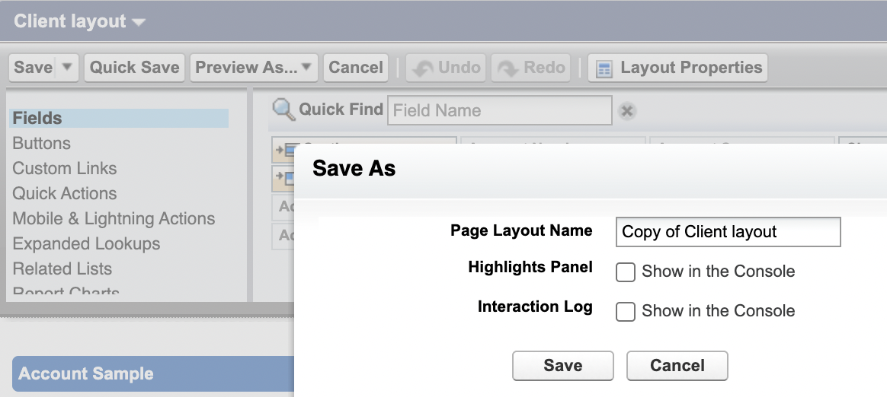 | 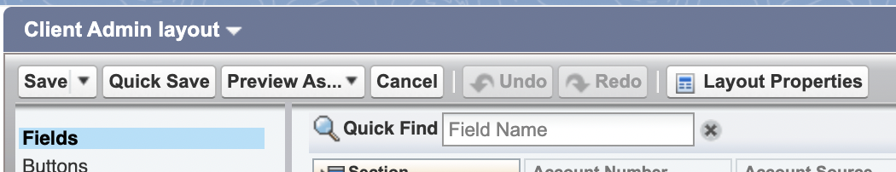
Then add some fields concerning for System admin.  Then goto Page layout assignment and assign it to System administrator. | 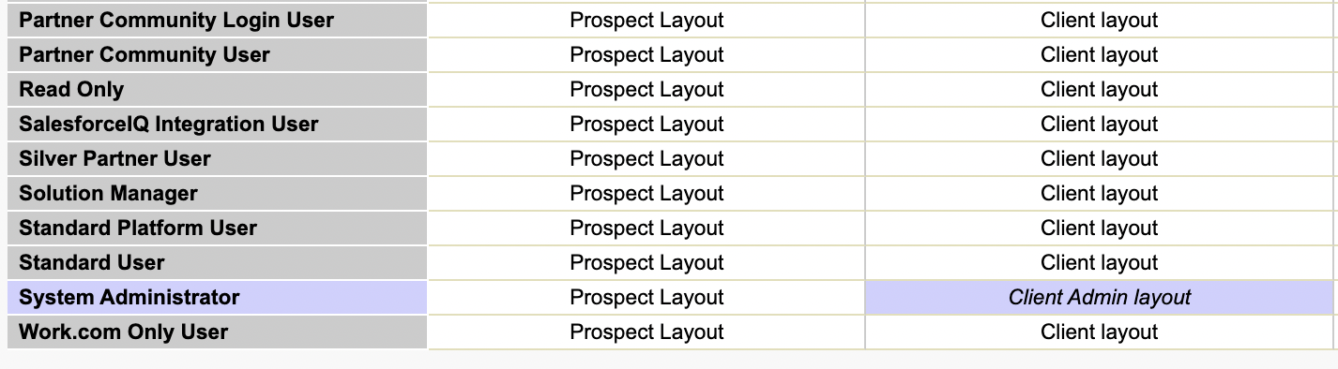
We see new fields like Segment, SIC Desc and more.  Because the system admin has Client Admin Layout for record type:Client  Only the Sys admin can see this, because he is only assigned Client Admin layout. | 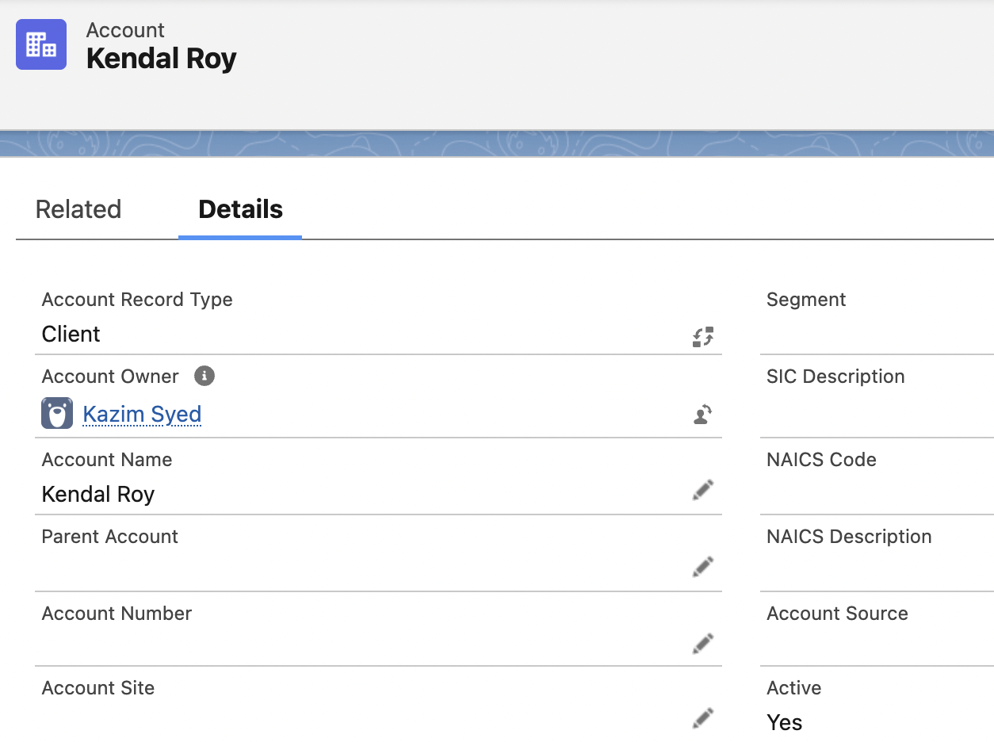

Creating Rollup Summary Fields
Problem: We have mass updated records to Prospect. But in reality, we have records of which many have closed won opportunity associated with them.
So we gonna create a field rollup summary that will display on these individual account records how many dollars of closed won opportunities are associated with these different accounts. So any records that have zero won opportunities we wont
change.
Rollup summary field | A read-only field that displays the sum, minimum, or maximum value of a field in a related list or the record count of all records listed in a related list.
Correction:  field to aggregate is used “Amount” | 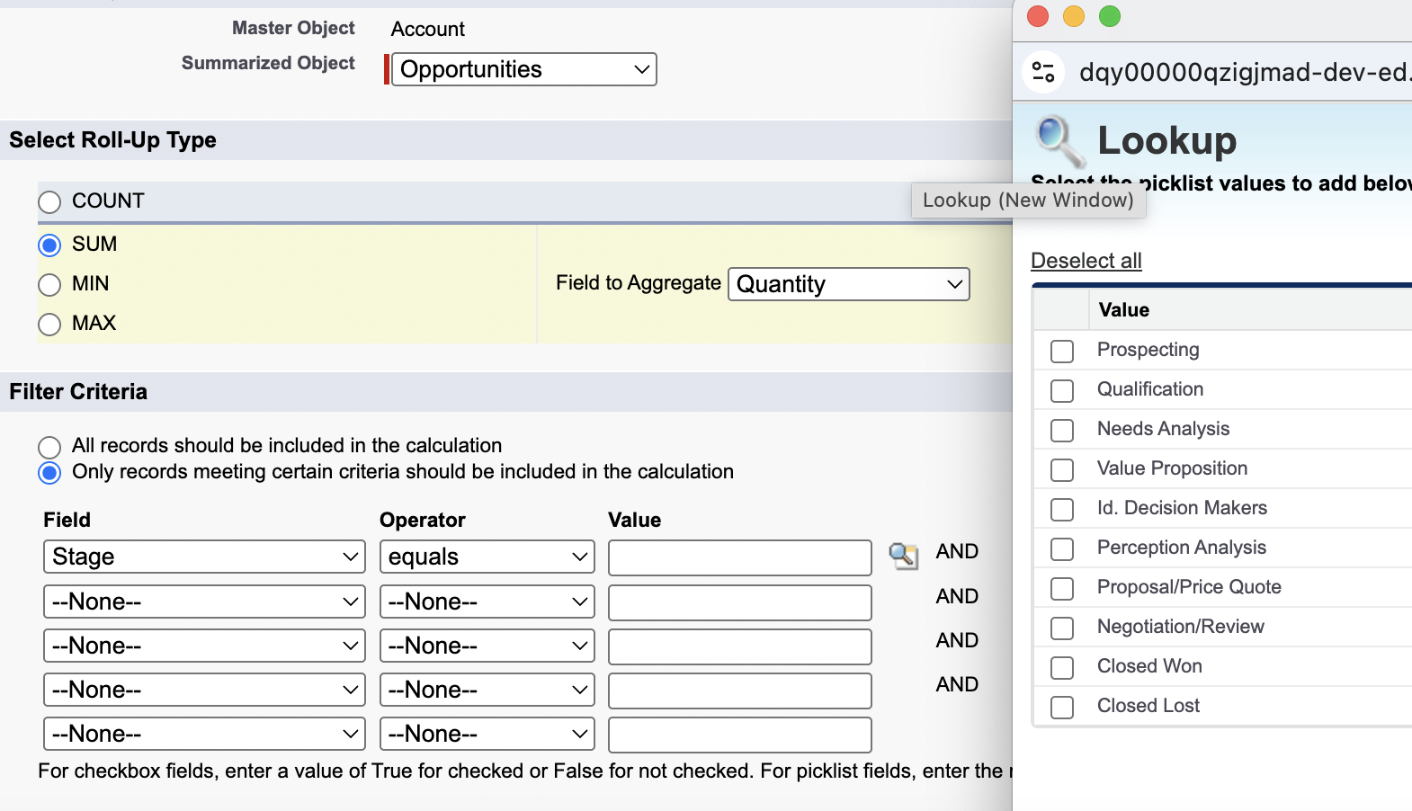  (1)  (2)  (3)  (4)  (4)

Mass Updating accounts Using a rollup summary
Problem: When we mass update all accounts to prospects. Some of those Accounts were client since they have closed won opportunity. To achieve to do that.
Apex code. | List<Account> accountsToUpdate=[SELECT ID FROM Account WHERE RecordTypeId = '012Qy0000091DqrIAE' and Total_Closed_Won_Opportunity__c > 0 ];  for(Account acc: accountsToUpdate){  acc.RecordTypeId='012Qy0000091CZp';  }  update accountsToUpdate;
Beck 1765 is the warranty provider.  Becks with closed won opportunity that is learned by viewing revenue generated is Client. | 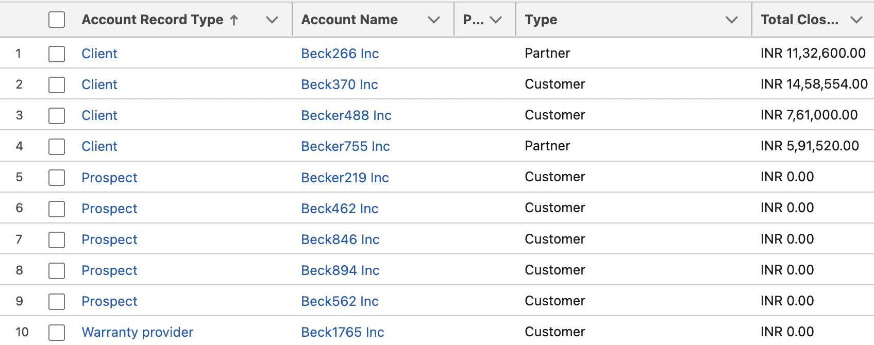

Lightning app builder
Task: Create warranty home page and then create an app.
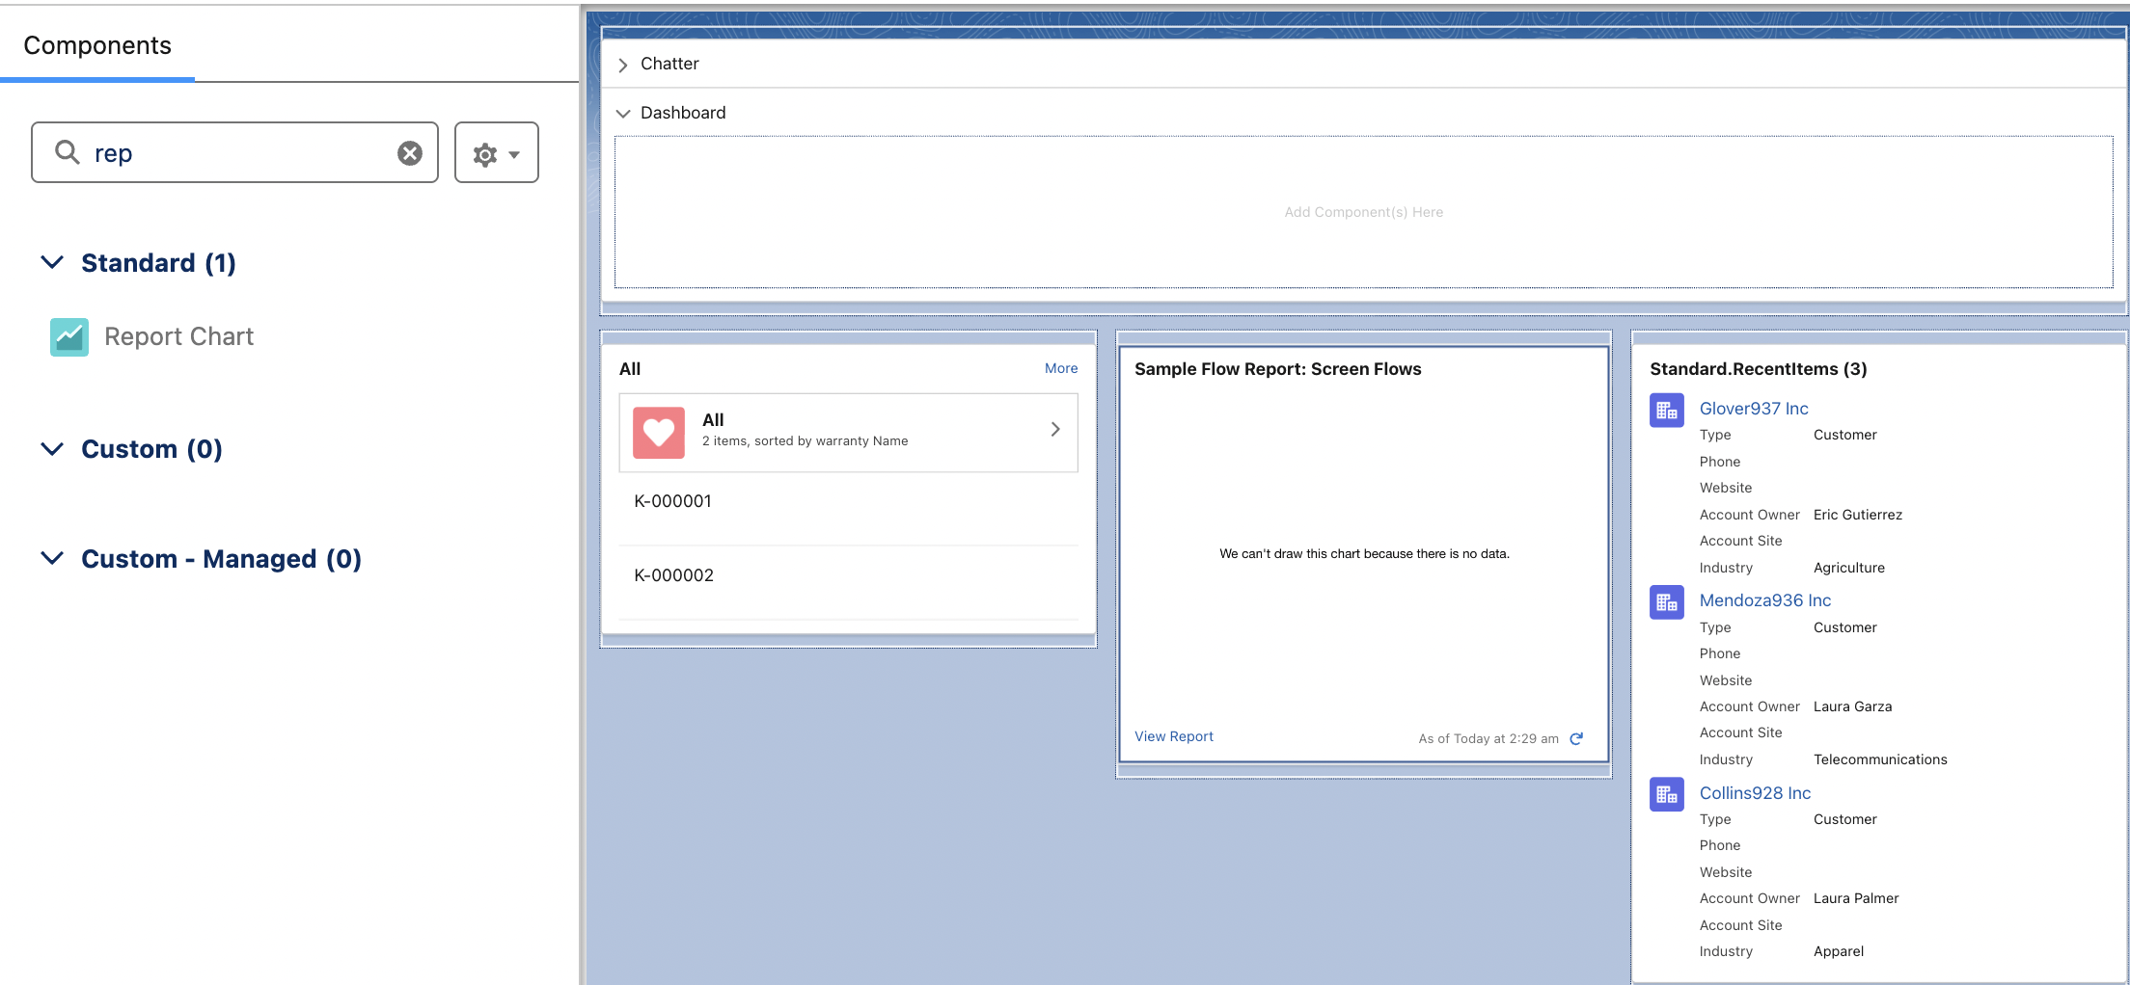 | Accordion  warranty object … recent  Home page created successfully...
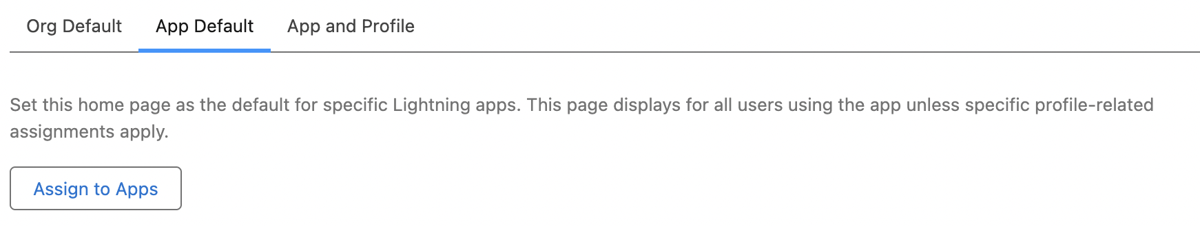  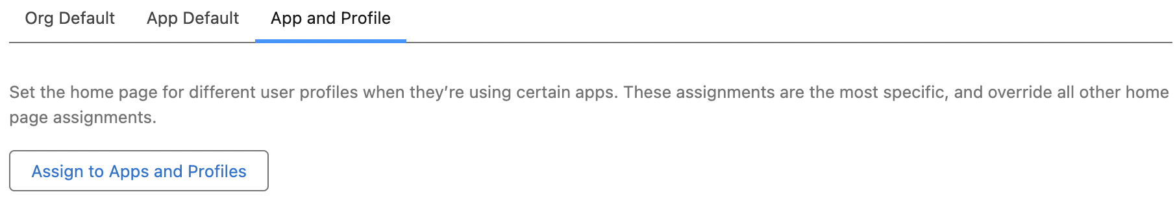 | 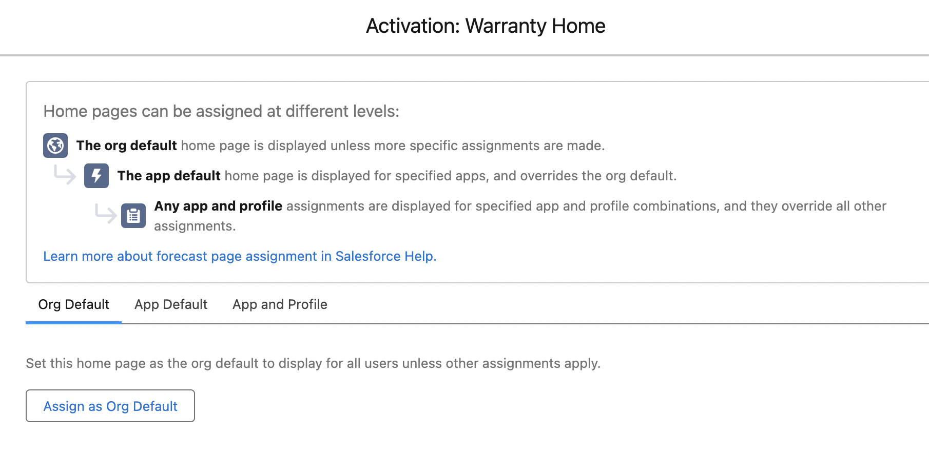
Goto Lightning Experience app manager
 | 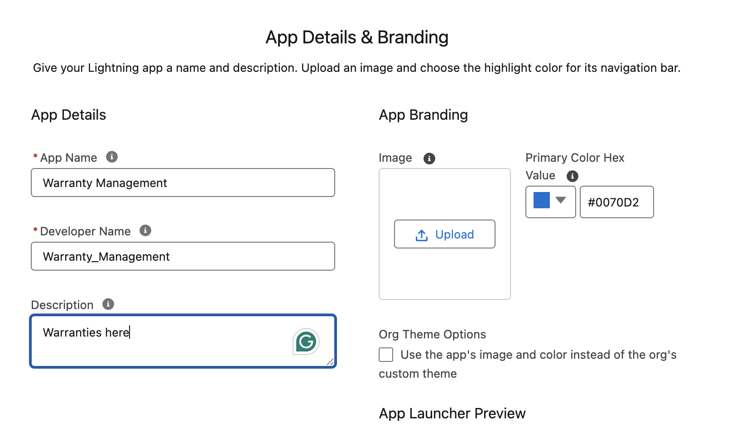
 | 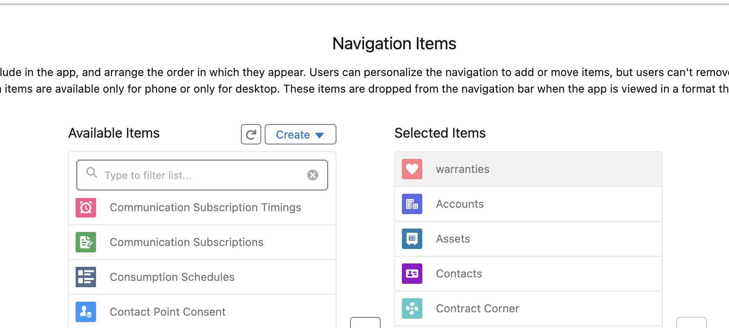
 | 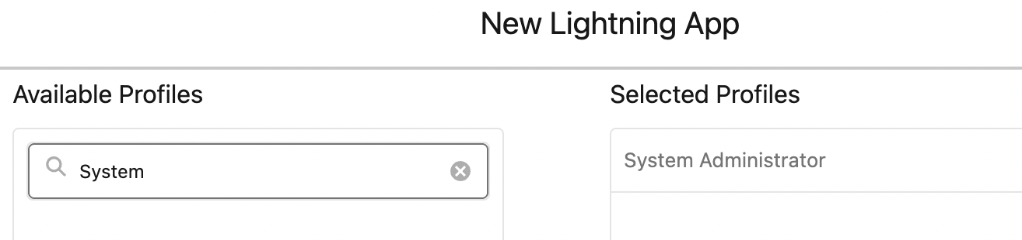

Output:
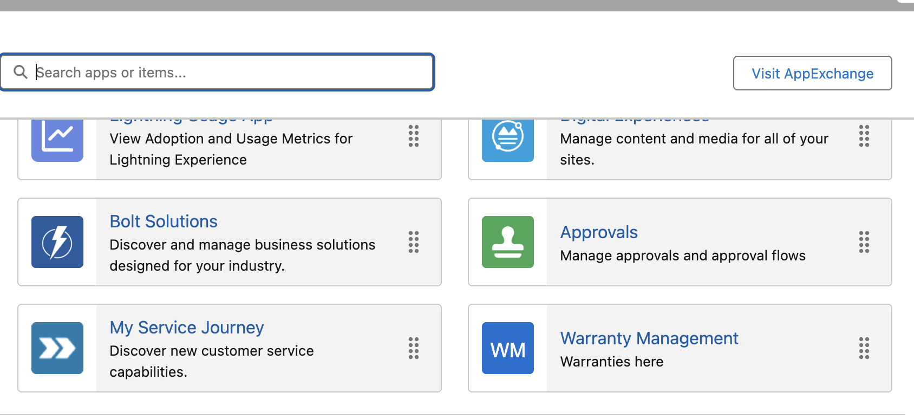

Goto App manager. Open Warranty Management and assign to apps. | 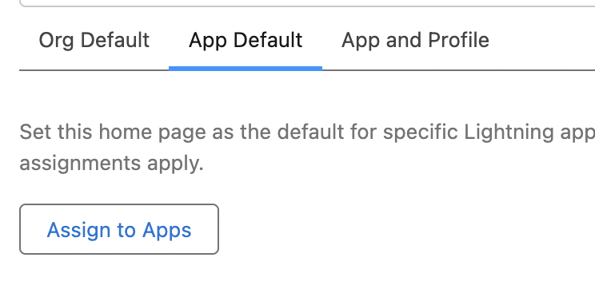
 | 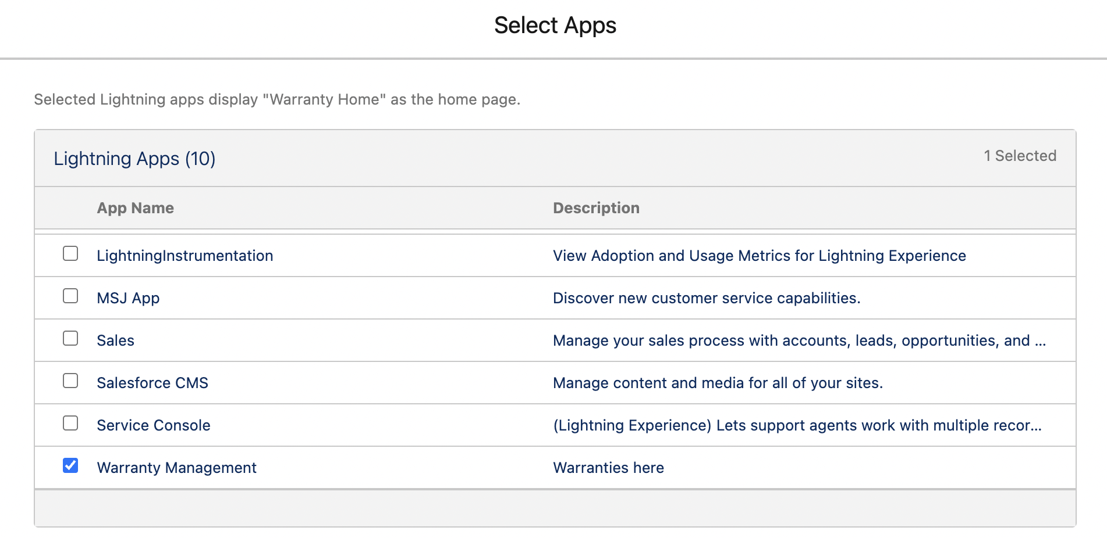
Goto Lightning experience App Manager → Warranty Management → click edit → Navigation items | 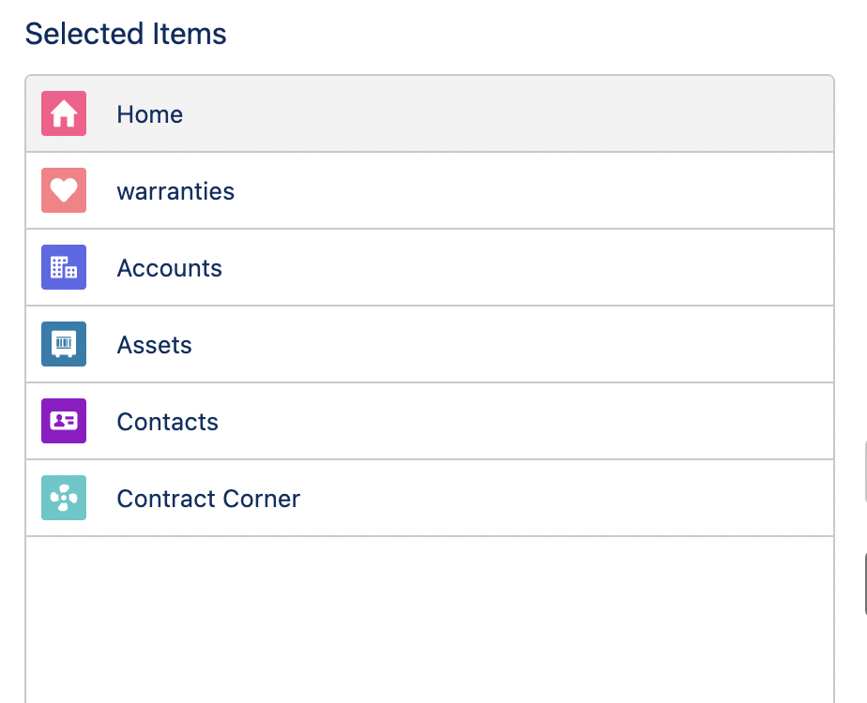

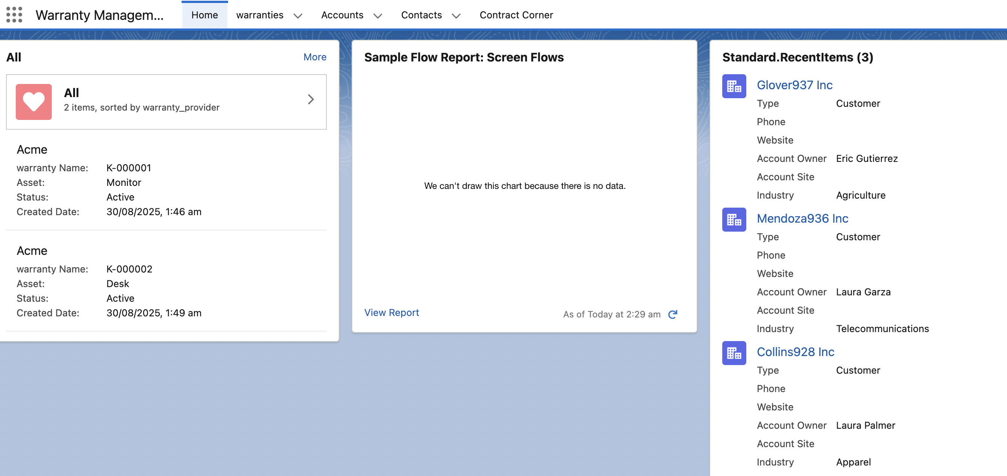

Creating a custom business process in salesforce
So for client record type on account, we may want to initiate some sort of process to denote where a client is In their customer boarding process.
So we create a picklist field.
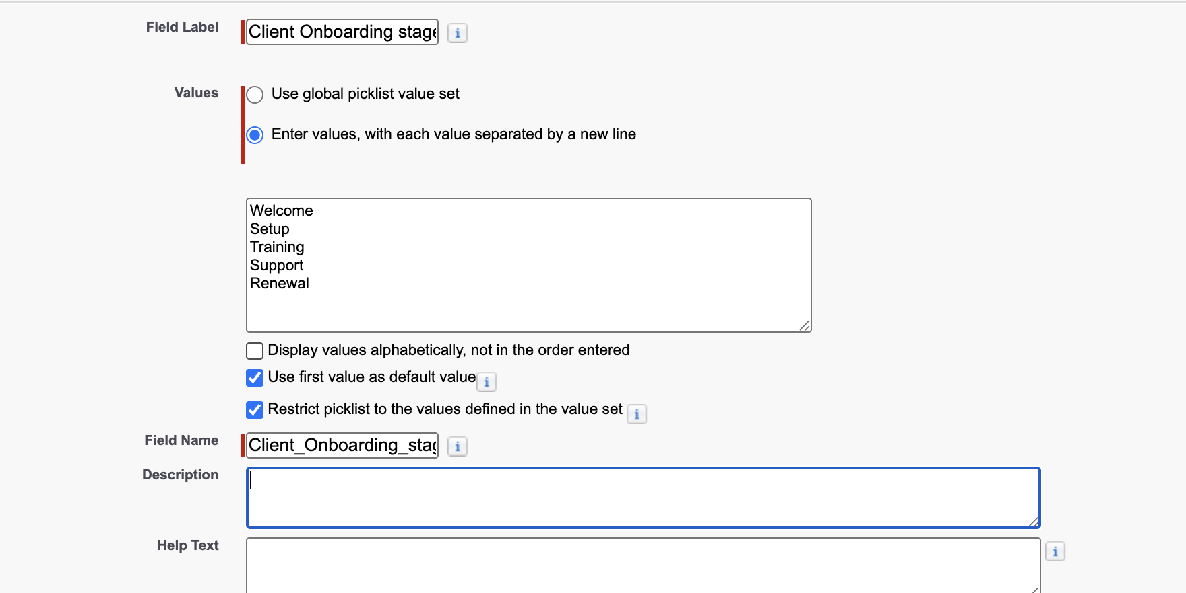
This would kick of one or multitude of processes that u want ur organization to do when u have a closed won opportunity and account becomes a client account. You can achieve automatically with a flow.
Client onboarding process
Welcome
Setup: u do integration and handle billing.
Training: trained ur client on the product or services to what expect as well.
Support:
Renewal
He made the field optional. Since only client and admin client will be able to access. This field is only visible to client and admin client pagelayouts.

Creating a path for our Custom business process
Task: Just like the stages for Opportunities, we gonna create for account object. It’s called path. So we want path to show only for client account since its client onboaring process.
User Interface → Path settings | 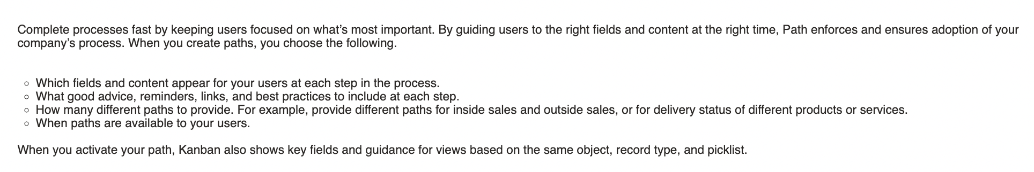
 | 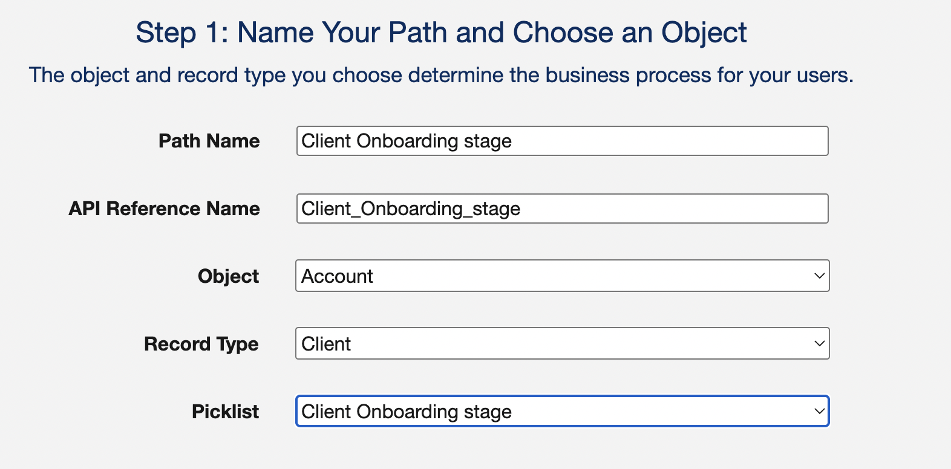
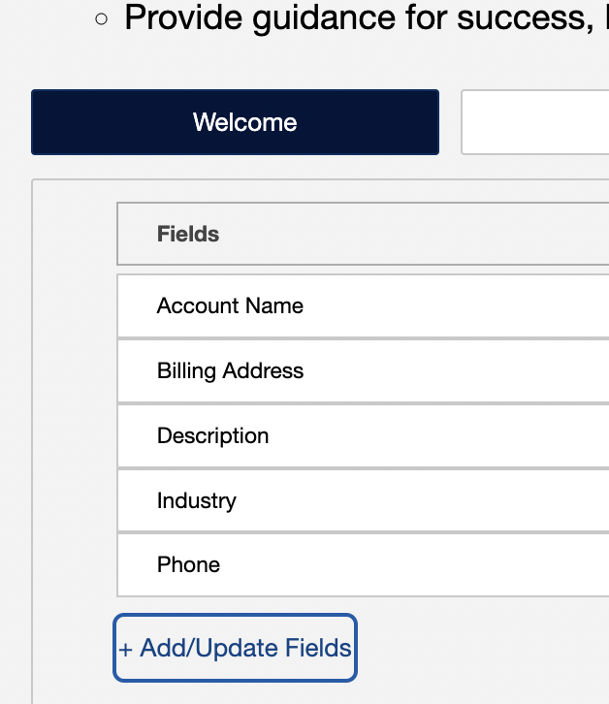  Welcome stage | 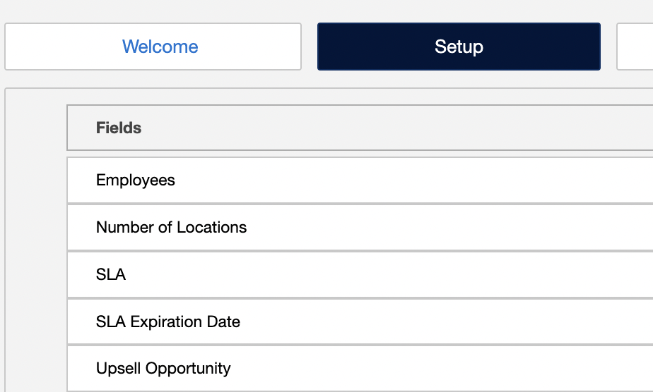  Setup stage
 | 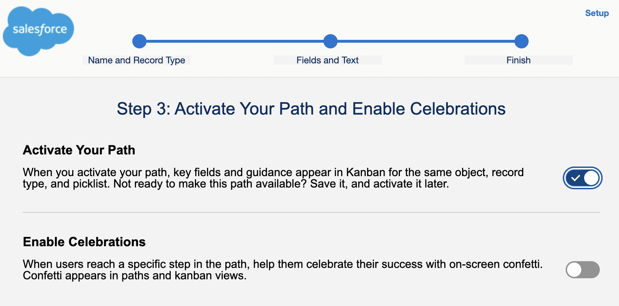

Adding path to page layout.
I just drag and drop the path to Accounts detail page. | 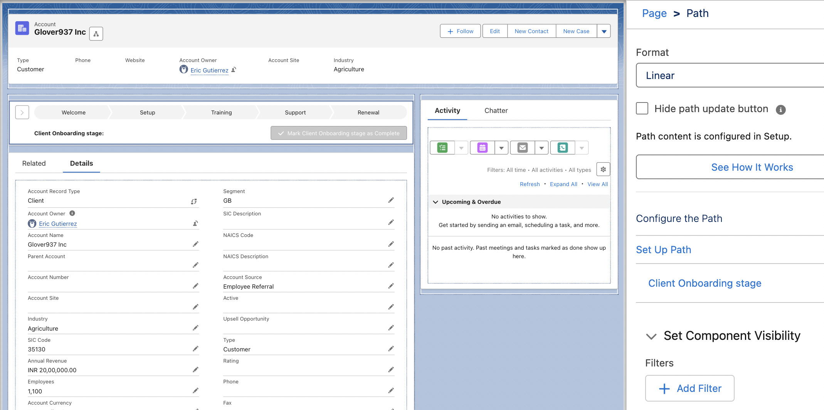
 | Set component visibility filters, so it will display only if a certain value is true.
Activate. | Then I made It default for app, record type and profile.
 | Default for Sales, Service console, Warranty management.
 | 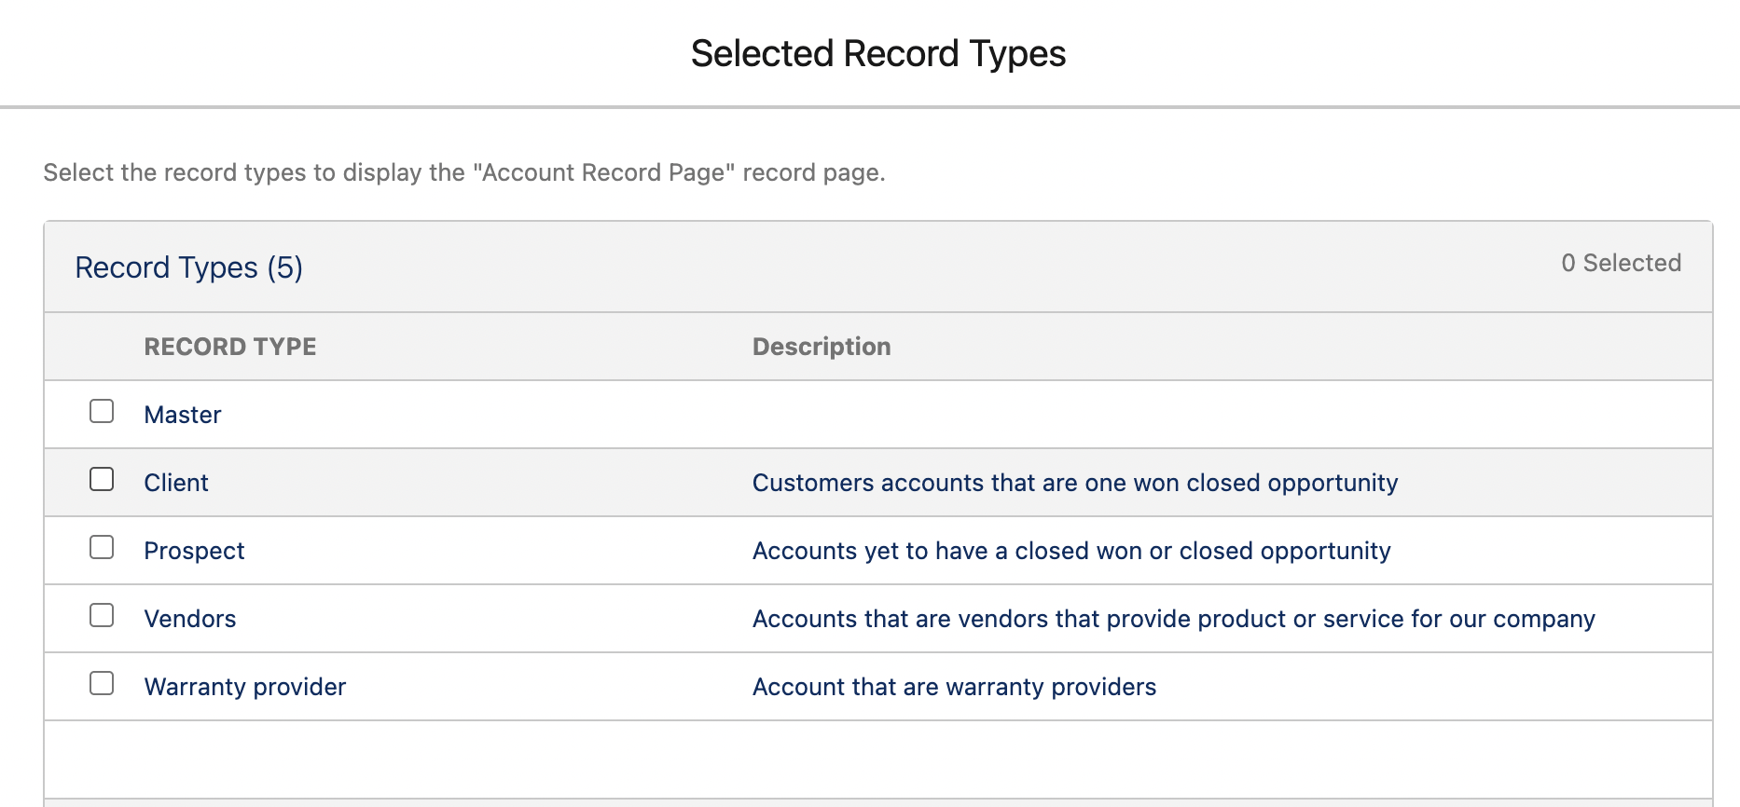
I can show or hide by profile | Select system admin and custom marketing profile.
 | 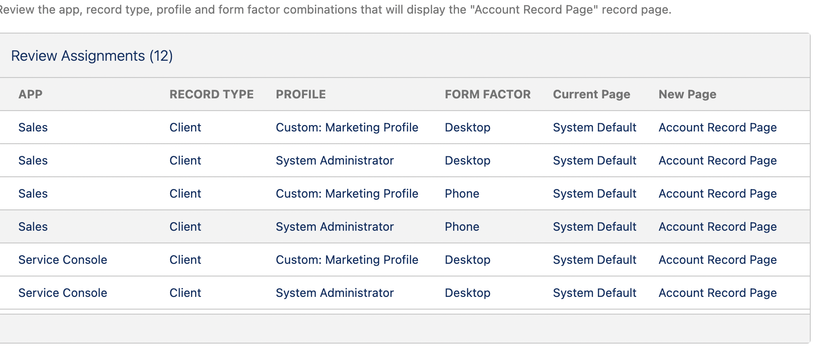
Now I goto account and see the paths for client accounts | 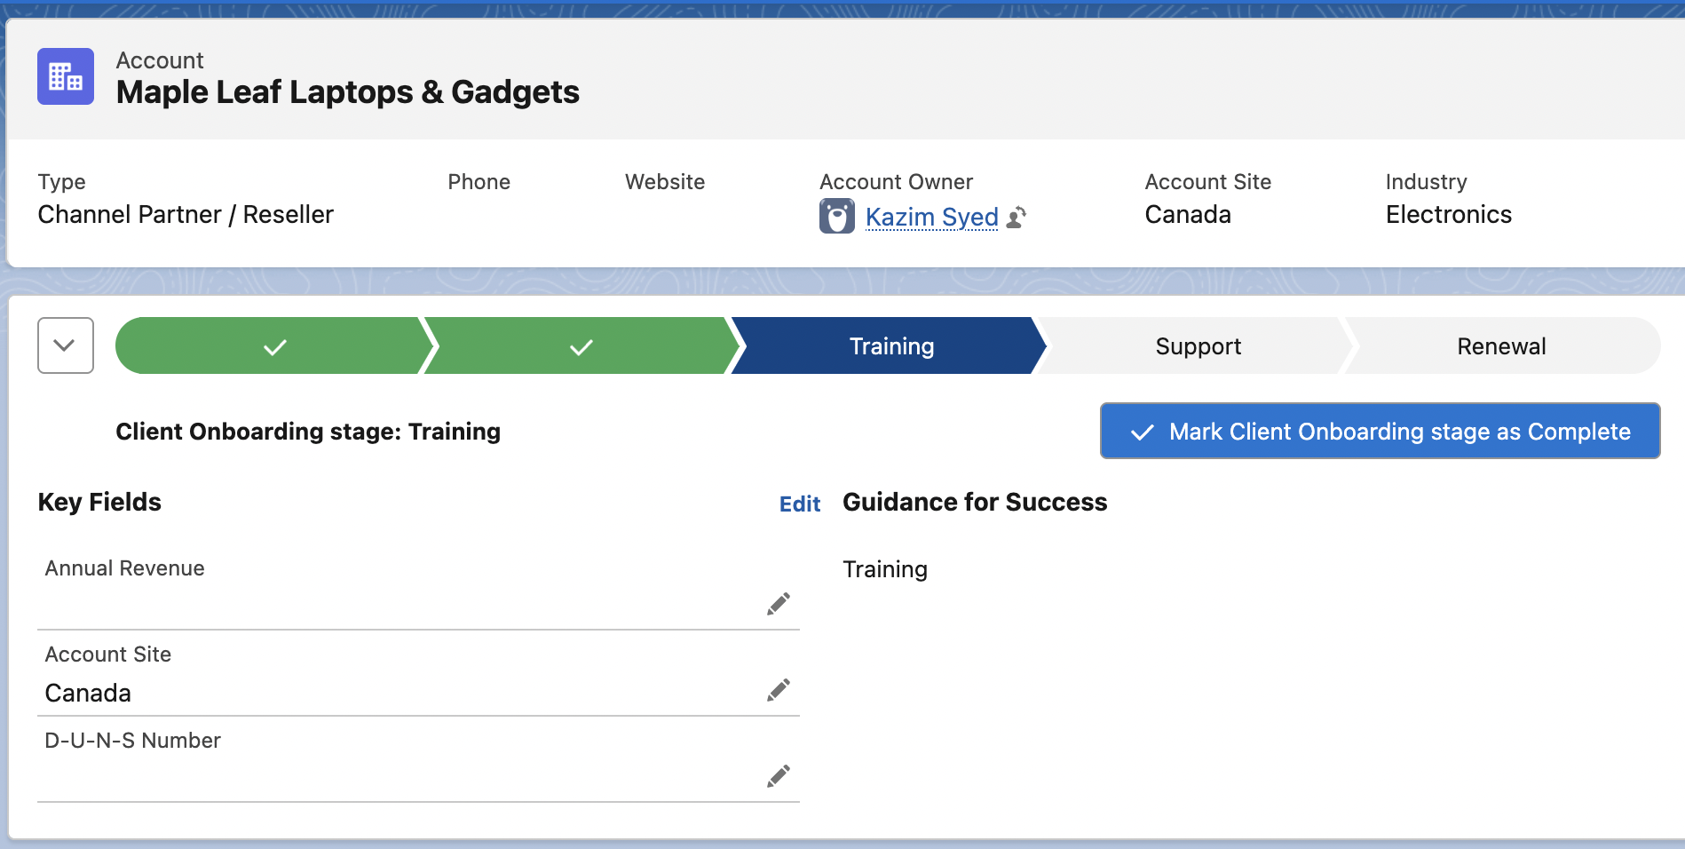

I cant see the path for warranty accounts. | 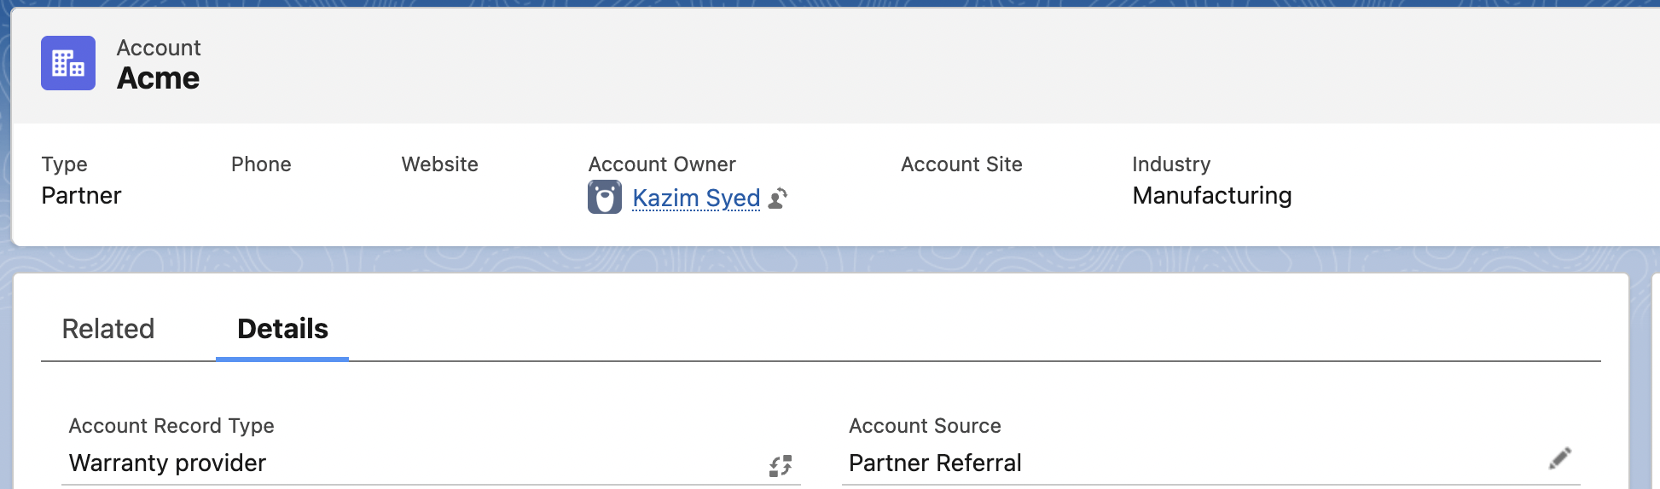
I login as Jim Lindsay I can see the path since he has custom marketing profile.
I login as Laura Garner I cant see the path since he has standard user profile.

