Formula field
subtitle

Heading 1

Heading 2

Heading 3

Heading 4

Logical condition
Keyword | Syntax & Purpose | Example Use Case
IF | IF(logical_test, value_if_true, value_if_false) | IF(ISPICKVAL(StageName, 'Closed Won'), "Win!", "Active") (Determines a simple status label.)
AND | AND(logical1, logical2, ...) | AND(AnnualRevenue > 100000, NumberOfEmployees > 50) (Checks if all conditions are met.)
OR | OR(logical1, logical2, ...) | OR(ISPICKVAL(Priority, 'High'), CreatedDate = TODAY()) (Checks if any condition is met.)
NOT | NOT(logical_test) | NOT(ISBLANK(CloseDate)) (Checks if the field is NOT blank.)
CASE | CASE(expression, value1, result1, value2, result2, else_result) | CASE(BillingCountry, "USA", 0.10, "Canada", 0.15, 0.20) (Returns a specific tax rate based on country.)

2. Text/String Keywords (For Text Manipulation)
Keyword | Syntax & Purpose | Example Use Case
& | text1 & text2 (Concatenation Operator) | FirstName & " " & LastName (Creates a full name.)
TEXT | TEXT(value) (Converts a number/date/picklist value into text.) | "The amount is: " & TEXT(Amount) (Used to mix numbers with text.)
VALUE | VALUE(text) (Converts a text string to a number.) | VALUE(External_ID__c) + 1 (Used if you need to perform math on a text field.)
MID | MID(text, start_num, num_chars) (Extracts a specific number of characters.) | MID(SerialNumber__c, 4, 3) (Pulls the 3-digit product code from a serial number.)
LEFT/RIGHT | LEFT(text, num_chars) / RIGHT(text, num_chars) (Extracts characters from the beginning or end.) | LEFT(AccountName, 1) (Pulls the first letter of the account name.)
BLANKVALUE | BLANKVALUE(expression, substitute_expression) (Returns a substitute if the expression is blank.) | BLANKVALUE(ShippingStreet, MailingStreet) (Uses Mailing Street if Shipping Street is empty.)

Function | What It Does | Example
CONCAT() | Joins multiple text values | CONCAT(FirstName, " ", LastName)
LEFT(text, num_chars) | Gets left part of a text | LEFT(Account.Name, 5)
RIGHT(text, num_chars) | Gets right part of text | RIGHT(Email, 3)
LEN(text) | Length of text | LEN(Phone)
LOWER(), UPPER() | Case conversion | UPPER(FirstName)
TRIM() | Removes spaces | TRIM(Name)
BEGINS(text, compare_text) | Returns TRUE if starts with... | BEGINS(Email, "sales@")
CONTAINS(text, compare_text) | Returns TRUE if contains... | CONTAINS(Email, ".org")
TEXT() | Converts number/date/picklist to text | TEXT(StageName)

3. Date & Time Keywords (For Time Calculations)
Keyword | Syntax & Purpose | Example Use Case
TODAY | TODAY() (Returns the current date only, with no time.) | TODAY() - CreatedDate (Calculates the number of days a record has been open.)
NOW | NOW() (Returns the current date and time.) | NOW() - LastModifiedDate (Calculates the time elapsed since the last update.)
DATE | DATE(year, month, day) (Returns a Date value from year, month, and day inputs.) | DATE(YEAR(TODAY()), MONTH(TODAY()), 1) (Calculates the first day of the current month.)
YEAR/MONTH/DAY | YEAR(date) / MONTH(date) / DAY(date) (Extracts the specific component from a Date field.) | MONTH(CloseDate) (Pulls the month number from the Close Date.)
ADDMONTHS | ADDMONTHS(date, num_months) (Adds/subtracts a number of months to a date.) | ADDMONTHS(Service_Start_Date__c, 12) (Calculates a one-year contract end date.)

Function | What It Does | Example
TODAY() | Current date | TODAY() - CreatedDate
NOW() | Current date & time | NOW() - LastModifiedDate
DATE(year, month, day) | Creates a date | DATE(2025, 12, 31)
YEAR(date), MONTH(date), DAY(date) | Extract parts | MONTH(CloseDate)
DATEVALUE(datetime) | Converts datetime → date | DATEVALUE(CreatedDate)
DATETIMEVALUE(text) | Converts text → datetime | DATETIMEVALUE("2025-01-01 00:00:00")
CASESAFEID(Id) | Converts 15-char ID → 18-char | CASESAFEID(Id)
ADDMONTHS(date, num) | Adds months | ADDMONTHS(TODAY(), 6)

4. Check/Validation Keywords (For Data Quality)
ISBLANK | ISBLANK(expression) (Checks if a field has no value. Works on text, number, and date fields.) | IF(ISBLANK(Next_Step__c), "Needs Follow-up", "On Track")
ISNULL | ISNULL(expression) (Similar to ISBLANK, but generally for numbers, dates, and currency.) | IF(ISNULL(Discount__c), 0, Discount__c) (Treats a null discount as 0.)
ISPICKVAL | ISPICKVAL(picklist_field, text_literal) (Checks the value of a non-multi-select picklist field.) | ISPICKVAL(StageName, 'New Lead') (Only works in validation rules and formula fields.)
ISCHANGED | ISCHANGED(field) (Checks if the value of a field has been changed by the user.) | ISCHANGED(OwnerId) (Mostly used in Validation Rules, Workflow Rules, and Process Builder/Flow.)

Function | What It Does | Example
IF(condition, true_value, false_value) | Conditional logic | IF(Amount > 10000, "High", "Low")
CASE(expression, when1, then1, when2, then2, else) | Multi-condition switch | CASE(StageName, "Prospecting", 10, "Closed Won", 100, 0)
BLANKVALUE(expr1, expr2) | If blank, use fallback | BLANKVALUE(Discount__c, 0)
ISBLANK(field) | Checks blank | ISBLANK(Phone)
ISNULL(field) | (Older, same as ISBLANK for non-text fields) | ISNULL(Email)
ISPICKVAL(field, text) | Checks picklist value | ISPICKVAL(StageName, "Closed Won")
TEXT(picklist) | Converts picklist to text | TEXT(StageName)

Operators:
Operator | Name | Purpose | Example
+ / - / * / / | Math Operators | Addition, Subtraction, Multiplication, Division. | (Amount * 0.10) / 1.15
= / != | Equality | Equals to / Not equals to. | RecordType.Name != "Admin"
> / < / >= / <= | Comparison | Greater than, Less than, Greater than or equal to, Less than or equal to. | CloseDate < TODAY()
& | Text Concatenation | Joins two strings of text together. | "ID: " & Account_Number__c
() | Parentheses | Groups expressions to control the order of operations. Use heavily! | (Amount - Discount) * Tax

Function | What It Does | Example
Cross-object reference | Access parent object fields | Account.AnnualRevenue on Opportunity
$User | Reference current user info | $User.Department, $User.Id
$Profile | Current user’s profile info | $Profile.Name
$Organization | Org-level info | $Organization.Name
$RecordType | Record type ID/name | $RecordType.Name

Function | What It Does | Example
VLOOKUP() | Lookup a value from another object (special use) | VLOOKUP($ObjectType.Pricebook2.Fields.Name, Name, "Standard Price Book")
HYPERLINK(url, friendly_name) | Creates clickable link | HYPERLINK("/" & Id, Name)
IMAGE(url, alt_text, height, width) | Shows image | IMAGE("/img/samples/flag_green.gif", "Green", 15, 15)
PRIORVALUE(field) | Value before record update (for validation/workflow) | PRIORVALUE(StageName)

1.
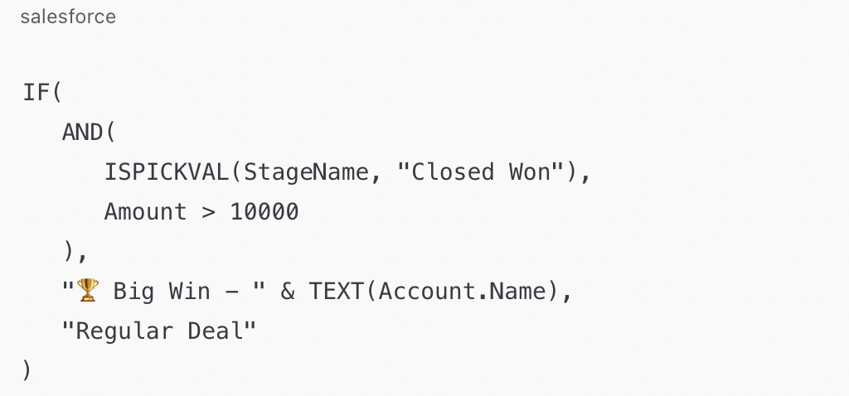
2.
Example 2: Opportunity Win Probability Category Formula: IF( Probability > 75, "🔥 Hot", IF(Probability > 40, "🌤 Warm", "❄️ Cold"))

Why it matters: Visually categorize sales opportunities using nested IFs.

🎯 Tip: Limit nesting; for complex logic, consider CASE() instead of deep IF chains.
3.
Example 5: Smart Lead Score Label Formula: CASE( TRUE, Score__c >= 90, "⭐ Elite", Score__c >= 70, "🔥 Promising", Score__c >= 40, "🌱 Nurture", "❄️ Cold" )

Why it matters: Demonstrates advanced CASE logic with Boolean evaluation.

🧠 CASE(TRUE, …) lets you write readable, scalable logic — cleaner than nested IFs!
Example 4: Subscription Renewal Reminder Formula:

IF( TODAY() > (Renewal_Date__c - 30), "⏰ Renew Soon", "✅ Active" )

Why it matters: Flags records for attention before critical renewal dates. 📅 Remember: Use `TODAY()` for date comparisons, not `NOW()`

