Salesforce

subtitle

Heading 1

Heading 2

Heading 3

Heading 4

360 view of unified data across  sales, service, marketing, commerce, and more. | With Salesforce, every employee has the apps, trusted AI, and unified data they need to exceed expectations and make customers happier. Our portfolio of solutions works across your entire business to give you a 360-degree customer view from unified data across sales, service, marketing, commerce, and more.
Trusted AI: Einstien | It all happens right within CRM where your employees are working and assisted by our trusted AI, Einstein.
CRM + AI + Data + Trust. | In a nutshell, Salesforce is the world’s #1 AI CRM that helps you connect with your customers in a whole new way with CRM + AI + Data + Trust.

Bring Ai to salesforce
 | AI agents can take action autonomously.
Agentforce | Using Agentforce, our groundbreaking suite of customizable agents and tools, you can build autonomous agents that assist your employees and customers with common business interactions.
 | Agentforce’s capabilities are made possible by Salesforce’s unique ability to deliver a unified experience between apps, models, and data layers.
Common metadata model – seamless ways for apps.  Service cases become sales opportunities. | And it all happens on one platform that’s truly integrated in one common metadata model—which is a fancy way of saying data that describes data that creates a seamless way for apps to communicate and work with each other. AI can learn from that 360-degree view and apply its full context to every customer experience, wherever they’re interacting with your business: Service cases become sales opportunities. Merchants can resolve service issues.

Why
Because u don’t want disjointed data. | Salesforce helps you overcome these challenges by helping you create a 360-degree view of your customers in every app to enable your employees to meet your customers where they are in their journey. Any company can create a Customer 360 with our industry-leading CRM apps, and because every app runs on the same integrated platform, all your AI, data, customizations, and upgrades work seamlessly in every experience.
 | Unlike disconnected point solutions for every separate team, Salesforce apps work on one platform, so you have fewer contracts, integrations, trainings, and out of sync release cycles that slow down your business.

Mike wheeler course
Two sides to Salesforce platform, the backend that is the setup menu and the frontend that is accessible using App launcher.
Note: You can click on the setting → Setup.
  Two sides | Salesforce: Restaurant analogy. Has a front side and the backside(kitchen).
80% of end Users focus on Marketing, services & Sales | Vast majority of user see in salesforce is Something around Marketing, sales or service.

Get a new salesforce instance: https://trailhead.salesforce.com/promo/orgs/analytics-de

Configuration and Setup

Prompt
Prompt: | The first learning objective in the Salesforce Certified Administrator Exam Guide is: Describe the information found in the company settings (for example: company settings fiscal year, business hours, currency management, default settings). Give me a conceptual prompt I should ask as a new Salesforce learner in order to fully understand these topics found in the first learning object: fiscal year, business hours, currency management and default settings, in Salesforce company settings. Place these conceptual prompts in a table, with the prompts to the left and then respond to each prompt in the column on the right.

Conceptual Prompt | Explanation
What is a fiscal year in Salesforce, and why would a company customize it? | A fiscal year defines the 12-month financial reporting period for a company. Salesforce allows for Standard Fiscal Years (based on the Gregorian calendar) or Custom Fiscal Years (which can vary in start/end dates or structure). Companies customize it if their financial year doesn’t align with the calendar year.
How do business hours and holidays impact Salesforce automation? | Business hours and holidays define the working schedule for a company in Salesforce. They are crucial for features like case escalation rules and entitlement processes, which use these settings to calculate response and resolution times accurately.
Why is currency management important in Salesforce, and how does multi-currency work? | Currency management allows Salesforce to handle deals in various currencies. Multi-currency enables users to enter amounts in their local currency while the system stores data in the corporate currency. With advanced currency management, currency exchange rates can be tracked over time for historical accuracy.
What are default settings in company settings, and how do they affect user experience? | Default settings in Salesforce include items like the default locale, language, time zone, and currency. These impact how users see data (e.g., date format, number format) and streamline the onboarding experience by pre-populating user profiles with company-wide preferences.

Case escalation rules: bumps up the incident based on case type, priority and business working hours and holidays to a higher level supporting agent. If an incident hasn’t been resolved within 4 hrs during business hour, the case is reassign to tier 2 supporting agent. The users are notified and alerts are triggered.
Entitlement processes: define SLA’s by specifying steps and timelines to response and resolution. If a gold level premium customer raises an incident, the incident must be responded within 1 hour and the issue must be resolved within 1 day.

Feature | Case Escalation Rules | Entitlement Processes
Focus | Case reassignment/time-based escalation | SLA tracking and milestone management
Trigger | Time elapsed without resolution or update | Specific service milestones (e.g., response)
Used For | Making sure no case is forgotten | Ensuring promised service levels are met
Business Hours Aware? | Yes | Yes

Section 2:
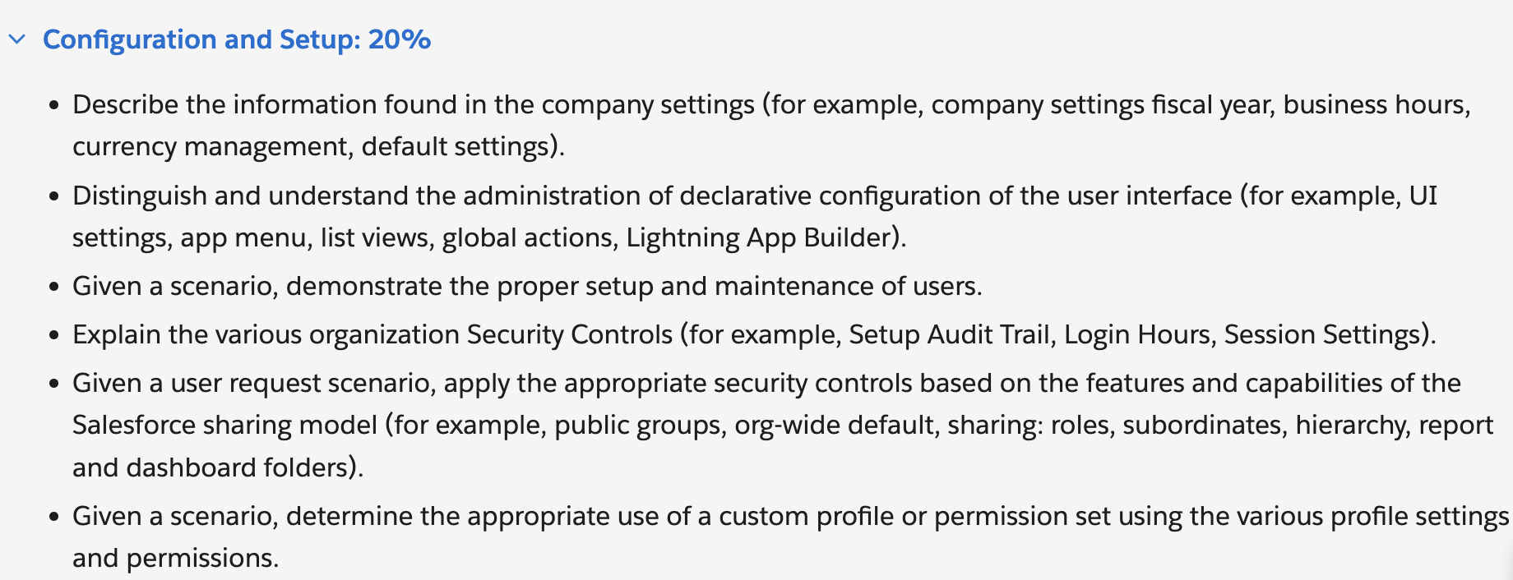

Fiscal year
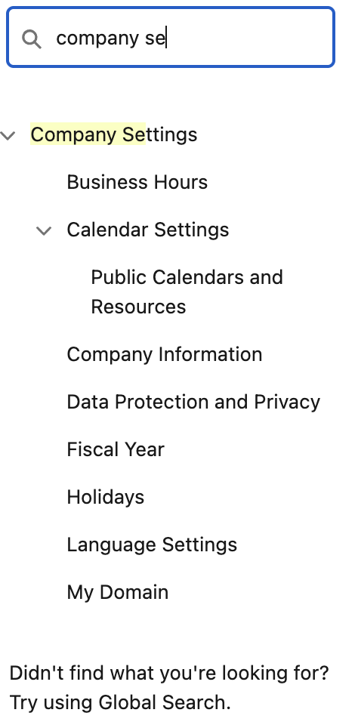 | 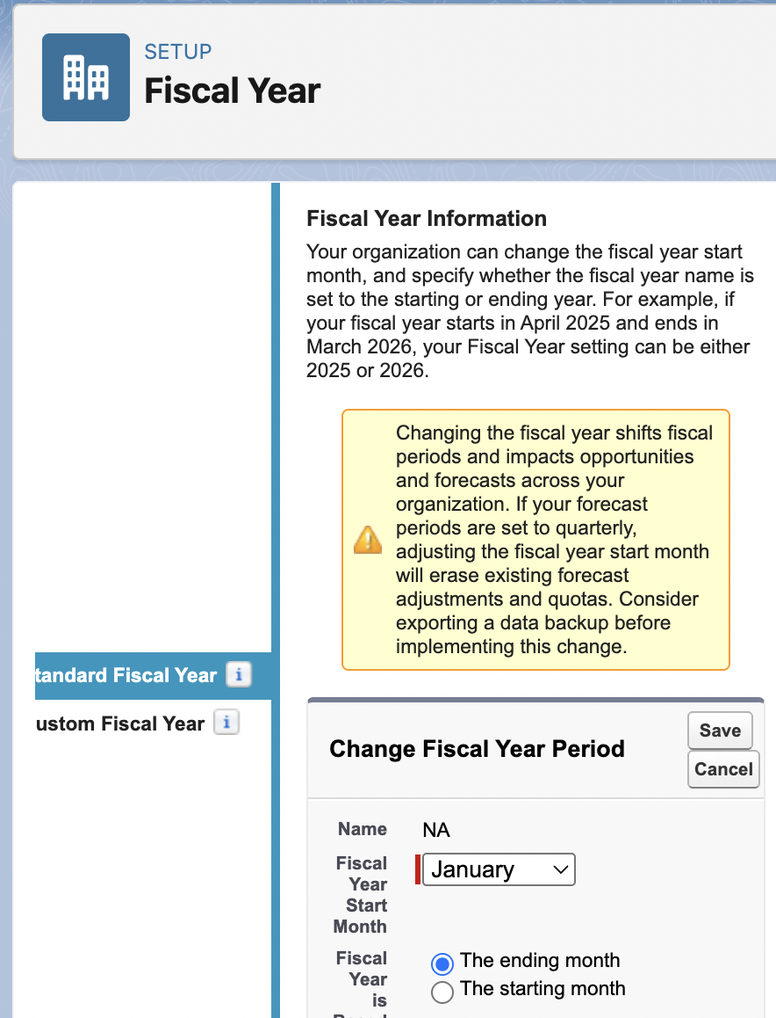

Switching between Salesforce classic and Salesforce lightening
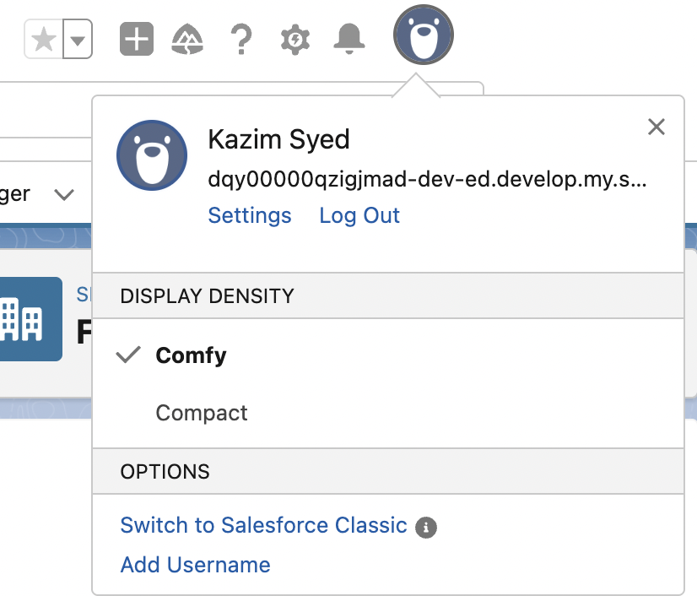

Business hours
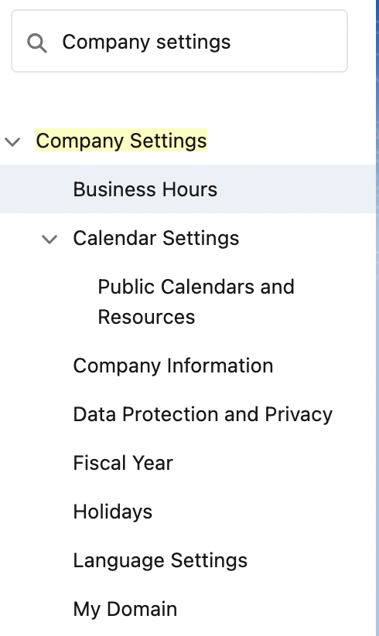 | 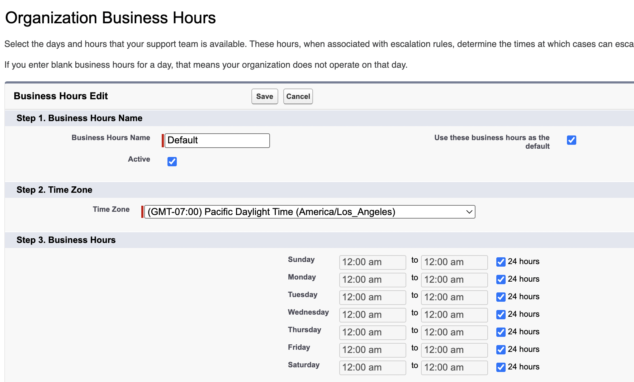

Currency Management
- Support 150 different currencies.
- facilitates global trades with suppliers worldwide.
- Customer retention

Default settings
Edits the following | Edit organization info  - Company name  - Address  - Logo
Default locale | Impacts the language and numeric value representation.  Like data, month and number format.  You can adjust the time Zones.  (Eastern Standard time or Daylight savings time)

Summary
Settings: Advance currency management, Default settings, Fiscal years and Business hours. | Accurately setting this info impacts  - SLA’s  - Reports  - Forecasting

Part 2
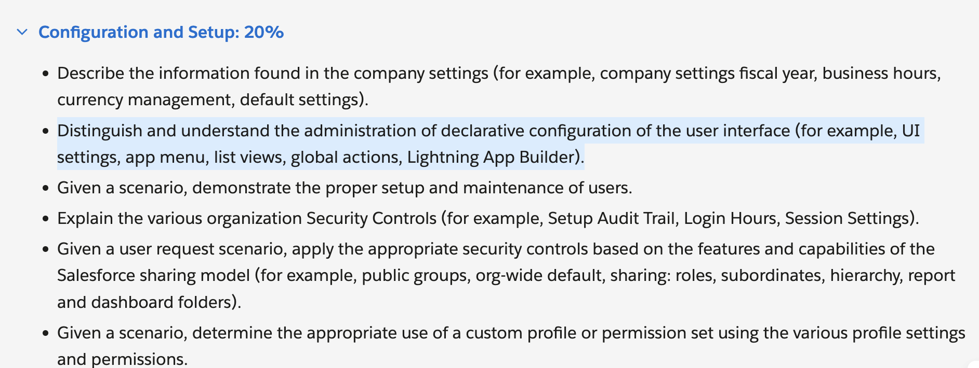

Distinguish and understand the administration of declarative configuration of the user interface (for example, UI settings, app menu, list views, global actions, Lightning App Builder).
Declarative configurations are configuration done solely using clicks and no code.
Setup → User interface → User interface Settings

Here’s a table with conceptual prompts and responses to help you understand the key topics in the Salesforce Certified Administrator Exam Guide’s second learning objective:

| **Conceptual Prompt** | **Response** |

|-----------------------|-------------|

| **What are Salesforce UI Settings, and how do they impact user experience?** | UI Settings in Salesforce control the look and feel of the interface for users. These include enabling/disabling features like the "Enhanced Lookup" or "Enable Hover Details" in list views. Administrators can configure these settings to improve usability, streamline workflows, and ensure users have access to the right tools. |

| **How does the App Menu work in Salesforce, and why is it important for navigation?** | The App Menu is the primary navigation tool in Salesforce, allowing users to switch between different apps (e.g., Sales, Service, Marketing). Admins can customize which apps appear, set default apps, and control visibility based on user profiles. A well-organized App Menu ensures users can quickly access the tools they need. |

| **What are List Views, and how can they be customized for different users?** | List Views display records (e.g., Accounts, Contacts) in a tabular format with filters and sorting options. Admins can create, modify, and share custom List Views to help users focus on relevant data (e.g., "My Open Opportunities"). Filters, columns, and visibility can be tailored per user profile or permission set. |

| **What are Global Actions, and how do they differ from object-specific actions?** | Global Actions are quick actions available across Salesforce (e.g., Log a Call, Create a Task) that aren’t tied to a specific record. Unlike object-specific actions (e.g., "New Opportunity"), they appear in the global header or utility bar, providing shortcuts for common tasks regardless of the page a user is on. |

| **What is the Lightning App Builder, and how does it help customize Salesforce pages?** | Lightning App Builder is a drag-and-drop tool for designing and customizing Lightning pages (e.g., Home Pages, Record Pages). Admins can add, remove, or rearrange components (e.g., Related Lists, Charts) without code, tailoring the UI to different roles (e.g., Sales Reps vs. Support Agents). |

This table breaks down each concept with a clear question and explanation, helping you grasp how declarative configuration shapes the Salesforce user interface. Would you like any topic explored in more depth?

User interface
You can setup organization wide changes to User interface behavior
Such as
- Enhanced lookups
- Enable hover
- Enable Separate loading of related lists

User interface
- Enable collapsable sections
- Show Quick Create
- Enable hover details
- Enable inline editing
- Enable related list hover links
- Enable sort by multiple columns in related lists
Setup  - Enable Enhanced page editor  - Enable Streaming api  - Enable set audit fields upon Record creation and update records with inactive Owners” user permissions | Makes page layout customization faster and more intuitive especially in lightning experience.  Allows real-time notifications when records change (via PushTopics or Platform Events).  Enables live dashboards, chat apps, or event-driven workflows without constant polling.  Real-time alerts (e.g., stock price changes, support ticket updates).
What is polling | When a system or a device constantly checks the status of another device to see if its ready or if a certain condition is met.  This checking can be done in regular intervals or when certain conditions are met.  Once the conditions are met, the system can proceed with the intended action.  Computer-printer to see if it has completed the current page so it could perform the next page.  In a system design context, polling can involve a central system (like a server) regularly checking multiple devices (like sensors or other systems) to gather data or monitor their status.
Enable set audit fields upon Record creation and update records with inactive Owners” user permissions | Set Audit Fields: Lets admins modify CreatedDate/CreatedById during data imports.Critical for historical data migration.Update Records with Inactive Owners: Allows editing records owned by deactivated users.Prevents orphaned records from becoming uneditable.

User Interface - Continued
User Interface → App Menu | Organization wide default for the order of apps for users. And visibility of apps in apps launcher.
This order will be accessible
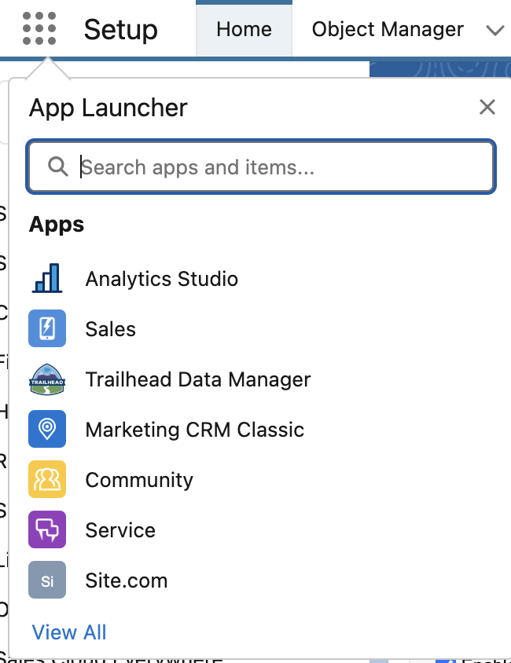

User personal customization(User based order) doesn’t not impact org-wide changes. | You can customize it for yourself. Using drag and drop feature in App launcher when he opens view All in vertical App Launcher option.
 | Applications which are not assigned to me are invisible based on my profile. If I want access to a specific application I can be granted that by making adjustments on my profile or permission sets.

List view

| **What are List Views, and how can they be customized for different users?** | List Views display records (e.g., Accounts, Contacts) in a tabular format with filters and sorting options. Admins can create, modify, and share custom List Views to help users focus on relevant data (e.g., "My Open Opportunities"). Filters, columns, and visibility can be tailored per user profile or permission set. |
Segment and prioritize records and share views to team members and perform bulk operations on multiple records all at once.
Use-cases:
Sales representative filtering their opportunities by stage, support team viewing cases by priority or manager tracking their progress of their leads in their pipelines.

Marketing
Account vs customer vs client
Customer: limited conversation after service are delivered.
Client: someone who buys a service from a company. They usually keep in contact with the company until the service is complete. Sometimes, a contract is involved.
The client needs her wedding photgrapher to send the files now!"
"The lawyer met with their client to review the case"
Note: More Conversation involved in client. And ongoing consultation and tailored solution.
Account: Usually an account is a business buying a service from another business, but it could also be an individual. An account will keep in contact with the company for a long time, because they need the same product or service on a regular basis. Accounts are usually large, and involve a contract.
"This account needs ice delivered from us once a week"
"Which salesman will be in charge of the Smith account?"

 | 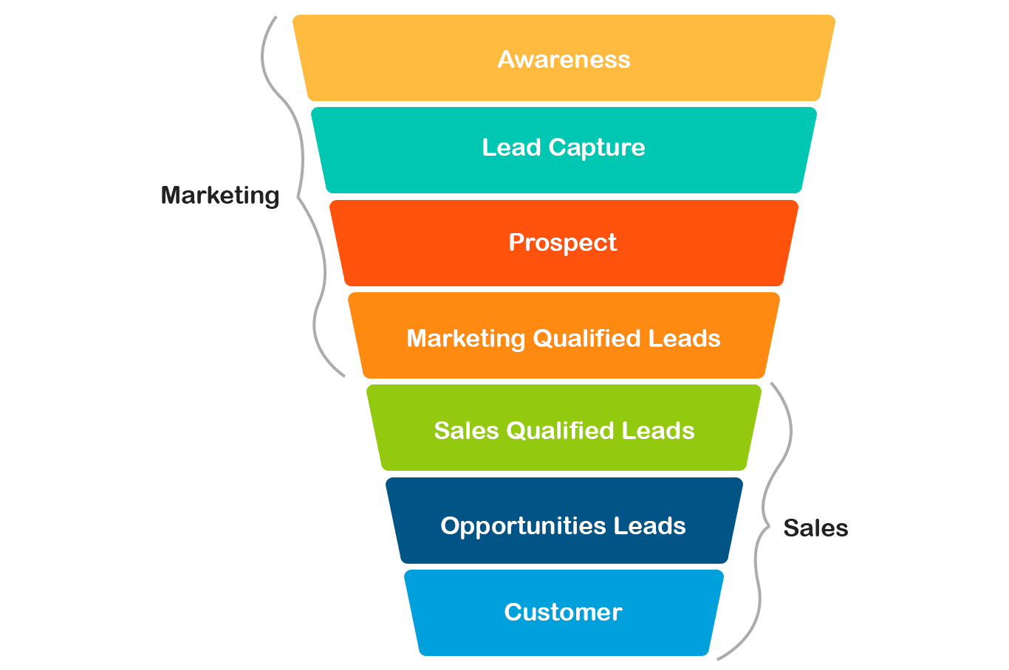
 | What are leads in marketing?
Leads(General lead) | Individual or organization that have shown some interest to your Awareness campaign.
Engagement | Leads engage with a company's brand in various ways, such as visiting a website, filling out a form, downloading content, or signing up for a newsletter.
Prospect(Potential lead) | Potential customer who has been identified as a good fit based on certain criteria and is further along the sales funnel than a general lead.  Factors can be industry, budget, demography and timeline.  Prospecting involves identifying and vetting with a potential customer who align with company’s ideal customer profile.  Once potential customers are identified, marketing efforts are done to nurture these relationship and move them further down the sales funnel.
MQLs | Some marketing teams categorize leads further, often distinguishing between marketing qualified leads (MQLs) and sales qualified leads (SQLs). MQLs are those who have shown interest through marketing activities but haven't yet been vetted by sales.
SQLs | SQLs are leads that sales teams have deemed likely to become customers based on their engagement and expressed interest.

Funnel | - Suspects  - Prospects  - Leads  - Customers
 | Marketing vs. Sales: Teams may define stages differently (e.g., Marketing calls everyone a "lead"; Sales reclassifies them as "prospects").

Analogy
Suspects  leads  prospects  customer | You have a coffee shop, every passing by the shop are suspects.  Every stood near the glass window reading the offerings are leads.  Every who entered the shop are Prospect.  Everyone who buys the coffee is a customer.

Sales Opportunities vs leads vs prospects
Leads | These leads are often generated through various marketing endeavours, including advertising campaigns, engaging social media content, or targeted email marketing initiatives.
MQLs → SQLs | Recognizing and prioritizing hight quality leads is essential for optimising sales strategy and conversion rates.  - If that leads fit company’s ideal customer profile based on factors like industry, company size, budget.  - Some leads might need nurturing to transition from potential lead to customer.  - Promptly addressing their queries and concerns
Prospect | They are qualified by some criteria. Another way to identiy lead is through a questionnaire. I have a weighted graph in my mind.  Prospect → lead nurturing.
Sales Opportunity | Involves assessing prospect’s needs, budget and timeline
Two tier qualification | Two phase Qualification: Opportunity level and Stakeholder level.  This process includes opportunity level qualification to determine if the prospect could effectively implement the company’s offering and benefit from the product or service at the opportunity level, before proceeding to the stakeholder level.
 | Once qualified, manage it through a sales process this involves developing a sales strategy, creating a timeline and assigning resources to the opportunity.
Benefits of tracking and managing sales opportunities
- Forecast Future Revenue
- Sales efficiency
- Improved Customer satisfaction → Advocacy
 | 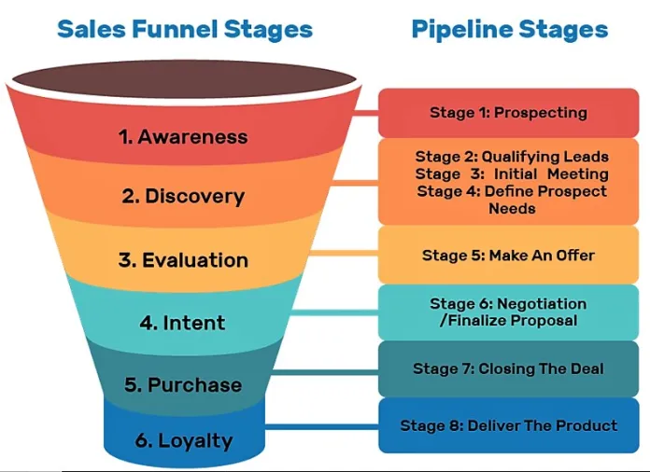
Leads vs Sales opportunity | Leads require more nurturing and cultivation to move them further down the sales funnel, while opportunities demand more focused attention and tailored sales strategies. By understanding this distinction, sales professionals can optimise their approach, improve lead conversion rates, and ultimately drive revenue growth.
Stages of sales opportunity:
- Prospecting: potential customer are identified and contacted. Generate leads through Social media, marketing, email marketing and even cold calling.
- Qualifying: identify prospects who are more likely to transition into customer. Based on industry, timeline and budget.
- Proposal: When the sales person presents a customized solution to the prospects needs. It outlines the product or service, the benefit it offers and the terms of the sale. The goal is to convince the deliverables is the best solution.
- Closing: finalize the sale and collects the payment. Turn the prospect into customer.

How does salesforce helps
Create custom fields and report to track specific information.
E.g:
Real estate agent: leads from open houses, online listings and referrals.
Track property preferences, budget and contact information.

Software salesperson: IT needs. Generate leads throught webinars and ads.
Car salesperson: vehicle preference.

App launcher → Sales
Sales has many Custom Objects
Opportunity, lead, Contacts.
Within Sales Opportunity | 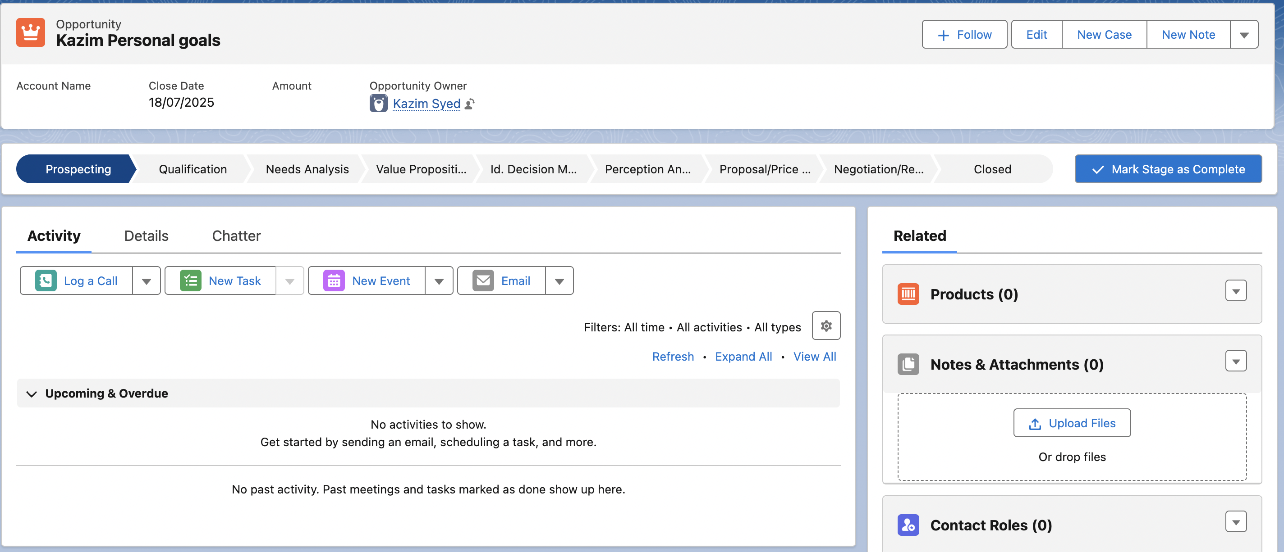
- Prospecting
- Qualification
- Need Analysis
- Value proposition
- Identify Decision makers
- Perception Analysis
- Proposal/Price quote
- Negotiation
- Closed Win
- Closed Lost
Prospecting: | What it means: Initial contact is made; potential interest identified.  - Activities: Identify leads, reach out to potential customers.  - Stage Type: Open  - Probability: ~10%
Qualification | Assessing whether the lead is a good fit and has potential. Activities: Used BANT(Budget, Authority, Needs, Timeline. And industry.

Need Analysis | Dive into Customer requirements and discover pain points. Activities: gathering detail requirements, identifying problems to solve.
Value proposition | How your product/service meets your customer needs.  Activities: Presenting benefits, ROI, demos, differentiation, cost-benefit analysis, competitive advantages.
Decision makers | Identify key stakeholders or decision-makers in your customer organization.  Activities: Engage with decision makers and understand approval process.
Perception Analysis | Gauge customer’s attitude toward your solution.  Activities: Handles Objections, gather feedback.
Proposal/Price Quote | Submit a proposal or pricing quote to the customer.  Negotiation and finalizing terms.
Negotiation | Active discussions on pricing, terms and customer. Handle final objections, legal review and discounts.
Closed Won | Customer has accepted the product and the deal is successful.  Activities: contracts signs, delivery begins.
Closed Lost | Deal did not go through.  Document reason, possibly nurture for future.

Stage | Role of Value Proposition | Key Actions
1. Prospecting | Identify why the prospect should care about your solution. | Research pain points; tailor initial messaging to highlight relevance.
2. Qualification | Confirm your solution aligns with their needs (BANT). | Ask: "Does our value prop solve their top challenges?"
3. Needs Analysis | Refine the value prop based on deeper discovery. | Use questions like: "What would make this a must-have solution for you?"
4. Proposal | Clearly articulate value in the quote/proposal (ROI, differentiation). | Include case studies, cost-benefit analysis, and competitive advantages.
5. Negotiation | Defend the value prop against objections (price, timing, features). | Re-emphasize unique benefits: "Our solution saves X hours/week because..."
6. Closed Won | Reinforce value to ensure smooth onboarding and adoption. | Share success stories, ROI metrics, and training aligned to their goals.
7. Closed Lost | Analyze if the value prop was misunderstood or misaligned. | Ask for feedback: "What could we have offered to win your business?"

List views
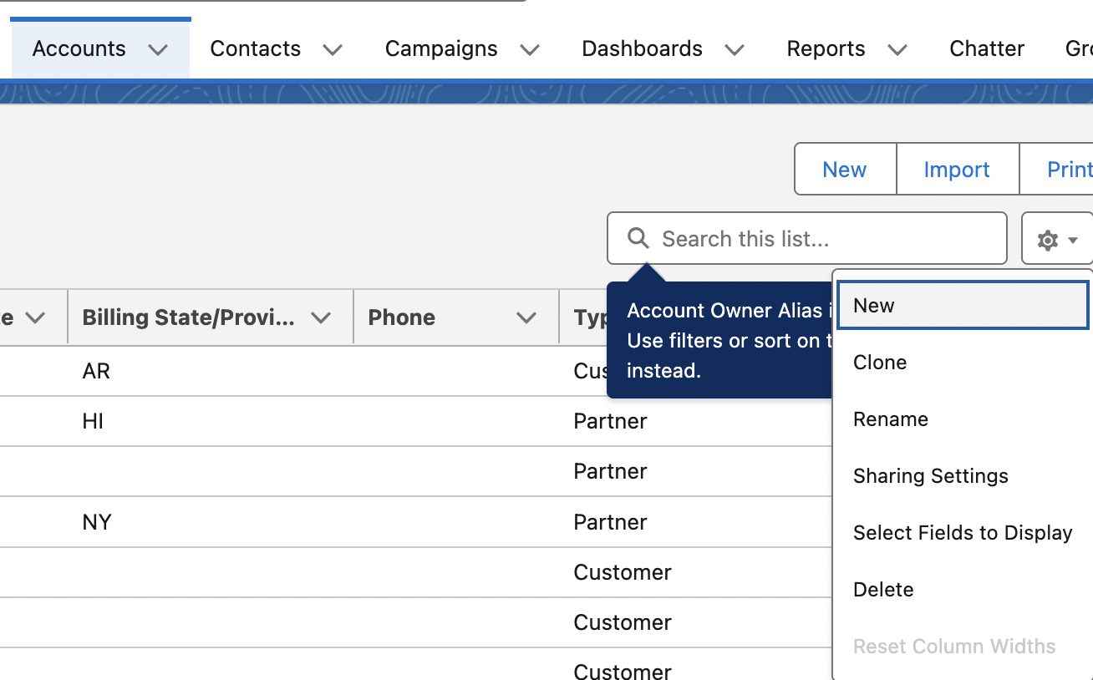 | Select fields to display:  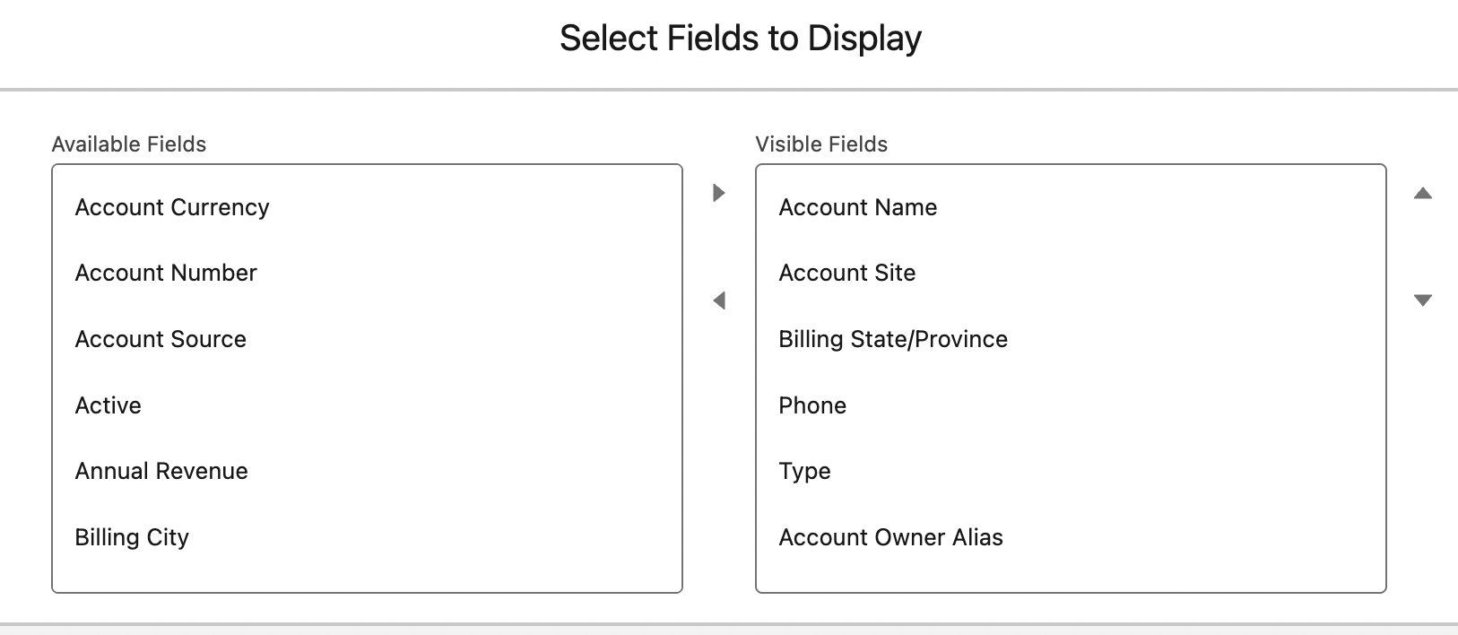

Global Actions – logging a call
global actions for user to log call detail, create records and even send emails all together in one place.
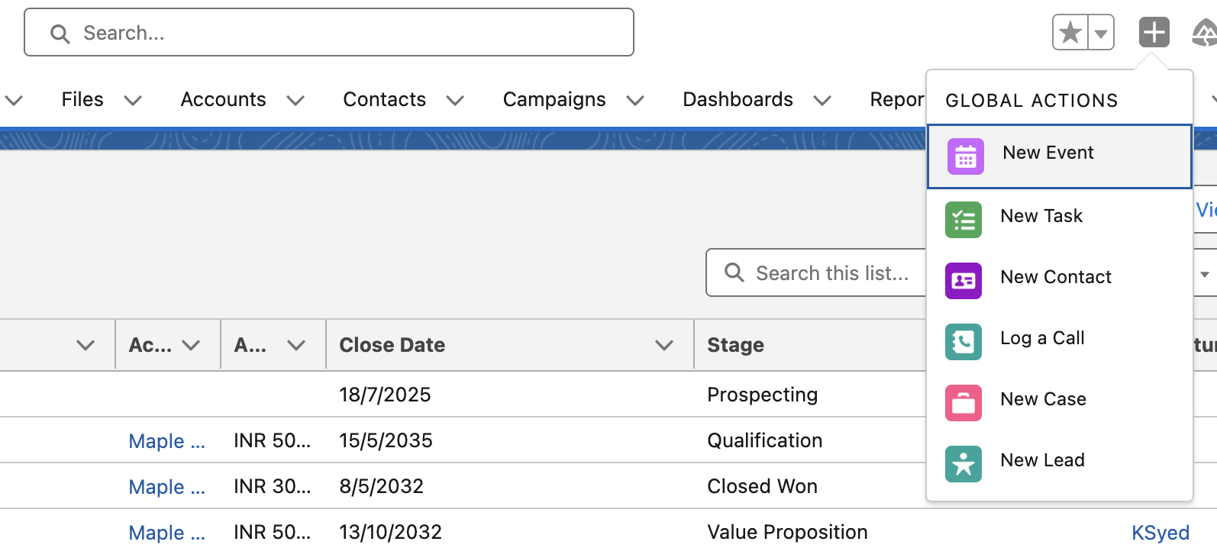 | Click on the plus.
I choose to log a call. And inside the open window. I can write some stuff. Create a new contact or matched with an existing one. Also, related it to an account. | 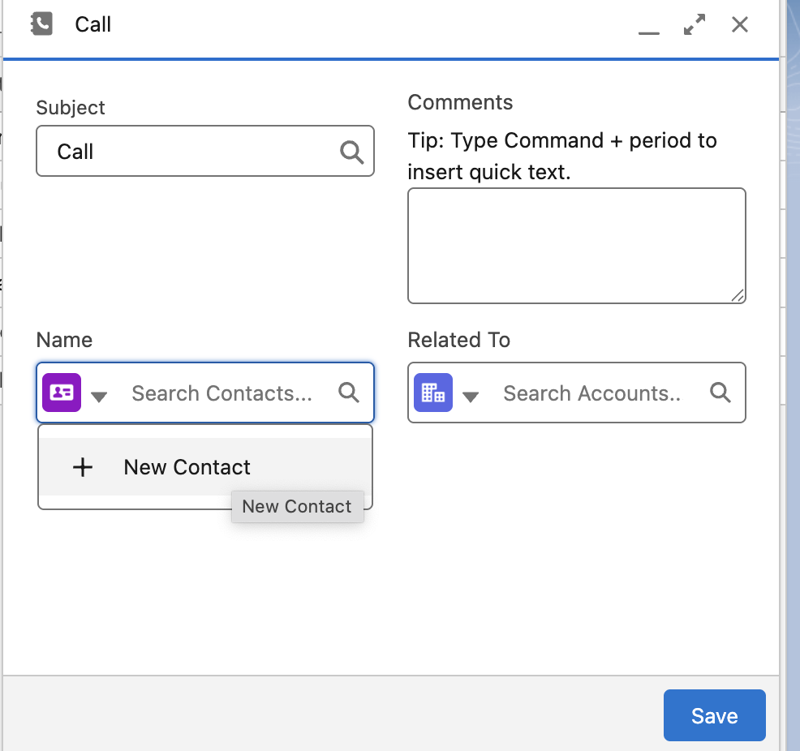

Creating a new global action and publisher layout
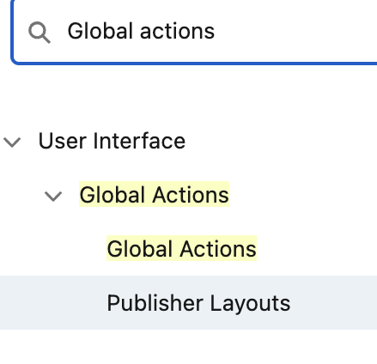 | 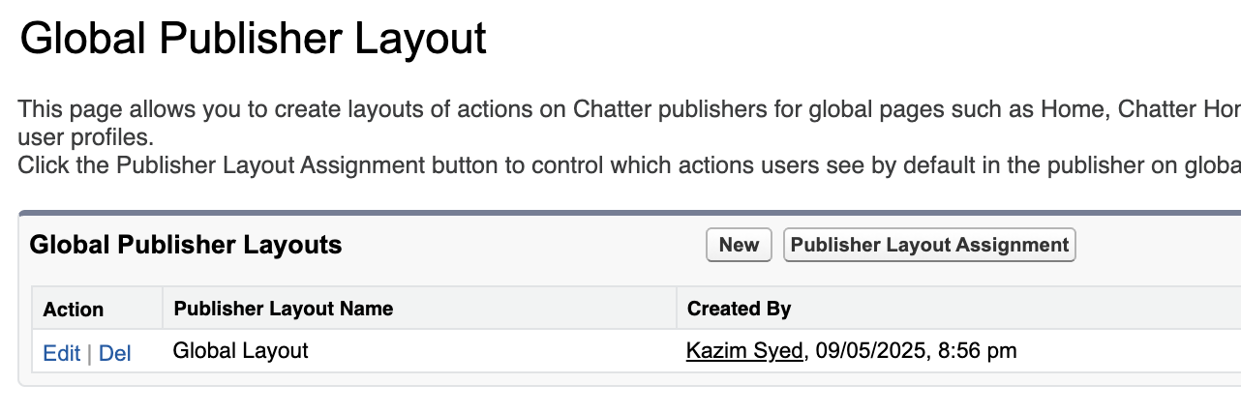
I drag the email section to Salesforce classic publisher from Quick actions.  And drag email section from Mobile and lightning actions into Salesforce actions. | 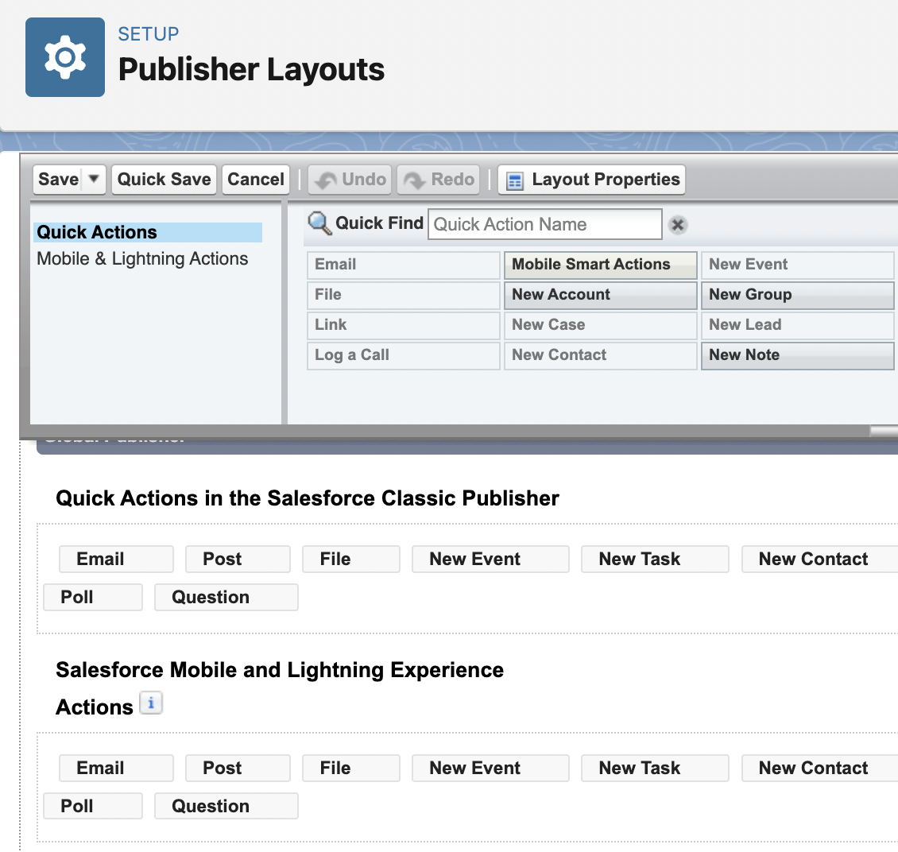

Global Actions: logging call
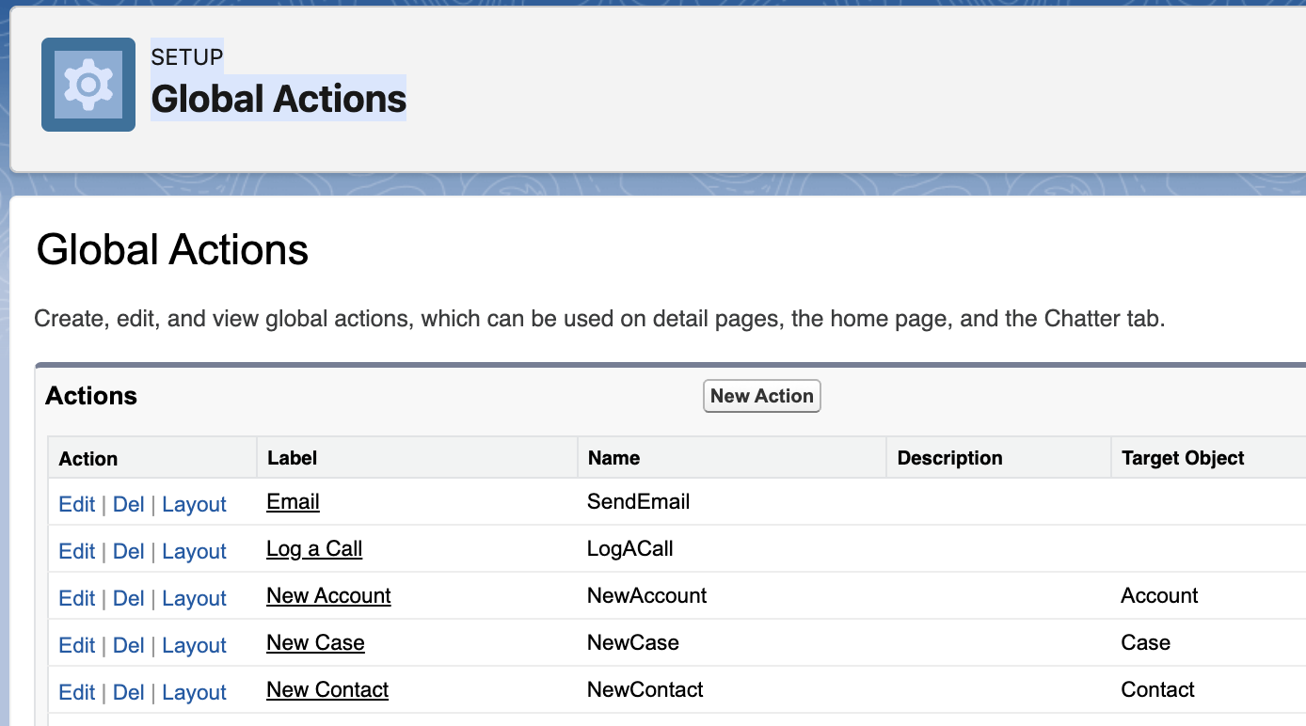 | New Action
Target Objects: Contract( A standard object) | 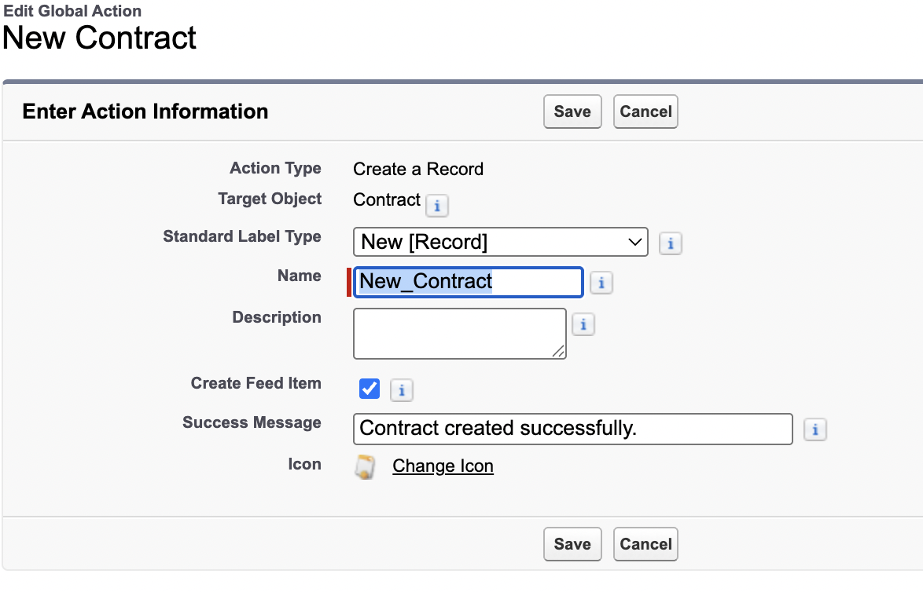
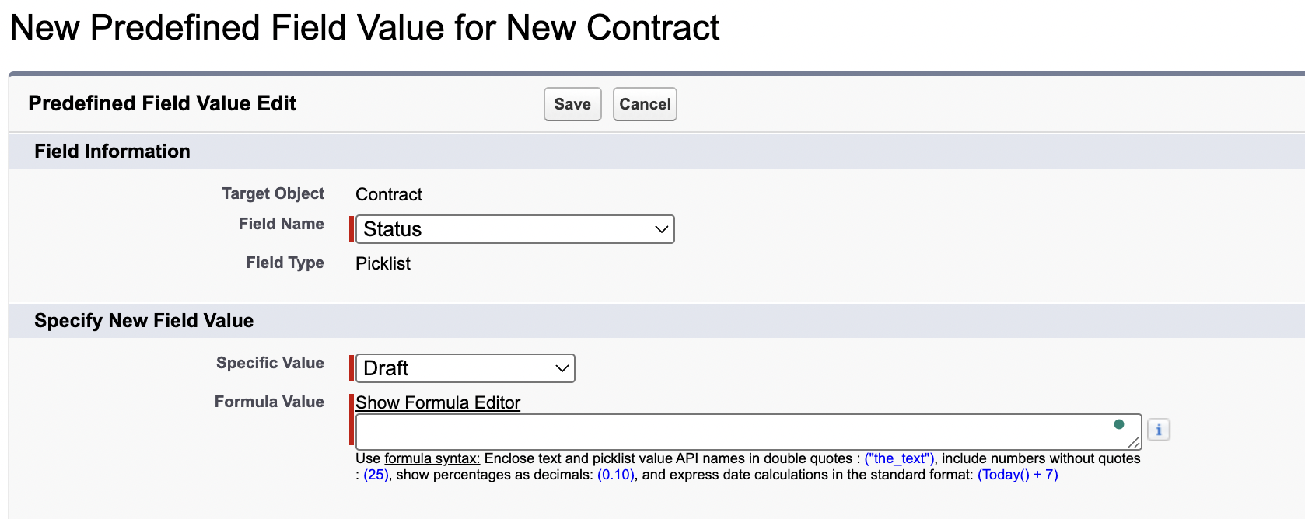 | You can set predefined values.  Such as for status: draft.  Draft → in approval → Activated
You can edit layout. Here, u can add more fields. Using the drag and drop feature. | 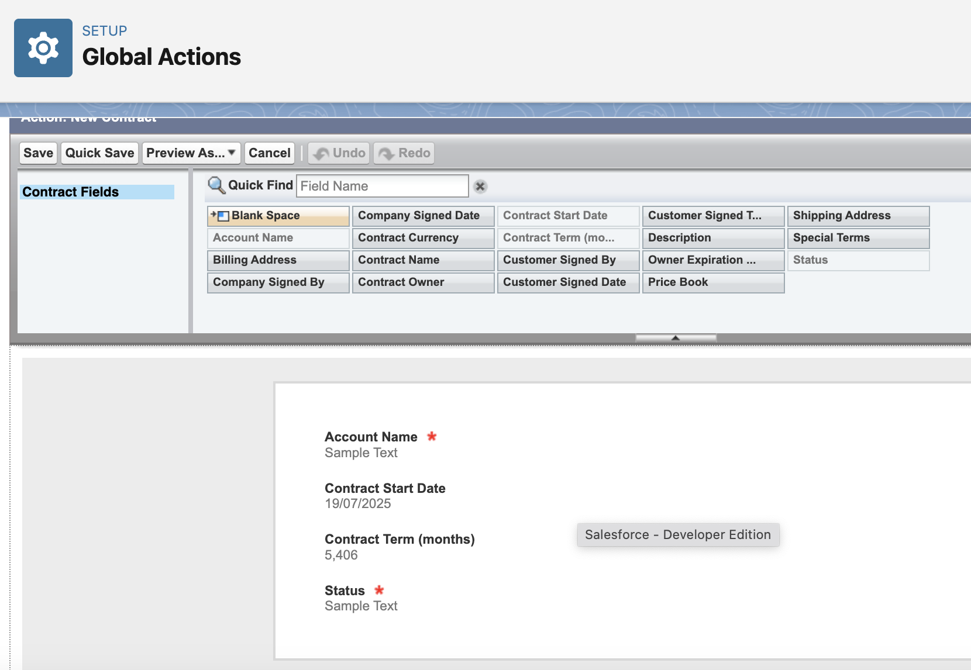
Last step: You have to go to the publisher layout and drag and drop that element.

Output:
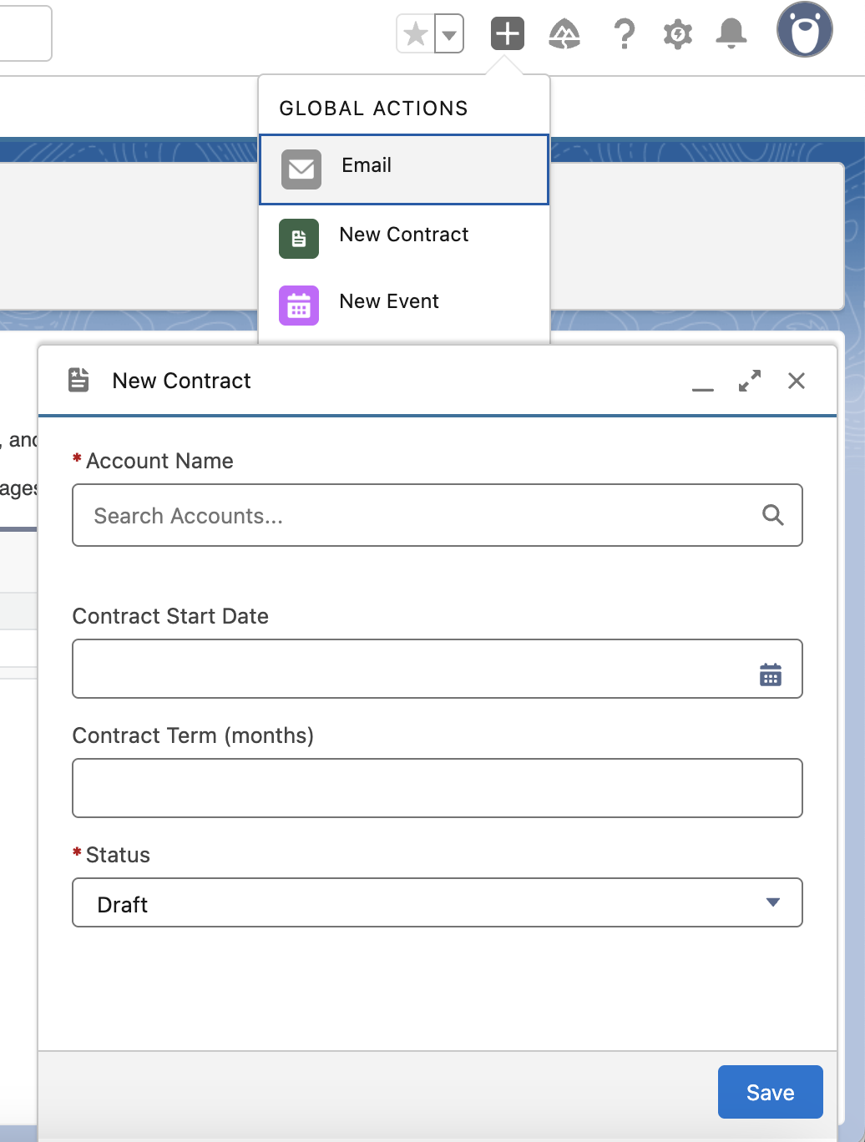

Creating a single page app using the lightning app builder
Easy to use gui for creating custom lightning pages for salesforce lightning experience and the mobile application. Lightning pages are built using lightning components which are compact, configurable and reusable elements. They can be drag and drop in the regions of the page in the lightning app builder.
User Interface → Lightning app builder
App page | Build one page app for lightning experience and the mobile app.
Home page
Record page | Record detail page. We look at record detail page whenever we look at an account or individual opportunity for eg.

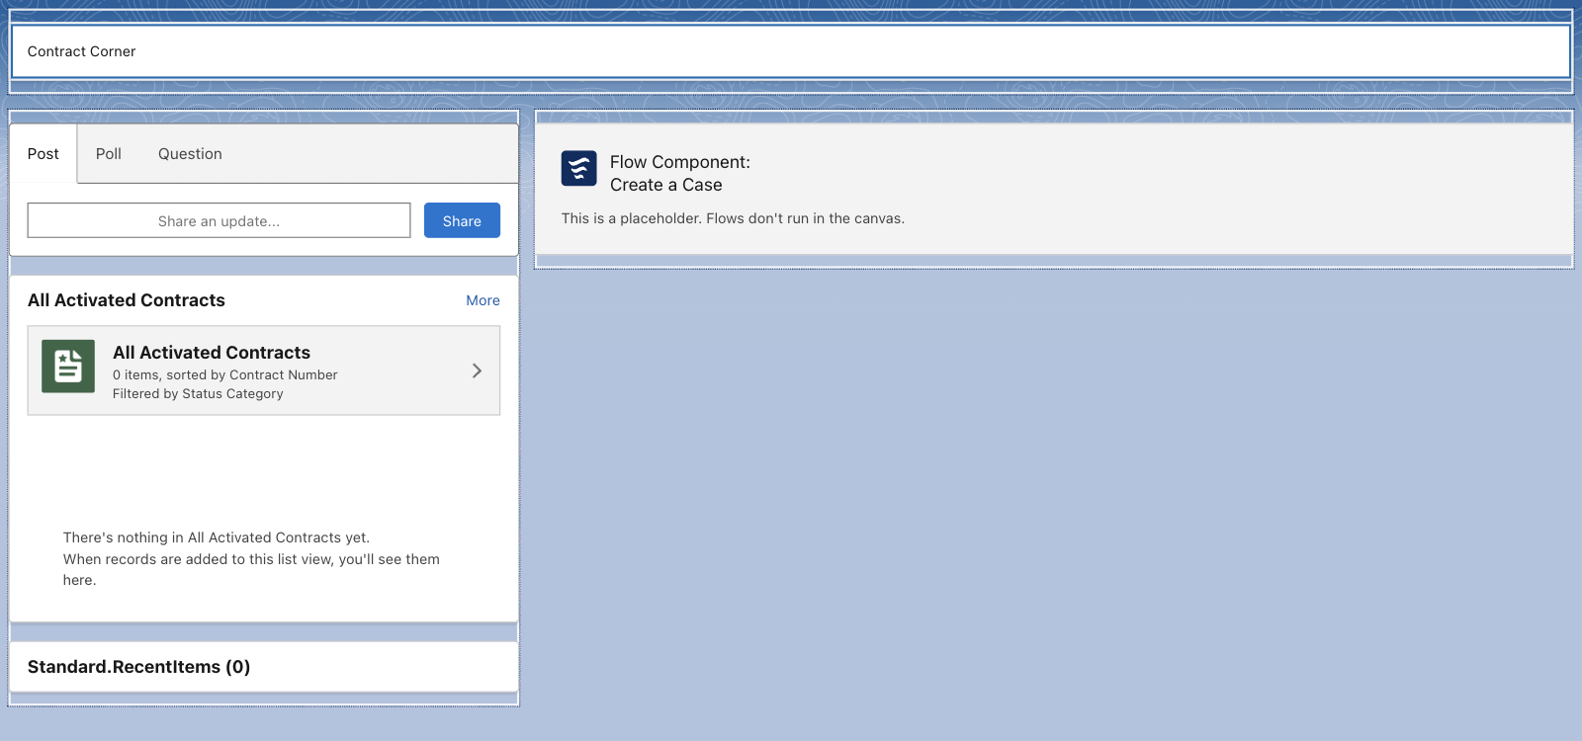 | Header: rich text  left sidebar:  chatter publisher  List view of Contracts  Recent items  Right sidebar:  flow: create a case.  Save → Activate
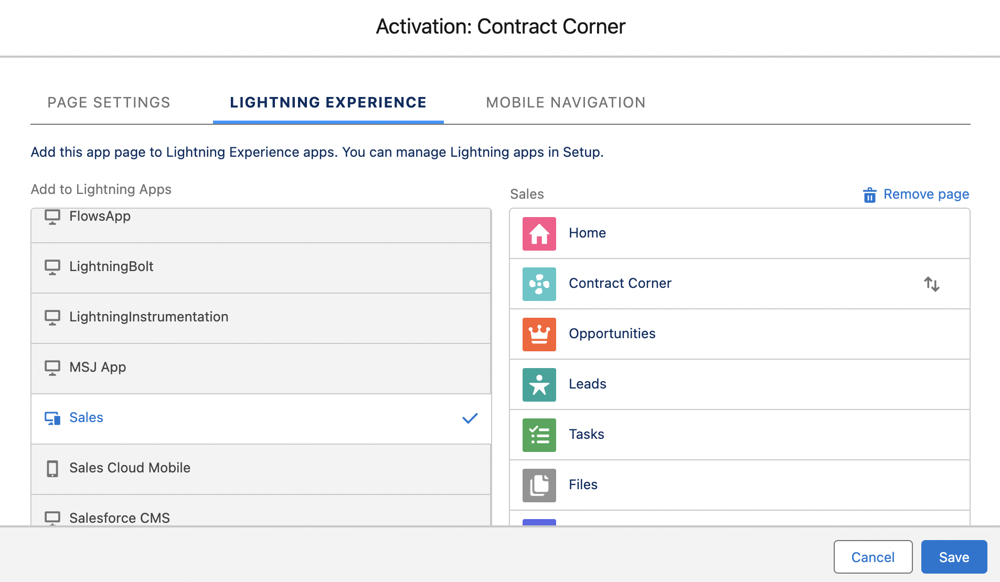 | Add the page to app. For lightning experience and mobile navigation.

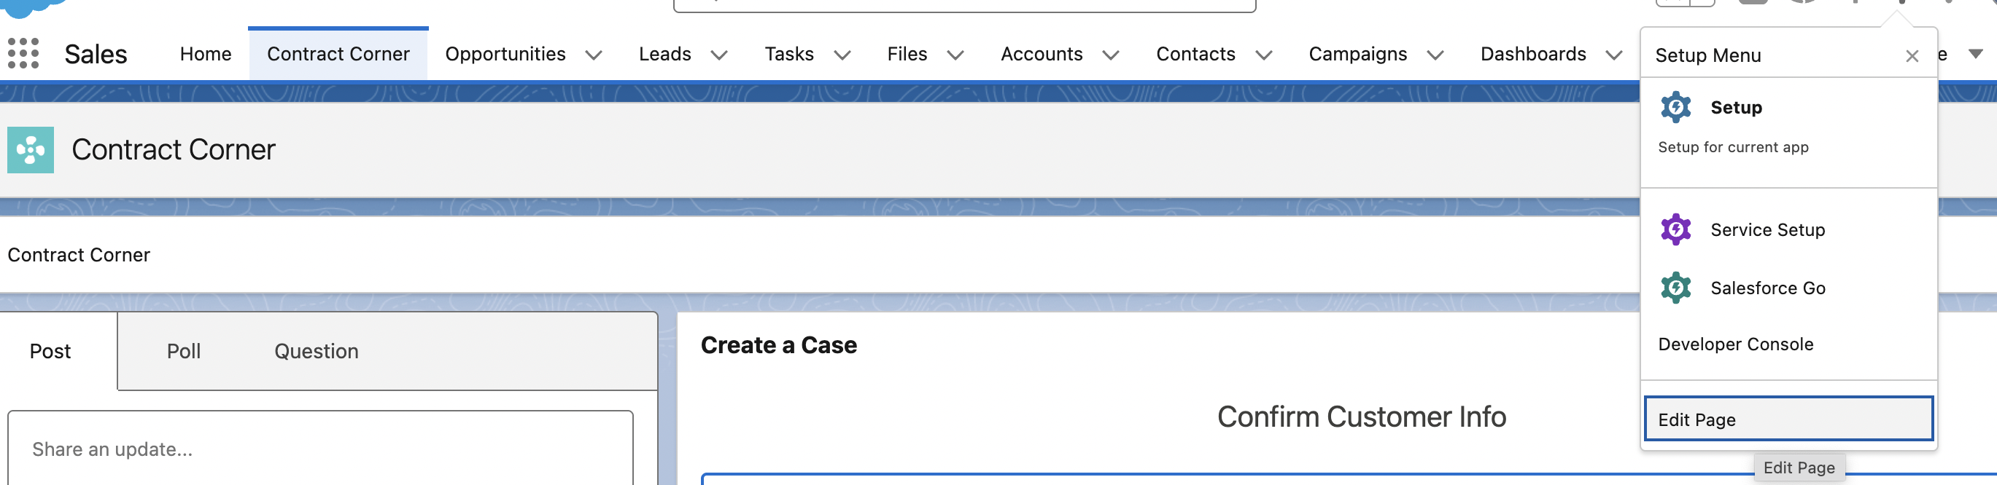
You can directly edit the lightning app page. It will open the lightning app builder. Since its already activated, we don’t have to reactivate.

Deactivate and creating User accounts
Company settings→ Company information
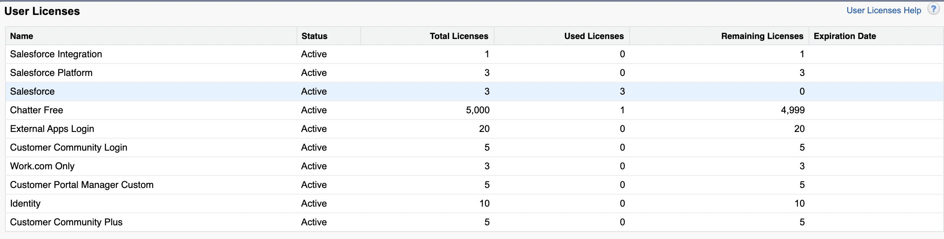
To create a new user. Since I have used all the licenses by default. To create a new user, u must deactivate one.
Users → Users
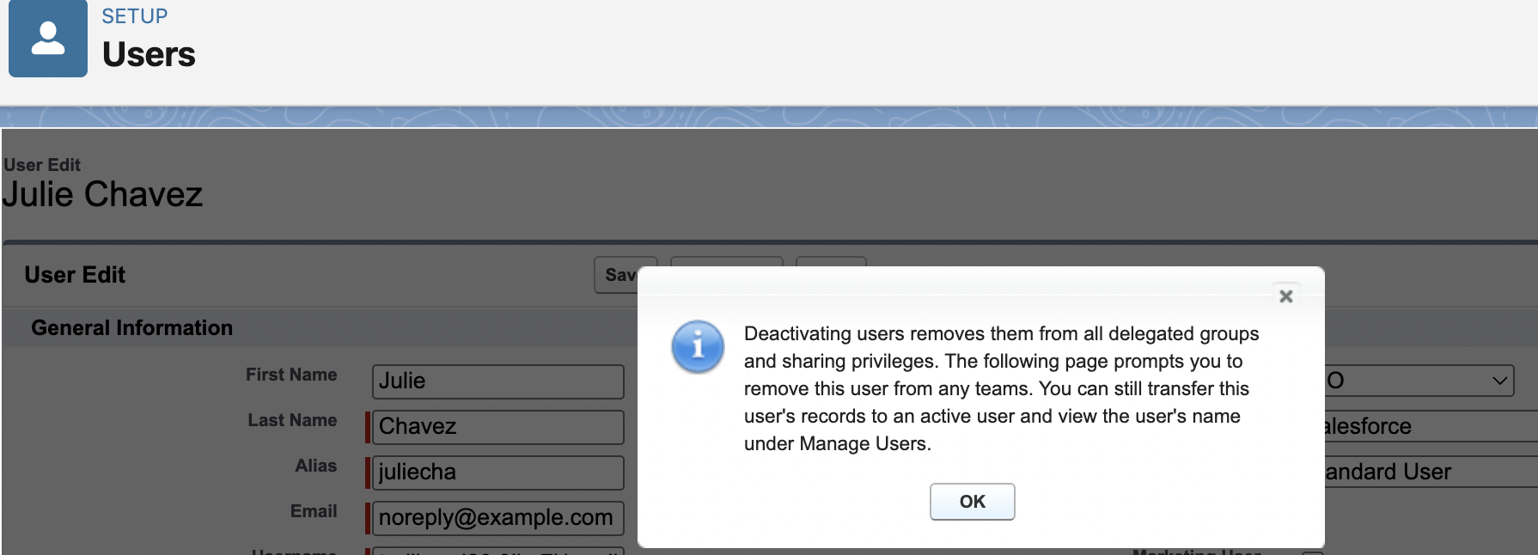
Deactivate a user.
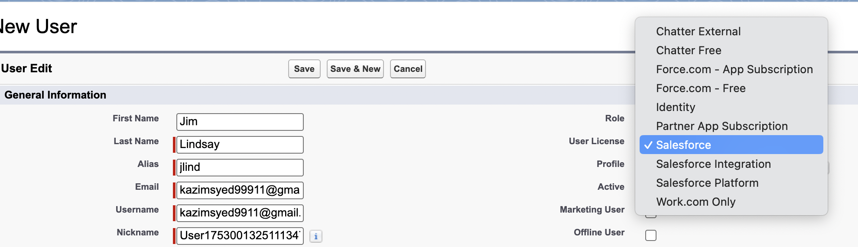
Do not click on Salesforce platform, its more limited in nature.
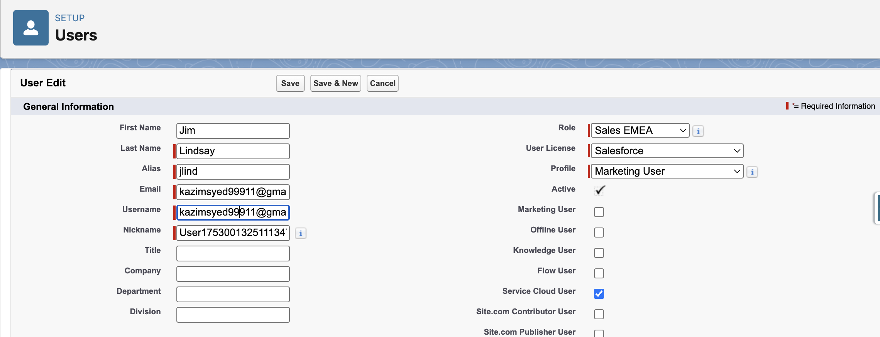

Maintaining and logging in as a user
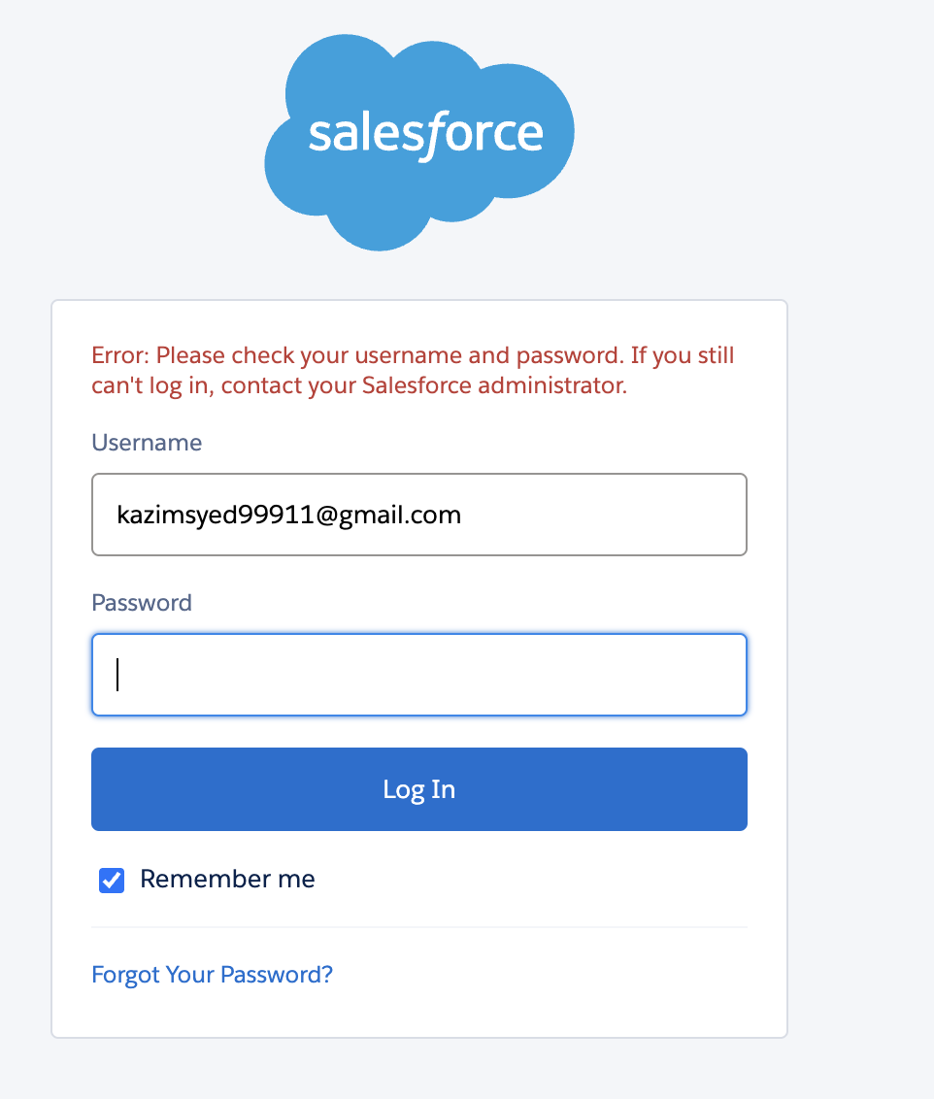  I purposefully entered a wrong password. | 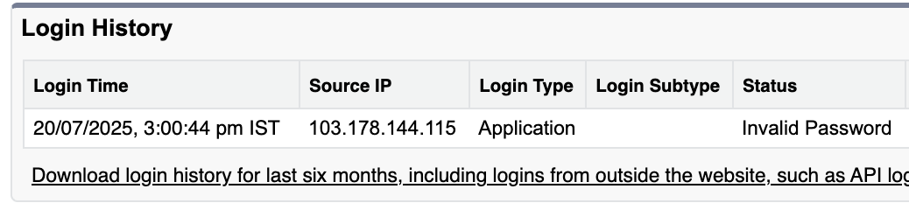  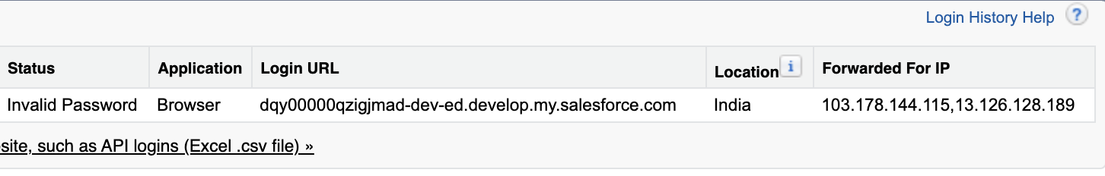
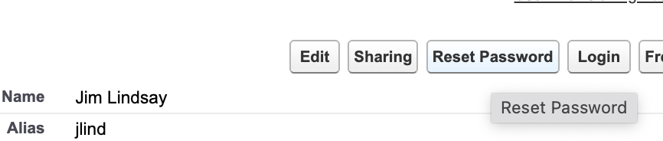 | 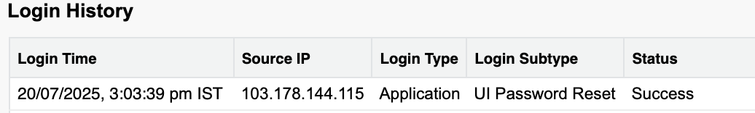
Users → Users  I can directly login as that person since I am the System administrator. | 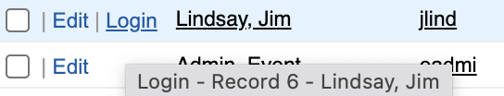

Benefits:
Troubleshoot login issues | You can see the login attempts and see what issues has been occurring for them. And diagnosed whether its caused by wrong username or password.
Login as them | To see what issues they have by logging in as them.

To avoid passing the credentials to log in as the system administrator. We use sessions settings.
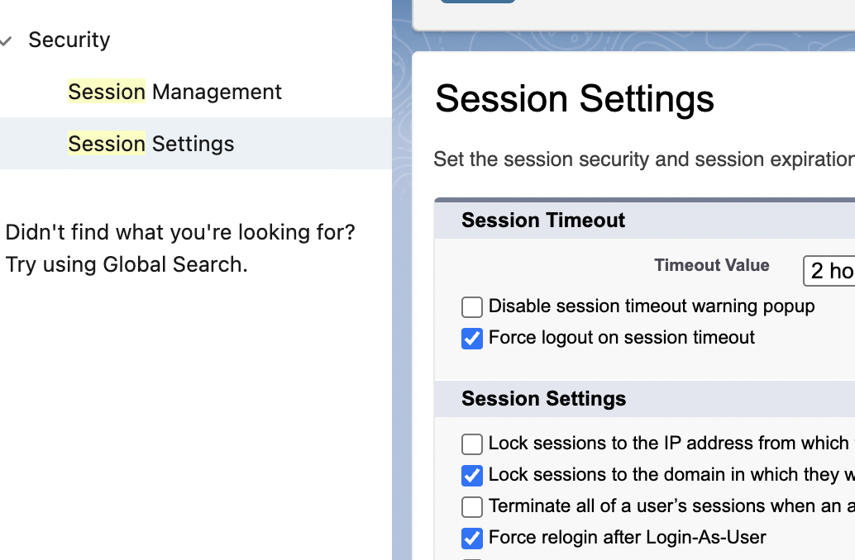 | Uncheck force re-login after login-as-user

Freezing user
There might be times when we cant simply deactivate a user like we did previously by unchecking the active checkbox.
If you have users who are tied with automations or have a lot of integrations and entanglement in your setup.
Then you may not be able to just simply deactivate that user. And there maybe situation where you need to freeze them out of being able to login quickly so that they don’t steal customer data.
You can click freeze to keep them out of the system and then you can effectively untangle any sort of automations that are tied to them. And if you try to deactivate a user that has automations and other reasons why they can’t be deactivated. Salesforce will list those during the process.
The frozen user still shown as active and typed to the license but they cant login. Once you are ready, you can unfreeze and edit→ deactivate.

Setup Audit trails
Setup Audit trails | Track the recent setup changes that you and other admins do.
Systems shows | 20 most recent setup changes made to your org and it list the date of the change, who made it and what change was.
I change the settings in Sessions and reset the password for Jim Lindsay. | 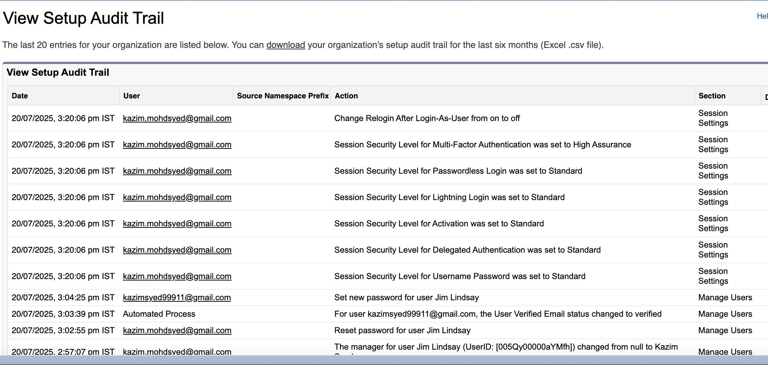
 | Helps you to remember and keep track of the changes you made. You need to package those up and deploy those to another salesforce organization

Login in hours
 | You can look at login history of the user. But u cant set the hours which they login. Because that is done at the profile level.
Users → Users | 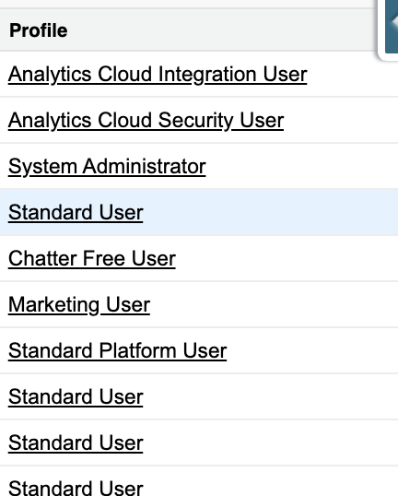
Click on the profiles | 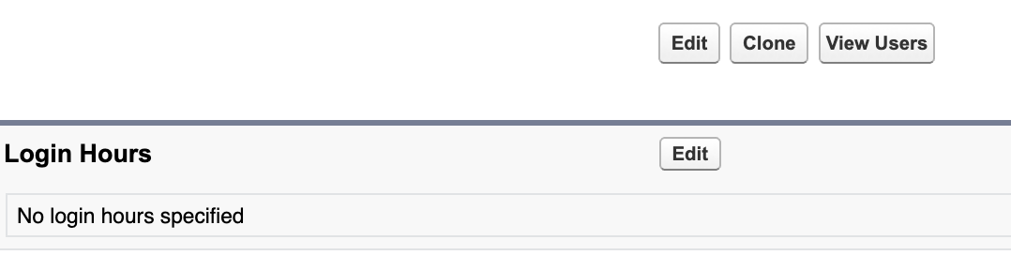
 | 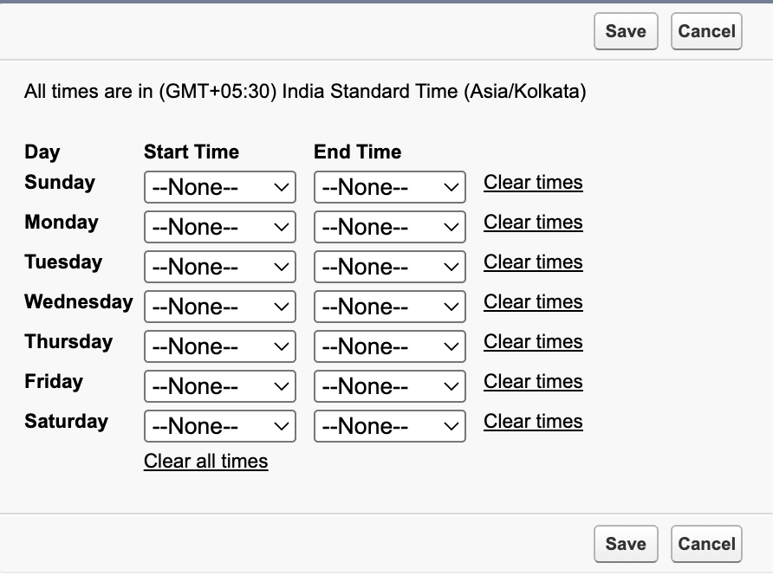

Enabling the enhanced profile user interface
 | Users → Users[‘Marketing User’]
 | There are two different interfaces for profile display inside of salesforce.
 | 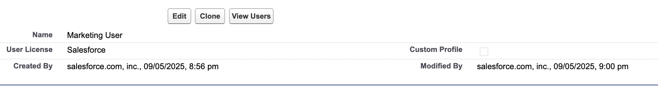
 | You can tell whether this is standard or custom by looking at the checkbox Custom profile since its unchecked that means its a standard profile.
 | There are some limits about what you can edit or change on a standard profile. As u saw in the last lesson, we were able to change the login hours for standard profile.
 | You also have login ip ranges, enabled apex classes, visual force page access and more.
User → User mangement  User mngmt settings(Organization wide changes) | 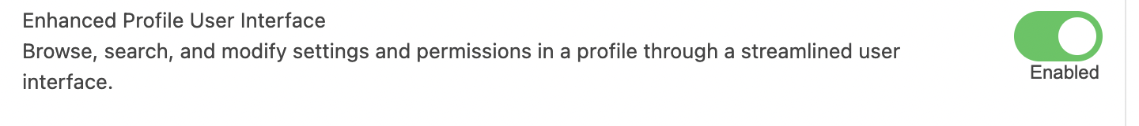  This will impact all adminisitrative backend users that have access to be able to view profiles and make changes.
The Profile is divided into apps and System settings.
Apps: Settings that apply to Salesforce apps such as Sales and Custom App built on the lightning platform.

Settings that apply across all apps, such as record and user management.

Session settings

(Organization wide changes) | 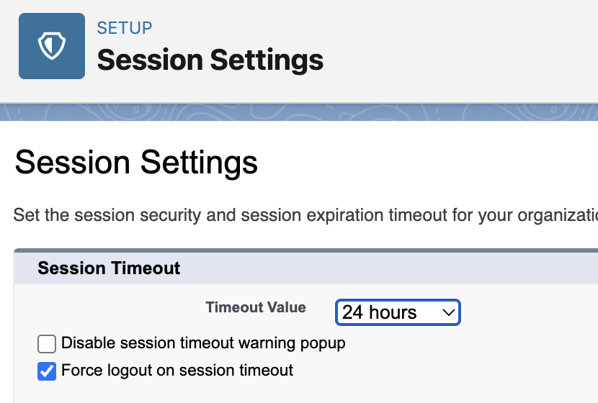
You can edit Organization wide setting for a particular profile. | 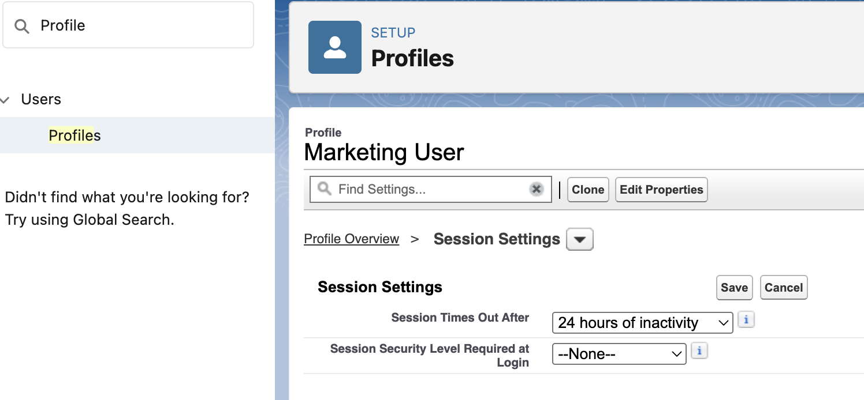
Uncheck the second option, since later in the course u would be making changes to the data model or to page layout. Perhaps, u may not be seeing the result of ur changes bcoz of caching. | 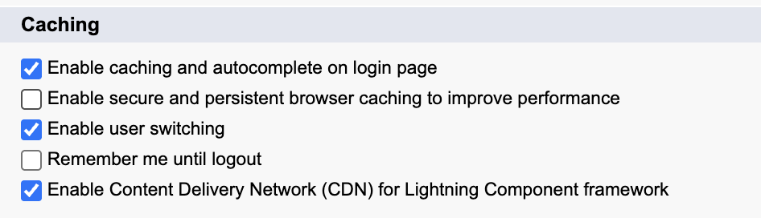

Salesforce sharing modal overview

Resource: Platform sharing architecture
Secure application data access
Architect your sharing model correct to meet your current and future data access requirements.
- Data accessibility components
- Sharing model use cases
- Real customer sharing solutions

Types of Data access
Record level security | Access some records but not others.  Must know the User before providing access based on type.
Users and licenses
High Volume user | Skip
 | 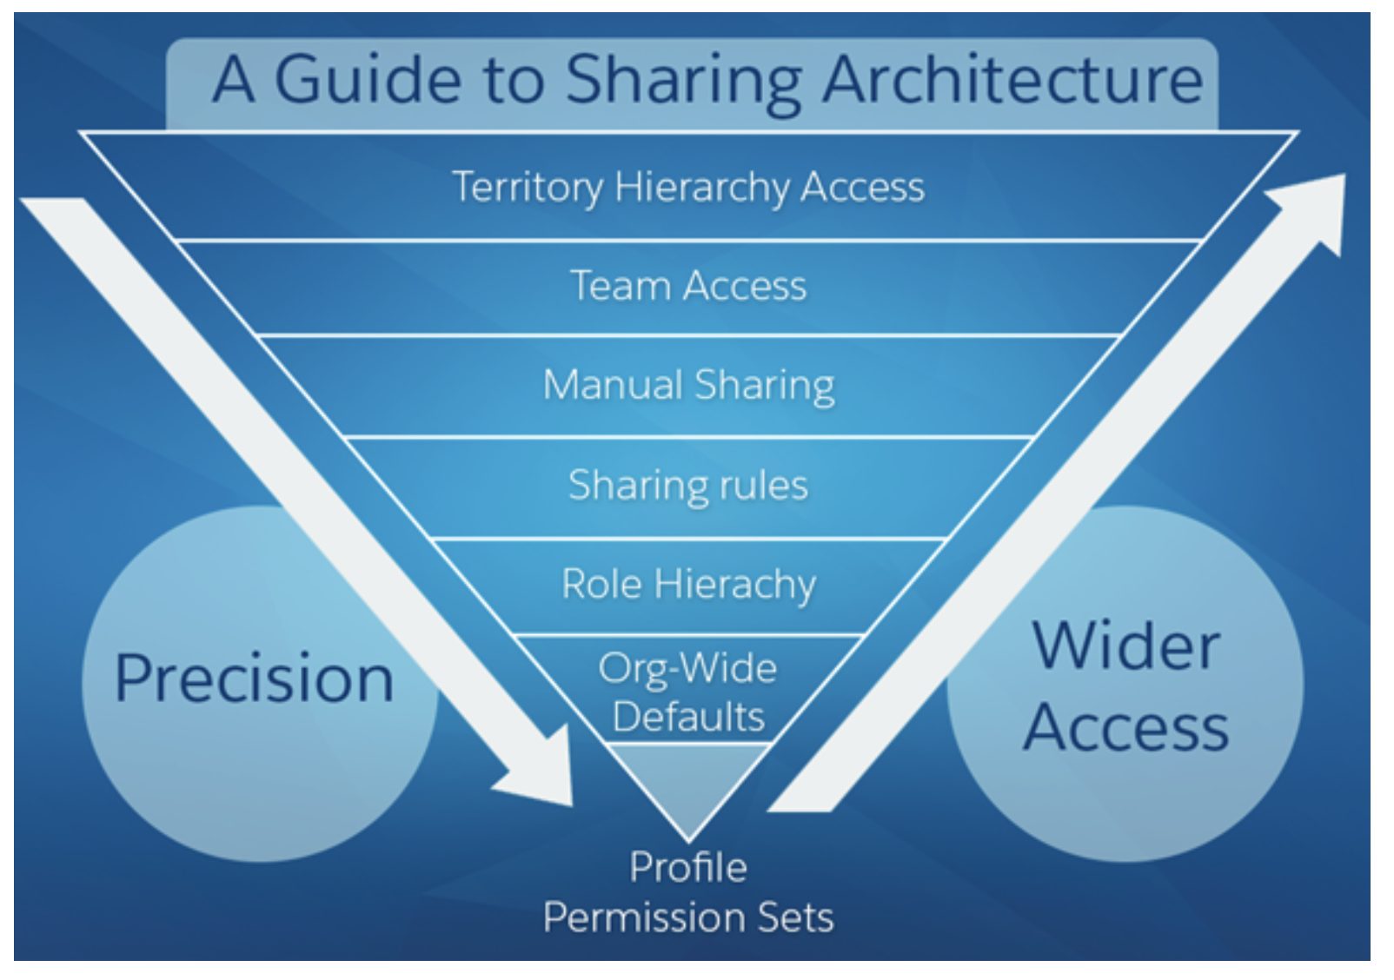
Profile and permission sets
 | (View All Data/Modify all Data) greater than View All/Modify All
 | View All data gives read permission on all records of all objects. Which is a very powerful permission. Whereas View All gives access to all records one object at at time. Its more granular and restrictive and safer than View All data object.
 | P&PS can also do field level security.
Recommend | Using PS to manage user object permissions rather profile. PS are reused and u wanna limit # of profiles.
Record Ownership and Queues

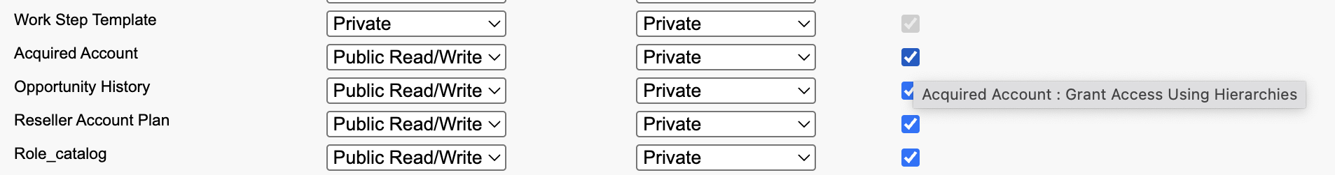
We knows users higher in hierarchy has access to the records of their subordinates,  (Manager access subordinates created records)  Simple words → Child implicit sharing  In Case of subordinates being the owner. The Superiors will have the same access level as the record owner. | (1)Every record must be owned by a single user or a queue. The owner has access to the record, based on the Object Settings for the owner’s profile. For example,  if the owner’s profile has Create and Read permission on an object, but not Edit or Delete permission, the owner can create a record for the  object and see the new record. However, the owner won't be able to edit or delete the record. Users  higher in a hierarchy (role or territory) inherit the same data access as their subordinates for standard  objects. If the subordinate has read-only access, so will the users above them in the role hierarchy.  This access applies to records owned by users, as well as records shared with them.
Can the owner edit?
├── No → Can superiors edit?
│ ├── No → Check:
│ │ ├── Admins.
│ │ ├── Permission Sets.
│ │ ├── Manual Sharing.
│ │ └── Queue Ownership.
└── Yes → Owner/superiors can edit.

OWD’s
Most Restrictive.  By Default, its read only.  You grant them privileges through P&PS. | You use organization-wide sharing settings to lock your data to the most restrictive level.  For example,  users have object-level permissions to read and edit opportunities, and the organization-wide sharing  setting is Read-Only. By default, those users can read all opportunity records, but can’t edit any unless  they own the record or are granted other permissions.
OWD from private to parent controlled | Organization-wide default settings can be changed from one setting to another (Private to Controlled  by Parent, then back to Private). However, these changes require sharing recalculation and depending  on volume could result in long processing times.
For custom objects only, you can configure the Grant Access Using Hierarchies setting. If unchecked
(default is checked), users higher in the role hierarchy are prevented from inheriting access. This
setting is found in the organization-wide default settings.

Queues:
Every record must be owned by a single user or a queue
Queues help you prioritize, distribute, and assign records to teams who share workloads.
Queue members and users higher in the role hierarchy can access queues from list views and take ownership of records in a queue.

If a single user owns more than 10,000 records, as a best practice:
The user record of the owner should not hold a role in the role hierarchy.
If the owner's user record must hold a role, put the role at the top of the hierarchy in its own
branch of the role hierarchy.

Private or Parent controlled
Private
Only Record owner and child implicit sharing. | Only the Record Owner of the Standard object(Opportunity, Case, order, Contact) and Users higher in Hierarchy can view that record.
E.g | Sales rep can work in their space and in-silos. Not a competitive organization.
Parent controlled | The child record mirrors the parent Account’s sharing settings for every user (not just the owner).
If u read access to the account, u would only have read access to the child records.  Mirror the parent account sharing settings for every user.  (cut-paste the sharing setting) | If sales rep Bob has Read only on the Account then for the new child record(case, opportunity, contact) he can only do read.  If sales rep Charlie has Read and write on the Account then for the new child record , he has read and write..
  controlled by parent is dynamic cut paste of the sharing setting for every user. if the access level of some user bob is changed from read-write to read on account, it would be reflect on the associated cases as well.
Private | Means only the Record owner and the people in higher role hierarchy can access the Opportunity, case, order, contact.  Parent implicit sharing doesn’t give access to the child records of the parents.
You can give permission using permission sets or manual sharing or sharing rules
like give child records of Smiths account to every sales rep.

Security → Sharing settings → OWDs
You can’t turn off the role hierarchy for standard object but possible for Custom objects. | 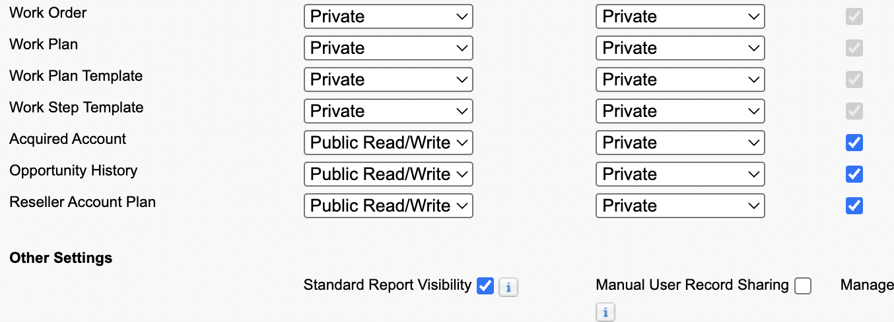
Accounts don’t have Transfer whereas leads has transfer.
  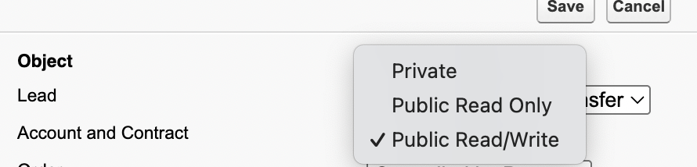 | 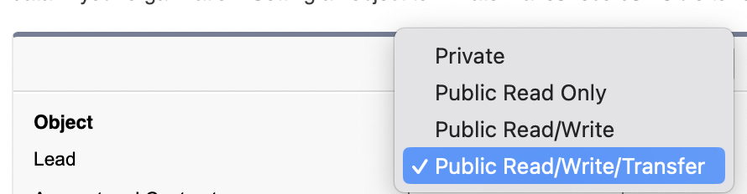

The implication of turning the account object private has a lot of cascading effects. Account is one of the primary object.

Role Hierarchy
Supervisor can supervise their subordinates
As a best practice, keep the role in the hierarchy no more than 10 levels of branches in the hierarchy.
Modeling the role hierarchy starts with understanding how the organization is structured.
Role hierarchy not necessarily exact image of organization, instead its more about who needs what access.
EMEA(Europe, middle east and Africa) and APAC(Asia and Pacific)
This is usually built from understanding a manager’s scope, starting from the top. The CEO oversees the entire company. The CEO usually has direct reports that can then be segmented by Business Unit (Sales or Support) or geographical region (EMEA, APAC). That person then has direct reports that could be further segmented, and so on

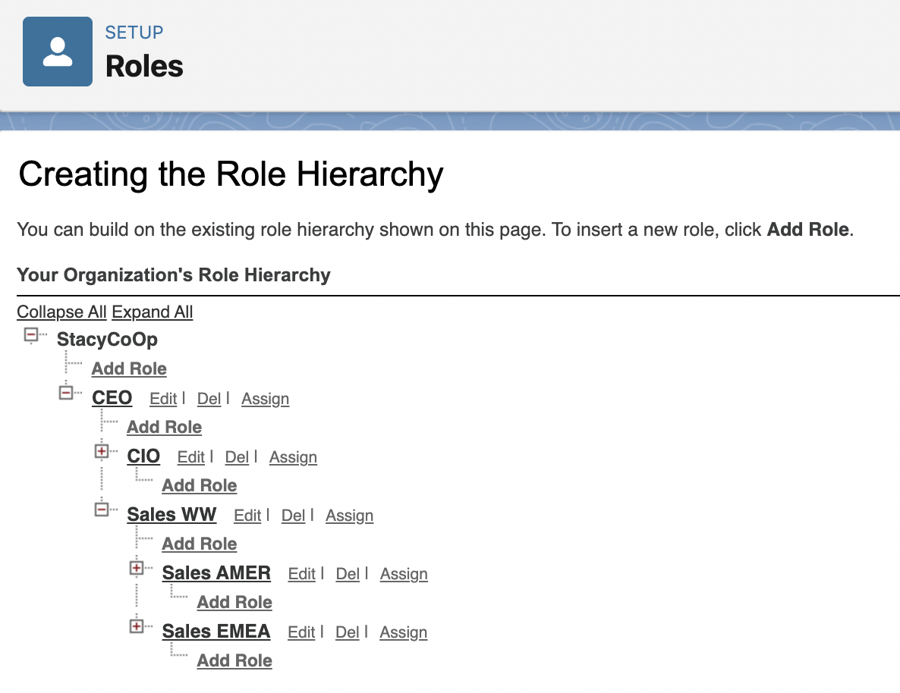

Role hierarchy Use cases:
Child implicit sharing | Management access – Supervisor supervise subordinates.
Rollup of access to the top | Management reporting – reporting rollup so any1 on higher role sees more than those below.
Segregation(between BU) while Rolling up access | Segregation between organizational branches – Different BU don’t need to see each other, while still rolling visibility up to the executive levels above those units.
Private | Segregation within a role – in many organizations/applications, people who all play the same role  should not necessarily see each other’s data. Having hierarchical roles allows you to define a “leaf” node in which all data is essentially private, and still roll that data up to a parent role that can see all.

Cascading effect/Manual Sharing
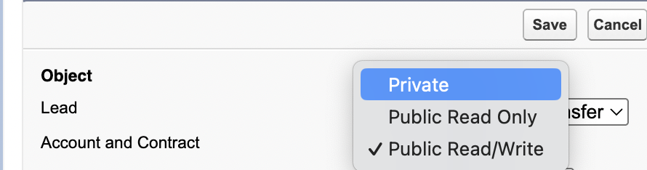 | If we change OWDs.
 | 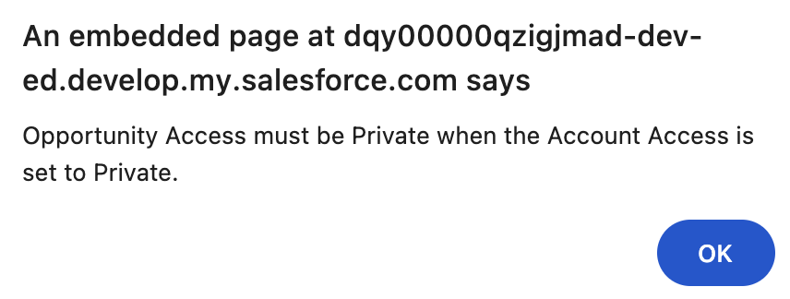
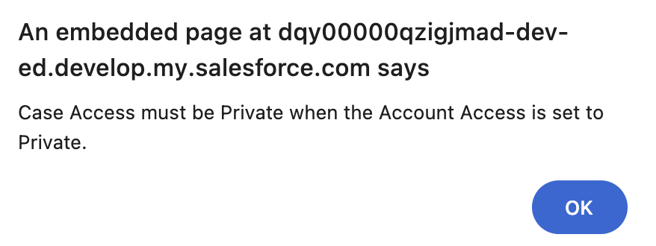
Changes happens when we press okey. | 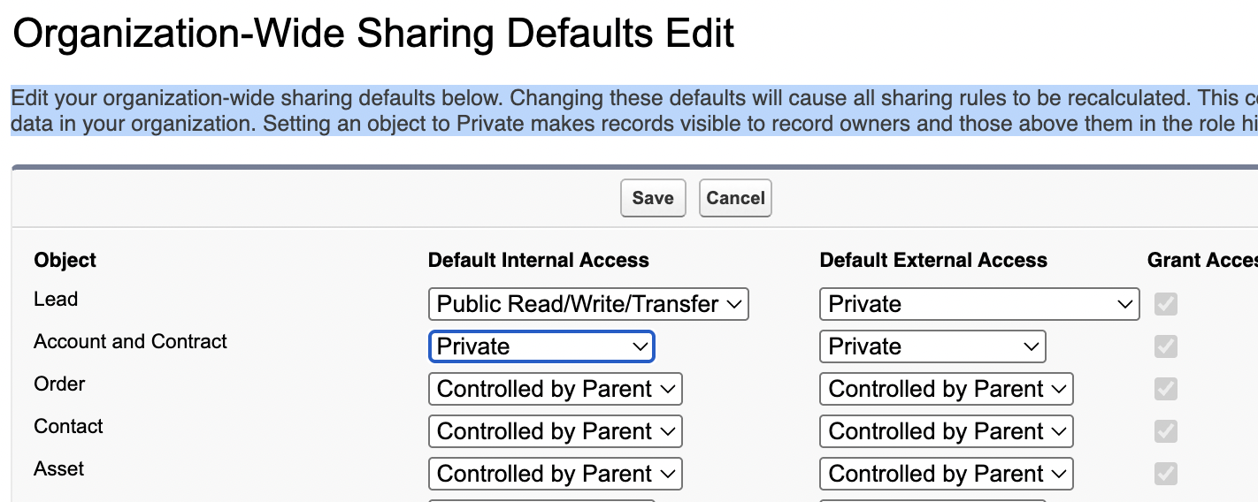
Before  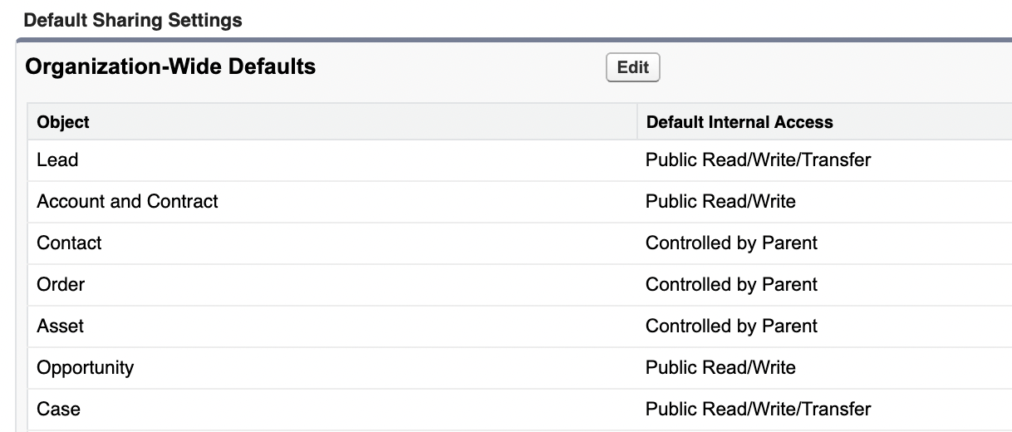 | After  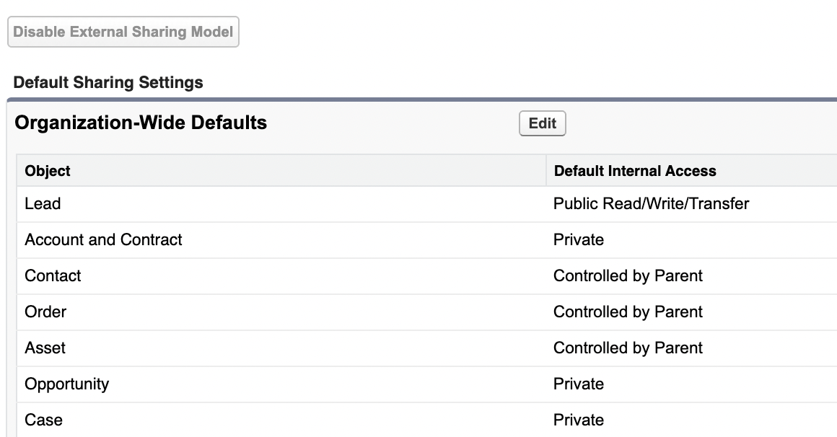

If alice has r/w on object permission for opportunity. owd for opportunity is read all. if she created a record and is the record owner, will she have edit options on her own record?
However, the OWD only sets the baseline for non-owners. As the record owner, Alice automatically gets Read/Write (Edit) access to that specific record.

I login as Laura Garza and then I went to Accounts.  And then I viewed sharing. | 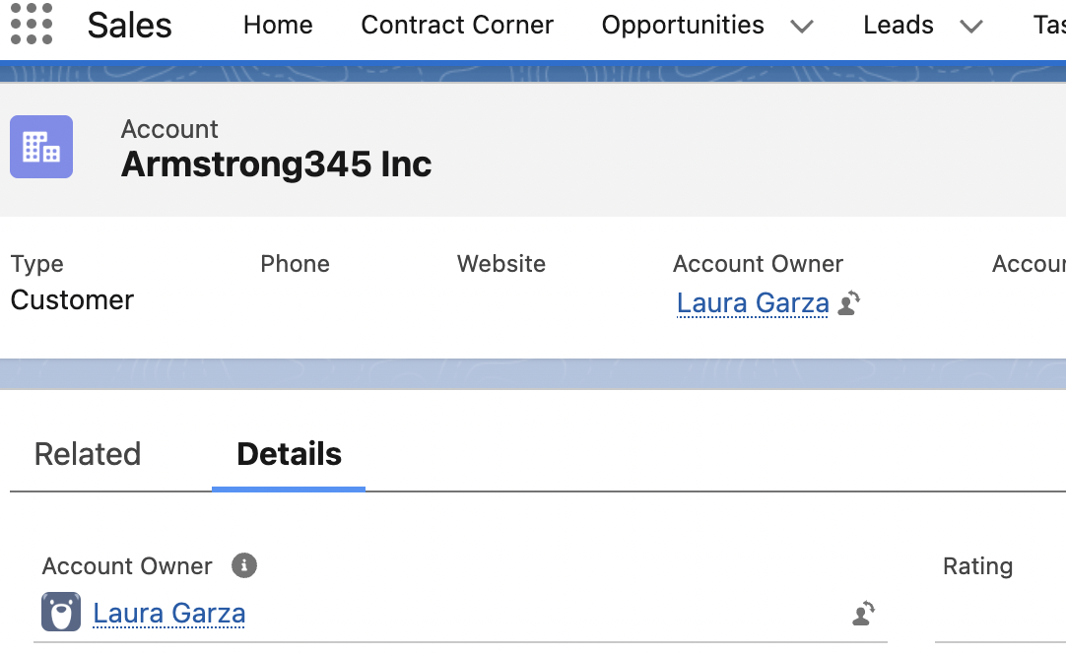
The account was shared by 6 individual(herself included).  She controlled record level access for others. | 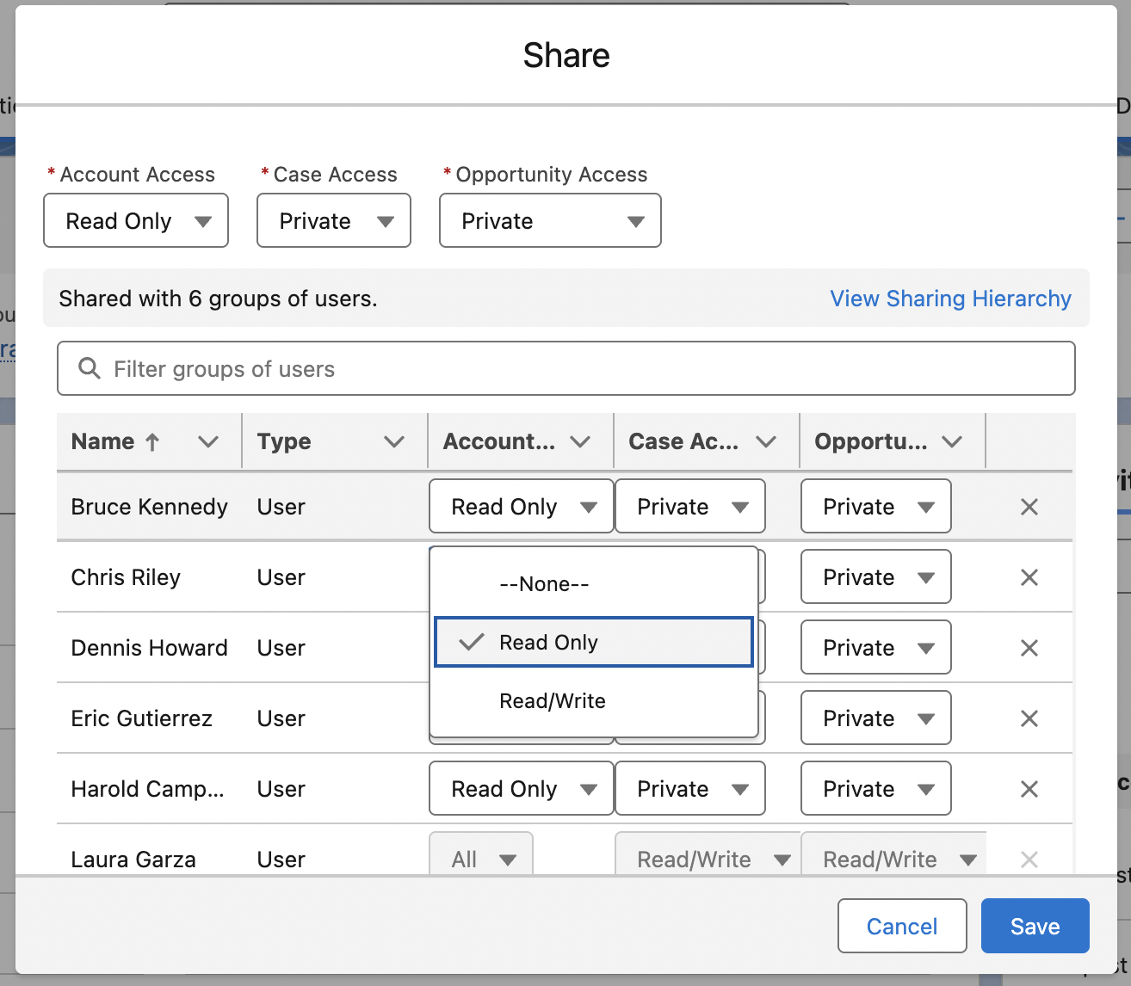
I shared the a/c w/ jim lindsay | 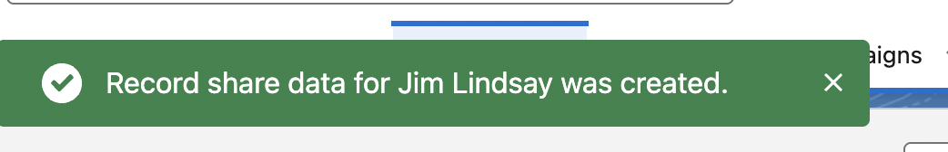
 | Then I login as Jim Lindsay and can see the new account but no opportunities cuz it was set to private, which blocked the child implicit sharing.

Public group

Public group: have function in common. | A public group is a collection of individual users, roles, territories, and so on, that all have a function  in common. Public groups can consist of  - Users  - Customer Portal Users  - Partner Users  - Roles  - Roles and Internal Subordinates  - Roles, Internal, and Portal Subordinates  - Portal Roles  - Portal Roles and Subordinates  - Territories  - Territories and Subordinates  - Other public groups (nesting)
Don’t nest more than 5 levels. | Groups can be nested (Group A nested into Group B), but don't nest more than five levels.  Nesting has an impact on group maintenance and performance due to group membership calculation.  As a best practice, keep the total number of public groups for an organization to 100,000.

Public Group usecases
Group A is member of group B. Then group B have access to the data of group A | If Group A is a member of Group B, then the members of Group A will have access to data shared to Group B at the same access level as the  members of Group B.  Groups also have the ability to protect data shared in the gro
Think of nested group as a person.
Using Grant Access using Hierarchy settings: you can prohibit child implicit sharing within groups. | Groups also have the ability to protect data shared in the group from being made accessible to people  in the role hierarchy above the group members. This (and dealing with the access of record owners and  their management hierarchy) allows the creation of groups in which very highly confidential  information can be shared—the data will be accessible ONLY to group members, and nobody else in the  organization. This is accomplished by using the Grant Access Using Hierarchies setting

This (and dealing with the access of record owners and
their management hierarchy) allows the creation of groups in which very highly confidential
information can be shared—the data will be accessible ONLY to group members, and nobody else in the
organization. This is accomplished by using the Grant Access Using Hierarchies setting.
How would u achieve that?

1. Set the Baseline (Maximum Restriction)
The key to creating a truly isolated data set is to set the most restrictive baseline possible.
- Org-Wide Default (OWD): Set the OWD for the custom object containing the confidential data to Private. This ensures only the record owner and users explicitly granted access can see the record.
- Grant Access Using Hierarchies: Set this to Disabled (unchecked) for the custom object. This is CRITICAL for isolation. If it were enabled, managers in the Role Hierarchy would automatically see all of their subordinate's records, which might violate the requirement to restrict access only to group members.

2. Grant Access to the Confidential Group
You use Criteria-Based Sharing Rules or Owner-Based Sharing Rules to grant access only to the members of the specific group.
- Create a Public Group: Create a Public Group containing only the users who are authorized to see the confidential data.
- Create a Sharing Rule: Create a Sharing Rule for the custom object that grants Read/Write access to the records. The rule should specify that access is granted to the Public Group you created.

3. Include Management (The Hierarchical Exception)
The statement says the data must be accessible to group members and their management hierarchy. Since you disabled "Grant Access Using Hierarchies" in Step 1 (to block access outside the group), you must use an exception to grant manager access back to this confidential group.
- Manager Group: Use a Manager Group or create a Sharing Rule specifically for the managers of the users in your confidential group.

4. Exclusion of Administrators (The Advanced Requirement)
The original text hints at data being inaccessible to nobody else in the organization, which often includes System Administrators, a feature usually reserved for highly sensitive data like encryption keys or health information.
- User/Schema Permissions: Typically, an admin with "View All Data" or "Modify All Data" can see everything. To bypass this, you must use:
  - Platform Encryption: Encrypt the data at rest, making it unreadable without the encryption key (though the record itself is still visible).
  - External Sharing Model: For true administrator exclusion, you would need to use advanced features like a Person Account or a custom object set up under the External Sharing Model where the permissions of the internal System Administrator are intentionally limited.

Implementing Salesforce Platform Encryption (often referred to as Shield Platform Encryption) to encrypt data at rest involves several critical setup and maintenance steps, primarily focused on key management and defining the encryption policy.

Steps to Implement Platform Encryption
The process is generally performed by a System Administrator and involves the following high-level steps:

1. Key Management (The Foundation)
This is the most critical step, as it determines who controls the key used to encrypt and decrypt the data. The encryption key is derived from a combination of a Master Secret (controlled by Salesforce) and a Tenant Secret (controlled by you).
- Assign Permissions: Ensure the administrator performing the setup has the Manage Encryption Keys system permission (typically assigned via a Permission Set).
- Generate the Tenant Secret: Navigate to Setup → Platform Encryption → Key Management. You can choose one of three options:
  - Salesforce-Generated: Salesforce generates and manages your Tenant Secret for you.
  - Bring Your Own Key (BYOK): You generate your own key material outside of Salesforce and upload it. This gives you more control.
  - External Key Management (EKM): You connect Salesforce to an external key service (like AWS KMS) to manage and store the key material outside of the Salesforce environment.
- Export/Back Up the Key: You must export and securely store a backup of your Tenant Secret. This is crucial for disaster recovery, as Salesforce cannot recover data without your Tenant Secret.
- Rotate Keys: Plan to rotate the key material periodically to maintain security best practices.

2. Define the Encryption Policy
Once the Tenant Secret is active, you define which data elements should be encrypted.
- Select Data for Encryption: Navigate to Setup → Platform Encryption → Encryption Policy.
- Choose Fields: Use a simple point-and-click interface to select standard and custom fields for encryption.
  - Probabilistic Encryption (Default): Recommended for most data but blocks filtering/sorting capabilities.
  - Deterministic Encryption: Used for fields you need to filter or sort (e.g., matching a contact's name), but it offers slightly less security than probabilistic.
- Other Data: You can also choose to encrypt other data at rest, such as:
  - Files and Attachments
  - Data in Chatter
  - Search Indexes

3. Encrypt Existing Data (Synchronization)
When you enable encryption on a field, all new data written to that field is encrypted automatically. However, existing data in that field must be encrypted manually.
- Synchronize Encryption: Use the Self-Service Background Encryption service available in Setup to traverse your database, decrypt existing plain-text data for the selected fields, and then re-encrypt it using the new active key.
The complex process of implementing Shield Platform Encryption is well-documented by Salesforce. View a video about Shield Platform Encryption if you'd like to see a guided walkthrough of the setup process.

Owner based Sharing rules
Exercise by the owner of the record. | Owner-based sharing rules allow for exceptions to OWD AND RH that give additional users access to records they don’t own.
Owner-based sharing rules are based on the record owner only.
Contact owner-based sharing rules don't apply to private contacts, or contacts that aren’t associated with an account.
The limit of total sharing rules per object is 300.

Owner based sharing rules use cases
"Share Accounts owned by East Sales with the East Marketing Team." | Role-based matrix management or overlay situations: a person in Service must be able to see some  Sales data, but they live in different branches of the hierarchy, so you can create a rule that shares data between roles on different branches.
"Share all Opportunities owned by 'East Sales Reps' (Public Group) with 'Sales Managers' (Role)." | To provide data access to other groupings of users (public groups, portal. roles, territories). The  members of the groupings who own the records can be shared with the members of other groupings
 | To provide data access to peers who hold the same role or territory.

Scenario | Alice’s Ability to Share Her Records | Alice’s Ability to Share Bob’s Records
Private OWD | ✅ Manual Share / Owner-Based Rules | ❌ No access to Bob’s records
Controlled by Parent | ✅ Manual Share / Owner-Based Rules | ❌ Can view but not share Bob’s records

Criteria based sharing
Based on criteria, if criteria is met then a share record is created for the rule. | Criteria-based sharing rules provide access to records based on the record’s field values (criteria). If  the criteria are met (one or many field values), then a share record is created for the rule. Record  ownership is not a consideration.
 | The limit of criteria-based and guest user sharing rules per object is 50.

Manual Sharing
Record owner has the read and edit and share option. | Record owners or other users with adequate privileges, such as system admins, can use  manual sharing to give read and edit permissions to users who don’t have access any other way.
 | Manual sharing is removed when the record owner changes or when the sharing access granted doesn't grant additional access beyond the object's organization-wide sharing default access level. This also applies to manual shares created programmatically.
 | Manual share records are defined as share records with the row cause set to manual share.
 | To provide the user with the ability to give access (read only or read/write) to the current record to other users, groups, or roles.

Sharing rules
Security → Sharing settings
 | 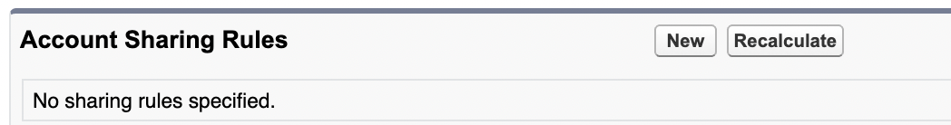
Records owned by Sales EMEA will be shared to Sales AMER(Role). | 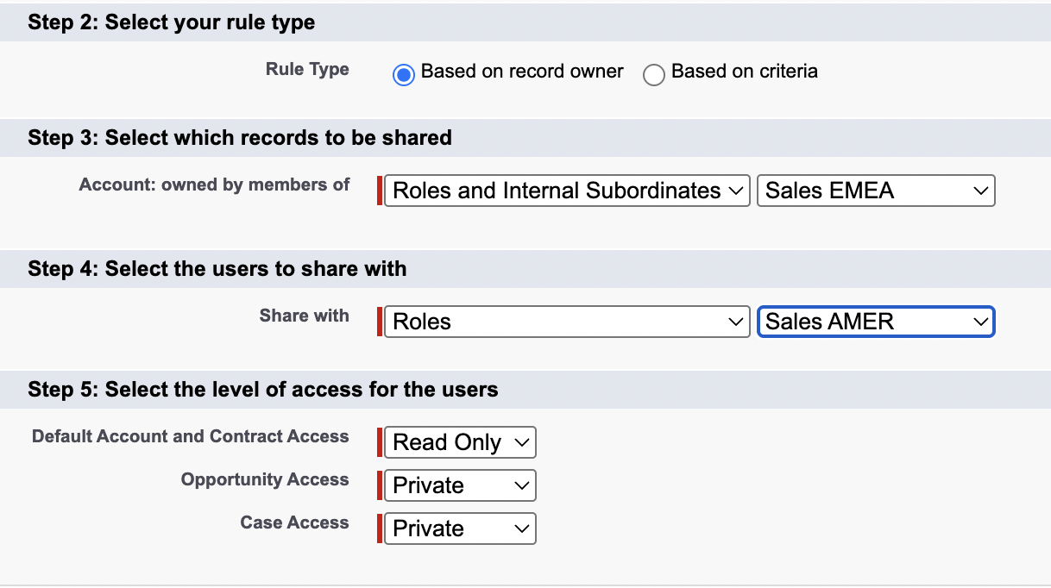
You can block child implicit sharing by setting the child object(Cases, opportunity) access to private. | - Parent-to-Child Implicit Sharing: Access to a parent record can grant a user implicit access to certain child records. This sharing is automatic and flows from parent to child. The parent object's OWD does not block this; rather, the child object's OWD setting dictates whether it will be implicitly shared.  - When a user has access to a parent record (e.g., an Account), they automatically gain access to certain child records (e.g., Contacts, Opportunities, Cases) associated with that parent.  - If the child object's OWD is set to Private, implicit sharing is blocked, meaning a user with access to the parent will not automatically get access to the child record.  - If the child object's OWD is set to Public Read Only or Public Read/Write, implicit sharing is active, and access is granted.
Sharing rules are created as Exception to OWDs for Standard objects. | 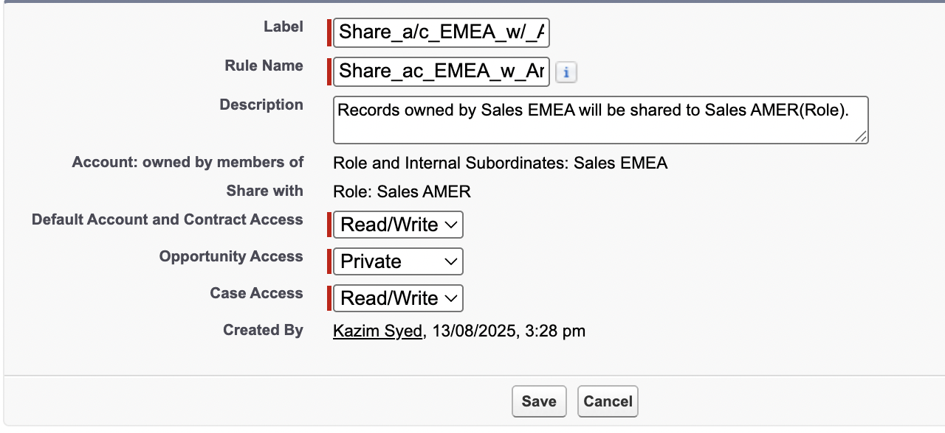

 | You cant edit the sharing rule is based on ownership or criteria based.
 | 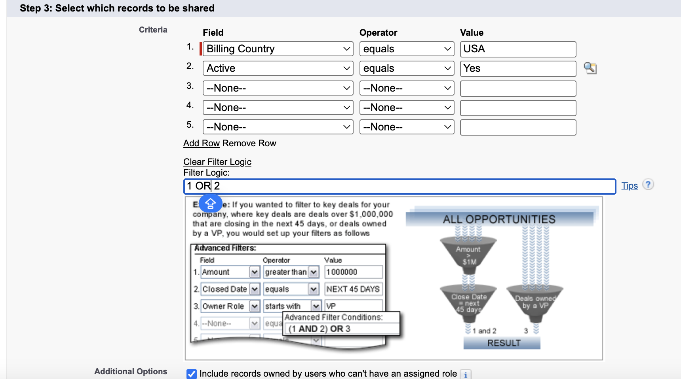
Criteria based and owner based sharing rule. | 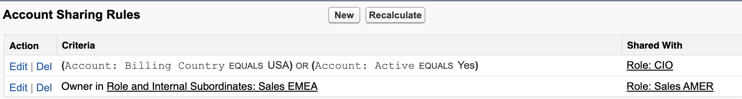

Teams
Team work together on an account, opportunity or case. | A team is a group of users that work together on an account, sales opportunity, or case.  There is only one team per record (Account, Opportunity, or Case). If  multiple teams are needed, depending on your specific needs, consider territory management or  programmatic sharing
 | Record owners can build a team for each record that they own. Some team members can have read-only access, while others have read/write.
Gemini says its wrong. A team member must have manage permission to be able to add new members. | Only owners, people higher in the hierarchy, and administrators can add team members and provide  more access to the member. A team member with read/write access can add another member who  already has access to the record with which the team is associated.
A team member in the app creates two records, a team member and an associated share record. | Creating a team member in the app creates two records: a team record and an associated share  record. If you create team members programmatically, you have to manage both the team record and  associated share record.

Teams use cases
To provide the user with the ability to give access (read-only or read/write) to a single group of users
(the team).

If teams are managed externally, say through an external commission or territory management system,
then integration can be used to manage the account team. There are cases when territory
management in an external system can align to a team solution within Salesforce.
Multiple owners of an account can be managed by the account team. | Multiple owners of an account can be managed by the account team.  A single group of users (team) require either read-only or read/write access to an opportunity record.  (Opportunity Team)

Team Access
There’s few types of different teams in salesforce. There are a/c team and sales team, opportunity teams.
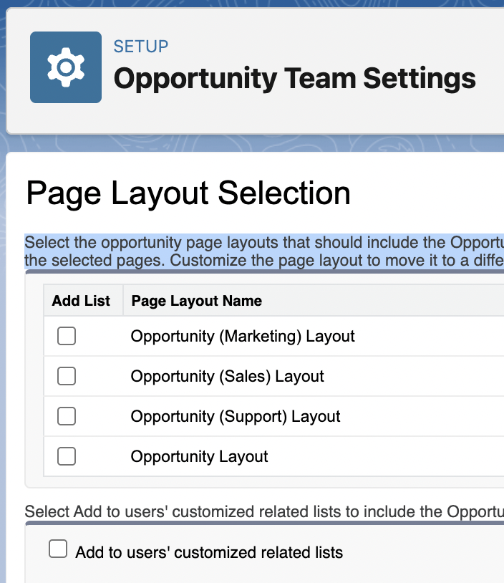

Turn them all on. | 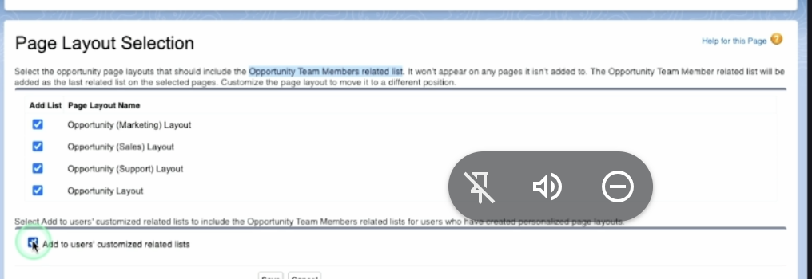
When goto opportunity on sales cloud.  You will see this appear. | 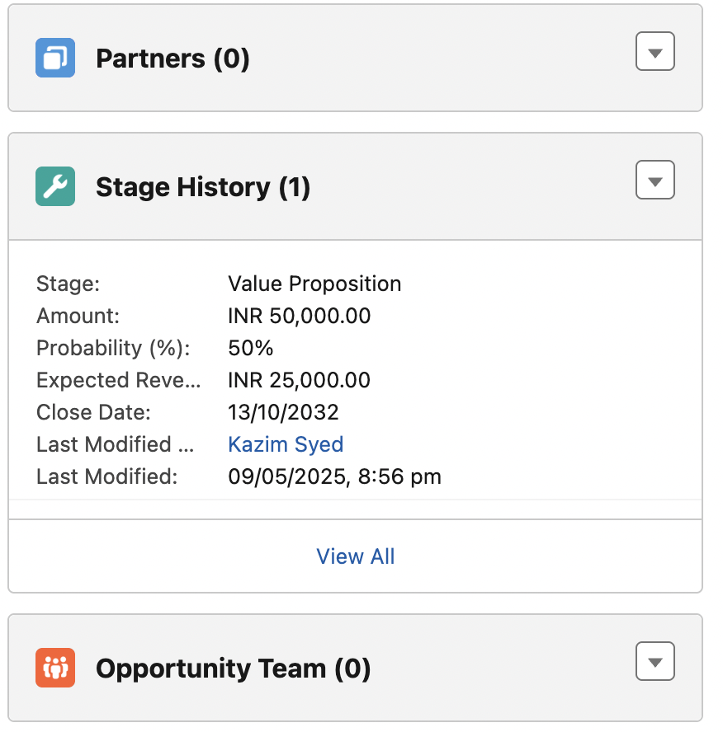
I added members. | 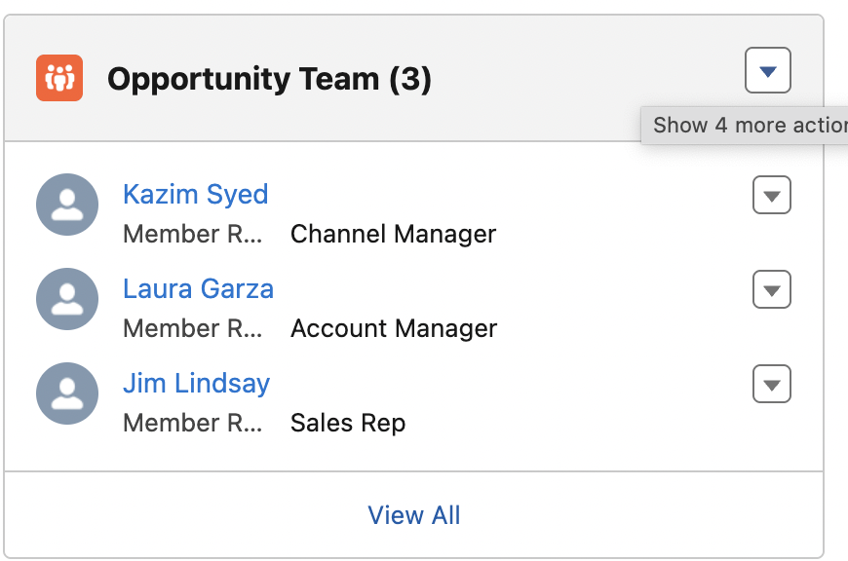
U can remove all member at once. | 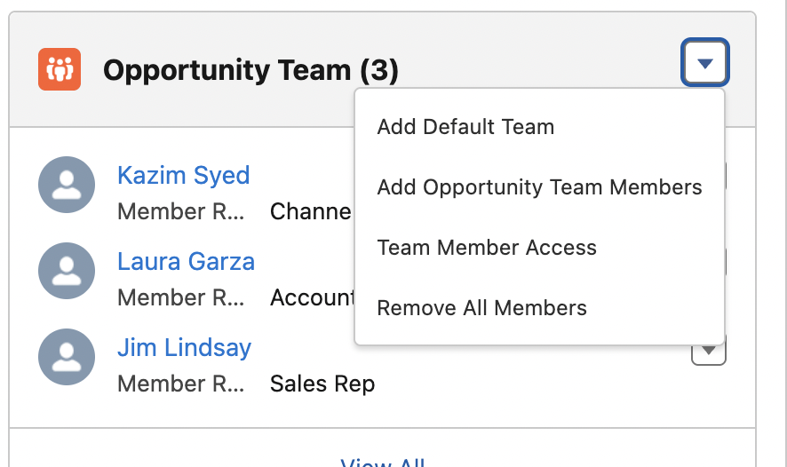

Overriding user Customizations
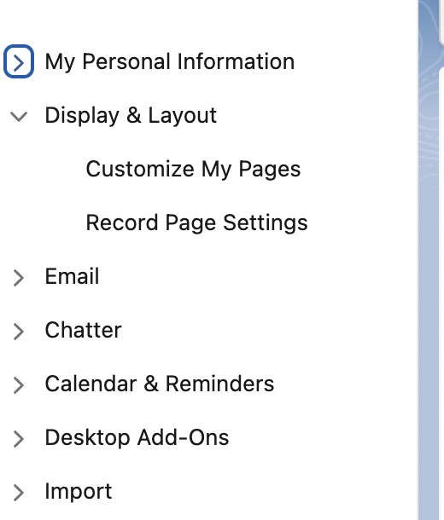 | Under settings
 | 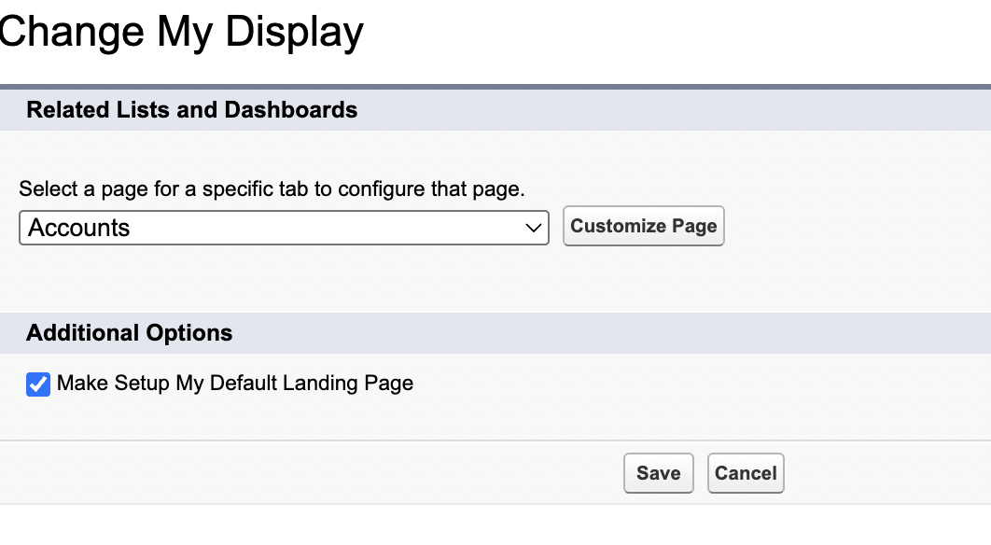
The "Selected List" column shows the contents and order of the "related lists" that will display on your page. The list can be reordered by selecting the Up/Down arrows, or items can be eliminated by moving them to the "Available List."  So if Jim Lindsay didn’t need to see partner related list. He could do that.  These changes are not organization wide. | 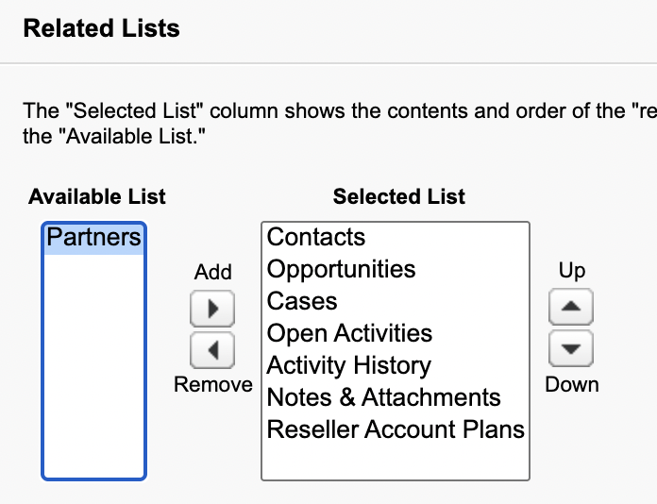
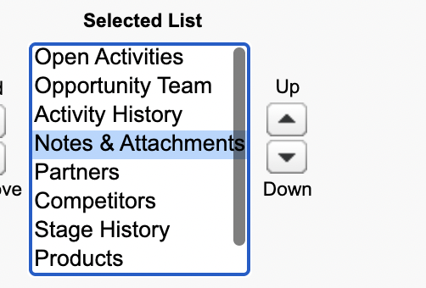 | 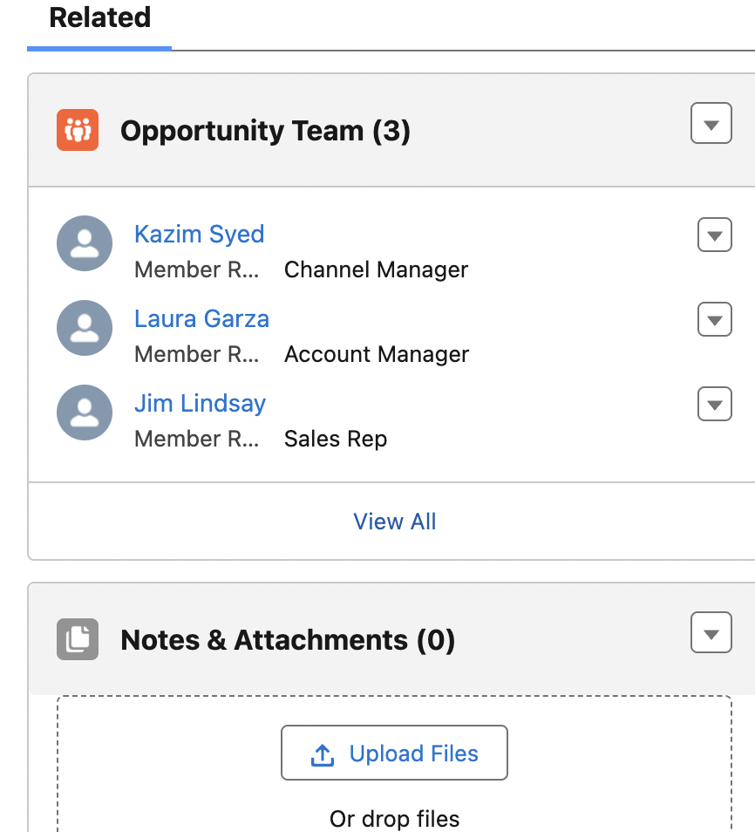

Creating a lightning User permission set
Jim lindsay is a custom marketing user, I wanna verify on his profile. That he doesn’t have lightning access.  I am gonna search his profile for lightning.  So if u wanna give lightning experience to this profile u do this way.  U click on it and then toggle them to turn on.  Instructor wants us to use permission set. | 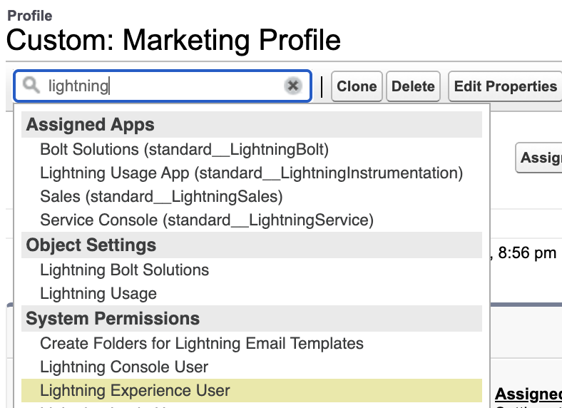
Permission set → new → fill in the metadata and save → System permission
 | Access Lightning Experience and switch between Lightning Experience and Salesforce Classic.
Note: | Uncheck boxes do not overwrite checkboxes on the profile level.  Its anything that we explicitly check, though will override anything thats checked.  So this granting further access in this instance.
  Uncheck ones will not take away access when its provided system wide for the users that is assigned the permission set.
Confusing lang: PS are means to provide more access. If anything, we will have more access with PS. | 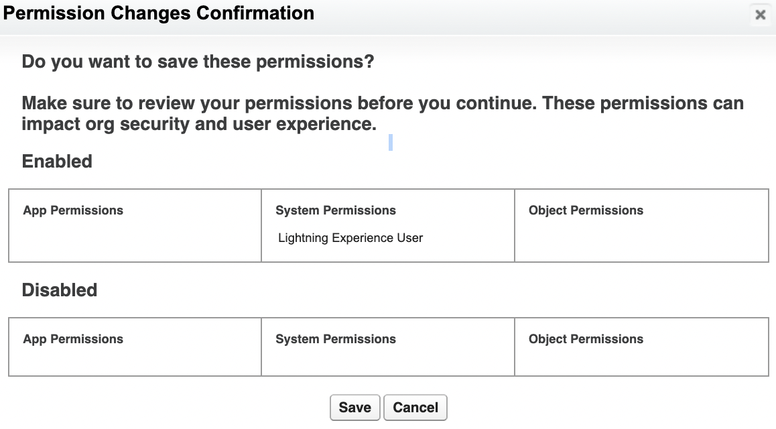
Then Manage assignments | 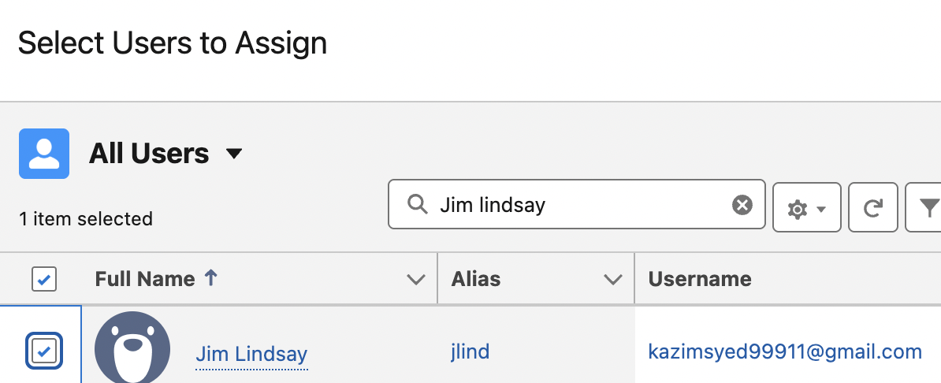
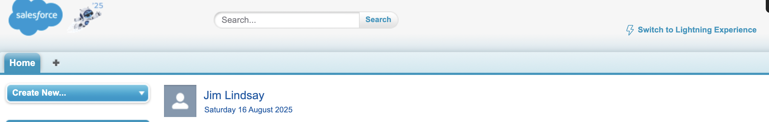 | Now jim can go from being lightning user to classic user.

Restriction rules
 | instead of opening up access to users, they further restrict sensitive data or data that is not required for their work.
 | It restricts the records that the users is allowed by the OWD’s and RH and Sharing rules. And u can filter the records so that user can access only the records that meets the criteria.
Restriction rules applies on | Custom objects, external objects, contracts, events, tasks, time  sheets, and time sheet entries.
2 Restrictions per record | You can create up to two active restriction rules per object in  Enterprise and Developer editions and up to five active restriction rules per object in Performance  and Unlimited editions. Restriction rules are applied to the following Salesforce features:  - List views  - Lookups  - Related lists  - Reports  - Search  - SOQL  - SOSL

Implicit sharing
Implicit sharing is automatic. You can neither turn it off, nor turn it on—it is native to the application.
In other words, implicit sharing isn't a configurable setting; however, it's important for any architect to
understand.
Child implicit sharing is providing access to an account’s child records to the account owner. This access is defined at the owner’s role in the role hierarchy.
Child implicit
sharing only applies to contact, opportunity, and case objects (children of the account). The access
levels that can be provided are View, Edit, and No access for each of the children objects when the
role is created.
By setting to View, the account owner can implicitly see the associated object records
(contact, opportunity, or case). By setting to Edit, the account owner can implicitly modify the
associated object (contact, opportunity or case).
Implicit sharing doesn't apply to custom objects.
Parent implicit sharing is providing access to parent records (account only) when a user
has access to children opportunities, cases, or contacts for that account. Salesforce has a data access policy that states if a user can see a contact (or opportunity, case, or order), then the user implicitly sees the associated account.

User licenses and profiles

1. Core CRM Clouds
Product | Purpose | Key Features
Sales Cloud | Sales pipeline management, lead-to-cash automation. | - Leads & Opportunities  - Quotes & Contracts  - Einstein AI forecasting
Service Cloud | Customer support & case management. | - Omni-Channel Routing  - Knowledge Base  - Field Service
Marketing Cloud | Email/SMS marketing, customer journey automation. | - Email Studio  - Journey Builder  - Advertising Studio
Commerce Cloud | E-commerce solutions (B2B & B2C). | - Order Management  - AI-powered product recommendations
Experience Cloud | Build customer/partner portals (formerly "Community Cloud"). | - Self-service portals  - Partner collaboration hubs

2. Data & Analytics
Product | Purpose
Tableau | Advanced data visualization & business intelligence.
Einstein Analytics | AI-powered analytics (now part of "Tableau CRM").
MuleSoft | API integration platform (connect Salesforce with other systems).
Data Cloud (Genie) | Real-time customer data platform (CDP) for unified profiles

Collaboration and Productivity
Product | Purpose
Slack | Team messaging & workflow automation (integrated with Salesforce).
Quip | Collaborative documents & spreadsheets.
Einstein Copilot | AI-powered assistant for Salesforce workflows.

4. Industry-Specific Clouds
Product | Industry
Health Cloud | Healthcare patient management.
Financial Services Cloud | Banking, insurance, and wealth management.
Manufacturing Cloud | Supply chain & production optimization.
Nonprofit Cloud | Donor management & fundraising.

5. AI & Automation
Product | Purpose
Einstein AI | Predictive analytics, chatbots, and AI-driven insights.
Flow Builder | No-code workflow automation (replaces Process Builder).
Omni Studio | Low-code tools for complex service workflows.

6. Developer Tools
Product | Purpose
Heroku | Cloud platform for app development (PaaS).
Lightning Platform | Low-code app development (custom objects, Apex, LWC).
DevOps Center | CI/CD tools for Salesforce development.

7. Specialized Add-Ons
Product | Purpose
CPQ (Configure-Price-Quote) | Streamline quoting & pricing for sales teams.
Field Service Lightning | Mobile workforce management (scheduling, dispatching).
Sustainability Cloud | Track and reduce carbon footprint.

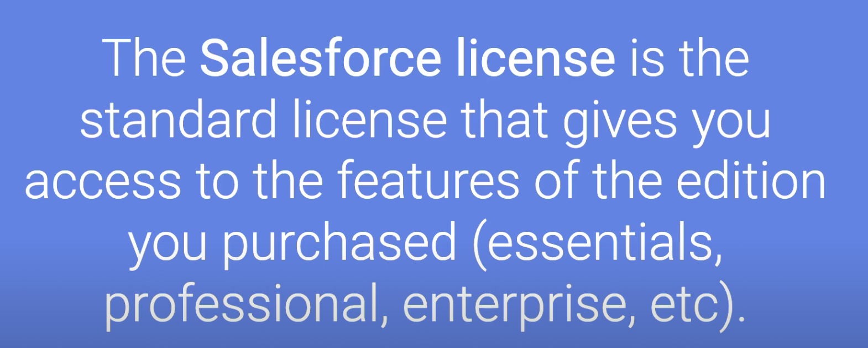

License Type | Purpose | Profiles (Default) | Key Standard Objects
Salesforce (Full License) | Full CRM access (Sales/Service Cloud) | - Standard User  - Sales User  - Service Agent  - System Admin | Accounts, Contacts, Leads, Opportunities, Cases, Activities
Salesforce Platform | Custom app access (no Sales/Service Cloud) | - Platform User  - Custom Profiles | Custom Objects, Accounts, Contacts (limited)
Chatter Free | Chatter-only access (no CRM data) | - Chatter Free User | Chatter (Posts, Files, Groups)
Chatter External | External collaboration (partners) | - Chatter External User | Chatter (limited)
Identity | SSO/login-only (no Salesforce UI) | - Identity User | None

Salesforce user licenses

User license:
Licenses: access to baselines features/products.  For more access, use P&PS.  License:  - Lightning platform user license  - Salesforce user license | Every user must be assigned a user license to access Salesforce. A user's license determines the baseline of features that the user can access. You assign user permissions for data access through a profile and optionally one or more permission sets.  Assign licenses for your users’ job functions, so that they have the permissions required for their day-to-day tasks. For example:  - Allison needs access to custom apps, but not the full CRM functionality. Assign Allison a Lightning Platform user license, which supports standard object permissions for accounts and contacts, but not cases.  - George needs full access to standard CRM apps and objects. Assign George a Salesforce user license, which allows you to grant them standard object permissions for accounts, contacts, and cases.
Seat based license  or  login based license | Some licenses can be either a member or seat-based license or a login-based license. To use a member or seat-based license, purchase one license per user. To use a login-based license, purchase the number of logins to be used every month. Users associated with a login-based license consume one login each time they log into a site. After they’ve logged in, switching between sites or logging in multiple times doesn’t consume extra logins. This type of login is referred to as a unique login.

https://help.salesforce.com/s/articleView?id=platform.users_license_types_available.htm&type=5
read more:

Standard User license  Full CRM + Custom apps | - Full CRM access.  - Sales, Service and Marketing features.  - Access to standard and custom apps.  - Typical users: Sales Reps, Sales Managers, Service Agents, Marketing Users, System Administrators, Developers, Business Analysts  - Sales: Account, Contact, Lead, Opportunity, Campaign, Product, Price Book, Order, Contract, Report, Dashboard, Task, Event.  - Service: Case, Account, Contact, Solution, Knowledge, Report, Dashboard, Task, Event.  - Marketing: Lead, Campaign, Account, Contact, Report, Dashboard, Task, Event.  - General: User, Profile, Permission Set, App, Tab, Files, Chatter.
Salesforce platform  Access to custom apps or subset of standard apps.  Restricted access to standard sales or service cloud (unless granted using PS) | Description: Designed for users who need access to custom apps developed on the Salesforce Platform, or a subset of standard CRM objects. They do not get access to standard Sales or Service Cloud functionality like Leads, Opportunities, Cases (unless explicitly granted via custom permissions on specific objects).  Typical Users: Employees using custom HR apps, Project Management apps, Supply Chain apps, or any internal application built on Salesforce that isn't core Sales/Service. Users needing access to custom objects and reports/dashboards built on them.  Standard Objects typically needed access (limited):  - Account, Contact (often read-only or limited access for context).  - Report, Dashboard, Task, Event.  - Files, Chatter.  - Crucially, extensive access to Custom Objects.
Customer Community / Partner Community (now part of Experience Cloud Licenses) | For external customers/partners who needs access to Salesforce community(Experience cloud). Highly restricted access to specific objects and data shared with them.  Typical Users: Customers seeking support, viewing orders, tracking cases. Partners managing leads, opportunities, or deals with your company.  Standard Objects typically needed access (highly customizable and restricted by Community setup):  - Customer Community: Case, Knowledge, Contact, Account (often limited to their own records), Chatter, Files.  - Partner Community: Lead, Opportunity (their own), Account (their own), Contact (their own or shared), Case, Files, Chatter, Reports, Dashboards (often custom ones).

More Access | Service Cloud Portal / Customer Community Plus (Legacy/Tiered Experience Cloud):  - Description: Similar to Community licenses but often with more advanced features like reports & dashboards access, or delegated administration, depending on the tier.  - Standard Objects: Similar to Community licenses, but may include broader access to Reports & Dashboards.
Chatter free:  For employees, internal collaboration.  No access to standard objects, only a record linked with a chatter. | Chatter Free:  - Description: For users who only need access to Chatter. They can post, view profiles, and access groups but cannot access standard Salesforce objects or data unless explicitly shared through Chatter Feeds.  - Typical Users: Employees who primarily need internal collaboration and communication, but not CRM functionality.  - Standard Objects: None directly, only what's exposed via Chatter Feeds (e.g., if a record is linked in a post).
Chatter External:
- Description: For users outside of your company's email domains (e.g., customers, prospects) who you invite to Chatter groups. Very limited access, only to groups they are invited to.
- Standard Objects: None directly.
Knowledge Only User:
- Description: For users who primarily need to create, edit, and manage Knowledge Articles.
- Typical Users: Knowledge Base authors, content managers.
- Standard Objects: Knowledge. Potentially minimal Account/Contact access for context if needed.
Single sign on. | Identity  Description: For users who only need access to Salesforce as an identity provider (e.g., for single sign-on to external apps). They don't have access to CRM data.  - Standard Objects: None directly related to CRM data.

Salesforce license | Baselines of features/products.
Profile | A profile enhance/restrict users permissions  - field level security  - record level security  - Layout settings  Every user is assigned exactly one profile.
Profile controls | Object permissions: CRUD on Custom and standard objects.  Field level security: Visibility and edit ability of individual objects.  App permissions: Which S&C-apps a user can see.  Tab Settings: Which tabs are visible, hidden, or default on/off.  User Permissions: A vast array of individual permissions (e.g., "Export Reports," "Manage Users," "Modify All Data").  Page Layouts: Which page layout a user sees for a given object.  Login Hours/IP Ranges: Restrictions on when and from where users can log in.
Salesforce → Standard user
Standard User:

CRUDelete most records they own. Can’t delete most records.

CRU on (Campaign, leads, contact, account, opportunity, task, chatter, event, report, dashboard, products, price book, contract(basic access).

R on Solution and Knowledge.

No access/ limited access to Users, P&PS(often limited to own profile).

Salesforce → Marketing User
No access to price quote/price books and contract. | Similar to standard user but with enhanced permission for marketing related objects.  CRUD on campaign + permissions(Manage campaign permissions).  Read, Create, Edit: Lead, Account, Contact, Opportunity, Task, Event, Report, Dashboard, Files, Chatter.  Read Only: Solutions, Knowledge.
Salesforce → Sales user
Designed for sales rep.
More focus on leads, contact, Account, opportunity.
Might have more delete permissions on their own records.

Salesforce → Service cloud user
Interesting that they can edit client info. | Designed for customer service agents.  - Read, Create, Edit, Delete: Case (on their own or based on sharing rules).  - Read, Create, Edit: Account, Contact, Solution, Task, Event, Report, Dashboard, Files, Chatter.  - Read Only: Knowledge (but often has permissions to author/manage articles if also a Knowledge User).
Salesforce → System Administrator
- Description: The most powerful profile. Has "Modify All Data" and "View All Data" permissions for virtually all standard and custom objects, full access to setup, and can manage users, profiles, permissions sets, etc.
- Standard Object Access (Typical):
  - Read, Create, Edit, Delete, View All, Modify All: ALL standard objects (Account, Contact, Lead, Opportunity, Case, Campaign, Product, Price Book, Order, Contract, Solution, Knowledge, User, Profile, Permission Set, etc.).
  - Full access to all administrative settings.
Salesforce → Read only
Description: Can view data but cannot create, edit, or delete records.
- Standard Object Access (Typical):
  - Read Only: Account, Contact, Opportunity, Lead, Case, Campaign, Task, Event, Report, Dashboard, Files, Chatter, Products, Price Books, Contracts, Solutions, Knowledge.

Salesforce → Salesforce platform
No access to anything from marketing or sales. | Key difference is lack of access of Core sales/service cloud.  Standard Object Access (Typical):  - Read, Create, Edit: Account, Contact (often limited), Task, Event, Report, Dashboard, Files, Chatter.  - No Access (by default): Lead, Opportunity, Case, Campaign, Product, Price Book, Order, Contract, Solution, Knowledge.  - Crucially, permissions on Custom Objects as configured.
Platform System Administrator: | Description: An administrator role primarily for the Salesforce Platform, often without full administrative control over core Sales/Service Cloud features like Lead Assignment Rules or Case Escalation Rules that are tied to specific objects they don't have license access to.  - Standard Object Access (Typical): Similar to a full System Admin for objects they can access, but limited by the Platform license itself. They can manage users, profiles, permission sets, but their ability to grant permissions on core Sales/Service objects is limited by the underlying license.

Important considerations
Permission sets over profiles for granular control.
Custom profiles, clone standard one and modify it for security and efficiency.
Least privilege: always grant the user the least amount of access.

Prompt 1: What is the difference between a Standard and a Custom Profile in Salesforce?

Feature | Standard Profile | Custom Profile
Definition | Pre-built by Salesforce with fixed permissions. | Created by admins to tailor permissions.
Flexibility | ❌ Cannot be modified (except for minor tweaks via Permission Sets). | ✅ Fully customizable (object/field permissions, tabs, apps).
Use Case | Best for common roles (e.g., "Sales User," "Read Only"). | Ideal for unique business needs (e.g., "HR Profile," "Custom App User").
CRUD Permissions | Fixed (e.g., "Standard User" can edit Accounts). | Adjustable (e.g., restrict Contacts to "Read Only").
License Alignment | Tied to specific licenses (e.g., "Salesforce" or "Platform"). | Can be assigned to any license.
Deletion | ❌ Cannot be deleted. | ✅ Can be deleted if unused.
Default Settings | Includes default page layouts, apps, and tabs. | Starts blank; admins configure everything.
Best For | Quick setup for generic roles. | Granular control for specialized teams.

Key Notes:
- Standard Profiles are "out-of-the-box" (e.g., System Administrator, Standard User).
- Custom Profiles are cloned from standards or built from scratch.
- Permission Sets extend access for both types.

Example:
- Standard Profile: "Read Only" → Users can view but not edit records.
- Custom Profile: "HR Manager" → Custom access to HR objects (e.g., Employee__c).

Prompt 2: What are limitations of Standard Profiles in Salesforce?
CRUD is locked | 1. Cannot Modify Core Permissions  - Object/Field Access: CRUD (Create, Read, Update, Delete) permissions are locked.  - Example: A "Standard User" can’t be restricted from editing Accounts without a Permission Set.  - Tab Visibility: Cannot hide default tabs (e.g., "Chatter" for non-collaborative roles).
login-hours/restriction for custom profile only.  And layouts. | 2. Limited Customization  - Apps & Page Layouts: Use Salesforce defaults (e.g., "Sales" or "Service" app layouts).  - Login Hours/IP Restrictions: Only adjustable via Custom Profiles or Permission Sets.
In a custom profile, u have to be within a family.  Like a sister or sibling. | 3. License Dependency  - Each Standard Profile is tied to a specific license (e.g., "Salesforce" or "Platform").  - Example: A "Marketing User" profile can’t be assigned to a "Chatter Free" license.
Standard profile cant be deleted. | 4. Cannot Be Deleted or Renamed  - Standard Profiles (e.g., "Read Only," "System Administrator") are permanent.
Lack access to custom objects. | 5. Restricted Access to Custom Objects  - By default, Standard Profiles lack access to custom objects unless manually granted via Permission Sets.
6. Inflexible for Unique Roles
- Example: A "Contract Manager" role might need a mix of Sales + Legal object access—impossible with Standard Profiles alone.

Profiles

Edit: since I am the system administrator.  The sys admin has cru, view all, modify all, delete all, view setup, delete setup. | 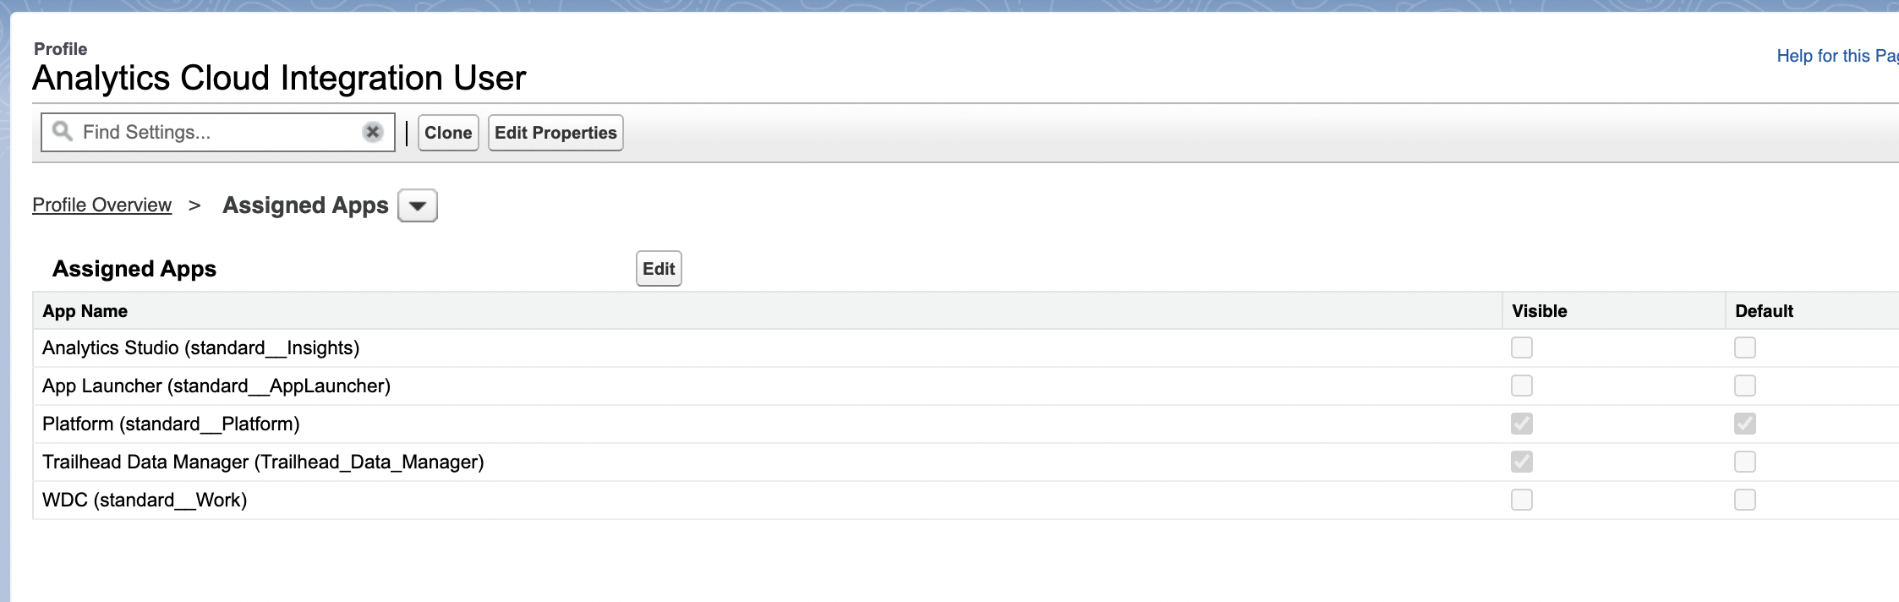
You can change between apps and systems. | 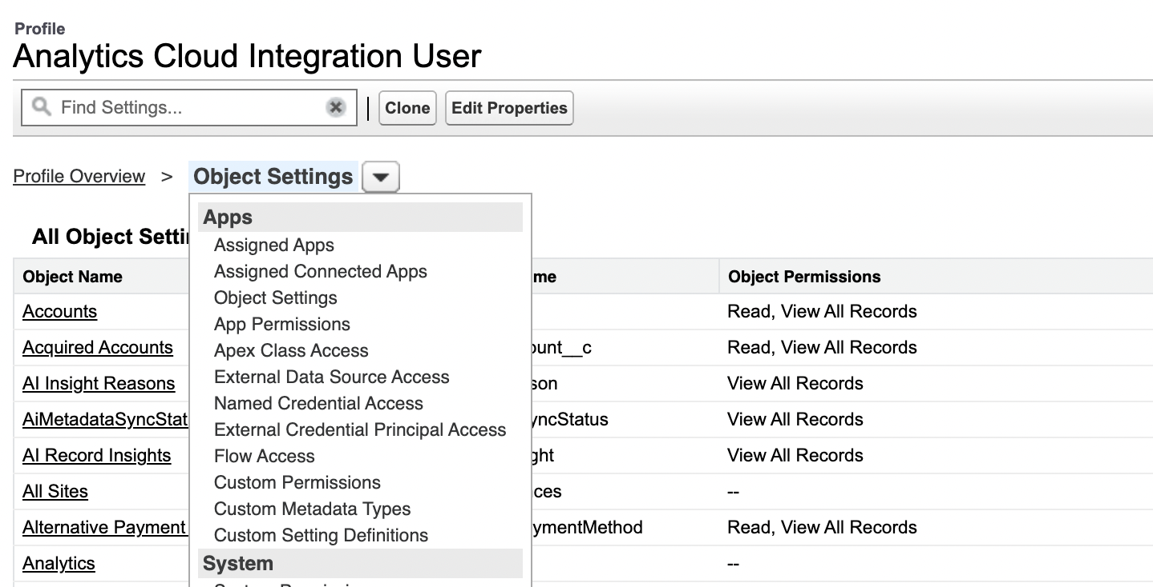

Permission sets
To grant delete permission to Custom marketing profile.
 | Instead of creating a custom profile, we use PS.
Users → permission sets
 | Rather than granting access to any1 with that profile, just a select few to have the ability to delete cases.
 | You can do specific things like opening up the further access by creating what is known as permission sets.
Permission sets  Rather than adjust an existing PS, We create a new. | 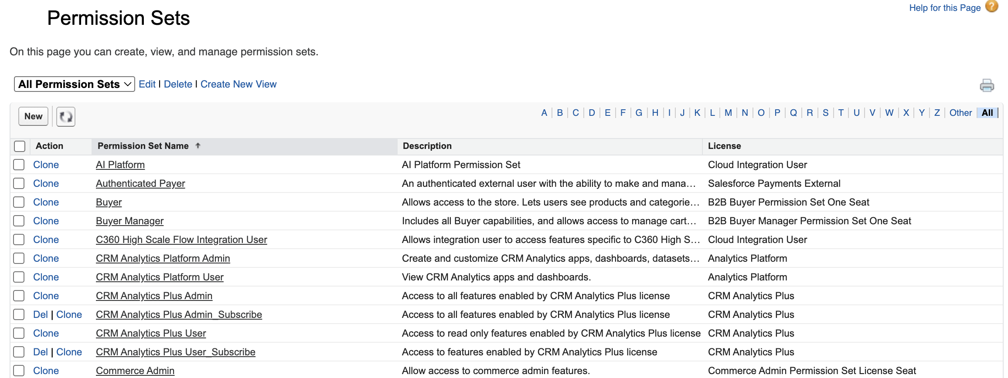

 | 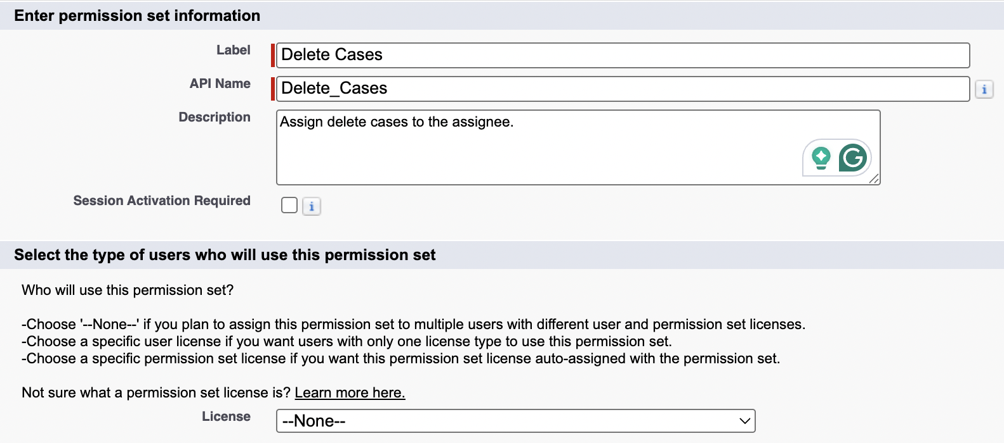
 | P&PS differs at system settings, with profile we can adjust things like login hours. With permission sets, it only has system permissions and system providers.
PS → Role → Case.  Case → Edit  Since I am the sys admin, I can grant permissions.  You can also adjust the field level security in PS.  Since u select delete, u immediately get access to read, create and delete.  A user cant delete a text that they cant see. And deletion is more worse edit than edit itself. | 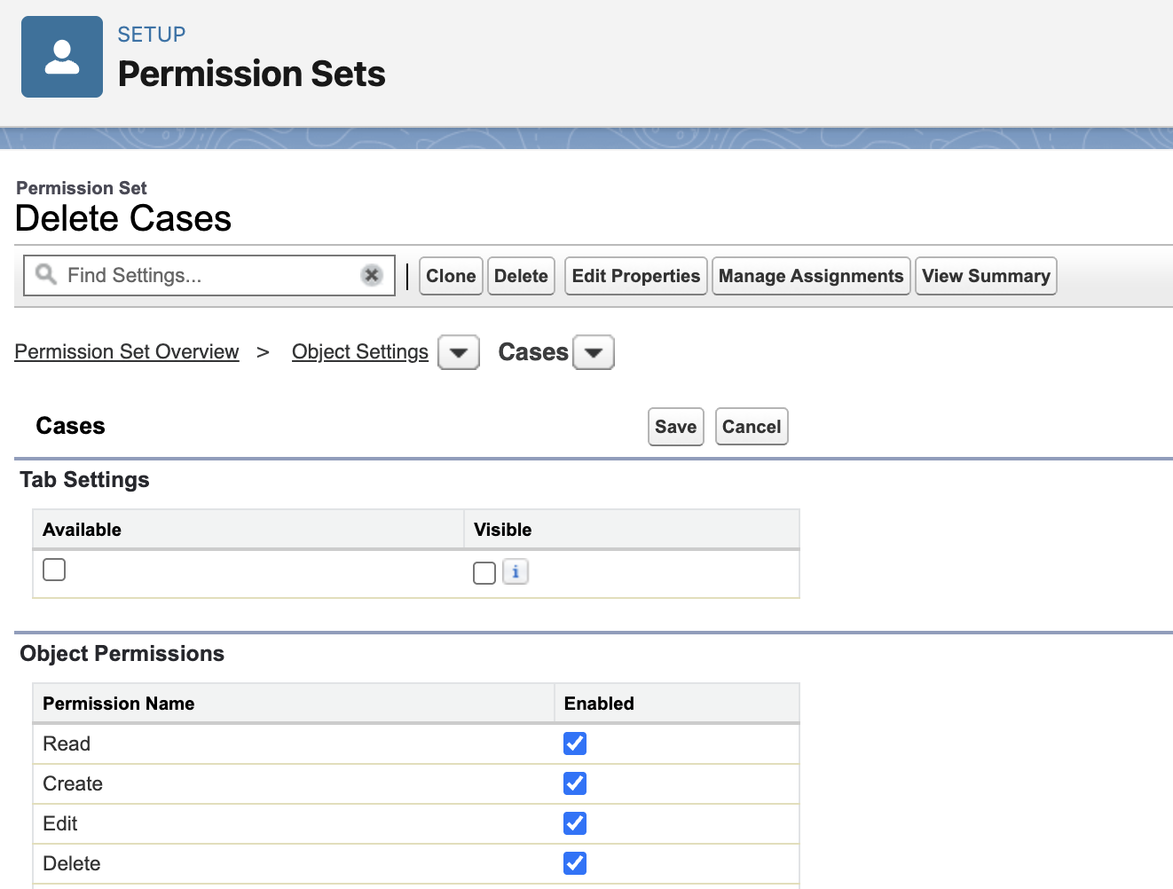
Manage permissions
PS is assigned to a person Jim Lindsay. | 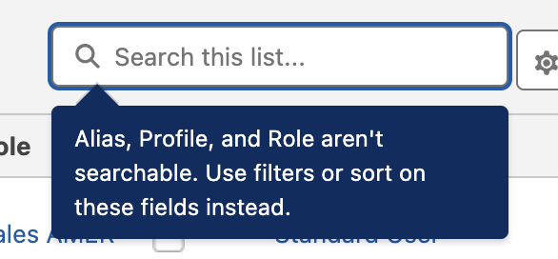
 | 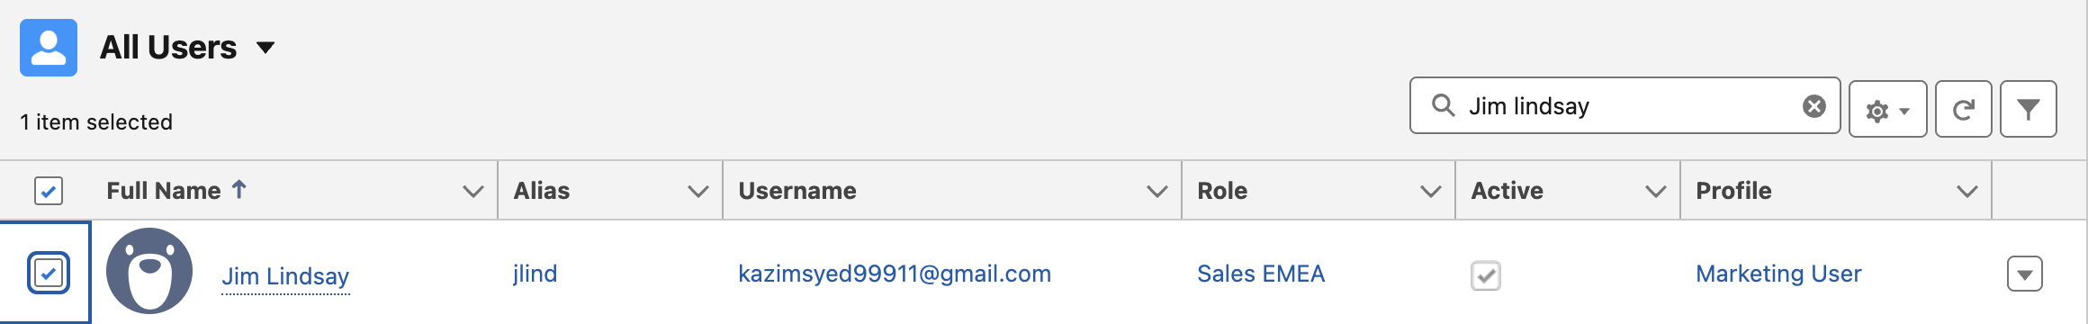

Having the PS isnt enough. U have to enable.  Jim Lindsay → PSA(permission set assignment) | 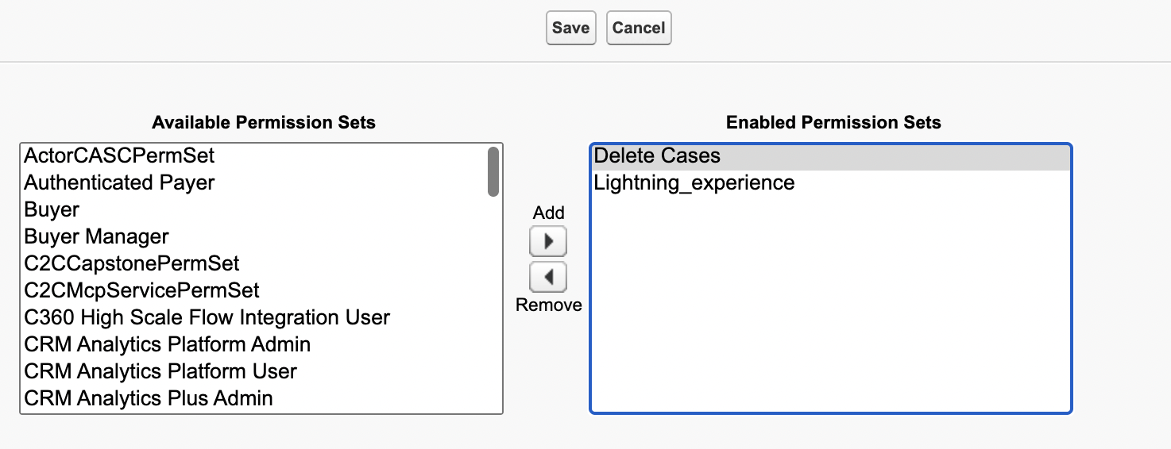
Then we | 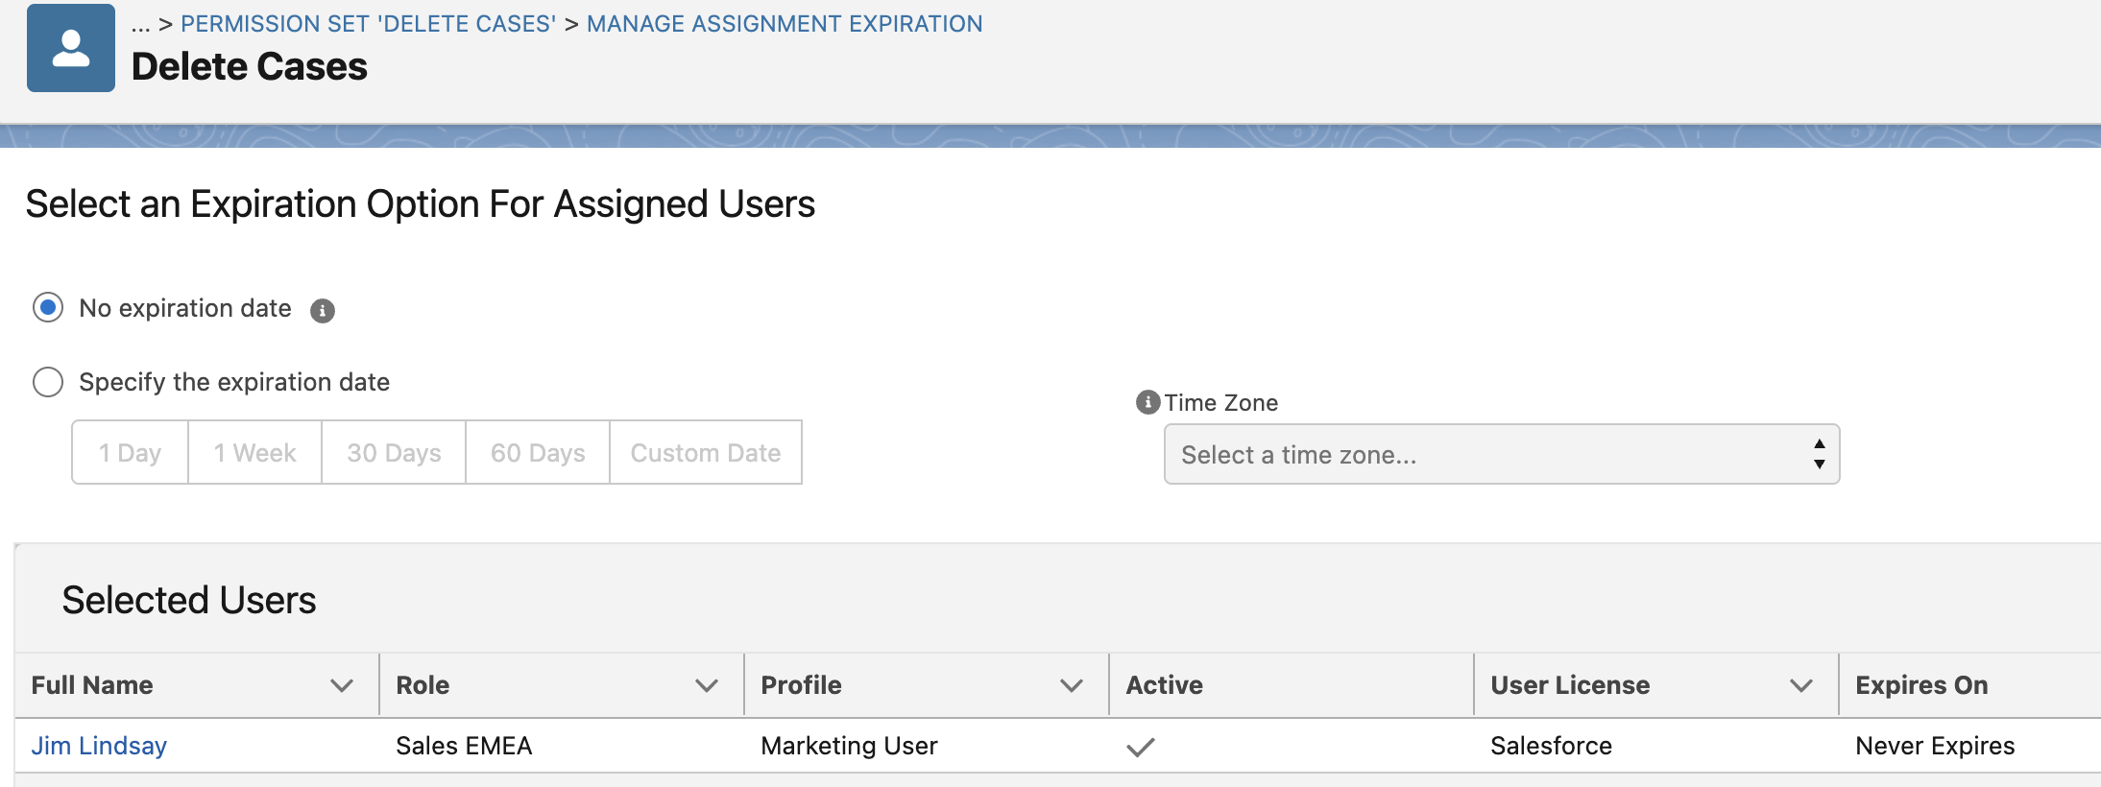
You can go edit Permission set Assignments. | 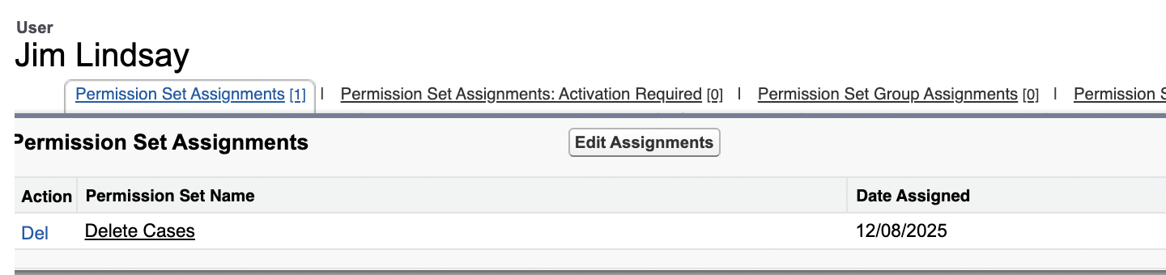
Here, | Mike showed that in Custom Marketing user doesn’t have access to CRUD on Cases, but PS can grant him that access.

No access vs --

Permission State | Profile Behavior | Permission Set Override? | Best For
--(No Setting) | Neutral (no access by default) | ✅ PS can grant access | Custom objects, flexible control
No Access (✔️) | Hard block (user can’t see object) | ❌ PS cannot override | Enforcing strict restrictions
Read/Edit (✔️) | Grants access | ✅ PS can extend (but not reduce) | Baseline permissions

 | Permission sets cant grant access if profile has allowed access
Permissive settings | Two conflicting permissions sets, will not cancel out.  Salesforce never "subtracts" permissions—it only adds or ignores restrictions.

Salesforce sharing model
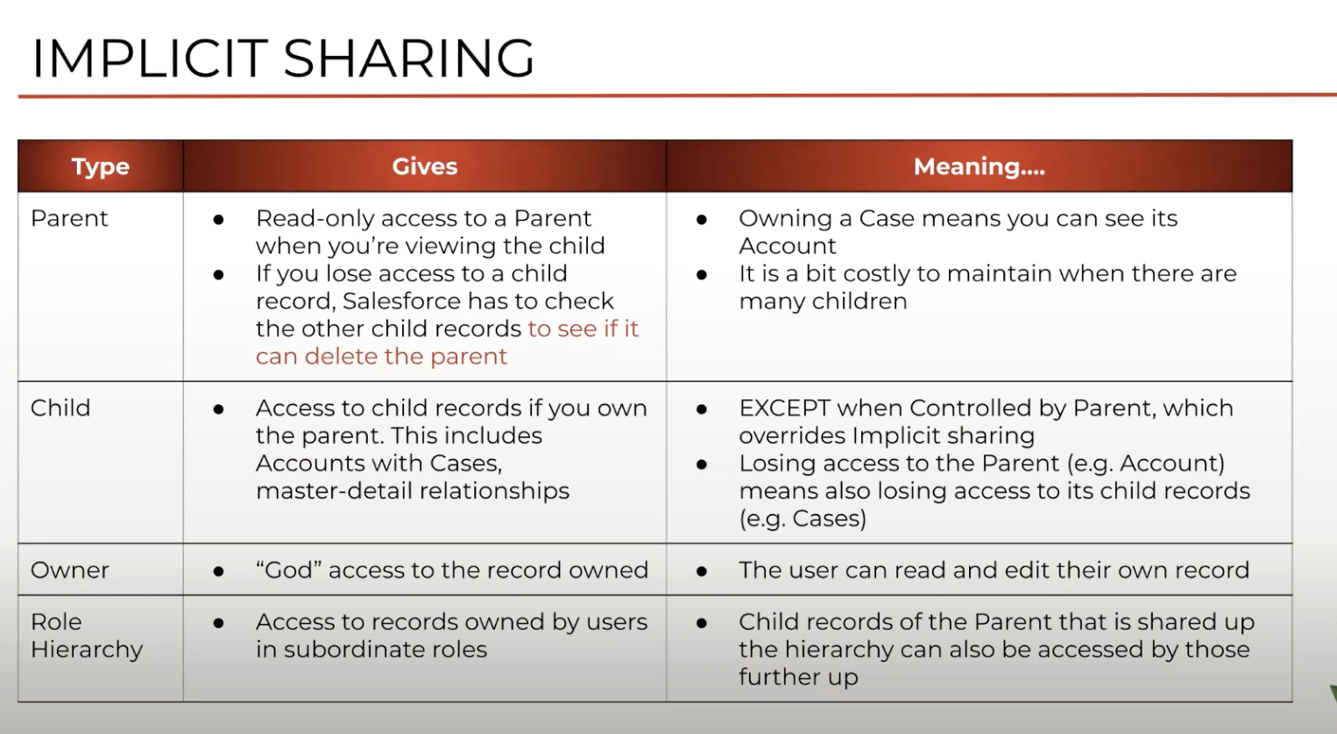

Case vs Incident
Common foot | Case and Incident share a common purpose: tracking and resolving issues.
Different how? | Their primary context, audience and underlying philosophy is different.This leads to distinct strength and use-cases.
Service now incident
tackles  unplanned interruption of service or degradation of quality of service. | Primary focus: ITSM(IT service managements) and broader ESM(Enterprise Service Management). An incident in Servicenow is fundamentally an unplanned interruption to an IT service or reduction in the quality of IT service.
Audience | Primarily internal users(employee, it staff) and sometime partners. While servicenow does have CSM(Customer service managements), its root and strength is embedded in IT operations.
Philosophy | Emphasize work flow automation across various dept(IT, HR, Security, Facilities, etc). Digitizing and automating process within an organization.
Salesforce’s Case
For | CRM AND CSM(Customer Service management).
Audience | B2C and B2B and the internal teams that support them(Customer Service agents, Sales reps, field service technicians).
Philosophy | Managing and improving customer interactions across sales, service, marketing and commerce. Enhancing the customer experience and driving revenue(net sales)
Typical Users: | Customer service agents, sales representatives, marketing professionals, field service dispatchers.
Key characteristics

Reports and Dashboard folder security
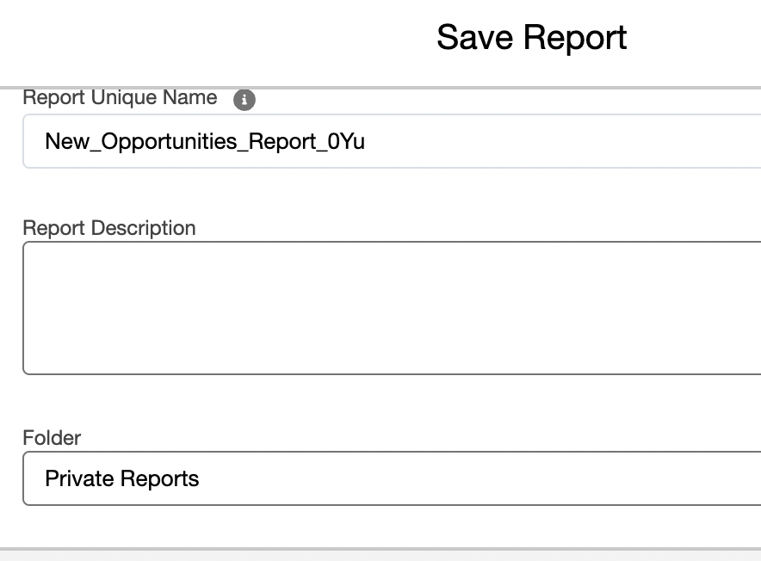 | Is a folder for private reports.
I selected public reports instead of default private reports. So other users could access it. | 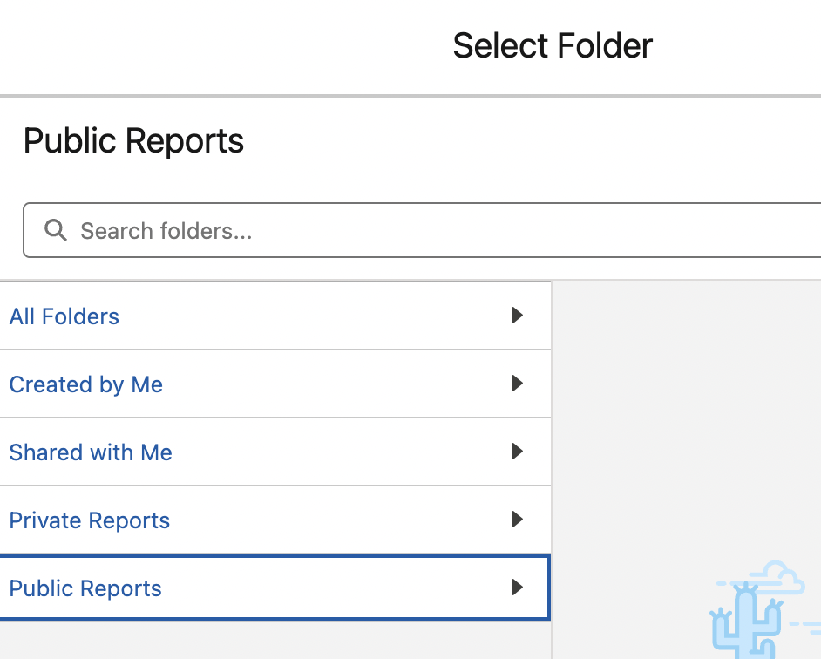
After saving → goto edit → play with filters to retrieve more opportunities
Instead of just first qurater. U can change the close date to all time.  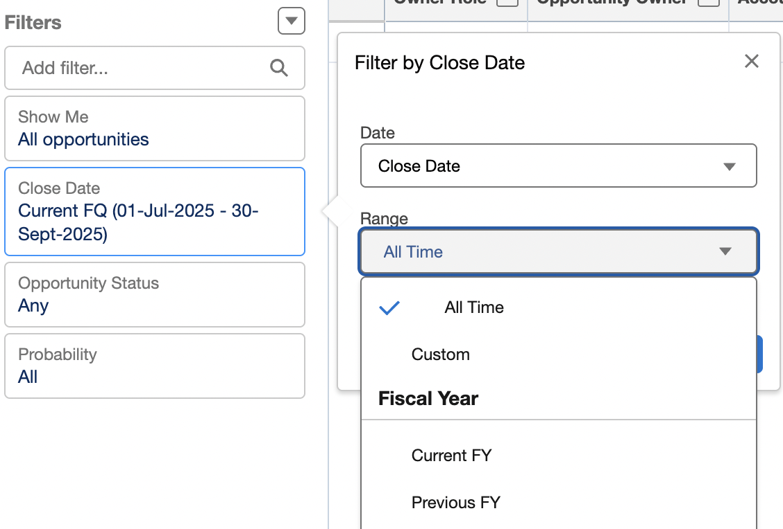 | 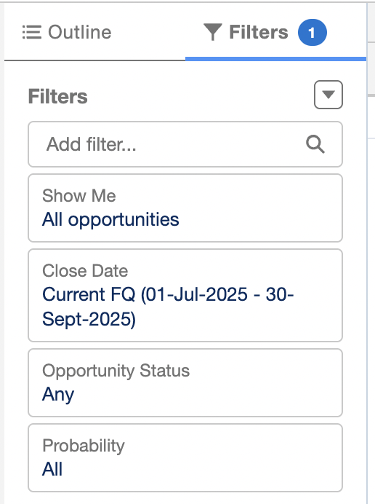
Now we have pull in more records. | 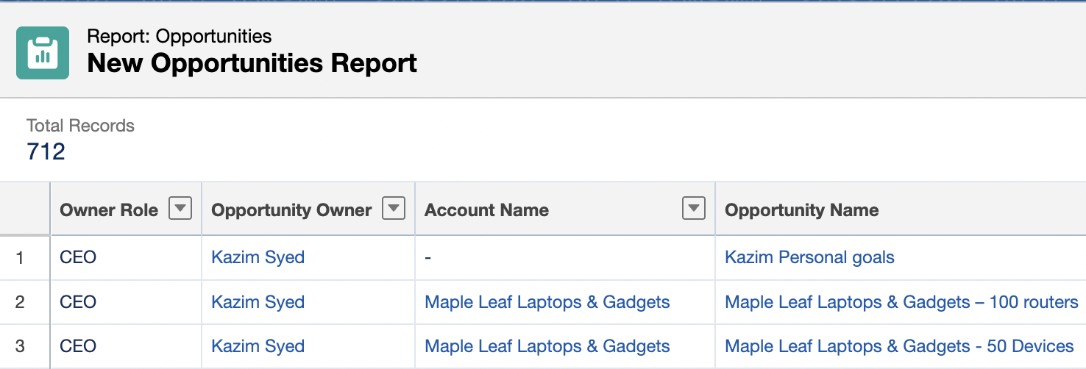
Since Jim lindsay was able to view the report and he can see the opportunities. | We goto Security → Sharing settings → owd → set opportunity to private.
 | The yellow bar ontop means calc is happening. So if it disappear that means they are done.
So in the report, he now would only be able to access one record that he owns or was manually shared or by a sharing rule. | 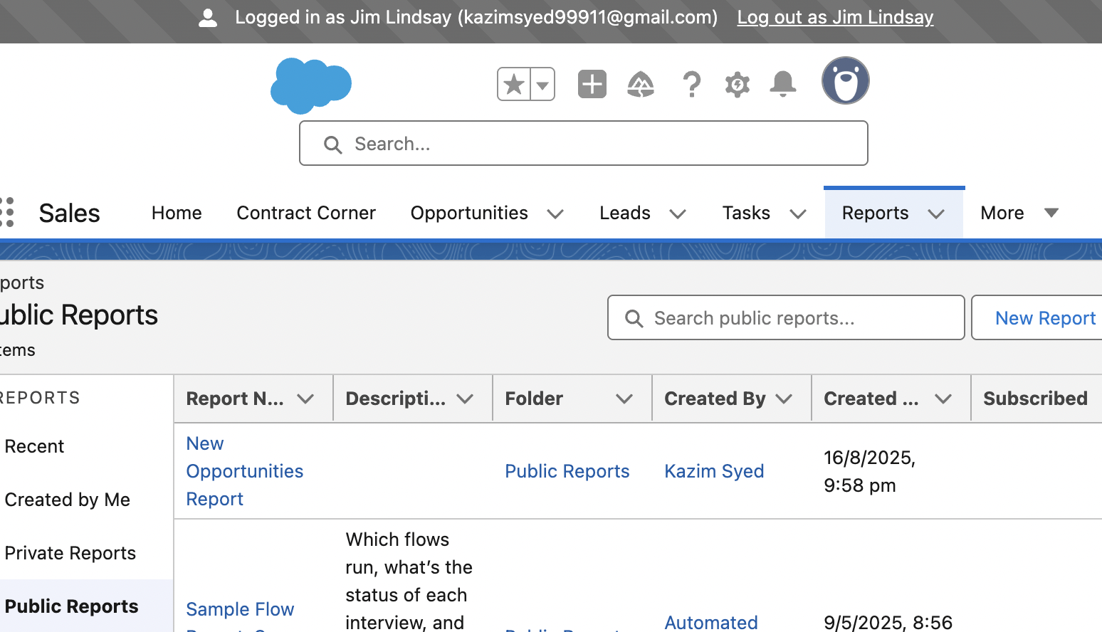
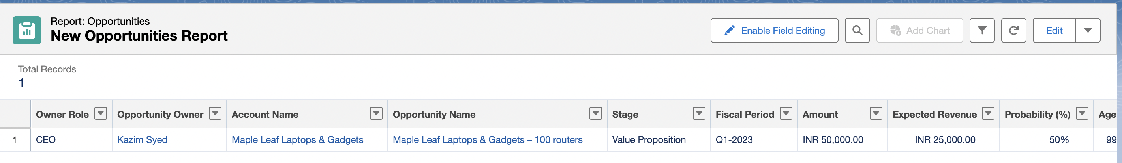  He only sees a single record | 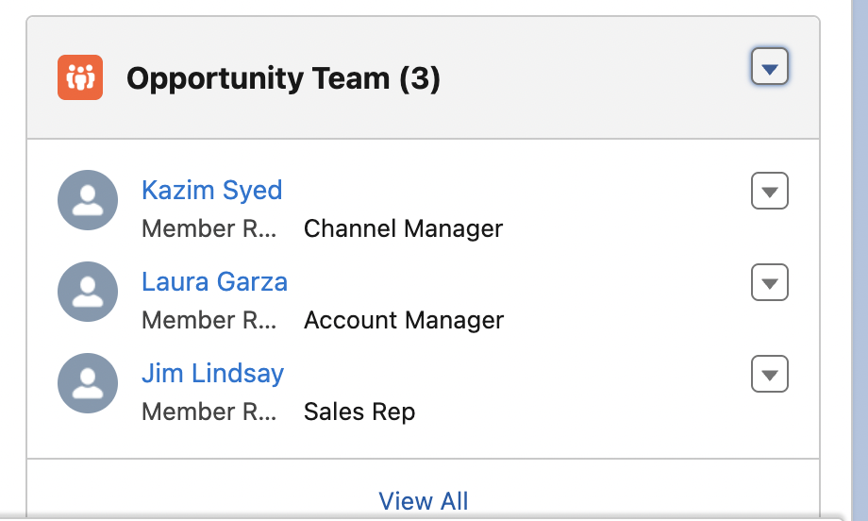  I.e because he was part of the opportunity team from the previous lectures.

Restriction rules
Link: Restriction rule
video: video
For sensitive record.  It filters records that user has access and it determines that based on some criteria. | Restriction rules let you enhance your security by allowing certain users to access only specified records.  They prevent users from accessing records that can contain sensitive data or information that isn’t essential to their work. Restriction rules filter the records that a user has access to so that they can access only the records that match the criteria you specify.
 | Restriction rules are available for custom objects, external objects, contracts, events, tasks, time sheets, and time sheet entries. You can create up to two active restriction rules per object in Enterprise and Developer editions and up to five active restriction rules per object in Performance and Unlimited editions. Restriction rules are applied to these Salesforce features:
Links
- List Views
- Lookups
- Records
- Related Lists
- Reports
- Search
- SOQL
- SOSL
 | 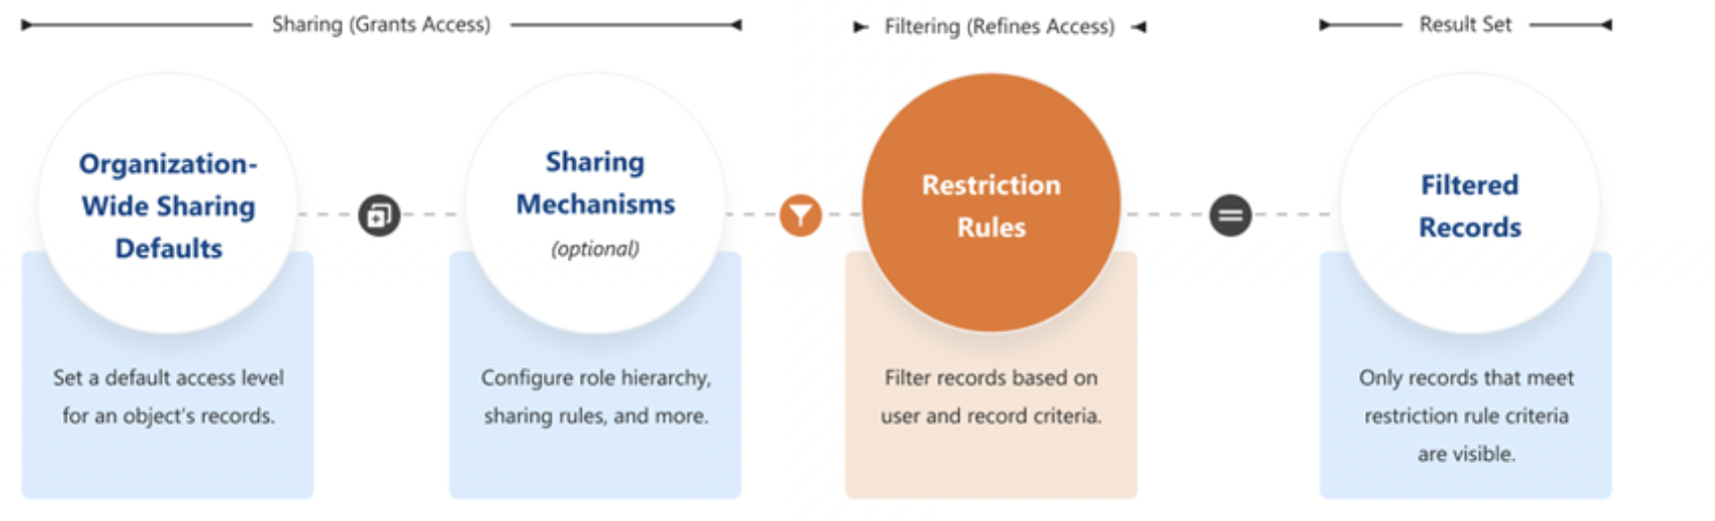
Two teams working on the Acme a/c. In a public r/w opportunity env. Would have access to all opportunity.  So for the two competing teams we can restrict the visibility of other team opportunities using restriction rules.  So we achieve this w/o making it private. | For example, you have competing sales teams that can’t see each other’s activities, even though these activities are on the same account. With restriction rules, you can make sure that sales teams see only activities that belong to them and are relevant to their work. Or, if you provide confidential services to various individuals, use restriction rules so that only team members responsible for supporting these individuals can see related tasks.

Only 1 active rules gonna work per user.  Having two cause uncertainty. | When creating more than one restriction or scoping rule, configure the rules so that only one active rule applies to a given user. Salesforce doesn’t validate that only one active rule applies for a given user. If you create two active rules, and both rules apply to a given user, only one of the active rules is observed.
Turn off salesforce classic.
  Salesforce can't guarantee that restriction rules work as intended for end users who are in the Salesforce Classic experience.

How does Restriction rules affect Other sharing settings
This behavior is similar to how you can filter results in a list view or report, except that it’s permanent. | 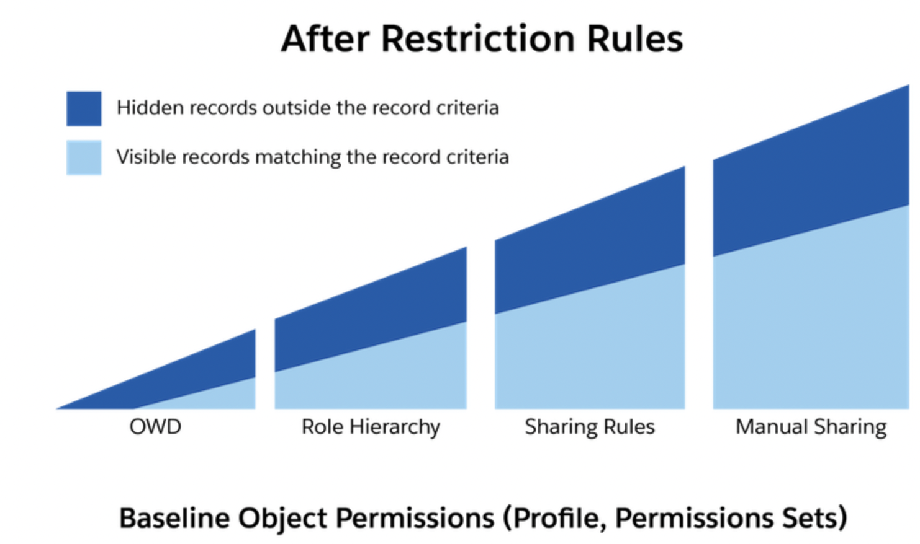
Within Object Manager → goto contact object.  Create a restriction rule →  Mike applied the criteria based on timezone.  Second, it applies based on what critieria.  He used [contract].ownerId=current user.  //restriction rules filter. It selects which record the user is allowed to see.  So by this the user can only see record whom they are the owner.  1. on whom it applies to.  2. and what criteria. | 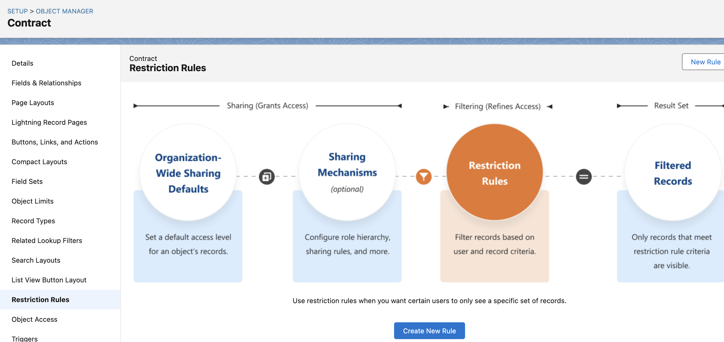

Profiles vs Permission sets
PS extend access beyond baseline feature based upon profile. An individual can have only one profile, but many PS. Having permission set gives u more granular control. To gives access to a user but not to other users having the same profile. And you can make accessibility only for desired duration of time.

Permission Set Groups
Aim: Add permissions set in groups.
Objective: Adding Delete case and lightning experience to a PS groups
Users → PS groups | 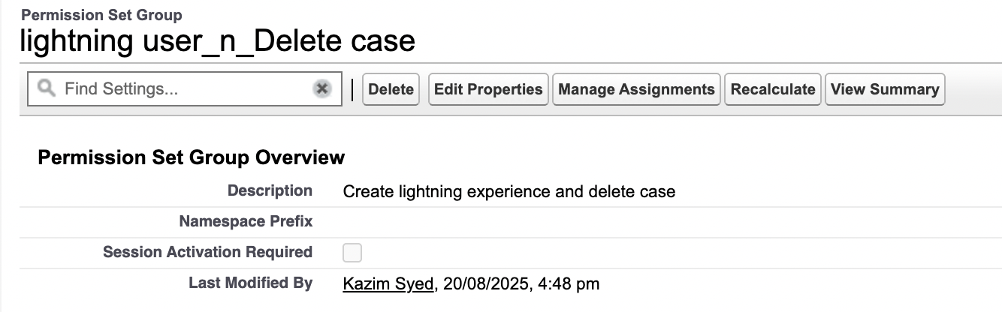
Goto PS group | 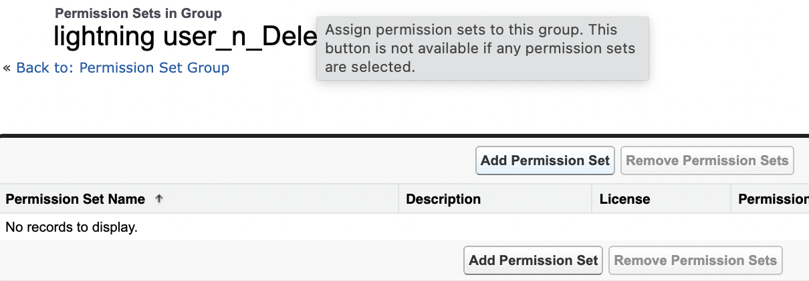
Added the two PS into the group. | 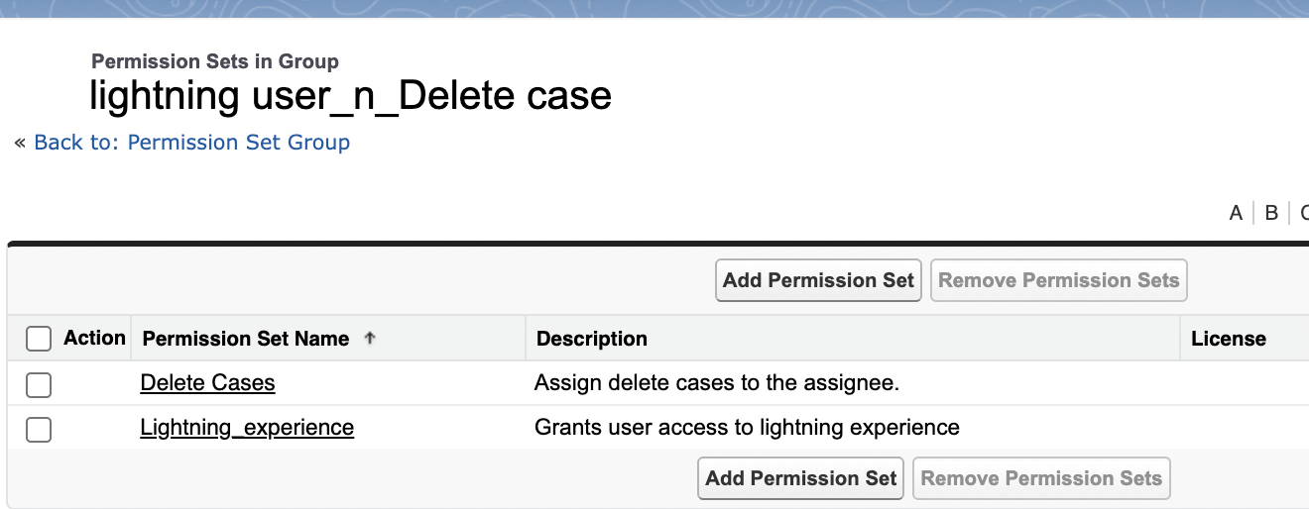
Then I goto Manage assignments and assign it to a person. | 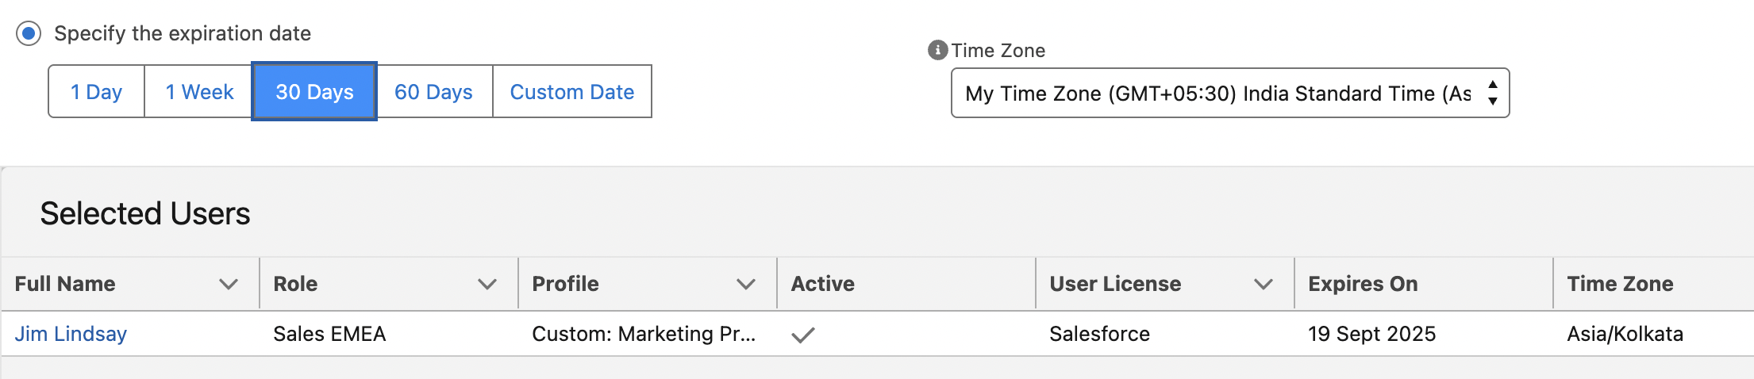
 | I even set the expiration date.

