Salesforce
subtitle

Heading 1

Heading 2

Heading 3

Heading 4

360 view of unified data across  sales, service, marketing, commerce, and more. | With Salesforce, every employee has the apps, trusted AI, and unified data they need to exceed expectations and make customers happier. Our portfolio of solutions works across your entire business to give you a 360-degree customer view from unified data across sales, service, marketing, commerce, and more.
Trusted AI: Einstien | It all happens right within CRM where your employees are working and assisted by our trusted AI, Einstein.
CRM + AI + Data + Trust. | In a nutshell, Salesforce is the world’s #1 AI CRM that helps you connect with your customers in a whole new way with CRM + AI + Data + Trust.

Bring Ai to salesforce
 | AI agents can take action autonomously.
Agentforce | Using Agentforce, our groundbreaking suite of customizable agents and tools, you can build autonomous agents that assist your employees and customers with common business interactions.
 | Agentforce’s capabilities are made possible by Salesforce’s unique ability to deliver a unified experience between apps, models, and data layers.
Common metadata model – seamless ways for apps.  Service cases become sales opportunities. | And it all happens on one platform that’s truly integrated in one common metadata model—which is a fancy way of saying data that describes data that creates a seamless way for apps to communicate and work with each other. AI can learn from that 360-degree view and apply its full context to every customer experience, wherever they’re interacting with your business: Service cases become sales opportunities. Merchants can resolve service issues.

Why
Because u don’t want disjointed data. | Salesforce helps you overcome these challenges by helping you create a 360-degree view of your customers in every app to enable your employees to meet your customers where they are in their journey. Any company can create a Customer 360 with our industry-leading CRM apps, and because every app runs on the same integrated platform, all your AI, data, customizations, and upgrades work seamlessly in every experience.
 | Unlike disconnected point solutions for every separate team, Salesforce apps work on one platform, so you have fewer contracts, integrations, trainings, and out of sync release cycles that slow down your business.

Mike wheeler course
Two sides to Salesforce platform, the backend that is the setup menu and the frontend that is accessible using App launcher.
Note: You can click on the setting → Setup.
  Two sides | Salesforce: Restaurant analogy. Has a front side and the backside(kitchen).
80% of end Users focus on Marketing, services & Sales | Vast majority of user see in salesforce is Something around Marketing, sales or service.

Get a new salesforce instance: https://trailhead.salesforce.com/promo/orgs/analytics-de

Configuration and Setup

Prompt
Prompt: | The first learning objective in the Salesforce Certified Administrator Exam Guide is: Describe the information found in the company settings (for example: company settings fiscal year, business hours, currency management, default settings). Give me a conceptual prompt I should ask as a new Salesforce learner in order to fully understand these topics found in the first learning object: fiscal year, business hours, currency management and default settings, in Salesforce company settings. Place these conceptual prompts in a table, with the prompts to the left and then respond to each prompt in the column on the right.

Conceptual Prompt | Explanation
What is a fiscal year in Salesforce, and why would a company customize it? | A fiscal year defines the 12-month financial reporting period for a company. Salesforce allows for Standard Fiscal Years (based on the Gregorian calendar) or Custom Fiscal Years (which can vary in start/end dates or structure). Companies customize it if their financial year doesn’t align with the calendar year.
How do business hours and holidays impact Salesforce automation? | Business hours and holidays define the working schedule for a company in Salesforce. They are crucial for features like case escalation rules and entitlement processes, which use these settings to calculate response and resolution times accurately.
Why is currency management important in Salesforce, and how does multi-currency work? | Currency management allows Salesforce to handle deals in various currencies. Multi-currency enables users to enter amounts in their local currency while the system stores data in the corporate currency. With advanced currency management, currency exchange rates can be tracked over time for historical accuracy.
What are default settings in company settings, and how do they affect user experience? | Default settings in Salesforce include items like the default locale, language, time zone, and currency. These impact how users see data (e.g., date format, number format) and streamline the onboarding experience by pre-populating user profiles with company-wide preferences.

Case escalation rules: bumps up the incident based on case type, priority and business working hours and holidays to a higher level supporting agent. If an incident hasn’t been resolved within 4 hrs during business hour, the case is reassign to tier 2 supporting agent. The users are notified and alerts are triggered.
Entitlement processes: define SLA’s by specifying steps and timelines to response and resolution. If a gold level premium customer raises an incident, the incident must be responded within 1 hour and the issue must be resolved within 1 day.

Feature | Case Escalation Rules | Entitlement Processes
Focus | Case reassignment/time-based escalation | SLA tracking and milestone management
Trigger | Time elapsed without resolution or update | Specific service milestones (e.g., response)
Used For | Making sure no case is forgotten | Ensuring promised service levels are met
Business Hours Aware? | Yes | Yes

Section 2:
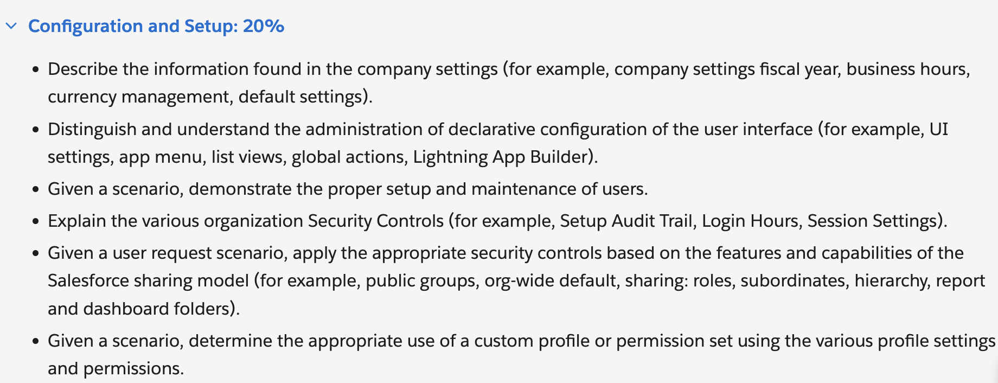

Fiscal year
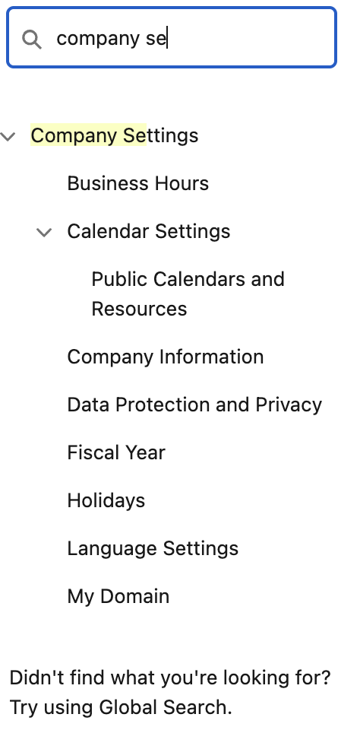 | 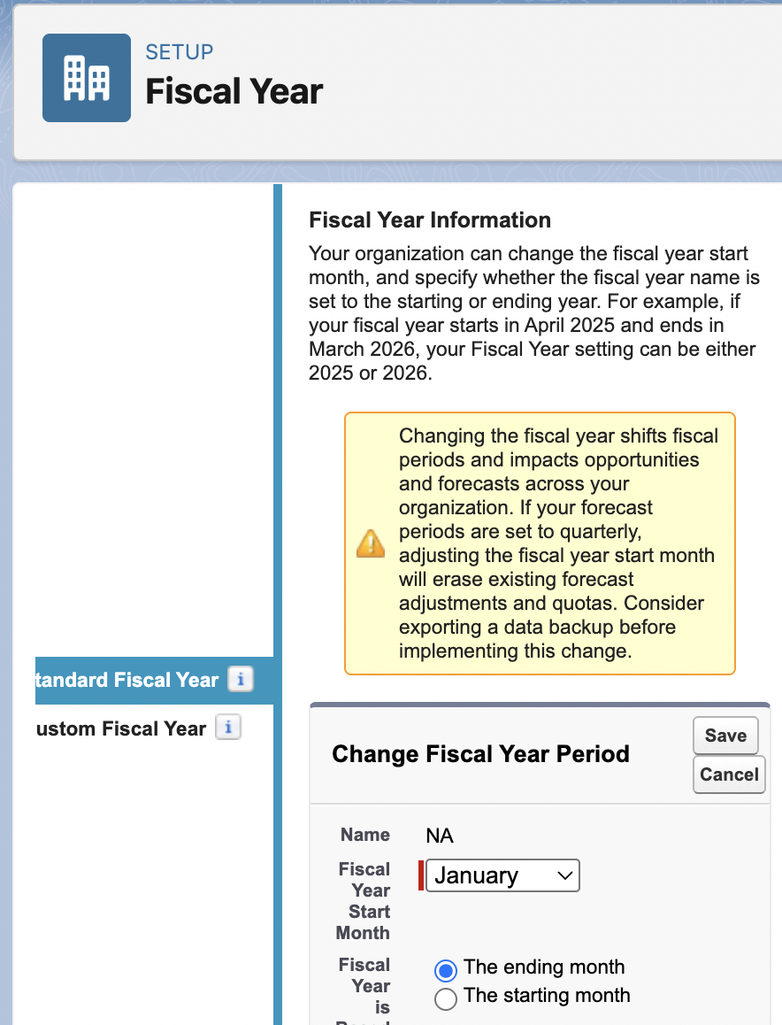

Switching between Salesforce classic and Salesforce lightening
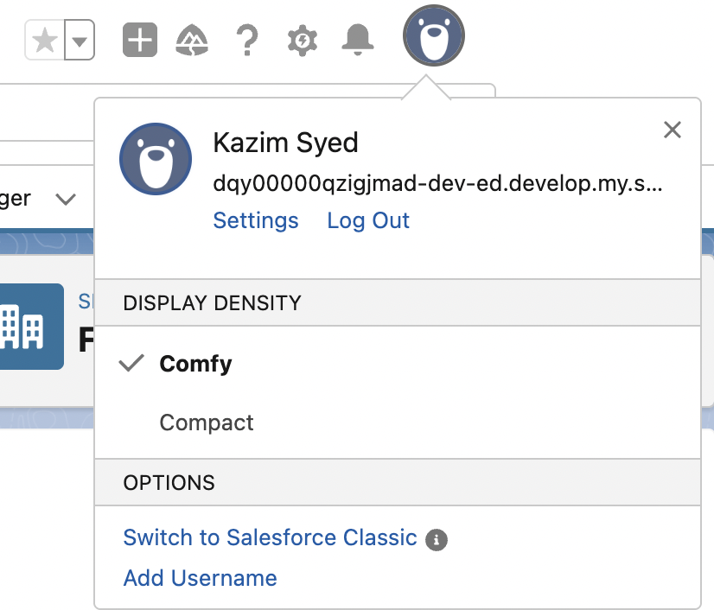

Business hours
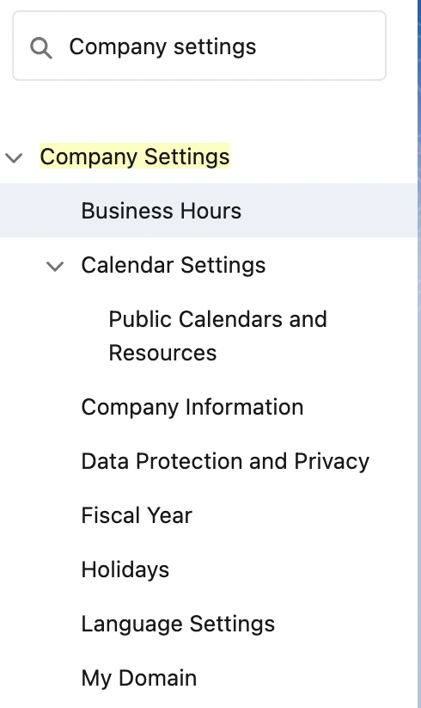 | 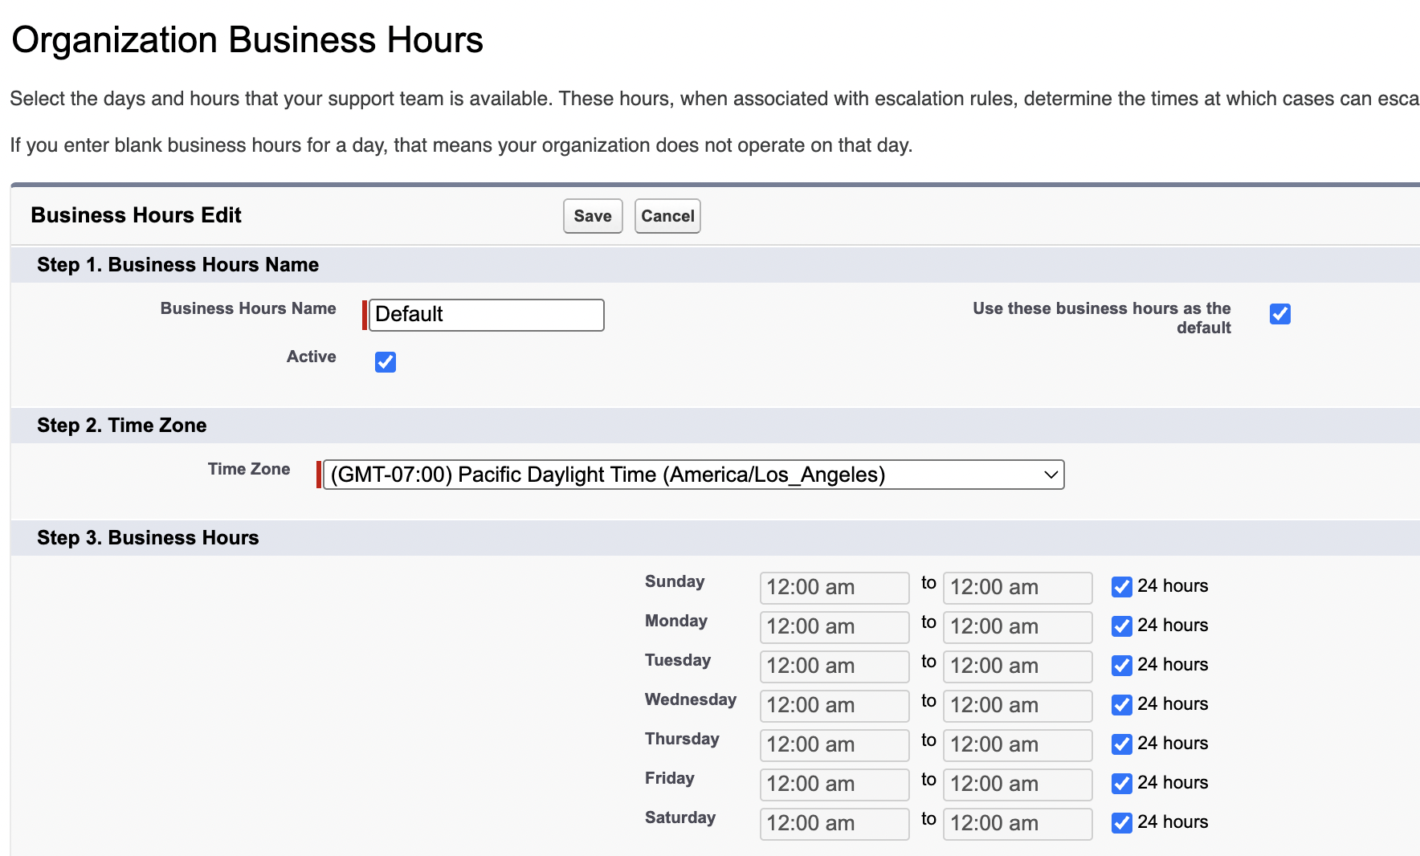

Currency Management
- Support 150 different currencies.
- facilitates global trades with suppliers worldwide.
- Customer retention

Default settings
Edits the following | Edit organization info  - Company name  - Address  - Logo
Default locale | Impacts the language and numeric value representation.  Like data, month and number format.  You can adjust the time Zones.  (Eastern Standard time or Daylight savings time)

Summary
Settings: Advance currency management, Default settings, Fiscal years and Business hours. | Accurately setting this info impacts  - SLA’s  - Reports  - Forecasting

Part 2
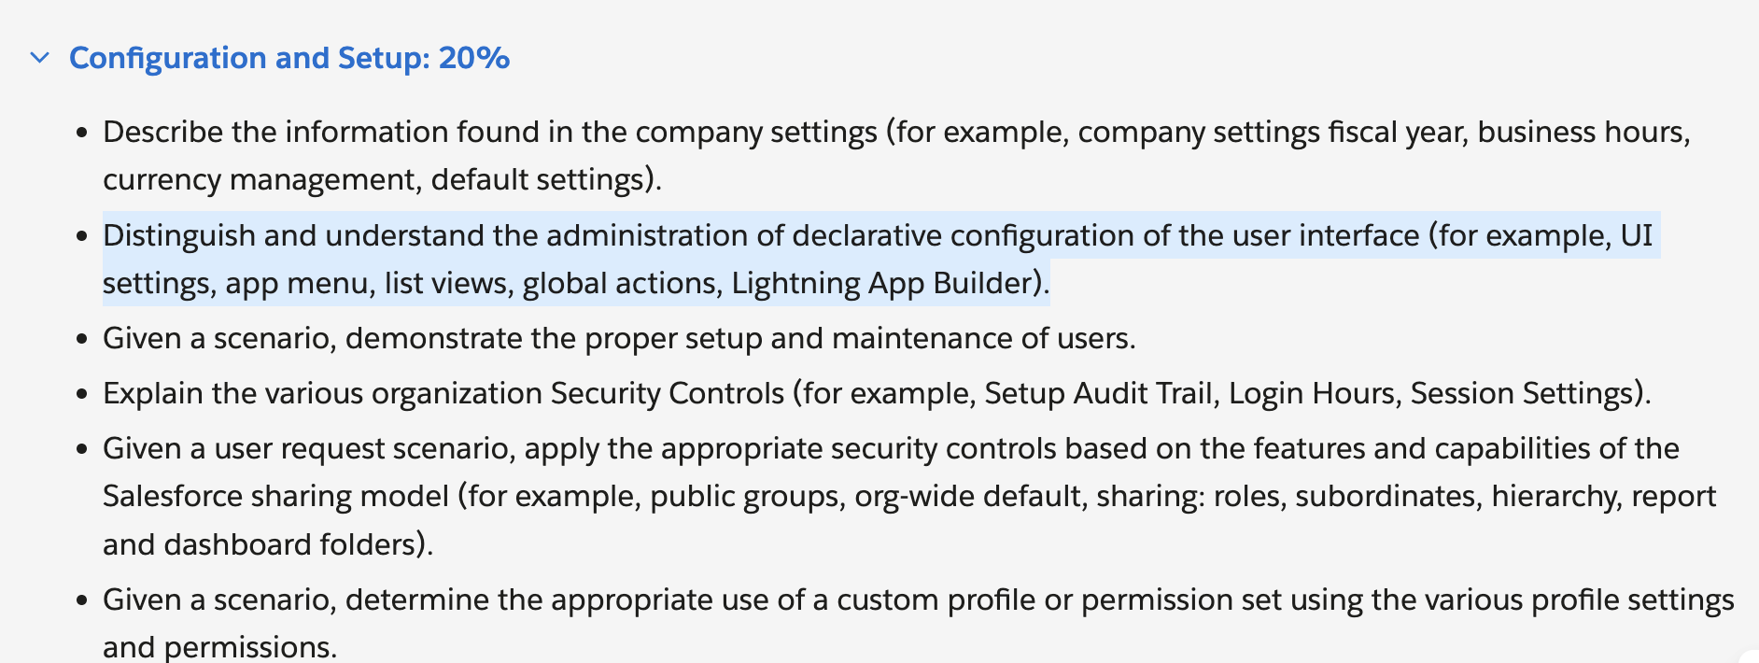

Distinguish and understand the administration of declarative configuration of the user interface (for example, UI settings, app menu, list views, global actions, Lightning App Builder).
Declarative configurations are configuration done solely using clicks and no code.
Setup → User interface → User interface Settings

Here’s a table with conceptual prompts and responses to help you understand the key topics in the Salesforce Certified Administrator Exam Guide’s second learning objective:

| **Conceptual Prompt** | **Response** |

|-----------------------|-------------|

| **What are Salesforce UI Settings, and how do they impact user experience?** | UI Settings in Salesforce control the look and feel of the interface for users. These include enabling/disabling features like the "Enhanced Lookup" or "Enable Hover Details" in list views. Administrators can configure these settings to improve usability, streamline workflows, and ensure users have access to the right tools. |

| **How does the App Menu work in Salesforce, and why is it important for navigation?** | The App Menu is the primary navigation tool in Salesforce, allowing users to switch between different apps (e.g., Sales, Service, Marketing). Admins can customize which apps appear, set default apps, and control visibility based on user profiles. A well-organized App Menu ensures users can quickly access the tools they need. |

| **What are List Views, and how can they be customized for different users?** | List Views display records (e.g., Accounts, Contacts) in a tabular format with filters and sorting options. Admins can create, modify, and share custom List Views to help users focus on relevant data (e.g., "My Open Opportunities"). Filters, columns, and visibility can be tailored per user profile or permission set. |

| **What are Global Actions, and how do they differ from object-specific actions?** | Global Actions are quick actions available across Salesforce (e.g., Log a Call, Create a Task) that aren’t tied to a specific record. Unlike object-specific actions (e.g., "New Opportunity"), they appear in the global header or utility bar, providing shortcuts for common tasks regardless of the page a user is on. |

| **What is the Lightning App Builder, and how does it help customize Salesforce pages?** | Lightning App Builder is a drag-and-drop tool for designing and customizing Lightning pages (e.g., Home Pages, Record Pages). Admins can add, remove, or rearrange components (e.g., Related Lists, Charts) without code, tailoring the UI to different roles (e.g., Sales Reps vs. Support Agents). |

This table breaks down each concept with a clear question and explanation, helping you grasp how declarative configuration shapes the Salesforce user interface. Would you like any topic explored in more depth?

User interface
You can setup organization wide changes to User interface behavior
Such as
- Enhanced lookups
- Enable hover
- Enable Separate loading of related lists

User interface
- Enable collapsable sections
- Show Quick Create
- Enable hover details
- Enable inline editing
- Enable related list hover links
- Enable sort by multiple columns in related lists
Setup  - Enable Enhanced page editor  - Enable Streaming api  - Enable set audit fields upon Record creation and update records with inactive Owners” user permissions | Makes page layout customization faster and more intuitive especially in lightning experience.  Allows real-time notifications when records change (via PushTopics or Platform Events).  Enables live dashboards, chat apps, or event-driven workflows without constant polling.  Real-time alerts (e.g., stock price changes, support ticket updates).
What is polling | When a system or a device constantly checks the status of another device to see if its ready or if a certain condition is met.  This checking can be done in regular intervals or when certain conditions are met.  Once the conditions are met, the system can proceed with the intended action.  Computer-printer to see if it has completed the current page so it could perform the next page.  In a system design context, polling can involve a central system (like a server) regularly checking multiple devices (like sensors or other systems) to gather data or monitor their status.
Enable set audit fields upon Record creation and update records with inactive Owners” user permissions | Set Audit Fields: Lets admins modify CreatedDate/CreatedById during data imports.Critical for historical data migration.Update Records with Inactive Owners: Allows editing records owned by deactivated users.Prevents orphaned records from becoming uneditable.

User Interface - Continued
User Interface → App Menu | Organization wide default for the order of apps for users. And visibility of apps in apps launcher.
This order will be accessible
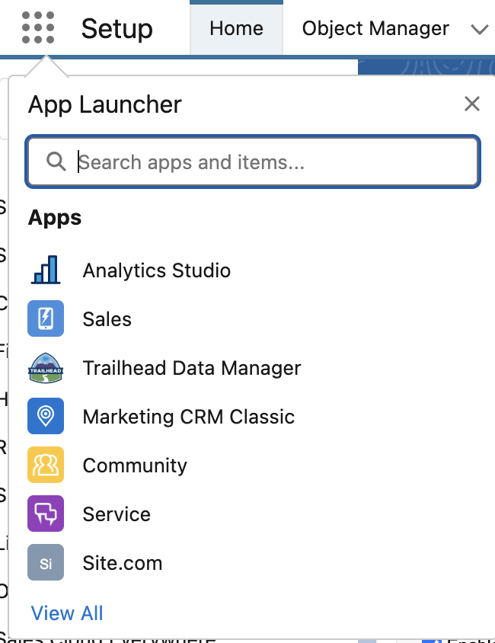

User personal customization(User based order) doesn’t not impact org-wide changes. | You can customize it for yourself. Using drag and drop feature in App launcher when he opens view All in vertical App Launcher option.
 | Applications which are not assigned to me are invisible based on my profile. If I want access to a specific application I can be granted that by making adjustments on my profile or permission sets.

List view

| **What are List Views, and how can they be customized for different users?** | List Views display records (e.g., Accounts, Contacts) in a tabular format with filters and sorting options. Admins can create, modify, and share custom List Views to help users focus on relevant data (e.g., "My Open Opportunities"). Filters, columns, and visibility can be tailored per user profile or permission set. |
Segment and prioritize records and share views to team members and perform bulk operations on multiple records all at once.
Use-cases:
Sales representative filtering their opportunities by stage, support team viewing cases by priority or manager tracking their progress of their leads in their pipelines.

Marketing
Account vs customer vs client
Customer: limited conversation after service are delivered.
Client: someone who buys a service from a company. They usually keep in contact with the company until the service is complete. Sometimes, a contract is involved.
The client needs her wedding photgrapher to send the files now!"
"The lawyer met with their client to review the case"
Note: More Conversation involved in client. And ongoing consultation and tailored solution.
Account: Usually an account is a business buying a service from another business, but it could also be an individual. An account will keep in contact with the company for a long time, because they need the same product or service on a regular basis. Accounts are usually large, and involve a contract.
"This account needs ice delivered from us once a week"
"Which salesman will be in charge of the Smith account?"

 | 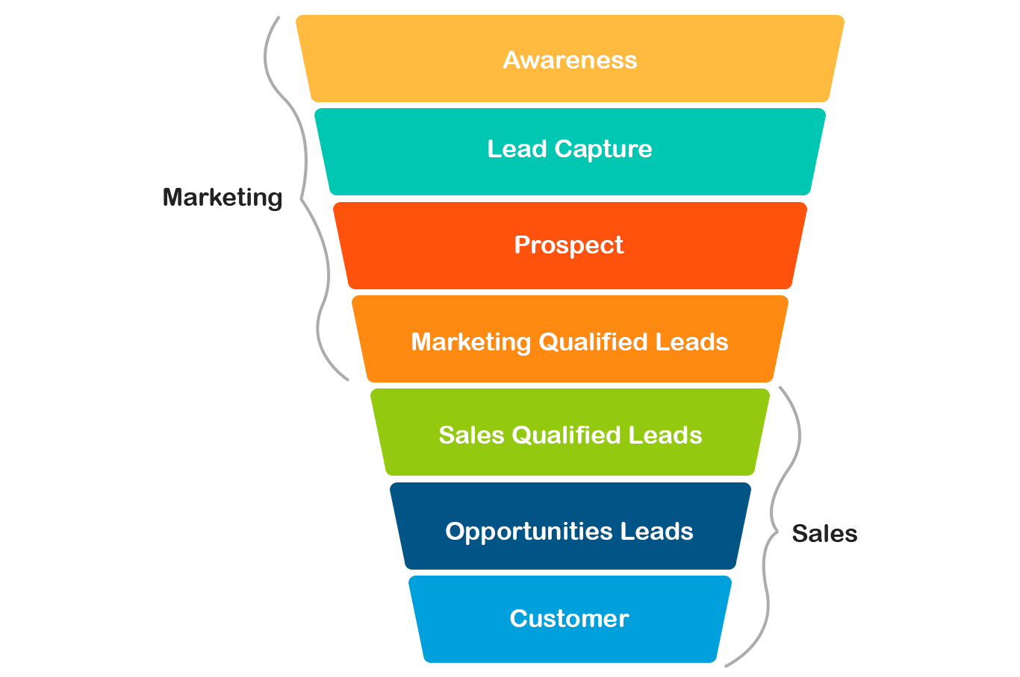
 | What are leads in marketing?
Leads(General lead) | Individual or organization that have shown some interest to your Awareness campaign.
Engagement | Leads engage with a company's brand in various ways, such as visiting a website, filling out a form, downloading content, or signing up for a newsletter.
Prospect(Potential lead) | Potential customer who has been identified as a good fit based on certain criteria and is further along the sales funnel than a general lead.  Factors can be industry, budget, demography and timeline.  Prospecting involves identifying and vetting with a potential customer who align with company’s ideal customer profile.  Once potential customers are identified, marketing efforts are done to nurture these relationship and move them further down the sales funnel.
MQLs | Some marketing teams categorize leads further, often distinguishing between marketing qualified leads (MQLs) and sales qualified leads (SQLs). MQLs are those who have shown interest through marketing activities but haven't yet been vetted by sales.
SQLs | SQLs are leads that sales teams have deemed likely to become customers based on their engagement and expressed interest.

Funnel | - Suspects  - Prospects  - Leads  - Customers
 | Marketing vs. Sales: Teams may define stages differently (e.g., Marketing calls everyone a "lead"; Sales reclassifies them as "prospects").

Analogy
Suspects  leads  prospects  customer | You have a coffee shop, every passing by the shop are suspects.  Every stood near the glass window reading the offerings are leads.  Every who entered the shop are Prospect.  Everyone who buys the coffee is a customer.

Sales Opportunities vs leads vs prospects
Leads | These leads are often generated through various marketing endeavours, including advertising campaigns, engaging social media content, or targeted email marketing initiatives.
MQLs → SQLs | Recognizing and prioritizing hight quality leads is essential for optimising sales strategy and conversion rates.  - If that leads fit company’s ideal customer profile based on factors like industry, company size, budget.  - Some leads might need nurturing to transition from potential lead to customer.  - Promptly addressing their queries and concerns
Prospect | They are qualified by some criteria. Another way to identiy lead is through a questionnaire. I have a weighted graph in my mind.  Prospect → lead nurturing.
Sales Opportunity | Involves assessing prospect’s needs, budget and timeline
Two tier qualification | Two phase Qualification: Opportunity level and Stakeholder level.  This process includes opportunity level qualification to determine if the prospect could effectively implement the company’s offering and benefit from the product or service at the opportunity level, before proceeding to the stakeholder level.
 | Once qualified, manage it through a sales process this involves developing a sales strategy, creating a timeline and assigning resources to the opportunity.
Benefits of tracking and managing sales opportunities
- Forecast Future Revenue
- Sales efficiency
- Improved Customer satisfaction → Advocacy
 | 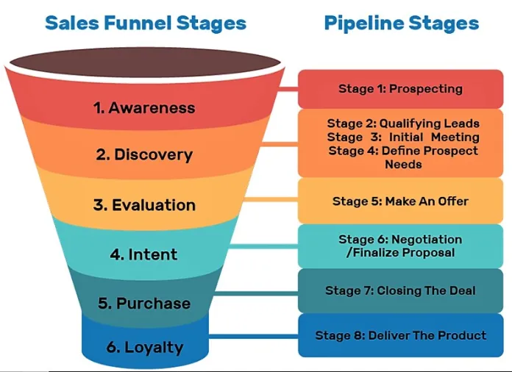
Leads vs Sales opportunity | Leads require more nurturing and cultivation to move them further down the sales funnel, while opportunities demand more focused attention and tailored sales strategies. By understanding this distinction, sales professionals can optimise their approach, improve lead conversion rates, and ultimately drive revenue growth.
Stages of sales opportunity:
- Prospecting: potential customer are identified and contacted. Generate leads through Social media, marketing, email marketing and even cold calling.
- Qualifying: identify prospects who are more likely to transition into customer. Based on industry, timeline and budget.
- Proposal: When the sales person presents a customized solution to the prospects needs. It outlines the product or service, the benefit it offers and the terms of the sale. The goal is to convince the deliverables is the best solution.
- Closing: finalize the sale and collects the payment. Turn the prospect into customer.

How does salesforce helps
Create custom fields and report to track specific information.
E.g:
Real estate agent: leads from open houses, online listings and referrals.
Track property preferences, budget and contact information.

Software salesperson: IT needs. Generate leads throught webinars and ads.
Car salesperson: vehicle preference.

App launcher → Sales
Sales has many Custom Objects
Opportunity, lead, Contacts.
Within Sales Opportunity | 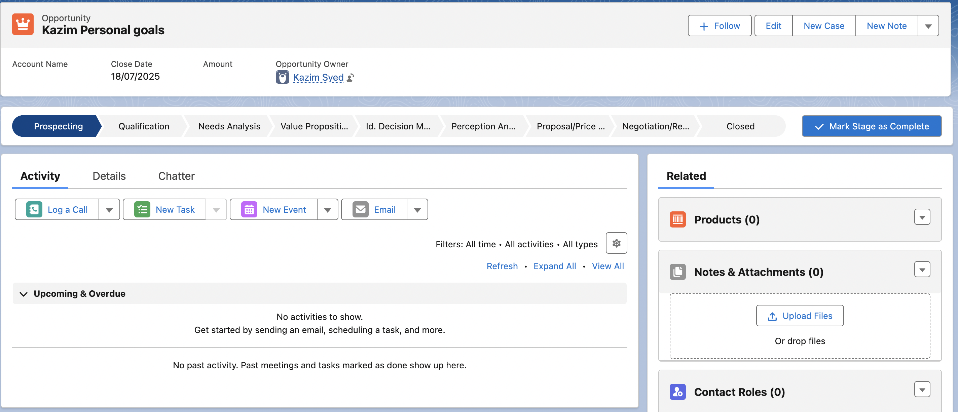
- Prospecting
- Qualification
- Need Analysis
- Value proposition
- Identify Decision makers
- Perception Analysis
- Proposal/Price quote
- Negotiation
- Closed Win
- Closed Lost
Prospecting: | What it means: Initial contact is made; potential interest identified.  - Activities: Identify leads, reach out to potential customers.  - Stage Type: Open  - Probability: ~10%
Qualification | Assessing whether the lead is a good fit and has potential. Activities: Used BANT(Budget, Authority, Needs, Timeline. And industry.

Need Analysis | Dive into Customer requirements and discover pain points. Activities: gathering detail requirements, identifying problems to solve.
Value proposition | How your product/service meets your customer needs.  Activities: Presenting benefits, ROI, demos, differentiation, cost-benefit analysis, competitive advantages.
Decision makers | Identify key stakeholders or decision-makers in your customer organization.  Activities: Engage with decision makers and understand approval process.
Perception Analysis | Gauge customer’s attitude toward your solution.  Activities: Handles Objections, gather feedback.
Proposal/Price Quote | Submit a proposal or pricing quote to the customer.  Negotiation and finalizing terms.
Negotiation | Active discussions on pricing, terms and customer. Handle final objections, legal review and discounts.
Closed Won | Customer has accepted the product and the deal is successful.  Activities: contracts signs, delivery begins.
Closed Lost | Deal did not go through.  Document reason, possibly nurture for future.

Stage | Role of Value Proposition | Key Actions
1. Prospecting | Identify why the prospect should care about your solution. | Research pain points; tailor initial messaging to highlight relevance.
2. Qualification | Confirm your solution aligns with their needs (BANT). | Ask: "Does our value prop solve their top challenges?"
3. Needs Analysis | Refine the value prop based on deeper discovery. | Use questions like: "What would make this a must-have solution for you?"
4. Proposal | Clearly articulate value in the quote/proposal (ROI, differentiation). | Include case studies, cost-benefit analysis, and competitive advantages.
5. Negotiation | Defend the value prop against objections (price, timing, features). | Re-emphasize unique benefits: "Our solution saves X hours/week because..."
6. Closed Won | Reinforce value to ensure smooth onboarding and adoption. | Share success stories, ROI metrics, and training aligned to their goals.
7. Closed Lost | Analyze if the value prop was misunderstood or misaligned. | Ask for feedback: "What could we have offered to win your business?"

List views
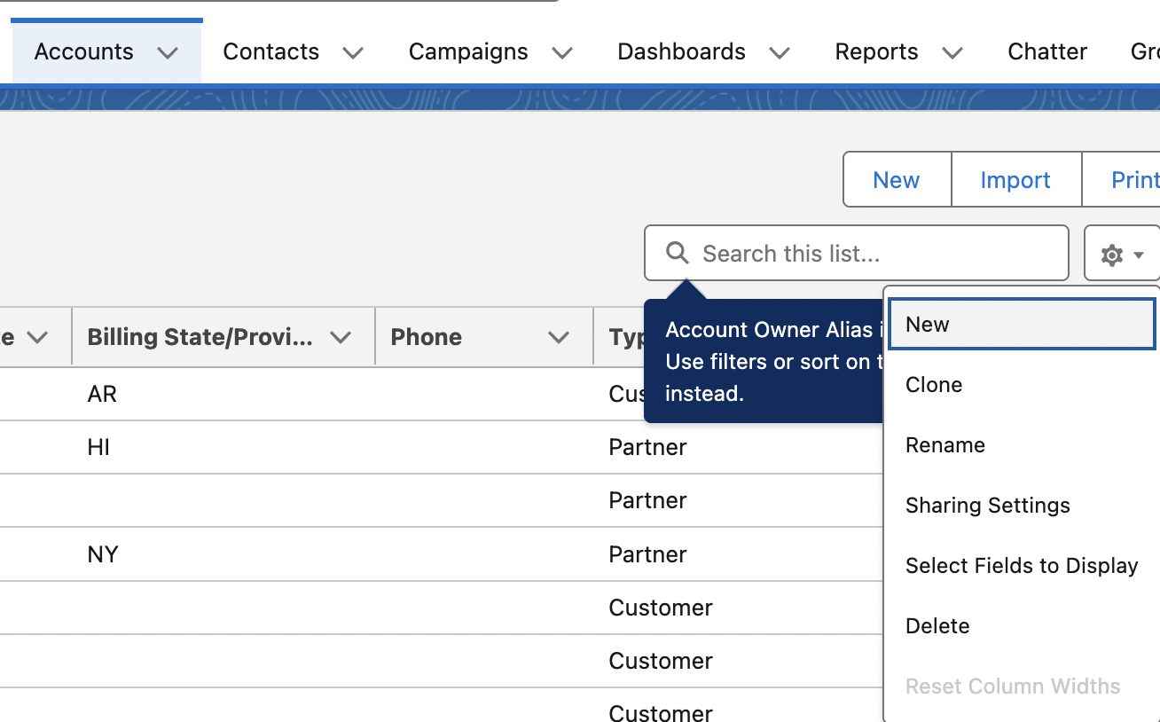 | Select fields to display:  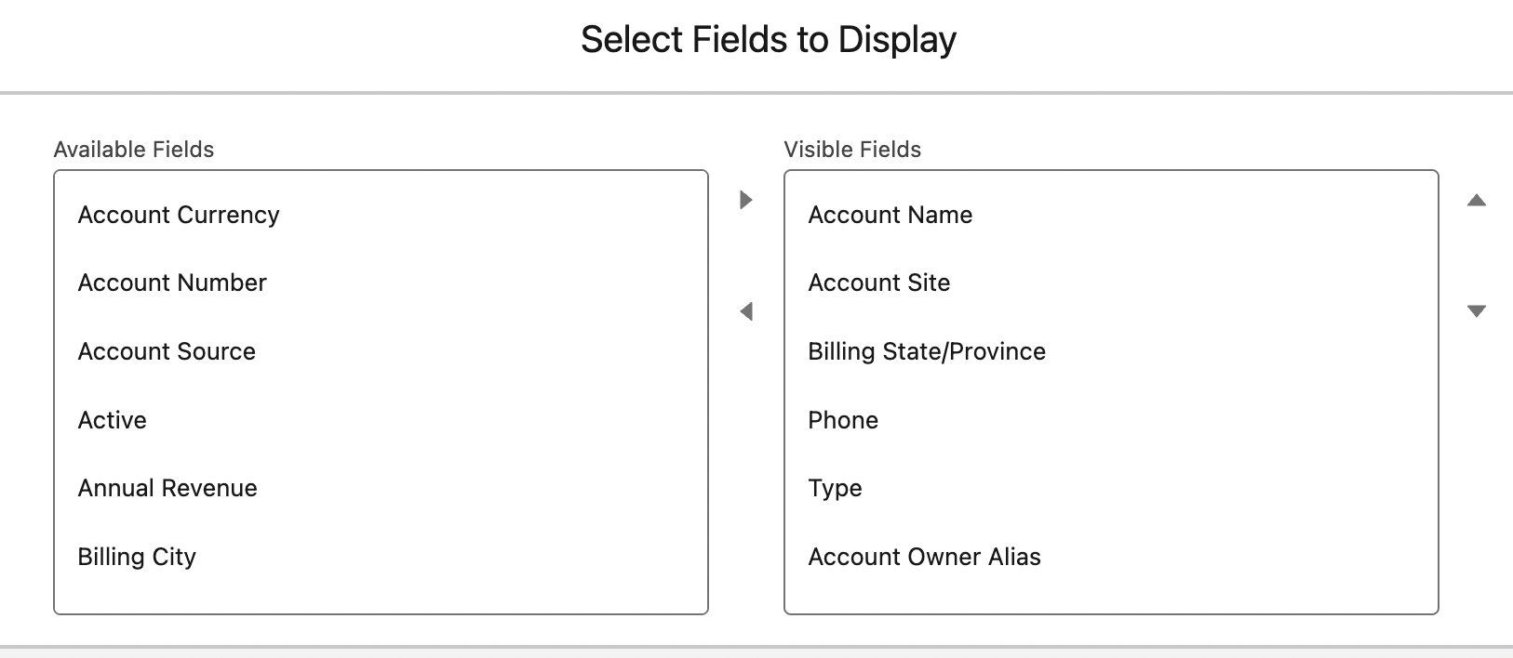

Global Actions – logging a call
global actions for user to log call detail, create records and even send emails all together in one place.
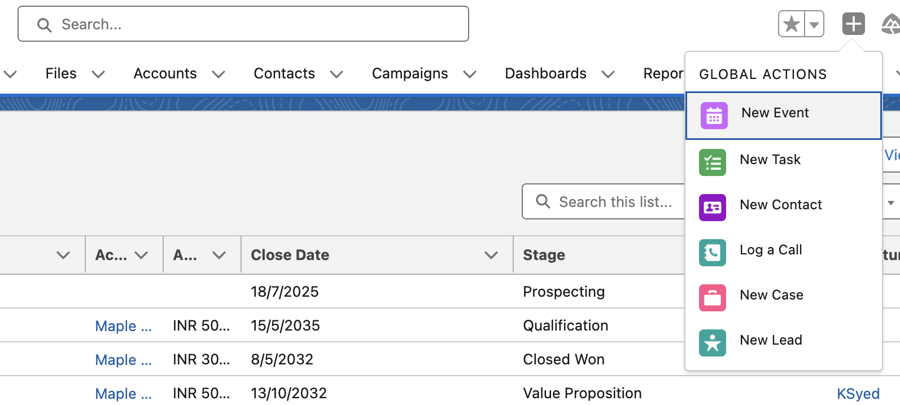 | Click on the plus.
I choose to log a call. And inside the open window. I can write some stuff. Create a new contact or matched with an existing one. Also, related it to an account. | 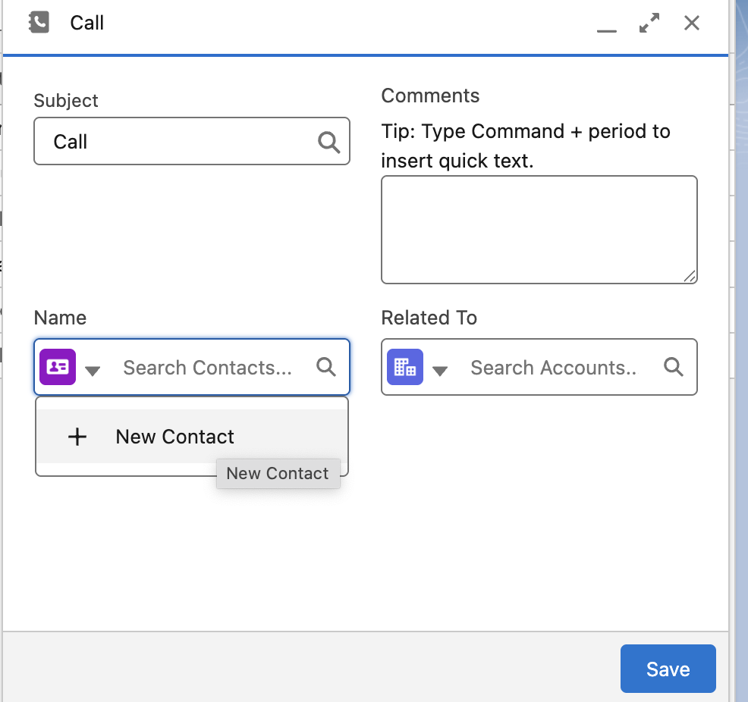

Creating a new global action and publisher layout
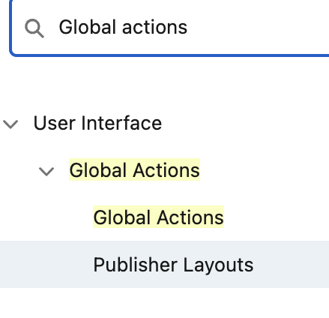 | 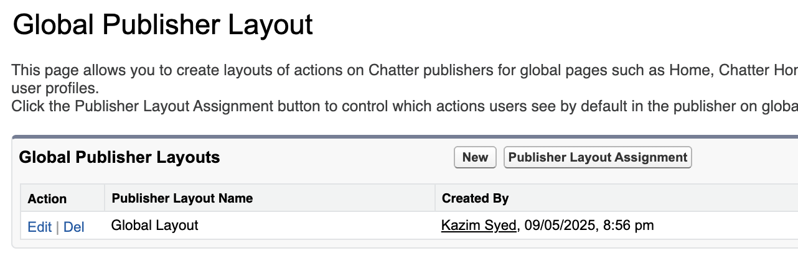
I drag the email section to Salesforce classic publisher from Quick actions.  And drag email section from Mobile and lightning actions into Salesforce actions. | 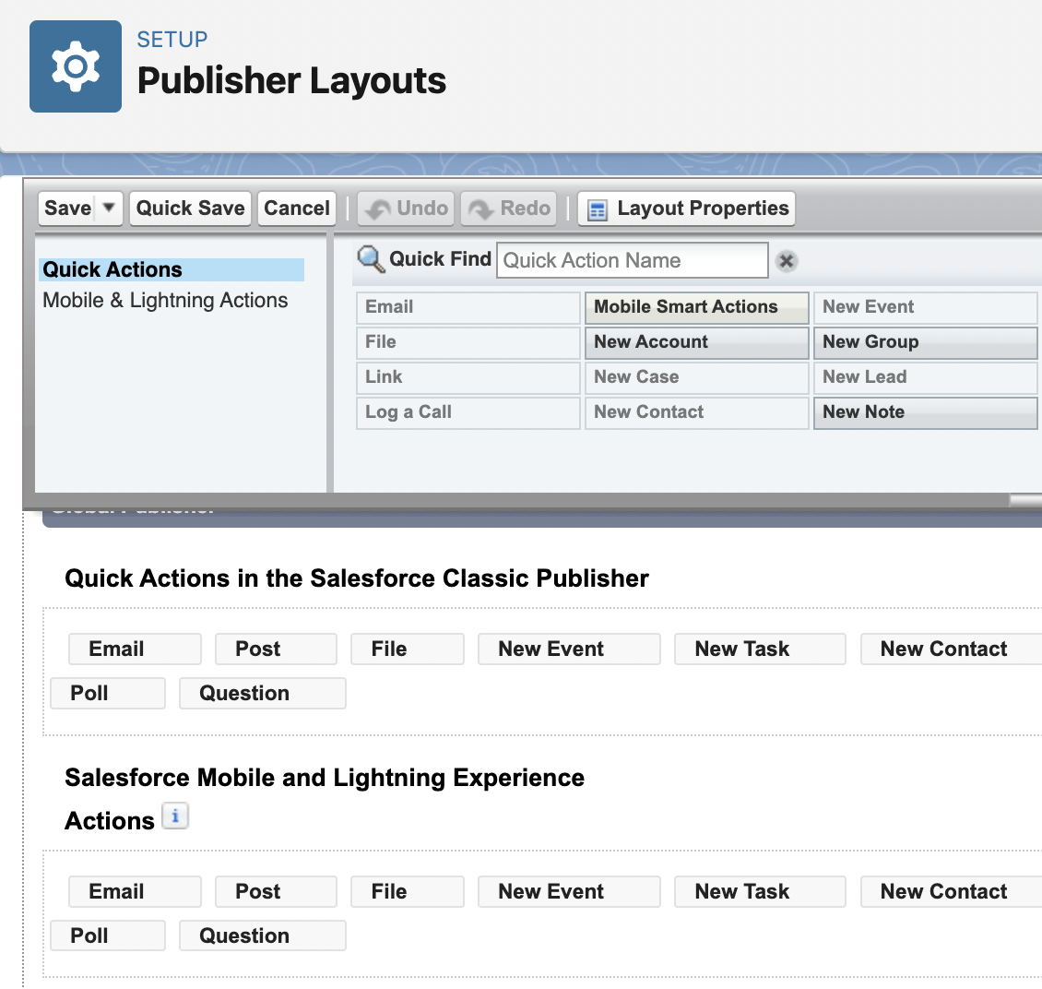

Global Actions: logging call
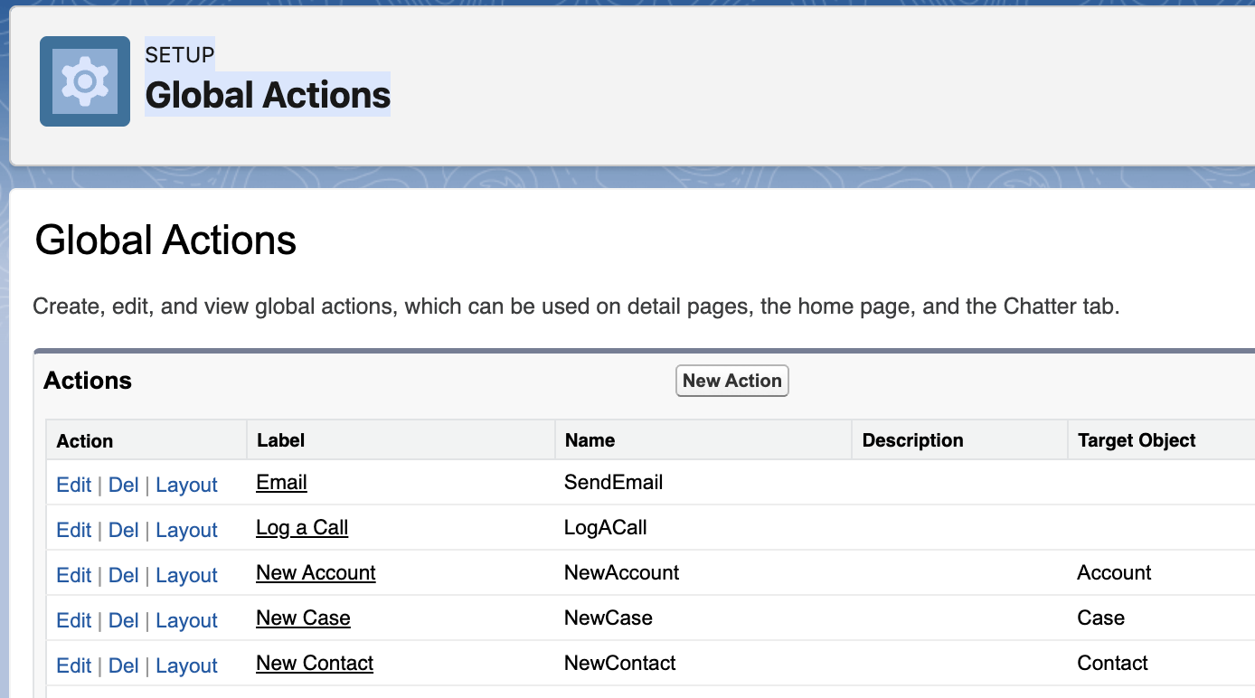 | New Action
Target Objects: Contract( A standard object) | 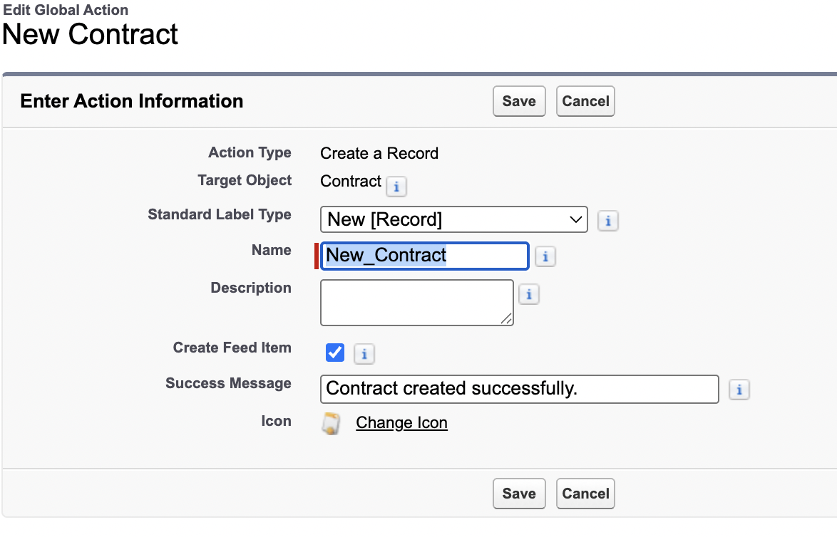
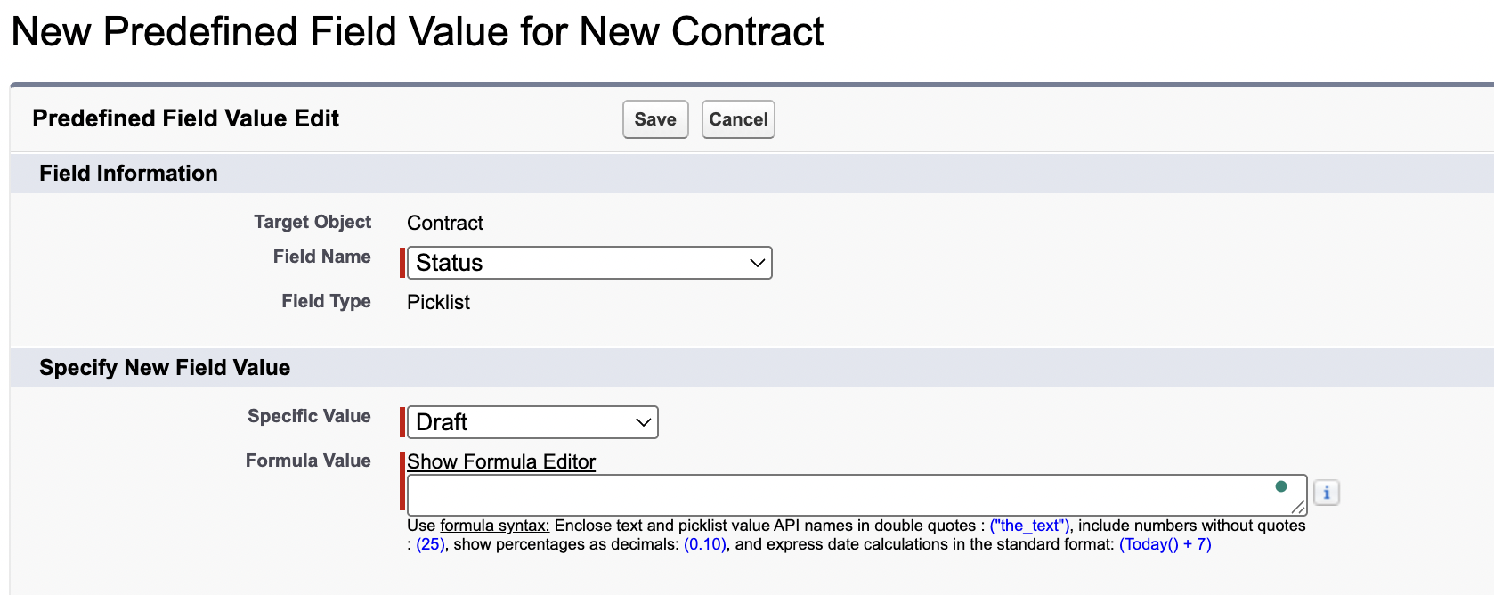 | You can set predefined values.  Such as for status: draft.  Draft → in approval → Activated
You can edit layout. Here, u can add more fields. Using the drag and drop feature. | 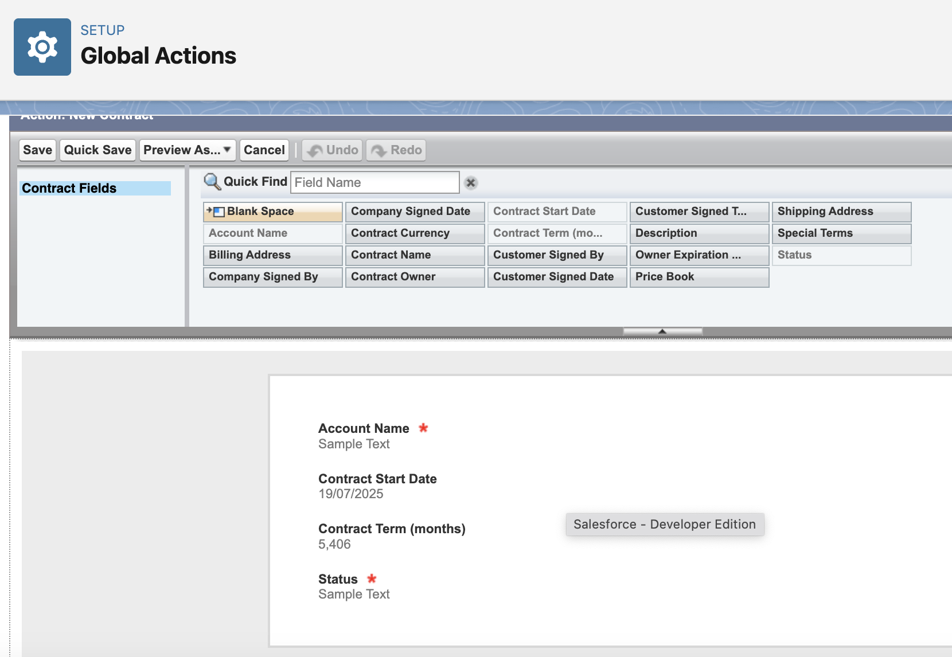
Last step: You have to go to the publisher layout and drag and drop that element.

Output:
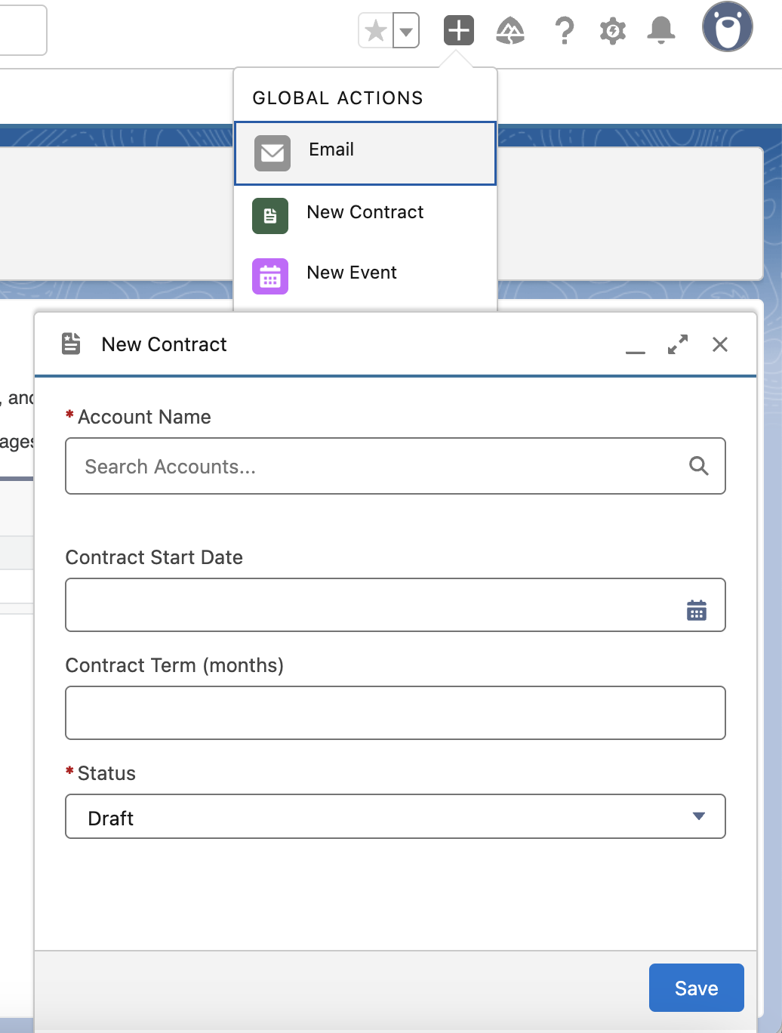

Creating a single page app using the lightning app builder
Easy to use gui for creating custom lightning pages for salesforce lightning experience and the mobile application. Lightning pages are built using lightning components which are compact, configurable and reusable elements. They can be drag and drop in the regions of the page in the lightning app builder.
User Interface → Lightning app builder
App page | Build one page app for lightning experience and the mobile app.
Home page
Record page | Record detail page. We look at record detail page whenever we look at an account or individual opportunity for eg.

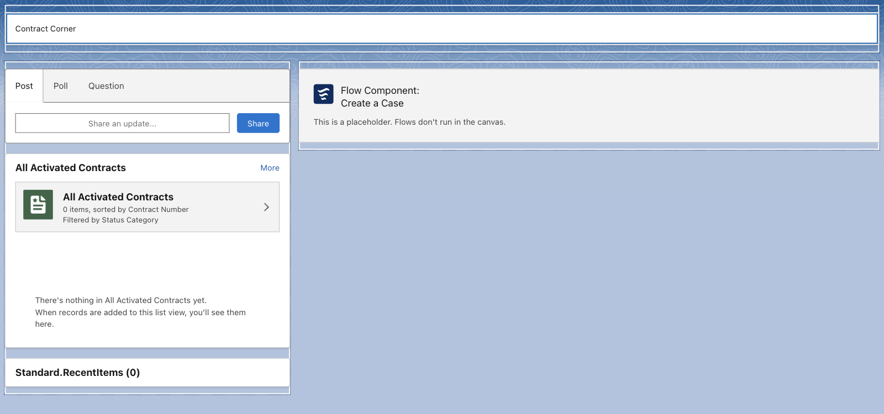 | Header: rich text  left sidebar:  chatter publisher  List view of Contracts  Recent items  Right sidebar:  flow: create a case.  Save → Activate
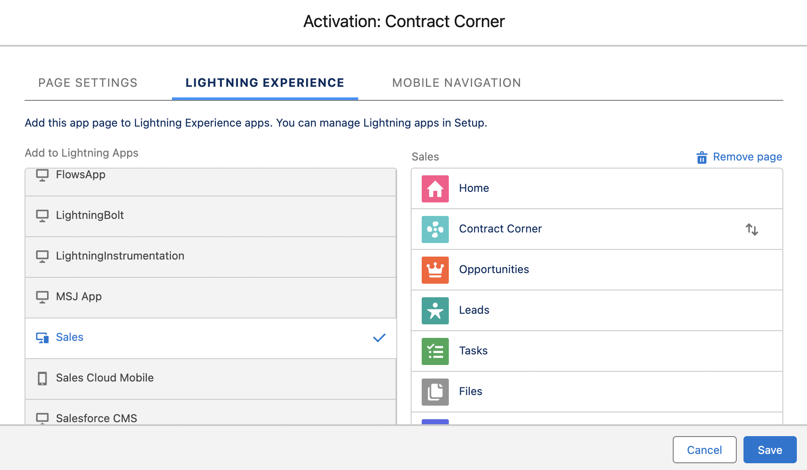 | Add the page to app. For lightning experience and mobile navigation.

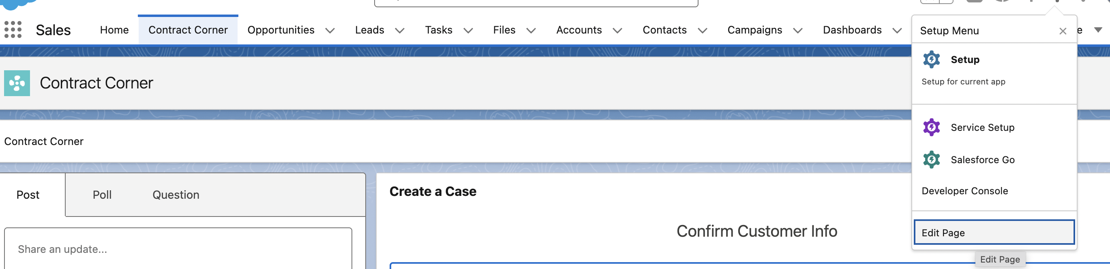
You can directly edit the lightning app page. It will open the lightning app builder. Since its already activated, we don’t have to reactivate.

Deactivate and creating User accounts
Company settings→ Company information
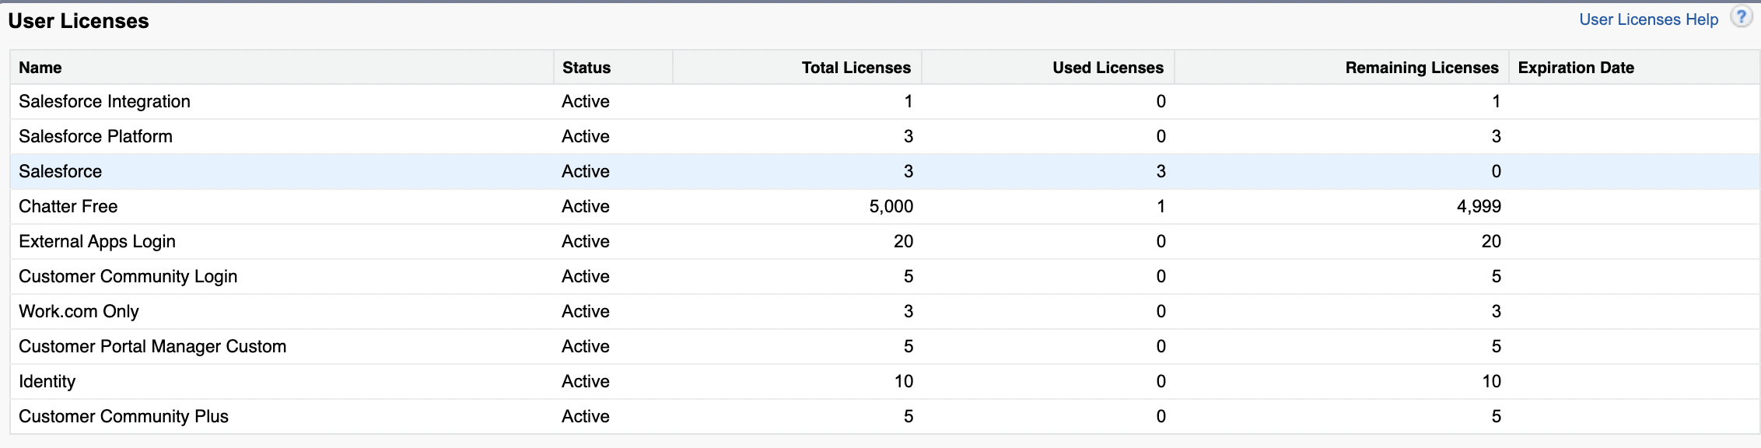
To create a new user. Since I have used all the licenses by default. To create a new user, u must deactivate one.
Users → Users
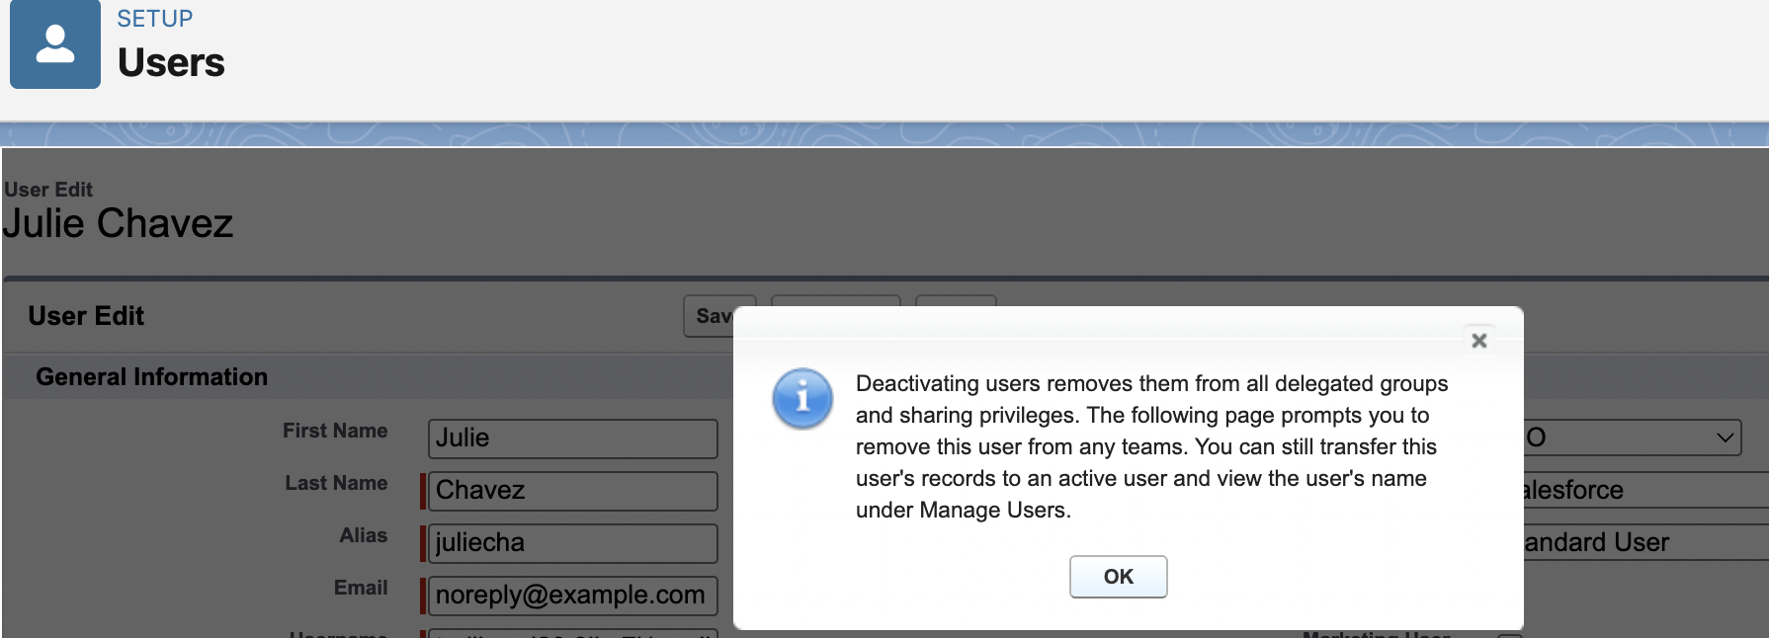
Deactivate a user.
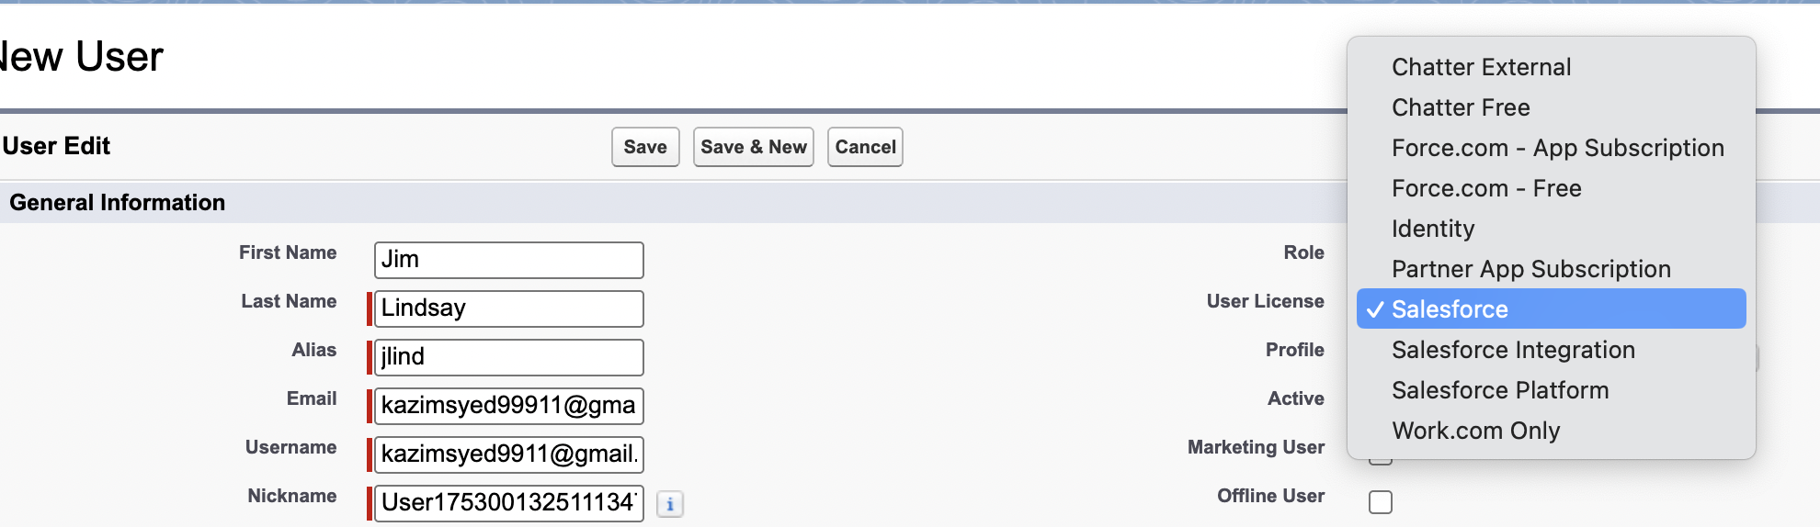
Do not click on Salesforce platform, its more limited in nature.
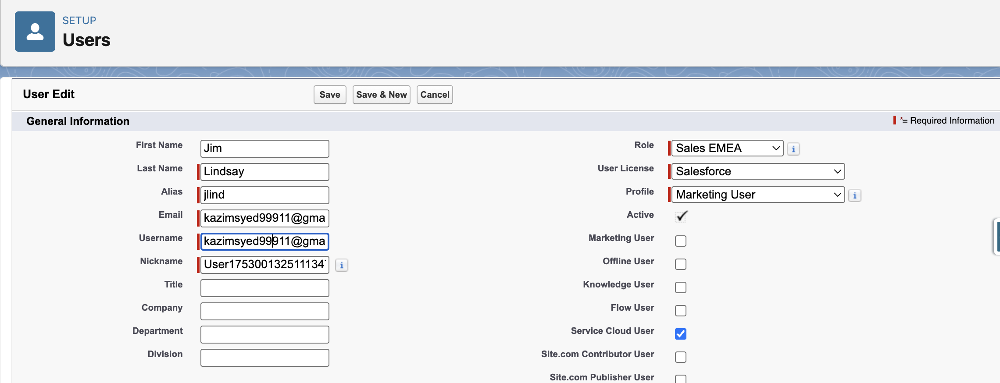

Maintaining and logging in as a user
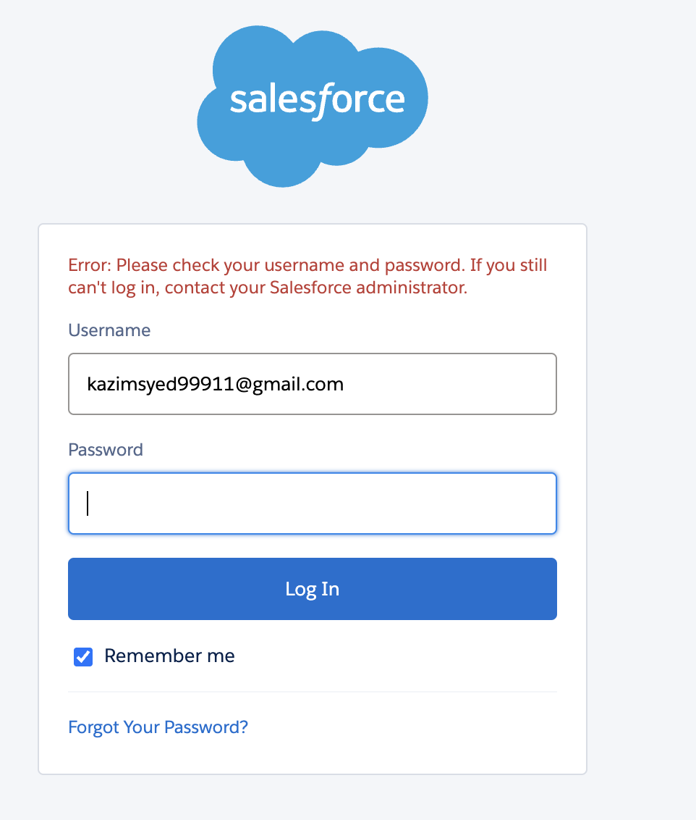  I purposefully entered a wrong password. | 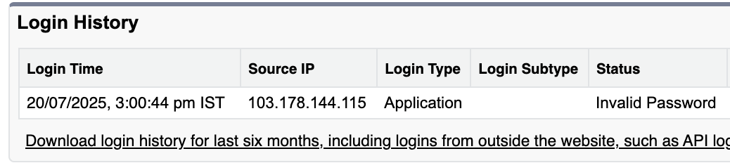  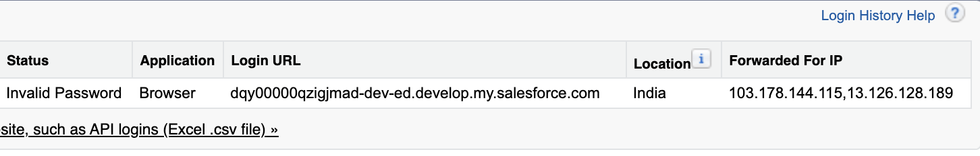
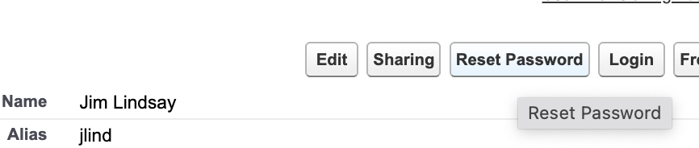 | 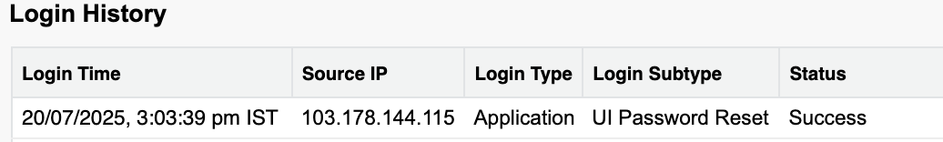
Users → Users  I can directly login as that person since I am the System administrator. | 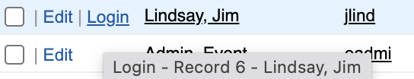

Benefits:
Troubleshoot login issues | You can see the login attempts and see what issues has been occurring for them. And diagnosed whether its caused by wrong username or password.
Login as them | To see what issues they have by logging in as them.

To avoid passing the credentials to log in as the system administrator. We use sessions settings.
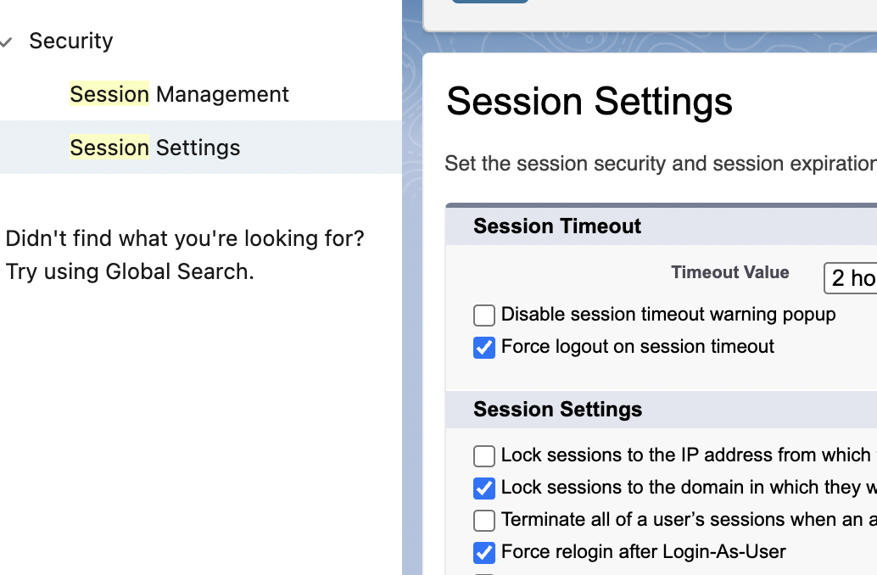 | Uncheck force re-login after login-as-user

Freezing user
There might be times when we cant simply deactivate a user like we did previously by unchecking the active checkbox.
If you have users who are tied with automations or have a lot of integrations and entanglement in your setup.
Then you may not be able to just simply deactivate that user. And there maybe situation where you need to freeze them out of being able to login quickly so that they don’t steal customer data.
You can click freeze to keep them out of the system and then you can effectively untangle any sort of automations that are tied to them. And if you try to deactivate a user that has automations and other reasons why they can’t be deactivated. Salesforce will list those during the process.
The frozen user still shown as active and typed to the license but they cant login. Once you are ready, you can unfreeze and edit→ deactivate.

Setup Audit trails
Setup Audit trails | Track the recent setup changes that you and other admins do.
Systems shows | 20 most recent setup changes made to your org and it list the date of the change, who made it and what change was.
I change the settings in Sessions and reset the password for Jim Lindsay. | 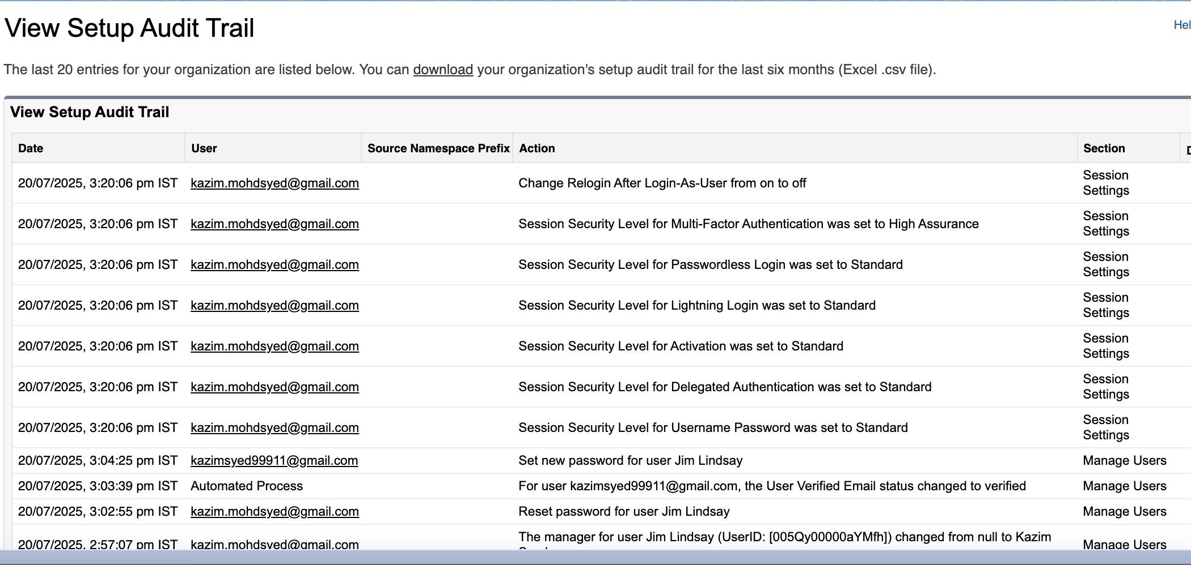
 | Helps you to remember and keep track of the changes you made. You need to package those up and deploy those to another salesforce organization

Login in hours
 | You can look at login history of the user. But u cant set the hours which they login. Because that is done at the profile level.
Users → Users | 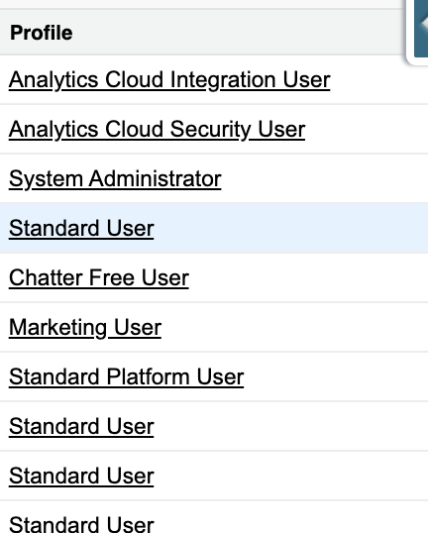
Click on the profiles | 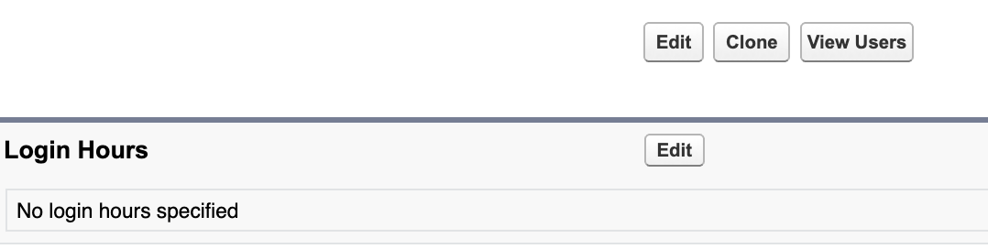
 | 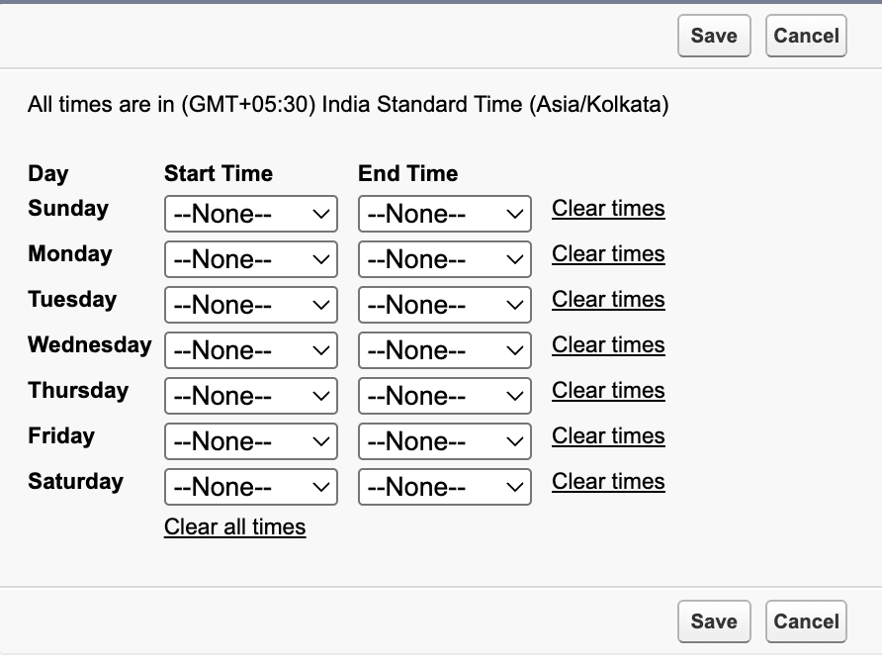

Enabling the enhanced profile user interface
 | Users → Users[‘Marketing User’]
 | There are two different interfaces for profile display inside of salesforce.
 | 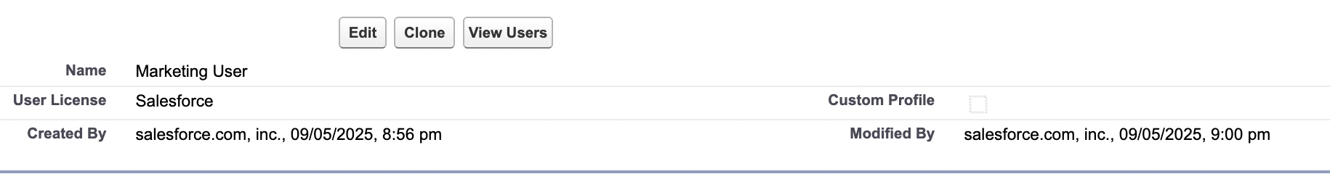
 | You can tell whether this is standard or custom by looking at the checkbox Custom profile since its unchecked that means its a standard profile.
 | There are some limits about what you can edit or change on a standard profile. As u saw in the last lesson, we were able to change the login hours for standard profile.
 | You also have login ip ranges, enabled apex classes, visual force page access and more.
User → User mangement  User mngmt settings(Organization wide changes) | 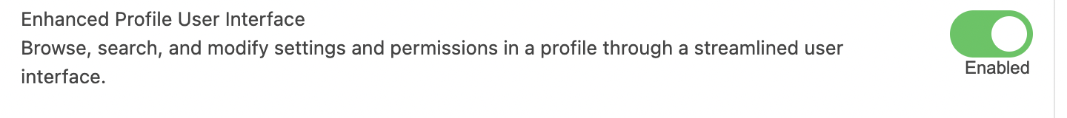  This will impact all adminisitrative backend users that have access to be able to view profiles and make changes.
The Profile is divided into apps and System settings.
Apps: Settings that apply to Salesforce apps such as Sales and Custom App built on the lightning platform.

Settings that apply across all apps, such as record and user management.

Session settings

(Organization wide changes) | 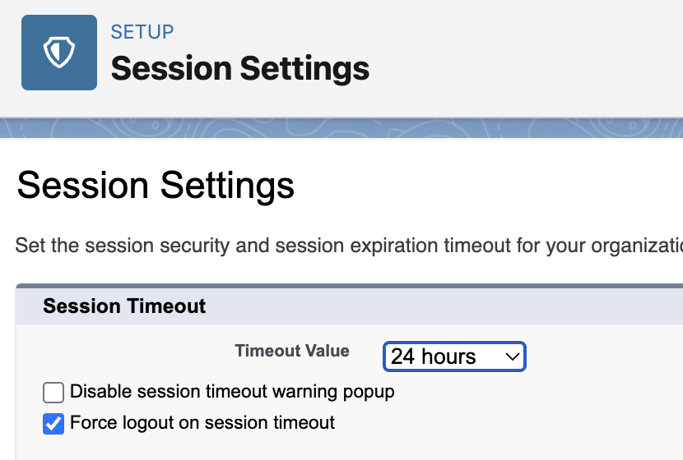
You can edit Organization wide setting for a particular profile. | 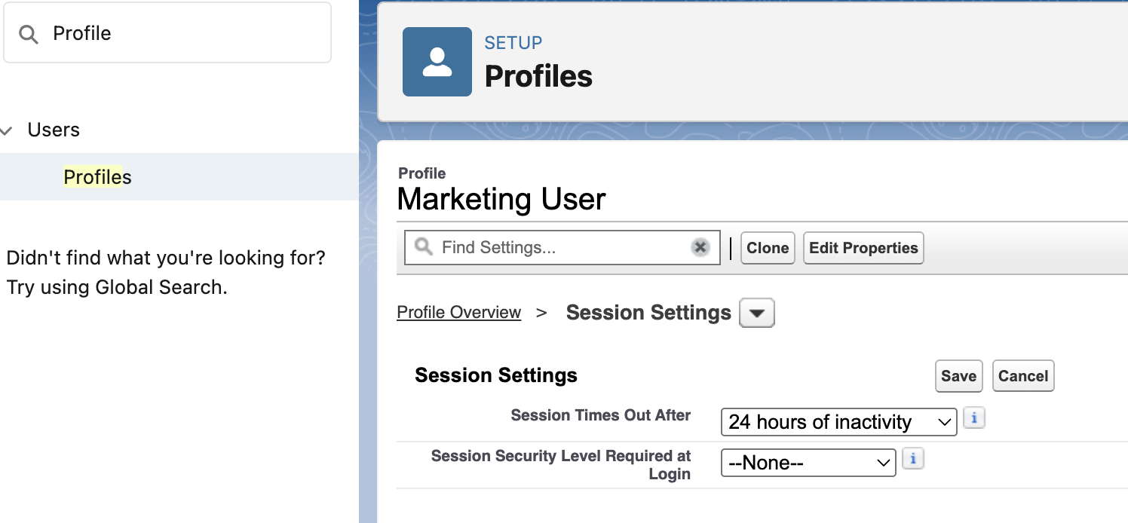
Uncheck the second option, since later in the course u would be making changes to the data model or to page layout. Perhaps, u may not be seeing the result of ur changes bcoz of caching. | 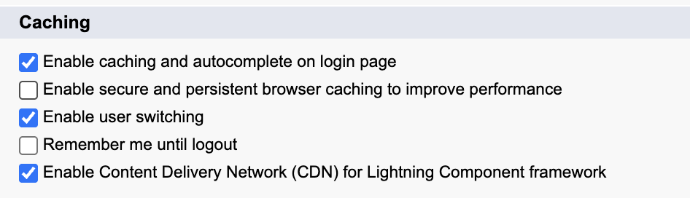

Salesforce sharing modal overview

Resource: Platform sharing architecture
Secure application data access
Architect your sharing model correct to meet your current and future data access requirements.
- Data accessibility components
- Sharing model use cases
- Real customer sharing solutions

Types of Data access
Record level security | Access some records but not others.  Must know the User before providing access based on type.
Users and licenses
High Volume user

Case vs Incident
Common foot | Case and Incident share a common purpose: tracking and resolving issues.
Different how? | Their primary context, audience and underlying philosophy is different.This leads to distinct strength and use-cases.
Service now incident
tackles  unplanned interruption of service or degradation of quality of service. | Primary focus: ITSM(IT service managements) and broader ESM(Enterprise Service Management). An incident in Servicenow is fundamentally an unplanned interruption to an IT service or reduction in the quality of IT service.
Audience | Primarily internal users(employee, it staff) and sometime partners. While servicenow does have CSM(Customer service managements), its root and strength is embedded in IT operations.
Philosophy | Emphasize work flow automation across various dept(IT, HR, Security, Facilities, etc). Digitizing and automating process within an organization.
Salesforce’s Case
For | CRM AND CSM(Customer Service management).
Audience | B2C and B2B and the internal teams that support them(Customer Service agents, Sales reps, field service technicians).
Philosophy | Managing and improving customer interactions across sales, service, marketing and commerce. Enhancing the customer experience and driving revenue(net sales)
Typical Users: | Customer service agents, sales representatives, marketing professionals, field service dispatchers.
Key characteristics

