Salesforce Module 2
subtitle

Heading 1

Heading 2

Heading 3

Heading 4

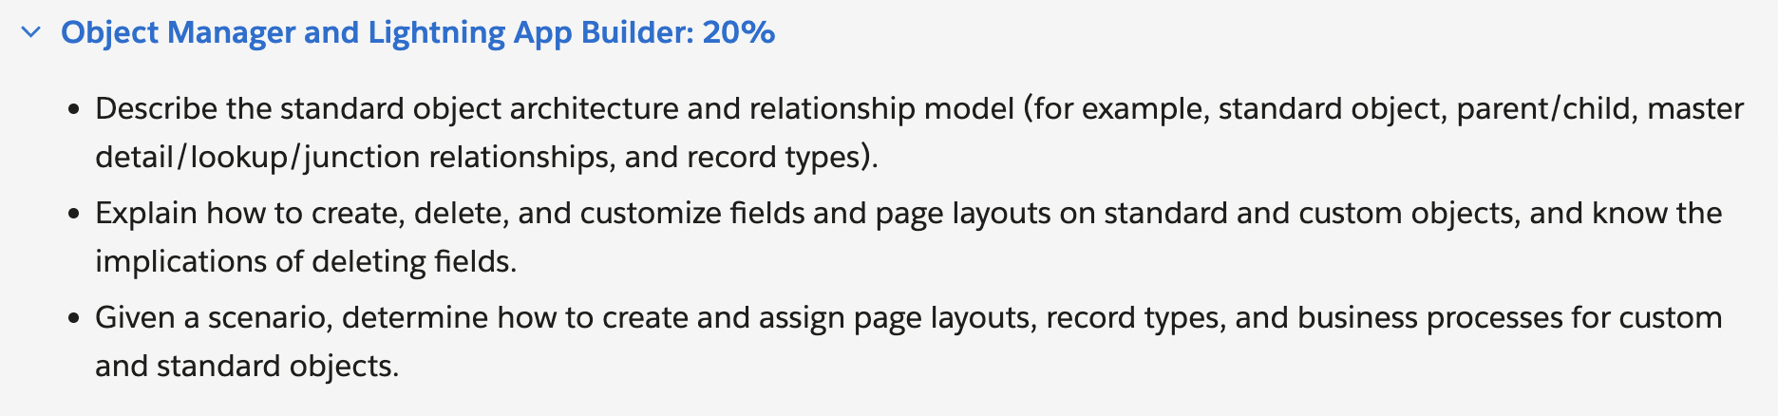
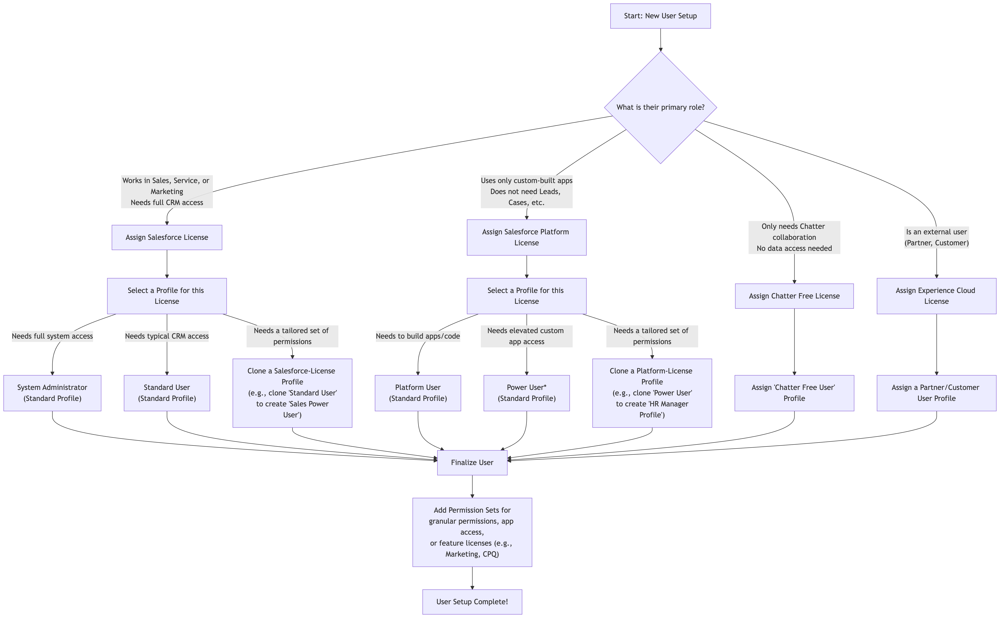

Introduction
Standard object architecture and relationship model. This include std object but also parent-child relationships, master detail relationship, lookup relationship, junction relationship and record types.
By the end of it, u will be able to create, delete and customize field and custom layouts and objects. And the implications of deleting fields as well.
How to create and assign page layouts, record types, and business processes for custom and standard objects.

Analyze object manager and lightning app builder
Standard object architecture. | The standard object architecture consists of a set of pre-defined objects such as accounts, contacts, leads, opportunities, cases, and more. Used by sales, marketing and support agents.
Relationship model  Account related to 1: (1 or many) Contact (Sales team)  Contact 1:M opportunity | The relationship model in Salesforce is based on the concept of related objects. Each object can be related to one or more other objects, creating a hierarchy of related data.  For example,  an Account object might be related to one or more Contact objects, representing the people who work at the account.  A Contact object might be related to one or more Opportunity objects, representing the potential sales opportunities that are associated with the contact.
Lookup fields  Master-detail relationship | Relationships between objects are defined using lookup fields or master-detail relationships.  A lookup field allows an object to reference another object, while a master-detail relationship creates a parent-child relationship between objects, with the child object dependent on the  parent object

A lookup relationship | Concept: A simple, loosely connected link between two objects.
Loosely?
Key characteristics | No cascade delete,  optional,  No Ownership Inheritance: The child record does not inherit sharing or security settings from the parent.  Standard Example: The AccountId field on a Contact is a lookup.
eg | Deleting an Account does not delete its Contacts (though it may orphan them).
Analogy | Two hyperlinks pointing to each other. Deleting one link doesn’t delete the other.

Master-detail relationship | Strongly coupled when the child’s existence depends on the parents.
Cascade effect,
required*,
Ownership Inheritance: The child record inherits its sharing and security settings from the parent record. The owner of the parent is effectively the owner of all children for sharing purposes.,
Roll-Up Summary Fields: This is a critical feature. You can create a field on the parent that automatically calculates the SUM, AVG, MIN, MAX, or COUNT of a field from all its child records (e.g., Total Opportunity Amount on an Account).

e.g | The Opportunity object has a master-detail relationship to Account (though it's often perceived as a lookup, its core behavior is M-D for sharing and roll-ups).

Pending:

C. Junction Object (A Special Use Case)
- Concept: A custom object used to create a many-to-many relationship between two other objects.
- How it works: The junction object has two master-detail relationships, one to each "parent" object.
- Example: Imagine a system for Students and Courses. One Student can take many Courses, and one Course can have many Students.
  - Create a custom object called Course Enrollment.
  - Create a Master-Detail relationship from Course Enrollment to the Contact object (representing the Student).
  - Create a Master-Detail relationship from Course Enrollment to a custom Course object.
Now, a Course Enrollment record represents the enrollment of one Student in one Course.

Other Standard Relationships
- Hierarchical Relationship: A special type of lookup relationship available only on the User object. It allows users to be related to each other (e.g., building a management chain where a manager has reports).
- External Lookup Relationship: Used to link a child object to a parent object that is stored in an external system (via Salesforce Connect).
- Indirect Lookup Relationship: The reverse of an External Lookup; it links an external object to a parent object stored within Salesforce

Implications of deleting a field
Soft delete | 15 days to recover the lost data, after it will vanish for good.
Reports and dashboards | Permanently remove it from all reports and dashboards → breaks the logic → display of the reports.
Automation and Business logic.

PENDING

Object manager tour
 | You can tell if an object is a custom object by looking at the api name suffix __c.
 | 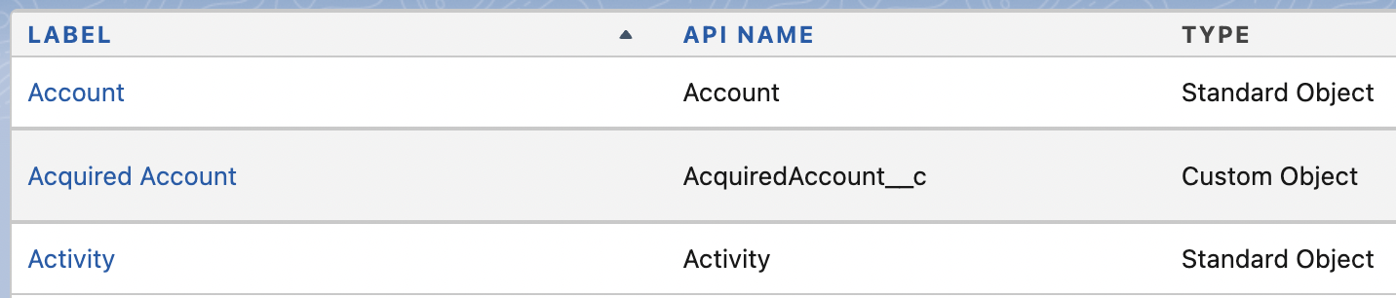
Within Account, u can see under  fields & relationships  field name is the api name. | 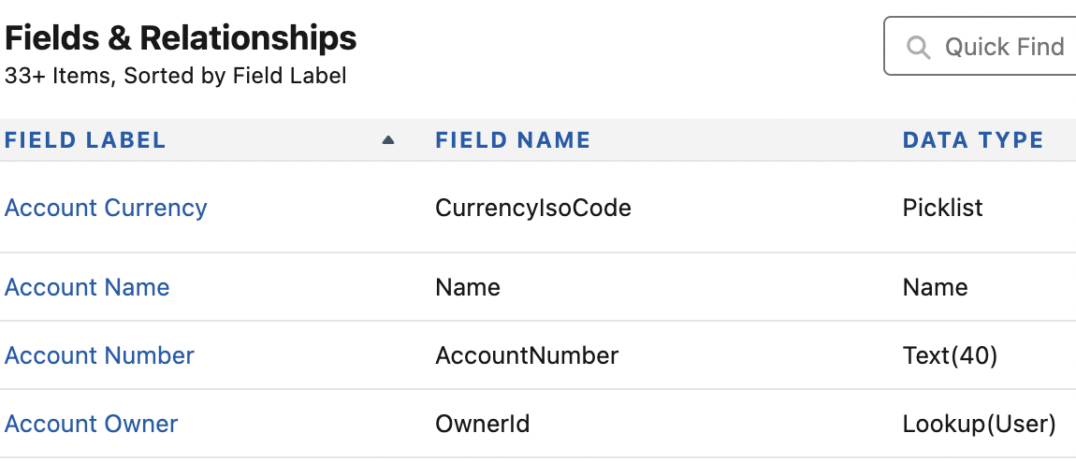
So we multiple relationship on an object. | 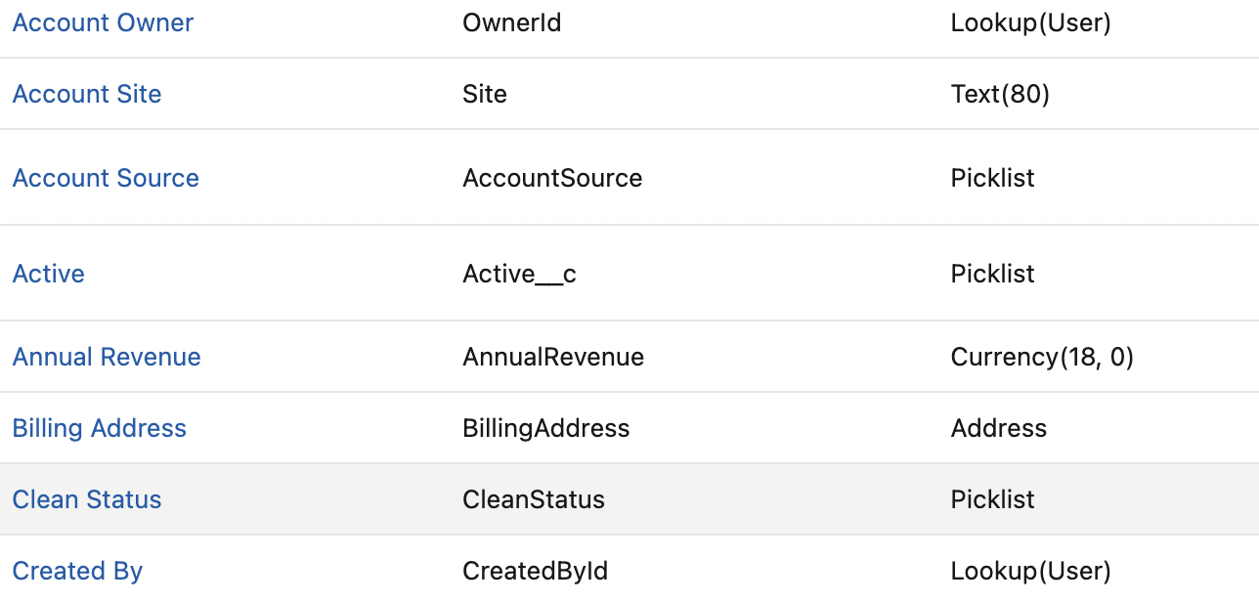
Within Acquired contact ->page layouts.  U can goto Acquired Ac page layout. | 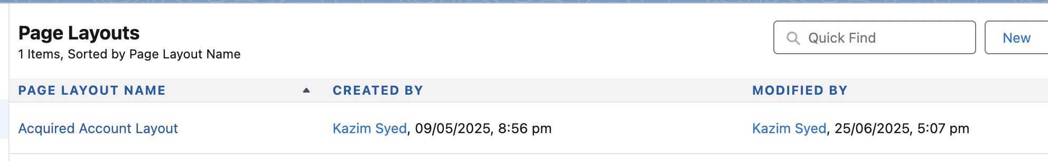
Look at the layout  (I am confused too) | 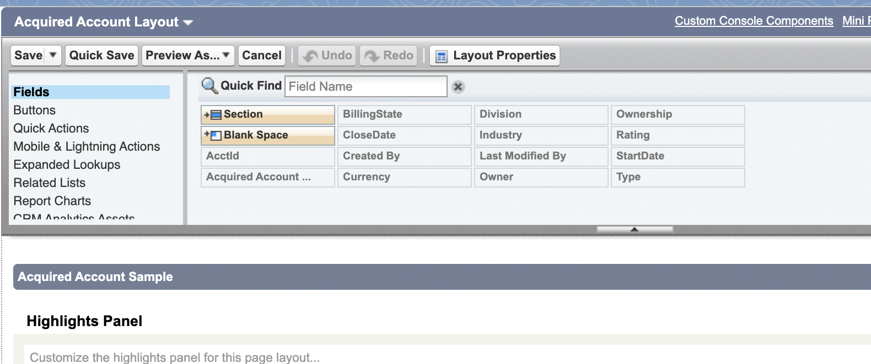

Record type being adjective of salesforce that those are the things that describe the nouns. You can segment different types of records that belongs to the object.

Salesforce Standard object Architecture and Relationship model
At Ac level we have company information.  This is where a lot of other objects related to. | the Account object might have fields like Account  Name, Industry, Annual Revenue, and Billing Address. The.
Contacts work for accounts. | Contact object might have fields like  First Name, Last Name, Email, Phone, and Mailing Address

link | 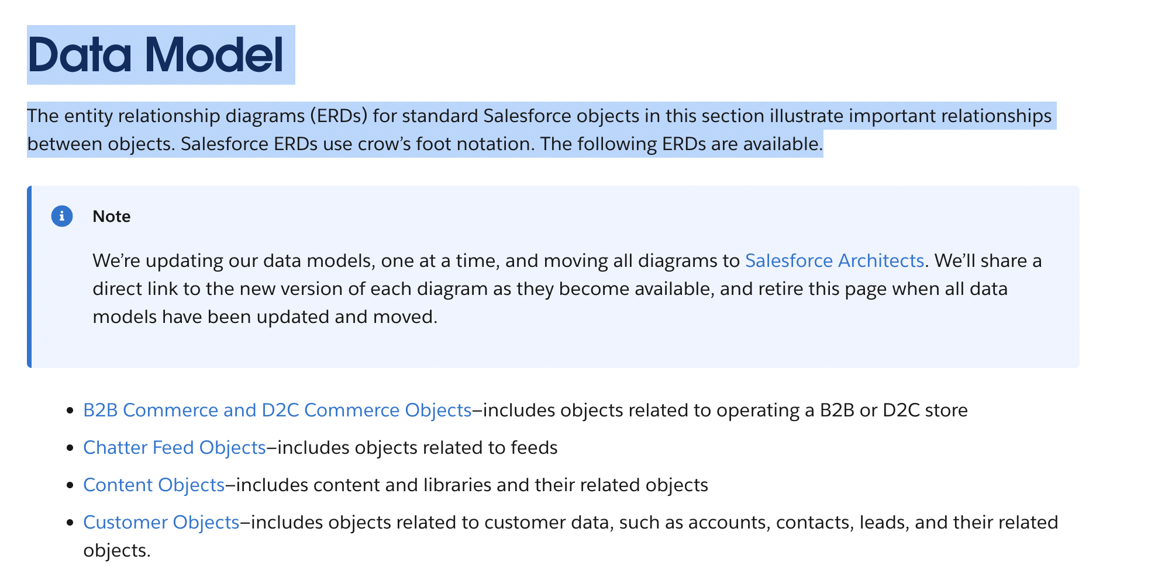
 | The entity relationship diagrams (ERDs) for standard Salesforce objects in this section illustrate important relationships between objects. Salesforce ERDs use crow’s foot notation. The following ERDs are availables.

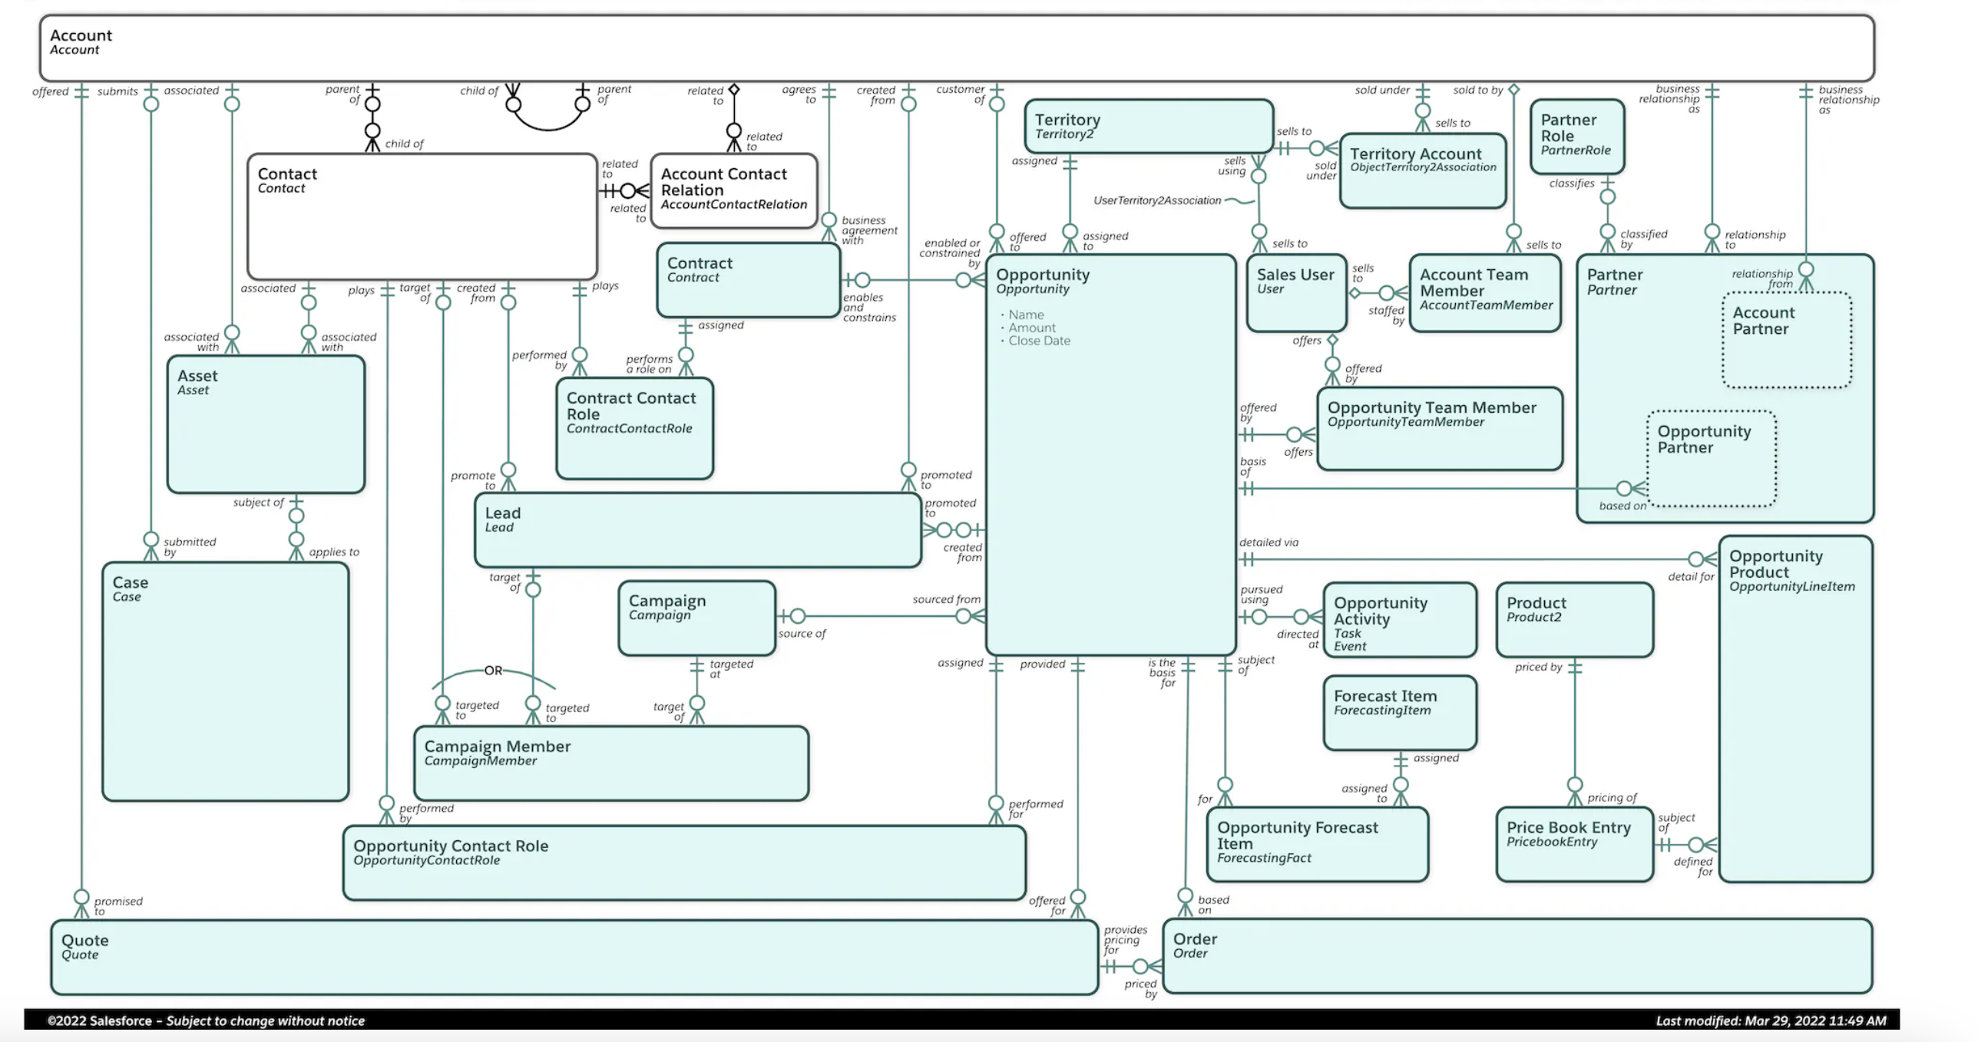
You can see the relationship in the object manager → Fields and relationship.
You can also goto support object → service cloud data model
If u want to look at some Smiths opportunity. U can goto Smiths ac and then goto his opportunities. This would be more record level than object level. You can see this using the frontend.

Using chat-gpt to create custom object ideas
Pending

Creating a Custom point for warranty Management of Assets
Goal: create a custom object warranty_c.
App launcher → Assets
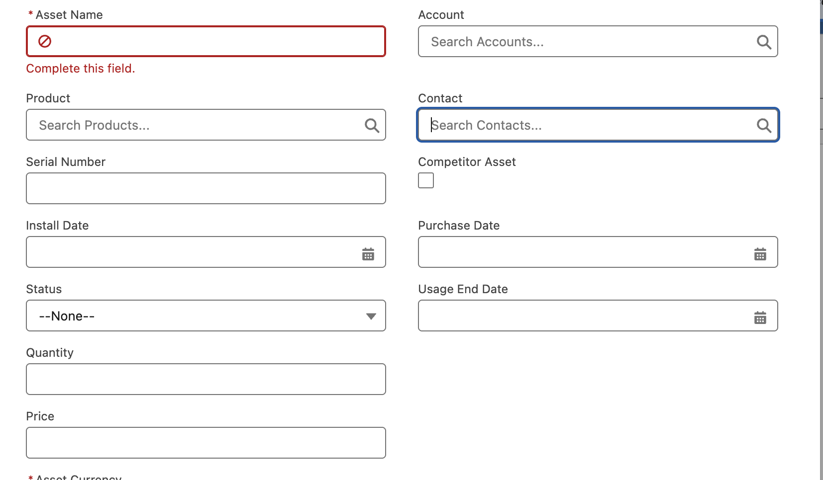 | Assets management if someone is provided with a computer. U can store his account and contact. And the asset serial number.
If u inside the assets object. You can goto Edit object, u will be taken to the object manager > Assets. | 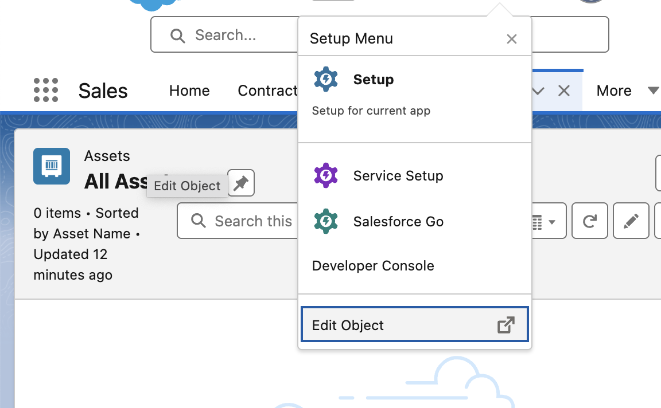
→ Fields and relationship | Anytime u created an asset records there is a lookup for the user who created that record.
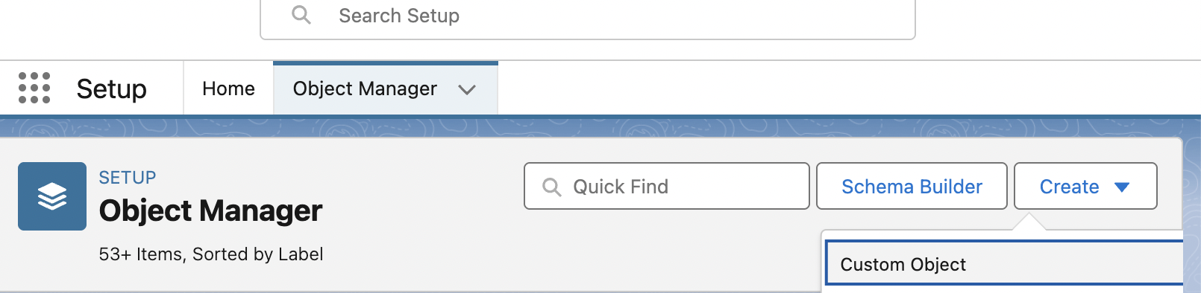 | Choose custom object
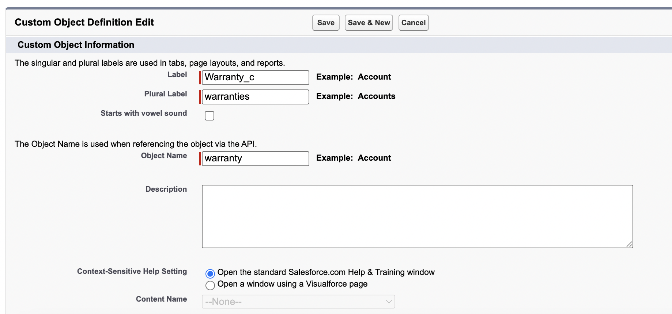  -> | 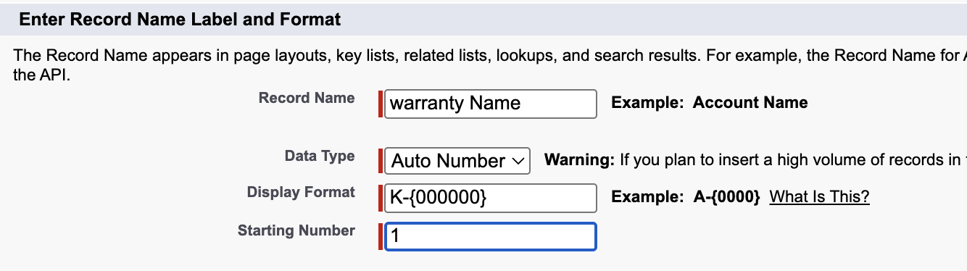  Any format, I use K for my name.

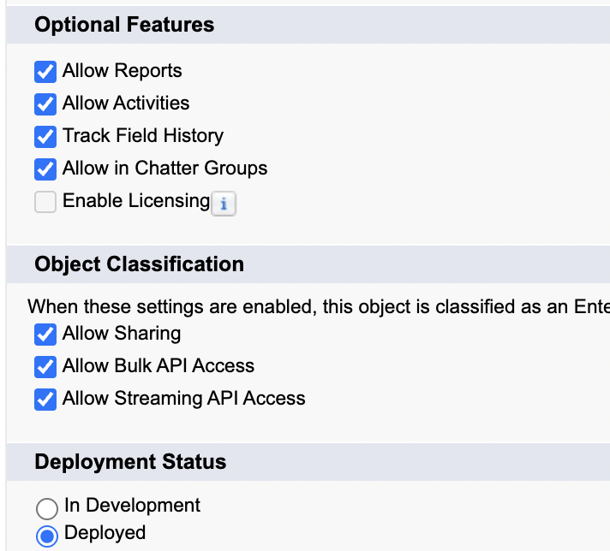 | In the real world, u wont be making changes live, u can safely make customizations, tests them out and then deploy to production.
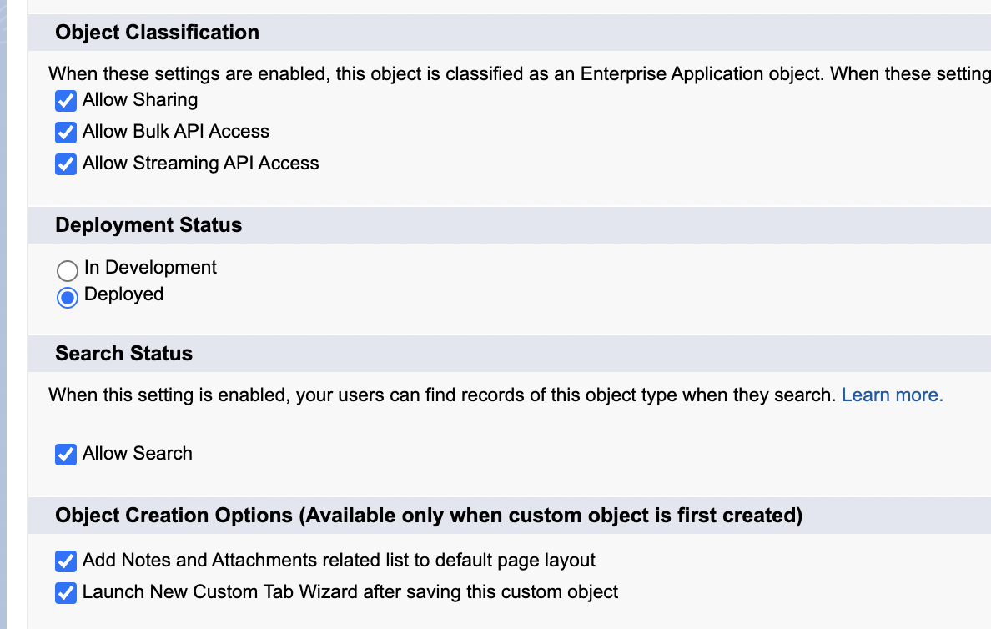 | Available only when custom object is first created.  That doesn’t mean you cant enter later to the default page layout.  You just need to know where to go to do so.  Launch new custom tab wizard after saving the custom object.  And essentially if you leave this final one unchecked. You will not have a custom tab created for this project and then you would have to go in and subsequently create a custom tab in order to access your warranties object.
After I open my custom tab wizard | 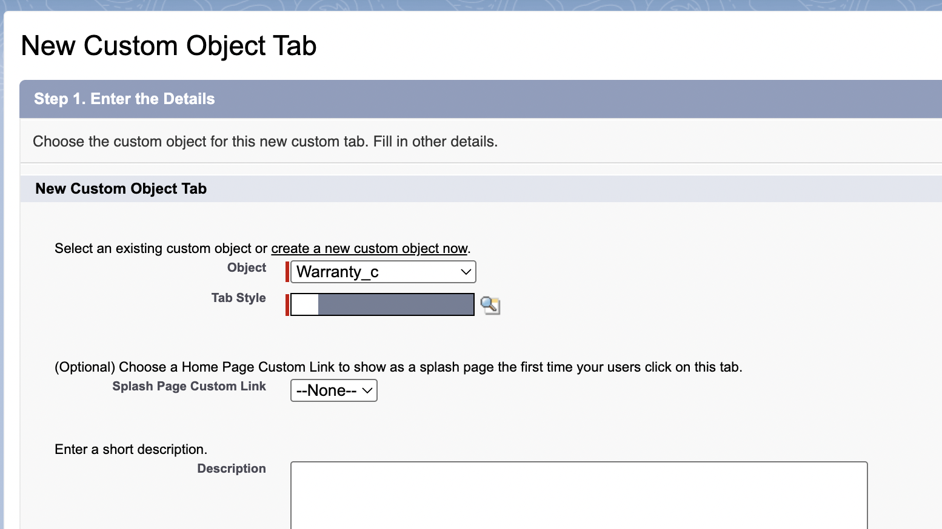
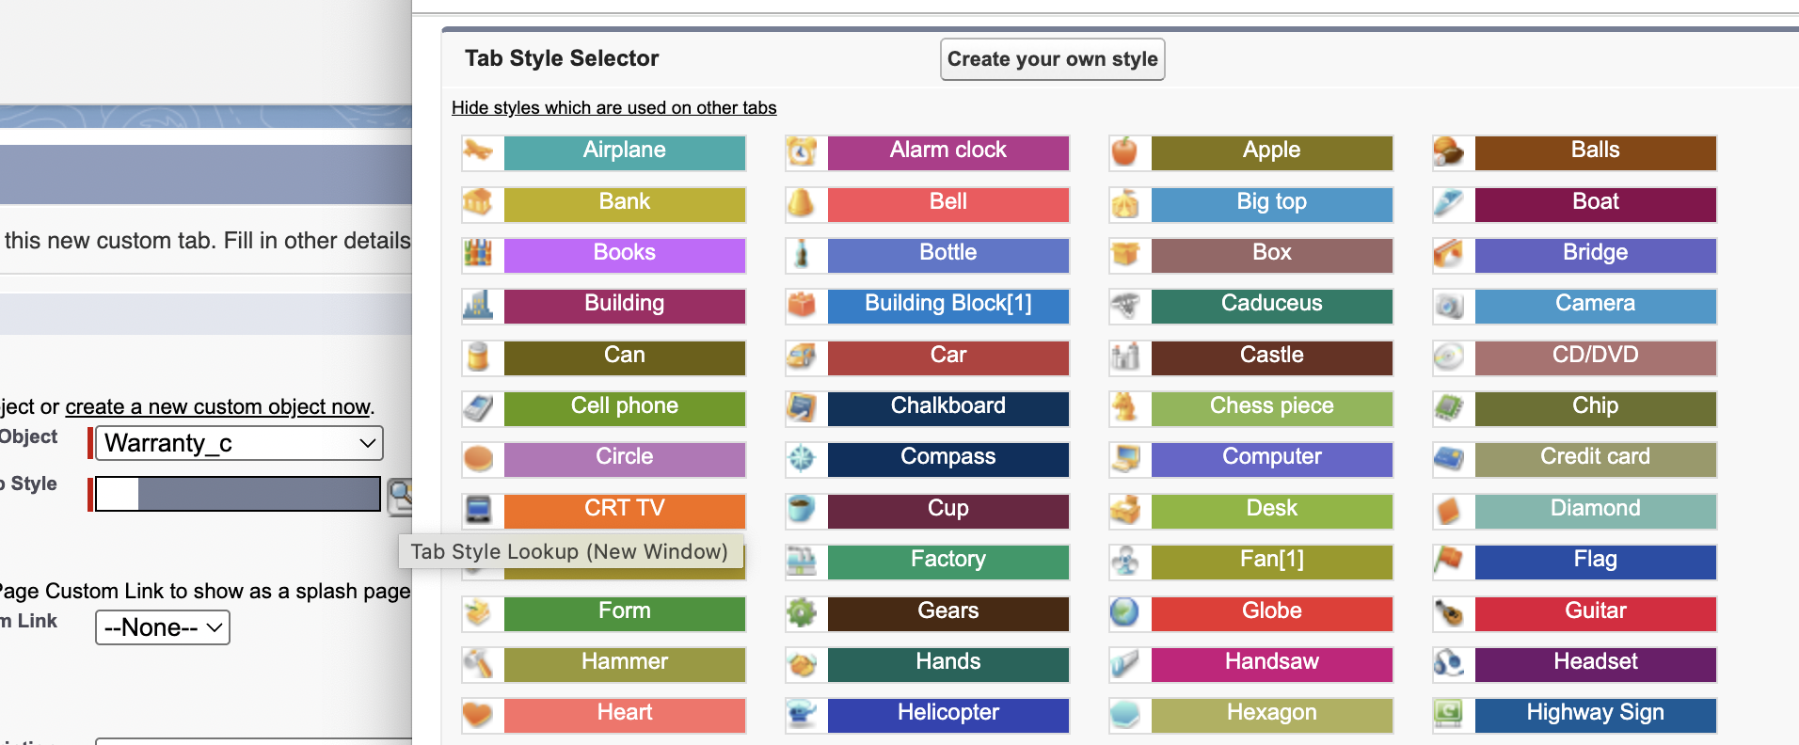 | I click on tab style

Its the icon | 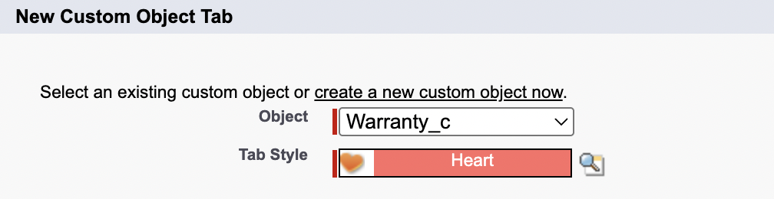
It will default on for everyone.  3 options  - Default on  - Default off  - Tab hidden | 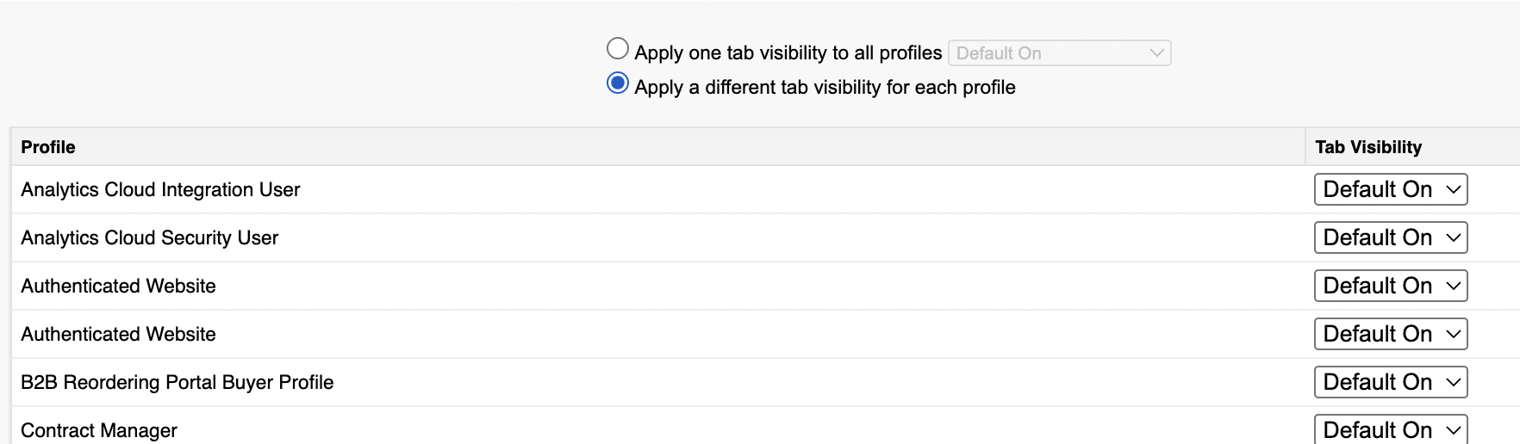  Next
Adding the tab to all custom app.  Why is it all selected by default mike questions. | 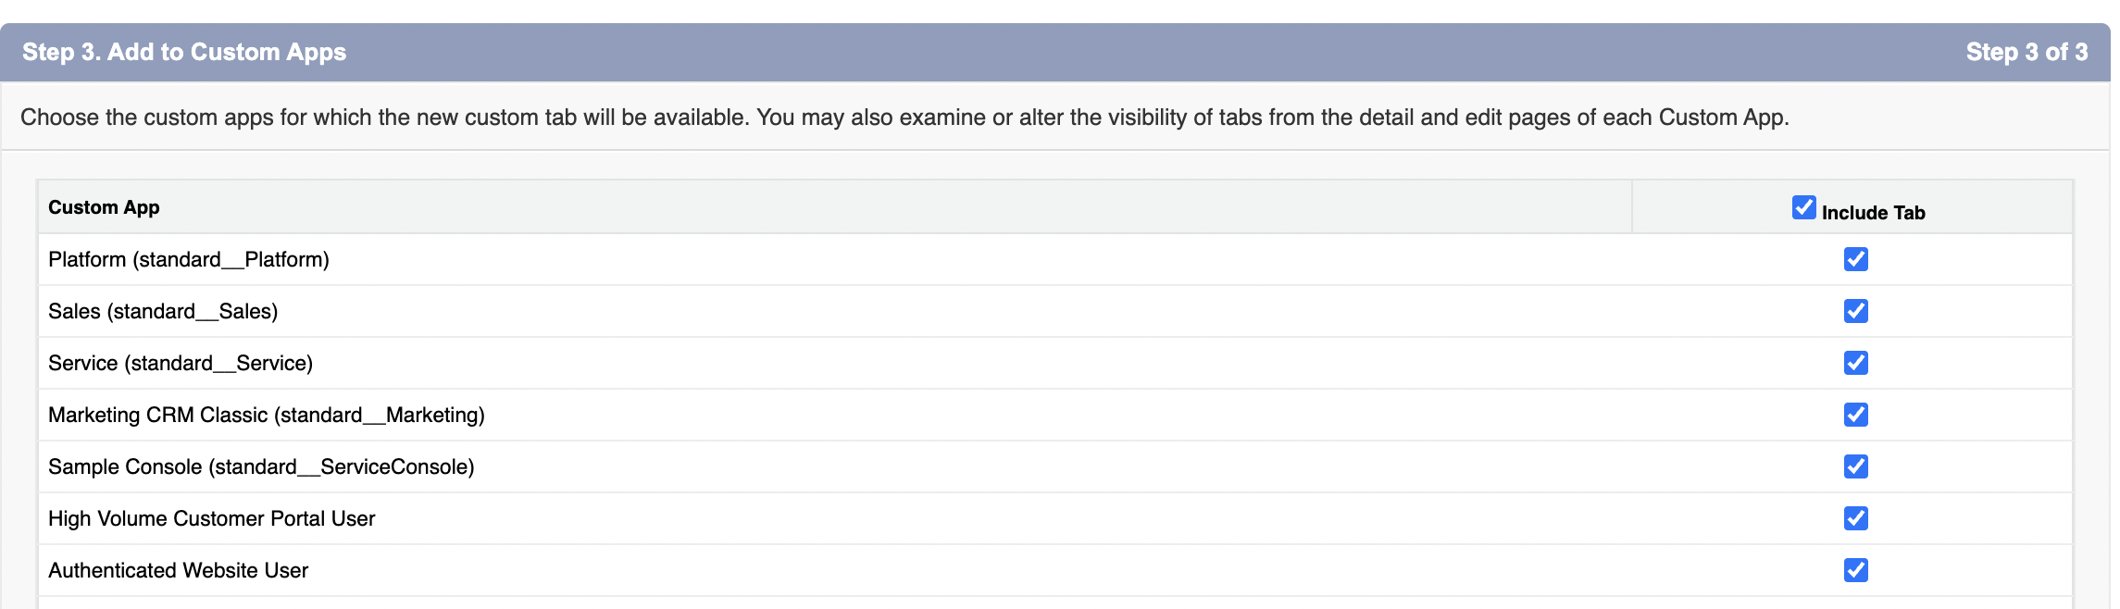
So we remove from all and given to only standard_lightningSales and sales(standard_sales) | 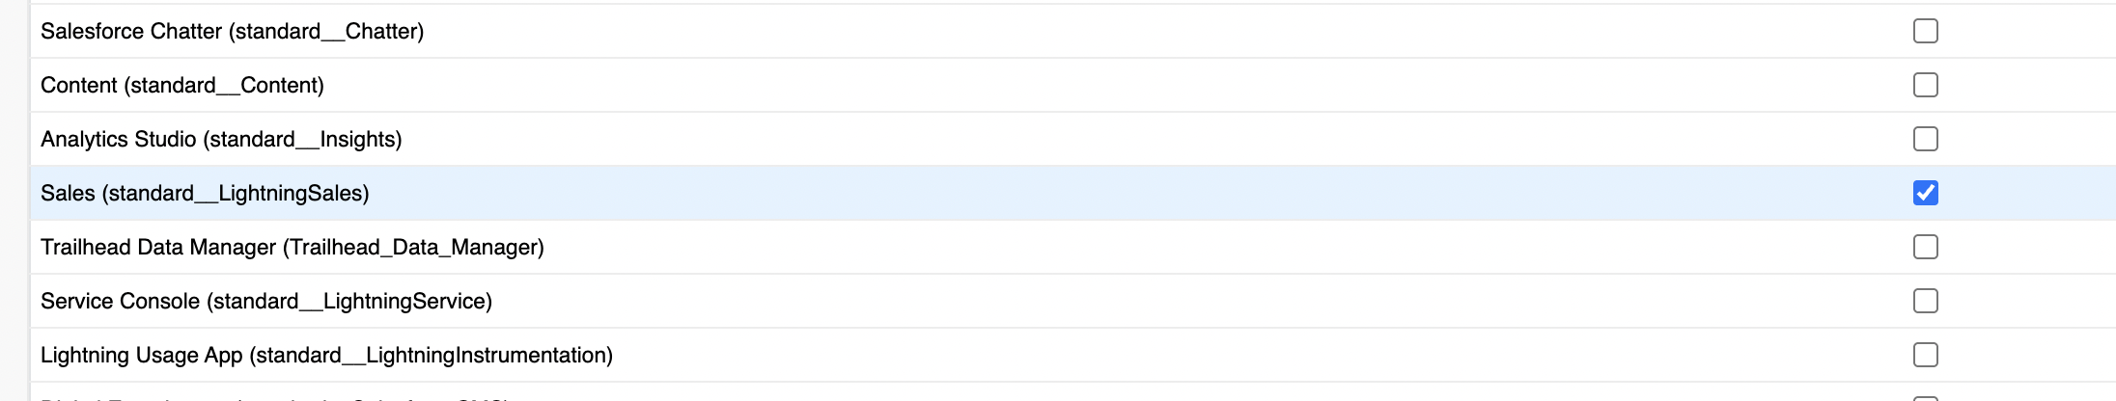
Our custom object is created  warranty_c → Fields and relationship | 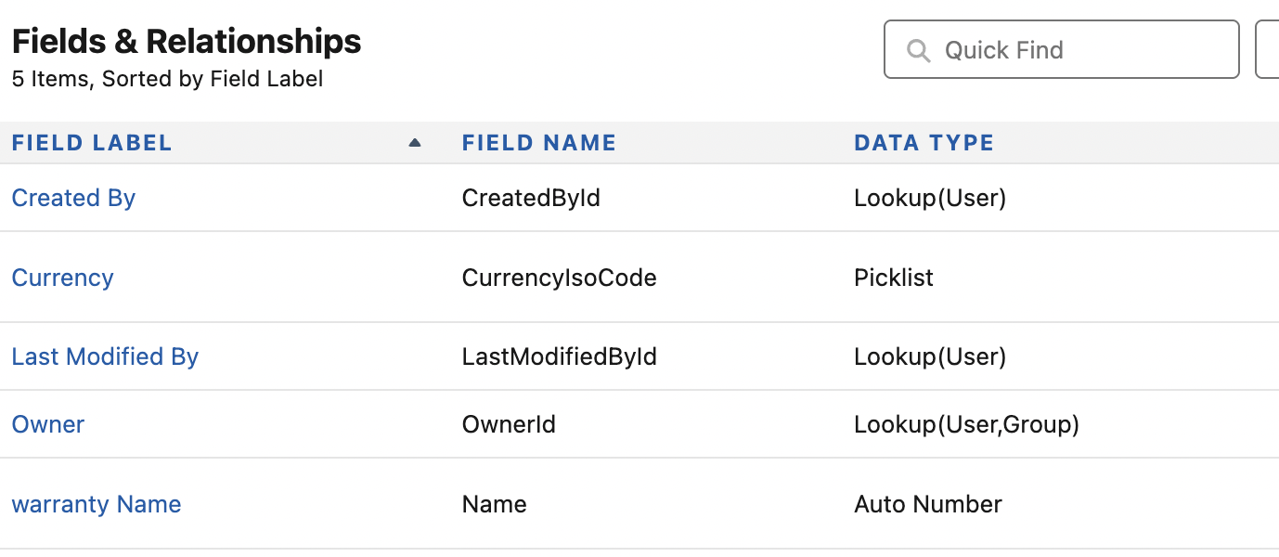

Creating a custom field – lookup relationship
Goal: Create a custom field.
Objectives:
- Create a field on Warranty object and set the datatype to lookup
- select the object referencing (Assets)and set the criteria like Required, Auto cascade, or filter the popuplist like if assets are installed from the picklist of options.
- Do field-level security based on profiles.
- Set the page layout
- to show this object as related list in the parent object.

New label: | 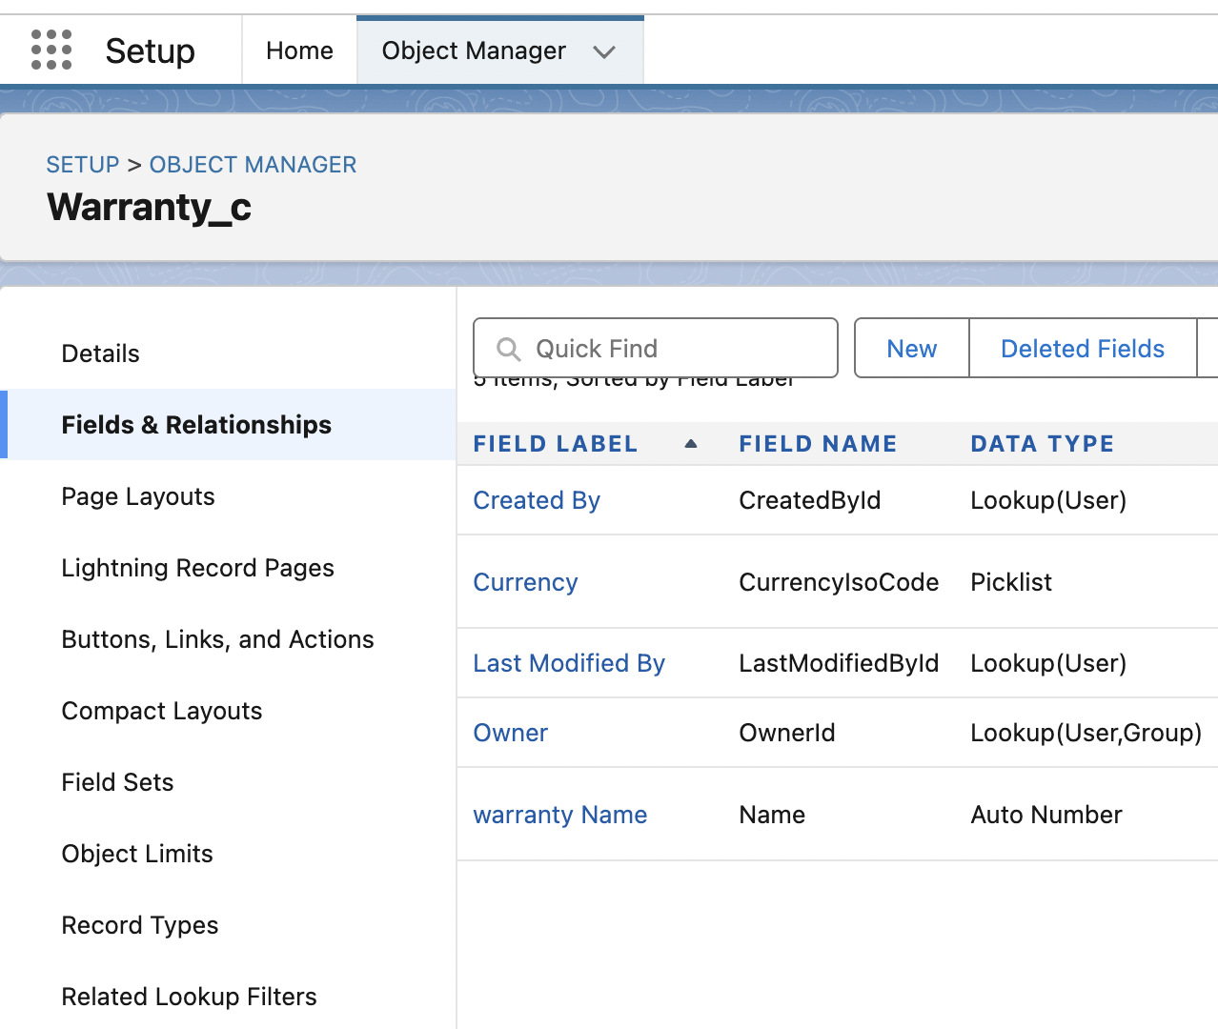
Select the data type

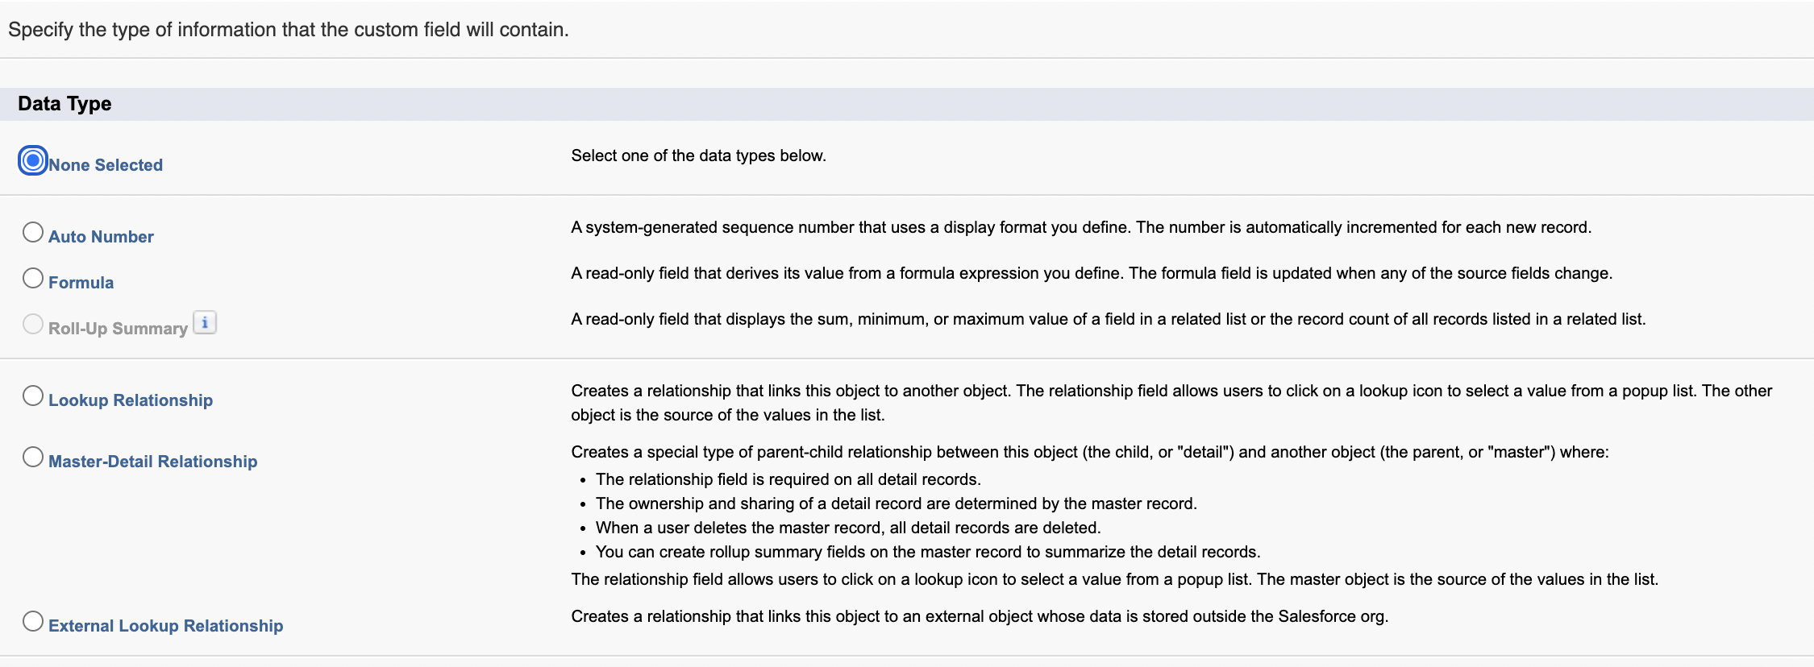

Select lookup relationship

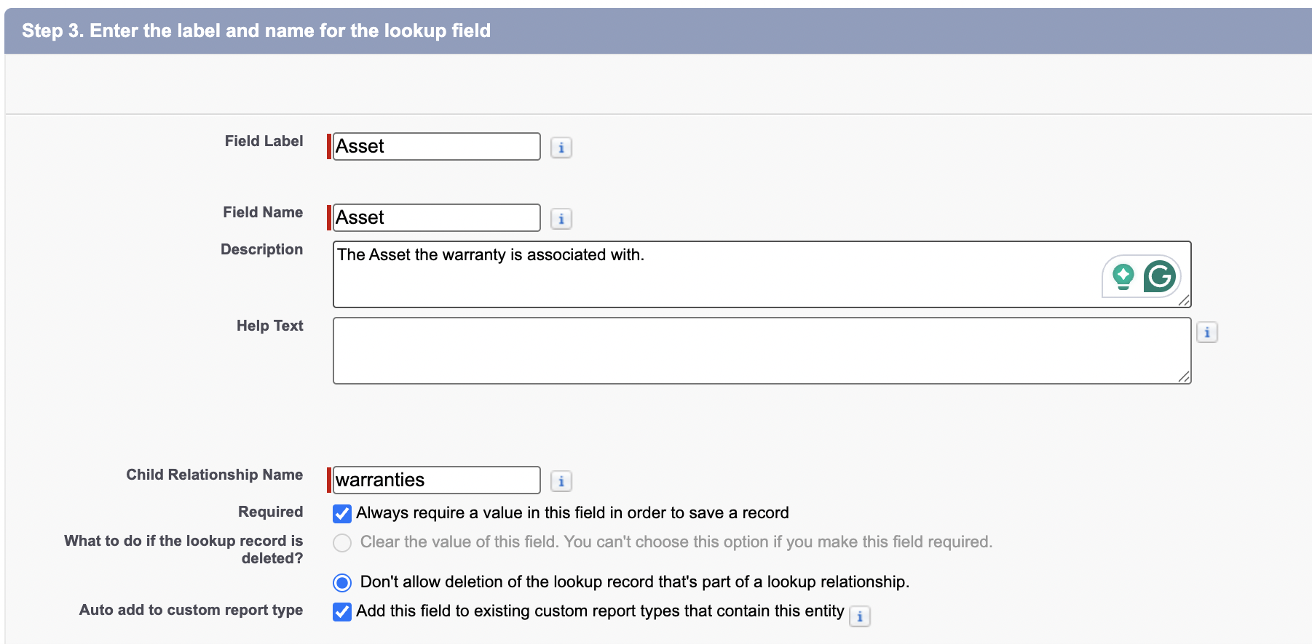
 | Required
 | Don’t auto cascade.
 | You can also filter the lookup options.
Note: | what if its required and cascade delete on a lookup relationship. how is it different than master-detail relationship?

Feature | Lookup Relationship (Required + Cascade Delete) | Master-Detail Relationship
Ownership | Child record retains its own owner and sharing settings. | Child record inherits ownership and sharing from the parent.
Data Integrity | Deleting the parent will delete the child, but the child can be moved to another parent. | Child records cannot be reparented; deleting the parent deletes the child.
Roll-Up Summary Fields | Not supported. | Supported on the master object to aggregate data from child records.
Security | Security and sharing rules are set independently on the child object. | Security and sharing are inherited from the parent.
Required Field | The lookup field can be set to required. | The master-detail field is always required by default.

Field level security based on profile.  Since the field is required, that field will be visible to everyone. | 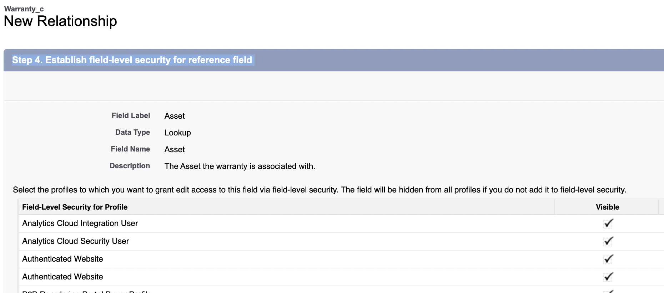
 | 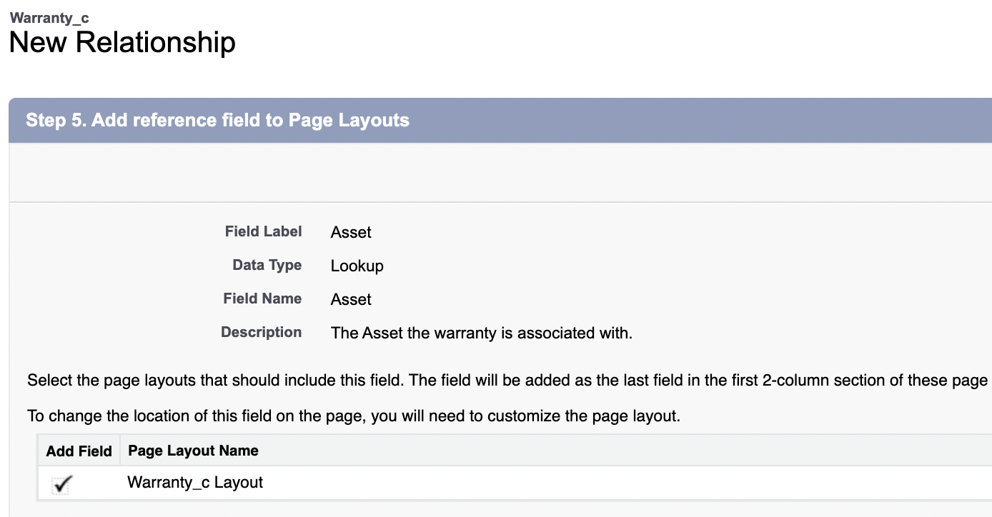
Add the warranties list to the asset page layout.  It automatically adds a Related List called "Warranties" to the Asset page layout. This related list finds and displays all Warranty__c records where the Asset__c field matches the Asset's ID. | 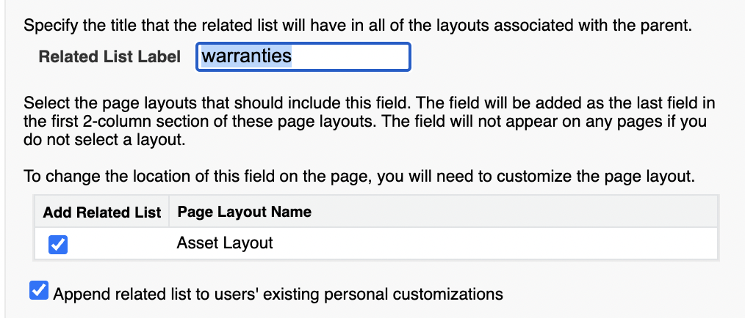

Output:
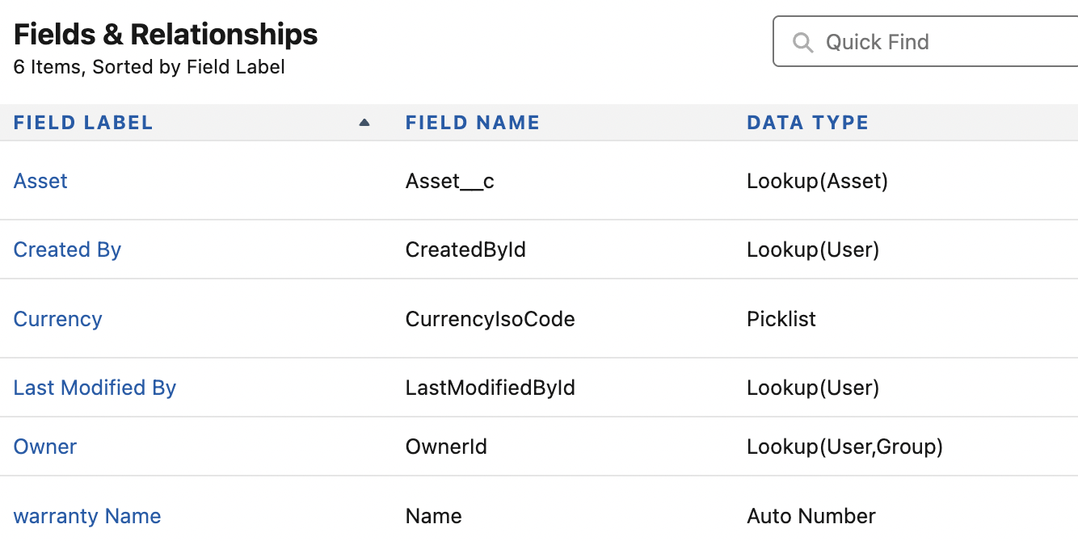

Creating Assets records and Adding Warranties
Goal: Obvio
Objectives:
1. Create an assets record first
2. create a warranty object second.
3. you can spot the custom object using the app launcher.
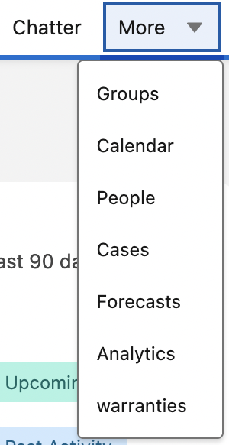
Sales → Warranties
Why Sales? Since the object is only available to standard_lightningSales and sales(standard_sales)
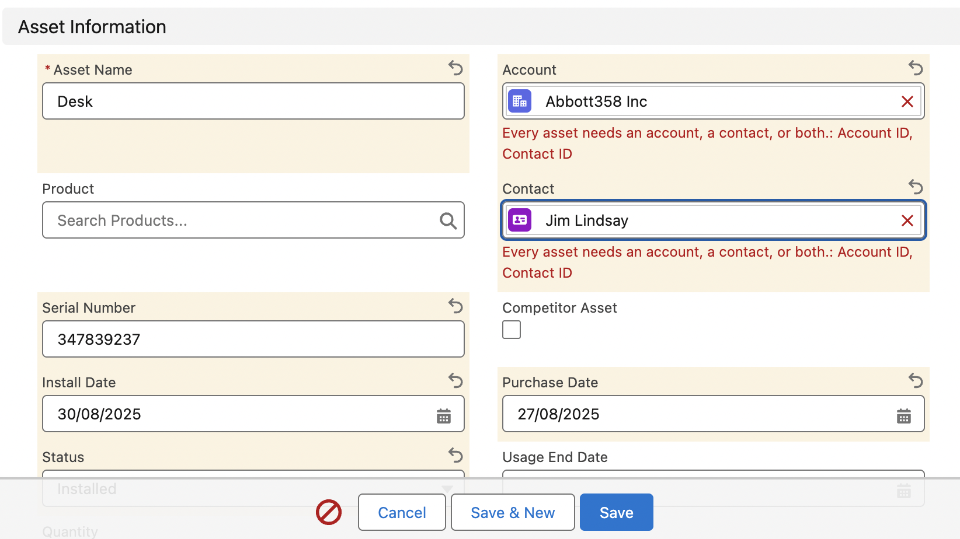 | The contact is for the person who works for that accounts Abbot.
 | 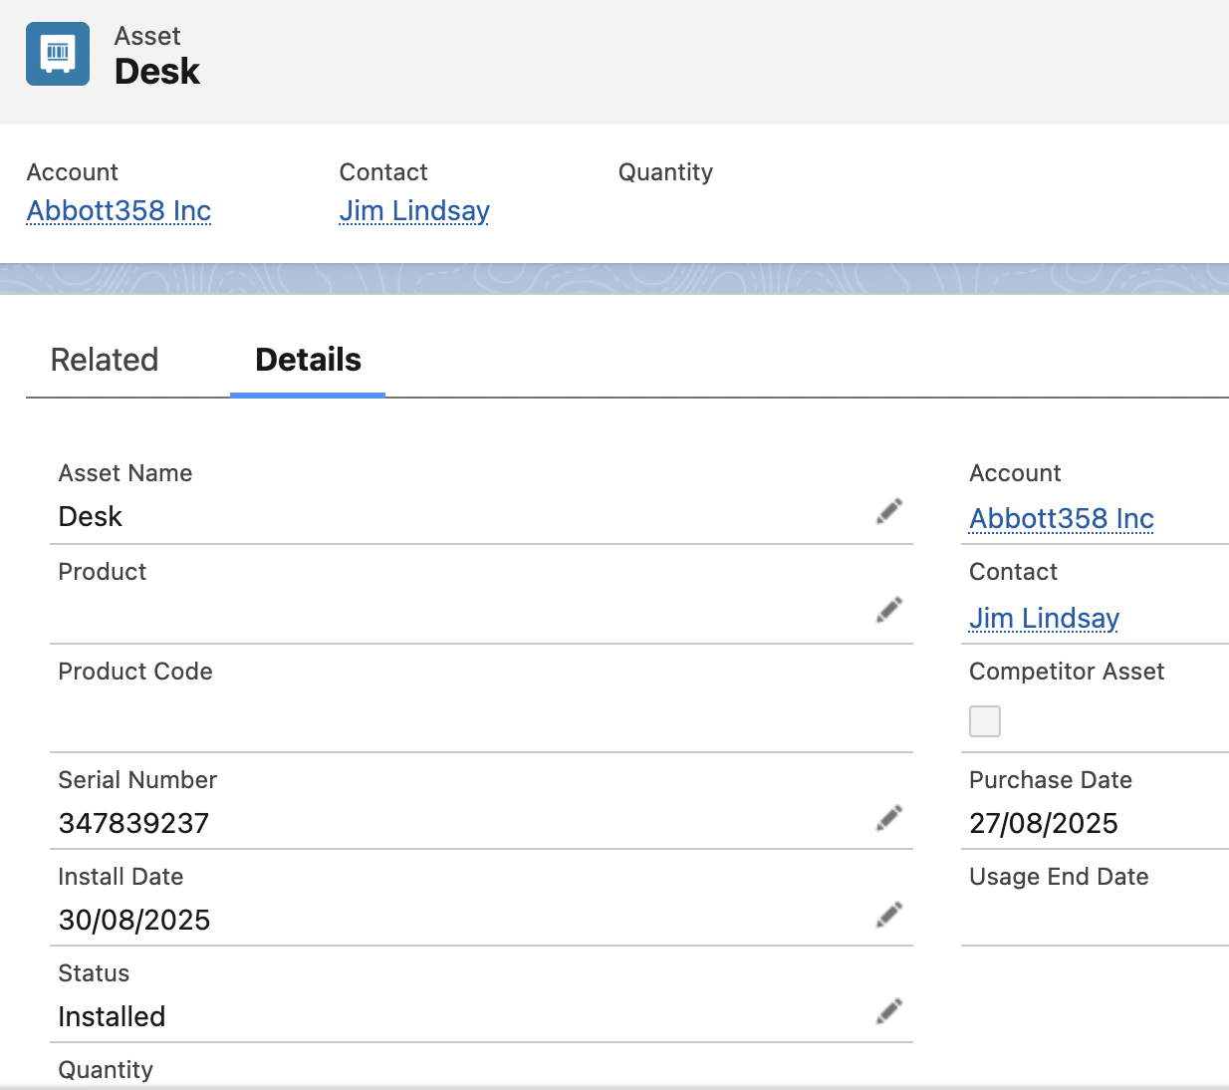
 | 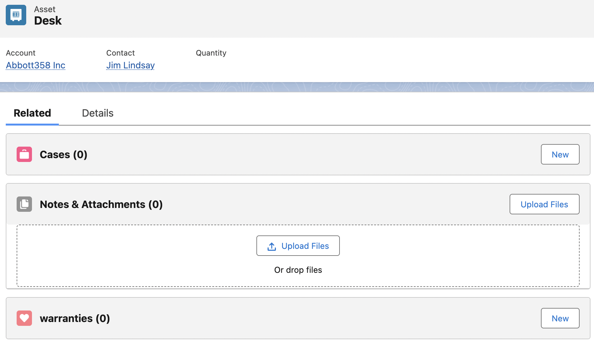
 | 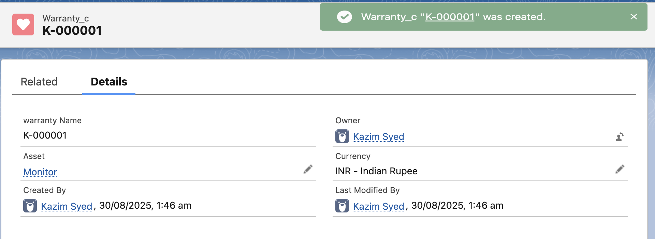
You can add new assets this way. | 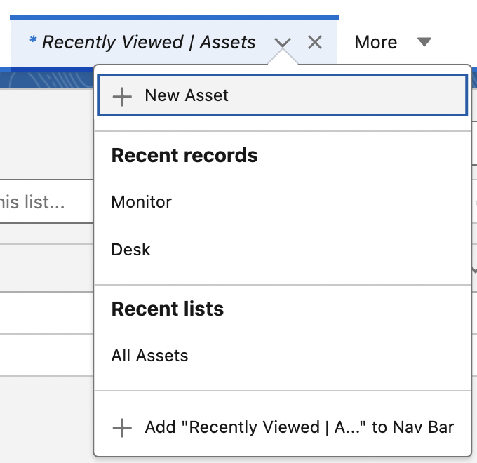
Output:
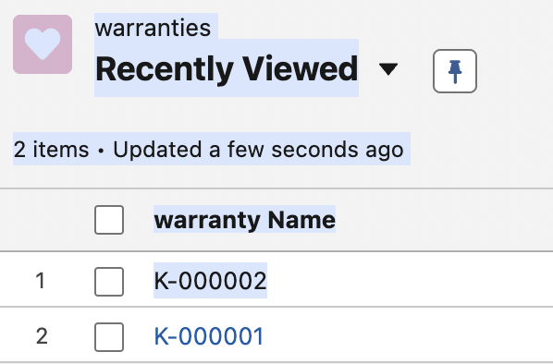

Note: u can have 1:M using lookups and M-D relationship.

Introduction to schema builder
Goal:
Objective:
1. Visualize the relationship using schema builder
2. Drag and drop fields using schema builder. Add a description field in the warranty object.
3. caveat of using drag and drop → multiple clicks for page layouts and field level security and related lists
4. u can create object as well(mike preferred not).

 | Use schema builder to visualize relationship between objects.
 | Any Custom objects will not appear in the ERD diagrams. So using and leveraging Schema builder will help u wrap ur mind around the diff relationships between custom and std objects.
Objects and fields → Schema builder
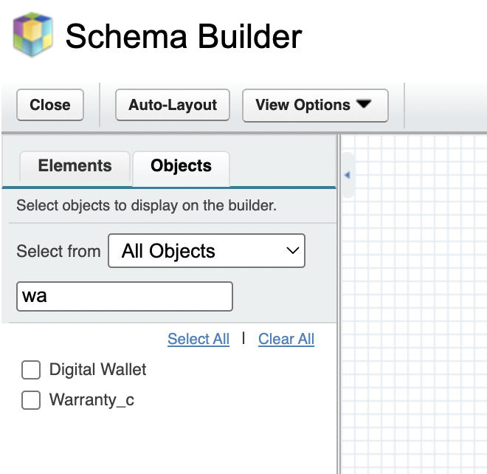 | I searched warranty_c  to view warranty_c relationship w/ Assets.  Assets has more relationship since my focus was warranty_c object. So I searched that only.

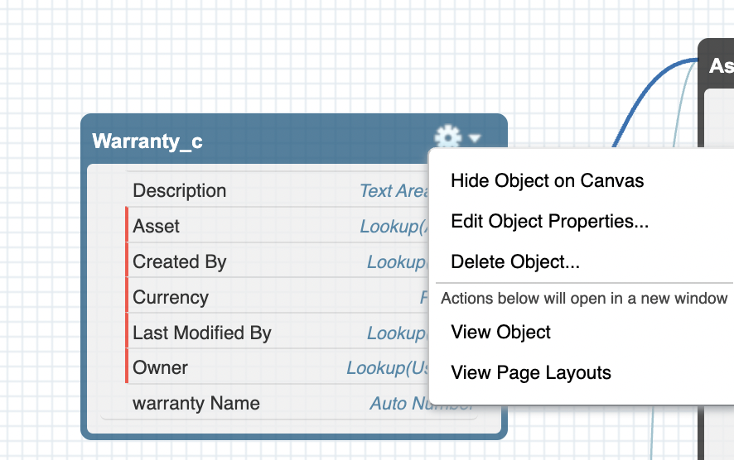
I had to visible both the users and assets and warranty_c to view them all. | 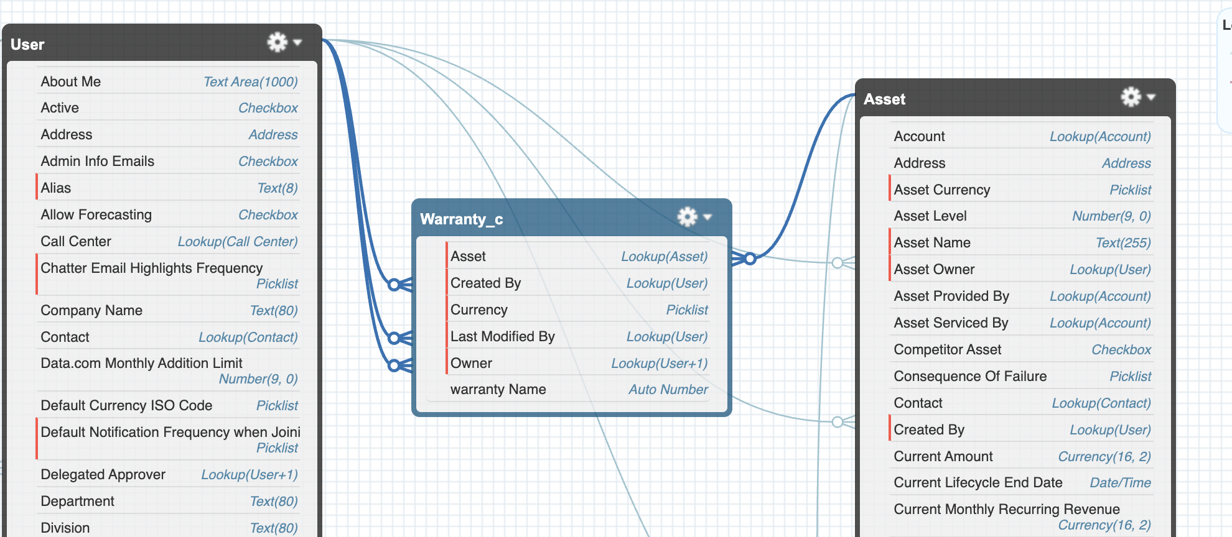
Under elements, u can drag and drop fields like text-area and even objects. | 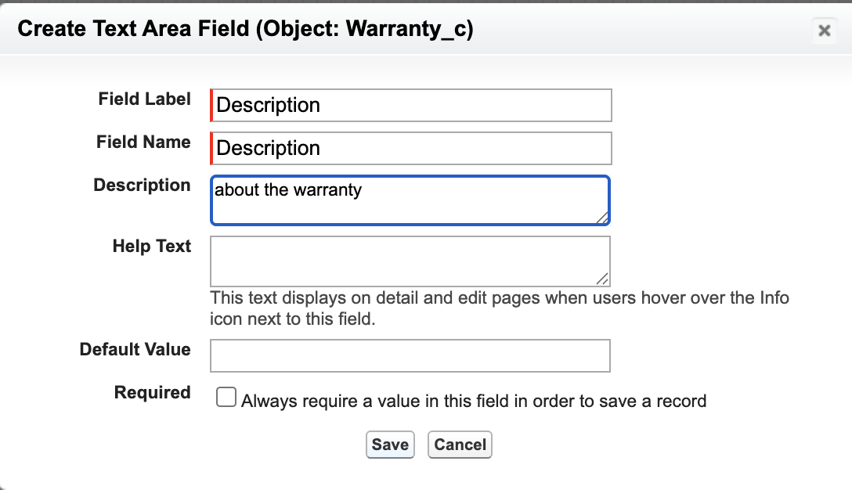
Desc is added, but the field isn’t visible.
 | 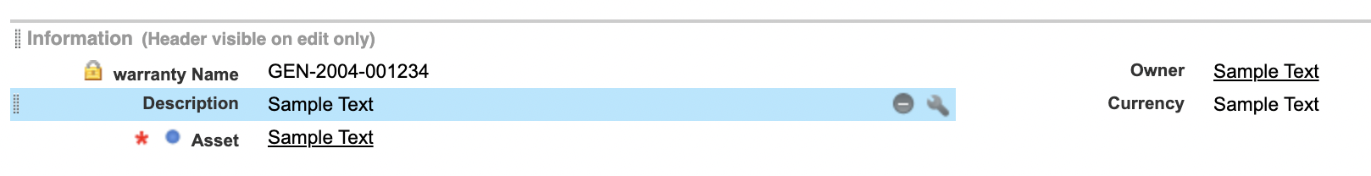
Within fields and relationship→ desc→ Set field level security.

Reviewing custom page layout and field visibility

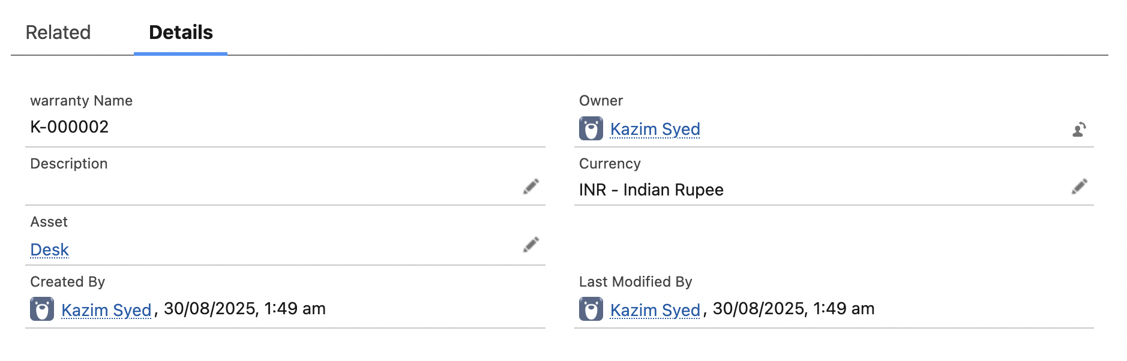
Creating additional custom fields
Warranty provider a field in warranty object referencing to Account.
Lookup or Master?
What if the warranty provider goes out of the business. We still wanna have the record. We just loose the association. The independence is the core principle of a lookup field.
We want different security for each record, I don’t want someone with access to the parent object and by using controlled by parents have access to everything. A sales team might own the account, but a service team would likely manage the warranty.
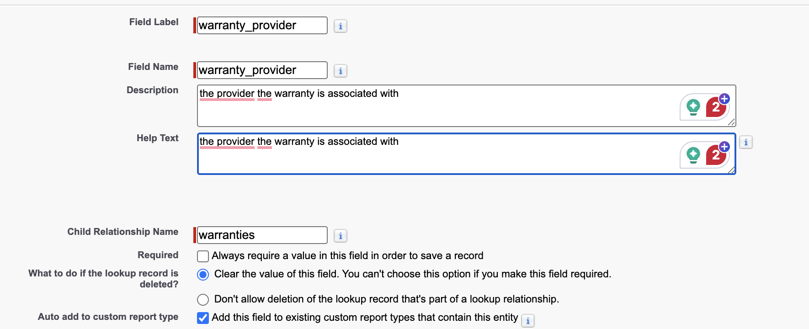
We let this field be not required, so it could be left with blank.
We can add filter so only warranty provider will populated as warranty provider.

For the meantime, mike has unchecked this. Because its a setup for different lesson.  For a specific layout but not for all. | 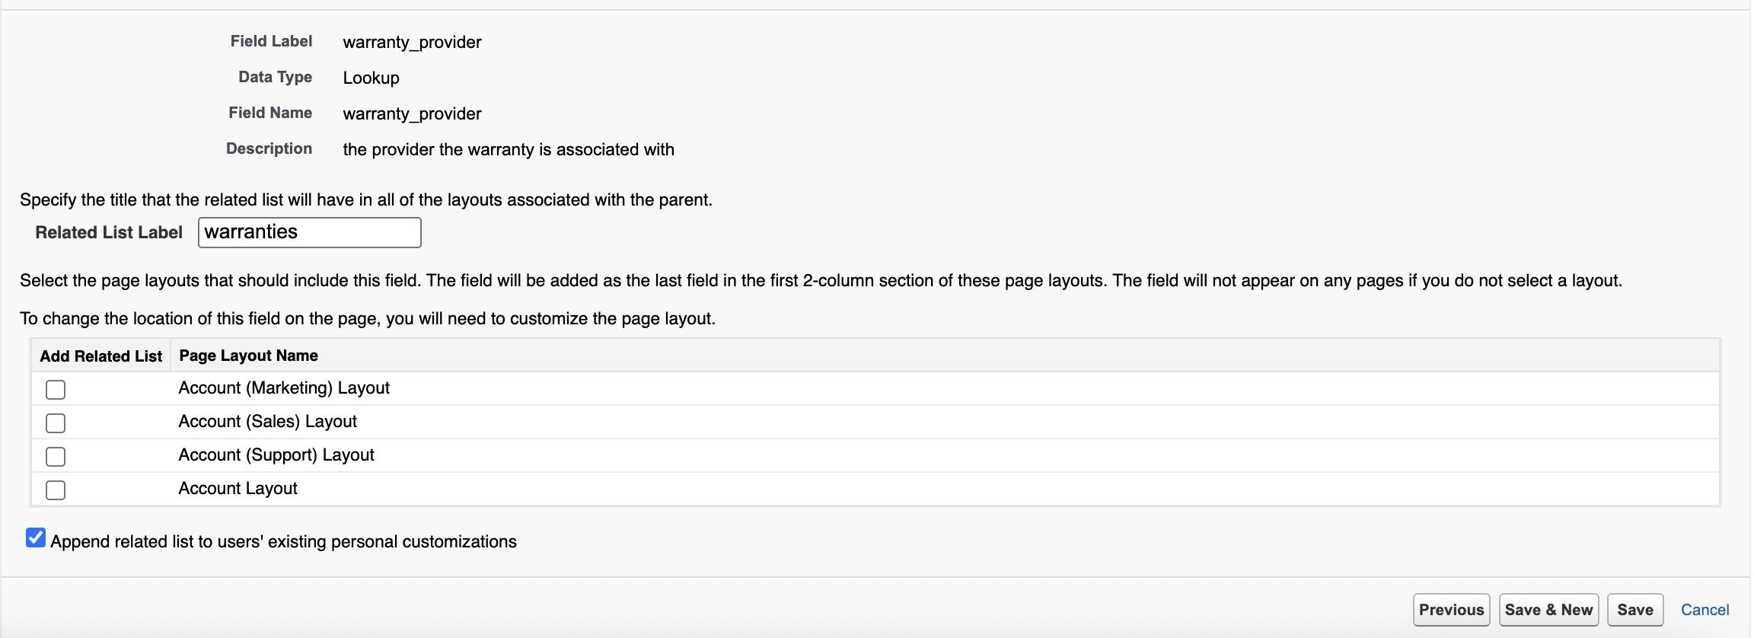

output:
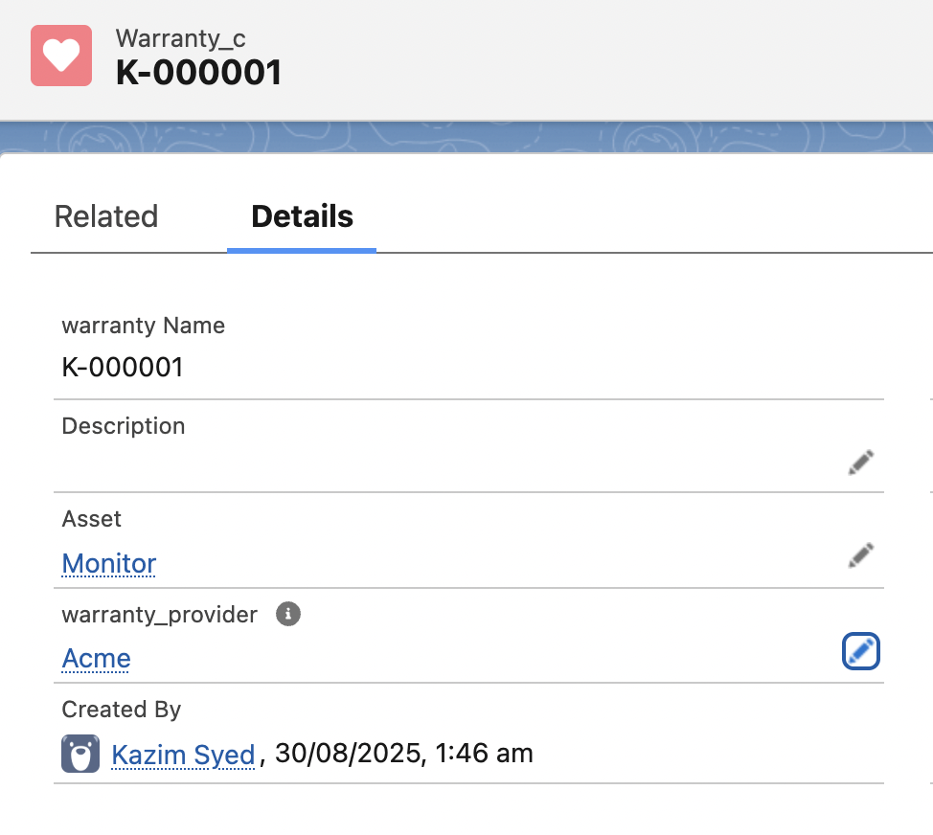

Picklist
I create a custom list
Status: Active,Expired, cancelled, void.
Set by default the first one.
Note records which existed before this field wont have default value.
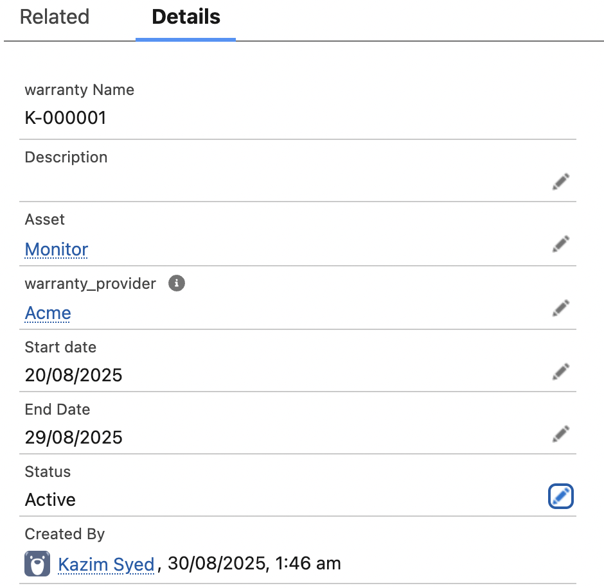

List view control arent working for the admin
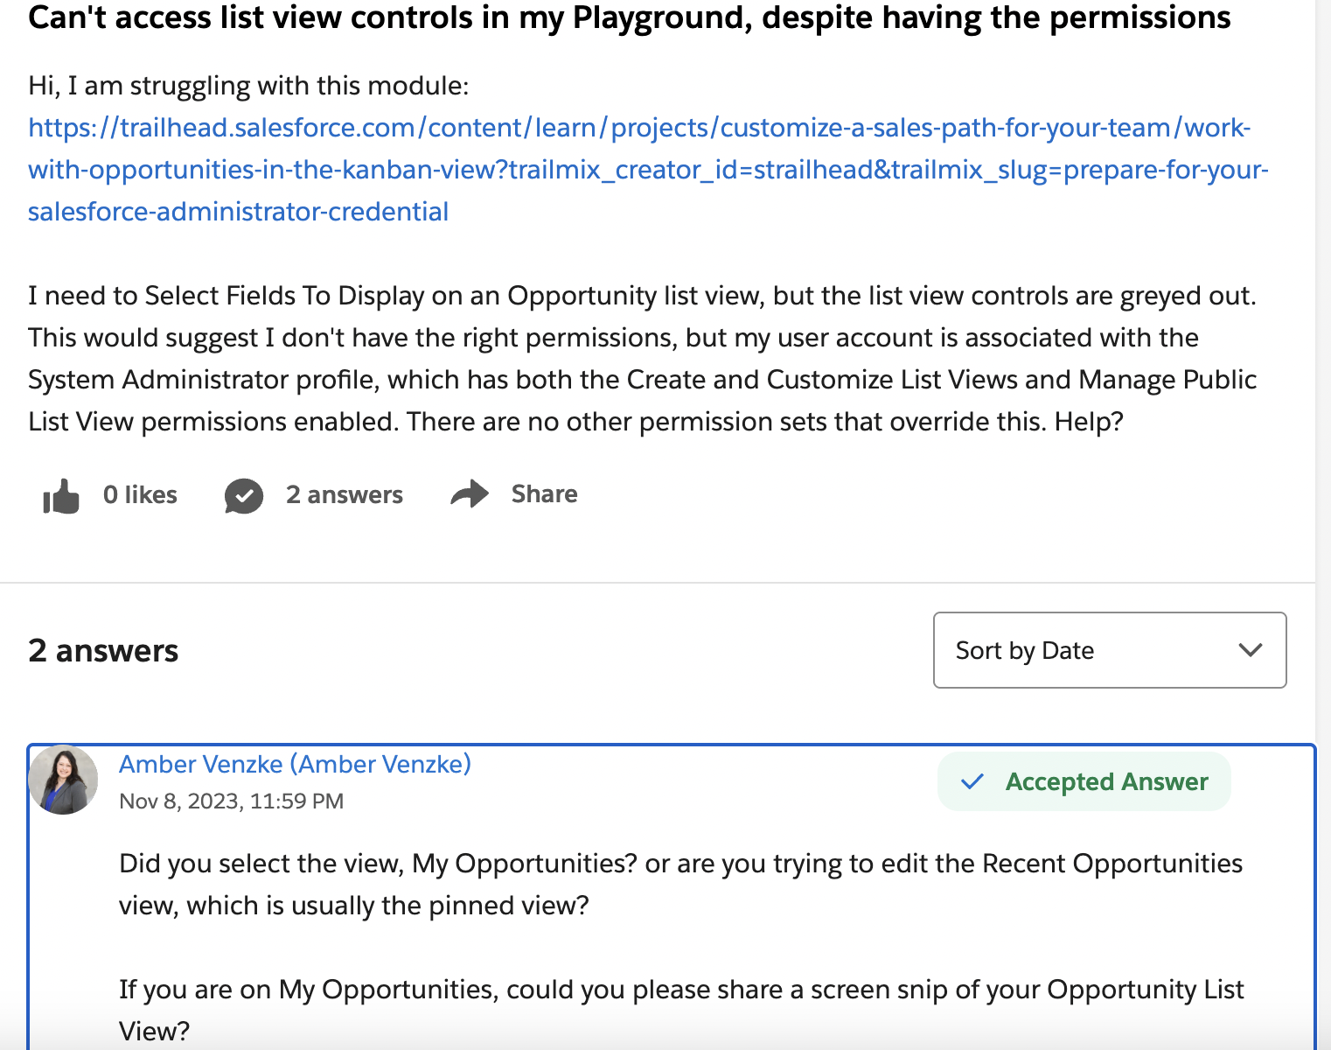

Converting a lookup field to a Master-detail relationship
 | Converting a lookup field to a Master-detail relationship.
Situation | Whenever u have an existing object with records u cant have a new master-detail relationship on that object. Because master-detail relationship are always required fields.  The one having the Master-detail relationship might be child entity.  Not necessarily a weak entity unless the parent entity pk is part of the child entity composite key.  Parent child relationship cardinality would be (1,1) to (0:N).

FAQ | will the master-detail relationship will be shown on the child or parent entity?
Ans | The master-detail relationship is a field created on the child object, but its effect is shown on both the child and parent records(related lists created automatically by SF).  It is existence dependence. So it necessitates a lookup field to a parent.
Sol | So for an existing child record to establish a Master-detail relationship, we will have to create parent records in the parent entity and then set the lookup field for the legacy records in child that don’t have one.(Note we are converting a lookup field to Master-detail relationship)

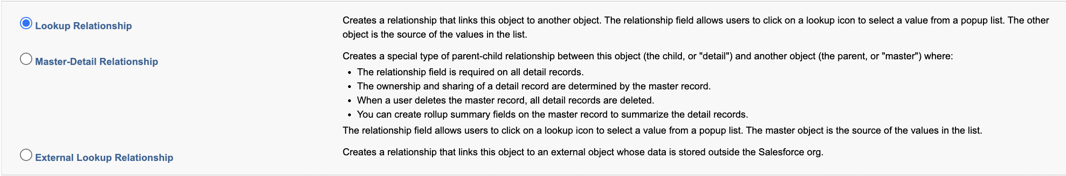
Since I have legacy records, I cant create Master-detail relationship. Its weird SF doesn’t tell me that at the go.
Lookup → Master-detail
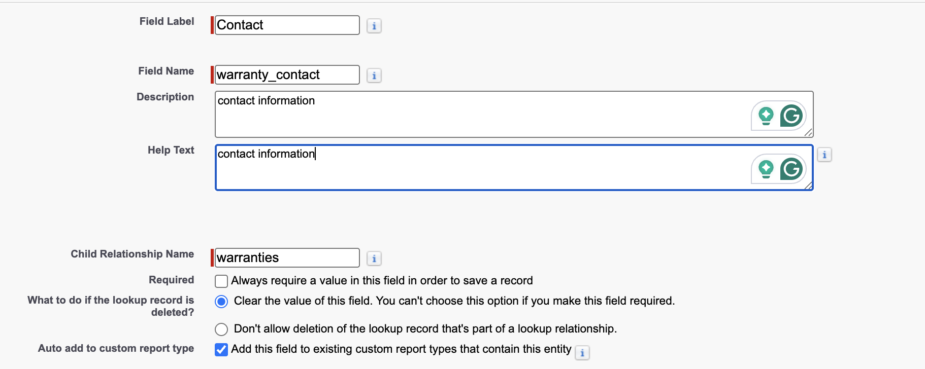

Build up for another lesson | 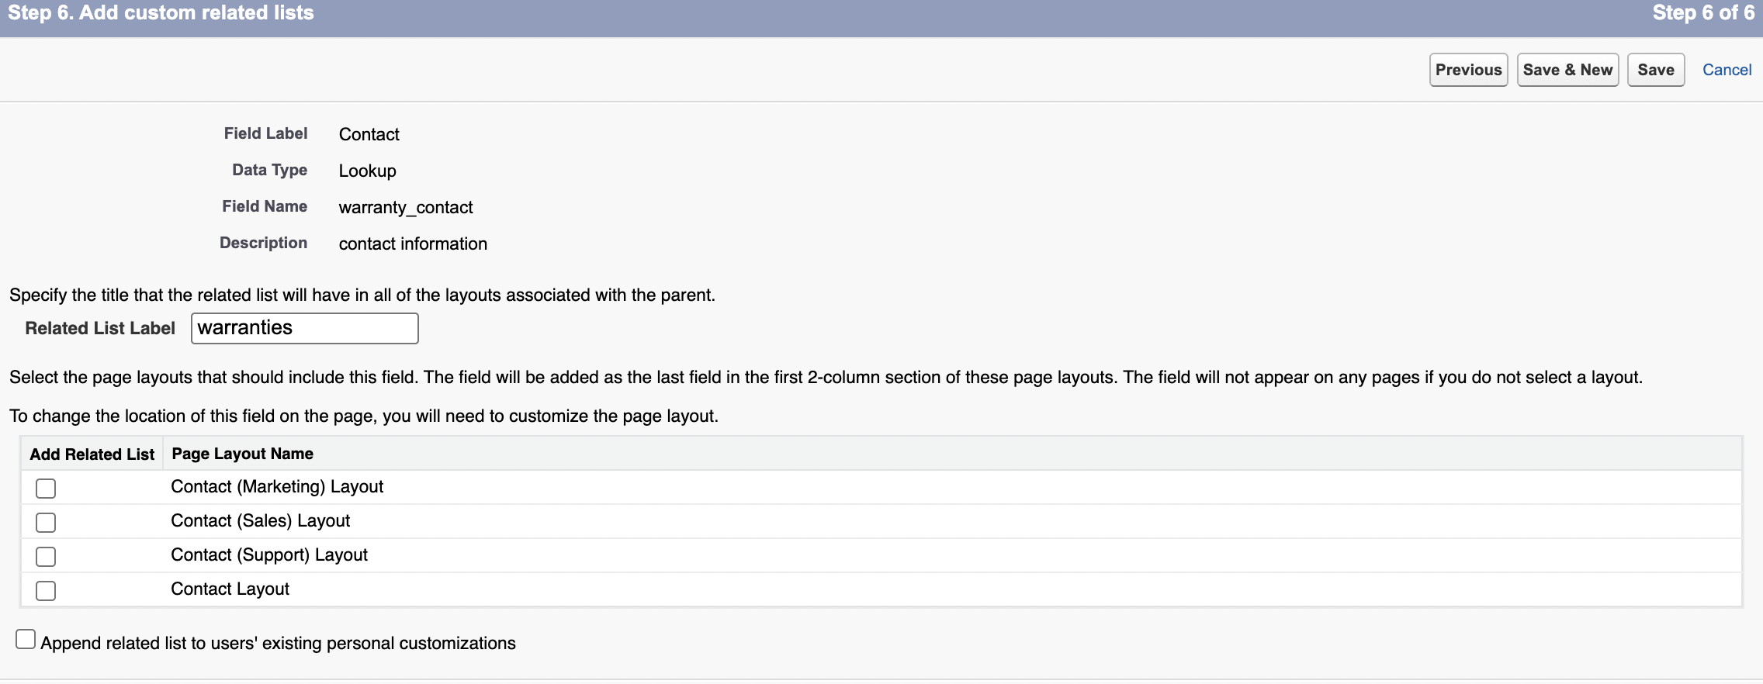
 | 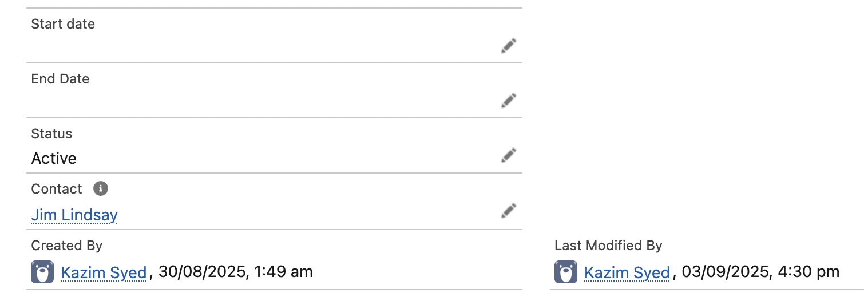
 | 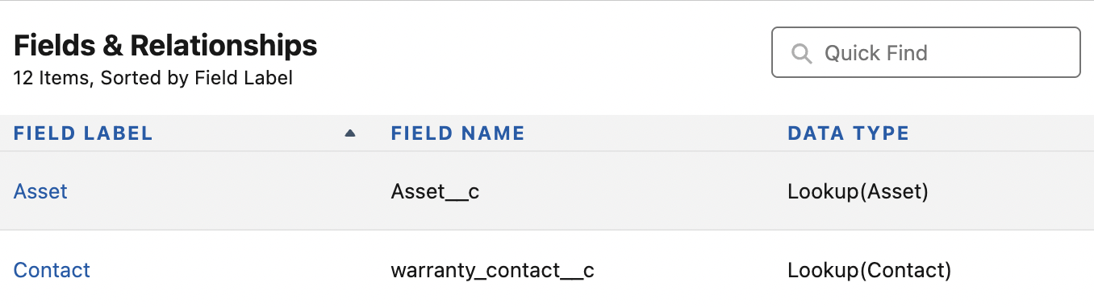
 | 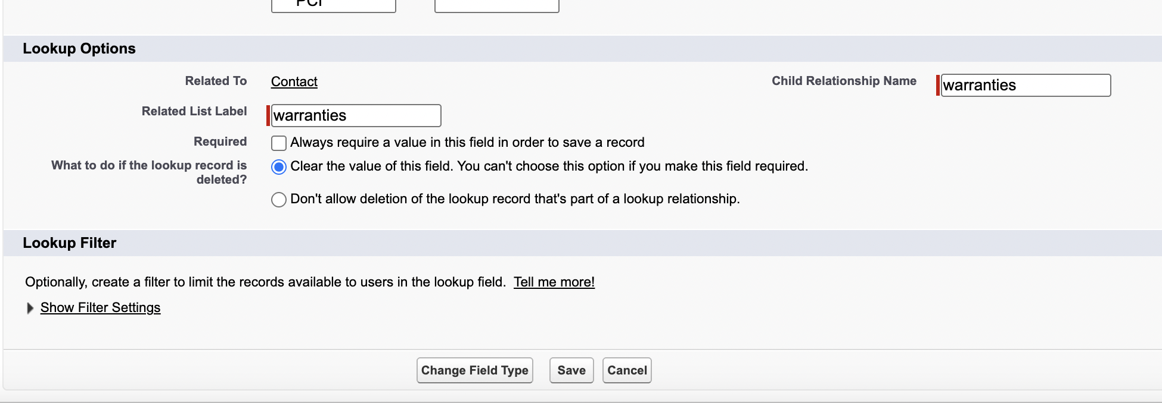
 | 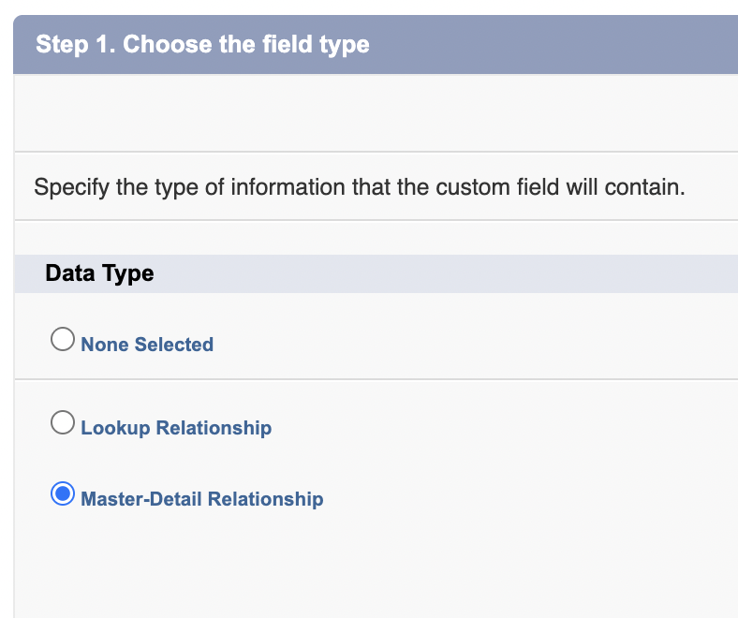

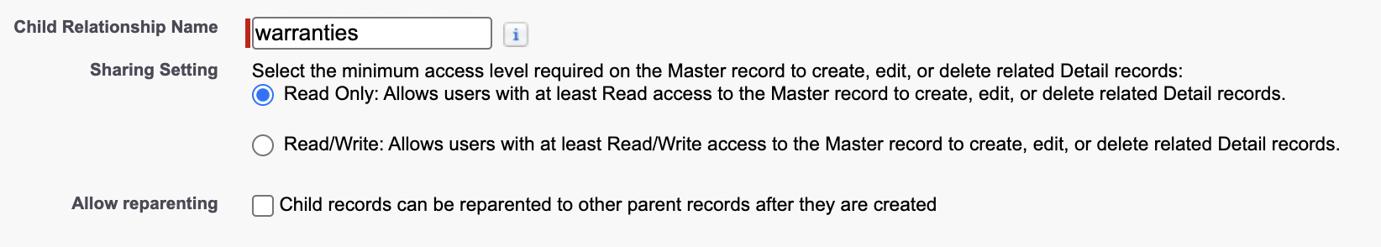
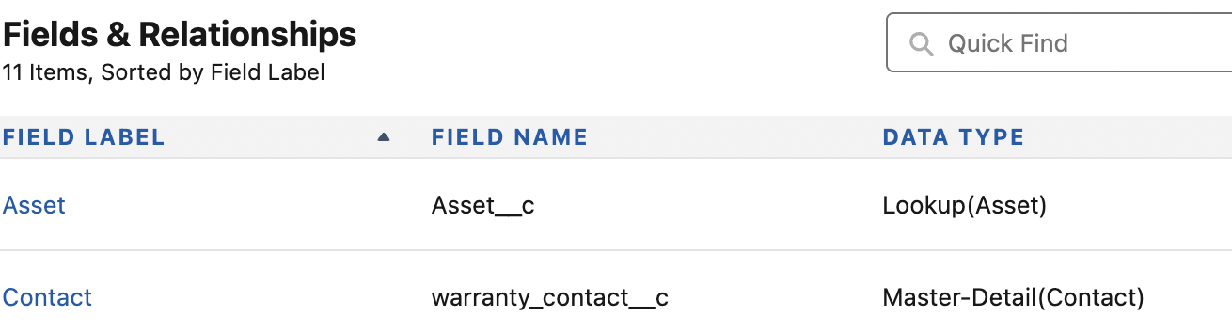

Added Related lists to Page layout
Click on edit page to open the LAB. | 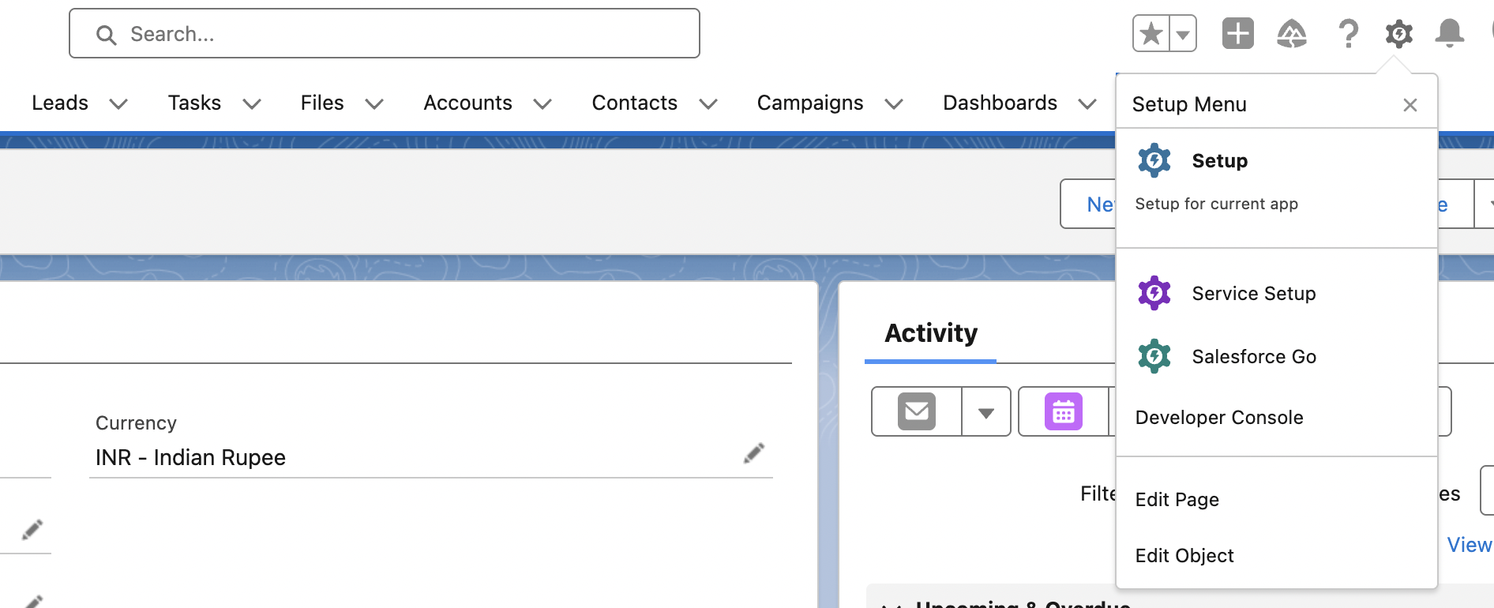
Drag and drop warranties. | 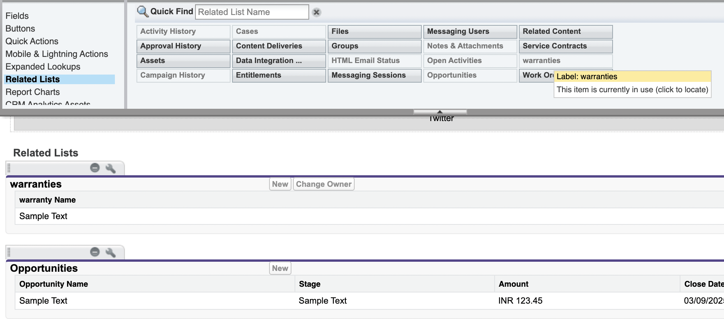
Yes | 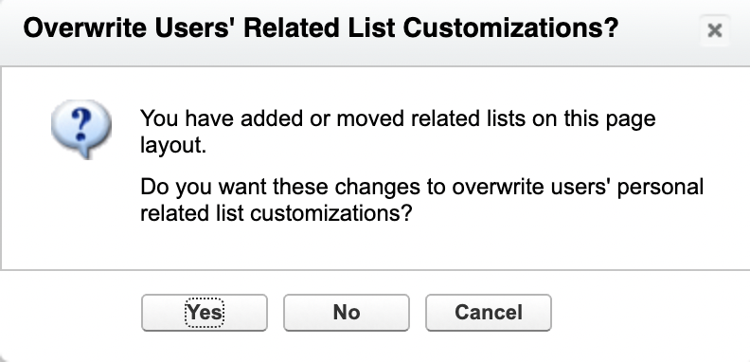

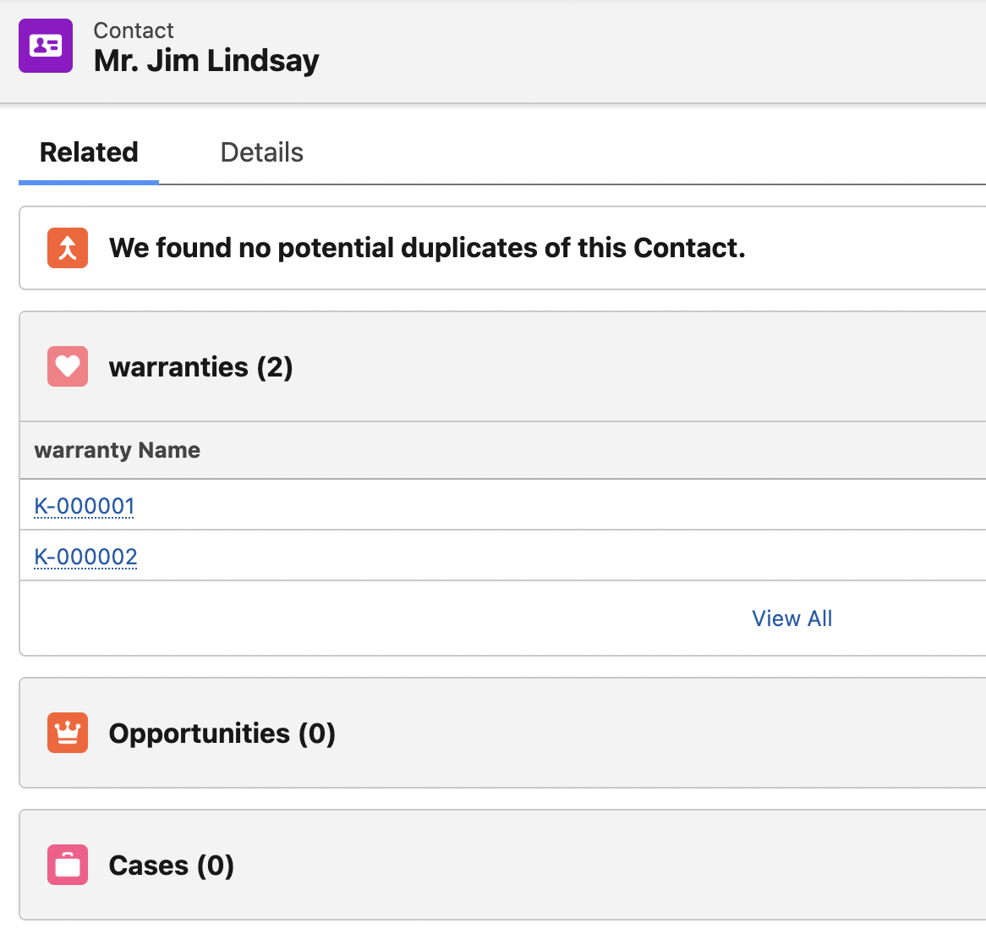

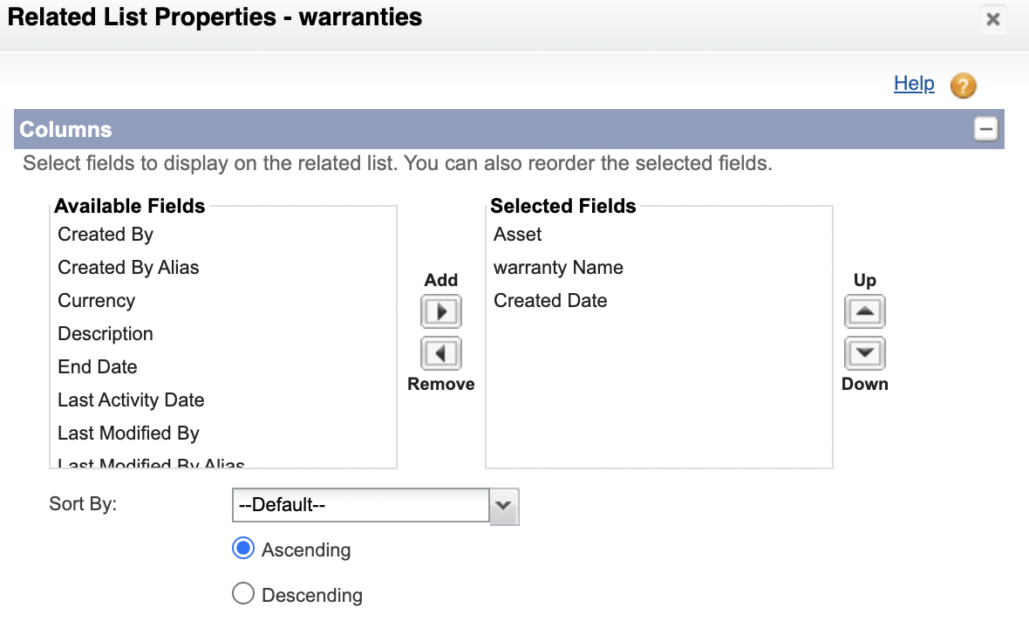

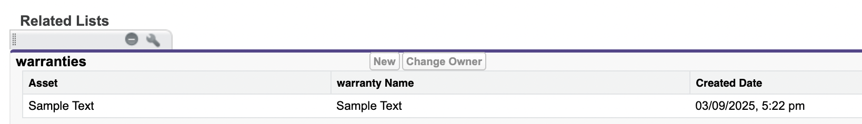

Using Chatgpt for junction object ideas
Junction objects typically have two Master-detail relationships, one to each of the objects it is connecting. The fields on the junction object represents the relationship between the two objects. For example, in the attendees junction object, u might have fields for the contact name, Event name, and Attendee Type.

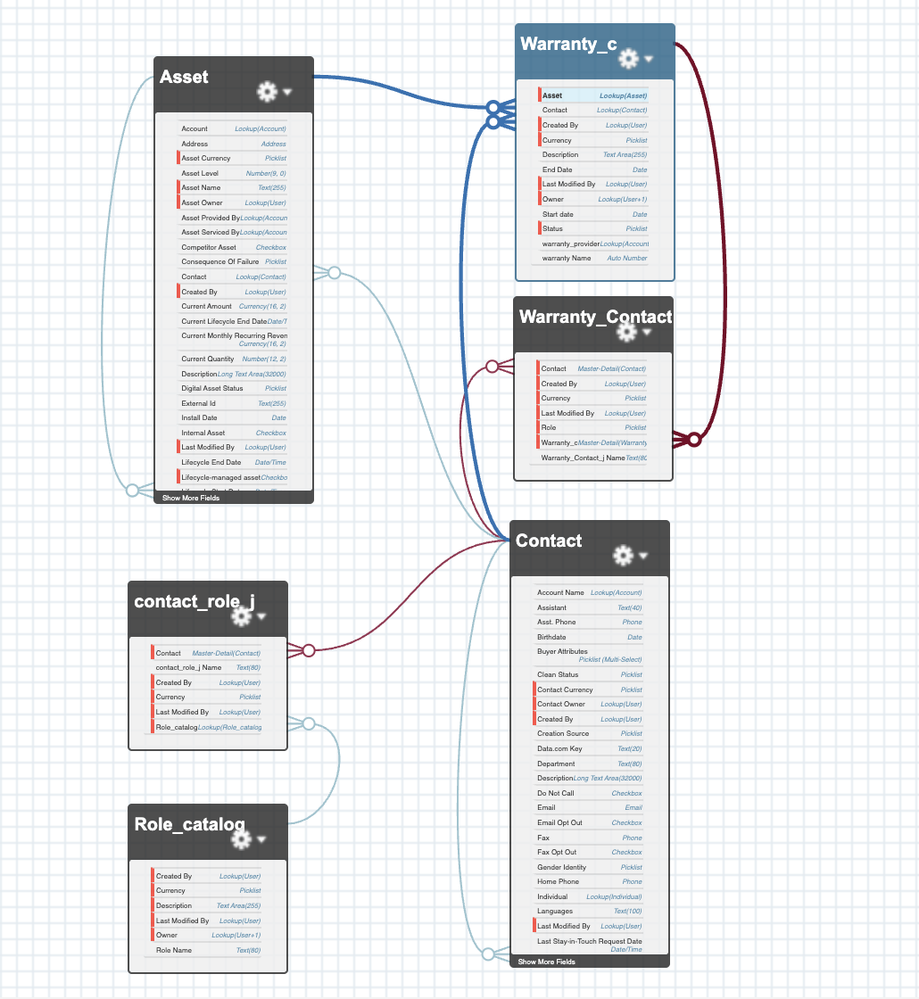

Deleting fields and implications
Delete all dependent information for any dependent or controlling field.
Change the result or Assignment or Escalation rules that rely on the custom field status.
In order to preserve, do a data export. 15Days grace period.

