Sales and Marketing application
subtitle

Heading 1

Heading 2

Heading 3

Heading 4

Worth read posts:
reddit: relatively new to enterprise sales. how do i slowly build a pipeline without any leads?
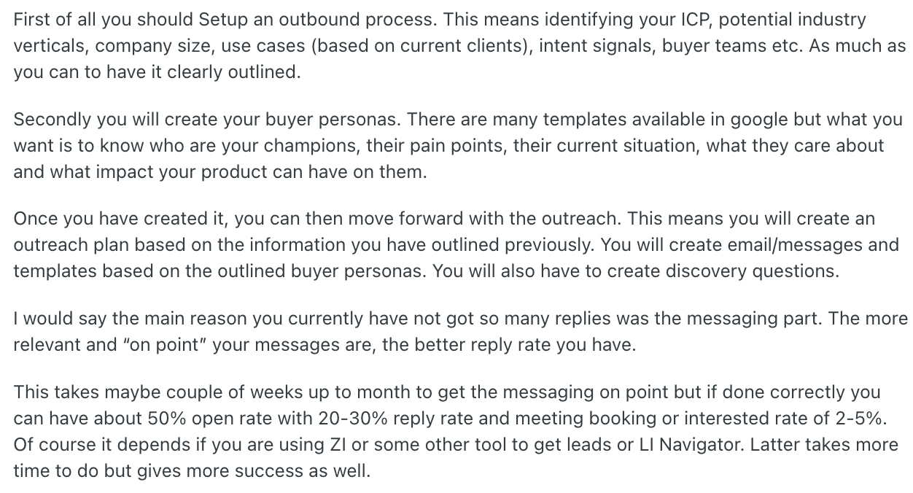

Mike equate marketing, Sales and Service to the phrase attract, attain, retain.

Core marketing components of salesforce
Task: He added a campain member to thec campaign.
A lead is some1 who we are in the process of qualifying and figuring out if there’s an opportunity to do business with this individual. If there is a subsequent opportunity that can be brought out of this.
Lead is contacted
Then lead is either converted or not converted.
Once its converted, it becomes then a contact record.

Leads Creation overview
Leads generations | Through campaigns.
Lead info | Are recorded(lead job title, company size and industry)
Qaulify based on | Level of interest and determing whether they meet the criteria to become a sales opportunity.
Once a lead is qualified, it can be converted into Account, Contact an opportunity record in salesforce. | Allowing sales rep to continue tracking and managing the customer relationship as it progresses through the sales pipeline.

Creating a web to lead form
Feature settings → Marketing → Web to Lead
 | Any new leads created will be noted as created by you. You can also set default response.
He said use limited fields so that people actually submit the form. | 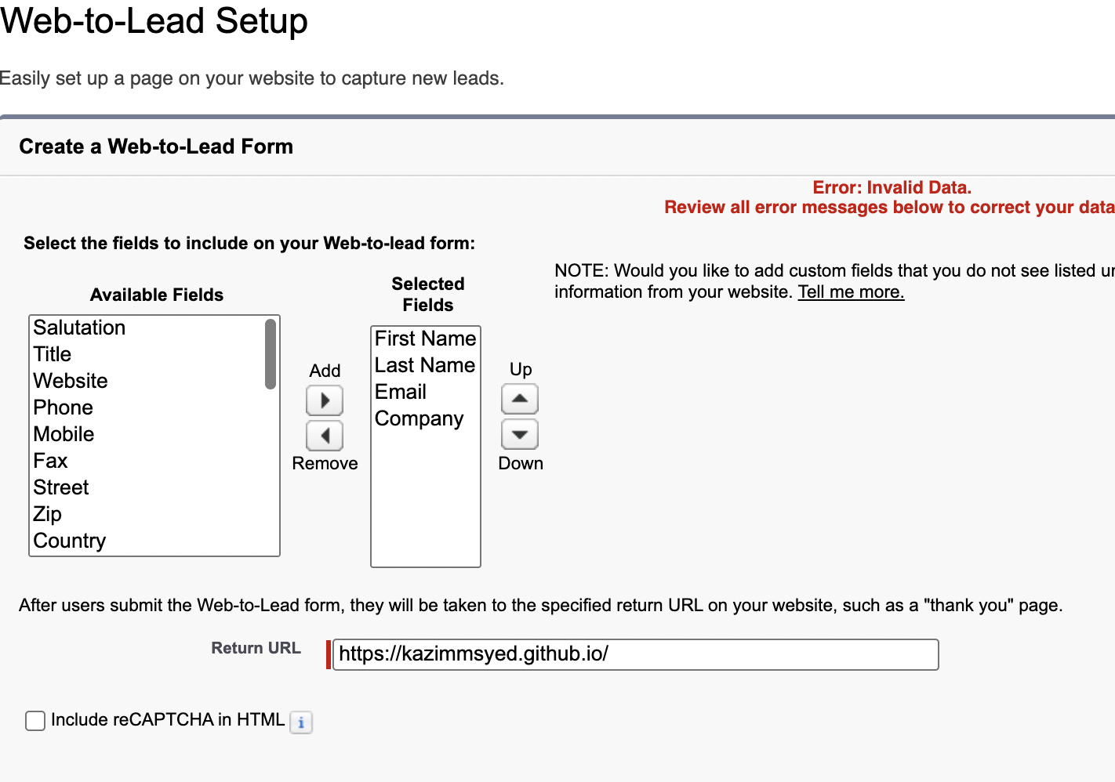
Web to lead | It created an html form. Then I put style on it using Chatgpt. Mike displayed the style using replit.
I even got the toast message, that msg was sent. | 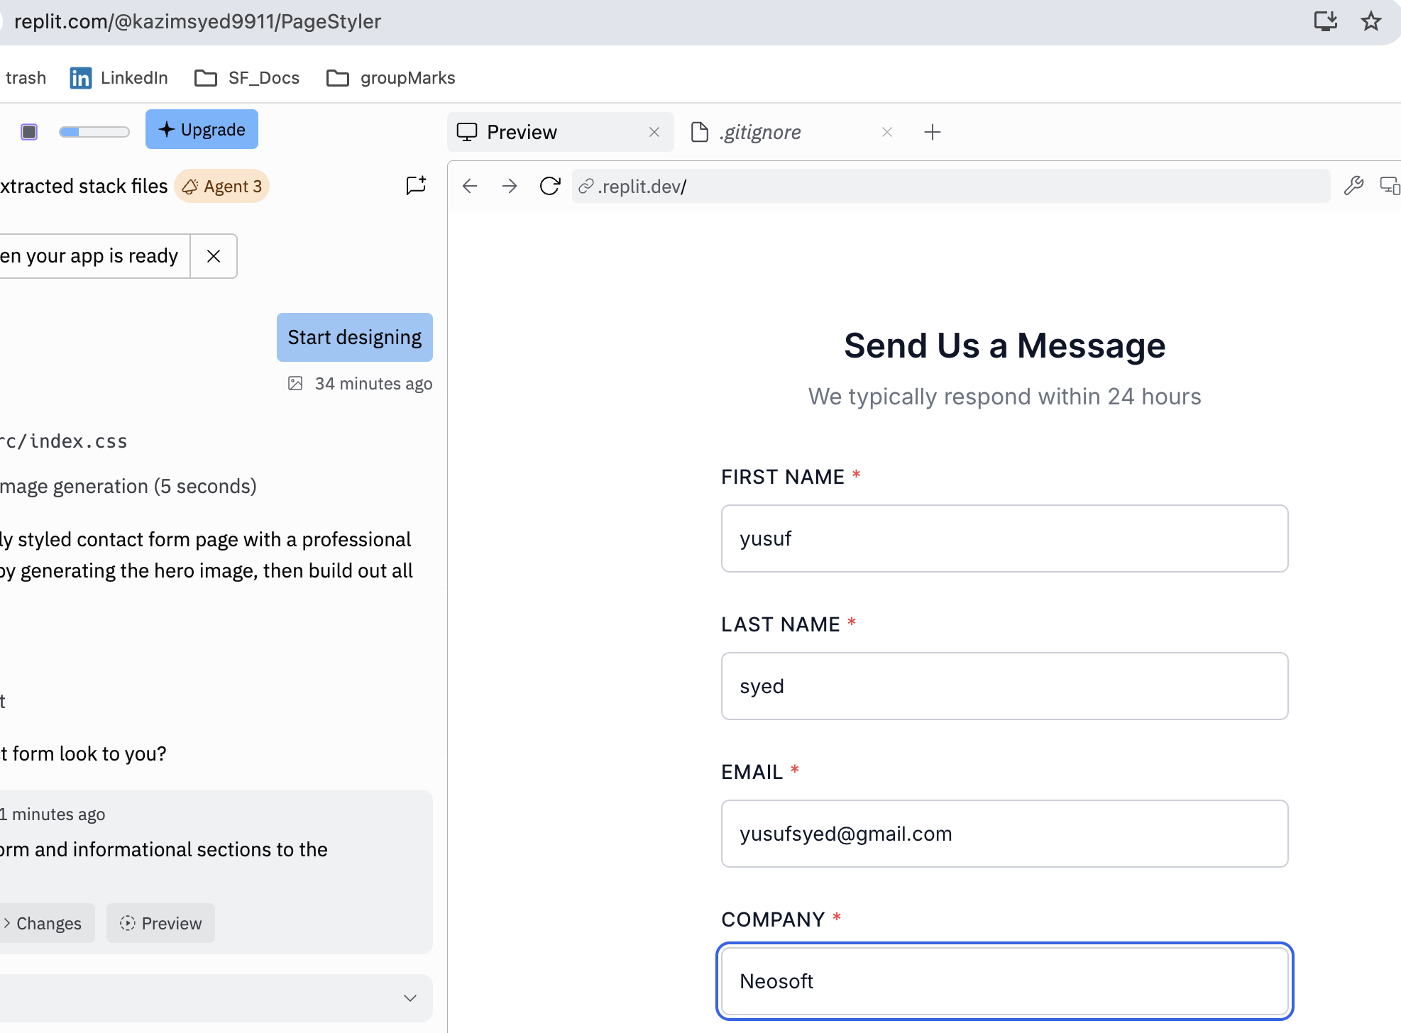
 | 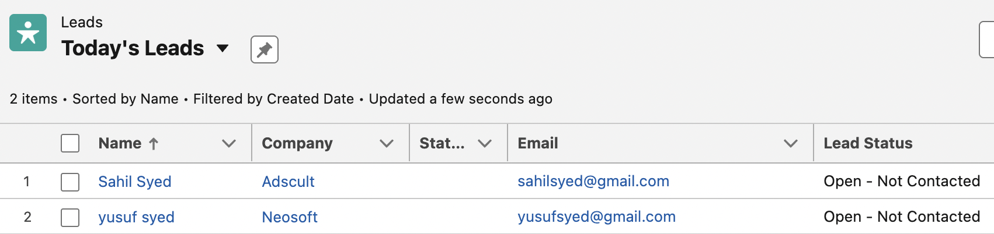

Lead settings
Marketing → Lead settings | You can specify the default lead behaviour for your organization.
Assignment rule  Queue or user | Underneath the lead queue settings, this will be the queue or user that will own a lead when assignment rules fail to locate an owner. And it defaults to yourself
Lead conversion settings
Require validation for converting leads | When user converts leads, enforce: required field settings, field valiation rules, workflow actions and apex triggers.
 | There is a lead conversion action that happens whenever u convert a lead into a account, contact and opportunity. Having this checked, make sure those account, contact and opportunities pass all validation rules and workflow actions and apex triggers.
Preserve lead status | If I converted the lead owned by some1, I become the lead owner. Lead status will change to closed-converted. So when I converted, I don’t want to flip it back to the default lead value set by the owner.
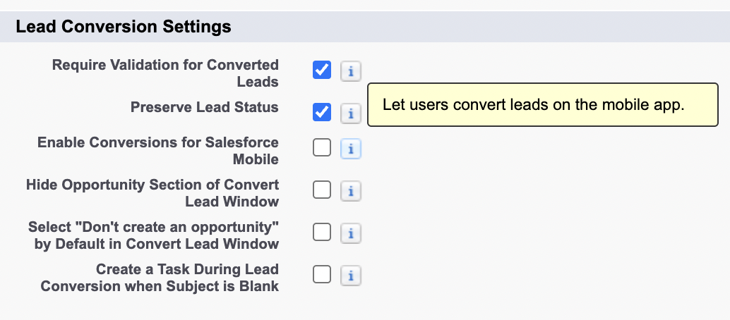
Lead Merge settings | Gives ability to merge and delete leads when access to lead is public read/write and transfer

Converting leads
Task:
Log a call.
Change status from start to Working – Contacted. Why did yusuf lead record, the lead generation I.e lead source field was empty? How will u handle? Lead to ACO. Why we see data loss?
BANT | BANT and product/service interest.
Tailer to the prospect | Using the info, we can create a customized sales and marketing strategies to address the specific needs of each lead.
How to hold the hand of the prospect along the way to client. | SF also provides insights into the behaviour of the customer. Allowing businesses to keep track of their progress through their sales funnel and identify areas where they may need additional support or engagement.
Up Conversion rates and build relationships. | By leveraging the power of the salesforce, businesses can increase the conversion rates and build stronger relationship with their customers.
Rating: Cold, warm, hot | You wanna prioritize hot leads. That means how likely they are to do business with you. Hot leads would be things that you want to prioritize
Primary contact | Whether its a primary contact for the company or solely a division.

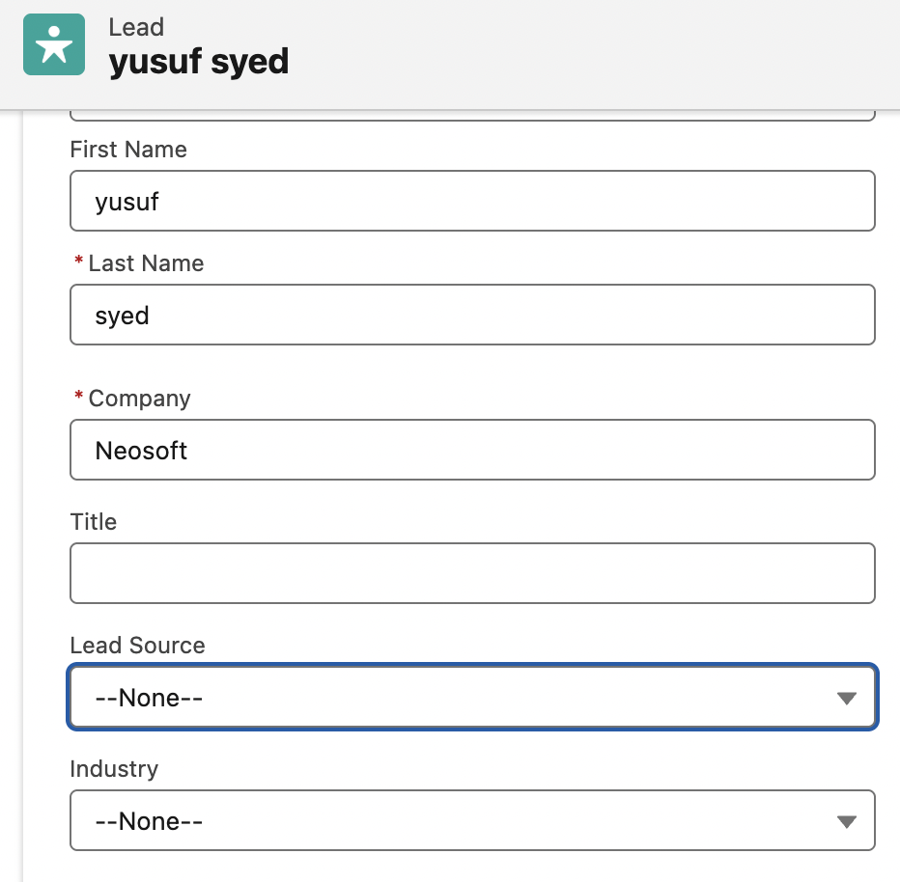 | Lead source is missing. Even though the lead is generated by Web-to-lead.
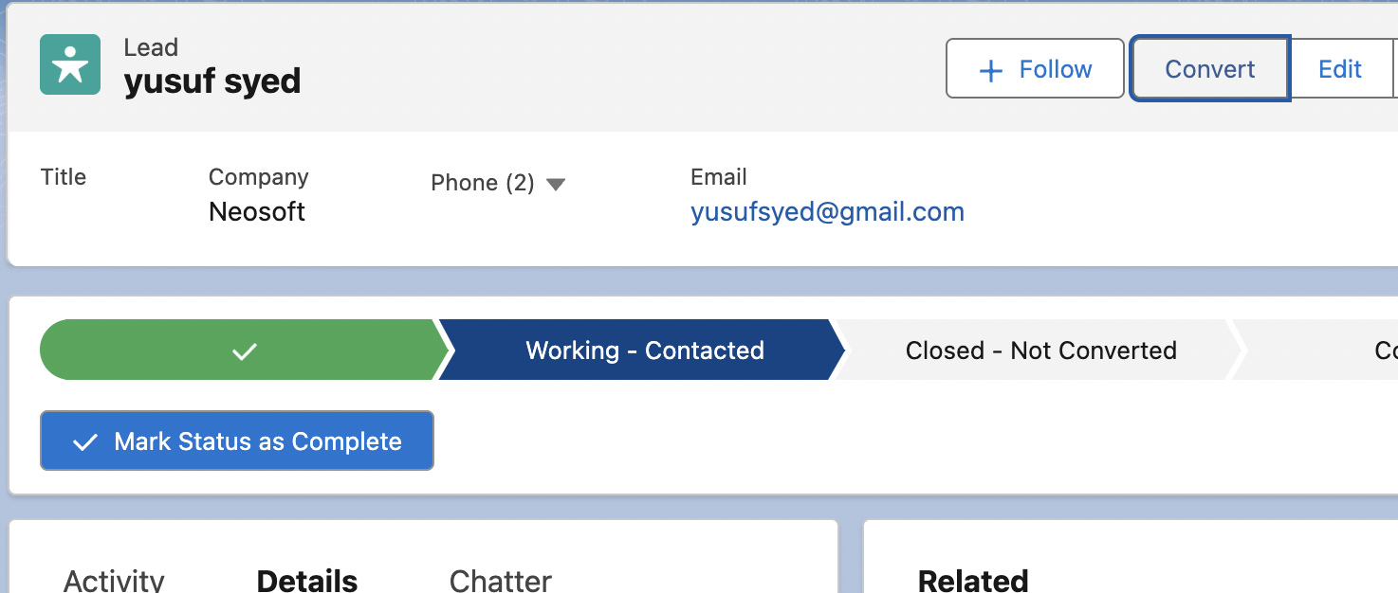 | Handing out leads to sales team aka converting into Account, contact and opportunity
Search for existing accounts before creating a new1. | 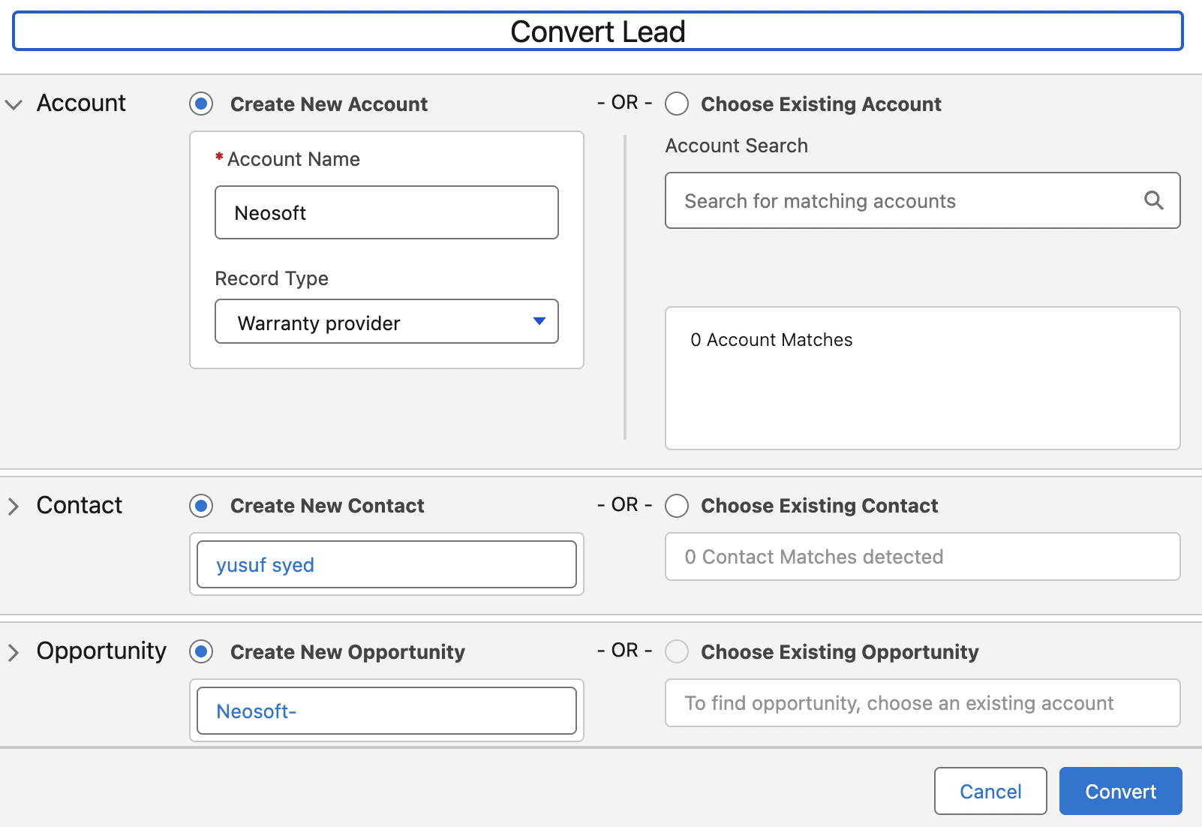
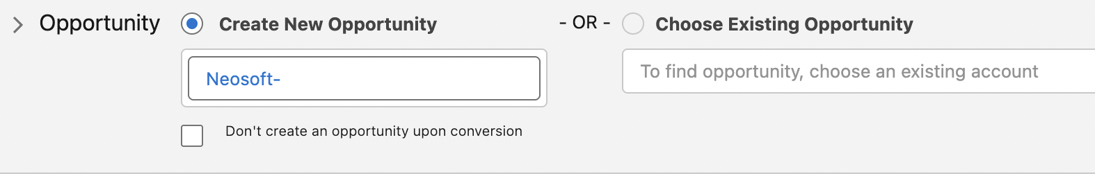 | If u don’t want ur marketing team to convert that lead into opportunity during the process, u can turn that off in lead settings.
 | In the opportunity, it fills it with Account name follwed by – aka “Neosoft -”
Some data loss because custom fields aren’t configured yet. So those values arent passed down to Account, contact and opportunity. | 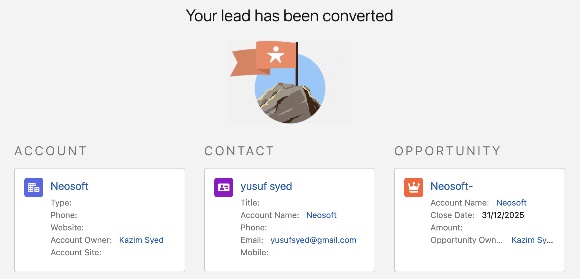

Custom to Custom field mapping to Prevent data loss during conversion
Task: Custom fields in the lead object need to be mapped to ACO. Otherwise the data that you have in those Custom fields on the lead record will be lost during conversion process.
Custom to Custom field mapping | Custom fields in the lead object need to be mapped to ACO. Otherwise the data that you have in those Custom fields on the lead record will be lost during conversion process.
Object manager > lead | Lead object has additional option to have map lead fields.
We mapped # of locations in accounts.  We mapped Current Generator in Opportunity. | 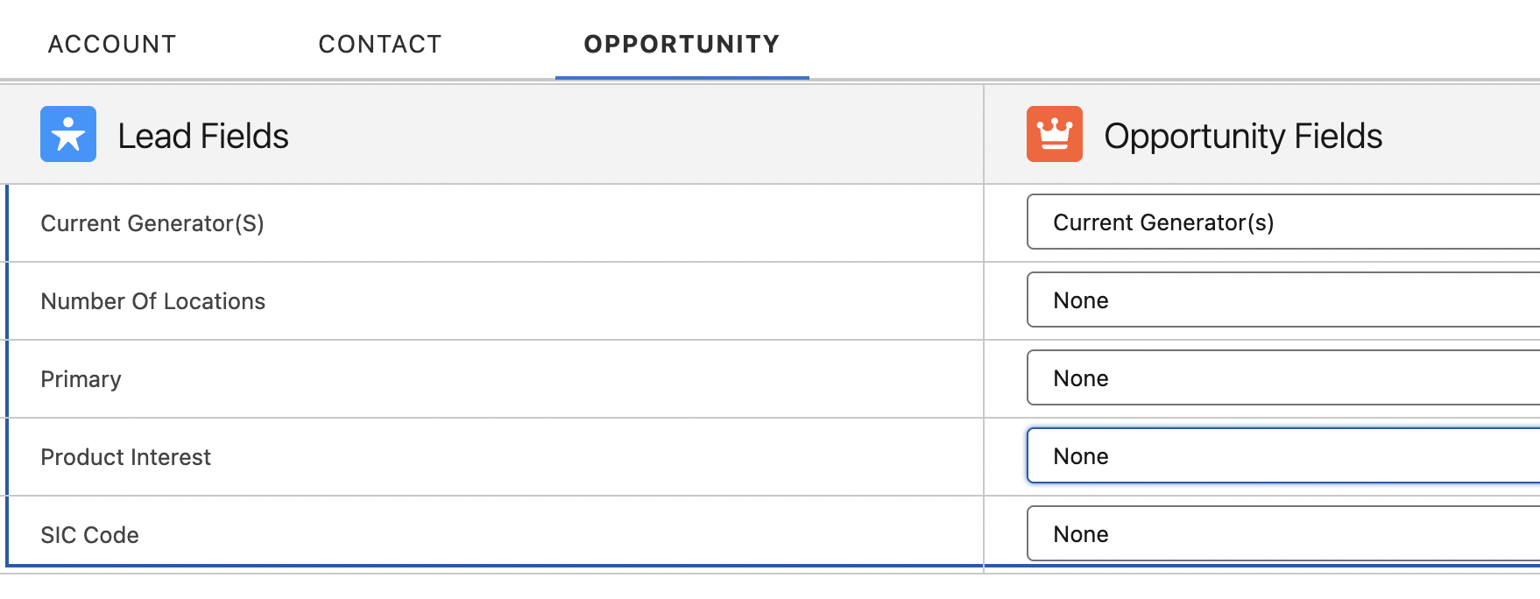
Mapping lead(fields) to Account(fields) | We see we don’t have a match for Current Generator. It shows all the possible custom fields in Accounts.

Fields that passed from Leads are:  Account source,  Rating,  Account name,  Number of locations,  Number of employees | 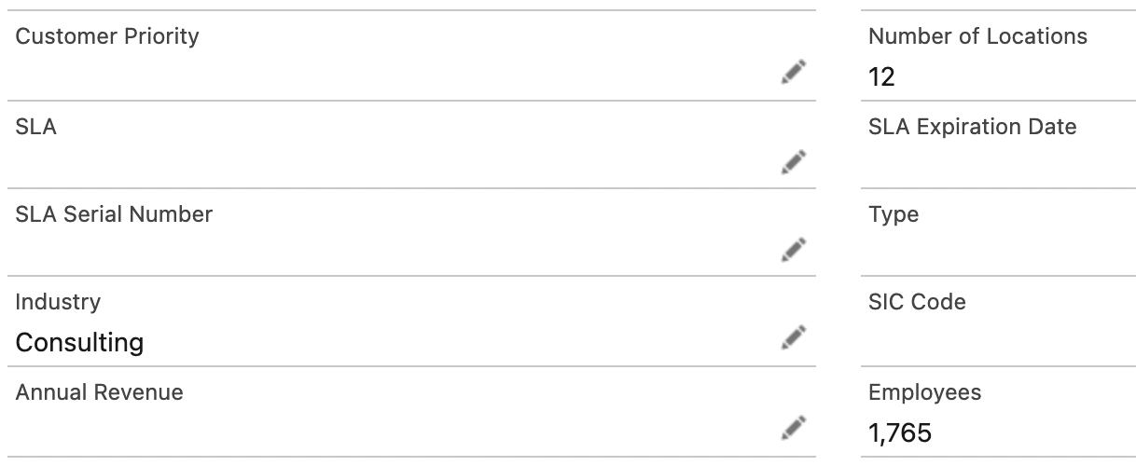  I only mapped no of locations.
We see Current Generators an Lead Source are mapped. | 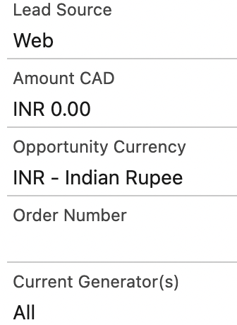

Sic Code
Sic code | Standard industrial classification. Used to tell primary business activity. A company might have multiple sic code to suit their operations.
First two digits indicates major group.
First three digits indicates industry sub groups.
First 4 digits indicates a specific product group.
Research related: | If any research-related data is tagged with the above four-digit code, it becomes easy to classify data at various levels.
Applications: | - What was the total production of all agricultural crops in 2019 in Arizona? Simply pull records matching the first two digits of SIC codes as “01” (or 4 digit SIC code =”0100”) and state=”Arizona” and year =”2019”  - How many businesses operate in the “Cash Grains” segment (which includes Wheat, Rice, Corn, Soya, etc.) in the U.K.? Simply pull records matching first three SIC code digits as “011” (or 4 digit SIC code = “0110”) and country=”UK”  - To know how many companies are registered in Utah producing corn, one simply needs to generate a report which has the 4 digit SIC code “0115.
Used by Business | 1. identify existing customer and potential customers by industry.  2. Targeted Marketing campaigns.  3. Find Competitors in their industry or region.  4. For taxation and industry specific support.  5.Banks and creditors use SIC codes to identify the industry a company belongs to when they consider credit applications.
Used by government | The SEC uses sic codes when sorting company filings.  Compare data across disparate government agencies.  The government uses SIC codes to organize and standardize key economic data for various federal and state agencies as well as private companies.

Creating Custom fields for additional lead Conversion field mapping
Task: create custom fields on Account and opportunity. For account, we will create an sic field. For Opportunity, we will create a product interest field. For contact, we will have a primary field.
Account → create SIC_Code field | Made the field larger than a pre-exisiting standard field, so we don’t lose any existing data.
Show Account std and custom sic field
Map lead sic field to Account sic field
>video 3:15 ??? confused about page layout
Created SIC_Code | 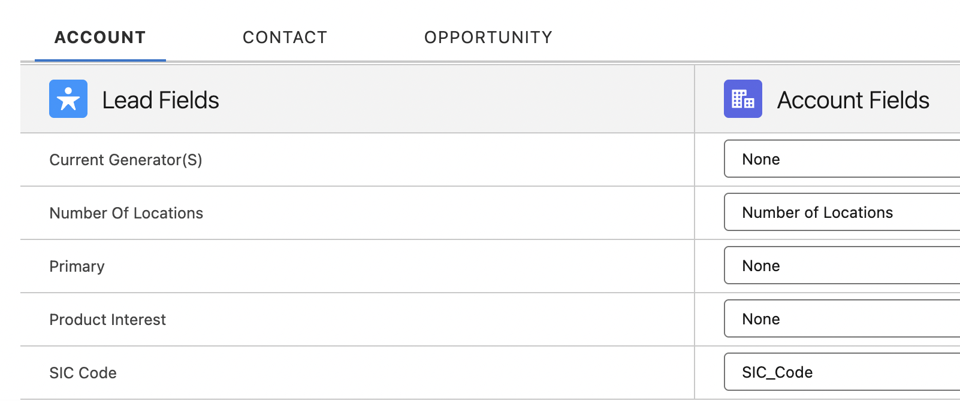  Sic code for account.
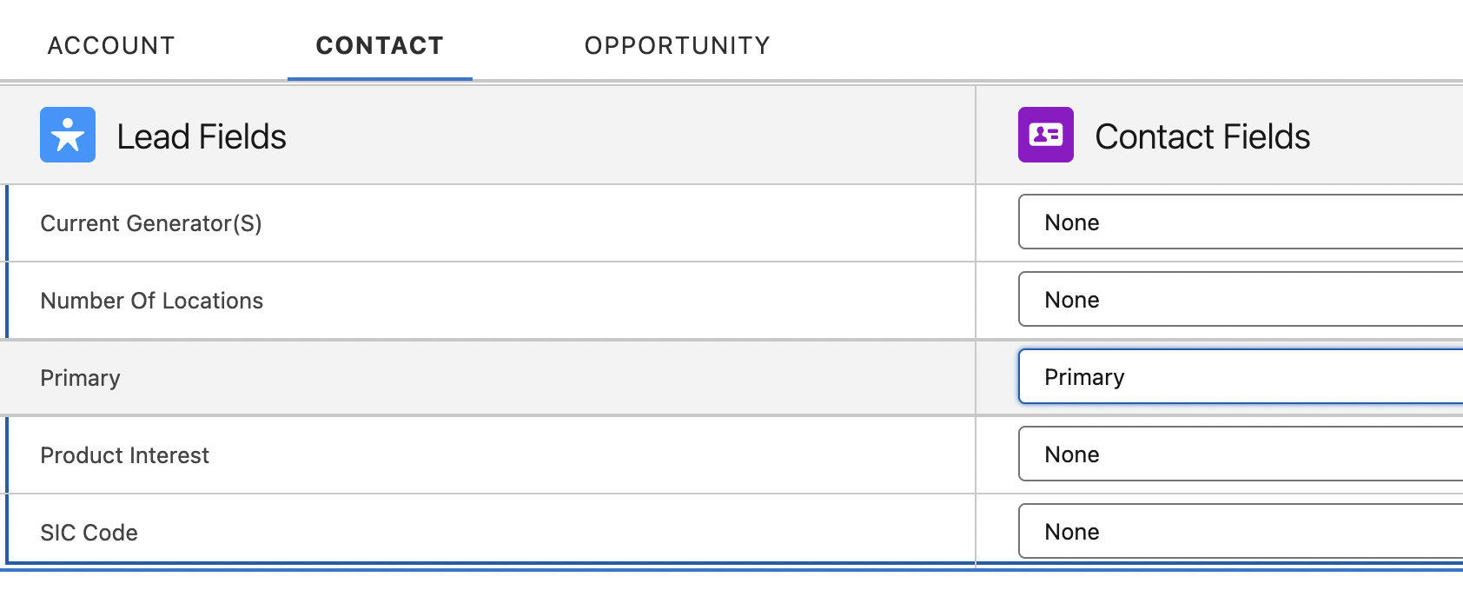  Primary field is mapped for Contact | 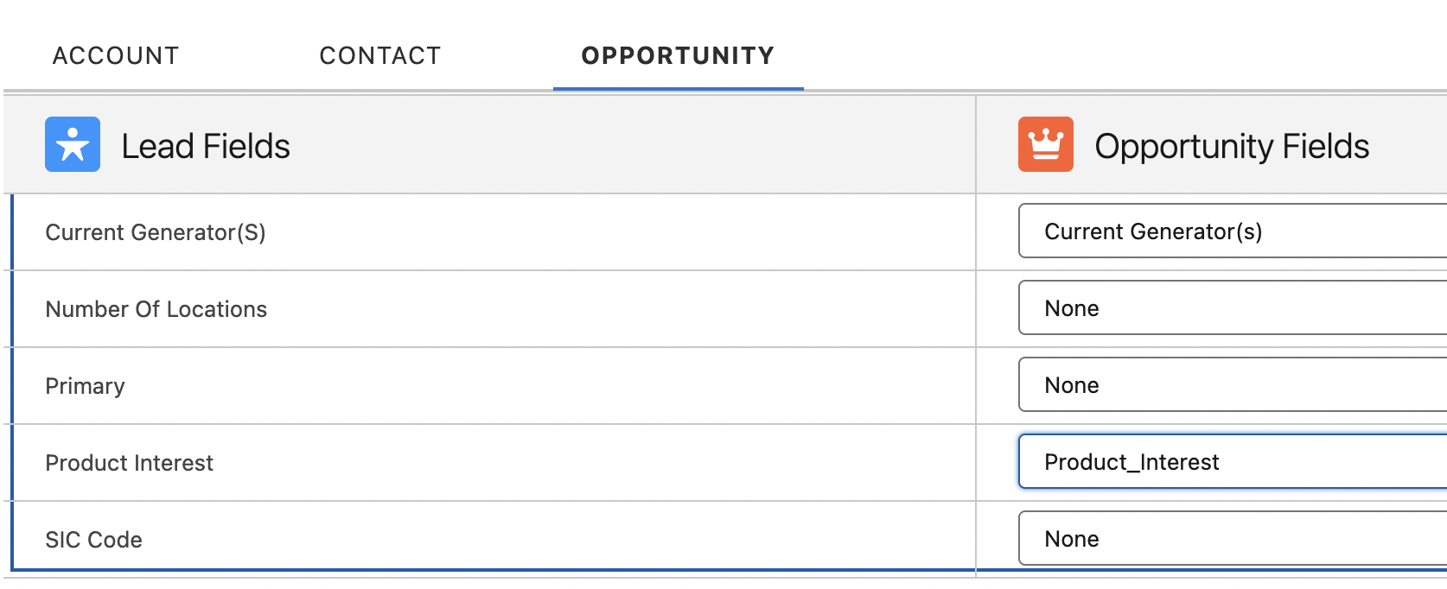  Product Interest is mapped for Opportunity.

Setting Lead Source for Web to Lead forms
Task: Add a hidden field to our form that will hide from our users. This will enable us to update our code inorder to update the lead source field. And pass the value of web to our salesforce instance.
Hint:
<input type="hidden" name="lead_source" value="Web">
The form will be made available on different platform with slightly different html. Since, u can even submit form using api like Postman. Which on submit on our endpoint, will fill the field lead_source. In our scenario, we are doing web to lead. So value=Web.

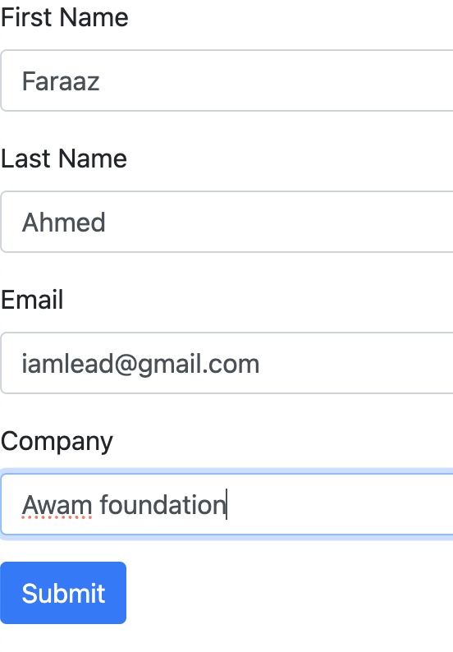 | 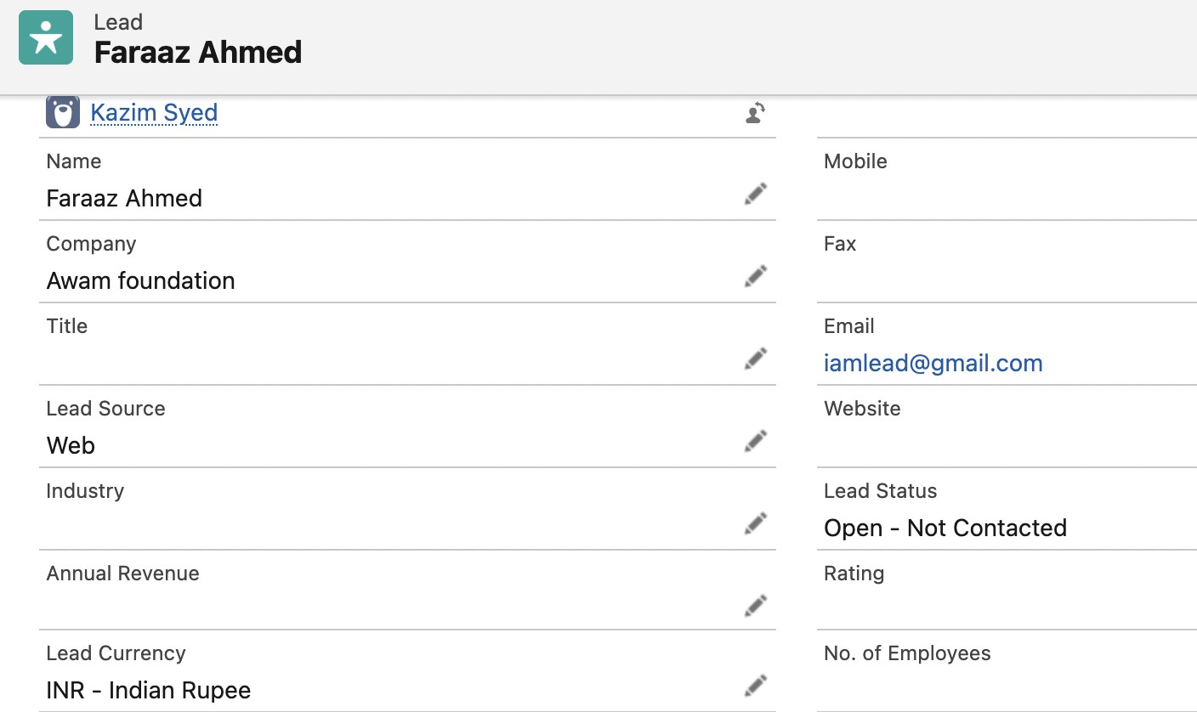
Oid and form action are two important fields.  We have used bootstrap in our code. | <form action="https://webto.salesforce.com/servlet/servlet.WebToLead?encoding=UTF-8&orgId=00DQy00000QZigj" method="POST" class="needs-validation" novalidate>  <input type="hidden" name="oid" value="00DQy00000QZigj"
Validation. | <script>  // Enable form validation using Bootstrap  (function() {  'use strict';  window.addEventListener('load'  , function() {  var form = document.getElementsByClassName('needs-validation')[0];  form.addEventListener('submit'  , function(event) {  if (form.checkValidity() === false) {  event.preventDefault();  event.stopPropagation();  }  form.classList.add('was-validated');  }, false);  }, false);  })();  </script>

Creating Queue for leads
Problem: All leads are assigned to Ksyed. So u want to distribute leads to make and generate revenue by being effficient.

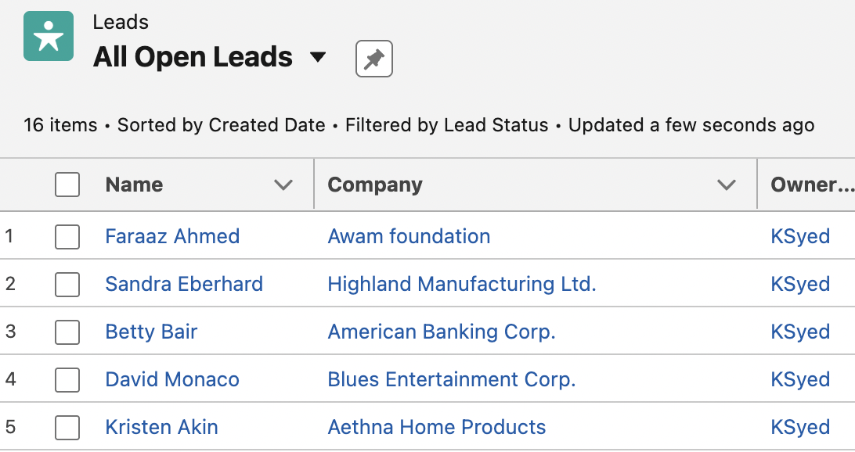

Lead management process | Leads can be routed to specific queue based on some criteria such as the industry or by location.
Setup->Users→ queue | Mike created queue based on product_interest.
Public groups | You can have all internal users in our org would be in this queue. Or you can highlight specific roles and subordinates.
You input which object the queue is for. | 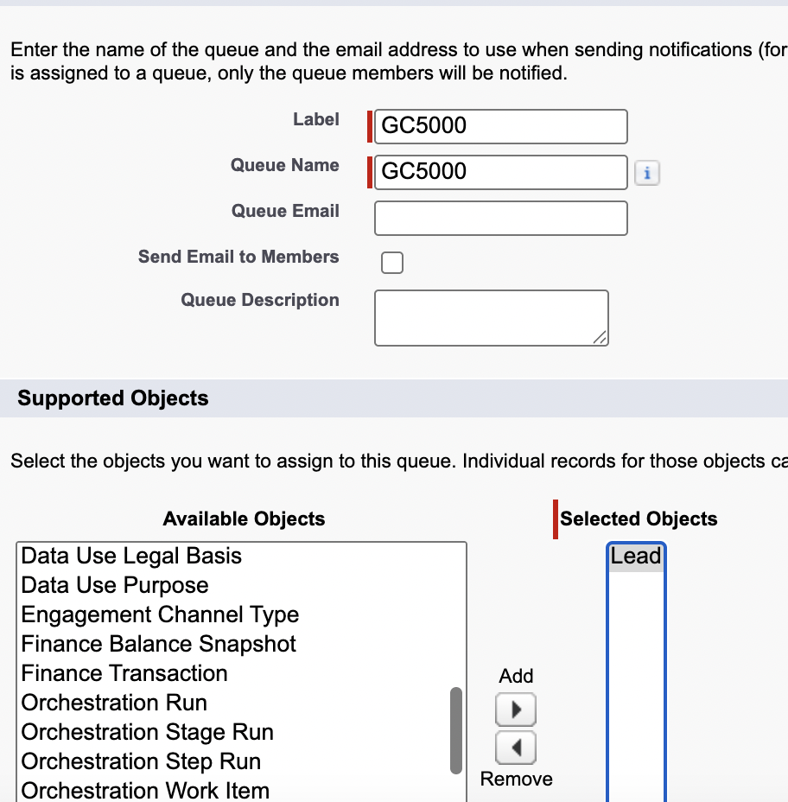
For which users or roles or group, this queue is accessible to. | 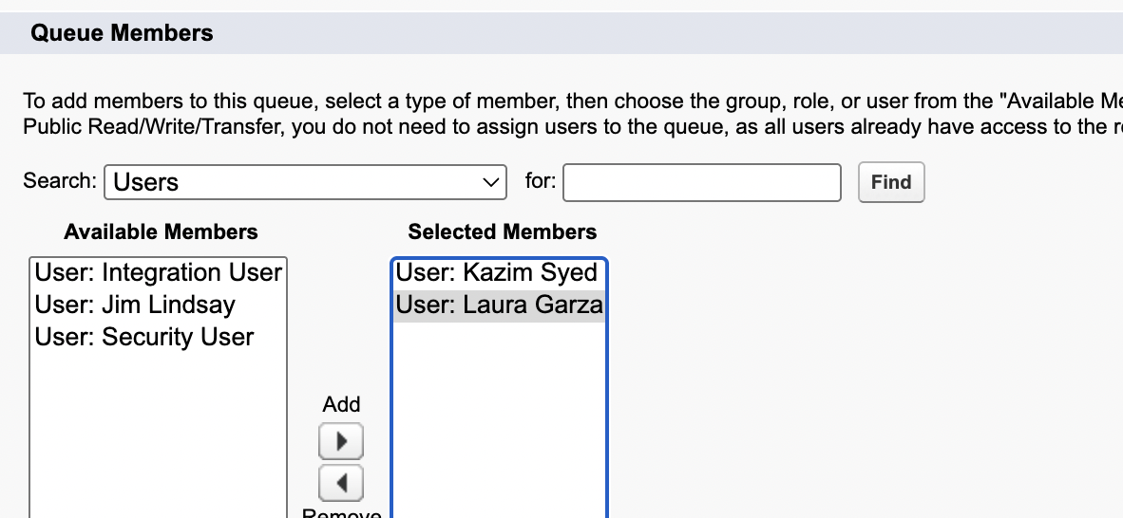
You can see view queue based on accessibility shown above. | 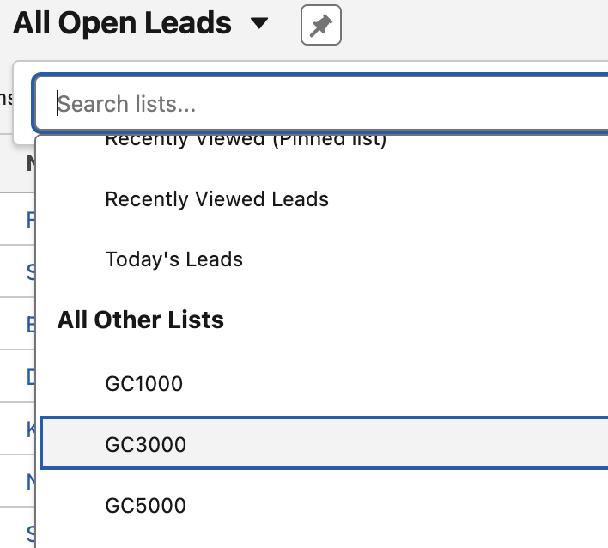

Creating Lead Assignment rules
Problem: Create a lead assignment rule. Leads either be in queue or assigned to a user. | 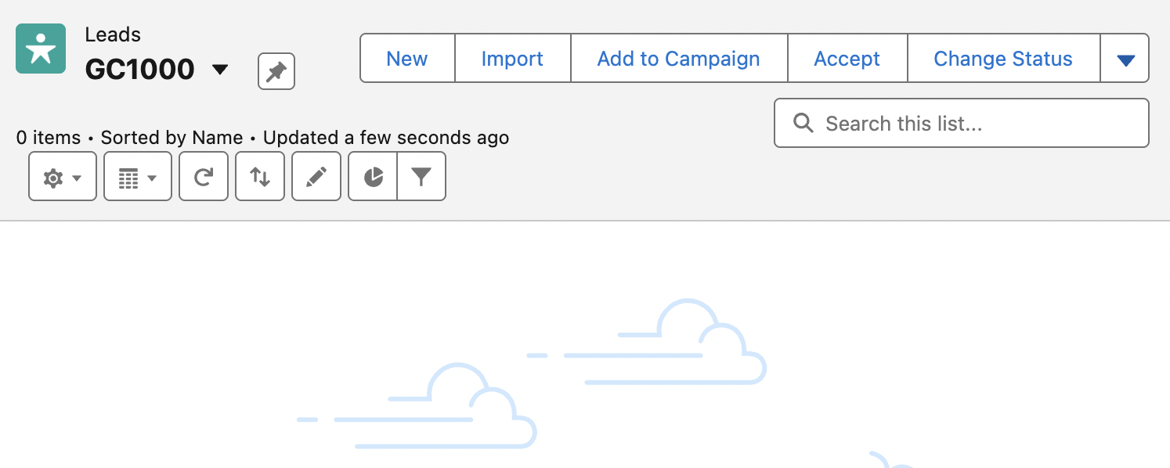
Objective:
Enable lead history tracking for owner field

Marketing → Lead Assignment rule
1 active at a time | There can be only lead assignment rule active at a time. We already have a standard lead assignment rule
 | Any leads coming from web-to-lead or manually, we will go through this in the order below.
If lead country is usa, then assign to Kazim syed.  Else assign to kazim syed. | 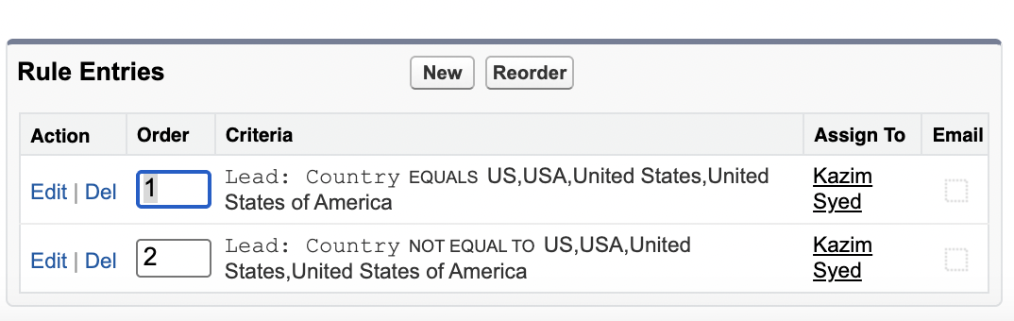
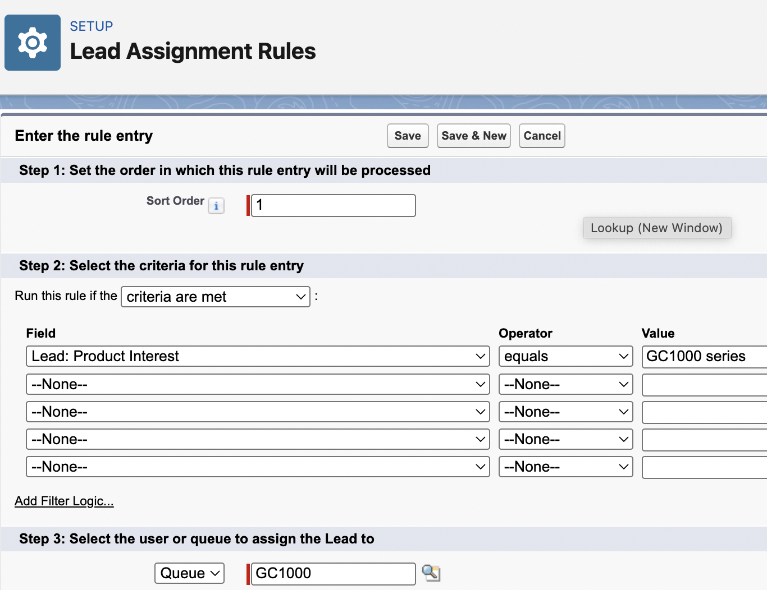 | Lead Assignment.

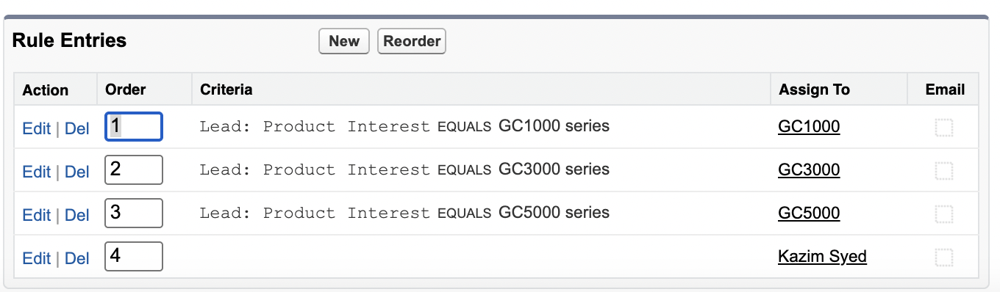 | If product interest is empty, then assign it to Kazim Syed.
Note: | Deactivate and activate the Lead Assignment rule.
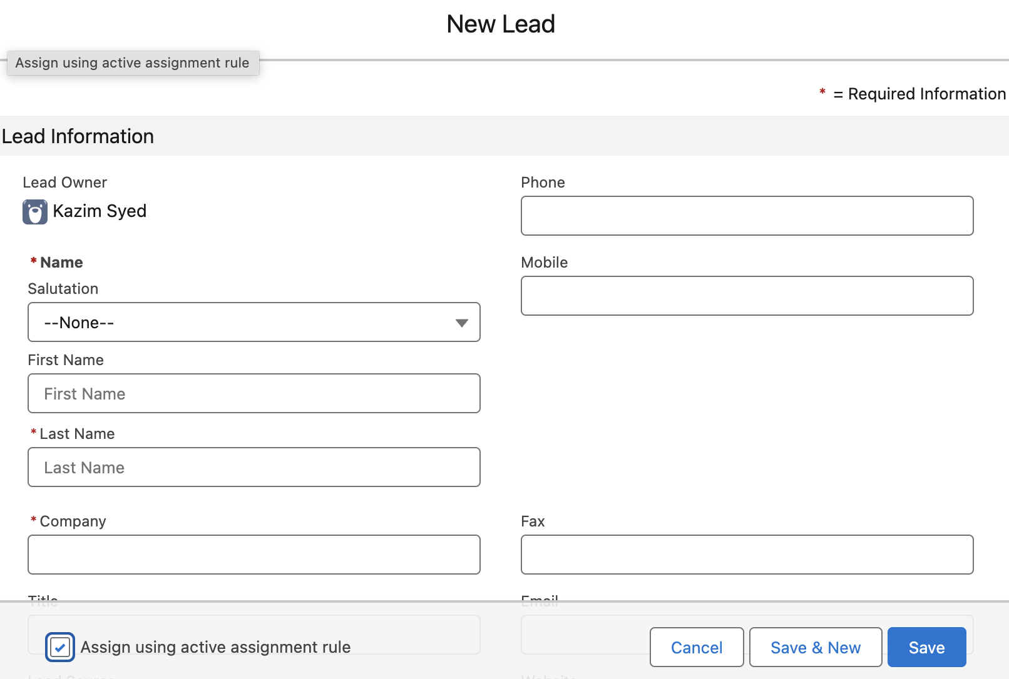
There you go. | 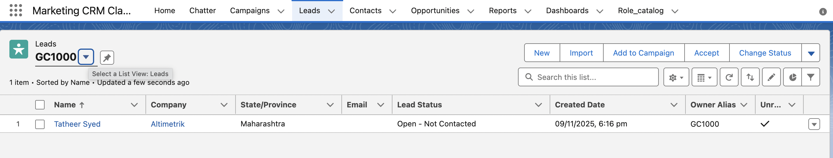

Task 2: Enable lead history tracking
This page allows you to select the fields you want to track on the Lead History related list. Whenever a user modifies any of the fields selected below, the old and new field values are added to the History related list as well as the date, time, nature of the change, and user making the change. Note that multi-select picklist and large text field values are tracked as edited; their old and new field values are not recorded. | 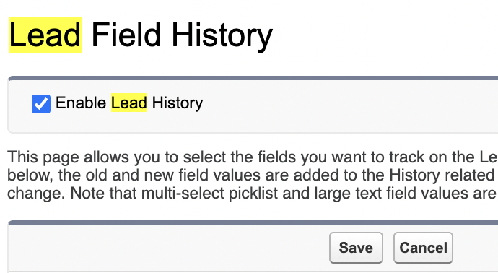
 | 

Creating Lead processes
Marketing > Lead processes  Marketing > Sales processes  Marketing > Support processes | We have 3 processes
Lead processes | To control the different status designations on leads.
Create and maintain multiple lead processes for your organization to use. Lead processes use the lead status field to identify a lead within the lead lifecycle. | Lets say we not only sell generator but also power supplies. So we need to lead two lead processes. You may have scenarios where customers want to buy both the lead and the supplies. So we need a third lead process.
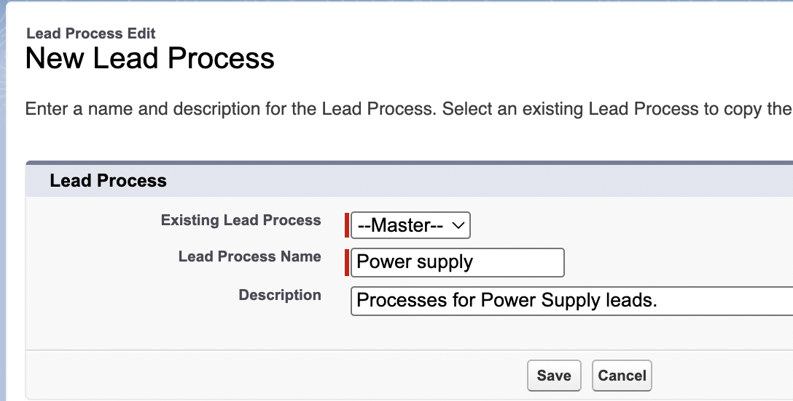 | 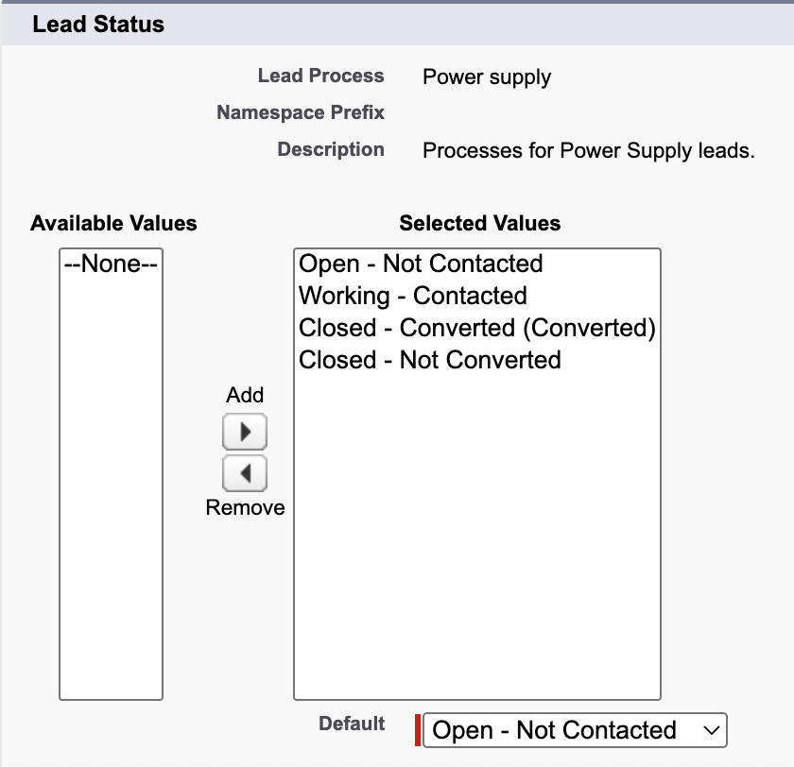
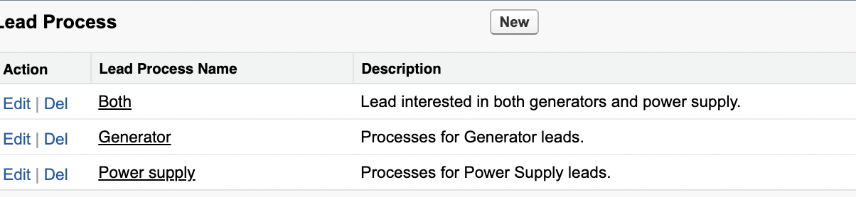

Creating lead record types
Pre-requisite | You will have to create lead processes, to create a lead record type.
 | You should only create a record type, if u need multiple else one will suffice.
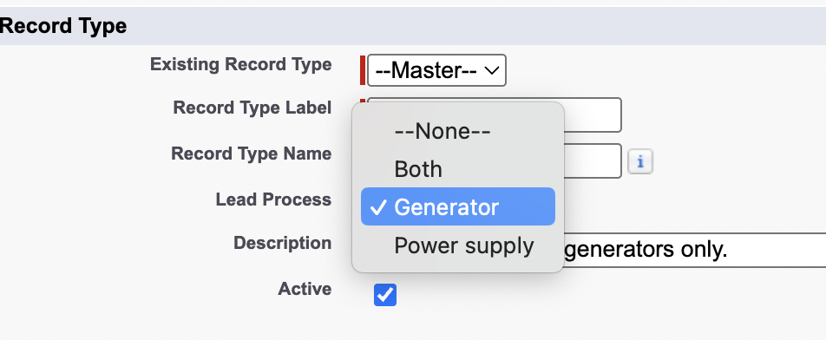 | 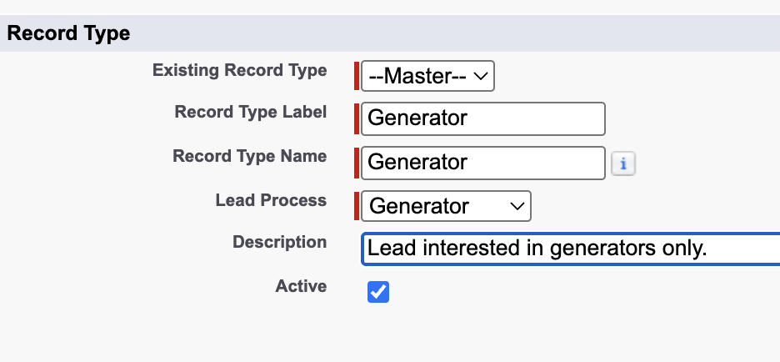
Before that u handle the visibility based on profile.  Then u tell which layout they will use. | 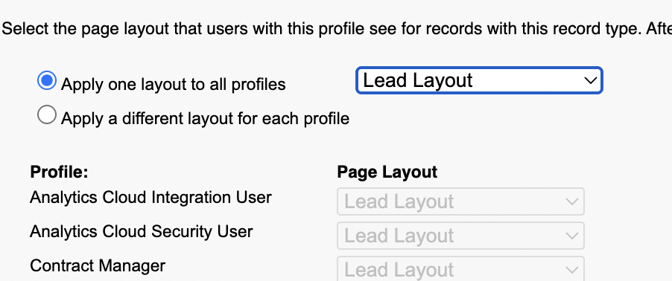
 | Similarly for both and Powersupply.
 | Lead marketing layout for powersupply and sales layout for “Both” record type
Output | 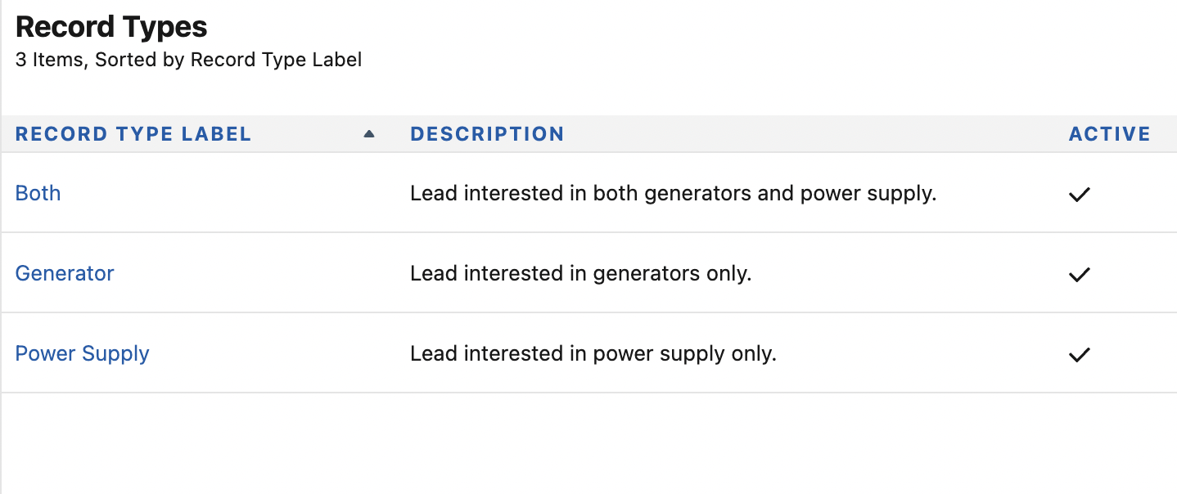
Picklist available for editing. All picklist will be available except one I.e lead status. | 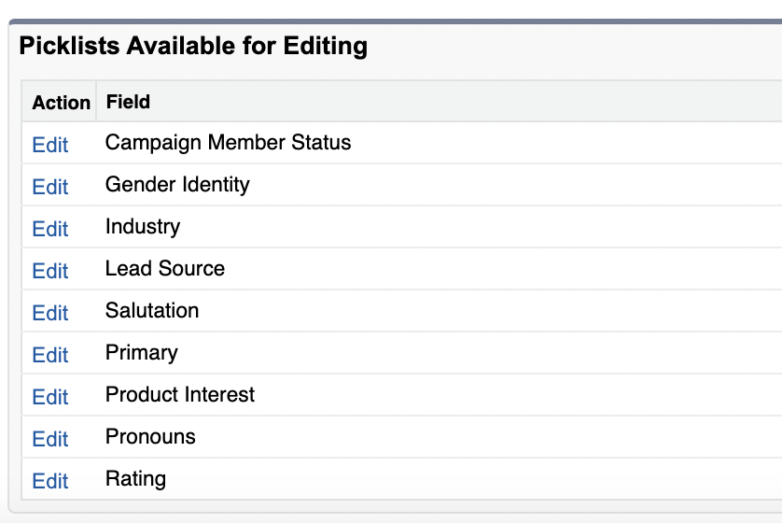

Lead status field – Adding values and displaying them based on lead processes.
Tasks: add new stages to lead status.
Two primary reasons | You introduce record types on object.  I.e to control and show or hide different fields on different page layout.
Another reason | Is to show or hide different picklist values.
Object manager > Lead | 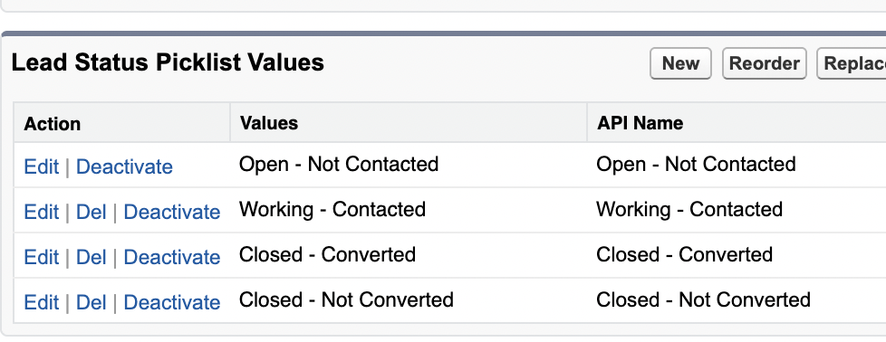
 | 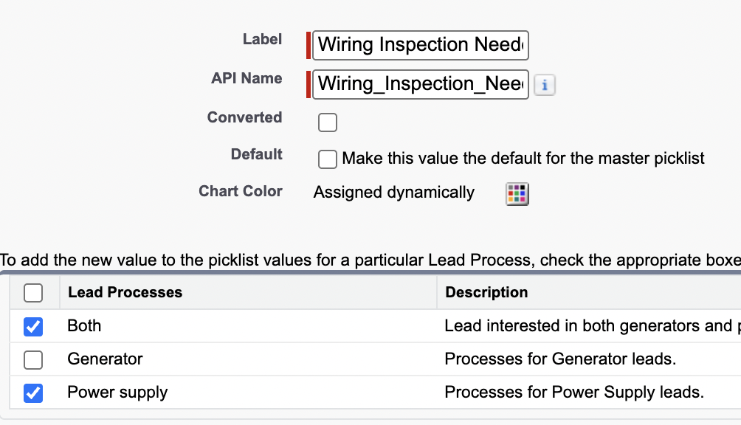
IsConverted  converted checkbox is unchecked  Only checked it when u want the picklist value appear after conversion. | We have a closed not converted lead status and we have a closed converted lead status designation. This means this would only appear as an option once u converted the lead. So this before you converted.
 | 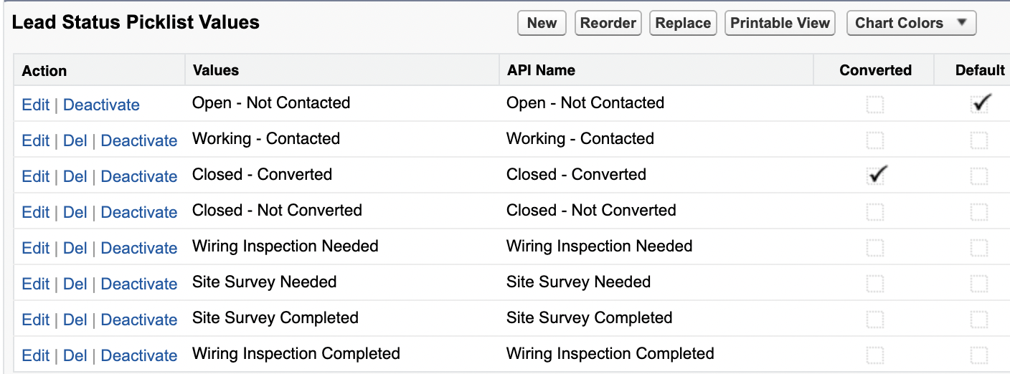

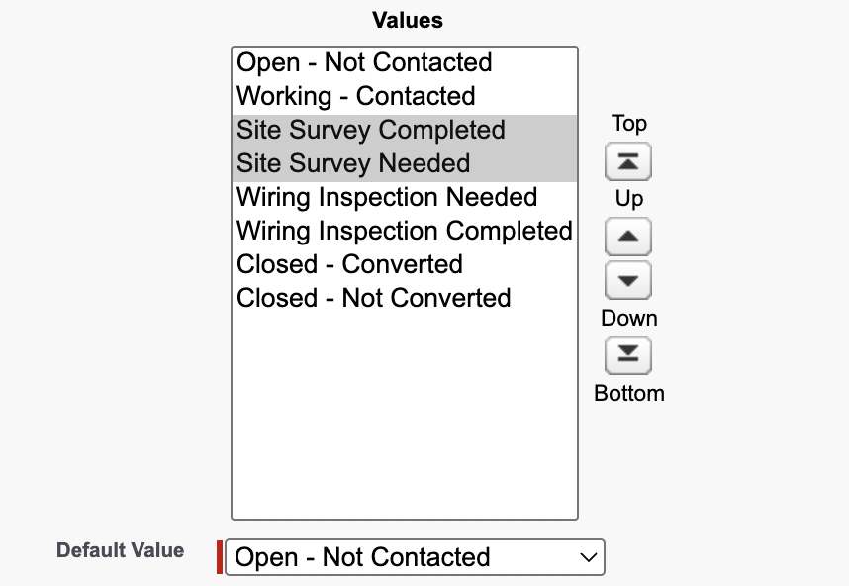  To reoroder, u have to goto Object manager and field status (edit) | 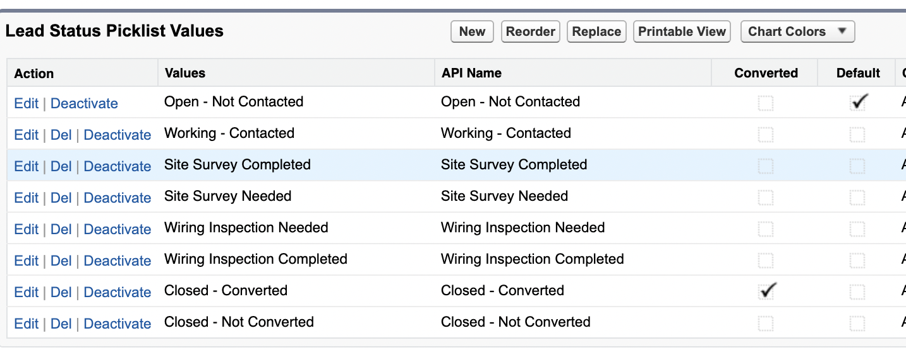
Setup> Lead processes.  You can see we have more stages. | 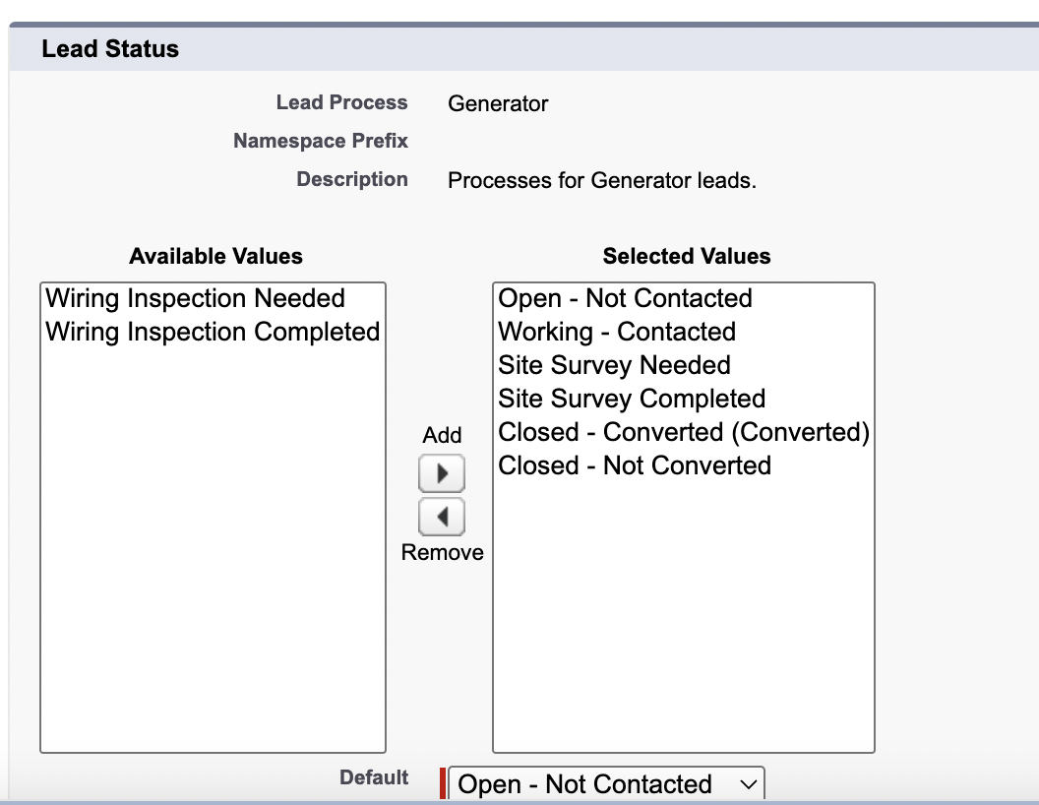

Lead picklist values available for editing
Record type is Generator. | 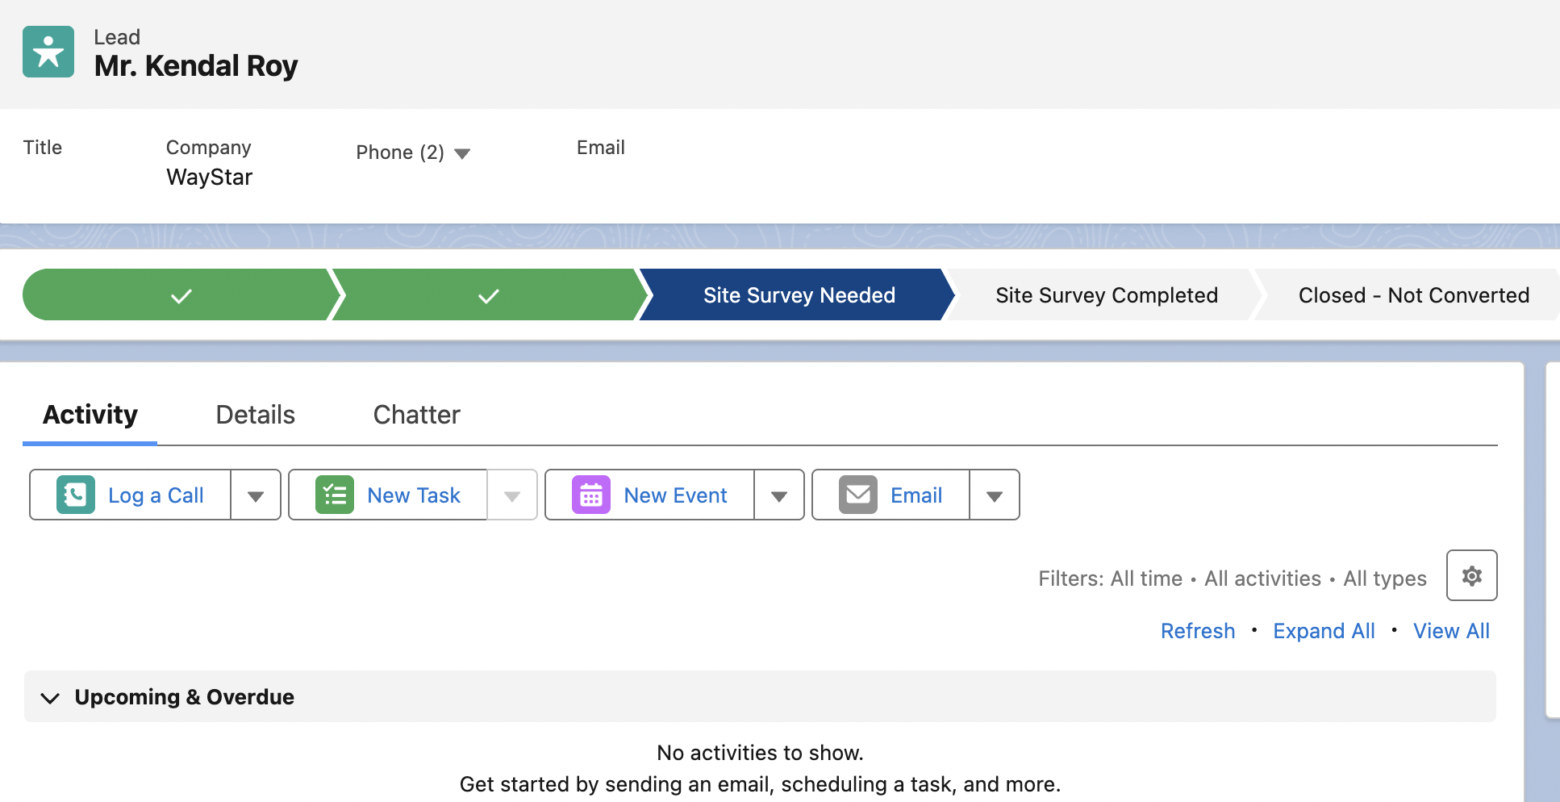
Record type is Power supply.  We see the path is different with different record type. | 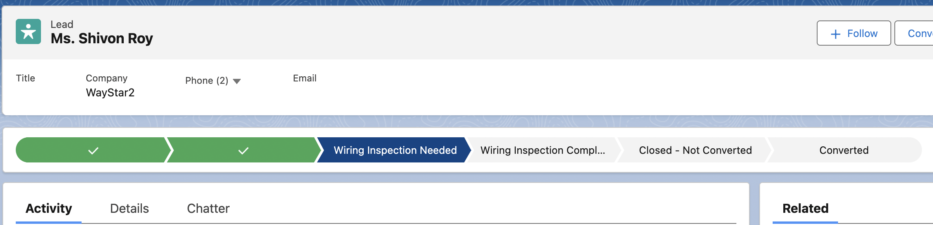
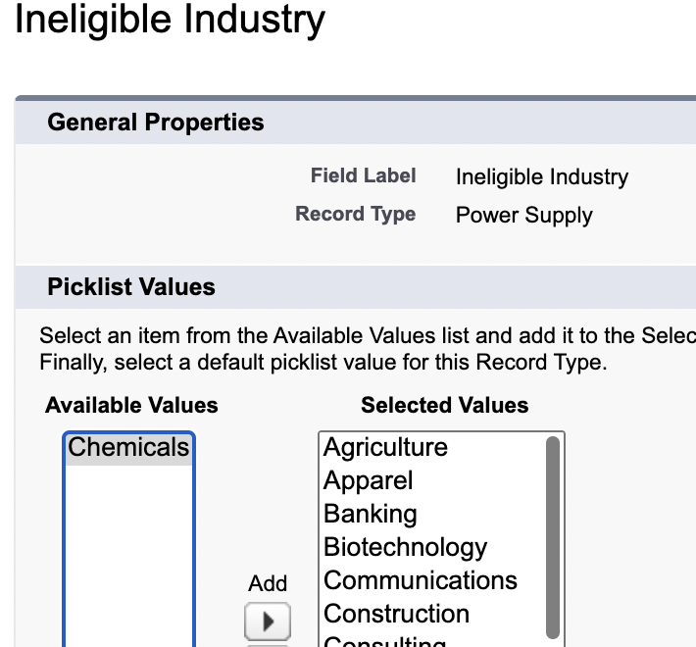 | Remember picklist available for editing in record type. Those are from the lead object form. You can edit the option in the picklist based on record type.
Note: | Lead status field is changed using the lead process and other picklist values are using record type.

Adding picklist values to the product interest and picklist field.
Object manager → Lead → F&R → Product interest | 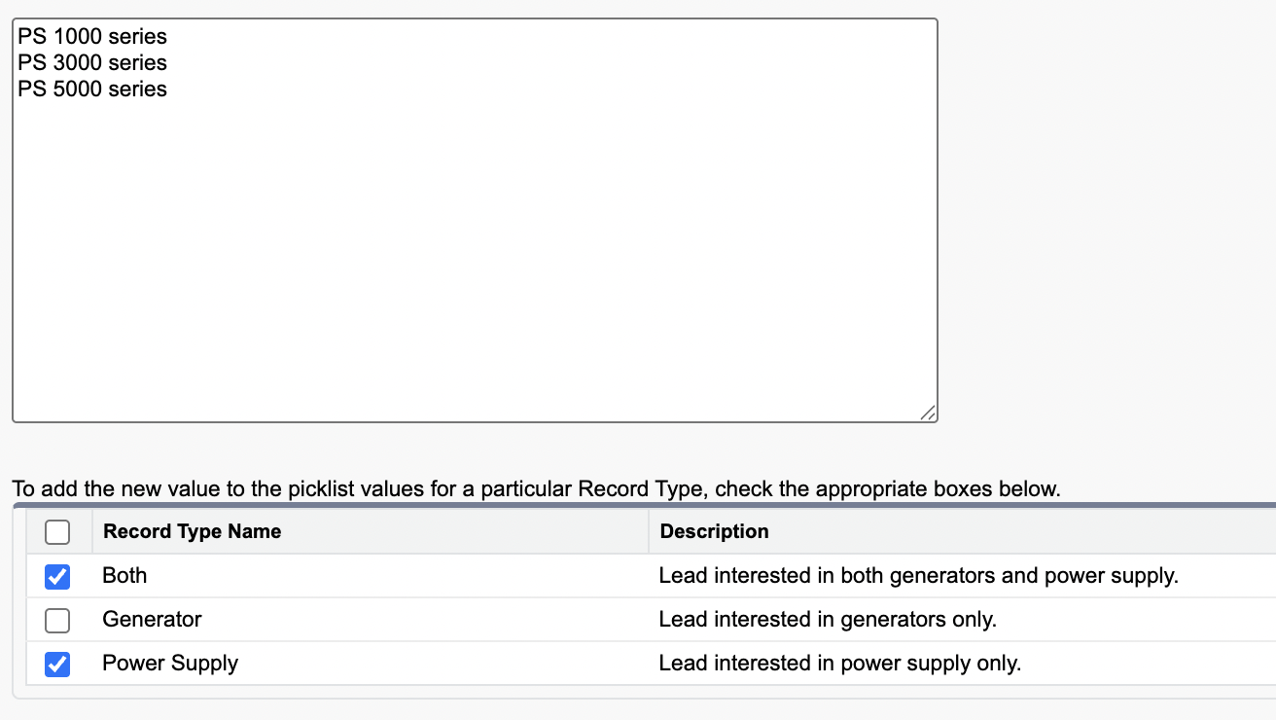
Each record type affect the options in picklist. | You can see why the option of record type appear and wonder to answer correctly.
Observation: | You would see picklist value of both power and generators in both lead process and record type.
Object manager → record type → I had to remove the selected values from power supply about generators. | 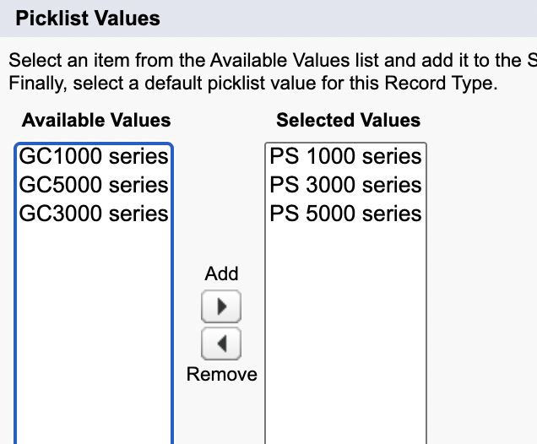

Renaming and aligning page layouts with record type
Object manage → record type → click on page assignment → under layout properties renmae them | This video was focused on renaming the page layout.
Add lead record type to all page layout
Then make them visible in the list view
Address the problem. | 