

Zoho Creator Assignment
24/05/2025
Application: Create a step-by-step application process for an Automated Costing System to be developed in ZOHO Creator.

By
Kazim Syed
kazim.mohdsyed@gmail.com
+91 8779 81170

Index
Key Features must have in Costing System:
Features | Sol | Click reference | Click Reference
(1) Variant Management | Using Forms. | Variant Management:
(2) Cost Calculation | Using forms and workflows | Cost Calculation
(3) Reporting | Using pages and charts | Reporting
(4)Customization | Effective database design and few things included in the chart section | Conclusion

Apps:
- Task 1: Create a step-by-step application process for an Automated Costing System to be developed in ZOHO Creator.*
- Task 2: Create a simple inventory management app where we can see live tracking of the fabrics & accessories inventories getting consumed in every order. How would you approach designing the database structure, forms & reports for this app?*

Variant Management:
The system allows the user to define and manage different product variants, like Premium, Value, Eco. For each variant, the system should store the respective price per square foot.
Database Structure/Form Structure:
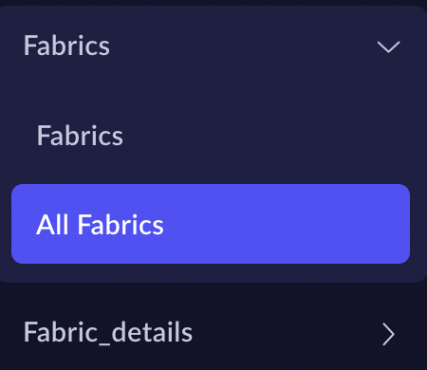 | We need two databases to store fabrics.  So that we can maintain referential foreign key integrity.  Fabrics & Fabric_details has one to many relationship.
Fabrics table with unique fabric codes. | 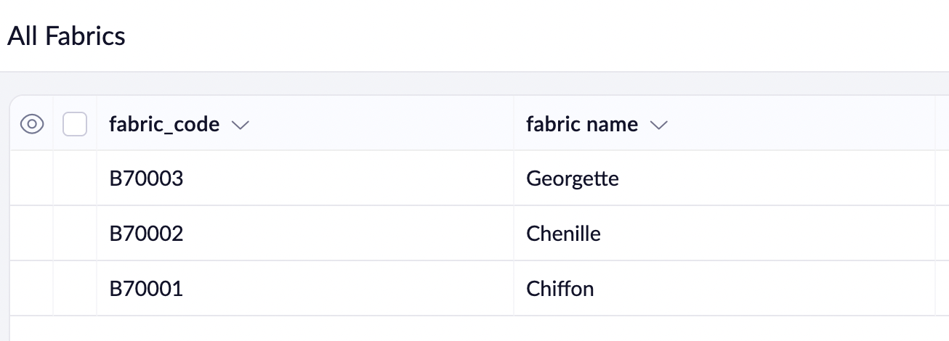
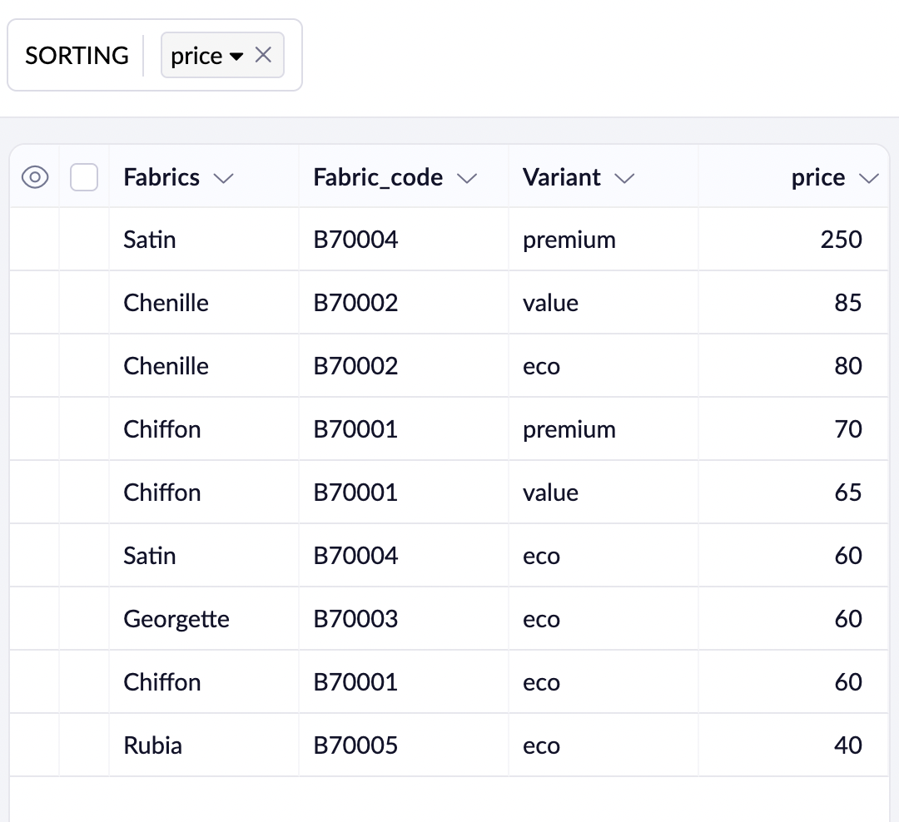 | Fabric details with different price point based upon the fabric code.

Cost Calculation
The system should calculate the total cost of each order based on the selected variant and the fabric consumption provided. The cost calculation should be derived by multiplying the fabric consumption by the respective price per square foot for the chosen variant.
Steps:
1.Create a form Order_Purchases.
2. Define fields using drag and drop feature.

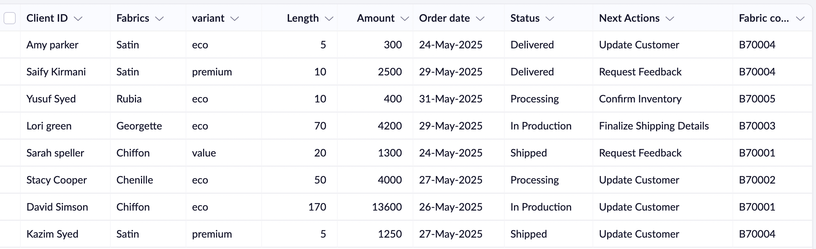
Orders_Purchases
Form Structure.
Client ID | Text | Lookup
Fabric | Number(InternaL) because FK | Lookup→ Fabrics
Variant | Number(Internal ) because FK | Lookup →  Fabric_details
Length | Number | 5 (Default value: business rules)
Amount | Number
Order date | date
Status | Text
Next Actions | Text
Order time | Time
Sys date | Time(System generated)
Fab_code | Unique code

Fabrics:
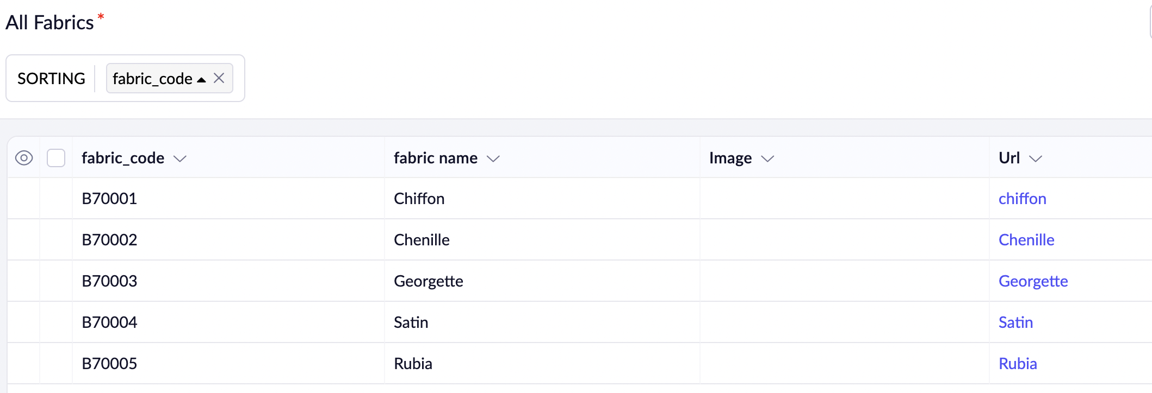
Fabrics_details
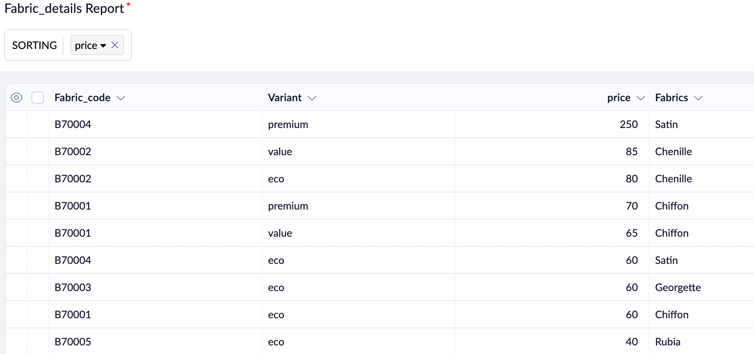
3. Write a workflow that updates the Amount field whenever there is a creation of new record or edit on {Fabric, variant, length} fields of the form.

Crux of the Cost Calculation → Services
User Action Flow:
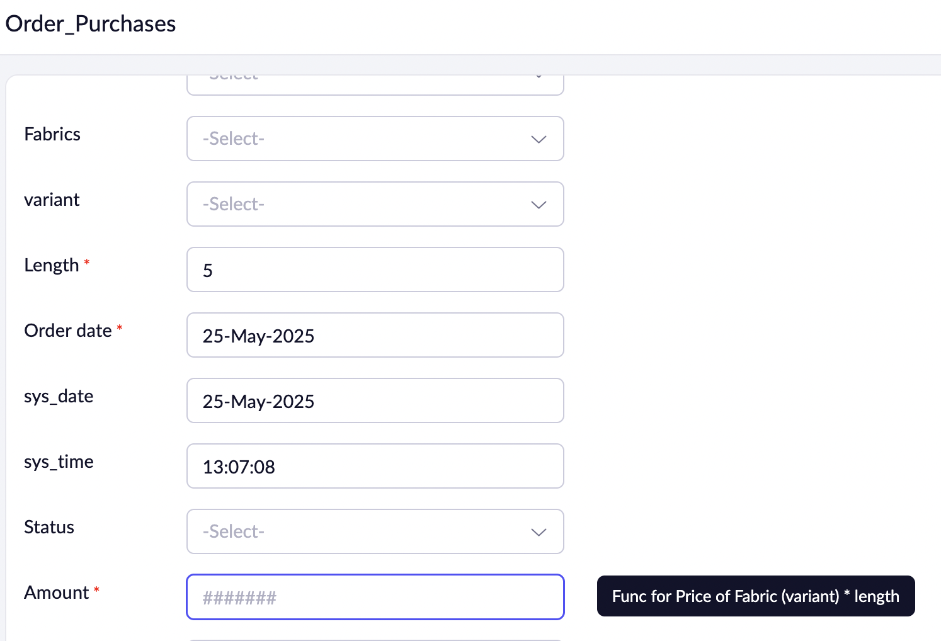

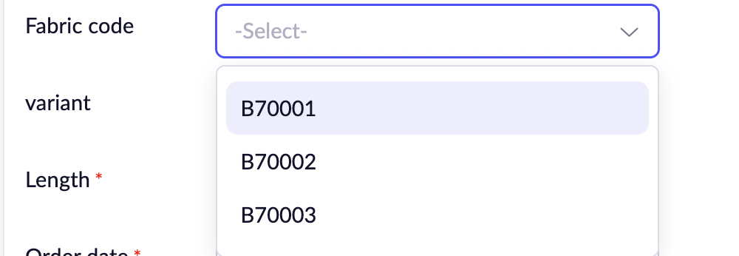  Fabric code is a lookup field populated by Fabrics form.  (1) | 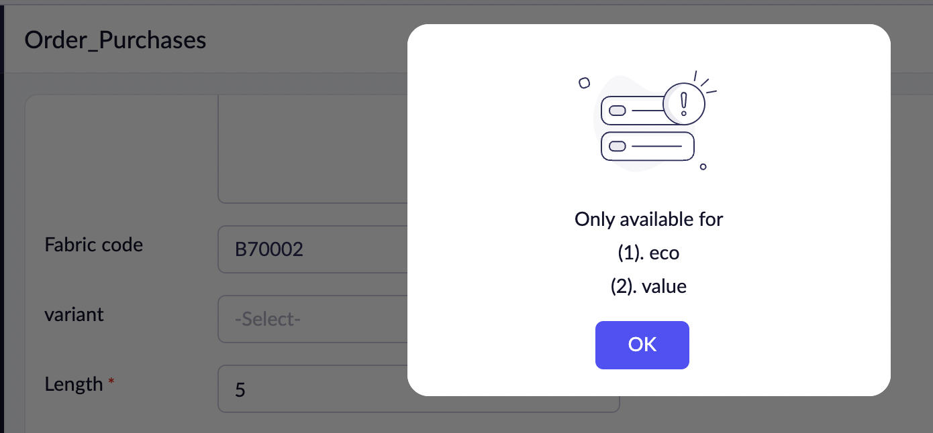  System pops possible variant available for that particular fabric.  (2)
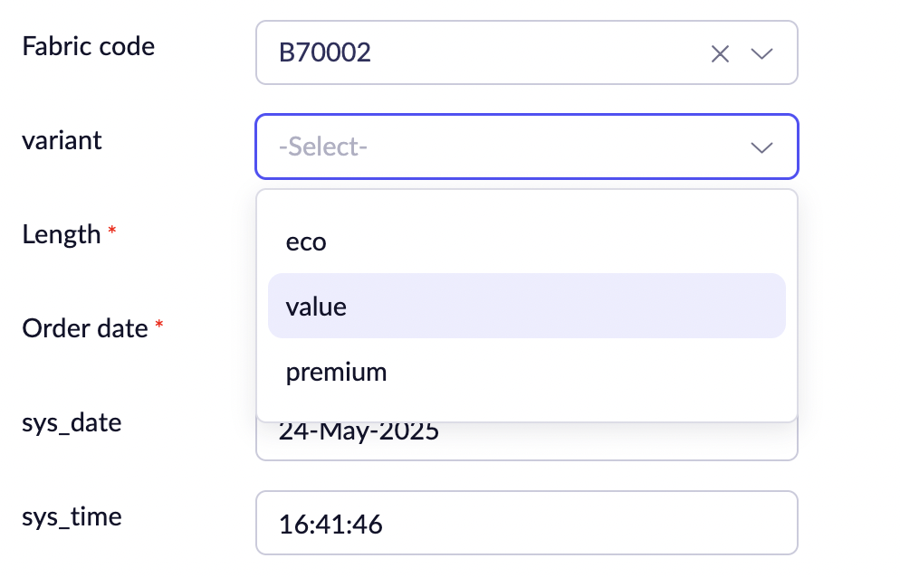  End-user selects the variant of their choice. | 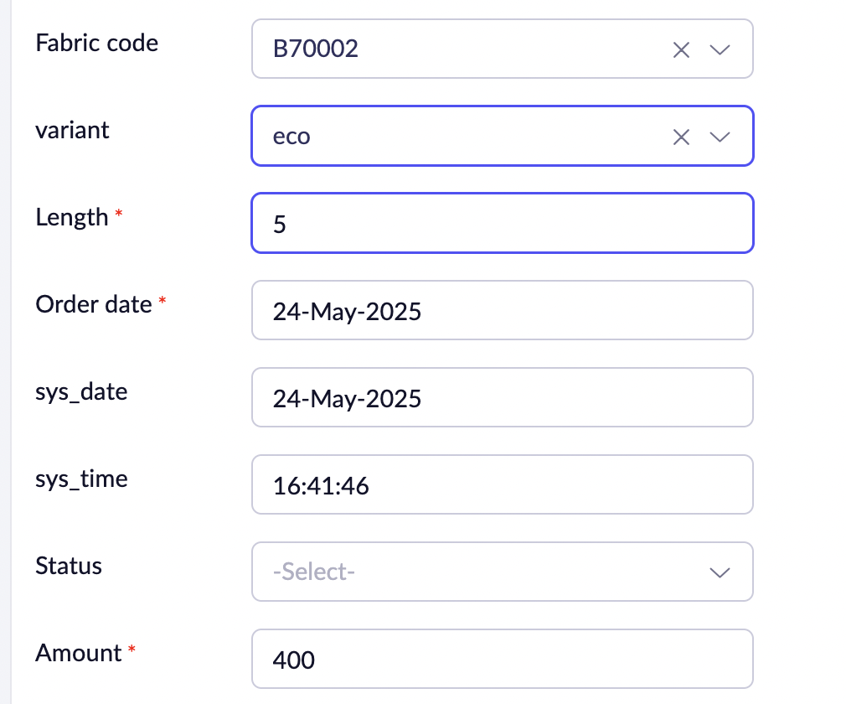  As the user select or edits the value of the fields involved {fabric, variants, length}. The changes in Amounts are reflected instantaneously using a workflow.

Database structure for our Services
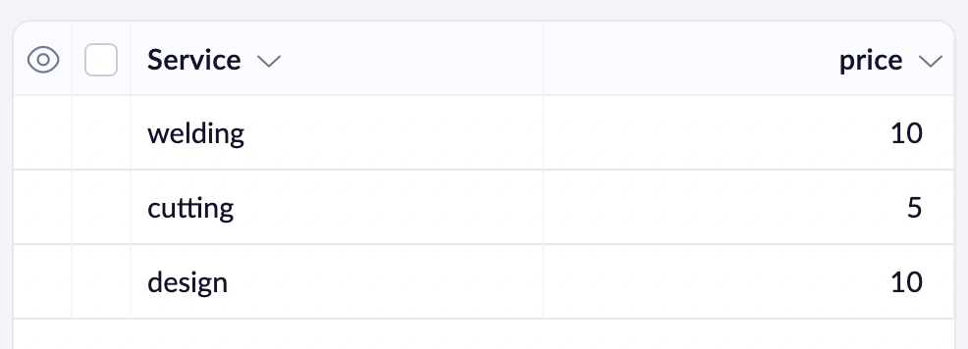
LTM_Services

Client_Services
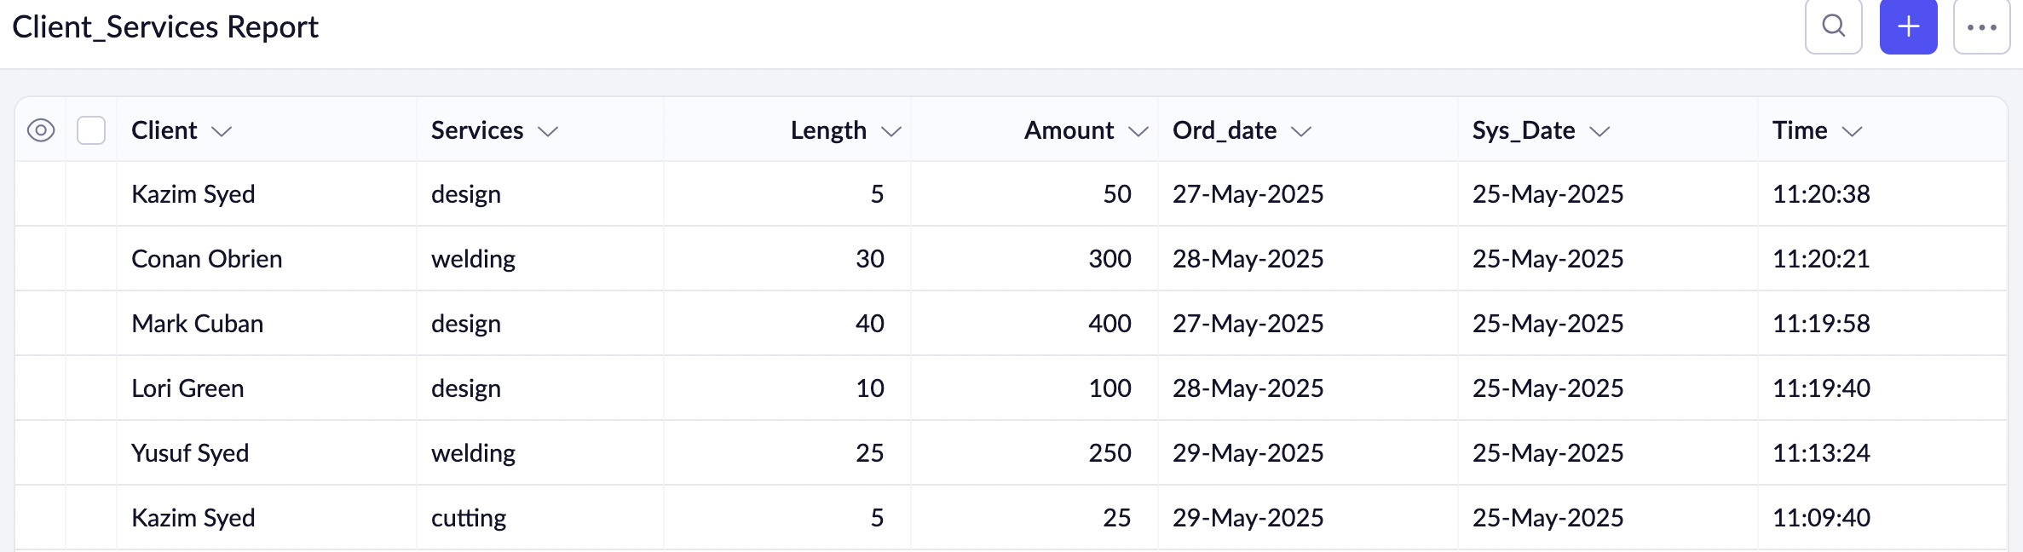
Cost Calculation using workflows.
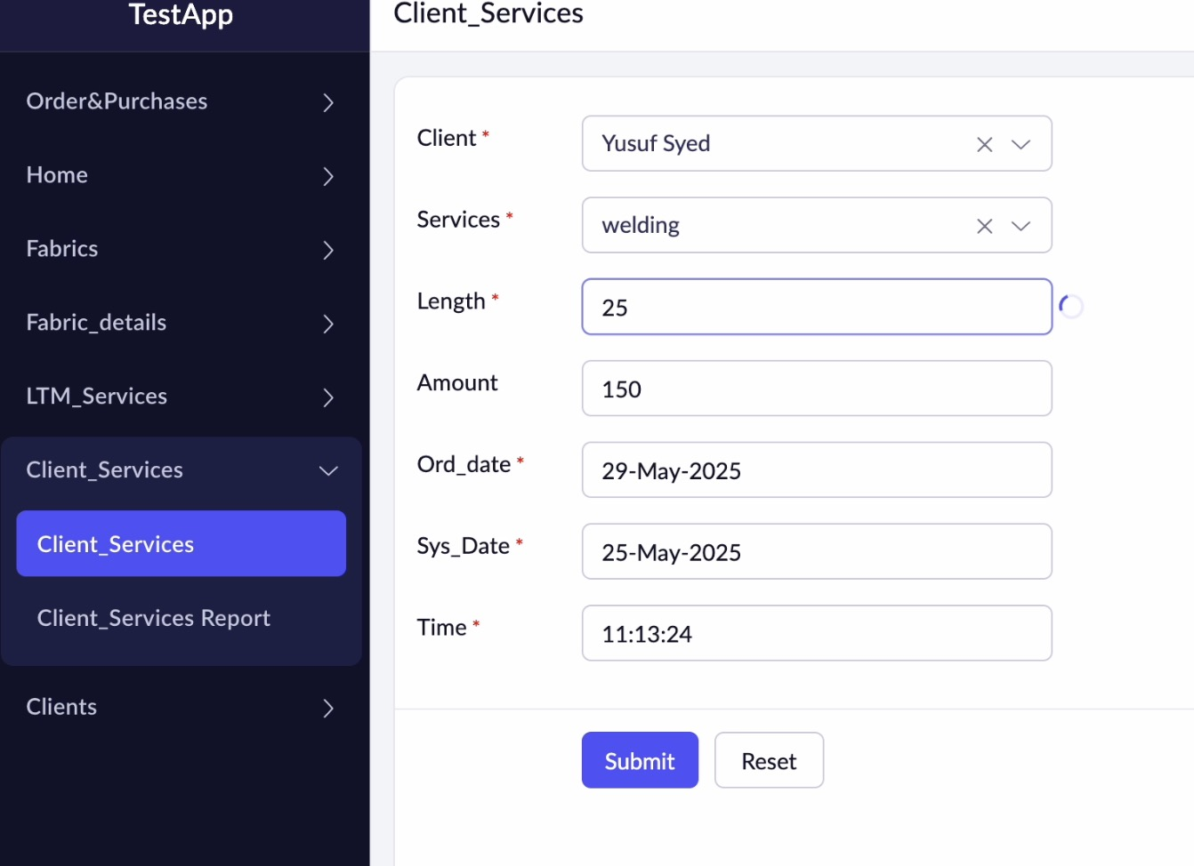 | Here, we cane see at length field. A small buffering indicating workflow is being used.  Here, 150 is the stale value.
 | Updated value

Step 3 is to write workflows:

Workflow:
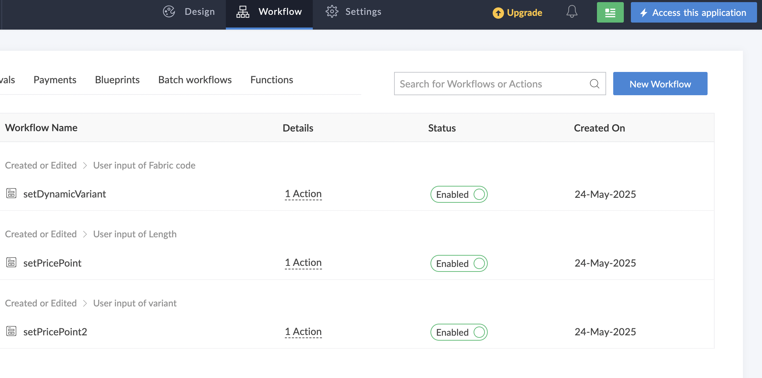
There are Three workflows.
Workflow | Executes when | Field | Purpose:
setDynamicVariant | (Created or edit) on Orders_Purchases | Fabric Code | Tells all the variants available for this particular fabric
SetPricePoint | (Created or edit) on Orders_Purchases | Fabric_length | Instantaneous reflection to the calc.
setPricePoint2 | (Created or edit) on Orders_Purchases | Fabric variant | Instantaneous reflection to the calc.

Reporting
The system should provide reporting capabilities to generate cost summaries for different orders. This can include displaying the total cost for each order, as well as aggregating costs by variant, order date, or other relevant criteria.
Steps:
Step 1: Create a page.
Step 2: Using the drag and drop functionality, drop Panel and charts.
We have 3 Pages:
- Home → Home
- Home → Inventory
- Home → Service_pages

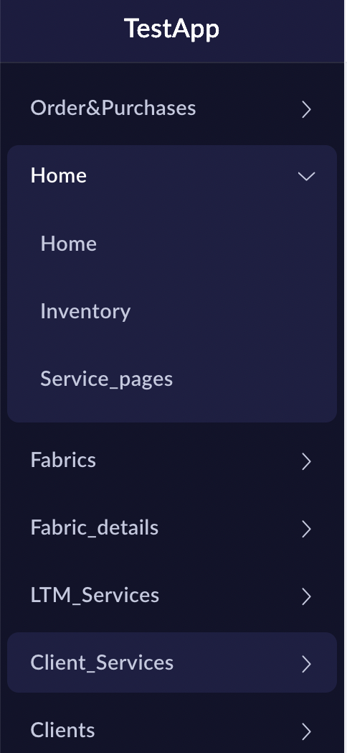 | Note: I intend to change the names of this chart pages in the near future.  Home: is for managing the logistics of our products and tracking orders.
  Logistics | Controls
  Confirmed | When the order placed by our clients are ack by the system
  Processing | The orders is processed.
  In production | Creation of our final assembled product.
  Waiting for shipping details
  Shipped
  Delivered | Product received by customer.

Home→ Home (Logistics and tracking orders)

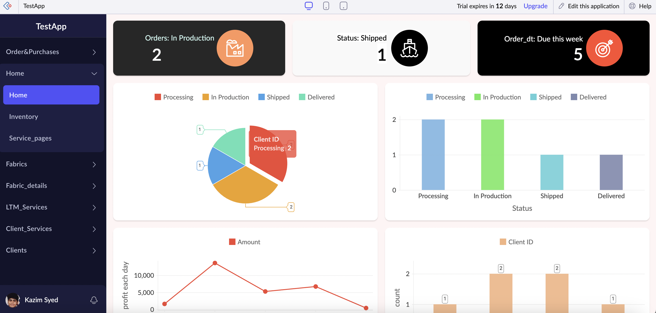

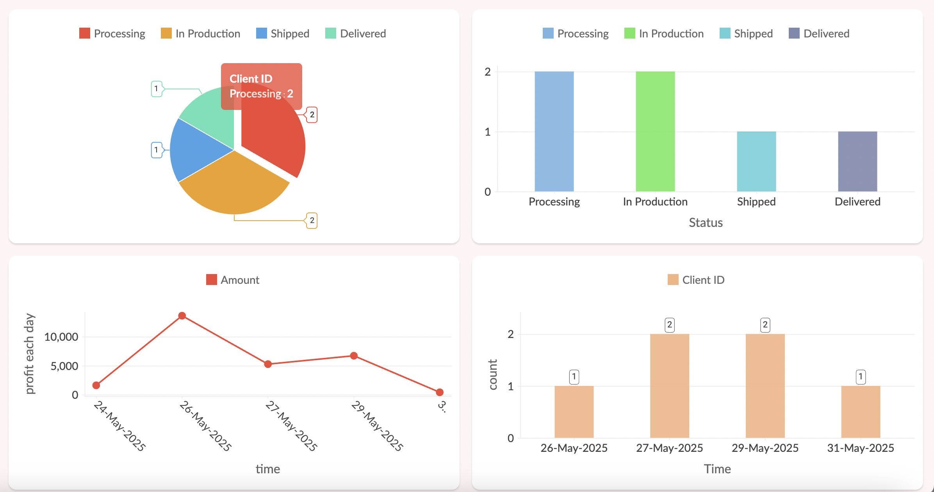
One of our enthused customization in the charts is belowed.
Once the order is delivered. Our attention can be allocated to the next fulfillment of product.
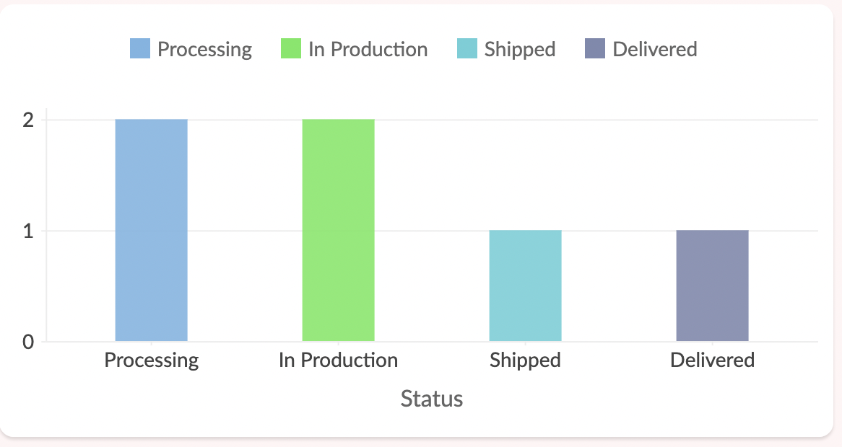 | 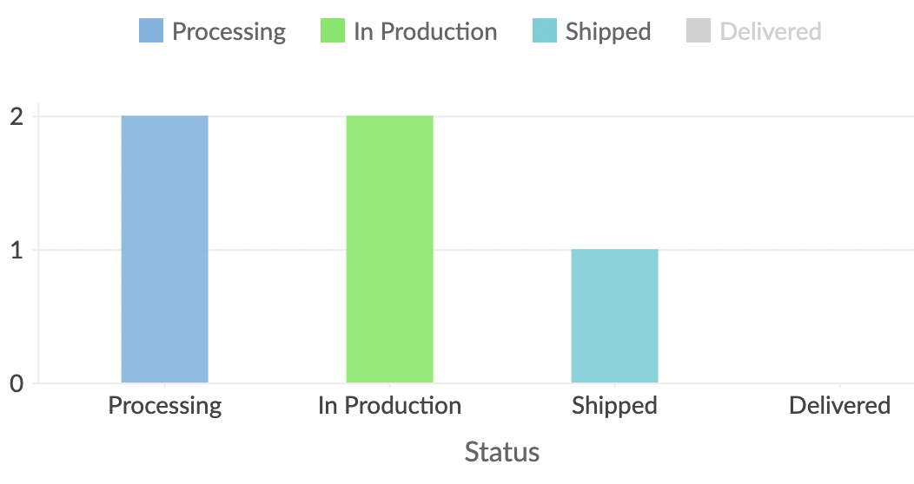
The ability to see underlying data beneath the status.

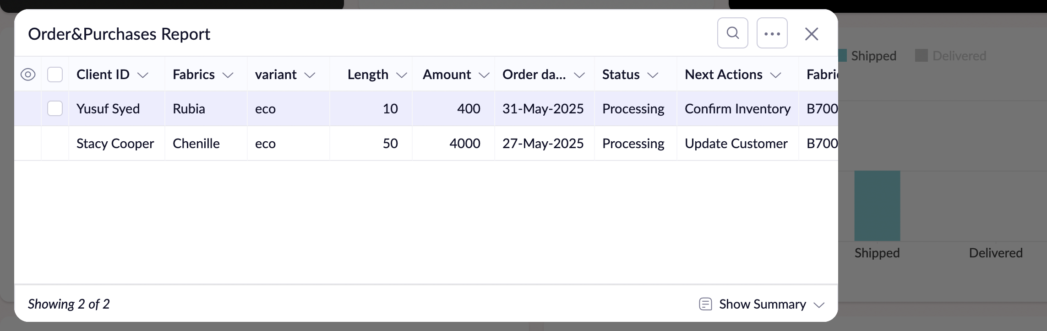

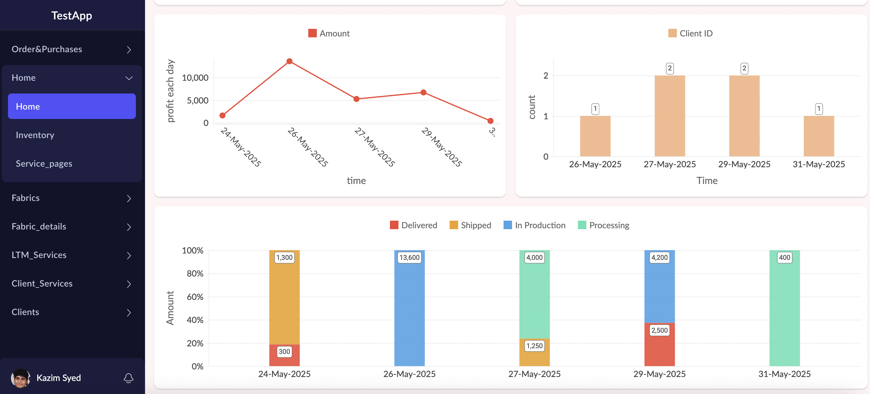

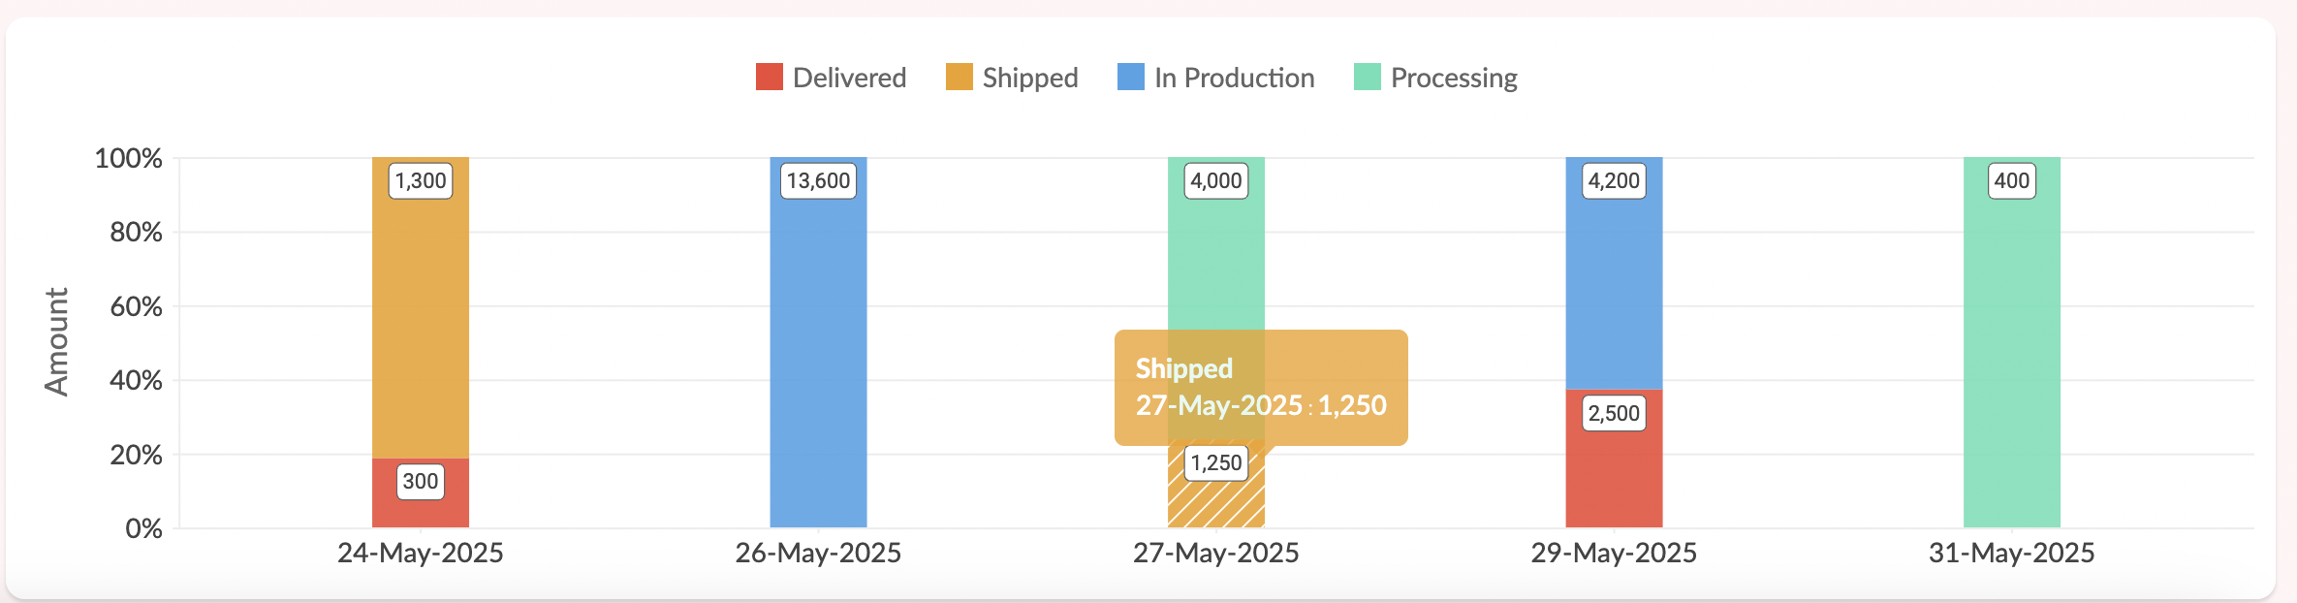

Home → Inventory
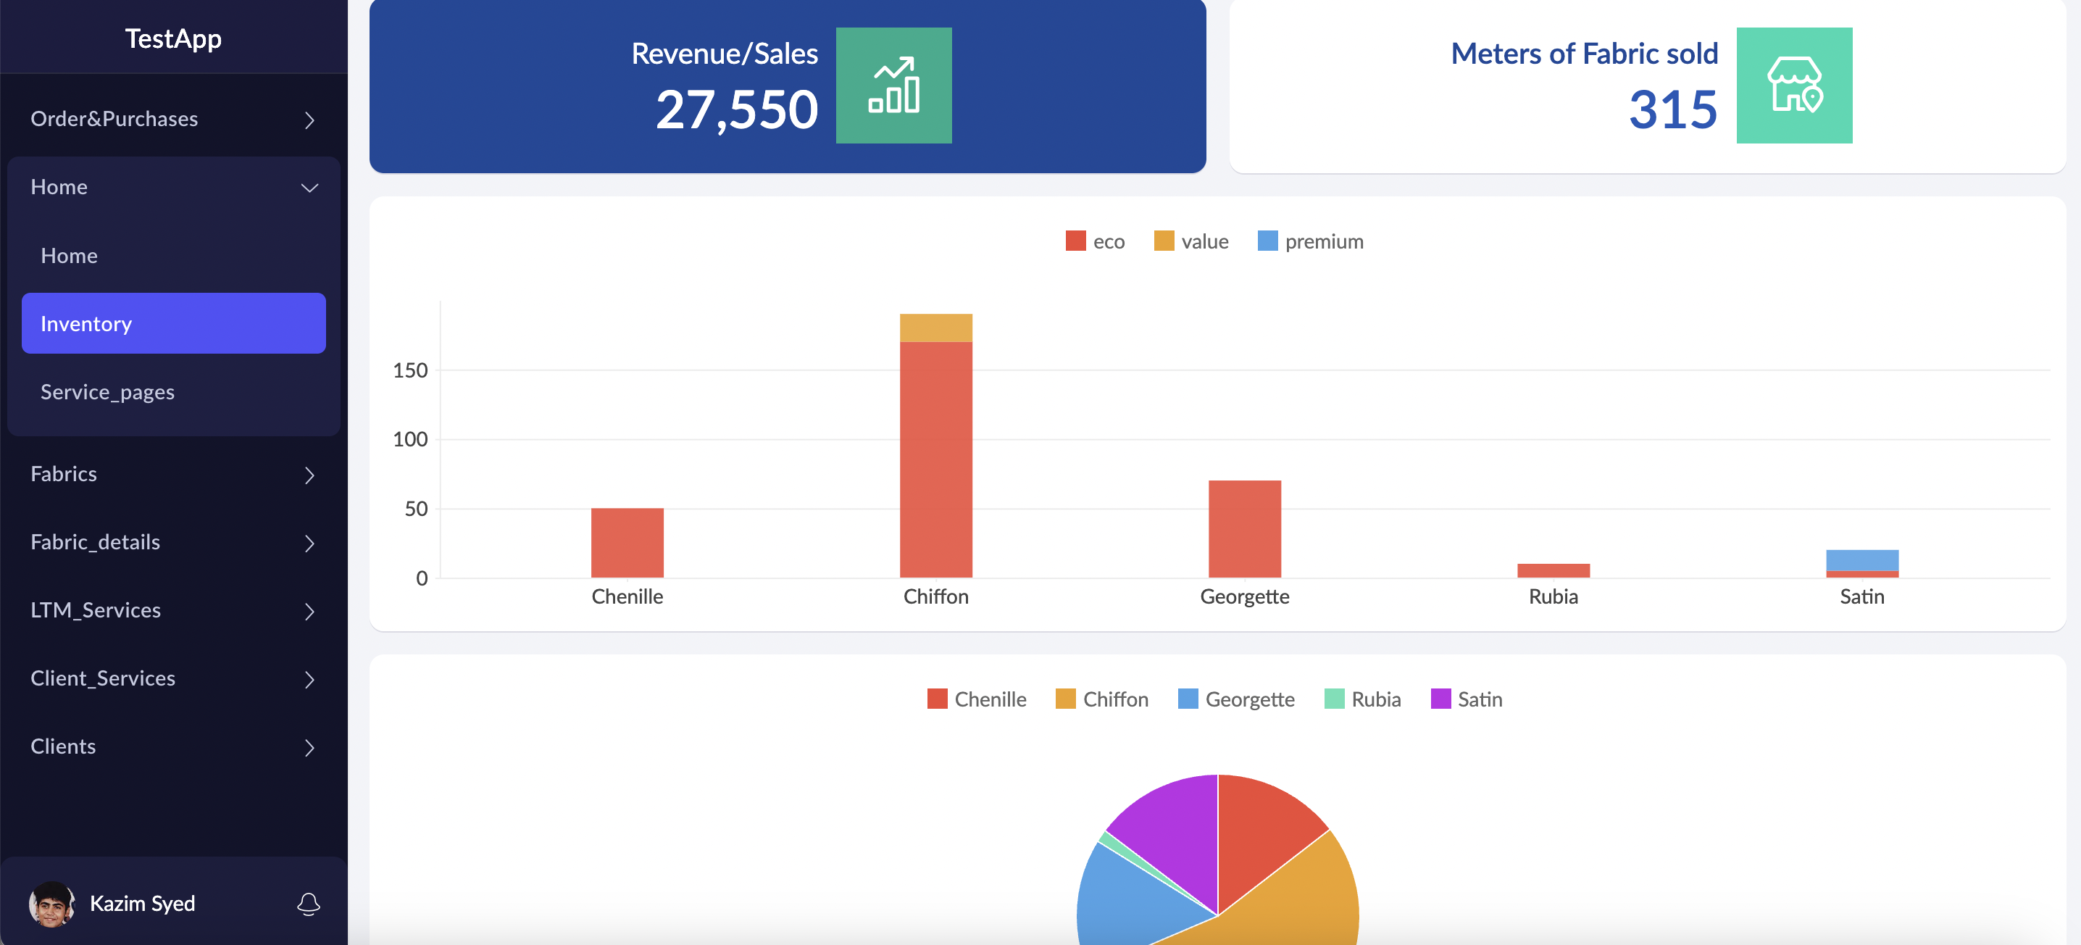

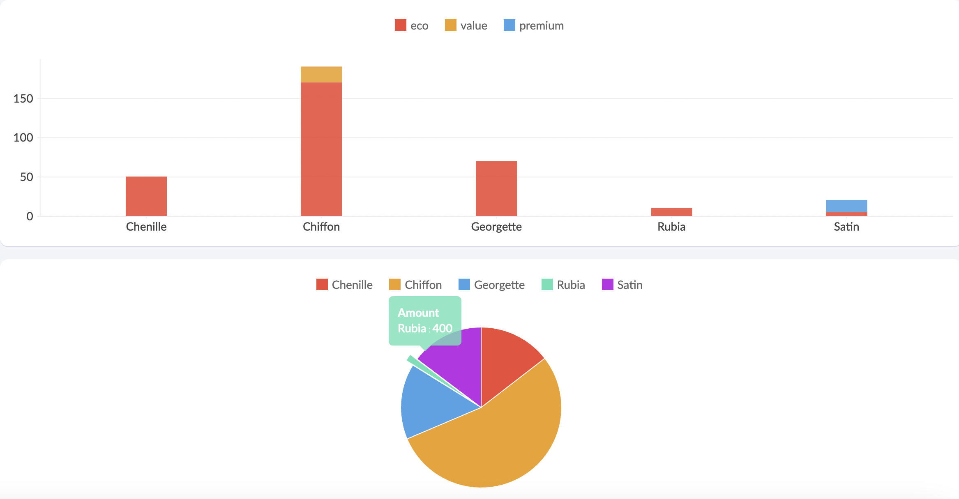

Top line Revenue generated from the sale of particular fabric.

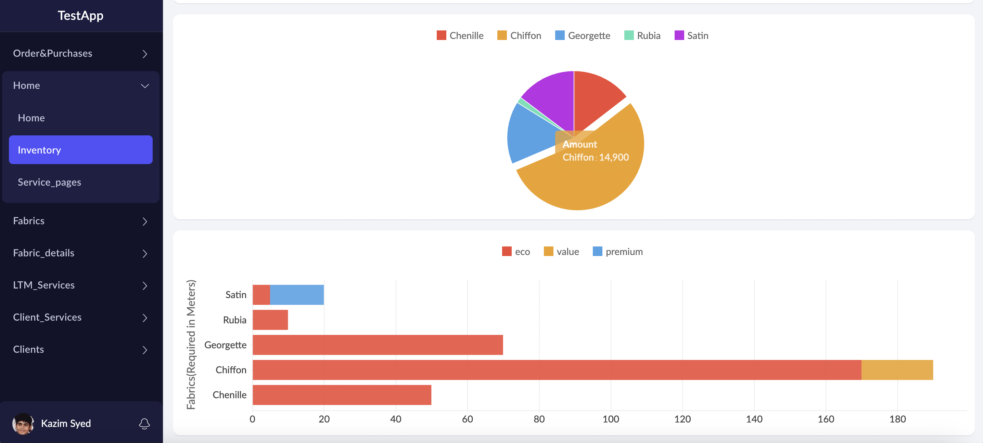

Home → Service Pages
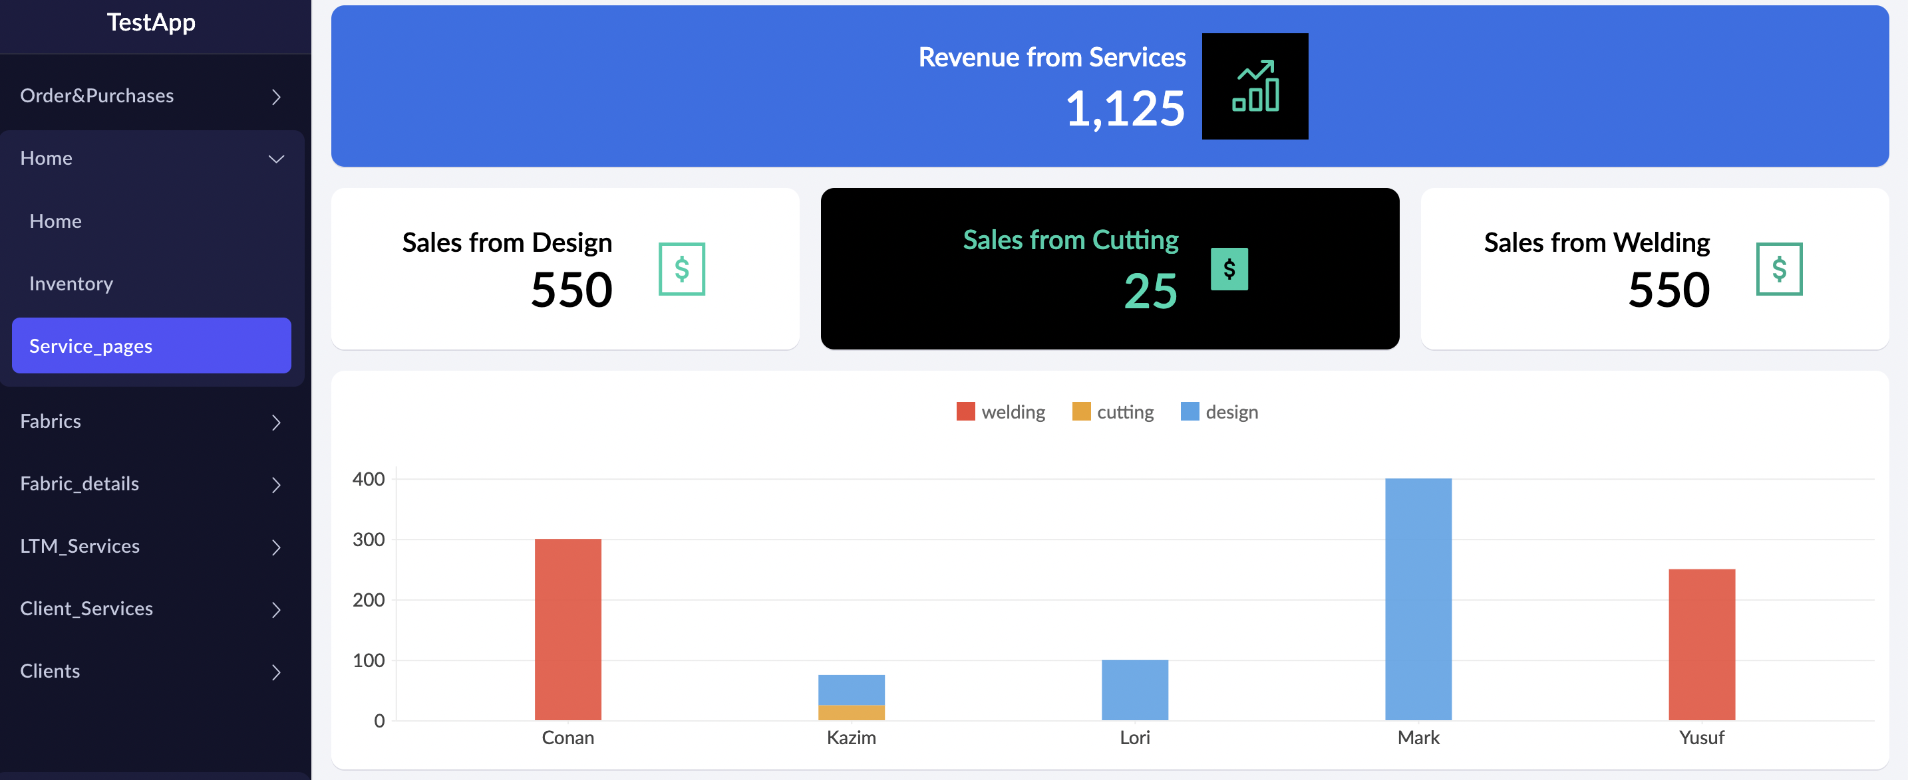
Top line revenue generated by providing our clients with our services.
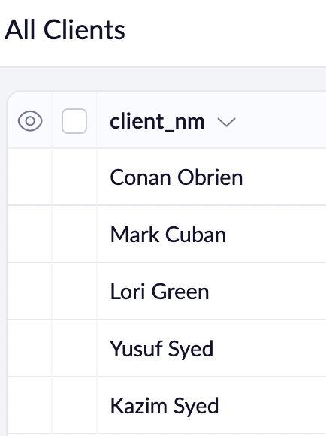

Customization
The system should allow for easy customization of variant names, prices, and other relevant parameters, as well as the ability to add or remove variants as needed.
Solution offered:
Effective database design is central to achieving ease of customization. Specifically, a database normalized to Fourth Normal Form (4NF) mitigates common issues such as data redundancy, along with insertion, update, and deletion anomalies.
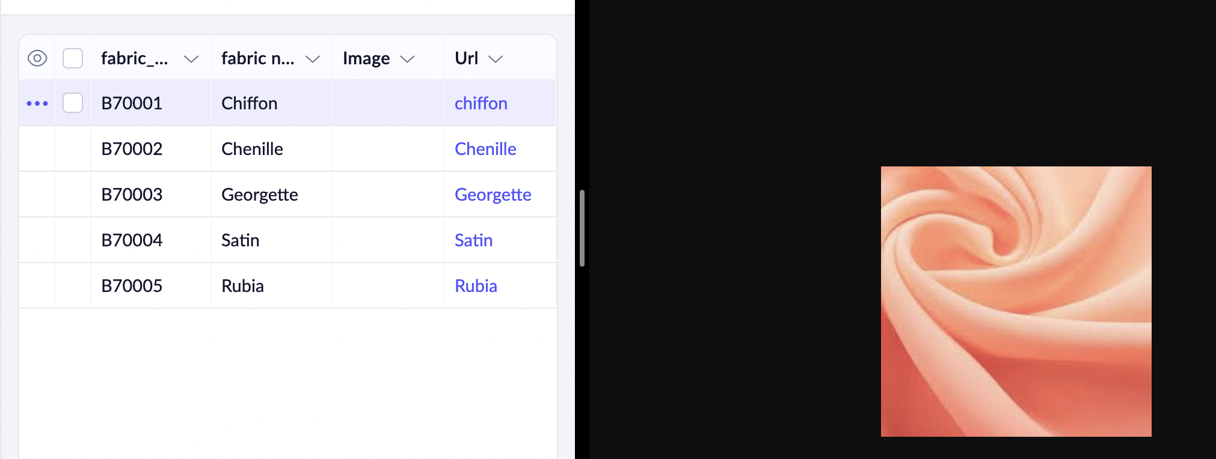
The url is mapped to the respected hyperlink image. Most of the other customization are shown in the reporting section of the document.
And as we can see we can very easily edit and update information in the database.
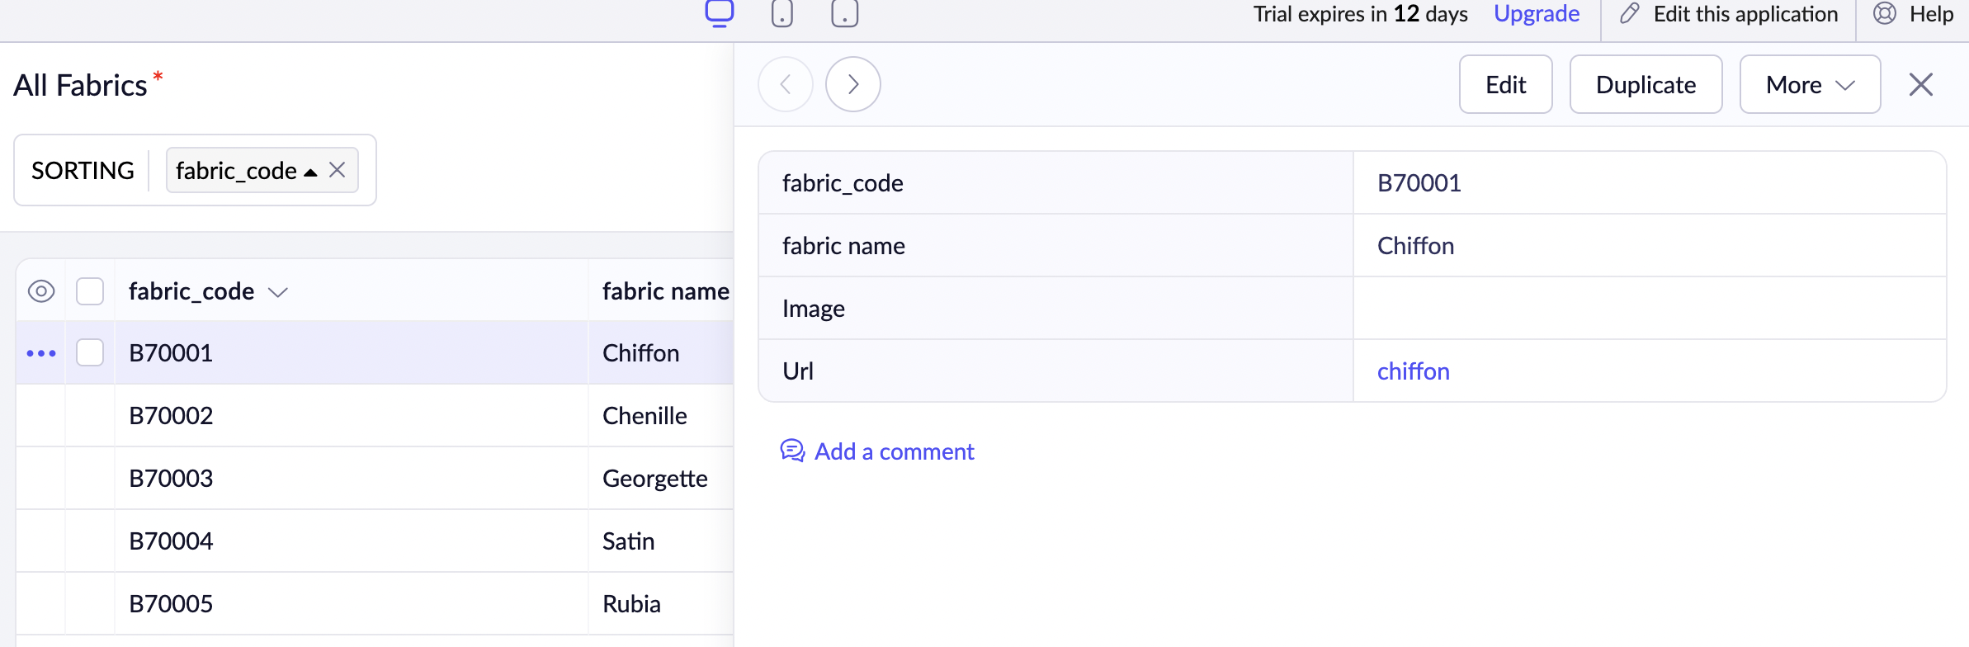

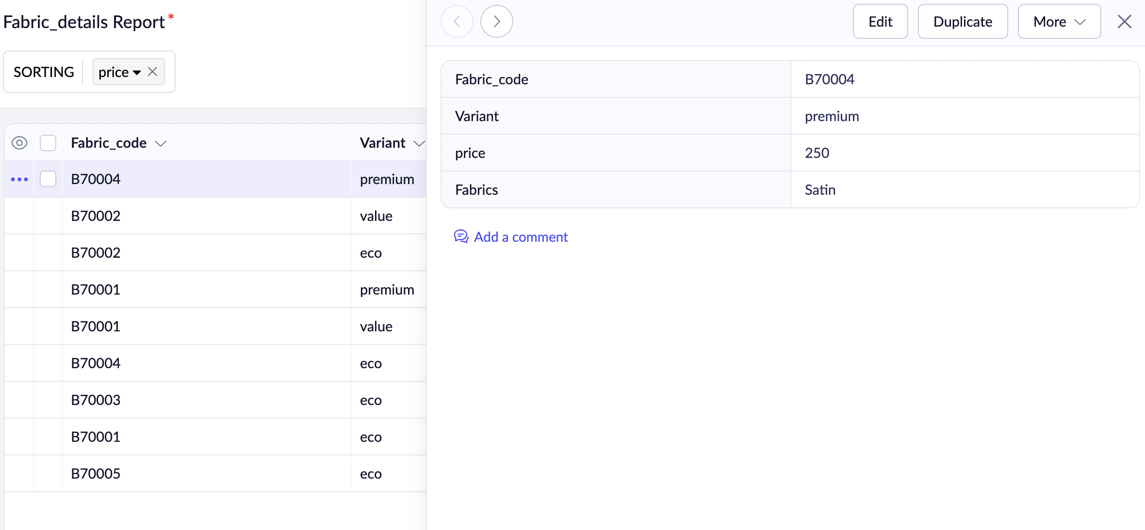
Note: I do believe this customization can be done better using a view of some sort. So even laymen can work through his way in the application. This is a MVP(minimum viable product from my end). I would be very enthused to bring better functionality and features in the final application.
Perks:
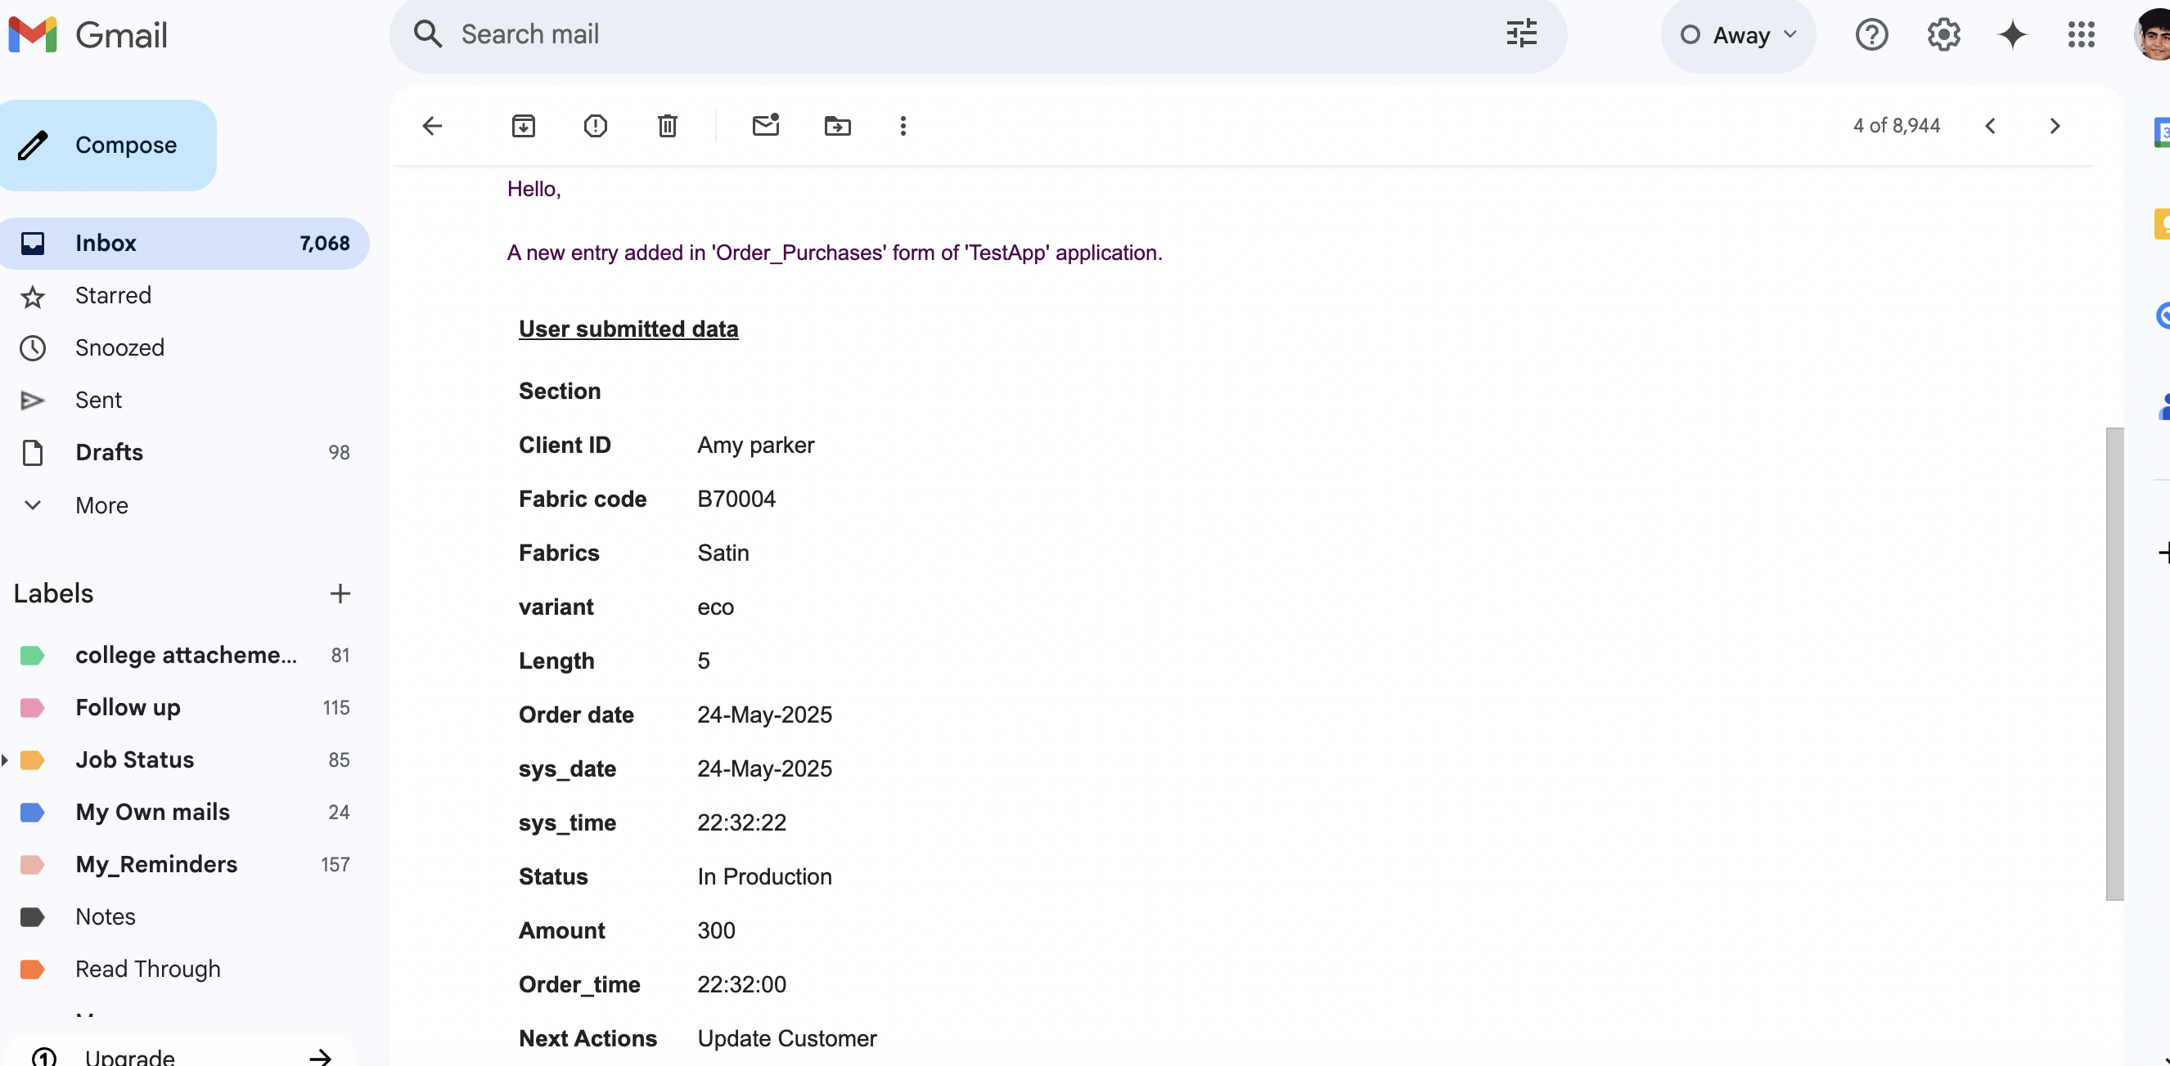
Whenever a new orders is placed, its reported in an email to the Manager.

Workflow scripts
(1)
Workflow Scripts → setDynamicVariant
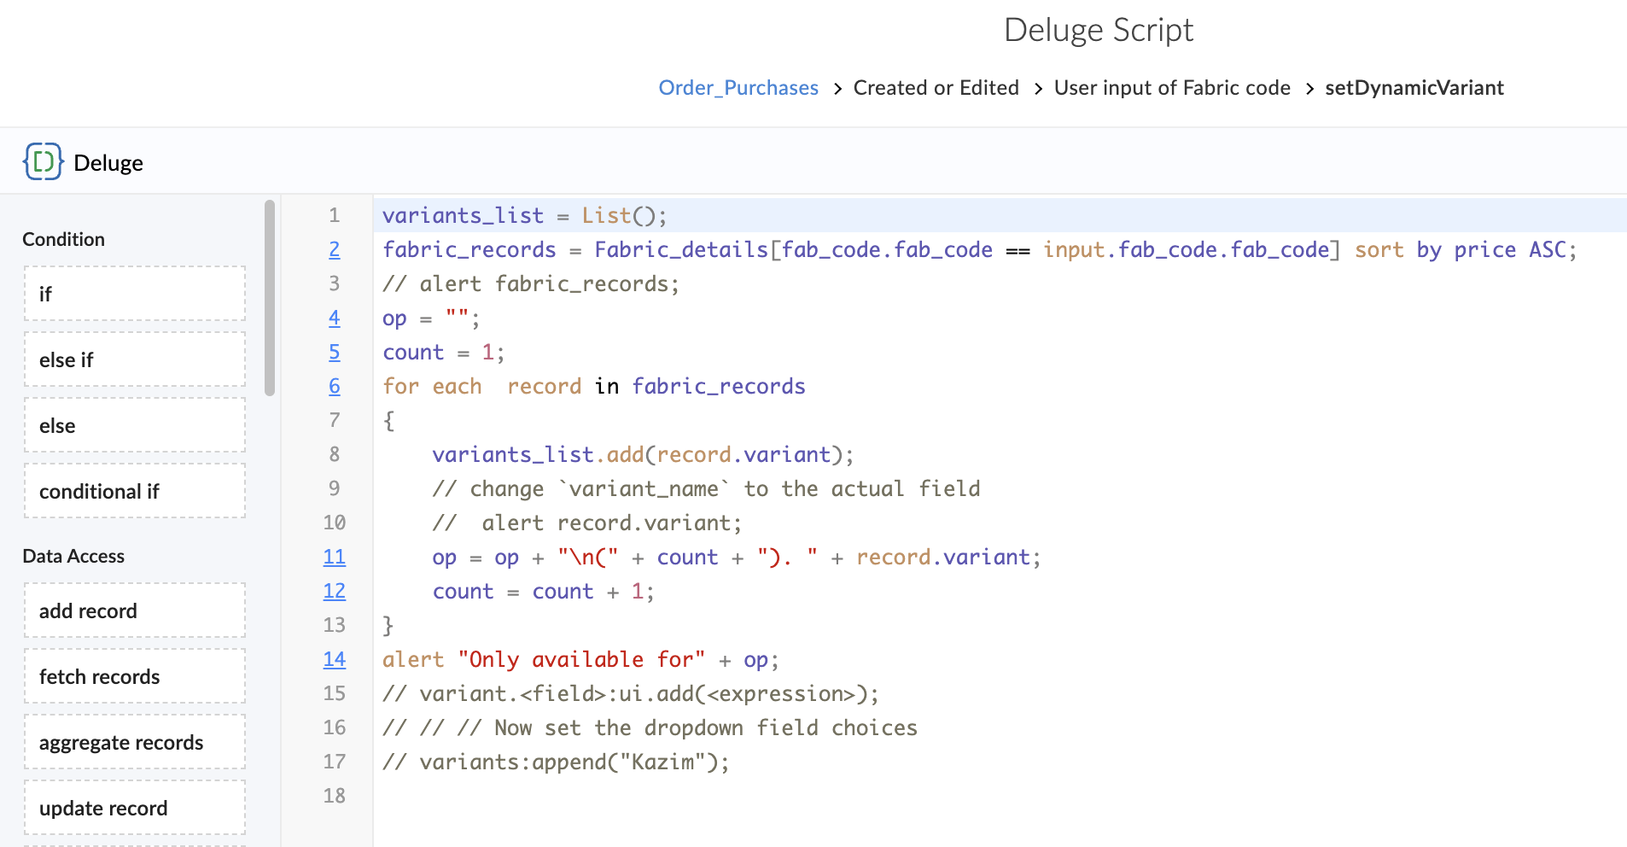
Output:
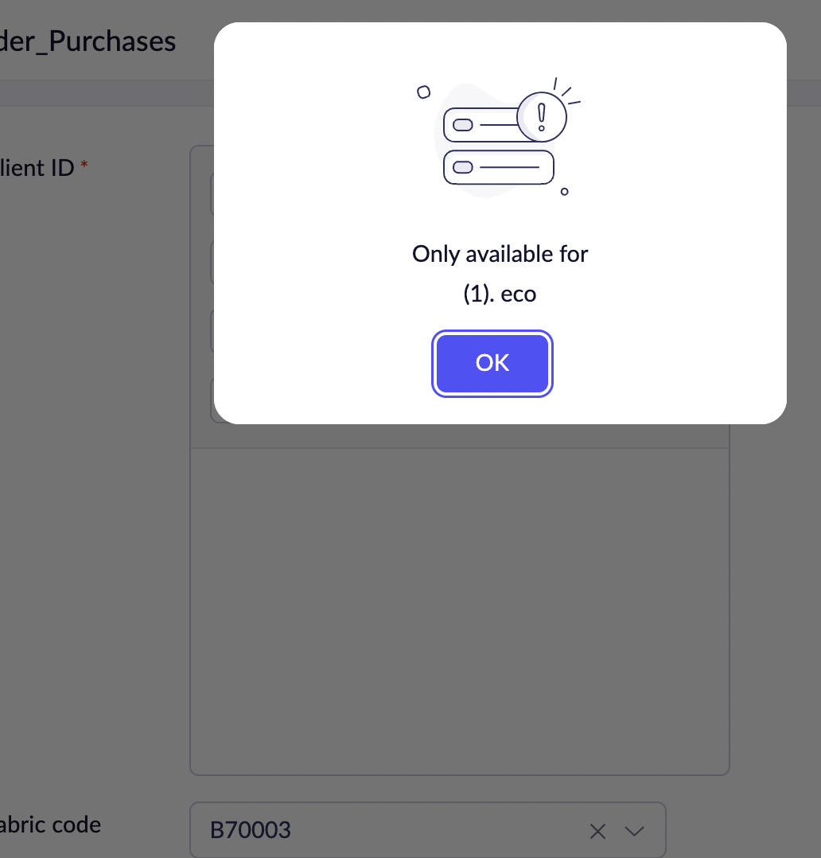
or

(2)
Workflow Scripts → setPricePoint
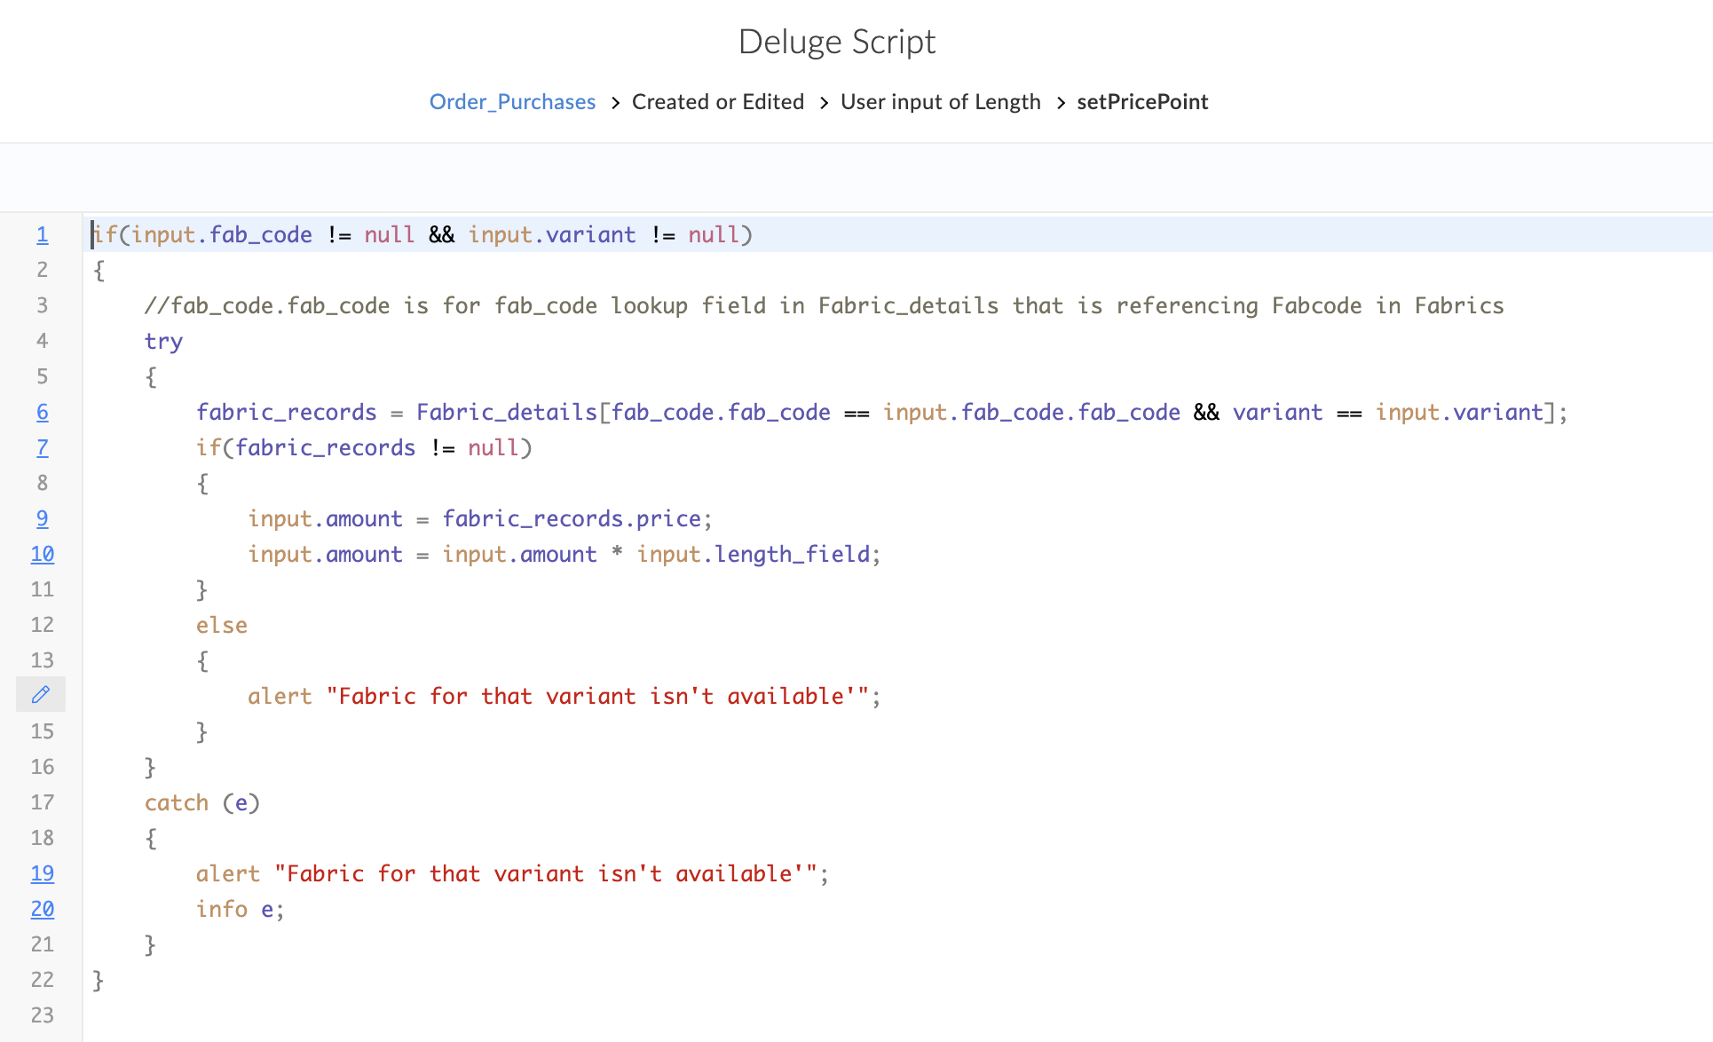

Conclusion
I have successfully fulfilled all the 4 features required in the assessment. I personally included an extra feature of logistics and tracking orders so we can fulfill our SLA agreements and meets our clients expectations and needs.

Future improvements:
Issue 1: Technical difficulty with Variant field. (Solvable in future).
Issue 2: More customization.
Issue 3: Need to find the accessibility to fire the same workflow on different fields.
Issue 4: Generates automatic reports and delivered it to the Manager in timely manner.



Updated
Use of a subform:
A form name All Quotations:
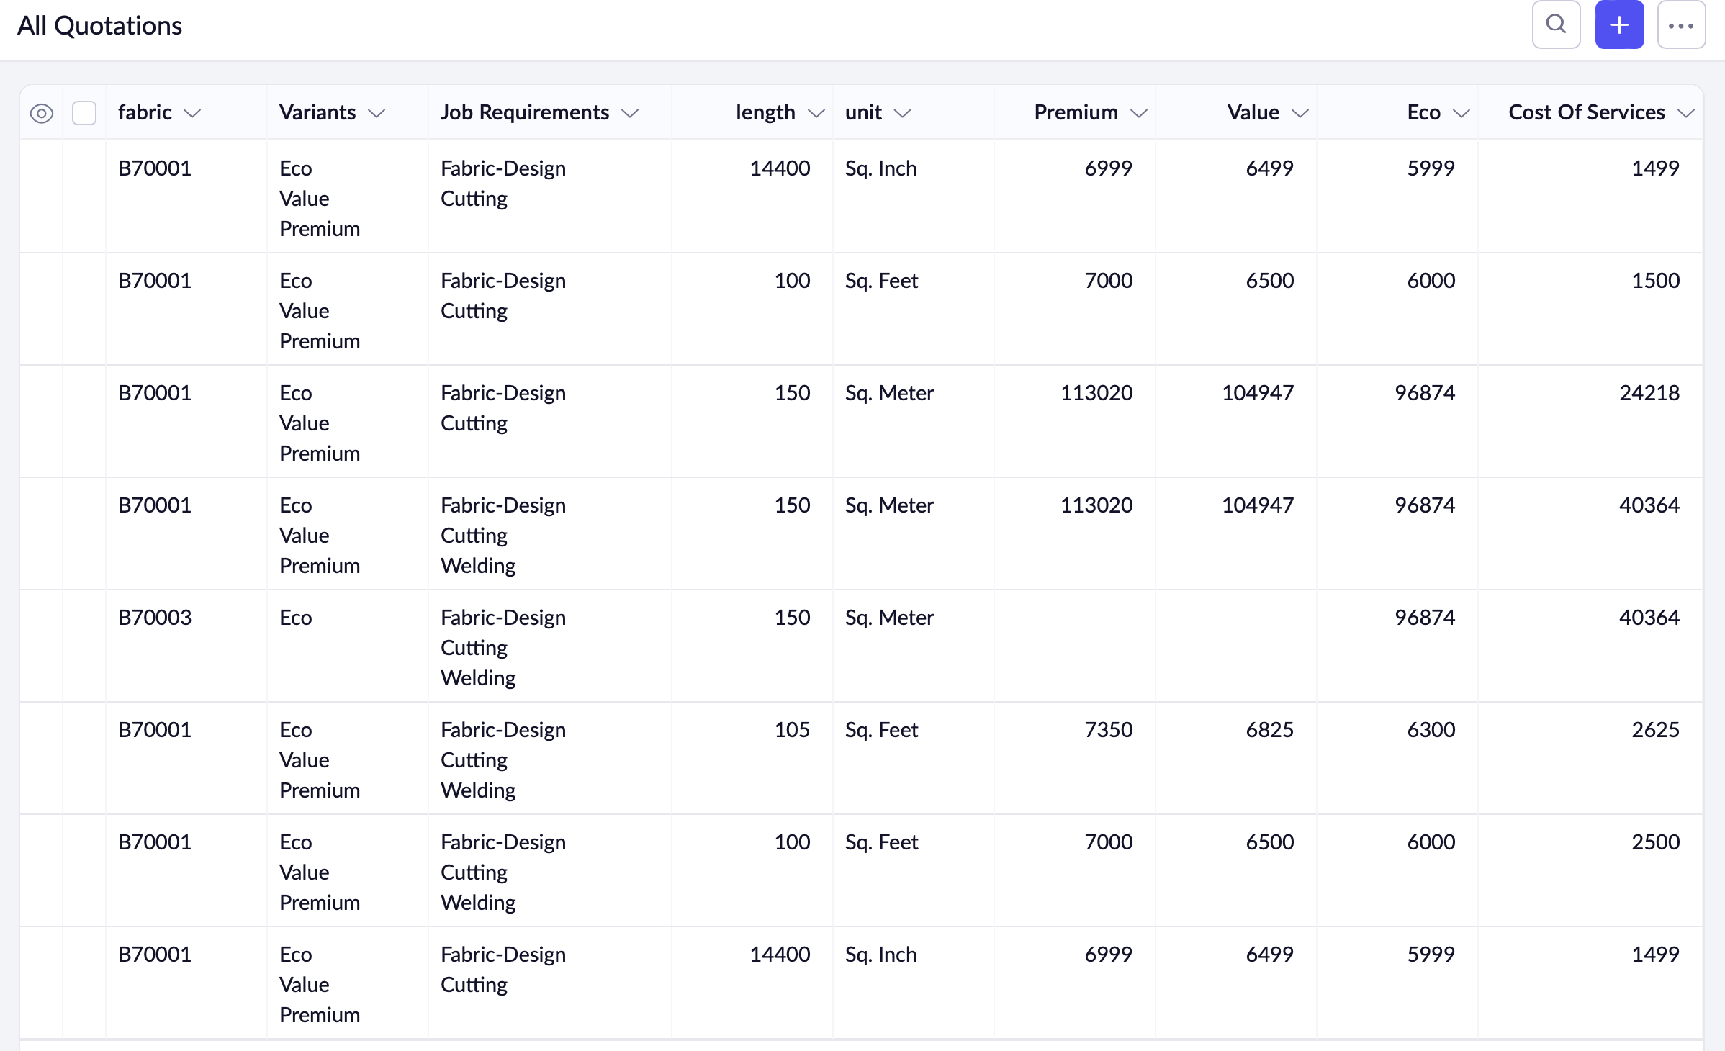

A client can make multiple Orders:

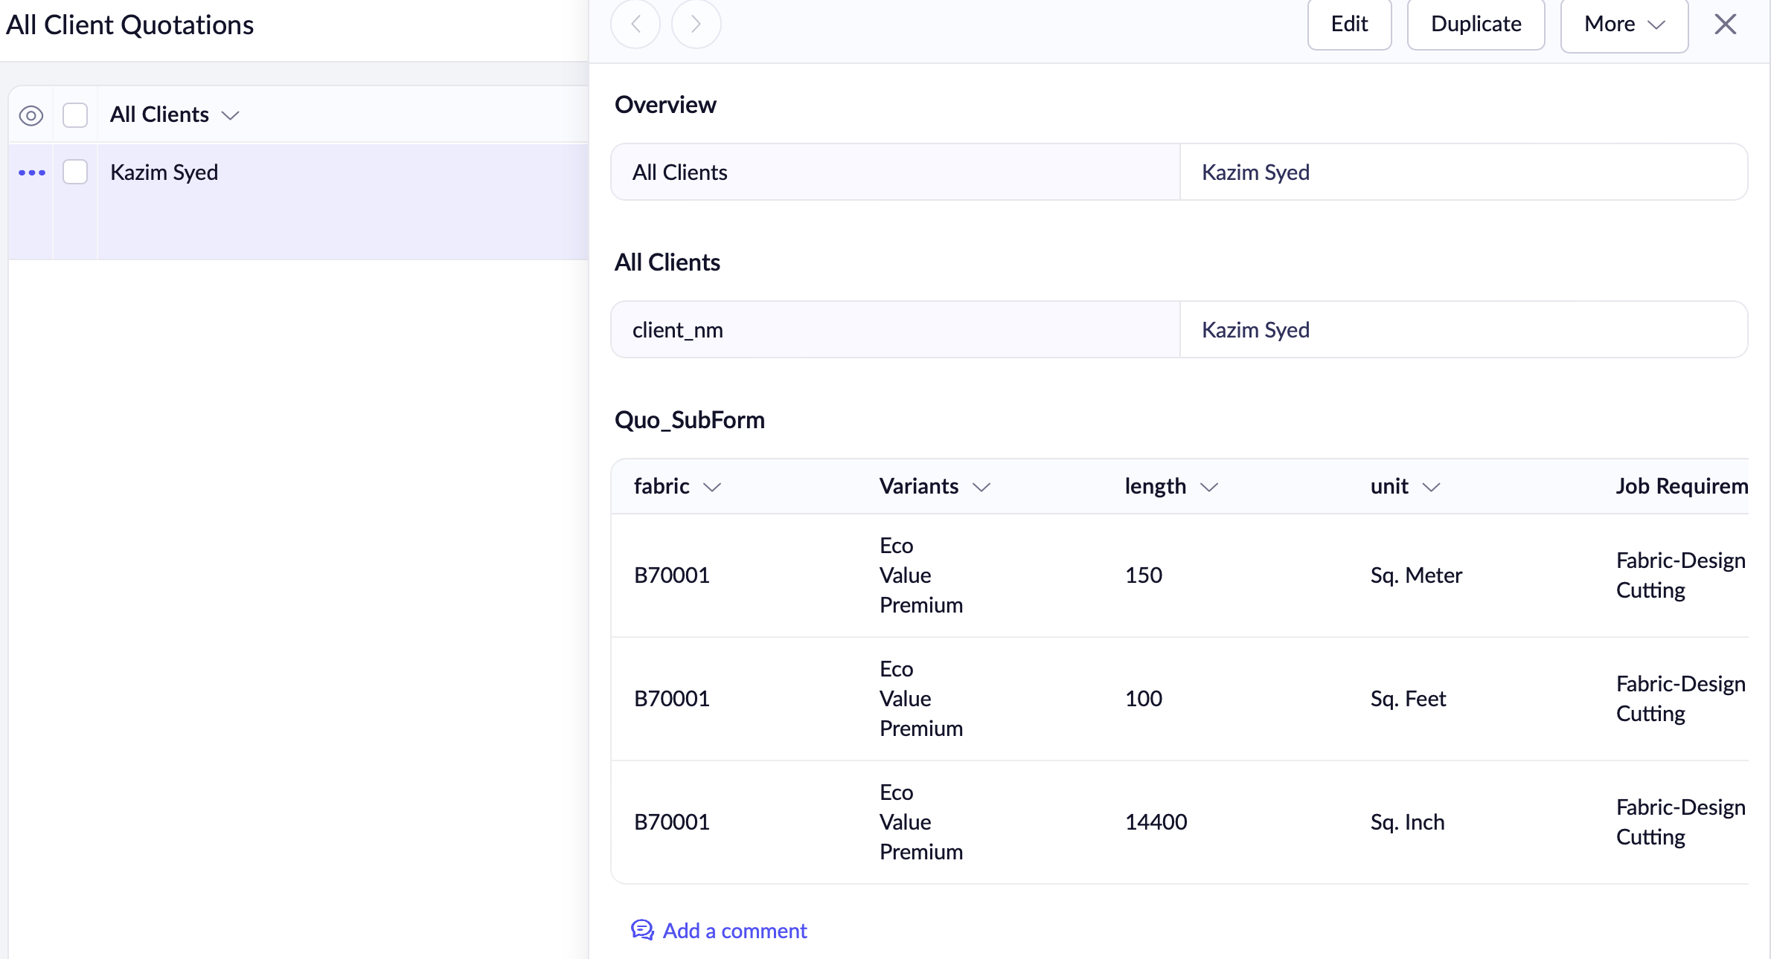

Workflow for the Automated Cost Calculation.
//declarations
in_fabric = row.fabric.fabric_code;
variants_sel = row.variants;
length = row.length_field;
unit = row.unit;

//We have taken fabrics as in Sq. Feet, so how much 1 Sq. Ft equals to the following unit.
Sqfoot2that = {"sq. inch":0.00694444,"sq. feet":1,"sq. yard":9,"sq. mile":27878400,"sq. meter":10.76388,"sq. cm":0.00107584,"sq. kilometer":10763884.28,"sq. rod":272.25,"sq. fathom":36,"sq. furlong":435600};
// rod and furlong are used in old land deeds, fathom to measure ocean depth.
//Retrieving the record, turning the argument case-insensitive.
if(unit != null && unit != "")
{
Squnit2ft = Sqfoot2that.get(unit.toLowerCase());
}

//Setting the fields(Premium, Eco, Value) in the form
if(unit != "" && length >= 1 && variants_sel.size() > 0 && in_fabric != "")
{
// Get the price of the variants based on the fabrics.
for each var in variants_sel
{
try
{
entry = thisapp.setPricePoint(in_fabric,var,length,Squnit2ft);
if(entry == 0)
{
continue;
}
}
catch (e)
{
alert "That fabric variants isn't available";
}
if(var == "Eco")
{
row.Eco=entry;
}
else if(var == "Premium")
{
row.Premium=entry;
}
else if(var == "Value")
{
row.Value=entry;
}
}
}
else
{
alert "Make sure to provided the following fields \n fabric, length, variants, unit";
}

if(row.Job_Requirements.size() > 0)
{
cos_multiplicant = 0;
for each e in row.Job_Requirements
{
records = LTM_Services[Service == e];
if(records.count() > 0)
{
cos_multiplicant = cos_multiplicant + records.price;
}
}
row.cos=cos_multiplicant * length * Squnit2ft;
}

I have equipped myself with a function to do the calculation for each variant cost
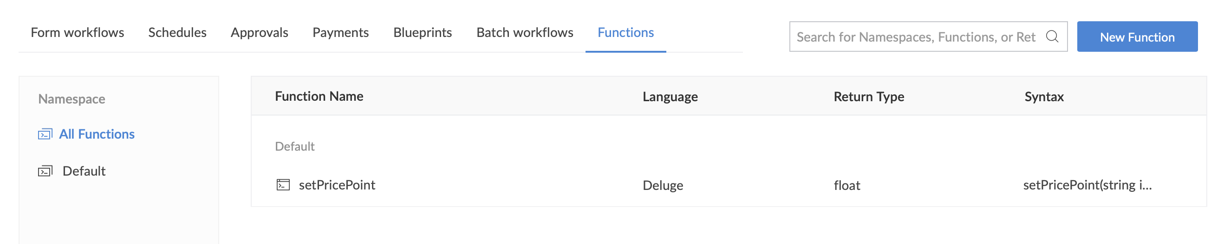Figure 1: Use of a function for cost Calculation
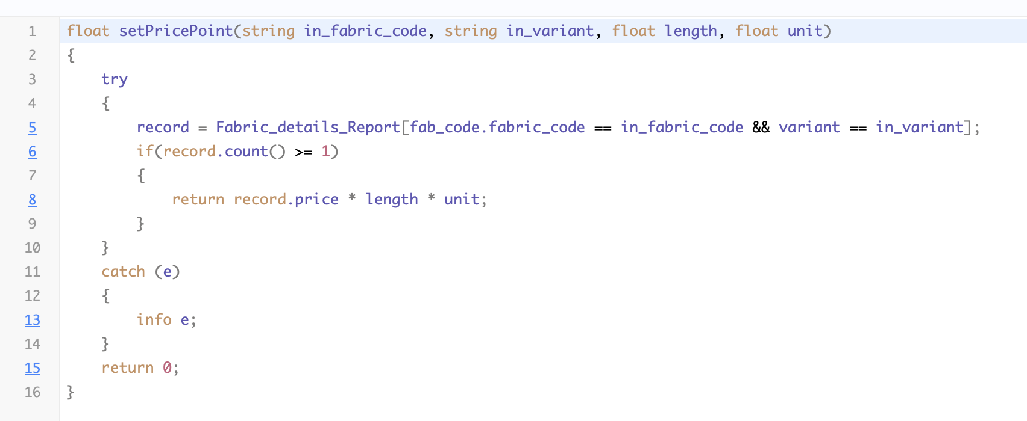

Pretty format in deluge workflow
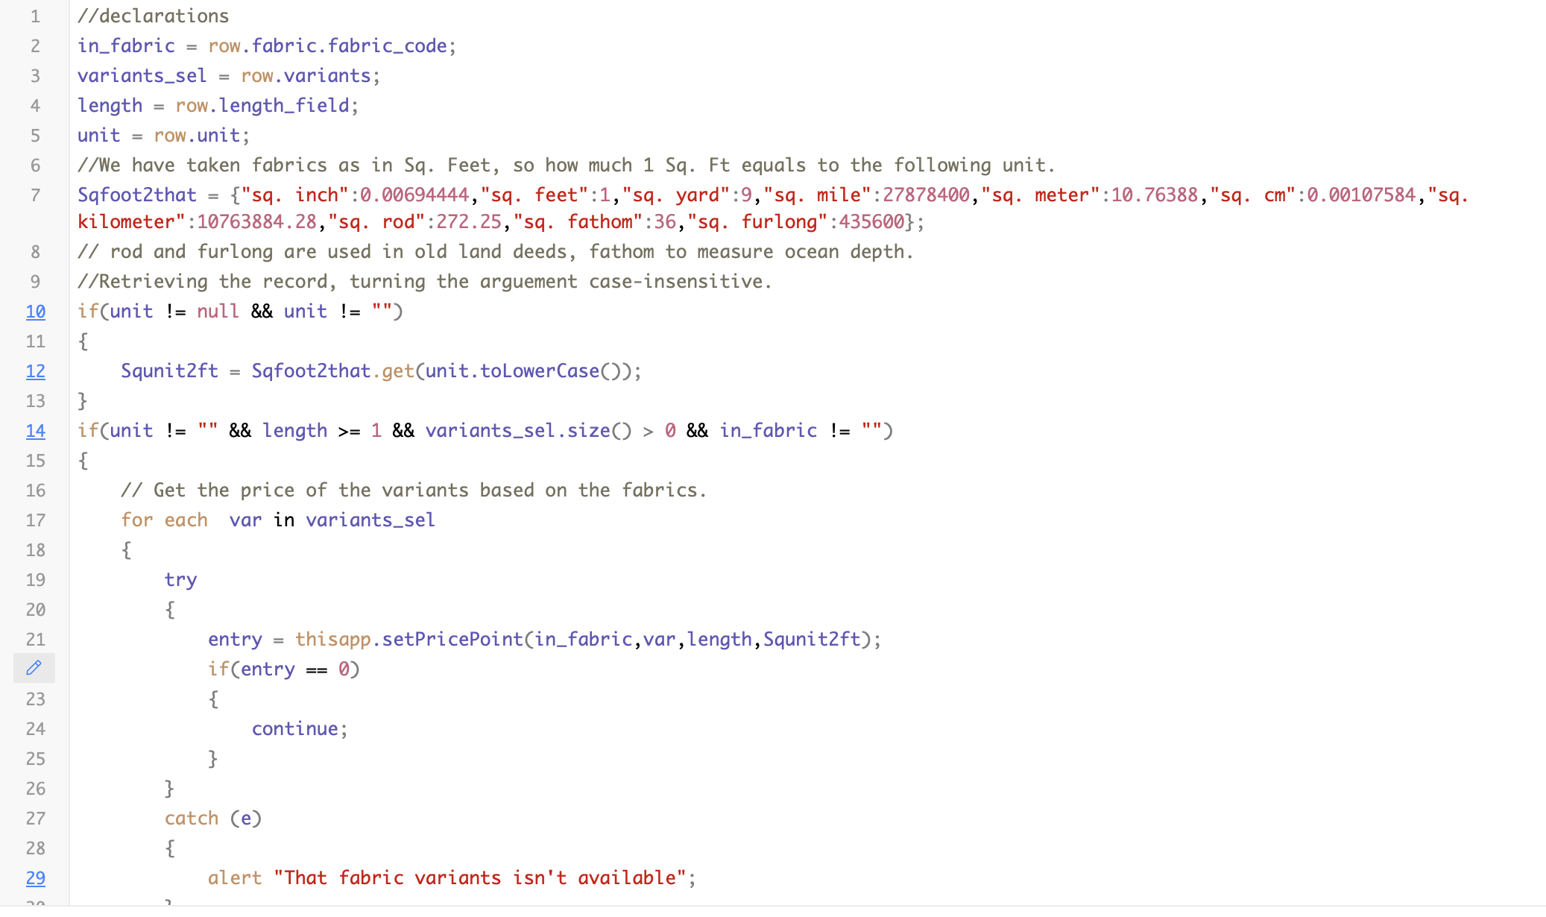
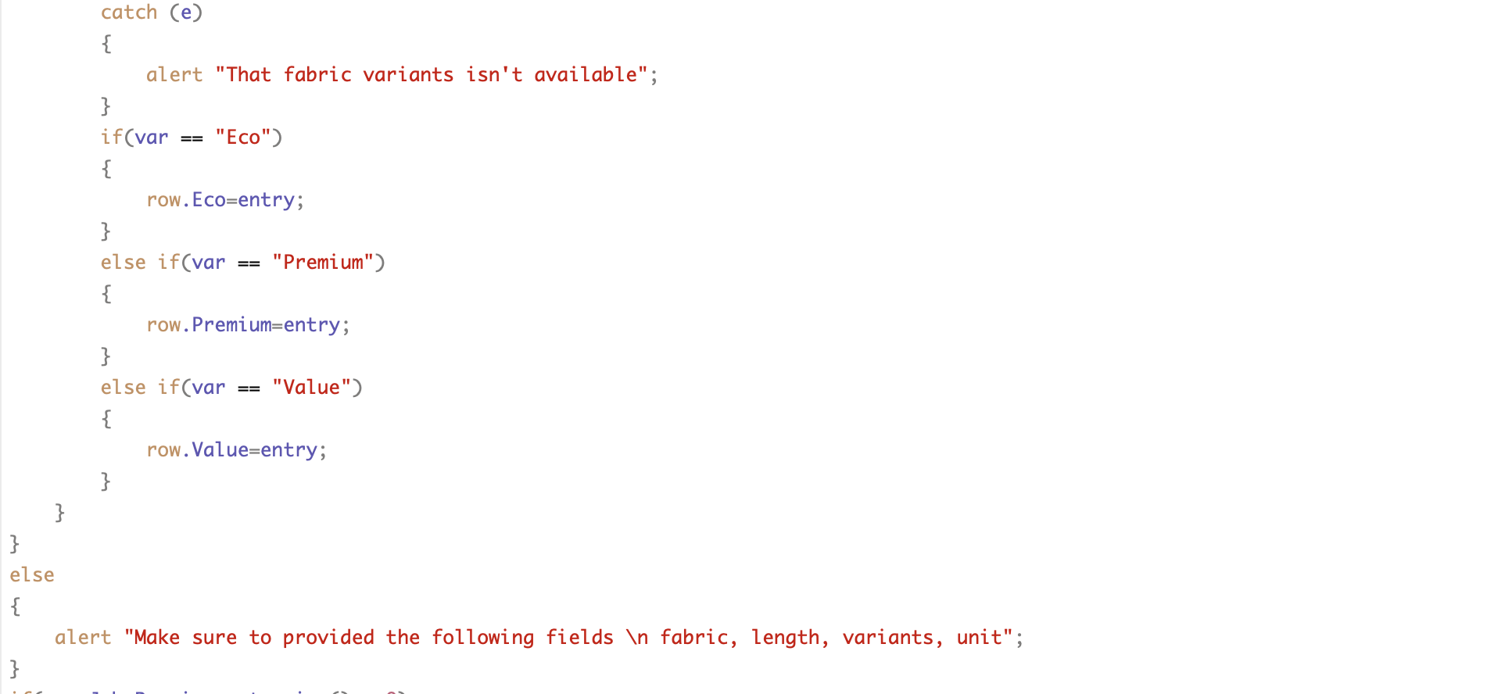
Continue

Setting the Job Requirements
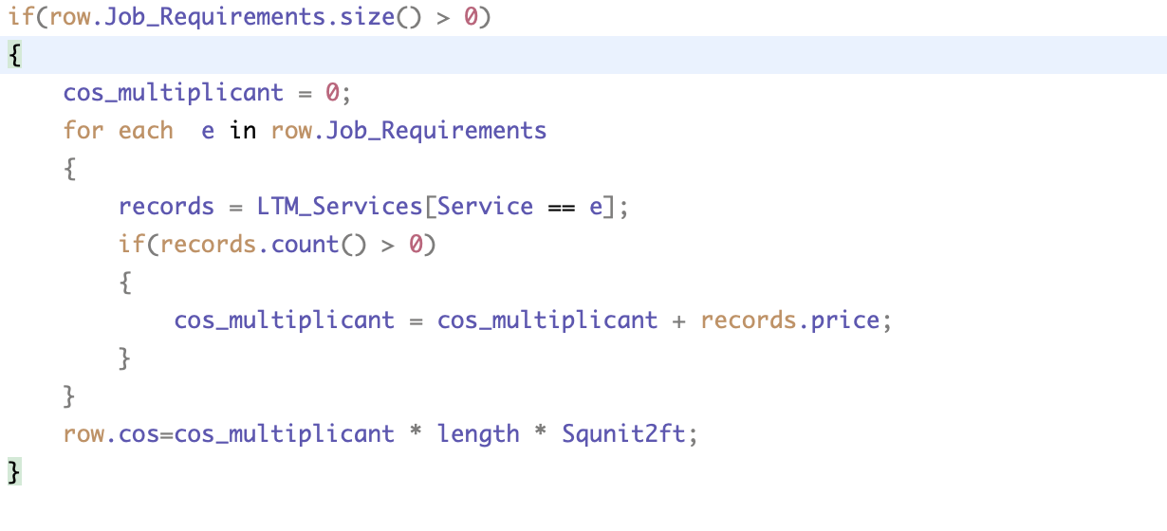
Output:
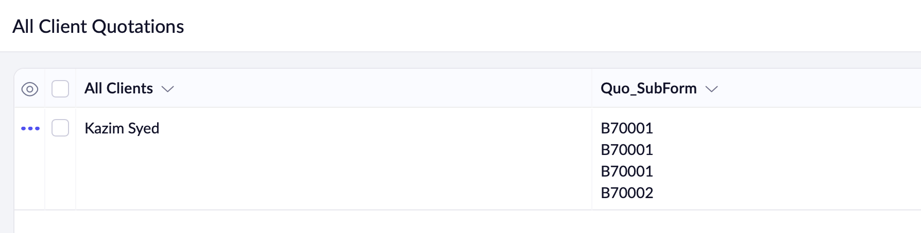
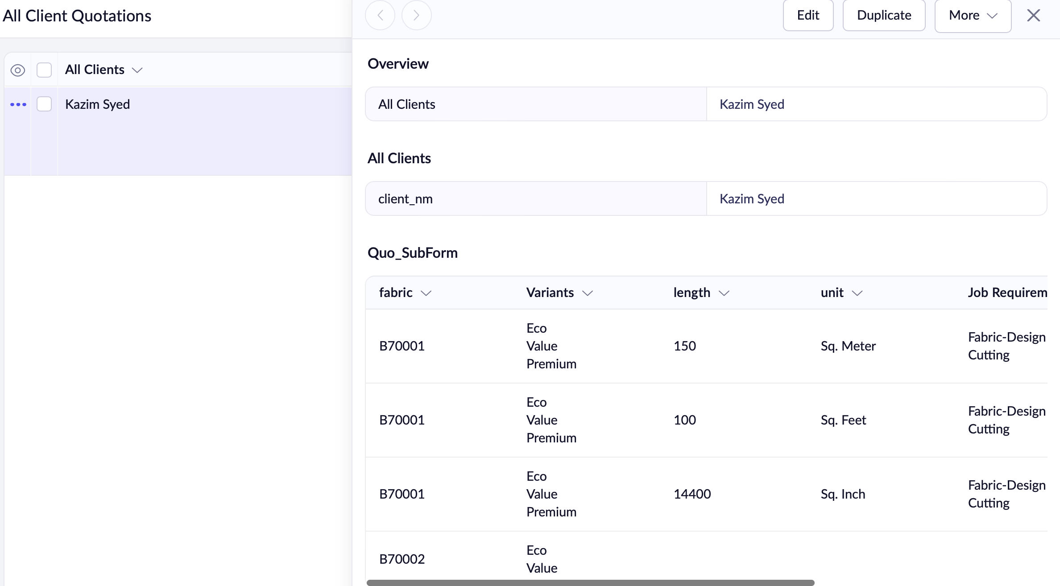

Within Quotations form:
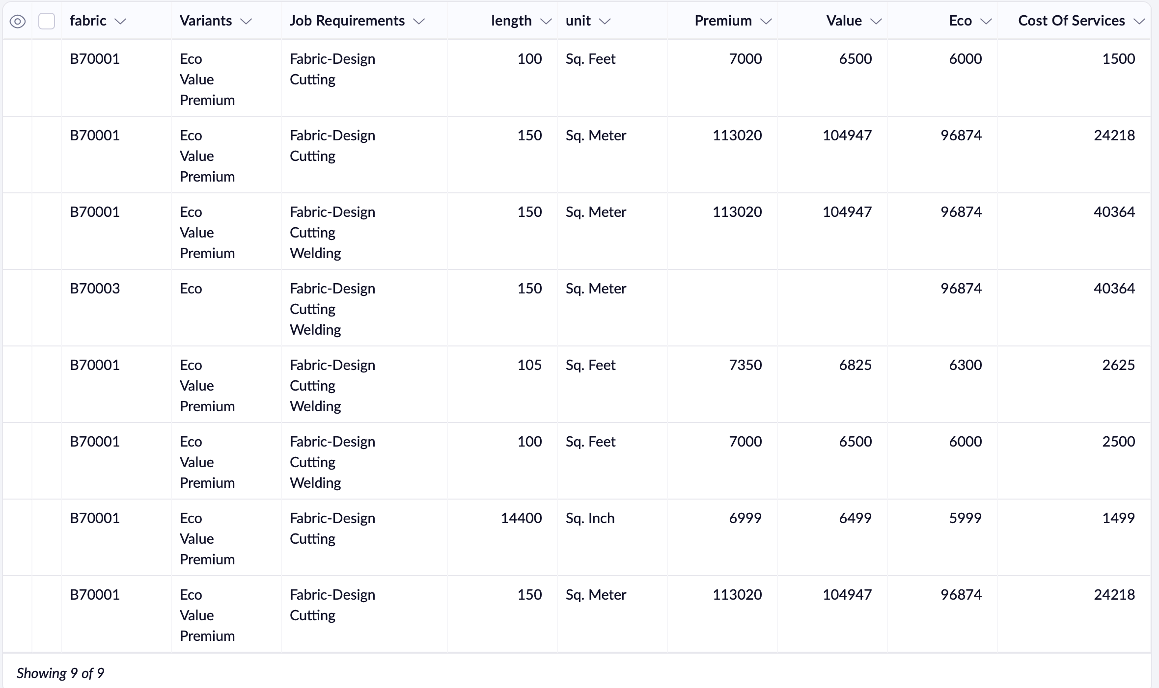Figure 2: Look at 150 Sqm and calc for eco.
Note:
- Ability to handle different units
- Multi-select variants are dynamic
- In the blue u can see the conversion is working properly, the discrepany of 1rs is shown between the two records. Due to zoho limitations.
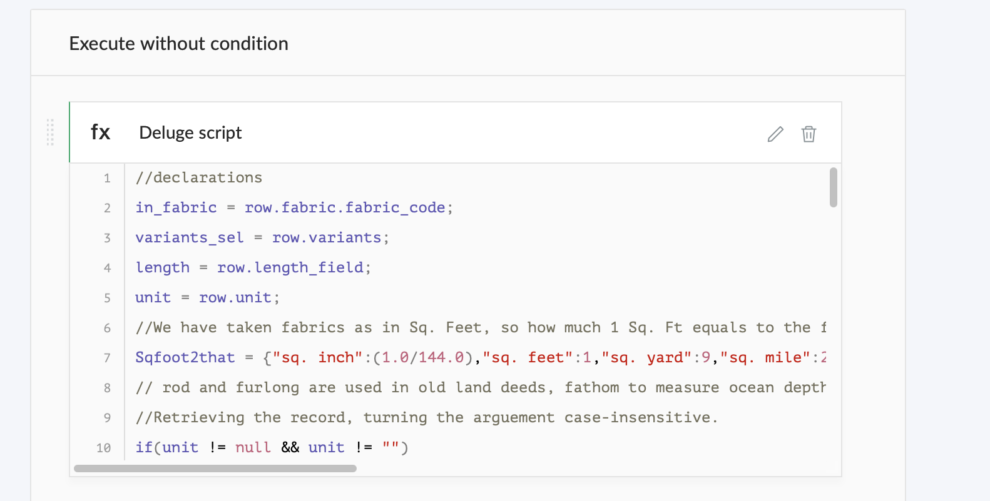Figure 3: To handle units precisely. I have used (1.0/144.0) for accuracy. For Sqinch to Sqfeet conversion.

Dynamic Variant workflow
A workflow → Dynamic Variants triggers whenever user creates or edits a field (fabric).
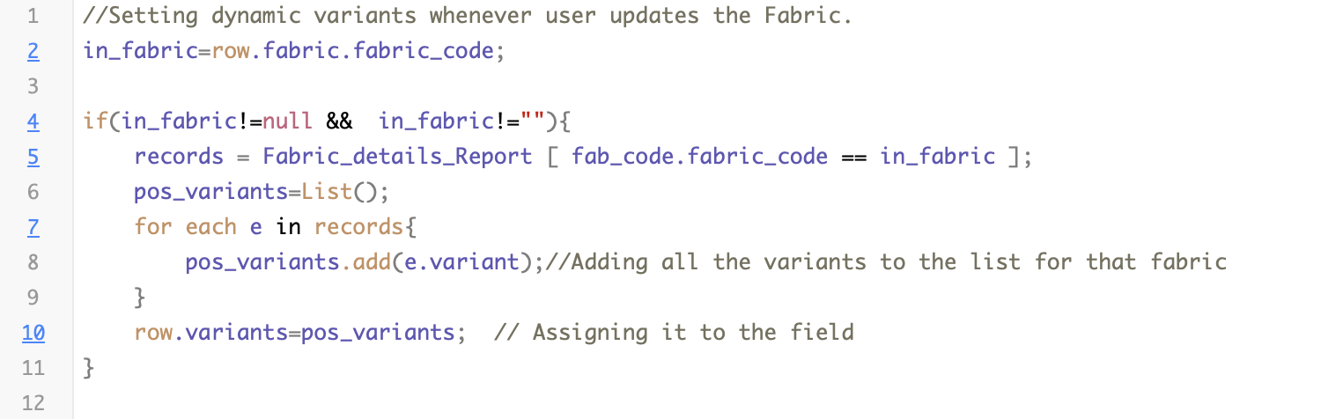
Output:
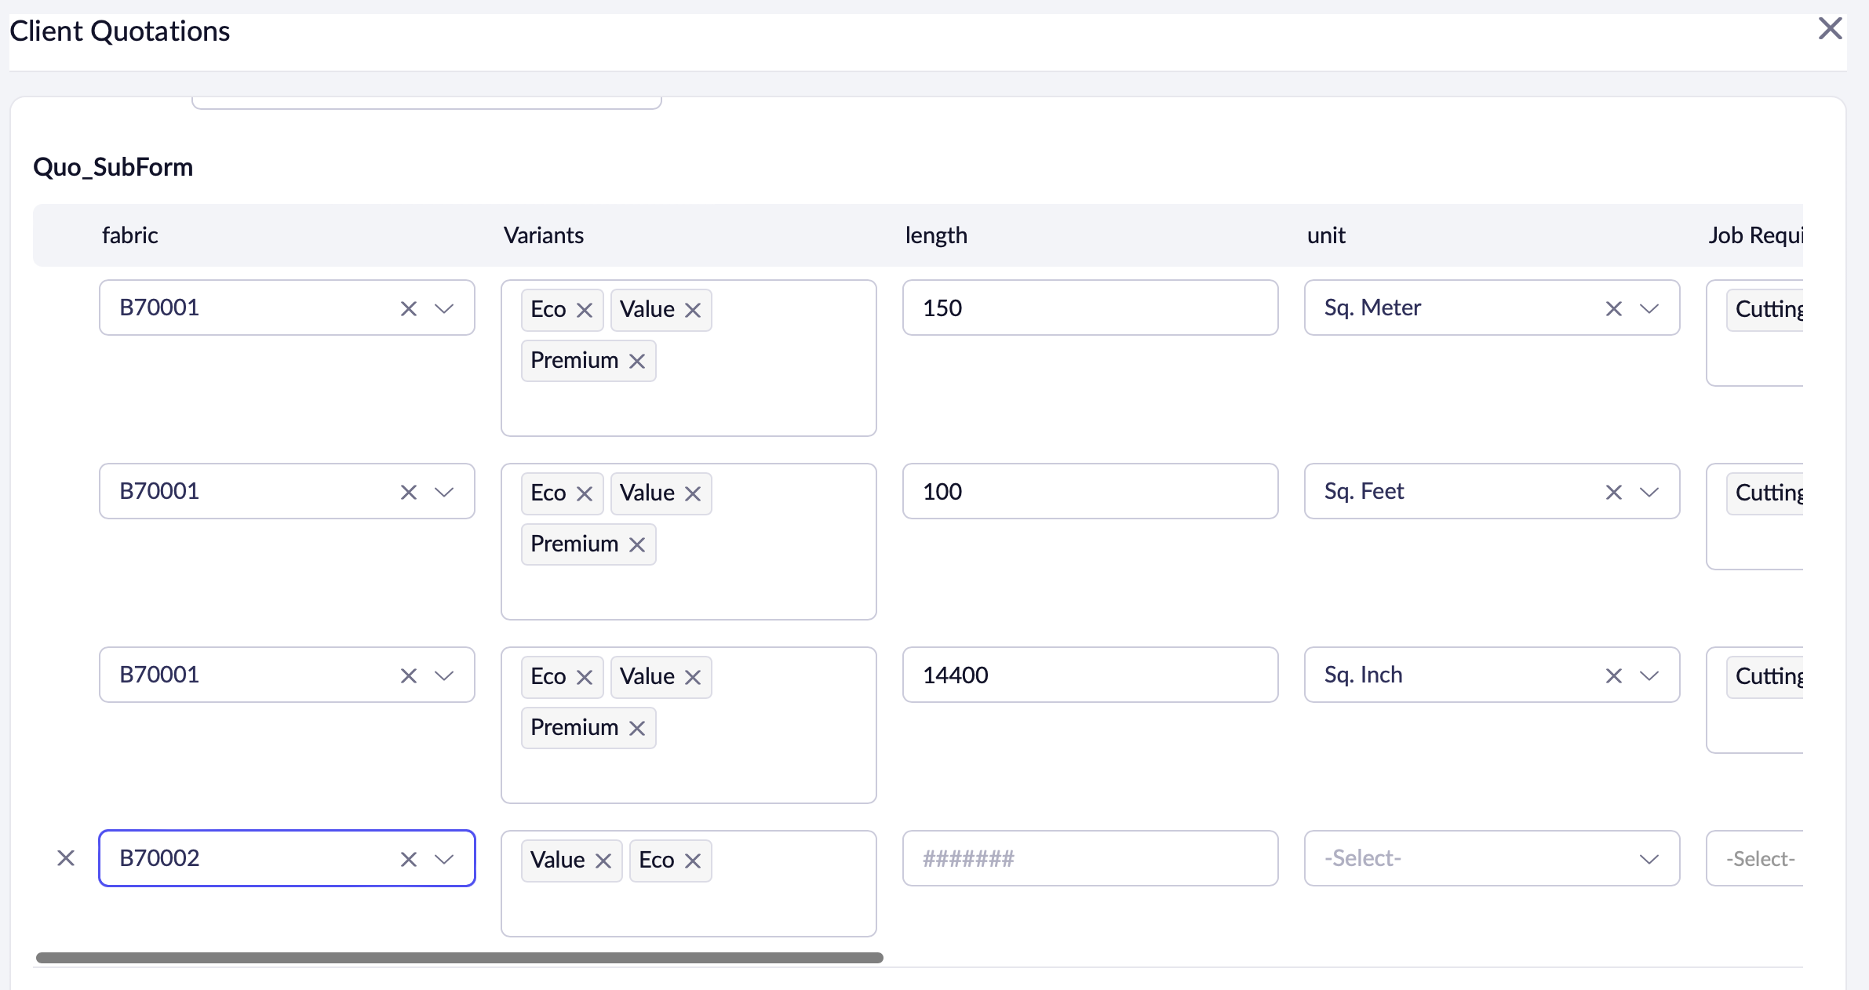Figure 4: Dynamic variant successful

Closing remarks
- I have successfully applied subforms for my client Quotations
- I have used workflows and Application wide Custom Functions for price Calculation based on parameters like (Fabric, variant, length, units)
- I have made the multi-select variant options dynamic.
- Any record that is entered in Client Quotations can be seen in the form All Quotations as record.(Note I understand better naming is needed for that Subform).

Kind Regards:
Kazim Syed
+91 8779 81170
kazim.mohdsyed@gmail.com
kazimsyed9911@gmail.com

Cover letter
I accidentally deleted the form and have the scar tissue of having my workflows getting deleted and I am surprised of my generate my code better than previous iteration and learned the hard truth of not being able to recover forms. Also I have went beyond the expectation to incorporate extra difficulty into the project like shopping and logistics. And putting html snippets into pages like
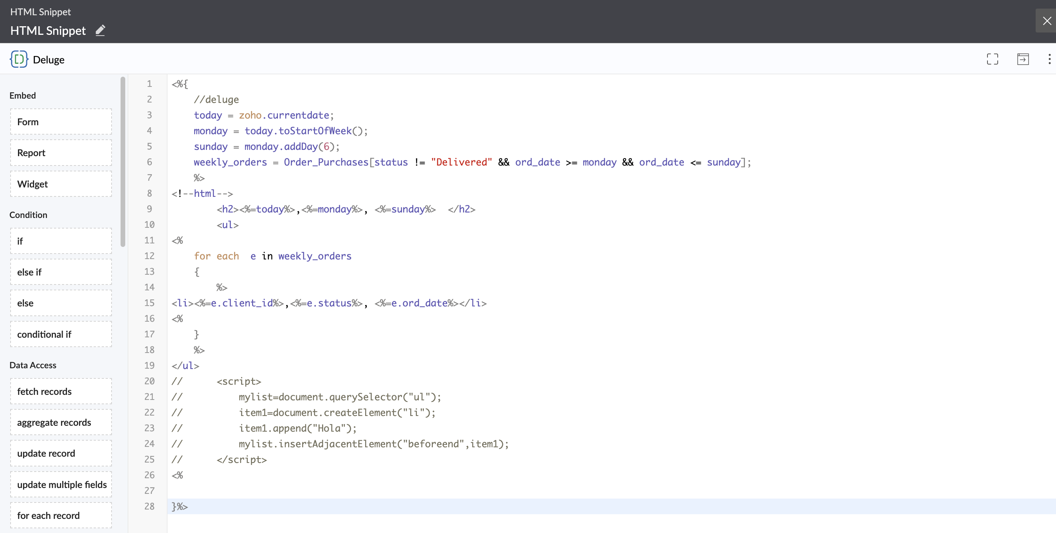
Thank you for your time!

