Zoho developer
subtitle

Heading 1

Heading 2

Heading 3

Heading 4

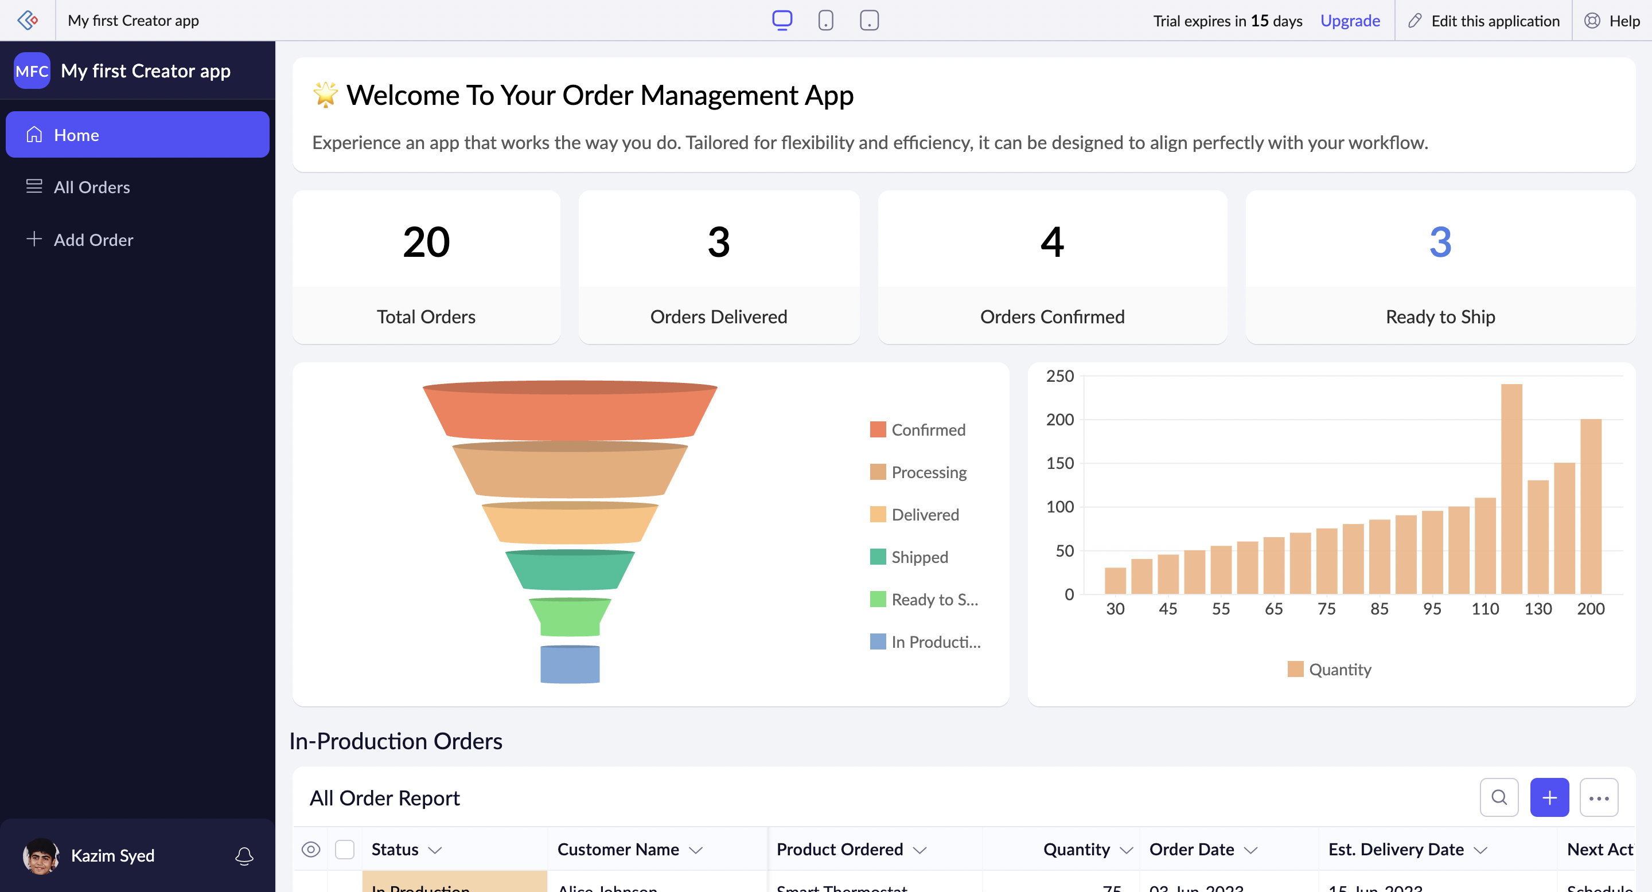 | 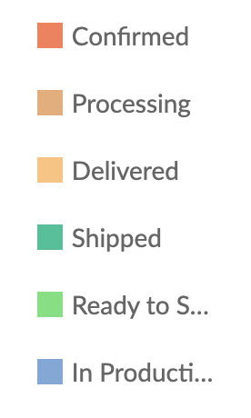  In Production → Ready to ship → Shipped → Delivered → Processing → Confirmed.
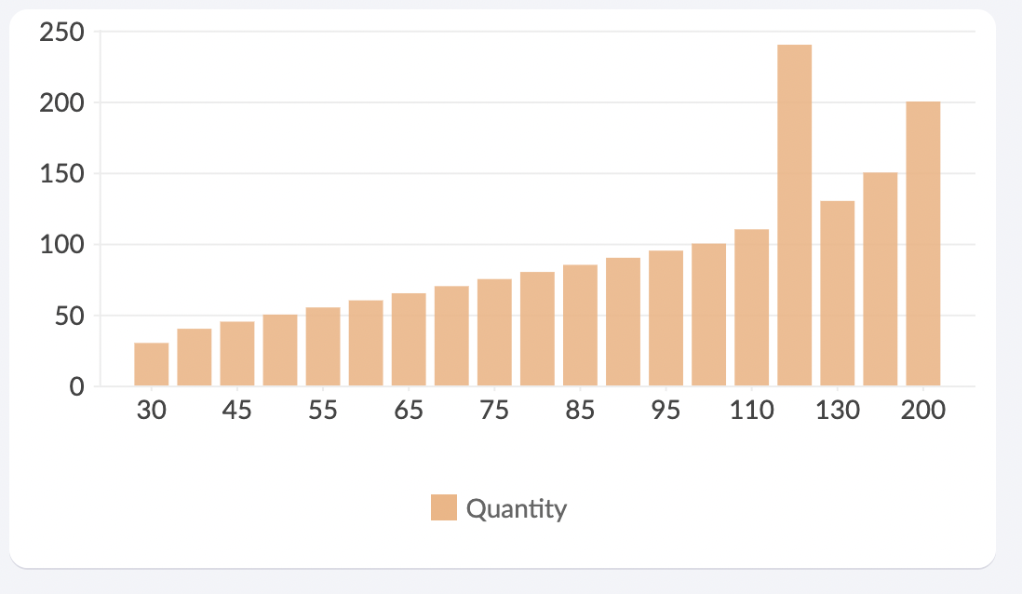 | 30 Means size of 30 orders.  For 120 Since there are two order with size 120, its 120:240. Which tells there are two orders of size 120.
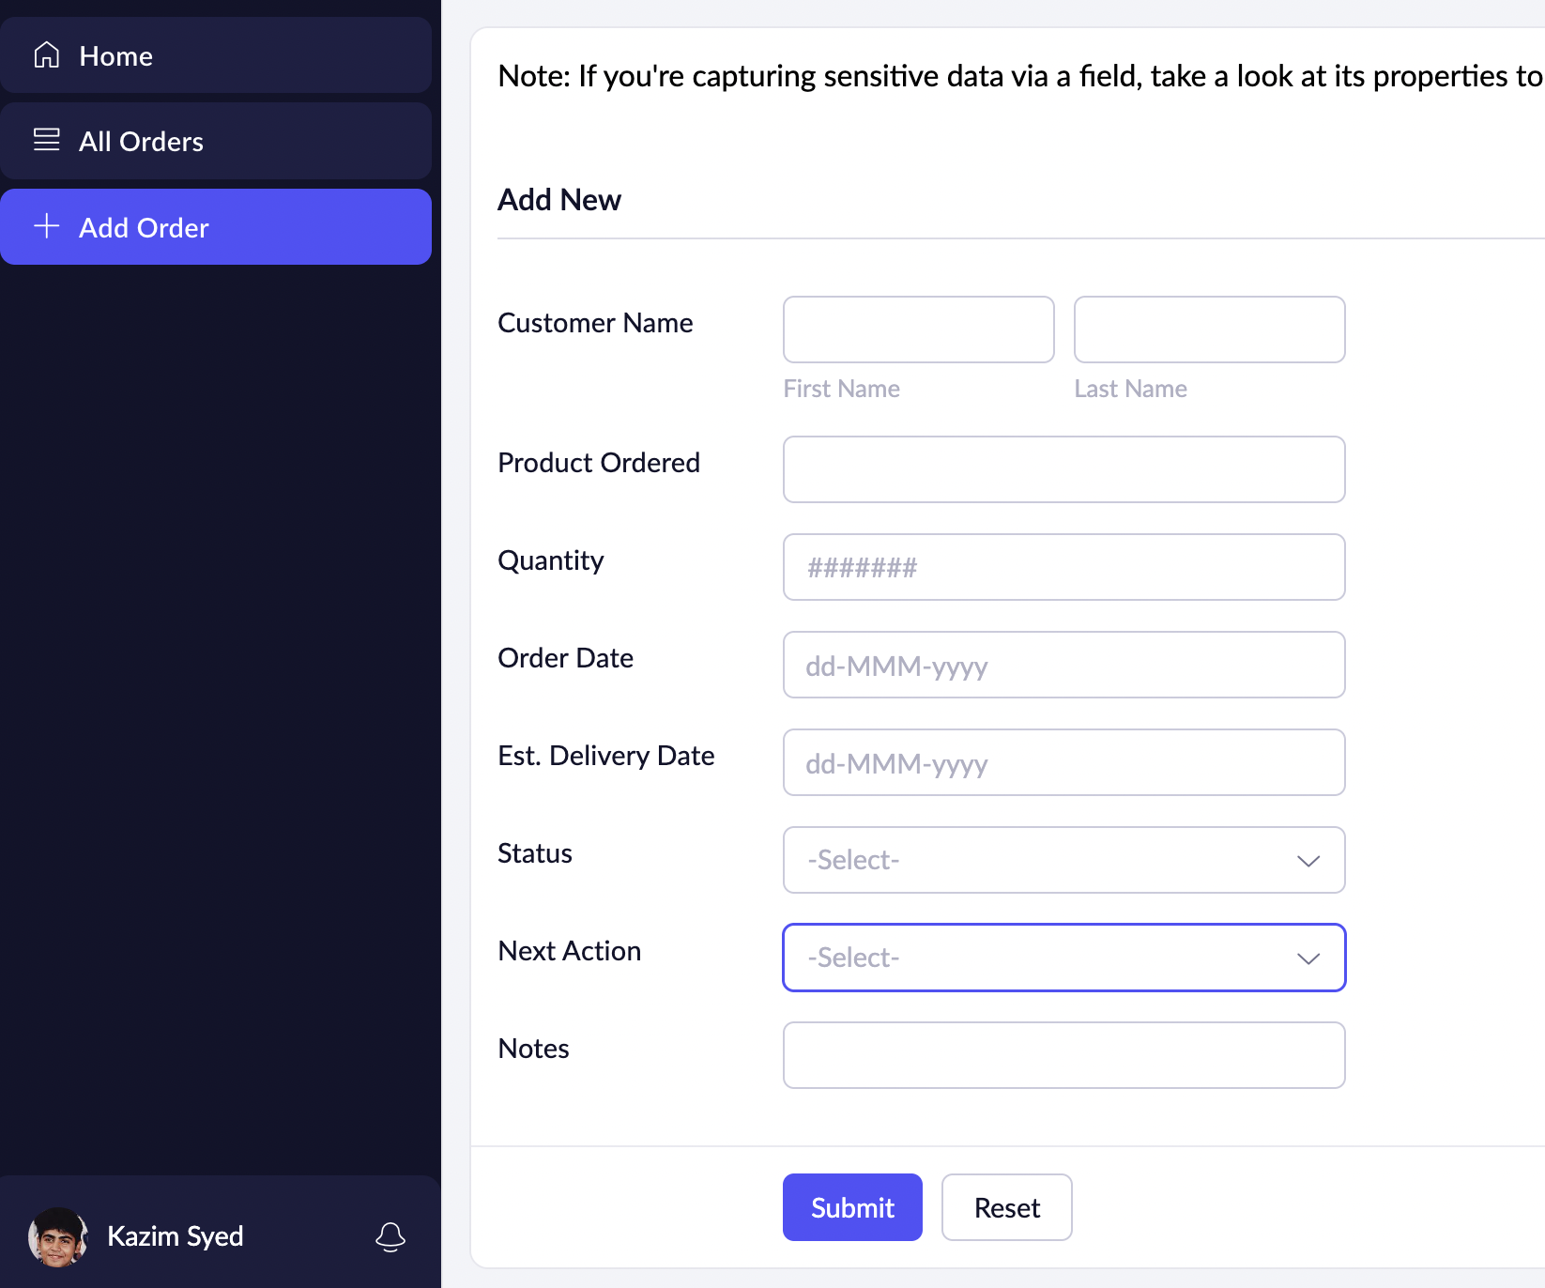 | 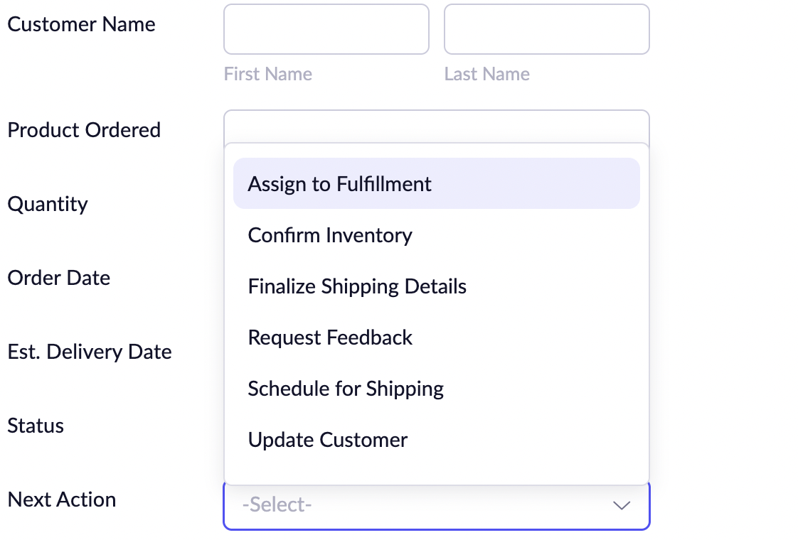  Status and Next Actions are drop-downs.

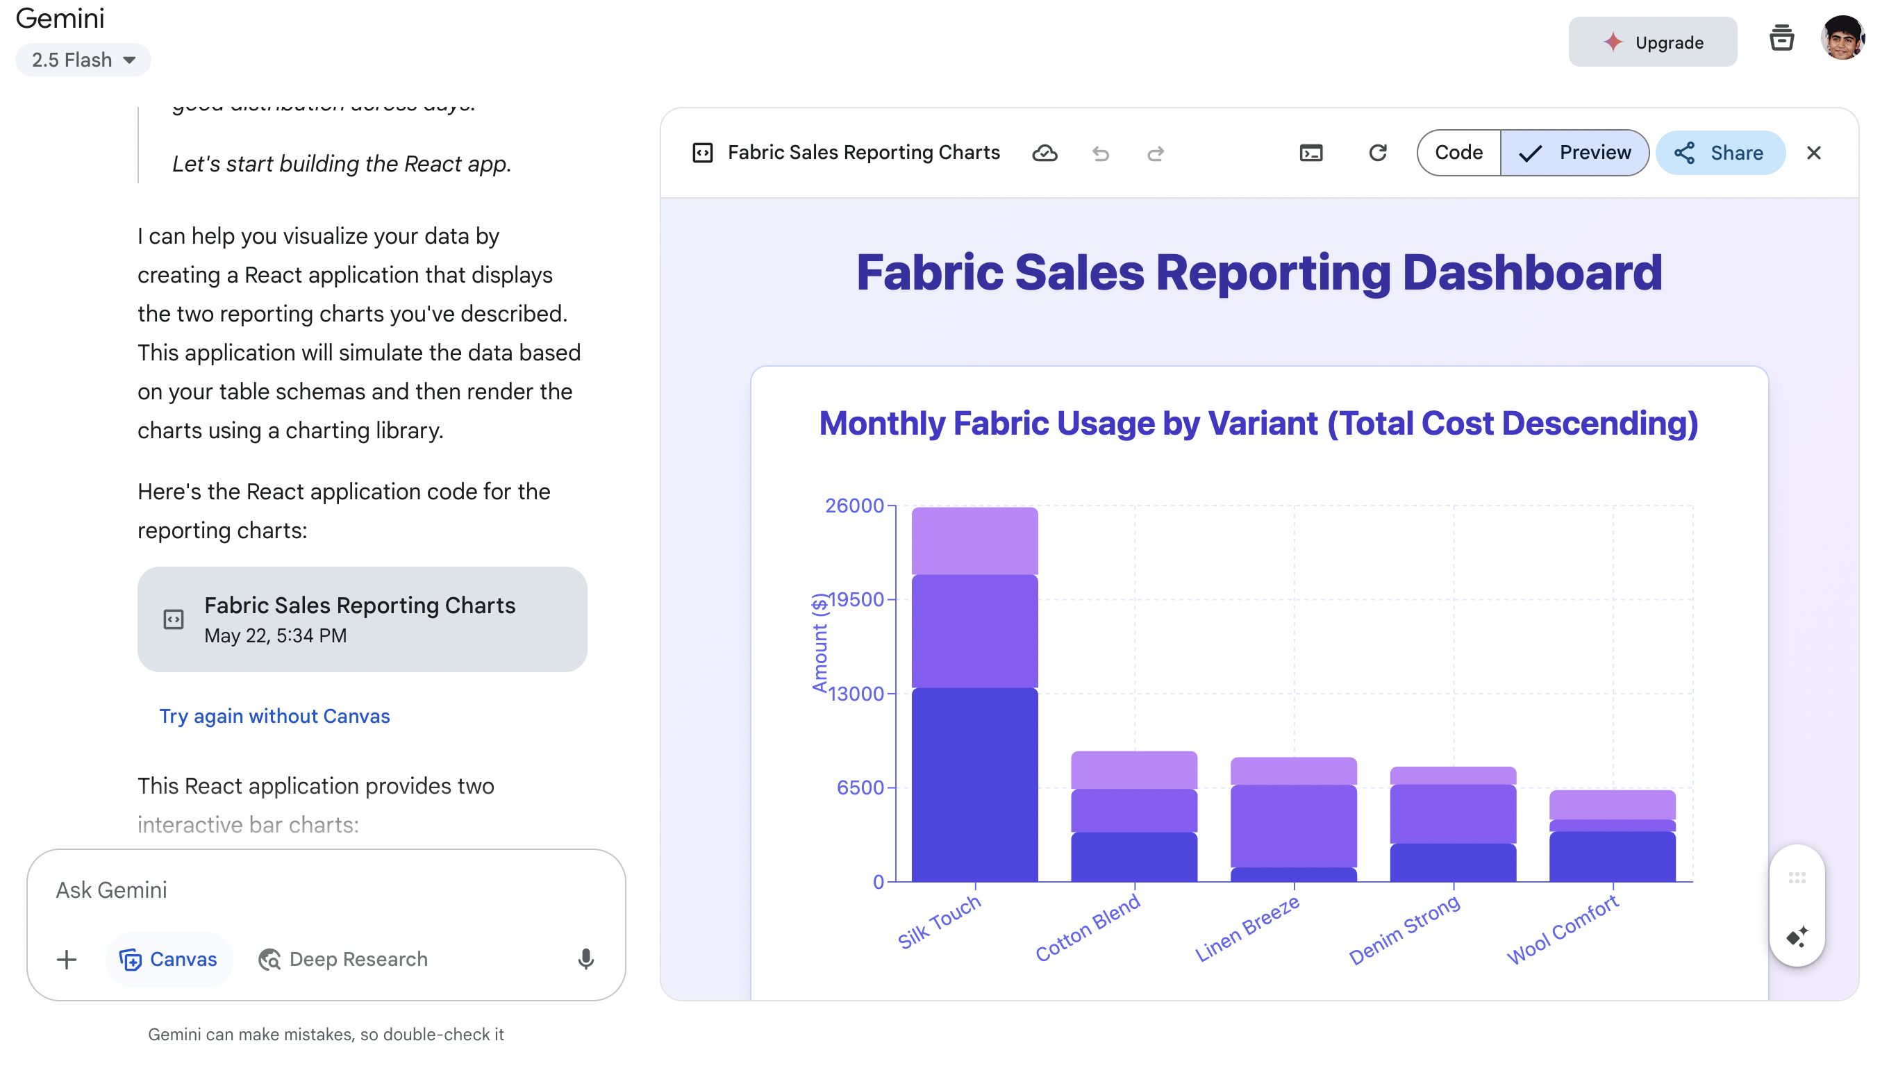
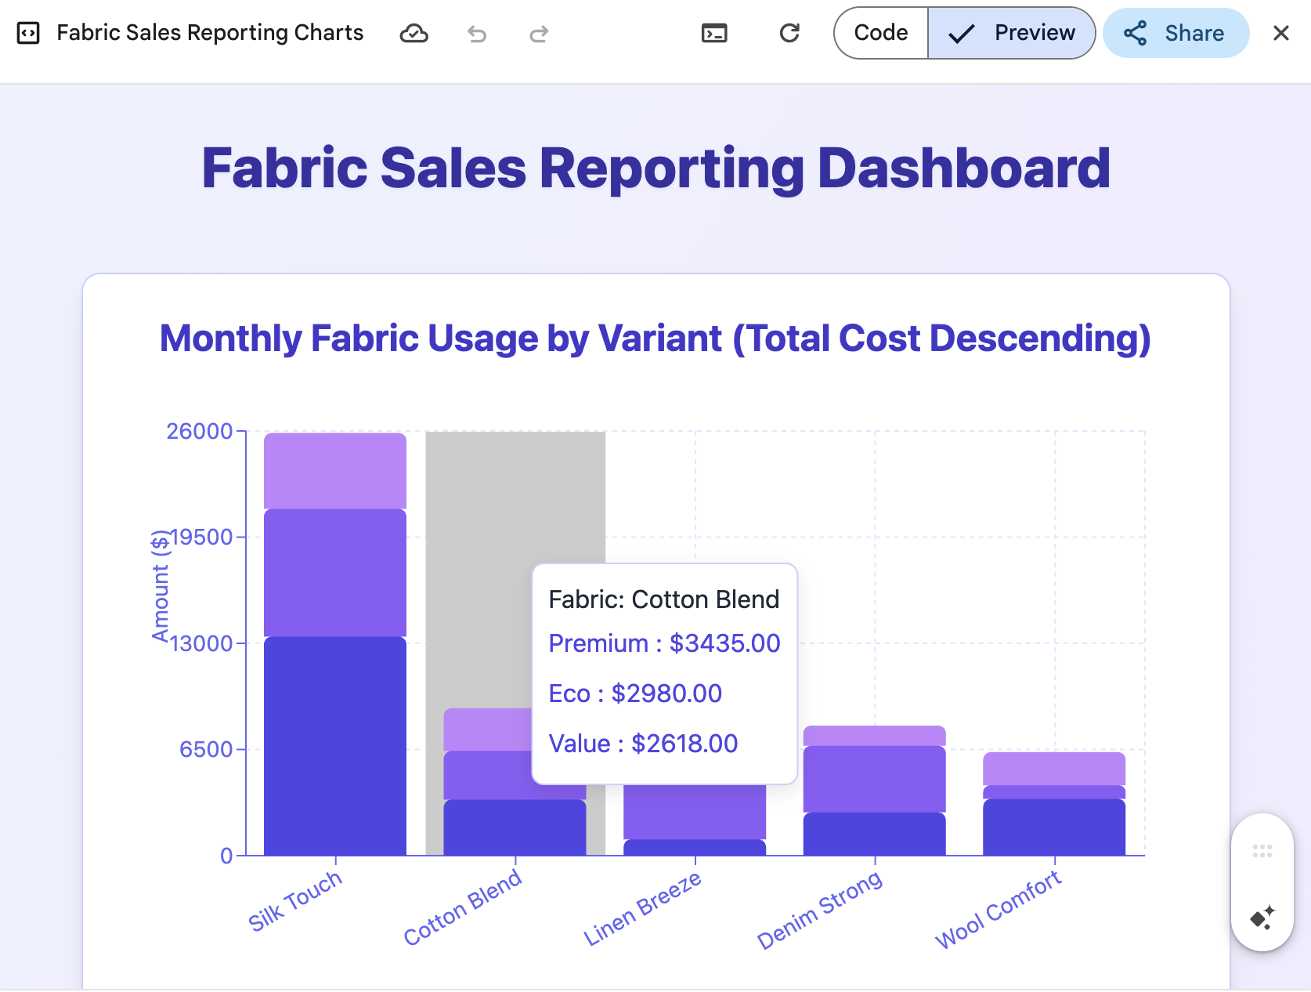

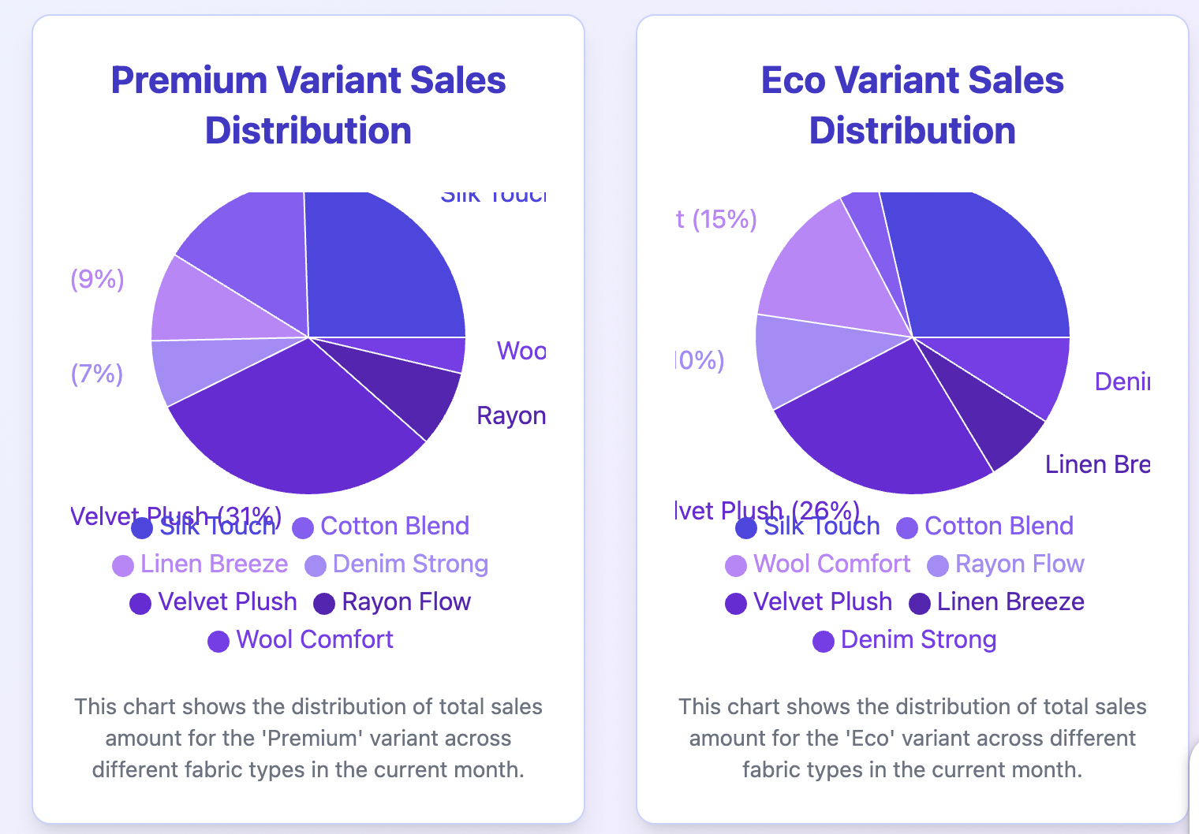

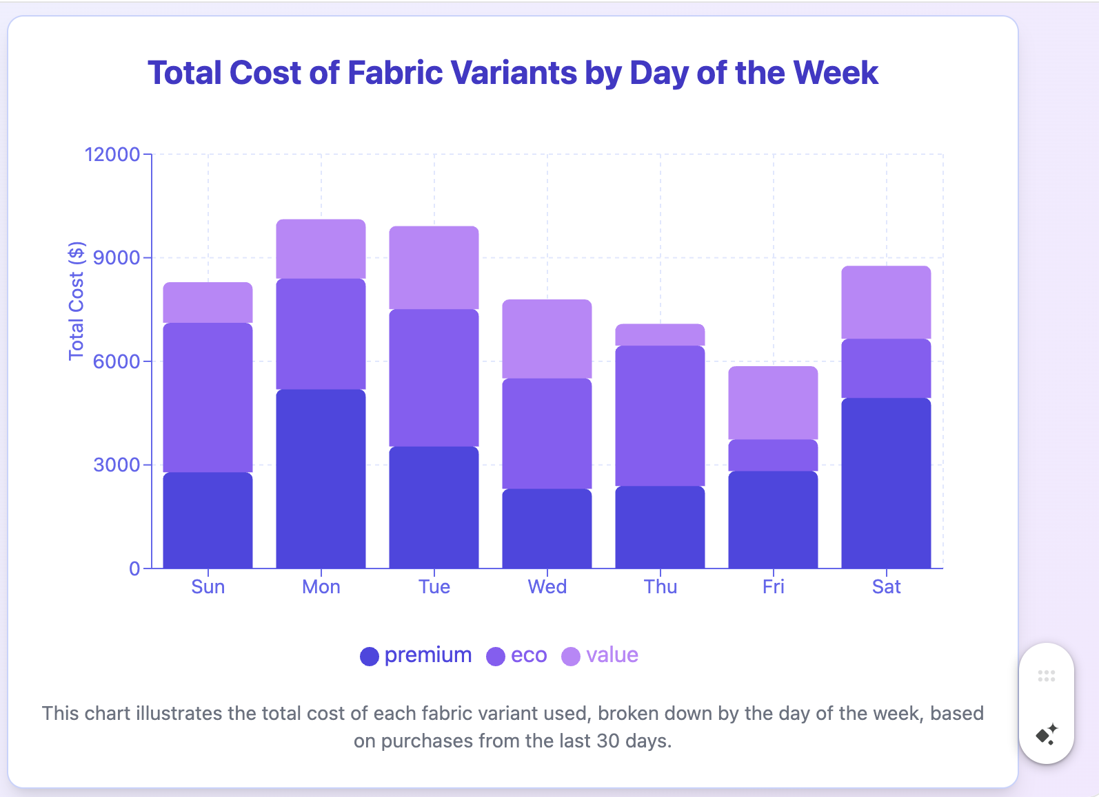

Lec 1. Getting Started With Zoho Creator Part 1 - App and Form Creation
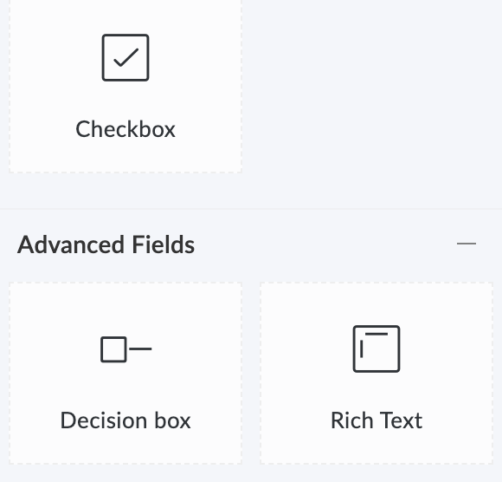

Decision box is differen than checkbox. Its a boolean whereas checkbox is a multi-select. It is helpful for trigger actions or trigger layout rules.
A user field either can be a internal portal user or customer user. Customer user referring to Customer portal. Within creator we can have an internal application but we can also deploy a customer portal. So we could link records to customer within that customer portal.

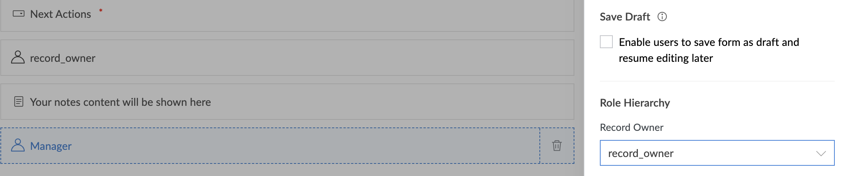 | Manager tab → press setting icon  → Role heirarchy is set to record Owner. Who should have the permission to see the record and Manager sees All.
Geo fence: maybe they have to be certain range to access this form. | 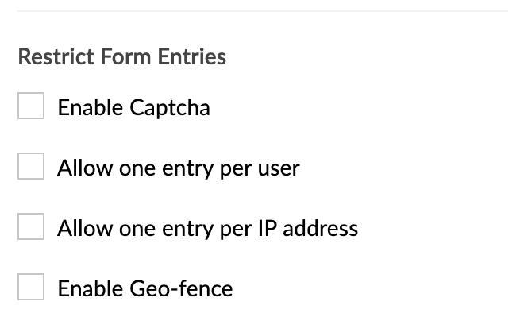

Getting Started With Zoho Creator Part 2 - Create Custom Pages
In Custom pages, u can have dashboards, embed certain components. U can embed certain buttons so its easy to quickly access reports. Dashboard can be view in Desktop as well as Mobile view.
Target indicators and some daily reports.
Lets add components, A component can be a panel. A panel can be a datapoint that u wanna show. That datapoint can either be a static value that shows for everyone.

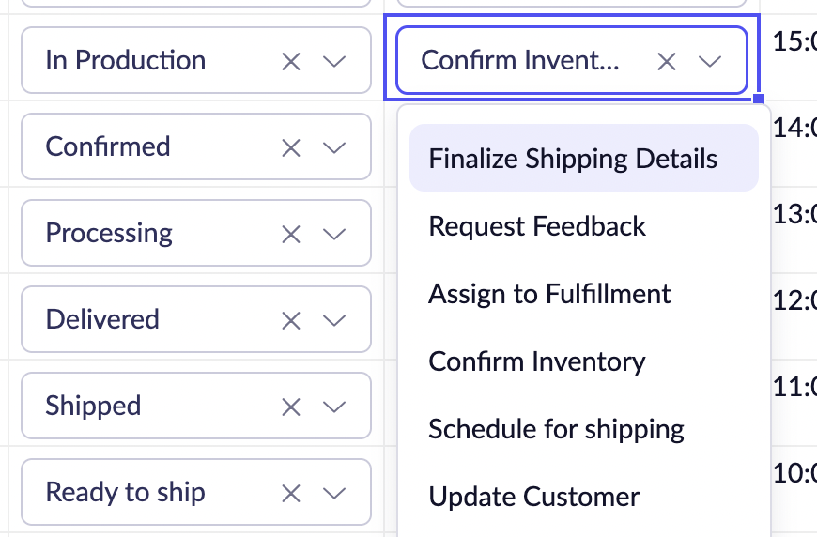 | 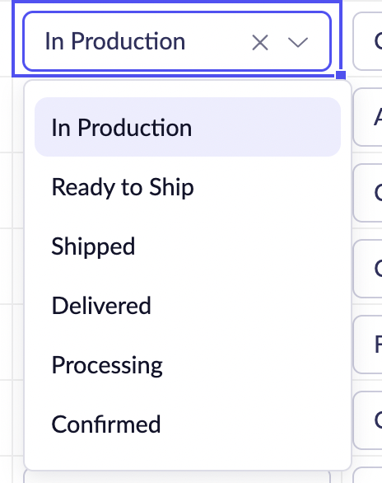

How to set an Action on the Panel
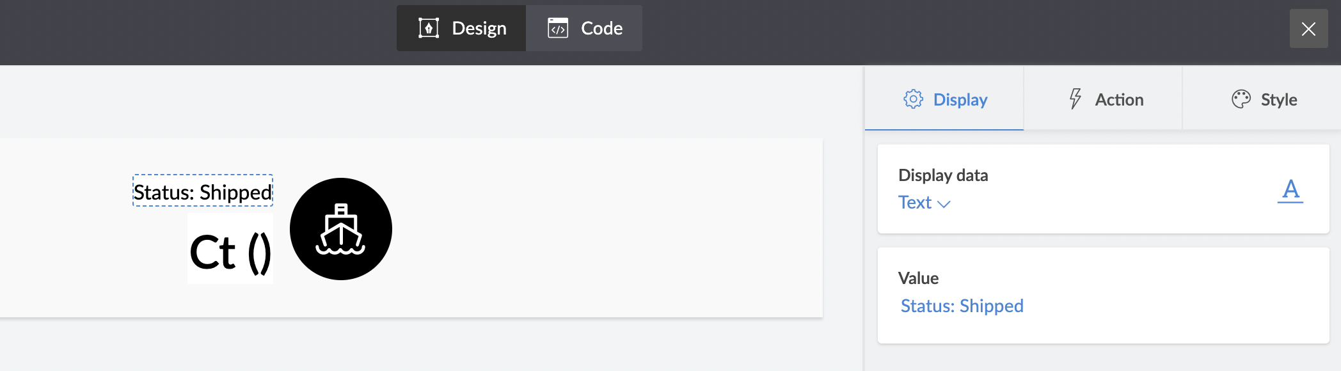

snippets allows you to embed html components. You could use zml which is zoho’s xml style coding which incorporates deluge. Html could also incorporate deluge to make ur html dynamic. Dynamic html that is gonna open a thing based on the page you are on.

--
/*
Note line 4
// Zoho creates this structure in memory:
when we do a lookup, it does for only one field at
a time.
input.fab_code is a lookup field.
input.fab_code.price will fetch the price for the record.

input.fab_code = {
id: "12345", // Zoho's internal ID
fab_code: "FAB1001", // Actual fabric code
fabric_nm: "Cotton", // Fabric name
owner: {...}, // Other standard fields
created_time: [...] // Metadata
// Plus any other fields from Fabrics_Master
}

// Only insert the values when these fields are known

if (input.fab_code != null && input.variant != null) {

cacheKey="fab_" + input.fab_code.id + "_var_"+input.variant;

//Check if the cacheKey present in Cache
if(zoho.appcache.contains(cacheKey) ){
input.price=zoho.appcache.get(cacheKey);
}
else {
//get the record in fabric_details
fabric_records = Fabric_details [ fab_code == input.fab_code.fab_code && variant==input.variant ].price;

//if there exists a record
if(!fabric_records.isEmpty()){
//fabric_records is an Array.
input.price=fabric_records.get(0).price;
}
else{
alert "No price found for: " + input.fab_code.fab_code + " - " + input.variant;
input.variant=null;
input.price=null

}

}

}
else
{
//do nothing
}
*/

Getting Started With Zoho Creator Part 3 - Create Custom Reports
You can use report to create actionable items.
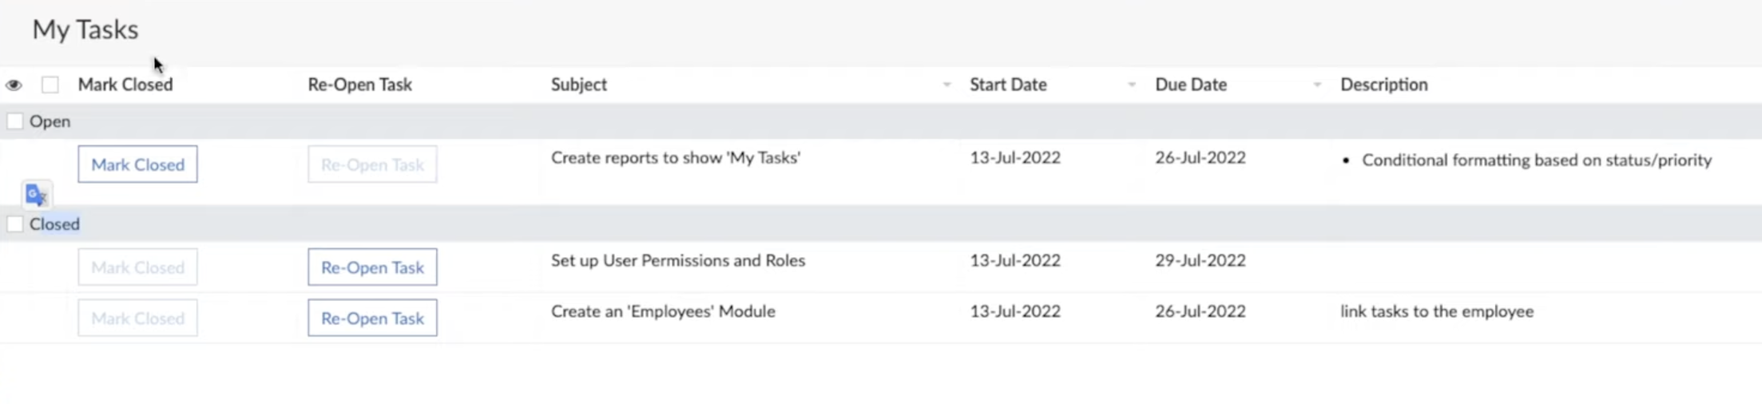
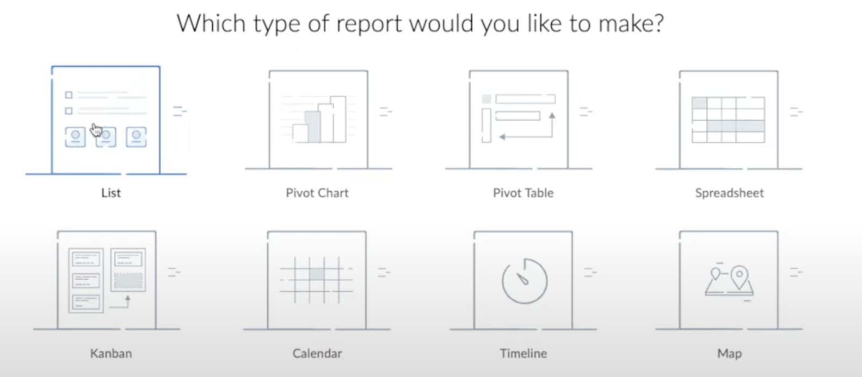
pivot chart and pivot table uses zoho analytics.
In spreadsheet, u can edit information about a task without opening them. The biggest limitation is that u cant have any workflows working on them.

--

- Filter: filter the report table
- Quick filter: More efficient than search.
- Custom filter: A report that filters on filter

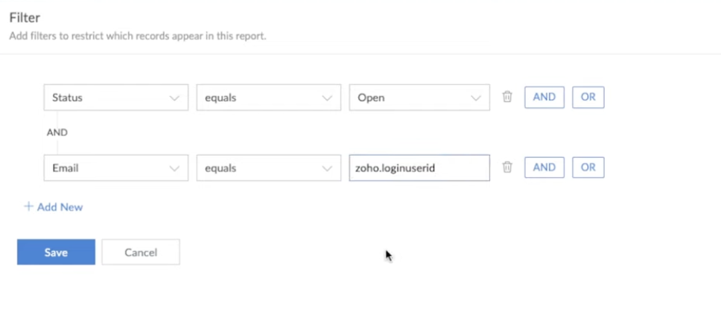
This will make sure it will only show form data for that user only.
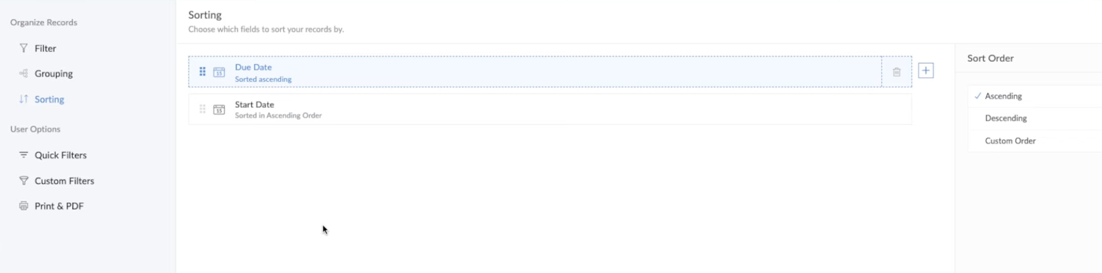
This will do pipeline sort.

You can on top of it use another filter that is Quick filter.
Custom filter, u can access it.

How to Link Zoho Creator Forms to Zoho CRM
Pending

How To Style Your Zoho Creator Pages Using HTML & CSS
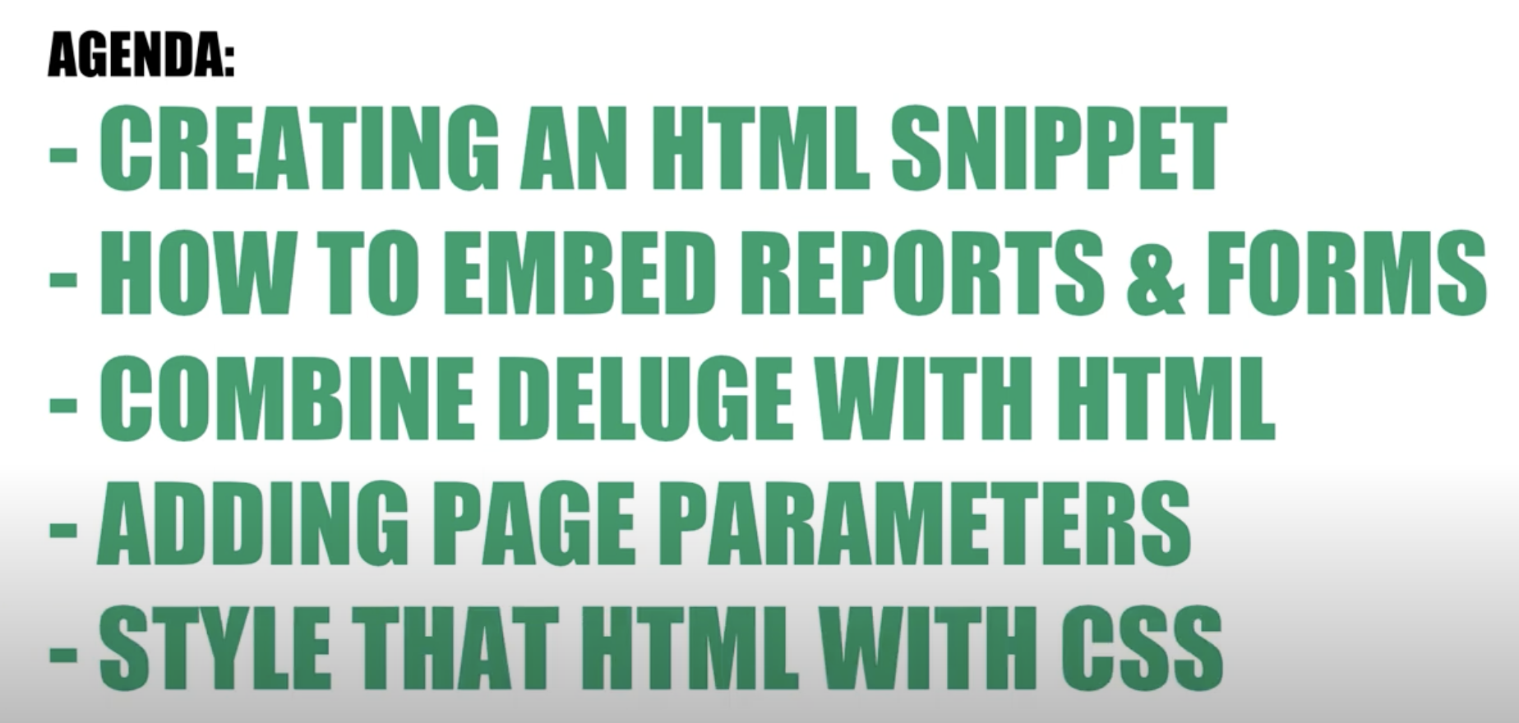
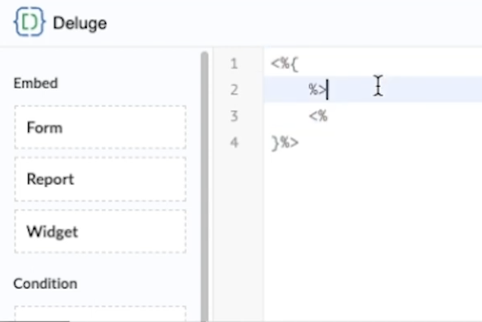

--

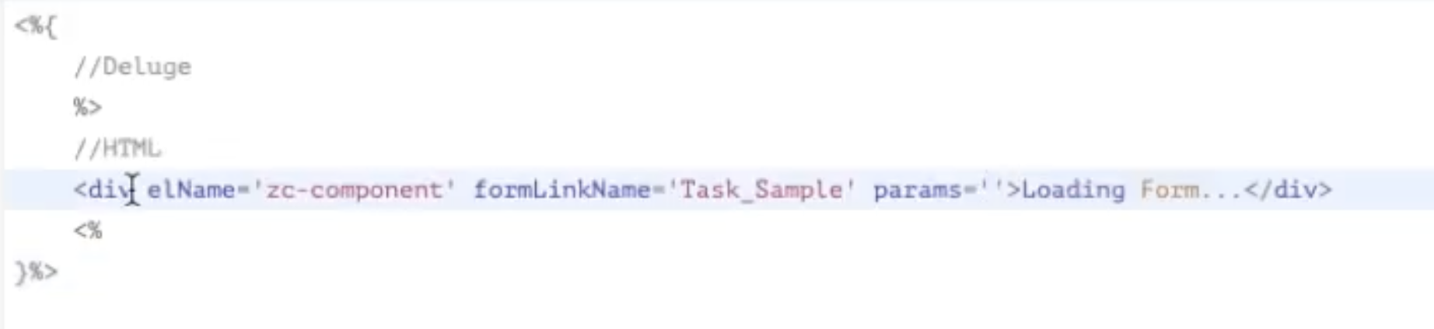
If u want to show the html, u would do %> <%. And if u want to show the deluge
<%= %>
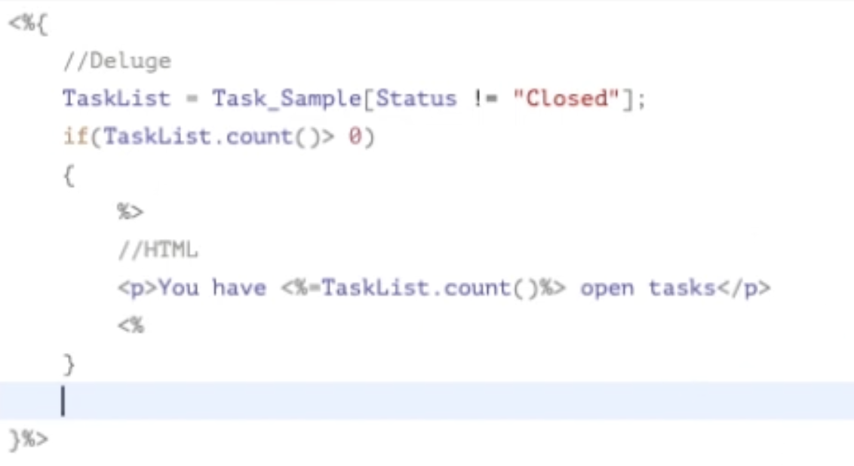

--

You can have a report from another app using the appLinkName.
--
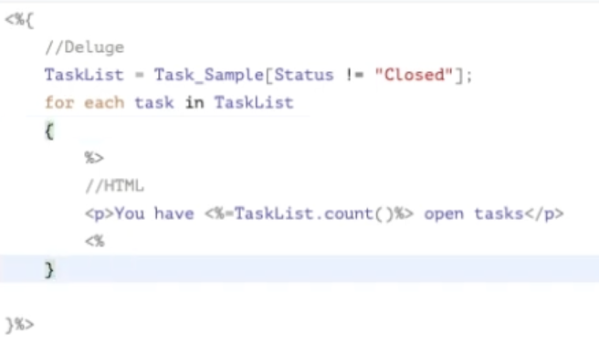

--

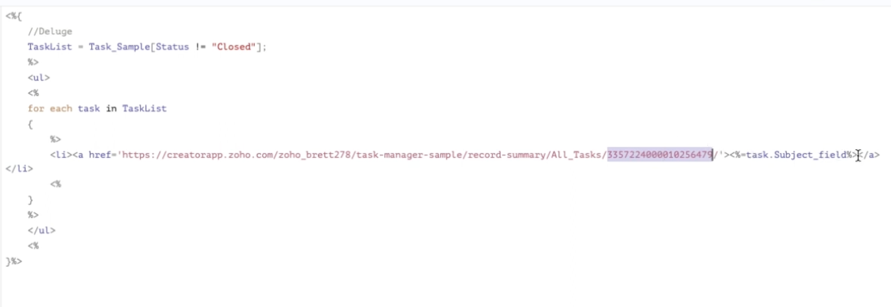
he got the url when he open the list item and print and copied the url.
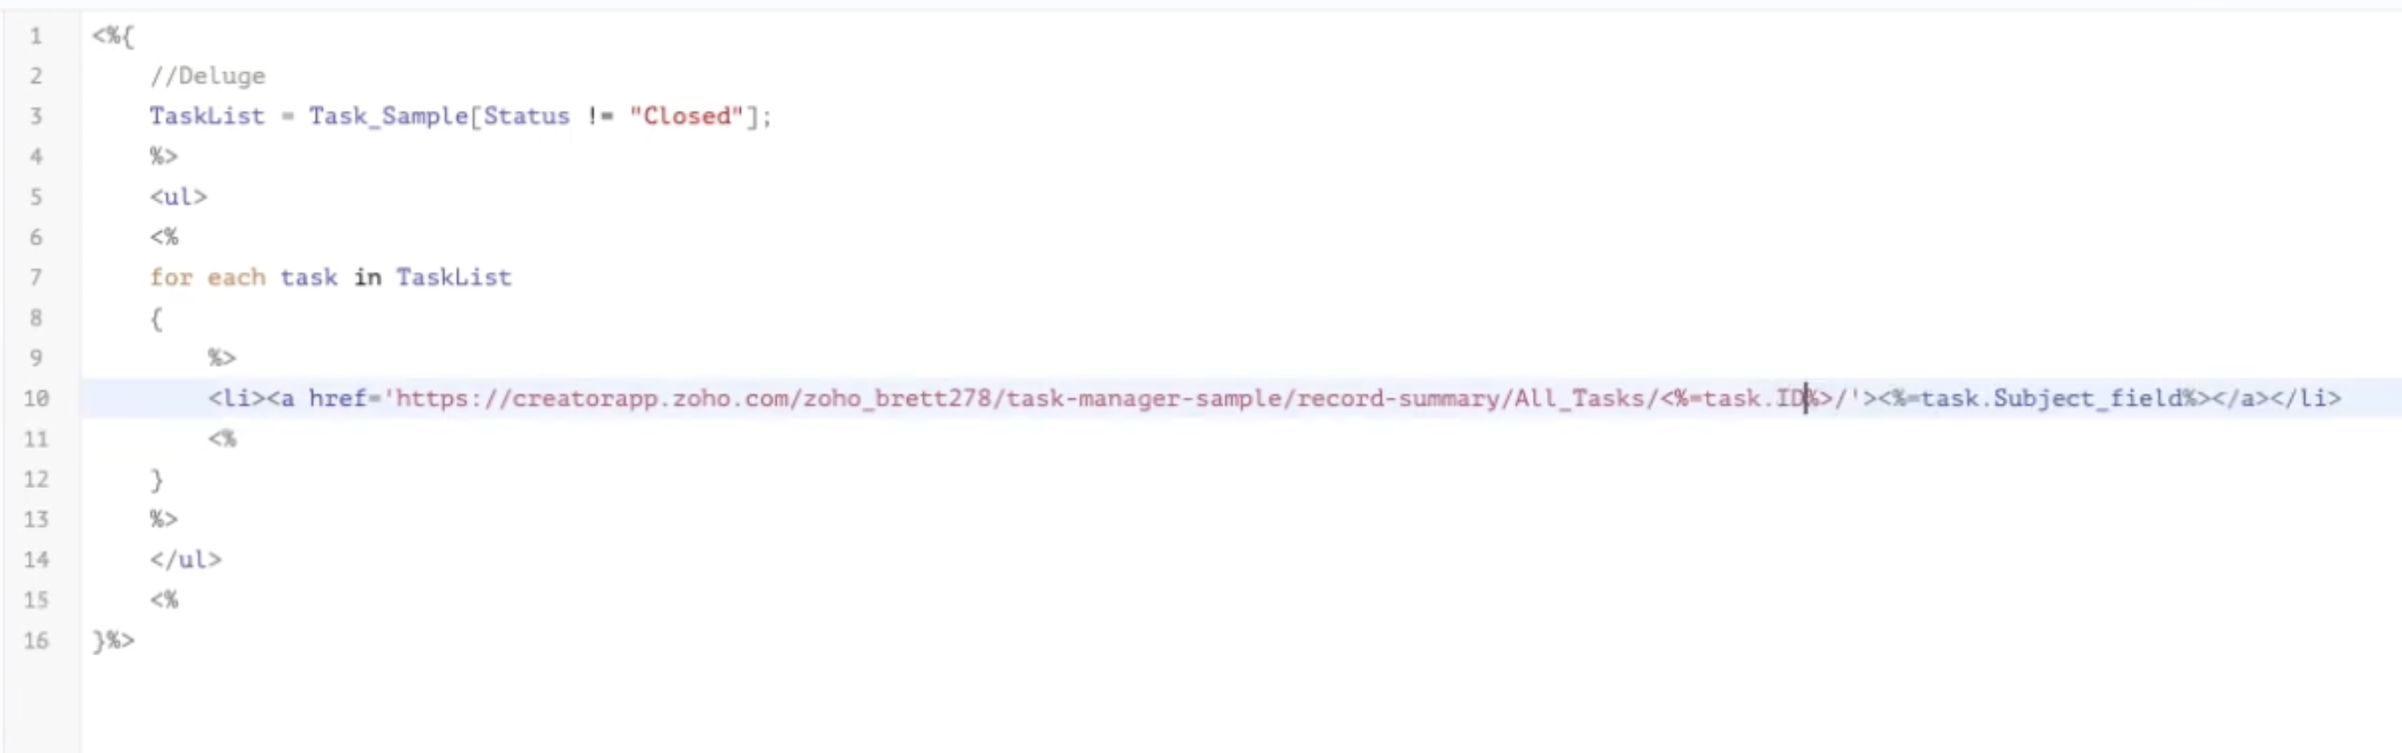

Style based header
https://help.zoho.com/portal/en/kb/creator/developer-guide/others/url-patterns/articles/style-based-urls-for-embedded-forms#ReportCustomization

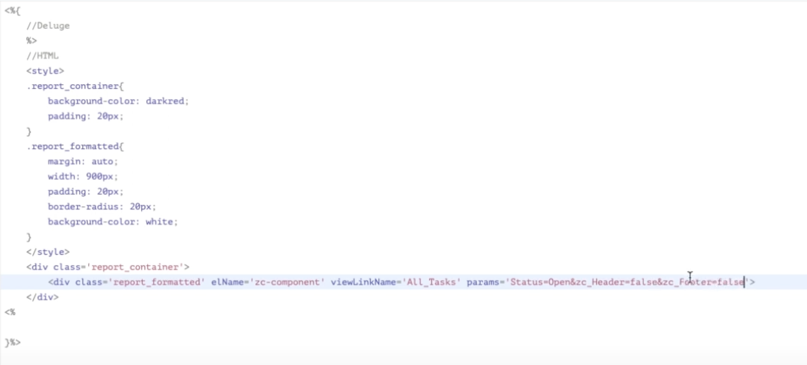
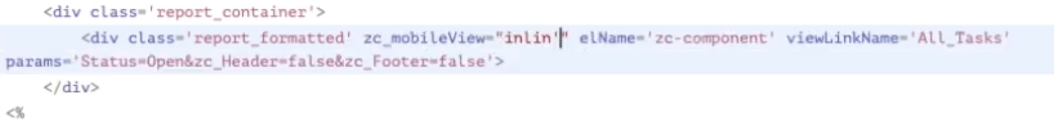
embedded elements wont appear properly. So u use zc_mobileView=”Inline”.
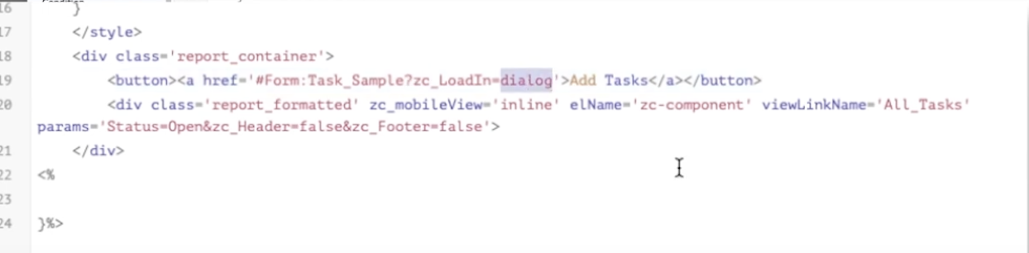

Game UI Design Using URL & Query Parameters In Zoho Creator
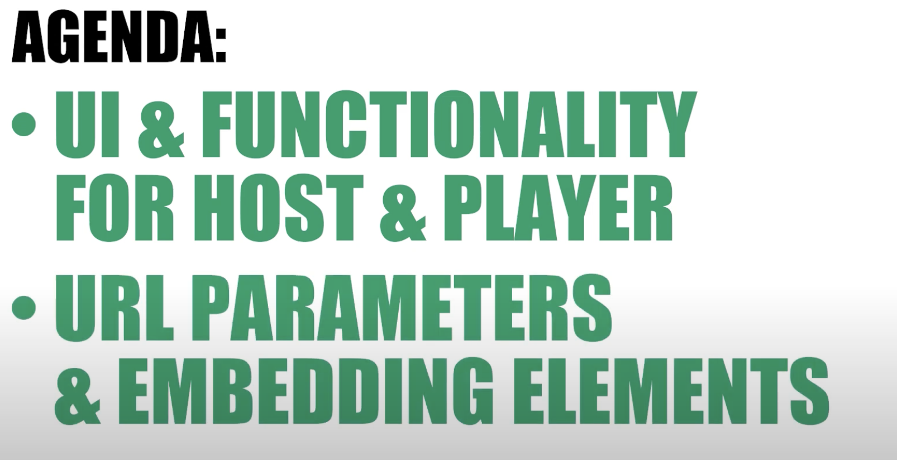
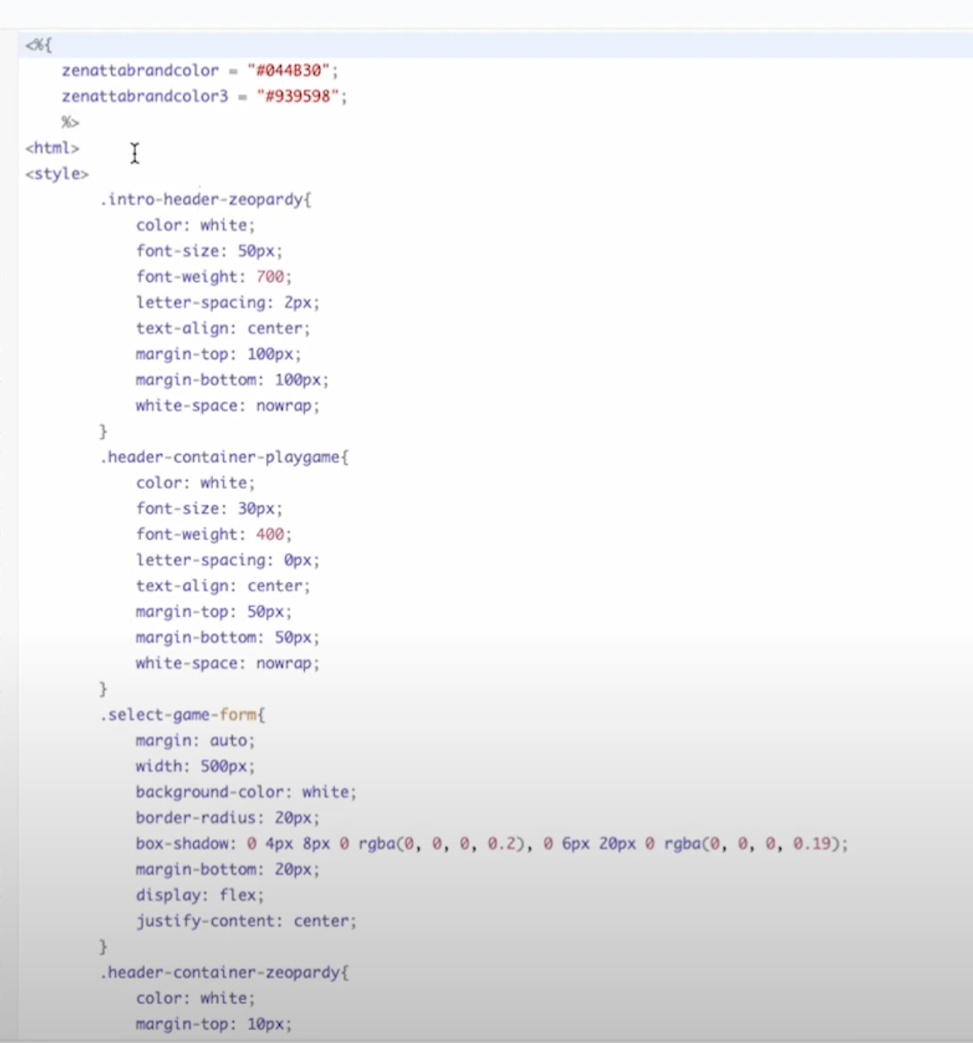 | 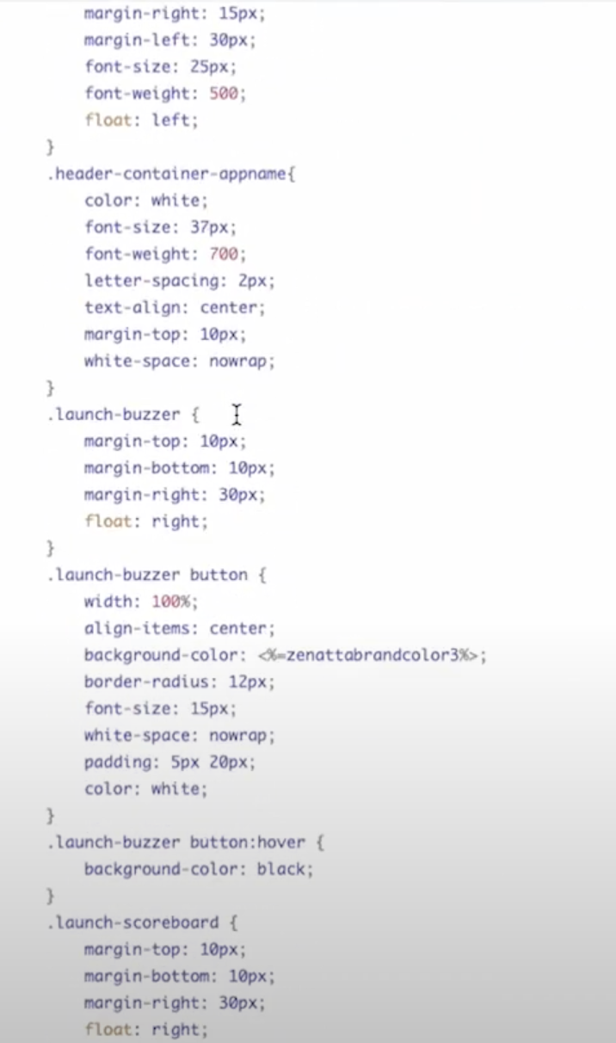

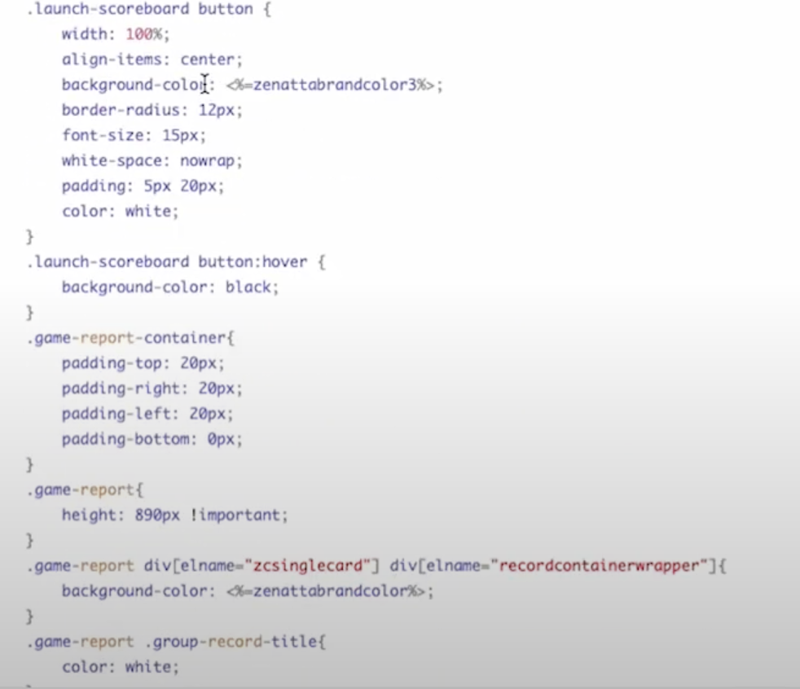 | 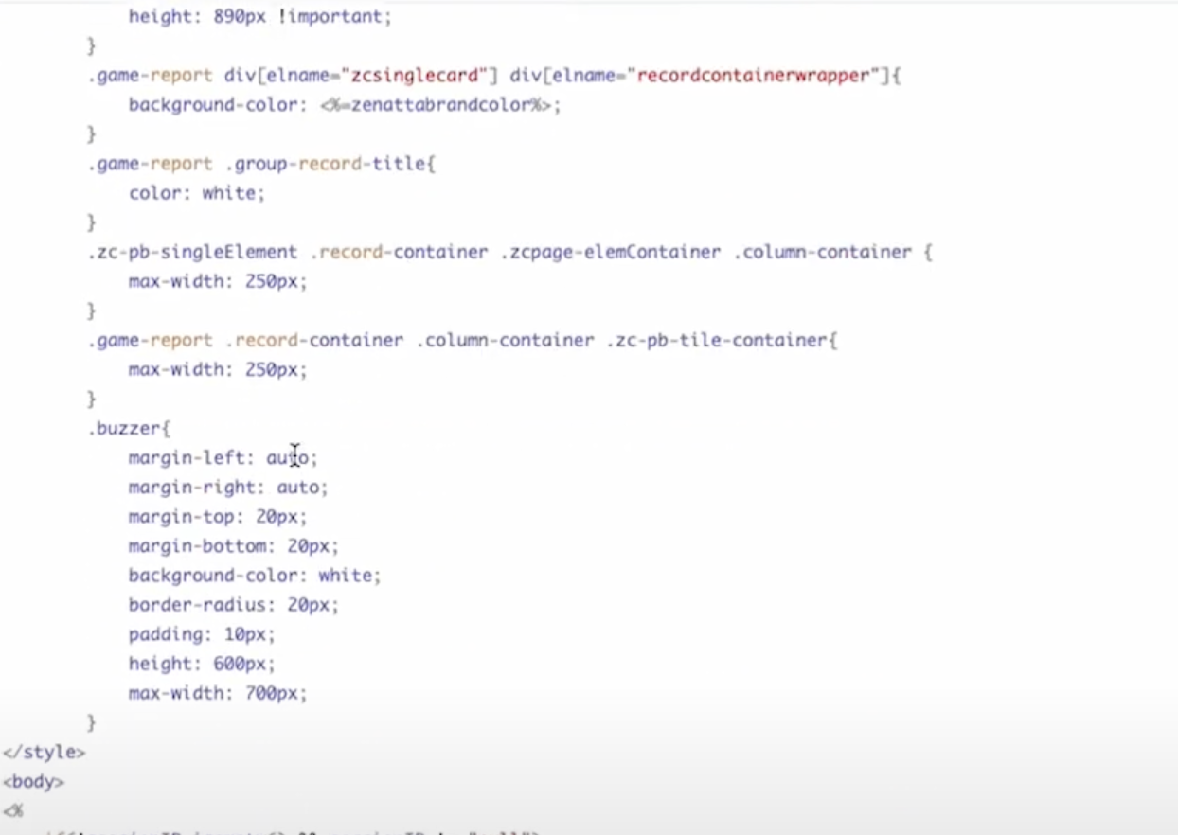

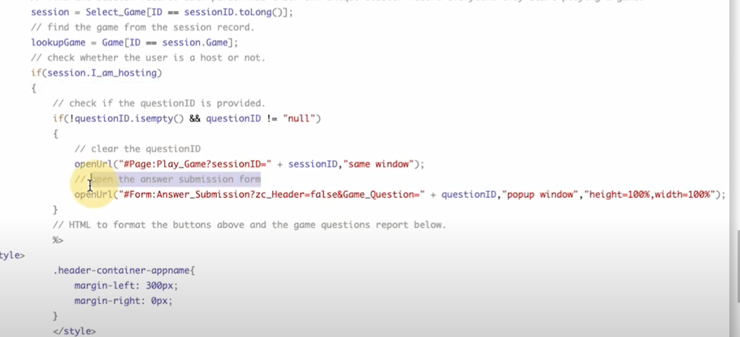

Subforms:
On a standard subform, running workflow rules are limited to certain triggers and the only trigger you can run on a workflow rule is on with the subform is called on Add of a row thats on the parent record.

