Finance @ Eclerx Notes

subtitle

Heading 1

Heading 2

Heading 3

Heading 4

- About eClerx
- Finance & Accounting - Definition
- Derivatives - Definition
- Types of Derivatives
- Global KYC in Investment Banking - definition & idea about the structure
- Anti money laundering - basic principles
- Difference between a future and forward contract/difference between a put and call option
- Trade life cycle - basic structure
- 3 Golden rules of accounting
- What is Capital markets?
- Primary and Secondary market
- What is Investment banking
- What is assets? Types of assets?

Finance
Create, manage, study of money and investments. | Finance is a term that addresses matters regarding the management, creation, and study of money and investments.
It involves.  Future income flows means to keep the project going since money which is not present is needed to fund future projects. | it involves the use of credit and debt, securities, and investment to finance current projects using future income flows.
Relates to | Finance is closely linked to the time value of money, interest rates, and other related topics because of this temporal aspect.

Finance is broadly divided into
Public Finance | Corporate finance | Personal finance

Other specific categories include behavioral finance, which seeks to identify the cognitive, emotional, social, and psychological reasons behind financial decision.

Fiscal year
Fiscal year is a 12 month period for institutions, organizations or foundations to account, budegting and generate financial reports.
For education institution, their Fiscal years is FY25 July which aligns with the academic calendar and student admission fees.  Non-profit organizations or foundations may align their fiscal year with the timing of grant rewards and fundraising events.  Apples fiscal year ranges froms launch of new device models and holiday sales quarter in the same fiscal year, this structure allows investor a clear pic of each product cycle performance. | A fiscal year enables organizations to better match their financial reporting with their operational patterns. When a fiscal year aligns with a company's particular business cycle, it provides a clearer picture of performance and can help managers make more informed decisions.
Note: | Publicly traded companies disclose their fiscal year periods on their Form 10-K annual reports

Calendar Year  - Begins Jan 1. and ends Dec. 31 | Fiscal Year  Can be any consecutive 12-month period
- Simpler to track and understand | - Aligns with natural business cycles
- Matches most standard calendars | - Facilitates more accurate year-over-year comparisons.
- No need for date conversion in communications | - Reduces end-of-year accounting burden

Net sales
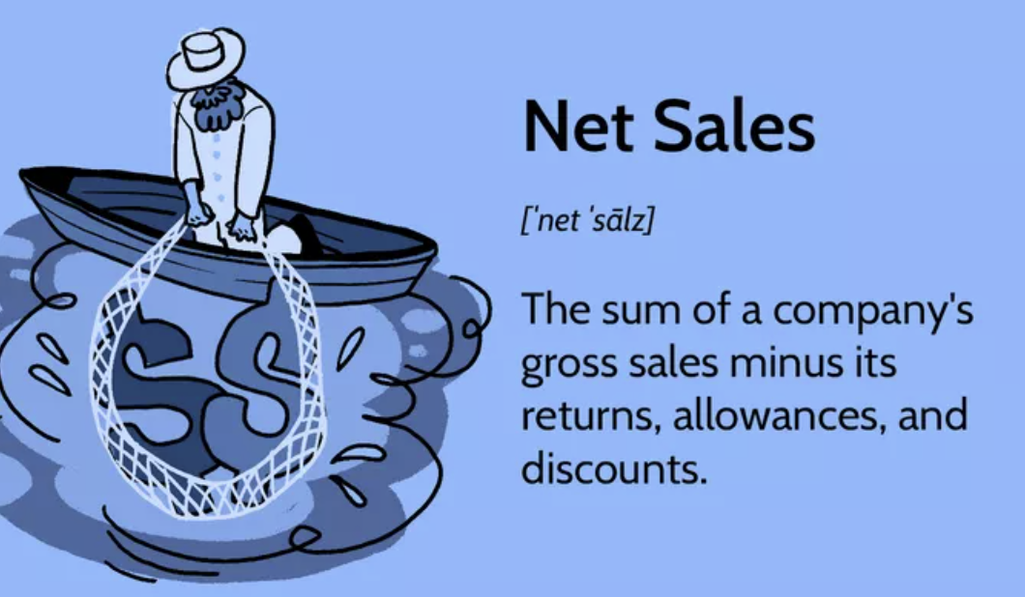 | Net Sales= Gross sales – (return, allowances, discounts).
Are top line sales same as Net sales | Net sales are gross sales or total revenue.
Net sales <> Gross sales | Net sales is better indicator.
Emma’s Fashion Inc. | 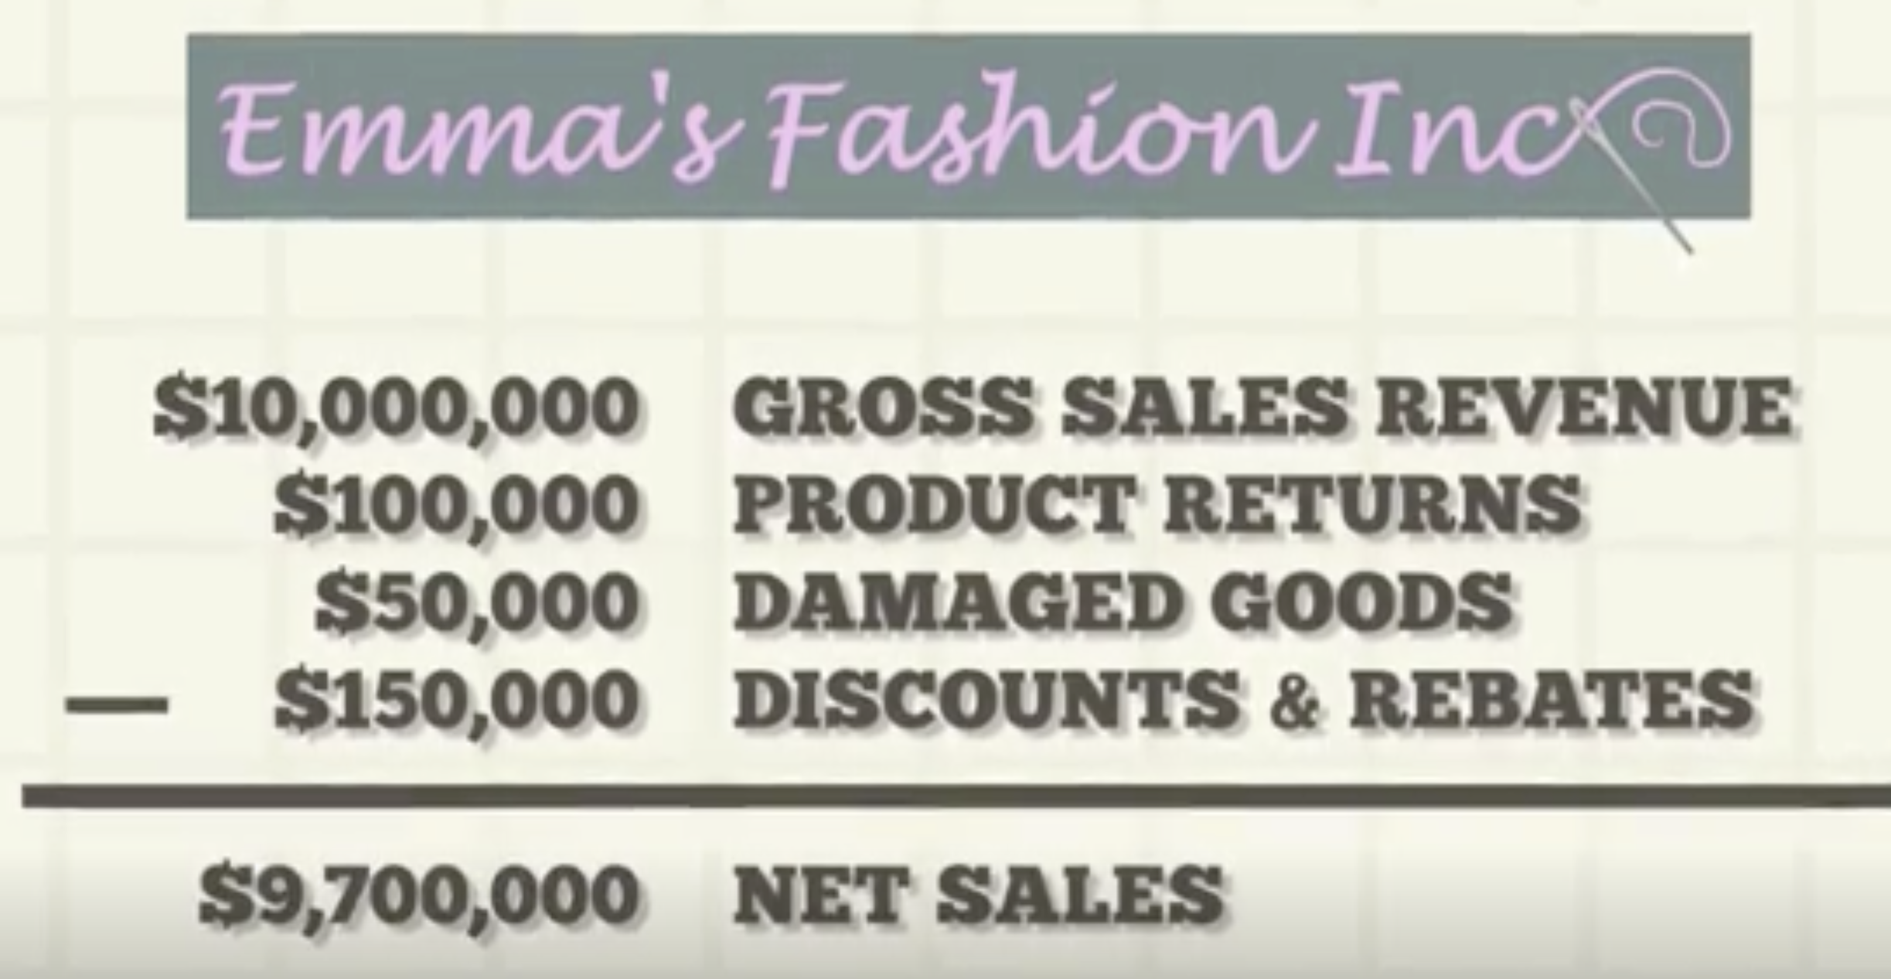
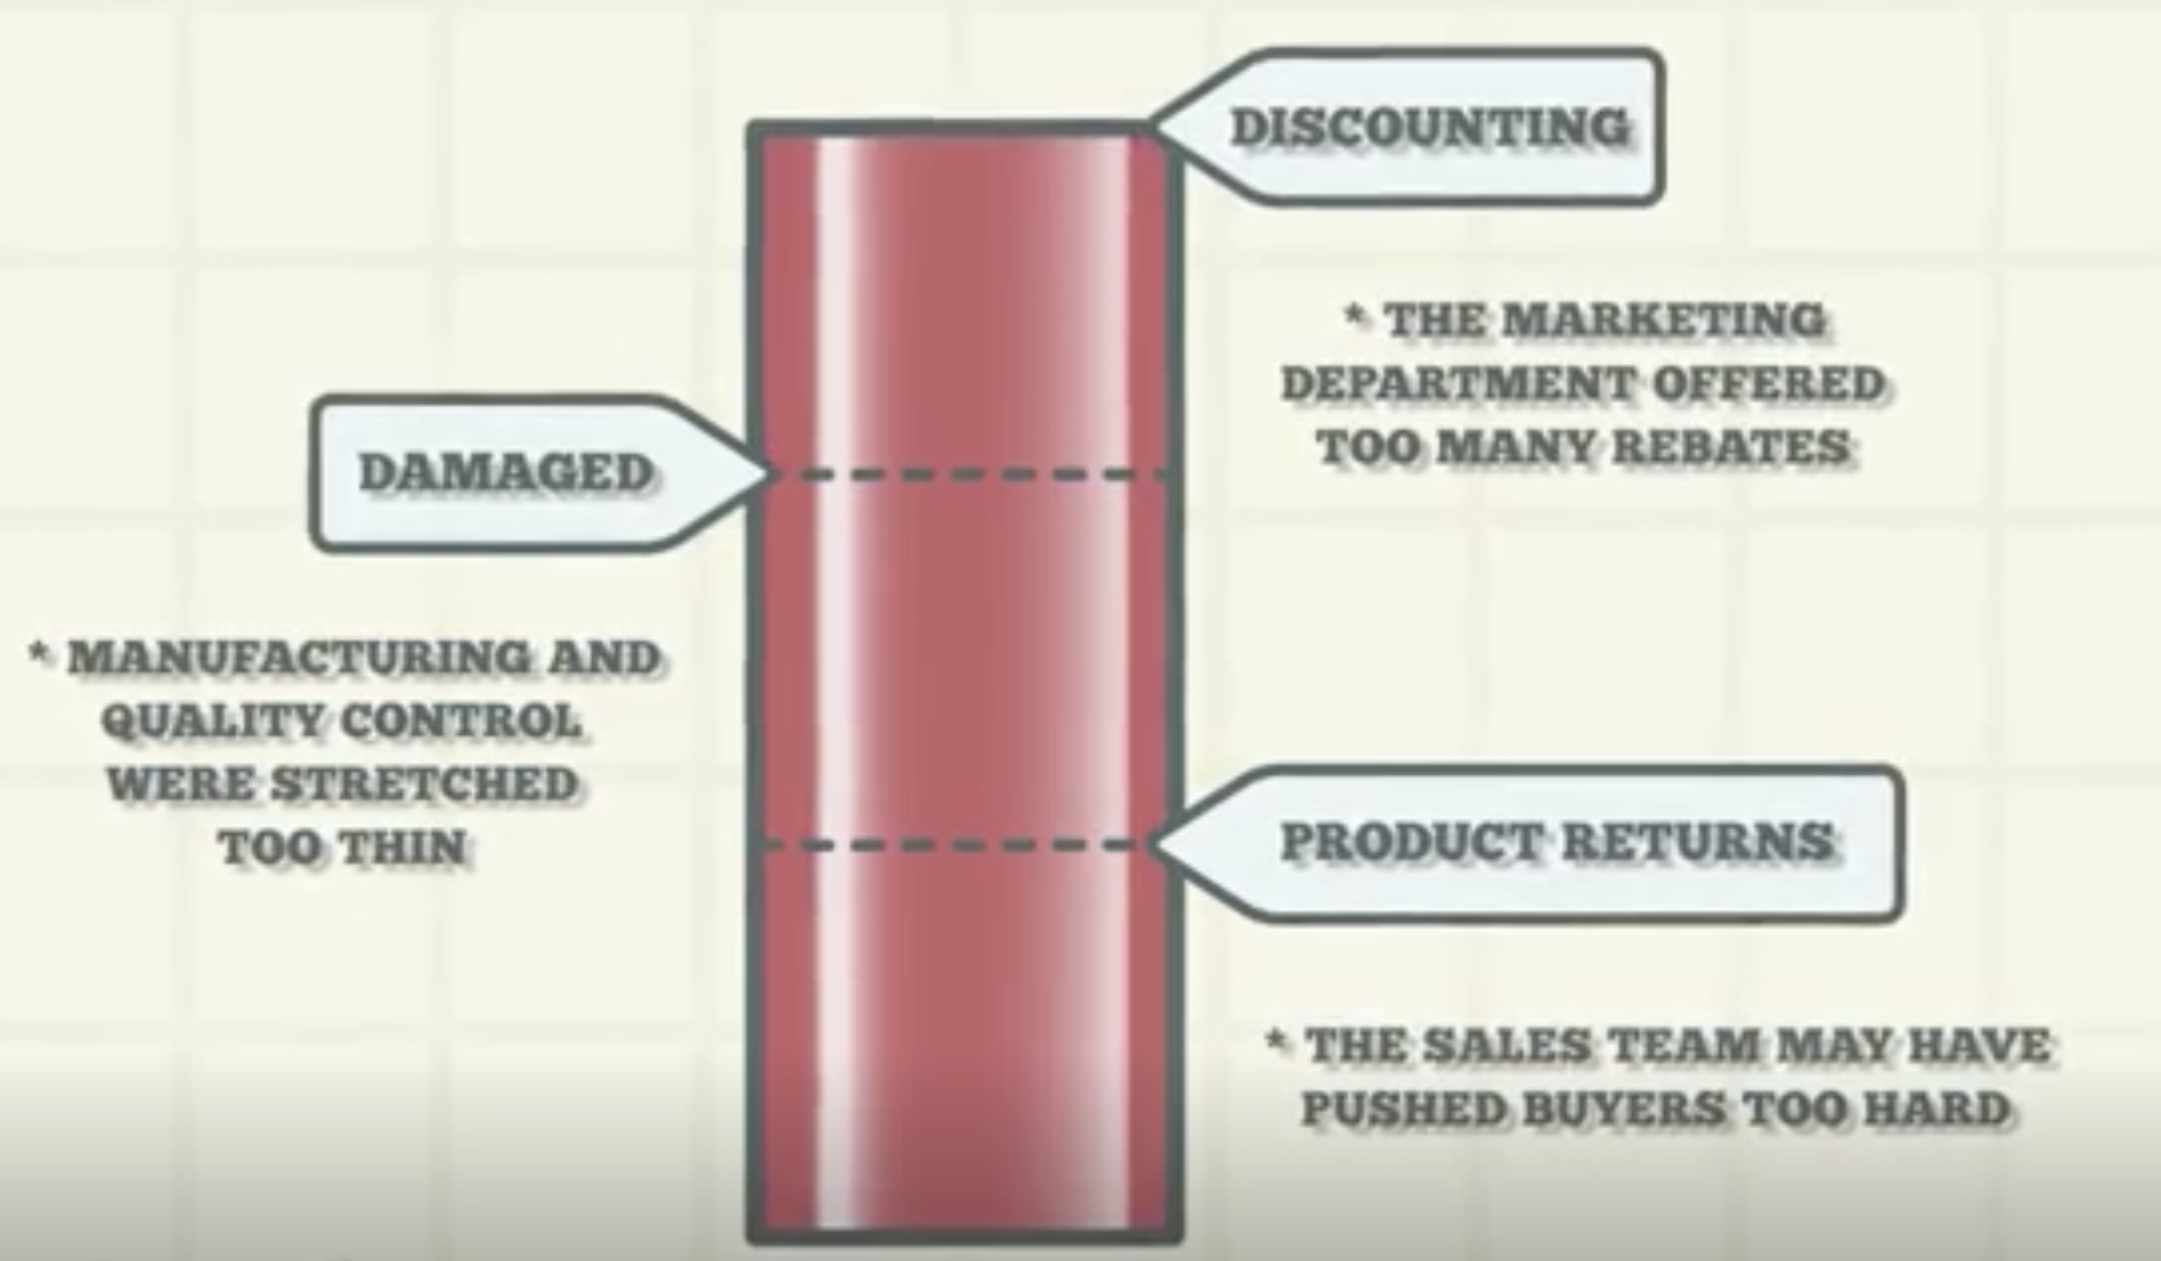 | Junior Analyst might see this as great news. But senior analyst shows concern.  Rebates are collected after payment, while discounts are taken before purchase.  Discounts are more likely to be offered by retailers, while rebates are more likely to be offered by manufacturers, such as automakers.

Understanding rebates.
Rebates are marketing tool. | - Customer wanting cash back  - Even if rebate might seem loss, Customer who buy item with rebates may buy other products giving the business net profit.  - Price protect certain product by price protecting other items in the store.  - Mail in Rebate. Ask for consumer to fill out of form and fill other details. Making it a little time consuming for customer to benefit out of it. Companeis can expect deduction less than the rebate amount.
Vehicle rebates | Manufactures pays the rebate to the customer. Not the dealer. Rebate sometimes harm the resale value since it lowers the stickers price.  Car shoppers are sometimes presented with a choice of a rebate or a reduced interest rate when purchasing a car. The rebate option will give the buyer more immediate cash in hand, but a lower interest rate can provide more significant savings in the long run.

Current Assets vs Fixed Assets
Current Assets | Fixed Assets
Short term assets | Long term, physical assets
Held less than one FY25 or have a life less than a year. | Held more than a year
Are more liquidable | Are less liquidable
Day-to-Day operations running
Cash, Account recievable, inventory | PP&E and intangible assets
Cash and cash equivalents, which might consist of certificates of deposit.
Marketable securities, such as equity or debt securities.
Accounts receivable, or money owed to the company for selling their products and services to their customers Inventory
Prepaid expenses
 | They undergo depreciation.

It's also important to know how the company plans to raise capital for its projects; whether the money comes from a new issuance of equity or financing from banks or private equity firms.

Expenses vs Expenditures

Factor | Expense | Expenditure
Timing | Recognized when the benefit is consumed (matching principle). | Recorded when cash is spent (regardless of when the benefit is received).
Financial Statement Impact | Reduces net income (P&L). | May appear on cash flow statement or balance sheet (if capitalized).
Capitalization | Never capitalized (always an immediate cost). | Can be capitalized (e.g., buying machinery → asset).
Scope | Always an expenditure, but not all expenditures are expenses. | Broader term—includes expenses, investments, and debt payments.

4. Why the Difference Matters
Taxes & Profit Reporting: Expenses reduce taxable income; expenditures may not.
- Financial Analysis: Investors check CapEx vs. OpEx (operational expenses) to judge growth vs. efficiency.
- Cash Flow Management: A company can have high expenditures (e.g., buying a factory) but low expenses (depreciation over time)

All Expenses are expenditure, but not all expenditure are expense. Meaning first they are bought telling the outflow of cash. Then they are consumed, which makes them expenses.
If u buy 50k worth of raw materials, they are noted as an Asset and an expenditure. When they are used in production, the Expenditure converts into Expenses as COGS(Cost of Goods and Services).
Purchasing a new machine:
Expenditure:
  - Action: XYZ buys a $200,000 bike-assembly machine.
  - Accounting: Capitalized as an asset (PP&E) on the balance sheet.
  - Cash Flow: Listed under investing activities.
- Expense:
  - When: The machine’s cost is depreciated over 10 years ($20,000/year).
  - Impact: Only $20k/year hits the income statement as depreciation expense.

The full $200k expenditure isn’t an immediate expense—it’s spread over time.
Scenario 3: Paying Employee Salaries
- Expenditure & Expense:
  - Action: XYZ pays $30,000 in monthly wages.
  - Accounting: Immediately recorded as an expense (no asset created).
  - Cash Flow: Operating activity outflow.
Key Takeaway:
- Some expenditures (like salaries) are always expenses—no delay in recognition

Why This Matters for Businesses
- Taxes:
  - XYZ can’t deduct the 200kmachine(allatonce)—only the 20k/year depreciation.

  - But the $50k raw materials reduce profit when used (lowering taxable income).
- Profit vs. Cash Flow:
  - A company can be profitable (low expenses) but cash-poor (high expenditures).
  - Example: XYZ’s $200k machine purchase doesn’t hurt profit immediately but drains cash.
- Investor Decisions:
  - High CapEx (like the machine) signals growth.
  - High operating expenses (like wages) may indicate inefficiency.

---
W.r.t to personal finance.
Expenses are associated with cost of living. They are recurring. If they are not recurring, and they are significant they are expenditure.
W.r.t Businesses.
Expenses are included to run everyday operations of manufacturing the product. They are associated with production. Expenses are incurred and their benefit are used within the fiscal period.
Expenditures: are long term assets. They are not expensed all at once. But for tangible assets PP&E(Power, plant and equipment) they are depreciated throughout its useful life. 100K worth of hardware. With 10 years of useful life, would be seen as an asset worth of 100k but expensed as 10k every year till year 10. Whereas for intangible assets they are amortized.

Expenses and Expenditures
link
An expenditure represents the investment a company makes to generate future revenue, while expenses are short-term costs that a company pays to continue operating. Expenditures can help companies increase their earning capacity, and they're often large, while expenses are usually much smaller in size.

Expenditure: Makes money reduces the liquidity by turning them into LTA. | Expenditures represent the monetary amounts an organization spends to purchase an asset or service. Expenditures are the costs that reduce its cash in the bank and increase its long-term liabilities.
 | Expanding operations and maximizing their long term value.
3 primary type of expenditure
Capital expenditure(CapEx): | Money that company spends to acquire or maintain a fixed assets.  Fixed Assets can be intangible like a design or patent with a useful life longer than a year.
Revenue expenditures:  Property taxes, Repairs and maintenance, Research and development expenses, Salaries and wages, Utilities and rent. | Revenue expenditures or operating costs help fund ongoing business operations. An organization often expects to recover its revenue expenditures within a year, since they often occur from the sale of a good or service.
Deferred revenue expenditures | Deferred revenue expenditures represent the money a company spends during one accounting period with the intention of generating revenue at a later date over the course of several accounting periods. For example, a company might purchase $3,000 worth of packaging material but only use $1,000 of it in a fixed accounting period. Common examples of deferred revenue expenditure include:

Capital

Investing capital or spending it as money, often builds more capital. Since capital generates income, the investor or companies who has the most capital are better off.
Capital: Bring benefits. (Tangible or Intangible)  Capital: capEx or software or patents. | Capital is anything that provides benefit to the owner. It could be financial assets like stocks, mutual funds or cash or capEX(Like PP&E).
Capital raised using equity financing or debt financing.  Capital != Money.  Capital generates more capital. | Investors use capital to buy stock and bonds. Companies raise capital by selling stocks and bonds to finance their operations. While capital can be currency or cash. Its not the same thing as money. With money u can buy goods and services. Capital is more durable and it can be used to generate wealth. Capital include capEx, software, intangible assets. They can be rented out or used to make products.
Two most common Capital Allocation | Labor and building.
2 vision of debt | Debt as a burden for individual but for businesses is an opportunity, if it doesn’t go out of hand. Both investor and businesses Need to keep an eye on debt to capital ratio.
Bonds are fav by business | When market interest rates are low.

Businesses raise capital either throught debt financing or equity financing.

Equity financing:
- Public equity
- Private equity
- real estate equity

Public and private equity are usually in the form of shares of stock in a company.
Public equity | public equity is raised by listing the company's shares on a stock exchange
Private equity | private equity is raised among a closed group of investors.
 | The biggest splashes in the world of raising equity capital come, of course, when a company launches an initial public offering (IPO).

Working capital:
A company's working capital is its liquid capital assets available for fulfilling daily obligations. It is calculated through the following two assessments:
 | Current Assets – Current liabilities
Working capital | Accounts-Recievable+inventory – Accounts payable.
 | A company with more liabilities than assets will short out run of working capital.

Trading capital:
Brokerages also list trading capital; that is the cash available for routine trading in the markets.

FAQ
can an investor who is invested in business through private quity sell his share on secondary market. so his shares will be available before the company goes public.
Private Secondary market  - isn’t centralized.  - isnt regulated. | what is the "Secondary Market" in this context? Unlike public stock exchanges (like the NYSE or NASDAQ), the "secondary market" for private equity or venture capital shares isn't a centralized, regulated exchange.
Privately traded to other private equity firms, hedge funds or institutions. | Instead, it refers to the market where investors can sell their stakes in privately held companies to other private investors. This is often called the private secondary market.
Private Secondary markets is facilitated by specialized platforms. | Forge Global, SharesPost(now part of Nasdaq private market), EquityZen.
The company itself buyouts the existing share holder.
Reasons for Selling on the Secondary Market:  Illiquid | Private equity investments are illiquid. Selling on private secondary markets provide an earlier exit than waiting for IPO or an entire company acquisition.
Portfolio rebalancing | Reduce their exposure to particular company or industrya and free up capital for new investments.
Important considerations and restrictions:

Restrictions: | Right of First Refusal (ROFR): The company or existing shareholders might have the first right to buy the shares being offered for sale.  Lock-up Periods: Investors might be subject to lock-up periods, preventing them from selling their shares for a certain duration after their initial investment.  Approval Requirements: Transfers might require approval from the company's board of directors or other major shareholders.

Illiquidity Discount: Shares in private companies often trade at a discount compared to what they might be worth in a public offering, due to their illiquidity and the lack of transparent pricing.

GDP
GDP | GDP Is gross domestic product which measures the production of final goods and services within the country
Gross domestic product | Domestic means within the country.
GDP and GNP | Domestic vs national.
GDP measures the production of final goods and services within its border.
GNP is just that but by American national or Indian national.

GDP?
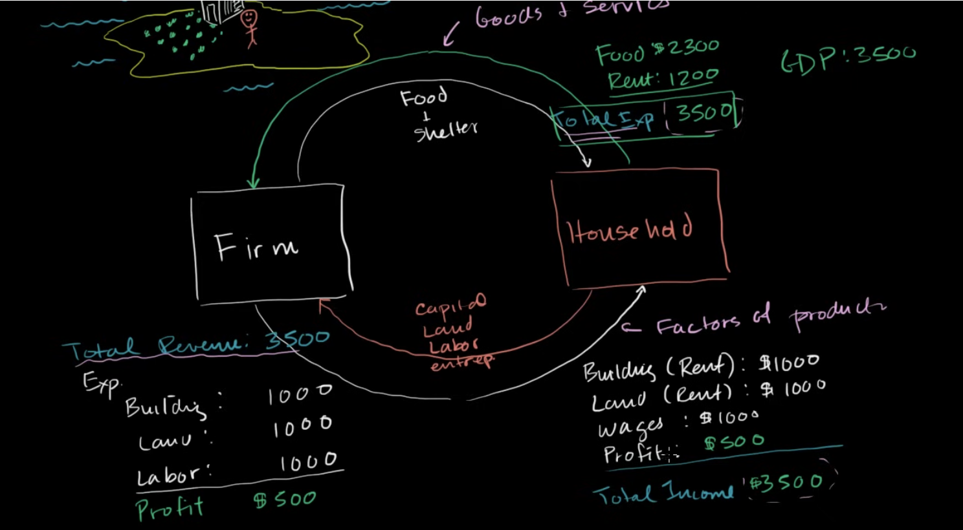
Imagine this person lives on an island which is declared as a country. This man/household founds a firm for blueberry. He provide that firm with means of production. Labor, land, capital and entrepreneurship.

The households leave the firm with land(rent) and provided labor, building. The firms provides rent to the household. The firm revenue = good + services.
The firm profit= Revenue – Operating costs
Since the firm is own by the household, the firms profit belongs to the household.
Company Revenue= Income of the household = Expenditure of the household.
To measure the economic activity of the nation we calculate GDP.
FAQ

Does it count for savings?

GDP
GDP= Consumption + Investment + Goverment Spending + Net Exports
Net Exports= Exports – Imports

Consumption | So if a car company produces a car. Then this new car when is bought by someone is categorized as consumption. And this car increase the gdp by the value of the car.
Investment | If the car isnt bought by someone, it is considered to be bought by the manufacturer. This is categorized as an Investment.
To prevent double counting. | The next year when the car is sold, to prevent double counting. We do +Consumption – investment= Net zero.
Net Exports | Lets say mexico make cotton threads for 25k. These threads are imported by US. The manufacturing unit turns this threads into fabrics valued as 100k.  This will increase the GDP by 100k – 25k = GDP+75k

Why increasing the spending doesn’t translate into Increase in GDP? | People assume government by lowering prices, they would increase the spending ability of people. Which will increase the demands of goods and services. Companies in order to meet the demands will increase the production.  That isn’t necessarily always true, since if the manufacturing unit has limited ability or its working at maximum capacity. More demands will lead to inflation of goods and might crowd out investments. Since, companies to meet the demands will delay spending on infrastructure to increase their capacity. Which on the long run will lead to higher prices for the goods.

Fiscal year and Bank Reconcilation
Fiscal year – 12month  Metric  Financial planning and budgeting.  Legal and Regulatory requirements.  Investor and stakeholder communication  Operational rhythm | Fiscal year is a 12 month period to fit business operational rhythm.  A metric: How we doing this year compare to the last year?  So we do budgeting, set target revenues and allocate resources.  Tax filing and reporting performance to Govt and Shareholders.  Every quarter  end of the year or quarter involves closing the book. Busy period for finalizing all financial records.  The rhythm drives internal deadlines for sales, procurement and deadlines.
Audit reconciling
book ledger = bank stmt.  Goal: explaina and account(verb) | Bank reconciliation is the process of matching the cash balance reported on a company's own general ledger (its "books") to the corresponding balance on its bank statement. The goal is to explain and account for any differences between the two balances.
Why is it done? | 1. Fraud detection  2. Error detection(either the bank or accounting dept) e.g duplicate recording, wrong amounts.  3. Cash flow management: It provides a true and accurate picture of how much cash the company actually has available at any given time.  4. Accuracy: ensures company records are accurate and complete.
Matching part? | Two balances rarely matches on the same data, thats expected.
 | Reconcilation is explaining the diff.

Common reasons for discrepancy
utstanding Checks: Checks the company has written and recorded in its ledger, but which have not yet been cashed or cleared by the bank.
- Deposits in Transit: Cash or checks the company has recorded as received and deposited, but which the bank has not yet processed and added to the account.
- Bank Fees: Service charges or fees that the bank has deducted but the company hasn't recorded yet.
- Interest Income: Interest earned on the account that the bank has added but the company hasn't recorded.
- Direct Deposits / Automated Payments: Electronic transactions initiated by a third party that the company may not know about until the statement arrives.
- Errors: Mistakes by either party (e.g., the bank deposits a check for the wrong amount, or the company records a payment twice).
b=business ledger balance.  bb=bank balance  so he will bb+deposits -outstanding check +- interests = company ledger | An accountant will take the bank statement balance, add deposits in transit, subtract outstanding checks, and then add or subtract any other items (like fees or interest). After these adjustments, the adjusted bank balance should equal the company's ledger balance.  This reconciled balance is the true amount of cash available. Doing this regularly (ideally monthly) is a cornerstone of accurate and auditable financial records.

Tax withholding is the pay as you earn tax that the employer deducts from your salary and sends it to the government body.
What u have left is the in-hand salary.
2 scenarios
2 Dependents | 2 dependent
U claim the dependents in the W4 form, then It will reduce ur tax withholding from your paycheck. Here, the taxes are sent to the govt behalf of you. When u file ur income tax return for the current taxing period, u would receive less on the difference. This discrepancy and explaining it is called true-up.  If there is discrepancy if u overpaid or underpaid, u would get the return | U don’t claim the dependents in the W4 Form, when u file ur tax return, u would get in a lump sum refund because of having a dependent.
Either way u owe the same
Also u might get like 2000 tax credit of whatever u are liable. So lets say ur final tax liability is 5000, so u would owe the govt 3000.

Non- Refundable tax credit | If u are liable for 1000 and have 2000 tax credit. So  =tax liability – tax credit  =1000 – 2000  = -1000  you don’t get -1000 accrued for the next taxing period
Refundable tax credit | You get accrued

