New Concepts-Salesforce 9th Dec, 25
subtitle

Heading 1

Heading 2

Heading 3

Heading 4

Default Opportunity team
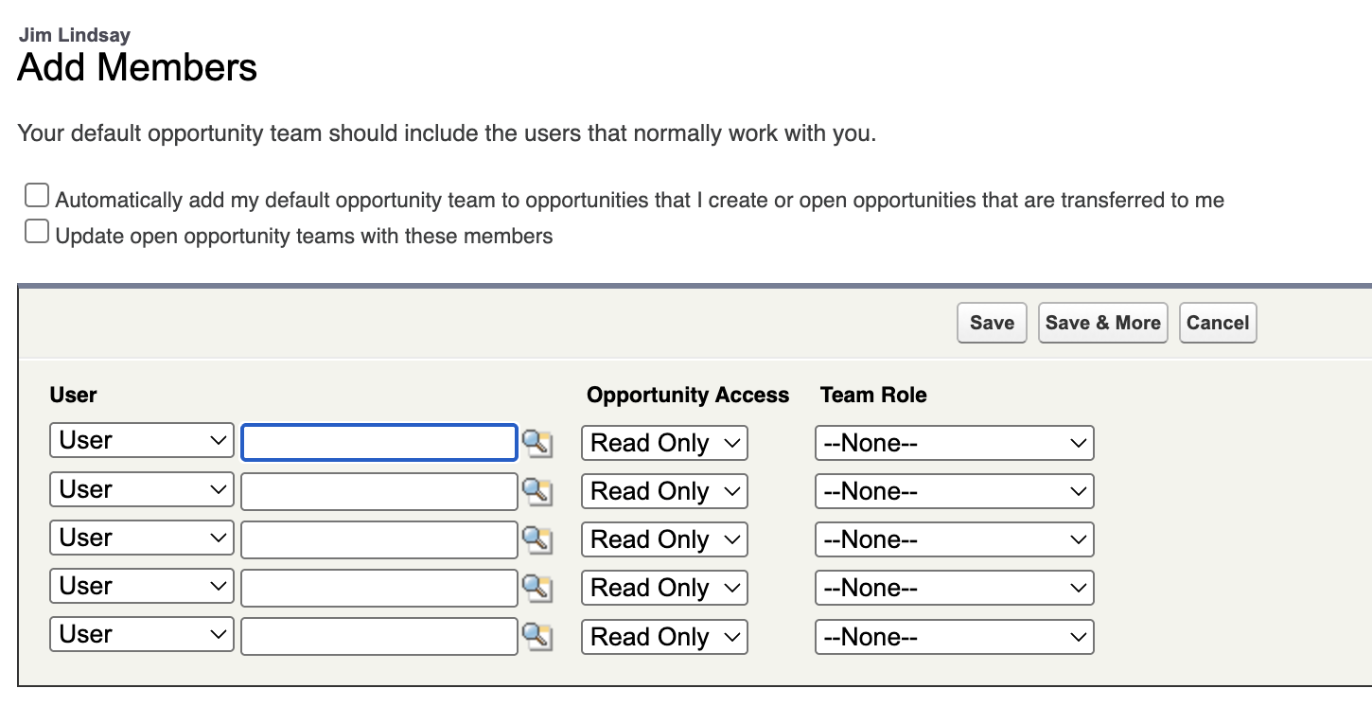
1st checkbox is for future open opportinities
2nd checkbox is for existing open opportunities.
Also, if unchecked. | Lets say the bob opportunity is manually shared with alice. If alice click add default opp team, the default team would be the Bob’s default opportunity team and not alice.

Assistant
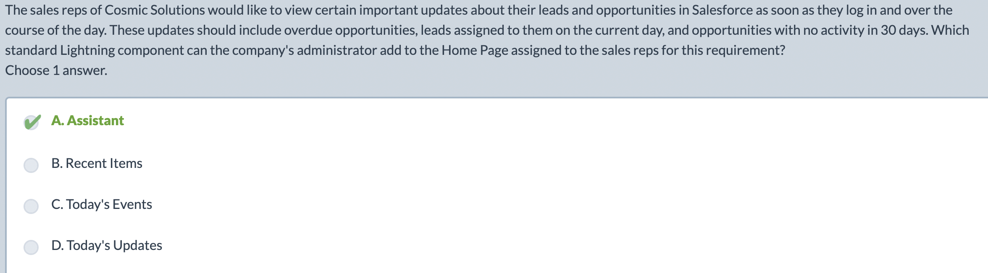
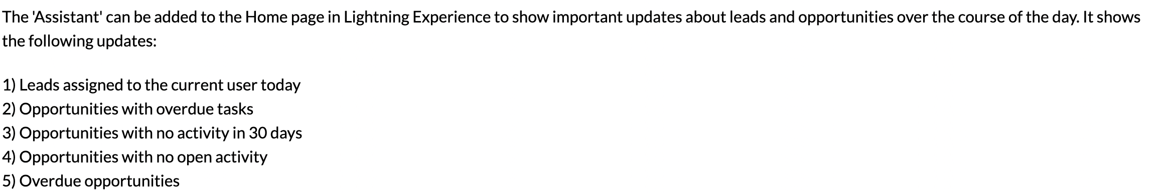

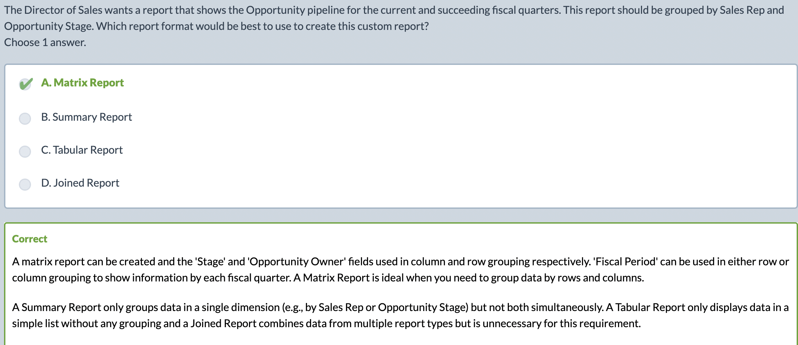
Summary report | Frequency chart
Matrix report | Frequency chart, segregation of each bar into categories.  Group data by rows and columns.
Joined report | Combine data from multiple reports
Tabular data | Simple list w/o any grouping.

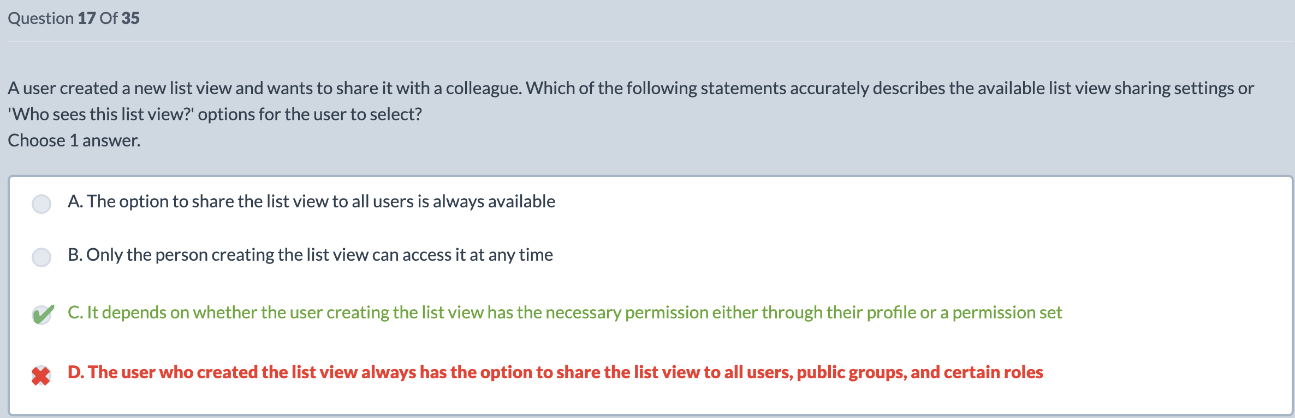
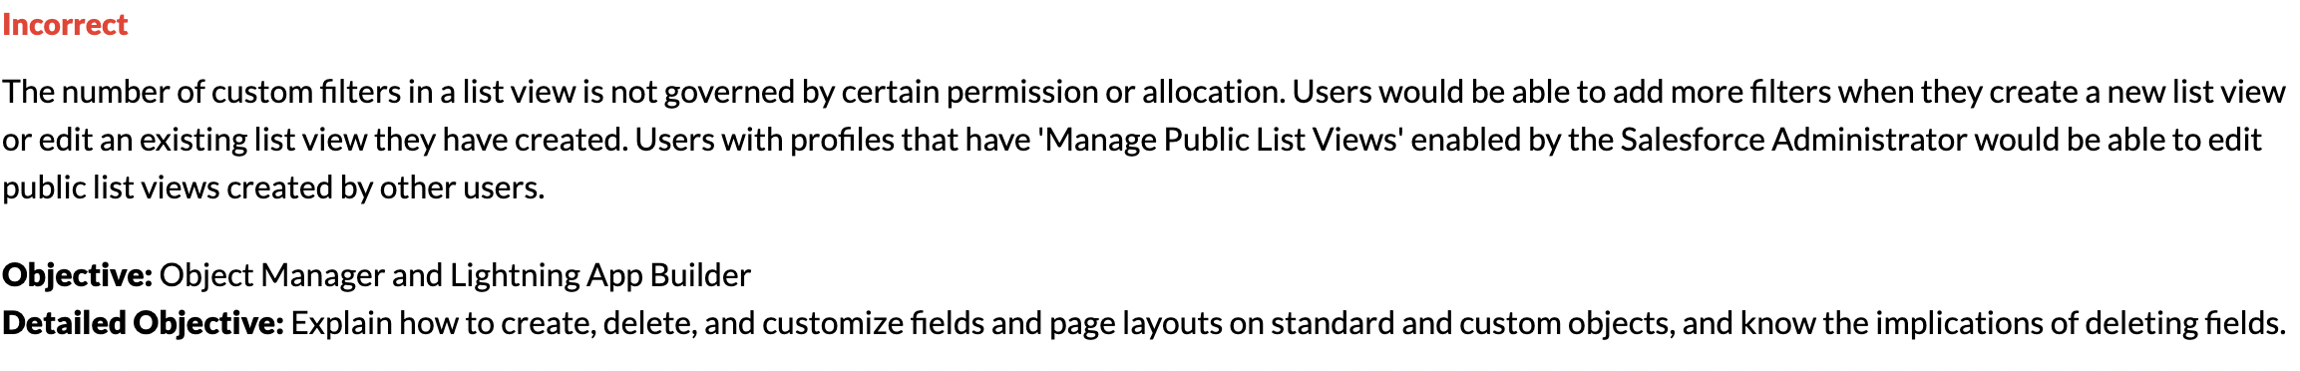

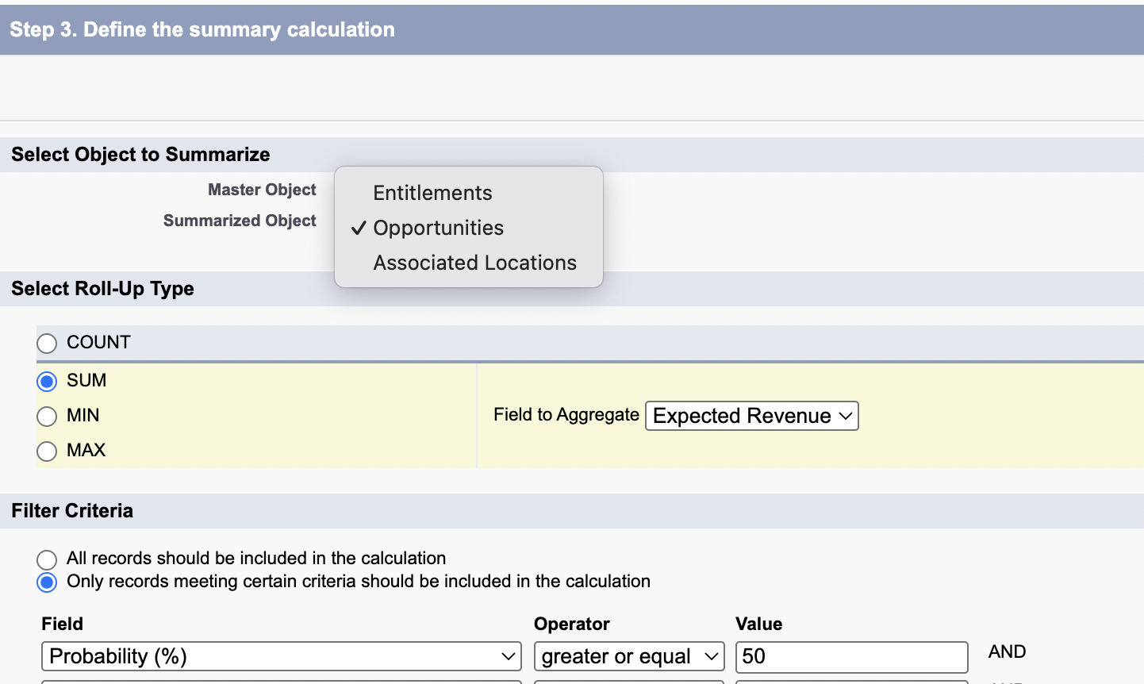

Deleted fields
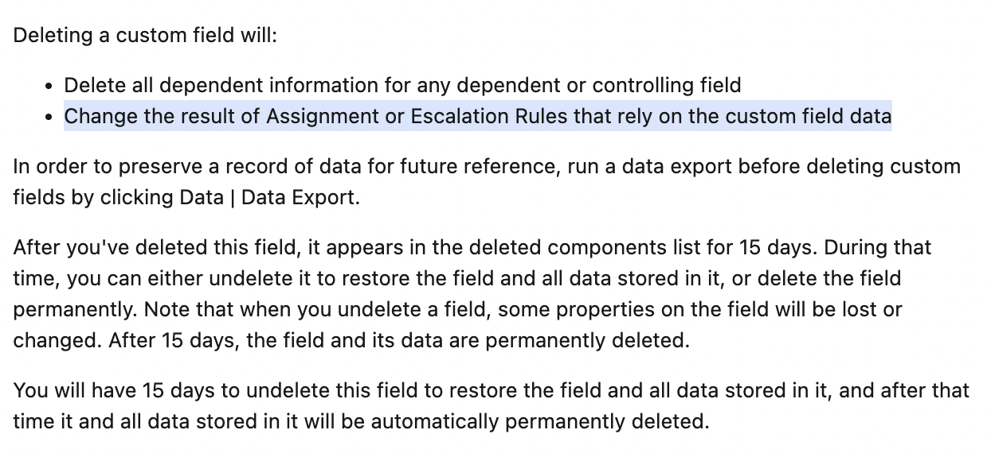 | When u delete a field.  Assignment and escalation rules will be affected.  All dependent or controlling field will be affected.  Custom field cant be deleted if there are references to it.

Search layout
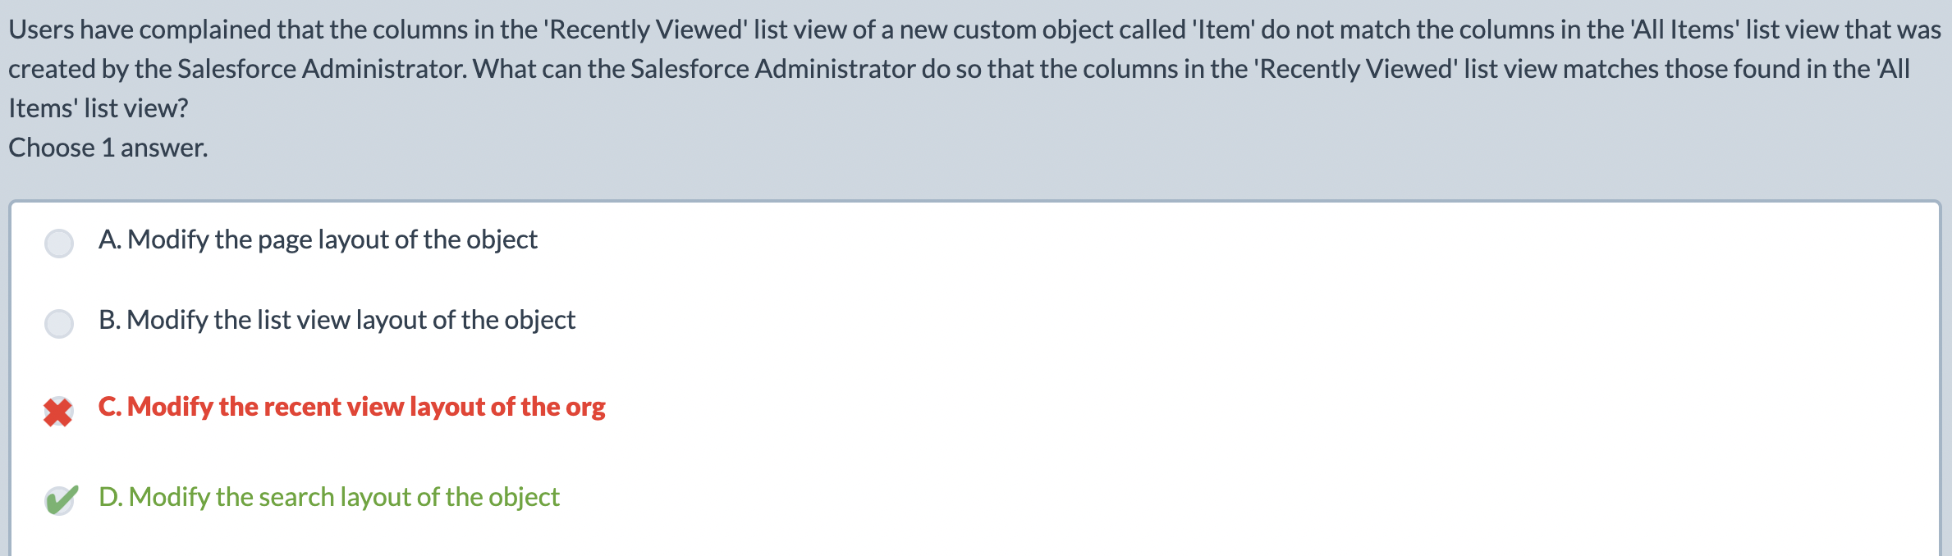
Search layout | Global search.
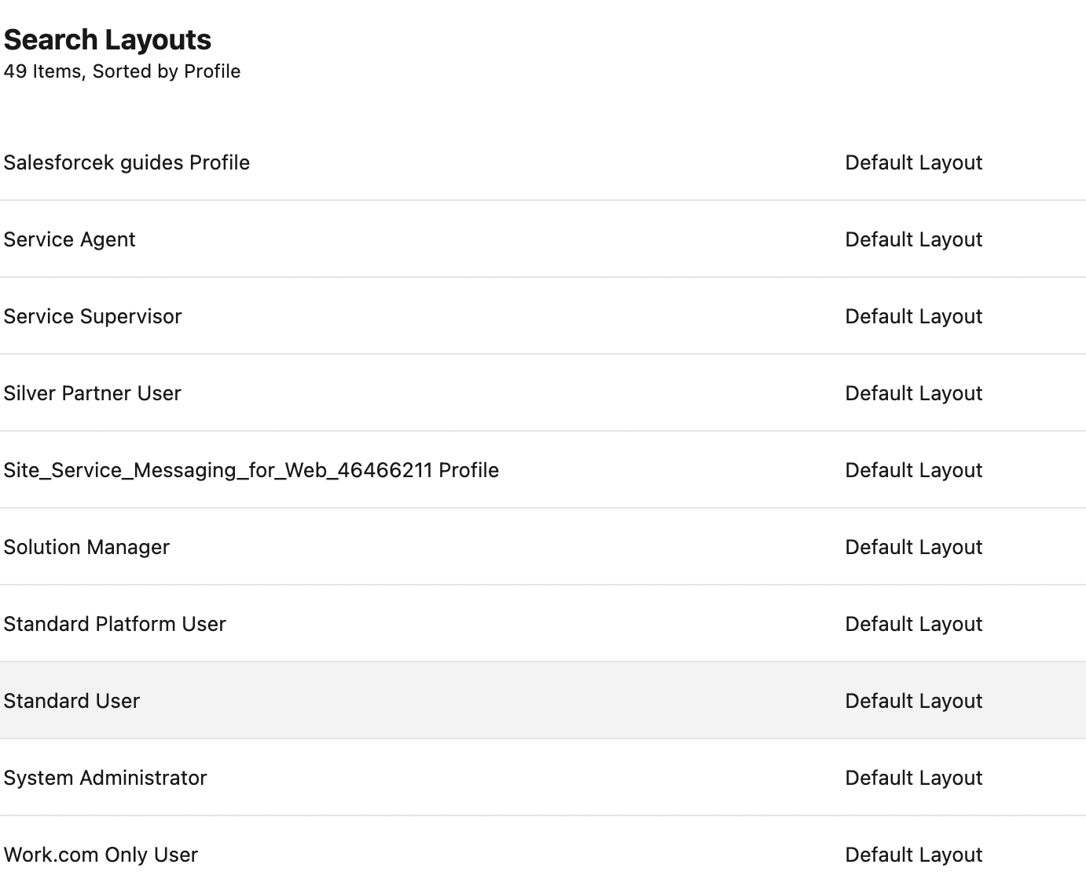  Search layout is different for each profile. | 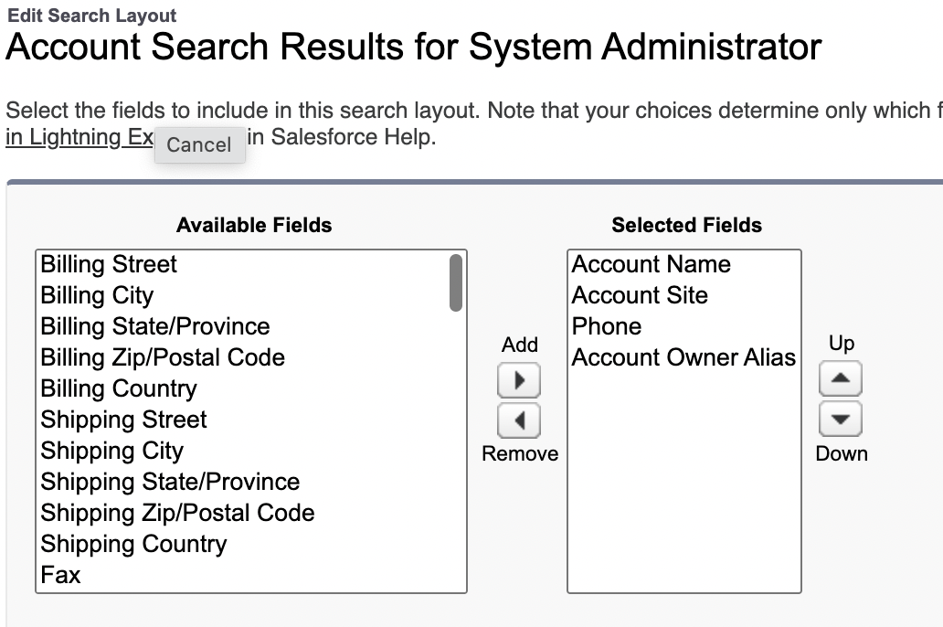
Global search | 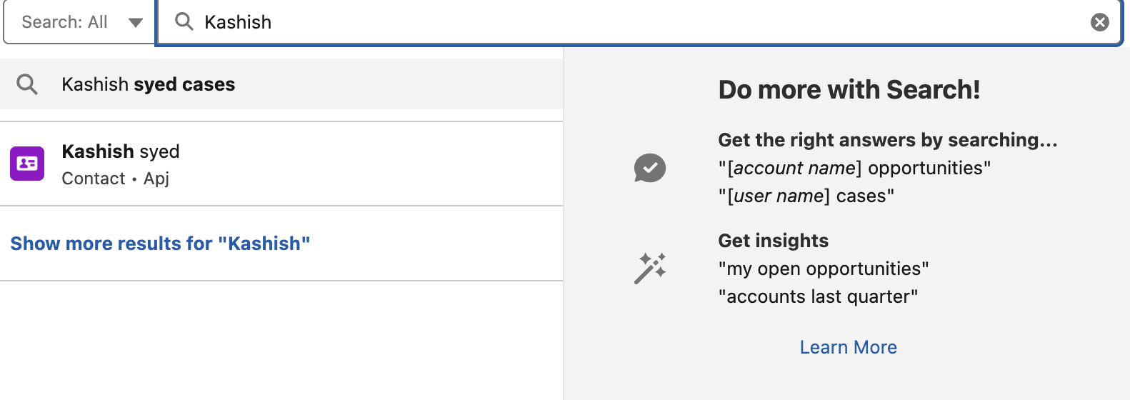
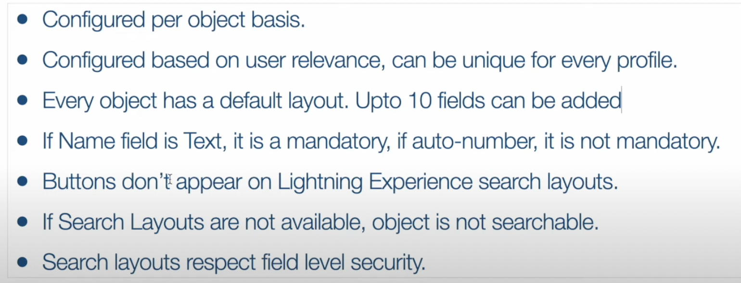

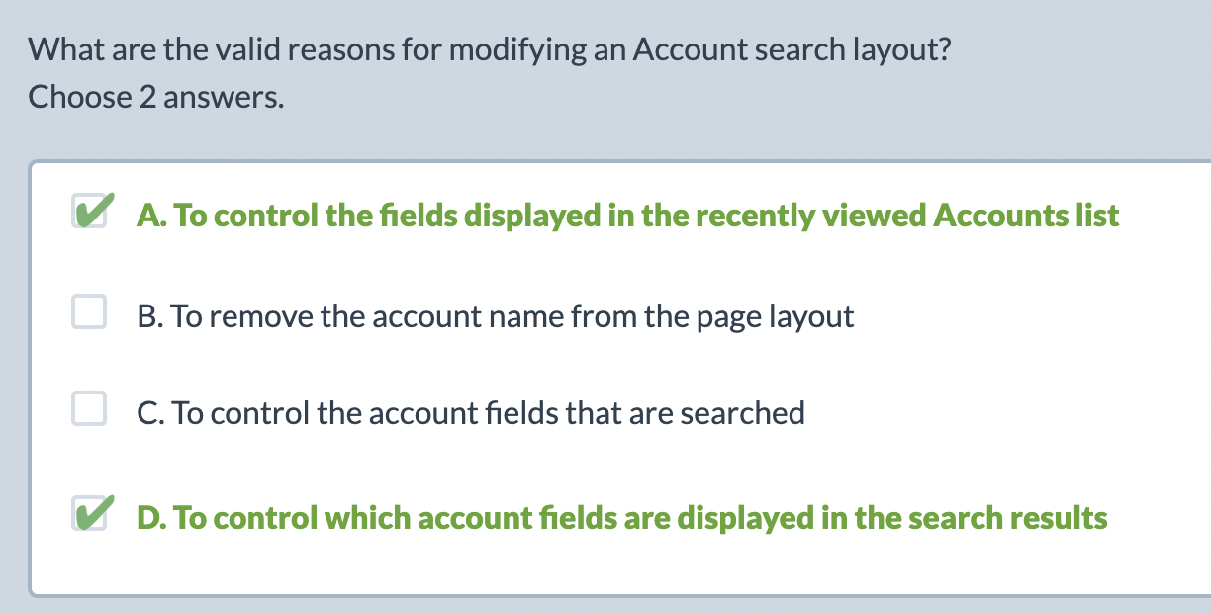

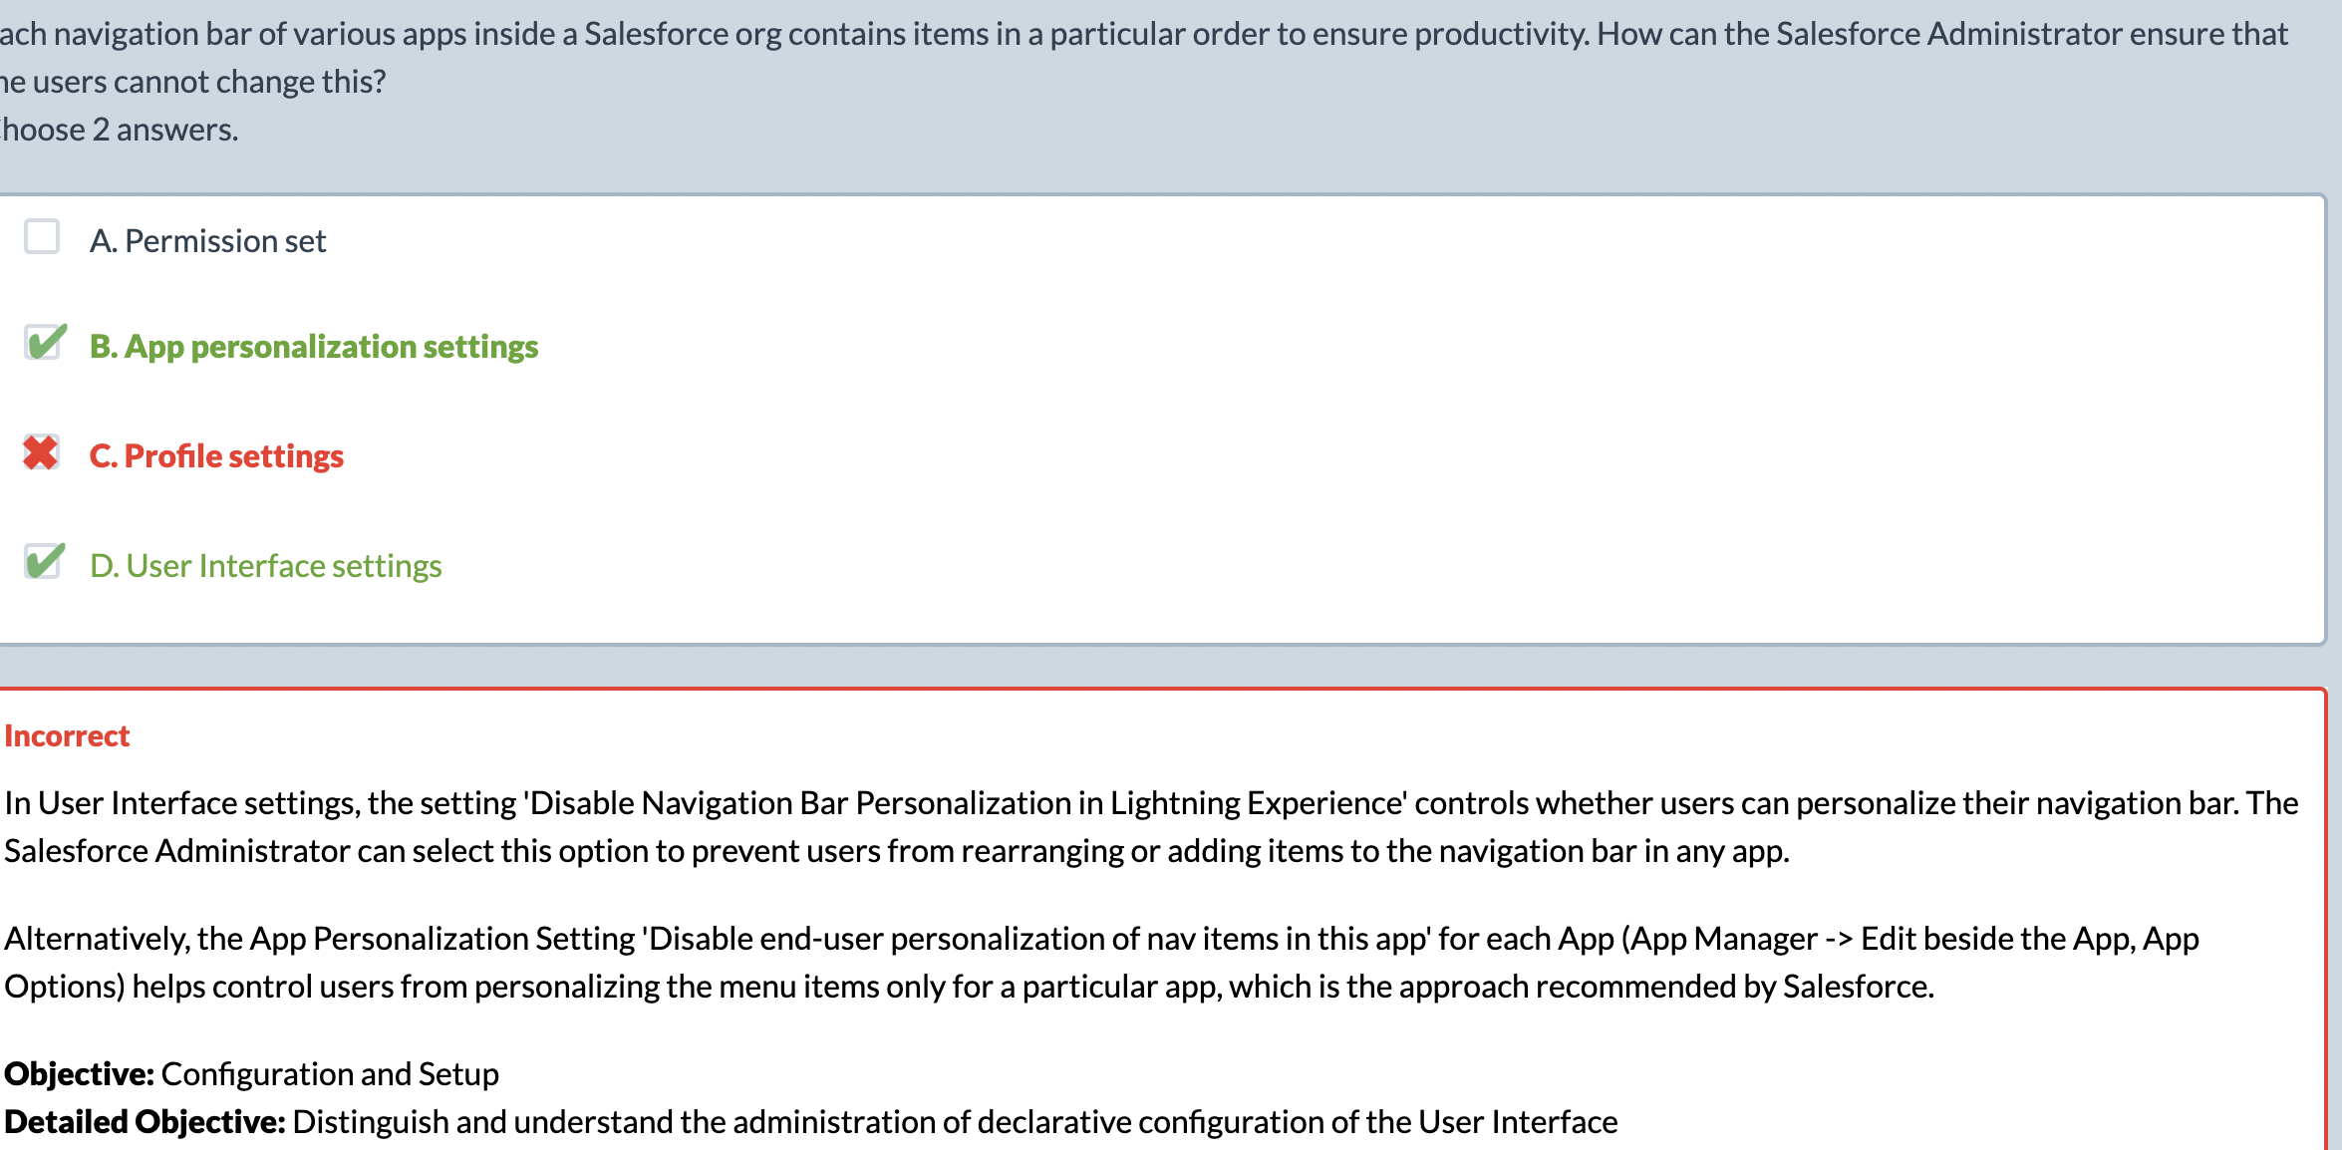
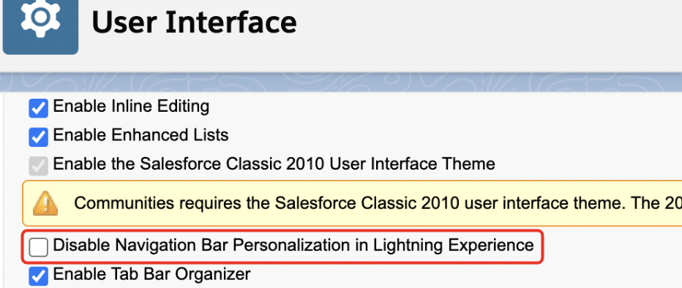
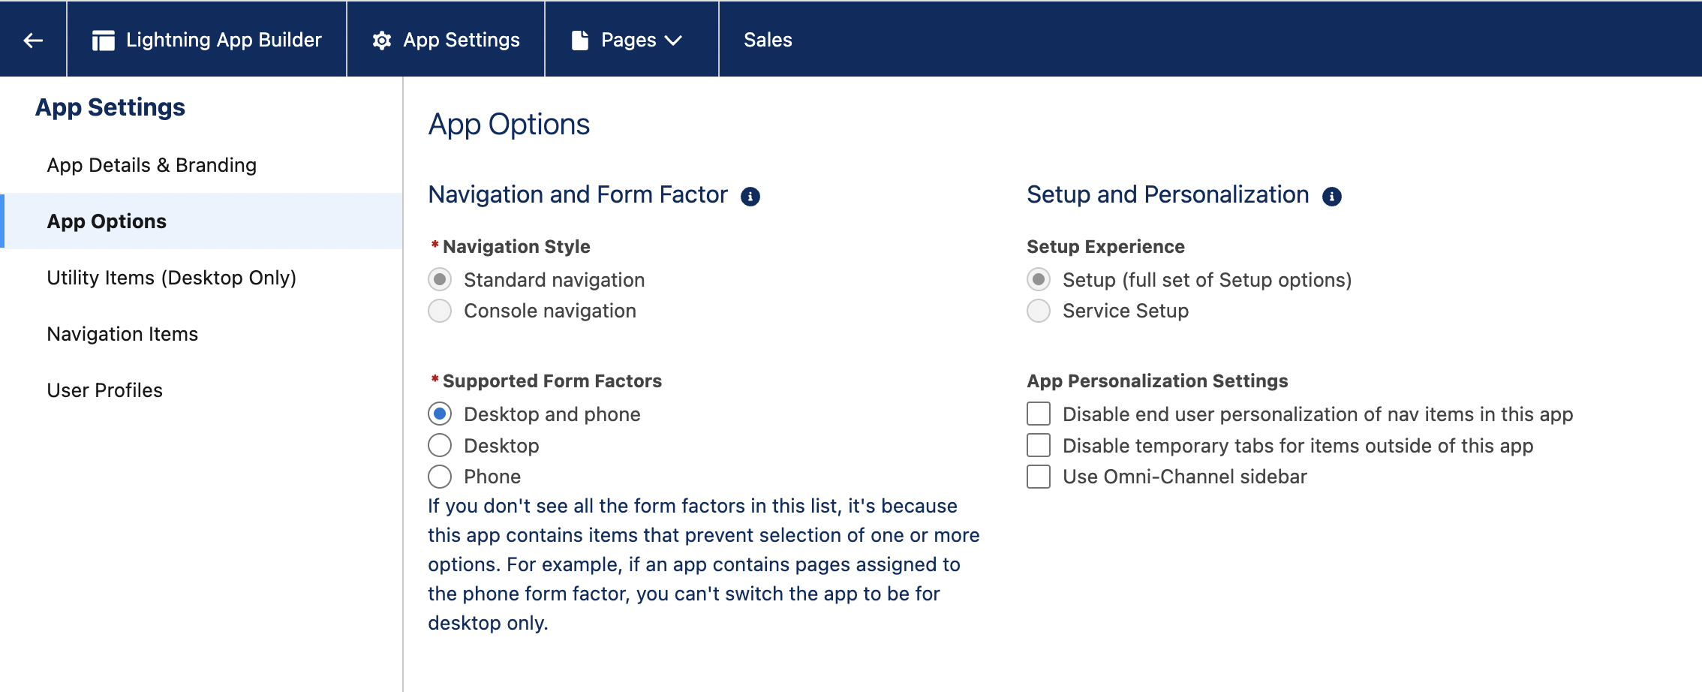

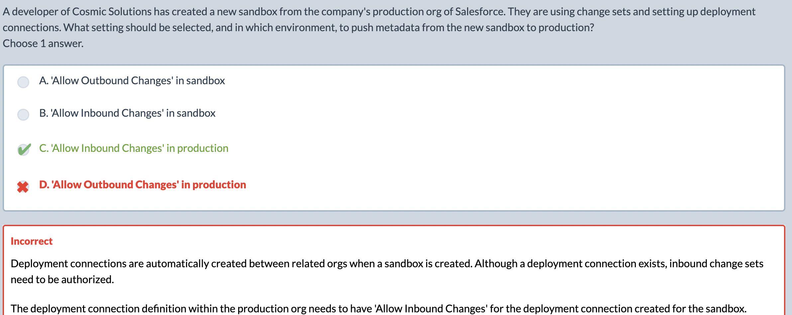

Einstien search.
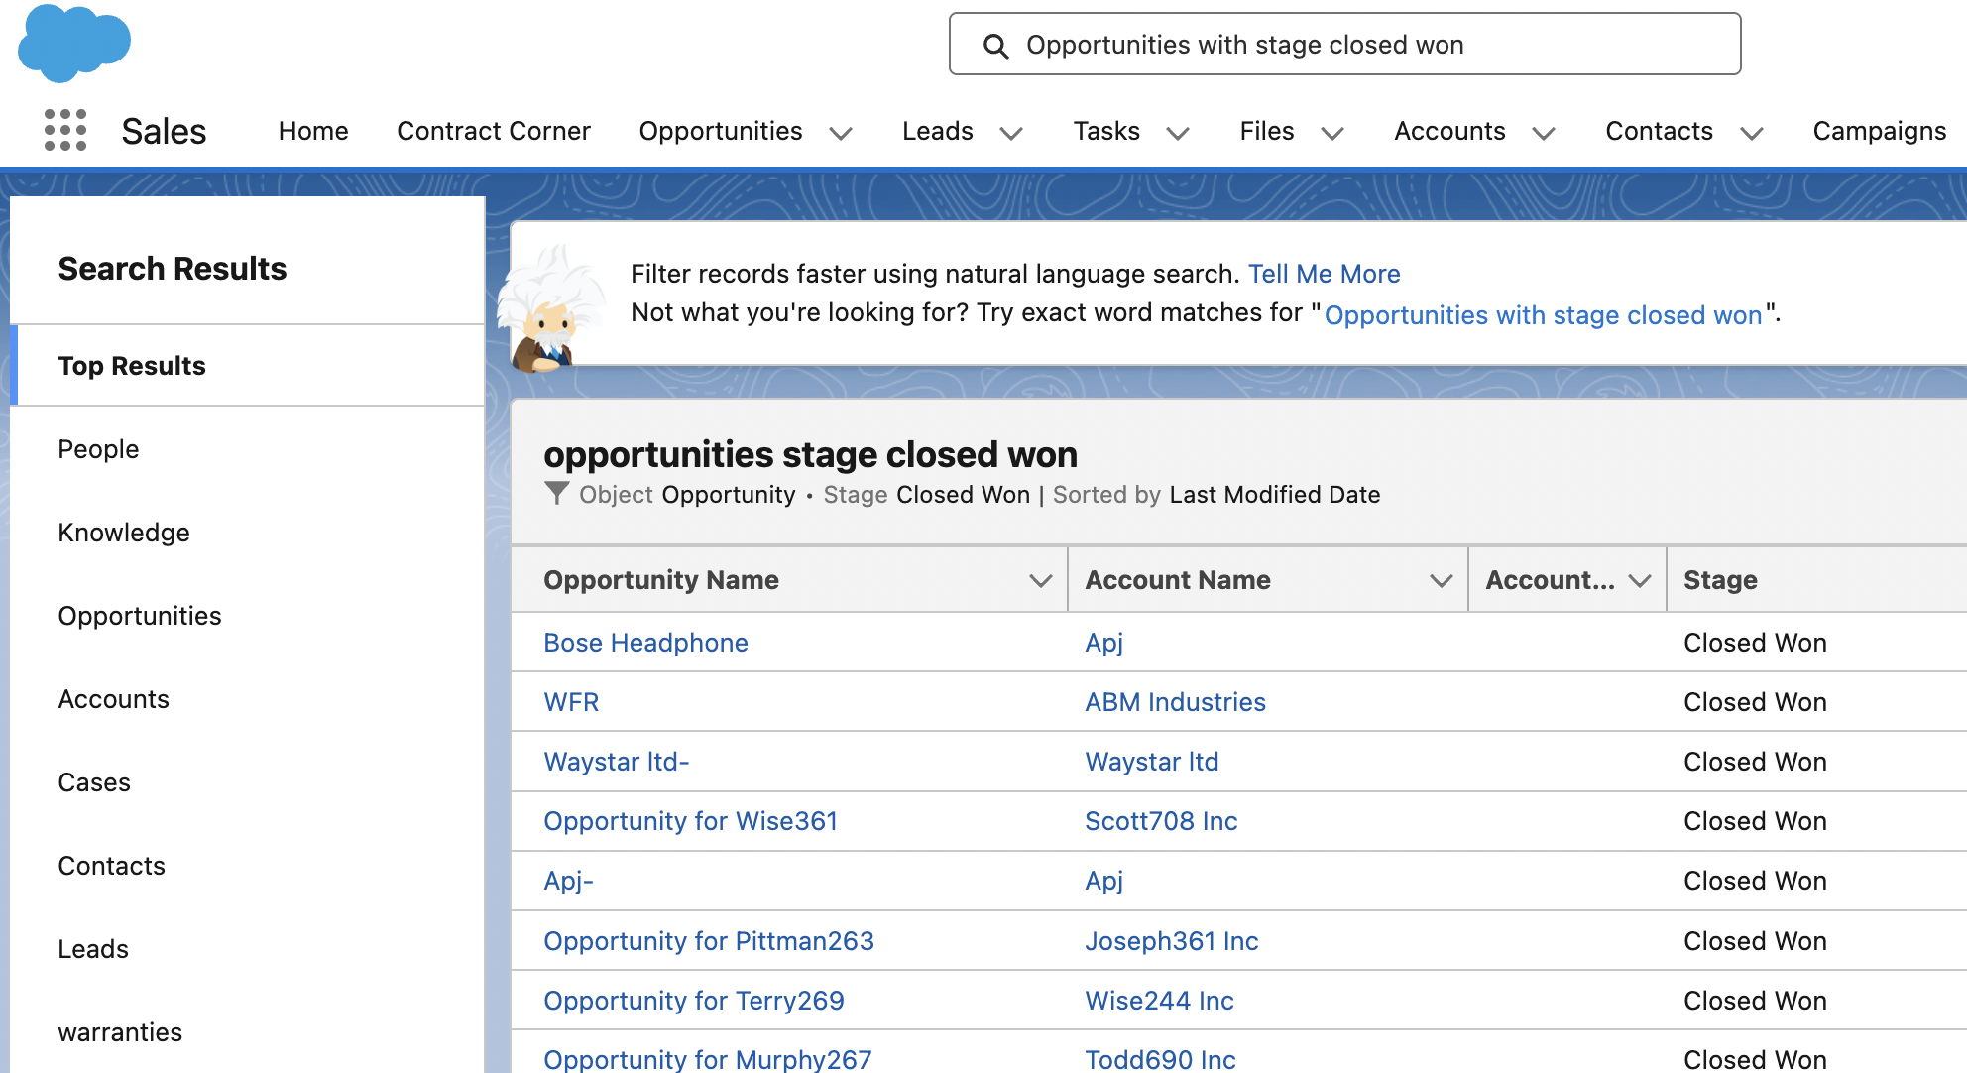

Bulk macros
 | A Bulk Macro is a macro that can be executed on multiple records at the same time, instead of just one.
 | They allow agents to update, close, change status, send emails, assign tasks, or apply templates to dozens or hundreds of Cases in one click.
FAE(send and close workflows)  Escalate cases to tier 2 and add a comment. | Bulk Macros can:  - Update field values on many Cases  - Apply quick actions  - Change Case status (e.g., to "Closed")  - Send emails using templates  - Apply “Send and Close” workflows  - Run Predefined quick actions  Bulk Macros cannot:  - Insert text into a specific email editor per record  - Require user input per record  - Be used outside the console  They work for mass actions that don’t require per-case customization.

Use Bulk Macros when:
- The action is identical across many records
- You want to close a large volume of cases
- You want to send the same message to many users
- You want to mass-update status or owner
- The action can be executed by quick actions
- High efficiency and speed are required

Use Regular Macros when:
- You’re working on a single case
- You need UI interactions (typing in fields, selecting values)
- You need personalized responses
- You need to populate email text dynamically

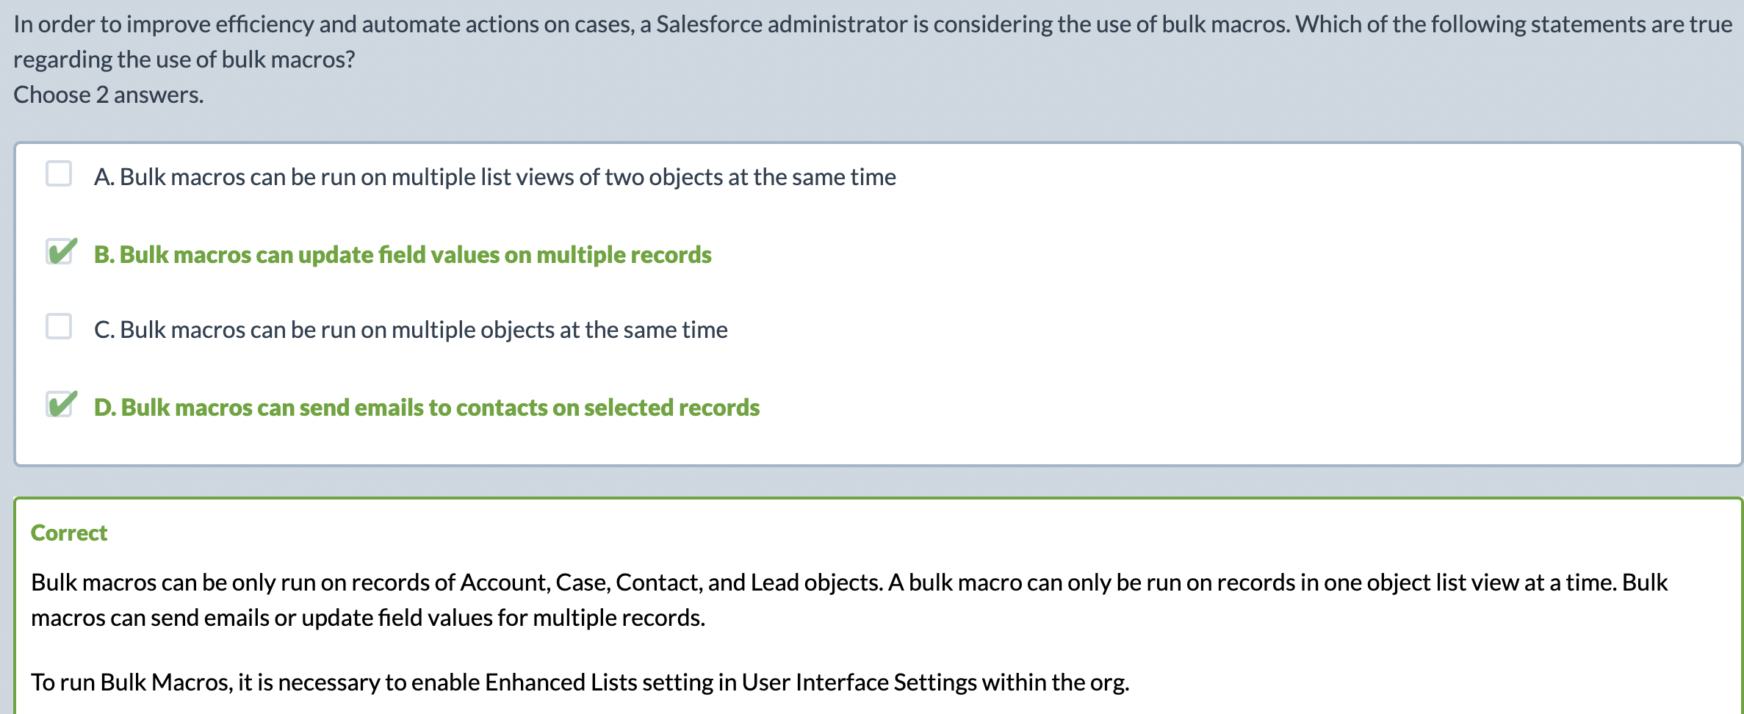

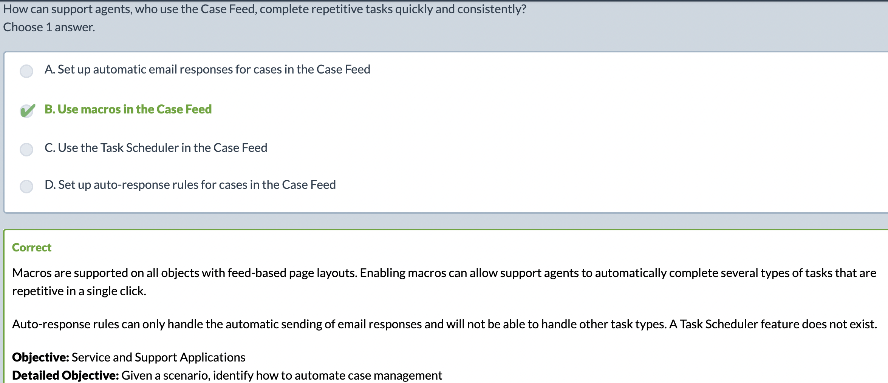
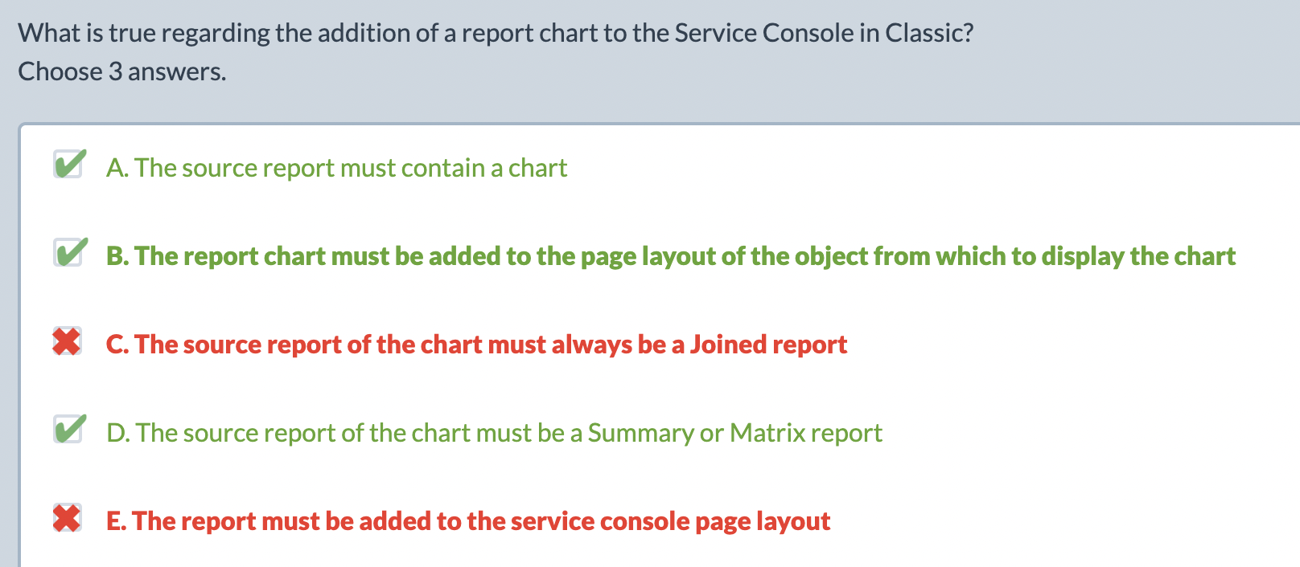

Data import wizard
What It can import | What it can’t
- Accounts  - Contacts  - Leads  - Solutions  - Campaign Members  - Custom Objects | Opportunities  - Cases  - Users  - Products  - Notes, Attachments, etc.
Account + whoId + All c except case + solution.
Accountant whose id all c except case solution.
What it can
 | Matching rules and field mapping.
Limitations | 50,000 record limit, no delete.
Competition | There exist “Basic Data import” for smaller imports and mapping.
Matching with external id | Only for object that has the field and can be imported.
It can update | Add existing contacts to a campaign in the same report. Update campaign member statuses.

Data export service/ Data export
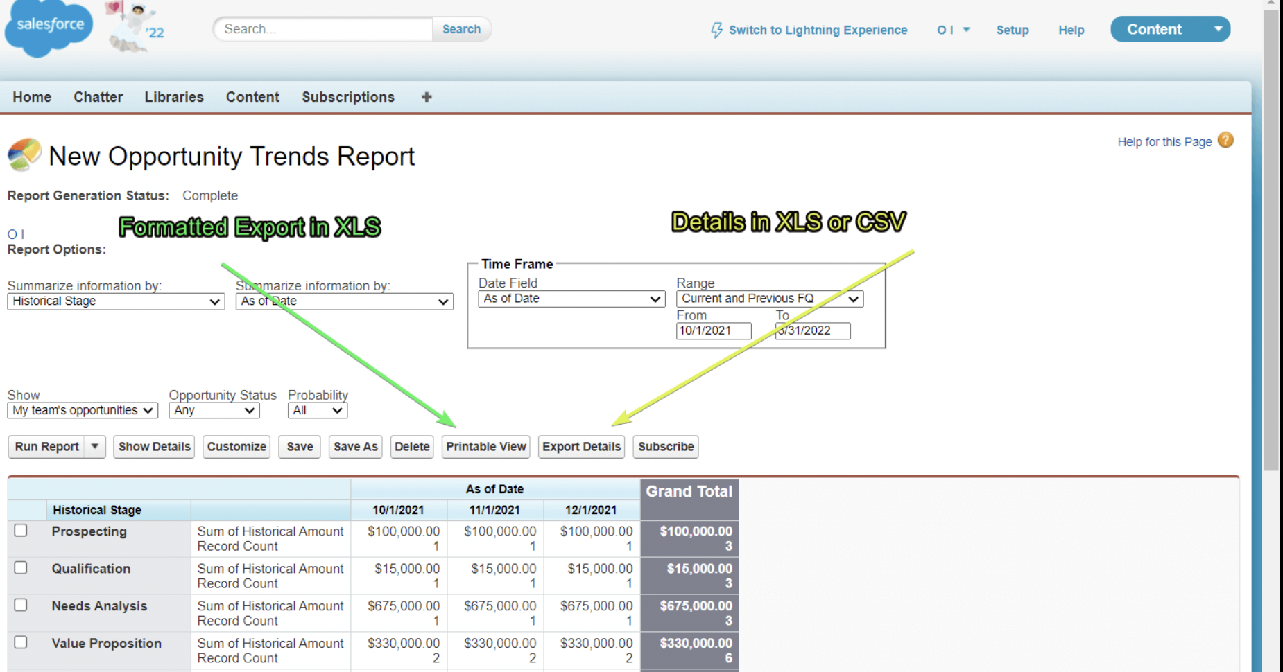
Export all data tables from SF
Manual export
Schedule export
Zipped .CSV files for each object. Optional includes files and attachments.
Can’t filter or transform data(just a dump)
Large export are broken down into a file.
Formula and rollup summary fields are excluded from exports.
You cant perfrom this daily, only weekly and ur data will persist for 48hrs.

Data Loader
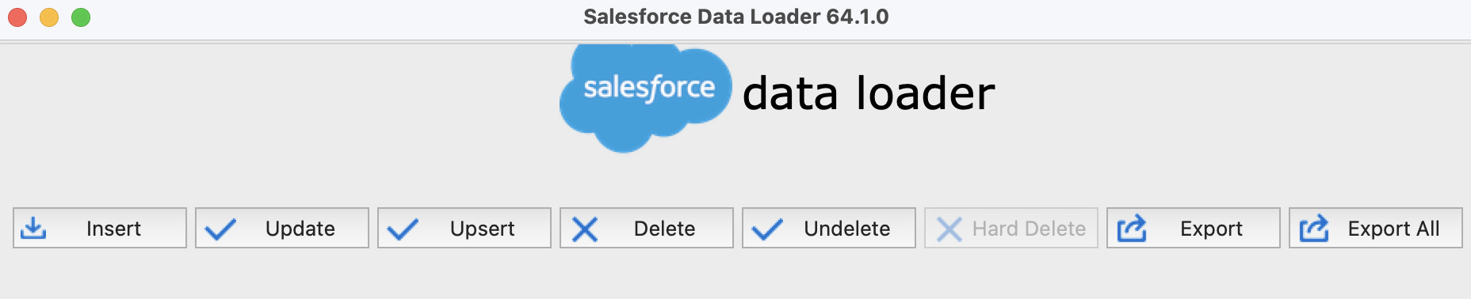
Crud and undelete and export.
Handles massive volume upto 5 millions records or more.
- iNSERT
- UPDATE
- UPSERT
- DELETE
- HARD DELETE (if enabled)
- EXPORT
- EXPORT ALL (including deleted/archived records)
Upsert:
If the record exists → UPDATE it
If the record does NOT exist → INSERT it
 | To handle duplicates for records exceeding vol > 50k, we use duplicate management and import the records via Data loader. It work only on “Account whoid All I can c except cases and solution”.
Dataloader cli can schedule. Dataloader cli is only supported on windows. | You can setup automated insertion using dataloader cli or use an app from appexchange like jitterbit dataloader. You can schedule
 | Data loader can support upto 5M records with bulk api and now upto 150M records using bulk api 2.

Important | You can export from a report to generate ids and then use that to perform a delete operation using data loader.

 | Validation rules can be turned off temporarily for old data and turned for new data.
If we important a file with a record having a picklist value that is no longer present. | That field will be empty and the file will be imported.
Record id | Is required to update a record using data loader.

Mapping can be saved with Data loader but not with the import wizard

Mass Transfer Accounts
 | This screen allows you to transfer an account from one user to another. When you transfer ownership of an account, the new owner will also gain ownership of the following records related to the transferred account:
Must-have | Notes, contacts, opportunities(closed too if selected), all open activities.
Optionally | Cases, account team, open opportunities not owned by the existing owner.
Remember
 | By default AOC, open Activities, Open Opportunities and contacts.

Duplicate management
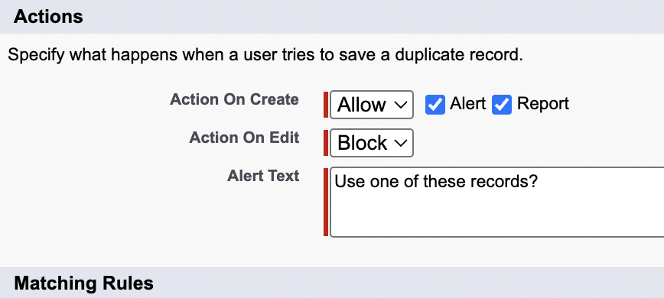  Duplicate management | Utilize duplicate management to allow duplicates on that object and create reports on those duplicate records.
Duplicate rule can be configured on | ACCL(! On Opportunities and Product)
 | Remember when u convert the opportunity, it says for existing account and contact. And I have created lead before. So Only Opportunity and product don’t pass.
 | Mulitple duplicate rules can be active at the same time.

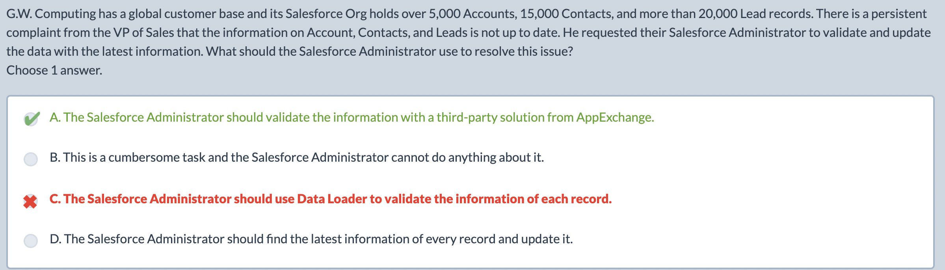
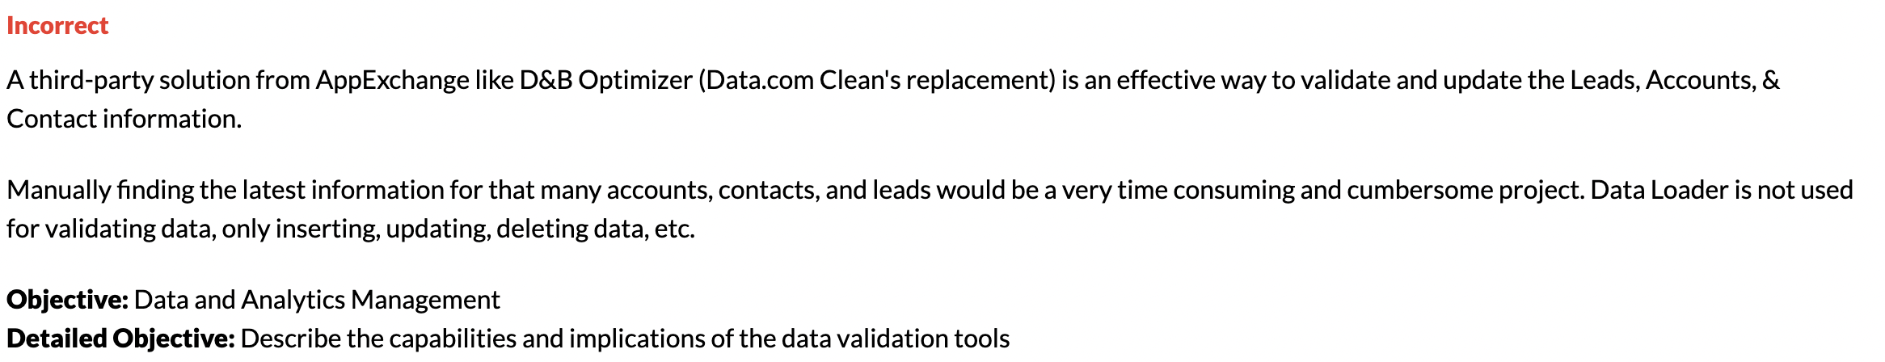

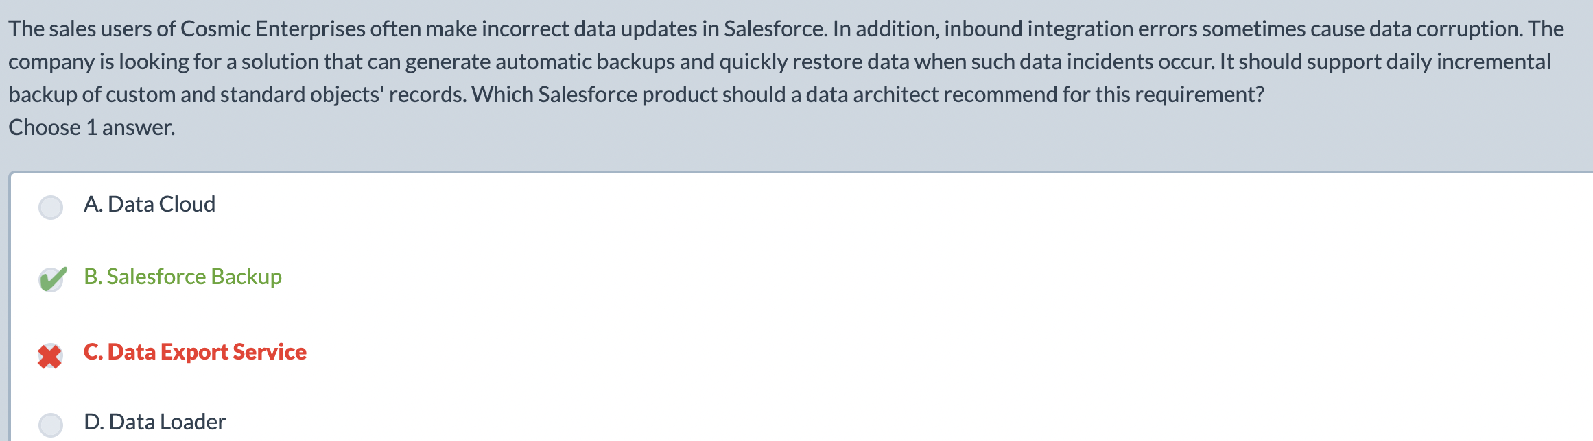
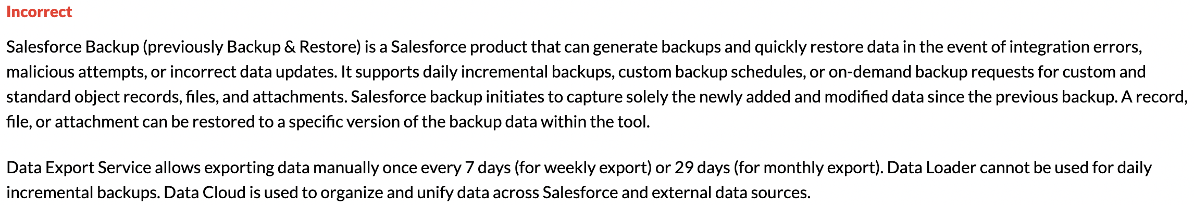

3:20:25 | Images, charts and widgets.


Reports
 | Recipients of the reports must be sf user.
Determined by running user | Data in the report may not be same as the data receiving user has visibility to.
 | Reports based on std and custom records time can be scheduled not hourly but daily, weekly, monthly.
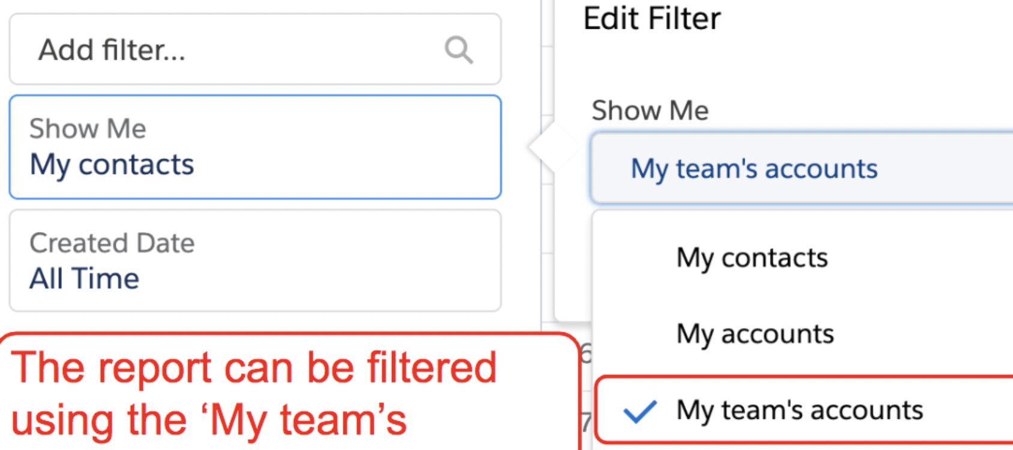 | Contact Report has a filter that says my team’s account. To view records own by my team.
 | History or schedule field can’t be added.
There doesn’t exist Opp+Acc or Opp+lead. | Newly custom fields are automatically added to standard report types.  But if the custom fied exist before the custom report type, then the field will be present. It aint dynamic.
The first will be the parent object.

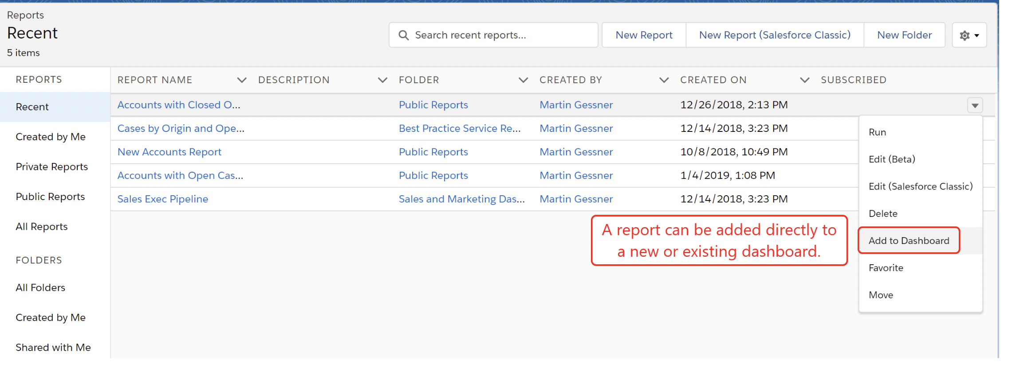 | An opportunity report can be added directly to dahsboard
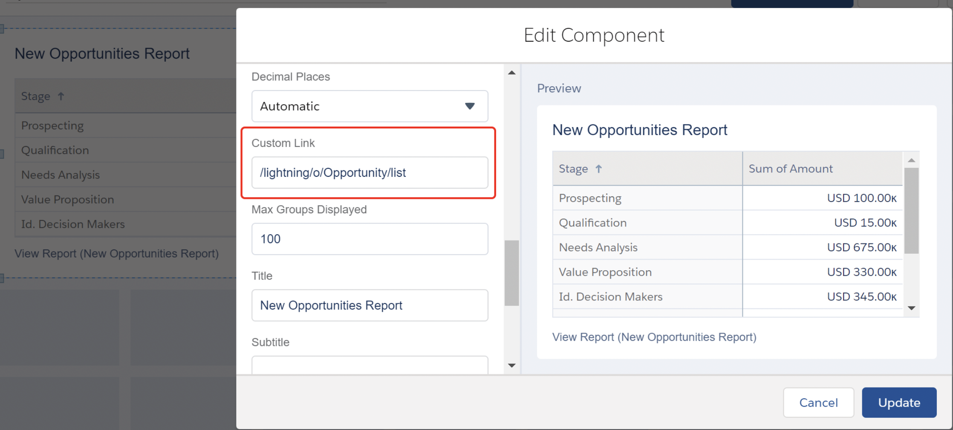 | A dashboard widget can be linked to an opportunity.
Recipient sees unfiltered | If u subscribe a recipient to a dashboard, the dashboard is seen unfiltered.
Recipient | Must have the permission to access the board to be added as a subscriber.
 | You can add by user, group or role

