Productivity and Collaboration
subtitle

Heading 1

Heading 2

Heading 3

Heading 4

Activity Management
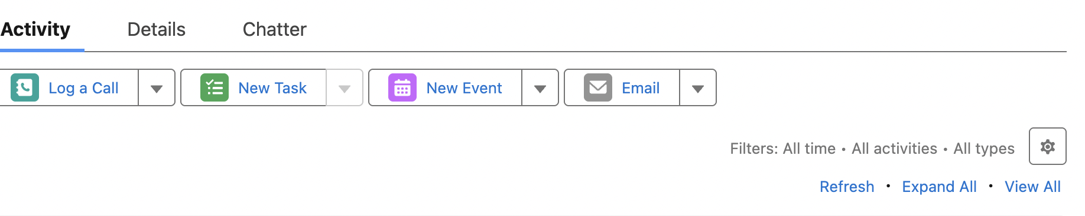

Logging call
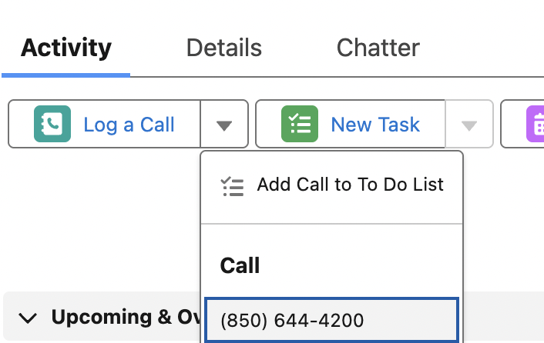 | You can log a call.  And actually call the number from salesforce if u have cti call integration.  You can also add call to your todolist.
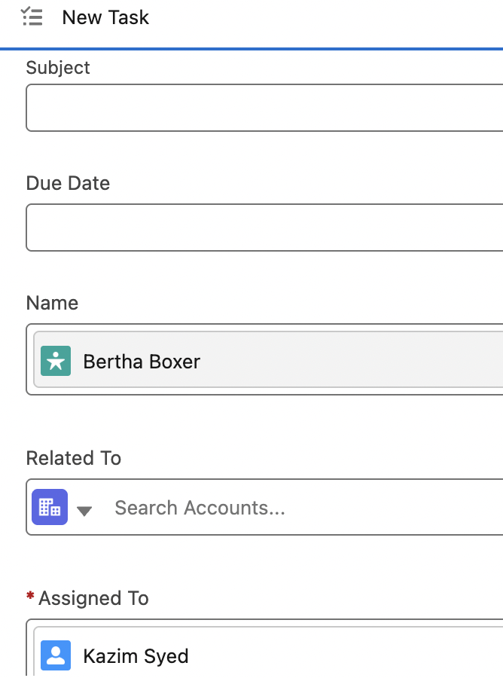 | It autopopulates the info in the task object.  You can put any related to like opp and so. Its default for accounts.  And u can set the status.
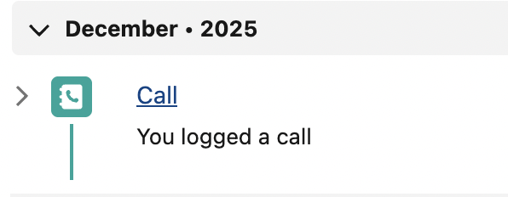 | Since we created a task for lead record, we don’t assign account record, because that will happen when lead is converted.
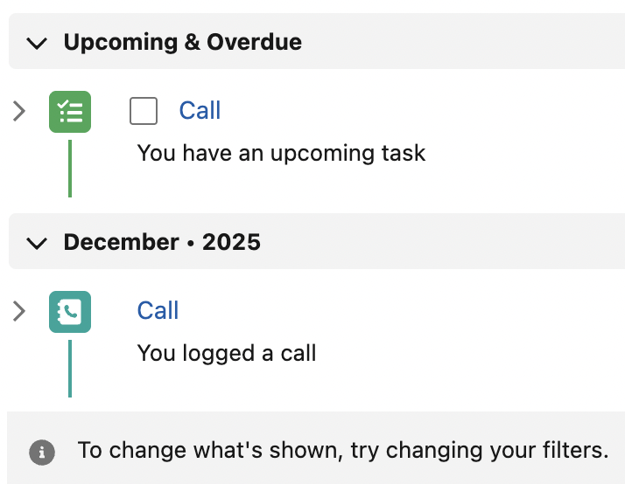 | -Task added to todolist  -logged a call.

Creating a task and marking them complete
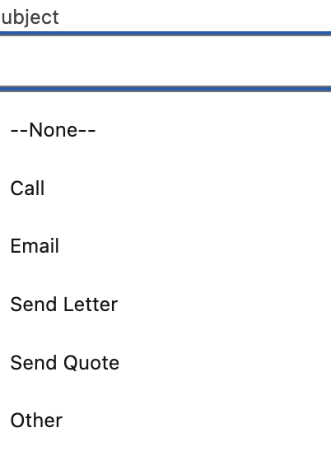 | Tasks are reminder that u typically want to do offline.
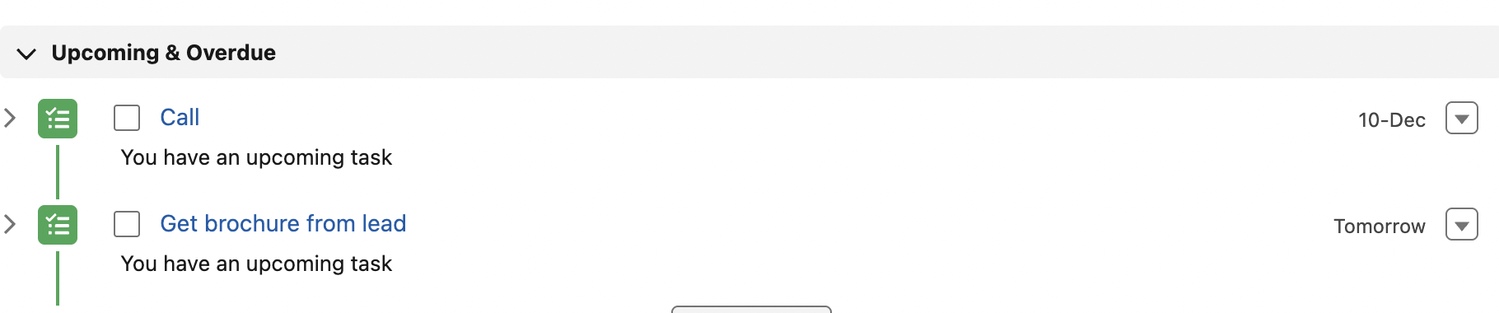 | You can even hardcode values like “Get brochure from lead”

Creating Tasks and marking them complete
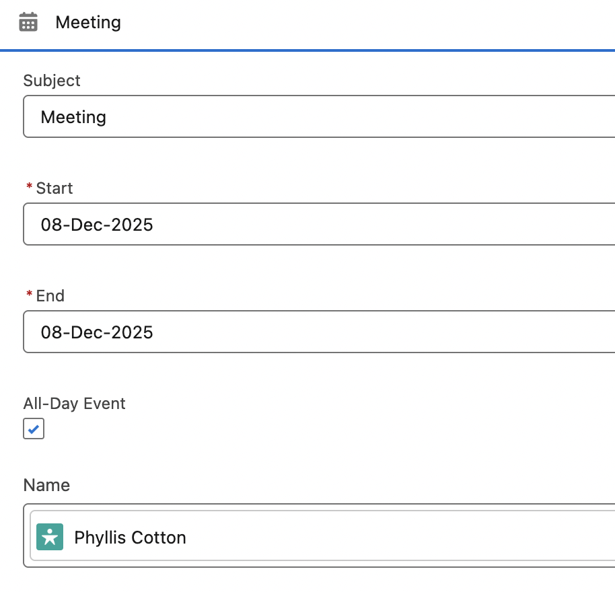 | An event is usually time,place and location and others are invited.
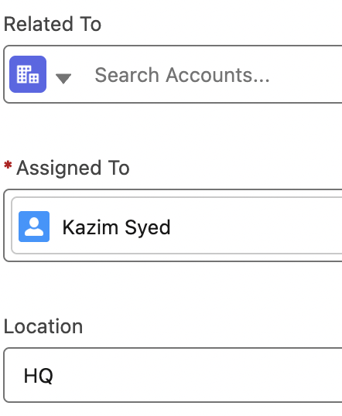 | Its different from a task which is to do something or delegate. Make sure u don’t forget something u care about.
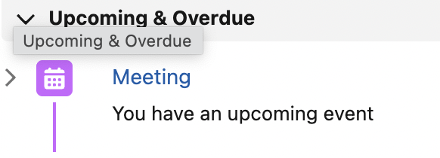 | Goto home > open calendar
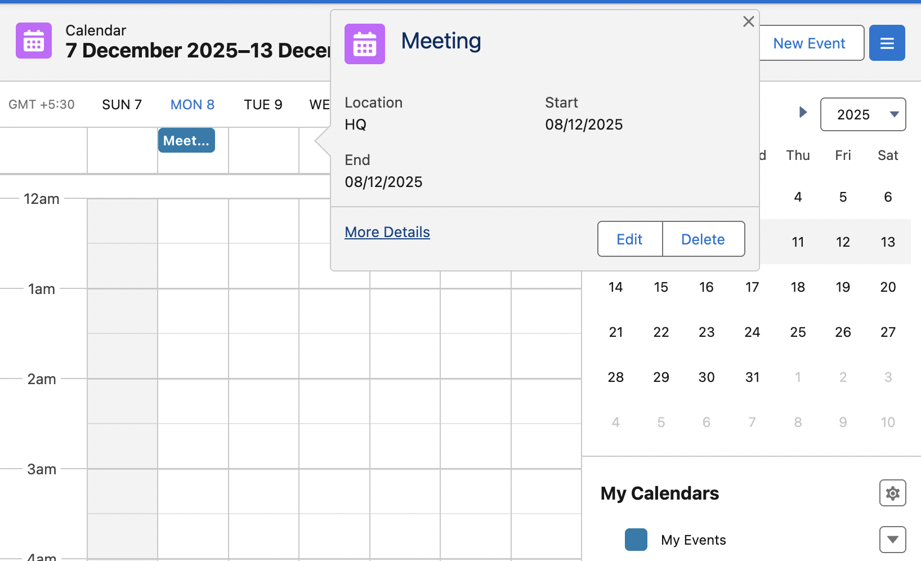

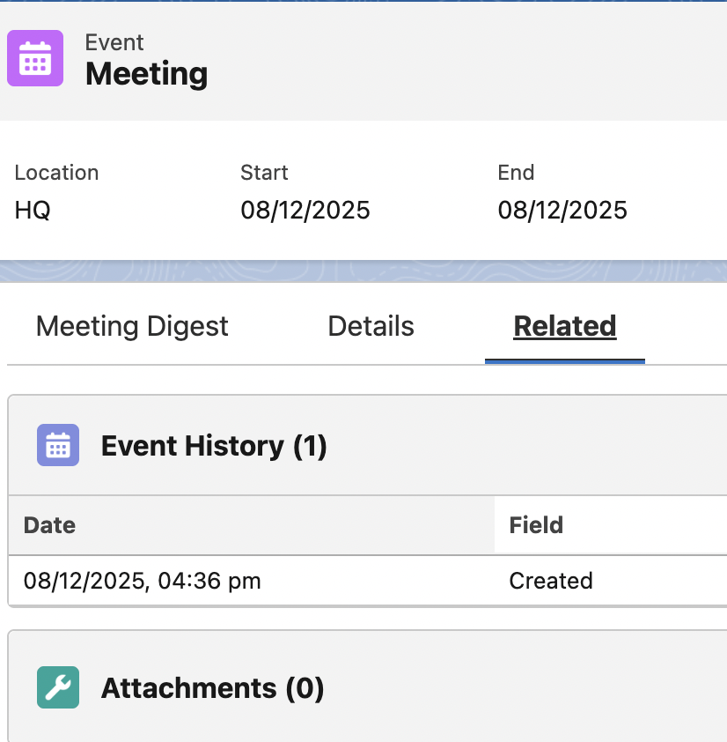 | You can edit the object and add attachments

Setting Email Deliverability and Sending emails
Email > deliverability
 | 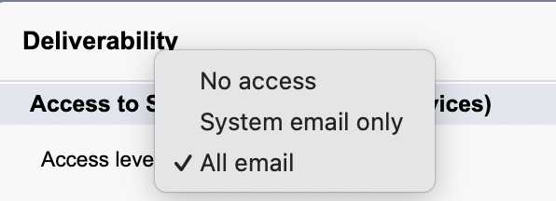
In the email body, u can attach files.  You can insert merge fields too. | 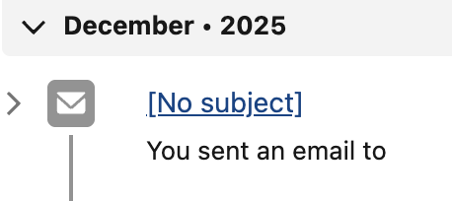
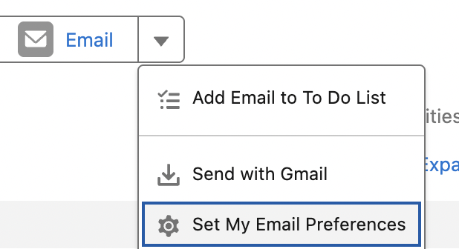 | 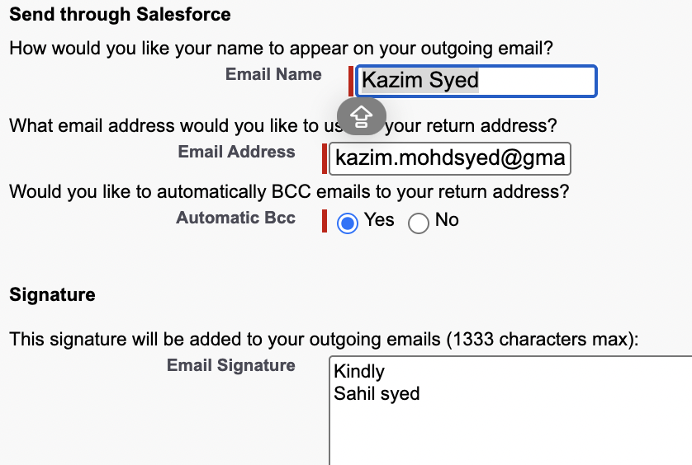
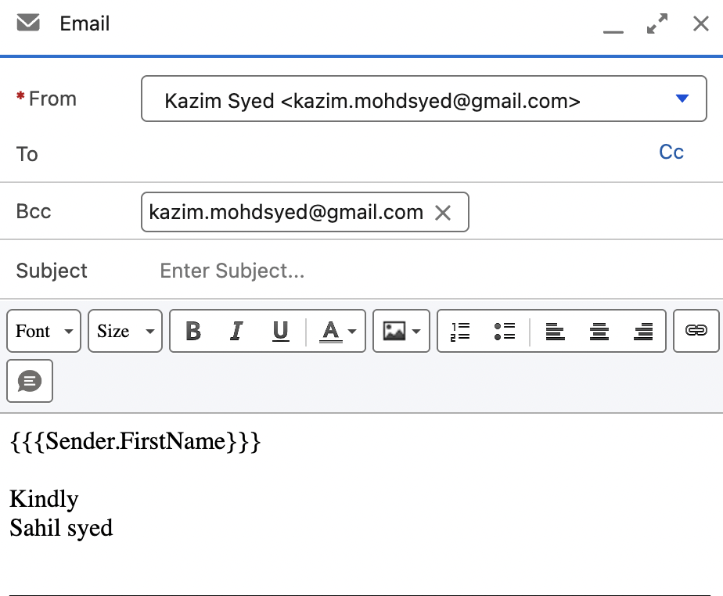 | You can insert merge field.  They are next to attachments.  You can put information of sender or recipient.
You can use templates for it. | 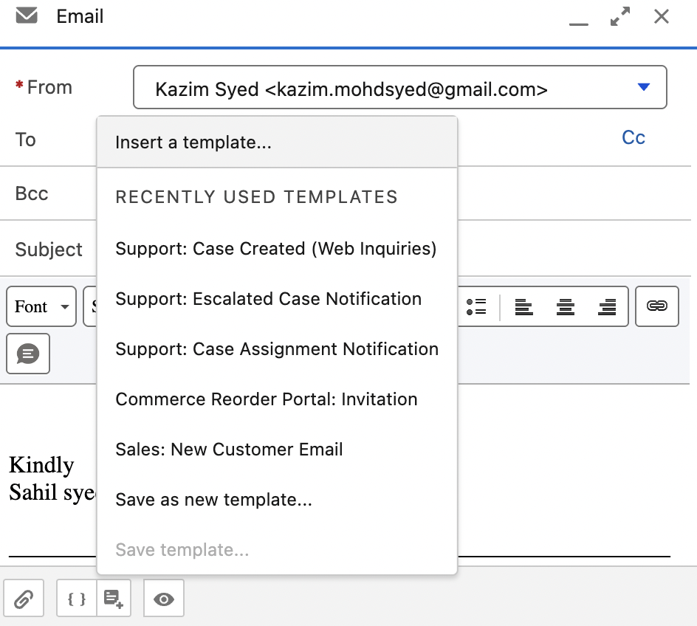

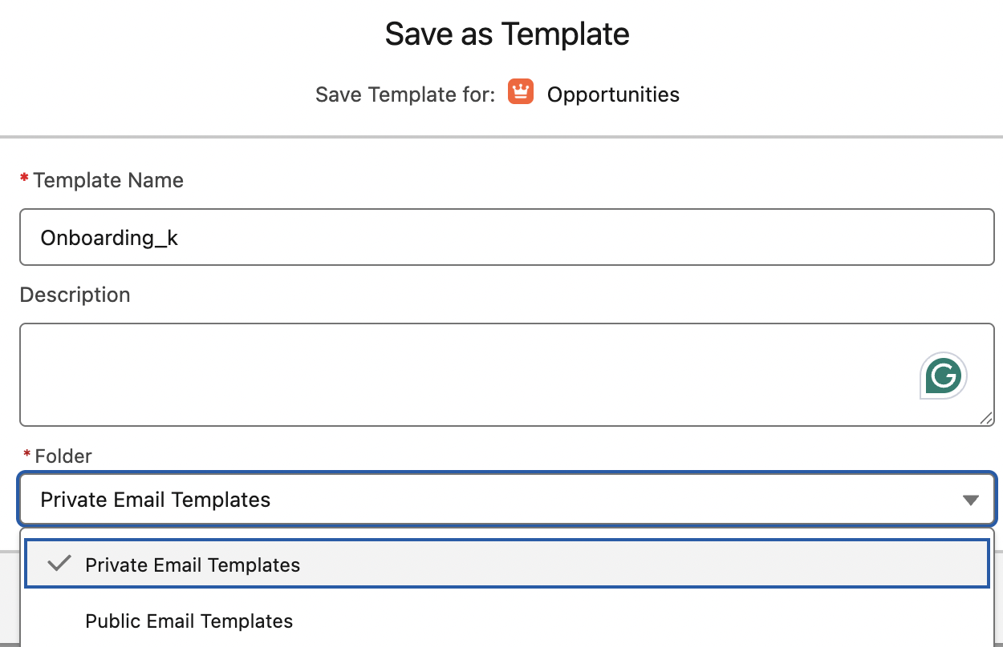 | I saved a Template and choose which folder to keep it.
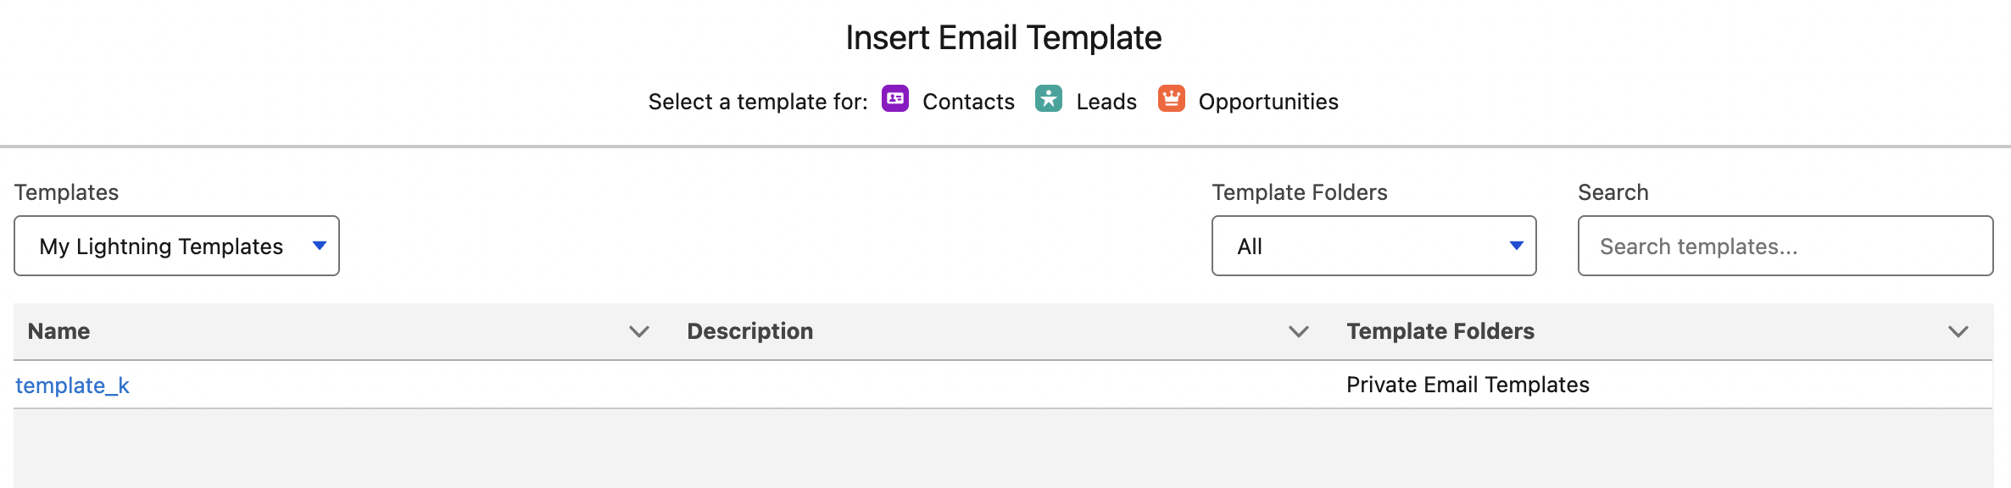 | Insert email template.

Record page settings for activity timeline or Related lists
 | So u have the option to configure your activity timeline to display. Or u can either represent those upcoming overdue and completed activities by way of related lists.
Setup > record page settings | 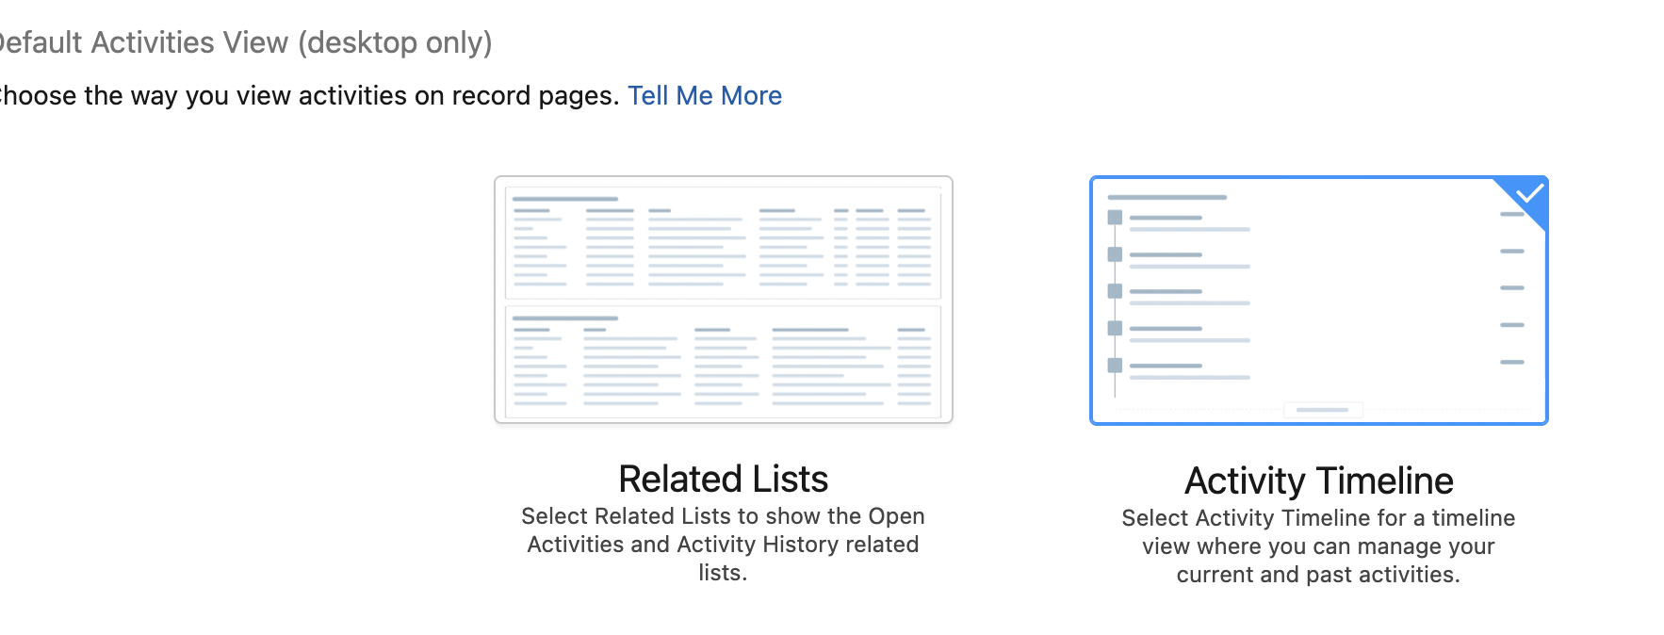  Activity timeline is the default.
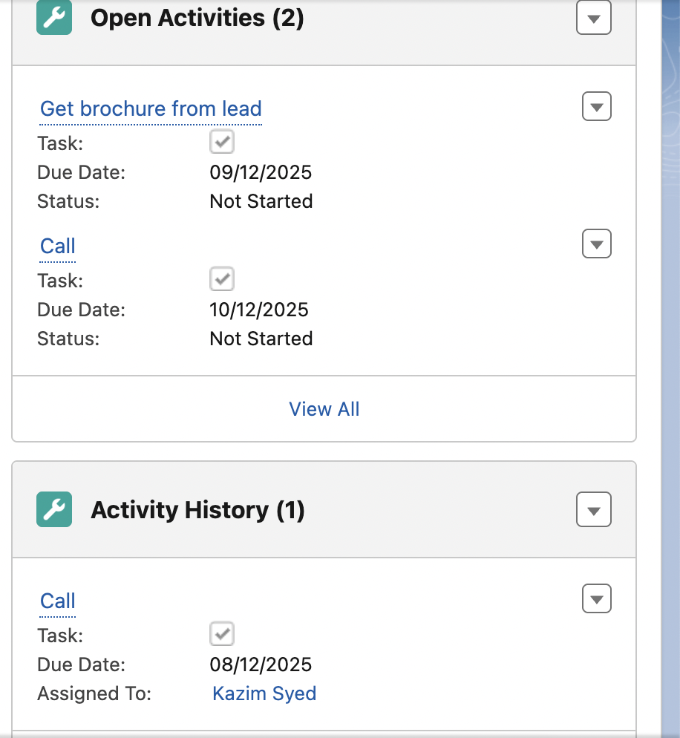

Activity Settings
Setup > Activity Settings | 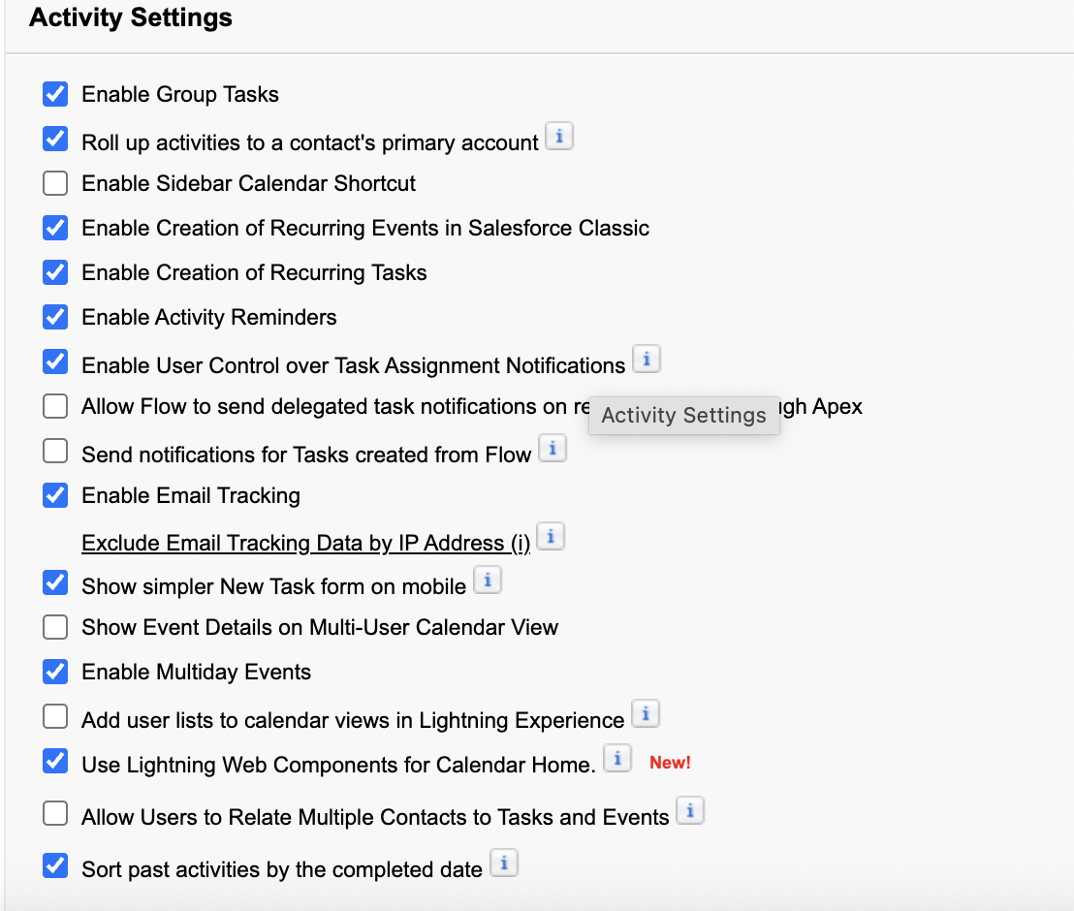
 | Mike deselected the rollup activities.

Creating a chatter post
 | Collaboration equates to chatter
You can put inside the chatter body # for topic.  So I wrote #chatter. So It became a topic. | 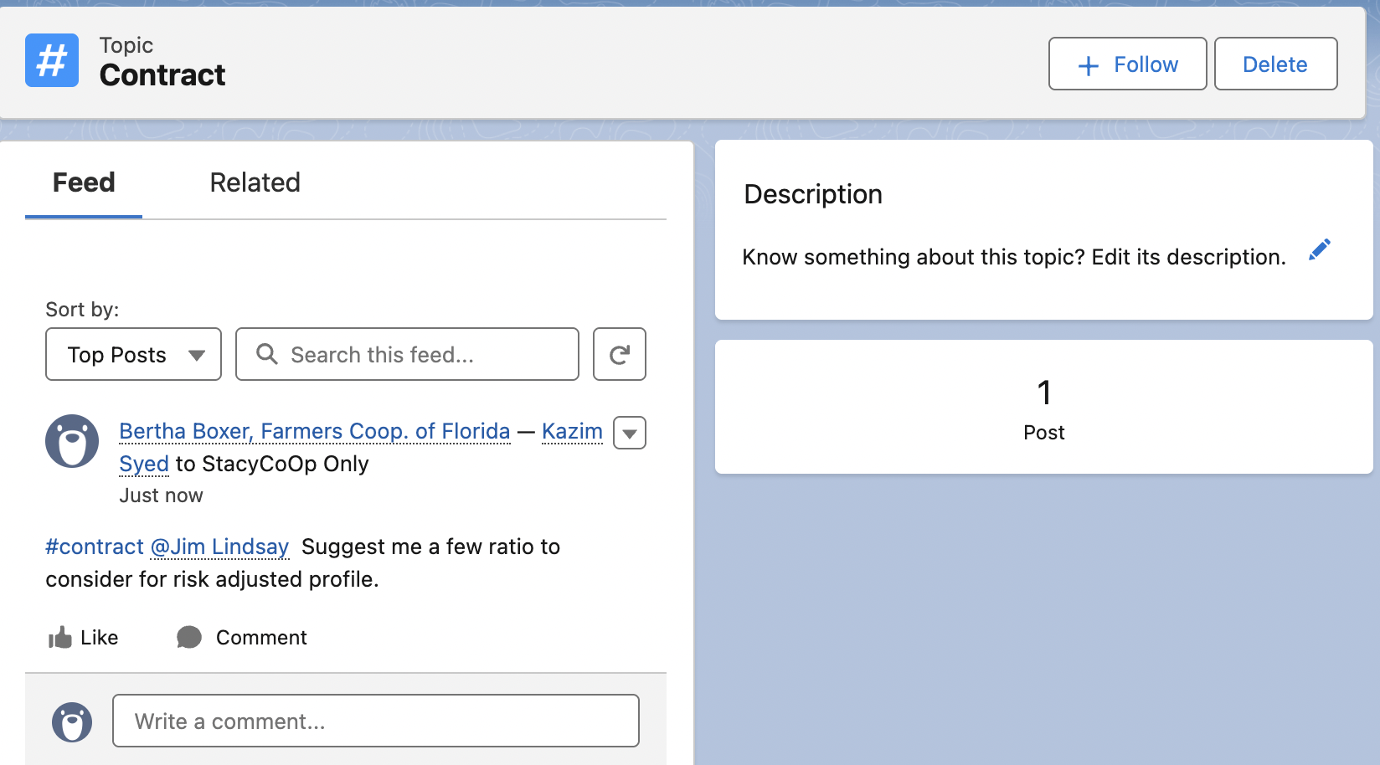

Enabling and disabling Chatter in your org
Chatter App and important features.
Chatter > Chatter settings | You can either enable or disable chatter.
 | If u disable chatter and then enable it, we see our data persist.
 | Salesforce chatter
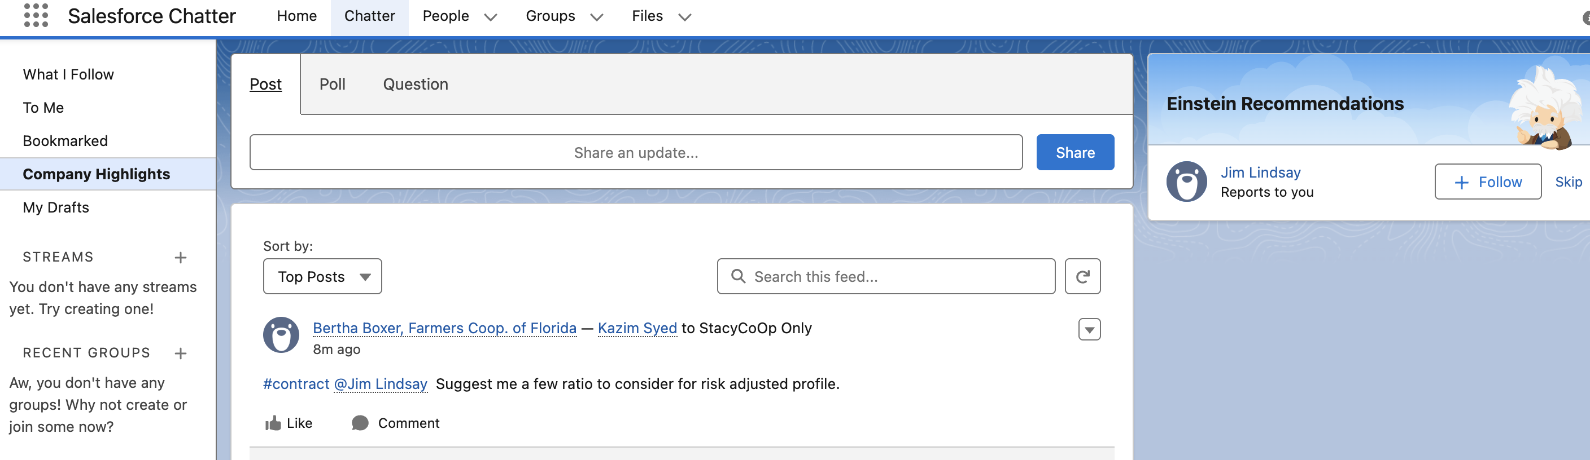 | You can open any opp that mentioned u, subscribe to it and bookmark it.

Chatter streams
 | Is where u combine multiple things into one single thing.
 | In real world instance u may have a lot of activities happening in the chatter and it may be confusing to find what u looking for.
Chatter Stream | 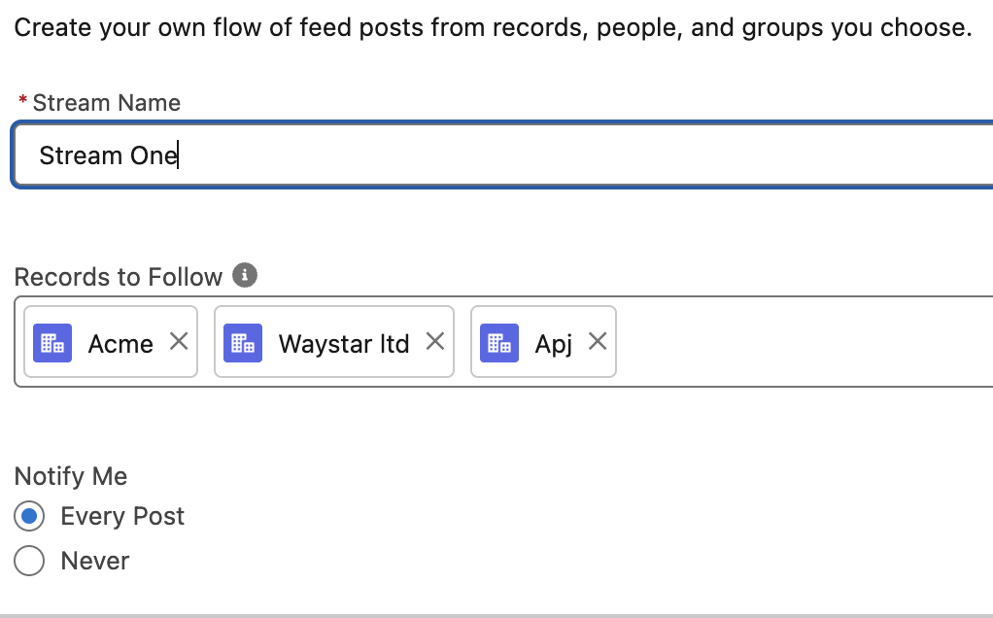
 | You can choose account u want to follow.

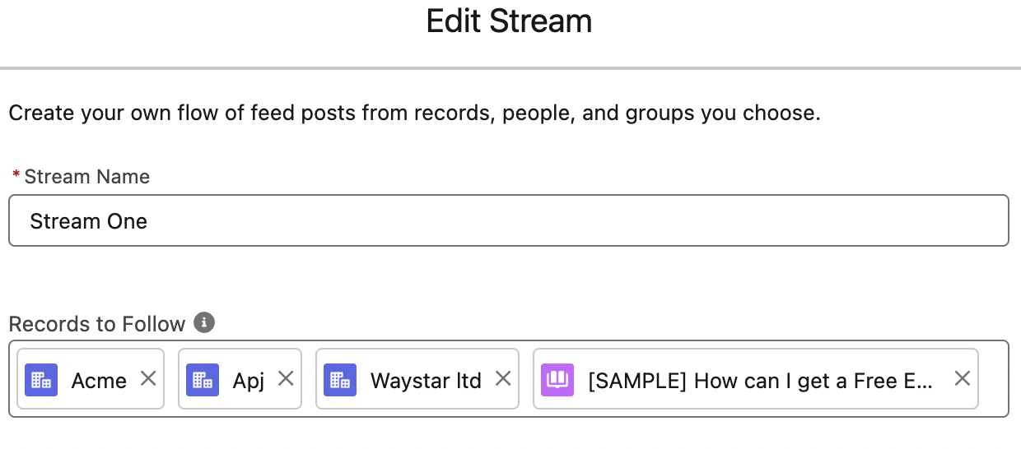 | You can add knowledge post or files.
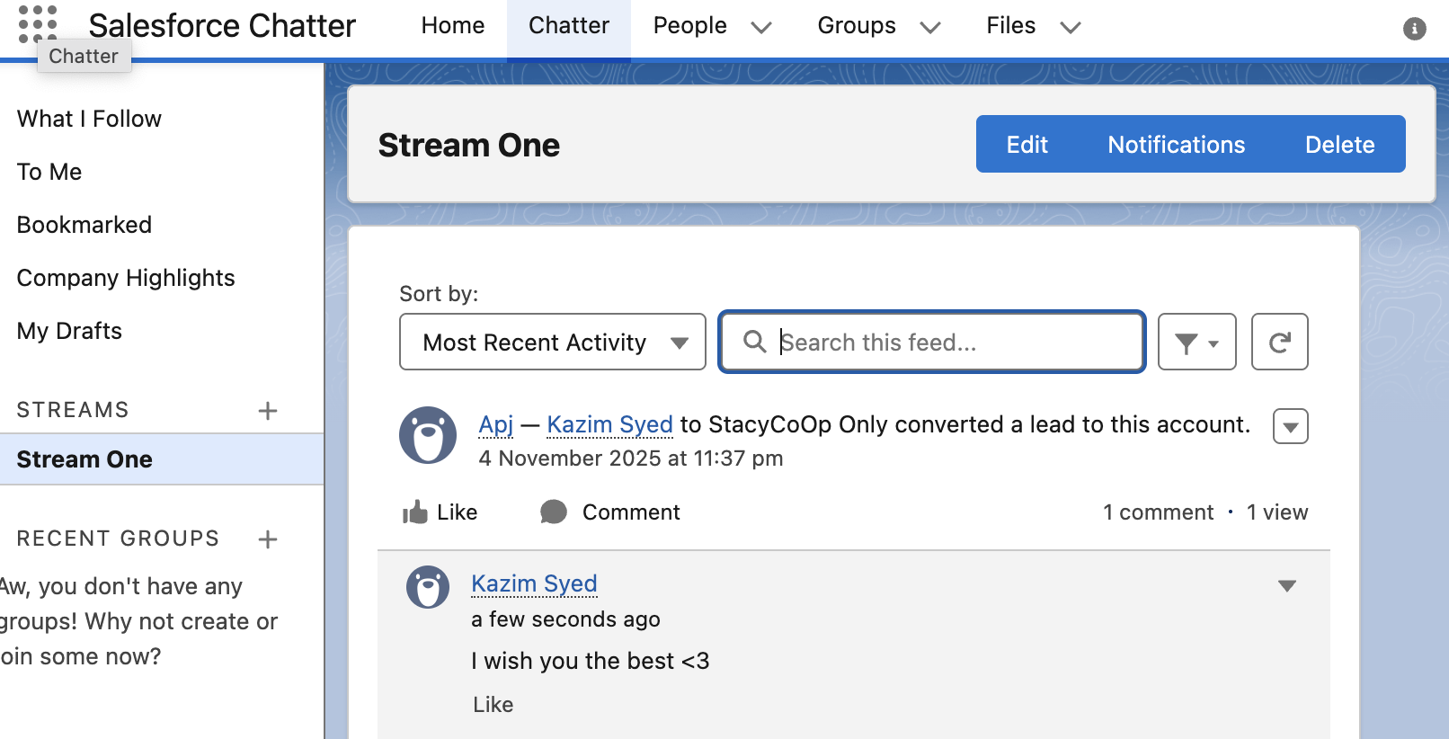 | Enable notifications.

Chatter group, Announcements and Engagement
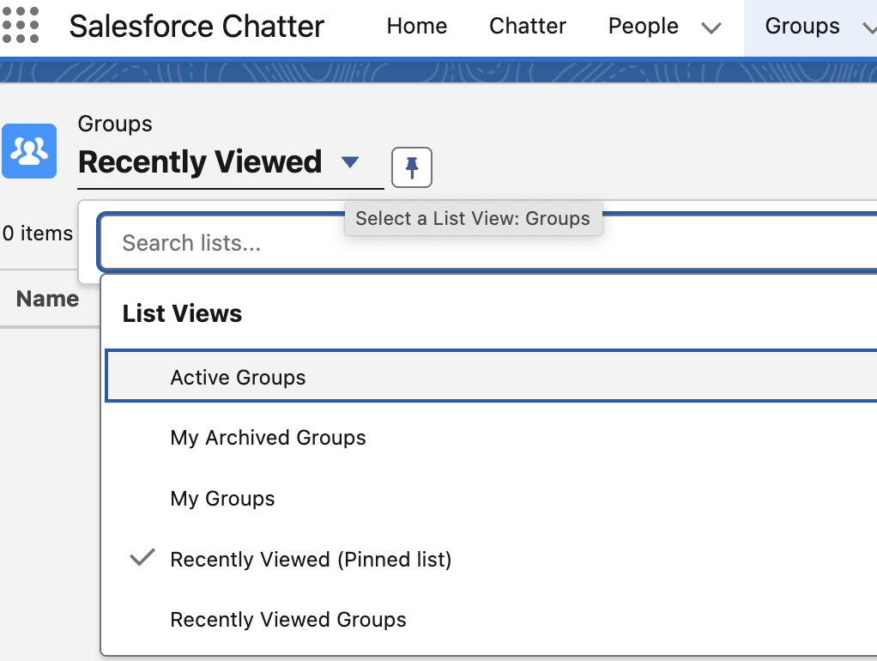
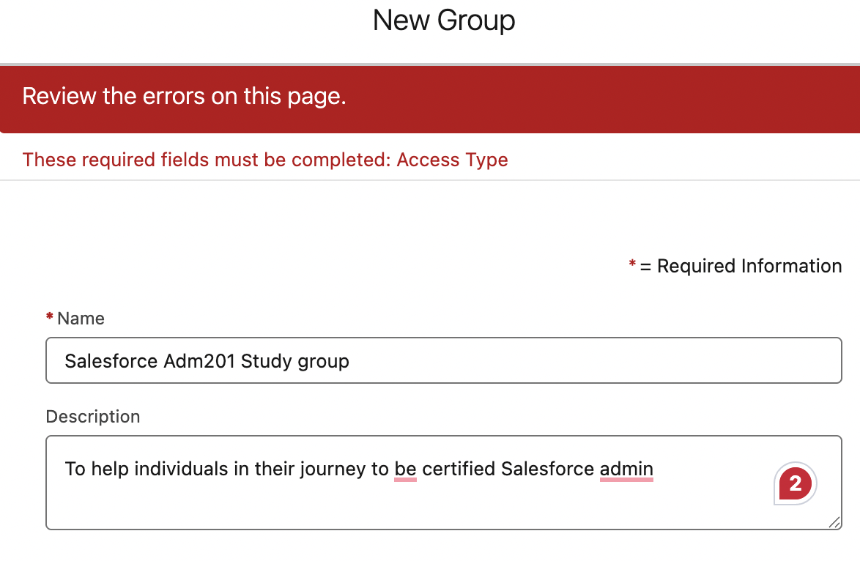
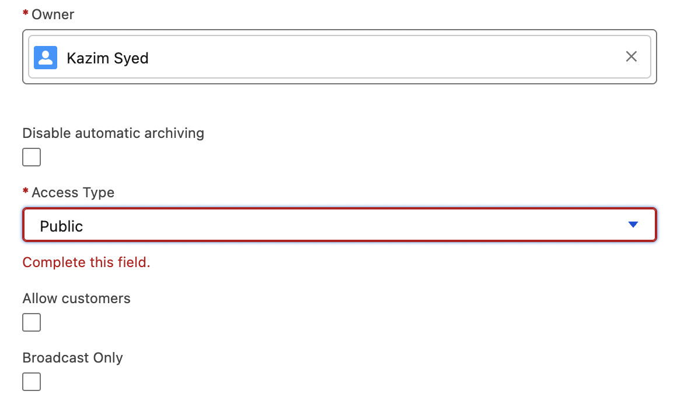 | Access type can be public, private.  Public means can join w/o approval.  Whereas in private, they can see the group in list view and can be invited or request for join by the owner.
Broadcast only | Only member can post, members can comment. Member can comment, but can’t start new post.  One way communication like company wide announcement.
Customer group | This is for collaborating with customer outside your org.  Requires:  Communities / Digital Experience enabled  Customer Users (external)
External users cannot see:  - Company public groups  - Internal chatter feeds  - Internal profiles unless allowed | Customer projects  - Joint design reviews  - Shared onboarding process

Chatter group management roles
Owner, add/remove members, can delete and change access type | Group owner
add members  C. Change access type of group | Group Manager
Read + post(except in broadcast only) | Group Members
Unlisted groups | Private groups != unlisted groups.  Private groups are NOT hidden.  Non-members:  - Cannot see posts  - Cannot join  - Cannot access files  BUT...  📌 They can still see the group exists in search or directory.
Email summary of group’s activity to member | Group email digest
Inactive groups auto-archived after 90 days | Group archiving
A customizable Lightning page that shows:  - Posts  - Files  - Members  - Group details | Group record page

1. Non-members of a Private Group cannot see the group exists.
(Exam loves this.)

❗ 2. Users cannot request to join a Private Group.
Only invited by Owner/Manager.

❗ 3. Broadcast-Only groups do NOT prevent comments.
Members can still comment.

❗ 4. Customer Groups require External Users + Communities.
Internal-only orgs cannot use customer groups.

❗ 5. Public vs Private has nothing to do with data access for records

A. View All Data  B. Chatter Internal User  C. Create and Own New Chatter Groups  D. API Enabled | What permission allows posting to records’ Chatter feeds?
11. Which statement is true about Chatter Files shared in groups?
A. Only Group Owner can upload files
B. Files can be shared with group members only
C. Files inherit group visibility
D. Files become public on the internet
Correct: C

What happens when a Chatter Group is archived?
A. Members cannot post
B. Group is deleted permanently
C. Only admins can see it
D. External users are removed
13. Who can unarchive an archived group?
A. Any group member
B. Group Owner
C. System Admin only
D. Anyone with Manage Chatter Groups permission
Correct: B

Which Chatter license is used for users who collaborate internally without Salesforce CRM?
A. Customer User License
B. Chatter Free
C. Chatter External
D. Platform Starter
A user cannot share a file in Chatter. Possible reason?
A. File size too small
B. File is private to the owner
C. File is in an unlisted group
D. User’s profile lacks Modify All Data
Which group type is hidden from group search and directory?
A. Customer Group
B. Private Group
C. Unlisted Group
D. Public Group

Chatter feeds Tracking and Adding the chatter tab, publisher and feed to a page
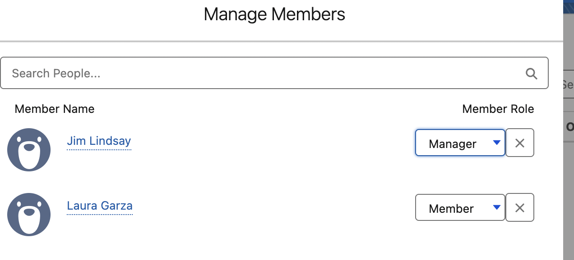 | When we add member we can change it if we want that person to be Manager or member.
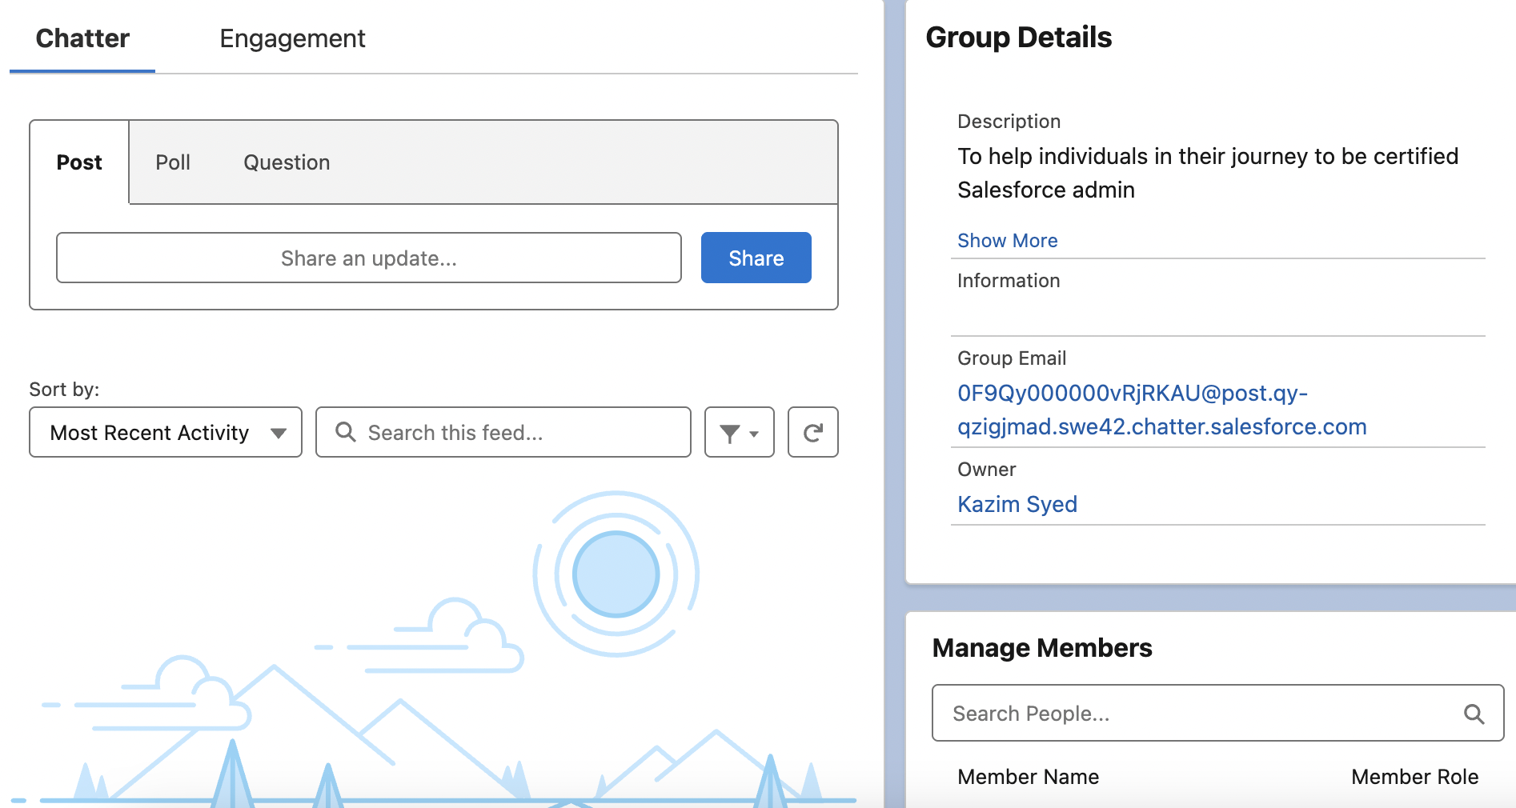 | 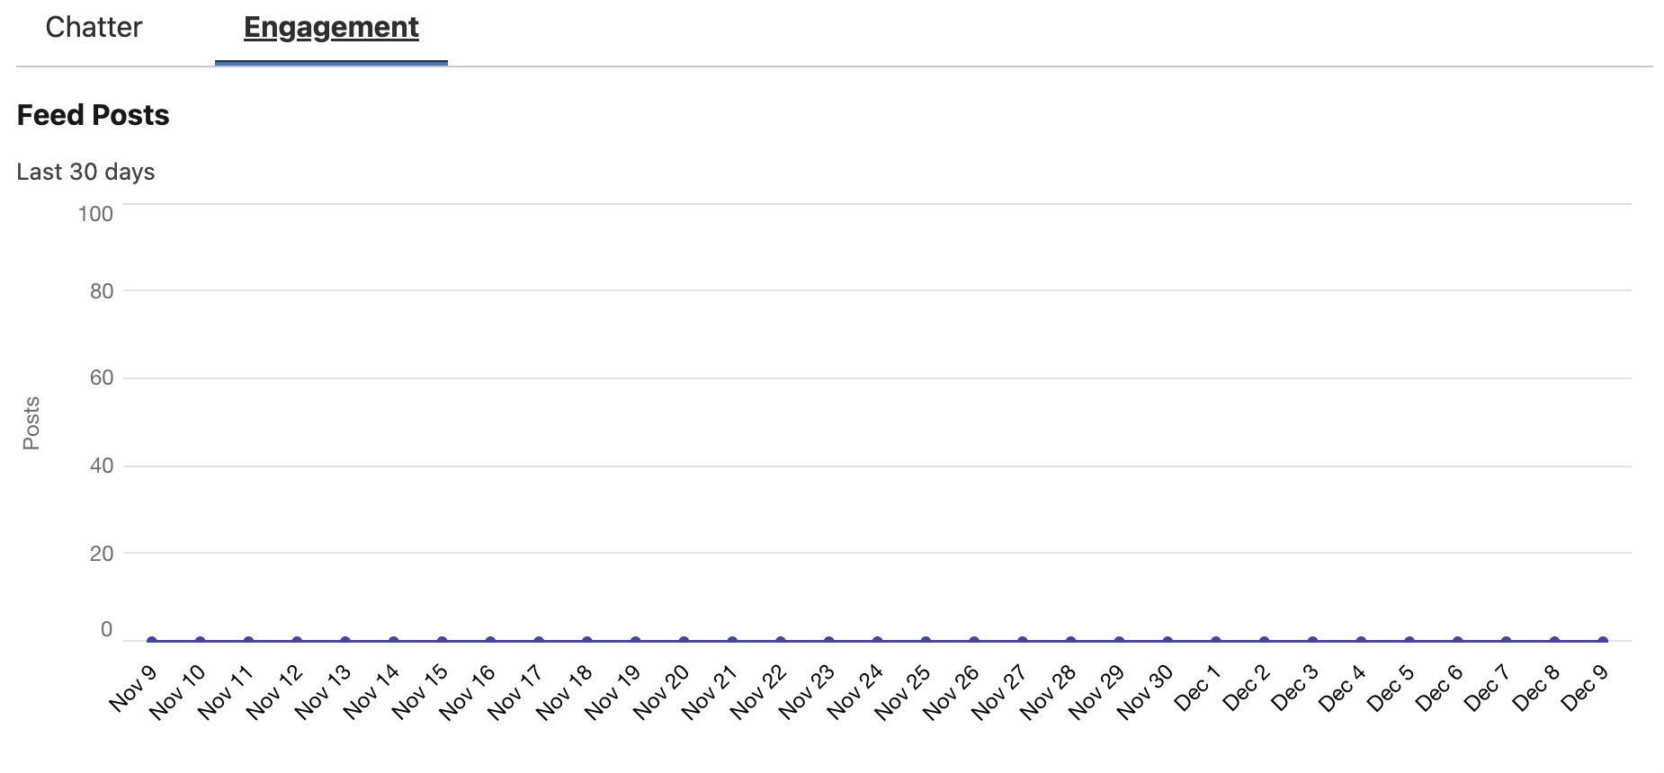  Also give u engagement level.

 | You can enable chatter feed tracking in order to share updates via the chatter feed for any updates that you make to the record if its a field that u are tracking changes for your chatter feed tracking
 | Enable feed tracking for objects so users can follow records of that object type. Select fields to track so users can see feed updates when those fields are changed on records they follow.
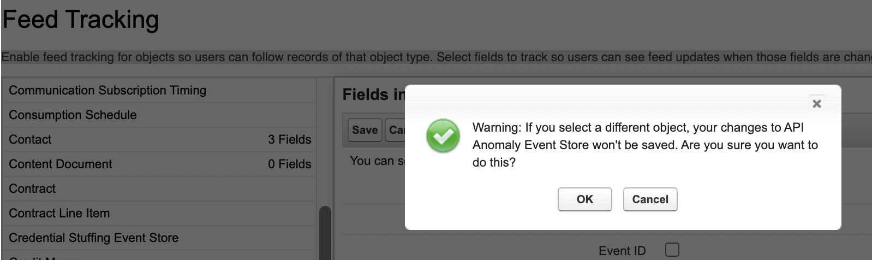 | 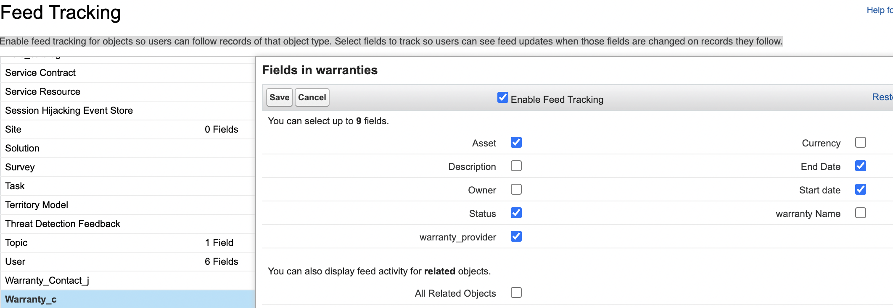

 | You can select upto 20 records.
Since I enable chatter feed tracking on warranty object. | 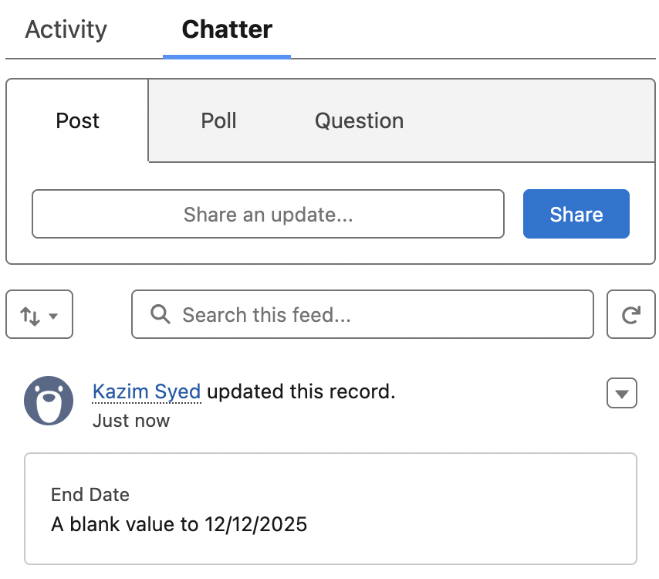

Salesforce mobile app settings
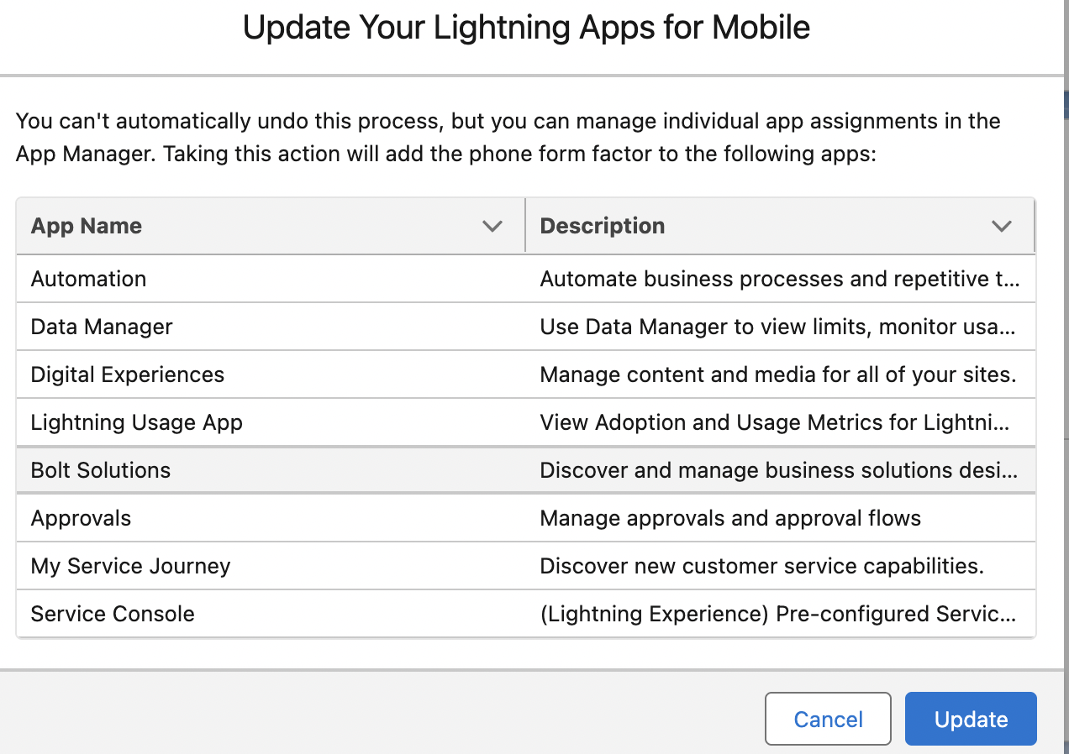 | You can update ur lightning apps for mobile.
Setup → Mobile app → Salesforce navigation. | So u can change navigation items for salesforce.
 | 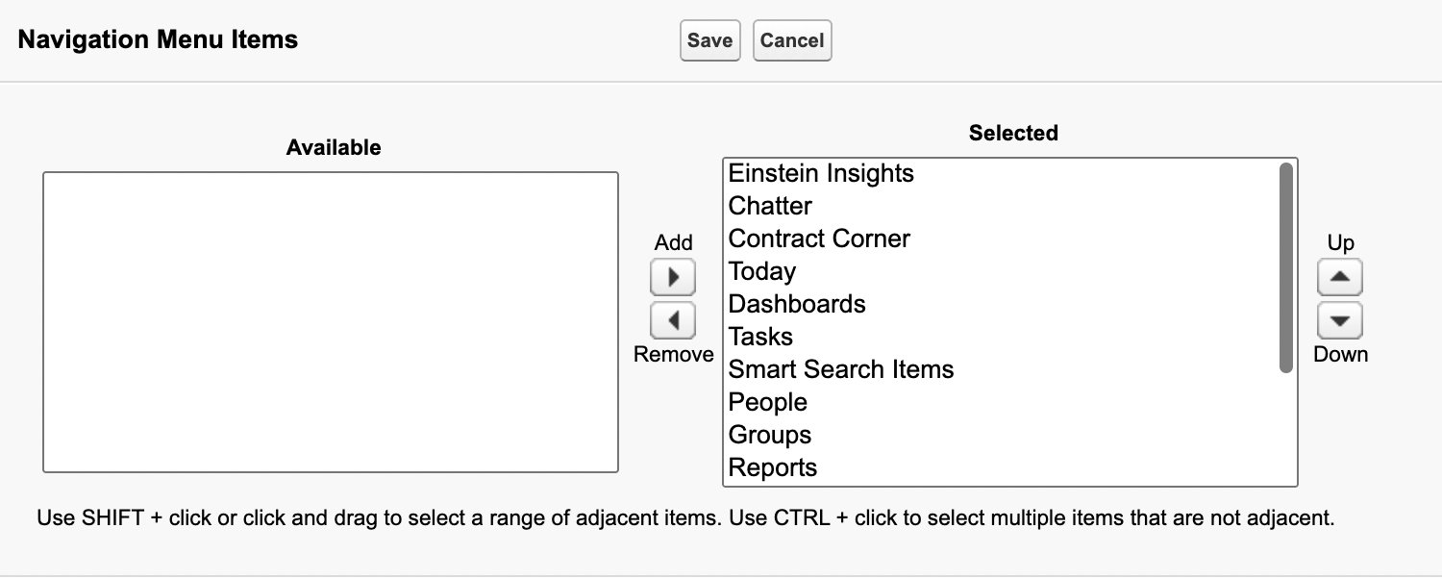

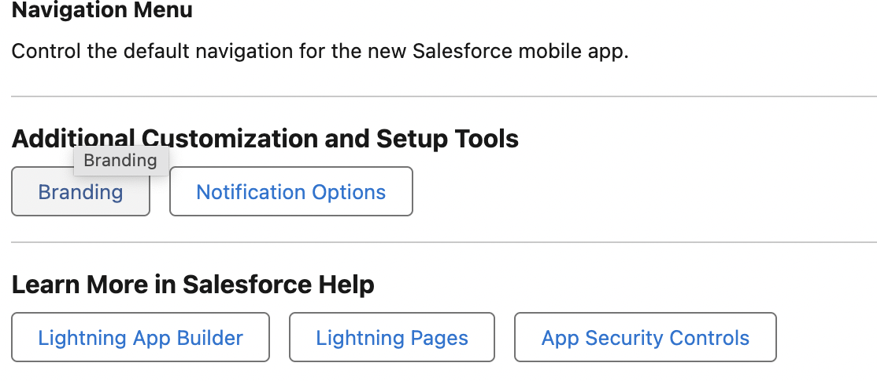 | You can do custom branding.  You can change notification  either in app notification  or push notification.
Salesforce offlines | Allows offline changes and then sync those changes when u come back online.
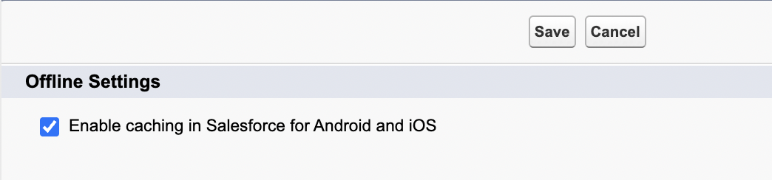
Salesforce settings | 