Workflow and Process Automation
subtitle

Heading 1

Heading 2

Heading 3

Heading 4

Tip 1
SOQL Queries typically only return active records, non-archived records.
Tip 2
Dont use limit w/o order by because the record might change before u run.
Tip 3
select name, account.name, createddate from contact where createdDate = Today
select name, account.name, createddate from contact where createdDate = LAST_N_Days:60.
select name, account.name, createddate from contact where createdDate < LAST_N_Days:60
select name, account.name, createddate from contact where createdDate = LAST_N_Months:1
select name, account.name, createddate from contact where createdDate = LAST_N_Months:1
select name, account.name, createddate from contact where createdDate = LAST_FISCAL_QUARTER

Tip 4
Record trigger → Scheduled path is equivalent to time triggered workflow rule or time based actions in process builder. e.g renewal of membership.
Its different than scheduled triggered for which run based on a schedule.
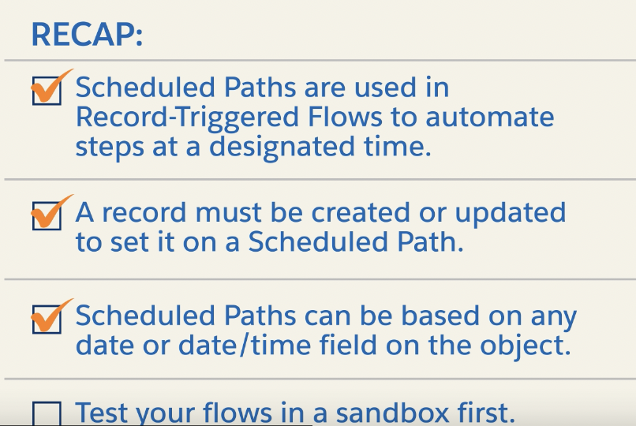

Workflow and Process Automation Introduction
Declarative tools like workflow rules and process builder. Both of which sf is retiring in favor of flows.

Why Flow retired Workflow rules and process builder
Flow | The “Apex for Admins” tool — declarative automation that behaves like code but without coding.
Flow | Can do everything workflow rules and process builder could do and more.
CRUD
Loop
Branching using decision logic.
Call invocable apex.
Send email.
Interact with users.
Run before/after save
Submit for approval.
Work in Screen mode and background mode.
5 types of Flow | 1. Record triggered flow  2. Scheduled triggered flow  3. Screen flow  4. Autolaunched flow  5. Platform event-triggered flow
Record triggered flow | Runs before/after.
Scheduled triggered flow | Run at scheduled time (daily/weekly)
Screen flow | Shows ui screen to users. Used for guided interactions.(intake forms)

Autolaunched flow  If a flow has screens → it is a Screen Flow.  If a flow has NO screens → it is an Autolaunched Flow (regardless of trigger). | Runs w/o user interaction.  Called by Apex, buttons, subflows, or processes.  💡 It can still be triggered by a user action, but it never interacts with the user once running.
Platform Event-Triggered flow | Runs when platform event is triggered. Used for event-driven integrations.

Mnemonic | ARSSP (Always remembers salesforce standardize properly)
A: Autolaunched flow
R: Record triggered flow
S: Scheduled triggered flow
S: Screen flow
P: Platform event-driven flow

Jargon

Element | A step inside the flow  - Assignment  - Decision  - CRUD  - Loops  - Screen
Resource | Variables used inside the flow  - Variables  - Constants  - Text templates  - Record variables(obj.field)  - Collections([obj,obj])
Fault path | Flows error handling branch
Subflow | A flow that is used by another flow. Used to modularize automation.
 | 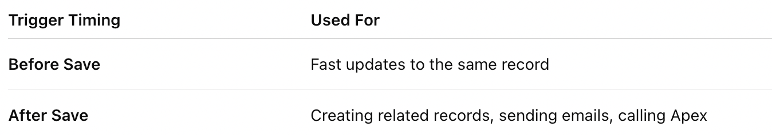

Process automation settings
Scenario: A Workflow Rule on the Opportunity object is set up to send a "Follow-up Email" 7 days before the CloseDate.  The Problem: Six days later, Sarah leaves the company and her user account is deactivated. The action is scheduled to run tomorrow.  The system uses the Default Workflow User to execute the action (send the email). This ensures the business process completes without interruption. | The default workflow user is required for scheduled paths in record-triggered flows and time-dependent actions in workflow rules. If the user who triggered the automation is no longer active, the default workflow user is associated with the actions that are executed by the automation. The default workflow user always runs schedule-triggered flows.  A time dependent workflow action involves two stages.  1. Workflow criteria is evaluated in sarahs context and permission. System creates a time based queue item. She is in the entry of the one who trigger it.  2. if she is inactive, defualt workflow user with his PS executes it.
The workflow isnt triggered by action but by clock. | Schedule triggered flow always run as Default user.
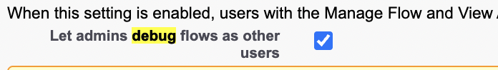 | When this setting is enabled, users with the Manage Flow and View All Data permissions can specify the running user each time they debug a flow.

Workflow Rules, Action and retirement
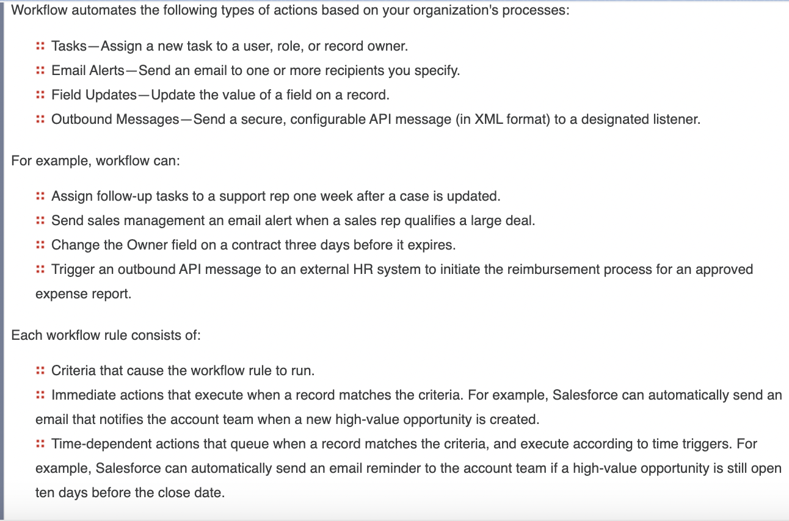
ETFO | Email Alerts  Fields updates  Task to user  Outbound messages to external system.
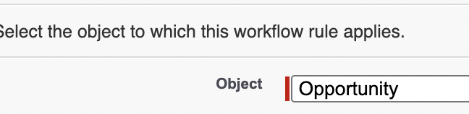 | Select the object to which workflow rule applies.
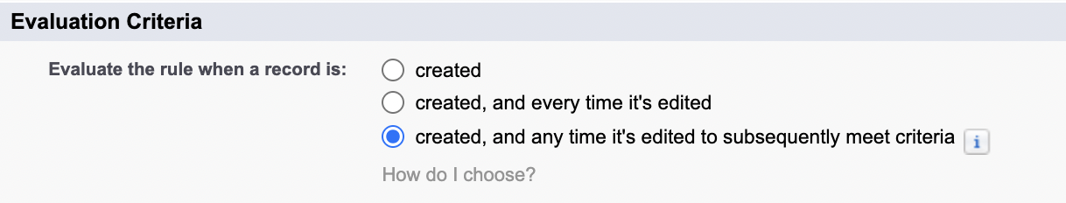 | 1st option: Created run only when its created and meets the criteria.  3rd option: runs when its created and meets the criteria but also when the criteria field is edited from not meeting the criter to meet the criteria. So unrelated edits on the record wont trigger it.

2nd option:
created, and every time it’s edited
With this option, the rule repeatedly runs every time a record is edited as long as the record meets the rule criteria.
If you select this option, you can't add time-dependent actions to the rule.
3rd option:
With this option, the rule can run multiple times per record, but it doesn’t run when the record edits are unrelated to the rule criteria.
For example, suppose that for an opportunity record to meet the rule criteria, the opportunity probability must be greater than 50%. If you create an opportunity with a probability of 75%, the workflow rule runs. If you edit that opportunity by changing the probability to 25%, the edit doesn't cause the rule to run. If you then edit that opportunity by changing the probability from 25% to 75%, the edit causes the rule to run. With this last edit, the rule runs, because the record is changed from not meeting the rule criteria to meeting the rule criteria.
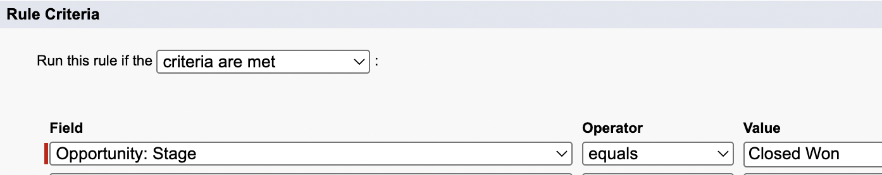 | Set the critieria
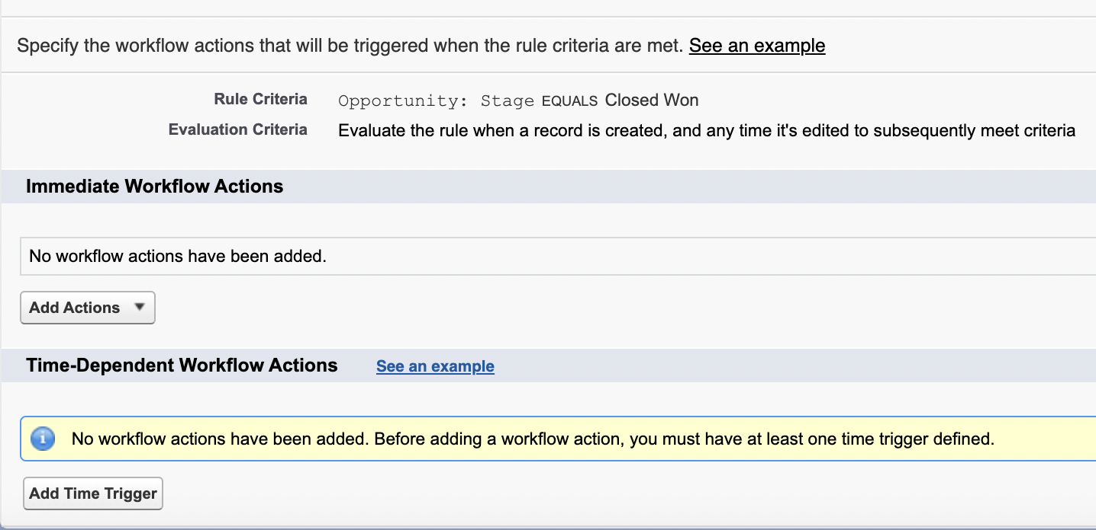 | You can either create  Immediate Workflow actions  Or  Time-dependent workflow actions.
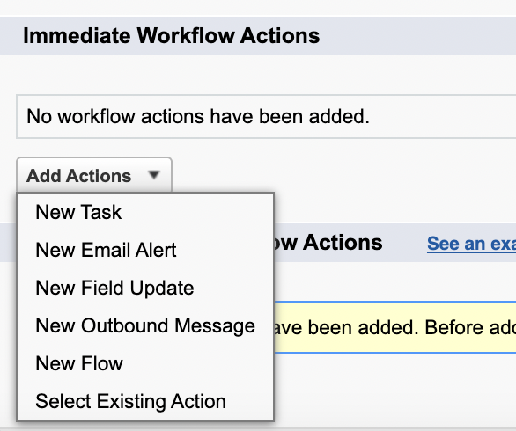 | ETFO + FLOW + existing actions.
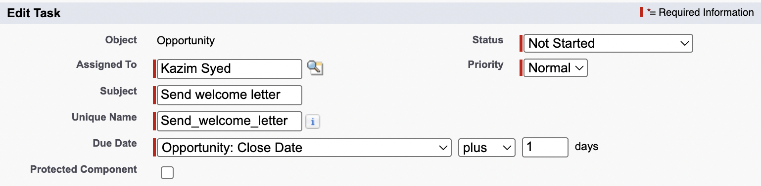 | The thing about task, its the only thing that a workflow rule can create an object for. Whereas process builder and flows can create new records for any object. Workflow rule for any task.

 | Create a task to associate with one or more workflow rules, approval processes, or entitlement processes. When changing a task, any modifications will apply to all rules, approvals, or entitlement processes associated with it.
Now mike is doing a field update
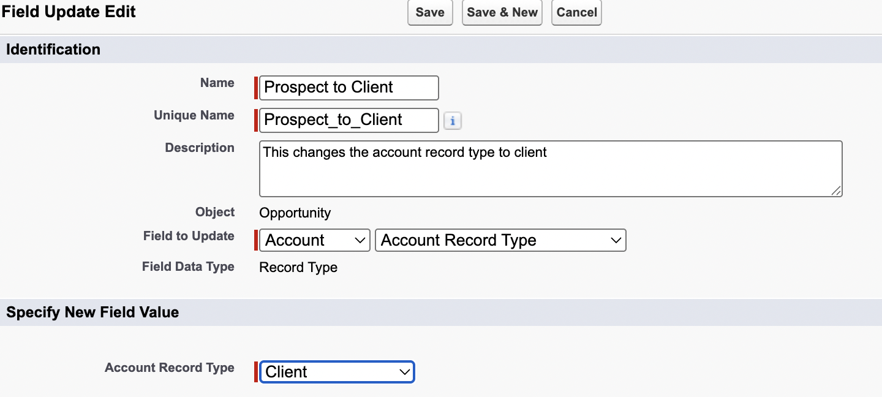 | Define the field update, including the object associated with the workflow rule, approval process, or entitlement process, the field to update, and the value to apply. Note that the field to update may be on a related object. Fields are shown only for the type that you select.
 | Cross object field update.
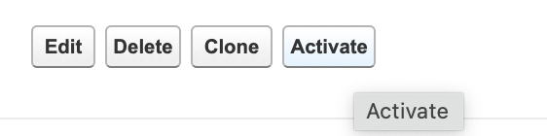 | Activate the workflow
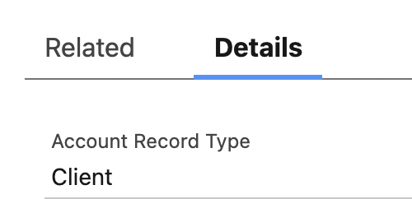 | It worked. I created an opportunity for ABM company and set the stage to closed won and the workflow rule set the stage to client.
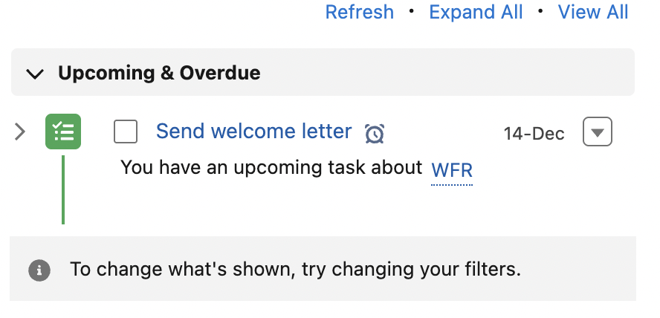 | We have a task that we are designated here.

Process Builder actions and retirement
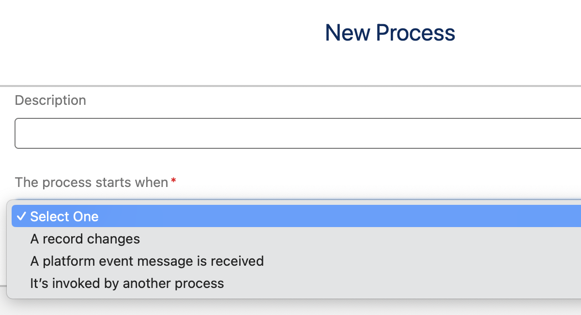 | Mike selected record changes
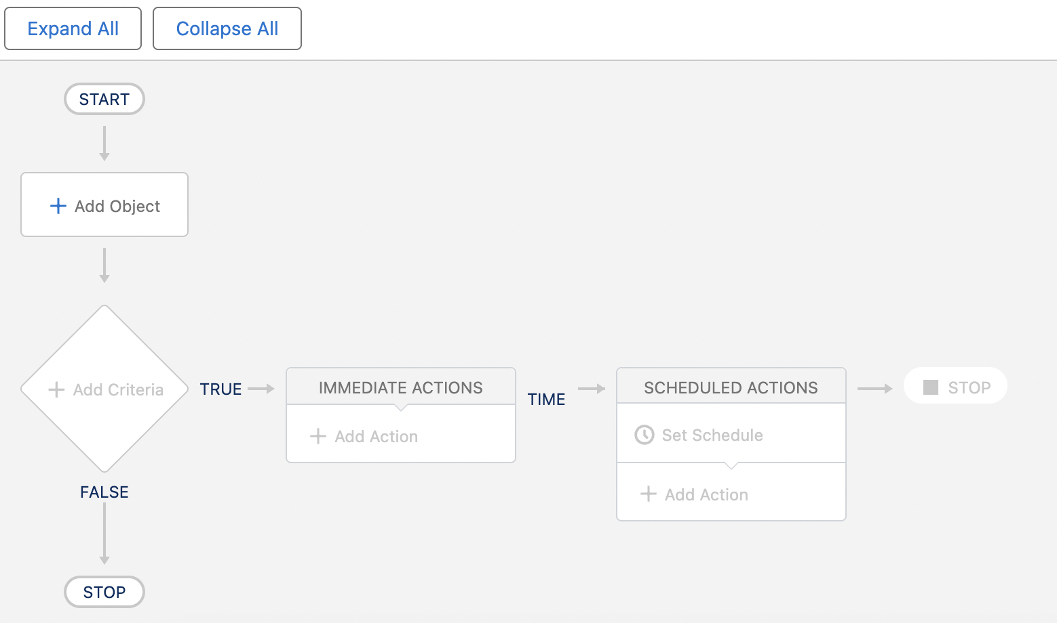 | Process builder
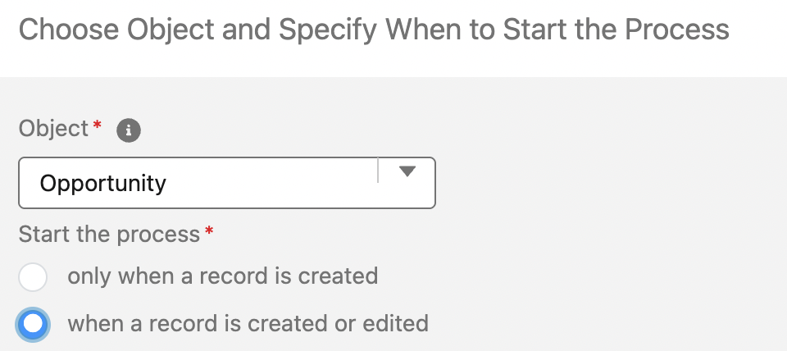 | Select the object
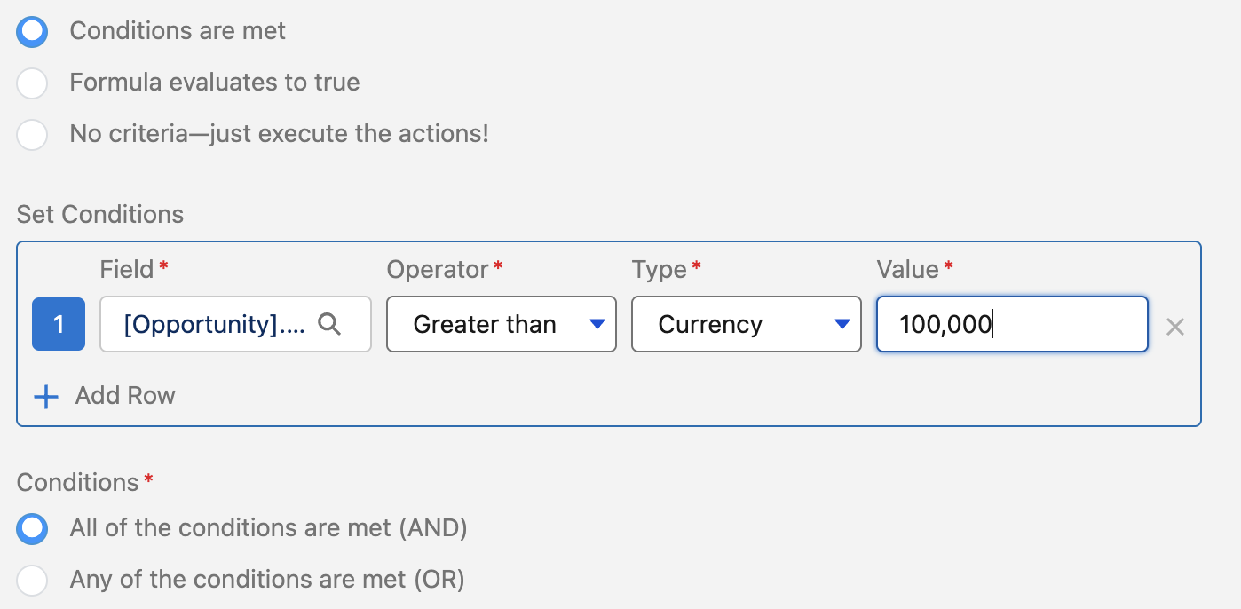 | Opportunity.amt > 100,000
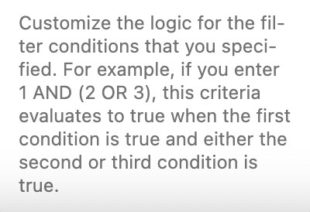 | Set custom logic.

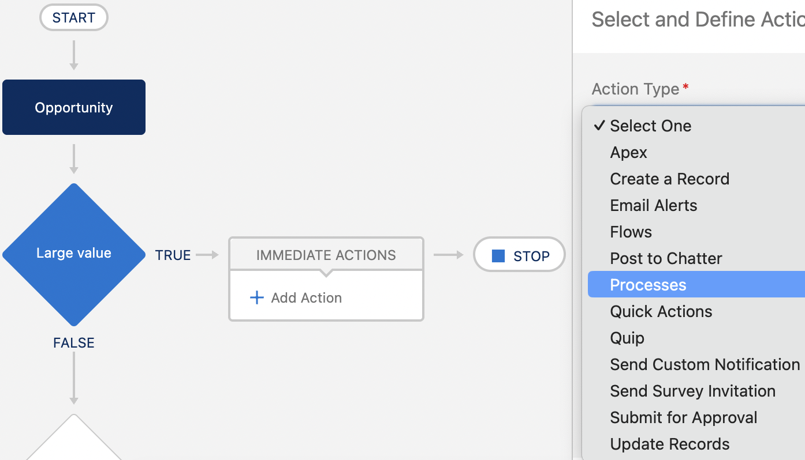 | He didn’t finish process builder.

Migrate to flow
Process Automation → Migrate to flow | Cross object reference workflow doesn’t properly migrate, so we would be modifying that workflow of ours.
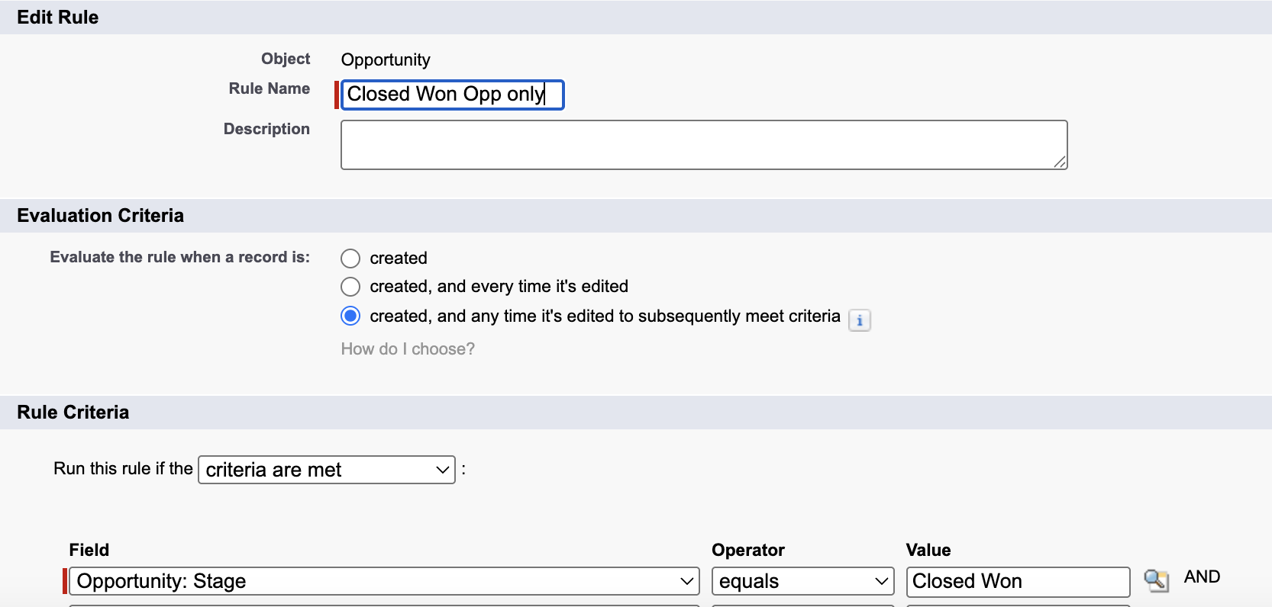
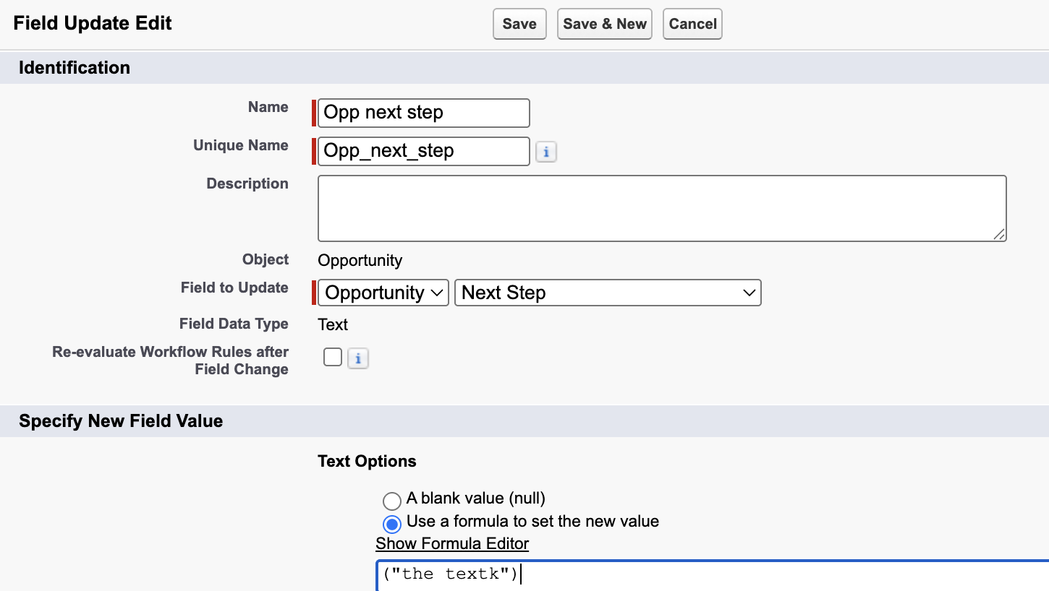 | Workflow action.  I deactived the existing flow.
Open migrate to flow and I converted my Closed won opp only into a flow. | 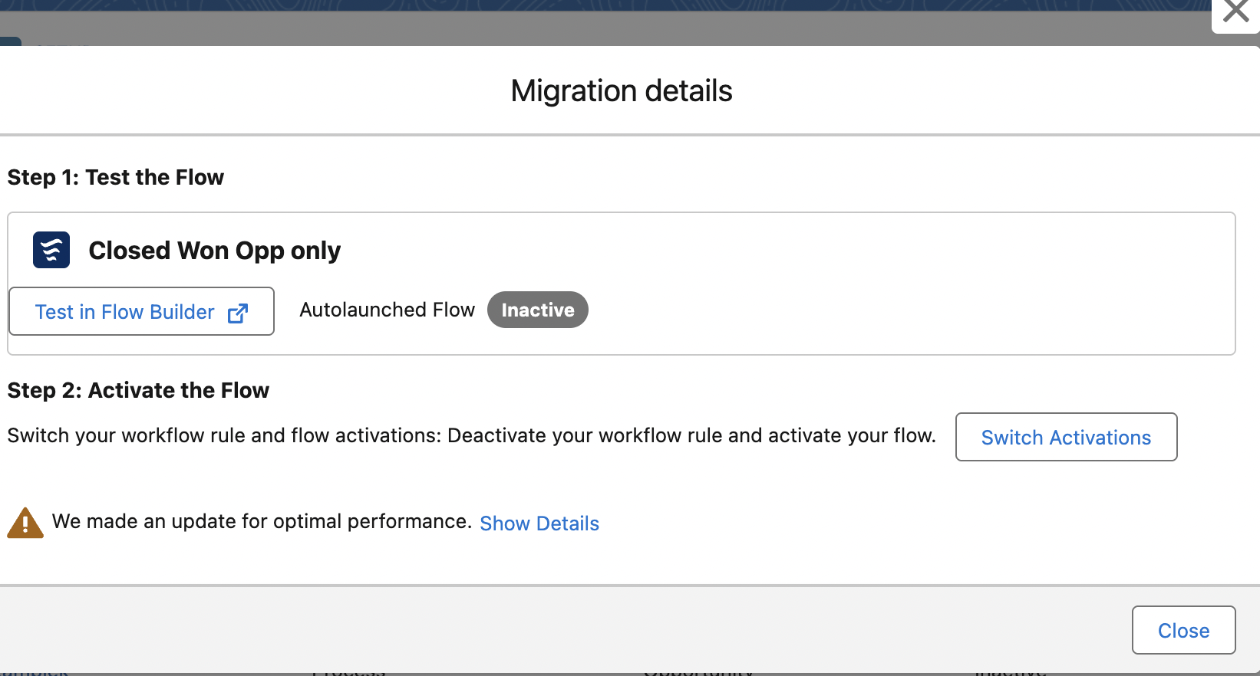

Flow builder
Process Automation > Flow builder | 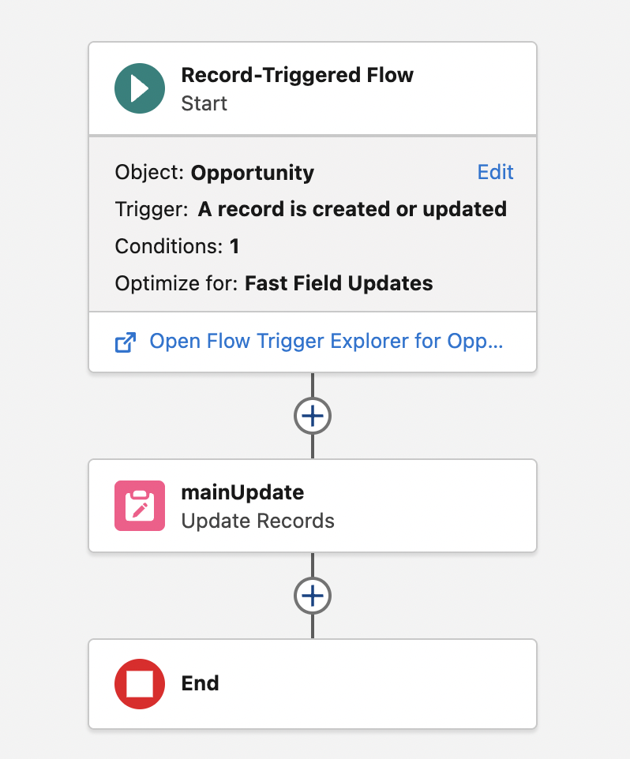
We received a record-triggered flow.
Edit record-triggered flow | Why use Set entry level  Specify entry conditions to reduce the number of records that trigger the flow and the number of times the flow is executed. Minimizing unnecessary flow executions helps to conserve your org’s resources.
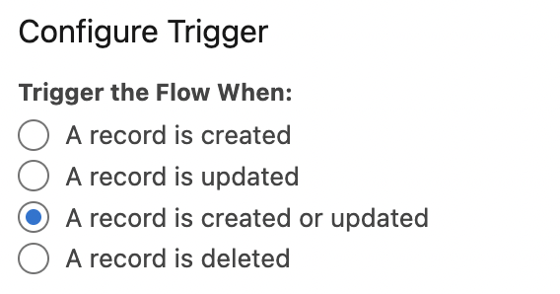
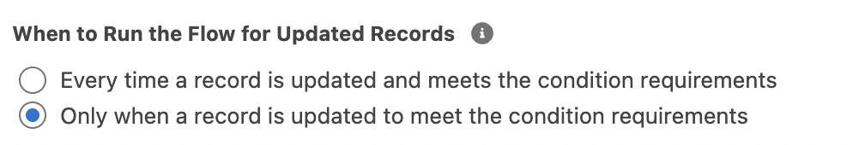 | I <3 second one.
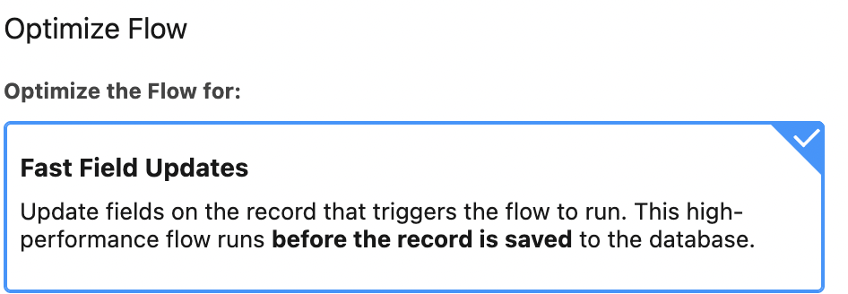 | Record trigger before save – used when the record that triggers the flow needs to be updated.

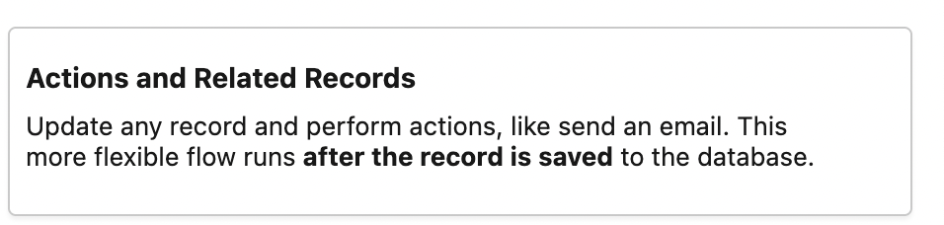
Now we editing update records
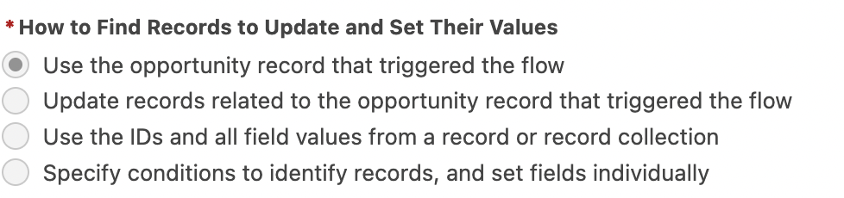 | Because this flow runs before a record is saved, you can only update the record that triggered the flow to run. To update other records, configure the trigger to run the flow after the record is saved.
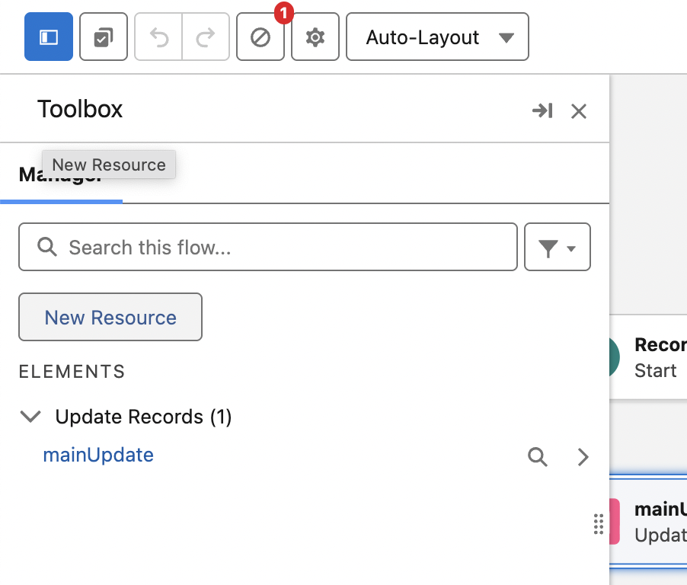 | You can add resources as well.
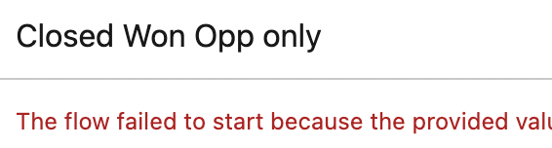 | The flow failed to start because the provided values were not valid: You can't launch a record-triggered flow from within Flow Builder. To launch this flow, activate it and then create, delete, or update a record, depending on the trigger configuration.
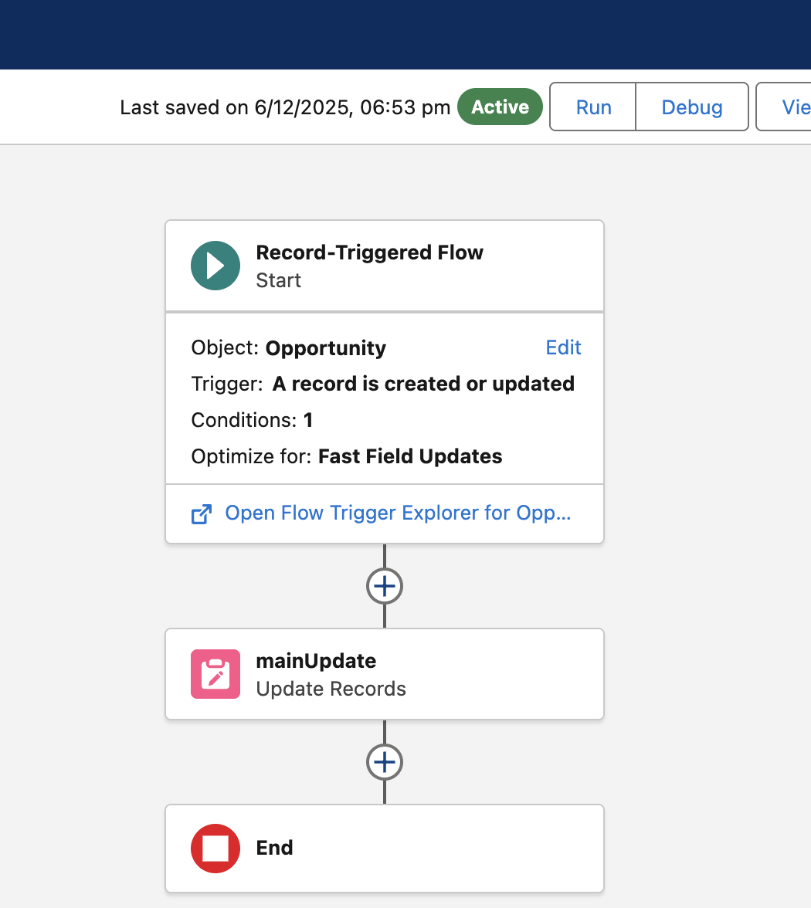 | U have to deactivate the exisiting workflow.

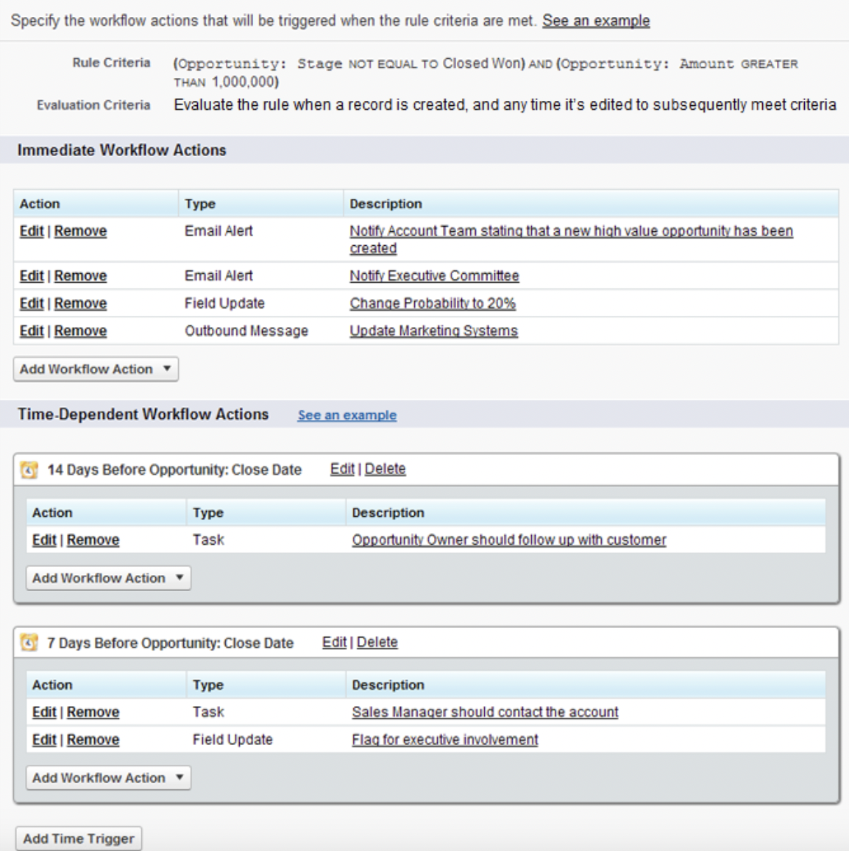
You can have both Immediate and time-dependent actions.

Testing our flow
On the process builder, open tests. | We can test records instead of updating records to trigger record-level trigger.
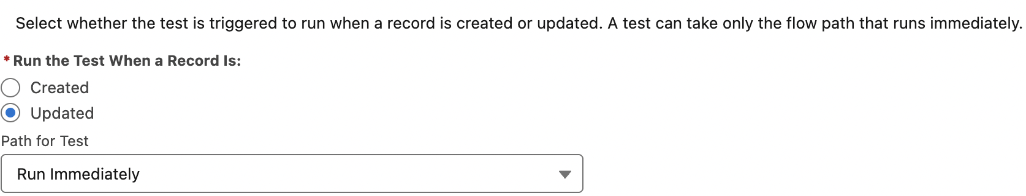
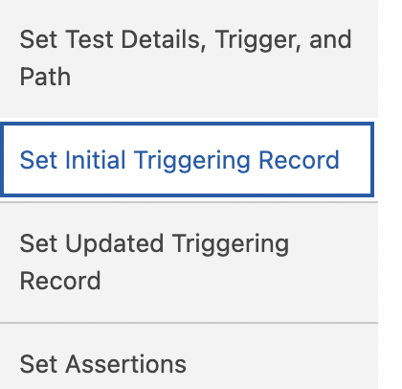 | Set the initial values for the record that triggers the test. If you convert the debug run to a test, the values are set from the debug run’s triggering record. After the test finishes, all transactions are rolled back, and record changes aren’t saved.  I selected awam foundation which isnt closed yet.
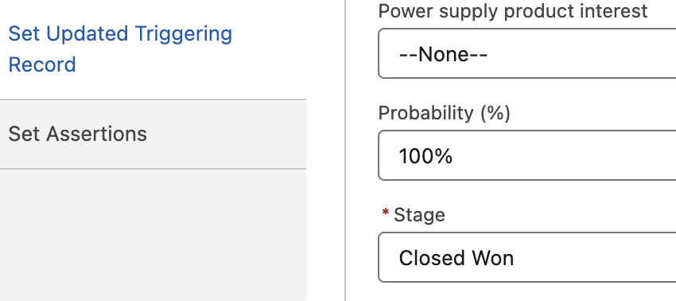
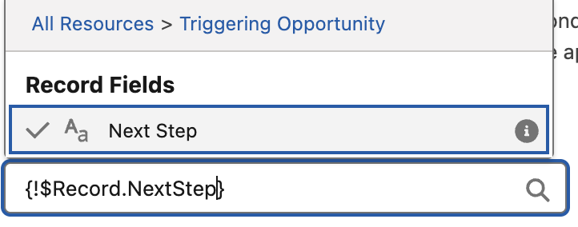  Many fields comes up. | 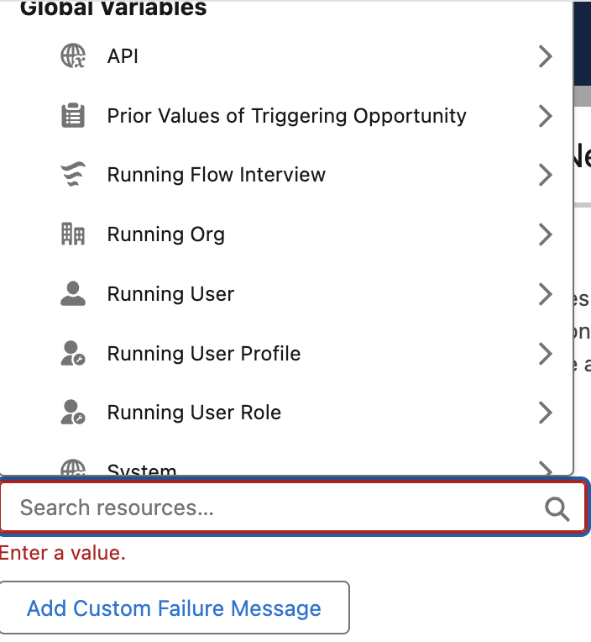
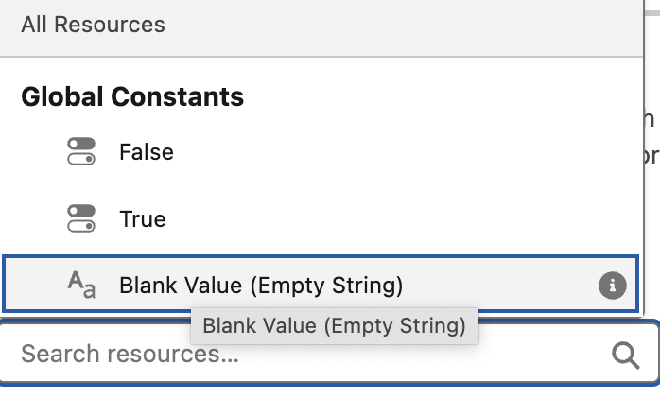

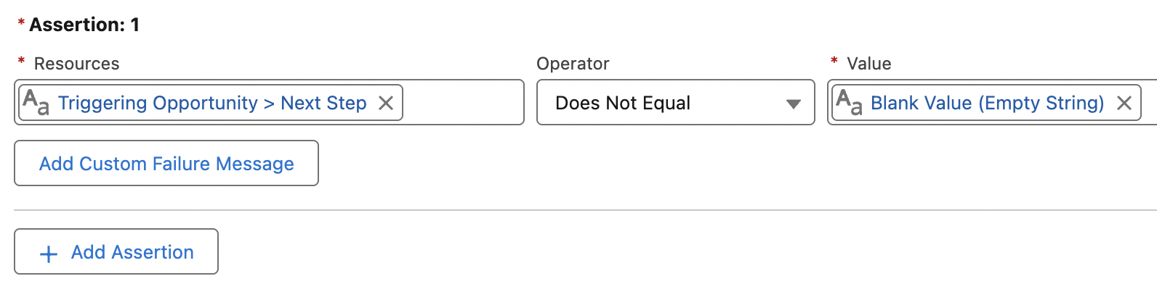 | To test a flow, set conditions and custom failure messages for each assertion. At run time, the test checks all of its assertions. If all conditions for each assertion evaluate to true, the assertion passes. If one condition for an assertion evaluates to false, the assertion and test run fail. If a failure occurs for an assertion during the test run, the custom failure message appears in the test run details.
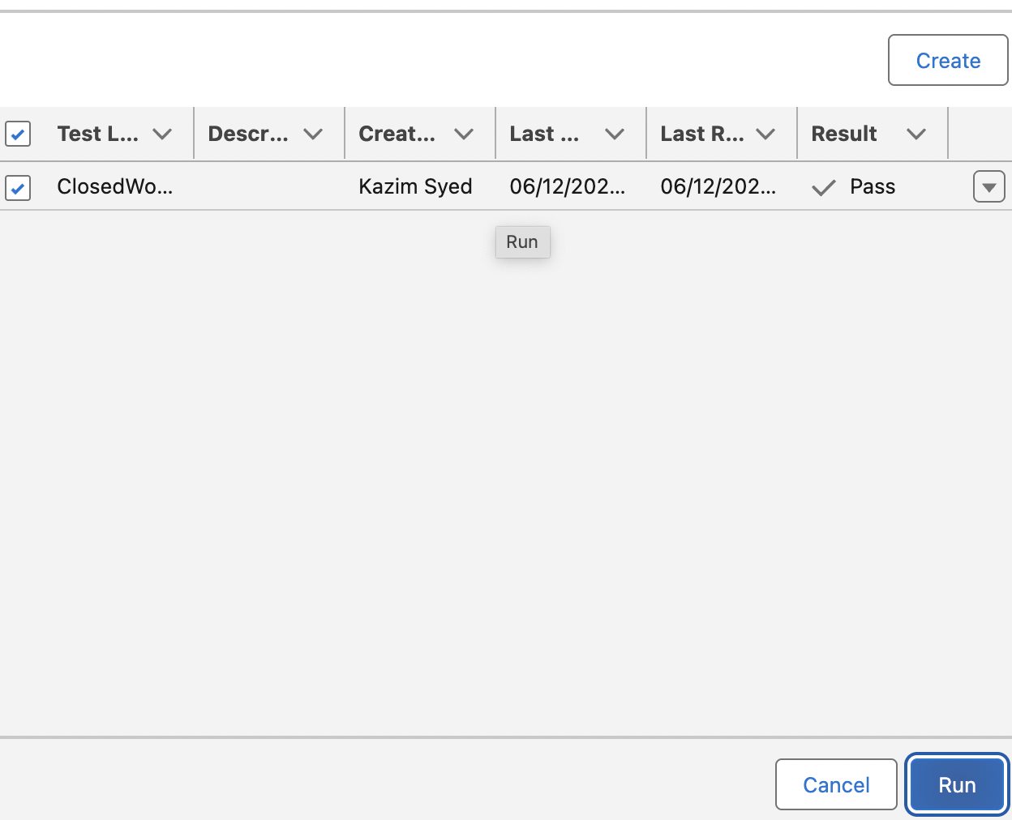 | I ran the test and the result says pass.  Mike wasnt able to pass. So he used the isChanged operator instead of does not equals.

Types of flow
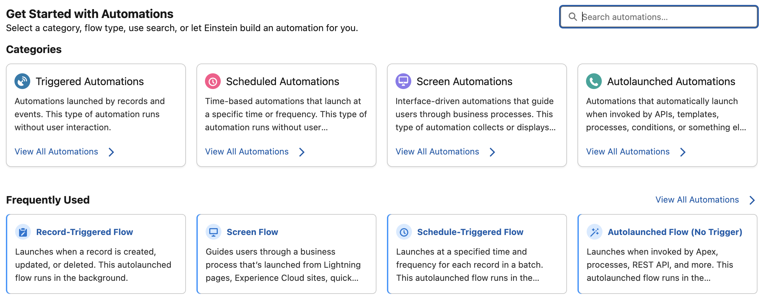

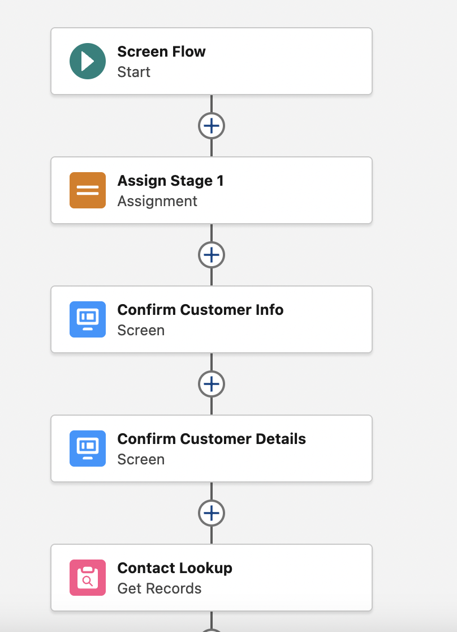 | Our contract cornor flow.
You can goto app exchange and search flows | U will spot flows by saleslab which is from salesforce like Questionaire flow provided by ibm. Profile wizard where u make updates to profile inside of a flow.
Omni channel flow | Where u route chates to agents with right skills and lot more around case routing, chat routing.
How to control the order of the flow in which they execute. Since we have auto launched flows that are happening behind the scene in automations. | Next lecture.

Flow trigger explorer
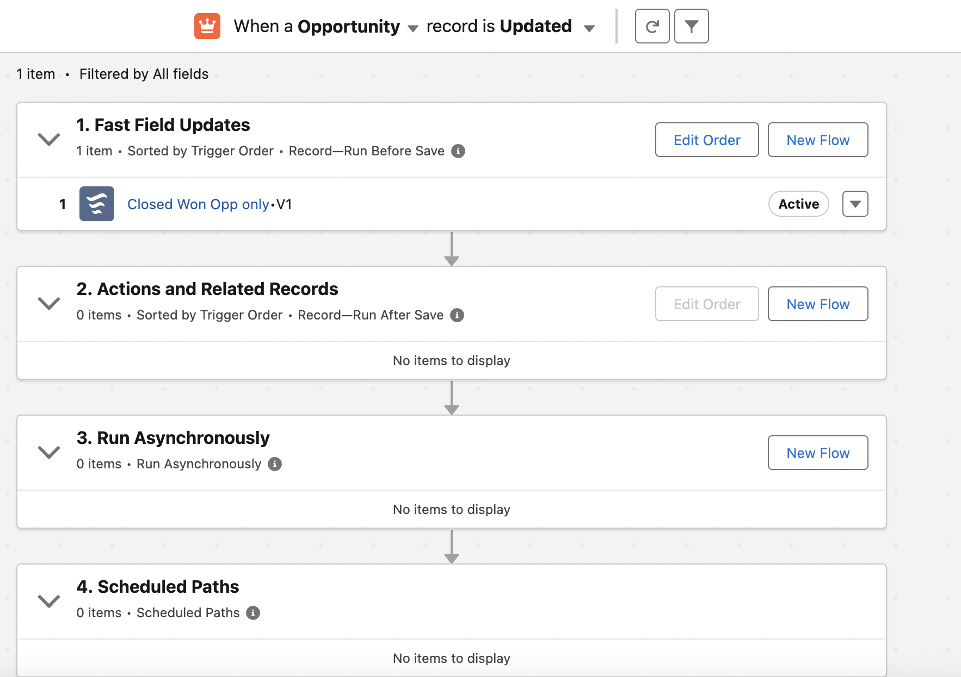 | Set the order in which flow execute in ur org.  when a record is updated.
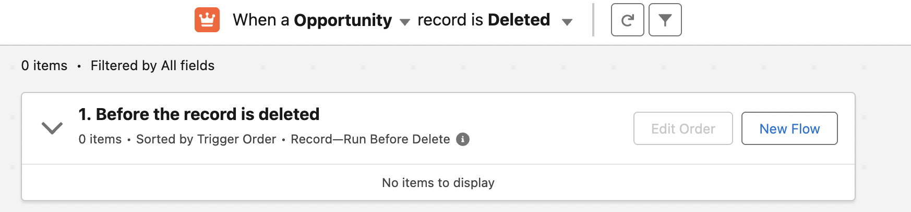 | We can change when record is updated to delete and we see we only have run-before delete.

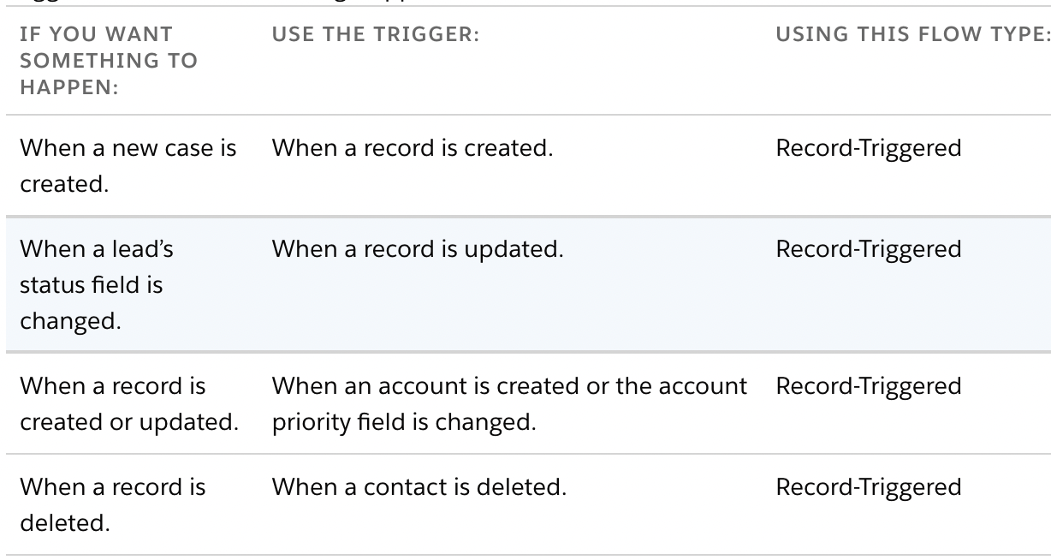
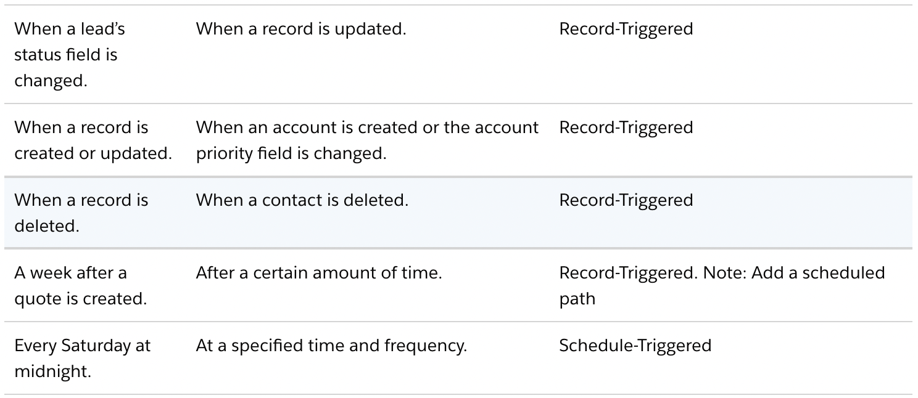
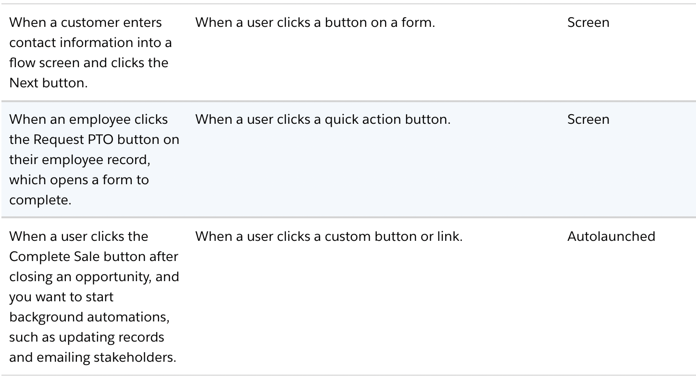
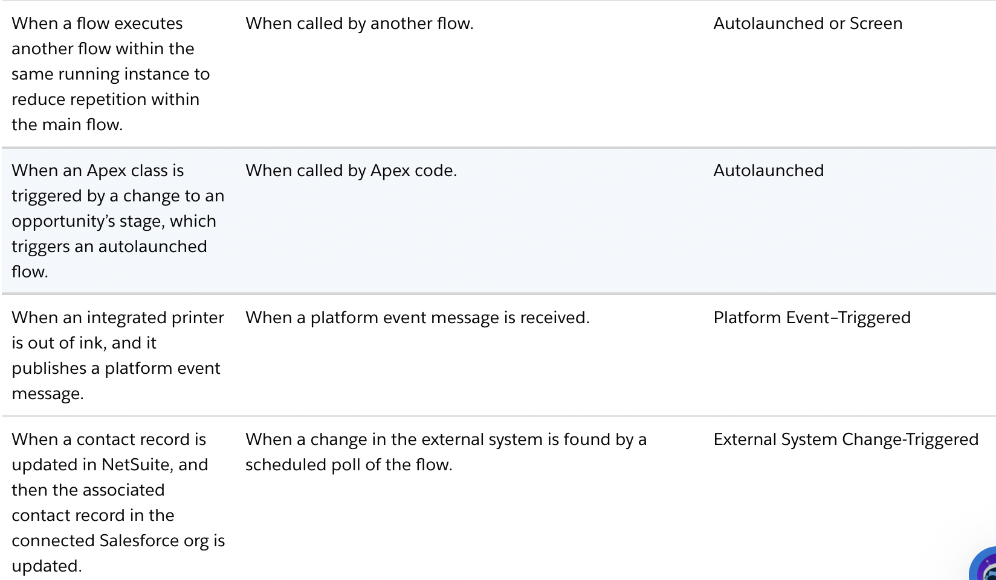
Read at | Automate ur business process

Design the solution
1. Send Email  Trigger: Contact created  Action: Send welcome email | Challenge: Our sales reps forget to email new customers to welcome them.  - Solution: Send emails to new contacts automatically.  - Trigger: After a contact is created.  - Action: Send a welcome email to the new contact.
2. Create Records via Form  Trigger: Agent submits screen form  Action: Create Opportunity | Challenge: On customer calls, agents scramble to capture customer interest in new products. They often use sticky notes, which are hard to read or get lost.  - Solution: Use an online form embedded on the case record page to quickly capture basic information and create a new opportunity. The agent can confirm the information with the customer before ending the call.  - Trigger: When the agent submits the online form.  - Action: Use an online form to gather information, and then create an opportunity record when the agent submits the form.
Scheduled Membership  Reminders Trigger: Daily schedule  Action: Email customer + update membership status | Challenge: We can’t keep track of our customers’ memberships. Customers aren’t notified before their memberships expire, and we lose out on renewals.  - Solution: Remind customers to renew their membership starting a month before it expires.  - Trigger: Check membership records each day to see if any are about to expire.  - Action: Email the customer when their membership is about to expire. Update the membership stage to pending so that you know which memberships are pending renewal.
External System → Salesforce Automation Trigger: NetSuite record created  Action: Auto-create Lead in Salesforce | Challenge: Our sales reps currently create records in NetSuite, an external system, leading to a manual and often delayed process for integrating this new data into Salesforce.  - Solution: Implement an External System-Change Triggered Flow that automatically creates a corresponding record in Salesforce whenever a new record is created in the external system.  - Trigger: A new Contact record is created in NetSuite.  - Action: A new Lead record is automatically created in Salesforce, populated with relevant information from the NetSuite Contact
Salesforce → External System Automation Trigger: Salesforce Order created  Action: Create Sales Order in NetSuite | Challenge: Our fulfillment center uses NetSuite, an external system, to process sales orders, while our sales team tracks them in Salesforce. The manual entry of sales orders into NetSuite from Salesforce leads to discrepancies, missing orders, and incomplete data.  - Solution: Implement a Salesforce Flow with an external action that automatically creates a new Sales Order in NetSuite whenever a new customer order is created in Salesforce.  - Trigger: A new customer order is created in Salesforce.  - Action: A new Sales Order record is automatically created in NetSuite, populated with relevant information from the Salesforce Order, ensuring the fulfillment center receives accurate and timely data to complete the order.
Extract Legacy  System Data Trigger: Button click Action: MuleSoft RPA extracts data and creates records | Challenge: Customer data exists in a legacy desktop application without API access. Employees manually copy and paste information into Salesforce, which is time-consuming and error-prone.  - Solution: Use MuleSoft RPA to extract data from the legacy application, and then create Salesforce records from your flow.  - Trigger: When a user initiates the data extraction process by clicking a button on a record page.  - Action: Call a MuleSoft RPA process that opens the legacy application, navigates to the customer data, extracts the information, and then creates the corresponding Salesforce records from within your flow.

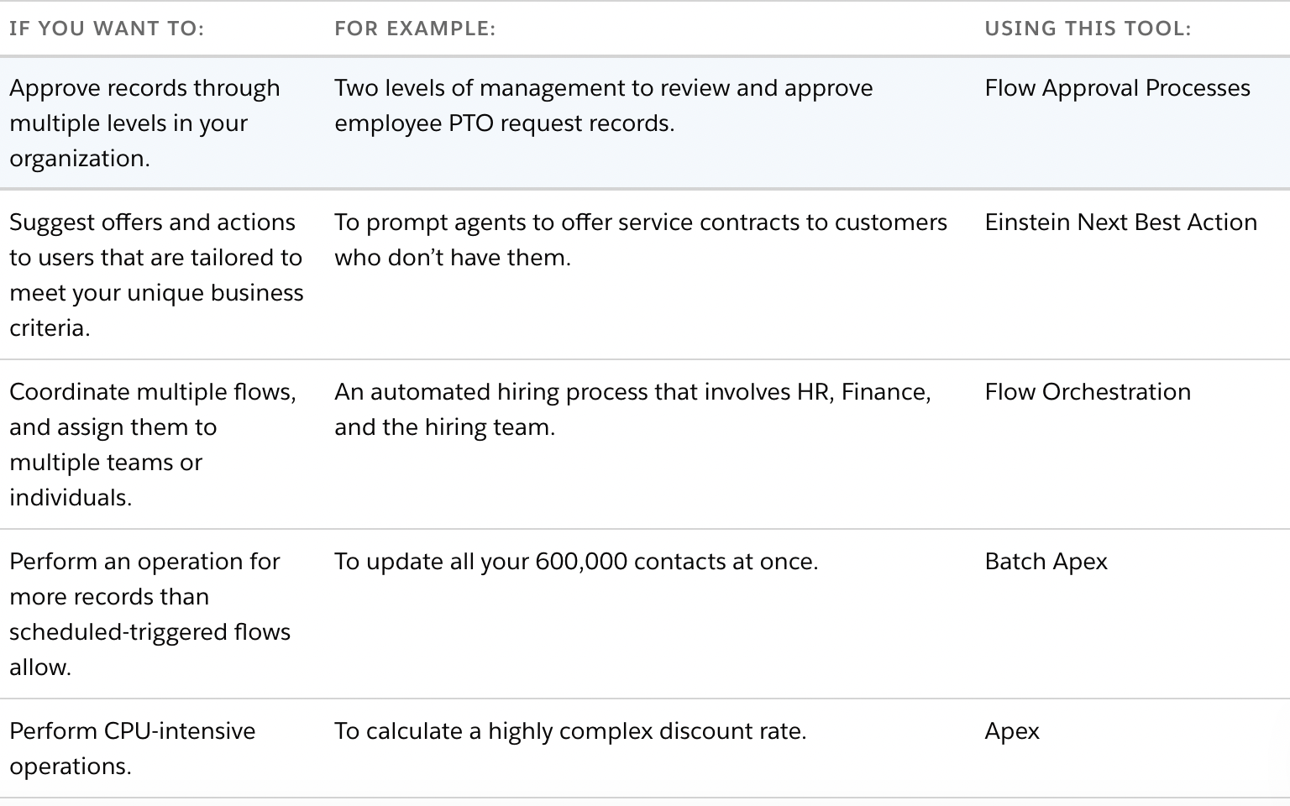

Creating an Approval process
Approval processes
A listing of both active and inactive approval processes for warranties is displayed below. To create a new approval process, click Create New Approval Process then select Use Jump Start Wizard to set up your approval process in a few short steps. Or, select Use Standard Wizard to configure all approval options. | 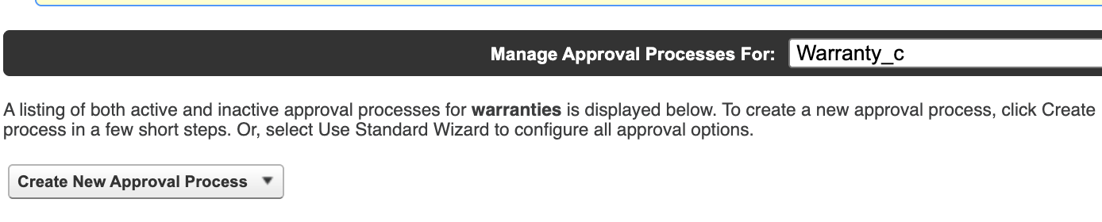
 | In the same way as workflow actions, approval actions consist of e-mail alerts, tasks, field updates, and outbound messages that can be triggered by the approval process.
Configure approval process | Providing the name of the process  Specifying the entry criteria for the records  Specifying who is going to approve  Specifying the e-mail template  Determining the fields to be displayed on the approver page  Specifying who is going to send the approval mail
1. Determine the steps and how many levels your process has. It is often useful to map out the process using a charting tool such as Microsoft Visio.
2. Decide if users can approve requests by e-mail and set up this feature accordingly.
3. Create an approval-request e-mail template. 4. Determine the approval-request sender.
5. Determine the assigned approver.
6. Determine the delegated approver, if necessary.
7. Decide if your approval process needs a filter. 8. Design initial submission actions.
9. Determine if users can edit records that are awaiting approval.
10. Decide if records should be auto-approved or rejected.
11. Determine the actions when an approval request is approved or rejected.

Approval process | An Approval Process in Salesforce is an automated workflow that routes a record to one or more people for approval.
- Discounts need approval
- PTO requests need a manager signature
- Expenses must be reviewed
- Contracts need multi-level approval
Entry criteria | Rules that decide which records are allowed to enter the approval process.  Example: discount_c > 20%.
Initial submission actions | Record locking  email alert  field update  Creating tasks
Record locking | Only admin or designated users can edit. This prevent users from modifying data mid approval.
Approval steps | Types of approval routing  Submitter’s manager.  Queue  specific user  Related user ( like account owner)

Action for each step | Update field(acc,rej), email, unlock record.
Approval submitter can recall. | I send the wrong document.
Reassign approval request
Delegate approval | Approver can assign some1 to approve on their behalf.
Jump wizard | 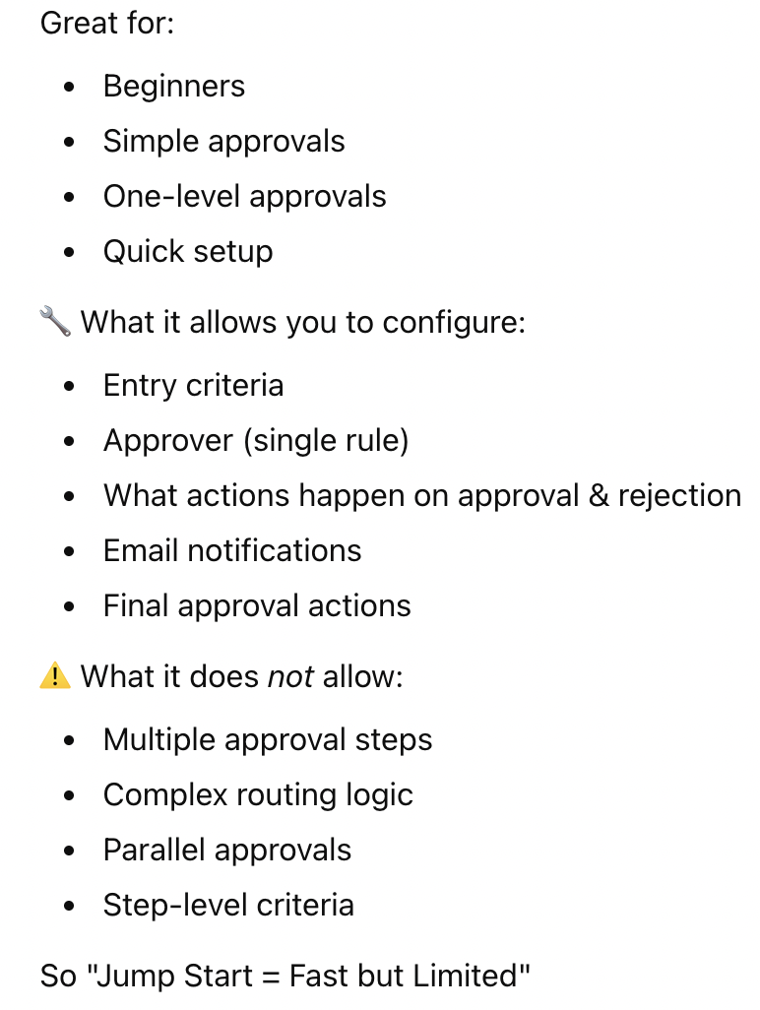
Standard wizard | 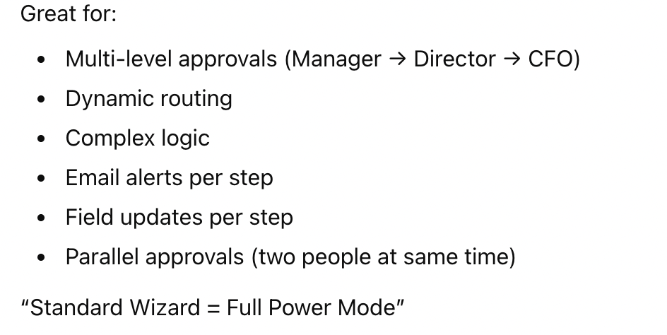

Creating an approval process
Create a new approval process.
Mike selected jump start wizard.
Object manager > Warranty_c > fields(status) | 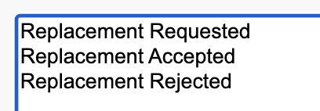  I added the following field
 | Customer calls wanting to file a warranty claim because of a defective asset. We would have status designation at that point of replacement requested.
 | The end user inside of salesforce can submit that for approval and then depending on whomever is the approver for that warranty claim can either select to accept that and approve that request and therefore then it will change to replacement accepted.
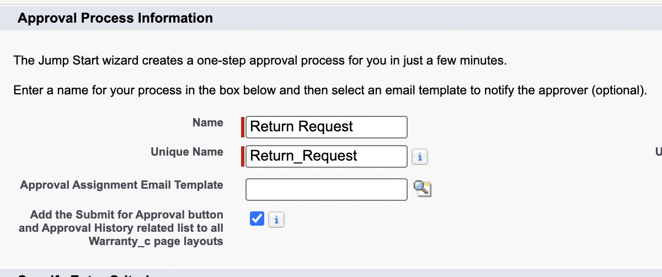
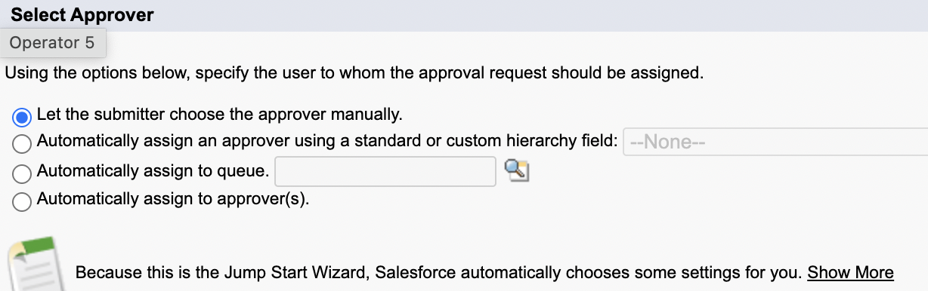

Editing our Approval process
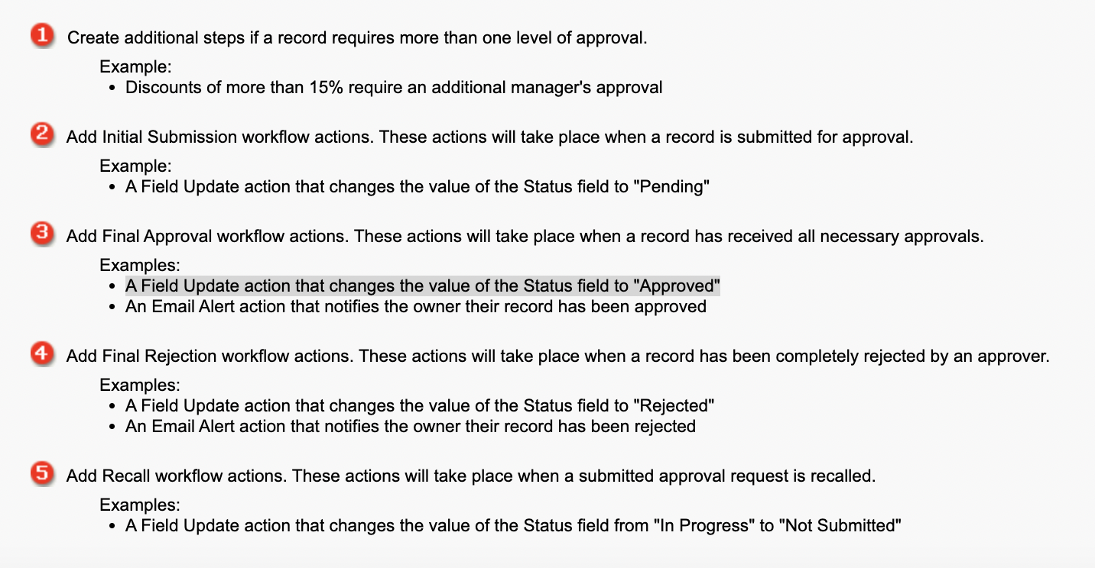

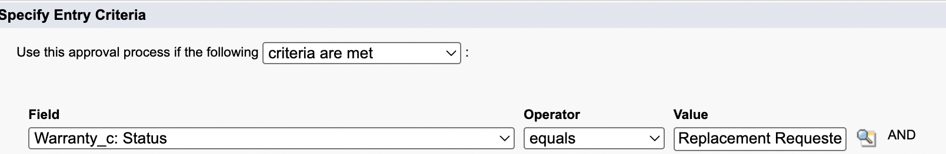 | Entry level criteria
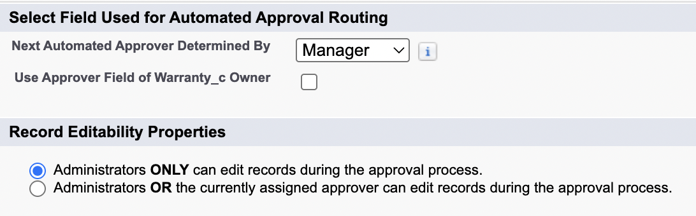 | Step 3. Specify Approver Field and Record Editability Properties  When you define approval steps, you can assign approval requests to different users. One of your options is to use a user field to automatically route these requests. If you want to use this option for any of your approval steps, select a field from the picklist below. Also, when a record is in the approval process, it will always be locked-- only an administrator will be able to edit it. However, you may choose to also allow the currently assigned approver to edit the record.
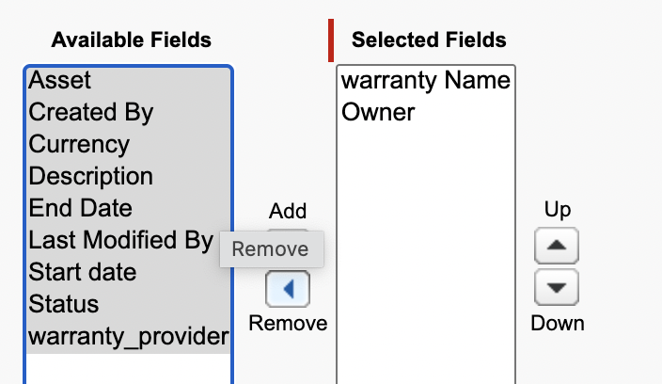 | Step 5. Select Fields to Display on Approval Page Layout
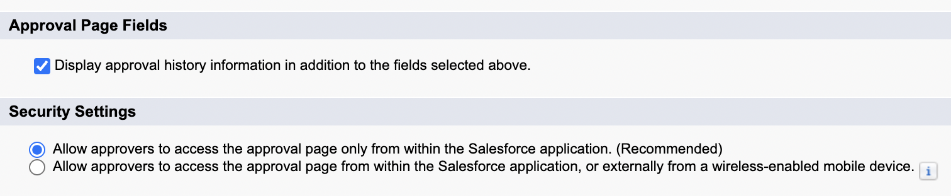

Step 6. Specify Initial Submitters
Using the options below, specify which users are allowed to submit the initial request for approval. For example, expense reports should normally be submitted for approval only by their owners.
The owner of the approver is the one who can submit for approval.  In submission settings, u can also recall from the queue. | 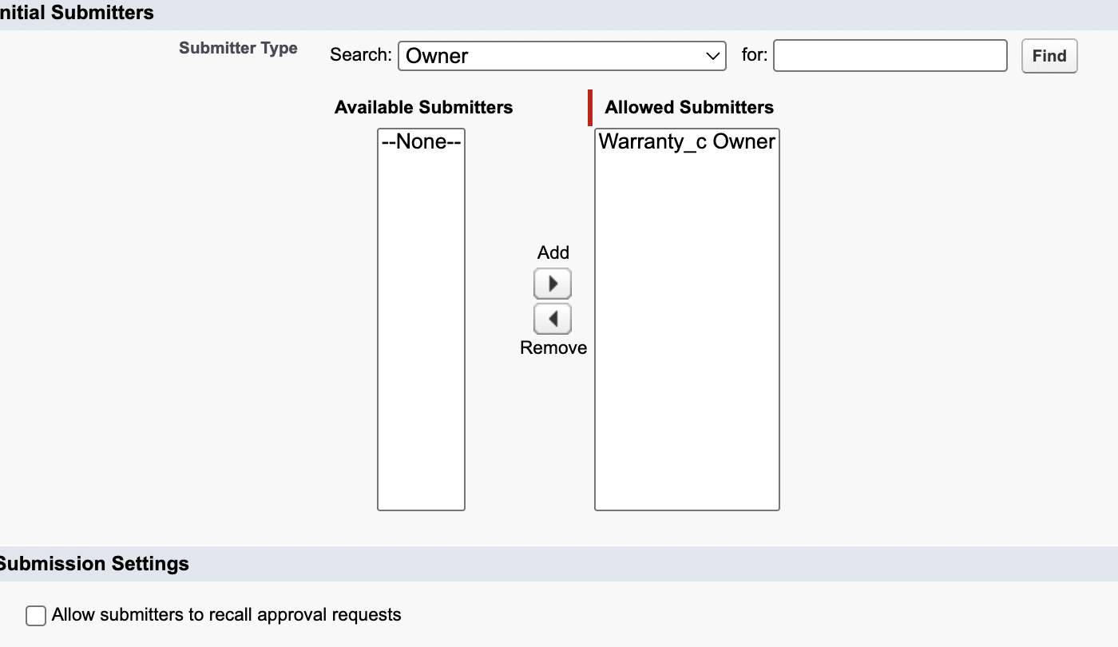

Activating our approval process
Select Activate to activate the approval process. | 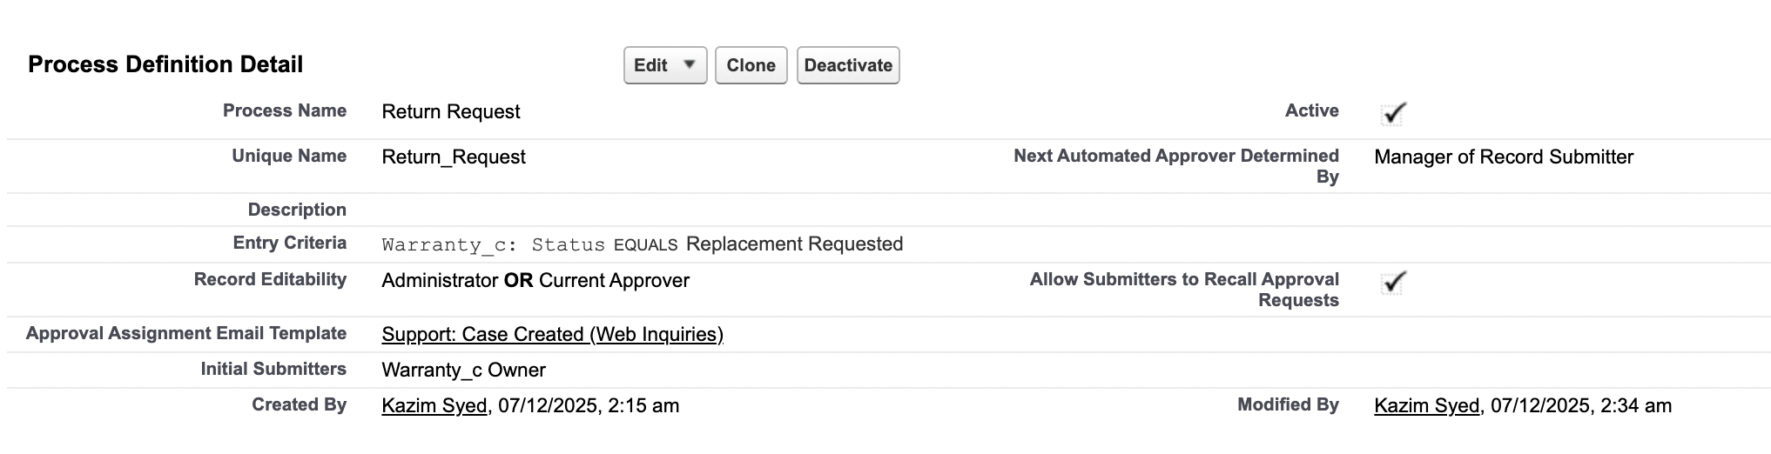
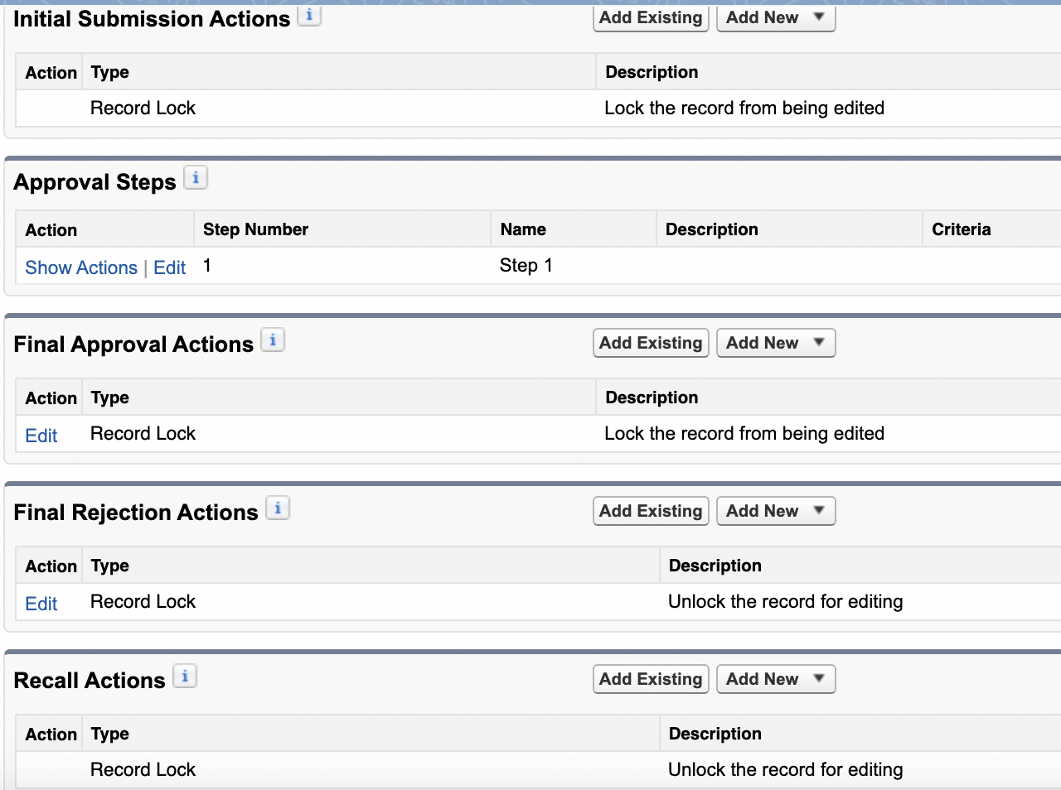

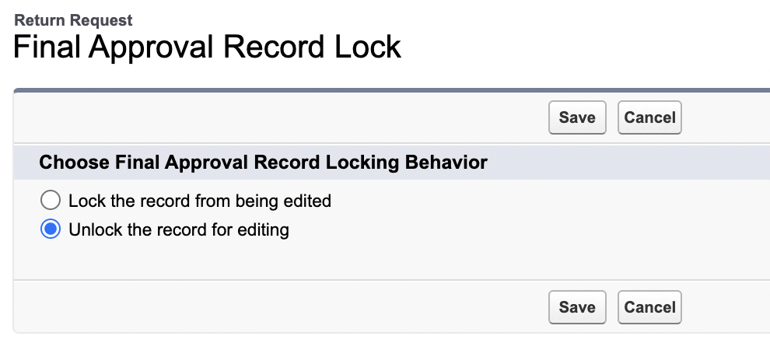 | Because we want to allow user to make edits on status like replacement req to accepted or rejected.
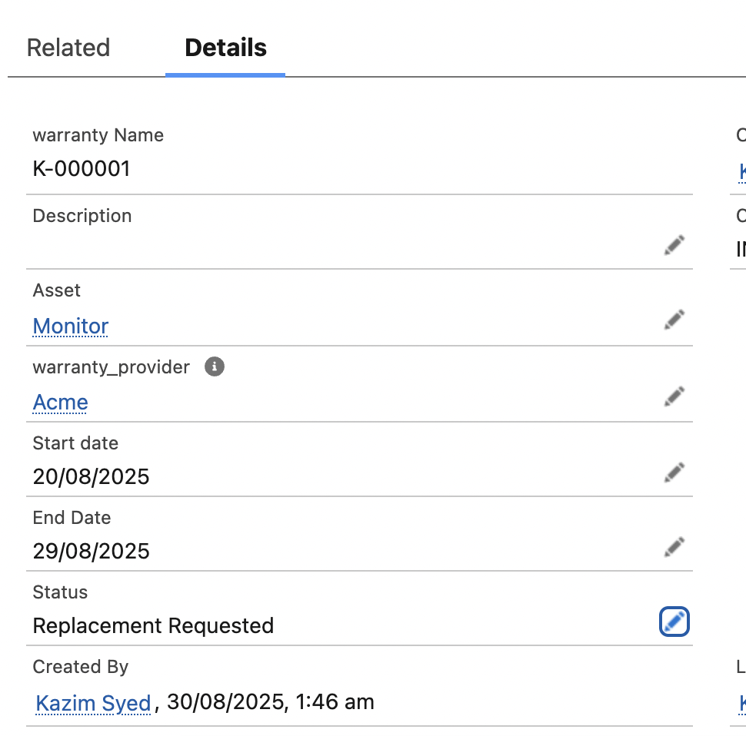 | We change the status of warranty record to “replacement req”.
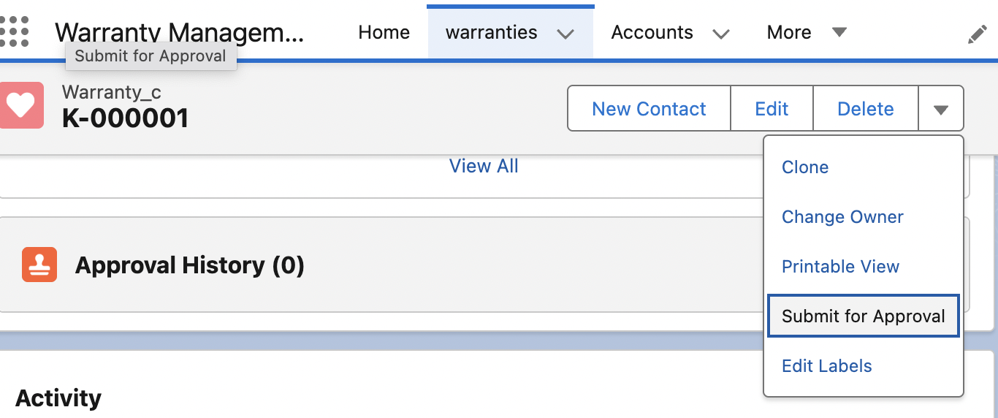
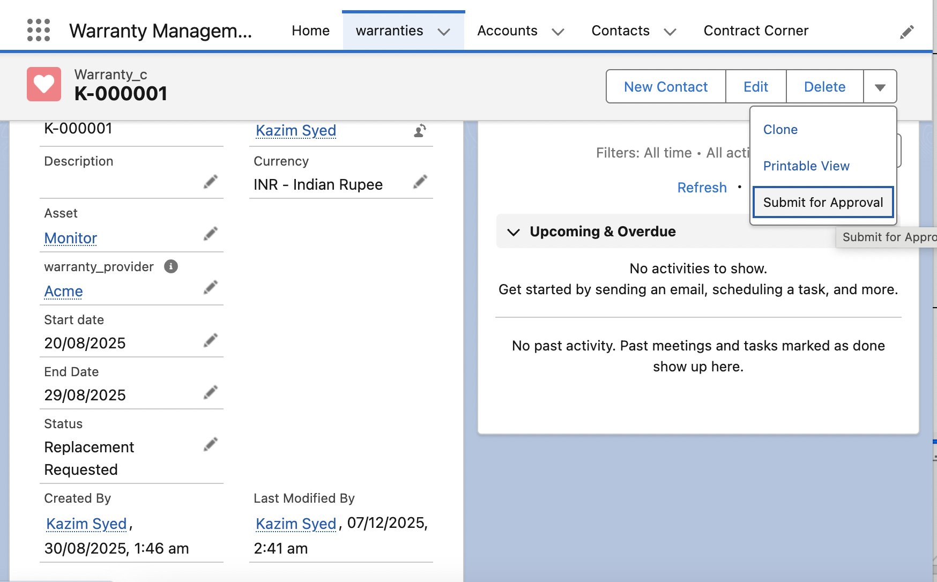 | I Logged in as jim lindsay

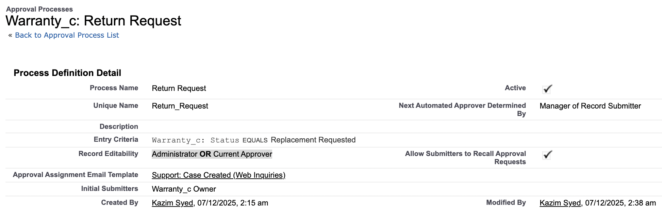

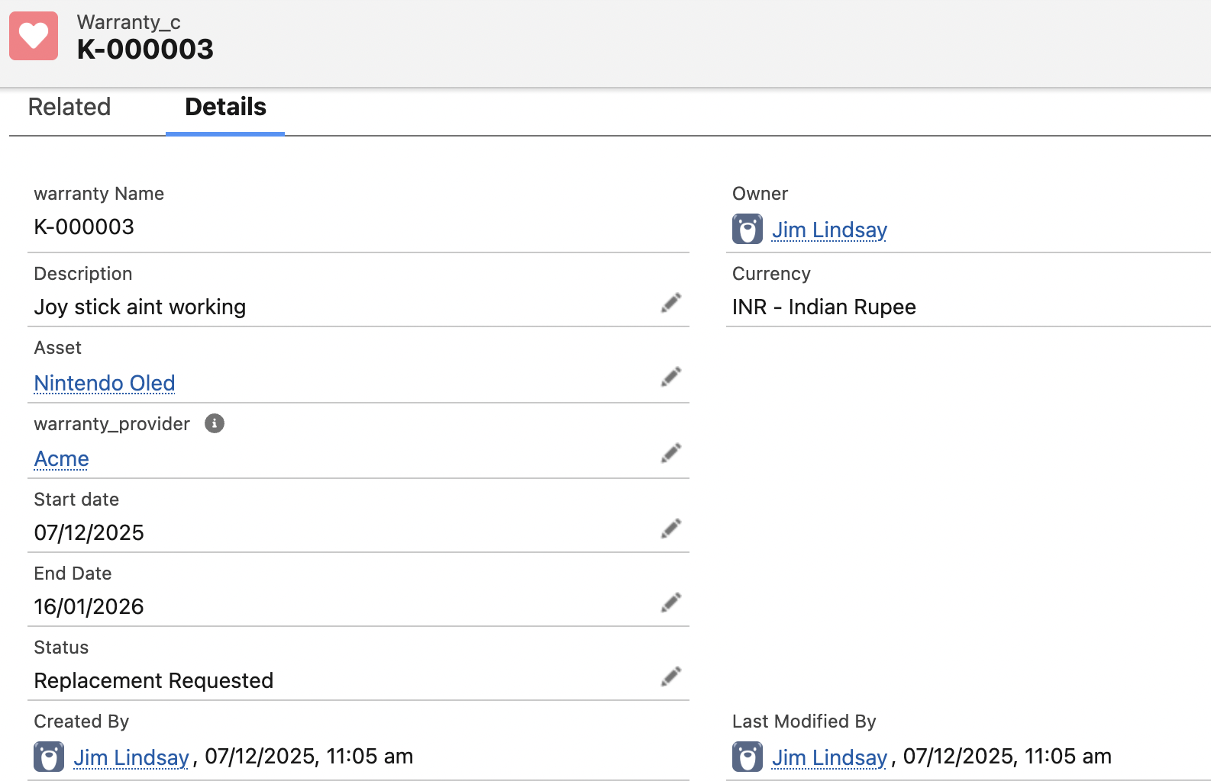 | You have to be the initial submitter to submit for approval.  So I had to create a record as Jim lindsay.
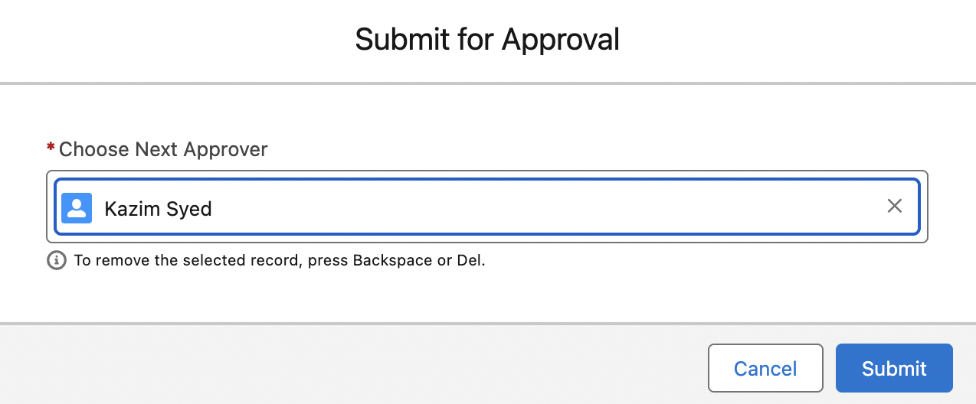
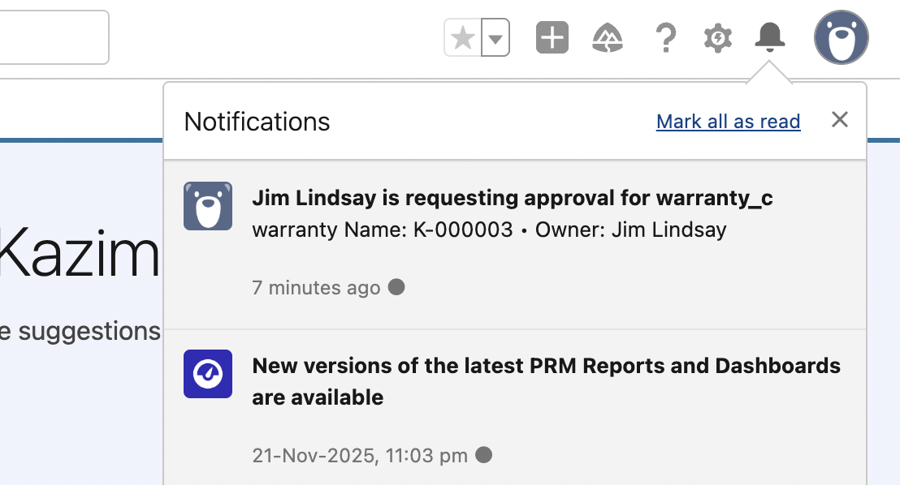

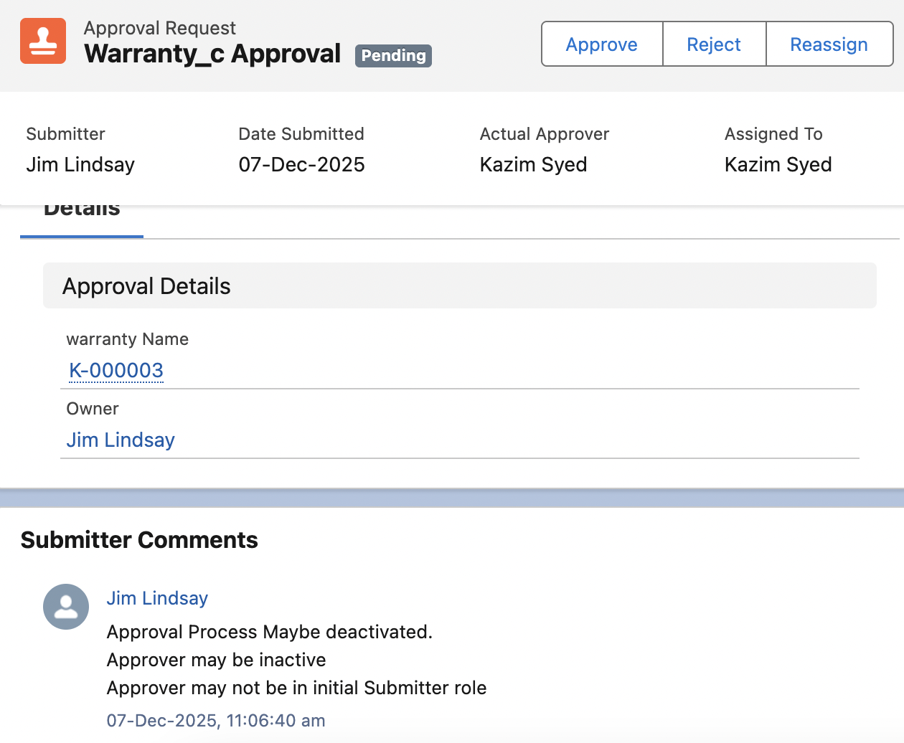 | 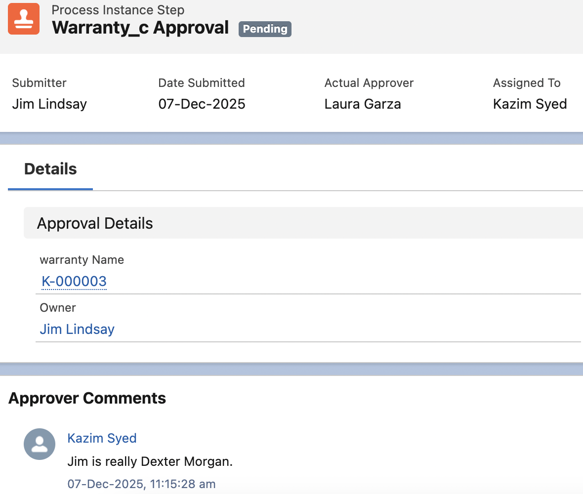
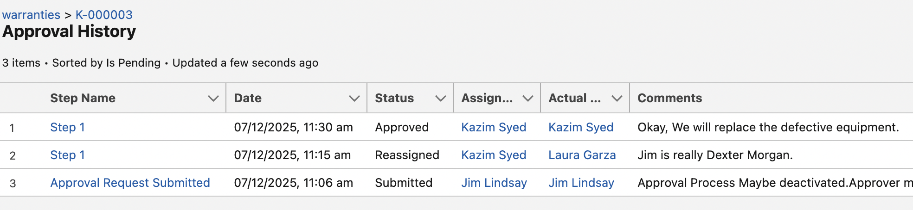 | 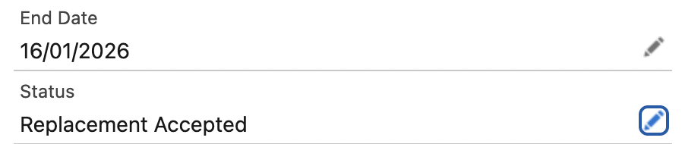  So the user changed the field to approved.

Create a Custom Hierarchical Relationship
Object manager > User object
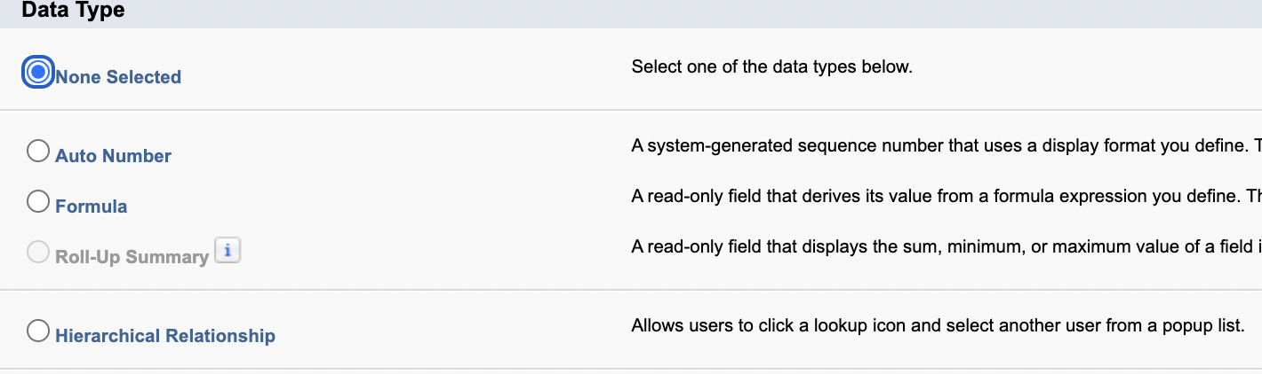 | Click new fields
 | Self lookup to associate another user.
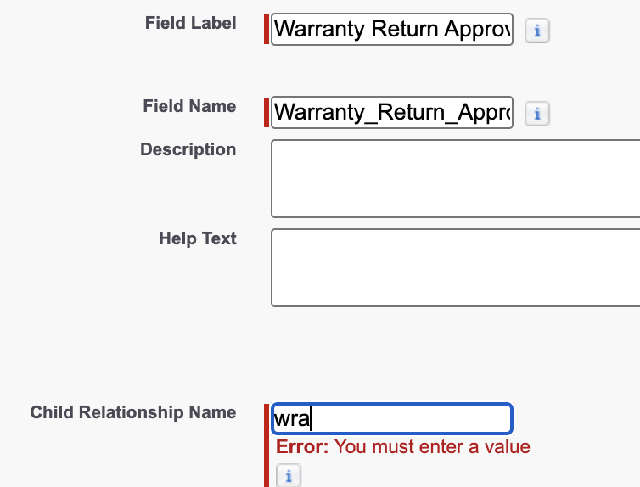
Setup> Users → edit Jim lindsay user record | 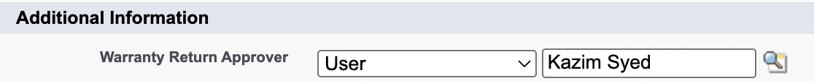
Setup > Warranty Return Approver | 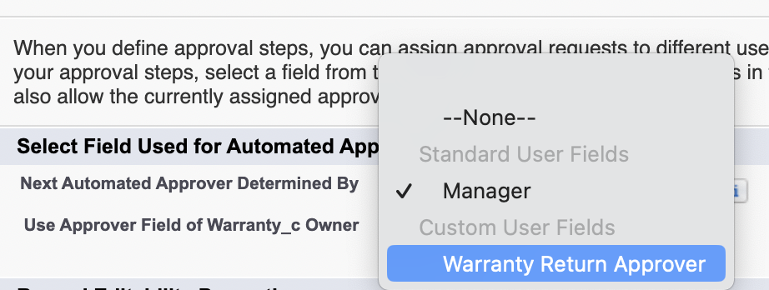

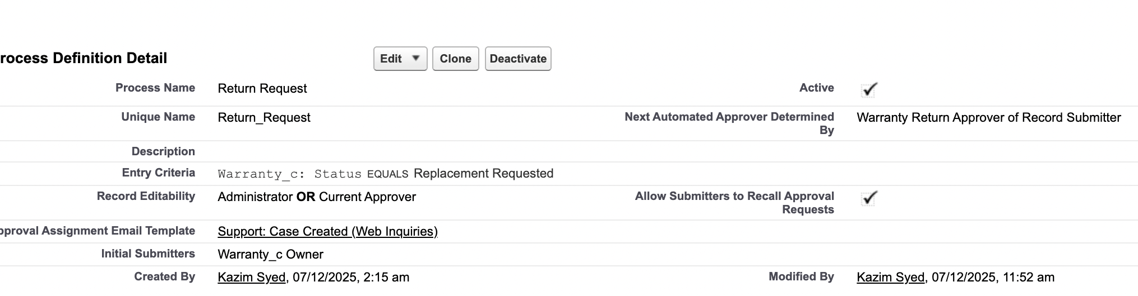
Now instead of the Initial submitter to choose the assigned approver.
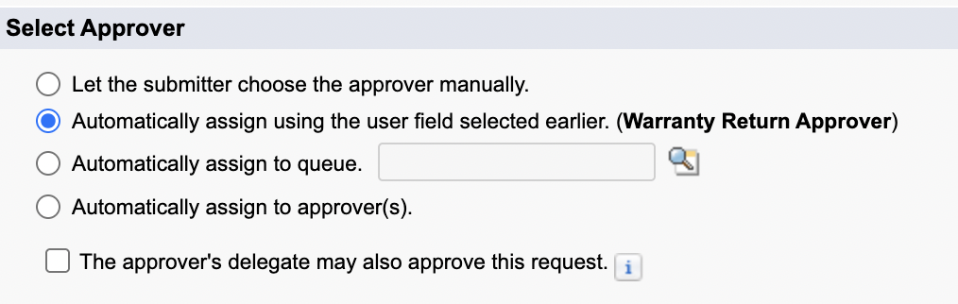

This document outlines the complete sequence of events, known as the Order of Execution, that Salesforce follows when a record is saved via an insert, update, or upsert DML statement (either through the user interface or API).

Salesforce Apex Trigger and Automation Order of Execution
This sequence ensures data integrity by enforcing validation, executing automation, and committing changes.

Step 1: Initialization and System Validation
- Load Record: The original record is loaded from the database, or the record is initialized for an upsert.
- Overwrite Values: The new record values provided by the user or API overwrite the old values.
- Client-Side Validation: The browser runs JavaScript validation (for standard UI requests) for dependent picklist fields.
- Initial System Validation: If the request is from a standard UI edit page, Salesforce runs basic system validations, including:
  - Compliance with layout-specific rules.
  - Required values and valid field formats.
  - Maximum field length.

Step 2: Before Automation and Validation (Before-Save)
- Before-Save Flows: Executes record-triggered flows configured to run before the record is saved (Fast Field Updates).
- Before Triggers: Executes all before Apex triggers.
- System & Custom Validation: Runs most system validation steps again (verifying required fields, etc.), and runs any custom validation rules.
- Duplicate Rules: Executes duplicate rules. If a duplicate is identified and the action is set to Block, the record is not saved, and the transaction stops.
- Foreign Keys: Salesforce verifies that any custom foreign keys do not refer to the object itself.

Step 3: Database Save (Uncommitted)
- Save Record: The record is saved to the database, but the changes are not yet committed (they can still be rolled back).

Step 4: After Automation (After-Save)
- After Triggers: Executes all after Apex triggers. (Used for updating related records or other complex logic).
- Assignment Rules: Executes assignment rules (e.g., Lead or Case assignment).
- Auto-Response Rules: Executes auto-response rules.
- Workflow Rules: Executes workflow rules.

Step 5: Workflow Field Update Recursion (Re-evaluation)
- Workflow Field Updates: If any Workflow Rules triggered a field update (a DML operation):
  - The record is updated again.
  - System validations are run again (Custom validation rules, Flows, Duplicate Rules, and Processes are NOT run again).
  - Before Update Triggers and After Update Triggers are executed one more time (and only one more time).

Step 6: Processes and Other Rules
- Escalation Rules: Executes escalation rules.
- Processes and Flows: Executes the following (not in a guaranteed order):
  - Processes built with Process Builder.
  - Flows launched by processes or by workflow rules.
  - Record-Triggered Flows configured to run after the record is saved (Actions and Related Records).
- Entitlement Rules: Executes entitlement rules.

Step 7: Final Calculations and Commitment
- Roll-up Summary/Cross-Object Formulas: If the record contains a roll-up summary field or is part of a cross-object workflow:
  - Calculations are performed, and the roll-up summary field in the parent record is updated.
  - The parent record then goes through its own complete save procedure (starting from Step 1).
- Sharing Evaluation: Executes Criteria Based Sharing evaluation.
- Commit to Database: All DML operations are committed to the database.

Step 8: Post-Commit Logic
- Post-Commit Logic: Executes final post-commit processes (asynchronous operations):
  - Asynchronous Apex jobs (@future, Queueable Apex).
  - Asynchronous paths in record-triggered flows.
  - Sending emails.
  - Outbound messages placed on the queue.

⚠️ Important Considerations
- Trigger Order: If more than one trigger is defined on an object for the same event (e.g., two before insert triggers), the execution order is not guaranteed. Use a Trigger Framework to control execution.
- API vs. UI: The specific system validations that run may vary based on whether the request originated from a standard UI page or an API call.
- Governor Limits: All steps within one transaction (from the initial trigger to the final commit) are governed by the same set of Apex Governor Limits (e.g., 150 DML statements, 100 SOQL queries).

Question 1 – Workflow Automation
What are the key concepts of workflow automation in Salesforce CRM? Select one: a) Workflow rules and time-dependent features.
b) Workflow rules and actions.
c) Workflow e-mail alerts and task actions.
d) Workflow field updates and task actions.
Question 2 – Workflow Processes
Which of the following processes can workflow rules be used to automate? Select all that apply:
a) Sending an e-mail alert to an account owner whenever updates are made to the account by another user.
b) Assigning a follow-up task to a marketing executive whenever a new lead is entered in the system.
c) Assigning a new lead to a queue.
d) Automatically updating an opportunity field whenever the opportunity reaches a specified sales stage.
Question 3 – Time-dependent Workflow
Which scenarios or criteria settings prevent you from adding time-dependent workflow actions? Select all that apply:
a) The rule is already active.
b) The rule criteria are set to evaluate when the record is created, and any time it's edited to
subsequently meet criteria.
c) The rule is deactivated, but has pending actions in the workflow queue.
d) The rule criteria are set to evaluate when the record is created, and every time it's edited.
Question 4 – Initiating Approval Processes
Which statements are correct when initiating an approval process? Select all that apply:
a) Approval processes can be set to automatically filter which users are initially involved with the approval process.
b) Approval processes can be set to allow users to choose a user to send the approval to.
c) Approval processes can be set to allow users to choose a queue to send the approval to.
d) Approval processes show an error message if the record does not meet the entry criteria.
e) Approval processes show a warning message showing the entry criteria if the record does not meet the entry criteria.
Question 5 – Approving or Rejectioning approval
processes
Which statements are correct when approving or rejecting approval requests? Select all that apply:
a) If enabled, approvers can approve or reject approval requests by e-mail.
b) Approval requests must always be approved or rejected by a specified user.
c) If enabled, approvers can approve or reject approval requests by Chatter.
d) If enabled and a user is set, an approver's delegate can approve or reject approval requests.

1)The answer is, a) Workflow rules and actions.
Answer 2 – Workflow Processes
The answer is, a) Sending an e-mail alert to an account owner whenever updates are made to the account by another user, b) Assigning a follow-up task to a marketing executive whenever a new lead is entered in the system, and ,d) Automatically update an opportunity field whenever the opportunity reaches a specified sales stage.
The answer c) Assigning a new lead to a queue, is not possible using workflow rules and instead can be carried out using lead assignment rules (see Chapter 8, Introducing Sales Cloud, Service Cloud, and Collaborative Features of Salesforce CRM).
Answer 3 – Time-dependent Workflow
The answer is, a) The rule is already active (here, you must deactivate the rule first),
c) The rule is deactivated, but has pending actions in the workflow queue (here, you must allow the pending actions to complete or delete the pending action using the time-based workflow queue, and, d) The rule criteria is set to evaluate when the record is created, and every time it's edited.
Answer 4 – Initiating Approval Processes
The answer is, a) Approval processes can be set to automatically filter which users are initially involved with the approval process, b) Approval processes can be set to allow users to choose a user to send the approval to, and d) Approval processes show an error message if the record does not meet the entry criteria.
The answer, c) and e) are not correct for the following reasons, respectively: Approval processes can be set to automatically assign approvers from a queue but not to allow users to choose a queue to send the approval to. Approval processes show an error message only, and not a warning message showing the entry criteria if the record does not meet the entry criteria.

Answer 5 – Approving or Rejecting approval Processes
The answer is, a) If enabled, approvers can approve or reject approval requests by e-mail, c) If enabled, approvers can approve or reject approval requests by Chatter, and d) If enabled and a user set, an approver's delegate can approve or reject approval requests.
The answer b) is not correct because approval requests can be set to be approved or rejected by individuals in a queue.
Answer 6 – During Approval Processes
The answer is, c) During an approval process approvers can reassign approval requests and d). During an approval process, approvers can view approval requests on their Salesforce homepage.

Qna
Perfect — let’s go slow, deep, and exam-oriented.
We’ll tackle your confusion on Q1, Q6, Q10, Q11, Q20, explain them in a way that builds intuition, and then give you new practice questions of similar difficulty, each with clear explanations.

✅ FIRST — Clarifying the 5 Confusing Questions

🔵 1) Why is Q1 = BEFORE SAVE?
Question Recap:
A Flow needs to update a field on the same record that triggered it. Which is most efficient?
Correct answer: Before-save Record-Triggered Flow

📌 Why?
Because before-save flows can update the same record very efficiently without performing DML.
Important rule:
Updating the triggering record → use BEFORE-SAVE
Updating related records → use AFTER-SAVE

📌 Why your reasoning ("it won't trigger again") is incorrect?
“Before save won’t trigger itself again” — true,
but that's not why we choose it.
We choose it because:
- It is FASTEST automation in Salesforce
- It performs implicit DML
- It is designed to modify the same record efficiently
👉 This is an ADM-201 gold rule.

🔵 6) Q6 Explanation — After Save
Scenario:
When Account Industry changes, create tasks for ALL related Contacts.
Correct Answer: After-Save Flow

📌 Why?
Because:
- You are updating related records (Contacts → Tasks)
- You cannot do that in before save (only the main record)
- You need the record to be committed to DB before creating related records
Rules:
Need to… Flow Type Update same record Before Save Create related records After Save

🔵 10) Q10 Explanation — Record-Triggered BEFORE Delete
Question:
Flow must run when a record is deleted.
Correct answer: Before Delete

📌 Why not After Delete?
Because Salesforce does NOT support After-Delete Flows (ADM-201 fact).
Only available deletion trigger:
✔ Before Delete

🔵 11) Q11 Explanation — Schedule-Triggered Flow
Scenario:
You want to mass-update Accounts missing Industry values.
Correct answer: Scheduled Flow

❓ “But isn’t that a one-time action? Why schedule?”
Because ADM-201 is testing capability, not intention.
You pick Scheduled Flow because:
- It processes multiple records at once
- It runs in batch mode
- It doesn’t need a user to make updates
- It is the only flow type that can run across the entire database on a schedule
Even if you want it only ONCE, the correct tool is still a Schedule-Triggered Flow.

🔵 20) Q20 Explanation — C is correct
Question Recap:
A flow runs when a user clicks a button.
Options:
- Screen Flow
- Autolaunched Flow
- Either
- None
Correct: Either

📌 Why?
A button can trigger:
- A Screen Flow (opens a wizard)
- An Autolaunched Flow (runs silently)
Button is just a trigger method, not an interaction.

✅ NOW — NEW QUESTIONS (similar difficulty)
Each question has full reasoning.

🔥 New Question Set (High Difficulty, ADM-201 Style)

Q1. A Flow must update the record AND create a Case when an Opportunity Stage changes to “Escalated”. Which Flow design is best?
A. One before-save flow
B. One after-save flow
C. Two before-save flows
D. One before-save + one after-save
👉 Correct Answer: D

Explanation
- Before Save → update Opportunity
- After Save → create Case (requires record commit)
You can’t do both in one flow.

Q2. A Flow must check if a Contact has more than 3 open Cases and prevent the user from saving the Contact. Which flow type?
A. After Save Record-Triggered
B. Before Save Record-Triggered
C. Autolaunched Flow
D. Screen Flow
👉 Correct Answer: B

Why?
Before Save flows can:
- Validate the record
- Prevent save via error message
After Save cannot block a save.

Q3. You need automation that runs when a Platform Event arrives and updates 10,000 records. Which Flow type?
A. Autolaunched
B. Record-Triggered
C. Platform Event-Triggered Flow
D. Schedule-Triggered Flow
👉 Correct Answer: C

Why?
Only Platform Event Flows respond to platform events.

Q4. A manager wants to run a flow manually from the Setup menu to clean up old Leads. Which flow type?
A. Screen Flow
B. Autolaunched Flow
C. Record-Triggered Flow
D. Schedule-Triggered Flow
👉 Correct Answer: B

Why?
Autolaunched Flows can be:
- Manually run from the Flow Runtime UI
- Triggered on demand
- Run without screens
Screen Flow requires UI interaction.

Q5. A user clicks a button and is presented with a guided 3-step wizard. Which flow?
A. Autolaunched
B. Screen Flow
C. Record triggered
D. Scheduled flow
👉 Correct Answer: B

Why?
Only Screen Flows display UI screens.

Q6. A flow needs to update 50,000 Contacts every night based on custom logic. How should you build it?
A. Before-save record triggered
B. After-save record triggered
C. Autolaunched + manual
D. Schedule-triggered flow
👉 Correct Answer: D

Explanation
Scheduled flows support:
- Running daily
- Batch processing
- Large volumes
- Background processing

Q7. A flow must run only if a field changes from “Draft” to “Submitted”. Where do you configure this?
A. Decision element
B. Start element entry criteria
C. Assignment
D. Loop
👉 Correct Answer: B

Why?
Record-triggered flow start conditions include:
- When the flow runs
- Field change conditions
- Old → new comparison logic

Q8. Which flow action stores temporary values that are used later in the flow?
A. Elements
B. Resources
C. Fault Paths
D. Subflows
👉 Correct Answer: B

Why?
Resources = variables.

Q9. A Flow needs to interact with the user AND update fields. Which type?
A. Before Save Flow
B. Screen Flow
C. Autolaunched Flow
D. After Save Flow
👉 Correct Answer: B

Q10. A Flow triggered by a record update must not run every time — only when a specific field value changes. What feature should you use?
A. Loop
B. Subflow
C. Entry conditions
D. Fault path
👉 Correct Answer: C

If you'd like, I’ll generate:

✓ 20 more (even harder) Flow scenario questions,

✓ A 1-page ADM-201 Flow Exam Cheat Sheet,

✓ or a Flow Decision Tree (which flow type to choose, instantly).
Just tell me which one you want!

