QnA from Salesforce admin book
subtitle

Heading 1

Heading 2

Heading 3

Heading 4

- Login restrictions based on profile(start and end time)  -IP Ranges  - Known device or not  - Cookie exist | You can access salesforce crm also through  - the API (for example, using an integrated client application or the Apex Data Loader)  - a desktop client (for example, Salesforce for Outlook)  - a mobile client application.  Whenever a login attempt is made to Salesforce using any of these methods, the user's login request is authorized by the system using the following sequence of checks:  1. Does the user's profile have any login restrictions?  2. Does the user's IP address appear within the organization's trusted IP address list?  3. Has the user been activated from this IP address before?  4. Does the user's web browser have a valid browser cookie from Salesforce stored?
Else  Follow the entire activation process. | If the user's login is from neither a trusted IP address nor a browser with a valid Salesforce cookie, the login is denied. To gain access to Salesforce, the user's identity must be confirmed by successfully completing the computer activation process.
You can set these setting for a particular profile based under system settings
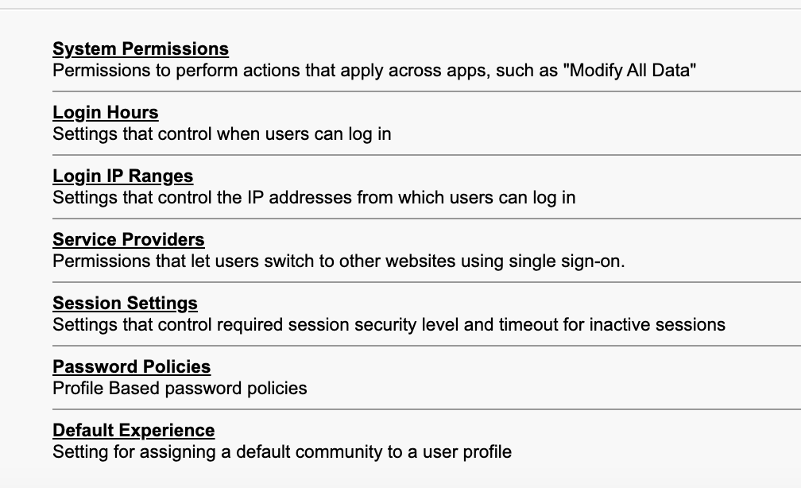

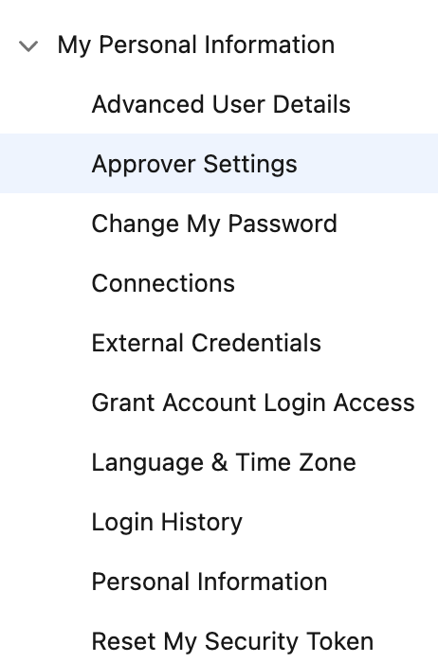  Your pfp → settings. | The company information settings for language, locale, and time zone can affect how key data is handled for the organization.  However, individual users can set their own language, locale, and time zone, overriding the organization-wide setting, by navigating to Your Name | My Settings | Personal | Language & Time Zone as shown in the following screenshot:
Approver settings. | Lets say vp of sales is the one who approves the discounted sales of a product of over 10,000$.  When the deal is offered, vp of sales can have assigned approver (Senior sales manager I.e Jim Lindsay) who can perform binary action like approve/reject but cant reassign it to some1 cuz it blows organization structure.
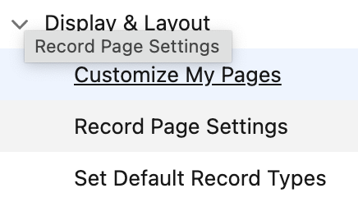 | You can customize your pages and remove related lists from objects.  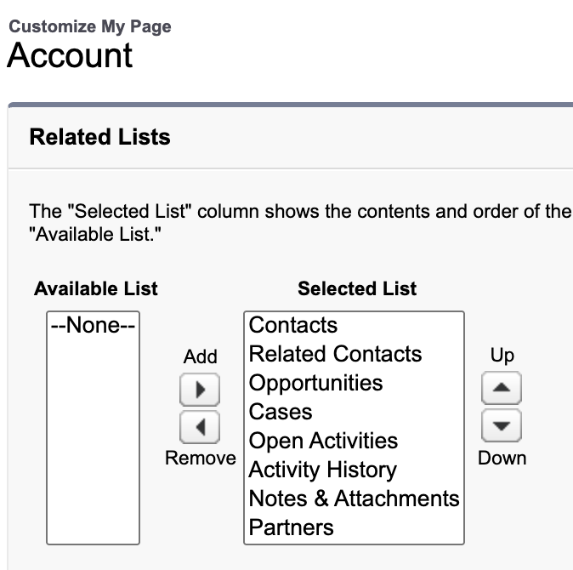

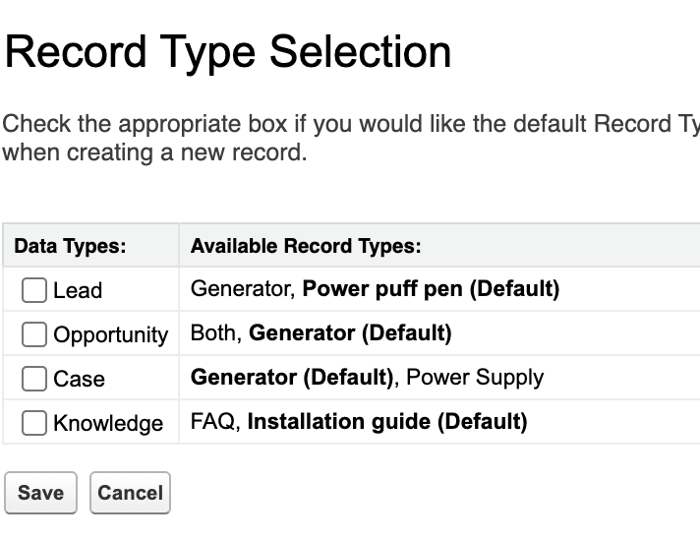 | You can check the box u like, if u do, the defualt will be selected w/o prompted.
Default locale | Impact dates, number formats.

