Microsoft excel tutorial for beginners
subtitle

Heading 1

Heading 2

Heading 3

Heading 4

SELECT Id, ActivityDate, Subject FROM Task WHERE ActivityDate > NEXT_N_DAYS:365

Mass deleting future tasks greater than one year from now
public class DeleteYearOldTask implements Database.Batchable<SObject> {

public Database.QueryLocator start(Database.BatchableContext BC){
return Database.QueryLocator([
SELECT Id FROM Task WHERE activitydate!=null and ActivityDate > NEXT_N_DAYS:365
]);
}

public void execute(Database.BatchableContext BC, List<sObject> scope){
List<Task> toDelete= (List<Task>) scope;
Database.DeleteResult[] results= Database.delete(toDelete, false);

for(Integer i=0; i<result.size();i++){
if(!results.isSuccess()){
for(Database.Error err: results[i].getErrors()){
System.debug(
'Delete failed for Id=' + toDelete[i].Id
+ ' : ' + err.getStatusCode() + ' - ' + err.getMessage()
);
}
}
}
}
public void finish(Database.BatchableContext BC){
System.debug('DeleteYearOldTasksBatch finished. Job Id: ' + BC.getJobId());
}
}

// Instantiate the batch class
DeleteYearOldTask deleteBatch = new DeleteYearOldTask();

// Execute the batch job
// The second parameter (scope size) is set to 200, which is the maximum allowed.
// Smaller sizes may be needed if the delete triggers complex automation.
Database.executeBatch(deleteBatch, 200);

System.debug('Batch job submitted to delete all AcquiredAccount__c records.');

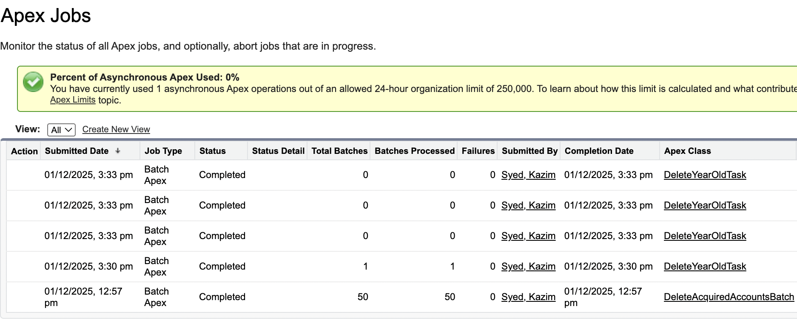

Mass deleting Acquired Account records
public class DeleteAcquiredAccountsBatch implements Database.Batchable<SObject> {

public Database.QueryLocator start(Database.BatchableContext bc) {
// Query all records of the custom object
return Database.getQueryLocator([
SELECT Id
FROM AcquiredAccount__c
]);
}

public void execute(Database.BatchableContext bc, List<SObject> scope) {
// Cast to concrete type for clearer debugging/logging if desired
List<AcquiredAccount__c> toDelete = (List<AcquiredAccount__c>) scope;

// Use Database.delete with allOrNone = false to allow partial success
Database.DeleteResult[] results = Database.delete(toDelete, false);

// Optional: log failures to the debug log
for (Integer i = 0; i < results.size(); i++) {
if (!results[i].isSuccess()) {
for (Database.Error err : results[i].getErrors()) {
System.debug(
'Delete failed for Id=' + toDelete[i].Id
+ ' : ' + err.getStatusCode() + ' - ' + err.getMessage()
);
}
}
}
}

public void finish(Database.BatchableContext BC) {
System.debug('DeleteAcquiredAccountsBatch finished. Batch Id: ' + BC.getJobId());
// Optional: Send an email notification to the administrator upon completion.
AsyncApexJob job = [SELECT Id, Status, NumberOfErrors, JobItemsProcessed, TotalJobItems
FROM AsyncApexJob
WHERE Id = :BC.getJobId()];

System.debug('Batch Job finished. Status: ' + job.Status +
', Total Records: ' + job.TotalJobItems +
', Errors: ' + job.NumberOfErrors);

// Example Email Notification:

Messaging.SingleEmailMessage mail = new Messaging.SingleEmailMessage();
String[] toAddresses = new String[] {'kazimsyed9911@gmail.com'}; // <-- CHANGE THIS EMAIL
mail.setToAddresses(toAddresses);
mail.setSubject('Batch Delete Job Complete: AcquiredAccount__c');
mail.setPlainTextBody('The mass deletion of AcquiredAccount__c records has finished. Status: ' + job.Status);
Messaging.sendEmail(new Messaging.SingleEmailMessage[] { mail });

}
}

Restoring Records from the recycle bin
Setup > Recycle bin
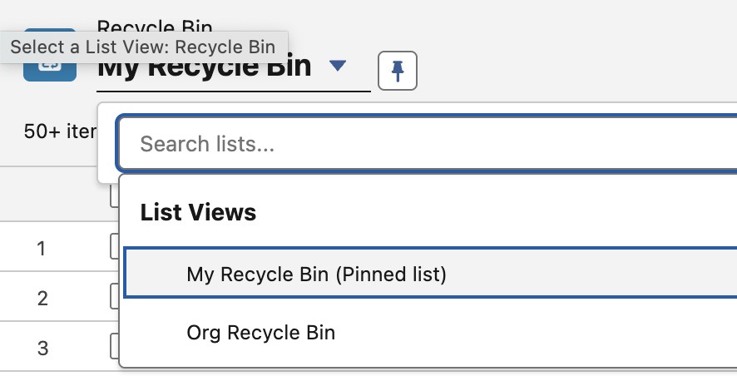 | You have records deleted by you in my recycle bin and records deleted by others in Org Recycle bin.
 | So it doesn’t delete, it just flag the isDelete field to be true. The way to hard-delete is using data-loader. You can also sort by deletedate.
The way mike did it. | Date x=Date.today.addyears(1)  select id from task where activitydate > x;

FAQ
does scope(0) means the the first chunk or is it the first record of the chunk.
First record of the chunk. Its a one dimensional array that gets converted into subarray that is chunks.
Chunk 1 would from i=0-200 scope(i)
chunk 2 would from i=201-400 scope(i)

public void execute(Database.BatchableContext bc, List<SObject> scope) { // Cast to concrete type for clearer debugging/logging if desired List<AcquiredAccount__c> toDelete = (List<AcquiredAccount__c>) scope; // Use Database.delete with allOrNone = false to allow partial success Database.DeleteResult[] results = Database.delete(toDelete, false); is their a need to cast it. or can we do? Database.DeleteResult[] results = Database.delete(scope, false);
No, its not necessary.
1. clarity
Casting tells you what object type you EXPECT.
2. Strong typing
Code completion in VS Code
- Compile-time validation
- Access to child fields during debugging before DML

Simple dml stmt | Insert contactstoinsert  update accounts  delete tasks
Partial dml stmt | Database.insert(records, false)  Database.update(records, false)  Database.delete(records, false)
Error handling | Result.getId()  Result.isSuccess()  Result.getErrors()

Estimating Your Organization Code Coverage
Setup → Apex classes | 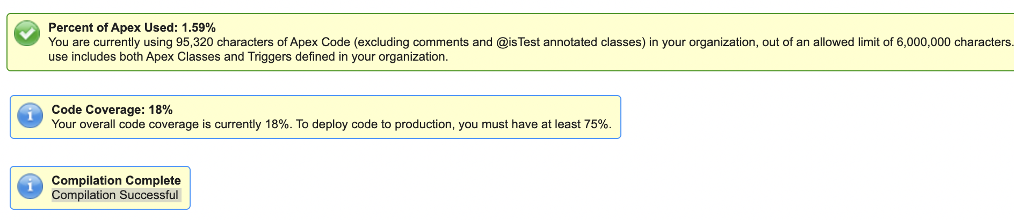

Creating a validation rule to enforce Positive numeric values
 | You create validation rules at the object level.
 | No of employees could be negative without validation rules.
Object manager → lead → validation rule | 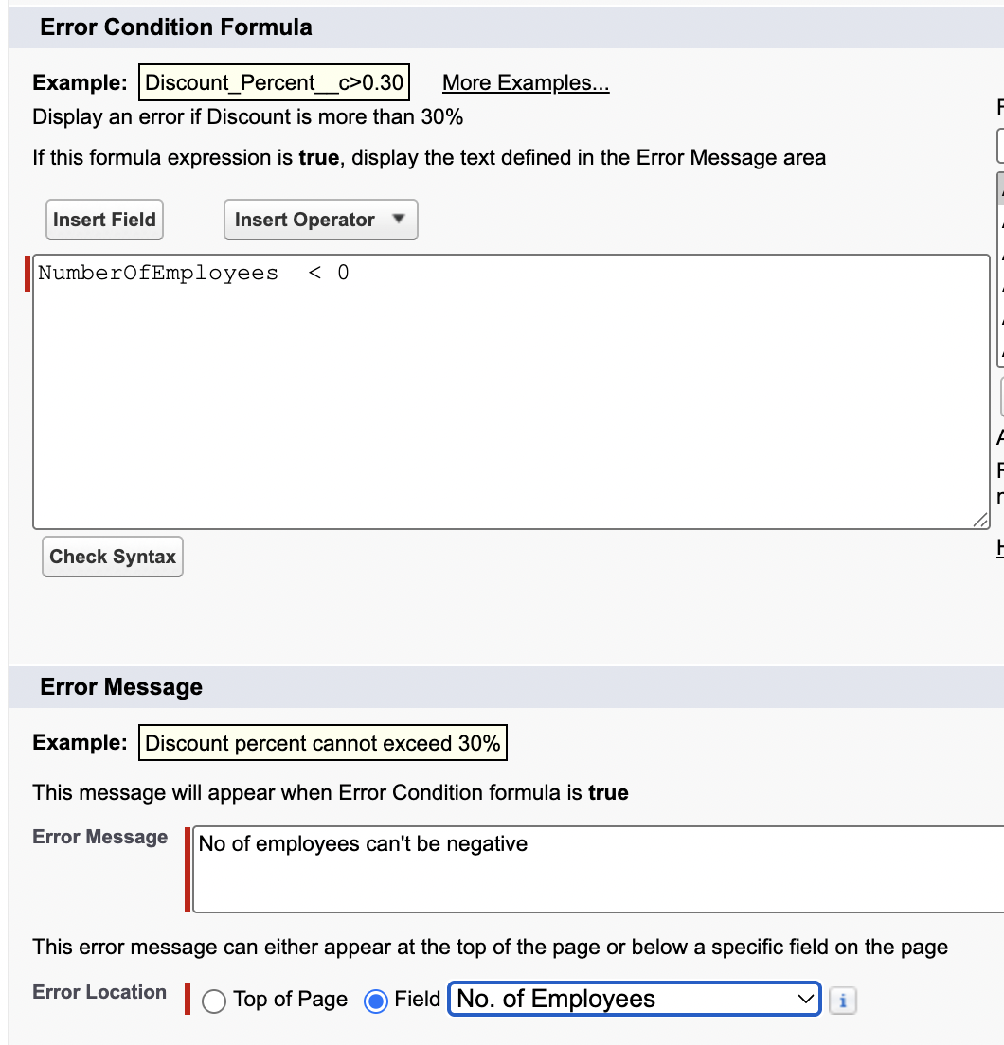

Make a field Required via a Validation rule
Task | How to make a field required?
We can’t uncheck it to make not required. | 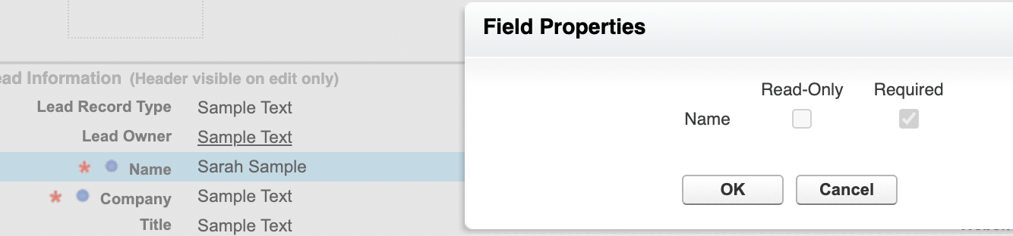
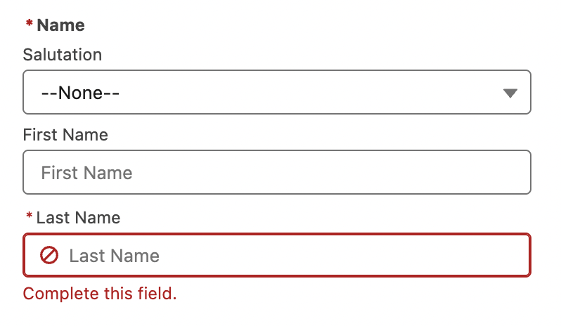 | Name and lname is required.
The way we do it.  Note: it doesn’t retroactively fix the issue of legacy records. It will block any future updates on this record.  Note: you can combine validation rule. But then u are occupied with a vague error message that states that either the field is empty or #ofemployees is less than zero. | 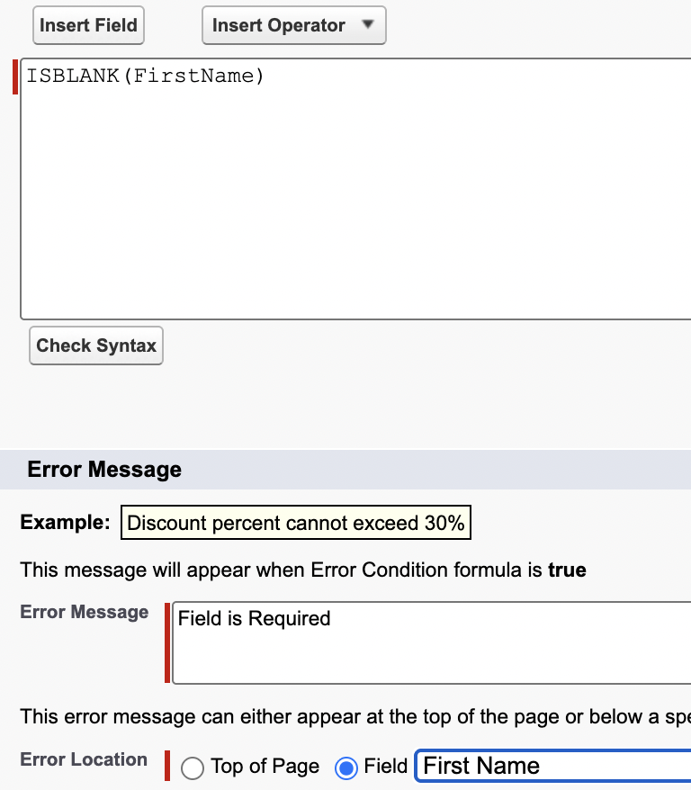

Use chatgpt to generate validation rules
refer to prompt library

Duplicate Management and Duplicate rules
 | You will find duplicate rules for account, contact, lead.
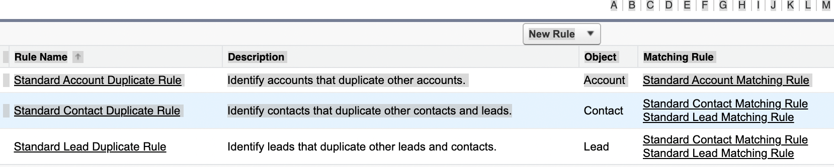
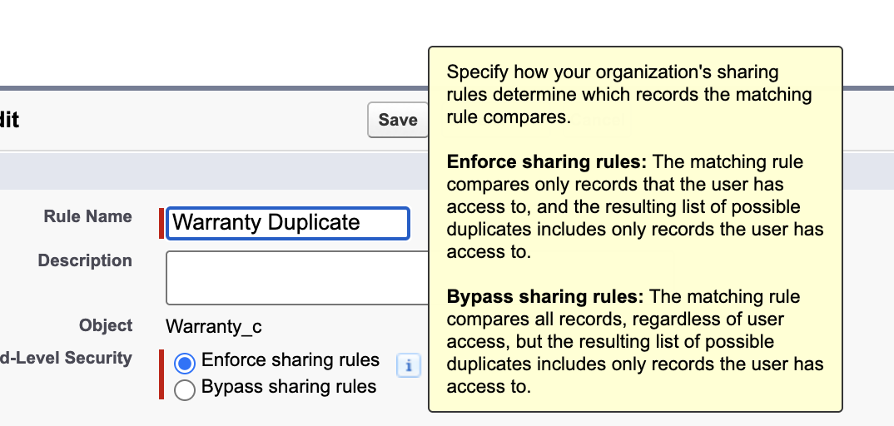 | Only compares record which user has.  OR  Even compare that.
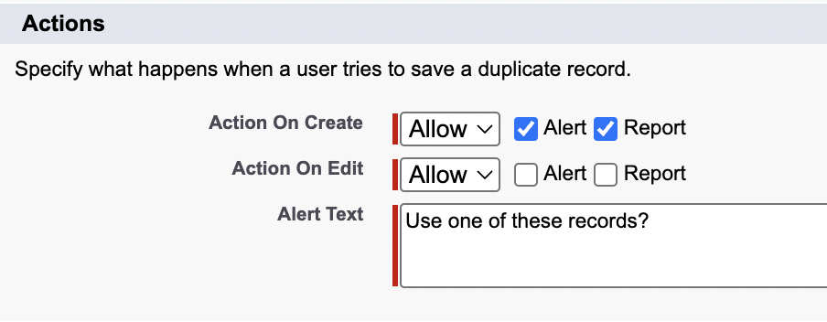 | You can allow to create a duplicat record and inform the user.  In case of insert from dataloader, it will trigger an error and those records will not be inserted.
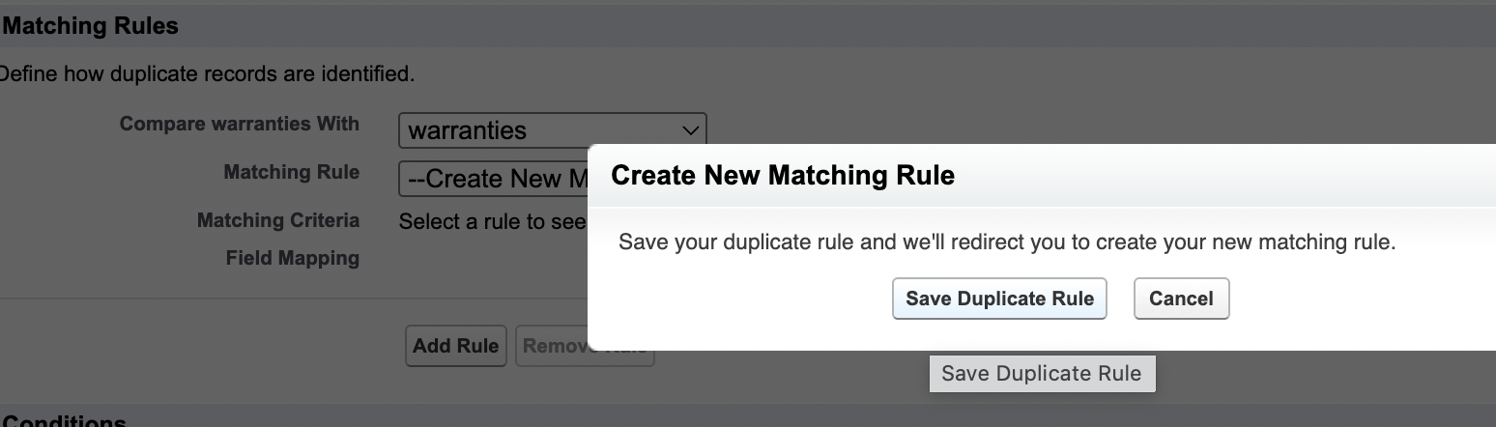
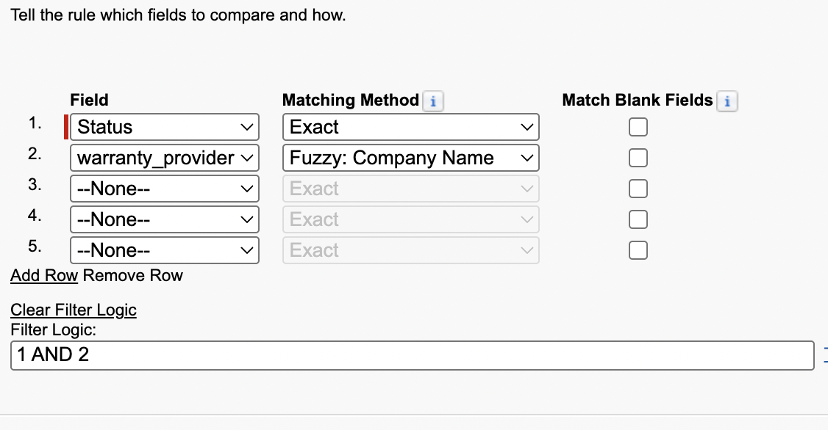 | Then click the activate button. We can also set the criteria to when to run the rule.

Potential Duplicates Lightning component
It only exists for std objects like account, contact and lead. Even if u open the lightning app builder, u wont see it as a components in the detail section.

Merging duplicates
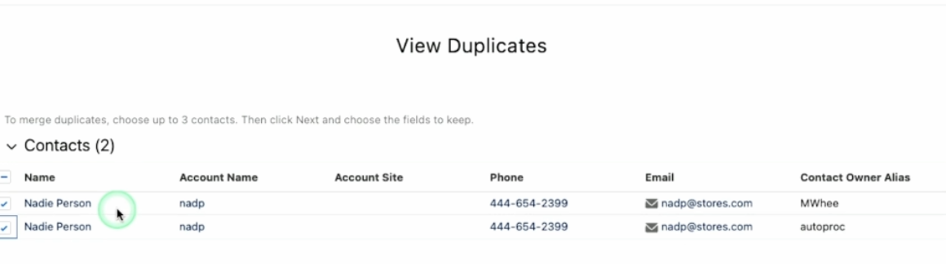
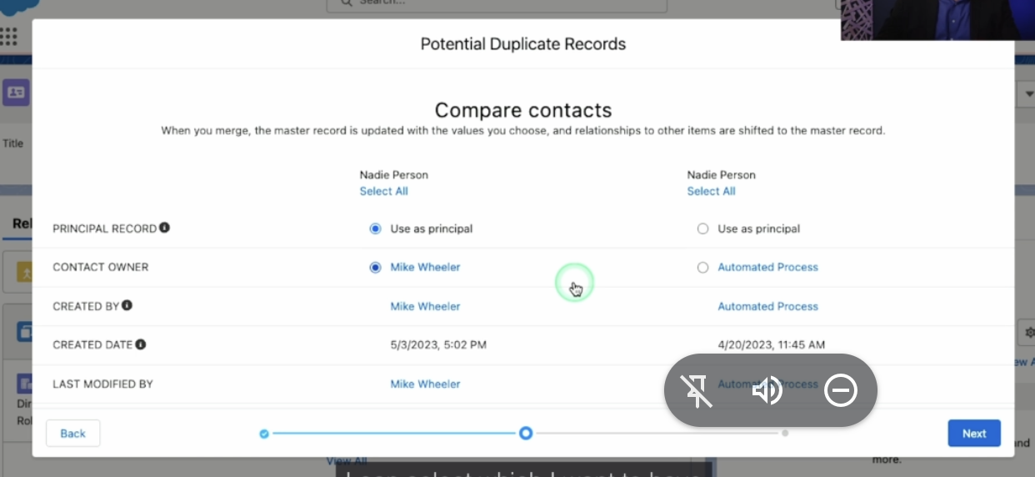

Duplicated record set
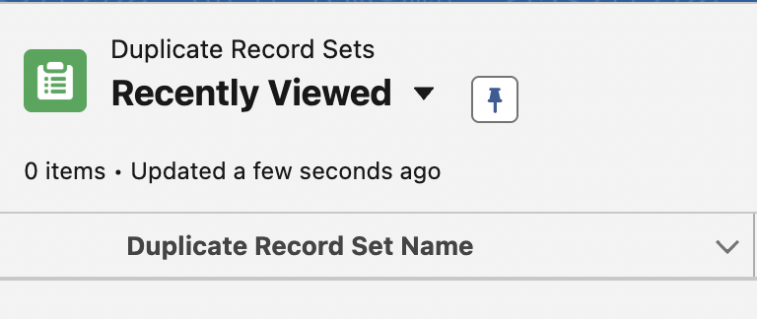 | App launcher → duplicated record set

Creating a tabular Report
 | Before u create a dashboard u need to create underlying source reports.
Differentiate between report format and report type | 1. tabular  2. summary  3. matrix  4. joined
 | We have private and public and all reports. Reports in public reports folder is available to all.
Report type is either one or multiple object that this report might contain. | 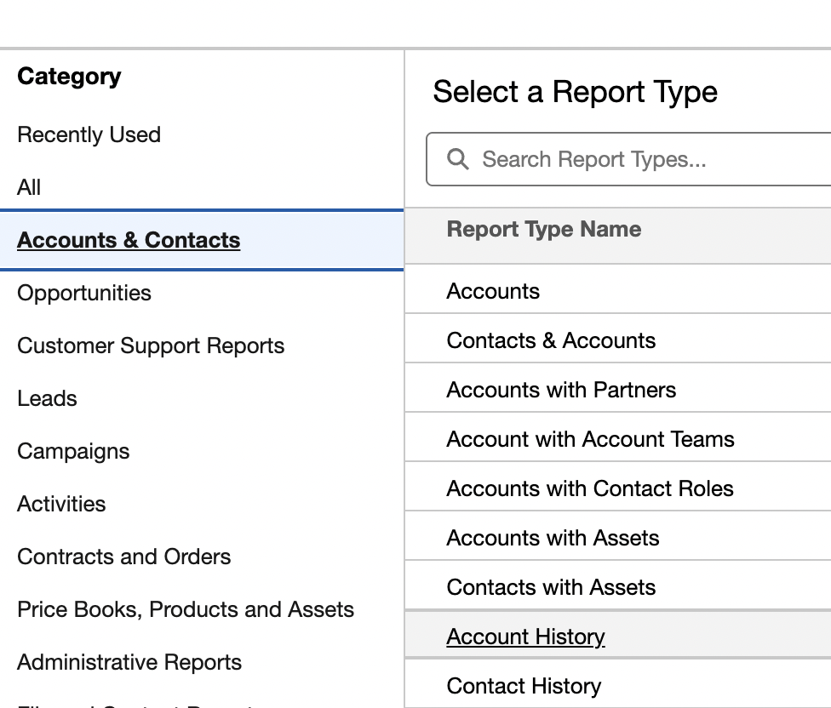
 | 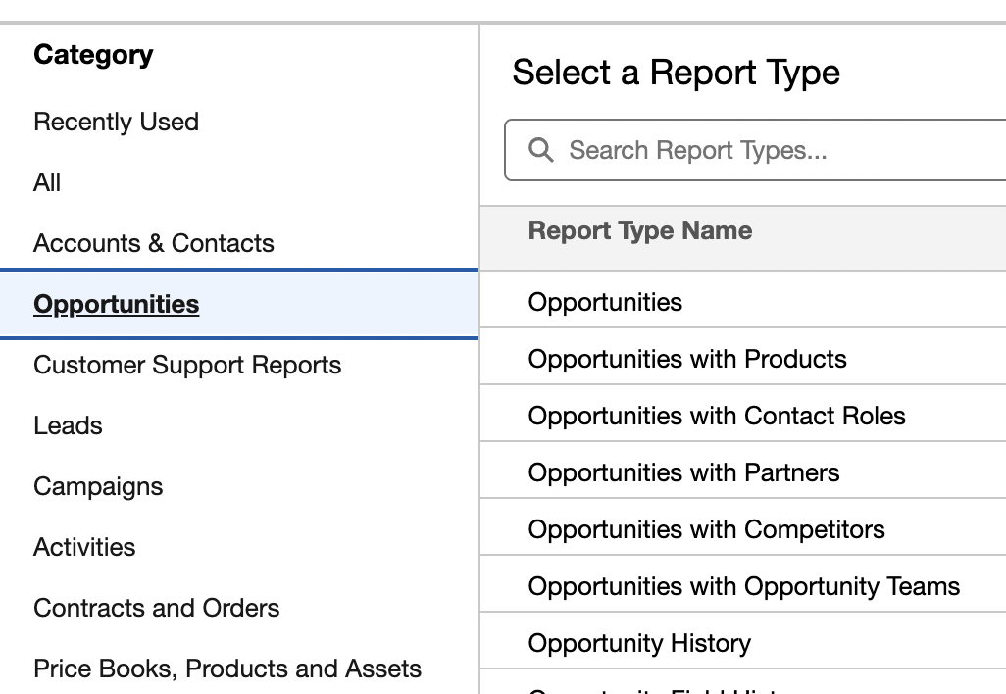

outline | 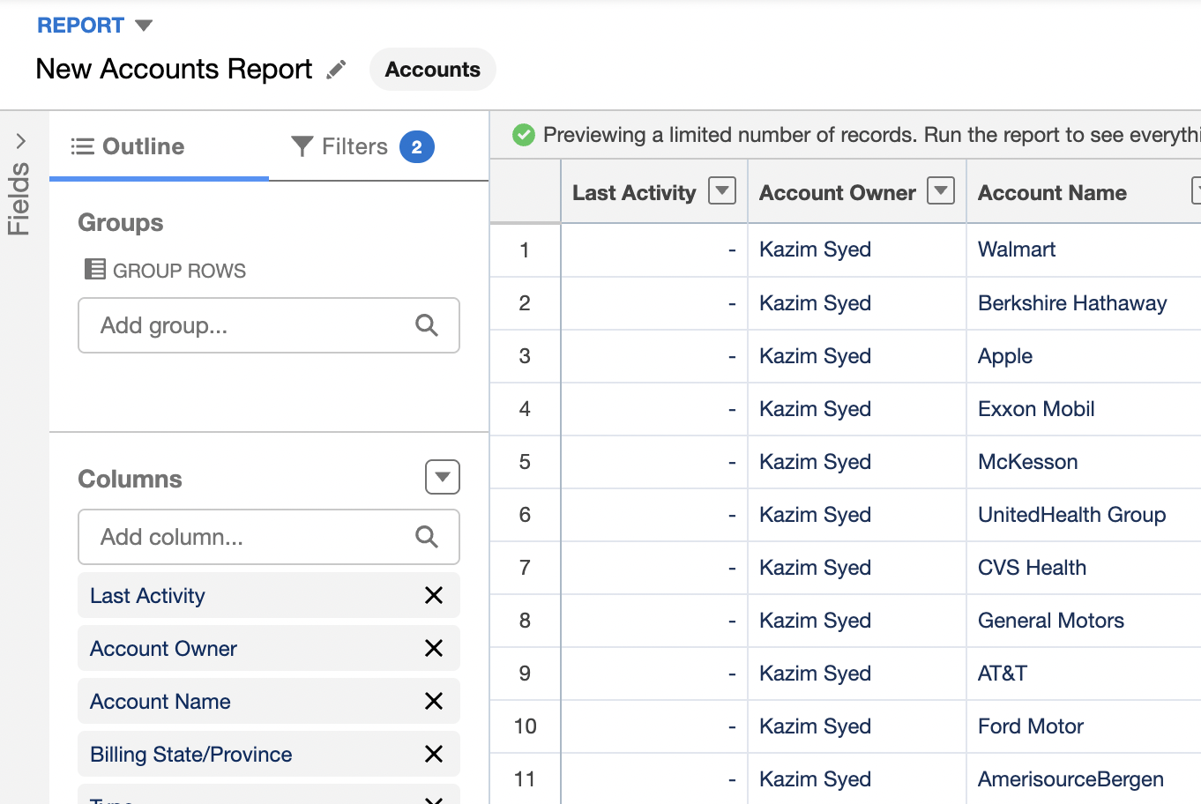
Add filter | 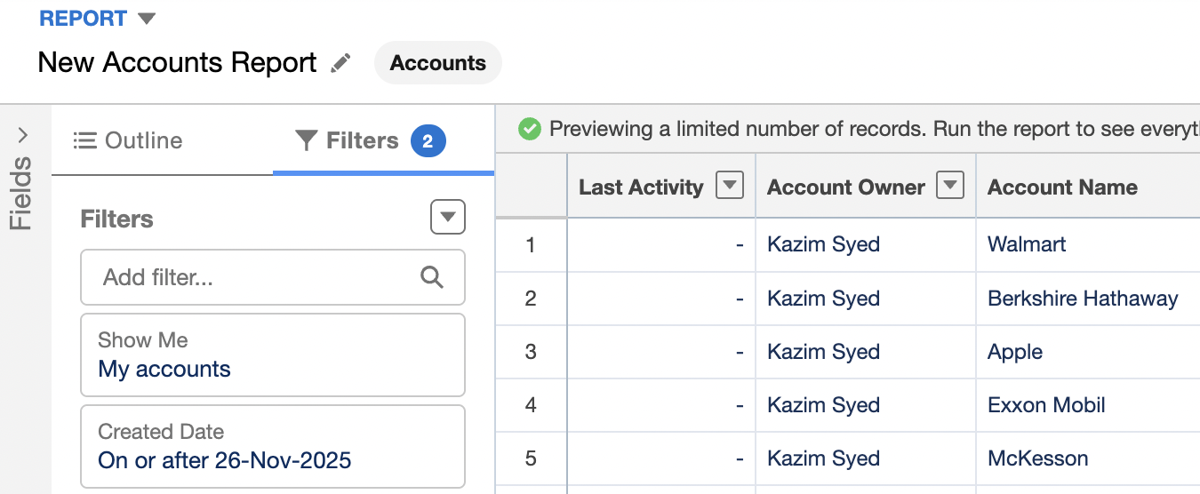
Edit filter: My account | 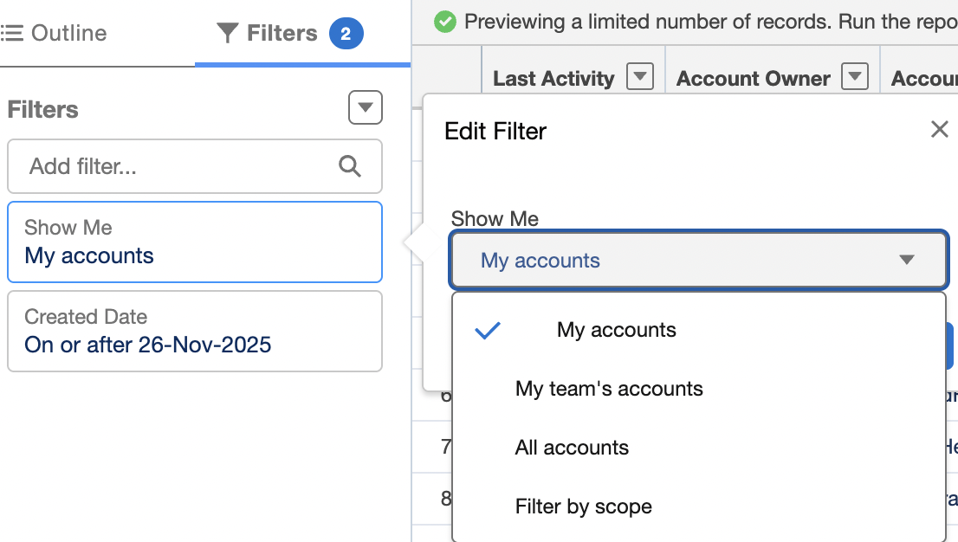
I saved it into public reports. U need this for dashbaord. Dashboards need to pull in data from public reports. | 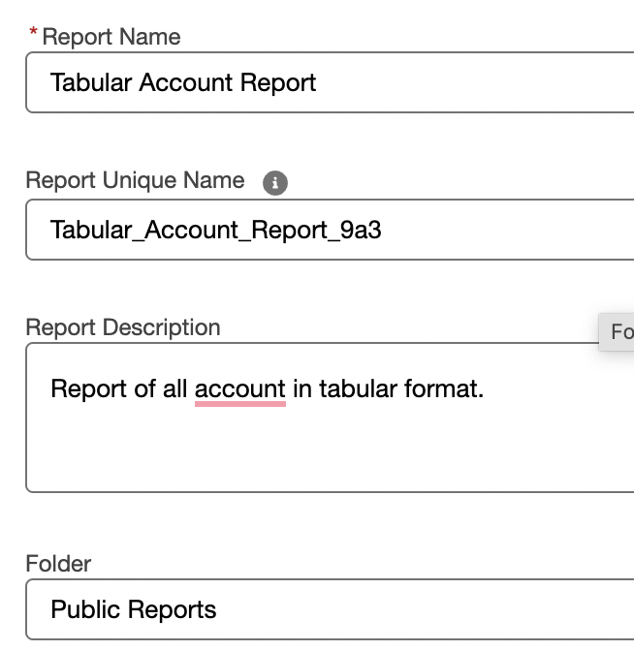

Since there aren’t row grouping, we wont be able to add charts. | 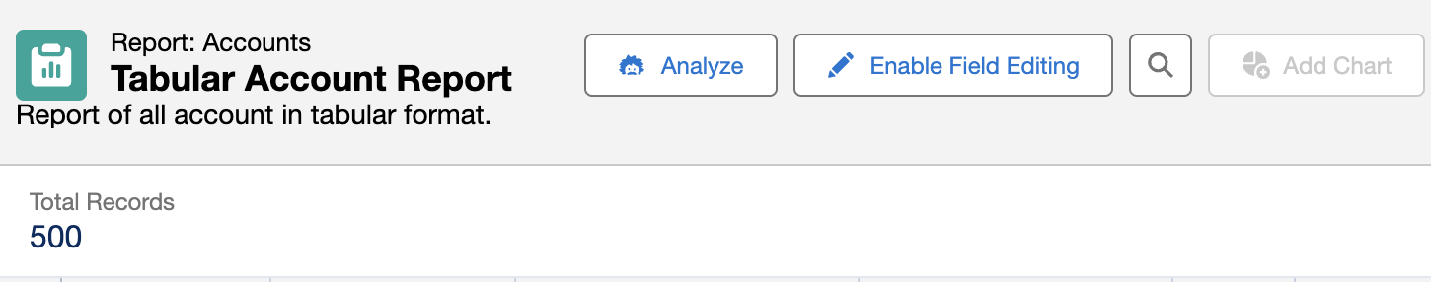

Creating a Summary report
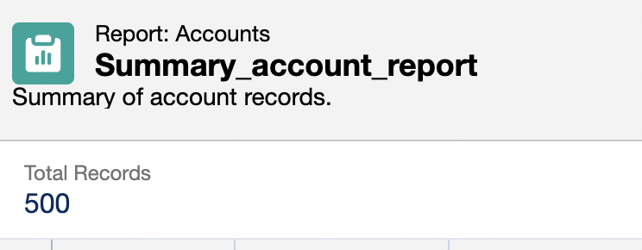 | We save the tabular account report as summary_account_report. To not lose data.
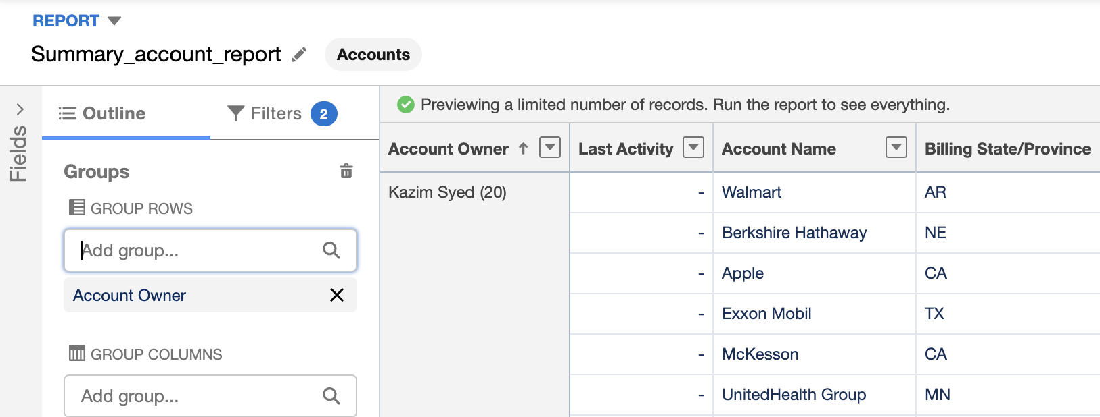 | We add group by account owner.
 | At the bottom we have the toggles.

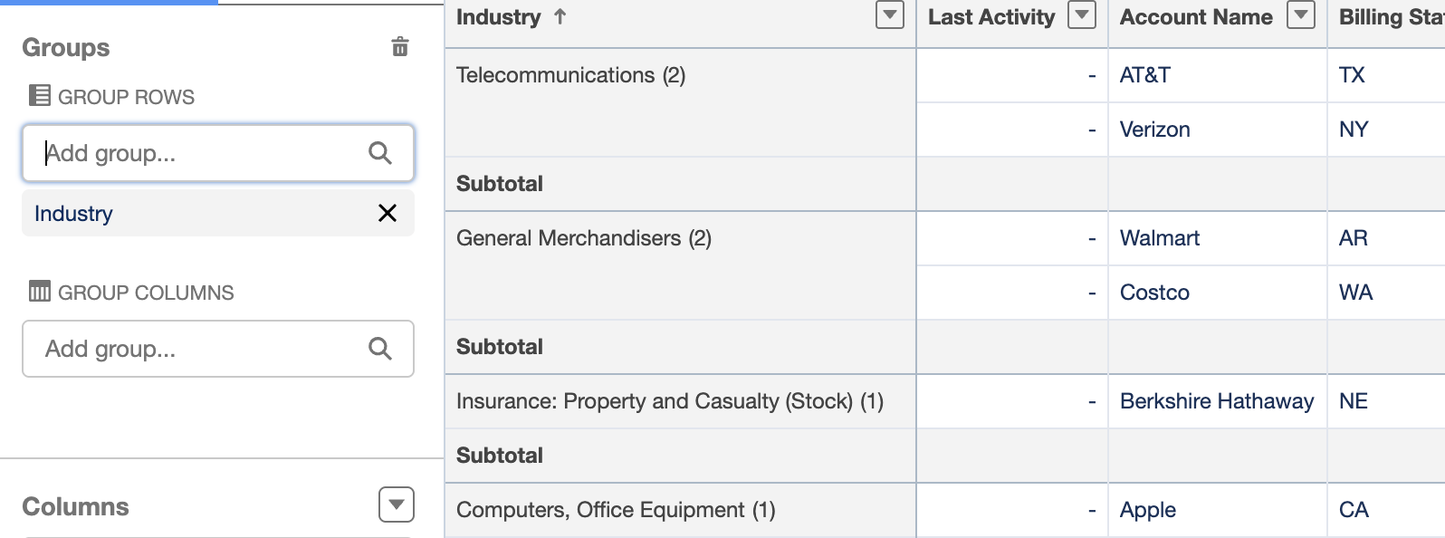 | I grouped the records using industry.
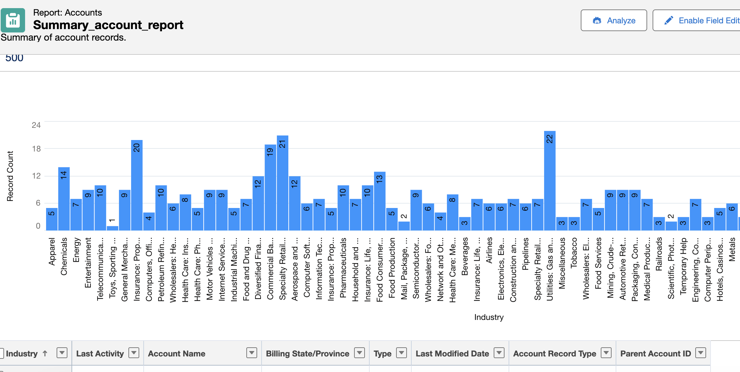 | Now u can create charts.

Create a Matrix Report
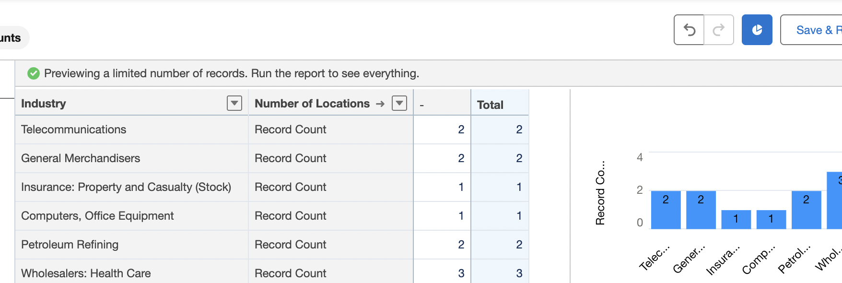
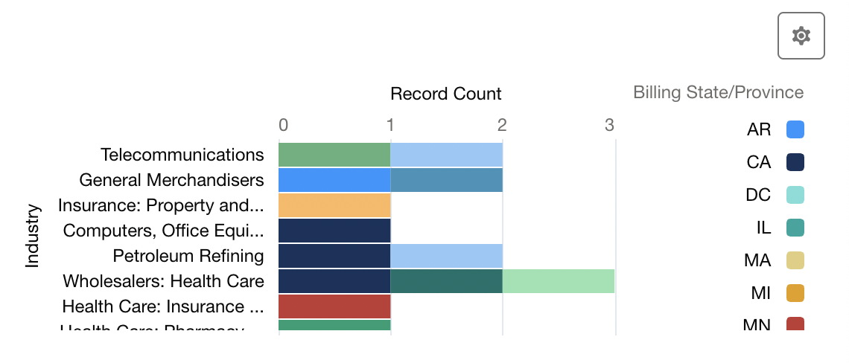 | I grouped by industry and then billing state.

Created a joined report
Is a type of reports that combines data from multiple report types to give u a comprehensive view of ur data.
A joined report is a type of report in Salesforce that allows you to combine data from multiple
report types, giving you a more comprehensive view of your data. Here are several scenarios
where a joined report would be useful:
1. When you need to combine data from different objects: Let's say you want to analyze your
sales data by region and by product. You have a report for your sales by region and another
report for your sales by product, but you need to see the data together to get a complete picture.
By creating a joined report, you can combine the data from both reports to see the sales by
region and by product in one place.
2. When you need to compare data across different time periods: If you want to see how your
sales have changed over time, you might create two reports: one for this year's sales and one
for last year's sales. With a joined report, you can easily compare the two reports side-by-side
and see how your sales have changed year-over-year.
3. When you need to analyze data at different levels of detail: Let's say you have a report for
your sales by account and another report for your sales by product. By creating a joined report,
you can drill down into the data at different levels of detail, such as seeing the sales by account
for each product or the sales by product for each account.
4. When you need to combine data from different report types: If you have multiple report types
with related data, such as opportunities and contacts, you can create a joined report to see how
the two types of data are related. For example, you can see how many opportunities each
contact has generated or how many contacts are associated with each opportunity.
5. When you need to create a more complex report: Sometimes a single report isn't enough to
answer your business questions. By creating a joined report, you can combine multiple reports
and data sources to create a more complex report that gives you a more comprehensive view of
your data

 | He created record type as opportunities.
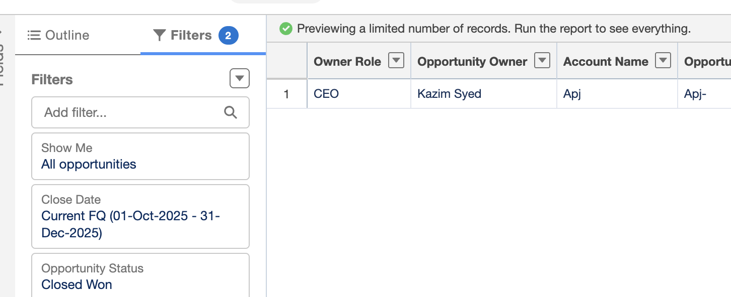 | Opportunity status is closed won.
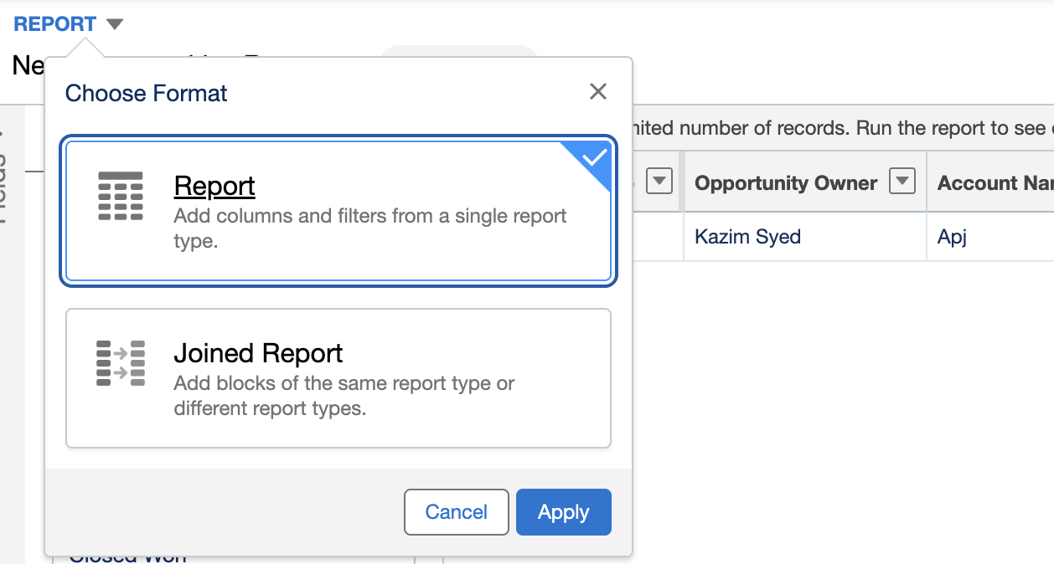
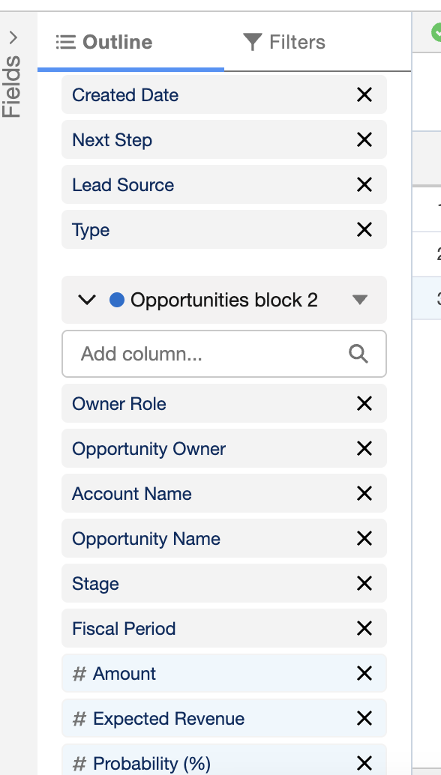 | Now we look at the outline, we see it gives the flexibility to choose whichever field we want. I thought it was gonna be same table.  Its because cause its side by side.

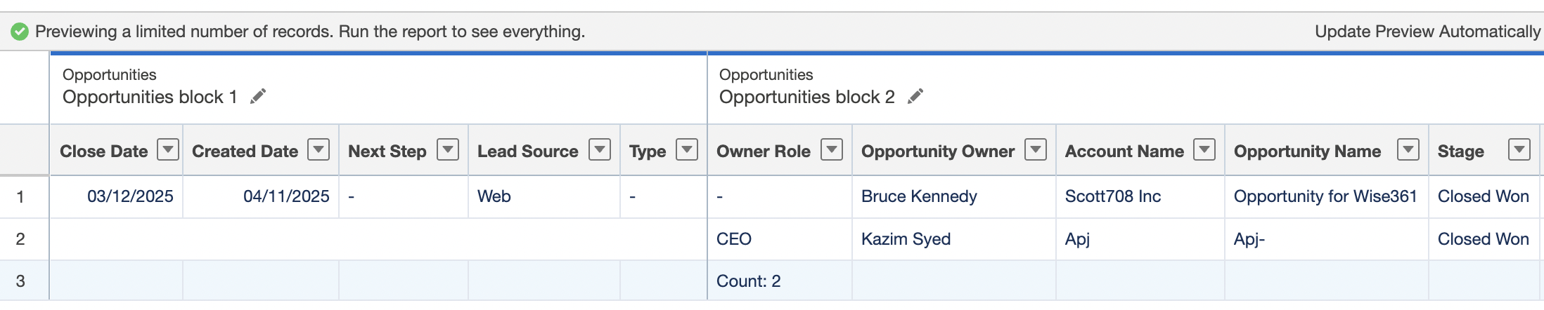
Mike did current quarter, previous quarter, and entire fiscal year.

Creating a history report
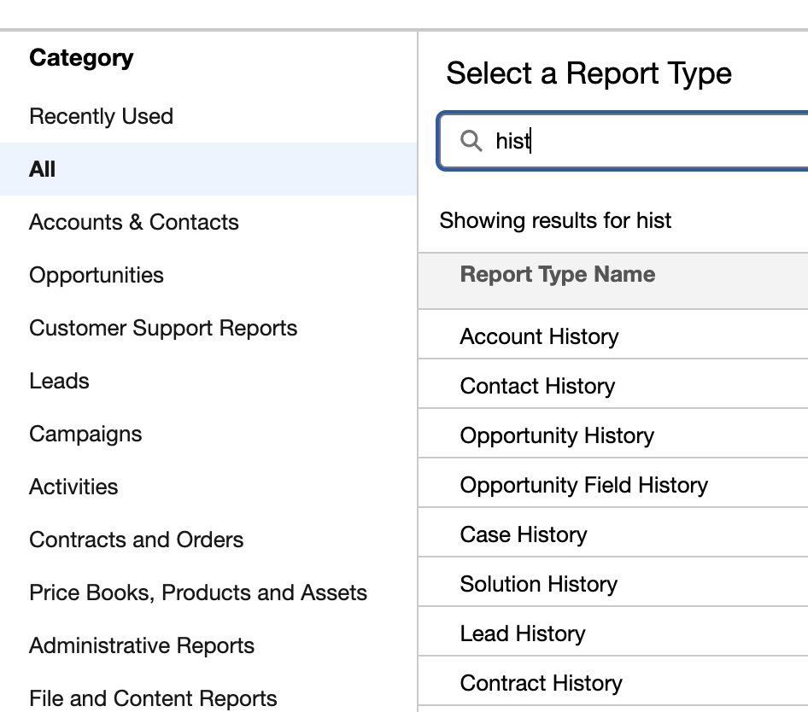 | New report → All → search history
 | He select opp history
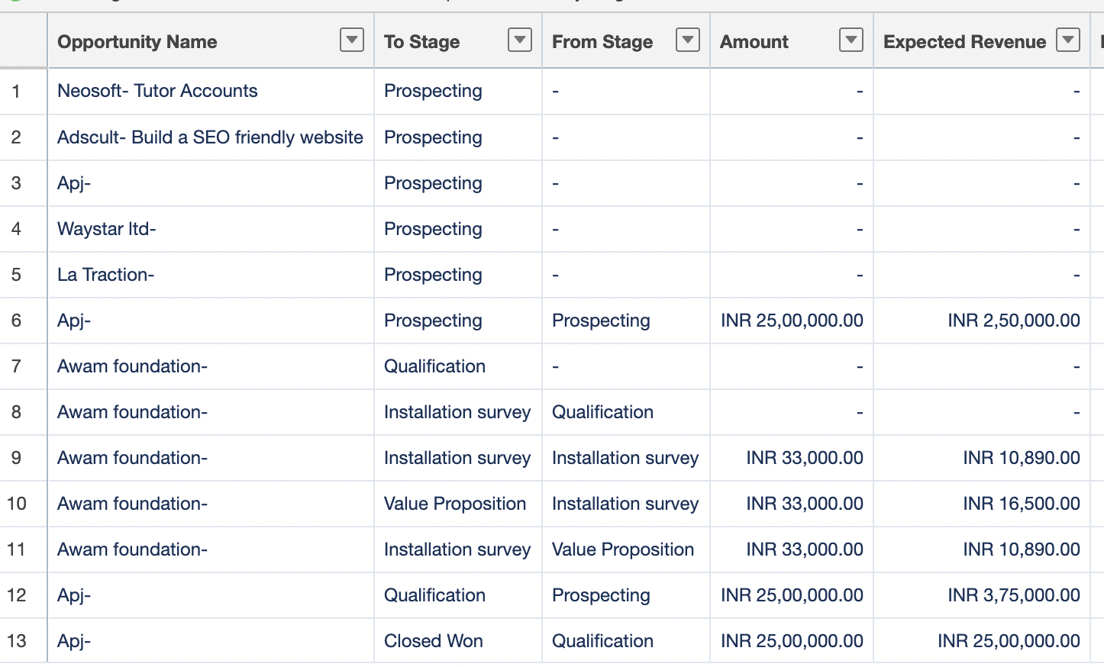 | We can see I changed apj from Qualification to Closed won.  U can see I change the stages from prospecting to qualification and exp revenue changed with the probability.
Diagnose changes using case history: | Mike perform the following actions: create a new open cases history. He select a single case using filter and then view when it was created, the record type, added to queue and similar.

Subscribing to reports
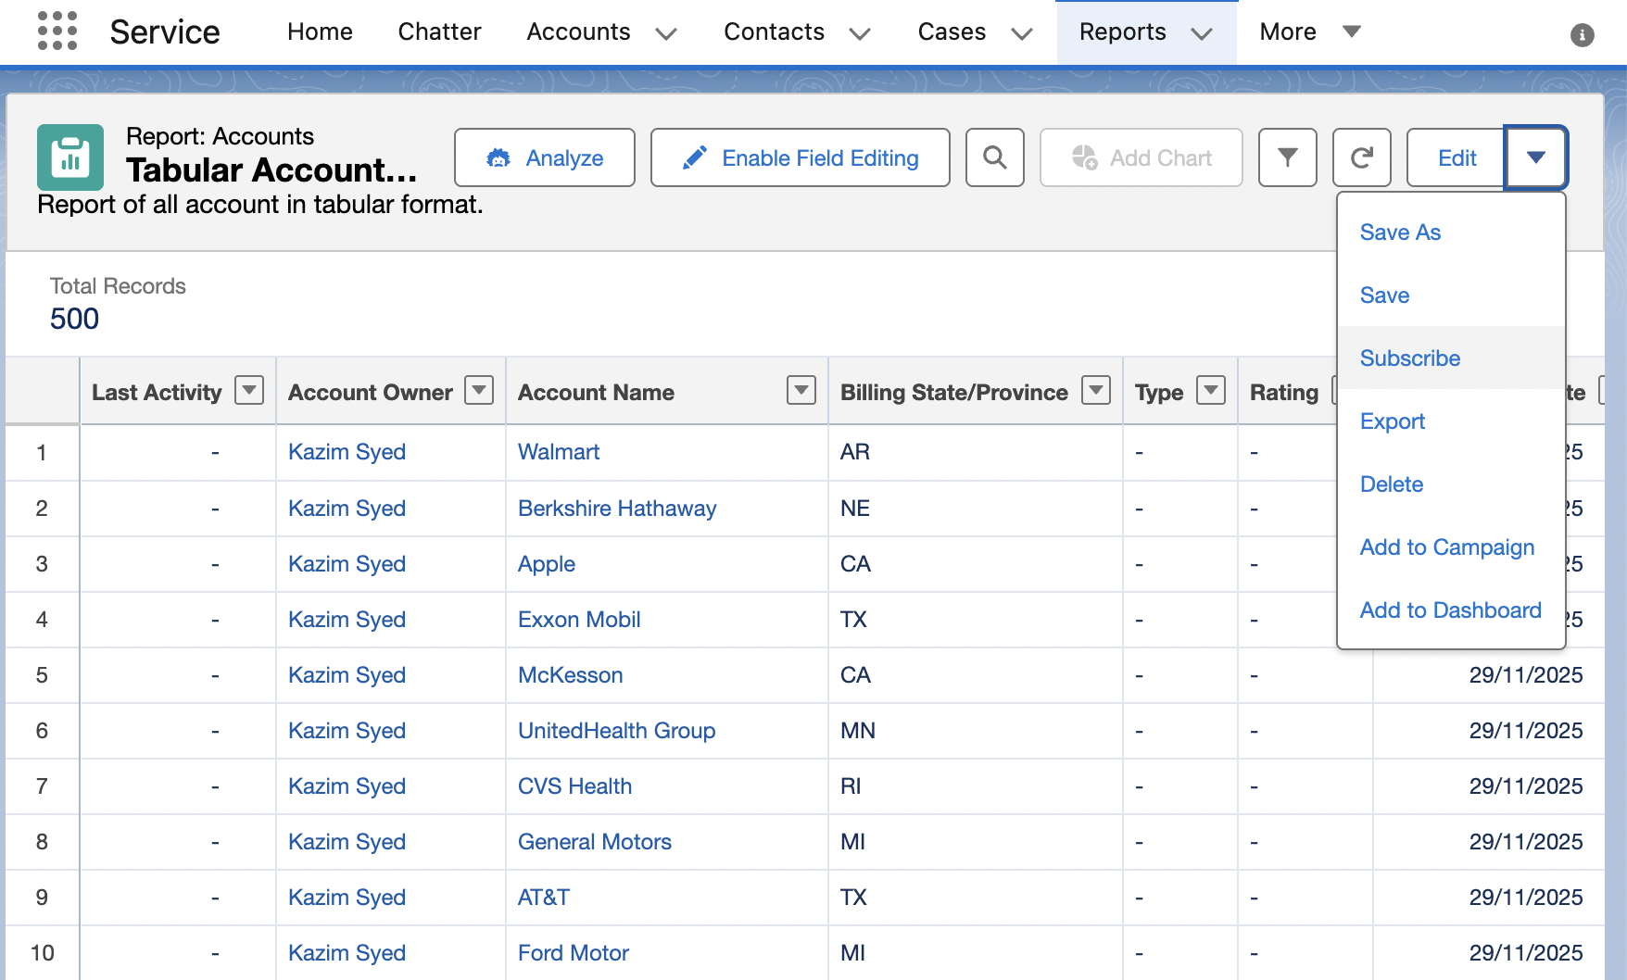 | You can select how frequent u want to receive the report, u can subscribe to it.
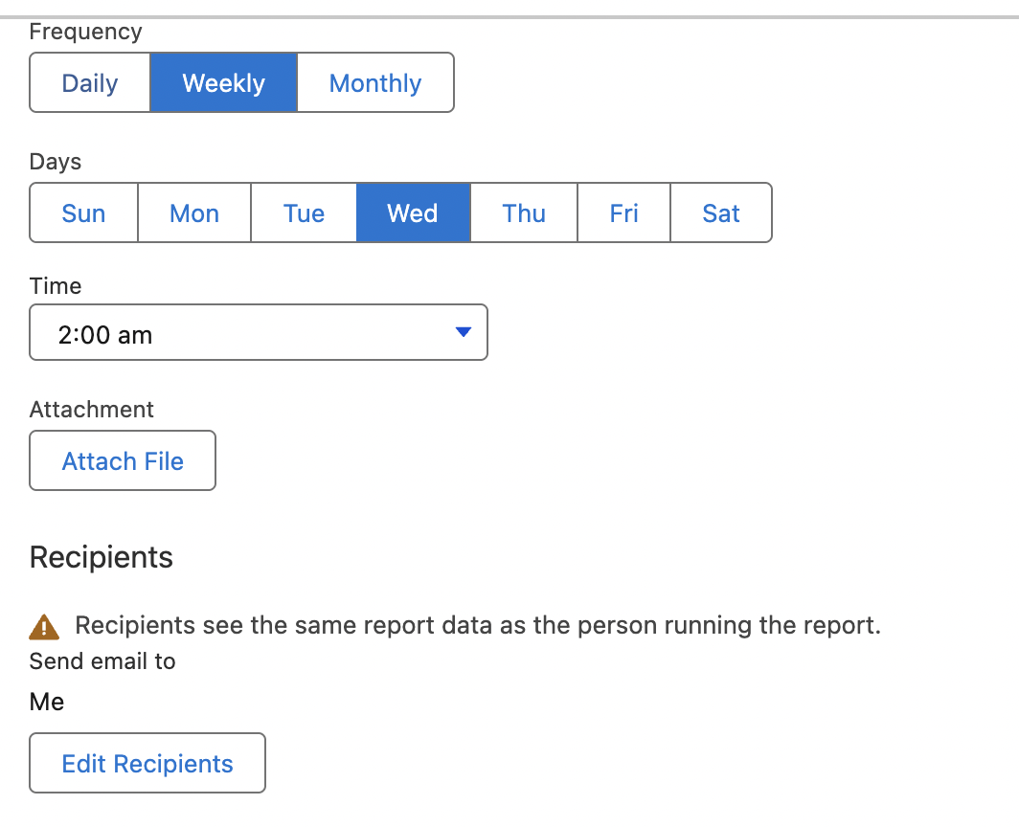 | You can add recipient based on user or roles, roles & sub, public group.
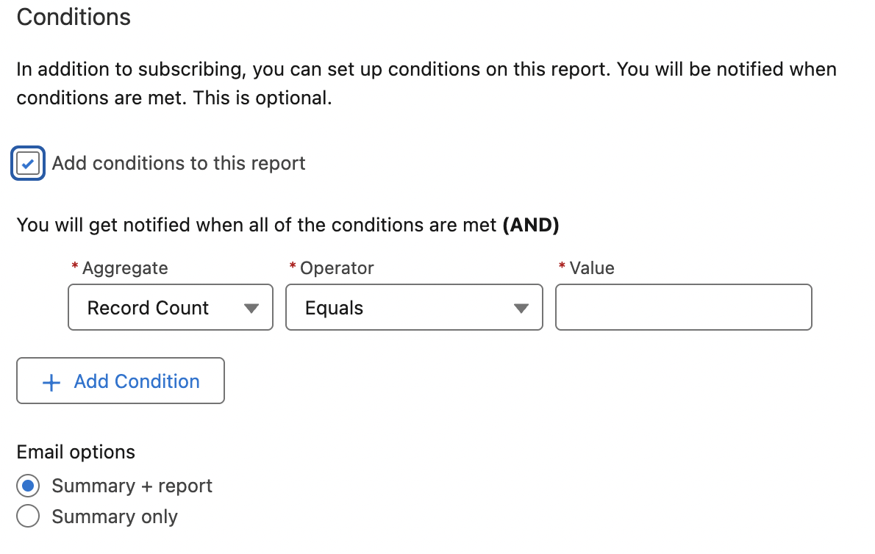 | You can also set conditions.  If there are inordinate no of cases, we can be alerted using conditions.  You can later unsubscribe or remove others from reciepient.

Creating Dashboard
Sales → Dashboard → new
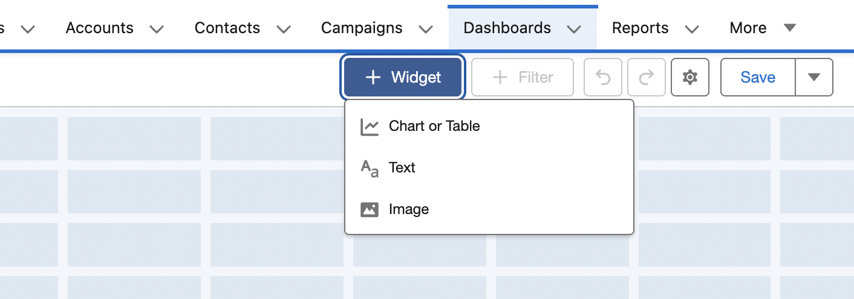
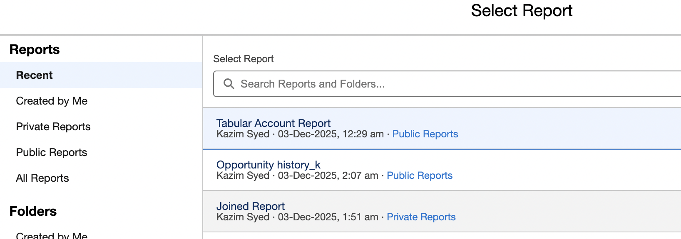 | In mike video, it said component.
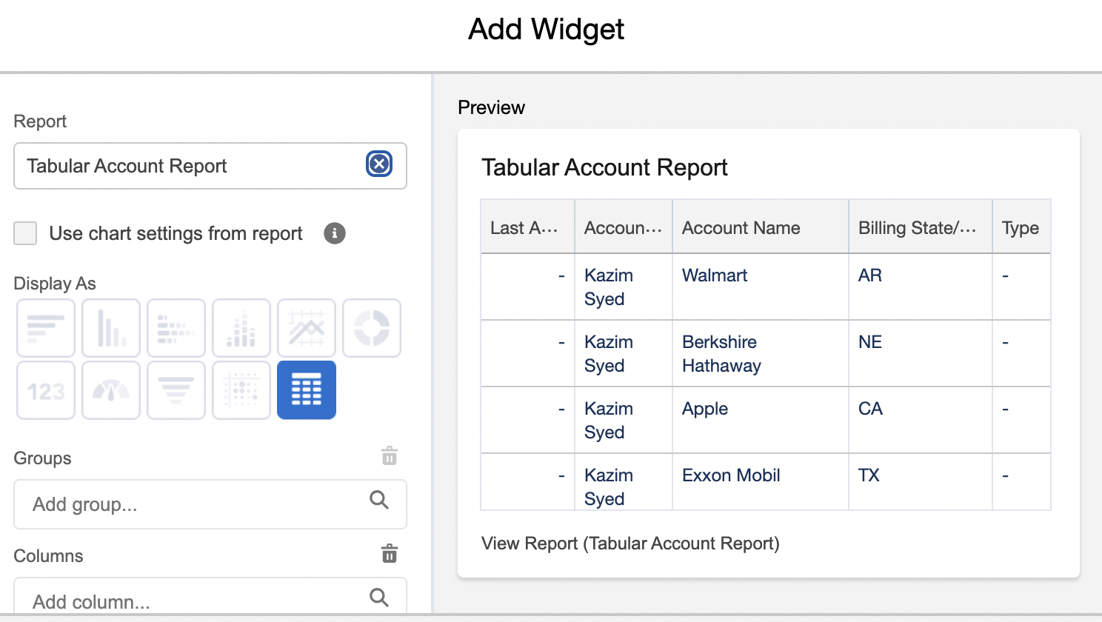 | For tabular component, only display format was table.  U can group and rearrange columns.
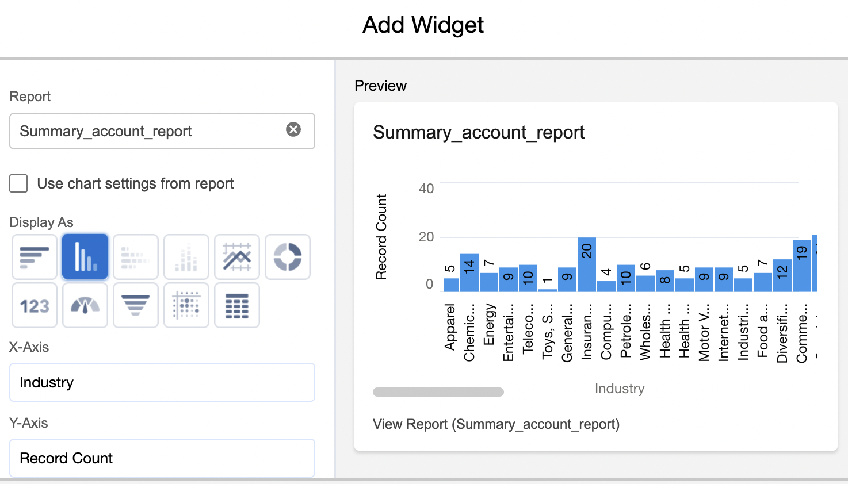 | U have multiple options.  U can set the legend like decimal precision, title, subtitle.
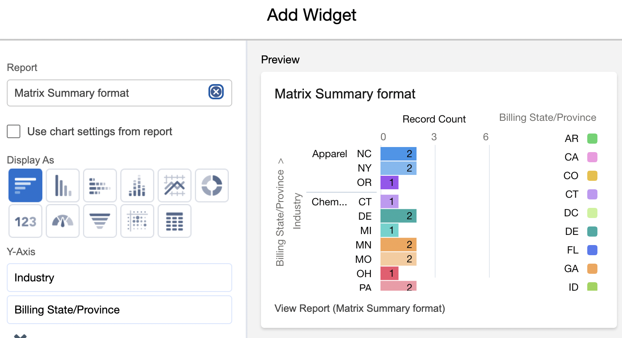 | Matrix report.

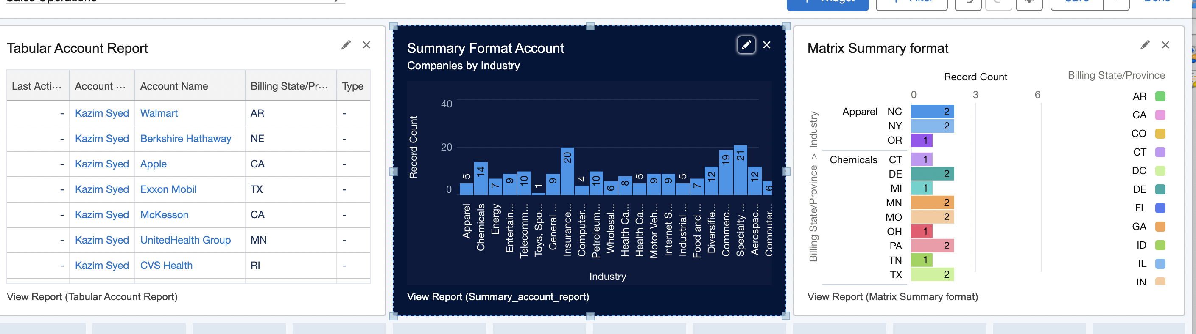
U can have hyperlink at the end of the chart to show which report the data is being derived from. Things like least # of logins.

Dashboard Filters
 | You can add filters to the dashboard and this way, u can toggle between various filter sets in order to display filtered information based on ur settings or filters that you specify.
On dashboard → edit(click) → filters | 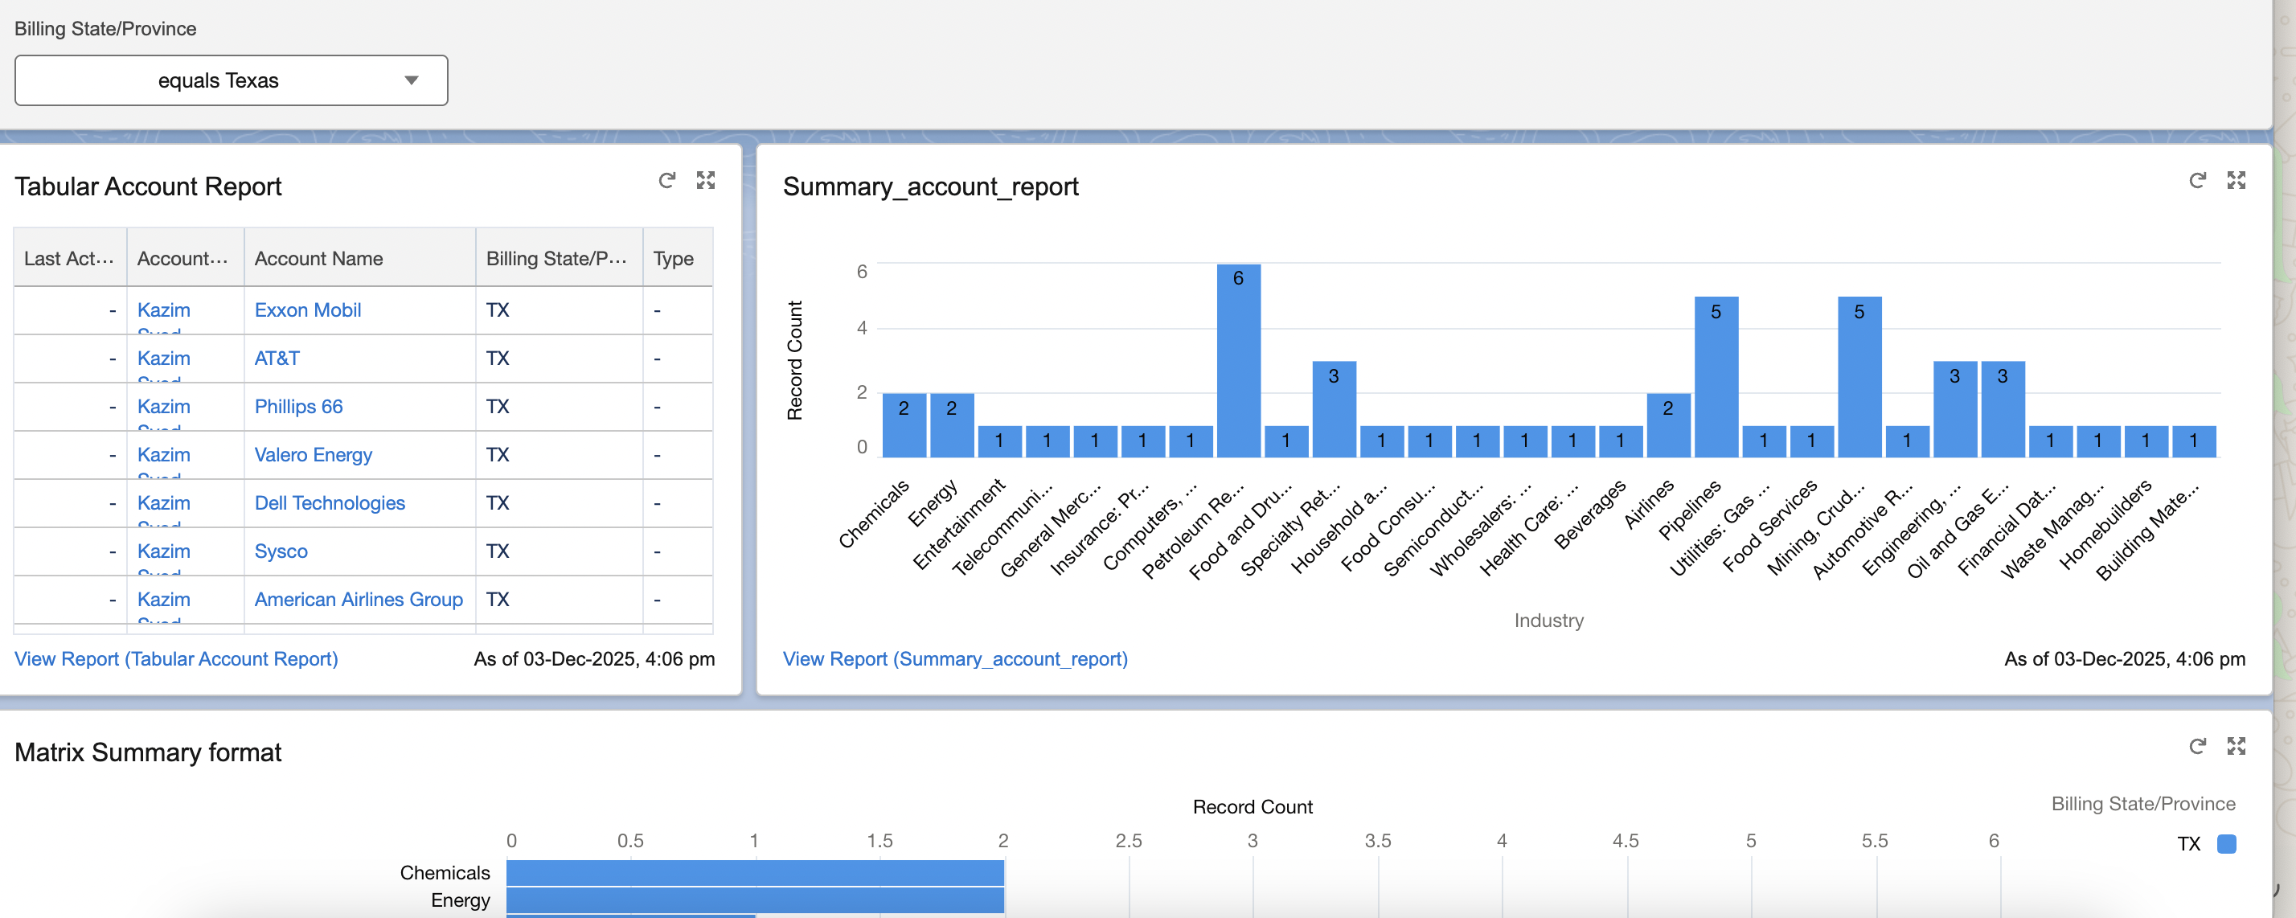
I used billing state, mike used record type.

Dynamic dashboards and Running user
 | U can change the designation as to which person u r viewing the dashboard as.
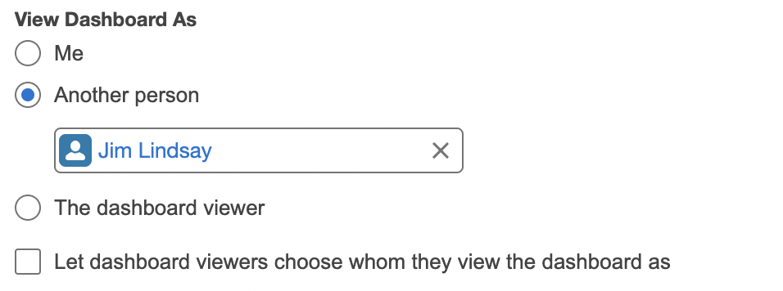 | Click the gear icon on dashboard  4 options.
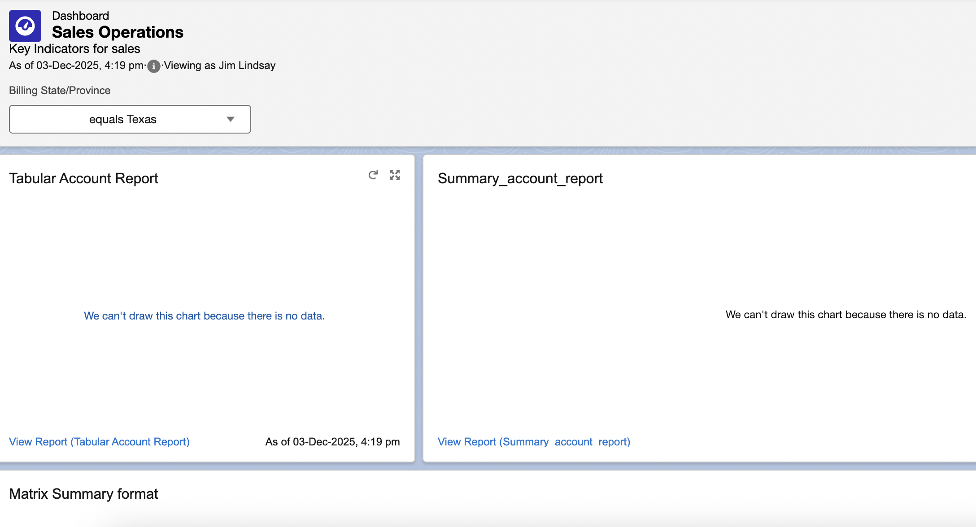 | I view the records as Jim lindsay
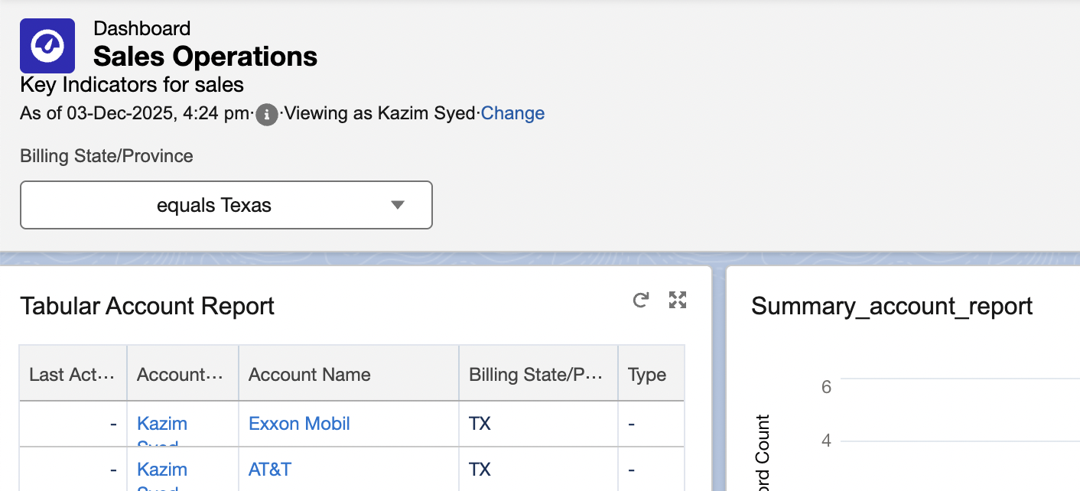 | Mike selected the 4th option

Helping chatgpt prompts for reports and dashboards.

Pending refer to prompt library

