ProMathAI Question Bank Audit
Findings report · Kazim Tuluk · July 2026 · Data source: production PostgreSQL (Neon), read-only analysis
Context and method
ProMathAI is a live exam-preparation platform for Grade 8 mathematics. This audit examined the production question bank (1,247 items) across its curriculum hierarchy (topics, subtopics, acquisitions) and difficulty levels using SQL, then cross-referenced the distribution against the national exam (LGS) blueprint built from the 2018-2025 papers, excluding 2020 and 2023 because both exams covered a reduced, first-semester-only curriculum. AI question-generation logs were analyzed to test whether adaptive generation compensates for coverage gaps. All queries ran against the database's information schema and content tables; no student personal data was used.
Findings register
ID | Finding | Severity | Action
F1 | Documentation drift: bank size documented as 1,252; actual count is 1,247. | Low | Documentation updated; durable phrasing (1,200+) adopted.
F2 | One invalid difficulty reference: question UC_044 points to a non-existent level_id (22). Root cause: no foreign-key constraint on questions.level_id. | Medium | Reviewed the question and assigned the correct difficulty level.
F3 | Easy-tier scarcity in four topics (Veri Analizi 6, Eşitsizlikler 8, Eşlik ve Benzerlik 8, Cebirsel İfadeler 9 easy items). The reinforcement flow serves struggling students, who need easy items by definition. | High | Author easy-level items for the four topics.
F4 | Three acquisitions have zero questions: Öteleme, Yansıma, Piramit. The exam tests transformation geometry in every normal year. | High | Author new item sets; see F7 for why the gap cannot self-heal.
F5 | Bank distribution diverges from the exam blueprint: Çarpanlar ve Katlar is +97 items over its expected share, while Doğrusal Denklemler (-64), Dönüşüm Geometrisi (-49), Eşitsizlikler (-42), and Eşlik ve Benzerlik (-38) are under. Root cause: authoring followed the teaching calendar, not the blueprint. | High | Blueprint-weighted authoring plan; ~95-item floor backlog for thin acquisitions.
F6 | Thin coverage clusters in figure-dependent acquisitions (transformations, solids, coordinate graphs). Visual production cost is the bottleneck. | Medium | Add a coverage check to the content workflow; allocate visual-authoring capacity.
F7 | AI generation is reactive: each generated item requires a seed question (original_question_id), so generation amplifies coverage where the bank is already strong. Empirically, 0 of 107 generated items fall in the three zero-coverage acquisitions. | High | Either support seedless generation for empty acquisitions or prioritize manual authoring; monitor AI item quality via the existing feedback votes.
+ | Positive finding: referential integrity is otherwise clean. Zero orphaned acquisition or subtopic references and zero duplicate question labels across 1,247 items. | Info | Documented as baseline.
Evidence
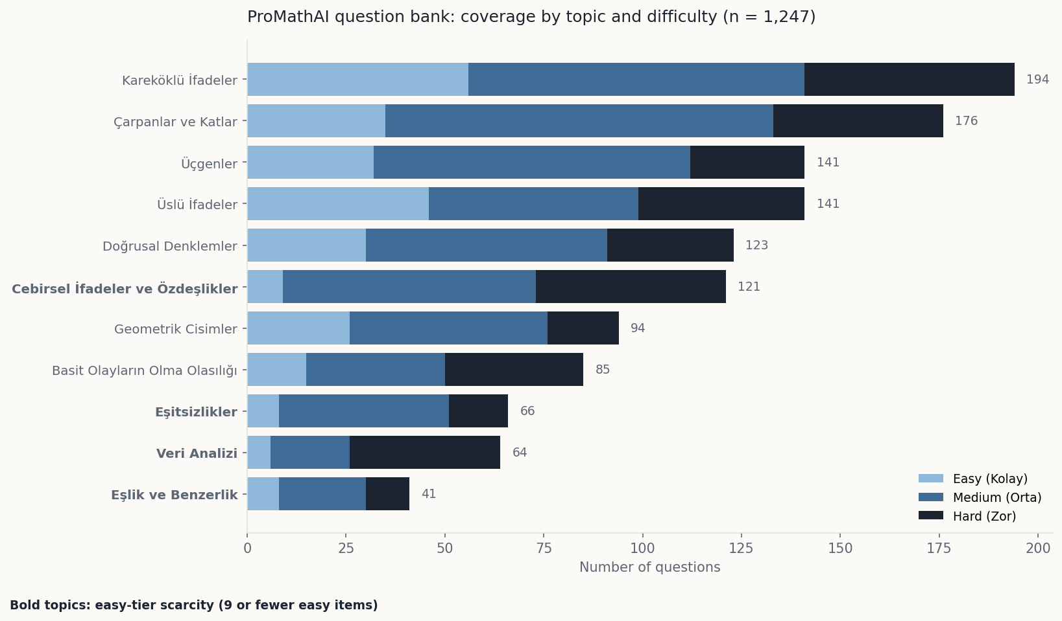
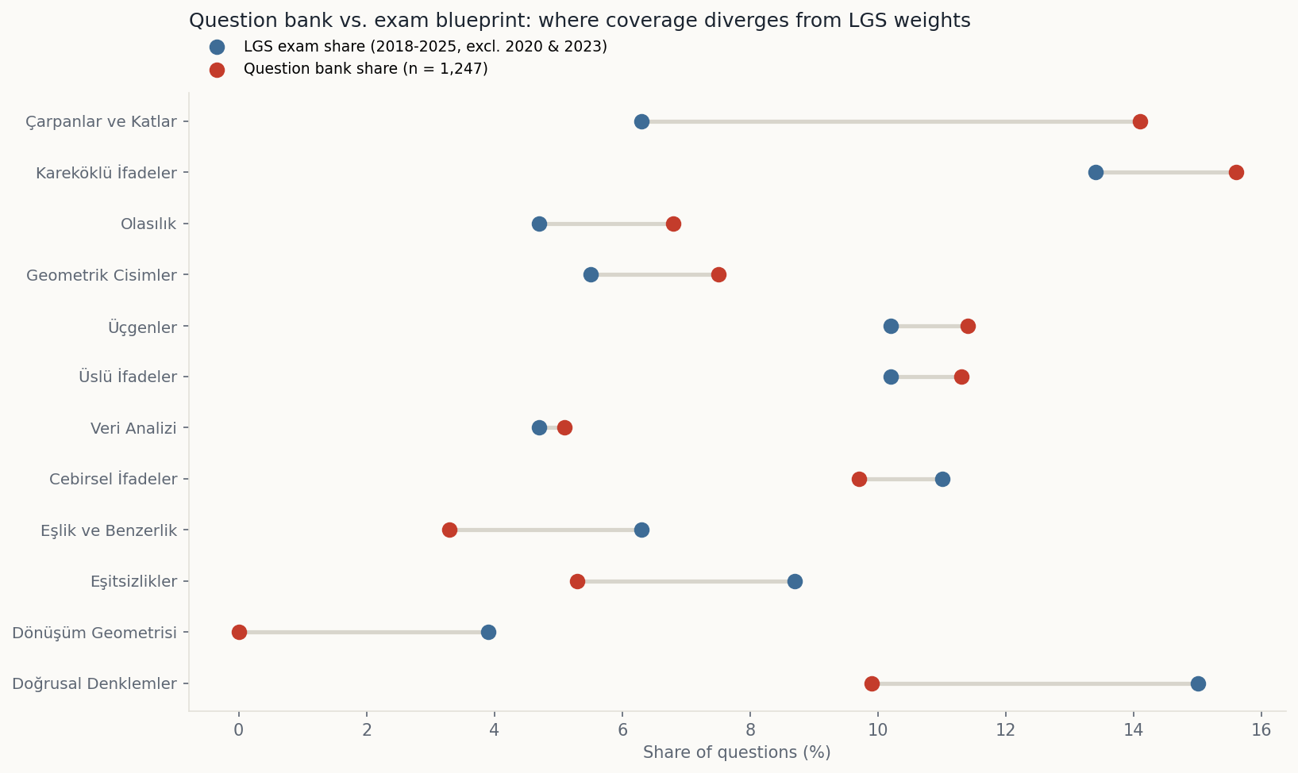
Recommendations
1. Adopt a blueprint-weighted authoring plan: rebalance new item production toward Doğrusal Denklemler, Dönüşüm Geometrisi, Eşitsizlikler, and Eşlik ve Benzerlik, with a minimum floor per acquisition (proposed: 15 items, ~95-item backlog).
2. Add foreign-key constraints to the questions table so invalid references cannot recur (prevention, not just correction).
3. Insert a coverage check into the content production workflow, mirroring the two-stage peer review already used for item quality.
4. Stand up AI-item quality monitoring from the existing Good/Problematic feedback votes, since generated items bypass human review.
Verified in the app (demo account): selecting a zero-coverage objective shows a designed empty-state message ("no questions available for this objective"). The platform degrades gracefully, but the content gap is user-visible. Short-term mitigation recommended: filter empty objectives out of the selector until items are authored.

