1. While opening app for the first time it gives a blank UI.
2. Project owner’s account/ Designer’s account>> update profile>> not functional.

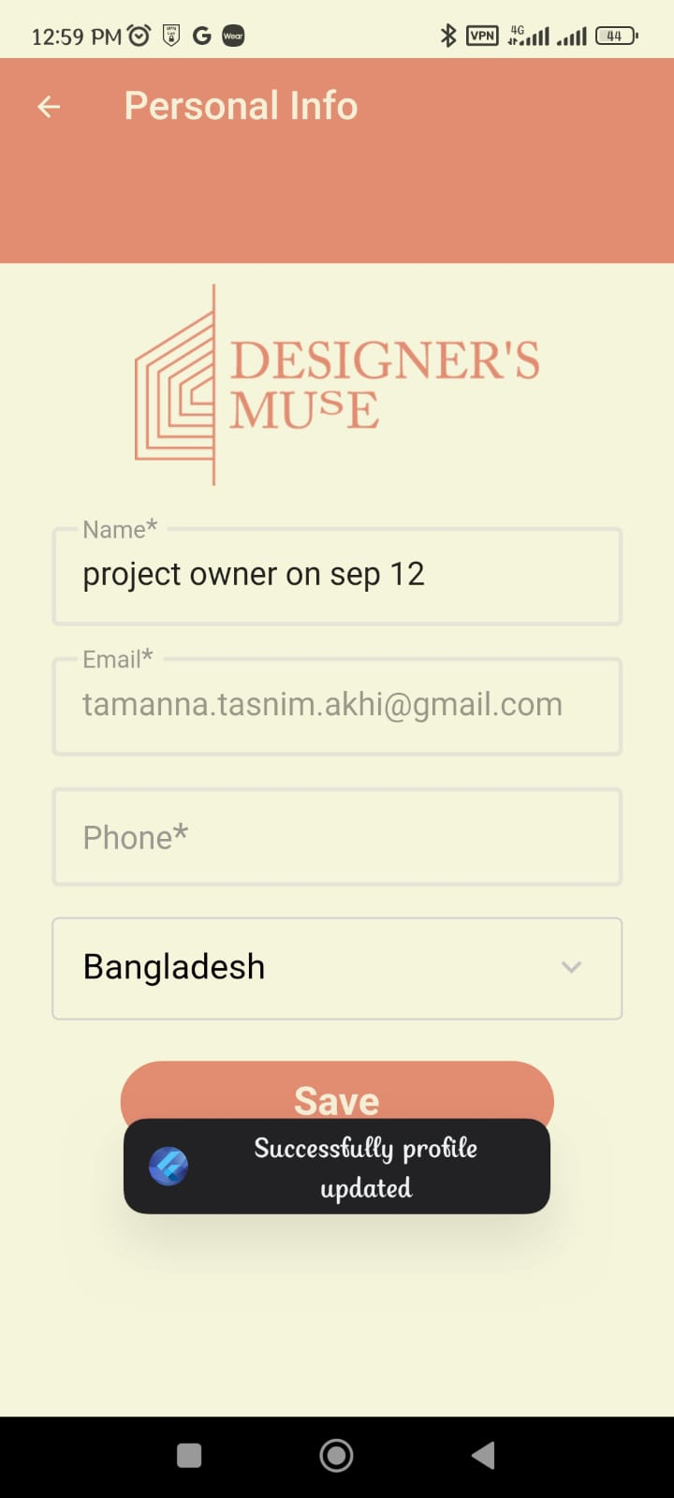

1. Project owner’s account>> AR>> not functional.

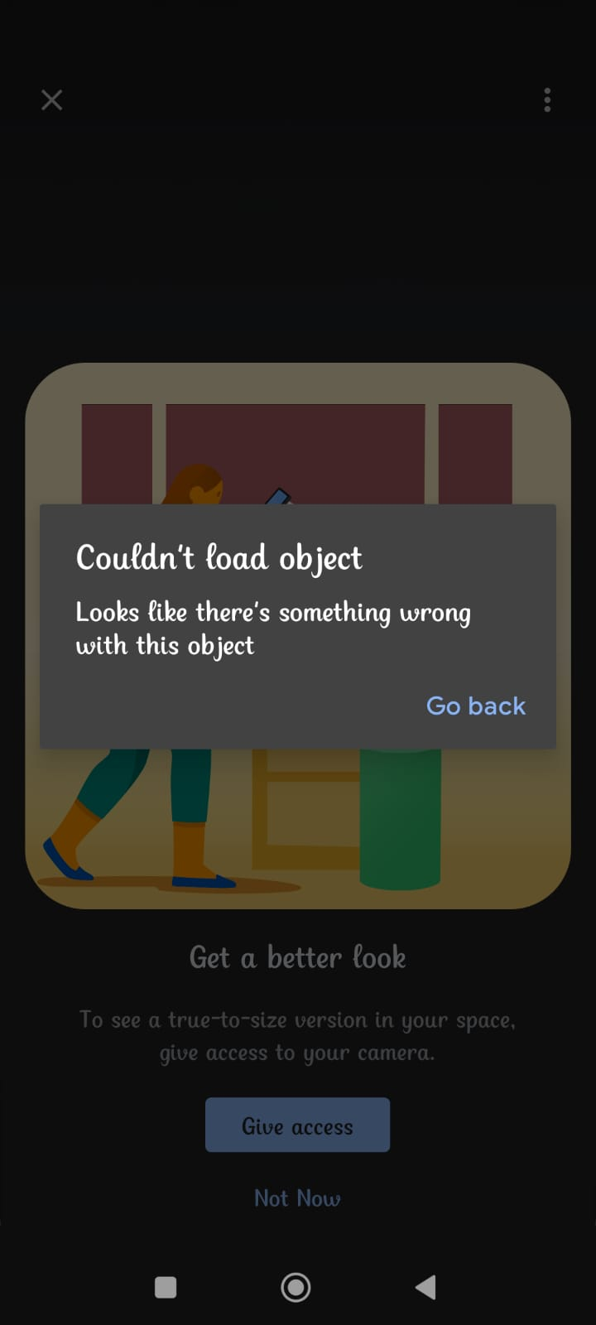

1. Project owner>> shopkeeper’s account>> product added to the cart>> checkout>> couldn’t checkout.

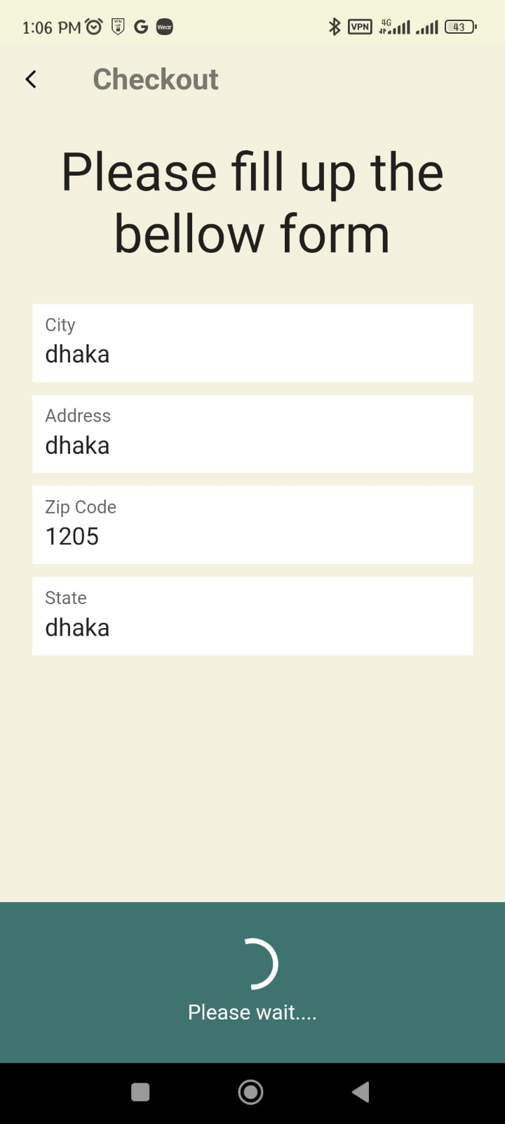

1. Following error message is showing while logging in to the admin.

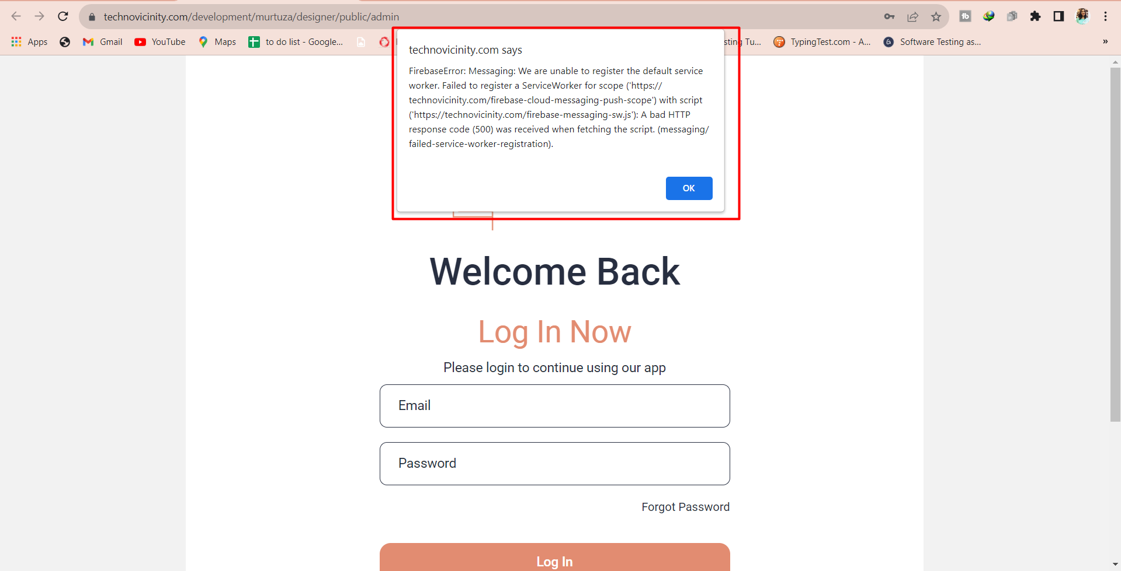

1. Admin>>user registration>>Designer Registration/ shop registration>> Action button>> Edit>> not functional.

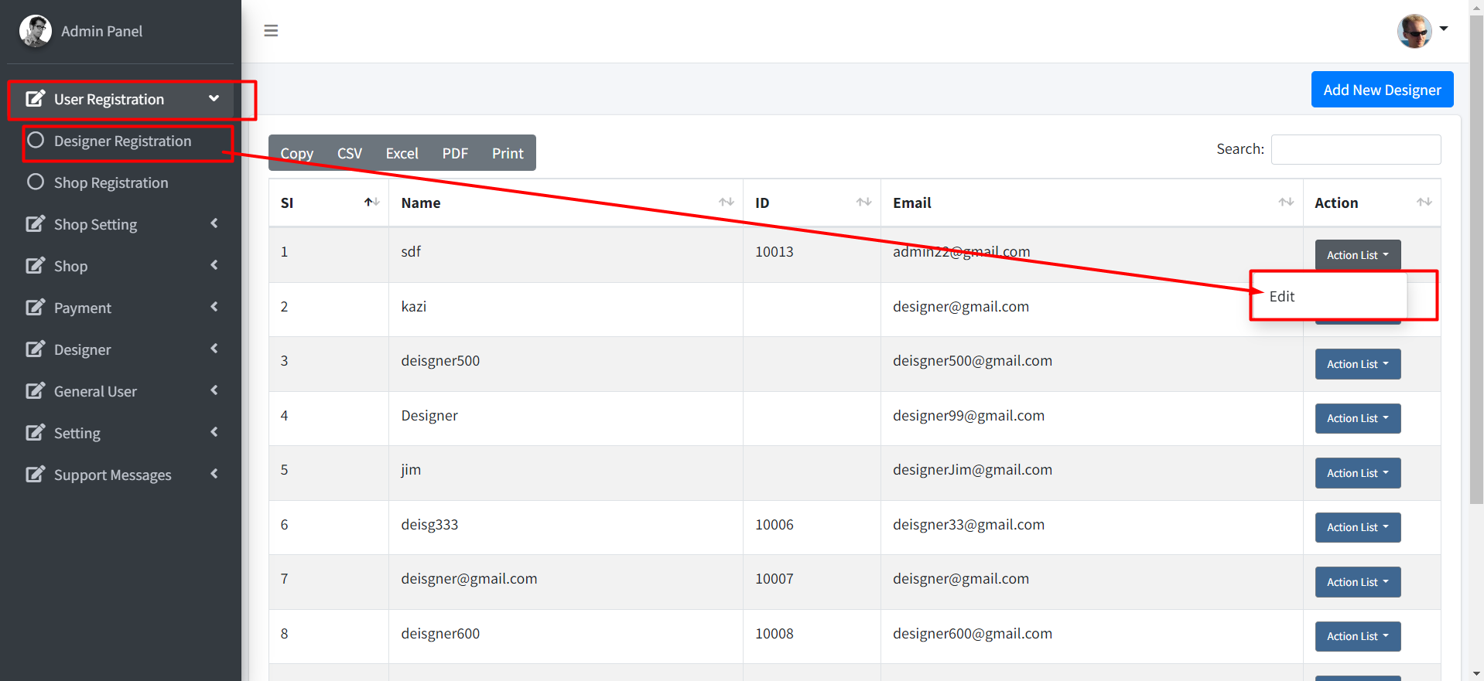

1. Admin>> withdrawal request >>gives following error.

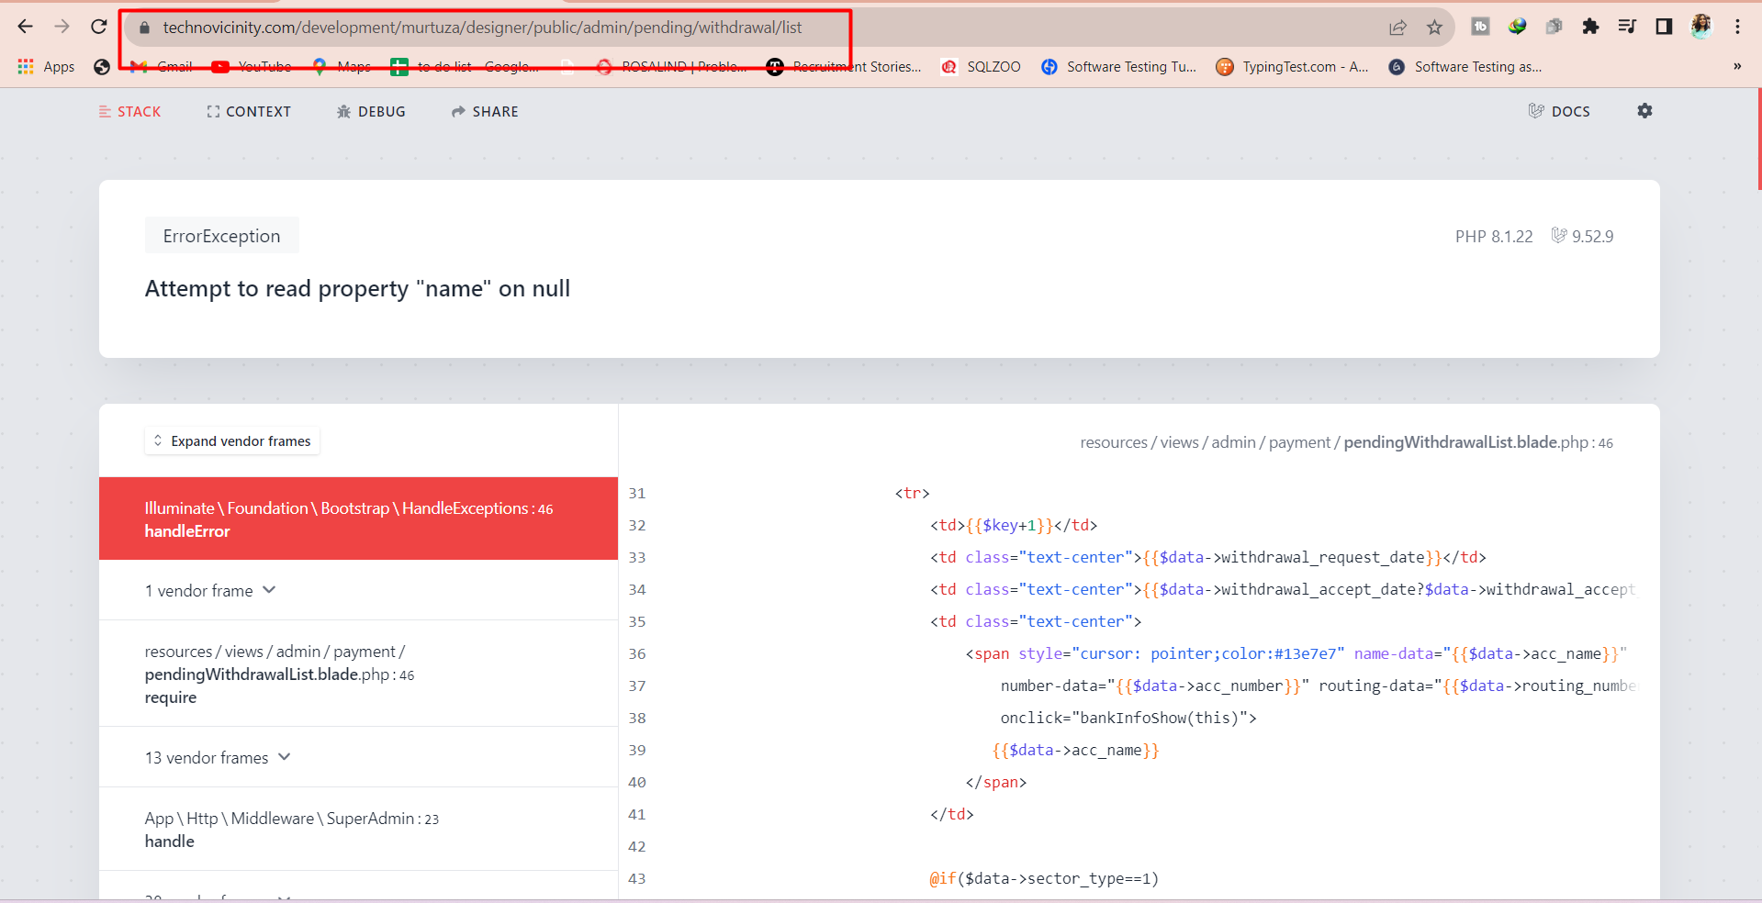

1. Design issue>> shopkeeper’s account>> Bottom menu>> “Product” and “Order” menu has dollar signs.

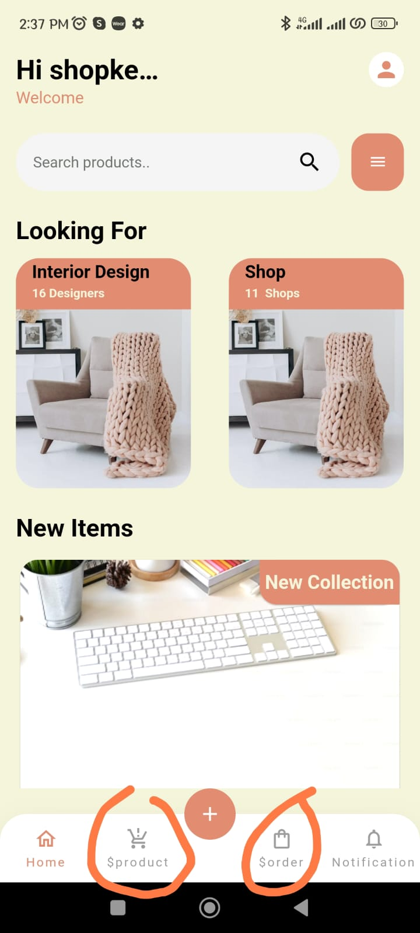

1. Verification email design issue:

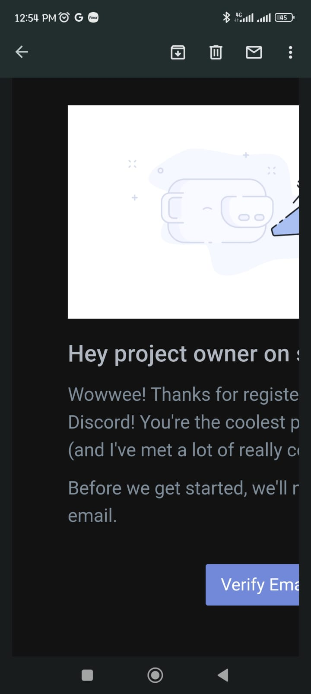

1. SandBox mode payment was successful while booking appointment of a designer.

