1. Shop account>> Balance>> Select bank>>not functional.
2. Shop account>> profile update>>failed.

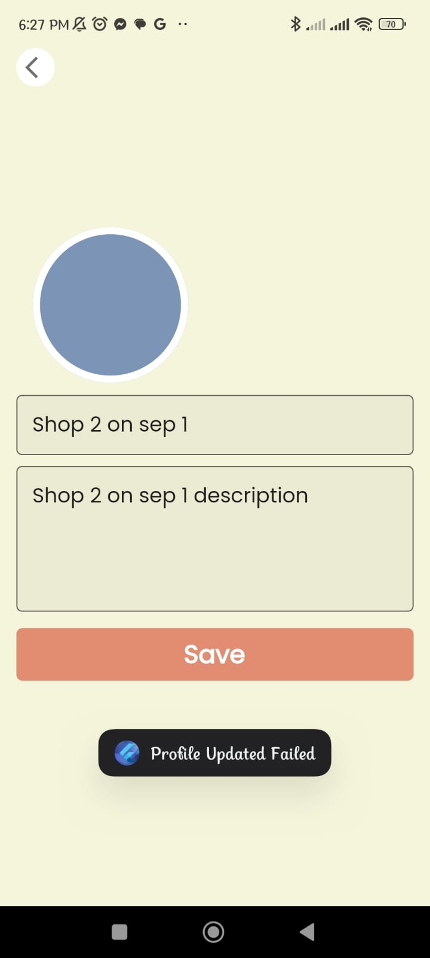

1. Newly created shop account is not visible from project account immediately (cleared cache but still not visible).
2. Project owner’s account>>checkout from the cart>>payment gateway gives following error.

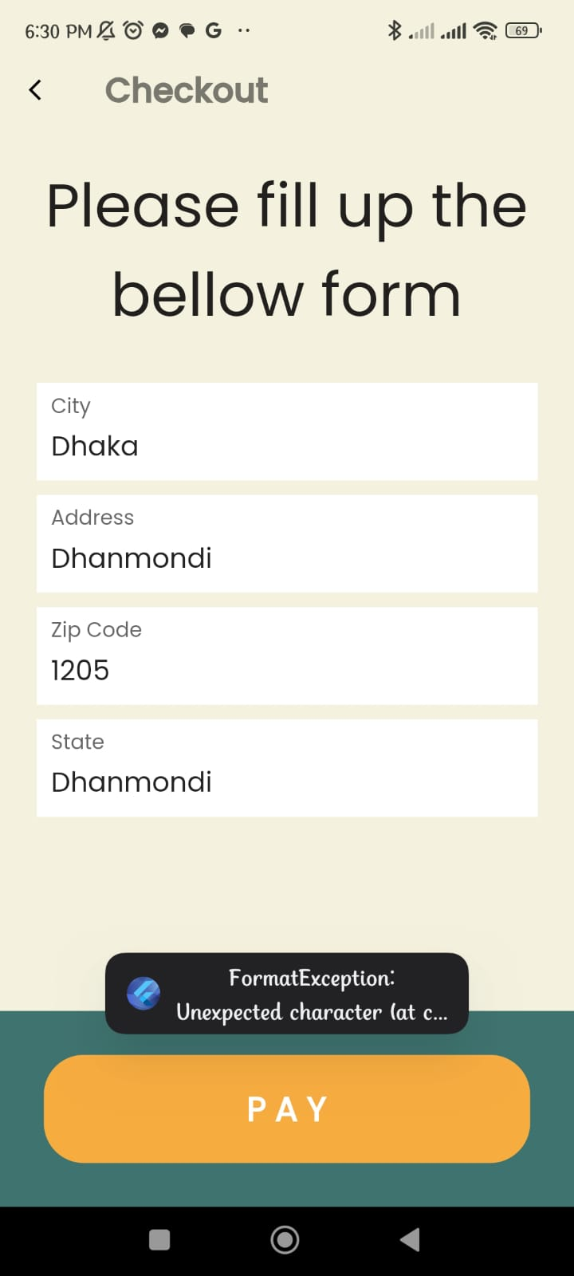

1. Project owner’s account>>booking appointment of a designer>>confirm pay button>> gives following error.

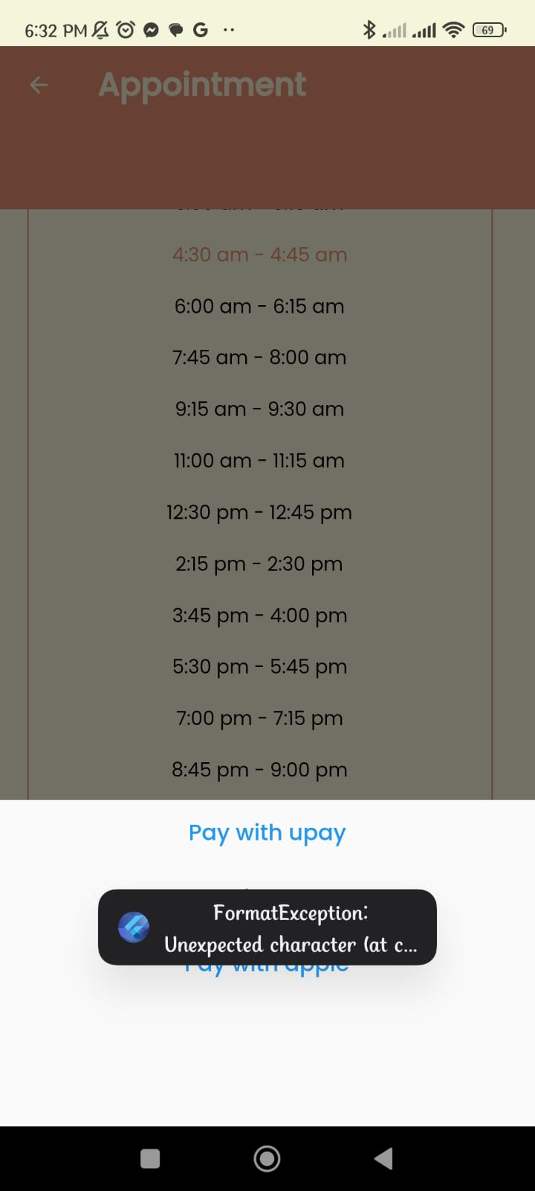

1. Project owner’s account>>My AR>>not option to get to the next phase.

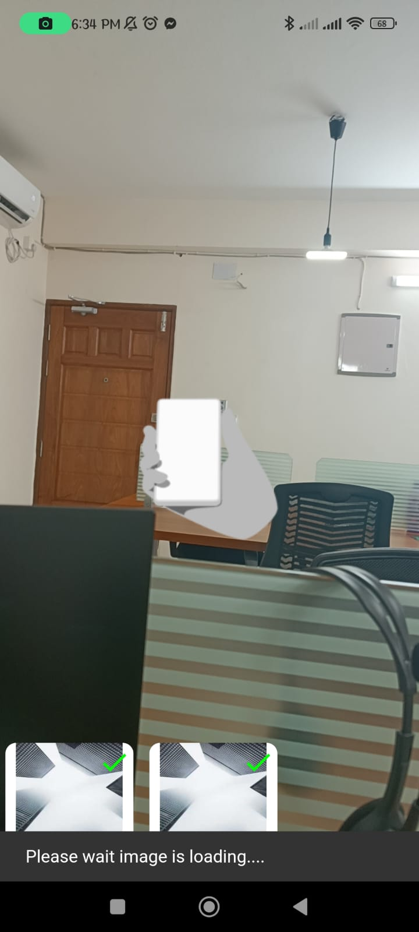

1. Web issue: Admin panel>> designer menu button>> marked buttons gives exception error.

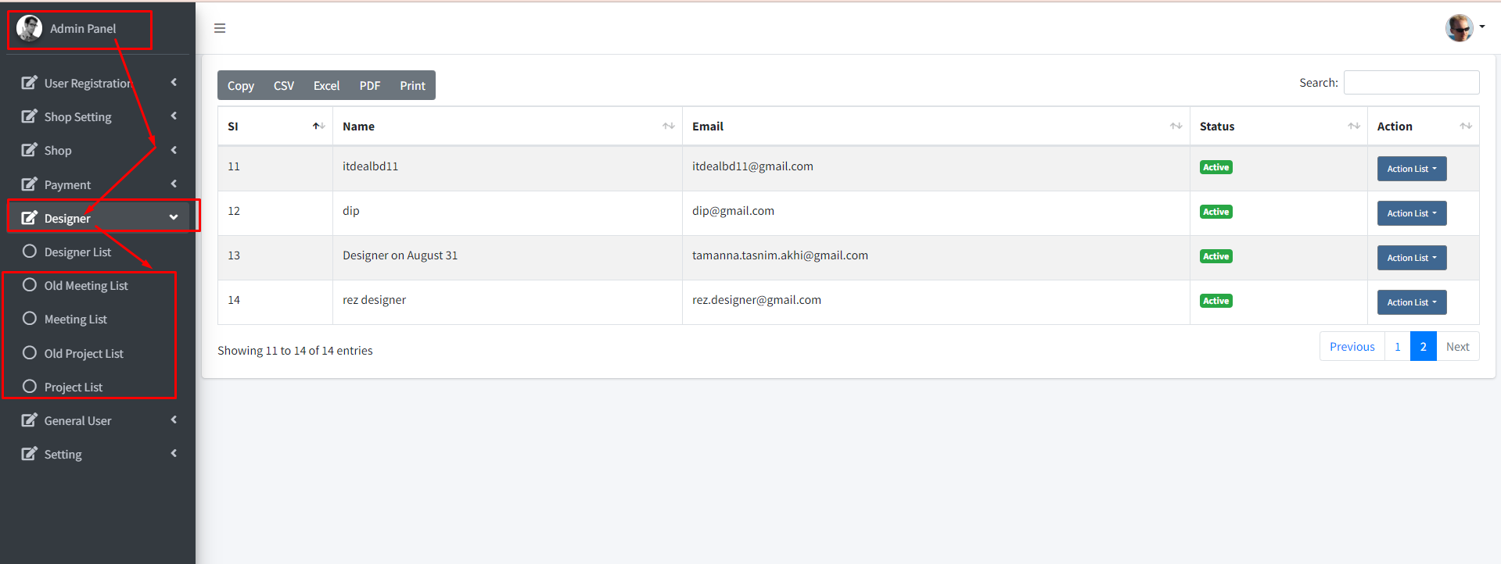

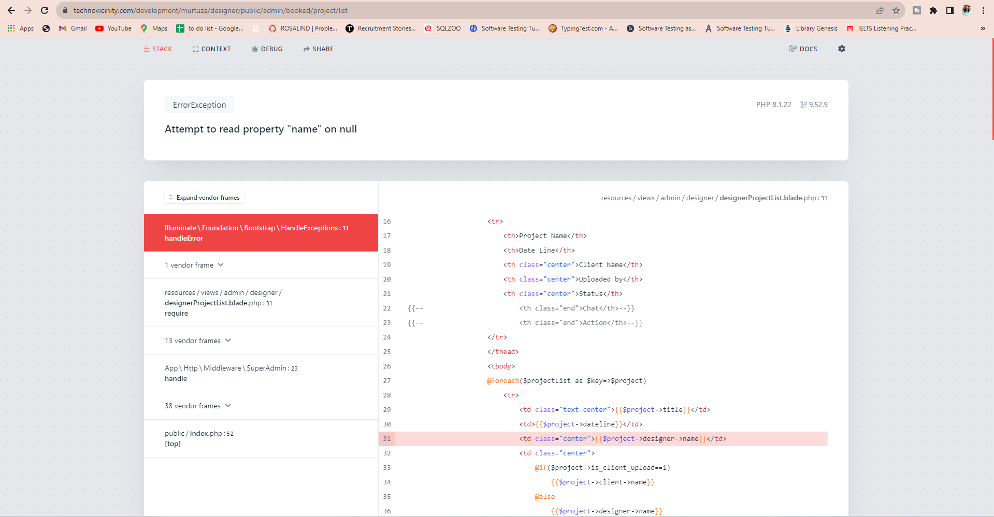

1. While creating an account from web admin panel, there are no password length constraints. But app has minimum length of 6 characters.