XYZ Automation design issue

1. Customer account>> profile >> Account information does not show properly

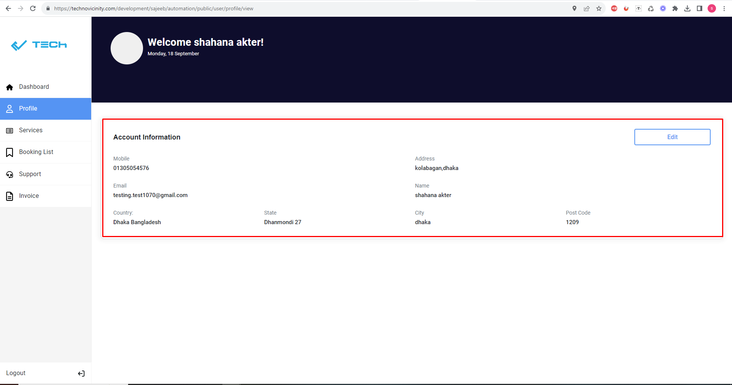

2. Company account>> profile >> Account information does not show properly

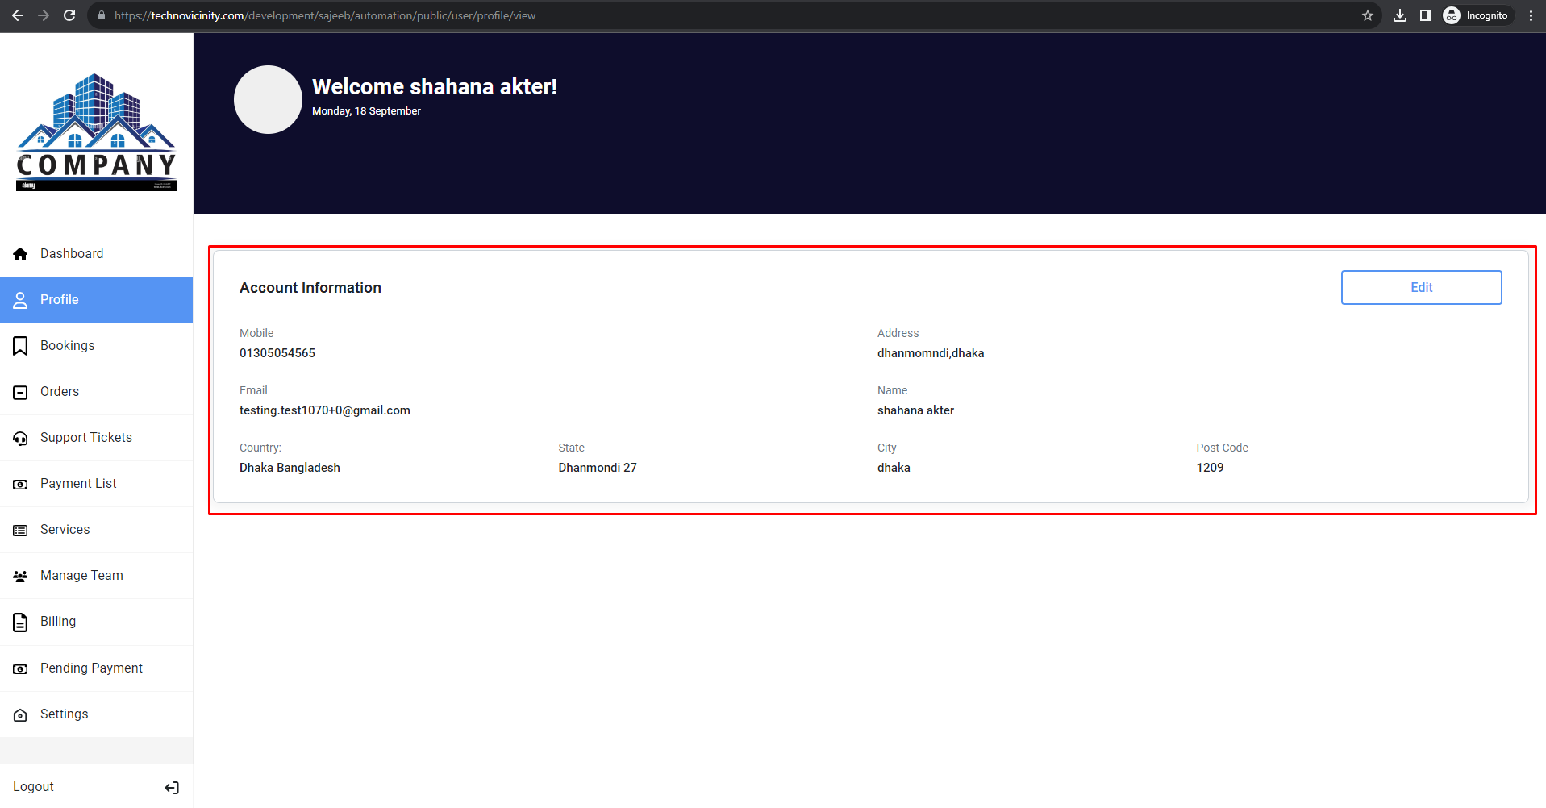

3. superadmin account>> profile >> Account information does not show properly

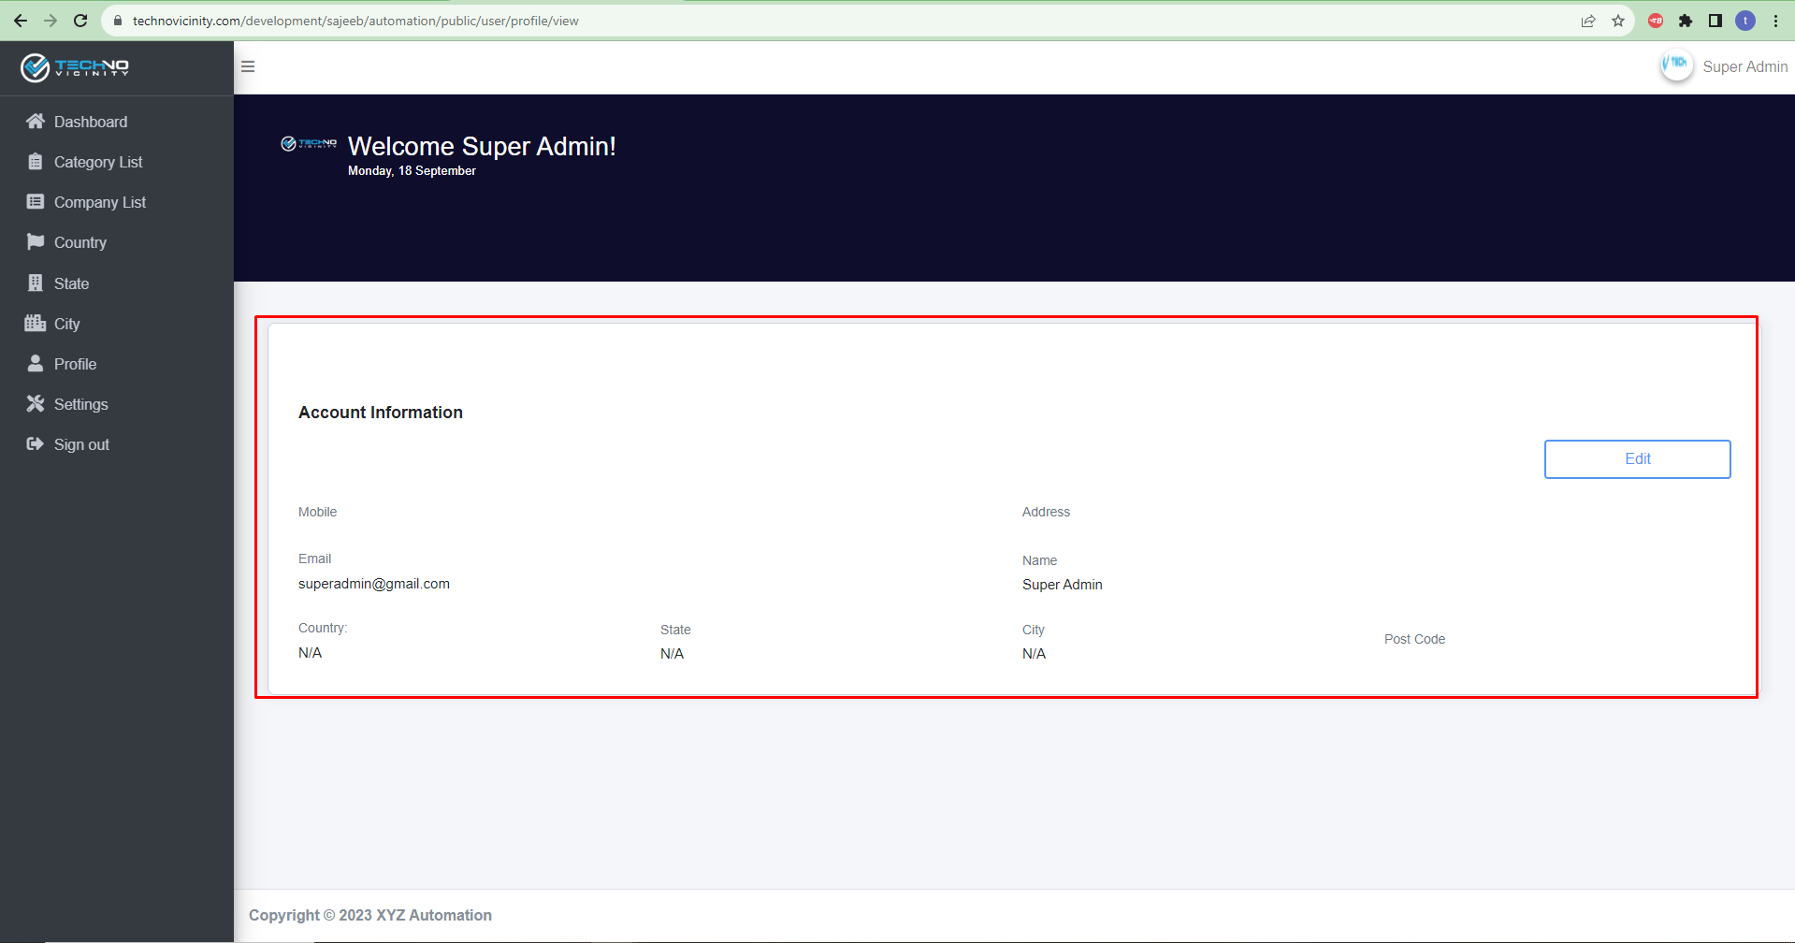

4. teamleader account>> profile >> Account information does not show properly

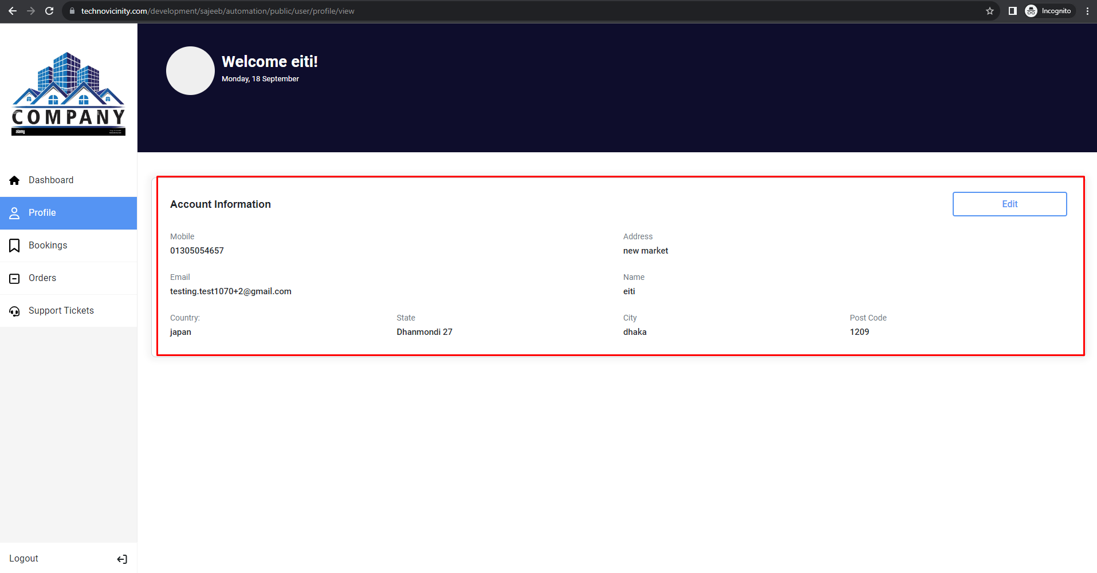

5. teammember account>> profile >> Account information does not show properly



6.customer>> services>>services design mismatch

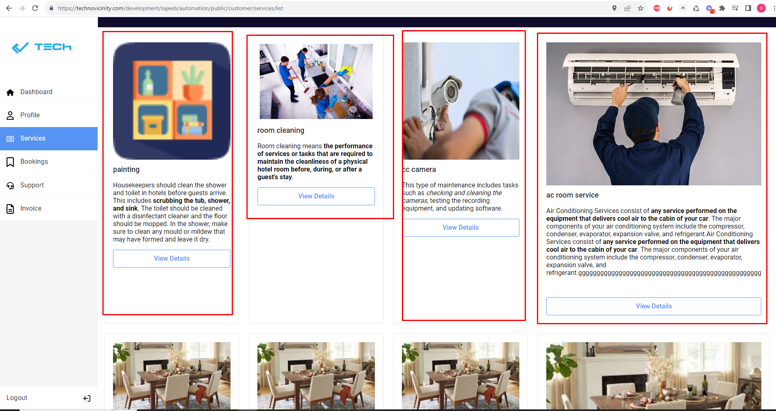

7. company>>booking>> here is the two column booking list //company account//team member account//team leader account

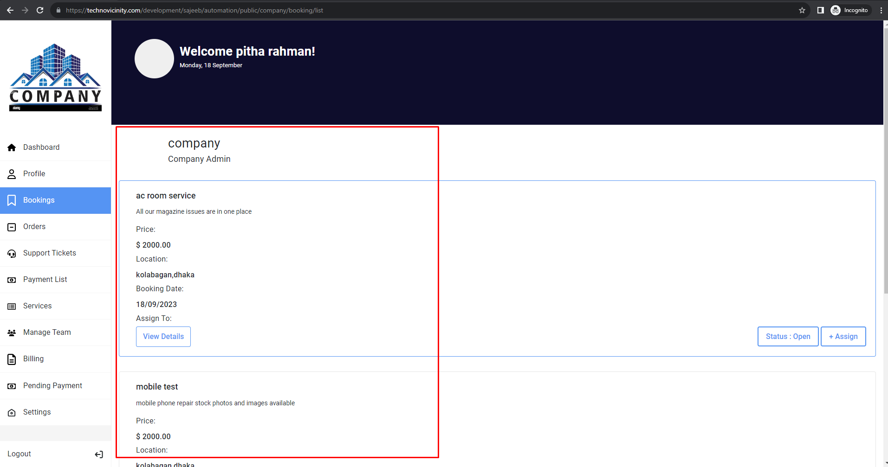

8.company>>services>>image size mismatch

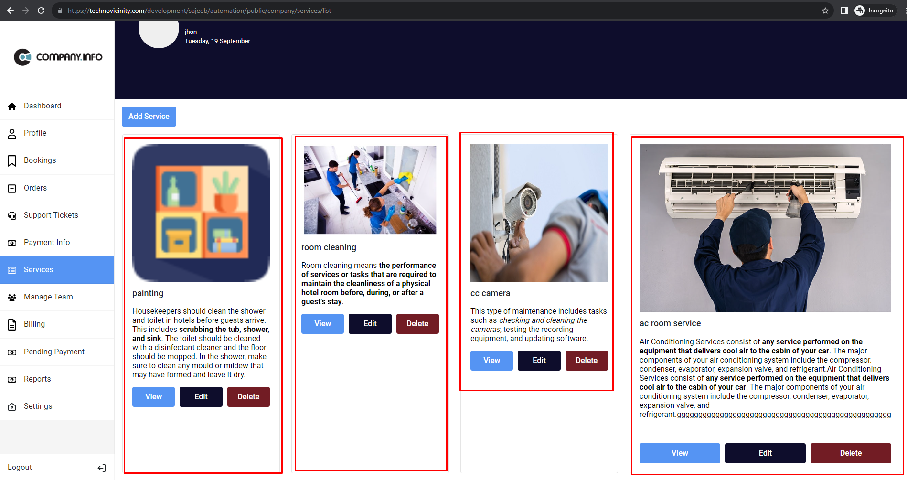

9.”firefox” all account design change.

