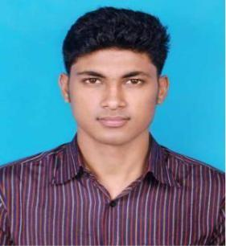
MD. RAFIUR RAHMAN RIYAD
Address: Road no- 2, Shyamoli, Dhaka.
Contact No: +8801677818813
Email: rafiurrr@gmail.com
LinkedIn: linkedin.com/in/Rafiur-riyad-615754186

Github: github.com/RafiurRiyad

EDUCATIONAL QUALIFICATION:

 | Path |  | Institution Name | Major | Result
 | BSc |  | Chittagong University of Engineering and Technology | CSE | 3.05(approx)
 | HSC |  | Birshrestho Nur Mohammad Public College, Dhaka | Science | 5.00
 | SSC |  | Dhanmondi Govt. Boys’ High School, Dhaka. | Science | 5.00
 | WORK EXPERIENCE:
 | Software Engineer Intern at SSD-Tech
• |  | Learned a few basic technologies JavaScript, Laravel, PHP and created small projects.

  - Using MVC (Model, View, Controller) knowledge performed CRUD (Create, Replace, Update, Delete) operations as well as created API(Application Programming Interface)
- to understand the back-end, front-end, database relationship precisely.

  - Through this entire three months journey I developed my technical skills along with the experience of working in a professional environment where I worked in teams as well as under some expert supervisors what taught me the team advantages.

PROJECTS:

 | Name | Technologies
 | Demo E-Comemrce website | HTML, CSS, Mysql, PHP, Laravel
 | Tour and Travels website | HTML, CSS, Mysql, PHP
 | The Best Classifier in | Python, Machine Learning
 | Coursera Capstone Project
 | TECHNICAL SKILL:

- Basic skill on C, C++, Python, Laravel, PHP, Javascript, SQL, HTML, CSS.

ACCOMPLISHMENTS:

- Joint General Secretary, CUET Computer Club.
- General Secretary, CUET Debating Society.
- Co-convener, CUET CSE Fest 2019.
- Experience on problem solving around in different online judges.
- Participated on different onsite programming contests.

REFERENCES:
Dr. Md. Mokammel Haque | Md. Abdullah Bin Amin
Professor, | Manager, Technology
Department of CSE, CUET. | SSD-Tech
Email- mokammel@cuet.ac.bd | Email- abdullah@ssd-tech.io

