**PSU Center for Global Health Research and Innovation**

The world is now facing a deep crisis on fundamental principles of fairness and solidarity of a right-based approach to health and broader development gains which lead to a break-down in trust among stakeholders and further attribute to vulnerable communities. Building up coalitions of like-minded individuals, institutions and organisations who share a similar value system and a track record of real accomplishments over time is important to overcome these challenges. There are three shifts that are particularly of concern for the global health and welfare: increasing a damage to human societies and ever to the planet and the environment, growing inequality across countries, and finally rising complex governance.

The Sustainable Development Goals (SDGs) have given us a plan to fight these challenges. As we now approach a decade of action under SDGs, and we are in urgent to work together to ensure we leave no one left behind in all areas. Health is a particular important goal (SDG 3) to "ensure healthy lives and promote well-being for all at all ages" which emphasizes the achievement of universal health coverage (UHC) and access to quality health care (no one must be left behind). Prince of Songkla University (PSU) where has diverse faculties, research and innovation experiences, must be ready to actively engage multi-disciplinary, multi-faculty, multi-sectoral groups coming together and interacting with global partners and institutions in further translating local experiences, evidence and innovations into and contribute to addressing changing global health problems, agenda and initiatives.

The term “Global Health” in the name of the Center recognizes the globality of public health which considers the formalized and systematized process. The center will draw from many disciplinary possibilities available at PSU. At initial initiative, eight Faculties including the Faculty of Medicine, Faculty of Nursing, Faculty of Destistry, Faculty of Pharmaceutical Sciences, Faculty of Veterinary Science, Faculty of Science, Faculty of Engineering, and Faculty of Agro-Insdustry have agreed upon to build this partnership under the Center addressing health related issues, generating evidence and creating innovative approaches.

**The Mission**

The Center is initially formulated from the dream and passion to help the population in the global village we are living in by protecting vulnerable health and enhancing the welfare of people living in a country, in the region and world. The public health, social development and human security of the wider society globally will be enhanced and sustained.

**Aims of the Center**

1. To enhance the University’s own research and innovations initiatives to contribute to regional and global efforts through south-south, north-south and triangular institution and organizational collaboration in monitoring epidemiological transition at national, regional and global level.
2. To develop a common collaborative research and innovation agenda and conduct research to generate empirical evidence in support of universal health coverage and managing well future epidemics and mitigate is impact on live and livelihood.
3. To build national, regional and global technical knowledge, skills and competencies for research and innovations and its translation into policies, strategies and programmes

**Framework of work agenda**

The center will produce two main tasks: data-driven utilization and research-driven projects in terms of research and innovation for global health.

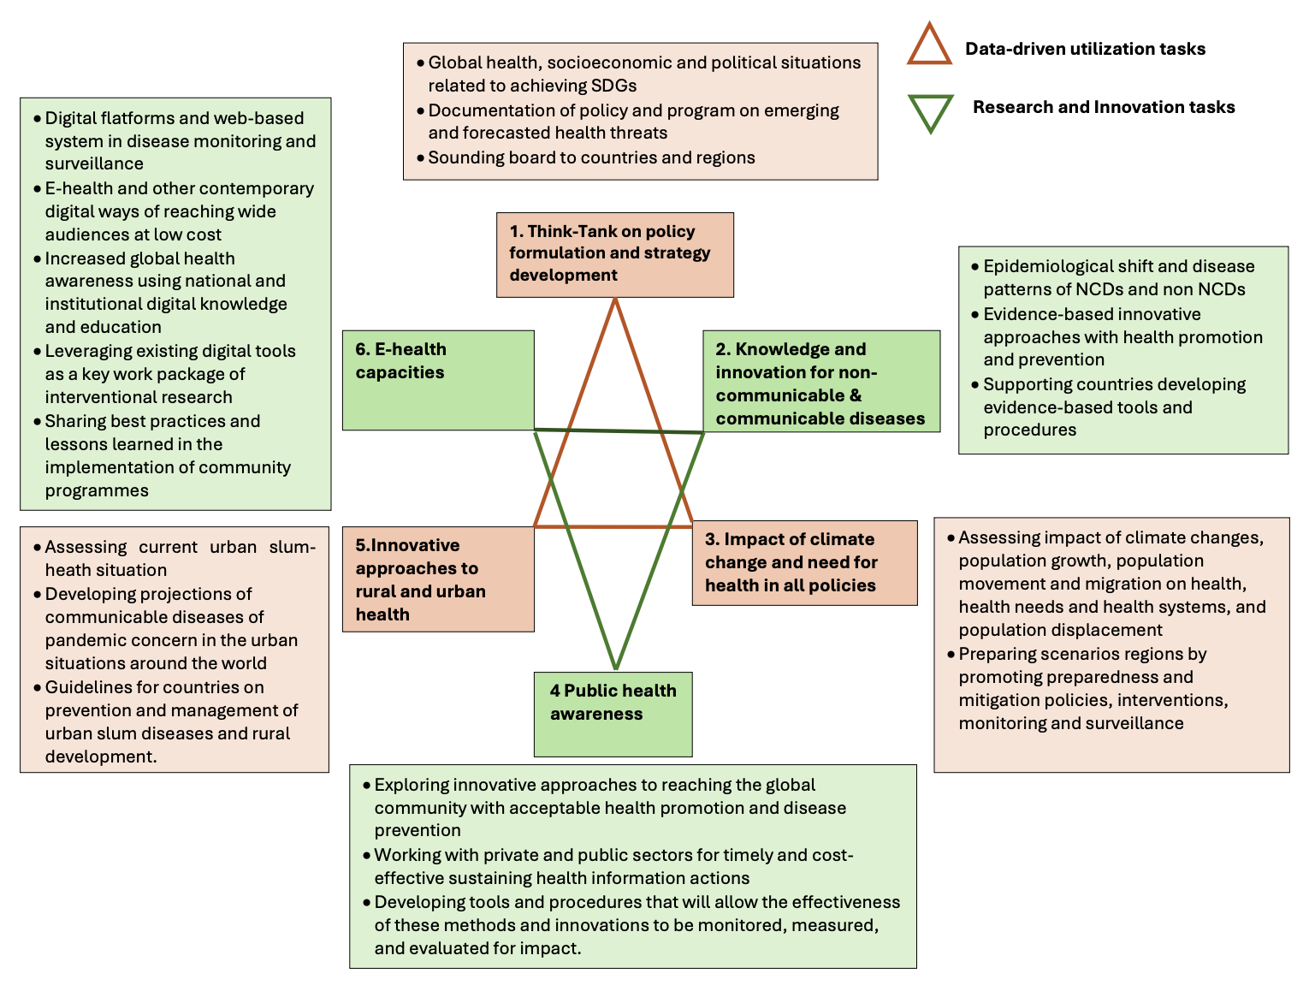

**Address**

PSU Center for Global Health Research and Innovation (CGHRI)

6th Floor, Research Innovation and Medical Technology Transfer Building

Faculty of Medicine, Prince of Songkla University  
15 Karnchanavanich Road

Hat Yai, Songkhla 90110

Thailand