**Facts**

1.Fact_Student

**Dimensions**

1. DIM_UNIVERSITY
2. DIM_SERVICES
3. DIM_SEMESTER
4. DIM_PROFESSOR
5. DIM_ELECTIVE_COURSE
6. DIM_DEPARTMENT
7. DIM_COURSE_FEES
8. DIM_COURSE_CREDIT
9. DIM_COURSE
10. DIM_CORE_COURSE
11. DIM_ADMISSION_DATE

1. Query to get the student who has fee due?

select FEE_DUE,STUDENT_ID,NU_ID from DIM_COURSE_FEES

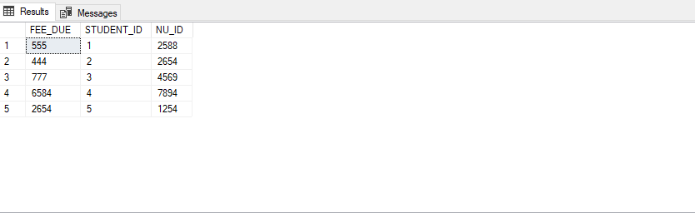

2. Query to get the Admission Status of students

select STUDENT_ID,STUDENT_STATUS from FACT_STUDENT

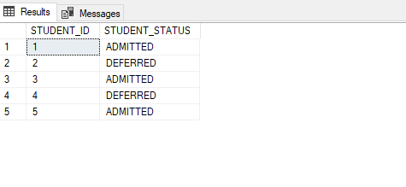

3. Query to get the students who has visied any services in the university

select STUDENT_ID,NU_ID,SERVICE_NAME NAME FROM

DIM_SERVICES

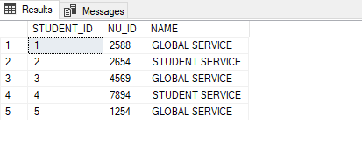

**POWER BI**

1. Representation of FEE DUE on the basis of international or local students.

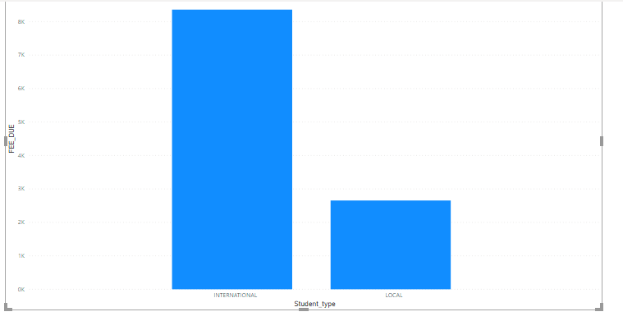

1. Representation of FEE DUE on the basis of semester.

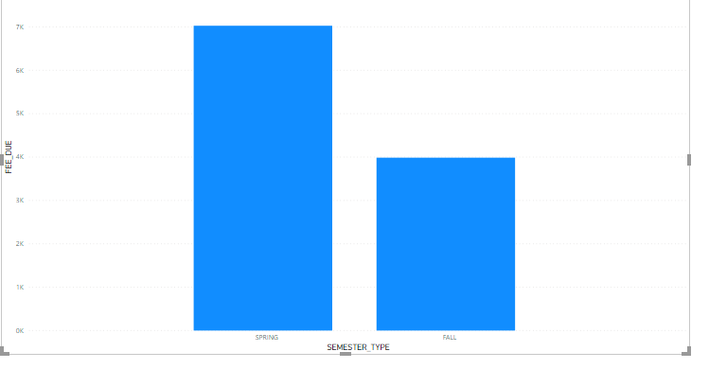

1. Credits earned based on students.

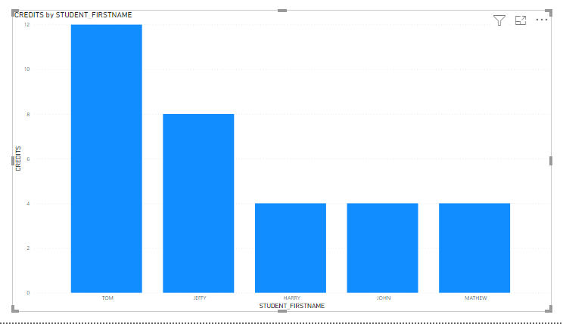

**ALTERYX WORKFLOW**

