

BANGLADESH ARMY INTERNATIONAL UNIVERSITY OF SCIENCE AND TECHNOLOGY

LAB REPORT-01

Lab Title: Introduction to Network Hardware and Basic Networking Equipment
Course Title: Computer Networks Sessional
Course Code: CSE-328
Submission Date : 26.10.2026

Submitted By, | Submitted to,
Name: Jahidul Alam Fahim  ID : 1119026  Level:3 Term: 2 Section: A  Semester: Fall-2026 | Name: Khandakar Md. Shafin  Designation: Lecturer Department: CSE

Objective
This lab was meant to move us from textbook diagrams to real equipment. By the end of the session,
I wanted to be able to:
• become familiar with the basic equipment used in computer networks;
• understand what common network devices and accessories do;
• make and test a copper straight-through cable myself; and
• see a real server room and recognise its main parts.

Equipment and Components
During the lab activities, we observed and used the following equipment and components:
1. Switch
2. Router
3. Hub
4. Server
5. Personal Computer (PC)
6. Copper straight-through cable
7. RJ-45 connector
8. CAT cable cutter and crimping tool
9. Cable tester (for the straight-through cable)
10. Network Interface Card (NIC)
11. Network bridge
12. Server room and its equipment
Lab Work and Observations
Our class was divided into small groups. First we visited the BAIUST ICT Wing to see the university server room, and then we went back to the main lab, where we saw how to make and test an Ethernet cable. Below, I describe each item in the same order as the equipment list.

Switch
Description : A flat box with a row of Ethernet ports on the front. The one we saw was a blue NETGEAR 24-port switch.
Function : It connects many devices inside one local area network (LAN). It learns the MAC address of each connected device and sends data only to the port where the receiver is, instead of to everyone
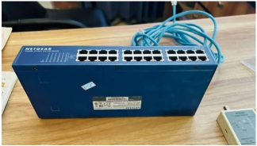
Observation : We used this switch on the lab table during the cable activity, and we also saw similar switches mounted in the rack in the server room. The ICT staff explained how switches and wiring together link computers across the campus.
Figure : NETGEAR 24-port switch used in the lab
Router
Description : A small box with several ports (and often antennas) that sits at the edge of a network.
Function : It joins different networks together and decides the best path for data to travel. At home or on campus, it is what connects the local network to the internet.
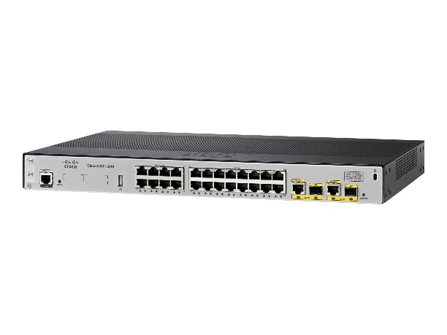
Observation : In the server room we talked about how routers, switches and cables work together to connect all the devices on campus, and how Wi-Fi is spread to halls, classrooms and offices.
Figure : Router seen on campus
Hub
Description : A basic box with several Ethernet ports. It looks like a switch but is much simpler.
Function : It connects devices in a LAN, but it has no intelligence. Whatever data arrives on one port is copied to all the other ports, so it wastes bandwidth and is rarely used today.
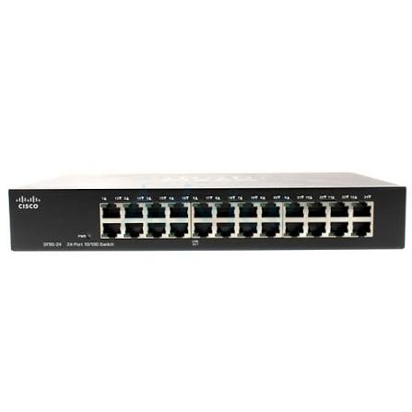
Observation : This was not part of our hands-on work, so this entry is based on class discussion and reference material. Learning about the hub helped me understand why switches replaced it.
Figure : Hub seen on campus
Server
Description : A powerful computer built to run all the time. The ones we saw were flat, rack-mounted units sitting on shelves inside a black cabinet.
Function : It provides services to other computers on the network, such as websites, files, email or storage.
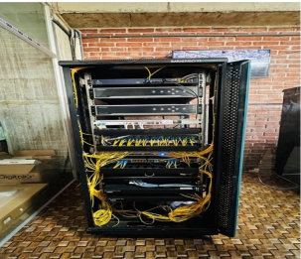
Observation : Inside the server room, a BAIUST alumnus who now works in the ICT Wing showed us the servers and explained how they deliver different services to users across the university.
Figure : Server seen on the ICT wing
Cable Tester
Description : A small two-piece device. The main unit has an RJ-45 port and a row of numbered lights (1 to 8), and the smaller remote unit has matching lights.
Function It checks whether each of the eight wires in a cable is connected properly from one end to the other
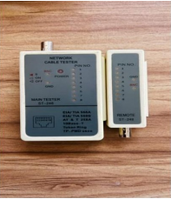
Observation : We plugged one end of our cable into the main unit and the other end into the remote unit.
Figure: Network Cable Tester
Copper Straight-Through Cable
Description : A cable with four twisted pairs (eight thin copper wires) inside a plastic jacket, with an RJ-45 connector on each end. Ours was blue.
Function : It connects two different kinds of devices, for example a computer to a switch. The wires are arranged in the same order at both ends.
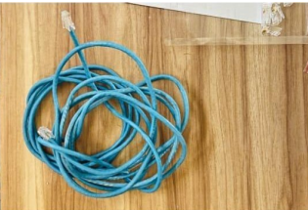
Observation : We made one of these cables ourselves (see Section A below) and then tested it.
Figure : Copper Stright Through Cable
RJ-25 Connector
Description : A small, clear plastic plug with eight metal pins inside and a clip on top. We received them in a small plastic bag.
Function : It is fitted onto the end of an Ethernet cable so the cable can be plugged into a computer, switch or wall port.
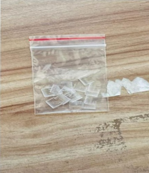
Observation : We slid the arranged wires into the connector until they reached the end, then crimped it in place.
Figure : RJ-45 connectors
CAT Cable Cutter and Crimping Tool
Description : Two hand tools. he yellow one is a cable stripper and cutter. The black and red one is a crimping tool with a slot shaped to fit an RJ-45 connector.
Function : The stripper removes the outer jacket and cuts the wires. The crimping tool presses the connector firmly onto the wires so each pin touches its wire.
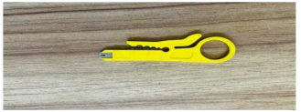
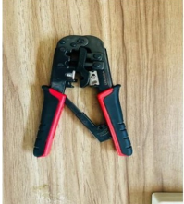
Observation : We used the stripper to expose the eight wires and the crimping tool to fix the connector. Some of the group also used scissors to trim the wires even .
Figure : Yellow cable stripper and cutter & RJ-45 crimping tool
Practical Activities
Copper Straight-Through Cable Construction :
Purpose : A straight-through cable connects unlike devices, such as a PC to a switch. For this, both ends of the cable use the same wire order.
What we used : A length of UTP (CAT) cable containing eight colour-coded wires in four twisted pairs, RJ-45 connectors, a stripper/cutter and a crimping tool.
Wiring standard : We discussed the two standards, T568A and T568B. For a straight-through cable, you pick one and use it at both ends. For reference, the T568B order, which is the more common one, is:
Steps we followed :
• Used the stripper to remove the outer jacket from the end of the cable and expose the eight wires.
• Untwisted the pairs and straightened each wire.
• Arranged the wires in the chosen colour order, side by side and flat.
• Trimmed the ends so all the wires were the same length.
• Pushed the wires into the RJ-45 connector, making sure each one reached the end.
• Put the connector into the crimping tool and squeezed firmly.
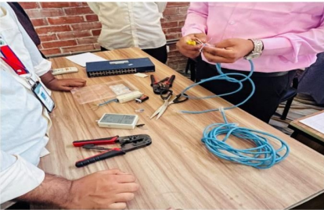
• Repeated the same steps, with the same wire order, on the other end.
Figure : Constructing Copper-Straight Cable
Server Room Inspection
The room : We visited the main server room in the BAIUST ICT Wing in small groups.
What we saw : Black equipment racks holding servers and networking gear, switches, patch panels, and many cables, including yellow fibre cables, tidily bundled and routed. We also learned about the IP-based CCTV cameras connected to the same network, and how Wi-Fi reaches different halls, classrooms and offices.
Why it matters : The server room is the heart of the campus network. Servers provide the services, switches and routers carry the traffic, and good cable management makes faults easier to find. I also learned that a backup or secondary system can keep services running if the main hardware fails, depending on how it is set up.
Discussion
This lab showed me how the pieces of a network fit together. Computers (PCs) reach the network through their network cards. Cables carry the signal to a switch, which passes data to the right device. A router links the local network to other networks and the internet, and servers sit on the network providing the services people use every day. Seeing all of this in a real server room made it much easier to picture than a textbook diagram. Making the Ethernet cable was the most useful part for me. Before the lab, I had only read about wiring standards. Doing it by hand showed how much depends on putting the wires in the right order, keeping them straight, and crimping firmly. The cable tester then made it easy to see whether the work was done properly, which is a simple kind of troubleshooting. The small, tight wires were the trickiest part, since they must all reach the end of the connector and stay in order while you crimp. Working in a group helped, because we could check each other's work.
Conclusion
This session gave me a practical understanding of basic network hardware. I became familiar with devices such as switches, routers, servers and PCs, learned how to build and test a copper straight-through cable, and saw how a real server room is organised. The visit and the hands-on work together made the concepts from class much clearer, and I feel better prepared for the more advanced networking topics ahead.

