Analysis of the microbial data from Leg 2 of the 2023 Amundsen expedition

1. Data analysis in R
Since there is a difference in filtration protocols and nutrient data availability between Leg 2 and Leg 4, Leg 2 was analysed separately. During Leg 2, only non-sequential filtration (pore-size 0.22 um) samples were collected, and nutrient data is available for all Leg 2 samples. While it is true that some non-sequential filtration samples are available from Leg 4, they are few and were found to interfere with Leg 2 clustering. While deep samples were found to cluster separately during a full data analysis, they are not analysed separately from the rest of the Leg 2 samples due to lack of clear depth separation and for comparison with the surface samples.
Samples were clustered based on the relative abundance of microbial communities using Ward’s clustering of Bray-Curtis distances. Hence, each cluster represents a “microbial community” that was shaped by – and differentiated from the rest of taxa – by the environmental variables/forces acting upon it. The environmental parameters shaping the microbial communities the most were identified with db-RDA analysis. The most significant non-correlating variance-explaining parameters were depth, salinity, nitrate and temperature. Phosphate and nitrite had additional moderate contributions. Surprisingly, fluorescence – a parameter indicative of primary production – was not one of the significant variables.
Alpha diversity (Shannon index) was calculated for each cluster. Based on the Kruskal-Wallis test, alpha diversity was significantly different between the clusters. The microbial taxa most associated with each cluster were identified, and the most abundant taxa specific to each cluster are reported here.
An important environmental parameter overlooked in the db-RDA analysis but important for interpreting of the sample clustering is the storm that happened on August 17-19 in Baffin Bay and Davis Strait, moving from north to south. As a result, the Amundsen crew were forced to move south, while sampling Davis Strait’s transects E, C, and A before/during the storm, and then sail back north after the storm, sampling Davis Strait’s transects B and D. The storm was still in Davis Strait as we sailed across it on August 19 from station A9 off the coast of Greenland to station B1 (a supplementary video is available). Later, the Amundsen crew moved further north to sample Baffin Bay and the North Western Passages (NWP).

2. ODV figures/animations
kazmiruk_6 palette was constructed to have distinct colors for 6 clusters in both R and ODV
4 transects were constructed for section distance figures:
- the Davis Strait (A-E) transect;
- the middle Baffin Bay transect: 153, 322-325 transect, 163, BGC-Argo;
- the NWP major transect consisting of 2 mini-transects: 305 transect and S transect;
- the top Baffin Bay transect: 100-115.
Sampling time animation was created for the upper surface (1-6 meters) samples colored by cluster (step 0.065 for 25 days starting on August 12, hence 385 frames). A final image was also provided.
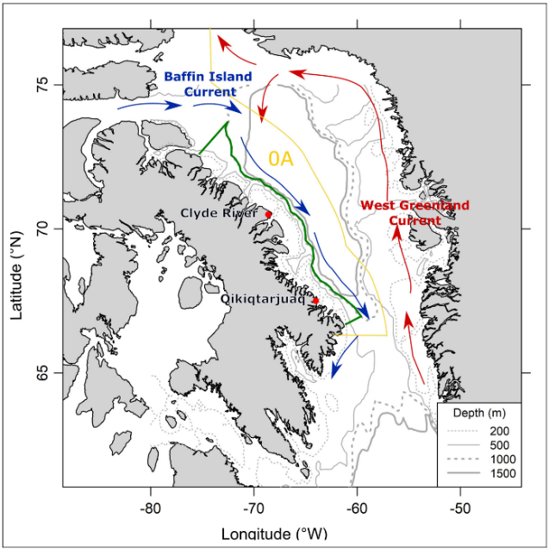

Pedro et al. (2023)

3. Cluster analysis summary

Cluster 1
Cluster 1 is a deep-water cluster found throughout Baffin Bay, Davis Strait, and NWP.
In our samples, Cluster 1 was found below 135 meters throughout Baffin Bay, Davis Strait, and NWP. Except for one sample, Cluster 1 was the only cluster identified below 160 meters. It is characterized by relatively low temperature (mean 0.3 C, -1 to 3 C), high salinity (mean ~34), absence of primary production (mean fluorescence 0.07 ug/l), microbial counts an order of magnitude lower than those in the waters above, and nutrients an order of magnitude higher than those in the waters above (mean nitrate 14.46 uM).
Cluster 1 microbial community has relatively high diversity (Shannon index). The abundant taxa specific to Cluster 1 are Thermoproteota (Family Nitrosopumilaceae), Opisthokonta, Verrucomicrobiota (Roseibacillus), Actinomycetota (Sva0996 marine group), Bacteroidota (Aurantivirga), and Pseudomonadota (SAR92 clade).

Cluster 2
Cluster 2 is a surface water cluster found in pre-storm central Davis Strait.
Cluster 2 is found in the top 35 meters at all stations of Davis Strait transects C and E as well as station A5, which were sampled before the storm. Cluster 2 also occupies the surface water of the eastern-most station of the top Baffin Bay transect, most likely due to the north-flowing Western Greenland Current somewhat connecting the microbial taxa between central Davis Strait and eastern Baffin Bay. The Cluster 2 samples inhabit waters with relatively moderate temperature (mean 1.9 oC, -2 to 6 oC) and low salinity (mean 31 psu).
The abundant taxa specific to Cluster 2 are Actinomycetota (Candidatus Aquiluna), Pseudomonadota (Sulfitobacter, Planktomarina, SAR86 clade), and Opisthokonta.

Cluster 3
Cluster 3 is a surface water cluster likely originating in Nares Strait. Cluster 3 is closely related to Cluster 2.
Cluster 3 is very abundant in the top 25 meters of the western and middle parts of the top Baffin Bay transect, where Nares Strait waters flow into Baffin Bay from the north. The Cluster 3 samples inhabit waters with relatively low temperature (mean 0.1 oC, -2 to 2 oC) and low salinity (mean 31 psu), likely due to sea ice melt in August and Siberian river signature of Nares Strait (Burgers et al., 2023). Moreover, Cluster 3 occupies waters with relatively low nutrients (mean nitrate 0.9 uM) and elevated primary production signature (mean fluorescence 1.8 ug/l). Indeed, the waters on the western side and in the middle of the top Baffin Bay transect have a differentiating characteristic of relatively high nitrate and phosphate in some spots between 20 and 100 meters, most likely originating from nutrient release as a result of melting of the ice carried south by the Nares Strait waters, which in turn fuel primary production.
Cluster 3 is also found in the coastal sections of Davis Strait, at D1, D1-2, and B1, which were sampled following the storm. It is likely that the storm facilitated the waters from the Nares Strait to reach the west coast of Davis Strait via the Baffin Island Current.
The abundant taxa specific to Cluster 3 are Bacteroidota (Polaribacter), Verrucomicrobiota (Rubritalea) and Pseudomonadota (Colwellia). Interestingly, Cluster 3 has a high number of Chloroplasts, especially at chlorophyll maximum depths of stations 100, 103 and 111 in Baffin Bay and station B1 in Davis Strait, likely indicating algal blooms. Indeed, one of the Cluster 3 samples was found in a bottom sample of station 113 at 539 m, potentially due to bloom-induced deposition of cell debris from the surface waters. Moreover, within Cluster 3, the Davis Strait samples cluster together and separately from the Baffin Bay samples due to more nuanced taxa differences. Specifically, the Davis Strait samples have lower abundances of Polaribacter and Sulfitobacter, and higher abundance of Pseudoalteromonas and Psychrobacter.

Cluster 4
Cluster 4 is a small psychrophilic cluster in NWP and post-storm central Davis Strait.
Cluster 4 samples are few and come from the transect 305 in NWP and station D5 in Davis Strait. The clustering of the NWP samples and the D5 samples together can be explained by microbial taxa being transported by the south-moving storm and via south-flowing Baffin Island Current. Cluster 4 samples have a relatively large depth range of 5 to 157 meters. The environmental property that distinguishes the Cluster 4 samples from other Clusters is very low temperature (mean -0.2 oC, -2 to 2 oC). Cluster 4 also has relatively moderate salinity (mean 32 psu) and elevated primary production signature (mean fluorescence 1.8 ug/l).
The abundant taxa specific to Cluster 4 are Pseudomonadota (e.g., Pseudoalteromonas, Psychrobacter and Marimonas) and Bacteroidota (Olleya).
Cluster 5
Cluster 5 is the West Greenland Coastal Current cluster.
Cluster 5 occupies exclusively the area above the continental shelf along the west coast of Greenland (stations A7-9) and its samples range in depth between 5 and 116 meters. These waters have relatively high temperature (mean 4.4 oC, 1 to 6 oC) and elevated nitrite (mean 0.10 uM). Cluster 5 also has relatively moderate salinity and moderate primary production signature (mean fluorescence 1.1 ug/l). The waters occupied by Cluster 5 are likely representative of the microbial community of the coastal portion of the West Greenland Current.
The abundant taxa specific to Cluster 5 are Pseudomonadota (e.g., Kineobactrum and SAR92 clade), Opisthokonta, Bacteroidota (Formosa and Gilvibacter), Verrucomicrobiota (Rubritalea and Roseibacillus), and Actinomycetota.

Cluster 6
Cluster 6 is a surface water cluster originating in NWP and central Baffin Bay and found in post-storm central Davis Strait.
Cluster 6 mostly occupies the surface waters (depth 2 to 116 meters), and found mostly in NWP and central Baffin Bay, where it most likely originates. Cluster 6 also occupies the surface waters of non-coastal stations of transect D. Since the latter stations were sampled after the storm, the south-ward storm and Baffin Bay Current most likely transported the waters and associated microbial communities from NWP and central Baffin Bay to central Davis Strait. Moreover, Cluster 6 also occupies the surface waters of station A6, most likely due to the surface waters of NWP and central Baffin Bay being transported south to central Davis Strait by the Baffin Bay Current.
Cluster 6 has the greatest range in temperature (-2 to 5 oC) and salinity (25 to 32.5 psu) among all clusters. Cluster 6 also has the highest primary production signature among all clusters (mean fluorescence 1.9 ug/l). Indeed, one of the Cluster 6 samples – collected at the chlorophyll maximum depth of station D4 – has the highest fluorescence recorded among all Niskin samples collected during Leg 2 (14.8 ug/l). The great range in physical and biochemical environmental parameters associated with Cluster 6 is likely due to the vigorous vertical mixing and horizontal transportation of waters due to the storm.
Cluster 6 microbial community has relatively low diversity (Shannon index). Only Pseudomonadota (Psychrobacter and Yoonia) are the abundant taxa specific to Cluster 6.
It is peculiar how the surface waters of stations A5, A6 and A7 are represented by Cluster 2, 6, and 5 respectively, transitioning from central Davis Strait to the continental shelf along the west coast of Greenland. The A5-A7 transect is less than 100 km and all three stations were sampled within a 15-hour period on August 18.

References:
Burgers et al. 2023. https://agupubs.onlinelibrary.wiley.com/doi/full/10.1029/2022JC019393
Pedro et al. 2023. https://online.ucpress.edu/elementa/article/11/1/00015/195301/Structure-and-function-of-the-western-Baffin-Bay

