A Tutorial in language C

Section 1
Variables, Assignment statements, and simple I/O
1. Introduction
The foundation of any high-level language has several features: Variables, I/O, assignment, conditional, loop statements. There are two categories of variables: Simple and structured variables. As a first step in any programming language we need to learn input and output statements (instructions). A program without I/O is useless. Next we learn about simple variables and their use in a C program. Finally we learn the assignment statements.
You can download an IDE that works with a C compiler for free named: CodeBlocks. This IDE has a version for Windows and a version for Ubuntu:
http://www.codeblocks.org/downloads
https://apps.ubuntu.com/cat/applications/codeblocks/
All the programs in this lecture have been tested with both versions.
Those of you with a Mac need to find out whether or not there are version for Mac computers
2. The general structure of a C program
A C program is a collection of function Declarations (definitions). One function which is specific to the operating system is the function whose name is: main. The system only knows this function. The system always starts the execution of the C program from this function. Therefore declaring the function main is a must be. Below is a C program. I do not expect you understand it.
Example 1: The following program asks the user to enter her/his name and yearly income. If the income is below $30,000 the program informs the user to $0 income tax. If the income is in the range $30,000 to $100,000 the program calculates the income tax based on 15% and informs the user the amount of tax. If the income is higher than $100,000 the program calculates the tax based on 25%.

#include <stdio.h>
float calculate(float income)
{
if (income < 30000)
return 0;
else if (income < 100000)
return 15.0/100 * income;
else
return 25.0/100 * income;
}

int main()
{
char name[100];
float income, tax;
setvbuf(stdout, NULL, _IONBF, 0);
setvbuf(stderr, NULL, _IONBF, 0);
printf("Please enter your name: ");
gets(name);
printf("Please enter your income: ");
scanf("%f", &income);
tax = calculate(income);
printf("%s pay $%.2f for your tax.\n", name, tax);
return 0;
}

Execution:
Please enter your name: John Doe
Please enter your income: 75000
John Doe pay $11250.00 for your tax.

Description:
This program has two functions: main and calculate. The function main is a must be. The operating system starts executing main only. In this function three variables are declared (defined): name, income and tax. The variable name is an array of 100 consecutive locations, each can have one character. The variables income and tax are of type float. This means the locations of these variables can contain floating point numbers.
The first printf statement prompt the user to enter her/his name. The instruction gets makes the control of execution to wait until the user enters a name (like John Doe). This instruction reads this name from the keyboard and stores it in the locations of the variable: name. The second printf statement prompts the user to enter a number. The instruction scanf reads the numbers from the keyboard and stores it in the location variable: income. The next line calls the function: calculate. This function calculates the tax and returns it to the caller (which is main). The caller assigns this value to the variable tax. Finally the last printf displays the name and the amount of tax.
Note: All the names in a program are called identifiers. An identifier should start with a letter, followed by letters, digits, and/or underscore. In this program main, calculate, name, income, and tax are identifiers. These names identify something to the C compiler. The identifiers main and calculate identify that they are functions name. The identifiers income and tax identify that they are variables. The line “char name[100];” and “float income, tax;” are called declarations. The program declares to the C compiler that I have the identifiers name, income and tax as variables. The program also has two more declarations: main and calculate. The program declares that I have these identifiers as functions’ name. The declaration of a function consists of its name and its body.
Note: The identifiers we use in our program should be meaningful names to have a more informative program. But to the compiler these names have no meaning. Whether we use the names calculate, income, or tax or f, x, or y for the compiler they are same.
2.1. Execution of a C program
The execution of a program is done by a C compiler. The compiler goes through the following phases:
1. It reads the source program (e.g. the above program) and checks it to be sure its format is correct according to the grammar of the language C. If its format is not correct (e.g. Missing a semicolon, a parenthesis, etc) stops and informs the user of such error(s). If the format of the source program is correct the compiler translates the source program into binary numbers and saves the result of this translation into a file called object program with extension obj.
2. The compiler then adds to the object program whatever is needed from the library of C and stores the object program and these additions into a file called executable program with extension: exe. If we simply enter the name of this executable file we get the result of our program.
2.1.1. Execution in Linx/Unix environment
To execute a C program do the following:
1. Use a text editor like gedit (or vi) and copy the above program into the editor. Save the editor to a file named: a.c (no space in between).

Note: Make sure the extension is c and not txt or cpp (short for C Plus Plus).

2. Enter the following:
cc a.c
4. Enter:
./a.out

Note: Do not forget to enter the period (dot).

5. Enter John Doe, hit enter and enter 123000 in front of the prompts:
Please enter your name: John Doe
Please enter your income: 123000

Note: The boldfaced name and number are the ones the user (you) enters.

Excecution:
John Doe pay $30750.00 for your tax.

3. Simple types and variables
In C there are two kinds of types: Simple types and structured types. We study the first kind here and the second kind after I teach loops.
In a C program we must declare (tell to C compiler) all of our variables and functions before using them. Let us look at a wrong example:

Example 2: In the following program we assign a value to variable x and then print its value.

#include <stdio.h>
int main()
{
x = -123;
printf("The value of x is: %d\n", x);
}
When we compile this program we get the following two lines in the output (lower window):
a.c: In function main:
a.c:5:2: error: ‘x’ undeclared (first use in this function)
a.c:5:2: note: each undeclared identifier is reported only once for each function it appears in

Description:
This is not warning errors. We cannot ignore them. It says:
In line 5th the variable x is not declared (defined)
Therefore we must declare all of our identifiers (variables, function names, etc) before we use them.

Note: In C all the variables must be declared at the beginning of the body of a function.
Example 3: The following is the same program in example 2 but this time we declare the variable x:

#include <stdio.h>
int main()
{
int x;
setvbuf(stdout, NULL, _IONBF, 0);
setvbuf(stderr, NULL, _IONBF, 0);
x = -123;
printf("The value of x is: %d\n", x);
return 0;
}
This time when we execute it we see:
The value of x is: -123

A variable is an identifier that must be declared together with its type. Simple types in C are as follow:
Note: I know I have not explained I/O instruction but please be patient with me. I promise by the end of this Section I/O instructions are cleared to you.
Type | Variable | Examples
char | char x | x = 'A'; x = 65; x = -23
short | short x | x = -23
int | int x | x = 56
long | long x | x = 1234
float | float x | x = 12.5
double | Double | x = -33.27
long double | long double | x = 233445.55

We normally assign a character to a variable of type char. To the variables of type short, int, and long we assign integers. The difference between these three is that we can assign bigger integer to a variable of type long than to the one of type int and we can assign bigger integers to a variable of type int than short. Similarly this is true for the types float, double and long double for decimal numbers. Most of the time in our program we use char, int, and float.
Every variable has a location in memory. A program with a declaration like:
int x;
Tells the compiler I need a location in memory labeled (named) x and I am planning to put an integer in this location. A program with a declaration like:
float y;
Tells the compiler I need a location in memory labeled (named) y and I am planning to put a decimal number in this location. A program with a declaration like:
char z;
Tells the compiler I need a location in memory labeled (named) z and I am planning to put a character in this location. Note that we can also insert a number in the location of variable z.
Note: A variable declaration must be unique in the block of a function. A block is {......}. The body of a function is a block. Global variable (explained later) also follow this restriction.

Example 4: The following program is wrong. We are declaring the identifier p more than one time:
#include <stdio.h>
int main()
{
int x;
float p;
char p;
x = -123;
printf("The value of x is: %d\n", x);
return 0;
}
When you compile this program the following error message is displayed:
a.c: In function ‘main’:
a.c:7:7: error: conflicting types for ‘p’

4. Assignment statement
The format of an assignment statement is:
Variable = Expression
The control of execution evaluates the Expression to a value and puts this value into the location of the variable.
Do not make mistakes:
The following is correct:

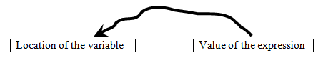

The following is wrong:

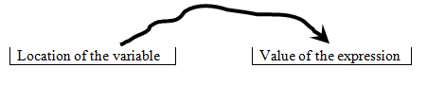
Example 5: In the following program we declare six variables and assign to them expressions.
#include <stdio.h>
int main()
{
char a, b; //1
int m, n; //2
float x, y; //3
a = 'P'; //4
b = a; //5
m= 15; //6
m = m + 5; //7
n = m; //8
x = 12.5; //9
y = 23.7; //10
y = y - x; //11
printf("The final value of the variable a is: %c\n", a); //12
printf("The final value of the variable b is: %c\n", b); //13
printf("The final value of the variable m is: %d\n", m); //14
printf("The final value of the variable n is: %d\n", n); //15
printf("The final value of the variable x is: %f\n", x); //16
printf("The final value of the variable y is: %f\n", y); //17
return 0;
}

Execution:
The final value of the variable a is: P
The final value of the variable b is: P
The final value of the variable m is: 20
The final value of the variable n is: 20
The final value of the variable x is: 12.500000
The final value of the variable y is: 11.200001

Description:
I added comments to this program to explain it more clearly. Comments are ignored by the compiler. We have two kinds of comments in C. A short comment that starts with // and continues to the end of the line. Long comment that takes several lines. For this kind we write /*. We then write several lines (like the programmer’s name, course name, date posted) and close the comment by */. Lines marked by:
//1: We declare two variables a and b of type character. The compiler allocates two locations for a and b. The compiler knows we are going to give a character to each of them.
//2: Two variables: m and n are declared of type integer. The compiler allocates two locations for these variables in memory and knows we are going to insert an integer to each of these locations.
//3: Two variables: x and y are declared of type float. The compiler allocates two locations for these variables in memory and knows we are going to insert a decimal number to each of these locations
.//4): There is an assignment statement: a = 'P'. The control of execution evaluates the expression on the right-hand side (in this case to character 'P') and store it to the location of variable a on the left-hand sign.

Important Note: The assignment: a = 'P' is completely different than the assignment: a = p. The execution of the first one means the value on the right-had side which is: 'P' is stored into the variable’s location a. The second one: a = P means evaluate the expression on the right-hand side which is the value of the variable P and store in the location of variable a on the left-hand side. If we have this statement in the above program the compiler issues an error message and stops. The compiler thinks P is a variable and we are using in an expression. It complains that the programmer has not declared this variable before using it. This means the compiler has no location for P at all.
//5: The assignment statement on this line is: b = a. The expression on the right-hand side is simple. It is just a. Evaluation of this expression means take a copy of the content of the location a (which is 'P') and store it into the location of the variable b.
//6: The assignment statement on this line is: m= 15. The expression on the right-hand side is simple. It is just 15. Evaluation of 15 is 15. This value is stored in the location of variable m.
//7: The assignment statement on this line is: m = m + 5. The expression on the right-hand side is: m + 5. This control of execution takes a copy of the content of the variable m in which is in: m + 5 and adds 5 to it. The result of the evaluation of this expression is 15 + 5 which is 20. The control of the execution stores 20 in the location of m. This means the previous value of m (i.e. 15) is replaced by 20.
//8: The assignment statement on this line is: n = m. The expression of the right-hand side is simple. It is just m. The control of execution evaluates this expression to 20 (which is the content of m). This value is stored in the location of variable n.
//9: The assignment statement on this line is: x = 12.5. The expression on the right-hand side is simple. It is just 12.5. Evaluation of 12.5 is 12.5. This value is stored in the location of variable x.
//10: The assignment statement on this line is: y = 23.7. The control of execution stores 23.7 in the location of the variable y.
//11: The assignment statement on this line is: y = y - x. The expression on the right-hand side is: y - x. This control of execution takes a copy of the content of the variables x and y that are 23.7 and 12.5 respectively and stores the difference of these values (i.e. 23.7 – 12.5) in the variable’s location y. Note that evaluation of decimal numbers are with an approximation. As you see in the output the value of 23.7 – 12.5 is not 11.2. It is 11.200001.
//12 to //17: Prints the current contents of these variables.

Note: In the assignment statement: variable = expression the operation = does not means equality.
Note: There are more letters. But for our purpose these four letters are enough. If we need more I will explain in the spot. The meaning of c, i, f and s are:

5. Simple I/O
In this section we look at the instructions to display (output) data and to wait for the user to enter values (Inputs) from the keyboard. These instructions are defined in a file named: stdio.h. This is called standard input output header file. If we have I/O instructions in our program we must include this already available file into our program. The first line of the programs in the above examples is: #include <stdio.h>.
Exercise 1: Remove: #include <stdio.h> from the program in example 5. Run the program. What do you see on the screen?

5.1. Output
The general structure of the mostly used instruction to display is:
printf("Control String", expression, expression,...., expression)
The word: printf stands for print formatted. We may have zero or more expressions. But the control string must be there. Remember a variable alone is a simple case of an expression. The simplest format of the printf is the time we do not have any expression. We only have the control string:
printf("Enter your name: ")
This displays the message: Enter your name on the screen.
When we have expression(s) we must have the so called: Type specifier(s). To the number of expressions we must have type specifiers.
The value of an expression is just a binary numbers inside computer. In C we must tell to the compiler to display this binary number as a character, an integer, a floating point number, string, etc. The job of type specifiers is to accomplish this. A type specifier is the symbol: % followed by one of the letters: c, i, f, s, etc.
%c: Display the value of the expression as a character.
%d or %i: Display the value of the expression as an integer.
%f: Display the value of the expression as a floating point (decimal) number.
%s: Display the value of the expression as a string.

Example 6: The following program using the above specifiers.

#include <stdio.h>
#include <string.h>

int main()
{
char a; //1
int m; //2
float x; //3
char z[30];

a = 'A'; //4
printf("The value of the variable a is: %c\n", a); //5
printf("The value of the variable a is: %d\n", a); //6
a = 65; //7
printf("The value of the variable a is: %c\n", a); //8
m = -123; //9
printf("The value of the variable m is: %d\n", m); //10
x = -25.7; //11
printf("The value of the variable x is: %f\n", x); //12
strcpy(z, "Hello World"); //13
printf("The value of the variable a is: %s\n", z); //14
printf("Finally we display the value of all of a to be %c, m + 5 to be %d, x to be %f, and z to be %s: ", a, m + 5, x, z); //15
return 0;
}

"Hello World. Have a nice day."
Note: The instruction: printf("Finally we… is on one line in the editor. We cannot break a string in to two lines. The following is correct:
But the following is not correct:
"Hello World. Have
a nice day."
A string must be open by the symbol: " and closed by the symbol: " on the same line. The two quotations play the role of open and close parentheses.

Execution:
The value of the variable a is: A
The value of the variable a is: 65
The value of the variable a is: A
The value of the variable m is: -123
The value of the variable x is: -25.700001
The value of the variable a is: Hello World
Finally we display the value of all of a to be A, m + 5 to be -118, x to be -25.700001, and z to be Hello World

Description: In this program we declared three simple variables a, m, and x and one structured variable z (do not worry I explain this in the later Section). I just use this variable to copy (strcpy) the string "Hello World" into it to show you how %s works.
The function: strcpy is in the header file: string.h. Therefore we needed to add:

#include <string.h>

to the program.

//4: The assignment statement: a = 'A'. We store the value 'A'(Yes this is a value. In is not a number but it is a character) in the location of a.

//5: The instruction: printf("The value of the variable a is: %c\n", a). Displays the message: The value of the variable a is: A. Let us analyze this instruction. Any character other than symbols %c and \n comes on the screen as it is. We have one expression in this printf. It is the expression a after the comma. Therefore we must have one specifier. We have one and it is: %c. This specifier asks the control of execution to display the binary number of the value of the expression: a as a character. According to the ASII table at the end of this Section this binary number is: 0100 0001. This binary number in decimal (see the table) is 65 and this is the ACSII code (number) of character: A. The symbol \n won’t be printed. When the control if the execution sees this symbol it moves the cursor to the next output line.

Note: The symbol \n is called an escape character. Although this symbol looks like a string of two characters to us but to the control of execution is one character. A character constant in a program by itself must be put into single-quotations like 'P' in example 5 for the character P. Therefore to show \n as a single character we must write: '\n'. A string must be put in double-quotations like: "Please enter your name: " in example 1, whereas a character must be put in single-quotations.
Note: A single space is a character like any other characters. We can write: ' '.and this means character space (there is only one space).
//6: The instruction: printf("The value of the variable a is: %d\n", a). This is the same as the previous one except for the specifier that is changed to: %d. This specifer instructs the system to print the value of the expression a as an integer (not a character).
Note: There are several escape characters. The other one which we use in this course is the tab character and is written as \t. When control of the execution sees this one it makes the cursor to jump a tab forward.
The next three printf’s are straightforward. I now explain the last printf.

//15 The instruction:
printf("Finally we display the value of all of a to be %c, m + 5 to be %d, x to be %f, and z to be %s: ", a, m + 5, x, z)
In this printf we have four expressions: a, m + 5, x, and z. As you see inside the string we have four specifiers:
%c for a
%d for m + 5
%f for x
%s for z.

Therefore the system prints the binary value of the expressions a as a character, m + 5 as an integer, x as floating point number, and z as a string. This is shown in the last line of the output. Note: To control the numbers of digits after the period we use %f with a number.
For example in example 1 we have %.2f and the output for this is: 11250.00. As you see we have two digits (0 and 0) after the period in the number. Do not forget the dot after the symbol: %.
Exercise 2: Change printf in line marked //12 to print the value of x with three decimal digits.

Exercise 3: Change the printf to print the value of x with no decimal digit.

Exercise 4: Change the printf to print the value of x with four decimal digits.

5.2 Input

The format of the instruction to inputs values is:

scanf("Control String", address-of-variable, address-of-variable, ..., address-of-variable)

The word: scanf means scan the input stream (here the keyboard) formatted. The: Control String is used direct the system how to convert the data-value. In the: Control String we specify whether or not to treat a data-value as an integer, floating point number, character, etc.
We are not allowed and do not make sense to write expressions for input. We must write the address-of-variable. We must not write the variable itself. If we do the system either freezes, write the input value elsewhere in memory rather than into the location of the variable. In C by:
Variable we mean the content of the location of the variable.
&variable we mean the address of the variable’s location in memory.
If we declare a variable such as x (for example: int x) by x we mean its content. By &x we mean its address.
Note: Exception: For array (explained later) variables we do not use the symbol &.

Example 7: The following program prompts the user for a number and displays twice of that number:

#include <stdio.h>

int main()
{
int x;
printf("Enter a number: ");
scanf("%d", &x);
printf("Twice of %d is %d\n", x, 2 * x);
return 0;
}

Execution:

Enter a number: 12
Twice of 12 is 24

Description:

The first printf prompt the user. The instruction scanf("%d", &x): makes the control of execution waits until the user enters something. This instruction tell to the system whatever the user enters bring it as an integer (%d) and insert it into the address of the variable’s location x. Finally in the last printf we have two expression x and 2 * x. That is why we have two specifiers %d and %d.

Exercise 5: Run the program but enter a non-number value (like: ab).

Example 8: The following program supposedly reads a full name (First name Last name) and displays the name.

#include <stdio.h>

int main()
{
char a[100];

printf("Enter Your first and last name separated by a space: ");
scanf("%s", a);
printf("Your full name is: %s\n", a);
return 0;
}

Execution:

Enter Your first and last name separated by a space: John Doe
Your full name is: John

Description: First of all do not worry about the declaration of variable: a. This is how we declare an array. I will explain arrays after I teach you loops. I simply use this variable to read a line. But the specifier %s in scanf only reads the first word. Note that I did not use &a because this variable is an array variable. For simple variables we must use &.

To input a line we should use the built-in function gets.

Example 9: The following program reads a full name (First name Last name) and displays the name.

#include <stdio.h>

int main()
{
char a[100];
printf("Enter Your first and last name separated by a space: ");
gets(a);
printf("Your full name is: %s\n", a);
return 0;
}

Execution:

Enter Your first and last name separated by a space: John Doe
Your full name is: John Doe

Description:

In this program we replaced the scanf in the previous program by gets. The built in function gets only reads a line of a string. We cannot use it for any other kind of data values (such as integers, floating point numbers).

Example 10: A program to input a character, an integer and a decimal number and prints them:

#include <stdio.h>

int main()
{
char a;
int m;
float x;

printf("Enter a letter, an integer, and a decimal number all in one line separated by spaces: ");
scanf("%c%d%f", &a, &m, &x);
printf("You entered:\n%c\n%d\n%.3f\n", a, m, x);
return 0;
}

Execution:

Enter a letter, an integer, and a decimal number all in one line separated by spaces: P -123 12.342512
You entered:
P
-123
12.343

Description:

In this program we have one scanf with three specifiers %c%d%f to input a character, an integer and a decimal number into the address of three variables a, m and x. The last printf displays the phrase: You entered: then the cursor goes to the next line because of the first: \n. The program displays the content of variable a as a character because of the specifier: %c. Now the cursor goes to the next line because of the second: \n. Now the content of the variable m is displayed as an integer because of the specifier %d. The third \n makes the cursor goes to the next line. Finally the content of the variable x is displayed as a floating point number because of the specifier: %.3f and the cursor goes to the next line because of: \n.
Note: The specifier %.3f displays 12.342512 with three decimal digits. Note that the number is rounded to 12.343 in the output.

Integer and floating point division: If both operands are integers the division is an integer division.
For example 7/2 evaluates to 3.
If one or both operands are floating points number the division is floating point division.
For example:
7.0/2, or 7/2.0, or 7.0/2.0 evaluates to 3.5.
When you have two variables of type int and you like to make a floating point division multiply the first operand by 1.0.
For example:
int x, y;
x = 7;
y = 2;

Then expression: 1.0 * x / y evaluates to 3.5

Remainder operation: The remainder operation is the symbol: %. It has two operands and both are integers. For example 7%2 evaluates to 1.

Note: If in the sample output of the following exercises the values (numbers, strings) are in boldface and underlined this means the program reads these values from the keyboard.

Exercise 6: Write a program using a single printf to display:

Execution:

*
* * *
* * * * *
* * * * * * *
* * * * *
* * *
*

Note that between every two stars there is a single space.

Exercise 7: Write a program to print a bill of an auto shop. Use the following variables in your
program. The tax is 3%.

Variables-
Parts
Labor
Sales Tax
Total

Execution sample:

Parts: 104.50
Labor: 145.20
Auto Shop
Parts: $104.50
Labor: $145.20
Sales Tax: $14.98
Total: $264.68

Exercise 8: Write a program to calculate and print interest on a loan. The formula is:

interest = principal * (rate/100) * (days/365).

Print a bill of an auto shop. Use the following variables in your program. The tax is 3%.

Variables-
Principal
Rate
Days
Interest

Execution sample:

Principal: 3500.75
Rate: 20
Days: 300
Interest: $575.47

Exercise 9: Write a program to convert a number of seconds to days, minutes, hours and seconds.

Variables-
Days
Minutes
Hours
Seconds

Execution sample:

How many seconds: 234567
Days: 2
Hours: 17
Minutes: 9
Seconds: 27

Exercise 10: Write a program to ask for number of half-dollars, quarters, dimes, nickels and pennies and outputs the total values in dollars and fraction of dollars.

Variables-
Half Dollars
Quarters
Dimes
Nickels
Pennies

Execution sample:

Half dollars:2
Quarters: 5
Dimes: 6
Nickels: 7
Pennies: 12

Your total is $3.32

ASCII table

DEC | ASCII | DEC | ASCII | DEC | ASCII | DEC | ASCII
000 | NUL | 032 | Space | 064 | @ | 096 | `
001 | SOH | 033 | ! | 065 | A | 097 | a
002 | STX | 034 | " | 066 | B | 098 | b
003 | ETX | 035 | # | 067 | C | 099 | c
004 | EOT | 036 | $ | 068 | D | 100 | d
005 | ENQ | 037 | % | 069 | E | 101 | e
006 | ACK | 038 | & | 070 | F | 102 | f
007 | BEL | 039 | ' | 071 | G | 103 | g
008 | BS | 040 | ( | 072 | H | 104 | h
009 | TAB | 041 | ) | 073 | I | 105 | i
010 | LF | 042 | * | 074 | J | 106 | j
011 | VT | 043 | + | 075 | K | 107 | k
012 | FF | 044 | , | 076 | L | 108 | l
013 | CR | 045 | - | 077 | M | 109 | m
014 | SO | 046 | . | 078 | N | 110 | n
015 | SI | 047 | / | 079 | O | 111 | o
016 | DLE | 048 | 0 | 080 | p | 112 | p
017 | DC1 | 049 | 1 | 081 | Q | 113 | q
018 | DC2 | 050 | 2 | 082 | R | 114 | r
019 | DC3 | 051 | 3 | 083 | S | 115 | s
020 | DC4 | 052 | 4 | 084 | T | 116 | t
021 | NAK | 053 | 5 | 085 | U | 117 | u
022 | SYN | 054 | 6 | 086 | V | 118 | v
023 | ETB | 055 | 7 | 087 | W | 119 | w
024 | CAN | 056 | 8 | 088 | X | 120 | x
025 | EM | 057 | 9 | 089 | Y | 121 | y
026 | SUB | 058 | : | 090 | Z | 122 | z
027 | ESC | 059 | ; | 091 | [ | 123 | {
028 | FS | 060 | < | 092 | \ | 124 | |
029 | GS | 061 | = | 093 | ] | 125 | }
030 | RS | 062 | > | 094 | ^ | 126 | ~
031 | US | 063 | ? | 095 | _ | 127 | DEL

Section 2

Expressions and Conditional Statements

1. Introduction

You have studied and practiced with expressions and conditional statements. The syntax (grammatical structures) of these features is a little different but the meanings are the same. In this Section we first look at different kind of expressions and then study different kind of conditional statements. We also learn about two more instructions. These are the statement return and the built-in function exit.

2. Expressions

An expression is anything that can be evaluated to a value (decimal number, integer, character, string). In this section we look at arithmetic and logical expressions.
Let us look at some of the operators we use in an expression:

Operator | Explanation | Symbol | Example
Negative | Reverse the sign of an expression | - | -4
Increment | Add one to variable in expression | ++ | var++  ++var
Decrement | Subtracts one from variable in expression | -- | var—-  -–var
Logical NOT | Evaluates false expression (0) to true and vice versa
Size | Size of expression (or type) in bytes | sizeof | sizeof(var)  sizeof(type)
Multiplication | Multiples two expressions | * | 2 * 3
Divide | Divides two expressions | / | 7/2
Remainder | Remainder of a division | % | 7%2
Add | Adds two expressions | + | 2 + 3
Subtract | Subtract two expression | - | 2 – 3
Greater | If the first operand is greater than the second operand evaluates to true (1), otherwise false (0) | > | x + y > 2
Greater or equal | If the first operand is greater or equal to the second operand evaluates to true (1), otherwise false (0) | >= | x * 2 >= z
Less | If the first operand is less than the second operand evaluates to true (1), otherwise false (0) | < | x * 2 < z
Less or equal | If the first operand is less or equal to the second operand evaluates to true (1), otherwise false (0) | <= | x+y < r - 3
Equal | If the first operand is equal to the second operand evaluates to true (1), otherwise false (0) | == | x – 2 == z
Not equal | If the first operand is not equal to the second operand evaluates to true (1), otherwise false (0) | != | x – 2 != z
Logical AND | If both operands evaluate to true the result is true(1), otherwise is false (0) | && | x<5 && u>z
Logical OR | If both operands evaluate to false the result is false(0), otherwise is true(1) | || | x<5 || u>z
Conditional expression | if the test is true evaluates the first operand, else evaluates the second operand | ? : | x < 5 ? a * b ? z + c
Assignment | Assigns the value of the expression on the right to variable on the left and evaluates to the value of the expression. | = | x = y + 4

Note: The increment and decrement operator has one operand and their meaning are:

var++: Obtain the value of the variable var for the expression that ++var is part of it and then increment var.
++var: First increment var then obtain its value for the expression that ++var is part of it.
Note: The operator -- for var-- and --var is similar.

Note: The operand of --.and ++ must be variables of type integer.

2.1 Parenthesis and Precedence Rules

In order not to write a lot of parentheses in an expression, C imposes precedence rules over the operators from high to low precedence. The high precedence operator is evaluated first and the low precedence operator is evaluated last. The above table is sorted in terms of the precedence of the operators. In other words, the operator in the first row has the highest and the one in the last row has the lowest precedence.
The operators with the same precedence in an expression are evaluated from left to right (except the assignment operator).
The assignment operator (=) is evaluated from right to left.
Note: The operators + and – have the same precedence. So is for *, / and %. So is for <, <=, ==, !=, > and >=.

Example 1: The following table shows some examples for precedence of the operators. In each row the first column is the expression without parentheses and the second column is the same expression if we like to have (unnecessary) parentheses.

Expression with no parentheses | Same expression with parentheses
2 + 3 * 4 | 2 + (3 * 4)
2 + 3 * 4 * 5 / 3 | 2 + (((3 * 4) * 5) / 3)
2 + 3 < 6 + 7 | (2 + 3) < (6 + 7)
2 < 6 && 3 > 5 | (2 < 6) && (3 > 5)
2 + 3 < 3 + 4 || 5 + 6 < 7 – 8 | ( (2 + 3) < (3 + 4) ) || ( (5 + 6) < (7 – 8) )

Example 2: The following program uses most of the above operators

#include <stdio.h>
int main()
{
int a = 2, b = 3, c = 4;
float x = 2.5, y = 4.2;

printf("The value of the expression: a + 4 * b * 2 / c / 2 is: %d\n", a + 4 * b * 2 / c / 2);
printf("The value of the expression x < y is: %d\n", x < y);
printf("Since x is less than y the expression c + 2 is evaluated: %d\n", x < y ? c + 2 : c * 2);
printf("Since y is not less than y the expression c * 2 is evaluated: %d\n", y < x ? c + 2 : c * 2);
printf("The value of b + a++ is: %d\n", b + a++);
printf("The new value of a is: %d\n", a);
printf("The value of --b + c is: %d\n", --b + c);

printf("The size of the location of any variable of type float is: %d bytes\n", sizeof(float));
printf("The size of any variable of type char is: %d byte\n", sizeof(char));
printf("The size of the address of a location is: %d bytes\n", sizeof(&a));

return 0;
}

Execution:

The value of the expression: a + 4 * b * 2 / c / 2 is: 5
The value of the expression x < y is: 1
Since x is less than y the expression c + 2 is evaluated: 6
Since y is not less than y the expression c * 2 is evaluated: 8
The value of b + a++ is: 5
The new value of a is: 3
The value of --b + c is: 6
The size of the location of any variable of type float is: 4 bytes
The size of any variable of type char is: 1 byte
The size of the address of a location is: 4 bytes

Description:

The first printf shows the order of the execution of the expression is as follows when we include unnecessary parentheses:

a + ((((4 * b) * 2) / c) / 2)

The second printf shows that x is less than y by evaluating the expression x < y to true. In C the value 1 (and any positive integer) means true.

In the third printf since x is less than y the expression: x < y ? c + 2 : c * 2 means: c + 2. Therefore it is this expression that is evaluated.

In the fourth printf since y is not less than x the expression: y < x ? c + 2 : c * 2 means: c * 2 . Therefore it is this expression that is evaluated.

In the fifth printf the current value of variable a (i.e. 2) is picked to evaluate the expression (i.e. 3 + 2 which is 5). Then the variable a is incremented to 3. That is why in the sixth printf the value of a is 3.

In the seventh printf the variable b is decremented first (to 2). Then its value is picked to evaluate the expression (i.e. 2 + 4 which is 6).

The eight printf shows the location of variable of type float is 4 bytes.
The ninth printf shows every variable of type char (character) needs 1 byte.

The last printf shows the size of the address of any variable is 4 bytes
Note: In C not only we can declare variables we also can initialize them. For example in the above program we declared: int a = 2.We are declaring and initializing the variable a. This means the C compiler allocates a location for variable a in memory and initialize this location by 2.

3. Conditional Statements

So far our statements in our program were executing in sequence. That is in a program we have the structure:

Statement 1
Statement 2
Statement 3
Statement 4
……

First statement 1 is executed; next statement 2, next statement 3 and so on are executed. In this section we deal with the kind of statements that are based on a conditional expression are executed. If the condition is true the statement(s) won’t be executed. These kinds of statements are called conditional and loop statements. In this section we study conditional statements and in the next one we learn loops.
A conditional statement is controlled by a boolean expression. We look at three kinds of conditional statements: if-statement, if-else-statement and switch-statement.

3.1 If Statement

The format of an if-statement is:

if (boolean expression)
Statement

The execution of this if-statement means if boolean expression evaluates to true the statement gets executed.

Note: In C zero means false and any other number means true.

Question: How many statements other than if-statement we learned so far?
Wrong answer: One so far and this is the assignment statement.
Correct answer: Two so far assignment statement and block (compound) statement.
The format of a block statement is:

{
Statement 1
Statement 2
Statement 3
Statement 4
……
}

Question is this one statement?
Answer: Yes a block statement is one statement no matter how many statements are inside it.

Therefore if we have more than one statement for the body of our if-statement we put all of them in { and } to make it one statement. The body of an if-statement must be one statement.

Note: There is no word then or fi in the if-statement of C.

Example 3: The following program reads two numbers from the keyboard. If the first number is smaller than the second number it displays the sum of the numbers.

#include <stdio.h>

int main()
{ float a, b;

printf("Enter two numbers separated by a comma: ");
scanf("%f, %f", &a, &b);
if (a < b)
printf("%f\n", a + b);
printf("This printf is after if-statement\n");

return 0;
}

First Execution:

Enter two numbers separated by a comma: 2.5, 3
5.500000
This printf is after if-statement

Second Execution:

Enter two numbers separated by a comma: 3, 2.5
This printf is after if-statement

Description:

In the first execution the user enters 2.5 for variable a and 3 for variable b. Since the value of variable a (i.e. 2.5) is smaller than the value of variable b (i.e. 3) the sum of these two numbers (i.e. 5.5) is displayed.

In the second execution the user enters 3 for variable a and 2.5 for variable b. Since the value of variable a (i.e. 3) is not smaller than the value of variable b (i.e. 2.5) the statement of the if-statement printf("%f\n", a + b) won’t be executed.

The last printf is executed no matter what. This is because it is out of if-statement.

Note: Pay attention to the comma in: scanf("%f, %f", &a, &b). Note the way the user
enters the data values: 2.5, 3.

3.2 If-else Statement

The format of an if-else-statement is:

if (boolean expression)
Statement1;
else
Statement2;

The execution of this if-else-statement means if the Boolean expression evaluates to true then statement1 gets executed else statement2 is executed.

Example 4: The following program reads two numbers from the keyboard. If the first number is smaller than the second number then it displays the product of the numbers else it displays the division of the first number by the second number.

#include <stdio.h>

int main()
{ float a, b;

printf("Enter two numbers separated by a semicolon: ");
scanf("%f; %f", &a, &b);
if (a < b)
printf("%f\n", a * b);
else
printf("%f\n", a / b);
printf("This printf is after if-statement\n");
return 0;
}

First Execution:

Enter two numbers separated by a semicolon: 2; 7
14.000000
This printf is after if-statement

Second Execution:

Enter two numbers separated by a semicolon: 7; 2
3.500000
This printf is after if-statement

Description:

In the first execution the user enters 2 for variable a and 7 for variable b. Since the value of variable a (i.e. 2) is smaller than the value of variable b (i.e. 7) the then-part is executed and the product of these two numbers (i.e. 14) is displayed and the else-part is not executed. The last echo is always displayed no matter what. This is because it is out of if-else-statement.
In the second execution user enters 7 for variable a and 2 for variable b. Since the value of variable a (i.e. 7) is not smaller than the value of variable b (i.e. 2) the else-part is executed and the quotient of these two numbers (i.e. 3.5) is displayed and the then-part is not executed. The last printf is always displayed no matter what. This is because it is out of if-else-statement.

Note: Pay attention to the semicolon in the scanf. In this case the user must enter a semicolon.
So far apart from built-in functions printf and scanf we learned the following statements:
Assignment statement,
if-statement
if-else statement.

Note: We can write any kind of statement for the statement of if-statement and for the statements of if-else-statement. When in an if-statement or if-else-statement we use conditional statements (if and if-else) we are writing a nested if-statement.

Example 5: There is a country with three states specified by letters A, B, and C. The state A has 6% sales tax rate. The state B has 3% sales tax rate. The state C has no sales tax rate. We would like to write a program to read the state’s letter and the amount of the purchase and to display the state’s letter, the amount of the purchase, and the total bill.

#include <stdio.h>

int main()
{ float amount;
char state;

printf("Enter the state's letter: ");
scanf("%c", &state);
printf("Enter the amount of the purchase: $");
scanf("%f", &amount);
if(amount <= 0)
printf("Wrong amount: %f\n", amount);
else if (state != 'A' && state != 'B' && state != 'C')
printf("Wrong state letter: %c\n", state);
else if(state == 'A')
{
printf("In state: ", state);
printf("Purchase $%.2f\n", amount);
printf("Your bill is $%.2f\n", amount + amount * 0.06);

}
else if(state == 'B')
{
printf("In state: ", state);
printf("Purchase $%.2f\n", amount);
printf("Your bill is $%.2f\n", amount + amount * 0.03);
}
else
{
printf("In state: ", state);
printf("Purchase $%.2f\n", amount);
printf("Your bill is $%.2f\n", amount);
}

return 0;
}

First Execution:

Enter the state's letter: A
Enter the amount of the purchase: $-20.5
Wrong amount: -20.500000

Second Execution:

Enter the state's letter: X
Enter the amount of the purchase: $100
Wrong state letter: X

Third Execution:

Enter the state's letter: A
Enter the amount of the purchase: $100
In state: Purchase $100.00
Your bill is $106.00

Fourth Execution:

Enter the state's letter: B
Enter the amount of the purchase: $100
In state: Purchase $100.00
Your bill is $103.00

Fifth Execution:

Enter the state's letter: C
Enter the amount of the purchase: $100
In state: Purchase $100.00
Your bill is $100.00

Description:

The first execution: The user enters A for the state’s letter and -20.5 for the amount. The first if: if(amount <= 0)printf("Wrong amount: %f\n", amount) finds the amount is negative and display an error message.

The second execution: The user enters X for the state’s letter and 100 for the amount. The second if: if (state != 'A' && state != 'B' && state != 'C')printf("Wrong state letter: %c\n", state) finds the state’s letter is not one of A, B, or C and display an error message.

The third execution: The user enters A for the state’s letter and 100 for the amount. The third if:
if(state == 'A')
{
printf("In state: ", state);
printf("Purchase $%.2f\n", amount);
printf("Your bill is $%.2f\n", amount + amount * 0.06);
}

Displays the state’s letter, the amount, and the total bill which is: amount + amount * 0.06

The fourth if-statement is similar to the above if-statement with a change on the sales tax from 6% to 3%.

The fifth if-statement is similar to the above if-statement with a change on the sales tax. The sales tax in this case is zero. Therefore the amount purchased and the bill is the same.

Exercise 1: Write a program to compare two decimal numbers with execution similar to the following:

Variables:

number1, number2

First execution:

Enter two numbers separated by a comma: 23.5, -12.7
23.500000 is greater than -12.700000

Second Execution:

Enter two numbers separated by a comma: 12.3, 100
100.000000 is greater than 12.300000

Third Execution:

Enter two numbers separated by a comma: 12.5, 12.5
They are equal

The structure of my program is:

#include <stdio.h>

int main()
{
....

printf(...);
scanf(...); //Only one scanf
if(....)
.....
else if(...)
...
else
printf(...);
}

Exercise 2: Write a program that converts 24-hour time to 12-hour, a.m.-p.m. time. Assume the user always enters a four-digit integer.

Note: This is a challenging exercise.

Variables:

time, hours, minutes;

First execution:

Enter the time in the format of 24- hour’s time: 2700
The hours must be range 0 to 24 and minutes must be in the range 0 to 59 inclusive.

Second Execution:

Enter the time in the format of 24- hour’s time: 2277
The hours must be range 0 to 24 and minutes must be in the range 0 to 59 inclusive.

Third Execution:

Enter the time in the format of 24- hour’s time: 2433
The hours must be range 0 to 24 and minutes must be in the range 0 to 59 inclusive.

Fourth Execution:

Enter the time in the format of 24- hours time: 0009
The time in the format of 12-hour, a.m.-p.m. is: 00:09 a.m.

Fifth Execution:

Enter the time in the format of 24- hour’s time: 1055
The time in the format of 12-hour, a.m.-p.m. is: 10:55 a.m.

Sixth Execution:

Enter the time in the format of 24-hour’s time: 1200
The time in the format of 12-hour, a.m.-p.m. is: 12:00 p.m.

Seventh Execution:

Enter the time in the format of 24- hour’s time: 1233
The time in the format of 12-hour, a.m.-p.m. is: 12:33 p.m.

Eighth Execution:

Enter the time in the format of 24- hour’s time: 1544
The time in the format of 12-hour, a.m.-p.m. is: 03:44 p.m.

Ninth Execution:

Enter the time in the format of 24-hour’s time: 2400
The time in the format of 12-hour, a.m.-p.m. is: 12:00 a.m.

The structure of my program is:

#include <stdio.h>

int main()
{ int time, hours, minutes;
printf("Enter the time in the format of 24-hours time: ");
scanf("%d", &time);
if(...)
{
hours = 0;
minutes = time;
}else {
hours = time/100;
minutes = time % 100;
}
if(...)
printf(...);
else if(...)
printf(...);
else if(...)
printf(...);
else if(...)
printf(...);
else
printf(...);
}

Extra information for this exercise is as follows:

a. The 24-hours format is: dddd. where the first two dd is for hours and the second two dd is for minutes. For example: 0933, 1200, or 2315.

b. Midnight is 12 a.m. and Noon is 12 p.m.

c. Your program needs to read the input by the directive %d and not %d. The directive %d works for both signed and unsigned integers whereas the directive %d works for signed integers (we do not write the symbol: + for positive integers).

d. To print a single-digit number with a leading zero we should use the directive: %02i or %02d.

Exercise 3: A postal company for a package charges $15 for the first pound or a fraction thereof and $10 per pound for anything over one pound. Write a program that prints the charge of a package.

Variables:

weight

First execution:

Weight? -12
Weight must be a positive number.

Second Execution:

Weight? 0
Weight must be a positive number.

Third Execution:

Weight? 2
Pay: $25.00

Fourth Execution:

Weight? 2.8
Pay: $33.00

Fifth Execution:

Weight? 2.07
Pay: $25.70

The structure of my program is:

#include <stdio.h>

int main()
{ float weight;

printf("Weight? ");
scanf("%f", &weight);
if (...)
printf(...);
else if(...)
printf(...);
else
printf(...);
}

Exercise 4: Social Security (FICA) tax is currently 6% of earnings up to 50,000 for the year. Write a program to accept earnings of the current month and previous cumulative earnings up to the current month, and displays the amount of FICA tax to be withheld.

Variables:

Current Earnings, Previous Earnings

First Execution:

This month's pay? -500
Previous pay? -100000
Earnings must be positive numbers.

Second Execution:

This month's pay? -500
Previous pay? 100000
Earnings must be positive numbers.

Third Execution:

This month's pay? 500
Previous pay? -100000
Earnings must be positive numbers.

Fourth Execution:

This month's pay? 500
Previous pay? 45000
FICA to withheld: $30.00

Fifth Execution:

This month's pay? 500
Previous pay? 49500
FICA to withheld: $30.00

Sixth Execution:

This month's pay? 500
Previous pay? 49800
FICA to withheld: $12.00

The structure of my program is:

#include <stdio.h>

int main()
{ float currentEarnings, previousEarnings;

printf(...);
scanf(...);
printf(...);
scanf(...);
if (...)
printf(...);
else if (...)
printf(...);
else if(...)
printf(...);
else
printf(...);
}

3.3 Switch statement

The switch statement is a multi-branch statement. Its format in C is:

switch (Expression)
{
case label: case label:...case label: statements
case label: case label:...case label: statements

................
................
case label: case label:...case label: statements
default: statements
}

The execution of this switch-statement means: The expression is a valuated to a value.
If the value is one of labels on one of the above lines then the statements of that line is executed and the control of execution goes after the switch-statement (i.e. after: }) to execute the rest of the program provided that the last statement of the statements be a break statement. If the value of the expression is none of the labels then the statements of default gets executed. There is no need to add the statement break here. Then the control of execution goes after the switch statement (i.e. after: }).

Note: The execution of the statement: break breaks out of a block-statement.

Note: The expression of the switch must not be evaluated to a decimal number and the labels also cannot be decimal numbers.
Example 5: In the following program the user enters the number for a month and the program displays the number of days of this month.

#include <stdio.h>
#include <stdlib.h>

int main()
{
int month, days;

printf("Enter a number 1 to 12 for a month: ");
scanf("%d", &month);

switch(month)
{
case 2: days = 28; break;
case 8: days = 29; break;
case 4: case 5: case 6: case 9: case 11: days = 30; break;
case 1: case 3: case 7: case 10: case 12: days = 31; break;
default: printf("Wrong month number %d\n", month); exit(0);
}
printf("There are %d days in month %d\n", days, month);
return 0;
}

Description:

The program logic says that if the value of the variable month is 2 then number of days is 28. If this value is 8 then the number of days is 29. If this value is either 4, 5, 6, 9 or 11 then the number of days is 30. If it is 3, 7, 10 or 12 then the number of days is 31. If the value of the variable month is none of these numbers then the default of the switch is executed. Since in this case we do not want to print the month’s number and its number of days which is comes from the last printf we terminate the execution of the program by the new statement: exit(0). The built-in function exit is in the header file: stdlib.h

Note: Execution of exit (...) in any place in the program terminates its execution.

Note: If we do not have the statement: break as the last statement of a label not only the statements of that label gets executed but the control of execution keeps executing the next statements until either it hits a break or reaches to the end of the body of the switch.
Exercise 6: Remove the built-in function call exit(0) and run the program. Why the program is not working correctly?

Example 7: The following program tells the user what character is entered.

#include <stdio.h>

int main()
{
char x;

printf("Enter a character: ");
scanf("%c", &x);

switch(x)
{
case 'A': printf("You enterd A.\n"); break;
case 'B': printf("You enterd B.\n"); break;
default: printf("You enterd a character other than A or B.\n");
}
return 0;
}

Description:

This program is easy. If the user enters A the program displays a message saying you entered A. If the user enters B the program displays a message saying you entered B. If the user enters any other character than A or B the program displays a message saying you entered a character other than A or B.

Exercise 6: Remove (or comment) the first break. Run the program and enter A. What do you see? Why the program is behaving like this?

Exercise 7: Rewrite the program of example 6 but use nested if-else statement rather than a switch statement.

Exercise 8: Write a program to assign grade points to a letter score. An A is 4, B is 3, C is 2, D is 1 and F is 0. Use a switch statement. Your program must not have an if-statement or if-else-statement.

Variable:

LetterGrade

First Execution:

Enter a letter grade: A
Grade Points: 4

Second Execution:

Enter a letter grade: B
Grade Points: 3

Third Execution:

Enter a letter grade: C
Grade Points: 3

Fourth Execution:

Enter a letter grade: D
Grade Points: 1

Fifth Execution:

Enter a letter grade: F
Grade Points: 0

Sixth Execution:

Enter a letter grade: X
You must enter one of the letters A, B, C, D, or F.

The structure of my program is:

#include <stdio.h>

int main()
{ char letterGrade;

printf(...);
scanf(...);
switch(letterGrade)
{
case ...
case ...
case ...
case ...
case ...
default: ...
}
}

Exercise 9: Write a program to assign grade points to a letter score. An A is 4, B is 3, C is 2, D is 1 and F is 0. Use a nested if-else statement. Your program must not have a switch statement.

Variable:
letterGrade

Section 10
Loops

1. Introduction

In this Section we learn how to use loops in our program. The next Section would be about arrays. As I mentioned earlier if you learn and feel comfortable in these two features of the programming language I am confident that you will have a good background in solving programming problems. In C there are three kinds of loops. These are while-loop, do-while-loop, and the for-loop. The for-loop is used more than the other two in programs.

2. While-loop

The format of a while-statement (while-loop) in C is:

while (expression)
Statements

Description:

The while-loop is repeatedly executed as long as the condition evaluates to true. When the condition is evaluated to false the control of execution goes after the statement of the while-loop and executes any statement. Note that statement of the loop could be any kind of statement including the block-statement (the one in the format of: {...})

Example 1: We would like to write a program to display numbers 1, 2, 3, ..., 4.

#include <stdio.h>

int main ()
{ int i=1;

while(i <= 4)
{
printf("i = %d\n", i); //Can use %d instead %d
i = i + 1; //Can replace i = i + 1 by i++
}
printf("This message is after the loop\n");
return 0;
}

Execution:

i = 1
i = 2
i = 3
i = 4
This message is after the loop

Description:

In the first iteration the value variable i which is 1 is less than 4. Since the condition evaluates to true the body of the loop is executed. In the body of the loop the printf displays the value of i which is 1 and the statement: i= i + 1 increments (by 1) the variable i.
In the second iteration the value variable i which is 2 is less than 4. Since the condition evaluates to true the body of the loop is executed. In the body of the loop the printf displays the value of i which is 2 and the statement: i = i + 1 increments (by 1) the variable i.
....
In the fourth iteration the value variable i which is 4 is equal to 4. Since the condition evaluates to true the body of the loop is executed. In the body of the loop the printf displays the value of i which is 4 and the statement: i = i + 1 increments (by 1) the variable i.

In the fifth iteration the value variable i is 5 which is not less or equal to 4. Since the condition evaluates to false the body of the loop is not executed. The control of execution comes after the body of the loop and executes the instruction:
printf("This message is after the loop\n")

Note: If you fall into an infinite loop (the system keeps displaying) hit Ctrl-C.

IMPORTANT NOTE: Do not forget to change the value of the control variable (in the above example is i). Otherwise you fall into an infinite loop. A control variable controls the numbers of iterations of a loop.

Note: In the program we declared and initialized the variable i. This is better than:
int i;
i = 1;
That is declaring i and then assigns one to it.

Example 2: Example 1 is restricted to a specific number of iterations. In this example we like the user to enter a number for: n and let the loop iterate n times to display: 1, 2, 3, ..., n.

#include <stdio.h>

int main ()
{ int i=1, n;

printf("Enter a number: ");
scanf("%d", &n);
while (i <= n)
{
printf("i = %d\n", i);
i++;
}
printf("This message is after the loop\n");
return 0;
}

Execution:

Enter a number: 15
i = 1
i = 2
i = 3
i = 4
i = 5
i = 6
i = 7
i = 8
i = 9
i = 10
i = 11
i = 12
i = 13
i = 14
i = 15
This message is after the loop

Note: The user entered 15.
Note: In this program I used %d rather than %i
Note: In this program I used i++ rather than i = i + 1.

Example 3: This program asks the user to enter numbers repeatedly until the user enters a negative number. The program obtains and displays the sum of the positive numbers (that last number which should be negative must not sum out).

#include <stdio.h>

int main ()
{ float sum = 0, x;

printf("Enter a positive number to add up or a negative number to stop: ");
scanf("%f", &x);
while (x >= 0)
{
sum = sum + x;

printf("Enter a positive number to add up or a negative number to stop: ");
scanf("%f", &x);
}
printf("The sum of positive numbers is: %f\n", sum);
return 0;
}

Execution 1:

Enter a positive number to add up or a negative number to stop: 2.5
Enter a positive number to add up or a negative number to stop: 3
Enter a positive number to add up or a negative number to stop: 4.5
Enter a positive number to add up or a negative number to stop: -33
The sum of positive numbers is: 10.000000

Description 1:

The variable sum is initialized to zero. Both variables sum and x are declared with type float. The while-loop keeps iterating as long as the user enters a positive number. When the user enters a negative number the loop stops iterating. At this time the condition evaluates to false and the control of execution goes after the body of the loop and executes the last printf. The control variable x must eventually have negative value otherwise the loop won’t terminate. Comment the second scanf and you will get an infinite loop.

Execution 2:

Enter a positive number to add up or a negative number to stop: -33
The sum of positive numbers is: 0.000000

Description 2:

In this execution the user did not enter any positive number and entered:
-33 right away. The condition evaluated to false. The while-loop did not iterate at all.

Exercise 1: Add code to the above example to display the average of the numbers. The average you obtain is accurate and should be displayed as a floating point number.

3. Do-while-loop

This kind of loop is similar to the while-loop. In the while-loop the condition is evaluated first and if it is evaluated to true the body is executed. If the condition evaluates to: false in the beginning the body won’t be executed. In a do-while-loop the body of the loop is executed first and then the condition is evaluated. This means the body of the do-while-loop is at least executed once even if the condition evaluates to false.

The format of the do-while-loop is as follows:

do statement
…….
while(expression)

Once again if the body of the loop has more than one statement you must put them in { and } to make one statement which is the black statement.

Example 4: Let us do example 1 with this kind of loop. Example 1 displays numbers 1 to 4.

#include <stdio.h>

int main ()
{ int i=1;

do
{
printf("i = %d\n", i);
i = i + 1;
}while(i <= 4);
printf("This message is after the loop\n");
return 0;
}

This example displays the same output.

Let us try example 3 and use a do-while-loop.

Example 5: Display the sum of some positive numbers. Once the user enters a negative number the loop should terminate.
Like the above example we move the condition after the body of the loop:

#include <stdio.h>

int main ()
{ float sum = 0, x;

printf("Enter a positive number to add up or a negative number to stop: ");
scanf("%f", &x);
do
{
sum = sum + x;

printf("Enter a positive number to add up or a negative number to stop: ");
scanf("%f", &x);
}while (x >= 0);
printf("The sum of positive numbers is: %f\n", sum);
return 0;
}

Execution 1:

Enter a positive number to add up or a negative number to stop: 2.5
Enter a positive number to add up or a negative number to stop: 3
Enter a positive number to add up or a negative number to stop: 4.5
Enter a positive number to add up or a negative number to stop: -33
The sum of positive numbers is: 10.000000

Description 1:

This execution results exactly like execution 1 in example 3.

Execution 2:

Enter a positive number to add up or a negative number to stop: -33
Enter a positive number to add up or a negative number to stop:

The program does not terminate. It is waiting for a second input. Let us enter another -33:

Enter a positive number to add up or a negative number to stop: -33
Enter a positive number to add up or a negative number to stop: -33
The sum of positive numbers is: -33.000000

The program now terminates but the sum of positive number is -33 which is wrong. What happened is:
The user enters the first -33. The first scanf which is before the loop assigns this value to x. The control of execution now enters the do-while-loop and assigns the value of x (-33) to sum. At this point the program executes the second printf and prompts the user. The user enters the second -33. The second scanf assigns this value to x. Now the condition gets evaluated. Its result is false. The do-while-loop terminates and the last printf displays the value of sum (which is -33).
The problem is that we did not want the loop iterate at all but it does and does one time.

4. For-loop

The format of the for-loop is:

for (expr1; expr2; expr3)
Statement
Description:

The first expression expr1 is executed only once and this is before the first iteration. This expression normally is an assignment statement. The second expression expr2 is a boolean expression. The third expression expr3 normally changes the value of the control variable that controls the number of iterations of the loop. The loop is executed according to the following figure:

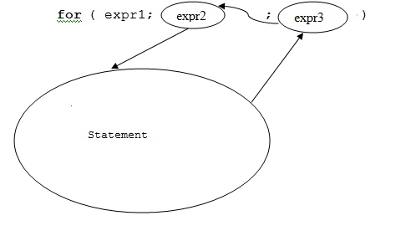

Before the first iteration the expression expr1 is executed and it is executed only once.
The expression expr2 which is a boolean expression is executed. If this expression evaluates to true then the body of the for-loop is executes. The control of execution now executes the expression expr3. Now the control of execution executes the boolean expression expr2. If it evaluates to true the control of execution executes the body of the for-loop. This cycle is repeated again and again until the boolean expression expr2 evaluates to false. At this time the control of execution goes after the loop (after Statement) and executes any statement that is after this for-loop.

Example 6: Let use the for-loop to program example 1.

#include <stdio.h>

int main ()
{ int i;

for(i = 1; i <= 4; i++)
printf("i = %d\n", i);

printf("This message is after the loop\n");
return 0;
}

Execution:

i = 1
i = 2
i = 3
i = 4
This message is after the loop

Note: the instruction i++ increments the variable i by 1.

Description:

In this example first expr1: i = 1 is executed and assigns 1 to i. This variable is our control variable. It controls the number of iterations (here 4 times).
Next the test: i <= 4 is executed. Since the value of i is 1 and 1 is less than 4 the body of the loop is executed for the first time and the output 1 is displayed. Next the instruction: i++ is executed and makes the content of i to be 2.
Next the test: i <= 4 is executed. Since the value of i is 2 and 2 is less than 4 the body of the loop is executed for the second time and the output 2 is displayed. Next the instruction: i++ is executed and makes the content of i to be 3.
Next the test: i <= 4 is executed. Since the value of i is 3 and 3 is less than 4 the body of the loop is executed for the third time and the output 3 is displayed. Next the instruction: i++ is executed and makes the content of i to be 4.
Next the test: i <= 4 is executed. Since the value of i is 4 and 4 is equal to 4 the body of the loop is executed for the fourth time and the output 4 is displayed. Next the instruction: i++ is executed and makes the content of i to be 5.
Finally the test: i <= 4 is executed. Since the value of i is 5 and 5 is not less than 4 and 5 is not equal to 4 the test evaluates to false. The body of the loop will not be executed and the control of execution goes after the body of the loop.

Note that the program is shorter than its counterpart in example 1.

Note: The body of the loop is the first printf. Since this is one statement it does not need to put it in {and } (though you can).
Example 7: The goal of this example is to obtain the sum of numbers: 1, 2, 3,..., n. The value of n is entered via keyboard.

#include <stdio.h>

int main ()
{ int i, n, sum = 0;

printf("Enter a positive integer: ");
scanf("%d", &n);
for (i=1; i <= n; i++)
sum = sum + i;
printf("The sum is %d\n", sum);
return 0;
}

Execution:

Enter a positive integer: 5
The sum is 15

Description:

Since the user enters 5 for n this for-loop iterates five times. Initially the value of sum is zero.
In the first iteration the value of i is 1. This value is added to the value of sum which is 0 by the execution of: sum = sum + i and makes the content of the variable sum to be 1.
In the second iteration the value of i is 2. This value is added to the value of sum which is 1 by the execution of: sum = sum + i and makes the content of the variable sum to be 3.
Similarly the value of sum in the third, fourth, and fifth iteration would be 6, 10, and 15 respectively. The last instruction of the program which is after the body of the for-loop displays this number. Therefore we obtained the sum of: 1 + 2+ 3 + 4 + 5.

Exercise 2: Write a C program to display the power of m by n (i.e. m^{n} ). The program asks the user to enter an integer for the base and enter a positive integer for the power and displays the value of base the result of the base to the power. For example if the user enters 4 for the base and 3 for the power the program should displays: 64.

Below are two samples the execution:

Enter an integer for the base: 5
Enter a positive integer for the power: 2
The result of 5 to 2 is 25

Enter an integer for the base: -5
Enter a positive integer for the power: 3
The result of -5 to 3 is -125

Note: You must not use any built-in function or any power operation (if any) in your program. You must program this exercise using loop(s).
Example 8: Let us rewrite the above example 7 and omit expr1 and expr3 from the parenthesis and put them elsewhere

#include <stdio.h>

int main ()
{ int i = 1, n, sum = 0;

printf("Enter a positive integer: ");
scanf("%d", &n);
for ( i <= n)
{
sum = sum + i;
i++;
}
printf("The sum is %d\n", sum);
return 0;
}

Description:

In this example we put expr1: i=1 before the for-loop. We also put expr3: i++ as the last instruction of the body of the loop. Therefore it is executed after the instruction: sum = sum + i. This means the logic of this and the previous example are the same.

Now I show you that every while-loop can be rewritten by a for-loop. As I described the format of the while-loop is:

while (expression)
Statement;

As you remember the expression: expression is a boolean expression. This can be written with a for-loop as follows:

for ( ; expression ; )
Statement

All I did was adding two semicolons. Here expression is our expr2 in the general definition of the for-loop.

Exercise 3: Write a C program to obtain the sum of n decimal numbers. The value of n and the n decimal numbers (positive, zero, or negative) are entered via keyboard.
The following is two samples of execution. Your program must work for any number of decimal numbers.

Sample execution:

How many numbers do you want to add up? 3
Enter a your number: 6.5
Enter a your number: 3
Enter a your number: 12.5
The sum of your numbers is: 22.000000

Sample execution:

How many numbers do you want to add up? 5
Enter a your number: 2
Enter a your number: -9.5
Enter a your number: 0
Enter a your number: 5.5
Enter a your number: -2
The sum of your numbers is: -4.000000

Exercise 4: Write a program to read a positive integer for n and then reads n decimal numbers and display the smallest of these n decimal numbers. Your program should work for any number of decimal numbers. For example if I enter 100 for n I should enter 100 decimal numbers.

Sample execution:

How many numbers? 3
Enter a number: 1.2
Enter a number: 4
Enter a number: -2.5
The smallest number is -2.500000

Exercise 5: You have found ants in your house and do not like to exterminate them every day. You prefer to call the exterminator when the number of ants would be over one million. Write a program to input the current number of ants and their breeding rate and display the number of ants for day 1, 2, 3, 4, ... until their number goes beyond 1000000.
Note your program should work for any number for the current ants and any breeding rate. In the following execution sample the current number of ants is 100 and every day after the first day they are 6 times of the previous day

Sample execution:

How many ants? 100
What is the breeding rate? 6
Day Ants

1 100
2 700
3 4900
4 34300
5 240100
6 1680700

Exercise 6: Write a program to display the product of a collection of decimal numbers. Your program should ignore any negative number and should terminate when a zero is entered.

Enter a collection of non-zero number and a zero at the end separated by space
2.5 2 -3 4 0
The product of positive numbers is: 20.000000

Section 11
Arrays & I/O text files

1. Introduction

So far the variables we had in our programs were simple variables. There are other kinds of variables and are called structured variables. Array variables are of this kind. It is time to study arrays. As I mentioned in the introduction of the previous section this is the second subject that needs a lot of practice. Once you feel good about this subject I am confident that you have a good background in solving programming problems. When arrays are involved in programs we are dealing with a lot of input values. Therefore it is not practical to enter these many input values via keyboard. It is better to input data value from a text file and output them to a text file.

2. I/O text files

Since for arrays we are dealing with big numbers of data it is not practical to enter the data values via keyboard. It is better to store the values in a text file and let the program read from the file rather than from the keyboard. Similarly outputting a lot of data values on the screen is not good. It is better to output to a text file.

To use files we need to declare them first. The format is:

FILE *myFile;

Note: Do not forget the asterisk. The word myFile is optional we can choose any name.

To use the file’s identifier (e.g. myFile) we should do the following:
1. Declare the file:
For example: FILE *myFile;

2. Relate the file name to the actual text file on the hard drive. The easiest way is having the text file in the same folder that we made for the C program. Suppose the name of the text file is a.txt and we like to open it as an input file. That is a file the program reads from it. We should write:

myFile = fopen("a.txt", "r");

If we like to write to a file named b.txt we should write:

myFile = fopen("b.txt", "w");

Note: If the output file does not exist the system creates an empty file with the name b.txt. On the other hand if it exists the system deletes its content and makes it an empty file.

3. Finally once we do not need the file we should close it (both for input and output file):
fclose(myFile);

4. To write to a file we should use the following built-in function:

fprintf(file-name, "Control String", expression, expression,...., expression)

Note: The file-name is the identifier we declare in our program. The file-name is not the name of the file on the hard drive.
For example:

fprintf(myFile, "%d , %f", x + 5, y * z);

5. To read from a file we should use the following built-in function:

fscanf(file-name, "Control String", address-of-variable, address-of-variable, ..., address-of-variable)

For example:
Note: Once again the file-name is the identifier we declare in our program. The file-name is not the name of the file on the hard drive.
fscanf(myFile, "%d %f", &x, &y);

To create a text file it is better we use the editor of C. In other words we do not need to go out of the C’s editor and make a text file with notepad. We now look at several examples

.Example 1: A program to read a number from a file and displays it on the screen.
Note: When your program reads from a file do not prompt the user asking to enter a number
First use notepad to create file named: a.txt. The content of this file should be a number (like -12).
Now make the following program and run it:
#include <stdio.h>
int main()
{
FILE *myFile;
int x;
myFile = fopen("a.txt", "r");
fscanf(myFile, "%d", &x);
printf("%d\n", x);
fclose(myFile);
return 0;
}

Execution:
-12
Description:
The declaration: FILE *myFile;declares the identifier myFile to be of type FILE.
The statement: myFile = fopen("a.txt", "r");relates the identifier myFile to the file a.txt on the hard drive to be used as an input file (r means read from).
The statement: fscanf(myFile, "%d", &x); reads an integer (that must be in the file a.txt) into the location of the variable x.
The printf prints the value of x on the screen.
The statement: fclose(myFile);closes the file.

Note: The file a.txt must be inside the folder: myProject. This folder is inside the folder: myProject. Therefore save this file in: C:\myProject\myProject.
Note: You must save the text file in the Encoding: ANSI. In the notepad of my Win 7 I have:

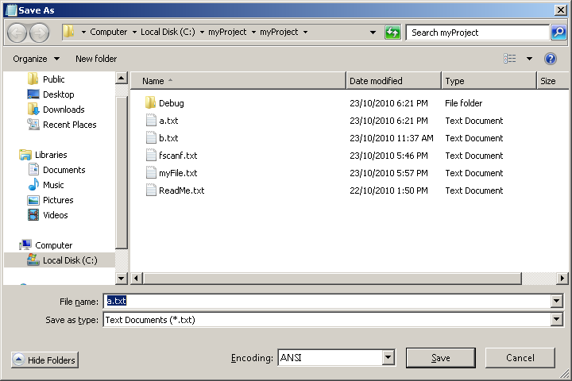

Example 2: The following programs reads ten pairs of numbers from a file named a.txt, multiplies each pair and stores the result into an output file named b.txt.
First we make a text file named a.txt with 20 integers like:

2 3
2 4
3 1
3 5
-2 3
-3 5
4 5
4 6
-5 3
-5 5

We save the file.

Note: We could enter all these numbers on the same line separated by space (or tab).

Note: There is no need to create the output file b.txt. Our C program creates it.

The program is:

#include <stdio.h>

int main()
{
FILE *inFile, *outFile;
int i, x, y;

inFile = fopen("a.txt", "r");
outFile = fopen("b.txt", "w");

for(i = 1; i <= 10; i++)
{
fscanf(inFile, "%d%d", &x, &y);
fprintf(outFile, "%d\n", x * y);
}
fclose(inFile);
fclose(outFile);
return 0;
}

Execution:

No number shows in the DOS window. Bring the newly created file b.txt in to the C editor to see:

6
8
3
15
-6
-15
20
24
-15
-25

Description:

The declaration: FILE *inFile, *outFile; declares identifiers inFile and outFile to be of type FILE.
The statement: inFile = fopen("a.txt", "r");relates the name inFile to the file named a.txt on the hard drive and specifies the file is for “reading from”.

The statement: outFile = fopen("b.txt", "w");creates an empty file named b.txt on the hard drive and specifies the file is for “writing to”
The for-loop iterates 10 times. On each iteration it does the following:
The built-in function call: fscanf(inFile, "%d%d", &x, &y);reads two numbers from the input file and stores them into the location of the variables x and y.
The built-in function call: fprintf(outFile, "%d\n", x * y);writes the product of these two numbers (that are in locations of x and y) to the out file.

Exercise 1: Write a program that reads 20 numbers from the keyboard and stores them in a file named b.txt on the hard drive.

Example 3: The following program read 20 characters from a file and displays them on the screen:

#include <stdio.h>

int main()
{
FILE *inFile;
int i;
char a;

inFile = fopen("a.txt", "r");

for(i = 1; i <= 20; i++)
{
fscanf(inFile, "%c", &a);
printf("%c", a);
}
printf("\n");
fclose(inFile);
return 0;
}

The content of the file a.txt is the following line:

The following program reads 20 characters from a file

Execution:

The following program

Description:

The for loop iterates 20 times. On each iteration a character is read into variable a and displayed on the screen. The important point with this program is to say every symbol is a character. Space is a character, tab is a character, carriage return is a character etc. Count the number of character in the above output line and it should be 20 (including space).

Important Note: A character must be in a single-quotes. A string must be in double-qoutes. Therefore 'x' is a character and "y" is a string with one letter. We cannot write 'abc'. Only one character must be in single-quotes. But we can write "abc". This is a string of length 3 (means there are three characters in the string). Even we are allowed to write "". This is a string of length zero. There is no character in " and ". We can write " ". This is a string of length one. There is a chacater inside " and ". It is the space character. A single space is a character like any other characters. We can write ' '. One character is in single-quotes. It is the space character. We cannot write ''. There must be one character in single-quotes. We do not use the term length for a character. Always there must be one character in single-quotes.

There are special characters that are called escape characters. The symbol \n is one of them. The following table shows the escape character.

Character | Description
\b | Backspace
\t | Horizontal Tab
\n | New Line Feed
\v | Vertical Tab
\f | Form Feed
\r | Carriage Return
\\ | Back slash (solidus)
\' | Single quote
\" | Double quote
\0 | null (String terminator)
\a | Alert (beep sound)

I said only one character must be in single-quotes. But here '\n' it seems we have two. Yes we have two symbols \ and n. The characters in this table are special. They are called escape characters. The term escape character means this character escaped from its ordinary meaning. The symbol 'n' is character n. But the symbol '\n' does not mean n. It means new line. When we print 'n' the letter n shows up. But when we print '\n' no letter shows up. Printing '\n' means move the cursor to the next (new) line. By writing '\n' we escaped from ordinary meaning of character 'n'.
Let us learn some of the special characters through the following example.

Example 4: The following program outputs some of the escape characters to the file b.txt.

#include <stdio.h>

int main()
{
FILE *outFile;

outFile = fopen("b.txt", "w");

fprintf(outFile, "(%c)", 'A');
fprintf(outFile, "(%c)", '\'');
fprintf(outFile, "(%c)", '\t');
fprintf(outFile, "(%c)", '\\');
fprintf(outFile, "(%c)", '\"');
fprintf(outFile, "(%c)", '\n');

fclose(outFile);
return 0;
}

Execution:

(A)(')( )(\)(")(
)

Description:

In this program we surround each character by parentheses ( and ). The first printf prints letter A. The second printf prints a single-quote. The third printf prints a tab. That is first ( shows up, then a tab shows up and then ). It is like we type ( then we hit the tab key and we type ). The fourth printf prints a single back-slash (not two). The fifth printf prints a double-quote. The last printf prints a new-line character. That is first ( show up then the cursor goes to the next line and then ) shows up. Therefore printing '\n' means move the cursor to a new line.

2.1 End of file

Sometimes we like to read all the characters in a file. The question is how to code the program to find out the reading process reached to the end of file. When we make a text file and enter the very last character and close the file one extra invisible character will be added to the end of file. This extra character is called end-of-file character. The built-in function: fscanf not only reads from a file it also returns an integer. When this integer is -1 it means the function fscanf read the end-of-file character.
Let us make a text file named a.txt from the above paragraph.

Example 5: The following program reads all the characters of the file a.txt and displays them on the screen:

#include <stdio.h>

int main()
{
FILE *inFile;
char x;
int b;

inFile = fopen("a.txt", "r");
b = fscanf(inFile, "%c", &x);
while(b != -1)
{
if(31 < x && x <127)
printf("%c", x);
b = fscanf(inFile, "%c", &x);
}
printf("\n");
fclose(inFile);
return 0;
}

Execution:

The program displays:

Sometimes we like to read all the characters in a file. The question is how to code the program to
find out the reading process reached to the end of file. When we make a text file and enter the
very last character and close the file one extra invisible character will be added to the end of file.
This extra character is called end-of-file character. The built-in function: fscanf not only reads from a file it also returns an integer. When this integer is -1 it means the function fscanf read the end- of-file character.

Description:

The statement: b = fscanf(inFile, "%c", &x);does two things:
a) It reads a character from the file and stores it in the location of the variable x.
b) It returns an integer. We assign this integer to variable b. The while-loop iterates until thestatement: b = fscanf(inFile, "%c", &x);.in the body of the loop read the end-of-file character. At this moment the function returns -1 which is assigned to variable b.

To show that we can do the same when the input file has integers (including negative integers) we look at the last example in this section.

Let us make a text file named a.txt of the following integers:

23 22 21 20 19 18 17 16 15 14 13 12 11 10 9 8 7
6 5 4 3 2 1 0 -1 -2 -3 -4
-5 -6 -7 -8 -9 -10 -11 -12

Example 6: The following program reads all the integers of the file a.txt and display them on the screen:

#include <stdio.h>

int main()
{
FILE *inFile;
int x, b;

inFile = fopen("a.txt", "r");

b = fscanf(inFile, "%d", &x);
while(b != -1)
{
printf("%d ", x);
b = fscanf(inFile, "%d", &x);
}
printf("\n");
fclose(inFile);
return 0;
}

Execution:

23 22 21 20 19 18 17 16 15 14 13 12 11 10 9
8 7 6 5 4 3 2 1 0 -1 -2 -3 -4 -5 -6
-7 -8 -9 -10 -11 -12

Note: All these numbers appear on the same line in the DOS window.

Description:
This is similar to the program as the one in example 5. In this program we read numbers from the file rather than characters.
2. Arrays
To find out why we need arrays we look at the following.
Example 7: We like to write a program to read three integers and display them in reverse order.
#include <stdio.h>
int main()
{
int x, y, z;
printf("Enter three integers separated by spaces: ");
scanf("%d %d %d", &x, &y, &z);
printf("The numbers in reverse order are: %d, %d, %d\n", z, y, x);
return 0;
}

Execution:
Enter three integers separated by spaces: 1 2 3
The numbers in reverse order are: 3, 2, 1
Description:
All we need to read these three numbers into three variable x, y, and z and print z, y, x.
This is a simple program. Let us change this program to a program that reads ten thousand numbers and display them in reverse order. Now we need to declare ten thousand variables (rather than three), we also need to write a scanf with these ten thousand variables, and a printf with these ten thousand variables.
Conclusion: It is not practical to write such a program with ten thousand variables (though it is possible in theory).
We need a different kind of variable to handle this problem and this is array. Array has one name with many locations. Let me give you an example. Suppose we have a building named doe. In this building rooms are numbered 0, 1, 2, 3, etc. Now I can say:
doe number 0, doe number 1, doe number 2, doe number 3 or better:
doe[0], doe[1], doe[2], doe[3],.... Therefore doe refers to the building and for example doe[10] refers to room number 10 in this building. As you see we only use one name (doe) and refer to these locations by 0, 1, 2, 3, ...
In this course we deal with arrays of one dimension but we also have two dimensional, three dimensional, four dimensional, etc arrays.
2.1. Array declaration
Like a simple variable that we declare we should also declare the array variable before using it. The format of the declaration of one dimensional array is:
type name[size]
Where type is int, float, char, etc and name is an identifier and size is a positive unsigned integer. For example:

int doe[10]

Means we declare an array named doe with ten consecutive locations (like rooms) of type integer which means we are planning to insert an integer in any of these ten locations. In memory this array is stored as follows:

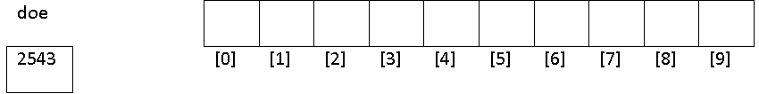

First one location is allocated labeled doe and then ten consecutive locations are allocated. The address of the first element of the array is stored in the location labeled doe. I assumed the address of the first element of the array is 2543. Since we do not know the address of the first location of the array and it is up to the operating system to find where to allocate the array we show an arrow rather than this imaginary address. That is:

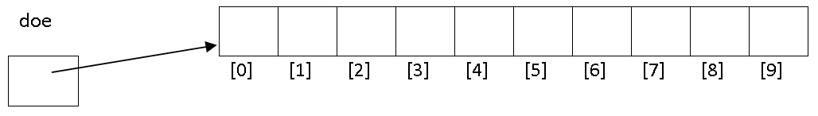

The notations [0], [1], [2], etc are called the subscripts of the array.

2.2 Accessing an element of the array
To refer to each individual location of the array we write:
name[n]
Where name is the name of the array and n is an unsigned positive integer in the range of 0 to (size -1) inclusive. For example for the above array:
doe[2]
Means location with the subscript [2]:
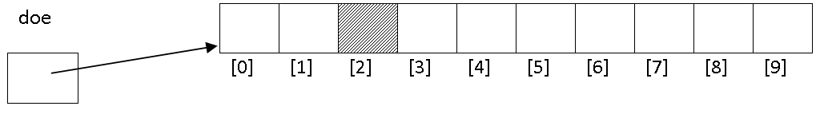

IMPORTANT NOTE: Do not make mistake with [...] in the declaration of and array and [...] in accessing an element (location) of an array:
char x[15];
Means our program is asking the system to allocate fifteen consecutive location for array x of type character:
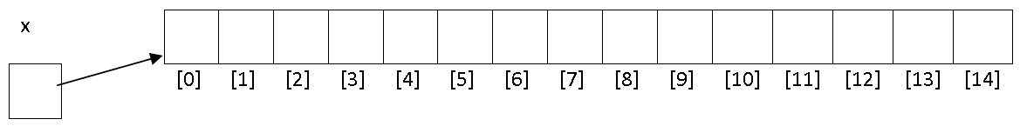
But x[5] means accessing to subscript five. Note that the last element of array is x[14]. We do not have x[15], x[16], etc. The last subscript of an array is one less than its size. The following example shows how to declare and access an array.
Example 8:
#include <stdio.h>
int main()
{
int sales[8];
sales[1] = 12;
sales[5] = 16;
sales[0] = sales[1] + sales[5];
printf("%d\n", sales[0]);
printf("%d\n", sales[1]);
printf("%d\n", sales[5]);
return 0;
}
Execution:
28
12
16
Description:
On the declaration: int sales[8] the system allocates the array in memory as follows:
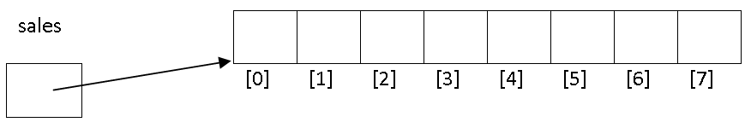After the execution of the assignment statement: sales[1] = 12 the memory configuration is:
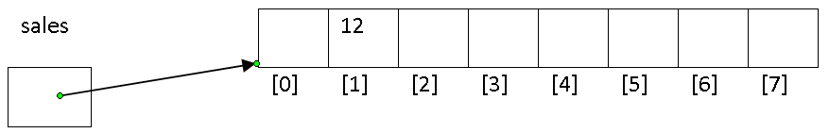
After the execution of the assignment statement: sales[5] = 16 the memory configuration is:
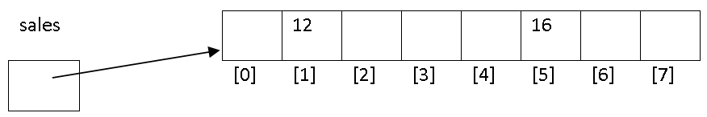
The execution of the assignment statement: sales[0] = sales[1] + sales[5]is done as follows:
a. The system evaluates the expression: sales[1] + sales[5]. This means the system takes a copy of the content of the location: sales[1], (which is 12) then takes a copy of location: sales[5],(which is 16), then evaluates 12 + 16 to 28.
b. The system stores 28 in the location: sales[0]. The memory configuration for the array would be:
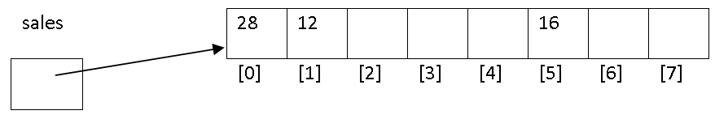
The printfs access to subscripts sales[0], sales[1] and sales[5] and print 28, 12 and 16 respectively.
2.3 Initializing arrays
As I mentioned in the previous Section we can declare and initialize a simple variable. For example:
int a = -23
We can also declare and initialize arrays. For example:
int sales[8] = {0, 12, 0, 0, 0, 16, 0, 0}
We do not have to give the size of the array. We can write the following and the C compiler understand that the size of the array is 8:
int sales[] = {0, 12, 0, 0, 0, 16, 0, 0};
Note that we have to initialize every element of the array. Initializing arrays are not as practical as initializing simple variable. Imagine we want to declare and initialize an array of size 10000. We have to enter 10000 numbers in { and }.
2.4 Some applications of arrays
Arrays are combined with loops. Without using loops it would not be practical to handle big sized arrays.
Example 9: The following program reads from a file named a.txt of integers and display them in reverse order. The name of the input file is a.txt and has the following seven numbers:
23 22 21
6 5
-1 -2 -3
#include <stdio.h>
int main()
{
FILE *inFile;
int x, b, n = -1, i;
int a[10000];
inFile = fopen("a.txt", "r");
b = fscanf(inFile, "%d", &x);
while(b != -1)
{
n++;
a[n] = x;
b = fscanf(inFile, "%d", &x);
}
for (i = n; i >= 0; i--)
printf("%d ", a[i]);
printf("\n");
fclose(inFile);
return 0;
}

Execution:
-3 -2 -1 5 6 21 22 23

Description:
The array size 10,000 which means it has 10,000 consecutive locations. But we only have 8 numbers. This is because we like our program works for a file up to 10,000 numbers.
Since we have 8 numbers in the input file the while loop iterates 8 times.
When the control of execution reaches the while loop (before executing it) we have the following memory configuration:

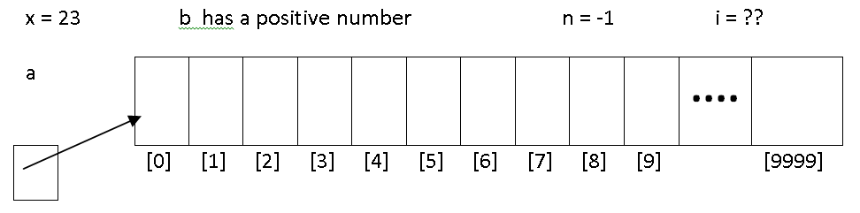
After the first iteration of the while loop we have the following memory configuration:

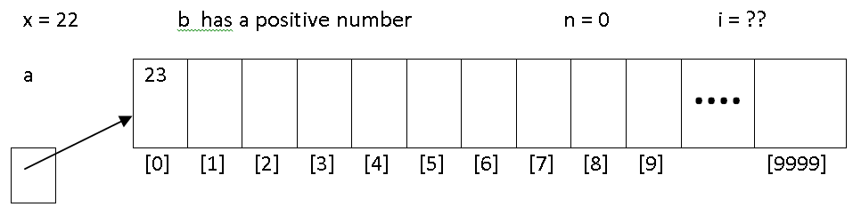
After the second iteration of the while loop we have the following memory configuration:

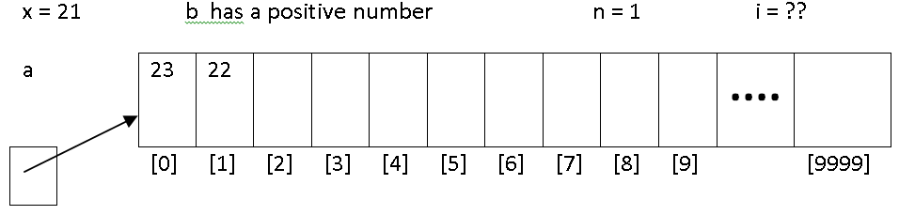

After the third iteration of the while loop we have the following memory configuration:
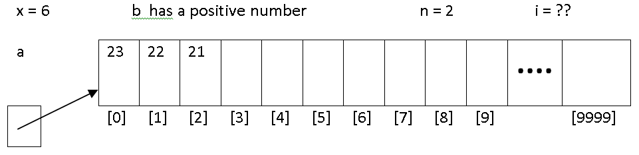

After the fourth iteration of the while loop we have the following memory configuration:

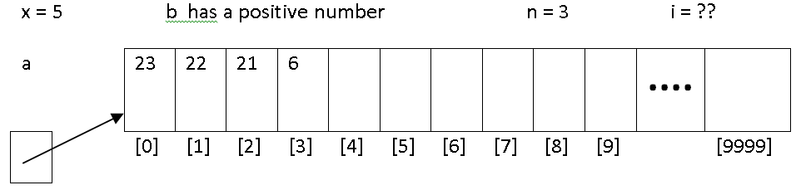

After the fifth iteration of the while loop we have the following memory configuration:

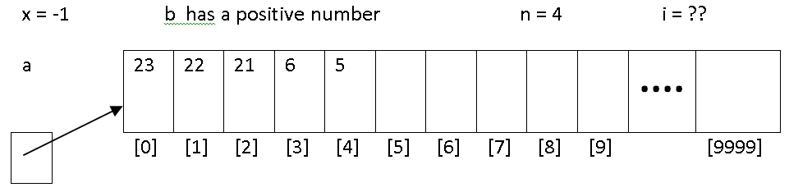

After the sixth iteration of the while loop we have the following memory configuration:

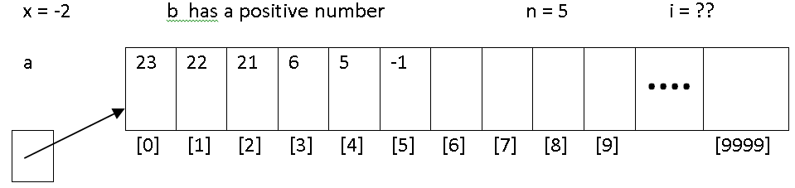

After the seventh iteration of the while loop we have the following memory configuration:

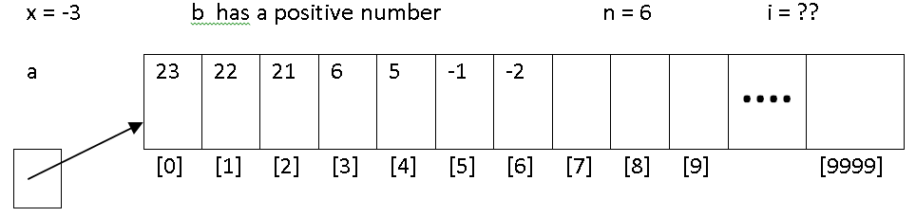

After the eighth iteration of the while loop we have the following memory configuration:

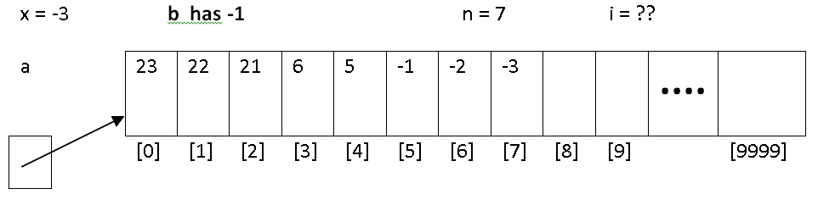

At this moment since the content of b is -1 the while loop does not iterate anymore and the control of execution reaches to the for-loop to execute it. The value of n (which is 7) shows up to which subscript of this big-sized array have been filled up.
In the for-loop:

for (i = n; i >= 0; i--)
printf("%d ", a[i]);
The value of i becomes 7.
On the first iteration of the for-loop since the value of i is 7 the content of a[7] (which is -3) is displayed. After the execution i-- the value of i becomes 6
On the second iteration of the for-loop since the value of i is 6 the content of a[6] (which is -2) is displayed. After the execution i-- the value of i becomes 5
....

On the eighth iteration of the for-loop since the value of i is 0 the content of a[0] (which is 23) is displayed. After the execution i-- the value of i becomes -1.
At this point the condition i >= 0 is evaluates to false and the for-loop does not iterate anymore.
Exercise 2: Make the size of the above array 5. Change the program such that when the array filled up with 5 numbers it does not read anymore number from the file.
Exercise 3: Write a program to read all the characters (at most 1000) from an input file. The program should replace every space character by the last character.

For example if the content of the input file is:
So far the variables we had in our programs were simple variables. There are other kinds of
variables and are called structured variables.
Array variables are of this kind@
The output should be:
So@far@the@variables@we@had@in@our@programs
were@simple@variables.@There@are@other@kinds@of
variables@and@are@called@structured@variables.
Array@variables@are@of@this@kind@
So far the variables we had in our programs were simple variables. There are other kinds of variables and are called structured variables. Array variables are of this kind. It is time to study*

Exercise 4: Write a program to read a positive integer (at most 100) for n then reads n decimal numbers from an input file. The program should print the average of the n number. The program should also print the numbers with one of the message: It is above average, It is the same as average, It is below average.
Note: This is just an example. Your program should work with any number of characters.
Note that the type of your array is float.
Note that you are not investigating the end of the file. It is the value of n that shows how many decimal numbers should be read from the file.
Note that every element of an array is a simple variable. Any thing you do with a simple variable you can do with an element of an array.

For example if the content of the input file is:
4
1.5 22.3 -1.5 7,6

The output should be:
The average is: 7.325000
1.500000: Below average
22.299999: Above average
-1.500000: Below average
7.000000: Below average

Exercise 5: Read some decimal numbers (at most 100 numbers) from an input file. The program should print the average of the n number. The program should also print the numbers with one of the message: It is above average, It is the same as average, It is below average.
Note: This is just an example. You program should work with any number of decimal numbers.
Note that the type of your array is float.
Note that you must investigate the end of the file.
Note that every element of an array is a simple variable. Any thing you do with a simple variable you can do with an element of an array.

For example if the content of the input file is:
1.5 22.3 -1.5 7.6
The output should be:
The average is: 7.325000
1.500000: Below average
22.299999: Above average
-1.500000: Below average
7.000000: Below average
Note: This is just an example. You program should work with any number of decimal numbers.

To remove an element of an array we should shift part of the array to the left to fill the location that we remove.

Example 10: The following program removes the 8th element of the array. The fifth element is in subscript 4 (i.e. a[7]).
#include <stdio.h>
int main()
{
int a[] = {9, 2, 8, 3, 4, -3, 66, -2, 12, -23, 6}, i;
for (i = 7; i < 11; i++)
a[i] = a[i+1];
for (i = 0; i < 10; i++)
printf("%d", a[i]);
printf("\n");
return 0;
}
Execution:
9 2 8 3 4 -3 66 12 -23 6
Description:
The eighth element of the array is a[7] which is -2. The size of array is 11. After the removal of this element the size of filled portion of the array is 10 (not eleven).
Initially the array configuration is:
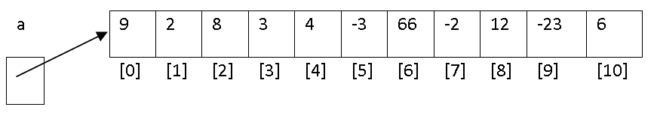

In the first iteration of for loop since the value of i is 7 by execution of: a[7] = a[8] the value 12 is copied to a[7]:

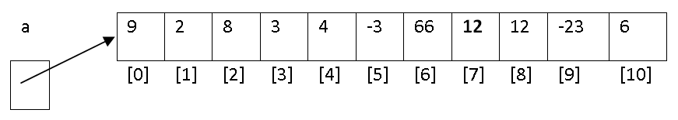

In the second iteration of for loop since the value of i is 8 by execution of: a[8] = a[9] the value -23 is copied to a[8]:

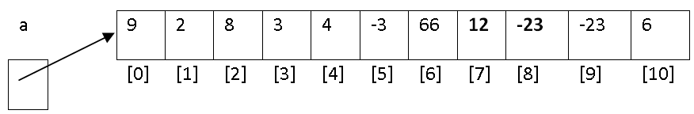

In the third iteration of for loop since the value of i is 9 by execution of: a[9] = a[10] the value 9 is copied to a[9]:

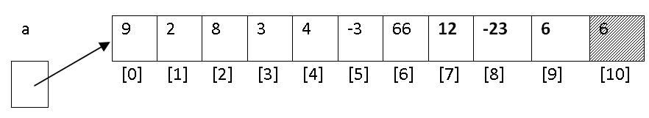
Note that the element a[10] must be ignored. We cannot blank number 6 in memory location. But for us this location is free and we can fill it with a new number.

Exercise 6: Change the program to accomplish the following:
The program reads a positive number (maximum 100) for n and n decimal numbers from an input file named a.txt. The program then reads a positive number for m. The program removes the mth element (which is in subscript m-1). The program displays the array.
For example if the content of the input file is:
10
9.5 2.3 8.5 3 4.5 -3.7 5 -2.5 12 -2 6.5
5
The following list should be displayed:
9.50 2.30 8.50 3.00 -3.70 66.00 -2.50 12.00 -2.00 6.50

.Exercise 7: Write a program to accomplish the following:
Note: This is just an example. You program should work with any number of decimal numbers
The program reads a positive number (maximum 100) for n and n decimal numbers from an input file named a.txt. The program then reads a positive number for m and a decimal number for x. The program inserts the value of x in subscript mth.
For example if the content of the input file is:

10
9.5 2.3 8.5 3 4.5 -3.7 5 -2.5 12 -2
5 123.45

The following list should be displayed:

9.5 2.3 8.5 3 4.5 123.45 5 -2.5 12 -2

Note: This is just an example. Your program should work with any number of decimal numbers.
Array is a powerful data structure. We can program many problems. An interesting problem is sorting a list of values. There are many sorting algorithms. Let us look at one of this algorithm through an example called bubble sort.
Bubble sort is based on swapping out-of-order pairs of data items, in sequence, so as to bubble to the top of the array (if pictured vertically) the largest data item. That largest item is somehow marked as done and the same game of bubbling the largest (of the rest of the data items) to the top is played all over again, etc. Thus we get the largest at the top, then the second largest, then the third largest, etc.
For example suppose we have five numbers: 9, 2, 8, 3, 4. We do the following:
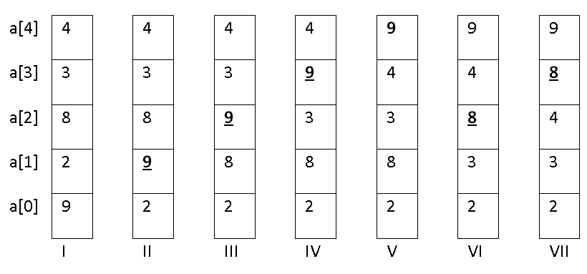First number 9 from the bottom (a[0]) bubbles up location by location (see I through V). Next number 8 bubbles up (see VI and VII)

Example 11: The following program executes the bubble sort algorithm.
#include <stdio.h>
int main()
{
int a[] = {9, 2, 8, 3, 4}, i, j, temp;
for (i = 1; i < 5; i++)
for (j = 0; j < 4; j++)
if (a[j] > a[j+1])
{
temp = a[j];
a[j] = a[j+1];
a[j+1] = temp;
}
for (i = 0; i < 5; i++)
printf("%d ", a[i]);
printf("\n");
return 0;
}

Execution:

2 3 4 8 9

Description:
The body of first for-loop (i.e. for (i = 1; i < 5; i++)) has one statement and this is the second for loop. The body of the second for loop (i.e. for (j = 0; j < 4; j++)) also has one statement and this is the if-statement.

The initial memory configuration for this program is:

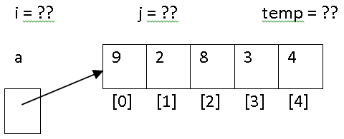

On the first iteration of the top for loop and after the first iteration of the nested for-loop we have the following memory configuration:

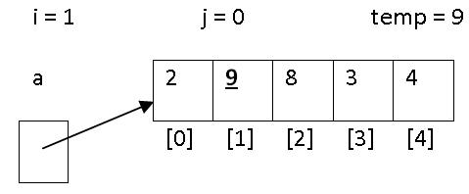

On the first iteration of the top for loop and after the second iteration of the nested for-loop we have the following memory configuration:

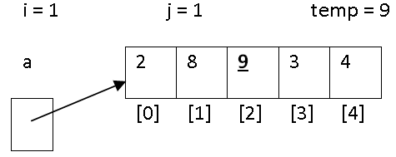

On the first iteration of the top for loop and after the third iteration of the nested for-loop we have the following memory configuration:

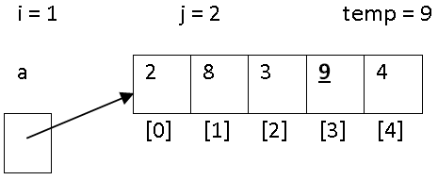

On the first iteration of the top for loop and after the fourth iteration of the nested for-loop we have the following memory configuration:

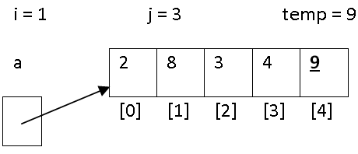

On the second iteration of the top for loop and after the first iteration of the nested for-loop we have the following memory configuration:

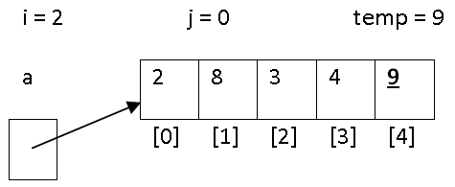
No change on the array since 2 is not greater than 8.
On the second iteration of the top for loop and after the second iteration of the nested for-loop we have the following memory configuration:

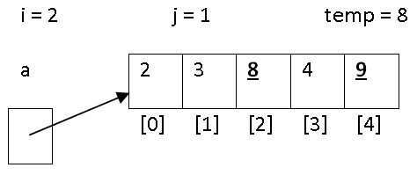

On the second iteration of the top for loop and after the third iteration of the nested for-loop we have the following memory configuration:

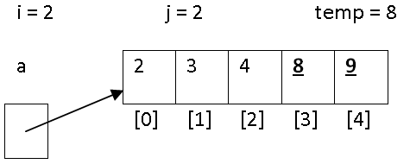

On the second iteration of the top for loop and after the fourth iteration of the nested for-loop we have the following memory configuration:

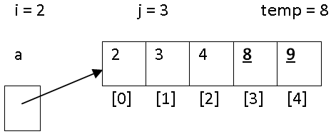

No change on the array since 8 is not greater than 9.
On the third iteration (i = 3) of the top for loop and after the all four iterations (j = 0, 1, 2, 3) of the nested for-loop no change happens on the array.
On the fourth iteration (i = 4) of the top for loop and after the all four iterations (j = 0, 1, 2, 3) of the nested for-loop no change happens on the array.
At this time the value of i becomes 5 and the top for-loop terminates.
Exercise 8: Change the above example to accomplish the following:
The program reads a positive number for n and n decimal numbers from an input file named a.txt, sorts these n numbers in ascending order and displays them on the screen.
For example if the content of the input file is:
10
9.5 2.3 8.5 3 4.5 -3.7 5 -2.5 12 -2 6.5

The display output should be:
-3.70 -2.50 -2.00 2.30 3.00 4.50 5.00 8.50 9.50 12.00

Exercise 9: Change the above example to accomplish the following:
Note: This is just an example. You program should work with any number of decimal numbers.
The program reads a positive number for n and n decimal numbers from an input file named a.txt, sorts these n numbers in descending order and displays them on the screen.
For example if the content of the input file is:
10
9.5 2.3 8.5 3 4.5 -3.7 5 -2.5 12 -2 6.5

The display output should be:
12.00 9.50 8.50 5.00 4.50 3.00 2.30 -2.00 -2.50 -3.70

Exercise 10: Change the above example to accomplish the following:
Note: This is just an example. You program should work with any number of decimal numbers.
The program reads characters from an input file named a.txt that has only one line, sorts these characters in ascending order and displays them on the screen. Assume the input file does not have more than 1000 characters. Save the editor while the cursor is blinking after the first line.
For example if the content of the input file is:
ifegdhcba

The display output should be:
abcdefghi

Note: This is just an example. You program should work with any number of characters on the same line.
Section 12
Functions

1. Introduction
Let us close this tutorial with functions. In most of the languages we have functions. In Java they are called methods, in assembly languages are called subroutines and in C are called functions. We have two categories of functions:
a. Built-in functions that we simply call (use, activate) them.
b. The function that we declare (define) in our programs and call them one or more times. In this case the declaration of a function is like describing a recipe for a cake. The function’s call is like doing the recipe to make the cake. Therefore a function’s declaration is like a recipe on the wall and a function’s call is like making a cake by following the instructions of the recipe. We can have one recipe and can make one, two, three and many cakes with the same recipe. Therefore we can have one function and call it one, two and many times.

2. Built-in functions
In C like all the high-level languages there are many built-in functions. In this section we look at the built-in functions for character and string manipulation.
In this section we look at built-in functions for characters and strings. However there are other built-in functions for handling files, mathematical and memory allocation built-in functions.

2.1. Built-in functions for a character
We look at some of these built-in functions. These are explained in the following table.

Note: That true means a non-zero number and false means a zero.

Function | Description | Examples
isalnum(character) | If character is alphanumeric 0-9, A-Z, or a-z returns true otherwise returns false. | isalnum('B' returns true  isalnum(' ') returns true  isalnum('?') returns false
isalpha(character) | If character is alphabetic returns true otherwise returns false. | isalpha('B') returns true  isalpha ('5') returns false  isalpha ('?') returns false
isdigit(character) | If character is a digit character returns true otherwise returns false. | isdigit('B') returns false  isdigit ('5') returns true  isdigit ('?') returns false
islower(character) | If character is a a-z character returns true otherwise returns false. | islower('a') returns true  islower('A') returns false  islower('?') returns false
isupper(character) | If character is a A-Z character returns true otherwise returns false.
tolower(character) | Returns the lower case of character. | tolower('A') returns a  tolower('a') returns a  tolower('+') returns +
toupper(character) | Returns the upper character of character. | toupper('a') returns A  toupper('A') returns A  toupper('+') returns +

These functions are in the header file ctype.h. The flowing example is using these built-in functions.

Example 1: The following program reads 7 characters performs several tests and convert the 6th and the 7th character to lower and upper case respectively:

#include <stdio.h>
#include <ctype.h>

int main ()
{
char a, b, c, d, e, f, g;
printf("Enter 7 characters: ");
scanf("%c%c%c%c%c%c%c", &a, &b, &c, &d, &e, &f, &g);
if(isalnum(a))
printf("%c is either a letter or a digit.\n", a);
if(isalpha(b))
printf("%c is a letter.\n", b);
if(isdigit(c))
printf("%c is adigit.\n", c);
if(islower(d))
printf("%c is a lower case character.\n", d);
if(isupper(e))
printf("%c is an upper case character.\n", e);
printf("The lower case of %c is: %c.\n", f, tolower(f));
printf("The upper case of %c is: %c.\n", g, toupper(g));
return 0;
}

Execution:
Enter 7 characters: 5A2mUTn
5 is either a letter or a digit.
A is a letter.
2 is a digit.
m is a lower case character.
U is an upper case character.
The lower case of T is: t.
The upper case of n is: N.

Description:
The user entered seven character 5A2mUTn for the variables a, b, c, d, e, f, and g respectively. Therefore the value of the variable a is '5', b is 'A', c is '2', d is 'm', e is 'U', f is 'T', and g is 'n'. The conditions of all five if-statements are evaluated to true. And the program displays the first output lines. The 8th and 9th printf’s display the lowercase of letter T and uppercase of letter n.

2.2. Built-in functions for Strings

A string is an array of type character with the escape character '\0' as its last element. This escape character tells the compiler that it is reached to the end of the string. To clarify this we look at the following example.
Example 2: The following program prints two string one that has '\0' as its last character and that does not have.

#include <stdio.h>
int main ()
{
char a[] = {'a', 'b', 'c', '\0'};
char b[] = {'e', 'f', 'g'};
printf("%s\n", a);
printf("%s\n", b);
return 0;
}

Execution:
abc
efgieÖ6Ü0±

Description:

The directive for printing a string is: %s. With this directive the compiler keeps printing the consecutive characters until it hits '\0'. The first printf displays the string abc correctly. But the second printf not only displays efg it also prints some funny characters like: ieÖ6Ü0±. What happened is:
The compiler keeps printing consecutive characters until it finds a '\0' somewhere in a memory location and then stops printing. Therefore the size of the array does not matter for the printing purpose. In the second printf the compiler printed the content of b[0], b[1], b[2], b[3], b[4], b[5], b[6], b[7], b[8] and b[9]. The compiler found the escape character ‘\0' in b[9]. Note that the size of array b is three but the compiler went out of bound of the array and printed these funny characters. If you run this program again you will get different funny characters and will get fewer or more of these. This is because the compiler looks for the escape character '\0' and this time it finds it in a different place in memory.
In short: The escape character '\0' flags the end of a string. All built-in functions for strings work based on the assumption that there is this escape character at the end of each string.
Note: We can write the declaration: char a[] = "abc" in place of char a[] = {'a', 'b', 'c', '\0'} in the above program. This means by writing "abc" we initialize a[0], a[1], a[2], a[3] to 'a', 'b', 'c', and'\0' respectively.

Note: When your program reads a string by the directive %s the compiler adds the escape character '\0' to the end of it automatically.
Example 3: The following program reads a string and prints it.
#include <stdio.h>
int main ()
{
char a[100];
printf("Enter a string: ");
scanf("%s", a);
printf("%s\n", a);
return 0;
}
Execution:
Enter a string: John
John

Description:
Obviously this time we did not initialize our array because the program reads from the keyboard. With the size of 100 the user can enter up to 99 characters because there should be room for the escape character '\0'. Since in the above execution entered 4 characters only the first 5 locations of array are filled up.
Note that it is wrong to write: scanf("%s", &a). Remember that in general we have scanf(“...”,address) which means read something and store it in the location(s) whose address (es) start at address. In the statement: scanf("%s", a) variable a contains an address which is the address of the first element of the array

Note: With the directive %s in scanf (and not in printf) the compiler reads the consecutive characters until it hits a space or end-of-line character. In the above execution the compiler reads four characters and stops at the end of line. If you enter: John Doe only the word John is read and the compiler stops on the space after John. The question now is how we make the compiler to read the whole line. The answer to this is using the built-in function gets explained in the following table.
Some of the built in functions for strings are listed in the following table:
In this table we assume the variables x and y contain "abc" and "efgh" respectively. In this table we name the strings dest (for destination) and src (for source);

Function | Description | Examples
gets(dest) | Reads a line and gives it to dest | Reads a line and assign it to string
strcat(dest, src) | Adds the string src to the front of dest. | After the execution:  strcat(x, y)  The content of x is: "abcefgh"
strcmp(dest, src) | Return a:  Negative integer if dest comes before src  Positive integer if dest comes after src  Zero if dest and src are the same.
strcpy(dest, src) | copies src into dest | After the execution strcpy(x, y) the variable y has "abc"
strlen(string) | Returns the length (number of characters) of the string | strlen(x) returns 3

* NULL means a string with no character inside. NULL means a string with length zero. NULL means: "". Note that there is no space in " and ".

Note: The header file for these functions is <string.h>

Note: It is wrong to use assignment statement to copy a string. The statement dest = src does not copy src to dest.
Example 4: The following program applies gets to read and display a string:

#include <stdio.h>
int main ()
{
char x[100];
printf("Enter a sreing: ");
gets(x);
printf("You enterd: %s\n", x);
return 0;
}

Execution:
Enter a string: John Doe
You entered: John Doe

Description:
The function gets reads the whole line of the input to the variable x.

Example 5: The following program uses the functions in the above table. To make the program small enough I did not use gets in this program.

#include <stdio.h>
#include <string.h>
int main ()
{
char x[] = "abc", y[] = "xyabcutabcm", z[] = "???";
int len;
if (strcmp(x, y) == 0)
printf("Both strings are the same.\n");
else if(strcmp(x, y) < 0)
printf("%s comes before %s in a dictionary.\n", x, y);
else
printf("%s comes after %s in a dictionary.\n", x, y);
printf("The content of variable z is: %s\n", z);
strcpy(z, x);
printf("The new content of variable z after coping x to it is: %s\n", z);
len = strlen(x);
printf("Varibale x has %d characters\n", len);
printf("The content of variable x is: %s\n", x);
strcat(x, y);
printf("The new content of x after adding the sting in y to the front of it is: %s\n", x);
return 0;
}

Execution:
abc comes before xyabcutabcm in a dictionary.
The content of variable z is: ???
The new content of variable z after coping x to it is: abc
Variable x has 3 characters
The content of variable x is: abc
The new content of x after adding the sting in y to the front of it is: abcxyabcutabcm

Description:
The strcmp(x, y) of the first if-statement returns a negative number because the string "abc" is less than the string "xyabcutabcm".
The function call strcpy(z, x) copies the content of x (i.e. "abc") to variable z.
The function call strlen(x) returns the length (number of characters) of x which is 3.
The call strcat(x, y) adds the content of y (i.e. "xyabcutabcm") to the front of the string of variable x.

Example 6: The following program uses the built-in function pow to obtain the power of an expression to another expression (i.e. expression1^{expression2}). You need this function for one of the exercises.

#include <stdio.h>
#include <math.h>
int main()
{
float base, power;
printf("Enter a number for base and power: ");
scanf("%f%f", &base, &power);
printf("%.3f\n", pow(base,power));
return 0;
}

Execution:
Enter a number for base and power: 2.5 3
15.625

Description:
The user enters two numbers 2.5 and 3 and the program displays the result of 2.5³. Note that the math functions are in the header file: math.h

3. User defined functions

As the programs get bigger and bigger there is a need to split it into several independent segments. Coding and debugging of a small segment is much easier than a big program. We declare (define) functions for several reasons.
1. We define a function and can call it several times instead of repeating a code segment several times. It is like of one recipe and making several cakes.
2. A manager of a programming company can split the solution of a big project into several smaller projects, gives each of these small projects to a member of his team to program it as a function and then put these functions together to accomplish the big project.
The general format a function declaration is:

type name (parameter, parameter,..., parameter)
{
Statement;
Statement;
....
Statement;
}

The type could be any type we learned so far (int, float, char etc) and a new type called void.
The name is the name of the function.
The function can have zero or more parameters.
You have already declared a function from the beginning of C. This function is main.
The definition of a function is like a blue print of a house. We do not have the house yet unless we make one or several of them using the blue print. A function call is like making one house. The general format of a function call is:
Name (argument, argument,..., argument);

3.1 Function with no parameter and no return value

This is the simplest kind of function. When we use void as the type of a function this function does not return any value.

Example 7: The following program calls a function twice to display a message twice.
#include <stdio.h>
void f();
int main ()
{
f();
f();
return 0;
}

void f()
{
printf("Hello World\n");
}

Execution:
Hello World
Hello World

Description:

The instruction: is called a prototype. It is the heading of our function definition. We must have the prototype before the call of a function. We normally write the prototypes on top of the program after all the header files (#include ....). We normally write the definition of our functions after the body of main.
In this program we defined one function whose name is f. The function has no parameter. The function does not return any value to its caller (which is main). Unless we do not call the function it is not going to be executed (unless we do not make a house the blue print is not done). This function is called twice in main. On each call the control of execution executes the statement(s) of the body of the function. Once this is done the control of execution goes back to the caller (i.e. main) after its call. For example on the first call (i.e. f( )) once the printf is executed the control of execution goes back to main after the first call of f and now implements the second call. On the second call the printf is executed again and the control of execution returns back to main after the second call (f( )) to execute the statement return 0.
Question: If you comment both calls what is displayed? Why?

3.2 Function with no parameter and return value

We have already seen this kind of function. The function main returns 0. When a function returns a value we must either have its call as part of an expression. It is bad program if we call the function as an isolated statement.
Example 8: The following program shows how to use the returned value of a function. The function simply returns 4.
#include <stdio.h>
int f();
int main ()
{
int x;
x = f() + f() + 10;
printf("%d\n", x);
printf("%d\n", f() + f() + 10);
return 0;
}

int f()
{
return 4;
}

Execution:
18
18

Description:
Since the function returns an integer the function is not of type void anymore. The prototype of the function: int f() shows its type is int. This prototype is the heading of the definition of the function. The instruction: return 4 returns 4 to the caller. Think like this:
After the call in your mind replace the call by its return value. In other words in your mind after the first call is over you have: x = 4 + f() + 10 and after the second call is over you have: x=4 + 4 + 10. Therefore the value of x is 18. As I mentioned above a function that returns a value must be called in an expression. In the above program we call the function 4 times.

3.3 Function with parameters

This is the most general and important case. Let us follow this kind of function through the following simple example:
Example 9: The following program displays the result of the addition of two expressions.
#include <stdio.h>
void f(int x, int y);
int main ()
{
int a = 2, b = 3;

f(a, b);
f(a + 2, b - 1);
return 0;
}

void f(int x, int y){
printf("%d\n", x + y);
}

Execution:
5
6
Description:
I explain a detailed description for this program.
A. The prototype still is the heading of the function definition.
B. In the heading of the function definition: void f(int x, int y). We have two parameters int x and int y. Like declaration of a variable a parameter has a type and a name (that is all).
C. In the call: f(a, b)we must have two arguments (that we have). The two arguments of the function call are a and b. Every argument must be an expression. In: f(a, b) a is an expression (think of a + 0) and b is an expression (think of b + 0). In the second call: f(a + 2, b - 1) it is so clear that the arguments: a + 2 and b – 1 are expressions. The following paragraph is the most important part of this Section. Never forget it.

At the time of a call of a function the system allocates locations for the parameters and local variables (if any). The arguments (expressions) of the call are evaluated. The value of each argument is copied in to the location of its corresponding parameter (the first value to the location of the first parameter and the first second to the location of the second parameter, etc). After this the body of the function is executed. Once the execution of the body is completed those locations of the parameters and local variables are de-allocated (removed) and the control of execution goes back to the caller.

The following figure shows this mechanism for the first call: f(a, b)

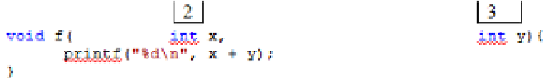
This is the definition of the function. I only made enough spaces between s and y to show the location of these two parameters. The system allocated two location (container) for parameters x and y. The system then copied the value of expression a (which is 2) in the location of its parameter (i.e. x) and copied the value of the expression b (which is 3) into its corresponding parameter’s location. Now the system executed the body of the function (which is the printf). The printf displays the value of x + y (which is 5). Now the system removes the locations x and y:

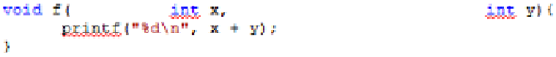
At the time of the second call: f(a + 2, b - 1) we have the following configuration:

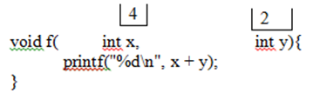
The system allocates a new memory location for x and a new memory location for y. The value of a + 2 goes into the location x and the value of b – 1 goes into the location y. The system prints the value of x + y. After this these two locations are de-allocated.
Once again: Remember the above boldfaced paragraph all the time (I suggest you do this for several programs by hand).

3.3.1. Arrays as arguments
In this section we see how arrays are used as arguments. Let us see this trough an example.
Example 10: We would like to write a program to negate elements of an array.
#include <stdio.h>
void doNegate(int x []);
int main ()
{
int a[] = {2, 5, 12, 10};
int i;
doNegate(a);
for(i = 0; i < 4; i++)
printf("%d", a[i]);
printf("\n");
return 0;
}

void doNegate(int x[])
{
int k;
for(k = 0; k < 4; k++)
x[k] = - x[k];
}

Execution:
-2 -5 -12 -10
Description:
In the heading (prototype) of the function doNegate: void doNegate(int x []) we declare the parameter x to be an array of type integer by: int x []. Note that x is an array variable and not a simple variable. For a simple variable of type integer we write: int x. Note that it is always better not to write the size of the array and leave [ and ] to be empty. In main when we do not initialize an array we have to write its size.
The memory configuration for array a in the main function is:
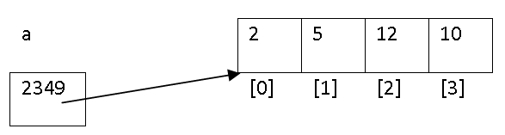As I explained in the previous Section the content of a is the address of the first element of the array. I am assuming this address is 2349.
Let us follow the bold-faced paragraph above to see how array works. We exactly follow this paragraph:

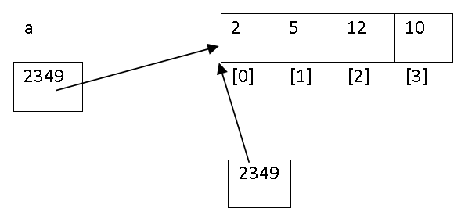
void doNegate( int x[])
{

int k;

for(k = 0; k < 4; k++)
x[k] = - x[k];
}

Go back and read the boldfaced paragraph. This time we have a local variable which is k. Therefore at the time of the call a location for k is allocated. Look at the figure carefully. Didn’t I say at the time of the call the value of the argument is passed into the location of its parameter? In the call: doNegate(a) what is the value of the variable a? The answer is: It is the content of a. The content of a is 2349. This content is copied to the parameter x. This means x now holds the address of the first location of the array. Whatever we do with x[0] to x[3] is like we do with a[0] to a[3]. By the for-loop of the body of the function the content of the local variable k would be 0, 1, 2, 3 and by x[k] = - x[k] we assign the negative of each element to the same element of the array. Therefore after the call we have the following configuration:

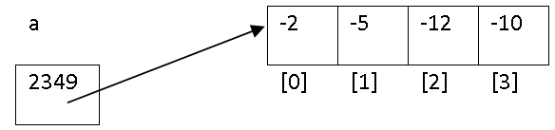
void doNegate(int x[])
{
int k;

for(k = 0; k < 4; k++)
x[k] = - x[k];
}
As you see the locations of the local variable k and the parameter x are disappeared.

To see how an array as an argument is useful we look at the following example.

Example 11: We would like to swap the content of two locations.

First try with simple variables:

#include <stdio.h>

void swap(int x, int y);

int main ()
{
int a = 2, b = 3;
printf("Before swap the content of a =%d, and the content of =%d\n",a,b);
swap(a, b);
printf("After swap the content of a =%d, and the content of b = %d\n",a,b);
return 0;
}

void swap(int x, int y)
{
int temp;
temp = x;
x = y;
y = temp;
}

Execution:

Before swap the content of a = 2, and the content of b = 3
After swap the content of a = 2, and the content of b = 3

Description:
It did not work. Let us look at the memory configurations I, II, III, IV, and V when swap is called:

I)

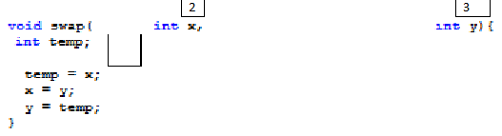
The value of arguments a and b are passed to the location of parameters x and y.

II)
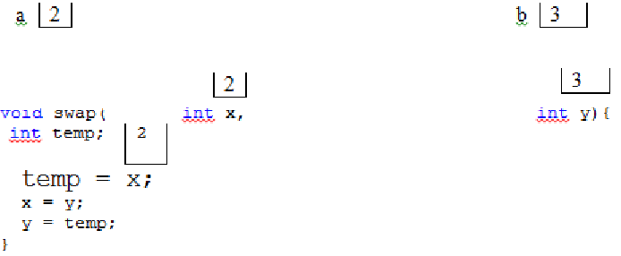
The assignment statement temp = x is executed.

III)
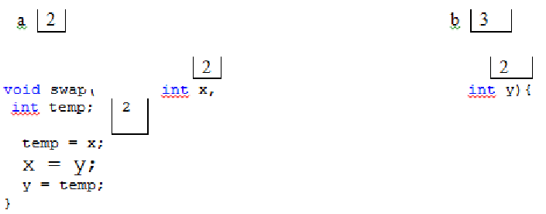

The assignment statement x = y is executed.

IV)
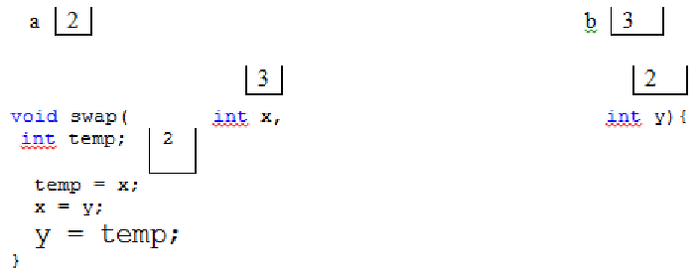
The assignment statement t = temp is executed. Note that the content of the locations x and y are swapped. So far nothing happened to locations a and b
V)

a | 2 | b | 3

The execution of the function is completed and the control of execution went back to the caller (which is main) after the call to execute the second printf.
As you see the content of locations a and b remained the same. Therefore the first try did not work.

Second try with array:

#include <stdio.h>
void swap(int x[]);
int main ()
{
int a [] = {2, 3};
printf("Before swap the content of a[0]=%d, and the content of a[1]= %d\n",
a[0], a[1]);
swap(a);
printf("After swap the content of a[0]=%d, and the content of a[1] = %d\n",
a[0], a[1]);
return 0;
}

void swap(int x[])
{
int temp;

temp = x[0];
x[0] = x[1];
x[1] = temp;
}
Execution:
Before swap the content of a[0] = 2, and the content of a[1] = 3
After swap the content of a[0] = 3, and the content of a[1] = 2

Description:
The second try worked. Let us look at the memory configurations A, B, C, D, and E

A)

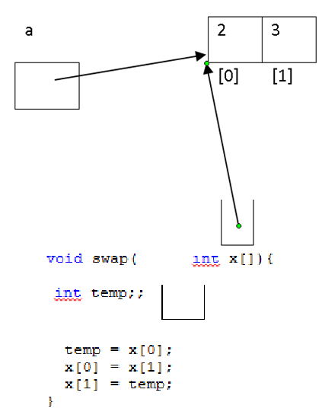
The value of arguments a (which is the address of the first element of array) is passed to the location of parameters x.

B)

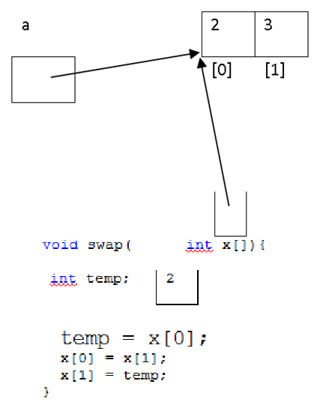
The assignment statement temp = x[0] is executed.

C)
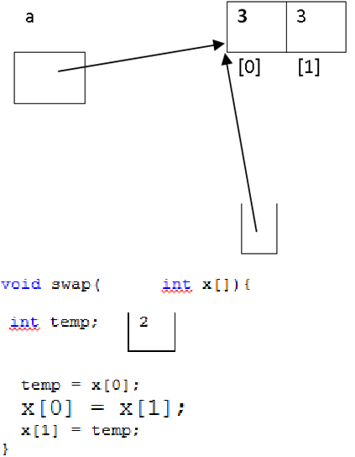

The assignment statement x[0] = x[1] is executed.

D)
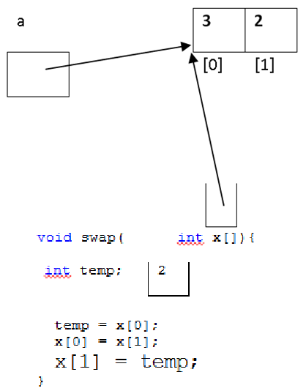
The assignment statement x[1] = temp is executed.

E)

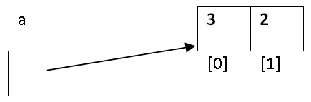

The execution of the function is completed and the control of execution went back to the caller (which is main) after the call to execute the second printf. As you see the contents of a[0] and a[1] are swapped.

Example 12: The following program read 10 characters from a file and displays them on the screen:
#include <stdio.h>
void display(char x[]);
void read(char x[]);
int main()
{
char a[20];
read(a);
display(a);
return 0;
}

void read(char x[])
{
FILE *inFile;
int i;
inFile = fopen("a.txt", "r");
for(i = 0; i < 20; i++)
fscanf(inFile, "%c", &x[i]);
fclose(inFile);
}

void display(char x[])
{
int i;
for(i = 0; i < 20; i++)
printf("%c", x[i]);
printf("\n");
}

The content of the file a.txt is the following line:
The following program read 20 characters from a file

Description:
This example shows the advantages of having functions in a program. We splited the problem into two sub-problems. One sub-problem is to read the characters and the other is to display them. Therefore we defined two functions:
read: To read the 20 characters into an array.
display: To display the characters.

On the call: read(a);.we have the following situation:

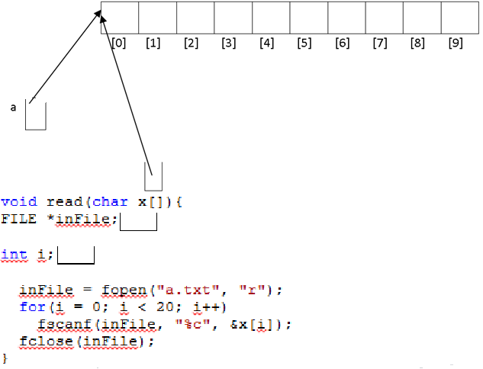
After the execution: inFile = fopen("a.txt", "r");the content of the local variable inFile is the address of the file on the hard drive.
On the execution of the for-loop the content of the variable i changes to 0, 1, 9 and 10.
When the execution of this function is complete the locations of x, inFile and i are removed and the control of execution goes to main after the call: read(a). At this point we have the following situation:

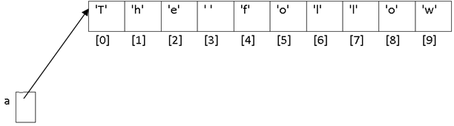
Now the system is going to execute the call: display(a). On this call we have the following memory configuration:

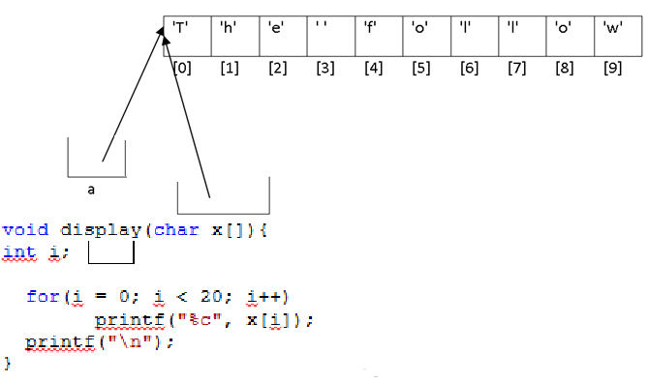
Note that the locations of x and i are newley created. After the execution of the function read the location of the parameter x and the local variables inFile and i has been removed. The location of x and i in that you see in the above figure has been newly allocated. In the for-loop the content of location i cheges to 0, to 9 and the printf displays x[i], i = 0,1,....,9.
Example 13: The following program removes the 8th element of the array. The eight element is in subscript 7 (i.e. a[7]).
#include <stdio.h>
void display(int x[]);
void remove(int x[]);
void read(int x[]);
int main()
{
int a[11];

read(a);
remove(a);
display(a);
return 0;
}

void read(int x[])
{
int i;
printf("Enter eleven integers\n");
for(i = 0; i < 11; i++)
scanf("%d", &x[i]);
}

void remove(int x[])
{
int i;
for (i = 7; i < 11; i++)
x[i] = x[i+1];
}

void display(int x[])
{
int i;

printf("The content of the array after removing an element is:\n");
for(i = 0; i < 10; i++)
printf("%d ", x[i]);
printf("\n");
}

Execution:
Enter eleven integers
-4 22 3 5 -45 34 21 60 -55 67 62
The content of the array after removing an element is:
-4 22 3 5 -45 34 21 -55 67 62
Description:
In this program we split the task into three sub-tasks. These are:
A sub-task to read eleven integers into an array of size 11.
A sub-task to remove the 8th number (i.e. 60).
A sub-task to display the ten (not eleven) numbers.
I now explain several exercises. Once again:
Your answer to any of the exercises in any Section must be general. Do not write your program just for the execution’s sample I show. You have no control over the user to force her/him to enter your data value. To make the program simple and small assume the user for the following exercises enters correct data values.

Exercise 1: Complete the following program to display the phrase Hello World n times.
#include <stdio.h>
void display();
int main()
{
//Do not change this function
display();
return 0;
}

void display()
{
//Complete this function.

int i, n;
printf("How many times? ");
scanf("%d", &n);
}

Execution:
How many times? 7
1) Hello World
2) Hello World
3) Hello World
4) Hello World
5) Hello World
6) Hello World
7) Hello World

Exercise 2: Complete the following program to accept an amount of dollars and breaks it down into dollars, half dollars, quarters, dimes, nickels and pennies.
#include <stdio.h>
void convert(float x);
void main()
{
//Do not change this function
float amount;
printf("Enter the amount: $");
scanf("%f", &amount);
convert(amount);
return 0;
}

void convert(float x)
{
//Complete this function.
}

Execution:
Enter the amount: $7.73
Dollar bills: 7
Half dollars: 1
Quarters: 0
Dimes: 2
Nickels: 0
Pennies: 3

Exercise 3: Complete this program to calculate the maturity value (principle plus accumulated interest) on a deposit at a given rate. The formula for this calculation is:

p(1 + r/100)^{y}
Where y is the number of years, r is the interest rate and p is the principal.

Note: For this exercises you need the built-in function pow (see example 6).

#include <stdio.h>
#include <math.h>
float maturity(int y, float p, float r);
int main()
{
//Do not change this function
int years;
float principal, rate;
printf("Enter the number of years, the principal, and the rate: ");
scanf("%d%f%f", &years, &principal, &rate);
printf("The answer is: %.2f\n", maturity(years, principal, rate));
return 0;
}

float maturity(int y, float p, float r)
{
//Complete this function
}

Execution:
Enter the number of years, the principal, and the rate: 5 1000 4
The answer is: 1216.65
Exercise 4: The following formula finds the number of possible combinations of n things taken k at a time. Complete the following program to display the result of the formula an integer for n and an integer for k.
n!/[k! * (n – k)!]
In general x! means 1 * 2 * 3 *....* x
#include <stdio.h>
int f(int x);
int main()
{
//Do not change this function
int n, k;

printf("How many things? ");
scanf("%d", &n);
printf("How many at a time? ");
scanf("%d", &k);
printf("Number of possible combination is: %d\n", f(n)/(f(k) * f(n - k)));
return 0;
}

int f(int x)
{
//Complete this function. Return the result of 1 * 2 * ...* x
}

Execution:
How many things? 3
How many at a time? 2
Number of possible combination is: 3

Note: When n is 3 and k is 2 it means how many combinations we have is we like to choose 2 by 2 from 3 things. For example if we have three things a, b, and c we can choose:
ab
ac
bc
Therefore we have three combinations. Once again your program must work for any two numbers entered by the user.
Exercise 5: Complete the following program. The program reads three words and display them in increasing alphabetical sequence.
#include <stdio.h>
#include <string.h>
void smallest(char wordx[], char wordy[])
void main()
{
//Do not change this function
char word1[100], word2[100], word3[100];
printf("Enter the first word: ");
gets(word1);
printf("Enter the second word: ");
gets(word2);
printf("Enter the third word: ");
gets(word3);
smallest(word1,word2);
smallest(word1, word3);
smallest(word2, word3);
printf("%s\n%s\n%s\n", word1, word2, word3);
return 0;
}

void smallest(char wordx[], char wordy[])
{
//Complete this function.
//This function puts the smaller word in wordx. Therefore on return wordx
//is smaller than wordy.
//You need the buit-in functions srcmp and strcpy. Also look at the
//function swap
}

Execution:
Enter the first word: complete
Enter the second word: the
Enter the third word: following
complete
following
the

Exercise 6: Complete the following program. The function: display replaces each space in the string by a specific character.

#include <stdio.h>
#include <string.h>
void display(char x[], char y)
int main()
{
//Do not change this function
char a[100];
printf("Enter a sentence\n");
gets(a);
display(a, '*'); //To replace every space by *
display(a, '-'); //To replace every space by -
display(a, '+'); //To replace every space by +
return 0;
}

void display(char x[], char y)
{
//Complete this function. You may need strlen
}

Execution:
Enter a sentence
The function: display replaces each space in the string by a specific character.
The*function:*display*replaces*each*space*in*the*string*by*a*specific*character.
The-function:-display-replaces-each-space-in-the-string-by-a-specific-character.
The+function:+display+replaces+each+space+in+the+string+by+a+specific+character.

Exercise 7: Complete the following program for a guessing a positive integer. For this program I use the built-in function: rand from the header file stdlib.h to generate the guessing number in the range of 0 to 100. Therefore you or the user of this program does not know what this number is:
#include <stdio.h>
#include <stdlib.h>
#include <time.h>

int guess();
int main()
{
//Do not change this function
int guessingNumber, userNumber;
srand((unsigned)time(NULL));
guessingNumber = rand() % 101;
printf("The guessing number is between 0 and 100.\n");
userNumber = guess();
while(userNumber != guessingNumber)
{
if(userNumber < guessingNumber)
printf("Too low\n");
else
printf("Too high\n");
userNumber = guess();
}
printf("Yes the guessing number is: %d\n", userNumber);
return 0;
}

int guess()
{
//Complete this function
}

Execution:
The guessing number is between 0 and 100.
What is your guess? 50
Too low
What is your guess? 70
Too high
What is your guess? 60
Too high
What is your guess? 55
Too high
What is your guess? 53
Too high
What is your guess? 51
Too low
What is your guess? 52
Yes the guessing number is: 52
A note on the random number generator:
1. Function srand((unsigned)time(NULL)): The function srand is called seeds. We need to call this function to get different seed on every execution of the program. This is accomplished if we pass the current time: (unsigned)time(NULL) to the function.
2. Function: rand()generates a random positive (or zero) integer. We obtain the remainder of this integer by 101. The remainder of 101 is a number between 0 or 100.

Section 13
Pointers
5.3 Pointers

It is famous that pointers are not good in C. They are the source of many bugs. Therefore be careful when you are using pointers in your program.
The content of the location of a pointer variable is (must be) an address of another location in memory. That is why this type of variable is called pointer because the content of the variable points to another location.
To declare a pointer variable we write:

Type* x; (1)

This means the content of x must be a pointer (the address) to another location of type Type.
To access the content of the location that x points to we write:

*x (2)

To the compiler this means from the location of variable: x dereference to the location that x points to (i.e. x contains its address).
Therefore the “*” in (1) and the “*” in (2) have completely different meanings. The “*” in (1) means the programmer declares (announces, defines) that I am declaring x as a variable of type pointer. The “*” in (2) means dereferencing.

Example 3: The following program is using a pointer to change the value of variable a.

#include <stdio.h>

void main()
{
int a;
int* x;

a = -7; // Mark: 1
x = &a; // Mark: 2
*x = *x + 2; // Mark: 3
printf("The content of variable a is: %d\n", a);
printf("The content of variable a is: %d\n", *x); // Mark:4
return 0;
}

The output of the program is:
The content of variable a is: 5
The content of variable a is: 5

Description:
The program allocates two locations for x and a.
In location: a, we are allowed to assign an integer (e.g. -7) and in x the address of a variable of type int.
Line marked 1: We assign -7 to variable: a. We assume the address of this location in memory is: 2000

Line marked 2: x = &a. means put the address of: a (and not its content) into the location of: x. Therefore we assign the address of a (i.e. 2000) to location: x.

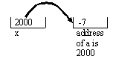
Since we do not know in which address a variable in memory takes place we show an address in a location by an arrow rather than a number (like: 2000). We mean location x points to (refer to, has the address of) variable: a. Therefore from now on we do not write a number for an address and only use arrows.

Line Marked 3: *x = *x + 2. First the expression on the right hand side gets executed. Execution of: *x means start from location: x and dereference to the location whose address is in x (which is the address of: a) and pick the value of that location (which is -7). Now make an addition and obtain 5. Where this number should be inserted? Certainly it is not x. We do not have x = 5. We have: *x = 5. To the system this means it starts from location x and dereference to the location whose address is in x and insert 5 in that location. Therefore after the execution of this statement we have:

Line Marked 4: The term: *x means print the content of the location that variable x refer to (i.e. a).

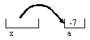

Example 4: The goal this example is to interchange (swap) the content of variables x, and y.
Wrong solution: The following program does not interchange the content of variables x, and y.

#include <stdio.h>
int x, y;
void swap(int a, int b);
void main()
{
x = 2;
y = 3;
printf("The content of variable x and y before swap\n");
printf("x = %d, y = %d\n", x, y);
swap(x, y);
printf("The content of variable x and y after swap\n");
printf("x = %d, y = %d\n", x, y);
}

void swap(int a, int b)
{
int temp;
temp = a;
a = b;
b = temp;
}

The output is:
The content of variable x and y before swap
x = 2, y = 3
The content of variable x and y after swap
x = 2, y = 3

Description:
The system on the call: swap(x, y) evaluates the argument: x to 2 and passes this value to the location of parameter: a. Similarly the value of y which is 3 goes to the location of parameter b. There we have 2 in a and 3 in b. Now the system executes the body of the function. Clearly after the execution of the body we have 3 in a and 2 in b. Now the system removes the locations a and b and the control of execution returns to main (after the function call). The problem is that the content of x remains 2 and y remains 3. Therefore we did not swap the contents of x and y.
Correct solution:

#include <stdio.h>
int x, y;
void swap(int *a, int *b)

void main()
{
x = 2;
y = 3;
printf("The content of variable x and y before swap\n");
printf("x = %d, y = %d\n", x, y);
swap(&x, &y);
printf("The content of variable x and y after swap\n");
printf("x = %d, y = %d\n", x, y);
}

void swap(int *a, int *b)
{
int temp;
temp = *a;
*a = *b;
*b = temp;
}

Description:
In this version the parameters: a and b accept addresses. The call: passes the address of: x into: a and the address of: y into: b. Before the execution of the body of the function: swap we have the following situation:

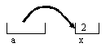
and:
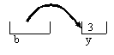
For the system the statement: temp = *a means dereference: a to obtain: 2 and assign it to the local variable” temp.

For the system the statement: *a = *b means dereference: b to obtain: 3. Now dereference: a to reach to location: a and insert 3 in location: a. Now we have the following situation:
The value of: temp is 2.

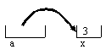

and:
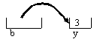
Finally the statement: *b = temp means insert the value of: temp (which is 2) and insert this number in the location that b is dereferenced to it. We now have:
The value of: temp is 2.

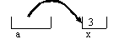
and:
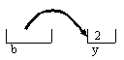
Therefore we successfully swapped the content of: x and y.

5.4 Arrays
Arrays in C are pointers. When we declare a variable of type array like:
int x[5];
The compiler allocates consecutive locations and put the address of the first element of the array into the variable. That is:

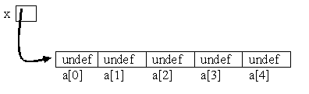

There for the address of the first element of the array is inside the location of the variable a.
Example 5: We create an array of 5 elements of type of integer. We put some numbers in these locations and we print them. We allocate space in stack.

#include <stdio.h>

void main( )
{
int a[5], i;

for(i = 0; i < 5; i++)
a[i] = i * i;

for(i = 0; i < 5; i++)
printf("%d", a[i]);
printf("\n");
}

void input(int x[ ])
{
for(i = 0; i < 5; i++)
a[i] = i * i;
}

The output is:
0 1 4 9 16

Description:
After the first for-loop the array looks like:

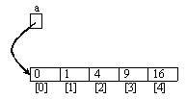

The second for-loop displays the content of the array.
For a parameter of a function the array always is passed by reference. In other words content of an array variable that is the address of an array is passed.
Example 6: The following program is the same as above one that we declare a function:

#include <stdio.h>
void display(int x[])
{
int k;
for(k = 0; k < 5; k++)
printf("%d", x[k]);
printf("\n");
}
void main()
{
int a[5], i;
for(i = 0; i < 5; i++)
a[i] = i * i;
display(a);
}

Description:
After the first loop the array looks like:
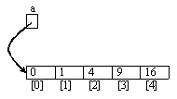

The first line of the definition of the function is: void display(int x[]). As you see we do not write the size of the array (i.e. 5) for x[ ]. This is because in the call: display(a) the content of: a is passed to: x. In other words at the time of the call a location for the parameter: x is allocated in memory and the content of argument: a that holds the address of array is passed to the location: x:

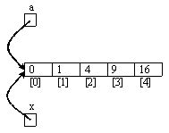
As you can see after the parameter passes mechanism the location: x points to the same array. Obviously the variable: a is not accessible in the body of the function: display. This variable is local for the function: main.
In the above program the space for all the variables and the array are allocated in stack (See Figure 2). Let us allocate space for the array in heap (See Figure 2).

Example 7: The following program is doing the same as the above one. But we allocate space in heap for the array.

#include <stdio.h>
#include <stdlib.h>
void display(int x[])
{
int k;
for(k = 0; k < 5; k++)
printf("%d", x[k]);
printf("\n");
}
void main()
{
int* a;
int i;
a = (int*)malloc(5 * sizeof(int));
for(i = 0; i < 5; i++)
a[i] = i * i;

display(a);
}

Description:
The declaration int* a : informs the C compiler that the content of the variable: a can point to an integer’s location.
The assignment statement: a = (int*)malloc(5 * sizeof(int)); does two things:
The built-in function “malloc”, which stands for memory allocation, is defined in the header file “stdlib.h”. This function allocates space in the heap (Figure 2 on page 2).
This function returns the address of the first of the five consecutive locations that are in heap. This address would be the content of a.
Therefore we have:
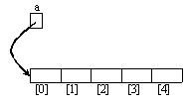
The location of: a is in the stack. But the locations of the array are in heap.
The rest of the program is the same as the above example.
Note that the function: malloc is similar to: new in Java. In Java: new creates an object in memory and return its address. But malloc creates space and returns the address of the beginning of the space.

Note: The default return type of malloc is of type: char. We needed to cast char to int because the variable: a is of type of a pointer to int.
5.5 Structure
This is the second structured type. Array was the first one. Therefore in this lectures we are learning about simples types (e,g, int, char, float, etc) and structured types (array and struct). The type: struct is similar to a class in Java but we are only allowed to declare variables. We cannot declare functions (methods).
The general format of struct is:
Struct
{
type₁ variables₁
type₂ variables₂
type₃ variables₃
.....
}
We have been using structure type several times in the above example. Let us write a program that uses an array of structure (page 136). To clarify this concept I write the examples in both C and Java. Let us put these two programs side by side.

Example 8: The following program assigns some numbers to the variables of the struct and displays the result of an expression:

C version | Java version
#include <stdio.h>
typedef struct{  int x, y;  float z;  } Rec; | class Rec{  public int x, y;  public double z;  }
void main(){  Rec a;  a.x = 2;  a.y = a.x + 20;  a.z = 3.5;  printf("%f", a.y + a.z);  } | public class Main{  public static void main(String[] args){  Rec a = new Rec();  a.x = 2;  a.y = a.x + 20;  a.z = 3.5;  System.out.println(a.y + a.z);  }  }

The output is:

25.5

Description:
Although we normally prefer to have each class in a separate Java file but I like to compare these two programs to show how to mimic a C program for Java (and vice versa).
In C we declare a struct type for a record (see 3rd row, 1st column).
In Java we declare a class type for a record (3rd row, 2nd column)

In C we declare the variable: a of a given type by: Rec a.
In Java we declare the variable: a of the type of a given class and initialize it by:
Rec a=new Rec().

Accessing a variable of a struct and a class are exactly the same in both C and Java.
Note that the instance variables are public.
Note that the identifier: Rec is an optional name and can be changed to any other name.

Note: In Java a class name plays the role of a type.

As a last example we write a program to create linked list. This program uses the heap on section 5.1.

Example 9: The following program makes a linked list.

C version | Java version
#include <stdio.h>
#include <stdlib.h>
typedef struct Node{  int key;  struct Node* next;  } Rec; | class Rec{  int key;  Rec next;  }
void main(){  Rec *newNode, *head, *temp;  int i, k;  head = NULL;  for(i = 7; i >= 1; i=i-2){  newNode = (Rec*)malloc(sizeof(Rec)); // Mark: 1  newNode -> key = i; // Mark: 2  newNode -> next = head; // Mark: 3  head = newNode; // Mark: 4  }  temp = head;  while(temp != NULL){  k = temp -> key;  temp = temp -> next;  printf("%d ", k);  }  printf("\n");  } | public class Main {  public static void main(String[] args){  Rec newNode, head, temp;  int i, k;  head = null;  for(i = 7; i >= 1; i=i-2){  newNode = new Rec();  newNode.key = i;  newNode.next = head;  head = newNode;  }  temp = head;  while(temp != null){  k = temp.key;  temp = temp.next;  System.out.print(k + "\t");  }  System.out.print("\n");  }  }

The output is:

1 3 5 7

Description: I explain the C version (Java version is similar)
The for-loop:
First Iteration: i = 7.
The line marked 1: newNode = (Rec*)malloc(sizeof(Rec)): The execution of the right hand side allocates space with the size of the struct and returns its address. This address goes into the location of the variable: newNode:
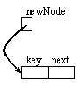
The line marked 2: newNode -> key = i: The control of execution from the location of: newNode dereferences, access the location of the variable: key and inserts the value of: i (i.e. 7) into this location.
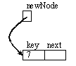
The line marked 3: newNode -> next = head: The control of execution from the location of: newNode dereferences, access the location of the variable: next and inserts the value of: head (i.e. NULL) into this location.
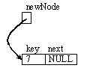
The line marked 4: head = newNode: Inserts the content of the variable: newNode to the location: head. Therefore both variables: newNode and head point to the same location:

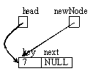
Second Iteration of the for-loop: i = 5.
The line marked 1: newNode = (Rec*)malloc(sizeof(Rec)): The execution of this statement creates a second node in memory and makes: newNode points to it:
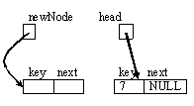
The line marked 2: newNode -> key = i: inserts the value of: i (i,e, 5) into the location of the variable: key that newNode is pointing to it:
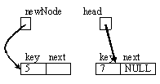
The line marked 3: newNode -> next = head: The control of execution from the location of: newNode dereferences, access the location of the variable: next and inserts the value of: head (which refers to the first node) into this location. Therefore both: head and the: next of the first node refer to the same location:
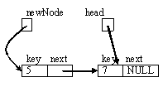
The line marked 4: head = newNode: Inserts the content of the variable: newNode to the location: head. Therefore both variables: newNode and head point to the same location:
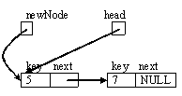

Third Iteration of the for-loop: i = 3.
The line marked 1: newNode = (Rec*)malloc(sizeof(Rec)): The execution of this statement creates a third node in memory and makes: newNode points to it:
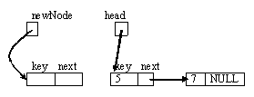
The line marked 2: newNode -> key = i: inserts the value of: i (i,e, 3) into the location of the variable: key that newNode is pointing to it:
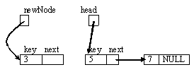
The line marked 3: newNode -> next = head: The control of execution from the location of: newNode dereferences, access the location of the variable: next and inserts the value of: head (which refers to the first node) into this location. Therefore both: head and the: next of the second node refers to the same location:
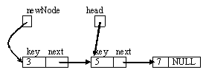
The line marked 4: head = newNode: Inserts the content of the variable: newNode to the location: head. Therefore both variables: newNode and head point to the same location:
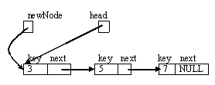
Fourth Iteration of the for-loop: i = 1. This is the last iteration. Similar to the third iteration the system creates a new node, inserts the value of: i (i.e. 1) into it and makes it to be the left most in the linked list:
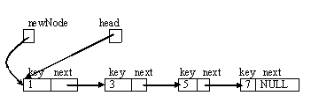
At this point the iterations of for-loop are complete and the control of execution executes: temp = head:
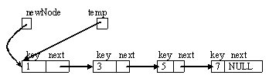
Now the while-loop gets executed.
The first iteration of the while loop executes: k=temp->key to give value: 1 to k. Next temp = temp -> next is executed to make temp refers to the second node:
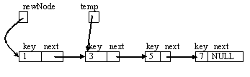
and the value of k (i.e. 1) is printed.

The second iteration of the while loop executes: k=temp->key to give value: 3 to k. Next temp = temp -> next is executed to make temp refers to the third node:

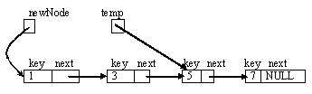
and the value of k (i.e. 3) is printed.

The third iteration of the while loop executes: k=temp->key to give value: 5 to k. Next: temp = temp -> next is executed to make temp refers to the last node:
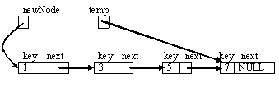
and the value of k (i.e. 5) is printed.

The fourth iteration of the while loop executes: k=temp->key to give value: 7 to k. Next: temp = temp -> next is executed. The value of temp -> next is: NULL. This value goes to: temp. Therefore the value of: temp is NULL and the value k (i.e. 7) is printed.

At this point the condition of the while loop is false and the system does not let the while-loop iterates anymore. The control of execution goes after the body of the wile-loop and executes: printf("\n") and the execution of the program is terminated.

5.7 Memory Leaks and Garbage Collection

Memory leak happens when space is allocated in heap but no variable points (refers to) it. When these useless locations are too many then a program called garbage collection collect all of these useless locations and put them together as free space to be used by the program. There are a number of algorithms for a garbage collection program. Let us look at a java program that creates garbage.
Example 10: In the following program a node in memory becomes useless (garbage):

#include <stdio.h>
#include <stdlib.h>

typedef struct Node
{
int value;
struct Node* next;
} Rec;

void main()
{
Rec *p, *q;
p = (Rec*)malloc(sizeof(Rec));
q = (Rec*)malloc(sizeof(Rec));
p->value = -12;
p->next = NULL;
q->value = 25;
q->next = NULL; //Mark 1
q = p; //Mark 2
printf("%d\n", p->value);
printf("%d\n", q->value);
}

The output of this program is:
-12
-12

Description:
Line Mark 1: At this point we have:

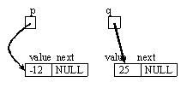
Line Mark 2: The execution of: q = p means copy the content of the variable: p into the location of: q. Therefore we have
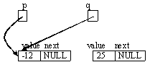
Now both: p and q point to the same node. But no variable points to the node that contains: 25. The garbage collection program will collect (free) this node.

Section 14
Functions as parameters

In C we can have a function like: f as parameter to a function like: func. In the following examples we look at the following formats.
a) f is not returning any value and has no parameter.
b) f is returning a value and has no parameter.
c) f is not returning any value but has parameters.
d) The function: func has parameters other than f.
e) The function: func has unknown number of parameters. But none of the parameters are of type function.
f) The function: func has unknown number of parameters. But the first parameter is f.

Note: Pay attention to (e) above. This is the type of function we need.

When we pass f to func we pass it as a pointer. This means the pointer points to the beginning of the body of: f.
When call fun we should dereferences for f. That is “*f” is passed.

Example 1: The function f is not returning any value and has no parameter.

#include <stdio.h>

void func ( void (*f)() );

void print ( ) {
printf("Hello world\n");
}

void func ( void (*f)() ) {
(*f)();
}

int main (){
func(print);
return 0;
}

Ouput:
Hello world

Description:
The prototype: void func ( void (*f)() ).informs the compiler that there is a function: func that has one parameter: f which is a function.
The instruction: (*f)() is in the body of function: func is a call of function: f. This means dereference from pointer: f to the body of the function: f and execute its body. The empty parenthesis: () means the function: f has no parameter.
The func(print). in: main is calling the function:func with one argument which is the function: print. Obviously this argument is a function the returns no value and has no parameter.

Example 2: The function f is returning a value and has no parameter.

#include <stdio.h>

void func (char* (*f)() );

char* print ( ) {
return "Hllo world\n";
}

void func (char* (*f)() ) {
printf("%s\n", (*f)());
}

int main (){
func(print);
return 0;
}

Output:
Hello world

Description:
With respect to the previous example we have the following changes:
void func (char* (*f)() ) : The term char* means return a pointer to a character location. Obviously if there are consecutive locations in memory containing characters each we are dealing with an array of characters as the return value.

The first line of the definition of the function print (i.e. char* print ( )) has no parameter and is returning an array of characters. Therefore we can call: func(print) in main.

Example 3: function f is not returning any value but has parameters.

#include <stdio.h>
void func ( void (*f)(int) );

void print ( int x ) {
printf("%d\n", x);
}
void func ( void (*f)(int)) {
(*f)(-123);
}
int main (){
func(print);
return 0;
}

Output:
-123

Description:
The declaration: void func ( void (*f)(int) ).informs the compiler that the program has a function: func. This function has one parameter: void (*f)(int). This parameter is a function: f with one parameter of the type integer (i.e. int).
In the body of: func we are calling this function and pass: -123 for its parameter.
In main call: func and pass a function named: print. Obviously the function: print has one parameter.
Example 4: A function: func has parameters other than f.

#include <stdio.h>
void func ( void (*f)(int), float, char);
void print ( int x ) {
printf("%d\n", x);
}
void func ( void (*f)(int), float y, char z)
{
(*f)(-123);
printf("The value of y is: %f\n", y);
printf("The value of z is: %c\n", z);
}
int main (){
func(print, 2.5, 'M');
return 0;
}

Output:
-123
The value of y is: 2.500000
The value of z is: M

Description:
The prototype: void func ( void (*f)(int), float, char) informs the compiler that the program has has function: func with three parameters. The first one is a function: f that has one parameter. The second and the third parameters are of type int and float.
In the call: func(print, 2.5, 'M') we are passing the function: print that has one parameter, a floating number(2.5), and a character (‘M’).

Example 5: A function with variable number of parameters but none of the parameters are of type function. In the following program the function: print has unknown number of parameters.
Note that we do not pass a function to the function: print. We look at this program to see how to access to each parameter. The ellipses: “…” must always be three dots.
#include <stdio.h>
#include <stdarg.h>
void print(int arg, ...){
va_list ap;
int i;
va_start(ap, arg);
for (i = arg; i >= 0; i = va_arg(ap, int))
printf("%d ", i);
va_end(ap);
printf("\n");
}
int main(void){
print(5, 2, 14, 84, 97, 15, 24, 48, -1);
print(84, 51, -1);
print(-1);
print(1, -1);
return 0;
}
Output:
5 2 14 84 97 15 24 48
84 51
1

Description:
The major parts of this program is about three features:
va_list ap: Declares the variable ap to walk through the list arguments. The built-in type: va_list is similar to the time that we like to declare a variable of type: pointer.
va_start(ap, arg);: This built-in function call makes the variable to point (refer) to the first agument.
va_arg(ap, int): This built-in function call picks up the content of a memory location with the size of: int. For example if a variable of type int needs 4 bytes it picks up the content of 4 bytes. Note that we can use any kind of type (int, float, etc.).
va_end(ap);: This built-in function call disconnects the variable ap from memory location (It is like we write m = NULL for the pointer variable: m).

I clarify this by the call: print(84, 51, -1) in main. Note that at the last argument is a negative number and the other two positive integers.
The arguments 84, 51, and -1 are in take consecutive memory locations. Assume a memory location for an integer needs 2 byts:

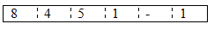
After the execution of va_start(ap, arg): we have the address of the first location of the first argument.
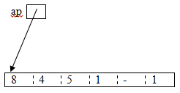

The first time execution of: i = va_arg(ap, int) in the above example the value of the variable: i would be 84 and the pointer walks to the next location:

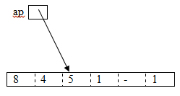
On the second time execution of: i = va_arg(ap, int) in the above example the value of the variable: i would be 51 and the pointer walks to the next location:
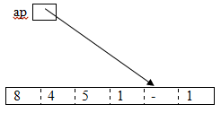
On the third time execution of: i = va_arg(ap, int) in the above example the value of the variable: i would be -1 and the pointer points to a location after the location for -1.
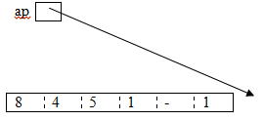

At this point the loop find out the boolean expression: >= 0 evaluates to false. Therefore the iterations of the loop stops.
Exercise 8: Suppose we remove -1 from the calls in the above example but add the number of parameters as the first parameter. For example:
print(2, 84, 51)
means there are two (i.e. 2) arguments. Change the above example to accomplish this requirement.
Example 6: The function: func has a maximum of 50 of parameters. But the first parameters is f and the rest of the parameters are treated as the parameters of: f
#include <stdio.h>
#include<stdarg.h>
#include <stdlib.h>
//Remove all the warning errors. Otherwise you will be in trouble.
void func(void (f)(), ...)
{
va_list ap;
unsigned pp[100];
int i = 0;
va_start(ap, f);
for (i = 0; i <= 99; i++)
pp[i] = va_arg(ap, unsigned);
va_end(ap);
f(
pp[0], pp[1],pp[2],pp[3],pp[4],pp[5],pp[6],pp[7],pp[8],pp[9],
pp[10],pp[11],pp[12],pp[13],pp[14],pp[15],pp[16],pp[17],pp[18],pp[19],
pp[20],pp[21],pp[22],pp[23],pp[24],pp[25],pp[26],pp[27],pp[28],pp[29],
pp[30],pp[31],pp[32],pp[33],pp[34],pp[35],pp[36],pp[37],pp[38],pp[39],
pp[40],pp[41],pp[42],pp[43],pp[44],pp[45],pp[46],pp[47],pp[48],pp[49]
);
}
void f(int* s)
{
// int newk, myid, term;
*s = *s + 10;
}

void g(int x, int y)
{
printf("%d\n", x + y);
}

void h()
{
printf("Hello World.\n");
}

int main()
{
int* s;
s = (int *)malloc(sizeof(int));
func(g, 2, 3);
s[0] = -555;
func(f, s);
printf("%d\n", s[0]);
func(f, s);
printf("%d\n", s[0]);
func(h);
return 0;
}

Note that this program works in LINUX/UNIX and not in windows.

Output:
5
-545
-535
Hello World.

Description:
In this type of call f and its parameters are of the same size. The size of a location for int is the size of a location for a pointer (i.e. address). Therefore make sure the size of any parameter is the size of the type: int.
With the for loop:
for (i = 0; i <= 99; i++)
pp[i] = va_arg(ap, unsigned);

We are saving the content of each parameter (including the first one that points to the body of a function) in array: pp.
Note that we cannot have more than 100 parameters (the first one for a parameter’s function like: f and the next 99th ones are for the parameter of: f).
In the call: f(pp[0], pp[1],pp[2],pp[3],…..) the argument of f are: pp[0], pp[1], pp[2], … It is like we call:
f(pp[0], pp[1], pp[2], …).
Question: What if we have less than 99 arguments? This does not cause any problem. The compiler by the call knows how many pp’s should pick up. For example for the call: func(g, 2, 3) the compiler picks up pp[0] for 2, and pp[1] for 3.

