Admin System User Manual
Step 1 It Locates to the Login page of the system
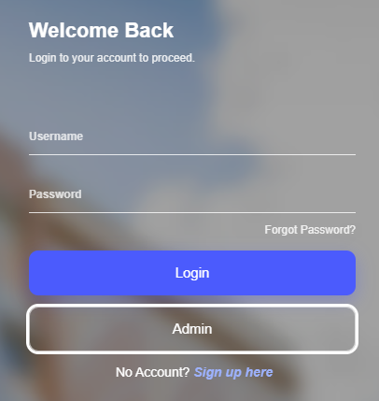
Step 2 Click “Admin”
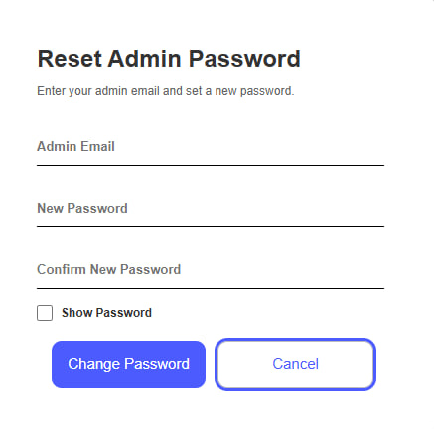
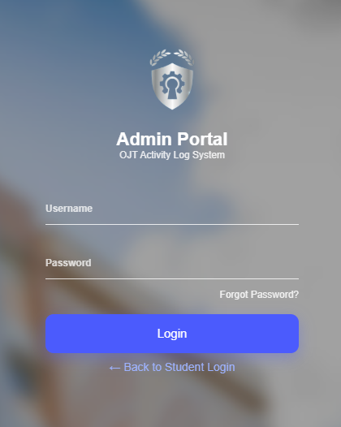

Step 3 Input the default password ( email : admin, password: admin )
Step 4 you will be direct into the home/analytics
Step 5 you will see the data of the users in the table
Step 6 The admin have a real time viewing of the users inputs data
Step 7 You can see the button in the upper right “All Users”
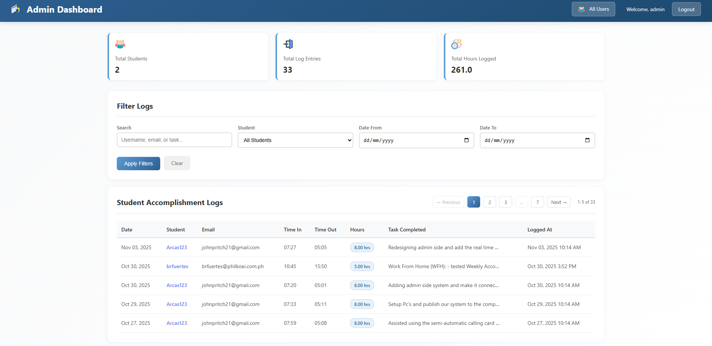
Step 8 Click “all users” to view all the accounts
Step 9 It has a dynamic viewing, you can see the users status “Active/Offline
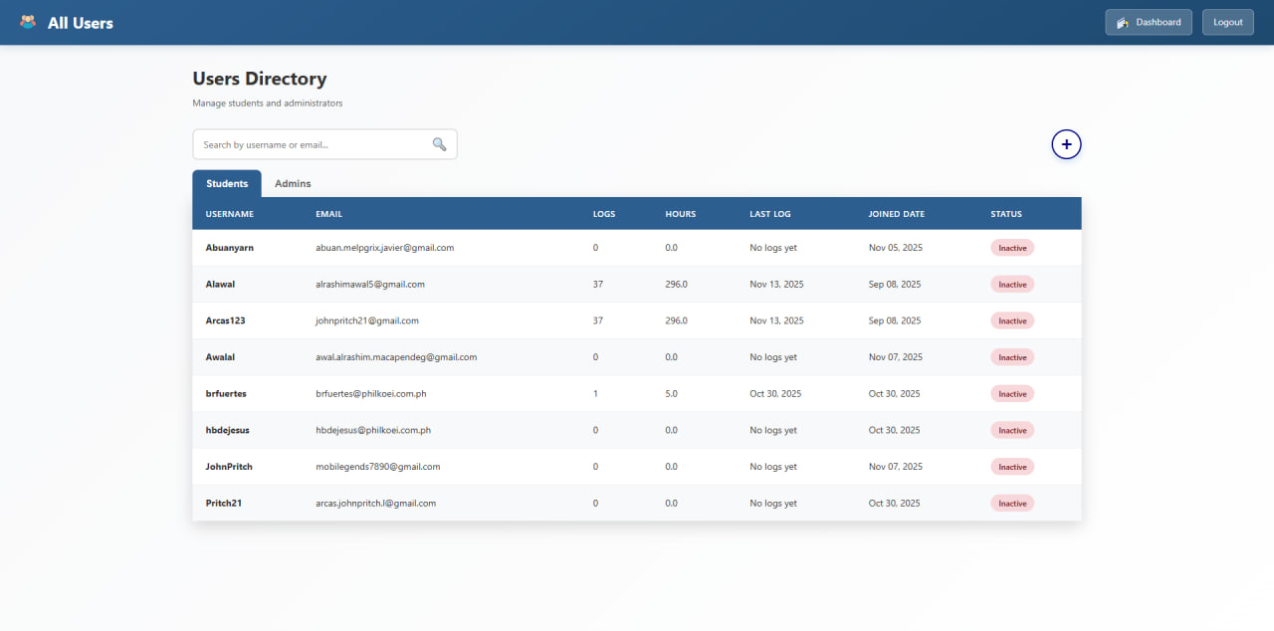
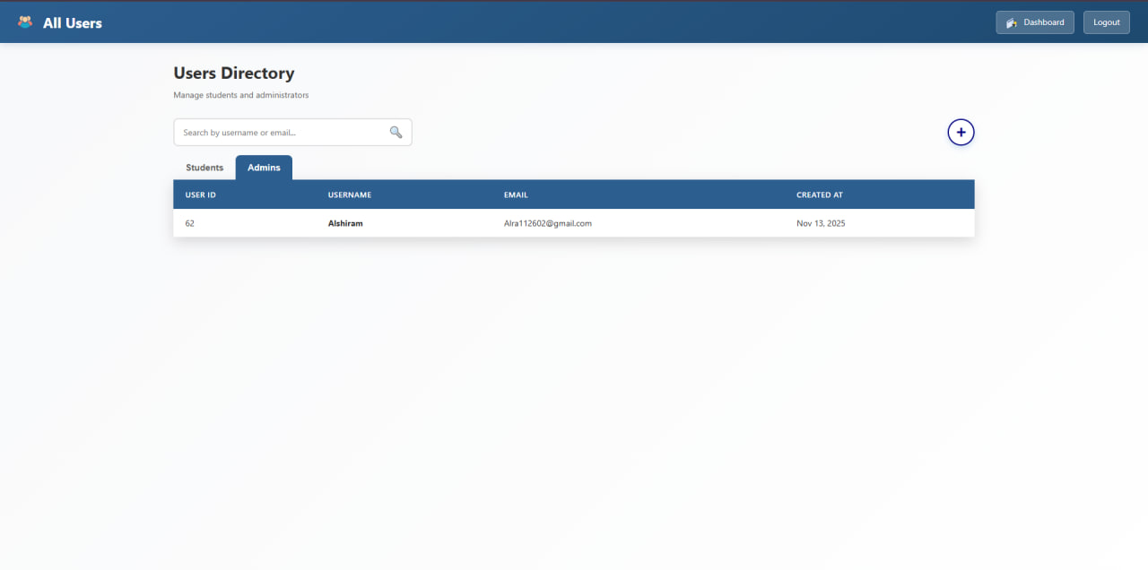
Step 10 You can add you personal admin account by clicking the plus icon button
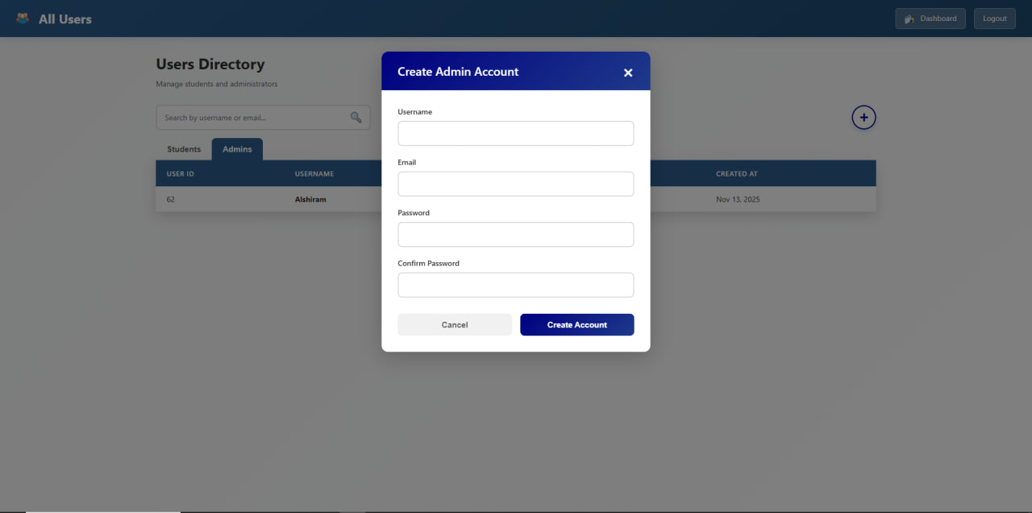

Step 11 You can view the users profile and there entires by clicking the users

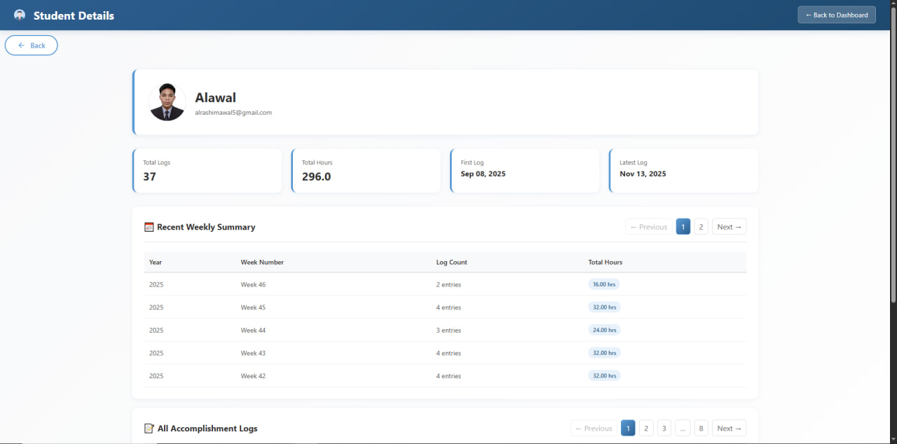

The Admin Side Function is only for viewing the data’s of all the users, it has a dynamic feature that can see the current updates, inputs, and active or offline status of the users.

