
Cgns
Analysis
Tool
for 2Dimensional Solvers
Last Updated:2016.08.01
Released: 2016.08.01
Copyright 2016 iRIC

Contents
I. Overview 2
II. Project file Data structure 3
III. CAT2D 4
III.1 Structure 4
III.2 Conditions 6
III.2.1 Files 6
III.2.2 Longitudinal and Cross sectional Data 8
(1) File name and contents of longitudinal data set 11
(2) File name and contents of Cross sectional data set 11
IV. Example 12

Overview
CAT2D is “Cgns Analysis Tool for 2 Dimensional solver”. CAT2D can compare calculation results which is produced by any solvers on the iRIC software. Also this tool provides the function which can extract longitudinal and cross-sectional calculation result along arbitrary line.

Project file Data structure
iRIC data set can be saved into two type of format as follows.

a) Save as Flie(*ipro)
b) Save as Project

The *.ipro file is ZIP file. So you can extract it after changing its extension from ipro to zip. After that you can get a folder which has the same name with *.ipro. You can get the same files which you save your data as Project.

Figure 1 Data structure of iRIC project file

CAT2D

Structure
Calculation conditions, grid information and Calculation results are stored into "Case1.cgn". You can find out the file at the iRIC project folder.

Figure 2 Contents of the iRIC project folder

This tool reads several CGN(s) files and integrates those data into another CGNS file. Also subtracted values from Base Case are stored at the same time. You can apply this tool for two dimensional solvers, structured and unstructured grid system.

River survey data is used for extracting longitudinal and cross sectional data as csv files.

Figure 3 Relationship Files and CAT2D

Current version has several restrictions as follows. Because this tool does not have interpolated functions.

- This tool cannot compare the calculation result by different type of grid. Only calculation results by using the same grid can be compared.
- Output time and its interval should be the same

These are the results by CTA2D analysis.
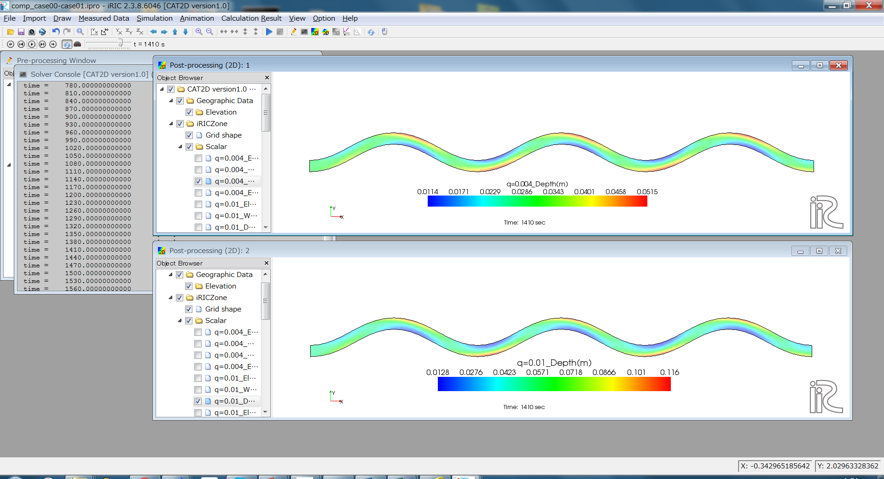
Figure 4 Depth contour: Discharge:0.004m³/s(above), 0.01m³/s(below). Several calculation results can be visualized and compared.
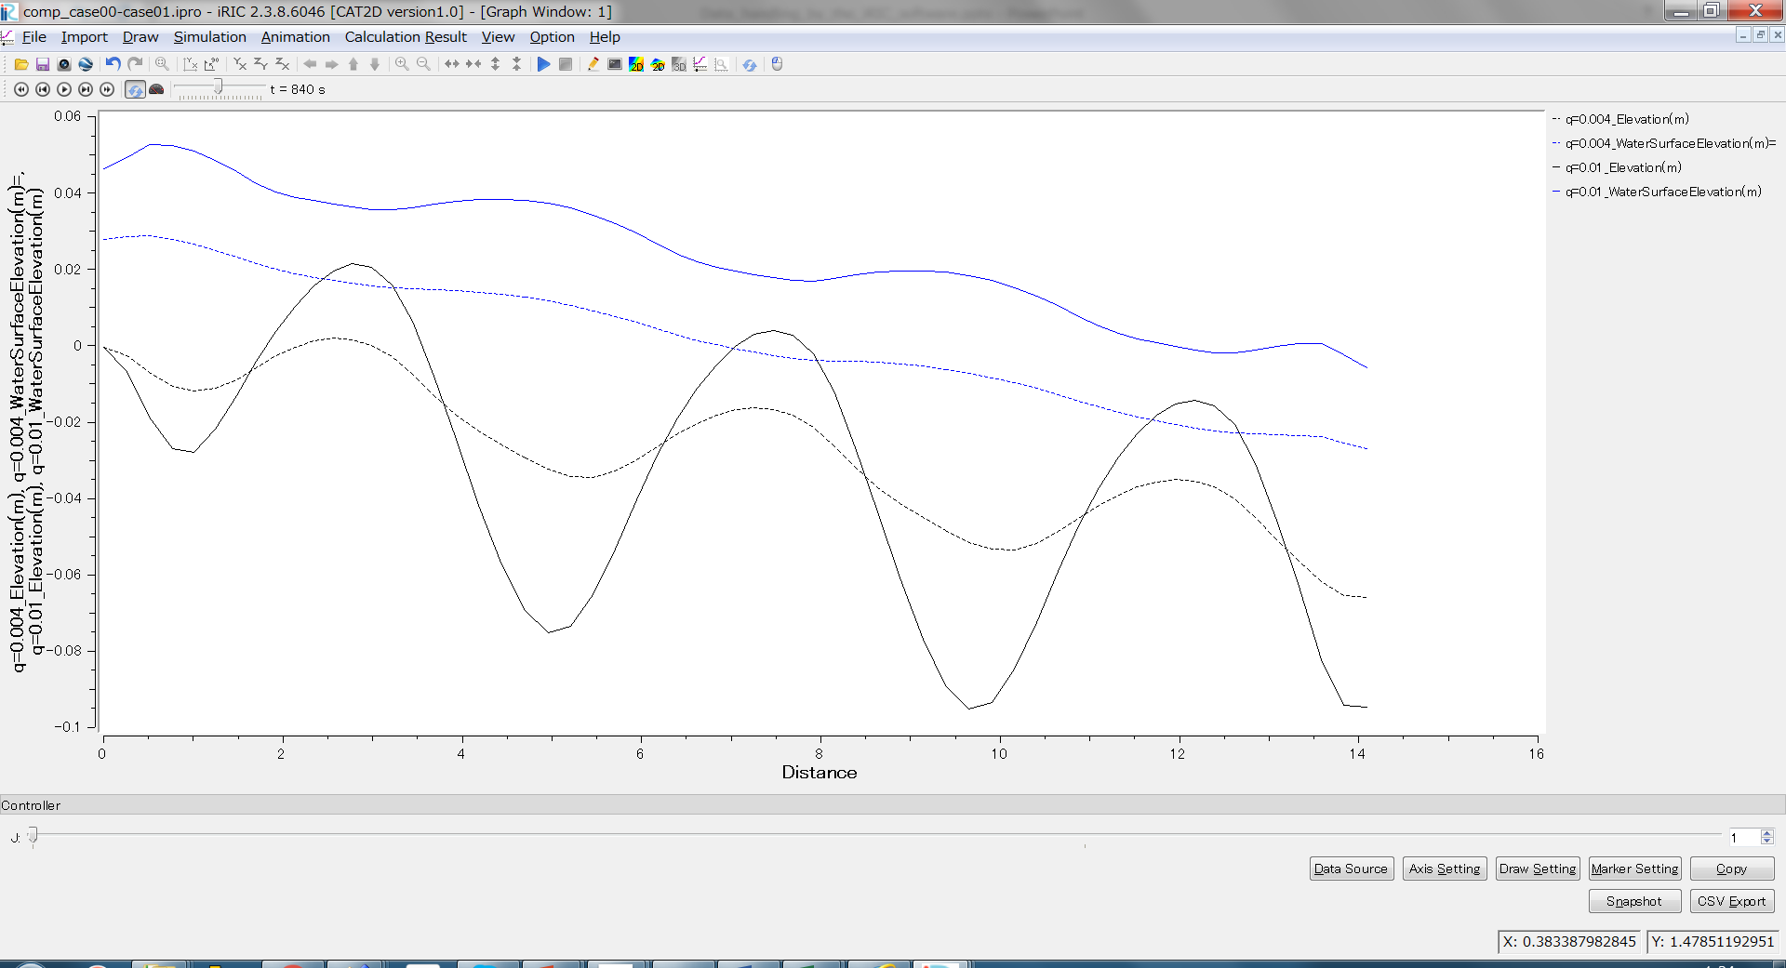
Figure 5 Longitudinal profiles of Elevation and Water Surface Elevation for two cases are drawn in one graph.

Conditions
Parameters which we should specify before running CAT2D, are described in this section.

Files
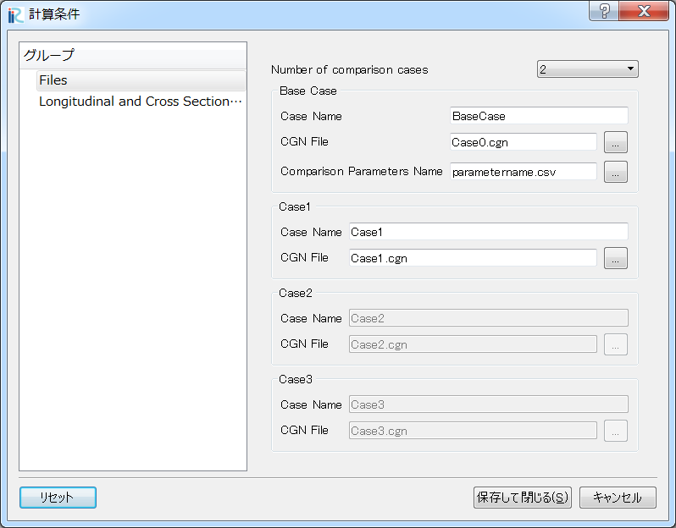
Figure 6 Setting Window for Files

# | Item Name | Description | Required/Optional
1 | Number of comparison case | You can specify the number of comparison cases from 2 to 4. | Required
2 | BaseCase | “Case Name” and the cgns file must be specified. “CaseName” is used for a parameter caption on the object browser. So short word is recommended.  Also, “Comparison Parameters Name”are specified by file. See next page. | Required
3 | Case1 |  | Required
4 | Case2  In each case, “Case Name” and the cgns file must be specified. “CaseName” is used for parameters caption on the object browser. So short word is recommended for that. |  | optional
5 | Case3 |  | optional

Csv file is used to specify the Comparison Parameter’s Name. Figure 7 shows format for that. Parameter Name should be specified for each solver. And the parameter name in the same row would be compared. Also, the order of several parameters must be defined as follow

(1) Bed elevation[m]
(2) Water Surface Elevation[m]
(3) Velocity in X direction [m/s]
(4) Velocity in Y direction [m/s]
:
You can define what you want, after above.
:

Figure 7 File format for specification file of the comparison parameter name

Longitudinal and Cross sectional Data
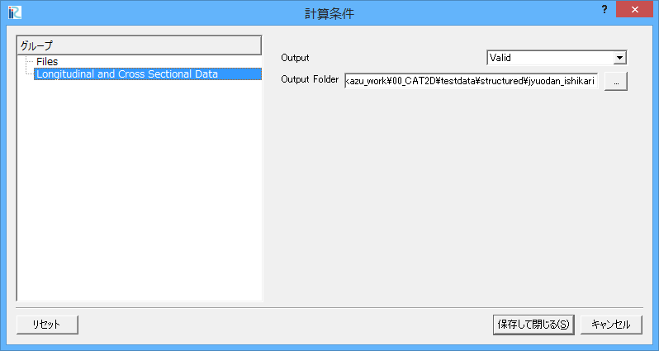
Figure 8 Setting Window for “Longitudinal and Cross Sectional Data”

# | Item Name | Description | Required/Optional
1 | Output | You can choose Valid or invalid. Valid should be specified when you want to output longitudinal and cross sectional data. | required
2 | Output Folder | Specify the place where you want to output the longitudinal and cross sectional data set. | Optional

You have to specify the output position by using River Survey data, when you choose “Valid” for “Output” in Longitudinal and Cross sectional Data section. River Survey data can be imported from Geographic Data on Object Browser. Using Center line of it (red line in Figure 9), CAT2D extracts the longitudinal data set from calculation result. Also using cross section line (purple line in Figure 9), the cross sectional data set of calculation result are extracted.

Figure 9 Image for extracting Longitudinal and Cross sectional Data

“judan” and “oudan” folder are generated under the specified folder, automatically.
And the extracting data set of longitudinal are outputted into “judan” folder as csv files. Cross sectional data set are outputted into "oudan" folder, as the same. File naming rule and its contents are described in next page.

File name and contents of longitudinal data set

File name and contents of Cross sectional data set

Example
Let’s compare Nays2DH calculation results here. Flow and bed variation under different discharge in the same channel and grid would be compared.

Step1: Double click the iRIC icon on the Desktop and you can see following window. Select “CAT2D version1.0” and click “OK”.
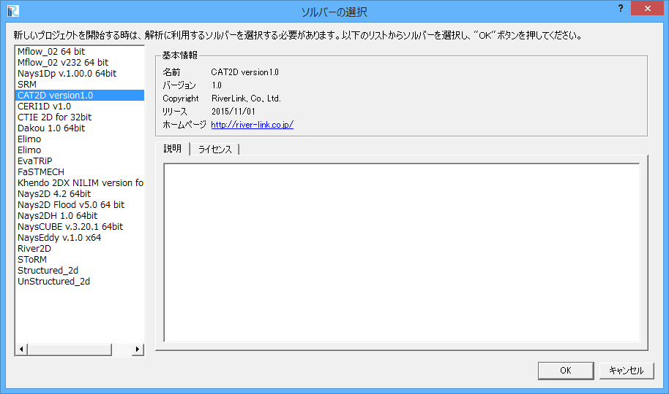

Step2: Select “Calculation Condition>Setting” and click.
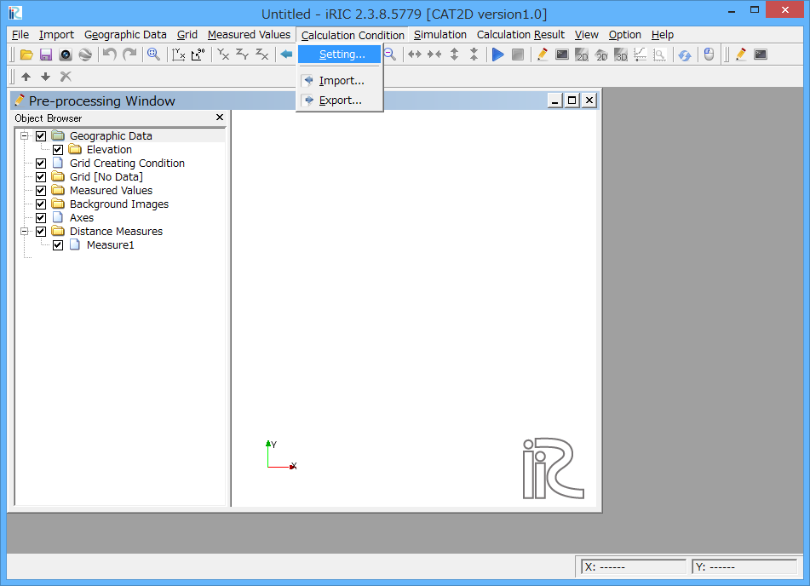

Step3: “Calculation Condition” window are shown. And specify following values to each conditions.
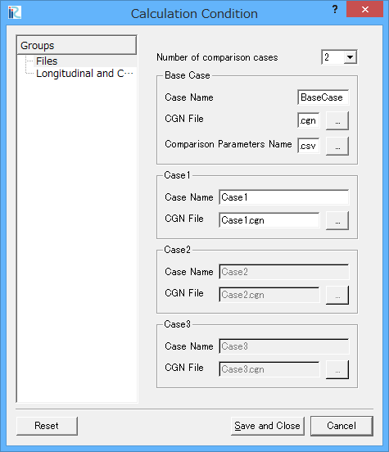 | Number = 2  Base Case:  -Case Name=Case00  -CGN file=…\case00\Case1.cgn  -Comparison Parameters Name  = parametername.csv  Case1:  -Case Name=Case01  -CGN file= …\case01\Case1.cgn

Parametername.csv: File contents is follow. All parameters name are the same in both BaseCase and Case1. Because both of calculation results are Nasy2DH result in this time.
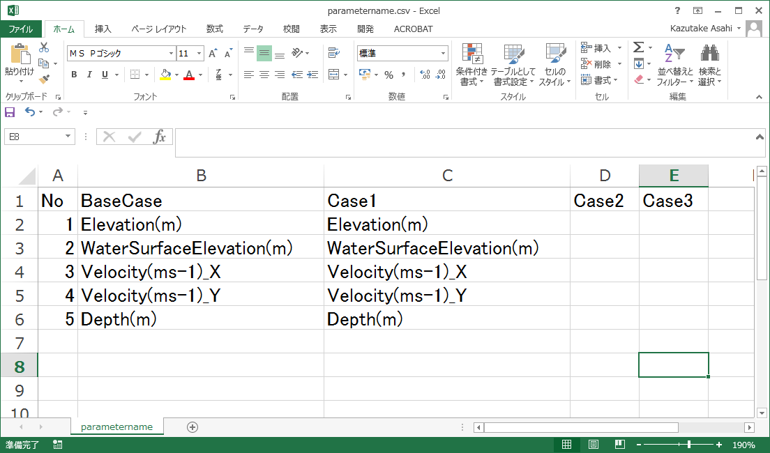

Step4: Close the “Calculation Condition” window and click Run button.
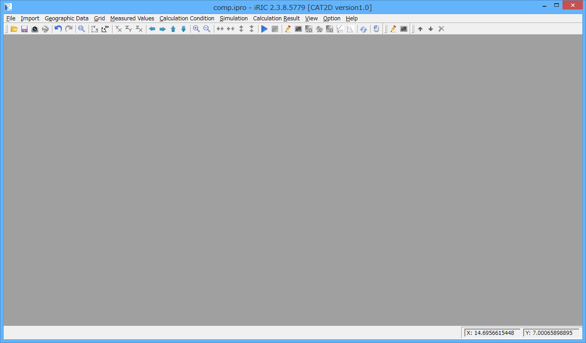

Attention: You can see several warning message windows. Corresponding methods are shown below.
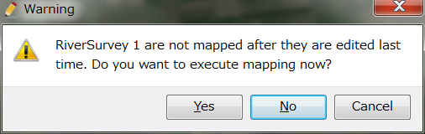 | You don’t need to execute mapping. So Click “No”.
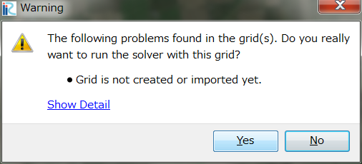 | CAT2D does not use grid. So Click “Yes”.
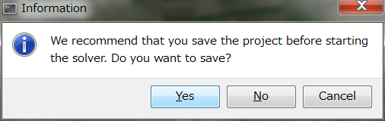 | I strongly recommend to save your project before running solver. So Click “Yes”.

Step5: You can see CAT2D running window.

Step6 You can see following window.

Step7 You can use all of iRIC functions for comparison data set. Here is an example to compare depth result. The difference between Case00 and Case01, is discharge. Discharge is 0.004m3/s for case00, and 0.01m3/s for case01. Other conditions are the same. First row is depth contour for the case00, and second row is for the case01. Third row is a depth subtraction contour for case01-case00. Also you can investigate those data by longitudinal and cross sectional graph tool. Furthermore, time variation of those values can be investigated on the iRIC software.

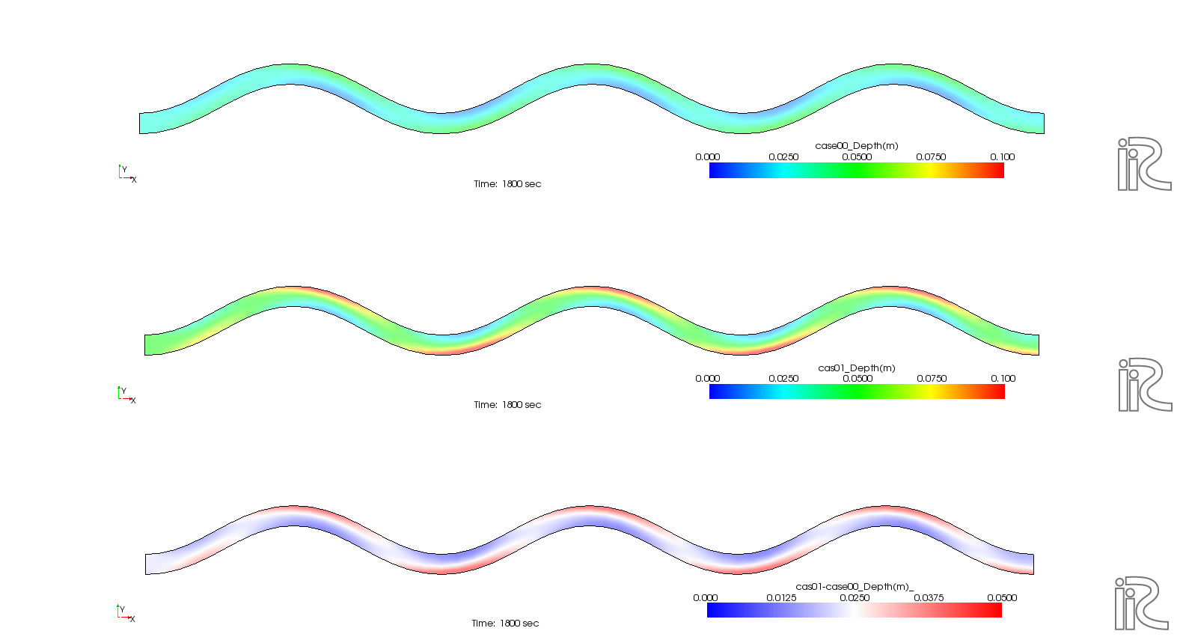

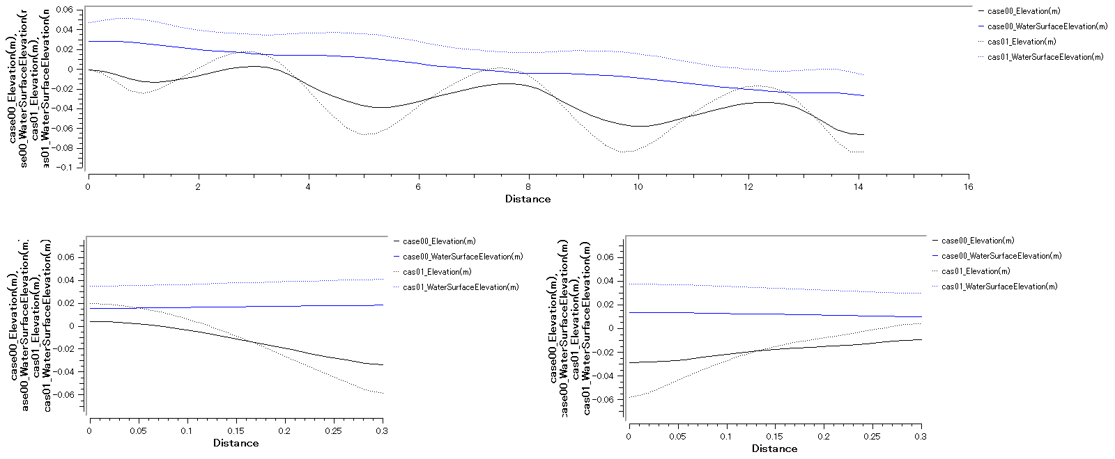

To Reader

● Please indicate the use of iRIC software, if you publish a paper with the results using iRIC software.
● Let us know your suggestions, comments and concerns at http://i-ric.org.


iRIC Software
CAT2D Manual

Edited by | Takuya Inoue(Civil Engineering Research Institute for Cold Region, Japan)  Kazutake Asahi (RiverLink, Co., Ltd., Japan) | All
Sponsorship | Civil Engineering Research Institute for Cold Region, Japan

