LAPORAN PRAKTIKUM ANALISIS ALGORITMA

REKURENSI DAN PARADIGMA ALGORITMA DIVIDE & CONQUER



Disusun oleh :

Risyad Pangestu

140810170003

PROGRAM STUDI TEKNIK INFORMATIKA

FAKULTAS MATEMATIKA DAN ILMU PENGETAHUAN ALAM

UNIVERSITAS PADJADJARAN

2019

Studi Kasus

1. Program Merge-Sort C++

|  |
| --- |
| /*  Nama : Risyad Pangestu  NPM : 140810170003  Kelas : A  Program Merge Sorting  */  #include <iostream>  #include<conio.h>  #include<stdlib.h>  #include<ctime>  #define MAX_SIZE 5  using namespace std;  void merge_sort(int, int);  void merge_array(int, int, int, int);  int arr_sort[MAX_SIZE];  int main() {  int i;  cout << "\nEnter " << MAX_SIZE << " Elements for Sorting : " << endl;  for (i = 0; i < MAX_SIZE; i++)  cin >> arr_sort[i];  cout << "\nYour Data :";  for (i = 0; i < MAX_SIZE; i++) {  cout << "\t" << arr_sort[i];  }  merge_sort(0, MAX_SIZE - 1);  cout << "\n\nSorted Data :";  for (i = 0; i < MAX_SIZE; i++) {  cout << "\t" << arr_sort[i];  }  //time  int start_s=clock();      // the code you wish to time goes here  int stop_s=clock();  cout << "\ntime: " << (stop_s-start_s)/double(CLOCKS_PER_SEC)*1000 << endl;  getch();  }  void merge_sort(int i, int j) {  int m;  if (i < j) {  m = (i + j) / 2;  merge_sort(i, m);  merge_sort(m + 1, j);  // Merging two arrays  merge_array(i, m, m + 1, j);  }  }  void merge_array(int a, int b, int c, int d) {  int t[50];  int i = a, j = c, k = 0;  while (i <= b && j <= d) {  if (arr_sort[i] < arr_sort[j])  t[k++] = arr_sort[i++];  else  t[k++] = arr_sort[j++];  }  //collect remaining elements  while (i <= b)  t[k++] = arr_sort[i++];  while (j <= d)  t[k++] = arr_sort[j++];  for (i = a, j = 0; i <= d; i++, j++)  arr_sort[i] = t[j];  } |

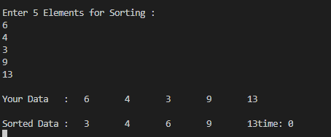

Kompleksitas Algoritma merge sort adalah O(n lg n).

1. Selection Sort

|  |
| --- |
| /**************  Nama Program : Selection sort  Nama : Risyad Pangestu  NPM : 140810170003  **************/  #include <iostream>  #include<conio.h>  using namespace std;  int data[100],data2[100];  int n;  void tukar(int a, int b)  {  int t;  t = data[b];  data[b] = data[a];  data[a] = t;  }  void selection_sort()  {  int pos,i,j;  for(i=1;i<=n-1;i++)  {  pos = i;  for(j = i+1;j<=n;j++)  {  if(data[j] < data[pos]) pos = j;  }  if(pos != i) tukar(pos,i);  }  }  int main()  {  cout << "\n=====================================";  cout<<"\nMasukkan Jumlah Data : ";cin>>n;  cout << "\n-------------------------------------" << endl;  for(int i=1;i<=n;i++)  {  cout<<"Masukkan data ke-"<<i<<" : ";  cin>>data[i];  data2[i]=data[i];  }    selection_sort();  cout << "\n-------------------------------------" << endl;  cout<<"Data Setelah di Sort : ";  for(int i=1; i<=n; i++)  {  cout<<" "<<data[i];  }    cout << "\n=====================================\n";  getch();  } |

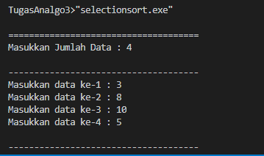

Menentukan T(n):

$$T\left(n\right)=\left(n-1\right)+\left(n-2\right)+…+1=\sum_{k=1}^{n-1}{n-k=\frac{n\left(n-1\right)}{2}}$$

Oleh Karena itu:

$$T\left(n\right)=O(n^{2})$$

$$T\left(n\right)=Ω(n^{2})$$

Karena $O\left(n^{2}\right)= Ω(n^{2})$,Maka $⊙(n^{2})$

1. Insertion Sort

|  |
| --- |
| /**************  Nama Program : Insertion sort  Nama : Risyad Pangestu  NPM : 140810170003  **************/  #include <iostream>  #include <conio.h>  using namespace std;  int data[100],data2[100],n;  void insertion_sort()  {  int temp,i,j;  for(i=1;i<=n;i++){  temp = data[i];  j = i -1;  while(data[j]>temp && j>=0){  data[j+1] = data[j];  j--;  }  data[j+1] = temp;  }  }  int main()  {  cout << "\n=================================="<<endl;  cout<<"Masukkan Jumlah Data : "; cin>>n;  cout<<endl;  cout << "\n----------------------------------" << endl;  for(int i=1;i<=n;i++)  {  cout<<"Masukkan data ke-"<<i<<" : ";  cin>>data[i];  data2[i]=data[i];  }  cout << "\n----------------------------------" << endl;  insertion_sort();  cout<<"\nData Setelah di Sort : "<<endl;  for(int i=1; i<=n; i++)  {  cout<<data[i]<<" ";  }  cout << "\n=================================="<<endl;  getch();  } |

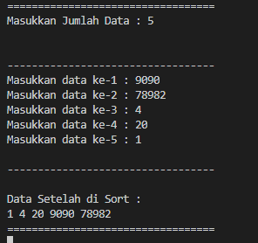

Menentukan T(n):

$$T\left(n\right)=2\left(1\right)+2\left(2\right)+2\left(3\right)+2\left(4\right)…+2\left(n-1\right)=2\left(1+2+3+4+…\left(n-1\right)\right)=\frac{2\left(\left(n-1\right)n\right)}{2}=\left(n-1\right)n=n^{2}-n=O(n^{2})$$

T(n) = $Ω\left(5\right)$

1. Bubble Sort

|  |
| --- |
| /**************  Nama Program : Bubblesort  Nama : Risyad Pangestu  NPM : 140810170003  **************/  #include <iostream>  #include <conio.h>  using namespace std;  int main(){  int arr[100],n,temp;  cout << "\n================================================"<<endl;  cout<<"Massukan banyak elemen yang akan diinputkan : ";cin>>n;  cout << "\n------------------------------------------------" << endl;    for(int i=0;i<n;++i){  cout<<"Masukkan Elemen ke-"<<i+1<<" : ";cin>>arr[i];  }    for(int i=1;i<n;i++){  for(int j=0;j<(n-1);j++){  if(arr[j]>arr[j+1]){  temp=arr[j];  arr[j]=arr[j+1];  arr[j+1]=temp;  }  }  }  cout << "------------------------------------------------" << endl;  cout<<"\nHasil dari Bubble Sort : "<<endl;  for(int i=0;i<n;i++){  cout<<" "<<arr[i];  }  cout << "\n================================================"<<endl;  } |

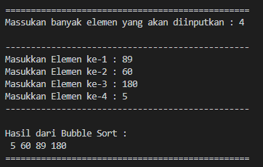

Menentukan T(n):

$$T\left(n\right)=n^{2}+n=O(n^{2})$$

$$T\left(n\right)=n-1=Ω(n)$$