FALL SEMESTER 2019-20

COURSE: MAT1011(CFE)-ELA

SLOT: L31+L32

ASSESSMENT 1: CONTINUITY, DIFFRENTIABILITY AND MEAN VALUE THEOREMS

REGISTRATION NUMBER: 19BCE0811

NAME: Akshat Srivastav

Exercise 1: Develop a MATLAB programme to verify the continuity of each of the following functions f(x) at the indicated points a.

CODE:

1. f(x)=x^3-4\*x^2+5x-6 at a=3 FUNCTION GRAPH:

INPUT AND OUTPUT:

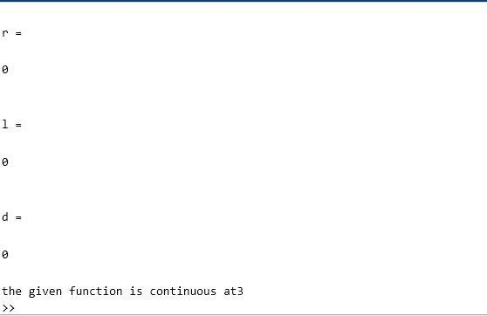

1. f(x)=e^-2x at a =7 Ans.

FUNCTION GRAPH:

INPUT AND OUTPUT:

Exercise 2:

Develop a matlab programme to verify the differentiability of each of the following functions f(x) at the given point a . Also identify the critical points wherever possible.

CODE:

1. f(x)=(x-2)(x^2+3\*x) at a=pi/2 Ans.

FUNCTION GRAPH:

INPUT AND OUTPUT:

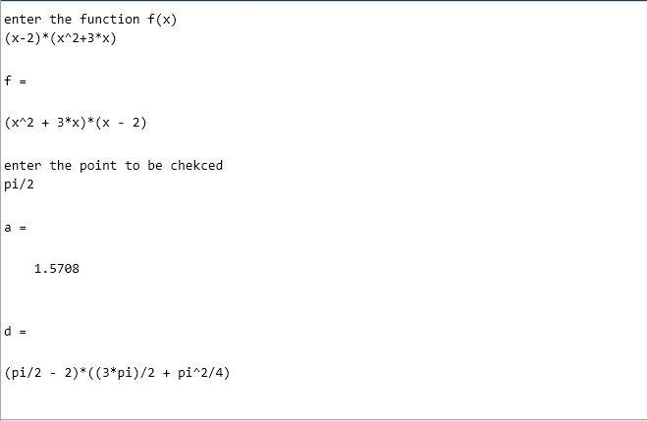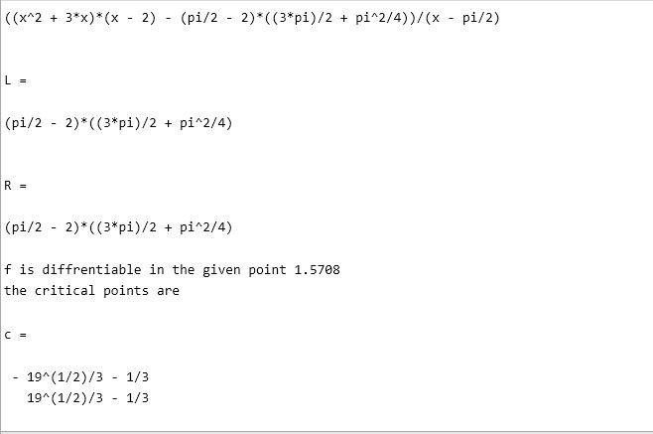

1. f(x)=2\*|3x-2| at a=2/3 Ans.

FUNCTION GRAPH:

INPUT AND OUTPUT:

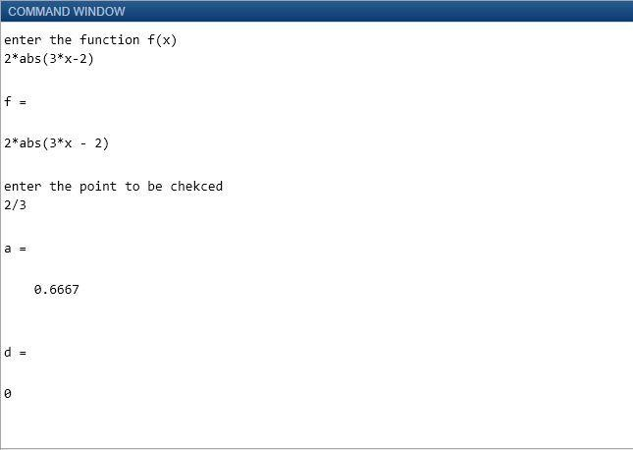

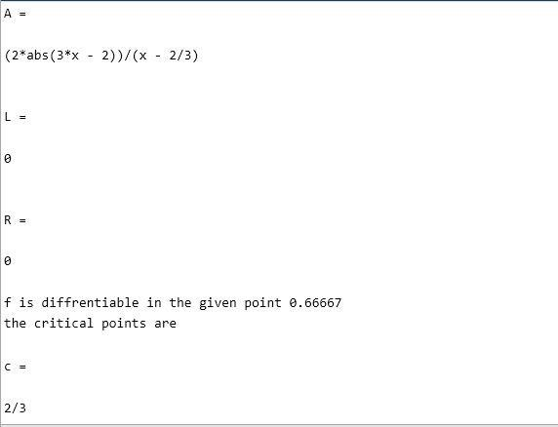

Exercise 3:

Let f(t) be continuous on closed interval [a,b] and differentiable on open interval (a,b).Write a matlab code to verify and to find the constant of Rolle’s theorem for f(x)=x^2(2-x) on [0,2] Ans.

CODE:

INPUT AND OUTPUT:

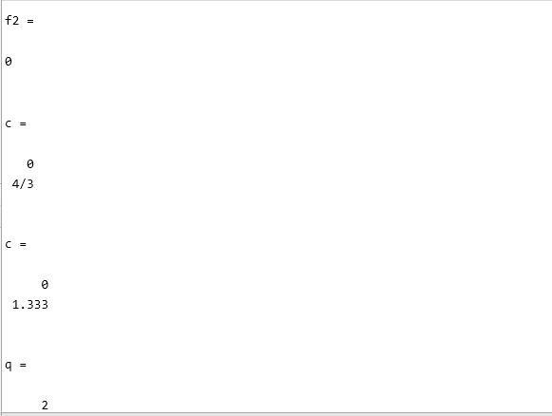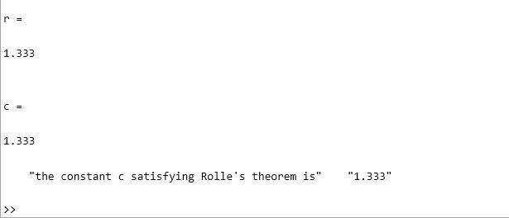

Exercise 4:

Find the constant of the mean value theorem for each of f(x)=x+1/x-1 on [-2,-1] Ans.

CODE:

INPUT AND OUTPUT:

