Name-

Akshat Srivastav

Reg no.-

19BCE0811

Digital assignment-1

# 50 ml of a standard hard water containing 1 mg of pure CaCO3 per 1 ml, consumed 20 mil of EDTA. 50 ml of a water sample consumed 25 ml of EDTA solution using EBT indicator. Calculate the total hardness of water sample?

Ans)

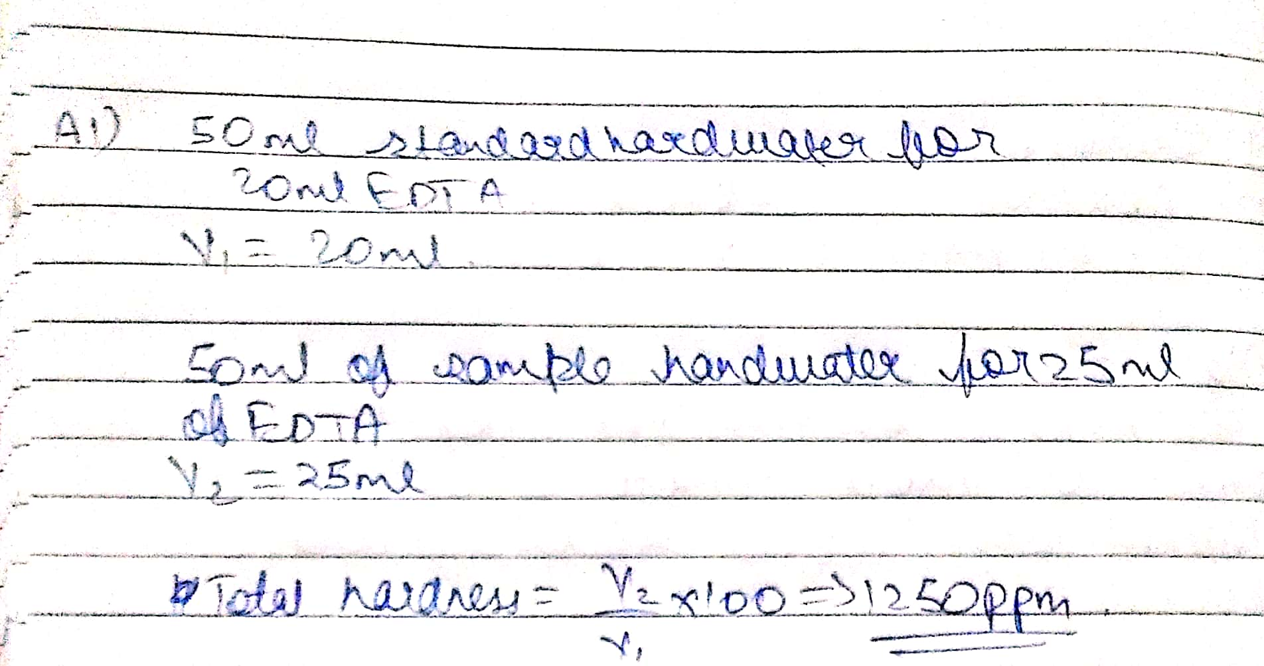

# A water sample contains the following Mg(HCO3)2 = 95 mg/L; Ca(HCO3)2 = 203 mg/L; CaSO4 = 1.36 mg/L; CaCl2 = 111 mg/L; MgCl2 = 95 mg/L. Calculate the temporary and permanent hardness of water

Ans

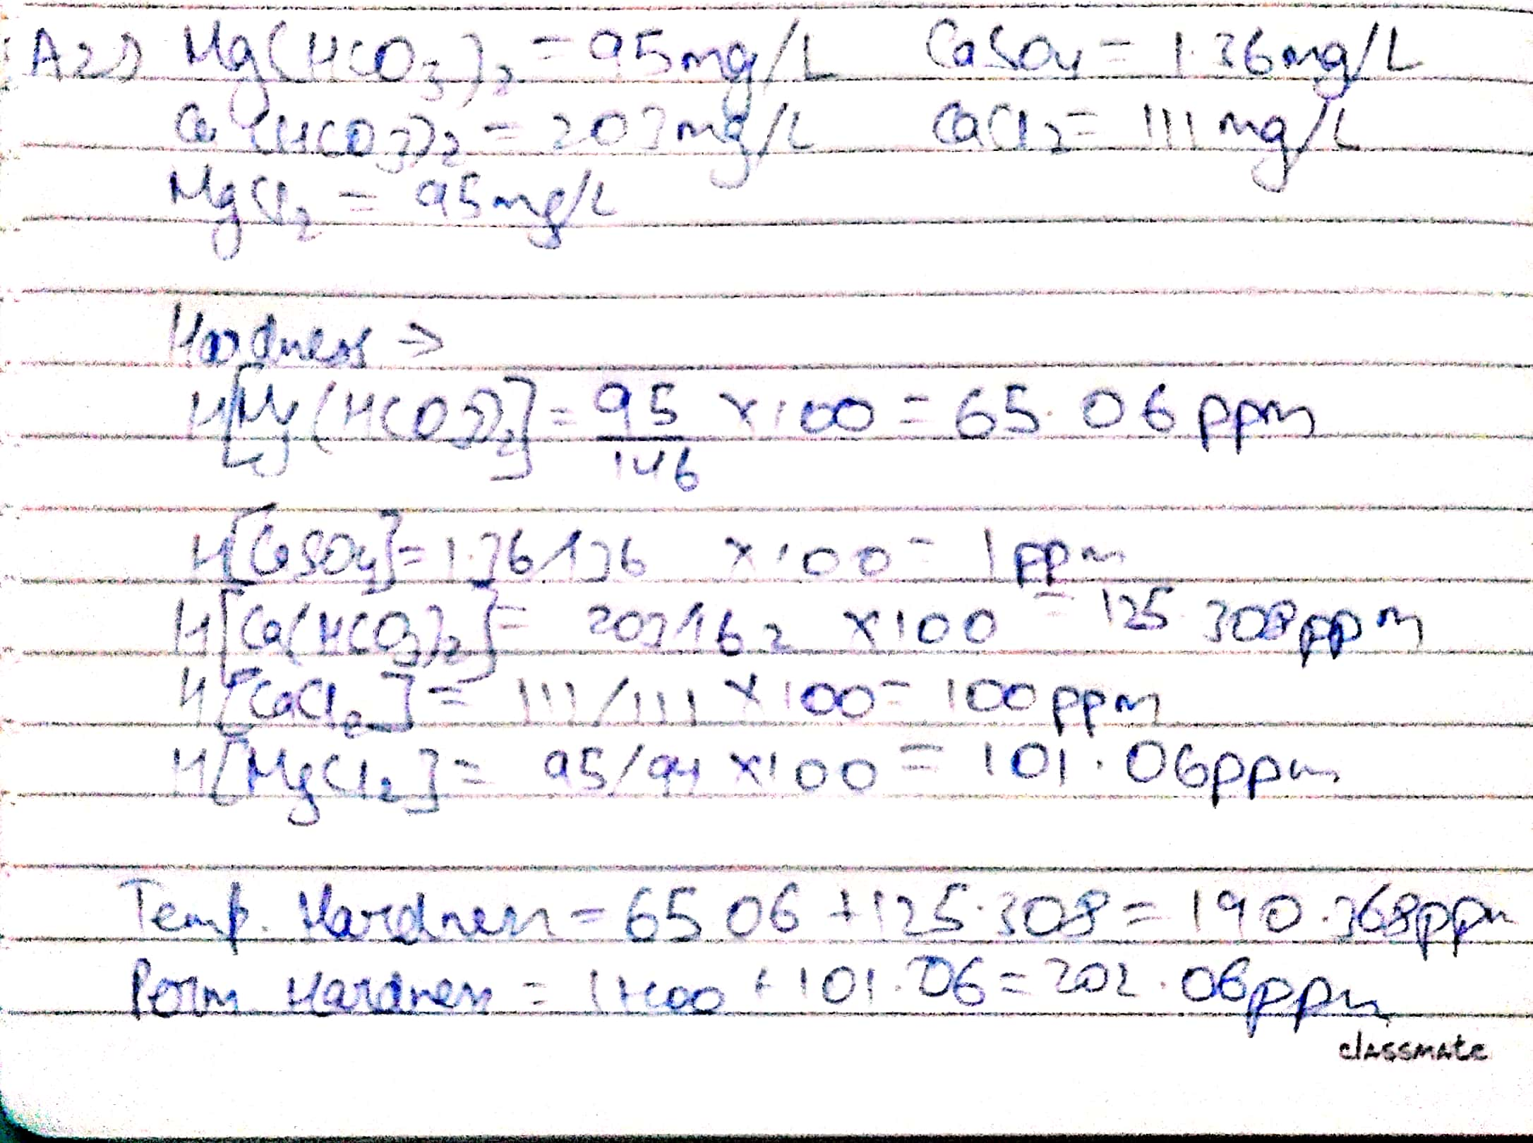

# Explain lime soda calculations and arrive the equation for lime and soda requirement.

Ans) In lime soda process hard water is treated with lime (CaO or Ca (OH)2), In this process the hardness is removed by sedimentation as calcium carbonate or magnesium hydroxide.

Lime is added either as calcium hydroxide or calcium oxide and soda is added as sodium carbonate.

As slacked lime is added to a water, It will react with any carbon dioxide present as follows Ca (OH)2 + CO2 → CaCO3 + H2O (1)

The lime will react with carbonate hardness as follows:

Ca (OH)2 + Ca (HCO3)2 → 2CaCO3 + 2H2O (2)

Ca (OH)2 + Mg (HCO3)2 → MgCO3 + CaCO3 + 2H2O (3)

The product magnesium carbonate in eqn 3 is soluble. To remove it more lime is added.

Ca (OH)2 +MgCO3 → CaCO3 + Mg (OH)2 (4)

Also, magnesium non-carbonate hardness such as magnesium sulphate is removed. Ca (OH)2 + MgSO4 → CaSO4 + Mg (OH)2 (5)

Lime addition removes only magnesium hardness and calcium hardness. In equation5 magnesium is precipitated however an equivalent amount of calcium is added. The water now contains the original calcium non-0carbonate hardness and the calcium non-carbonate hardness produced in equation5 Soda ash is added to remove calcium non carbonate hardness.

Lime requirement for softening:

74/100{Temp Ca+2 + 2XTemp Mg+2 + Perm. (Mg+2 + Fe+2 + Al+3) + CO2 + H+ +

HCO3- - NaAlO2} *X (Volume of water) Soda requirement for softening:

106/100{perm. (Ca+2 + Mg+2 + Fe+2 + Al+3) + H+ -HCO3-} *X (volume of water)

# How the scale is removed from the boiler water? Explain internal and external treatment methods for the removal of scales?

Ans) Removal of scales are done by various ways some are given below

* 1. By giving thermal shocks if they are brittle (Heating the boiler and then suddenly cooling with the cold water)
  2. If they are adherent and hard dissolving them with help of chemicals.

-calcium carbonate scales can be dissolved by using 5-10%HCL.

-calcium sulphates scales can be dissolved by adding EDTA (ethylene diamine tetra acetic acid) with which they form soluble complex.

* 1. Frequent Blow down operation.

**Prevention of scale formation

External treatment: - treatment includes efficient ‘softening of water’

* + - removing hardness-producing constituents of water.

Internal treatment: - phosphate conditioning

* + - Calgon conditioning

1. Phosphate conditioning – (For high pressure boilers)

Scale formation can be prevented by adding sodium phosphate to the boiler water which reacts with the hardness producing ions and forms easily removable phosphate salts of respective ions.

3Cacl2(boiler water) + 2Na3PO4→ Ca3(PO4)2 + 6Nacl

1. Carbonate conditioning

CasSO4(boiler water) + Na2CO3 ←→ CaCO3 + Na2SO4

1. Calgon conditioning

Na2[Na4(PO3)6] ←→ 2NA+ + [Na4(PO3)6]2-

2CaSO4(Boiler water) + [Na(PO3)6]2 → [Ca2(PO3)6]2- +2Na2SO4

# Explain the method of determining the hardness of water?

Ans) The estimation of hardness of water can be determined by the EDTA method.

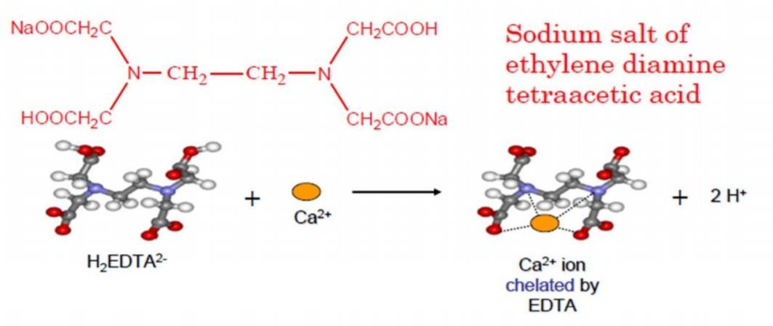

EDTA method: 1)Complexometric titration. 2)Pipette solution: Water sample.

1. Titrant: EDTA (Strong complexing agent).
2. Condition for titration: pH 9-10—ammonia-ammonium chloride buffer added. 5)Indicator: Eriochrome Black –T(EBT).

6)End Point: Wine Red to Steel Blue.

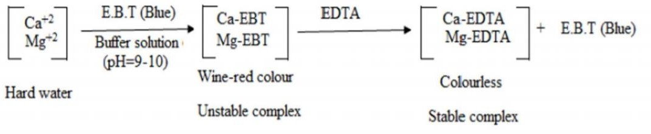

**Standardization of EDTA solution:

Burette – EDTA Solution(0.01M)

Conical Flask--50ml of standard hard water+10-15ml of ammonia buffer+few drops of EBT.

//Volume of EDTA consumed is V1//

**Estimation of total hardness:

Conical Flask-50ml of sample hard water+10-15ml of ammonia buffer+ few drops of EBT.

//Volume of EDTA consumed is V2//

**Estimation of permanent hardness:

Conical flask—50ml of boiled sample hard water+10-15ml of ammonia buffer+ few drops of EBT.

//Volume of EDTA consumed is V3// CALCULATION: Estimation of total hardness: 50ml of standard hard water = V1 ml of EDTA 1ml of EDTA = 50/V1 mg of caco3 eqvt.

50ml of given hard water=v2ml of EDTA

=(V2*50)/V1mg of caco3

1ml of given hard water = (V2*50)/(V1*50) mg of caco3 eqvt

1000ml of given hard water=1000V2/V1mg of caco3 **Total Hardness of water = 1000V2/V1mg/L or ppm.** CALCULATION: Estimation of permanent hardness. 50ml boiled water=V3 ml of EDTA

=V3*50/V1 mg of caco3 eqvt

1ml of boiled water =V3 *50/V1*50 mg of caco3 eqvt

1000ml of boiled water = V3*1000/V1 mg of caco3 eqvt or ppm **Permanent Hardness of water=1000*V3/V1 mg/L or ppm Temporary hardness of water** = [Total -permanent]

# ={V2-V3}/V1*1000

1. **How will you treat the municipal water for domestic purpose?**

Ans) Municipal water is treated by: 1)Removal of suspended impurity:

**Screening

Raw water is passed through screens having large numbers of holes which retain the floating particle.

**Sedimentation

To remove suspended particles, water is allowed to stand undisturbed in big tanks (about 5m deep) where most of the suspended matter settles down in the bottom due to force of the gravity.

The retention period in the tanks range from 2-6hours. When water contains colloidal and fine clay particles, a coagulant is added before sedimentation and the process is called “Sedimentation with coagulation”.

Coagulant when added to water forms an insoluble. Normally used coagulants:

Alum (K2SO4.Al2(SO4)3.24H2O

**Filtration

Filtration is the process of removing colloidal matter & most of the microorganisms, etc.

It is carried out by passing water through inlet through a bed of fine sand, coarse sand granular materials.

The irregular pores in the sand filter hold the sediment particles thereby allowing the filtered water to pass through an underground drain.

**Removal of microorganisms by disinfection

* 1. Contains the small percentage of pathogenic bacteria – disease producing.
  2. Drinking water must be freed from pathogenic bacteria and micro-organisms.
  3. The process of destroying/killing the disease producing bacteria, micro-organism in drinking water is called disinfection.

**By boiling

Boiling the water for 10 to 15 minutes can kill all the disease producing microorganisms.

Disadvantages: (a) Does not provide protection to the drinking water against future possible contamination. (b) Very costly method to employ in municipal water works. (c) Kill only existing germs in water at the time of boiling. (d) Impossible to employ this in large scale system.

Chlorination by adding bleaching powder: In small water-tank, 1 kg of bleaching powder (CaOCl2 ) is added to 1000 Litres of water (1000 ppm) and allowed to stand for several hours. The chemical action produces HOCl (Hypochlorous Acid, a powerful germicide). CaOCl2 + H2O Ca(OH)2 + Cl2 Cl2 + H2O HCl + HOCl Germs + HOCl Germs are killed.

# 50 ml of standard work requires 30 ml of EDTA solution. 100 ml of sample water requires 22 ml of EDTA solution for titration. 18 ml of the same EDTA was required for 100 ml of standard hard water containing 1 g CaCO3/litre. Calculate hardness of water sample in ppm.

Ans)

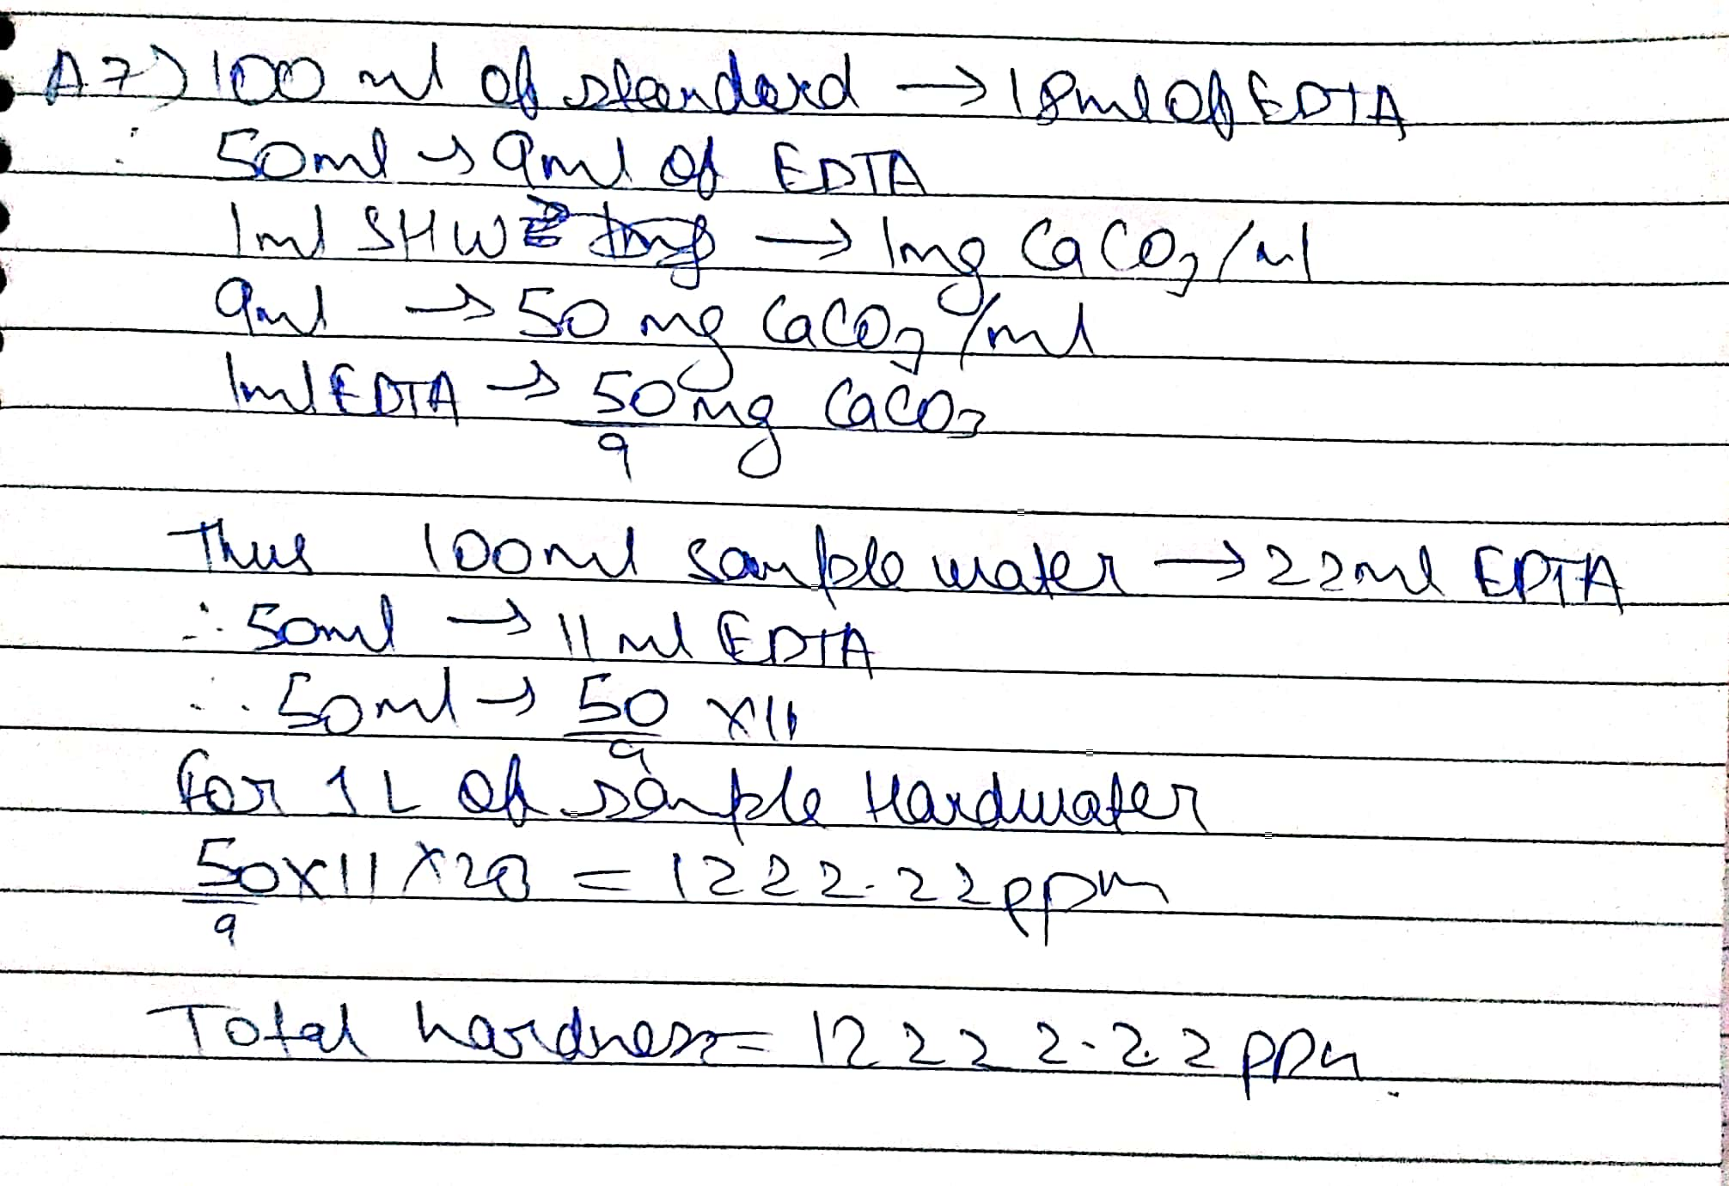

# Describe the activated carbon filtration method and reverse osmosis with diagram.

Ans) • Activated carbon filters are generally used in the process of removing organic compounds and/or extracting free chlorine from water.

* Coconut shells and coal (anthracite or bituminous) are both organic sources of activated carbon.

Carbon forms when an organic source is burned in an environment without oxygen. This process leaves only about 30% of the organic mass intact, driving off heavy organic molecules.

Prior to being used for water treatment, the organic mass must then be "activated by either vacuum Activation (800°C-1000°C) or Chemical Activation (a powerful dehydrating agent like phosphorous pentoxide (P2O5) or zinc chloride (ZnCl2)."

The process of activation opens up the carbon’s massive number of pores and further drives off unwanted molecules. The open pores are what allow the carbon to capture contaminants, through adsorption.

The rate of adsorption for a surface area of a just one pound (0.45 kg) of Activated Carbon is equal to 60-150 acres.

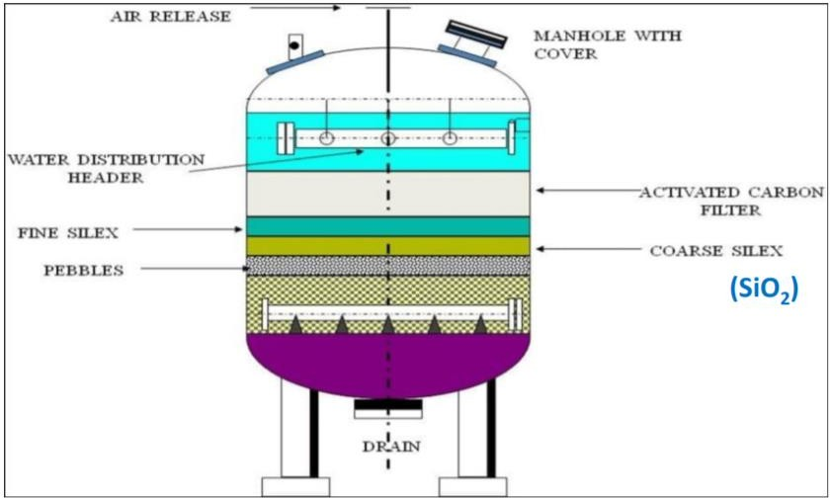

# Activated carbon filters

**\*\*Reverse osmosis**

Reverse osmosis filters have a pore size around 0.0001 micron.

After water passes through a reverse osmosis filter, it is essentially pure water. In addition to removing all organic molecules and viruses, reverse osmosis also removes most minerals that are present in the water.

Reverse osmosis removes monovalent ions, which means that it desalinates the water.

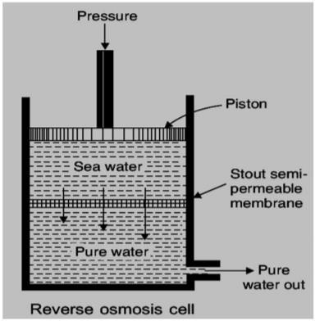

# Reverse osmosis cell.

1. **How will you determine the dissolved oxygen in water?**

Ans) The estimation of the dissolved oxygen in water is done by the Winkler’s method.

Theory of Winkler’s method:

* 1. Oxygen in the water sample oxidizes iodide ion(-I) to iodine (I2) quantitively. 2)The amount of iodine generated is then determined by the titration with the standard

Thiosulphate(S2O3-2) solution.

3)The endpoint is determined by using starch as a visual indicator. 4)The amount of oxygen can then be computed from the titre values.

MnSo4+2KOH→Mn (OH)2 + K2SO4 2Mn (OH)2 + O2→ 2MnO (OH)2

MnO (OH)2 + H2SO4→ MnSO4 + 2H2O + [O] 2KI + H2SO4 + [O]→ K2SO4 +H2O + I2

I2 + 2Na2S2O3→ Na2S4O6 + 2NaI

# Discuss the boiler troubles in detail?

Ans) If hard water is fed directly to the boilers, which led to many problems such as,

* 1. Scale and Sludge formation
  2. Corrosion
  3. Priming and Foaming
  4. Caustic embrittlement

**Scale and Sludge formation.

In boilers, water evaporates continuously (For steam generation) and the concentration of the dissolved salts also increases continuously.

When their concentration reaches a saturation point, they are thrown out of water in the form of precipitates on the inner walls of the boiler.

On the other hand, if the precipitated matter forms a hard, adhering crust/coating on the inner walls of the boiler is called scale.

Sludge is a soft, loose and slimy precipitate formed within the boiler. It can be easily scrapped off with a wire brush.

It is formed at comparatively colder portions of the boiler and collects in areas of the system, where the flow rate is slow or at bends.

**Boiler corrosion

Degradation or destruction of boiler materials (Fe) due to the chemical or electrochemical attack of dissolved gases or salts is called boiler corrosion.

1. Corrosion due to dissolved O2
2. Corrosion due to dissolved CO2
3. Corrosion due to acids formed by dissolved salts

**Corrosion due to dissolved O2

Fe + H2O + 1/2O2 → Fe (OH)2

Fe (OH)2 + O2 → [Fe2O3.nH2O] (rust)

**Corrosion due to acids formed by dissolved salts Fe + 2HCL → FeCL2 + H2

FeCL2 + 2H2O → Fe(OH)2 + 2HCL

**Caustic embrittlement are the minute cracks present in the boilers.

Water evaporates – dissolved caustic soda concentration increases progressively.

Sodium ferrate causes embrittlement of boiler parts particularly stressed parts (bends, joints, rivets)

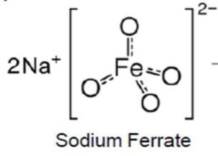

Priming: When steam is produced rapidly in the boilers. Some droplets of the liquids water are carried along with the steam. This process of wet steam formation is priming.

Foaming:

1)Formation of small but persistent foam or bubbles at the water surface in boilers. 2)Which do not break easily.

1. Caused by the presence of oil and alkali in boiler feed water.
2. Oil and alkali will react and form soap which greatly lowers the surface tension of water and thus increase the tendency of the liquid.