# FALL SEM 2019-20 MATLAB-MAT1011(CFE)-ELA

**DIGITAL ASSIGNMENT-3 SLOT: L31+L32**

**REGISTRATION NUMBER:19BCE0811 NAME: Akshat Srivastav**

EXERCISE 1:

Sketch the graphs of the following functions. Also, determine and plot the points of their local maximum, local minimum or saddle points.

Code for the problem:

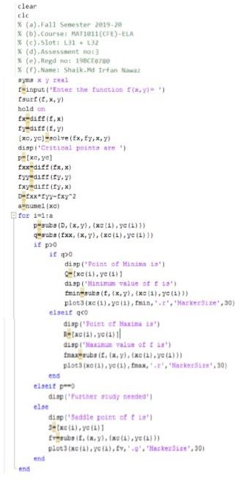

Reg number: 19BCE0811

Name: Akshat Srivastav

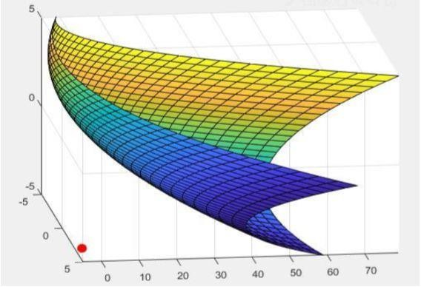

OUTPUT:

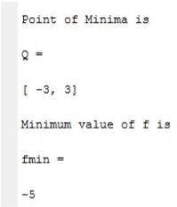

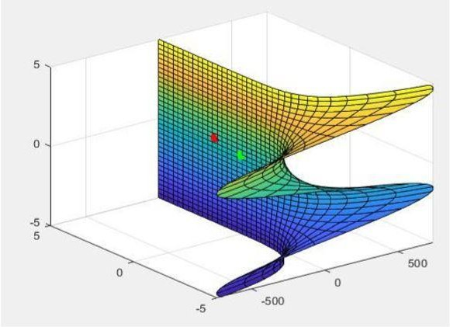

OUTPUT:

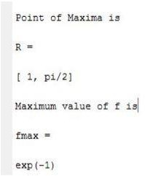

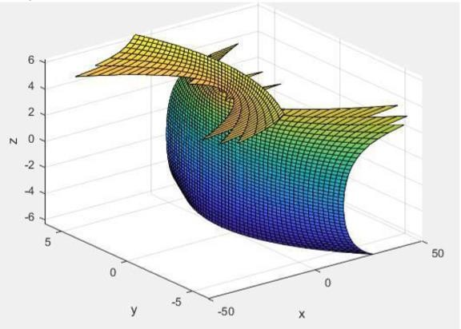

OUTPUT:

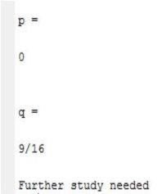

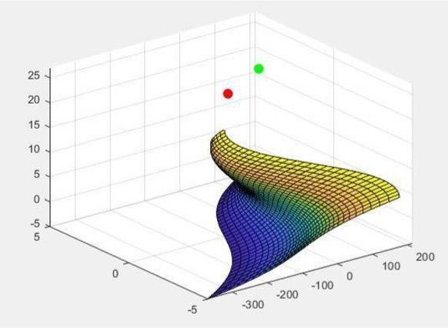

OUTPUT:

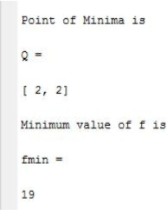

e)f(x,y)= s^2-2*y^2+8*x*y

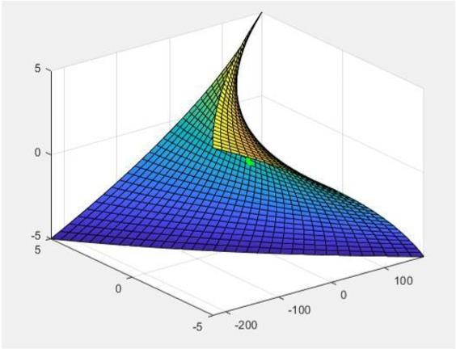

OUTPUT:

