Dice – Distributed Computing Environment
Mikkel Kamstrup Erlandsen, Dec. 2006, State and University Library, Statsbiblioteket, Denmark

About This Paper
This paper serves as a short introduction to the Dice framework, designed for the Summa project running on State and University Library, Statsbiblioteket, in Denmark. The general framework is independent on Summa and can be applied anywhere the tasks at hand makes sense to parallelize.

About Dice
The original purpose of Dice was to provide a distributed platform for compiling the Lucene index underlying the search interface for the State and University Library of Denmark. Scalability wise it is designed for clusters with 10-50 slaves and 2 central servers, however the real scalability will rely on the specific task being performed.
The Dice slaves was originally intended to be of high-end desktop computing powers, but by using the on-disk caching and data compression tools native to Dice it should be possible to use older hardware as well.

Overview of the Dice Framework
Dice is build around three central objects. Worker, Employer, and Consumer. They exchange informations in form of Job, JobStatus, and JobName.
The Employer is responsible assembling jobs, dispatching them on request from the workers, and keeping track of the status for each job.
The Workers' job is to request jobs from the Employer, process the data associated with the job, and send the processed job on to the Consumer.
The Consumer is the end station in the processing chain. It aggregates jobs processed by the Workers, and when all jobs have been registered it might take some action depending on the task at hand.
The important thing to notice is that the Workers are in fact completely anonymous. This is a design goal for Dice. The workers autonomously get jobs from the Employer and passes them on to the Consumer when done processing them. The workers report status on the individual jobs for the Employer to keep track of what's done and what's not, but there is no known status of a worker.
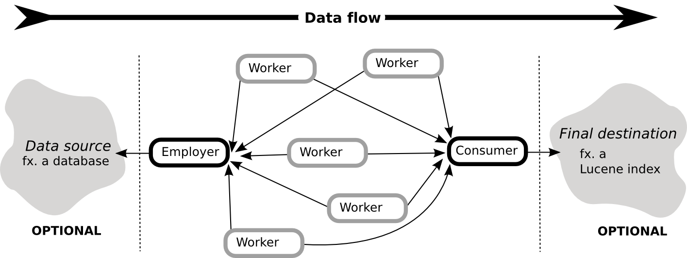Figure 1 : Data flow in a Dice session. Note that the arrows originate from the acting entity.
The lowlevel Dice API is quite simple.

Jobs and JobStatus
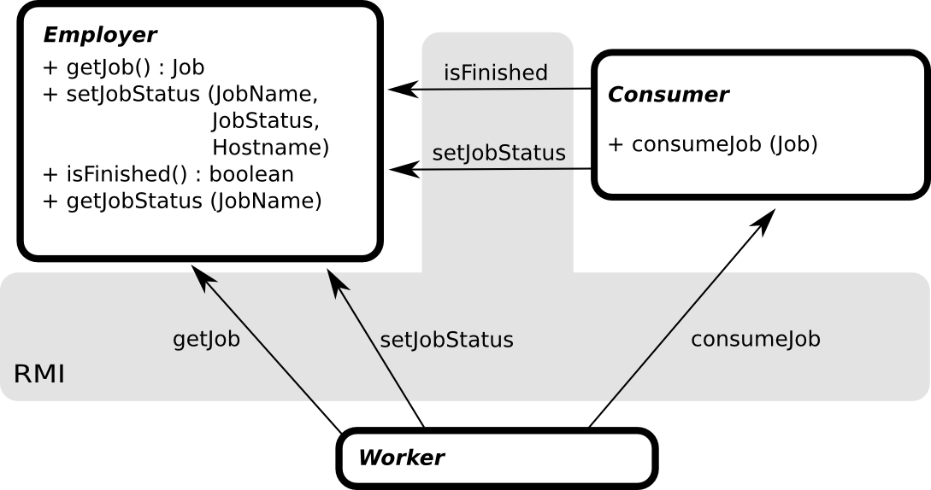Figure 2 : Basic interfaces and interactions in the Dice framework. Currently RMI is used as RPC mechanism, but the RPC mechanism can easily be modified to be a pluggable backend.
A Job object in Dice consist of a generic data Object representing the data to be processed by the Workers, a String jobName uniquely identifying this job to the Employer, and an optional jobHint hash map containing information relevant for the Worker for processing the Job. A Job object does not carry any status information about itself, this data is only stored by the Employer.
A JobStatus object is in essence an enumeration additionally containing the name of the job it describes. The enumeration can be one of:
- JOB_NONE, there's no job, the name String is set to null.
- JOB_FAILED, the job has failed to complete, description String should hold a stack trace. Failed jobs will be re-processed.
- JOB_WORKER_FETCHING, job is currently being transferred to a Worker
- JOB_WORKER_ENQUEUED, job is copied to a Worker and is waiting to be processed
- JOB_PROCESSING, the job is being processed by a Worker
- JOB_PROCESSED, job is finished on the Worker and is ready to be consumed
- JOB_CONSUMER_FETCHING, the job is being copied to the Consumer
- JOB_CONSUMER_ENQUEUED, the job stored on the Consumer, waiting to be processed
- JOB_CONSUMING, job is being processed by the Consumer
- JOB_CONSUMED, the job has been finally processed by the Consumer (Employer can discard Job info)
- JOB_LOST, the job has been lost on the Consumer after the Employer has purged it from the cache. A lost job can not be re-processed.

Dice Error Recovery
Upon dispatching a Job the Employer will keep a reference for the Job in a list of jobs in progress. When the main list of Jobs has been depleted and no more will become available (fx. if the external data source is depleted), the Employer will start issuing jobs from the in-progress list. This means that Jobs stuck on a crashed Worker eventually will be re-dispatched. This also has the added benefit that final Jobs crawling away on a slow Worker will be out run by faster Workers re-processing the in-progress Jobs.

Implementing a Dice Application
The Dice package contains generic implementations of the three main objects. They do all the bookkeeping and remote calls. By extending these base classes all that is left on the implementation side is filling out four abstract methods that define the basic behaviour of the three main objects.
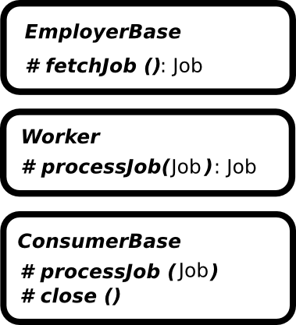Figure 3 : Abstract base classes.
EmployerBase.fetchJob() : Create a new Job object and return it. This method will be called repeatedly until it returns Null.
Worker.processJob (Job) : This will typically be where the actual data processing takes place. The Worker base class automatically downloads Jobs from the Employer, enqueues them, and processes the queued Jobs with this call. The returned Job will be uploaded to the Consumer.
ConsumerBase.processJob(Job) : Accept an incoming job from a Worker. The Consumer can either do some post processing, pass the processed data directly on to some other service, or just store the job somewhere (possibly on disk) for final treatment in the close() method. When this method exits the Job will marked as JOB_CONSUMED.
ConsumerBase.close () : Called when all jobs has been marked as JOB_CONSUMED.

Example Dice Application, Prime Detector
A simple distributed prime number detector could be implemented by extending the three base classes with PrimeEmployer, PrimeConsumer, PrimeWorker.
- PrimeEmployer.fetchJob() : Fill the next 10.000 odd numbers into an array and wrap it in a Job.
- PrimeWorker.processJob (Job) : Run through all numbers in the Job's array and copy all prime numbers to a new array. Wrap the new array in another Job object and return it.
- PrimeConsumer.processJob(Job) : Write the Job's array (now containing only primes) to a temporary file to avoid holding it in memory.
- PrimeConsumer.close () : Concatenate all temporary files into one big file. Delete all temporary files.

Caching and Data Compression
Dice features a caching and compression layer to help lower memory footprints and network traffic. Since it is assumed that consumers of the API will be dealing with rather large data objects, the caching API is designed so that you never have to hold an entire data object in memory. Because of this the cache is designed to store Java Iterables.
At the lowest level of the cache framework is the Cache interface. Applications will typically use this only indirectly through the CacheClient class providing a simpler interface centered around Iterators.
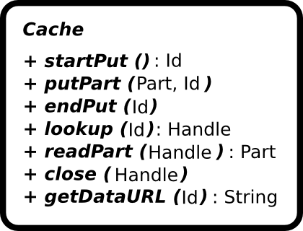Figure 5 : Low level Cache interface. Applications will typically use this indirectly through a CacheClient.
There is an implementation of the Cache interface called CacheService. This implementation relies on a CacheReader and a CacheWriter to get and put data. These reader and writer objects could read and write data anywhere in any way fitting the situation. There is bundled (among others) a reader and writer using gzipped data on disk.
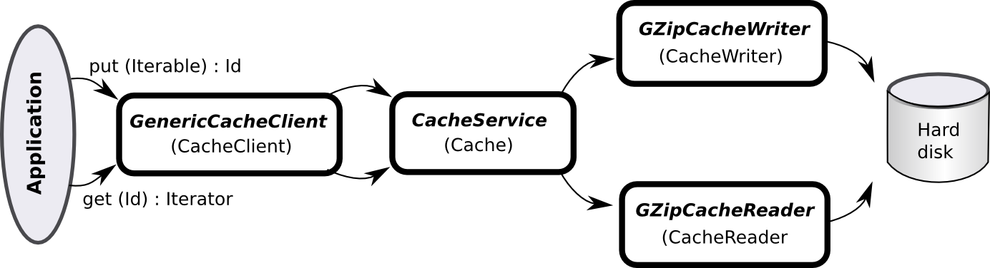
Figure 6 : Application utilizing a gzipping cache.

Specialized Caches
In addition to the CacheService implementation there is a BlockingCacheService and a RemoteCacheService. These both wrap another Cache in a decorator style pattern. This way it is possible to have a cache that is both blocking and remote.
The blocking cache blocks on Cache.lookup(id) until the requested object is available. The remote cache exports the Cache methods over RMI.
Trick: Consider Figure 6 above. If the CacheService was wrapped in a RemoteCache and the GzipCacheReader was replaced by a DataCacheReader (reading raw data from disk). The Iterator returned from CacheClient.get(id) would return raw chunks of gzipped data, thus reducing network traffic. Ofcourse the client application would have to reassemble the data somehow. There are tools for this in the Dice package as well.

A Caching Dice Setup
There are caching implementations of the Dice objects as well. Namely CachingEmployer, CachingWorker, and CachingConsumer. They all sport an embedded cache that is used transparently to the actual implementation. The only catch is that the data members of the Job objects are in fact Iterables returning iterators proxying the contents of the cache.
In a normal setup you might end up passing rather large data objects through your RMI calls. Since RMI is by no means a transfer protocol this is not desirable. This could be solved in several ways. One way could be to manually set up a stream to transfer the data objects (completely outside the RMI scope). The catch here is that this introduces a lot of extra logic all the way through the stack as well as requiring additional open ports on the servers. The choice in Dice was to break up the data objects into smaller parts and transfer them in chunks over RMI. This fits naturally into the Cache interface and is dubbed semi streaming RMI because of the inspiration from the normal Java streaming API.
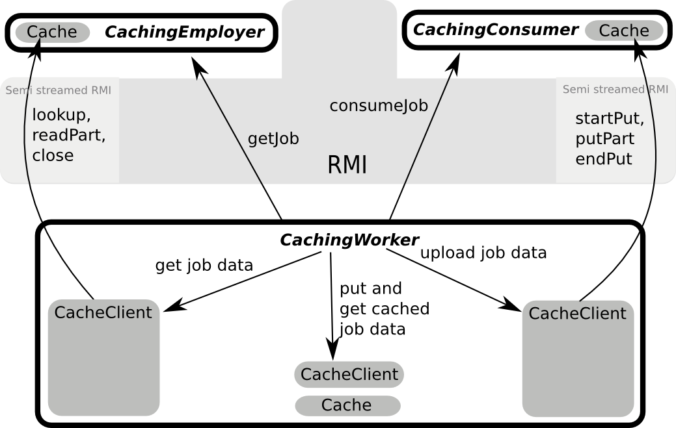
Figure 7 : Data flow in a caching Dice setup.

Summa Index Compilation with Dice
At Statsbiblioteket we deploy a Dice implementation where the Employer fetches records from a storage backend and creates Jobs with batches of 10.000 gzipped records. The Workers create local Lucene indexes for each Job, and ship the zipped index to the Consumer. The Consumer merges all subindexes into one optimized index. The compression and caching facilities of the Dice framework are used to this end.
In our current setup we compile our index with 25 desktop workstations as Workers and one single server acting as Employer, Consumer, and storage backend (quad Xeon 3.2GHz, 4Gb ram). This setup is not ideal or optimized in any way, but it meets our current needs fine.
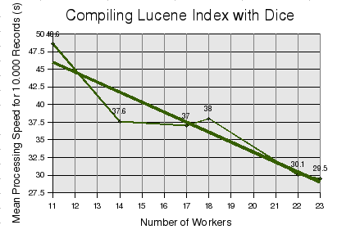Figure 8 : It is expected that the approximately linear speed increase will continue well beyond our current tests. It is anticipated that the bottleneck will be the storage backend.

Loosely speaking the Iterator.next() call proxies the RemoteCacheService.readPart() method.

