Apple M0110a USB PCB build guide

Very quick and dirty build guide.
If you need further help DM me on Reddit (u/_vastrox_) or on Discord (elmo#0101).

Parts required:
1 | ATmega32A 40 pin DIP (32L works too)
1 | 40 pin DIP socket (optional but highly recommended)
1 | 2x3 pin header 2.54mm (for ISP flashing)
1 | 3mm LED (any color should work)
1 | JST HA 2mm connector + cable (included in the package)
1 | mini usb breakout board (included in the package)
1 | 500 mA polyfuse
2 | 6mm momentary push buttons
1 | 16 MHz quarz crystal
1 | 4.7 uF electrolytic capacitor
2 | 100 nF ceramic disk capacitor
2 | 22 pF ceramic disk capacitor
1 | 10 kΩ resistor
2 | 68 Ω resistor
2 | 1.5 kΩ resistor
2 | 3.6 V zener diode (DO-35 BZX55C3V6)
78 | universal switching diode (DO-35 1N4148)

All of these parts can be easily found on eBay for fairly cheap prices.

Building the PCB:

1. Start with the controller socket. Put it in with the cutout nose like it‘s shown on the PCB silkscreen. Hold it in place with some electrical tape on top of the board. Solder every second pin on the board to prevent overheating the plastic. Then do the rest of the pins.

2. Solder in the quarz crystal into it‘s spot next to the controller (XTAL1). Polarity doesn‘t matter here. Do not pull hard on the parts legs as they can rip out quite easy.

3. Solder in the capacitors. The values are as follows:
- C1 (ELKO! Watch the polarity! white side = negative) = 4.7uF
- C2 & C3 (next to the controller socket) = 100nF
- C4 & C5 (left and right of the crystal) = 22pF

4. Next up are the two 3.6V Zener diodes. They go into the spots D1 and D2. Watch the polarity! The white line on the silkscreen has to match with the black or white line on the diode.

5. Now come the resistors. Their values are as follows:
- R1 (next to the reset button) = 10kΩ
- R2 & R3 = 68Ω
- R4 & R5 = 1.5kΩ

6. Solder in the rest of the parts:
- the 500mA polyfuse (spot F1)
- LED (watch the polarity, square pad = negative)
- JST connector (goes on the bottom side of the board facing down like the silkscreen shows)
- the two pushbuttons for boot and reset
- ISP flash connector (2x3 pin header) soldered in on top of the boards pointing towards you)

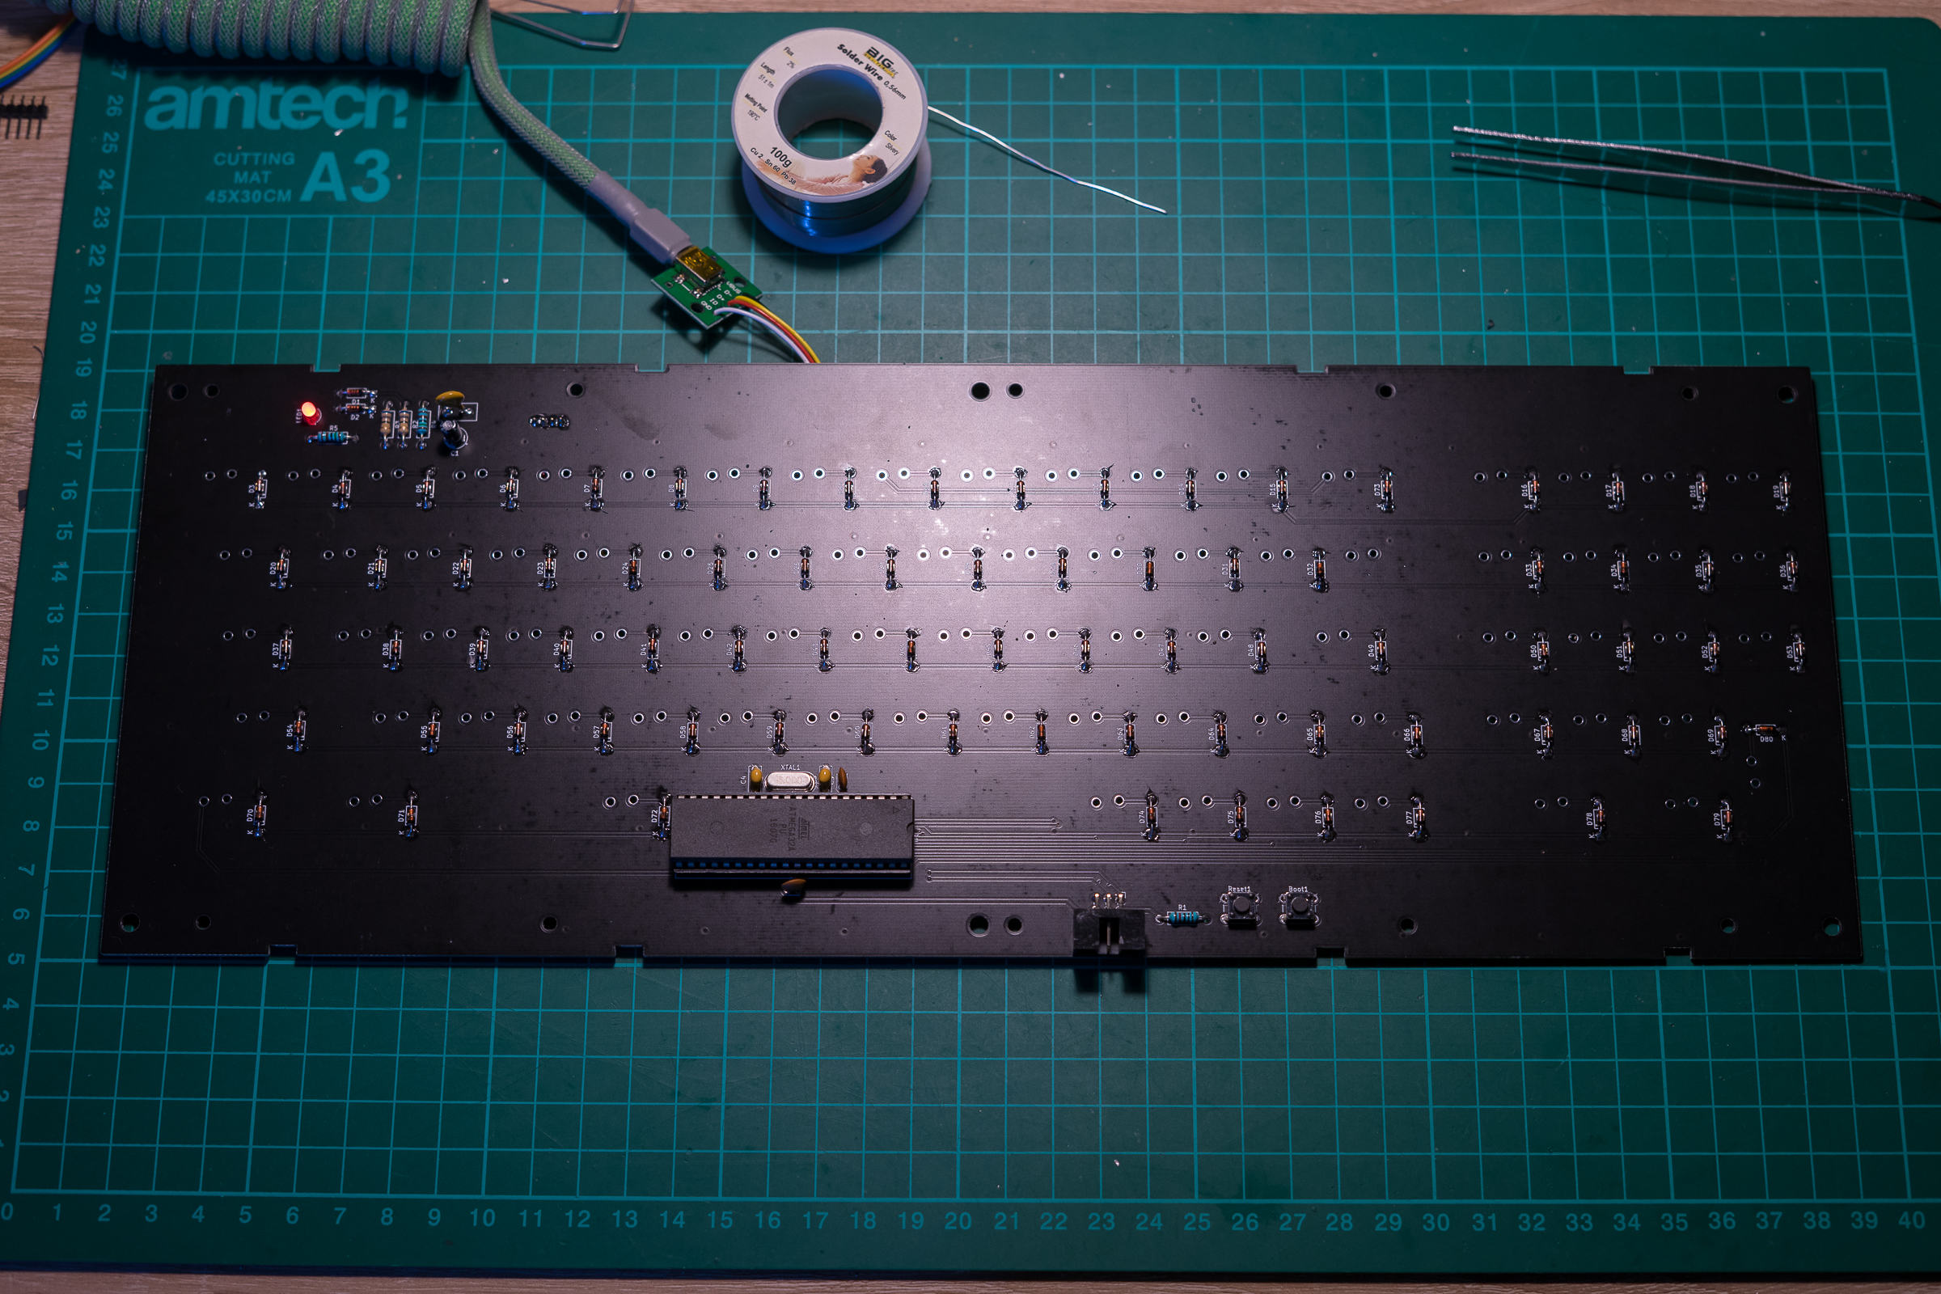
7. Finish the board by soldering in all 78 diodes. Watch the polarity (white stripe)
Building and flashing the bootloader:

Download the bootloader firmware from here:
https://github.com/kb-elmo/m0110a_usb/tree/master/firmware/bootloader

You need either a Linux system or MingW on Windows for this as this requires compiling some stuff.

The firmware is already set up and you don‘t need to change anything in the configuration files for this board.

1. Build the bootloader firmware by running „make“ on your console

2. Make sure that you can reach the controller by executing a chip erase with
„avrude -c usbasp -p m32 -e“ (you have to run these commands as root in Linux)

3. Flash the firmware on the controller with „make flash“

4. Set the controller fuses to the correct values „make fuse“

5. Finally lock the controller bootloader in place with „make lock“

The avrdude tool should show a „success“ after each operation. If the flashing process was successful you can unplug the ASP flasher and plug in the USB now.

Building and flashing QMK:

Unfortunately the pull request to integrate the board into the official QMK repository has still not been approved so you will have to clone and build QMK locally on your machine.
To set up the build environment simply follow the guide on https://docs.qmk.fm

After you have set up your QMK environment copy and paste the files from
https://github.com/kb-elmo/m0110a_usb/tree/master/firmware/qmk
into a new folder called m0110a_usb inside the keyboards folder of QMK.

Edit the keymap.c file in the default keymap to your liking and then build and flash the firmware with (set the board into bootloader mode first by holding down the boot button and tapping the reset button once): „make m0110a_usb:default:usbasp“

QMK should now flash the board automatically. After the flashing was successful press the reset button once to reset the board. The PCB should now work as a keyboard.

Putting everything together:

Starting point for this is a fully disassembled M0110a with all switches removed from the plate.

1. Screw in the PCB onto the backplate with the 10 small screws

2. Put in the switches and solder them in place. Take care to not bend any contact legs.
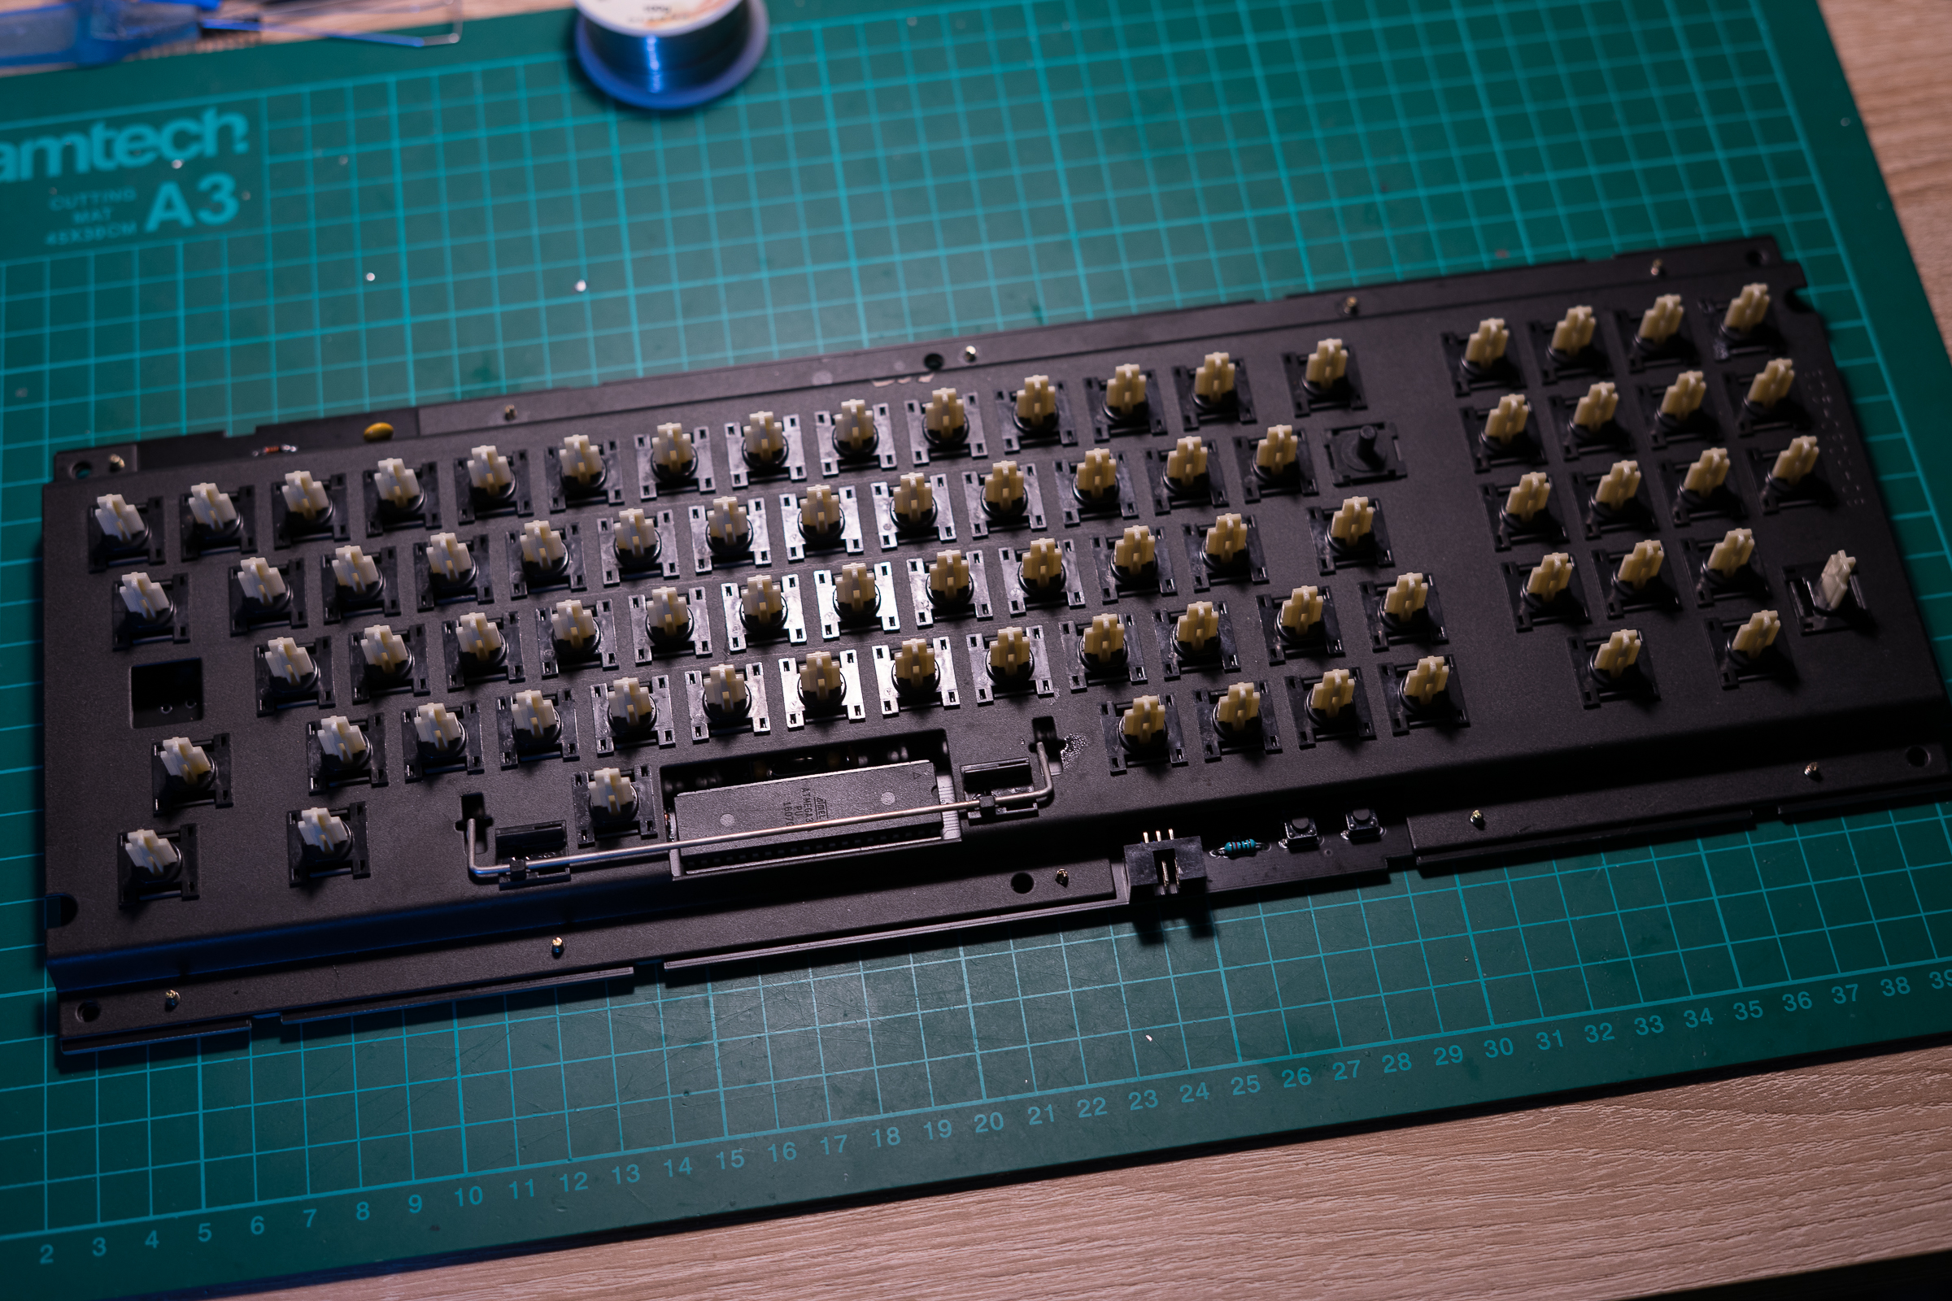
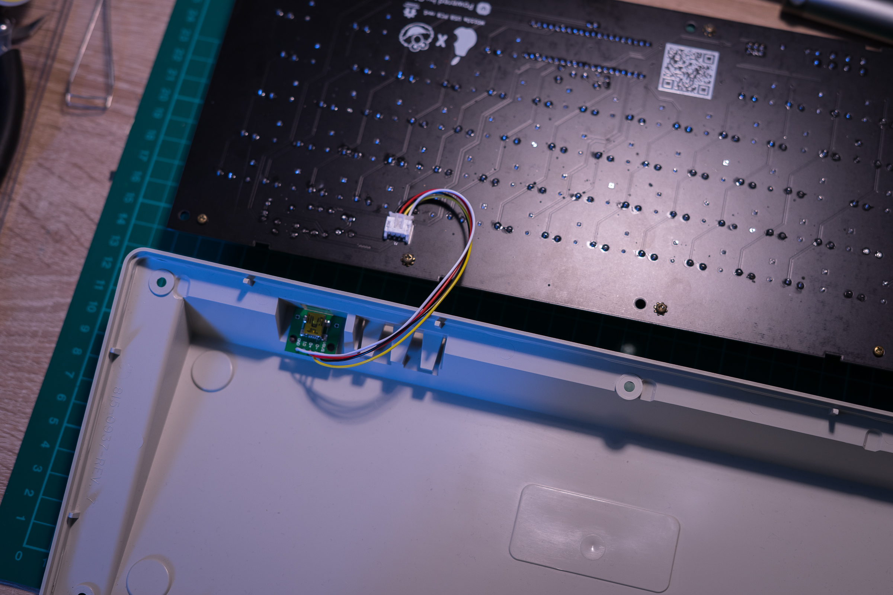
3. Stick the daughterboard into the cutout in the bottom of the case (doublesided tape works best for this).

4. Put the fully built plate into the bottom half of the case
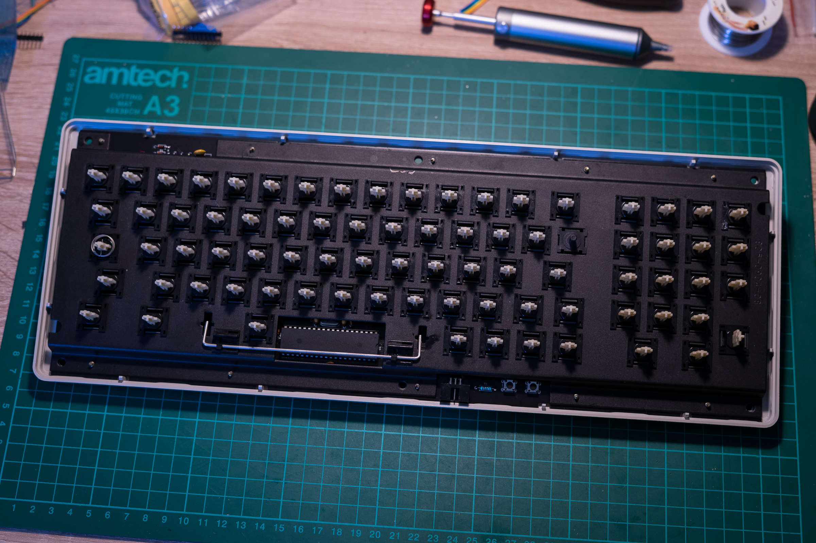
5. Put on the top half and screw both halves together. The case screws are going through the big holes in the PCB and clamp it in place.
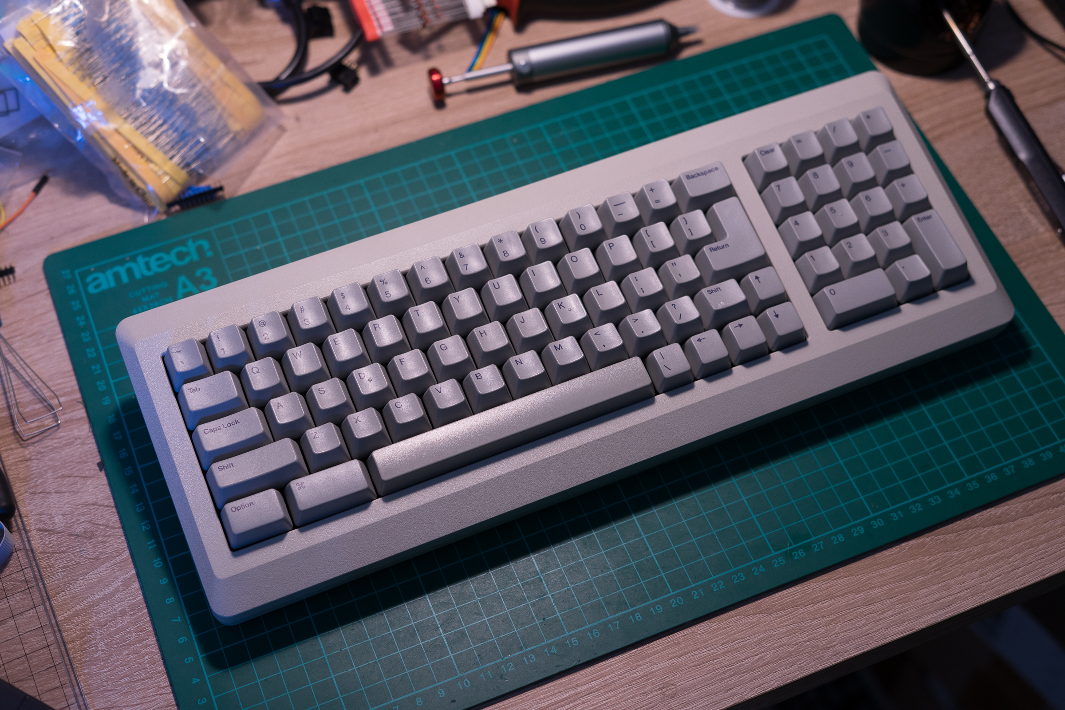

Finished!

